Project Summary
Increased awareness that consumer markets are prone to and often suffer from market failures, both traditional and behavioral, has resulted in growing pressure throughout the world for broader substantive regulation of consumer contracts. While much scholarly attention has been devoted to the need to protect consumers from exploitative market practices, to date, there has been almost no inquiry into sellers’ compliance with the regulatory requirements enacted to address this need. Using the residential rental market as a first test case, this dissertation seeks to fill this gap in the data.
The proposed dissertation will consist of four sections. The first will explore the pervasiveness and persistence of unenforceable terms in residential lease agreements, through content-based analyses of residential contracts currently used in a number of jurisdictions. Preliminary findings from the Massachusetts rental market suggest that unenforceable terms are routinely included in leases. Other forms of misleading drafting techniques have also been identified (Furth-Matzkin, 2017). Building on these findings, this dissertation’s second section dissertation will conduct qualitative fieldwork to analyze the factors underlying the persistent use of unenforceable contract terms. The Co-Principal Investigator will interview landlords, realtors, and housing lawyers to explore why drafting parties often fail to comply with mandatory regulations governing the content of standardized agreements. The dissertation’s third section will identify how the observed contract drafting techniques, particularly the use of unenforceable clauses, influences tenants’ decisions, behavior, and outcomes. The study’s hypothesis is that although these terms might not influence tenants’ initial renting decisions, they are likely to receive excessive weight ex post, after a rental problem or a dispute with the landlord arises. At that point, tenants, who are typically uninformed of their legal rights, may mistakenly believe that unenforceable contract terms are enforceable and binding, and consequently relinquish valid rights and claims. To explore this hypothesis, we will conduct large-scale surveys and experiments along with qualitative fieldwork consisting of in-depth interviews of residential tenants about their experiences with their leases and landlords. In the project’s fourth and final section, regulatory solutions will be considered and assessed, with the goal of ascertaining effective and efficient solutions that will improve consumer protection.
This dissertation should contribute to the literature on consumer protection and regulation by shedding light on contracting practices that have thus far been overlooked, identifying the mechanisms underlying them, and demonstrating the implications for consumers. This literature has focused on the failure of disclosure mandates to achieve their intended effect, either because they are inadequately designed or too burdensome for consumers to read. This project suggests that without adequate enforcement mechanisms, even stronger and more substantive regulation of consumer contracts may fail to protect consumers if sellers continue to misinform them about their legal rights and remedies.

Unenforceable Terms in Residential Leases: Scope, Causes, and Consequences
- Scientific Background
We live in a world of boilerplate agreements. Ninety-nine percent of the contracts we sign, or click “I agree” to, are standardized “take-it-or-leave-it” agreements that we typically do not read, let alone understand (Ben-Shahar & Schneider, 2014; Marotta-Wurgler, 2007). We encounter fine print all the time: when taking a loan or a mortgage, renting a car, opening a bank account, or purchasing a mobile phone. Because lengthy adhesion contracts are now routinely presented to consumers, especially on the internet, who click through them without so much as a glance, assent has increasingly become less informed and less meaningful (Hoffman, 2017; Wilkinson-Ryan, 2017).This modern form of contracting has attracted significant scholarly attention. Extensive research has been done on the “no-reading” problem in consumer contracts, with scholars noting that consumers rarely read or understand the fine print (e.g., Ayres & Schwartz, 2014; Bakos et al., 2014; Ben-Shahar & Schneider, 2014; Marotta-Wurgler, 2011), and cautioning against sellers’ practice of taking advantage of consumer inattention by inserting one-sided or exploitative terms (Bar-Gill, 2012; Korobkin, 2003; Radin, 2013; Rakoff,1983). In light of overwhelming evidence that sellers load the fine print with terms unfavorable to consumers, scholars have consistently advocated for stronger regulation of these standardized agreements in order to better protect consumers (Radin, 2013). Indeed, regulators and courts have heightened their scrutiny of standard form contract terms, both ex ante, by prohibiting or mandating the inclusion of certain terms in the fine print, and ex post, by judicially invalidating terms that are egregiously one-sided or unfair, on the basis of contract law doctrines such as fraud and unconscionability. Both ex ante and ex post scrutiny of standard form contract terms are intended to prevent businesses from “going too far” with terms that “deceptively peel off the value that consumers bargained for” (Draft Restatement of Consumer Contracts, 4).
While these measures undoubtedly represent welcome progress in the struggle to protect consumers, this dissertation project seeks to shed light on an important issue that has been overlooked by scholars and regulators alike: that is, by relying heavily on the consumers to bring claims to court, these protective measures may fail to attain their intended goals, as consumers may not realize that the contractual terms to which they consented can, in fact, be subject to judicial scrutiny and invalidation. This hypothesis is consistent with preliminary findings that consumers are typically uninformed of the law governing their transactions (Bar-Gill & Davis, 2017; Kim, 1997; Mueller, 1970), and that they are reluctant to bring claims to court in the face of unfavorable contractual clauses, such as exculpatory, choice of law, or choice of forum clauses (Stolle & Slain, 1997; Wilkinson-Ryan, 2017). In fact, several experimental studies have shown that consumers perceive standardized agreements as both legally and morally binding, even if they did not participate in drafting or negotiating their terms, and even if their consent was given in a superficial and formal manner (Eigen, 2008; Furth-Matzkin & Sommers, 2017; Mueller, 1970; Wilkinson-Ryan & Hoffman, 2015).
Building on these findings, this dissertation proposes that, in the absence of sufficient sanctions and adequate enforcement mechanisms, the combination of consumers’ ignorance of the law and their widespread assumption that boilerplate terms are enforceable might provide an incentive for profit-maximizing sellers to draft contracts in ways that conflict with, deviate from, or misrepresent the law. Clearly, while consumers fail to take the terms of the contractual agreement into account ex ante, they are likely to rely on them ex post, when a problem, question, or dispute with the seller arises. At this point, because consumers are typically unaware of the rules dominating their relations with sellers, consumers are likely to assume that their contracts are definitive and accurate sources of information. Consequently, even if these contracts contain legally invalid terms, the consumer is likely to misperceive them as enforceable and binding. Uninformed and unaware consumers might therefore forego pursuing valid legal rights and claims, and ultimately bear costs that the law has deliberately and explicitly imposed on the seller. In turn, profit-maximizing sellers are likely to realize that they can leverage their superior familiarity with the law by drafting contracts that overreach it, as there is much to gain and little to lose from this drafting practice.
Despite the clearly adverse effect of such contracting practices on consumers, there is surprisingly little literature about this issue (for exceptions, see Kuklin, 1988; Sullivan, 2003), and, in particular, there is a notable absence of empirical inquiry into the use of unenforceable terms in consumer contracts. This dissertation project seeks to address this deficiency by exploring the scope of such standard form contracting practices, as well as the factors underlying them and their implications for consumers, from the perspectives of both cognitive psychology and law and economics. It will employ mixed empirical methodologies and examine the residential rental market as a first test case. This project is being carried out in the hope it can help regulators devise appropriate regulatory solutions for a generally understudied yet particularly harmful behavioral market failure.

- Detailed Description of the Proposed Project

  - The Test Case: The Residential Rental Market
There are two primary reasons for this dissertation’s focus on the residential rental market as a first test case. First, this market is important from both social and economic perspectives. As of 2017, more than 111 million United States residents, representing 35 percent of the total population, lived in rental housing, and the market’s annual revenues exceeded $175 billion (“Quick Facts: Resident Demographics,” 2017). Second, this market is characterized by pervasive mandatory regulation of residential lease agreements. This regulation, which consists of both substantive and disclosure requirements, renders the rental housing market an interesting and pertinent test case for other types of consumer markets where such regulation is currently being adopted.
  - Research Objectives, Hypotheses, Methods, and Design
In the 1960s and early 1970s, the United States experienced a revolution in residential landlord and tenant law (Rabin, 1984), inspired by the rise of the civil rights movement and by developments in consumer protection laws. This revolution was rapid and pervasive, with almost all United States jurisdictions adopting major reforms and awarding tenants a variety of mandatory rights and protections. Since that period, there has been almost no investigation of landlords’ compliance with the new regulatory environment. Proposing to fill this gap, this research has four major objectives: to measure and quantify landlords’ compliance with substantives regulation aimed at protecting tenants; to explore the factors underlying non-compliance in the residential market; to identify the impact of non-compliance on tenants’ perceptions, decisions, and well-being; and to devise regulatory solutions to address these issues. The dissertation will be organized into four main sections as outlined below.
- Uncovering the Use of Unenforceable Lease Terms
The first section will include a comprehensive empirical inquiry into landlords’ compliance with landlord and tenant law, building on hand-compiled databases of residential lease agreements from several jurisdictions with different regulatory frameworks. The samples will be collected by using various online platforms, including Prolific Academic, to ask randomly selected participants, all residential tenants, to upload their lease agreements, redacting identifying details, to an online database in return for payment of a specified sum.
The sampled leases will be then analyzed and coded in terms of the applicable mandatory rules governing the content of residential agreements in each jurisdiction. The study will design an Unenforceability and Deceptiveness Index, assigning different scores to different terms according to the importance of the subject matter and the degree of deviation from applicable law. This index should enable us to explore correlations between the characteristics of landlord or firms and the deceptiveness of contracts (for examples of studies using similar indices, see Marotta-Wurgler, 2007; Schwarcz, 2011).
Preliminary findings already obtained suggest that unenforceable terms are regularly included in residential agreements in the greater Boston, Massachusetts area, notwithstanding regulatory efforts there to protect tenants (Furth-Matzkin, 2017). Objectionable terms typically limit or disavow the landlord’s mandatory duties or restrict the tenant’s rights and remedies. Unenforceable exculpatory clauses, disclaiming the landlord’s negligence liability, or clauses purporting to unlawfully restrict or condition the landlord’s warranty of habitability or to shift mandatory repair duties from the landlord to the tenant, were especially prevalent in the sampled agreements. The sample also exhibited ubiquitous examples of other potentially misleading drafting patterns. In particular, the sampled leases often contained clauses not unenforceable per se, but rather unenforceable as written. These clauses did not contravene the law outright, but were misleading by selectively disclosing only a particular part of the law, such as the tenant’s duties or the landlord’s rights and remedies. In addition, many leases contained legal fallback clauses, stipulating that they were “subject to applicable law,” or applied “to the extent permissible by law,” and so forth. This study now seeks to determine the vigor and comprehensiveness of these preliminary findings by analyzing hand-compiled samples of residential leases from different jurisdictions in other metropolitan areas, including New York City, Chicago, San Francisco and Philadelphia.

- Why Are Unenforceable Clauses Used in Residential Leases?
Building on the findings from the first part of the study, the second section of the dissertation will examine the issue of why unenforceable clauses are routinely included in contracts despite their lack of legal validity. There are several plausible explanations for this practice. First, landlords may intentionally include such provisions in order to increase profit while exploiting tenants’ misperceptions and ignorance of the law. This hypothesis is consistent with increasing evidence suggesting that companies take advantage of consumers’ imperfect information, restricted attention and limited rationality through product and contract design (e.g., Bar-Gill, 2012; Grubb, 2009; Heidues & Koszegi, 2010). Second, landlords may use clauses that deviate from the legal rule because they perceive the current law as unfair, imbalanced or skewed in favor of the tenant. Correspondingly, landlords might include these clauses to protect themselves from opportunistic tenants, but only selectively enforce these terms against those whom they consider troublesome tenants. In essence, this drafting pattern may be designed to shield landlords from opportunistic behavior on the part of the tenant (for similar propositions in the context of self-serving clauses in consumer contracts, see Bebchuk & Posner, 2005; Johnston, 2007). Finally, landlords may use unenforceable terms inadvertently as a result of their own ignorance of the law.
While it is reasonable that some individual landlords renting out only one or a few properties are unaware of the law governing their relations with tenants, it seems unlikely that sophisticated and frequent actors in the rental market, such as residential companies and real estate trusts, would be ignorant of their legal obligations. These parties are usually assisted by lawyers, and possibly even by in-house legal counsel. This leads to the hypothesis that residential companies, which are aware of the law, will exercise more caution in drafting leases than will individual landlords, in view of the legal sanctions and reputation costs involved.
Residential companies are far more likely to be significantly deterred by the negative consequences of including unenforceable contract terms than would private landlords for several reasons. First, private landlords typically own at most only a few apartments, while residential companies usually own and operate hundreds or thousands of units. As a result, residential companies are significantly more vulnerable to class action suits being brought against them, and in turn, to the imposition of significantly higher sanctions. Second, and relatedly, courts may be inclined to impose higher standards on companies, which are considered sophisticated market players, than on individual landlords, who may unknowingly include unenforceable lease terms. Third, official enforcement agencies may be more motivated to target deceptive residential companies rather than individual landlords in light of the anticipated difference in the scope of harm to tenants. Finally, residential companies may be more acquainted with judgments and enforcement actions sanctioning landlords for engaging in deceptive market practices, thus leading them to exercise more caution in drafting their leases.
This study’s preliminary findings provide tentative support for this last hypothesis, suggesting that companies include unenforceable terms in their contracts at significantly lower rates than do individual landlords (Furth-Matzkin, 2017, 34). It is interesting to note that both residential companies and individual landlords did use misleading terms selectively disclosing the legal conditions at statistically equivalent rates. It is possible that residential companies use misleading clauses with the same frequency as do private landlords because these clauses are perceived as simultaneously profitable and harmless. While unlikely to expose companies to sanctions, such clauses are likely to misinform tenants about their rights and remedies.
In order to empirically test these contractual practices, it is essential to complement the observational, content-based analysis described in Section One with qualitative fieldwork comprised of in-depth interviews with those who draft, market, and sign these agreements. For this purpose, the Co-Principal Investigator will interview individual landlords, directors of large landlord associations and real estate boards, realtors, and housing lawyers from the Boston area. Landlords, realtors, and housing lawyers will be invited to participate in the study during the course of numerous events and conferences administered by landlord and realtor associations, such as annual and semi-annual housing policy forums. A semi-structured model will be used to conduct the interviews to allow for flexibility while at the same time maintaining structure and permitting replication and coding (e.g., Drever, 1995).
Through these interviews, the research will explore the following issues: whether landlords are typically informed of the rules governing their relations with tenants; how landlords perceive these laws, such as whether they view them as overly-protective of tenants; how well-acquainted landlords are with their leases; who drafts these leases and how; and how landlords, lawyers, and realtors perceive the interactions among the law, the contract, and their relations with the tenants and with one another.
The responses to these questions in the interviews will help elucidate the factors behind the identified lease drafting patterns. Admittedly, it will be difficult to obtain candid answers about the motivations and intentions underlying the use of unenforceable terms from the landlords, lawyers, and realtors themselves. However, by asking indirect questions about their acquaintance with the law, their drafting procedures, and their interactions with tenants, the research hopes to shed light on the factors influencing these market players’ contract-drafting decisions and behavior. The findings of this qualitative inquiry will also assist in generating hypotheses to be tested quantitatively in future research.
- What are the Implications for Tenants?
Whether the use of unenforceable terms is intentional or inadvertent, it is essential to explore the implications of the practice for the non-drafting party: the tenant. Section Three of this dissertation will be designed to examine this issue. While the possibility exists that tenants are unaffected by the inclusion of unenforceable terms in their lease agreements because residential leases, like many types of standard form contracts, largely remain unread (e.g., Bakos et al., 2014; Ben-Shahar & Schneider, 2011), this project seeks to draw an important distinction between non-reading ex ante and reading ex post. Specifically, this work hypothesizes that even if tenants may not read their lease agreements before signing them, many of them will read these contracts ex post, after a tenancy-related problem or a dispute arises. At that point, because tenants are typically ignorant of their legal rights and remedies as renters, they are likely to rely on the contract as their main, or even only, source of information about their rights and remedies when encountering a rental problem. If the contract contains unenforceable terms, tenants are likely to misperceive these terms as enforceable and binding and, as a consequence, relinquish their valid legal rights and claims.
In order to explore this hypothesis, this study will combine the quantitative approaches of large-scale surveys and experiments with qualitative fieldwork. Using these methodologies, this study will examine four interrelated issues. The first is whether tenants read their leases and in what circumstances, with an emphasis on investigating whether tenants read their leases when a rental problem arises. The second issue to be studied is how tenants solve rental problems and disputes, and in particular, whether they rely on their leases as their main or only source of information about their rights and duties, or whether they seek alternative or complementary sources of information, such as legal or web-based advice. The relationships between tenants’ demographic characteristics and their perceptions, decisions, and behavior at the post-contract stage will be investigated in relation to this aspect of the study. Third, this study will test the hypothesis that tenants generally perceive the terms of their residential contracts as enforceable and binding, even when they are clearly void and unenforceable according to the law. Fourth, this study will identify the norms governing the tenant and landlords’ post-contract negotiations.
To date, field studies of landlord and tenant relations have focused on litigation of rental disputes in housing courts (e.g., Brakel and McIntyre, 1980; Heskin, 1978). Little attention has been devoted to landlord and tenant relations outside the courtroom. Substantial evidence from the literature of social norms suggests that in relations characterized by repeated interactions over time, such as neighborly relations or relations in closely-knit communities, contracting parties develop norms of negotiation and dispute resolution outside the formal legal system (e.g., Bernstein, 1992; Ellickson, 1991; Macaulay, 1963). Negotiations in these types of relationships are not conducted in the “shadow of the law” (Mnookin & Kornhauser, 1979), but rather outside its shadow, as other norms, social and moral in character, outweigh the formal legal rules.
This study seeks to expand on the existing research by examining negotiations that are simultaneously both within and outside the shadow or purview of the law. To a certain extent, they are within the law’s purview because the law, through its mandatory protections of tenants, has authority over the negotiations. Yet, the negotiations are also outside the law’s purview because the primary norm governing the post-contract negotiations is the contract. While the contract is itself a creature of law, at issue is a lease agreement that misrepresents the law. What, then, is the role of unenforceable contract terms in negotiations taking place after the contract has been signed, and what is the impact of the law on these transactions?
Section Three of the dissertation will address these issues using mixed empirical methodologies. During the first stage of relevant research, wide-scale online surveys will be conducted in order to understand whether, and under what circumstances, tenants read their residential leases, what type of rental issues or problems they encounter, and whether they are informed of their rights under the law. In addition to focusing on examining these interrelated issues, the surveys will also be used to generate scenarios for experiments to be conducted during the second stage of research.
Building on the surveys’ findings, a series of experimental studies will be designed to explore the effect of identified deceptive drafting techniques on tenants’ perceptions, decisions, and behavior. The first experiment will have a two variable, between subjects, design. The first variable, the contract, will have three levels: enforceable (liability); unenforceable (no liability); or no terms. The second variable of legal information will have two levels: guidance; or no information. Participants, all current Massachusetts residents recruited through online crowdsourcing platforms such as Prolific Academic, will be instructed to assume that they are renting an apartment in Boston. They will be randomly assigned to read a lease containing either an enforceable liability clause acknowledging the landlord’s negligence liability, an unenforceable clause absolving the landlord of liability, or no clause pertaining to the landlord’s liability for loss or damage caused to the tenant on the leased premises. Participants will subsequently be randomly divided into one of two information conditions, with only half of them obtaining access to the Massachusetts Consumer Guide to Tenant Rights and Responsibilities. These participants will be informed that they will have access to these materials throughout the experiment. Participants will then be provided with “filler” information about the apartment size, location and rental price, and will be asked some “filler” questions. They will subsequently be instructed to assume that a certain tenancy-related problem arises during the rental period. For example, in one scenario, based on a real case, they will be told that two months after having notified their landlord about a leak in the roof, rain water falls from the leaking roof and destroys some of their appliances. In an open-ended question, they will be asked to evaluate how they would behave under these circumstances.
Three independent coders, blind to the study’s hypotheses and design, will code participants’ open-ended responses. The study’s hypothesis is that tenants who read a lease containing an unenforceable liability disclaimer will be significantly more likely to bear the repair expenses themselves without even approaching the landlord than will be tenants encountering a lease containing an enforceable clause acknowledging the landlord’s liability. We also anticipate that participants will be significantly more likely to take action, including legal action, against the non-cooperative landlord when provided with information about their rights and remedies under the law.
Notwithstanding these expectations, there are two competing predictions as to the interaction between legal information and the content of the lease agreement. It is possible that tenants faced by the mere presence of an unenforceable lease provision, even if they realize or strongly suspect that the relevant contract term is unenforceable, may be deterred from taking any action (e.g., Stolle & Slain, 1997; Wilkinson-Ryan, 2017). In contrast, such tenants could possibly exhibit reactance, becoming more eager to take action against the non-compliant landlord once they realize that the lease agreement they had signed had overreached the law to their detriment (on reactance, see generally Brehm & Brehm, 1981; see also Furth-Matzkin & Sunstein, 2017; Rains, 2013). There is considerable literature in the field of psychology demonstrating people’s willingness to punish wrongdoers for their immoral or unfair behavior, even at a cost to themselves (Binmore & Samuelson, 1995; Kahenman, Knetsch, & Thaler, 1986; Rabin, 1993;). For example, Oren Bar-Gill & Omri Ben-Shahar (2004) contend that a decision to breach a contract can be rational even if it is not optimal financially for the breaching party when it is motivated by sentiments regarding the fairness of the transaction. In the context of rental disputes, tenants may be willing to punish the landlord for malfeasance, especially if they suspect that the unenforceable term was included intentionally.
While the first experiment will focus on how tenants’ decisions and behavior are affected by enforceable lease terms, the main purpose of the second experiment will be to explore how tenants respond to two other types of potentially deceptive drafting techniques: legal fallback language and negative framing. Legal fallback language refers to clauses stipulating that they are “subject to applicable law,” or that they apply “to the extent permissible by law,” and so forth. Such language was found to be particularly prevalent in the sampled Massachusetts lease agreements (Furth-Matzkin, 2017). For example, many of the sampled leases contained exculpatory clauses stipulating that “Subject to applicable law, landlord will not be liable for any damage to property or personal injury caused to the tenant or to third parties on the leased premises,” although the law explicitly prohibited landlords from waiving their liability for negligence. It is plausible to suppose that this drafting technique may be intended to shield otherwise unenforceable provisions from judicial intervention, while keeping the tenants ignorant of their rights and remedies. At the same time, it is possible that this language alerts tenants to the possibility that the clause is, in fact, unenforceable, or that the tenant has legal rights that are not explicitly mentioned in the contract. At least, it is possible that legal fallback provisions are more favorable for tenants than are unenforceable provisions that do not use such language. The proposed experiment will explore how legal fallback language affects tenants’ decisions and behavior, if it all.
Another prevalent yet potentially misleading drafting practice is what is termed negative framing. An example of negative framing is a liability clause which, instead of acknowledging that the landlord is legally liable for any damage caused to the tenant on the leased premises due to the landlord’s negligence, stipulates that the landlord will not be liable for any such damage, unless caused by the landlord’s negligence. Such negatively framed clauses, albeit enforceable, may adversely affect tenants’ decisions and behavior. Although the impact of negatively framed clauses on post-contract negotiations has apparently not yet been explored, framing effects have generally been found to influence people’s judgments and decision-making in areas as diverse as medical and clinical decisions, perceptual judgments, consumer choices, and social dilemmas (e.g., Beach et al., 1996; Chen & Pu, 2013; Ghosh & Boldt, 2006; Levin et al., 2002; Tversky & Kahneman, 1981 ). This study will therefore also explore whether framing a liability clause in a positive or negative manner influences tenants’ post-contract judgments and decisions.

The participants will read the same scenario presented in the previous survey. This time, however, they will be randomly assigned to one of the following contract-term conditions: an unenforceable term disclaiming landlord’s liability; an enforceable term acknowledging the landlord’s liability in negligence; an enforceable but negatively framed term stipulating that the landlord will not be liable, except in cases of negligence; or a legal fallback term disclaiming landlord’s liability “unless otherwise required by law.” Participants will then be asked how likely they would be to bear the repair expenses themselves without even contacting the landlord on a seven item Likert scale. Subsequently, they will be asked to assume that they contact the landlord, who in turn refuses to bear the repair expenses. They will be asked how likely they would be to insist that the landlord bear these expenses on a seven item Likert scale. A one-way ANOVA will be conducted to analyze the effect of the contract term conditions on tenants’ responses to both questions.
In order to complement and enhance the external validity of the experimental studies, qualitative interviews with tenants will also be conducted. The main purpose of these interviews will be to detect how tenants resolve rental problems in practice. By combining interviews with quantitative methods, the study will be able to explore whether tenants’ demographic characteristics, such as income, education, and race, interact with the impact of unenforceable terms, thereby addressing the issue of whether tenants from lower socio-economic backgrounds or belonging to minority groups are more adversely affected by the contract drafting practices being examined.
- Devising Solutions
The final stage of the project will consider various regulatory solutions aimed at improving landlords’ compliance with the rules governing landlord-tenant relations. One possible and straightforward solution is to strengthen substantive regulation by imposing higher sanctions on landlords failing to meet the regulatory requirements. Such sanction programs already exist in many states in the United States, and the Uniform Residential Landlord and Tenant Act, which has been adopted by 26 states to date, entitles a tenant whose landlord deliberately uses unenforceable lease terms to statutory damages as high as three months’ rent and reasonable attorney fees in addition to actual damages (see Uniform Residential Landlord And Tenant Act §1.403[b], [1972]). Yet, even these damages, when combined with the intentionality requirement and the low likelihood of detection, seem too low to serve as deterrents to landlords. Therefore, it may be warranted to drop the intentionality requirement and to adopt a negligence, or even strict liability, standard instead.
Another solution to be considered is requiring landlords to use one of several pre-approved statutory form leases containing information about the tenants’ mandatory rights and remedies (e.g., Bentley, 1974; Kirby, 1976; Olafsen, 1978). Precedent for statutory form contracts can be found in laws regulating insurance policy forms, and this solution should be seriously considered, as it could significantly enhance the protection of tenants’ rights at a relatively low administrative cost. Admittedly, disclosure can be, and often is, too burdensome and complex (e.g., Ben-Shahar & Schneider, 2014), and may lead to information overload or simply deter tenants from reading the statutory form lease. This problem could be solved, at least partially, through thoughtful design. Regulators could focus on requiring statutory form leases to contain simple disclosures that highlight only the most important rights and remedies granted to tenants under applicable law. The required disclosure list could reflect this study’s findings by including first and foremost those issues that have been identified as being prone to high rates of unenforceability and deceptiveness and as causing the greatest damage to uninformed tenants. In order to differentiate the relevant disclosed information from the fine print and increase the likelihood that the tenants will read it, regulators could require landlords to display the information in a conspicuous format, such as the “warning box” proposed by Ian Ayres and Alan Schwartz (2014).
Without adequate enforcement, sellers and landlords will not have an incentive and, indeed, will have an inverse incentive to comply with these disclosure requirements. Therefore, it is clearly essential to complement the proposed measures with adequate enforcement mechanisms. This study will propose that enforcement measures should combine private and public enforcement mechanisms to ensure that landlords and sellers are sufficiently deterred from overreaching the law. Additionally, in light of the collective action problem often raised in the context of standardized boilerplate agreements, courts should allow class actions to be filed. Class actions would not only mitigate the collective action problem, but would also solve the problem of relying on misinformed tenants to bring claims to court by incentivizing class action lawyers to inform tenants about their rights. From the landlord’s perspective, this mechanism raises deterrence not only by increasing the probability of detection, but perhaps more significantly, by increasing the expected magnitude of the sanction.

This dissertation project will explore these, and possibly other, regulatory mechanisms, evaluating their costs and benefits. Ultimately, it is our hope to devise effective and efficient solutions to an underexplored yet harmful consumer market failure.

Broader Impacts
This proposed dissertation will present new and compelling evidence of the pervasive use of unenforceable contract terms in residential lease agreements, explore the factors and mechanisms underlying this practice, and consider its implications for tenants and the aggregate welfare. This project is intended to pave the way for a series of studies aimed at demonstrating the use of unenforceable terms in different types of consumer contracts and markets across the globe. This study’s findings are expected to contribute to the literature on consumer contracts by identifying a particular pattern of standard form contracting behavior that has not yet been sufficiently studied. Until now, consumer contracts literature has focused on consumers’ non-readership of standardized agreements (e.g., Bakos et al., 2014), and on sellers’ incentives to include either egregious clauses in their boilerplate contracts (e.g., Rakoff ,1983) or clauses that, while enforceable, exploit consumers’ cognitive biases (e.g., Bar-Gill, 2010; Korobkin, 2003). Little attention has been devoted to the use of unenforceable contract terms and how this practice shapes consumers’ perceptions or misperceptions of their rights under the law. This dissertation seeks to remedy this lacuna in the data.
The project’s findings are expected to have clear public policy implications. Much has been written about the problems and perils of disclosure regulation in consumer markets, with scholars noting that almost nobody reads or pays attentions to the disclosed information, and that disclosures are poorly designed or crammed with too many terms to be effective (e.g., Ben-Shahar & Schneider, 2014). This dissertation suggests that even if effectively designed, absent adequate enforcement mechanisms, disclosure regulation may fail to produce its intended effect, and sellers will continue their patterns of noncompliance. Indeed, even stronger, more substantive regulation, of the kind currently considered and adopted in multiple markets and jurisdictions across the globe, might not succeed in enhancing consumer protection if sellers continue to misinform consumers about the law in their standardized agreements.
This project is expected to emphasize the importance of adequate public monitoring and enforcement mechanisms to ensure compliance with regulation. Legal rights and remedies can have little meaning as long as consumers remain uninformed, and consumers will seldom learn about their rights and remedies from the standard form contracts they sign. Strong public enforcement mechanisms are therefore needed to protect consumers from deceptive market practices, as consumers appear unlikely to protect themselves due to their unconscious assumptions about contracts and the law.

- Progress to Date and Preliminary Results
This project is currently underway, and some preliminary results have already been obtained. The project began with a content-based analysis of 70 residential lease agreements from Massachusetts. It was found that a total of fifty-one leases, constituting 73 percent of the sample, contained at least one unenforceable clause (Furth-Matzkin, 2017, 24). Figure 1 shows the distribution of the different types of clauses across categories. As illustrated in Figure 1, the highest rates of unenforceable clauses appeared in the categories of “warranty of habitability,” “maintenance and repair,” and “liability for loss or damage.” As Table 1 illustrates, it was also found that leases drafted by commercial publishers and real estate boards contained significantly lower rates of unenforceable terms in comparison to forms drafted by non-commercial parties (p < 0.01). Although these results are preliminary and intriguing, they seem to indicate that commercial drafters, such as landlord associations, are typically quite careful in drafting their leases.
Building on these findings, this study began exploring the implications of the identified drafting technique for tenants. In a survey conducted of 279 tenants from Massachusetts, the study found that while not all of them had read their leases before signing them, a substantial proportion of them, 51 percent, reportedly did read their leases in response to a rental problem they had incurred (Furth-Matzkin, 2017, 39). Remarkably, as Figure 2 reveals, when asked how the problem was ultimately resolved, a significant majority of the respondents, 65 percent, reported that they had acted according to the terms of their leases. In contrast, only three percent of the subjects reported that they had resorted to legal means or had threatened to do so, 27 percent reported that they had reached a different agreement with their landlord, and the remaining five percent reported that the issue had not been solved, or that they had failed to reach an agreement with the landlord, or the like.
Drawing on the preliminary evidence that tenants indeed read their leases and rely on them at the ex post stage after a tenancy-related problem arises, two pilot experiments were launched, designed as described above in Section Three. Subjects were Massachusetts tenants recruited online (n = 788, 45 percent female). Figure 3 shows the results of this pilot study. As it indicates, the content of the residential lease agreement significantly affected tenants’ behavioral intentions. While only eight percent of the respondents intended to forgo their rights and instead bear the repair expenses themselves without even contacting the landlord, even after having read an enforceable term placing the repair duties or liability on the landlord, 13 percent of those presented with the “no term” condition intended to follow the same course, and as many as 19 percent of the participants intended to follow this course after reading an unenforceable lease provision placing repair duties on the shoulders of the tenant or disclaiming the landlord’s negligence liability (collapsing across scenarios, χ² [2] = 6.3316, p < 0.05). Yet, remarkably, providing participants with information about the law significantly mitigated the adverse effect generated by the unenforceable fine print. Tenants who encountered an unenforceable term were significantly less likely to relinquish their rights after learning that the landlord was prohibited from inserting such a clause than were tenants who were not provided with such information: seven percent in the “legal information” condition versus 19 percent in the “no information” condition (collapsing across scenarios, χ² [1] = 9.6897, p < 0.05).
It is important to note the findings set forth in Figure 3, which reveal that most participants in each contract term condition indicated that they were likely to contact their landlords as a first step. It should be recalled that these participants were further instructed to assume that the landlord refused to cover the repair expenses and were asked about their behavioral intentions. The results revealed that, once again, the content of the residential lease agreement significantly affected tenants’ post-contract decisions across all dependent measures. Respondents’ intentions to insist that the non-collaborative landlord fulfill the contractual obligations (F[2, 347] = 21.17, p = 0.000), to seek legal advice (F[2, 354] = 3.45, p = 0.03) or to initiate legal proceedings (F[2, 35] = 5.35, p = 0.0052), as well as their perceived likelihood of winning in court (F[2, 354] = 54.07, p = 0.000), were all significantly influenced by the content of their lease agreements. Figure 4 reports these results in terms or percentage rates, based on dichotomization of each item at the scale’s mid-point (i.e., four on each seven item scale) and collapsing across scenarios.
Figures 5 and 6 report the results of the second pilot study (n = 482, 42 percent female). As Figure 5 illustrates, the results of the first study were replicated, in that that participants were significantly more likely to bear the appliances’ repair costs themselves, without even approaching the landlord, after reading an unenforceable, rather than an enforceable, contract term (M_{unenforceable} = 3.39, SD = 1.98; M_{enforceable} = 2.01, SD = 1.60; F [1, 248] = 37.41, p < 0.001). At the same time, the differences in participants’ intentions to relinquish their rights when faced by “unenforceable” or by “legal fallback” provisions were not significant. Participants were as likely to bear the repair costs themselves after reading that the liability clause was “subject to applicable law” as they were after reading an unenforceable clause that did not use the “legal fallback” language (M_{unenforceable} = 3.39, SD = 1.98, M_{legal_fallback} = 3.28, SD = 2.07; F[1, 244] = 0.12, p = 0.73). There was also no significant difference in participants’ responses when confronted by the “enforceable term” or by the “negatively framed” conditions. Although the results did reflect what the researchers anticipated, participants were not significantly affected by the negative framing of the liability limitation clause (M_{enforceable} = 2.01, SD = 1.60; M_{negative_frame} = 2.18, SD = 1.75; F [1, 234] = 0.611, p = 0.44). Similarly, tenants were significantly more likely to insist that the landlord bear the repair expenses after reading an enforceable rather than an unenforceable contract term or a “legal fallback” provision. Yet, surprisingly, participants were reportedly significantly more likely to insist that the landlord bear the repairs after encountering an unenforceable term rather than a “legal fallback” provision (M_{legal_fallback} = 4.52, SD = 1.92, M_{unenforceable} = 5.08, SD = 1.77, p = 0.04. χ² [1] = 5.595, p =0.018). These findings suggest that the “legal fallback” technique not only fails to signal to tenants that the landlord may be liable for negligence, but might also adversely affect tenants’ bargaining position. A “legal fallback” provision does not make tenants more skeptical and consequently more assertive. In fact, when such language is used, tenants are even less inclined to negotiate with the non-cooperative landlord. This may suggest that using “‘legalese” deters tenants from engaging in negotiations with the landlord. Consequently, “legal fallback” language may protect an otherwise unenforceable term from judicial intervention, while generating the same, or even stronger, behavioral effect of relinquishing rights by uninformed tenants.

In addition to these quantitative analyses, we have also begun conducting informal interviews with several housing lawyers, real estate agents, and landlords. In one interview with a housing lawyer, the latter acknowledged that “many leases […] do not comply with the legal rules,” explaining that the law is complex and confusing, especially for the individual, “mom and pop” owners. In another informal interview, a real estate agent explained that the likelihood that a private landlord’s lease will be fully compliant with the applicable housing regulation is low, since such landlords often download forms from the internet, and rarely check to make sure that these forms are up-to-date. Similarly, informal interviews with individual, small landlords appear to tentatively support the hypothesis that they are often unacquainted with landlord and tenant law, and rely on standardized agreements available on the internet. Perhaps most tellingly, one lawyer admitted that she deliberately refrained from disclosing information about the tenant’s rights and remedies in the leases she drafts, explaining that:

The law applies whether or not it’s in the lease, but if you mention it there, you risk drawing the tenant’s attention to it. Now if the landlord makes even a tiny mistake, the tenant knows how to retaliate. Our clients do not want us to tell the other party how to sue and when.

An interview with the director of the housing clinic at Harvard confirmed that tenant advocates indeed sometimes use violations of landlord and tenant regulations as defenses in eviction suits.

- Qualifications of the Co-Principal Investigator to Pursue Research
The Co-Principal Investigator, a third-year S.J.D. candidate at Harvard Law School, has extensively researched and written academic work in the fields of consumer contracts, consumer protection and regulation, and behavioral law and economics. She has a strong background in empirical research, and has completed coursework in econometrics, advanced statistics, survey, and experimental design. In recent years, her primary focus has been on her dissertation research, investigating the prevalence and impact of deceptive contracting techniques in the Massachusetts residential rental market, as described above, while applying mixed empirical methodologies together with psychological and economic insights. The first part of her dissertation revealed that landlords routinely contravene the law by using unenforceable lease terms. It was awarded the Harvard Law School John M. Olin Prize in Law and Economics, and was published in the Journal of Legal Analysis in 2017. Other research projects include an experimental study of social influences on policy preferences (co-authored with Cass Sunstein and forthcoming in the Minnesota Law Review) and a study of lay attitudes toward deception in consumer contracts (co-authored with Roseanna Sommers; under review). The Co-Principal Investigator has presented her work in multiple fora around the globe, including ALEA, ILEA, CELS, SIOE and the Harvard Law and Economics, Private Law, and Program on Negotiation seminars. Her dissertation committee consists of renowned scholars with outstanding expertise in their fields. With the close guidance of the Principal Investigator, an international expert in the fields of consumer contracts and of law and economics, the Co-Principal Investigator is optimistic that this dissertation project will contribute to consumer protection and regulation. The generous NSF LSS Doctoral Dissertation Improvement Grant will hopefully enable her to pursue this goal.

APPENDIX

Figure 1. The Distribution of the Different Types of Clauses across Categories. When a lease contained a provision complying with and adequately reflecting the law, it was coded as “enforceable.” When a provision was deemed void under Massachusetts Law, it was coded as “unenforceable.” A provision that selectively disclosed the law while misinforming tenants of their rights and remedies was coded as “misleading,” and when a lease contained no provision at all under a certain category, it was coded as “total omission” (when the lease failed to disclose an applicable mandatory arrangement) or “no provision” (when the parties exercised discretion, rendering the legal arrangement inapplicable).

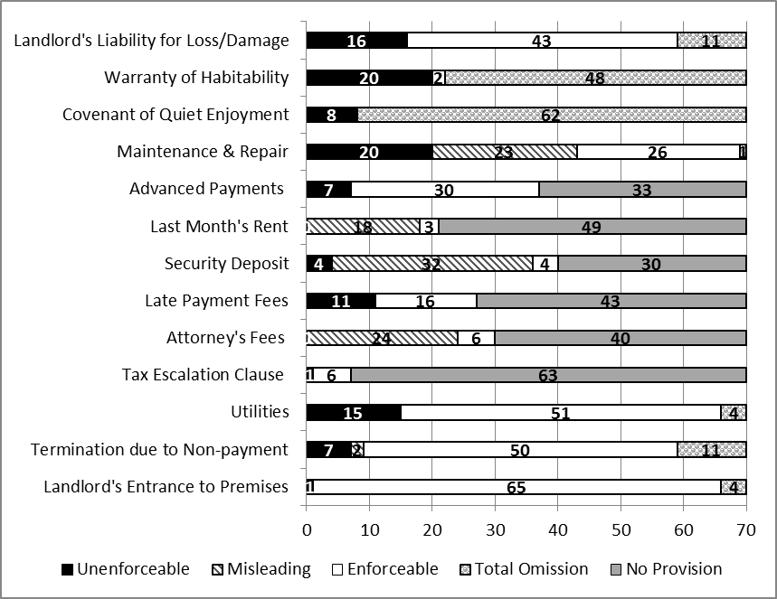

Table 2: Multiple Linear Regressions: Unenforceability and Lease & Landlord Characteristics. Standard errors are reported in parentheses. In the ‘Unenforceable Terms’ column, we regressed the number of unenforceable terms on the landlord type (a binary variable taking one of two categories: individual landlord versus residential company) and lease type (a binary variable taking one of two categories: commercial versus non-commercial form), and other apartment, lease and tenant characteristics (number of bedrooms; rental amount in dollars; a binary variable taking one of two categories: student or non-student tenant; and the length of the lease in months) were included as controls. The other columns differ in their dependent variables (misleading terms, total omissions and unenforceable terms) but share the same independent variables as the first column.

Variables | Unenforceable Terms | Misleading Terms | Total Omissions | Enforceable Terms
Residential Company | -0.712* | 0.507 | -1.599* | 1.993***
 | (0.381) | (0.357) | (0.844) | (0.683)
Commercial Lease | -1.059*** | -0.155 | 0.350 | 0.740
 | (0.347) | (0.301) | (0.765) | (0.718)
Bedrooms | -0.210 | 0.082 | -0.169 | 0.281
 | (0.210) | (0.144) | (0.472) | (0.486)
Rent | -0.000 | 0.000 | 0.000 | -0.000
 | (0.000) | (0.000) | (0.000) | (0.000)
Tenant (Not Student) | 0.542 | 0.106 | -0.895 | 0.195
 | (0.423) | (0.283) | (0.839) | (0.775)
Length | -0.012 | -0.018 | 0.062 | -0.038
 | (0.027) | (0.024) | (0.064) | (0.041)
Constant | 2.559*** | 1.369*** | 24.593*** | 4.665***
 | (0.706) | (0.474) | (1.334) | (1.292)
Adjusted R2 | 0.08 | -0.07 | 0.03 | 0.07
N | 40 | 40 | 40 | 40
* p<0.1; ** p<0.05; *** p<0.01

Figure 2. Survey participants’ reports on how their rental problems were resolved. Participants (Massachusetts tenants, n =279) were asked whether they incurred rental problems during their lease. Those who answered affirmatively (n = 251) were then asked to report how their problem was ultimately resolved. This figure reports their responses.

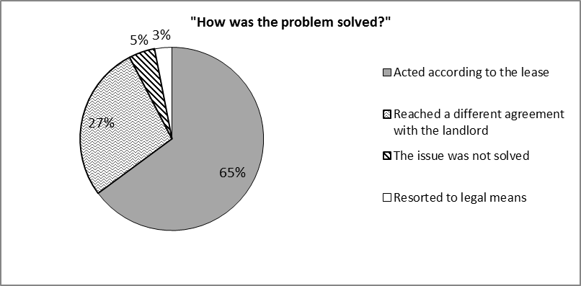
Figure 3. Tenants' Reported Intentions across Contract and Information Conditions. Participants (n = 788) were randomly assigned to one of three contract-term conditions and one of two information conditions and were asked, as an open-ended question, how they would behave under the circumstances described in the scenarios. Three independent RA’s, blind to the study’s hypotheses and manipulation, coded their open-ended responses as one of the following categories: (1) Search information – if participants indicated that they would search for more information about their rights, remedies, or obligations (for example, by searching the web or by consulting with family, friends, or other tenants); (2) Resignation – if participants indicated that they would bear the repair or replacement costs by themselves, do nothing, or move out of the apartment; (3) Contact landlord – if participants indicated that they would discuss the issue with the landlord, negotiate, or require the landlord to make (or pay for) the required repairs; (4) Non-legal action – if participants indicated that they would withhold rent, contact inspection authorities, or tarnish the landlord’s reputation; (5) Legal advice or action - if participants indicated that they would seek legal services or initiate proceedings against the landlord.
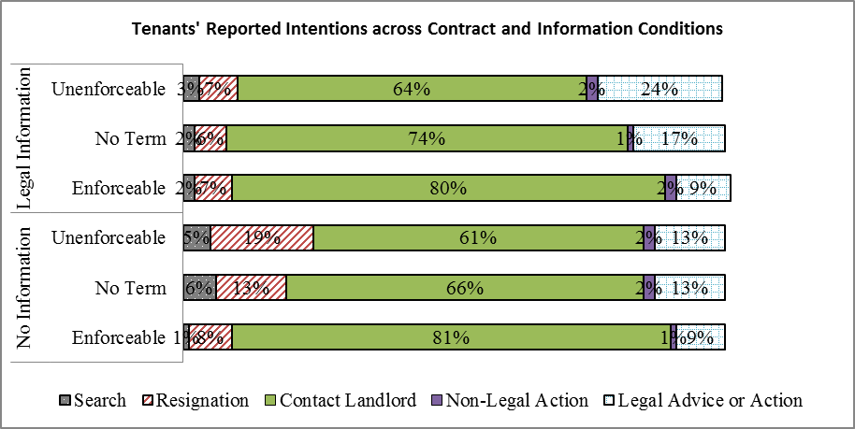
Figure 4: Tenants’ Reported Decisions after the landlord refuses to collaborate. Participants who indicated that they are likely to contact their landlords in response to the first question where subsequently asked how likely they would be, on a 7-item scale (1 = extremely unlikely; 4 = neither likely nor unlikely; 7 = extremely likely) to: (a) Insist that the landlord bears the repair costs; (b) Contact an attorney for legal advice; (c) Initiate legal proceedings against the landlord; and (d) win in court in case they decided to initiate proceedings. This figure reports the percentage of respondents who intended to insist that the landlord bear the expenses, seek legal advice, or initiate proceedings, based on dichotomization of each item at the scale’s mid-point (i.e., 4 on each 7-item scale) and collapsing across scenarios.
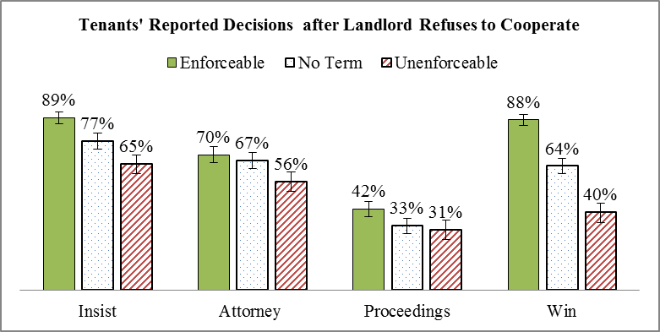

Figure 5.
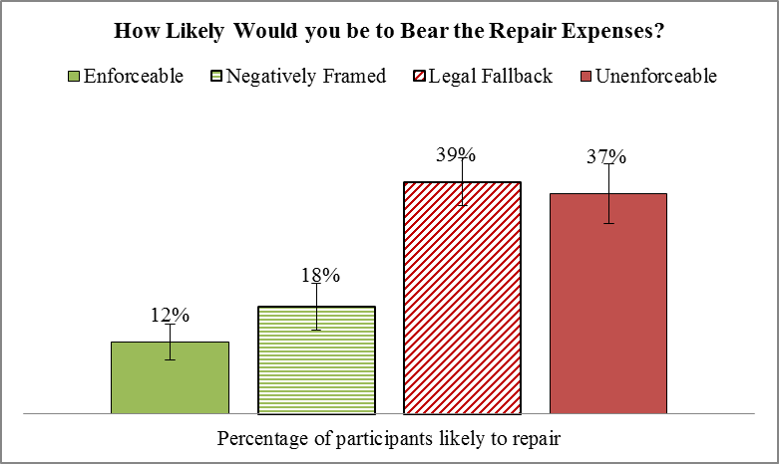

Figure 6.
