Rethinking the Textual Value of 4Q11 (4QpaleoGenEx^{l})

This paper focuses on a fragmentary copy of Exodus from Qumran that has not so far received sufficient attention – 4Q11 (4QpaleoGenEx^{l}). The paper proposes a material reconstruction of the scroll and discusses its contribution to the textual classification of the scroll. Although 4Q11 apparently reflects the short literary-form of Exodus, which does not include the major expansions characteristic of the pre-Samaritan tradition, an examination of individual readings reveals that the scroll includes some exegetical readings. Thus, 4Q11 demonstrates the necessity of exploring the scribal approach reflected in scriptural Qumran scrolls, in addition to their classification into known textual traditions. Only such a holistic investigation of the text can allow for an improved conception of the processes that occurred during the textual transmission of scriptural manuscripts.

Keywords: 4Q11; 4QpaleoGenEx^{l}; Pentateuchal scrolls; pre-Samaritan tradition; materiality; scribal approach; exegetical readings

4Q11, also known as 4QpaleoGenEx^{l}, is a fragmentary manuscript that preserves text from the last verse of Genesis and portions of Ex 1:1 to 36:36. It was written in paleo-Hebrew script, paleographically dated by McLean to the last century BCE. This date was accepted by Patrick Skehan, Eugene Ulrich, and Judith Sanderson, in their official edition of the scroll, published on 1992.
According to the editors, 4Q11 comprises sixty-four fragments, only thirty-eight of which were identified in the official edition. The paper aims to illustrate how 4Q11 carries importance far outweighing its relatively restrained evidence. It discusses material and textual matters related to 4Q11 and their implications for the conception of the various ways in which scriptural texts were transmitted in the late Second Temple period.
The discussion of 4Q11 takes into account both the extant and missing text of the scroll. The paper begins with the lost text, proposing a new material reconstruction of 4Q11. This reconstruction will provide crucial data concerning the amount of missing text between the preserved fragments, which will shed light on the literary form reflected in the scroll. It will then analyze exemplars of variant readings attested in 4Q11 in light of the interpretative processes of scriptural transmission in the late Second Temple period.

1 Three Literary Forms of the Book of Exodus

When contrasted with MT and LXX, SP-Ex includes seventeen major expansions and two transpositions (tab. 1; tab. 2). The pre-Samaritan version of SP-Ex is also attested in the Dead Sea scrolls: 4Q22, also known as 4QpaleoEx^{m}, is textually characterized as pre-Samaritan, as it preserves most of the major expansions of SP-Ex. As shown in Sanderson’s analysis, 4Q22 shares all the major expansions present in SP-Ex, with the exception of the tenth commandment to build an altar on Mount Gerizim. This conclusion became a scholarly consensus for many years. However, several scholars have recently suggested that the tenth commandment also belongs to the pre-Samaritan layer. If this is true, the assumption that it was not included in the pre-Samaritan 4Q22 may be reevaluated.

Plagues Narrative | Ex 6:9b; 7:18b; 7:29b; 8:1b; 8:19b; 9:5b; 9:19b; 10:2b; 11:3bi; 11:3bii
Organization of the Judiciary | Ex 18:24b (Deut 1:9–15)  Ex 18:25b (Deut 1:16–18)
The Theophany at Sinai | Ex 20:13b (the tenth commandment to build an altar on Mount Gerizim)  Ex 20:15 (Deut 5:21–24)  Ex 20:17b (Deut 5:25–28)
Making of Priestly Vestments | Ex 27:19b (Ex 39:1)
The Golden Calf Episode | Ex 32:10 (Deut 9:20)

Table 1: Major SP-Ex expansions

The instructions for the incense altar | MT, LXX: Ex 30:1–10; SP, 4Q22: Ex 26:35a–35j
The instructions for the installation of the high priest | MT, LXX: Ex 29:21; SP: Ex 29:28

Table 2: Transpositions across traditions in the book of Exodus

Of the seventeen major expansions, ten appear in the plagues narrative. These expansions are motivated by a formalistic need for perfecting the divine speech act, detailing both the divine command to Moses to speak with Pharaoh and its fulfillment. In the major expansions in chapters 18, 20, and 32, a certain amount of text in Exodus was copied from parallel accounts in Deuteronomy. As have already been suggested, these expansions are not simply harmonizations, but rather aim to increase the consistency of the reoccurring Pentateuchal narratives and to create an explicit text of two accounts, illuminating the earlier with the help of the other.
An additional literary form of the book of Exodus is evident in chapters 35–40. When contrasted with LXX, MT and SP-Ex are significantly different regarding the internal order of chapters 35–40. One may conclude, therefore, that the book of Exodus existed in (at least) three literary forms in the last centuries BCE, represented by MT-Ex; SP-Ex and 4Q22; and the Hebrew Vorlage of LXX-Ex.

2 4Q11’s Lost Text: Material Reconstruction of 4Q11 and Its Implications

There is insufficient evidence from 4Q11 to confidently determine whether 4Q11 follows MT/SP or LXX in the order of chapters 35–40, because of the small amount of preserved text from these chapters. Likewise, we are unable to determine whether it originally contained the major expansions found in the pre-Samaritan tradition. Only two fragments of the scroll may attest to a major expansion: fragments 6 and 7. However, whether the text of these fragments represents the pre-Samaritan expansion or not is impossible to determine with confidence, as the expansions themselves reproduce near-identical text from previous or subsequent verses.
In one instance, 4Q11 apparently does not agree with a major feature of the pre-Samaritan tradition: the instructions for the incense altar. MT-Ex, as well as LXX, place this passage at the beginning of Exodus 30. By contrast, 4Q22 and SP place the passage after Ex 26:35. 4Q11 agrees with MT and LXX in not representing the instructions for the incense altar after Ex 26:35, as documented in fragment 30 ii. Nevertheless, as Ex 30 has not been preserved in 4Q11, one cannot ascertain whether the scroll originally placed the altar instructions at that point in the text. Moreover, although the placement of the altar-instructions is characteristic of the pre-Samaritan tradition, this variant is one of transposition, rather than a lengthy expansion, as discussed here. Thus, the possible agreement of 4Q11 with the pre-Samaritan tradition in this respect does not necessarily indicate an agreement in terms of the large expansions as well.
Although 4Q11’s existing remains do not allow any decisive conclusions regarding its literary form, the material reconstruction of the scroll provides additional information about the unpreserved text of the manuscript. Skehan, Ulrich, and Sanderson offered an approximate calculation of the amount of missing text between fragments. They cautiously concluded that 4Q11 reflects a text with a similar length to that found in MT. In other words, it does not likely include typological features of the pre-Samaritan tradition. The editors do not present their reconstructive method in detail and do not proceed with a full material reconstruction. Moreover, to the best of my knowledge, no comprehensive reconstruction of the scroll has been attempted.
This paper proposes a material reconstruction of 4Q11 that encompasses forty-eight fragments – approximately two-thirds of the total – which encompass Gen 50:26 to Ex 28:42. In doing so, it will support the editor’s suggestion that 4Q11 included neither the SP expansions in the plagues narrative, nor the two SP-Ex expansions in chapter 18 (organization of the judiciary), nor the three SP-Ex expansions in chapter 20 (the theophany at Sinai).

In the following, I will describe the assumptions and principles underlying the reconstruction:

1. The reconstruction begins with a well-established initial step – identifying the locations of fragments that preserve bottom margins. In 4Q11, there are such three large fragments – fragments 10, 19 and 35 (fig. 1). These fragments contain ten to fourteen lines of text. The three fragments show a common recurrent damage pattern, as can be seen when a digital representation of the fragment borders is used (fig. 2). Common protrusions on the right edge of each fragment and on the left hand-side of fragments 19 and 35 indicate the corresponding points of damage. The sequence of the fragments within the original scroll is determined by the preserved text.
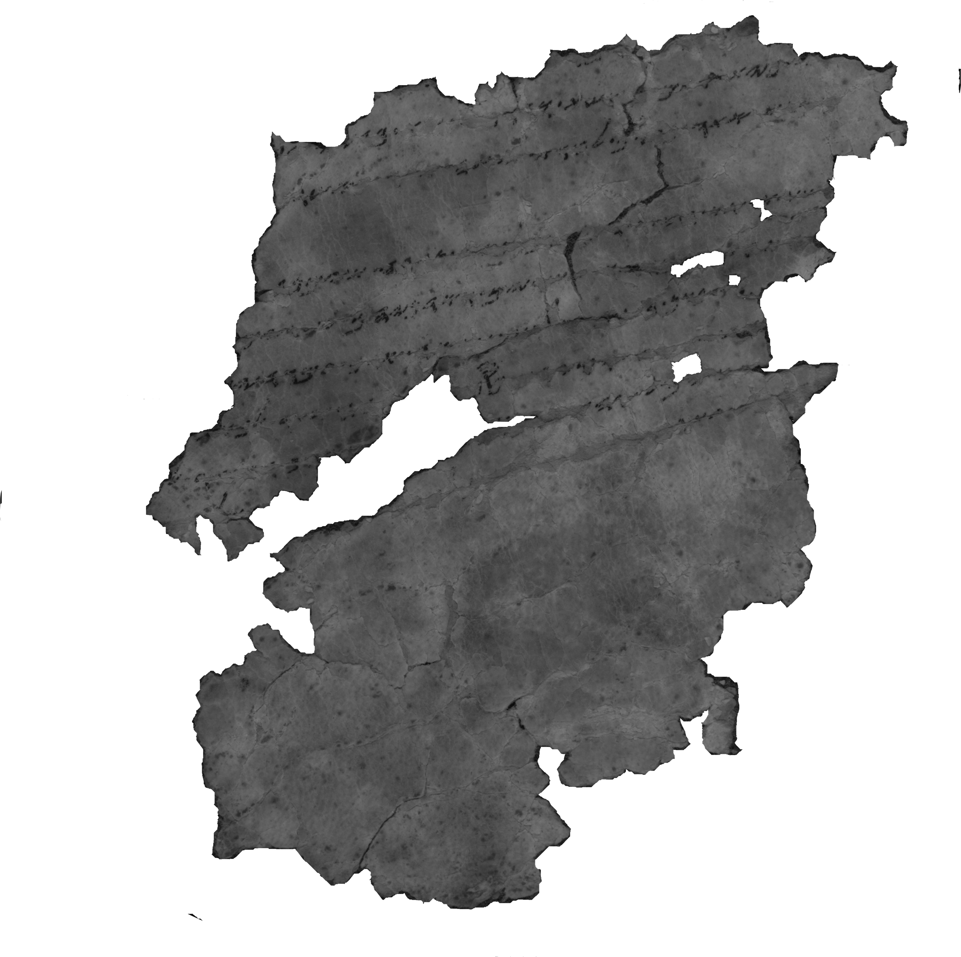
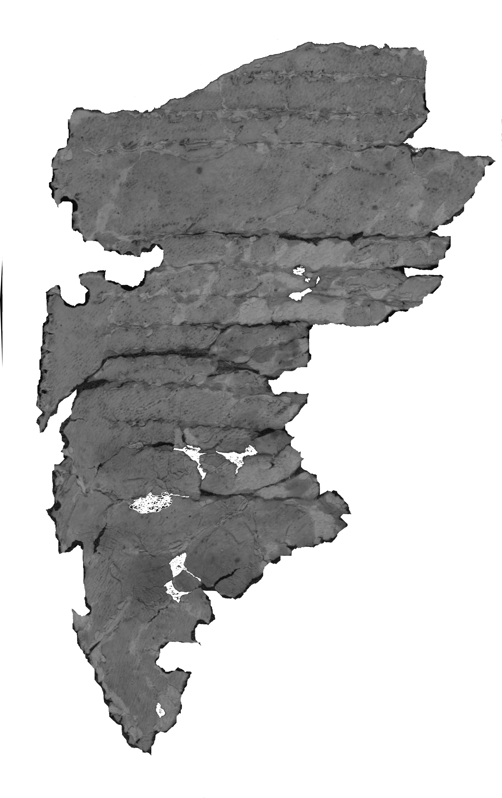
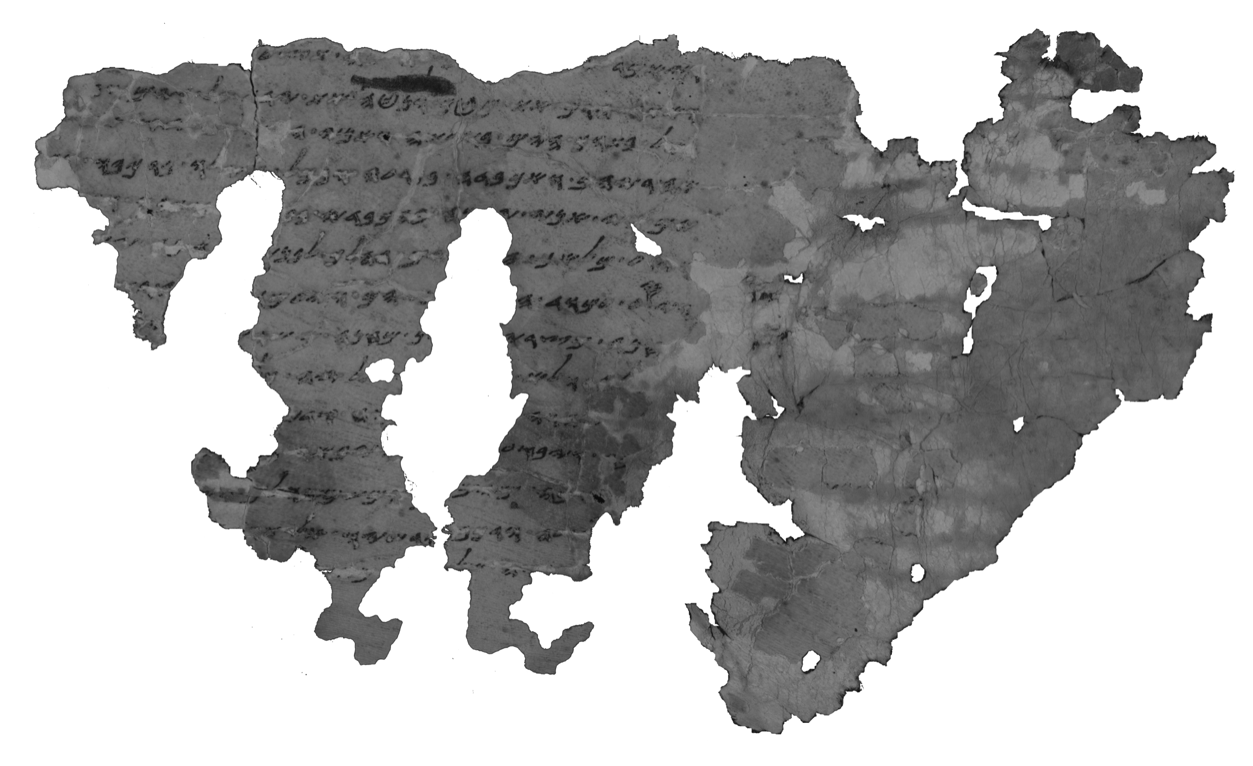

Figure 1: 4Q11 10, 19, and 35
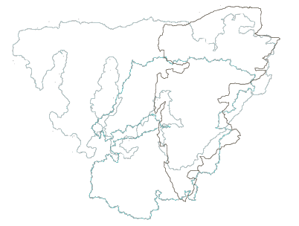

Figure 2: Recurrent damage pattern and corresponding points of damage – frgs. 10, 19, 35

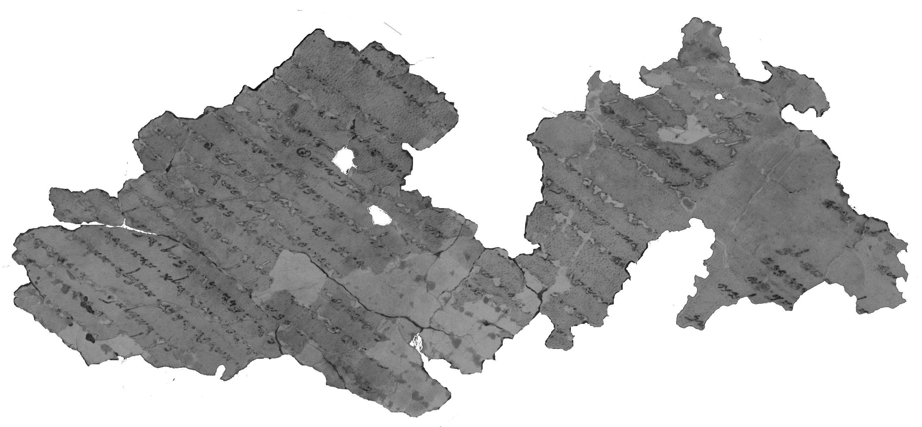
An additional large fragment is fragment 7 (fig. 3). Fragment 7 does not preserve bottom margin, but it also presents a recurrent damage pattern on the right and on the left-hand side (fig. 4). It seems therefore that fragment 7 was wadded with fragments 10, 19 and 35 in the rolled scroll.

Figure 3: 4Q11 7

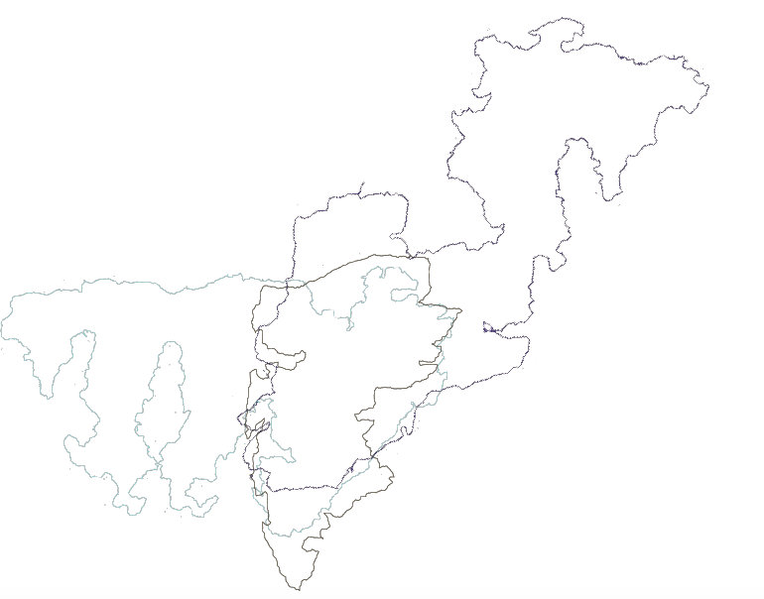

Figure 4: Recurrent damage pattern and corresponding points of damage – frgs. 7, 10, 19

2. Location of the fragments in a digital canvas simulating the original scroll in a horizontal axis according to the corresponding points of damage (fig. 5). The sequence of the fragments within the canvas is determined by the preserved text. At this point, we are still unable to estimate the distances between the fragments.
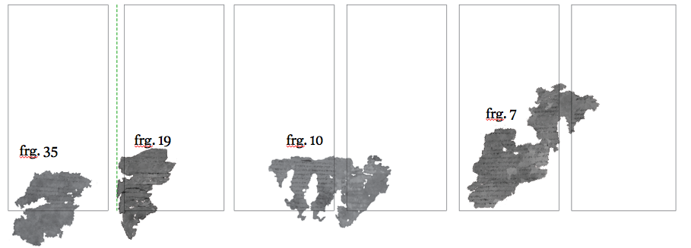
Figure 5: Aligning frgs. 7, 10,19 and 35 according to corresponding points of damage

The relative sizes of preserved bottom margins point to the progression of the scroll’s deterioration: fragment 35 preserves the largest bottom margin, fragment 19 preserves a smaller bottom margin, fragment 10 preserves an even smaller part of a bottom margin, and fragment 7 does not preserve the bottom margin at all.

3. Key data for the scroll’s reconstruction is the number of lines in each column. As stated, no complete column has been preserved, and therefore the number of lines cannot be directly observed. That being said, the number of lines per column can be inferred from fragments that preserve two consecutive columns. Filling in the missing text between columns may indicate the size of the writing block. Five fragments of 4Q11 preserve parts of two consecutive columns:
- Fragment 2: 2i attests to Ex 2:10; 2ii attests to Ex 3:17-21.
- Fragment 5: 5i attests to Ex 8:13-15; 5ii attests to Ex 9:25-29.
- Fragment 7: 7i+8 attest to Ex 9:33-10:5; 7ii+44 attest to Ex 11:4-12:12.
- Fragment 30: 30i attests to Ex 25:18-20; 30ii attests to Ex 26:33-27:1.
Fragment 10 also preserves portions of two consecutive columns, but the text of the first column is extremely damaged and is basically illegible. Therefore, fragment 10 is not valuable for present purposes.
The contents of the hypothetical missing text between the first and the second columns of fragments 5 and 7 would differ depending on whether they belonged to the textual tradition of MT or that of 4Q22 and SP. If 4Q11 belonged to the pre-Samaritan tradition, the hypothetical text would include major expansions. Due to these variant possibilities, these particular fragments cannot be used to determine the number of lines in a column. By contrast, the hypothetical missing text between the two columns of fragment 2 and the two columns of fragment 30 is stable. No major expansions, omissions, or transpositions are documented across textual traditions.
I reconstructed the missing text between the two columns of these fragments, using a font based on typical letters in the scribe’s script. The reconstruction indicates that the scroll originally consisted of 60 lines per column, although a minor change between columns is possible (fig. 6).

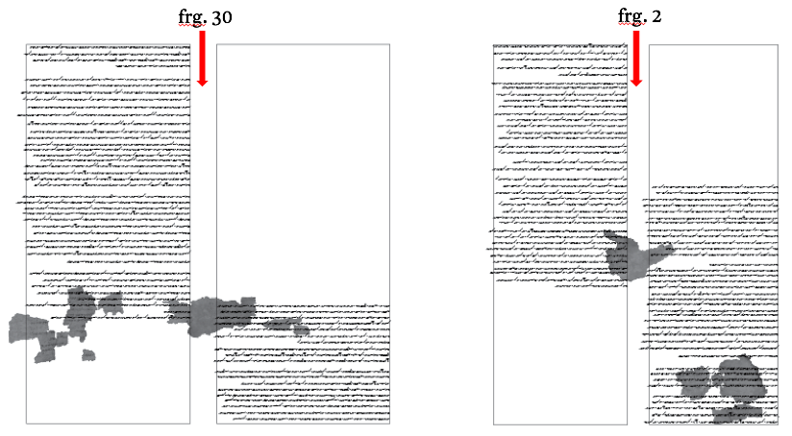
4. The next step is to determine the number of sheets. Fragment 1 preserves the right margin with remnants of a seam, indicating that it belongs to the first column of the first sheet containing Exodus in 4Q11 (fig. 7, col. I). Fragment 44, which is placed in proximity to fragment 7ii, preserves the left margin with seam remnants, indicating that both of these fragments belong to the last column of the sheet (fig. 7, col. VIII). As it is unlikely that one sheet contained all the text between Gen 50:26 (the beginning of frg. 1) and Ex 12:12 (the end of frg. 7ii), completion of the text requires two sheets. Furthermore, fragment 19 also preserves the left margin with seam remnants, indicating that it belongs to the last column of the next sheet. The next sheet starts with the column of fragment 20 (fig. 7, col. XIII), that preserves remnants of the seam on its right margins. This sheet ends with the column of fragment 23 (fig. 7, col. XVI), that preserves remnants of the seam on its left margin. Consequently, the parts of the scroll containing Gen 50:26 to Ex 28:42 (the end of frg. 37) must be assigned to five distinct sheets. The text restoration below will confirm that each sheet, except for the last one that was not completely reconstructed, comprises four columns.

Figure 6: Reconstruction of the hypothetical missing text between the two columns of fragments 2, 30

5. The position of the large fragments, the determination of the number of lines per column, and the number of sheets – all of these represent valuable data for a material reconstruction. Now we can completely reconstruct the missing text between fragments in instances where there is a relatively stable biblical text. The reconstruction also allows one to locate additional fragments and to propose new joins (fig. 7).
Three fragments, in particular, serve as litmus tests for examining whether the scroll originally contained major SP-Ex expansions: fragments 5, 7, and 20. SP-Ex contains three major expansions in the hypothetical text between the two columns of fragment 5 (Ex 8:19b; Ex 9:5b; Ex 9:19b), as well as in that between the two columns of fragment 7 (Ex 10:2b; Ex 11:3bi; Ex 11:3bii). According to the proposed reconstruction, however, there is simply no room for such expansions in either fragment. By contrast, the text of MT-Ex fits well into the space between columns in both cases (fig. 8). Since the three major SP expansions in each case include a significant amount of text, this can be asserted with a high level of certainty.
The large expansions in the plagues narrative exhibit a consistent and systematic character. Therefore, it is highly unlikely that a scroll that lacks expansions in the context of two plagues will include them in other parts of the narrative. Since the space between columns in fragments 5 and 7 is too short to encompass any major expansions, we may conclude that the scroll did not contain any of the large expansions characteristic of the plagues narrative in SP-Ex.

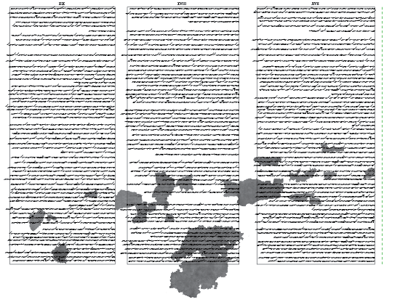
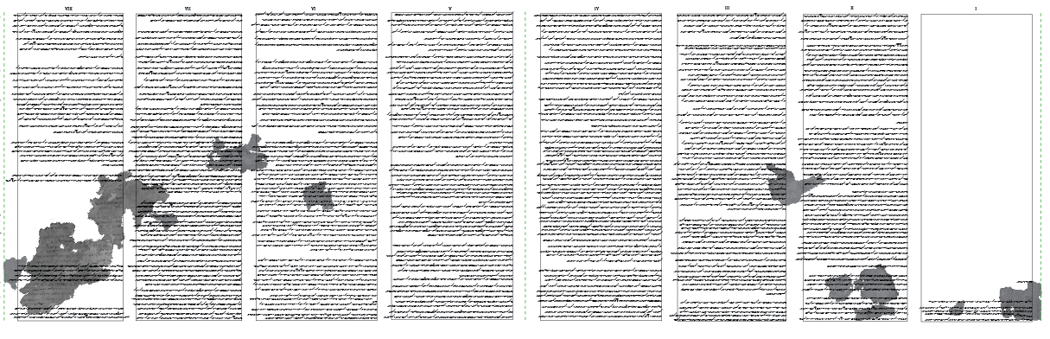
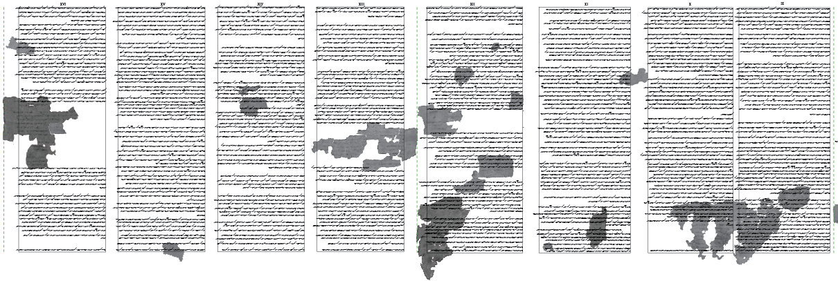

Figure 7: Reconstruction of nineteen consecutive columns of 4Q11

Fragment 20 preserves the text of Ex 18:17–24 (fig. 9). SP-Ex 18 includes two major expansions after verse 24 (Ex 18:24b; Ex 18:25b), both adapt text excerpted from Deuteronomy 1.
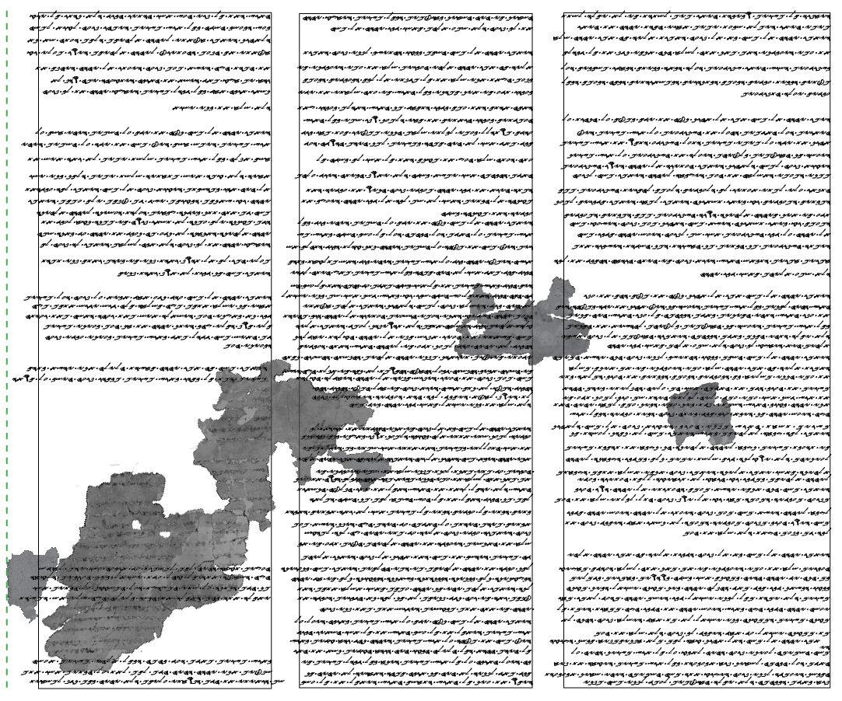
Reconstruction of the hypothetical text between fragment 20 and subsequent fragments further indicates that 4Q11 did not include the two major expansions in chapter 18 characteristic of SP-Ex (fig. 10). Fragments 52 and 35, which constitute the subsequent columns, preserve bottom margins. The text of MT-Ex would fit well into the bottom margins preserved in these fragments. Conversely, the reconstruction of the longer SP-Ex text would not allow one to place fragments 52 and 35 at the bottom of the columns. For the same reason, we may also conclude that the major SP-Ex expansions in chapter 20 were not included in 4Q11.
frg. 7

frg. 5
Figure 8: Reconstruction of hypothetical MT-like text between the two columns of fragments 5,7

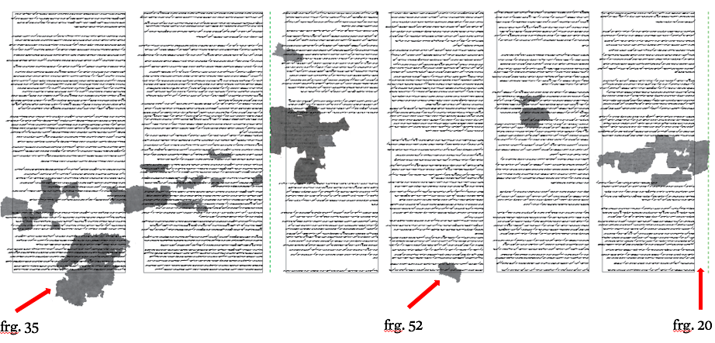
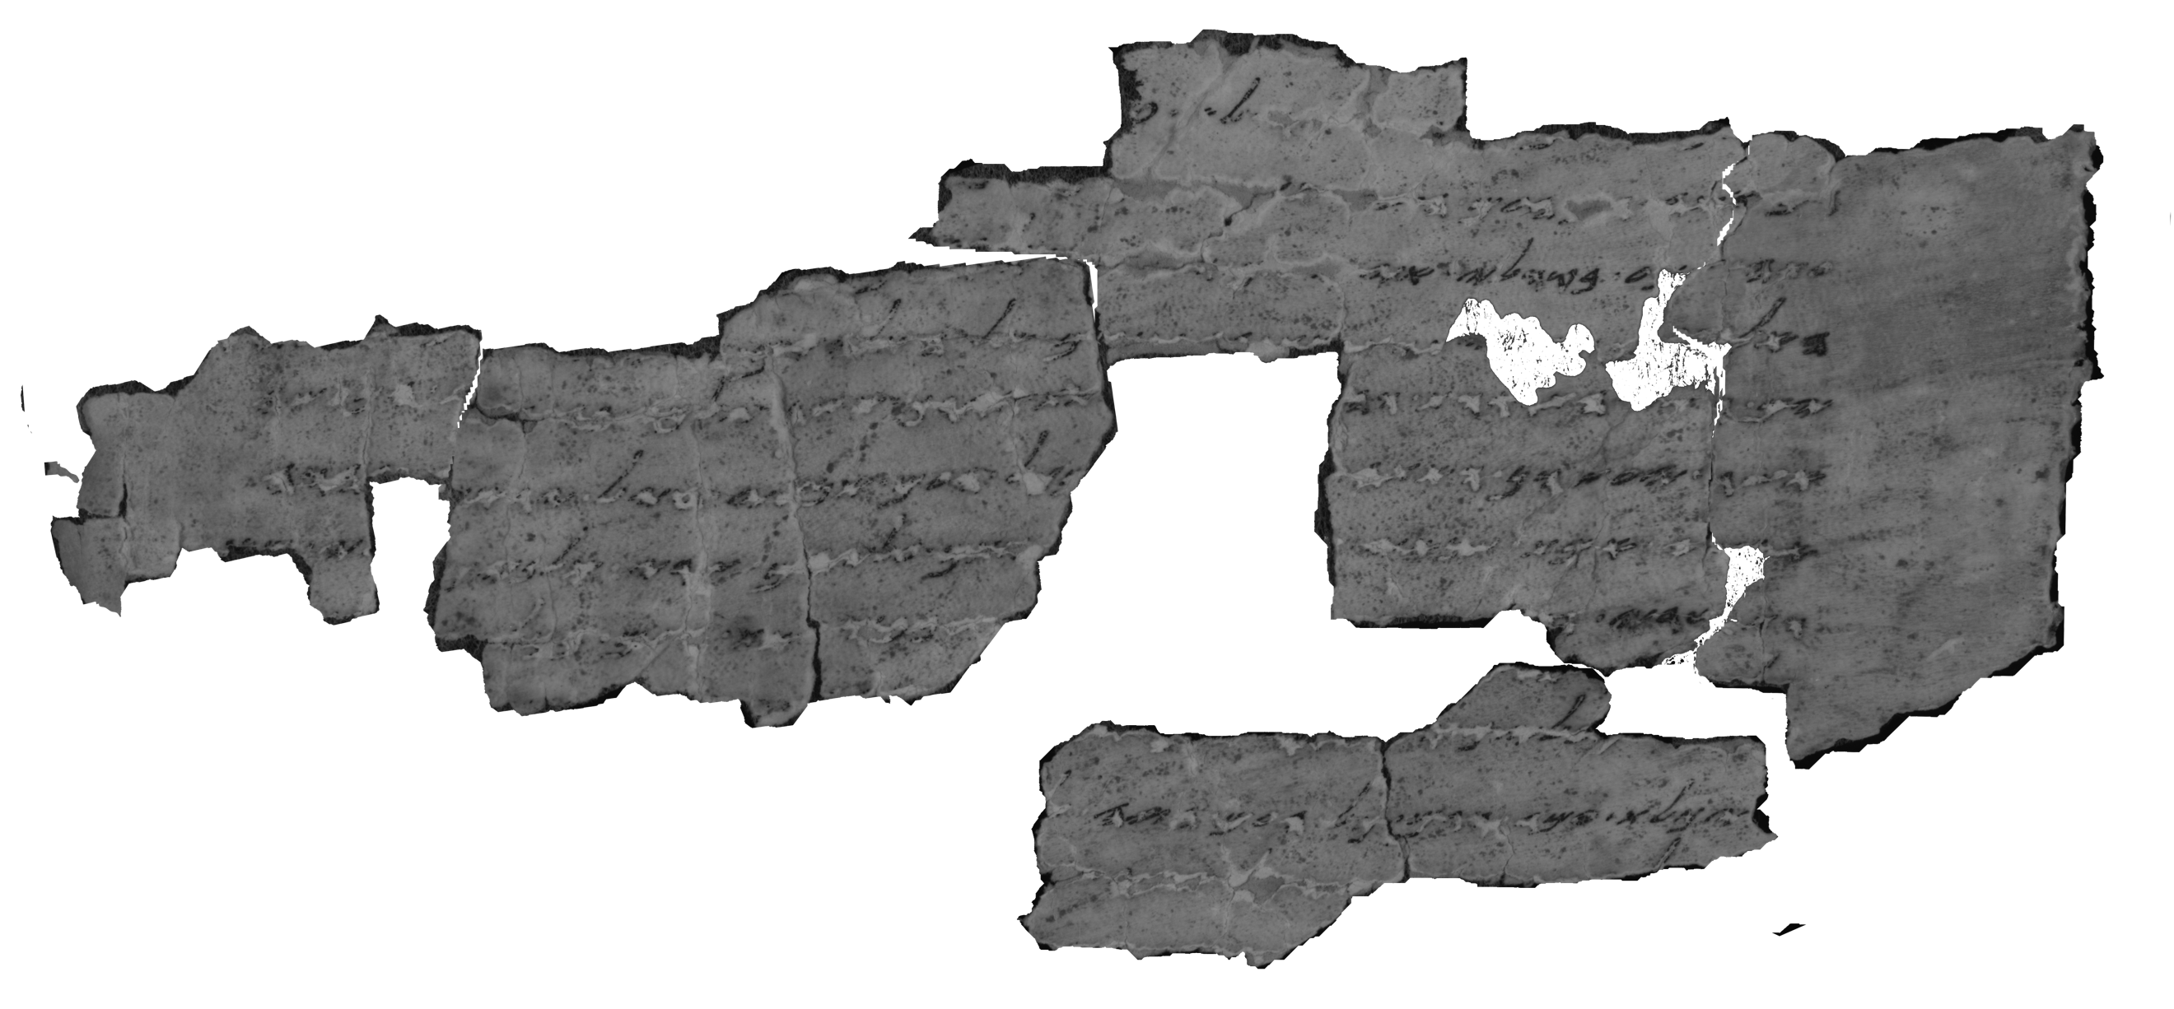Figure 9: 4Q11 20
Figure 10: Reconstruction of hypothetical MT-like text between fragments 20, 52, and 35

These cases are less certain than fragments 5 and 7, as the distance between the preserved fragments is greater. Nevertheless, this conclusion seems probable as the amount of text of the two major expansions in chapter 18 and the three major expansions in chapter 20 is significant. In addition, it is based on material signs of both fragments 52 and 35.

6. The material and textual reconstruction enables us to define column-width and to measure the distances between corresponding points of damage in fragments 7, 10, 19, and 35 according to Stegemann method. I have represented these points with the letters A–D (fig. 11). The distances between points A to D indicate that it is possible to display a series of ten circumferences of the scroll, ranging from 11.3 cm to 14 cm, with an incremental growth of 0.3 cm. In other words, the corresponding points of damage reflect ten consecutive layers in the rolled-up scroll. Moreover, the incremental growth between layers indicates that the scroll was rolled with the end of the scroll inside and the beginning of the text outside.

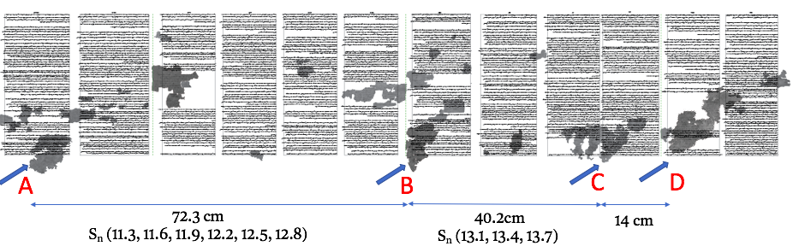
7. The application of Stegemann method is reinforced by the identification of additional fragments that preserve a repeated pattern of damage – fragments 16 and 23 (fig. 12). Both fragments preserve intercolumnar margins and have a similarly shaped bulge at their top-right edges, as can be seen in a representation of their borders (fig. 13). Importantly, in the proposed reconstruction, the fragments are aligned along the same vertical axis (fig. 14). In addition, the distance between the corresponding points of damage in these fragments, represented by the letters E and F, equals 49.1 cm. This distance is very close to 49.4 cm, the expected distance calculated earlier through the application of Stegemann method.

Figure 11: Distances between corresponding points of damage – frgs. 7, 10, 19, 35
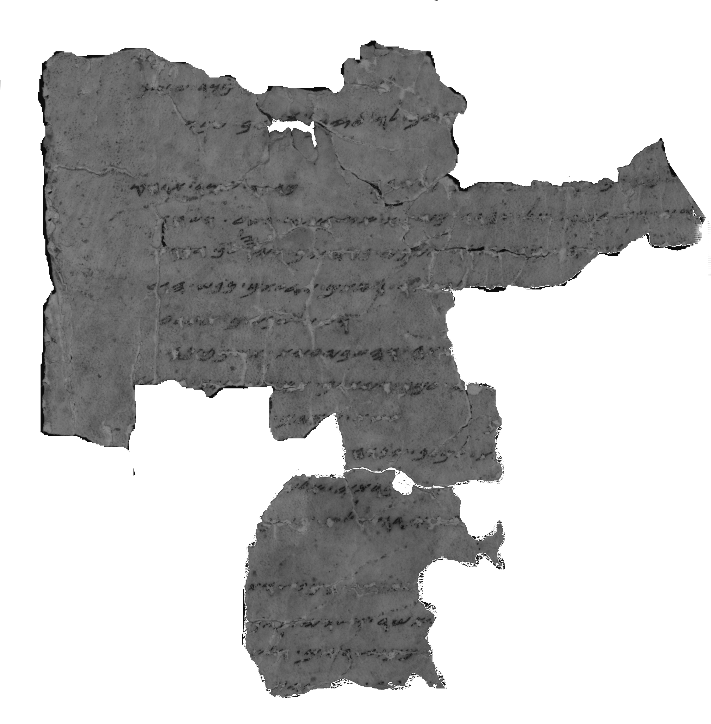
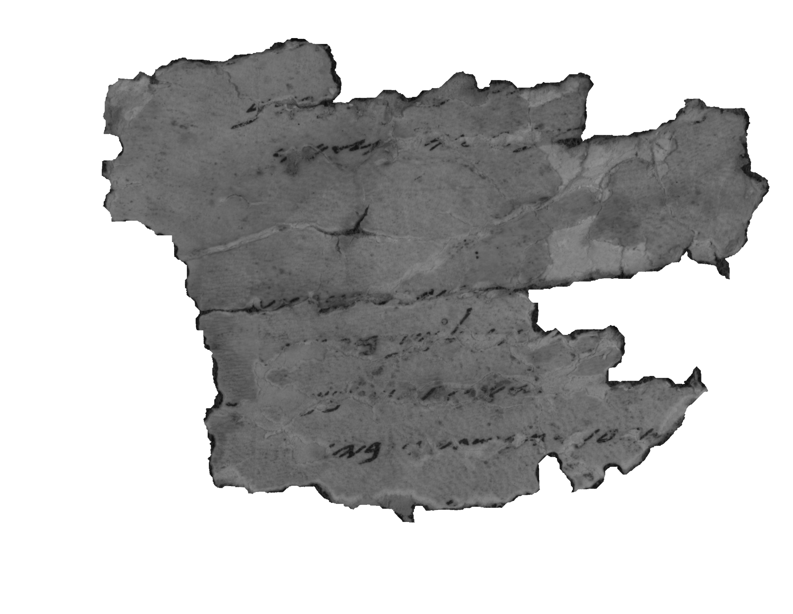

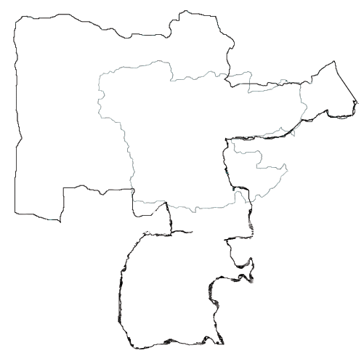
Figure 12: 4Q11 16, 23

Figure 13: Recurrent damage pattern and corresponding points of damage – frgs. 16, 23
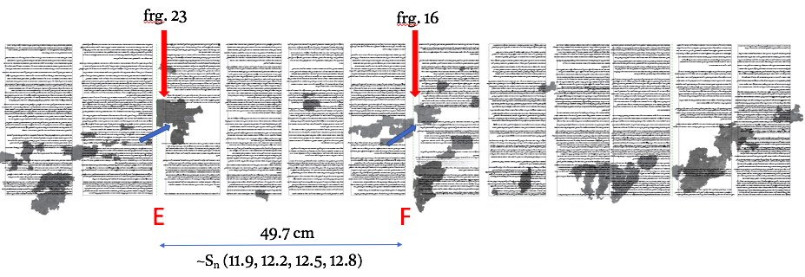
Figure 14: Distances between corresponding points of damage – frgs. 16, 23

Although I have shown the correspondence of all relevant material data, like any reconstruction, this one has a margin of error. Nevertheless, the fact that independent pieces of material evidence fit together in the proposed reconstruction, significantly narrows down that margin. The column-widths have been determined by reconstructing the missing text between fragmentary lines. They accord with the distances between corresponding points of damage that show incremental growth between the rolls of the scroll. The material reconstruction thus successfully combines independent data.
Moreover, in March 2021, I was fortunate to visit IAA laboratories and to closely explore the material evidence of 4Q11. Measurement of the leather of fragments 1, 3, and 4 indicates that the thickness of the leather is 0.3–0.4 cm. These findings reinforce the incremental growth suggested by the application of the Stegemann method.
The reconstruction proposal is further supported by fragments 10 and 20 – the widest of all the preserved fragments. According to my analysis, the two fragments do not preserve two iterations of patterns of damage. In other words, they do not preserve more than one roll of the original scroll. Indeed, the maximum width of fragment 10 equals 13.7 cm, similar to the circumference of the scroll at that point. The maximum width of fragment 20 is 12.9 cm, which is almost equal to the circumference of the scroll at that point. The latter equals 12.8 cm.
All of these considerations indicate that the core of the material reconstruction of 4Q11 is stable and has been established on abundant evidence. Although the margin the of error may slightly alter the positioning of the fragments and the distances between them, it will not significantly affect the main conclusion that the major SP-Ex expansion in plagues narrative, the organization of judiciary and theophany at Sinai were not originally included in 4Q11.
As a preliminary conclusion, the essence of this part of this paper was to use the materiality of 4Q11 as a fruitful resource for investigating its textual context. The material reconstruction of the scroll indicates that 4Q11 represents the short text-type of Exodus, of which MT and the Hebrew Vorlage of LXX are also exemplars.

3 The Extant Text: Scribal and Exegetical Techniques in the Second Temple Period

Not only does the shared literary form attest to textual proximity between MT and 4Q11, but so too does a statistical analysis of 4Q11’s readings. According to Armin Lange, there is a relatively large number of cases of agreements between 4Q11 and MT (tab. 3). However, this number is counterbalanced by an identical number of disagreements. Due to the inconclusive textual evidence, 4Q11 has not been classified straightforwardly as a Masoretic manuscript. Emanuel Tov placed it in the outer circle of proto-Masoretic texts.
 | Agreements | Disagreements
MT | 25 | 25
SP | 12 | 38
LXX Vorlage | 15 | 24
Independent readings | 12

Table 3: A statistical analysis of 4Q11’s extant text

The statistical analysis of 4Q11’s readings illustrate the necessity of exploring 4Q11’s text in terms of the scribe and his process, rather than merely through its comparison to other ancient versions. In other words, we should ask – what did the scribe do when he copied his Vorlage? Did he copy it faithfully? Or did he insert changes in the text in front of him? I approached 4Q11 with these very questions in mind. In doing so, I have followed Sidnie White Crawford, who emphasizes the importance of seeking patterns for scribal activity rather than a textual characteristic of a specific manuscript vis-à-vis other manuscripts.
At this point in the discussion, I should caution that it is often impossible to determine whether individual readings were inserted by the scribe or already existed in his Vorlage. In these cases, as in the following discussion of 4Q11, we can only draw conclusions about scribal processes in a general way. It is often impossible to point to a particular point in the transmission process at which a change was made to the text.
Most of the variants in which one of the four Hebrew texts of Exodus – 4Q11, 4Q22, MT, and SP – disagrees with another pertain to a single word or phrase. On first glance, it may appear as if these variants are insignificant or negligible. However, a closer inspection reveals that 4Q11 includes readings that demonstrate scribal work beyond mere copying. The scribe of 4Q11 or its predecessors intervened in the wording of the scriptural text in order to reflect a particular interpretation of the text, as well as to simplify and clarify phrases.
In two recent papers, Noam Mizrahi explored two of 4Q11’s unique readings in Ex 12:9:

4Q11 | MT | NRSV
[אל ת]א֯כׄל֯ו ממנו נו ובשל ומׄבׄשׄל בׄמ֯[ים כי אם צלי אש ראשו על כרע]יׄו וׄעל ק֯רבׄו | אַל־תֹּאכְלוּ מִמֶּנּוּ נָא וּבָשֵׁל מְבֻשָּׁל בַּמָּיִם כִּי אִם־צְלִי־אֵשׁ רֹאשׁוֹ עַל־כְּרָעָיו וְעַל־קִרְבּוֹ | Do not eat any of it raw or boiled in water, but roasted over the fire, with its head, legs, and inner organs

4Q11 differs from MT in two details in this verse: (1) While MT reads נא, commonly interpreted as “raw”, 4Q11 employs the hapax legomenon נו. (2) While MT reads the clause בשל מבשל, a conjunctive vav between the two words was inserted in 4Q11: בשל ומבשל. Mizrahi sees the interchange between MT’s נא and 4Q11’s נו as intentional on the part of the scribe. The scribe used the secondary biform נו, from his contemporary vernacular, in order to solve the ambiguity of the earlier form נא, which can also be interpreted as a common particle.
As for the phrase בשל ומבשל, the conjunctive vav indicates that the scribe of 4Q11, much like the Palestinian Targums, distinguished between two prohibited methods for cooking the meat of the Passover offering: בשל on the one hand, מבושל on the other. Therefore, he inserts a conjunctive vav, a syndetic marking the two methods, as was common in Second Temple Hebrew. These examples illustrate that the scribe of 4Q11 intervenes in the received text in order to express a specific interpretation and to avoid what he sees as a misinterpretation of the text.
I would like to follow this path by presenting another example in which a textual variant in 4Q11 possibly reflects the interpretative approach of the scribe of 4Q11 or its predecessors. I will discuss Ex 25:11, in which 4Q11’s reading adopts a particular interpretation of the word זר and, at the same time, rejects an alternative interpretation.

Ex 25:11
4Q11 | MT | NRSV
] זרׄ זהב | וְצִפִּיתָ אֹתוֹ זָהָב טָהוֹר מִבַּיִת וּמִחוּץ תְּצַפֶּנּוּ וְעָשִׂיתָ עָלָיו זֵר זָהָב סָבִיב | You shall overlay it with pure gold, inside and outside you shall overlay it, and you shall make a molding of gold upon it all around

זר is an enigmatic feature of the ark, as well as of the table, the table’s מסגרת, and the incense altar. In all its eight occurrences in MT-Ex and SP-Ex, the text specifies that the זר is made of gold and is situated “around” – סביב – the object it adorns. In 4Q11, of all the occurrences of זר זהב סביב, only the case of Ex 25:11, dealing with the ark, has been preserved. The scroll uniquely reads זר זהב, while the word סביב is excluded.
Raanan Eichler, discussing the significance of זר, illustrates that its accepted interpretation in LXX and related texts is a guilloche molding, a decorative element of Greek architecture attested in all periods. In contrast, in Targum Neofiti and Peshitta זר is rendered as (א)כליל, “crown”. The Vulgate similarly translates “corona.” This interpretation, evidently stemming from the assumption that זר is etymologically related to the biblical נזר, is also dominant in rabbinic exegesis.
Simply put, a crown is anything that surrounds an object, whether that object be a person’s head, as in spoken language, or the ark, as in Ex 25:11. Indeed, Kahler-Baumgartner interpreted זר as a “frame, border”. This interpretation would make the word סביב in the phrase זר זהב סביב redundant. Therefore, 4Q11’s reading may be a deliberate omission of סביב in order to avoid such a duplication. Perhaps the scribe of 4Q11 or its predecessors preferred the interpretation of זר as a crown, and thus revised the text of the verse in a manner that does not leave room for the interpretation reflected in the Greek text. If this is the case, then Ex 25:11 is further evidence of the exegetical readings attested in 4Q11.
Moreover, there are numerous examples in which 4Q11’s readings reflect a simplification of phrases in terms of their content and language. I will now discuss two of these: The first relates to content, and the second to language.

Ex 18:21
4Q11 | MT | LXX | NRSV
ואתה֯[ תחזה ]מ֯כ֯ל ה֯עם אׄנש֯יׄ ח֯יל יׄר֯א֯י֯ י֯הׄוה ‎‏אׄנ֯[ש]יׄ אמת שׄנׄא֯יׄ [בצע ושמת ]א֯תׄםׄ עלי֯ה֯םׄ ש֯רׄיׄ אׄלפיׄם֯[ ש]ר֯יׄ מ֯אׄ‎‏וׄתׄ ש֯רי ח֯[משים ושרי עשרת] | וְאַתָּה תֶחֱזֶה מִכָּל-הָעָם אַנְשֵׁי-חַיִל יִרְאֵי אֱלֹהִים אַנְשֵׁי אֱמֶת שֹׂנְאֵי בָצַע וְשַׂמְתָּ עֲלֵהֶם שָׂרֵי אֲלָפִים שָׂרֵי מֵאוֹת שָׂרֵי חֲמִשִּׁים וְשָׂרֵי עֲשָׂרֹת | καὶ σὺ σεαυτῷ σκέψαι ἀπὸ παντὸς τοῦ λαοῦ ἄνδρας δυνατοὺς θεοσεβεῖς, ἄνδρας δικαίους μισοῦντας ὑπερηφανίαν, καὶ καταστήσεις αὐτοὺς ἐπ᾿ αὐτῶν χιλιάρχους καὶ ἑκατοντάρχους καὶ πεντηκοντάρχους καὶ δεκαδάρχους, | You should also look for able men among all the people, men who fear God, are trustworthy, and hate dishonest gain; set such men over them as officers over thousands, hundreds, fifties, and tens

The question to whom the word עליהם, meaning “over them”, refers, is somewhat ambiguous in MT and SP. Nonetheless, the context certainly indicates that its sense is “over the Israelites” and not “over the judges”, as well as the description of the fulfillment in verse 25 (MT):
וַיִּבְחַר מֹשֶׁה אַנְשֵׁי־חַיִל מִכָּל־יִשְׂרָאֵל וַיִּתֵּן אֹתָם רָאשִׁים עַל־הָעָם שָׂרֵי אֲלָפִים שָׂרֵי מֵאוֹת שָׂרֵי חֲמִשִּׁים וְשָׂרֵי עֲשָׂרֹת
In 4Q11 and LXX the word אותם and αὐτοὺς (“them”)’ is added respectively, in order to clarify that it is the judges who should be appointed over the Israelites.

Ex 18:20
4Q11 | 4Q22 | MT | SP | NRSV
‏◦◦◦◦◦[ אתה]ם֯ א֯ת֯[ ]ה֯ח֯ק֯‏ים ו֯א֯ת֯ התו֯רׄות וה[ודעת להם ]אׄתׄ ה֯ד֯רׄך אׄשר֯ י֯לׄכ֯ו֯ ב֯ה֯ ו֯א֯ת֯  ה֯מעׄש֯ה֯ אשרׄ יעשׄון | [והזהרתה אתהם את החקים ואת התורת והודעת לה]ם֯ א[ת] הדרך אש֯[ר ילכו בה ואת המעשה אשר יעשון ] | וְהִזְהַרְתָּה אֶתְהֶם אֶת־הַחֻקִּים וְאֶת־הַתּוֹרֹת וְהוֹדַעְתָּ לָהֶם אֶת־הַדֶּרֶךְ יֵלְכוּ בָהּ וְאֶת־הַמַּעֲשֶׂה  אֲשֶׁר יעֲשׂוּן | והזהרת אתם את החקים ואת התורה והודעת להם את הדרך אשר ילכו בה ואת המעשה אשר יעשון | teach them the statutes and instructions and make known to them the way they are to go and the things they are to do

The relative particle אשר appears in 4Q11, 4Q22, and SP, but is absent in the clause הדרך ילכו בה in MT. It belongs to the group of grammatical elements whose presence in the text increased throughout the transmission process. The presence of אשר syntactically simplifies the phrase by eliminating asyndetic constructions.
The last two examples are not unique to 4Q11, but they demonstrate the tendency of the ancient scribes to modify the text in order to produce clear and coherent phrases.

4 Conclusions

This paper began with the question of whether 4Q11 reflects the long or the short literary form of the book of Exodus. By means of material reconstruction, I have demonstrated that it did not include the major SP expansions in the plagues narrative, in the organization of the judiciary, and in the theophany at Sinai. However, despite the general association with the Masoretic tradition, 4Q11 contains readings that reflect a free scribal approach.
There are varying degrees of scribal intervention in the received texts, shaping the transmission of the Pentateuch in the Second Temple period. 4Q11 introduces minor changes that may wrongly be evaluated as insignificant. I have listed some of what I believe are deliberate changes. The scribe of 4Q11 felt free to introduce his own changes, whether they had been passed on by another scribe or not. He seems to have been motivated by the wish to produce an improved text, with respect to both content and language.
This sort of scribal activity also underlies other scriptural texts. The study of 4Q11 illustrates that we should not focus solely on the accepted textual classification of Pentateuchal scrolls into simply the three known traditions and all non-aligned scrolls. As scribal exegetical techniques are not limited to a specific textual tradition, an integrative approach to the study of scriptural manuscripts is required. This approach involves scrutinizing their material and textual characteristics, comparing them with other ancient versions, as well as identifying the particular scribal approach. These are all important for advancing our understanding of the transmission of scriptural texts in the late Second Temple period.

* This research was supported by the Israeli Council of Higher Education and Orion Center for the Study of the Dead Sea scrolls. Earlier versions of this paper were presented at Orion’s Greenfield Seminar, Hebrew University of Jerusalem (January 2021), and at Gröningen-Leuven-Oxford Network Conference, University of Oxford, Oriel Centre for the Study of the Bible (March 2021). The final form has benefited enormously from the questions and suggestions received during these events. I thank Hindy Najman, Eibert Tigchelaar, Jonathan Ben-Dov, Eshbal Ratzon, and Ruth Clements for their comments on earlier drafts of this paper. I also thank Drew Longacre and the members of the Scripta Qumranica Electronica (SQE) project for their invaluable help. Mark David McLean, The Use and Development of Paleo-Hebrew in the Hellenistic and Roman Periods (Harvard University, 1982), 66. Despite the time elapsed, McLean’s study is still the most comprehensive typological development of the paleo-Hebrew script attested in the Dead Sea scrolls. Yet, the dating of paleo-Hebrew Dead Sea scrolls is intricate, mainly due to their limited number and the conservative nature of the paleo-Hebrew script. Thus, Michael Langlois dated 4Q11 even earlier, to the third century BCE, “though earlier and later dates are possible.” See Michael Langlois, “Dead Sea Scrolls Paleography and the Samaritan Pentateuch,” in The Samaritan Pentateuch and the Dead Sea Scrolls, ed. Michael Langlois (Leuven: Peeters 2019), 272.
Patrick Skehan, Eugene Ulrich, Judith Sanderson, “11. 4QpaleoGenesis-Exodus^{l},” in Qumran Cave 4 IV: Paleo-Hebrew and Greek Biblical Manuscripts (DJD 9; Oxford: Clarendon Press, 1992), 17–50.
On the basis of my research, I found that the number of fragments that should be associated with 4Q11 is even greater. These findings are not the concern of the present paper and will be the subject of a future publication.
See, e.g., Magnar Kartveit, “2.2.4.2 Exodus,” in Textual History of the Bible, General Editor Armin Lange. Consulted online on 10 March 2021 http://dx.doi.org.rproxy.tau.ac.il/10.1163/2452-4107_thb_COM_0002020402.
Sanderson’s conclusion is based on a material reconstruction of 4Q22. See Sanderson, An Exodus Scroll from Qumran: 4QpaleoExod^{m} and the Samaritan Tradition, HSS 30 (Atlanta: Scholars Press, 1986), *****; See also Skehan, Ulrich, Sanderson, “22. 4QpaleoExodus^{m},” in Qumran Cave 4 IV: Paleo-Hebrew and Greek Biblical Manuscripts (DJD 9; Oxford: Clarendon Press, 1992), 66; 101–102.
See Stefan Schorch, “The So-Called Gerizim Commandment in the Samaritan Pentateuch,” in The Samaritan Pentateuch and the Dead Sea Scrolls, ed. Michael Langlois (Leuven: Peeters, 2019), 77–97; Molly M. Zahn, “The Samaritan Pentateuch and the Scribal Culture of Second Temple Period,” JSJ 46 (2015):301–307; Edmon L. Gallagher, “Is the Samaritan Pentateuch a Sectarian Text?” ZAW 127 (2015): 101–104.
4Q22 is not extant at this point. The exclusion of the tenth commandment from 4Q22 is based on the estimation of the amount of missing text between preserved fragments.
Schorch, “Gerizim Commandment,” 87–90; Jonathan Ben-Dov, “Text Duplications between Higher and Lower Criticism,” in in The Samaritan Pentateuch and the Dead Sea Scrolls, ed. Michael Langlois (Leuven: Peeters, 2019), 220–222; Zahn, Rethinking Rewritten Scripture. Composition and Exegesis in the 4QReworked Pentateuch Manuscripts, STDJ 95 (Leiden: Brill, 2011), 173.
Only fragment 38 preserves text from these chapters, attesting to Ex 36:34–36.
Fragment 6 preserves the text of Ex 8:19-21. However, line 1 could represent either Ex 8:19 as in MT or Ex 8:19b as in 4Q22 and SP (Skehan, Ulrich and Sanderson, “11. 4QpaleoGenesis-Exodus^{l},” 29). Fragment 7 preserves two columns with an intercolumnar margin. Based on textual considerations, the editors joined fragment 7i with fragment 8 (Skehan, Ulrich and Sanderson, “11. 4QpaleoGenesis-Exodus^{l},” 30–31). Lines 10-12 of the composed text could represent either Ex 10:3-5 as in MT, or alternatively Ex 10:2b as in 4Q22 and SP. 4Q11 agrees with the MT reading אליו in line 10, as opposed to אל פרעה in 4Q22 and SP. However, as noted by the editors, such agreement does not necessarily preclude the possibility that the scroll also included the large expansion characteristic of the pre-Samaritan tradition. In other words, 4Q11 may have included the expansion, while also exhibiting a minor variant characteristic of the MT: אליו.
Skehan, Ulrich and Sanderson, “11. 4QpaleoGenesis-Exodus^{l},” 24.
The editors joined fragment 7i with fragment 8, since both preserve close text (Skehan, Ulrich and Sanderson, “11. 4QpaleoGenesis-Exodus^{l},” 30. In addition, Drew Longacre correctly identified fragment 44 as Ex 12:5-8, and consequently joined it to fragment 7ii. See Drew Longacre, A Contextualized Approach to the Dead Sea Scrolls Containing Exodus (PhD Thesis: University of Birmingham, 2015), 108.
Three considerations have to be taken into account when reconstructing missing text between fragments: orthography, paragraph division and distances between lines. According to Eugene Ulrich, “The Paleo-Hebrew Biblical Manuscripts from Qumran Cave 4,” in Time to Prepare the Way in the Wilderness, ed. Devorah Dimant, Lawrence H. Schiffman, STDJ 16 (Leiden: Brill, 1995), 127 4Q11 “strikes a moderate balance between conservative and full orthography, whereas MT-Ex tends to be somewhat more conservative.” Skehan, Ulrich and Sanderson, “11. 4QpaleoGenesis-Exodus^{l},” 21–22 listed words that are consistently represented with defective spelling, such as כל, אהרן, אלהים; they also listed orthographic variants, whenever 4Q11 differs from 4Q22, MT and SP. To reconstruct recurrent words, I followed the forms attested in the scroll. In other cases, I tentatively followed a balanced orthographic tendency, meaning I used the defective spelling of MT while occasionally inserting plene forms. As for paragraph division, there seems to be no consistent correspondence between the paragraph divisions of 4Q11 on the one hand and the system of פרשה פתוחה and פרשה סתומה attested in manuscripts of MT on the other. Nor do 4Q11’s paragraph divisions fully correspond with קצה used in the Samaritan manuscript tradition. As Ulrich, “Paleo-Hebrew Biblical Manuscripts,” 107 has argued, the scribe appears to have made a logical division between sections to help the reader. Based on the material evidence, Emanuel Tov, Scribal Practices and Approaches Reflected in the Texts Found in the Judean Desert (Leiden, Boston: Brill, 2004), 273 observes that 4Q11 uses an expanded system of paragraph division. Subdivisions are represented by a gap extending from the last word in the line to the end of line which is then followed by an entirely blank line (frg. 7i 5–6; 16 3–4; 19 5–6). Occasionally, however, the new section begins at the right margin of the next line, with no blank line intervening (see frg. 2i). The proposed reconstruction follows the spaced paragraph division system of the scroll by generally, albeit not consistently, inserting a blank line between two paragraphs. Moreover, the horizontal ruler lines, traces of which can be seen in many of the scroll’s fragments, indicate that 4Q11 was ruled – as is the case for almost all Qumran and Masada texts written on leather, see Tov, Scribal Practices, 53–54. The horizontal ruling runs across all the columns on the sheet. The distance between the horizontal ruling in 4Q11 is fairly regular, and is estimated at 0.5 cm. I digitally ruled each sheet on the canvas according to preserved lines on the fragments belonging to this sheet. Where the text has not been preserved, I ruled the lines with an average space of 0.5 cm between them.
Font design: Einat Tamir.
Fragment 52 was not transcribed and identified in the official edition. This fragment preserves two lines of text, as well as bottom margin. The first line is poorly preserved and cannot be read. Similarly, the beginning of the second line is barely visible in the image and no identification can be offered with confidence. The first legible letter in the line is mem, followed by the word לא. The next letter can be read in several different ways. In addition, tiny traces of the head of a lamed can be identified at the end of the line. The only possible readings of these remnants in MT-Ex and SP-Ex are 22:7 or 22:10; both include the words אם לא שלח ידו. Based on the textual reconstruction of the missing text, the identification of Ex 22:10 seems preferable, rather than Ex 22:7.
Intercolumnar margins have been completely preserved in fragments 2, 5, 7, and 30, and partially preserved in fragments 10, 22, 33, and 48. The width of the complete intercolumnar margins varies from 1.2 cm (frg. 7) to 2 cm (frg. 30), while the width of the partial margins varies from 1 cm (frg. 10) to 2.1 cm (frg. 48). There are four cases in which intercolumnar margins were not preserved at all between fragments 7, 10, 19, and 35 (see fig. 7, cols. XI-XII; XIII-XIV; XIV-XV; XV-XVI). In these cases, I assumed that the width of the intercolumnar margins equals the average number of 1.5 cm. Although complete margins between sheets have not been preserved in 4Q11, some fragments preserve the right or the left side of the seam (frgs. 1, 16, 19, 20, 23, 44). The width of the right or the left side of the seam varies between 0.9 cm (frg. 1) and 1.8 cm (frg. 23). According to the textual reconstruction, fragments 16 and 19 on the one hand, and fragment 20 on the other, preserve both sides of the same seam. Based on this, the total width of the margins between these sheets equals 2.8 cm. Two cases are important for the distances between fragments 7,10,19, and 35: columns VIII-IX and XVI-XVII (fig. 7). In these cases, only one side of the seam was preserved. As the width is not uniform throughout the scroll, I measured the width of the other side as it will fit the expected distances according to Stegemann method. This yields the width of margins between sheets of 1.7 cm (cols. VIII-IX) and 2.7 cm (cols. XVI-XVII).
The sum of the circumferences: 11.9; 12.2; 12.5; 12.8 (see fig. 11).
For the limitations of the Stegemann method and the caution required when applying it, see Eshbal Ratzon, Nachum Dershowitz, “The Length of a Scroll: Quantitative Evaluation of Material Reconstructions,” PloS one 15.10 (2020): e0239831.
I want to thank Joe Uziel, Orit Rosengarten, and Tania Bitler for their king support.
Armin Langue, “2.2.1 Ancient, Late Ancient, and Early Medieval Manuscript Evidence”, in Textual History of the Bible, General Editor Armin Lange. Consulted online on 11 March 2021 <http://dx.doi.org.rproxy.tau.ac.il/10.1163/2452-4107_thb_COM_0002020100>
Tov, “The Biblical Texts from the Judaean Desert: An Overview and Analysis of Published Texts,” in The Bible as Book: The Hebrew Bible and the Judaean Desert Discoveries, ed. Edward D. Herbert, Emanuel Tov (London: British Library, 2002), 154.
Sidnie White Crawford, “Interpreting the Pentateuch through Scribal Processes: The Evidence from the Qumran Manuscripts,” in Insights into Editing in the Hebrew Bible and the Ancient Near East, ed. Reinhard Müller, Juha Pakkala (Leuven: Peeters, 2017), 59–80.
Noam Mizrahi, “Linguistic Change through the Prism of Textual Transmission: The Case of Ex 12:9,” in Advanced in Biblical Hebrew Linguistics: Data, Methods, Analysis, ed. Adina Moshavi, Tania Notarius (Winona Lake, Indiana: Eisenbrauns, 2017), 27–52; Noam Mizrahi, “Text, Language, and Legal Interpretation: The Case of Ex 12:9,” in Philology and Textual Criticism: Proceedings of the Second International Colloquium of the Dominique Barthélemy Institute Held at Fribourg on 10–11 October, 2013, ed. Innocent Himbaza, Jan Joosten (Tübingen: Mohr Siebeck, 2020), 93–116.
The text of 4Q11 is transliterated into Jewish square script.
Mizrahi, “Linguistic Change.”
Mizrahi, “Text, Language, and Legal Interpretation.” See also Ex 14:23: כֹּל סוּס פַּרְעֹה רִכְבּוֹ וּפָרָשָׁיו (MT); כל סוס פ]ר֯עה ורכבו֯[ ו]פֹרשיו (4Q11).
Raanan Eichler, “The Meaning of zēr,” VT 64.2 (2014), 197–200. Note that NRSV translation follows this interpretation.
See Exodus Raba 34:2 and probably also b.Yoma 72b.
HALOT 1: 279.
The text of 4Q22 is transliterated into Jewish square script.
See e.g. Viktor Golinets, “Orthographical, Grammatical and Lexical Peculiarities in the Hebrew Text of Leviticus: Considerations about Hebrew Bible Editing in the Light of the Linguistic Development of Hebrew,” in The Text of Leviticus: Proceeding of the Third International Colloquium of the Dominique Barthélemy Institute, held in Fribourg (October 2015), ed. Innocent Himbaza, Orbis Biblicus et Orientalis 292 (Leuven: Peeters, 2020), 165.

