State Orthogonality Interferometer:

Generalization of the HOM Effect

Avi Marchewka

8 Galei Tchelet St., Herzliya, Israel

avi.marchewka@gmail.com

Abstract[1]

Are photons either bunched or unbunched, or are these states particular cases of a wider phenomenon? Here we will show that bunched and unbunched photons are indeed two extreme cases of a process parameterized by a continuous parameter, called the bunching parameter, which depends on the state orthogonality of the two photons. However, photons in the range of such states need to be tailor-made in the lab. For this purpose, we suggest employing the State Orthogonality Interferometer of two photons. This interferometer gives the full range of values of the above-mentioned orthogonality of states and the bunching parameter. Finally, as an application of the bunching parameter, we will show how the HOM effect is generalized in two different ways. We conclude that, while in the HOM effect, the interferences are between the two photons, the states produced by the States Orthogonally Interferometer exhibit both single-photon interference, as well as the interference of two indistinguishable photons. This is a property whereby both types of interferences take place in the same process, and it is observed uniquely with bosons. That is, fermions cannot have both types of interferences simultaneously.

# Introduction

The exchange degeneracy symmetry of identical particles gives rise to a novel type of interference of that between the particles’ wave functions. This interference plays a role in several important quantum physics effects, such as the electron configuration of atoms, the behavior of light, Fermi-Dirac and Bose-Einstein statistics, and many more. Included among these effects is the bunching of indistinguishable bosons (also called boson enhancements). Bunching refers to the preference of indistinguishable bosons to be found in the same state in contrast to the preference of distinguishable particles under the same scenario.

The footprint of bosons bunching is found in a variety of cases, including: the [Hanbury Brown-Twiss effect](https://www.nature.com/articles/s41598-017-02408-6) [1]; the HOM effect by Hong, Ou, and Mandel [2]; Ghosh and Mandel [3]; and atomic optics (Jeltes [4]).

Feynman [5] offered a quantified measure of bosons bunching, showing that the probability of finding  indistinguishable bosons in the same state is  higher than for  distinguishable bosons (see also Fano [6]). However, it has been shown that the reality is actually much subtler. In fact, in general, Feynman's claim does not hold. For example, Marchewka and Granot [7] have shown that the measure of a spatial probability of indistinguishable bosons is equal to that of distinguishable bosons. That is, the  rule does not hold, and, in fact, it is not well defined in the limiting case where the detector size goes to zero (Marchewka, [Granot](https://scholar.google.co.il/citations?user=uXEZPrQAAAAJ&hl=iw&oi=sra), and Schuss [8]).

While it is often argued that the bunching of indistinguishable bosons is due to “attractive forces” between the indistinguishable bosons (Mullin and Blaylock, [9]), this view, too, has only partial validity. In fact, it has been shown (Marchewka et. al., [10-12]) that when two bosons are released from a trap, the bosons behave as if they have “repelling forces” which govern their behavior.

Finally, one way to generalize the bosons bunching for Schrödinger particles has been suggested in Mousavi and Miret-Artés [12]. This generalization defines a "bunching parameter" which is equal to N! in the special case considered by Feynman.

The aim of this paper is threefold. First, in Section 2, the boson parameter for the two photons’ fields will be formulated by reformulating the bunching parameter in the second quantization language. In Section 3 we construct the state orthogonality interferometer in order to achieve different realizations of the photons’ state orthogonality. This interferometer facilitates the creation of "tailor-made" states of arbitrary state orthogonality of photons and their corresponding bunching parameters, in particular a “tailor-made" state that is not produced in natural light. Finally, in Section 4, these "tailor-made" states are applied in the HOM experiment, resulting in a finding that such states generalize the HOM effect. The notation of the “first quantization” is in accordance with Cohen-Tannoudji and Laloe [14], and the “second quantization” is in accordance with Gerry and Knight [15].

# Bunching Parameter for Two Photons

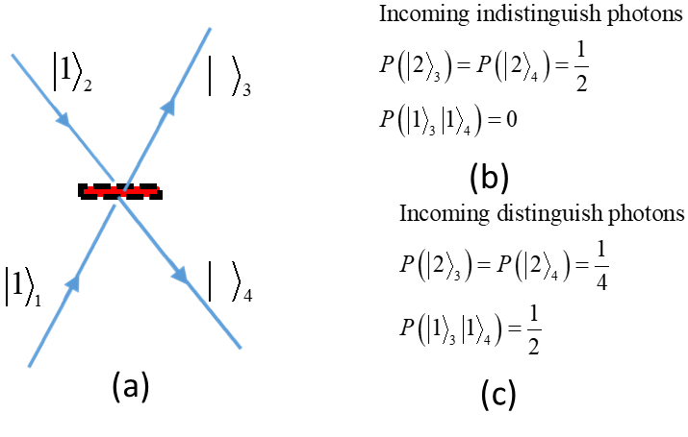

Figure 1: SCHEMA OF THE HOM EXPERIMENT

The HOM Effect (2) describes the bunching of two photons. The schema of the HOM experiment is represented in Fig.1(a). Two photons enter simultaneously from different legs onto a symmetric beam splitter. The notation here is that employed by Gerry and Knight [15]. For example, refers to one particle in leg 2. The photons’ probability of being found on the outgoing legs is shown in Fig. 1(b) for indistinguishable photons and in Fig.1(c) for distinguishable photons ( for example, according to their polarization degree of freedom).

As seen in Fig. 1(b), the indistinguishable photons are always emitted together, whereas, as seen in Fig. 1(c), distinguishable photons are emitted together only half of the time, and half of the time they are emitted to different legs. This preference of the indistinguishable bosons to be emitted together is a manifestation of the bosons bunching.

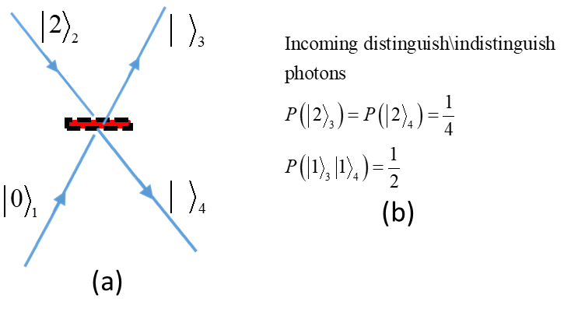

Figure 2: TWO PHOTONS ENTERING SIMULTANEOUSLY ON THE SAME LEG

In Fig. 2, two photons enter simultaneously on the same leg of the beam splitter. Fig. 2 (b) shows the probability of finding the emitted photons. It appears that the probability of finding the emitted photons is independent of the photons being distinguishable or not, as the difference between the indistinguishable and distinguishable photons disappears. These examples illustrate that the distinguishability of the photons is not the only condition that plays a role in whether they are bunched or unbunched.

* 1. The Bunching Parameter: First Quantization

Consider two particles in a two-dimensional space with an orthonormal base of two states ,



with



The scalar product of the two states is :



Here, the notation is in accordance with that of Gerry and Knight [15]. The index inside the ket  represents the particle, and the Greek letter is the state the particle is in.

If the two particles are distinguishable bosons, where one of the bosons is in the state  and the other is in the state , their joined wave function is



where and is the normalization constant given by the condition.

According to Equation :



From Equations , , and , we find that the probability of the two distinguishing distinguishable bosons being in the same state. For example,  results in:



However, the joined wave function of two indistinguishable bosons must be symmetrical (Cohen-Tannoudji, Diu, and Laloe, [14]). That is,



where is the symmetric operator defined for two particles as



with , and  is the permutation operator.

Normalization of the joined bosonic wave function  gives, as per

Equation :



That is, Equation becomes:



The probability of finding the two indistinguishable bosons in the same state, for example, , is:



Using Equations and , the bunching parameter is defined by the ratio:



Before discussing the bunching parameter, we shall derive it from the formalism of the Second Quantization.

* 1. Bunching Parameter for Photons: Second Quantization

In the Second Quantization, the initial state [Equations and ] for distinguishable photons becomes



where the first photon is denoted by operator , the second photon is denoted by the operator ,and the normalization is calculated by Equation . With the following bosonic commutation relations,



it is convenient to define:



The following commutation relation follows:



The number-like operators of the states in Equation are  with, and with.

The joined wave function of the two distinguishable photons is:



By the normalization we have:



The probability of finding both particles in the same state, for example,  is:



If, instead of two distinguishable bosons, the bosons are indistinguishable, the wave function becomes:



with the bosonic commutation relation:



Accordingly, we use the following definition:



The resulting commutation relation is as follows:



The number-like operator for the particles generated by is  , with.

The joined indistinguishable wave function is



where  is the normalization of the joined indistinguishable bosons.

Applying the normalization  results in:



The probability of finding both indistinguishable bosons in the same state, for example,  with the normalization  , is formulated as:



Using Equations and , the bunching parameter is formulated as:



Equations and are therefore clearly identical.

Since , it follows that the bunching parameter is . It is instructive to compare this result with the examples described in Fig.(1) and Fig.(2). In Fig.(1), the two photons have an orthogonal wave function: that is, . It follows from Equation that . As a result,



That is, the probability of finding the two indistinguishable bosons is twice as much in this state than if the two bosons were distinguishable, as can indeed be seen in Fig.1(b) and Fig.1(c).

However, if the two bosons enter on the same leg, as in Fig. (2), then. In this case, Equation results in . Thus,



That is, the probability of finding the two distinguishable bosons is identical to the probability of finding two indistinguishable bosons, as can indeed be seen in Fig. 2(b).

A quantity that is invariant under a unitary transformation plays an important role. It is therefore important to show that the bunching parameter is indeed invariant under a unitary transformation.

Consider two different two-dimensional spaces, with bases  and.

The bunching parameter for the base is:



Similarly, the bunching parameter for the base is:



These bases are related by a unitary transformation,



under which the scalar product is invariant, that is . Thus, according to Equations and , we have ; that is, the bunching parameter is invariant under a unitary transformation.

For typical cases of photons being emitted from separate sources, such as atoms, the photons are in orthogonal states, with . Since the bunching parameter is invariant under a unitary transformation, it follows that to change the bunching parameter, a non-unitary transformation is needed. This will be discussed in the following section.

# The State Orthogonality Interferometer

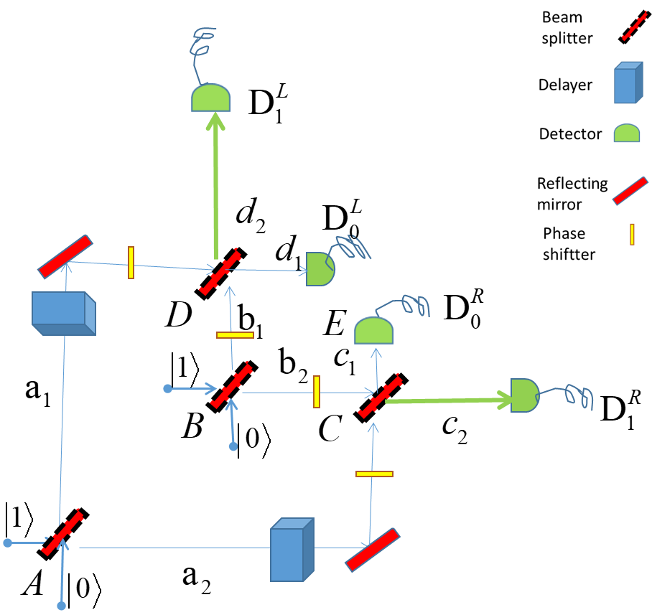

Figure 3: THE STATE ORTHOGONALITY INTERFEROMETER

Due to the separate nature of atoms, two indistinguishable photons emitted by the atoms are orthogonal, with. Therefore, their bunching parameter is. Indeed, since the original HOM experiment [2], the boson bunching with has been demonstrated in many variations, as in, for example, Jeltes et. al [4]. This gives rise to the question of how to achieve other values of the state orthogonality , and, as a result, a bunching parameter with . The interferometer described in Fig. (3) can be used to tail photons to achieve a state orthogonality .

In Fig. 3, there are two incoming photons, one on the incoming legs of beam splitter, and one on the incoming legs of beam splitter. The delays at  and at are set in such a way that the photons coming from beam splitter and reach beam splitter  and beam splitter simultaneously.

The photons will be detected eventually in one of the four detectors. Each of the beam splitters is unitary,



where . The phase shifter at each leg will be denoted by the leg where it appears; that is, , where . For the purpose of maintaining the simplicity of the notation, we first consider the case:



This will later be inserted oter vaule to those phases as necessary.

The amplitude of the photons entering the beam splitter  is determined by



where the subscript notation is as in Gerry and Knight [15] and above. The letter  above or below the arrow indicates that the photon passes through the  beam splitter.

The amplitude of the photons entering the beam splitter  is determined by:



Now, if the detectors both read zero, the remaining values are the states at legs  and . Such conditional processes at detectors are known as “post selected measurements,” as defined by Aharonov, Bergmann, and Lebowitz [16].

Then the photons’ state at  is determined by:



In addition, the photons’ state at is determined by:



The respective wave functions of the photons are



where  and  are the normalization constants determined by the condition. Using the commutation relations in , it is found that:



Defining:



the joined wave function is formulated as:

 .

Equation can be used to calculate the overall normalization :



In addition, it can be calculated from that:



If, however, the two photons are distinguishable (for example, by their respective polarization), Equation remains unchanged:



However, because the photons are distinguishable, the creation operator in is set to :



by means of the commutation relations in Equation .

The single-photon wave functions are:



where  and  are the normalization constants determined by the condition. Using Equation results in  and .

Defining



the joined wave function of the distinguishable photons is:



In addition, the normalization  results in .

Using Equations and for the state orthogonality [Equations and ], the bunching parameter becomes:



In the case where the phase of the interferometers in Fig. 3 is not zero, that is,, the output amplitude will be modified.

The modification at legs  and  is formulated as:



In addition, the modification at legs  and  is formulated as:



This is because given  for all , the normalization in Equation is unchanged.

The bunching parameter with a non-zero phase [Equation ] now becomes:



The representations of the reflected and transmitted coefficients of the beam splitter are the general matrix for a beam splitter:



such that  and .

In this particular case, we select



where  is the index of the beam splitter.

It is important to bear in mind that the State Orthogonality Interferometer may be used in three different ways:

* As an interferometer to track two distinguishable photons;
* As an interferometer to track two indistinguishable photons. In practice, we will receive non-trivial state orthogonality, ;
* And, as used in this paper, to combine the two above ways to determine the bunching parameter.

There are three cases of the state orthogonality interferometer which are examined:

* All phases are zero: ;
* All phases give real value output amplitudes;
* Different conditions hold for each photon.
  1. The Case of Zero Phases

To determine the range of values for the bunching parameter that this interferometer achieves, the simplified version of that interferometer will be considered.

If the beam splitters  and  are considered to be symmetrical,  , the range of the bunching parameter is given by Equation , as shown in Fig. 4.

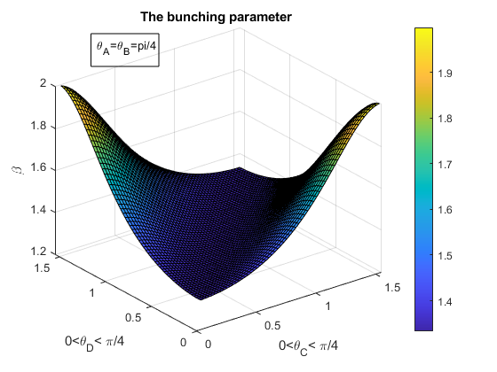

Figure 4 the bunching parameter range

That is, for this simple setup, where the beam splitters  and  are symmetrical, the bunching parameter range is more than 70% of its full range (see Fig. 4). However, it is not difficult to obtain a full-range parameter. For example, setting  results in a full-range bunching parameter.

* 1. The Case of Real Value Output Amplitudes

Producing real value amplitudes can be accomplished by adding phase shifters at the legs , as, for example, with the following phases:



In addition, the amplitude modification is formulated as,



as can be verified directly by Equations and , to determine that all amplitudes at the legs  and  have real values.

In this case, the bunching parameter becomes:



where the normalization is unchanged. The range of  is then .

* 1. The Case where Different Conditions Hold for each Photon

For this last setup, consider the following conditions:

1. All modulus amplitudes at legs  and  are equal;
2. The phase between the wave function at leg  as compared to leg  of one of the photons (for example, ) is ;
3. There is no phase difference between the amplitude of the second photons (for example,).

Condition A can be achieved by setting  . As a result, the amplitude is formulated as .

Condition B can be achieved by adding phase shifts and to the amplitudes of photons  at leg  and leg  . The wave function is determined by:



Accordingly, we arrive at Condition C:



To produce the same amplitude for a photon in leg  as in leg  for photon , we calculate:



One way of calculating Equations and is:



Using Equation , the orthogonal state is  , and thus:



Next, we will the results of Sections 3.2 and 3.3 will be used to demonstrate the generalization of the HOM effect.

* 1. Generalization of the HOM Effect

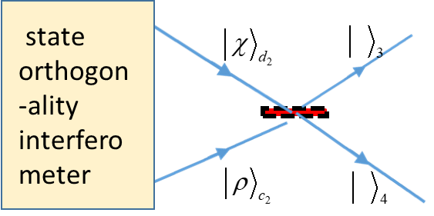

State Orthogonality Interferometer

Figure 5: state orthogonality in the HOM setup

Here, the question of how the application of the state orthogonal interferometer changes the bunching behavior in the HOM effect is examined. The HOM effect yields results with the following two properties:

1. Fig 1(a), the coincidence probability of the outgoing indistinguishable photons at different legs is measured as,
2. Fig 1(b), the joined photons will appear half of the time on the upper leg, and half of the time on the lower leg.

The goal here is to show how both of these properties can be generalized. To accomplish that, the following steps should be considered:

1. Remove the detectors ;
2. The wave functions at the legs  and  are the input of the symmetric beam splitter, as shown in Fig. 5;
3. Set the wave function amplitude at  and , as in Cases 3.2 and 3.3 above.
   1. Case 3.2 as the Input of the HOM Experiment: A Generalization of Property A

The results of this case in the HOM setup can be calculated as shown in Fig. 5. Here, this calculation was made using the bunching parameter. First, two *distinguishable* photons are run in the interferometer. As a result, their amplitudes represent a real value: the probability of finding them together at the output is determined by (see the Appendix for details):



Now, running two indistinguishable photons in the same setup (for distinguishable photons, the probability of finding them together can be calculated as in

Equation ), the probability is found to be:



By probability conservation, the probability of finding the indistinguishable photons in *different legs* is:



This equals zero only for ; that is, the HOM Effect cases. Consequently, this is a generalized result of the HOM effect.

3.6 Case 3.3 as an Input of the HOM Experiment, a Generalization of Property B.

First, two *distinguishable photons* will be run in the interferometer. As a result, according to their amplitude setup l (see the Appendix for details), the calculation is formulated as:



Note that because the construct of distinguishable photons  have a phase relation, it will only be emitted in each leg, while there is an equal probability of the distinguishable photons  being emitted in either leg.

Now, running two indistinguishable photons in the interferometer, the probability of finding them together is calculated by Equation :



and thus  in the case that all of the indistinguishable photons are emitted together, but in the same leg.

In the HOM case with Property B above, the indistinguishable photons will be emitted half of the time in the lower leg, and half of the time in the upper leg. This is a generalization of Property B of the HOM effect.

# Discussion and Summary

In Section 2, the theoretical bunching parameter was formulated for two photons [Equation ]. This formulation leads to the conclusion that indistinguishable photons appear at times as distinguishable photons, with a bunching parameter of, such that . The underlying property is that the bunching parameter depends on the state orthogonality of the two indistinguishable photons, such that .

The HOM effect (as in Jeltes [4]), illustrated in Fig. 1, is then understood as a special case with,and, as a result,. However, in natural circumstances, photons are produced from separate atoms and their initial states are orthogonal, i.e., . Therefore, a bunching parameter of  is not an ordinary phenomenon. This poses the question and the challenge of how to produce states with a bunching parameter other than 2.

Therefore, in Section 3, the state orthogonality interferometer was introduced using the post-selected measurements [16?] (Fig. 5). This interferometer can indicate state orthogonality, and by extension, the bunching parameter. In order to determine additional applications of the interferometer, we considered three specific interferometer setups. In Section 3.1, we used the setup where and for all . Those setups over the range  produced a full bunching range, i.e., full orthogonality of the states, as seen in Fig.

In order to arrive at an example that constitutes a generalization of the HOM effect, two further setups of the interferometer were examined in Sections 3.2 and 3.3.

Finally, in Section 4, the HOM effect was characterized by two properties:

1. Two indistinguishable photons emitted together; and
2. Two indistinguishable photons emitted half of the time to one leg and half of the time to the other leg together.

Therefore, applying Equation , it can be demonstrated that the setup of Section 3.2 for indistinguishable photons that enter in different legs in the HOM experiment violates Property A.

In essence, the HOM effect of two photons interferes with . The generalization of Property B is formulated by means of the setup in Section 3.3. Equation shows that indistinguishable photons will be emitted to a single leg. This clearly generalizes Property B of the HOM effect.

Another way to express the generalization of the HOM effect found here is as follows:

Whereas in the case of the HOM effect, the interference is only between the two photons, in the case of state orthogonality, where  , both single photon interference and two photons interference occurs.

Or, stated in a more general way, state orthogonality for photons combines interferences of a single photon with itself, and of two indistinguishable photons with one another. It appears that this property is unique to photons (bosons). Indeed, the state orthogonality for fermions is always . The supposition is that, according to the state orthogonality, fermions don’t exhibit the same process of single fermion interference and two fermion interference at the same time.

More details about the HOM dip for the state orthogonality interferometer, for example, the modification of HOM dip and other applications will be discussed in future studies.

[1] Hanbury Brown, R.; Twiss, Dr R.Q. (1956). ["A Test Of A New Type Of Stellar Interferometer On Sirius"](http://www.cmp.caltech.edu/refael/league/hanbury.pdf) . *Nature*. **178**: 1046–1048.

[2] C. K. Hong; Z. Y. Ou & L. Mandel (1987). "Measurement of subpicosecond time intervals between two photons by interference". *Phys. Rev. Lett*. **59** (18): 2044–2046.

[3] Ghosh R, Mandel L. “Observation of non-classical effects in the interference of two photons”. *Phys Rev Lett*. 1987;59(17):1903-1905.

[4] T. Jeltes, et al,” Comparison of the Hanbury Brown-Twiss effect for bosons and fermions". *Nature* **445**, 402 (2007).

[5] Feynman, R. P., R.B. Leighton, and M.L. Sands, *“The Feynman Lectures in Physics*”,Vo III Addison-Wesley 1963.

[6] Fano, U. (1961). "Quantum theory of interference effects in the mixing of light from phase independent sources".*American Journal of Physics*. **29** (8).

[7] Marchewka, A., Granot, E. “Destructive interferences results in bosons anti bunching: refining Feynman’s argument”*.* *Eur. Phys. J. D* **68,**243 (2014).

### [8] A Marchewka, [E Granot](https://scholar.google.co.il/citations?user=uXEZPrQAAAAJ&hl=iw&oi=sra), Z Schuss**:** “ [On the spatial coordinate measurement of two identical particles‏](https://www.sciencedirect.com/science/article/pii/S0375960116002620)” *Physics Letters A,* 2016‏

[9] W. J. Mullin and G. Blaylock, “Quantum statistics: Is there an effective fermion repulsion or boson attraction”?, *Am. J. Phys.***71**, 1223 (2003) and references therein

[10] Avi Marchewka and Er'el Granot, "Role of Quantum Statistics in Multi-Particle Decay Dynamics", *Annals of Physics*, 355, 348–359 (2015);

[11] Avi Marchewka and Er'el Granot, “Quantum Dynamics Arising from Statistical Axioms”**.**

[12] Mousavi, S.V., Miret-Artés, S. “Dissipative two-identical-particle systems: diffraction and interference”. *Eur. Phys. J. Plus* **135,**83 (2020).

[13] Marchewka, A., Granot, E. State orthogonality, boson bunching parameter and bosonic enhancement factor”. *Eur. Phys. J. D* **70,**90 (2016)

[14] Cohen-Tannoudji, C, Diu, B., and Laloe, F. (1977), “Quantum mechanics”, vols. II, *John Wiley*, New York.

[15] C. Gerry and P. Knight, “Introductory Quantum Optics” (2004) *Cambridge*.

[16] Y. Aharonov,

# Appendix

1. Derivation of Equation —Probability of Two Distinguishable Photons

Consider one photon superimposed on two incoming legs of a symmetric beam splitter  . Then, 

with the normalization  .

In the case where  the probability to find the photons at the output legs is



Thus, the probability of two distinguishable photons to be together in one leg is  --that is, as shown in Eq. .

1. Derivation of Equation

Consider the case:



which results in .

1. I wish to thank Dr. Oskar Pelc and Dr. Oded Kenneth for their helpful comments on this paper.