**Initial post-contact behavior of an axially compressed fiber constrained inside a rigid cylinder –**

**Experimental, analytical, and numerical investigations**

Yossi Dayan†, David Durban**, Sefi Givli†*

†Faculty of Mechanical Engineering, **Faculty of Aerospace Engineering, Technion – Israel Institute of Technology, Haifa 32000, Israel

*Corresponding author, email: [givli@technion.ac.il](mailto:givli@technion.ac.il)

**Journal of Applied Mechanics, Copyright © 2020 by ASME**

# **Abstract**

The research studies the post-buckling behavior of a clamped-clamped elastic fiber constrained inside a rigid circular cylinder. The focus of this research is on characterizing the contact configuration between the fiber and the cylinder wall during initial post-contact stages of the fiber deformation, in which only a small segment of the fiber length makes contact with the cylinder wall. This is the first time a fiber behavior study has been done in a cylinder, where an in-depth analysis of the fiber deformation stages has been performed at different loads. The analysis was performed using various tools, including representative experiments, image processing for the experimental results, analysis of the finite elements of the experimental system, and analytical models for all stages of deformation from the onset of the fiber load until after the transition to 3D deformation. The main contribution of this work is that it is now possible to characterize similar problems within a cylinder in the various engineering fields and to better understand the modes of failure and how to obtain a more suitable system. The main experimental challenge is to identify regions of contact between the fiber and the cylinder wall, yet distinguish them from segments of the fiber that are very close to the cylinder wall but make no contact with it. To this end, we employ a novel experimental setup consisting of a transparent rigid cylinder filled with an opaque milky fluid, combined with image processing and synchronized force measurements. The results agree with published theoretical predictions that are based on a simplified theoretical model assuming a perfect fiber and no friction under the restriction of initial diminutive geometrical imperfection. Supported by finite-element (FE) simulations, we find that friction increases the measured force for the same level of ends shortening but has a small effect on the overall behavior. In contrast, the initial geometrical imperfection may significantly affect the force-displacement relation and the evolution of the contact configuration. Both symmetrical and anti-symmetrical initial imperfections of the fiber shape are analyzed theoretically, whereas the symmetrical made has been checked experimentally. The study provides insights regarding the influence of relevant parameters on the behavior of such systems that may have practical implications in the fields of stent procedures, medical endoscopy, deep drilling, and the mechanics governing the growth of roots and plants.

# **Introduction**

The post-buckling behavior of a linearly elastic fiber subjected to lateral constraints is of practical importance in a variety of fields, ranging from medical procedures (such as in vivo diagnosis) to engineering applications. Examples of applications in the field of medical procedures include the threading of fiber for the purpose of medical imaging or for catheterization of the heart, urology ways and blood vessels. Understanding the nonlinear behavior of such systems, and in particular, the forces exerted by the fiber (the guidewire) on the constraining walls (artery) are greatly important in order to guarantee the safety of the procedure [[1](#_ENREF_1" \o "Katopodes, 2001 #3)]. In rare cases, the extensive deformations of the guidewire can result in the fracture of the guidewire or cause damage to the artery during the intervention procedure [[2](#_ENREF_2" \o "Ito, 2013 #27), [3](#_ENREF_3" \o "López-Mínguez, 2004 #51)]. Other applications include the internal examination of pipe systems, the insertion of artificial fibers in industrial crimpers, drilling of wells from a platform to reach deep hydrocarbon or gas reservoirs [[4](#_ENREF_4" \o "Tan, 1995 #40)], effects of delamination in composite materials [[5](#_ENREF_5" \o "Chai, 1998 #41), [6](#_ENREF_6" \o "Sheinman, 1993 #50)], the insertion of paper into toner, growth of plant roots [[7](#_ENREF_7" \o "Silverberga, 2012 #15)], and the growth of filopodia in living cells [[8-11](#_ENREF_8" \o "Mogilner, 2005 #68)] .

Originally, the engineering community was mainly concerned with ways of avoiding large deformations followed by buckling, and the scientific discussion focused mainly on assessing critical forces [[12-15](#_ENREF_12" \o "Timoshenko, 2009 #3)]. In the last half of century, starting in the early sixties, theoretical models of the post-buckling behavior began to emerge. These early works focused on formulating and solving problems of (laterally-unconstrained) compressed columns and curved beams subjected to various types of boundary conditions [[16](#_ENREF_16" \o "Lubinski, 1962 #43), [17](#_ENREF_17" \o "Seldenrath, 1958 #60)]. In the last few decades, the interest in post-buckling behavior of laterally constrained fibers has constantly grown. Theoretical and experimental studies have shown that a bi-laterally constrained fiber undergoing plane deformations exhibits an intriguing behavior, and the studies presented a rather rich sequence of events under a controlled axial end displacement [[5](#_ENREF_5" \o "Chai, 1998 #41), [18-20](#_ENREF_18" \o "Vetter, 2014 #61)]. This sequence includes the formation of discrete (point-contact) or continuous (line-contact) regions of contact between the fiber and the constraining walls, and the instantaneous transition from one equilibrium configuration to another due to the onset of local instability. The specific details of these events and their dependence on parameterssuch as slenderness of the fiber, the ratio between the fiber radius of gyration and the gap between the walls, the bending stiffness of the fiber, loading rate, and friction can be found [[21](#_ENREF_21" \o "Liu, 2013 #36)]. Theoretical studies have adopted various strategies and simplifying assumptions, such as fixed constraints, frictionless walls, or assuming small deformations [[4](#_ENREF_4" \o "Tan, 1995 #40)], and focused mainly on studying the range of possible equilibrium configuration and the evolution of contact between the fiber and the constraining walls [[4](#_ENREF_4" \o "Tan, 1995 #40)]. Also, numerical methods were employed to study the planar deformations of fibers subjected to more complex lateral constraints, such as non-parallel walls, non-continuous and curved surfaces [[22-28](#_ENREF_22" \o "Villaggio, 1979 #49)]. Only a handful of studies consider the effects of friction [[29](#_ENREF_29" \o "Chateau, 1991 #56)], and an even smaller body of work have considered the realistic case of compliant (deformable) constraining walls [[30](#_ENREF_30" \o "Katz, 2015 #62), [31](#_ENREF_31" \o "Katz, 2017 #64)].

The three-dimensional (3D) response of a fiber constrained inside a rigid cylinder has also received much attention [[32](#_ENREF_32" \o "Miller, 2015 #75)]. Here, in addition to the formation of discrete and/or continuous contact regions, a transition between planar deformations and three-dimensional configurations occurs. Typically, the initially straight elastic fiber buckles into a planar sinusoidal shape when subjected to edge-thrust. As the edge-thrust increases, the fiber contacts the cylinder wall, switches to a non-planar deformation, and eventually twists and adopts a helix-like shape. In some applications, such as oil well drilling, understanding the details of this behavior is crucial. In particular, once the fiber contacts the wall, the effectiveness of the drilling operation is dramatically decreased. Moreover, locking might occur when the fiber takes a helix-like shape with extensive wall contact. A similar phenomenon also occurs in stent operations [[2](#_ENREF_2" \o "Ito, 2013 #27), [3](#_ENREF_3" \o "López-Mínguez, 2004 #51), [21](#_ENREF_21" \o "Liu, 2013 #36), [33](#_ENREF_33" \o "Chen, 2007 #1)]. Studies of the (3D) deformations of a laterally constrained fiber have also been performed in the context of delamination occurring in fiber-reinforced composites, [[34](#_ENREF_34" \o "Miller, 2015 #74), [35](#_ENREF_35" \o "Martinez, 2000 #76)].

Theoretical studies investigating the (3D) deformations of a fiber constrained inside a cylinder can be roughly divided into two main categories. The first category assumes that the constraining cylinder is slender and the deformation of the fiber is small, thus making the assumption of small-rotations applicable. Different formulations for the critical loads and post-critical configurations were studied, and some studies consider the effects of friction [[21](#_ENREF_21" \o "Liu, 2013 #36)], gravity [[36](#_ENREF_36" \o "Tan, 1993 #44), [37](#_ENREF_37" \o "Paslay, 1964 #73)], and the inclination angle of the constraining cylinder [[13](#_ENREF_13" \o "Lubinski, 1953 #59), [38](#_ENREF_38" \o "Huang, 2000 #45)]. In the second category of studies, finite deformations are accounted for and the elastica theory is commonly adopted to describe the nonlinear behavior of a fiber undergoing finite deformations.

Almost all theoretical works studying the finite deformations of a fiber constrained inside a cylinder have focused on the final stage of the fiber deformation where almost the entire length of the fiber contacts the cylinder wall and the fiber adopts a helix-like deformation [[8-11](#_ENREF_8" \o "Mogilner, 2005 #68)]. The studies in [[17](#_ENREF_17" \o "Seldenrath, 1958 #60), [37](#_ENREF_37" \o "Paslay, 1964 #73)] are some of the earliest in this respect in which an energy method was used to extract the relation between the edge-thrust and the pitch of the circular helix. To date, very little attention has been given to the initial (post-contact) stages of the fiber deformation, following the first contact between the fiber and the cylinder wall. In this respect, the works of [[39-41](#_ENREF_39" \o "Liakou, 2018 #67)] provide valuable theoretical, numerical, and experimental information; here, focus was placed on extremely slender cylinders (inner radius to length ratio of ~) and on horizontal configuration, causing 90% of the fiber to be initially in contact with the cylinder even before the external load was applied. In the work published recently by Chen and his collaborators [[42](#_ENREF_42" \o "Fang, 2013 #12), [43](#_ENREF_43" \o "Chen, 2013 #11)], a rigorous theoretical model was developed to describe the post-buckling behavior of a perfect fiber inside a rigid and frictionless cylinder. Before external force is applied, the fiber is perfectly aligned in the center of the cylinder, making no contact with the cylinder wall. Numerical results considering a relatively large inner radius to length ratio of ~have demonstrated the many possible equilibrium configurations and contact characteristics between the fiber and the cylinder wall. However, there is luck of experimental studies that systematically investigates the post-contact characteristics in such systems. The goal of the present paper is to progress towards bridging this gap. We systematically study the initial deformation stages of a fiber constrained inside a rigid cylinder by means of novel experiments as well as finite-element (FE) simulations. Special effort has been placed on developing an experimental method that enables the identification of contact characteristics between the fiber and the cylinder wall. This identification is a challenging task since even if a transparent cylinder is used, the curvature of the cylinder strongly affects the optics and makes it practically impossible to categorically identify contact (or non-contact) between the fiber and the cylinder wall. The approach we adopted based on filling the transparent cylinder with an opaque white fluid and using a dark fiber and combining post-experiment image processing with synchronized force-displacement measurements has enabled us quantitative identification of the deformation pattern and corresponding contact characteristics. Comparison of the results with the theoretical predictions of [[42](#_ENREF_42" \o "Fang, 2013 #12)] provides valuable information regarding the applicability of the assumptions considered in that model.



# **Brief review of available theoretical predictions**

Since the model and results of [[42](#_ENREF_42" \o "Fang, 2013 #12)] are highly relevant to the current contribution, we briefly review its main theoretical considerations and predictions in the this section. In preliminary work, Chen and Fang [[43](#_ENREF_43" \o "Chen, 2013 #11)] adopted the assumption of small deformations to study the post-buckling of a fiber constrained inside a rigid cylinder. The model considered a slender, isotropic, linear elastic, and perfect fiber (no geometrical or material imperfections) of length and circular cross-section (bending stiffness), where the quantityrepresents the flexural rigidity of the beam in the plane of bending, that is straight and stress-free prior to loading. The effects of gravity and friction were assumed negligible, and clamped-clamped boundary conditions were considered, i.e., one end of the fiber is completely fixed (displacements and rotations) at the center of the cylinder cross-section while the other end can only move along the axis of the cylinder. The effects of the edge-thrust on the fiber deformation and corresponding contact configuration were investigated. According to this model, the transition from 1-point contact configuration to 2-point contact configuration occurs at edge-thrust of , which corresponds to the critical (Euler) buckling load of a clamped-clamped column of length . Interestingly, it was found that this transition involves a “jump” in the ends shortening. It has been argued that this peculiar jump phenomenon is due to the limitation of the small-deformation theory. In order to remedy this deficiency, a theory associated with the elastica model was developed in [[42](#_ENREF_42" \o "Fang, 2013 #12)] (a similar approach was applied in [[44](#_ENREF_44" \o "Chen, 2011 #17), [45](#_ENREF_45" \o "Li, 2014 #71)] to study the deformation of a fiber subject to end-twist rather than end-thrust). All the previously mentioned model assumptions of [[43](#_ENREF_43" \o "Chen, 2013 #11)] were adopted in [[42](#_ENREF_42" \o "Fang, 2013 #12)] except for the assumption of small deformations. Also, it was found that, contrary to the small-deformation theory, the planar 1-point contact evolves to spatial (3D) 1-point contact first and then gradually transforms to the 2-point contact configuration. Further, seven deformation shapes, each characterized by a different contact configuration, were identified: (1) no-contact, the fiber “buckles” into a curved shape as force approaches Euler’s critical load; (2-1) contact forms between the fiber and the cylinder, leading to a planar (2D) 1-point contact configuration, resulting in a sharp increase of the fiber response slope; (2-2) the fiber switches to a spatial (3D) 1-point configuration, which resulting in a significant decrease of the slope; (3) gradual evolution of a 2-point contact configuration; (4) three-point contact configuration; (5) point-line-point contact; (6) 1-line contact; and (7) three-line contact.



In this paper, we investigate the mechanical response of a fiber undergoing large deformation inside a stiff cylinder by comparing different FE simulations, experiments, and theoretical predictions. This paper is organized as follows: In Sec. ‎2, we describe the method and materials that include an experimental system, image processing, and numerical simulations to characterize the contact configuration between the fiber and the cylinder wall during initial post-contact stages of the fiber. In Sec. ‎3, we discuss the experimental, image processing, and numerical simulation results and compare them with the results from the theoretical predictions. Lastly, Sec. ‎4 summarizes the main conclusions drawn from this study and identifies problems for future research. In addition, symmetrical and anti-symmetrical initial imperfections of the fiber shape are analyzed theoretically, whereas the symmetrical made has been checked experimentally.

# **Materials and methods**

# **Description of system**

The theoretical predictions assume the following: the thin elastic fiber of length with circular cross-section is inextensible and unshearable; the fiber is uniform in mechanical properties along its length and is stress-free when it is straight and untwisted, the fiber deformation is constrained inside a straight cylinder with radius, and the centerline of the constraining cylinder coincides with the unstressed straight fiber. Gravity and friction force are not considered. The diameter of the fiber cross-section is negligible compared to that of the cylinder. We consider the deformation of the fiber when it is subject to prescribed edge-thrust and under the constraint of the cylinder. It is assumed that the fiber is completely fixed at one end and not allowed to rotate about the longitudinal axis. At the other end, the fiber is clamped laterally but is free to slide longitudinally. The solution method in theoretical predictions must envision first what the deformation pattern is, such as 1-point contact or 2-point contact. In the early stage of the deformation sequence, they are guided by previous experiences from the small-deformation theory, leading to point-line-point contact. Then, the constrained elastic deformation depends on the radius of the constraining cylinder. Based on , the ratio between cylinder radius and fiber length , for a relatively slender cylinder, such as [[42](#_ENREF_42" \o "Fang, 2013 #12)], the early stages of the deformation sequence are similar to the stages obtained from the small-deformation theory, and the stages are 1-point, 2-point, three-point, and point-line-point contact deformations. However, some fundamental differences exist between small-deformation theory and elastica model, even in this early stage of deformation.



According to small-deformation theory, the 1-point contact deformation only exists in planar form; while in the elastica model, the 1-point contact deformation of the spatial form also exists. In addition, according to small-deformation theory, the point-line-point contact deformation is the final stage of the deformation. Also, as the radius of the constraining cylinder increases, the deformation patterns become less complicated and the number of deformation patterns before the two end clamps meet decreases. As expected, the difference between the small-deformation theory and the elastica model grows as the radius of the constraining cylinder becomes larger. In the case whenis larger than 0.384 [[42](#_ENREF_42" \o "Fang, 2013 #12)], the constraining cylinder has no effect on the elastica deformation.



# **Experimental system**

Experiments were performed with an Instron 4483 machine, on which the designated experimental system was installed, see Fig. 1. The experimental system includes a CSN EN 10270-1 steel wire fiber with length of long and radius inside a transparent cylinder (radius ) filled with an opaque white fluid (metalworking-cooling fluid, PVR-925S, mixed with water). Due to the inherent curvature of the cylinder, which strongly affects the optics, it is practically impossible to identify the onset and progress of contact between the fiber and the cylinder wall. Filling the transparent circular cylinder with the opaque white milky fluid enables the identification to trace the progress of these contact regions, as explained below. Special adapters were designed and installed to impose clamped boundary conditions at both ends of the fiber. Then, the lower adapter was fixed to the cylinder while the upper one was attached to the moving arm of the Instron machine, so the fiber coincided with the symmetry axis of the cylinder at the start of the experiment. During the experiment, the distance between the two ends of the fiber was slowly decreased, upon lowering the upper end, by the Instron machine; this process resulted in the bending deformation of the fiber constrained by the cylinder. Our method in which the distance between the two ends of the fiber is shortened while the length of the fiber remains constant differs from the method in [[34](#_ENREF_34" \o "Miller, 2015 #74)], where the fiber is injected from the left to the right and pulled over two feeder rollers through a slave injector and forms a slack loop and then is pulled through a primary injector into the constraining glass cylinder. It can be said that an experimental method in this study has advantages over previous systems, including minimal friction and greater precision in measuring the fiber force. In our experiments reaction forces are transmitted over an air bearing slider to the force sensor. The fiber is then pulled through a channel by an idler wheel and a drive wheel that is driven by a servo-stepper motor close-up of an acrylic clamp holding the pipe in place. The deformation is examined for three different fiber radii and for two different inner radii of the cylinder . These geometries are chosen to enable quantitative comparison with the results presented in [[42](#_ENREF_42" \o "Fang, 2013 #12)], i.e., two different values of the non-dimensional ratio , namely, . Here is the free length of the fiber in the initial unloaded state, i.e., the distance between the two clamping points at the beginning of the experiment. Ends shortening (decrease in the distance between the two clamps) was determined by the displacement of the upper clamp that is controlled by the Instron machine using the displacement control method. In this configuration, loads are applied to a part based on the displacement, and the displacement is determined using an Encoder installed on the Instron. In this method, the displacement changes incrementally while the reaction force results depend on the stiffness of the structure. Edge-thrust (axial compressive force) applied on the fiber was measured by a static load cell, and together with displacement both were synchronized with a digital camera (MAKO G-223 with CMOSIS/ams CMV2000 sensor, global shutter; 50 frames per second) that was used to record the experiment. The maximum level of ends shortening was restricted by software to prevent plastic deformations.



In each experiment, two complementing characteristics of the response were recorded: the force displacement relation and details of contact. In order to determine these features the axial force was applied to the fiber along with the corresponding ends shortening. The analysis of the force-displacement relation provides the core information on the fiber loading process, revealing important aspects of the fiber behavior. The details of contact between the fiber and the cylinder were determined by analyzing the successive frames taken by the camera and complemented with MATLAB® assisted image processing, that allows clearly represent the contact region between the fiber and the cylinder wall. Synchronization between the camera and the Instron machine enables the contact configuration to be identified and related directly to the force-displacement relation. This synchronization enables qualitative and quantitative comparison between the behavior observed in the experiment and the structural response predicted by FE simulations and by the theoretical predictions of [[42](#_ENREF_42" \o "Fang, 2013 #12)].

# **Image processing**

Each snapshot (image) underwent image processing with MATLAB® to identify the contact region between the fiber and the inner wall of the cylinder. To this end, the following procedure was performed: First, the image is converted to a digital array of scalar integers in the range of [0,255]. The array size is identical to the number of pixels in the image, and the scalar values represent the gray level of each pixel, where the extreme values of 0 and 255 correspond to black and white, respectively.

Next, the image is corrected in order to produce an uniform background, i.e., make all pixels of the white fluid have the same gray level. The purpose of this step is to minimize the effects of non-uniform illumination due to the curvature of the cylinder wall. In particular, without this correction, columns of the array (image) that are far from the center is generally darker (have smaller gray-level values). The correction involves multiplying each column by a different factor such that the average values of the fluid pixels in all columns are identical. Finally, a threshold filter is applied to isolate pixels corresponding to contact between the fiber and the cylinder. The threshold level is calibrated as follows: By using the force-displacement plots, the image where the fiber makes first contact with the cylinder wall is identified. In that stage of deformation, the contact configuration is necessarily a “point contact” configuration. Thus, the threshold level is set as the gray level of that contact point, and the “size” of the contact region associated with a “point contact” is determined (practically, due to effects such as imperfections and compression of the fiber against the cylinder wall, the so-called “point contact” configuration should be actually considered as a small region of contact).

# **Finite-element simulations**

FE simulations were performed with the commercial FE software Abaqus FEA. A dynamic implicit analysis was designed to simulate the experimental system, which includes a fiber that is clamped at both ends and is laterally constrained by a rigid cylinder. The model of fiber meshed with hexahedral solid elements, type C3D8R (8-node brick, accounting for geometrical nonlinearity), with over 50 elements in the fiber cross-section and a total of 2700 elements in the fiber. A Young’s modulus of was assigned to the fiber, in accordance with tensile experiments that were performed with the Instron machine. Preliminary analyses with high-order brick elements and with a larger number of elements in the mesh have resulted in similar results.



In developing equations for the implicit integration, a formula for predicting the internal forces at time in terms of the internal forces, such as the tangential stiffness, , at a time is needed. For this purpose, two approaches are used: (1) tangential stiffness methods and (2) linear stiffness, pseudo-force methods. In the former, the internal nodal forces are predicted by [[46](#_ENREF_46" \o "Belytschko, 1976 #79)].



In contrast, in the pseudo-force method, the internal forces are predicted using as the linear stiffness and as the pseudo-force matrix, accounting for the non-linearities. Here the pseudo-force is either taken at time or is extrapolated to from its value at .



Boundary conditions were implemented by defining zero-displacement of all degrees of freedom associated with the nodes at the two ends of the fiber. The only exception is the vertical displacement of the upper end, which was gradually increased during the simulation.

As shown in Fig. 1, the fiber at the end of one side (on the side where no force is applied) is fixed to the x, y, and z axes for both displacement and rotation around each axis. At the other end of the fiber, where the force is applied, the fiber is fixed to rotate on the three axes and does not have the ability to rotate around them. On the two other axes that are not parallel to the movement of the end of the fiber, the fiber’s end is fixed and cannot move in the direction of these axes. On the axis that is parallel to the movement of the end of the fiber, the fiber’s end has a constraint that enables it to move in parallel to the axis for a defined displacement of 80 mm, as the motion occurred in the experiment. In order to facilitate our analysis, we compared between implicit and explicit methods. The primary difference between implicit and explicit types of FEM analysis is that the implicit analysis uses Newton-Raphson iterations to enforce equilibrium of the internal structure forces with the externally applied loads. This type of analysis tends to be more accurate and can take larger increment steps. In addition, this type of analysis can handle problems such as cyclic loading, snap through, and snap back as long as sophisticated control methods such as arc length control or generalized displacement control are used. One limitation of the method is that the stiffness matrix for each Newton-Raphson iteration must be updated and reconstructed, that is computationally costly. So, computationally intensive dynamic analyses are often performed with the explicit method. However, for static problems, it is common to perform the full implicit type of analysis, which is the method chosen for this work. In the numerical analysis, the vertical displacement represents the shortening between the two ends of the fiber, as described in Section ‎‎2.2. The vertical force on the upper end of the fiber, which is the force applied by the Instron machine in the experiment, was determined in the simulation. The shortening rate of the ends was , which is comparable to the rate at which the experiments were performed. Preliminary FE simulations showed that lower rates produce similar results, that means that our system behave as a quasi-static system.

To facilitate fiber bending response from the outset, thus avoiding a bifurcation analysis at the first buckling load, we introduced into analysis a realistic geometrical imperfection. Thus, the stress-free configuration of the fiber was assumed to admit the shape using symmetric imperfection as the initial deviation from the axis of symmetry of the constraining cylinder:



Where is the coordinate along the axis, and is the amplitude of the bending.



All variables here are measured in millimeters, and the maximum geometrical imperfection value obtained (approximately ) is about 0.2% of the fiber length . Eq. is recognized in the post-buckling theory to calculate the worst geometrical imperfection that is identical to the shape of the first buckling mode of a fiber subjected to clamped-clamped boundary conditions [[12](#_ENREF_12" \o "Timoshenko, 2009 #3)]. The influence of the imperfection amplitudeon the behavior of the constrained fiber. In Section ‎3 we analyzeusing Abaqus FEA. In the numerical analysis, a contact between the cylinder and the fiber was defined using penalty stiffness in the normal direction of the contact surfaces (pressure-overclosure with "hard" contact and no penetration). In addition, tangential interaction, accounting for friction between the two bodies, was set in the model. A few values of the friction coefficient were also examined, representing the estimated range of the friction coefficient between the metal fiber and the Perspex wall of the cylinder, including a greasy metalworking-cooling fluid as discussed before in Section ‎‎2.2.



# **Analytical insights from initial imperfection analysis**

In this section, we present analytical derivations for three key features associated with the behavior of the fiber. The first and second features are the end displacement (shortening) of the fiber at the onset of first contact between the fiber and the cylinder with symmetric and anti-symmetric imperfections as illustrated in Fig. 2, and the third is the load at which the transition from 2D (planar) to 3D deformation occurs. The analysis assumes linear stress-strain relation (Hooke’s law).

# **End displacement for the first contact with symmetric imperfection**

# The analysis in this section is based on a well-established elastic solution of a clamped-clamped fiber. An analytical model that describes the behavior of the fiber depending on the initial bending and material properties of the fiber is adopted from [[12](#_ENREF_12" \o "Timoshenko, 2009 #3)], where the initial shape of the fiber`s axis is given by Eq. (1). Thus, the axis of the fiber has initially the form of a sine curve with a maximum ordinate at the middle equal to. If this fiber is submitted to the action of a longitudinal compressive force , an additional deflection is produced so that the final ordinates of the deflection curve are . Because the lateral load vanishes when determining the critical load of buckled bars, the differential equation for the column is the following:



where the quantity represents the flexural rigidity and represents the distance along the fiber.



Separation of the variables gives:



by combining Eq. (3) with the definition of in (1), we obtain:



with the boundary conditions that are associated with the clamped-clamped at the ends of the fiber:



Eq. (4) with the boundary conditions (5) can be solved analytically, and a closed form of the deflectionis:



Here is the Euler buckling force, is the dimensionless axial compressive force, and is the dimensionless magnitude of the geometrical imperfection.



To assess the value of from the load and the total end displacement, we used the expression derived in [[40](#_ENREF_40" \o "Liu, 2018 #65)]:



evaluating the integral, we obtains:



the dimensionless total end displacement becomes:



neglecting the first term, as increases towards unity, we get an analytical estimation of the imperfection amplitude as:



In order to compare our analytical solution to the empirical and numerical simulation results, we assign as a function of for several values of and , see Fig. 7 and Fig. 8 (purple line, azure point-line-point line and green line), and their description in Section ‎3 (Results).



# **End displacement for the first contact with anti-symmetric imperfection**

For a case of the anti-symmetric imperfection, [[12](#_ENREF_12" \o "Timoshenko, 2009 #3)] provides the following initial shape :



with origin at beam center



Here is the first eigenvalue of and the critical load is:



The bending equation becomes:



with clamped boundary condition at .



Now, the bending solution is obtained as follows:



with a maximum at , here



, where  is buckling force.

The total anti-symmetric branch shape is determined as:



Note that due to limitations of modeling the fiber with symmetrical and anti-symmetrical imperfections together, our experiments refer to the fiber behavior with symmetrical imperfection only. The anti-symmetrical imperfection analyzed analytically for a theoretical examination of its effect on the fiber behavior.

In general case, the initial shape of the fiber is given by



The additional displacement is:



So the total bending displacement shape becomes:



Note that the second term diverges when .



Before proceeding further, we need to assess and from experimental data. Assuming that we can neglect the anti-symmetric branch at , where force applied to the fiber at first wall contact (). In addition, assuming and using linearization for Eq. (18), :



In order to find B, we write the fiber’s end displacement Eq. (7) due to the bending only:



inserting here both imperfections from Eq. (16) and (17), we obtain:



Eq. (21) can be simplified on account of orthogonality:



the first integral has already been evaluated:



and the second integral gives:



Thus:



where , and



for



Coefficients and can now be determined from measurements in the range of between one third and half of shortening up to contact.



once and have been fixed, we can define the curve with



where:



Next, it should be instructive to analyze that curve, in the absence of walls, as approaches in order to examine the hypothetical configuration near the second value of buckling force of the second contact point on the cylinder wall.



The values of and  were calculated using the least-squares method on the experimental results in effect of three matrices. The first matrix shows the values of after substituting the results of the experiment into Eq. (25) and the second matrix defines from the experimental results. The third matrix shows the values of and that were calculated by dividing the displacement matrix from the experiments by the matrix of terms containing from the experiment. Curves in Fig. 11 (a)÷(e) represent the normalized data obtained on the Instron device experiments, and the circles are approximate calculations obtained by the analytical model and the triangle are asymptotic model shown in Eq.(25), that uses the values of ****and****for symmetric and anti-symmetric imperfections.



Now, we could describe the curves in Fig. 12. from Eq.(26) and calculate values of location and buckling force , used and for all five experiments when the fiber contacts the cylinder wall, when the dashed red curves in Fig. 12 indicate the boundaries of the cylinder for and . To determine the location and first buckling force of the first point of contact in the cylinder, we solve the two equations obtained from the conditions of contact are: . We substitute the values of that were obtained according to Eq. (25) and a set of values of until the fiber contacted the cylinder wall in the range of , and the results are presented in Fig. 12. Also, the location and first buckling force were approximated ahead of the first contact [42]. By assuming and using linearization, we obtain from Eq. (19) and Eq. (26):



In addition, the location of the second contact point on the cylinder and second buckling force were calculated by Eq. (29).



# **Solution for fiber and cylinder wall in contact**

Fiber under axial load undergoes planar (2D) deformation, forming a point contact between the fiber and the cylinder. For increasing load, the end displacement of the fiber increases, but the curvature at the contact point decreases. When this curvature becomes zero, line-contact forms, which is the onset of the transition to 3D deformation. To clarify this transition, we analyzed it by considering small deformations. In this section, we describe the bending of the fiber, its contact with the cylinder wall, and the onset of the transition to 3D deformation. Fig. 2 shows the configuration under consideration, where is the initial imperfection of the fiber before loading. When loading begins, the fiber deformation increases up to the first critical point at a load , at which point the fiber buckles. Next, the growing load further deforms the fiber and, at a given force , the fiber touches the wall for the first time, and gives the fiber displacement from the *x* axis. When the load increases beyond, a small additional deflection occurs in the fiber. The fiber geometry remains 2D until a critical load is applied, at which point it becomes 3D because of bifurcation. The fiber shape relative to the direction of the force is , and relative to the bending is  because no bending forces exist at . As a result, we obtain the following equation (see Ref. [[12](#_ENREF_12" \o "Timoshenko, 2009 #3)]), which represents a balance of the external (compressive) and internal (bending) forces exerted on the fiber:



In Eq. (30), is the flexural rigidity, is a longitudinally compressive force, and represents the distance along the fiber. When the fiber touches the cylinder wall, we obtain :



# Subtracting Eq. (30) from Eq. (31) gives



# We introduce the dimensionless parameters , , [the root of the equation ].



# Upon differentiating with respect to , Eq. (32) takes the form

# 



The solution for is given in Eq. (26). The solution of Eq. (33) has homogeneous and non-homogeneous parts. The fiber deformation is not symmetric about the point of contact, so we divide the solution domain into left and right branches about the zero point (i.e., approximately in the middle of the fiber).



Next, the solutions of the left and right branches of Eq. (33) can be written as follows:



The solution for refers only to the first contact between the fiber and the cylinder wall, i.e., .



The constants of the homogeneous part are defined by the following four boundary conditions:



where .



The analytical solution of these equations provides the coefficients given below in Eq. (36). To present the coefficients more succinctly and clearly, we take the parts of the coefficients that depend on and bind them to variables :





We treat the right branch of the solution in a similar way by defining constants , which produces



The analytical solution of these equations gives



After inserting the dimensionless displacement into the areas defined in the solutions, Eq. (33) and Eq. (34) allow us to calculate the curves for different values of . The results are shown in Fig. 13.



The dimensionless fiber-tip displacement (see Fig. 2) can be calculated from the compressive force:



When the fiber contacts the cylinder wall under the force, Eq. (39) determines the dimensionless fiber-tip displacement :



Combining Eq. (39) and Eq. (40) yields



The terms in Eq. (41) can be evaluated by using the following assumptions: the middle of the fiber forms a pinpoint contact with the cylinder wall, whereas some parts of the fiber protrude beyond the virtual wall because the loading at the point of contact remains constant as a result of the developing deformation. No friction exists at the point of contact.



Here, calculating the right side of the first integral (values of in order of their appearance in the integral) yields





Calculating the left side of the first integral yields



Calculating the second integral yields



so



After calculating the integrals,

Eq. (47) includes an approximation based on two asymptotes in the pressure range between . To describe the asymptotic behavior of the dimensionless fiber-tip displacement  , we use the first significant term of the small-disturbance analysis. For and using Eq. (33), the significant term is



The solution of Eq. (48) satisfies the condition when the fiber first contacts the cylinder wall.

For and using Eq. (33), the significant term is



The solution of Eq. (49) is acceptable up to 3D deformation because we are dealing with small changes and there is one contact point and a line contact for the fiber along the cylinder wall. The curves in Fig. 11 show the normalized experimental results obtained by using the Instron device, and the solid circles give the results of the analytical model [Eq. (47)], which describes the situation when the fiber touches the cylinder wall. The triangles represent two asymptotic models [Eq. (48) and Eq. (49)]. In addition, Fig. 11 shows that the calculation of the circles prior to contact and after the transition to 3D deformation is consistent with the calculation in the previous section [Eq. (25)].

# **Results**

All results herein are presented in terms of non-dimensional quantities: the dimensionless fiber-tip displacement , the dimensionless axial compressive force , and the dimensionless magnitude of the symmetric initial imperfection. These quantities are built from the following real parameters: is the actual fiber-tip displacement, is the initial unloaded fiber length (i.e., the vertical distance between the clamped ends of the fiber at the start of the experiment), is the vertical force applied to the fiber, is the Euler buckling force for a perfect clamped-clamped column, is the Young’s modulus of the fiber, is the moment of inertia of the fiber, and is the fiber radius.



Fig. 7 and Fig. 8 show the vertical force versus fiber-tip displacement up to the first contact point between the fiber and the cylinder wall. As expected, before the first contact occurs, smaller geometrical imperfections cause the height of the “plateau” region to approach the theoretically predicted value of (dashed curve shows result for ideal fiber). Also, the results obtained from the analytic model shows that the geometrical imperfection affects the force before the first contact. Because increases and has no effect, the force required to produce the plateau region decreases. The main differences between the theoretical predictions and the analytical results are that the theoretical predictions are obtained without the initial binding and the solution in Ref. [[42](#_ENREF_42" \o "Fang, 2013 #12)] is numerical; in addition, the assumptions and boundary conditions differ. By comparing the FE results with those of the experiment at the initial stage of fiber deformation, we deduce that the level of imperfection in the experiment is equivalent to ≈ 10−3 and ≈ . Fig. 3 shows the force-displacement relation measured in three experiments that differ only in the fiber radius: *r* = 0.61, 0.78, and 0.88 mm. All three experiments have a free fiber length and an inner radius *R* = 55 mm of the cylinder, which leads to . The results of the experiments are compared with the theoretical prediction (dashed curve). The theoretical prediction may be divided into five distinct stages for the fiber-bending process that occurs over the measured range of loading. These stages are indicated in Fig. 3 by numbers in parentheses and are separated by the full circles that lie on the theoretical force-displacement curve.



To avoid plastic deformations, the fiber-tip displacement was limited in the experiments, so the theoretically predicted deformation stage (5), which is associated with the point-line-point contact configuration, could not be realized. The measured force-displacement relation for the fiber with *r* = 0.88 mm (black curve) may thus be consistent with the theoretical prediction within the range of values compared.

The minor deviation (less than 8%) in the critical value calculated for the fiber-buckling force is due to geometrical imperfections. This effect is expected to become more apparent with thinner fibers, which are more susceptible to geometrical imperfections. In fact, the critical loads measured for fibers with *r* = 0.78 mm (blue curve) and 0.61 mm (azure curve) are less than the Euler buckling load by close to 15% and 40%, respectively. As expected, the effect of geometrical imperfections diminishes with increasing fiber-tip displacement. Once contact forms between fiber and cylinder, the effect of the initial imperfection becomes negligible for both fibers (0.88 and 0.78 mm). For the 0.61 mm fiber, however, the imperfection is so significant that it influences the fiber behavior over a large range of fiber-tip displacement, up to about Note that the onset of (first) contact between fiber and cylinder wall can be directly deduced from the measured force-displacement relation; specifically, it occurs at the end of the plateau region associated with , followed by a sharp increase (jump) in the slope of the loading curve.



For all three fibers, first contact occurs at almost the same dimensionless fiber-tip displacement , which is consistent with the theoretical predictions. This result suggests that the initial deviation of the as-received fibers from the straight (perfect) geometry is very small. In addition, the transition from planar two-dimensional deformation to three-dimensional deformation occurs at a force , which is consistent with results reported in Refs. [[42](#_ENREF_42" \o "Fang, 2013 #12), [43](#_ENREF_43" \o "Chen, 2013 #11)]. The fluctuations in the measured force are presumably due to friction between the fiber and cylinder, causing a “stick-slip–like” behavior. The larger contact forces between the fiber and the cylinder wall cause these fluctuations to increase with increasing fiber-tip displacement. The contact configuration cannot be obtained directly from the force-displacement relation. Thus, to obtain the contact configuration, we use the image-processing procedure described below.

Fig. 4 shows the experimental results for which the contact between fiber and cylinder wall is analyzed by using the image-processing procedure described in Section ‎2.3. For each of the three fibers, the top row shows side-view photographs for different fiber-tip displacements. For convenience and to enable comparison, these fiber-tip displacements and associated labels a–i are identical to those in Fig. 3 and in the figures that follow. Specifically, fiber-tip displacement associated with deformation i could not be attained for the fiber with *r* = 0.88 mm. Applying the image-processing procedure to the previously mentioned photograph results in the images presented in the bottom row of Fig. 4. For the fibers with *r* = 0.88 and 0.78 mm, the deformation stages and contact evolution are qualitatively consistent with the predictions by the theoretical model and the FE simulations, which are similar to the deformation stages described in the preceding paragraph.



Perhaps the only discrepancy with the theoretical predictions is related to the notion of point contact. Clearly, theoretical point contact cannot occur in practice. Instead, a small segment of contact may be considered equivalent to the theoretical notion of point contact. As a result, all images (for both fibers) up to stage e indeed reflect a single-point-contact configuration. These images also clearly show the development of two distinct regions of contact that seem to move farther apart with increasing fiber-tip displacement, as predicted by the theoretical model in stages f–h. Still, it is noteworthy that the size of these contact regions depends on the reduction in fiber length.

Finally, the image-processing procedure reveals three separate regions of contact in stage i, which is consistent with the theoretical prediction. The good qualitative agreement, in terms of contact characteristics, between experimental results and theoretical predictions is consistent with the good quantitative agreement in terms of the force-displacement relation. For the fiber with *r* = 0.61 mm, in contrast, the measured force-displacement relation deviates significantly from the results of the theoretical prediction, mainly because of the effects of geometrical imperfection; see Fig. 3. Fig. 4 shows that the deviation from the theoretical prediction is also reflected in the way in which the contact evolves.

For example, after the two-point contact forms, further increase in fiber-tip displacement does not increase the distance between the contact points. Instead, the contact area at each of the contact points increases, resulting in what appears as a line-contact configuration. This evolution of contact, which is not identical between the two contact points, eventually evolves into (almost) a single line-contact configuration that connects the original point-contacts. This phenomenon and, in particular, the observed asymmetry, evolves from the single line contact and is probably a consequence of significant geometrical imperfection combined with friction.

Next, we analyze the deformation of the constrained fiber by using FE simulations. Fig. 9 shows the results of FE simulations for the fiber with *r* = 0.88 mm. Several force-displacement relations are shown and each is associated with a different geometrical imperfection amplitude and friction coefficient (Coulomb-type friction in Fig. 9, see black dashed curves, red curve, orange dashed curves, orange curves, azure curve, and azure dashed curve). For reference, the theoretical predictions (red dashed curve), analytical results (purple curve, azure point-dash-point curve, and green curve), and experimental results (black curve) that appear in Fig. 3 (for this fiber) are also recapitulated here. In addition, we include a simulation with negligible geometrical imperfection and very small friction coefficient (red curve). The results of this simulation are completely consistent with the theoretical prediction that assumes a perfect fiber and no friction. A minor discrepancy appears only for a relatively large fiber-tip displacement, for which the transverse force applied to the fiber by the wall becomes very large, resulting in non-negligible friction force. These results and the results of the FE-based analysis of the contact, which is discussed later, increase confidence in the results of the FE simulations shown in Fig. 10, from which several conclusions can be drawn.



Importantly, the geometrical imperfection in the latter stages of the deformation has negligible effect for . For larger values of (azure curve and azure dashed curve in Fig. 7), the external force is noticeably smaller, especially during the initial stages of deformation, before two-point contact occurs. A similar trend also occurs in experiments when comparing the behavior of fibers with different radii (see Fig. *3*).



In addition, Fig. 9 reveals the effect of friction. A larger friction coefficient results in a higher external force for the same reduction in fiber length (azure dashed curve). Contrary to the effect of geometrical imperfection, the effect of friction increases with fiber-tip displacement, and the difference between the measured force and the prediction of the theoretical model, in which friction is considered, becomes larger. This increased difference is probably a consequence of the higher normal force and larger contact area that develops in the advanced stages of fiber deformation.

Next, for the 0.88 mm fiber, we study the evolution of fiber-wall contact based on the FE simulation with conditions similar to the experimental conditions; namely,  and . Fig. 10 shows the deformation of the fiber for different fiber-tip displacements , where the labels a–i specify the corresponding locations on the force-displacement curve in Fig. 9. For each fiber-tip displacement, the top and bottom rows show side and top views, respectively. Contact with the cylinder wall is illustrated by the lighter (greenish) color. The following contact configurations are studied: (a) no-contact, (b, c) planar (2D) one-point contact, (d, e) spatial (3D) one-point contact, (f–h) two-point contact with increasing distance between the two contact points, and (i) three-point contact. These results are completely consistent with the theoretical predictions. Note that the extreme proximity of the fiber to the cylinder wall at the deformation stages that include two- or three-point contacts render extremely difficult the investigation of the contact characteristics. In fact, without the aid of the FE simulations or the unique experimental setup used in this work, one could easily (and incorrectly) interpret the contact characteristics as a continuous curve contact rather than as the actual case of two (or three) small areas of contact separated by a rather long segment that is extremely close to the cylinder wall but that does not interact with it.

We now consider the experiments investigating the behavior of the loaded fiber for . For this, we used a cylinder with an inner radius of *R* = 100 mm and fibers with *r* = 0.88 and 0.78 mm (black curve and azure curve). The theoretical predictions (red dashed curve) shown in Fig. 5 suggest that the deformation patterns should become less complicated with increasing radius of the constraining cylinder. In particular, for , the theory predicts that only deformations 1–4 should occur, whereas deformations 5–7, which occur for , should not occur for . In addition, the force-displacement relation for should differ significantly from that for , and the first contact should occur at a larger fiber-tip displacement. More important is the prediction that, once spatial (3D) deformation occurs (at force ), the force no longer increases but slowly decreases. This prediction is in contrast with the case of , where the force increases close to , whereas the deformation evolves from configuration 2-2 to configurations 3, 4, and 5 sequentially.



The exception is the small discrepancy before the first fiber-wall contact occurs; this discrepancy is associated with geometrical imperfection, as discussed earlier. The theoretical predictions are consistent with the results shown in Fig. 5. Following the experimental investigation and conclusions for the case of , it is not surprising that the prediction of the theoretical model is consistent with the evolution of contact between fiber and cylinder wall shown in Fig. 6.

# **Summary and conclusions**

We investigate experimentally and numerically the post-buckling behavior of an elastic clamped-clamped fiber constrained inside a rigid cylinder. By using a novel experimental setup, which uses a transparent cylinder filled with an opaque fluid, combined with image processing and synchronized force measurements, we study quantitatively the evolution of contact between the fiber and the constraining cylinder. Heretofore, the only relevant experiments were done with extremely slender constraining cylinders, namely , or for cases where (almost) the entire fiber was in contact with the cylinder.



In contrast, this paper presents experimental results for the evolution of deformation and contact configuration in the initial stages of deformation for non-negligible values of . Supported by FE simulations and analytical modeling, we determine the contribution of geometrical imperfection and friction. In general, the level of geometrical imperfection can be evaluated by analyzing the measured force-displacement relation before the fiber contacts the constraining cylinder.



The influence of friction can be determined based on the difference between the measured force and the theoretical (i.e., no friction) prediction at advanced stages of deformation, where the effect of geometrical imperfection is relatively small. The results show that the main contribution to friction comes from increasing the force (edge thrust) associated with the reduction in fiber length and from adding to the measured force “fluctuations” associated with stick-slip behavior. Qualitatively, friction does not significantly affect the fiber deformation or the contact configuration (this conclusion is limited to small-to-moderate values of the friction coefficient and needs to be further examined for larger values).

The results also show that the geometrical imperfection  =  (or larger) of a fiber length can significantly influence the measured force and the evolution of fiber-wall contact. Provided the geometrical imperfection is less than this value, the experimental results, the FE simulations, and the theoretical predictions that consider a perfect fiber and ignore the effect of friction are all consistent.

In addition, this study of fiber behavior considers a fiber in a cylinder and includes an in-depth analysis of the fiber deformation stages at different loads. Various tools are used for the analysis, including representative experiments, image processing of the experimental results, analysis of the finite elements used to simulate the experimental system, and analytical models for all stages of deformation from the onset of fiber load until after the transition to 3D deformation. The main contribution of this work is that it now becomes possible to characterize similar problems in a cylinder in various engineering fields and to better understand the modes of failure and how to obtain a more suitable system.

Future research should study the behavior of fibers subjected to boundary conditions different from those considered herein and extend the investigation to a range of sizes for the constraining cylinder (i.e., different values of ). It is also desired to use larger fiber-tip displacements than those used herein to examine more complicated contact configurations, such as the point-line-point and three-line contact configurations. Doing so would require a long, almost-perfect fiber with very small geometrical imperfection and that can withstand very large deformations. It would also be interesting and of practical importance to repeat each experiment with a different friction coefficient. In principle, this can be done by using cylinders and/or fibers made from several types of materials and controlling their surface roughness, or perhaps by changing the fluid inside the cylinder.



**Acknowledgments**

This work was partially supported by the Israel Science Foundation grant ISF 581/17 to S.G.

The financial support to Y.D. by RAFAEL is gratefully acknowledged.

|  |
| --- |
| **References** |

[1] F. V. Katopodes*, et al.*, "Torsional deformation of an endoscope probe," *Proceedings of the Royal Society of London. Series A: Mathematical, Physical and Engineering Sciences,* vol. 457, p. 2491, 2001.

[2] S. Ito*, et al.*, "A case of fractured guide wire perforating the coronary artery and ascending aorta during percutaneous coronary intervention," *Journal of Cardiology Cases,* vol. 7, pp. e137-e141, 2013.

[3] J. R. López-Mínguez*, et al.*, "Rupture and Intracoronary Entrapment of an Angioplasty Guidewire With the X-Sizer Thromboatherectomy Catheter During Rescue Angioplasty," *Revista Española de Cardiología (English Edition),* vol. 57, pp. 180-183, 2004/02/01/ 2004.

[4] X. C. Tan and B. Forsman, "Buckling of slender string in cylindrical tube under axial load: Experiments and theoretical analysis," *Experimental Mechanics,* vol. 35, pp. 55-60, 1995/03/01 1995.

[5] H. Chai, "The post-buckling response of a bi-laterally constrained column," *Journal of the Mechanics and Physics of Solids,* vol. 46, pp. 1155-1181, 1998/07/01/ 1998.

[6] I. Sheinman*, et al.*, "Post-buckling analysis of multiply delaminated beams," *International Journal of Solids and Structures,* vol. 30, pp. 1289-1300, 1993/01/01/ 1993.

[7] J. L. Silverberga*, et al.*, "3D imaging and mechanical modeling of helical buckling in medicago truncatula plant roots," *Proceedings of the National Academy of Sciences,* vol. 109 (42), pp. 16794-16799, 2012.

[8] A. Mogilner and B. Rubinstein, "The Physics of Filopodial Protrusion," *Biophysical journal,* vol. 89(2), pp. 782-795, 2005.

[9] P. K. Mattila and P. Lappalainen, "Filopodia: molecular architecture and cellular functions," *Nature reviews. Molecular cell biology,* vol. 9(6), pp. 446-454, 2008.

[10] N. Leijnse*, et al.*, "Helical buckling of actin inside filopodia generates traction," *Proceedings of the National Academy of Sciences,* vol. 112, pp. 136-141, 2015.

[11] S. Pronk*, et al.*, "The Limits of Filopodium Stability," *Physical Review Letters,* vol. 100, p. 258102, 2008.

[12] S. P. Timoshenko and J. M. Gere, *Theory of elastic stability*: McGraw-Hill Book, 2009.

[13] A. Lubinski and H. B. Woods, "Factors affecting the angle of Inclination and Dog-Legging in Rotary Bore Holes," 1953.

[14] A. Lubinski and K. A. Blenkarn, "Buckling of Tubing in Pumping Wells, Its Effects and Means for Controlling It (includes associated paper 1053-G)," 1957/1/1/ 1957.

[15] I. Sheinman*, et al.*, "Post-buckling behavior of beams under contact constriants," *ASME Journal of Applied Mechanics,* vol. 61, pp. 764-772, 1994.

[16] A. Lubinski and W. S. Althouse, "Helical Buckling of Tubing Sealed in Packers," *Society of Petroleum Engineers,* vol. 14, pp. 655-670, 1962/6/1/ 1962.

[17] T. Seldenrath and A. W. Wright, "Note on Buckling of Tubing in Pumping Wells," *AIME Journal of Petroleum Transactions,* vol. 213, pp. 369-399, 1958.

[18] R. Vetter*, et al.*, "Morphogenesis of filaments growing in flexible confinements," *Nature Communications* vol. 5, pp. 1-11, 2014.

[19] S. A. Koehler and T. R. Powers, "Twirling Elastica: Kinks, Viscous Drag, and Torsional Stress," *Physical Review Letters,* vol. 85, pp. 4827-4830, 2000.

[20] H. Chai, "On the post-buckling behavior of bilaterally constrained plates," *International Journal of Solids and Structures,* vol. 39, pp. 2911-2926, 2002/06/01/ 2002.

[21] C.-W. Liu and J.-S. Chen, "Effect of Coulomb friction on the deformation of an elastica constrained in a straight channel with clearance," *European Journal of Mechanics - A/Solids,* vol. 39, pp. 50-59, 2013.

[22] P. Villaggio, "Buckling under unilateral constraints," *International Journal of Solids and Structures,* vol. 15, pp. 193-201, 1979/01/01/ 1979.

[23] J.-S. Chen and S.-Y. Hung, "Deformation and stability of an elastica constrained by curved surfaces," *International Journal of Mechanical Sciences,* vol. 82, pp. 1-12, 2014.

[24] Z.-H. Lu and J.-S. Chen, "Deformations of a clamped–clamped elastica inside a circular channel with clearance," *International Journal of Solids and Structures,* vol. 45, pp. 2470-2492, 2008.

[25] E. Miersemann and H. D. Mittelmann, "Stability and continuation of solutions to obstacle problems," *Journal of Computational and Applied Mathematics,* vol. 35, pp. 5-31, 1991/06/26/ 1991.

[26] T. C. Soong and I. Choi, "An elastica that involves continuous and multiple discrete contacts with a boundary," *International Journal of Mechanical Sciences,* vol. 28, pp. 1-10, 1986/01/01/ 1986.

[27] V. Denoël and E. Detournay, "Eulerian formulation of constrained elastica," *International Journal of Solids and Structures,* vol. 48, pp. 625-636, 2011.

[28] J.-S. Chen and W.-C. Ro, "Deformations and Stability of an Elastica Subjected to an Off-Axis Point Constraint," *Journal of Applied Mechanics,* vol. 77, p. 031006, 2010.

[29] X. Chateau and Q. Son Nguyen, "Buckling of elastic structures in unilateral contact with or without friction," *European Journal of Mechanics - A/Solids,* vol. 10, pp. 71-89, 1991 1991.

[30] S. Katz and S. Givli, "The post-buckling behavior of a beam constrained by springy walls," *Journal of the Mechanics and Physics of Solids,* vol. 78, pp. 443-466, 2015/05/01/ 2015.

[31] S. Katz and S. Givli, "The Postbuckling Behavior of Planar Elastica Constrained by a Deformable Wall," *ournal of applied mechanics,* vol. 84 (5), 2017.

[32] J. T. Miller*, et al.*, "Buckling of a thin elastic rod inside a horizontal cylindrical constraint," *Extreme Mechanics Letters,* vol. 3, pp. 36-44, 2015/06/01/ 2015.

[33] J.-S. Chen and C.-W. Li, "Planar elastica inside a curved tube with clearance," *International Journal of Solids and Structures,* vol. 44, pp. 6173-6186, 2007.

[34] J. T. Miller*, et al.*, "Buckling-induced lock-up of a slender rod injected into a horizontal cylinder," *International Journal of Solids and Structures,* vol. 72, pp. 153-164, 2015/10/15/ 2015.

[35] A. Martinez*, et al.*, "Experimental Evaluation of the Lateral Contact Force in Horizontal Wells," *Journal of Energy Resources Technology,* vol. 122, pp. 123-128, 2000.

[36] X. C. Tan and P. J. Digby, "Buckling of drill string under the action of gravity and axial thrust," *International Journal of Solids and Structures,* vol. 30, pp. 2675-2691, 1993/01/01/ 1993.

[37] P. R. Paslay and D. B. Bogy, "The Stability of a Circular Rod Laterally Constrained to Be in Contact With an Inclined Circular Cylinder," *Journal of Applied Mechanics,* vol. 31, pp. 605-610, 1964.

[38] N. C. Huang and P. D. Pattillo, "Helical buckling of a tube in an inclined wellbore," *International Journal of Non-Linear Mechanics,* vol. 35, pp. 911-923, 2000/09/01/ 2000.

[39] A. Liakou, "Constrained Buckling of Spatial Elastica Application of Optimal Control Method," *Journal of applied mechanics,* vol. 85(8), 2018.

[40] J.-P. Liu*, et al.*, "Post-Buckling Analysis of a Rod Confined in a Cylindrical Tube," *Journal of applied mechanics* vol. 85(7), 2018.

[41] J.-P. Liu*, et al.*, "Buckling of a slender rod conﬁned in a circular tube Theory, simulation, and experiment," *International journal of mechanical sciences,* vol. 140, pp. 288-305, 2018.

[42] J. Fang*, et al.*, "On a compressed spatial elastica constrained inside a tube," *Acta Mechanica,* vol. 224, pp. 2635-2647, 2013.

[43] J.-S. Chen and J. Fang, "Deformation sequence of a constrained spatial buckled beam under edge thrust," *International Journal of Non-Linear Mechanics,* vol. 55, pp. 98-101, 2013.

[44] J.-S. Chen and H.-C. Li, "On an Elastic Rod Inside a Slender Tube Under End Twisting Moment," *Journal of Applied Mechanics,* vol. 78, p. 041009, 2011.

[45] S.-Y. Li and J.-S. Chen, "A twisted elastica constrained inside a tube," *European Journal of Mechanics - A/Solids,* vol. 44, pp. 61-74, 2014/03/01/ 2014.

[46] T. Belytschko, "A survey of numerical methods and computer programs for dynamic structural analysis," *Nuclear Engineering and Design,* vol. 37, pp. 23-34, 1976/04/01/ 1976.

**Figures**

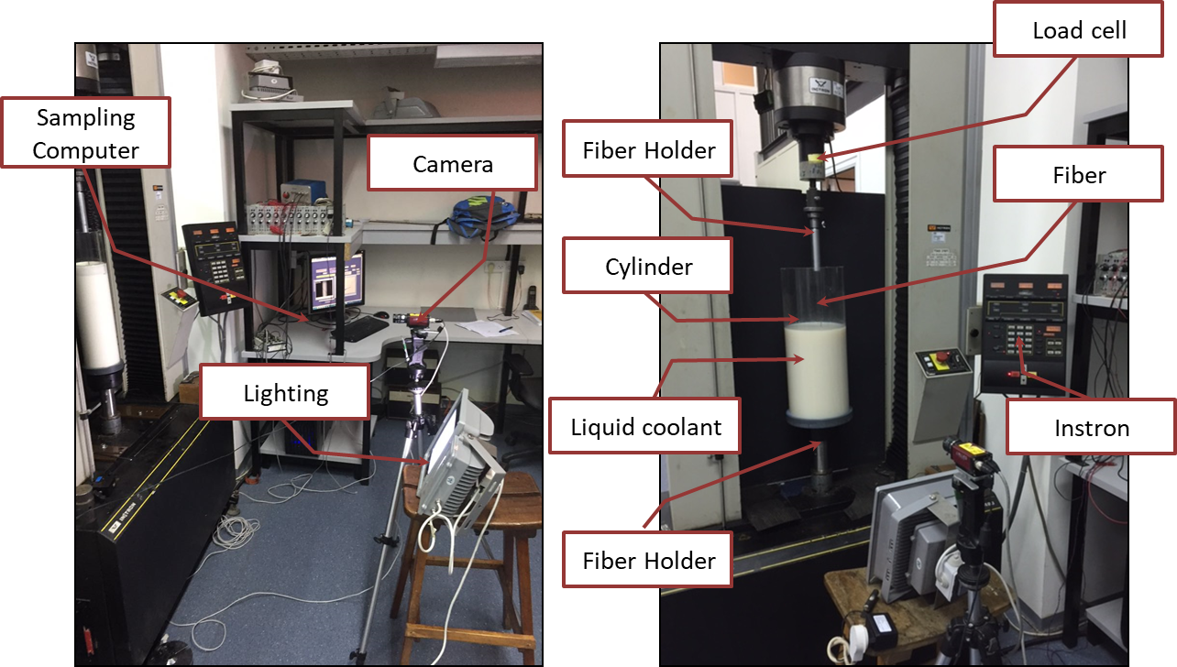

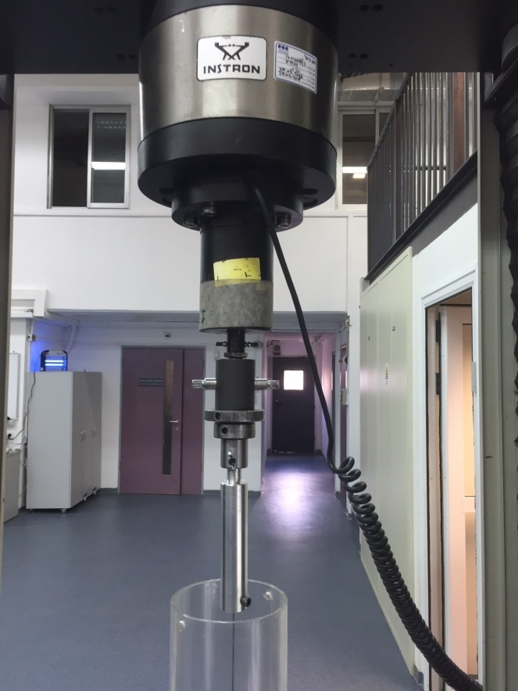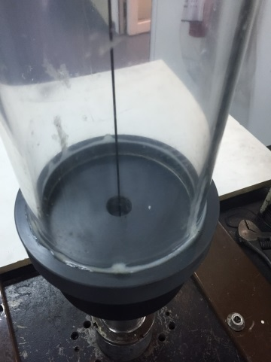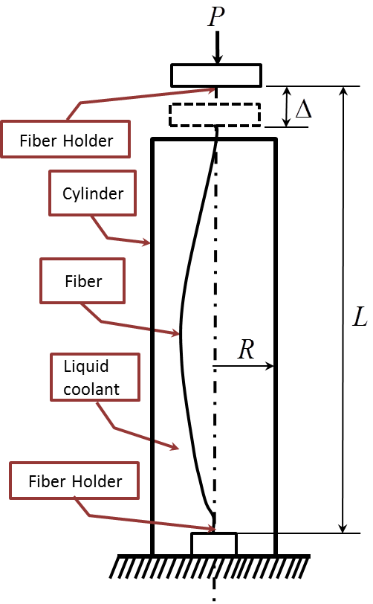

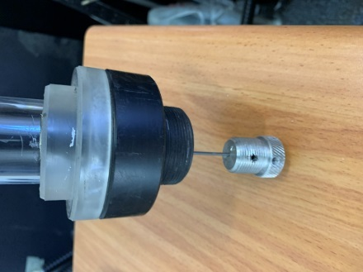

Fig. 1: (a) The experimental setup, with a cylinder of radius (left image), or radius (right image). In these images, the cylinder is not completely filled with an opaque milky fluid for the purpose of clarity. (b) Schematic description of the main experiment and system components.



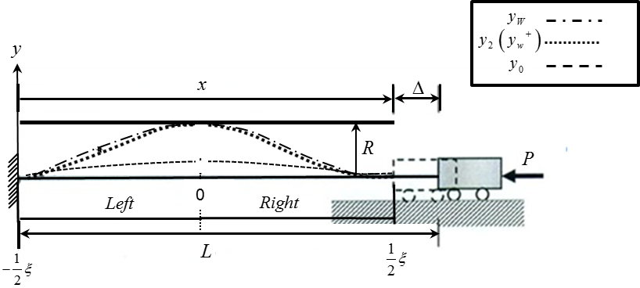

Fig. 2: Description of the boundary conditions and post-buckling response of the fiber in this research.

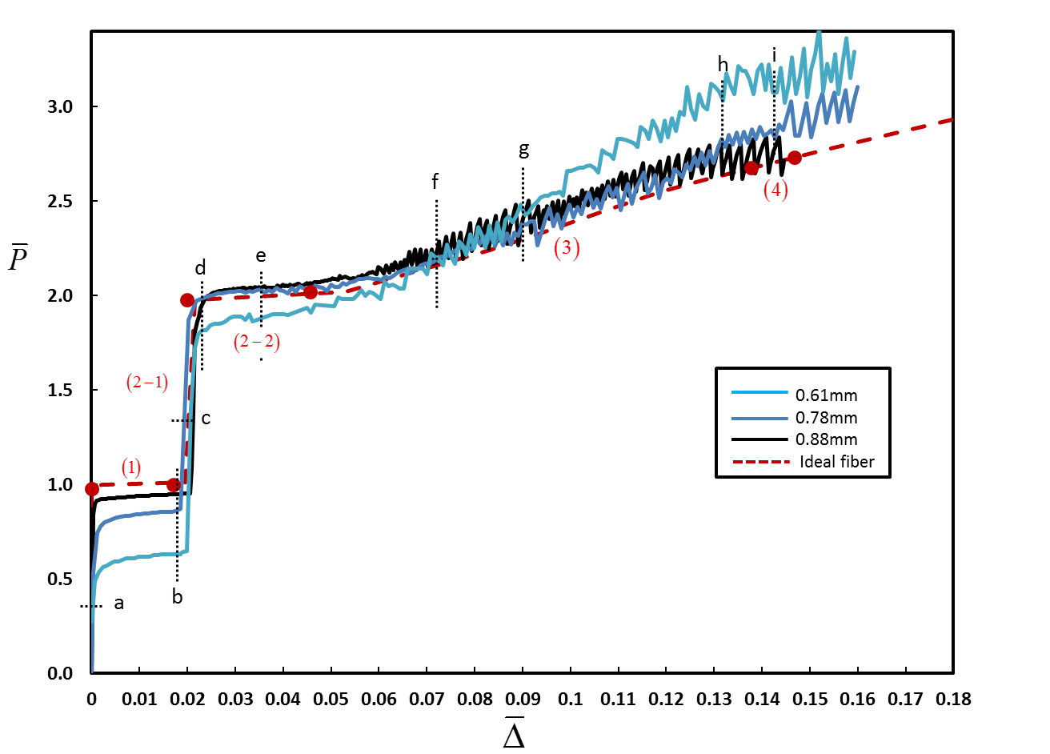

Fig. 3: Measured vertical force versus end shortening for three different fiber radii:, ,,, ε≈0.104. The experimental results are compared to the theoretical predictions of [[42](#_ENREF_42" \o "Fang, 2013 #12)] for ε=0.1 (Ideal fiber:red dashed curve). Numbers in parenthesis indicate the contact configuration in accordance with Fig. 1. Filled circles identify a transition from one configuration to the next.

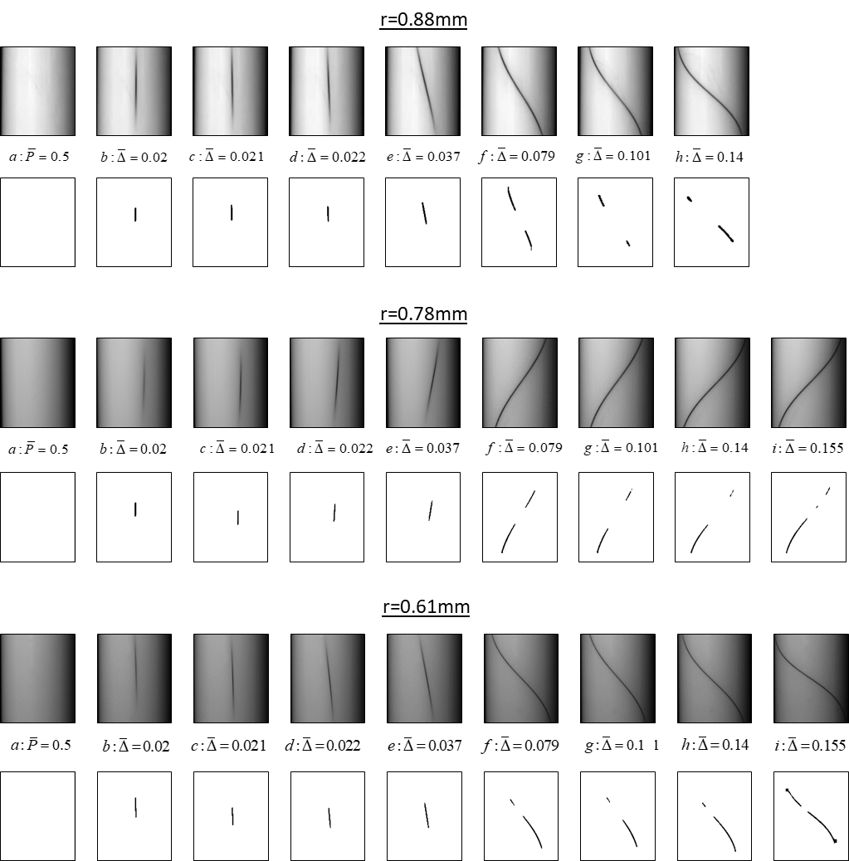

Fig. 4: Contact between the fiber and the cylinder wall at different stages of deformation for the fibers from Fig. 4 (ε≈0.104, ). For each fiber, the first row shows snapshots from the experiment at different levels of end shortening, while the second row shows the same snapshot after applying the image-processing procedure. End shortening is indicated by the numbers between the two rows and also by the letters a-h that appear in the force-displacement curve, Fig. 3.



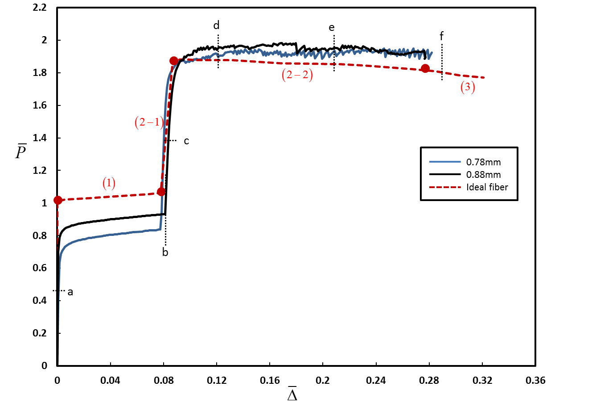

Fig. 5: Force-displacement relation. Measured vertical force versus end shortening for two different fiber radii: ,,, ε≈0.189. The experimental results are compared to the theoretical predictions of [[42](#_ENREF_42" \o "Fang, 2013 #12)] for ε=0.2 (Ideal fiber:red dashed curve). Numbers in parenthesis indicate the deformation stage described in [42]. Filled circles identify a transition from one deformation pattern to the other

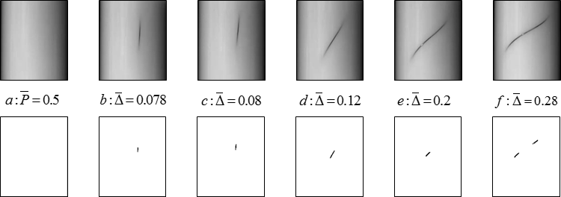

Fig.6: Force-displacement relation. Measured vertical force versus end shortening loading and unloading for: .,, ε≈0.189. The experimental results are compared to the theoretical predictions of [[42](#_ENREF_42" \o "Fang, 2013 #12)] for ε=0.2 (dashed curve). Numbers in parenthesis indicate the deformation pattern described in [42]. Filled circles identify a transition from one deformation pattern to the other.

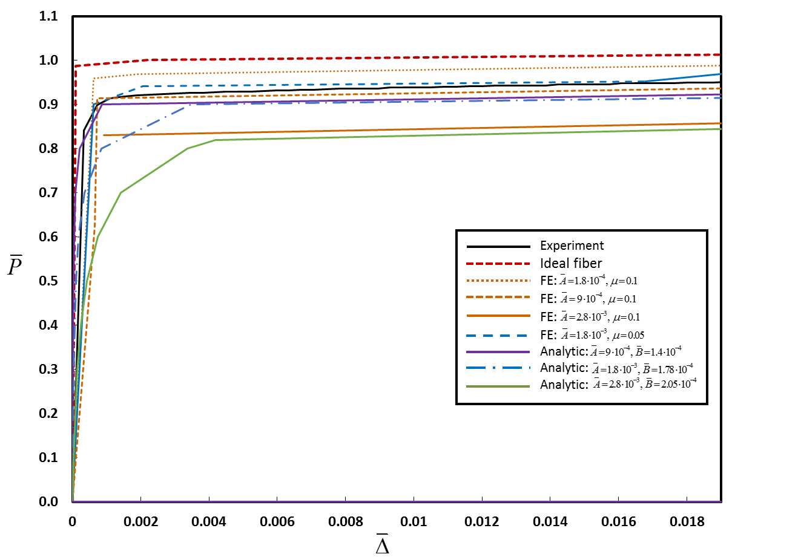

Fig. 7: Vertical force versus end shortening up to the first contact point of the fiber in the cylinder wall for:,,, ε≈0.104. The experiment, analytical model and FE simulations results are compared to the theoretical predictions of [[42](#_ENREF_42" \o "Fang, 2013 #12)] (Ideal fiber: red dashed curve). FE results are shown for simulations with various values of (amplitude of the deviation symmetric and anti-symmetric imperfection) and μ (friction coefficient).



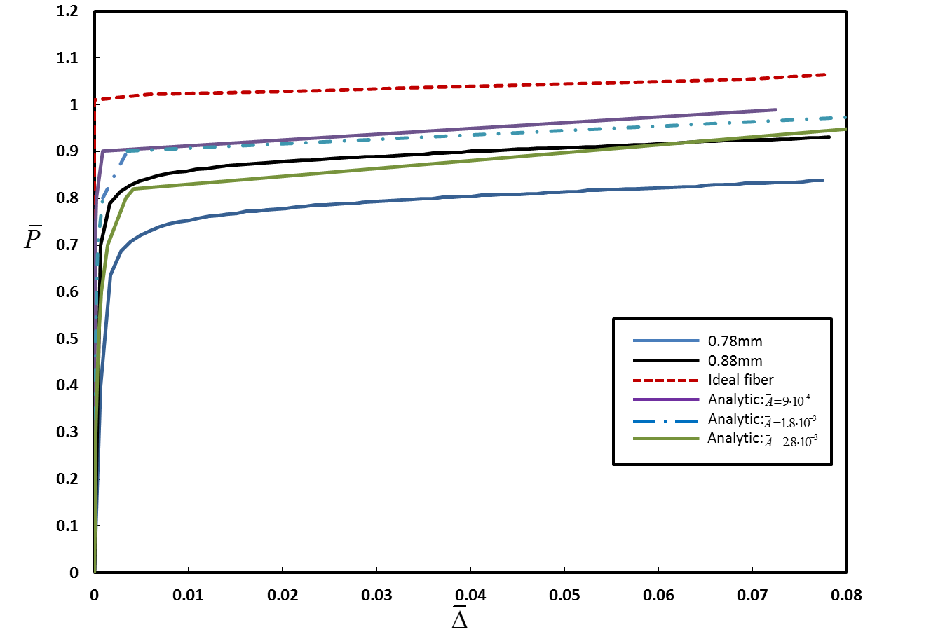

Fig. 8: Vertical force versus end shortening up to the first contact point of the fiber in the cylinder wall for:, ,, ε≈0.189. The experiment and analytical model results are compared to the theoretical predictions of [[42](#_ENREF_42" \o "Fang, 2013 #12)] (Ideal fiber: red dashed curve).

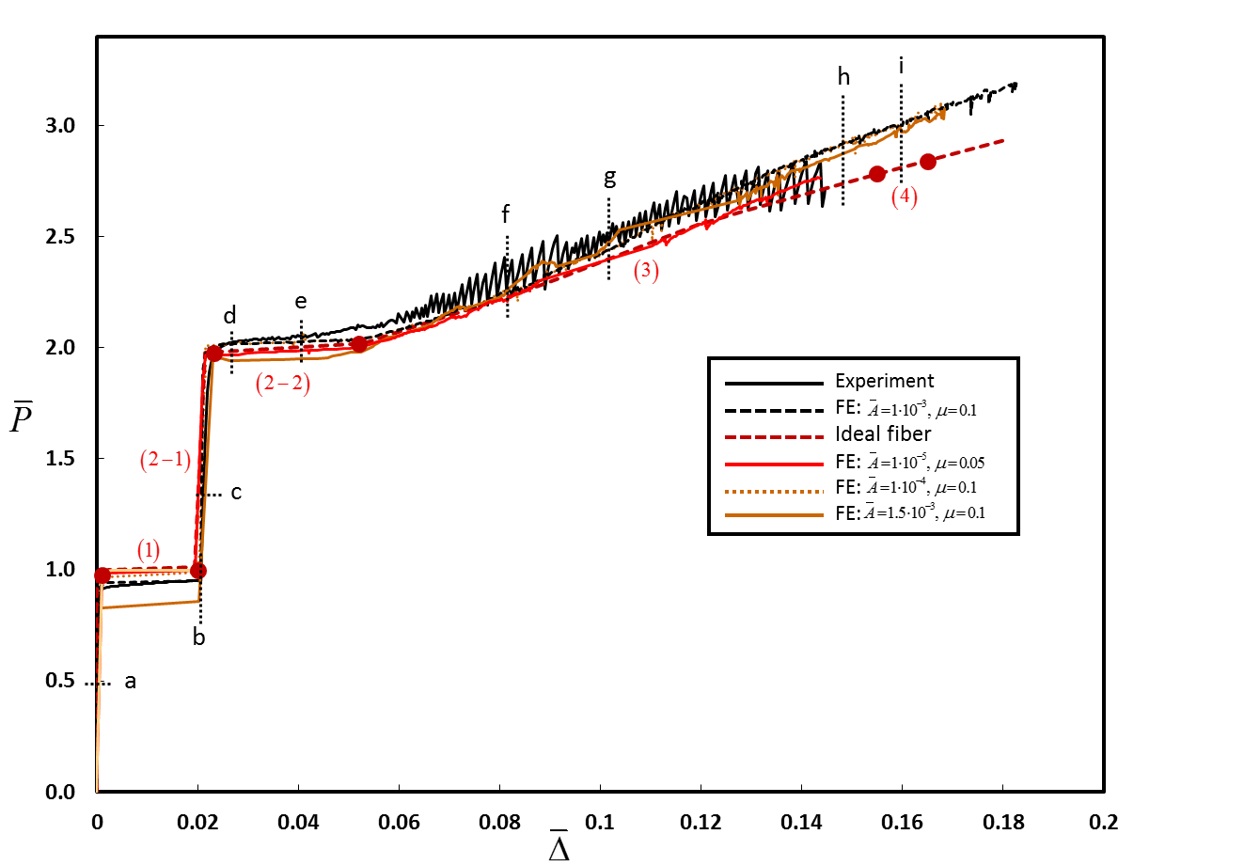

Fig. 9: Vertical force versus end shortening for:,,, ε≈0.104. The experiment and FE simulations results are compared to the theoretical predictions of [[42](#_ENREF_42" \o "Fang, 2013 #12)] (Ideal fiber:red dashed curve). FE results are shown for simulations with various values of (amplitude of the deviation) and μ (friction coefficient). Numbers in parenthesis indicate the contact configuration in accordance with [42]. Filled circles identify a transition from one configuration to the next.



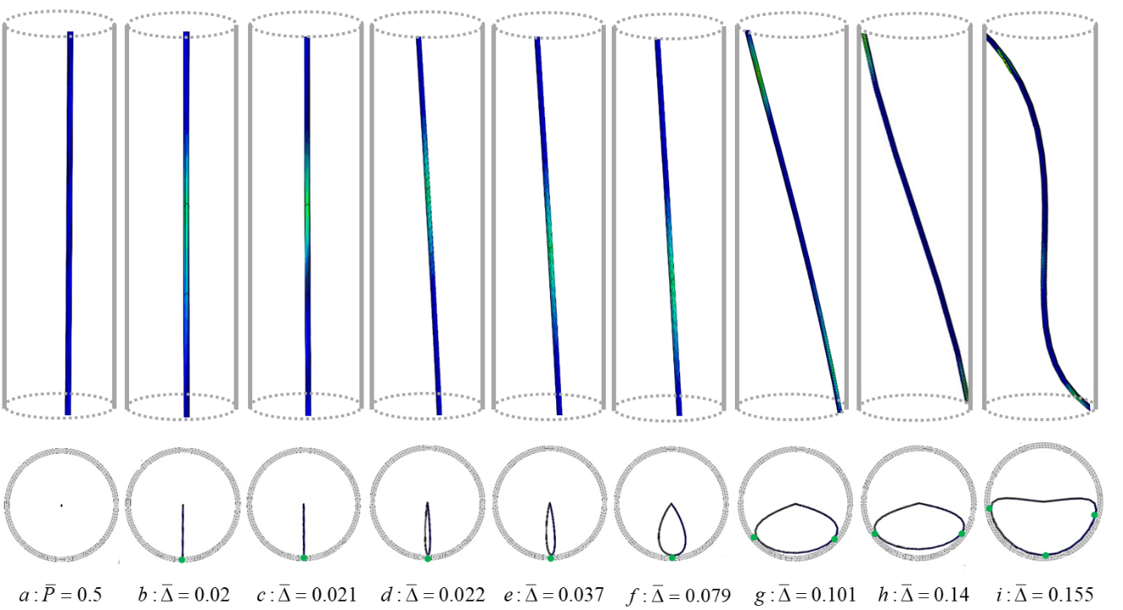

Fig. 10: Results of FE simulations showing the deformation of the fiber and contact with the cylinder wall, for:,, ε=0.104. First row: side view, where a lighter (greenish) color indicates interaction with the wall (in these images, the schematic cylinder is shown for clarity/orientation, but the images are not at identical scale in order to allow focusing on the contact region). Second row: top view (all images are at identical scale)

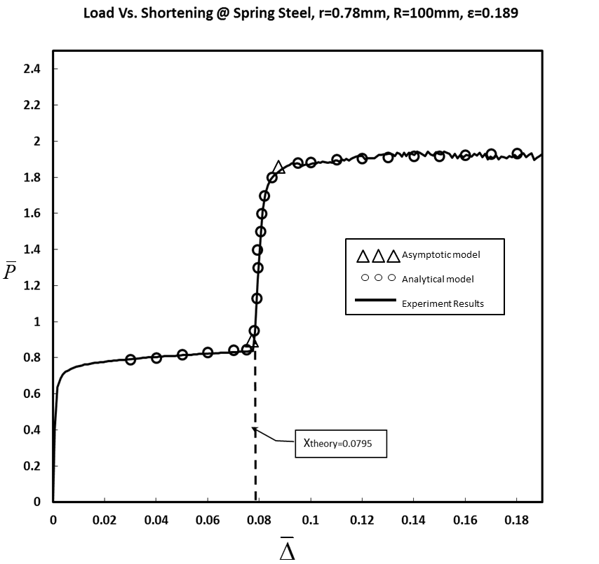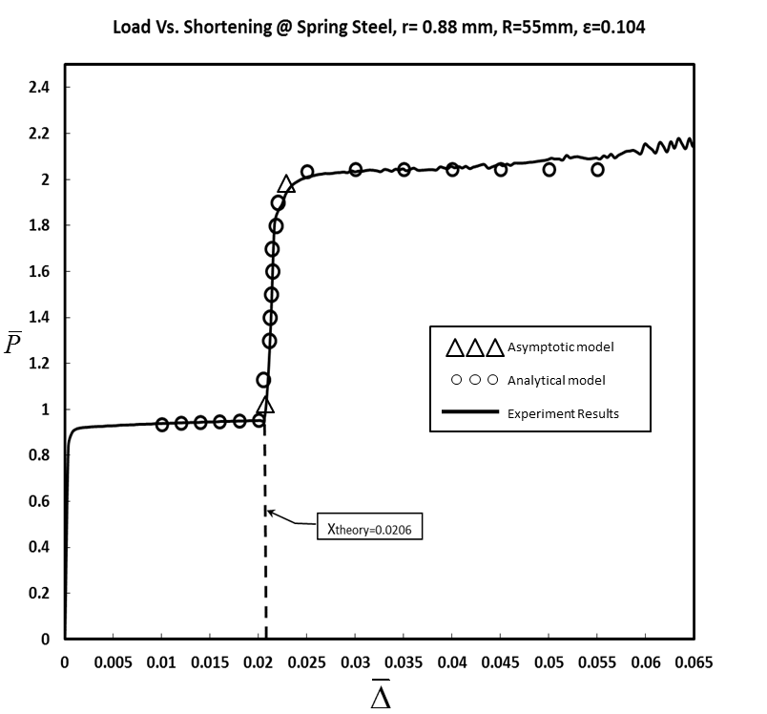

Fig. 11(a): Normalized vertical force  versus end shortening  for:. The experiment compared to analytical model results with (circle) and to asymptotic model (triangle).

Fig. 11(b): Normalized vertical force  versus end shortening  for:. The experiment compared to analytical model results with (circle) and to asymptotic model (triangle).

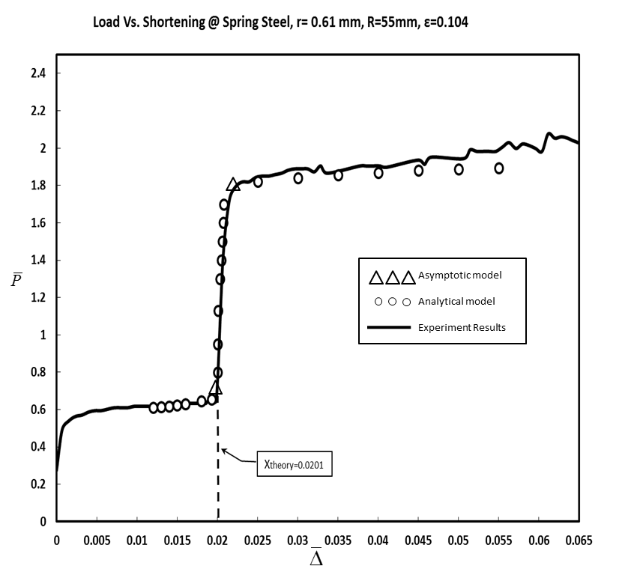

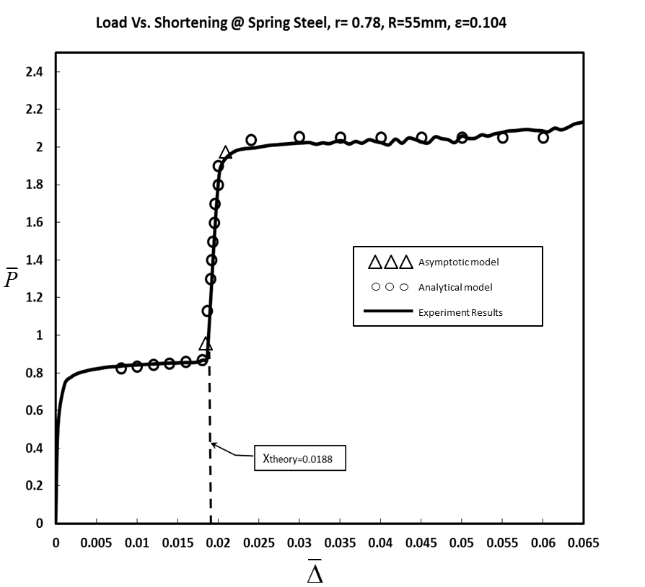

Fig. 11(c): Normalized vertical force  versus end shortening  for:,,. The experiment compared to analytical model results with (circle) and to asymptotic model (triangle).

Fig. 11(d): Normalized vertical force  versus end shortening  for:. The experiment compared to analytical model results with (circle) and to asymptotic model (triangle).

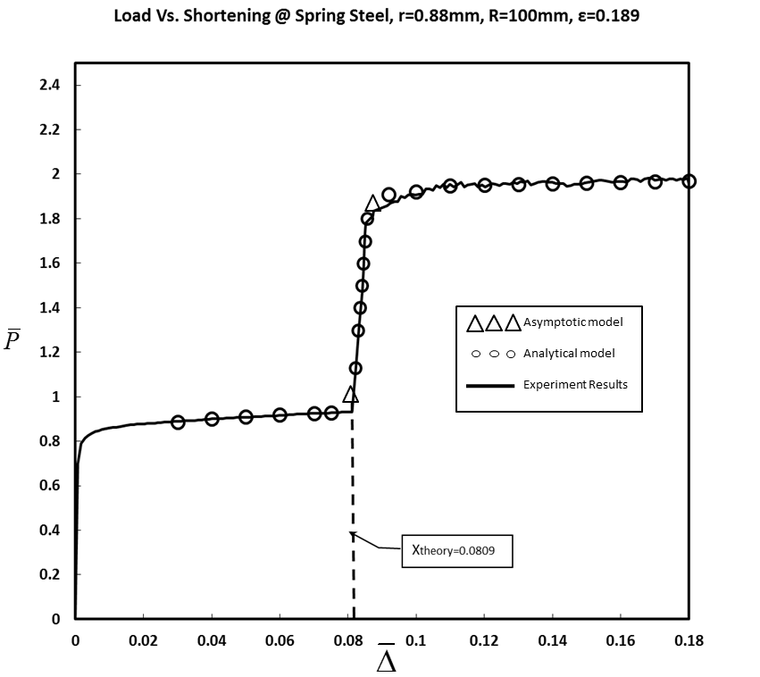

Fig. 11(e): Normalized vertical force  versus end shortening  for:. The experiment compared to analytical model results with(circle) and to asymptotic model (triangle).

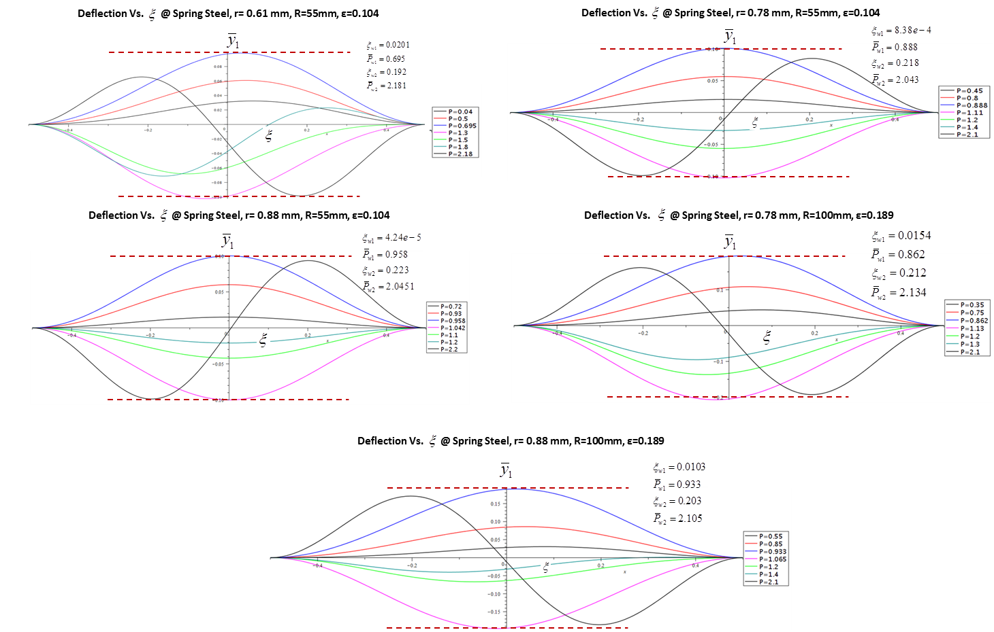

Fig. 12: Deflection curves from the expression  for:,,, for several values of and calculate of :

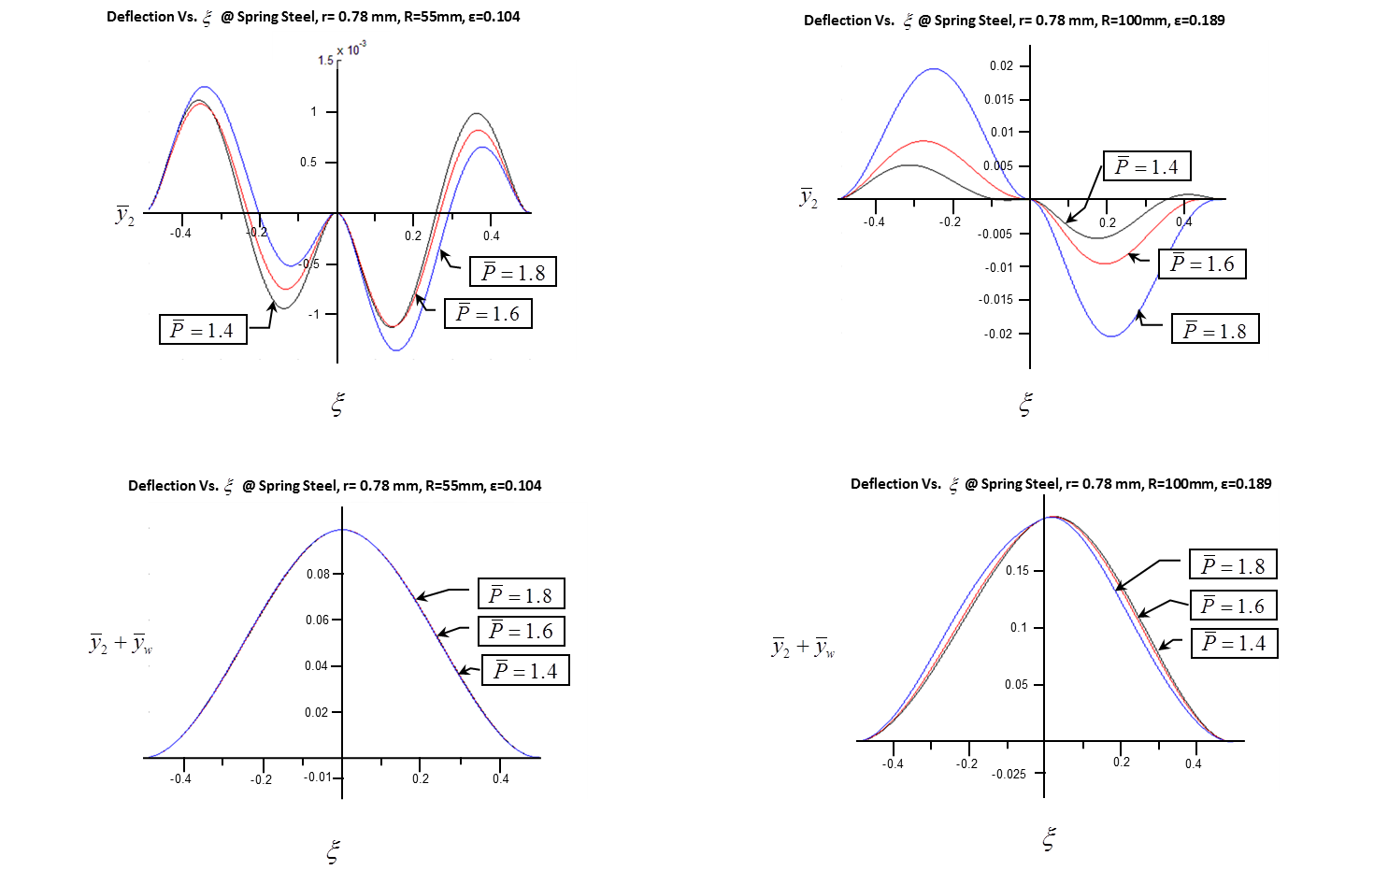

Fig. 13: Deflection curves from the expression  for:,,, for several values of 