**Initial post-contact behavior of an axially compressed fiber constrained inside a rigid cylinder –**

**Experimental, analytical, and numerical investigations**

Yossi Dayan†, David Durban**, Sefi Givli†*

†Faculty of Mechanical Engineering, **Faculty of Aerospace Engineering, Technion – Israel Institute of Technology, Haifa 32000, Israel

*Corresponding author, email: [givli@technion.ac.il](mailto:givli@technion.ac.il)

**Journal of Applied Mechanics, Copyright © 2019 by ASME**

# **Abstract**

The research studies the post-buckling behavior of a clamped-clamped elastic fiber constrained inside a rigid circular cylinder. The focus of this research is on characterizing the contact configuration between the fiber and the cylinder wall during initial post contact stages of the fiber deformation, in which only a small segment of the fiber length makes contact with the cylinder wall. The main experimental challenge is to identify regions of contact between the fiber and the cylinder wall, yet distinguish them from segments of the fiber that are very close to the cylinder wall but make no contact with it. To this end, we employ a novel experimental setup consisting of a transparent rigid cylinder filled with an opaque milky fluid, combined with image processing and synchronized force measurements. The results agree with published theoretical predictions that are based on a simplified theoretical model assuming a perfect fiber and no friction under the restriction of initial diminutive geometrical imperfection. Supported by finite-element simulations, we find that friction increases the measured force for the same level of ends shortening but has a small effect on the overall behavior. In contrast, the initial geometrical imperfection may significantly affect the force-displacement relation and the evolution of the contact configuration. The study provides important insights regarding the influence of relevant parameters on the behavior of such systems. Additionally, the insights from the theory and the experiment may have practical implications in the fields of stent procedures, medical endoscopy, deep drilling, and the mechanics governing the growth of roots and plants.

# **Introduction**

The post-buckling behavior of a linearly elastic fiber subjected to lateral constraints is of practical importance in a variety of fields, ranging from medical procedures (such as in vivo diagnosis) to engineering applications. Examples applications in the field of medical procedures include the threading of fiber for the purpose of medical imaging or for catheterization of the heart and blood vessels. Understanding the nonlinear behavior of such systems, and in particular, the forces exerted by the fiber (the guidewire) on the constraining walls (artery) are greatly important in order to guarantee the safety of the procedure [[1](#_ENREF_1" \o "Katopodes, 2001 #3)]. In rare cases, the extensive deformations of the guidewire can result in the fracture of the guidewire or cause damage to the artery during the intervention procedure [[2](#_ENREF_2" \o "Ito, 2013 #27), [3](#_ENREF_3" \o "López-Mínguez, 2004 #51)]. Other applications include the internal examination of pipe systems, the insertion of artificial fibers in industrial crimpers, drilling of wells from a platform to reach deep hydrocarbon or gas reservoirs [[4](#_ENREF_4" \o "Tan, 1995 #40)], effects of delamination in composite materials [[5](#_ENREF_5" \o "Chai, 1998 #41), [6](#_ENREF_6" \o "Sheinman, 1993 #50)], the insertion of paper into toner, growth of plant roots [[7](#_ENREF_7" \o "Silverberga, 2012 #15)], and the growth of filopodia in living cells [[8-11](#_ENREF_8" \o "Mogilner, 2005 #68)] .

Originally, the engineering community was mainly concerned with ways of avoiding large-deformations followed by buckling, and the scientific discussion focused mainly on assessing critical forces [[12-15](#_ENREF_12" \o "Timoshenko, 2009 #3)]. In the last century, starting at the early sixties, theoretical models of the post-buckling behavior began to emerge. These early works focused on formulating and solving problems of (laterally-unconstrained) compressed columns and of curved beams subjected to various types of boundary conditions, [[16](#_ENREF_16" \o "Lubinski, 1962 #43), [17](#_ENREF_17" \o "Seldenrath, 1958 #60)]. In the last few decades, the interest in post-buckling behavior of laterally constrained fibers has constantly grown. Theoretical and experimental studies have shown that a bi-laterally constrained fiber undergoing plane deformations exhibits an intriguing behavior, and the studies present a rather rich sequence of events under a controlled axial end displacement [[5](#_ENREF_5" \o "Chai, 1998 #41), [18-20](#_ENREF_18" \o "Vetter, 2014 #61)]. The sequence includes the formation of discrete (point-contact) or continuous (line-contact) regions of contact between the fiber and the constraining walls and the instantaneous transition from one equilibrium configuration to another due to the onset of local instability. The specific details of these events depend on parameterssuch as slenderness of the fiber, the ratio between the fiber radius of gyration and the gap between the walls, the bending stiffness of the fiber, loading rate, and friction [[21](#_ENREF_21" \o "Liu, 2013 #36)]. Theoretical studies have adopted various strategies and simplifying assumptions, such as considering fixed constraints, frictionless walls, or assuming small deformations [[4](#_ENREF_4" \o "Tan, 1995 #40)], and focused mainly on studying the range of possible equilibrium configuration and the evolution of contact between the fiber and the constraining walls [[4](#_ENREF_4" \o "Tan, 1995 #40)]. Also, numerical methods were employed to study the planar deformations of fibers subjected to more complex lateral constraints, such as non-parallel walls, non-continuous surfaces and curved surfaces [[22-28](#_ENREF_22" \o "Villaggio, 1979 #49)]. Only a handful of studies consider the effects of friction [[29](#_ENREF_29" \o "Chateau, 1991 #56)], and an even smaller body of work have considered the realistic case of compliant (deformable) constraining walls [[30](#_ENREF_30" \o "Katz, 2015 #62), [31](#_ENREF_31" \o "Katz, 2017 #64)].

The three-dimensional (3D) response of a fiber constrained inside a rigid cylinder has also received much attention [[32](#_ENREF_32" \o "Miller, 2015 #75)]. Here, in addition to the formation of discrete and/or continuous contact regions, a transition between planar deformations and three-dimensional configurations occurs. Typically, the initially straight elastic fiber buckles into a planar sinusoidal shape when subjected to edge-thrust. As the edge-thrust increases, the fiber contacts the cylinder wall, switches to a non-planar deformation, and eventually twists and adopts a helix-like shape. In some applications, such as oil well drilling, understanding the details of this behavior is crucial. In particular, once the fiber contacts the wall, the effectiveness of the drilling operation is dramatically decreased. Moreover, locking might occur when the fiber takes a helix-like shape with extensive wall contact. A similar phenomenon also occurs in stent operations [[2](#_ENREF_2" \o "Ito, 2013 #27), [3](#_ENREF_3" \o "López-Mínguez, 2004 #51), [21](#_ENREF_21" \o "Liu, 2013 #36), [33](#_ENREF_33" \o "Chen, 2007 #1)]. Studies of the (3D) deformations of a laterally constrained fiber have also been performed in the context of delamination occurring in fiber-reinforced composites, [[34](#_ENREF_34" \o "Miller, 2015 #74), [35](#_ENREF_35" \o "Martinez, 2000 #76)].

Theoretical studies investigating the (3D) deformations of a fiber constrained inside a cylinder can be roughly divided into two main categories. The first category assumes that the constraining cylinder is slender and the deformation of the fiber is small, thus making the assumption of small-rotations applicable. Different formulations for the critical loads and post-critical configurations were studied, and some studies consider the effects of friction [[21](#_ENREF_21" \o "Liu, 2013 #36)], gravity [[36](#_ENREF_36" \o "Tan, 1993 #44), [37](#_ENREF_37" \o "Paslay, 1964 #73)], and the inclination angle of the constraining cylinder [[13](#_ENREF_13" \o "Lubinski, 1953 #59), [38](#_ENREF_38" \o "Huang, 2000 #45)]. In the second category of studies, finite deformations are accounted for and the elastica theory is commonly adopted to describe the nonlinear behavior of a fiber undergoing finite deformations.

Almost all theoretical works studying the finite deformations of a fiber constrained inside a cylinder have focused on the final stage of the fiber deformation where almost the entire length of the fiber contacts the cylinder wall and the fiber adopts a helix-like deformation [[8-11](#_ENREF_8" \o "Mogilner, 2005 #68)]. The studies in [[17](#_ENREF_17" \o "Seldenrath, 1958 #60), [37](#_ENREF_37" \o "Paslay, 1964 #73)] are some of the earliest in this respect in which an energy method was used to extract the relation between the edge-thrust and the pitch of the circular helix. To date, very little attention has been given to the initial (post-contact) stages of the fiber deformation, following the first contact between the fiber and the cylinder wall. In this respect, the works of [[39-41](#_ENREF_39" \o "Liakou, 2018 #67)] provide valuable theoretical, numerical, and experimental information; however, focus was placed on extremely slender cylinders (inner radius to length ratio of ~) and on horizontal configuration, causing 90% of the fiber to be initially in contact with the cylinder even before the external load was applied. An exception is the work published recently by Chen and his collaborators [[42](#_ENREF_42" \o "Fang, 2013 #12), [43](#_ENREF_43" \o "Chen, 2013 #11)]. There, a rigorous theoretical model was developed to describe the post-buckling behavior of a perfect fiber inside a rigid and frictionless cylinder. Before external force is applied, the fiber is perfectly aligned in the center of the cylinder, making no contact with the cylinder wall. Numerical results considering a relatively large inner radius to length ratio of ~have demonstrated the many possible equilibrium configurations and contact characteristics between the fiber and the cylinder wall. Yet, despite the significant contribution of that work, the inherent assumptions of the model make its applicability to real systems questionable. Furthermore, there is currently no experimental study that systematically investigates the contact characteristics mentioned. The goal of this paper is to progress towards bridging this gap. We systematically study the initial deformation stages of a fiber constrained inside a rigid cylinder by means of novel experiments as well as finite-element (FE) simulations. Special effort has been placed on developing an experimental method that enables the identification of contact characteristics between the fiber and the cylinder wall. This identification is a challenging task since even if a transparent cylinder is used, the curvature of the cylinder strongly affects the optics and makes it practically impossible to categorically identify contact (or non-contact) between the fiber and the cylinder wall. The approach we adopted based on filling the transparent cylinder with an opaque white fluid and using a dark fiber and combining post-experiment image processing with synchronized force-displacement measurements has enabled quantitative identification of the deformation pattern and corresponding contact characteristics. Comparison of the results with the theoretical predictions of [[42](#_ENREF_42" \o "Fang, 2013 #12)] provides valuable information regarding the applicability of the assumptions considered in that model. The theoretical predictions assume the following: the thin elastic fiber of length with circular cross-section is inextensible and unshearable; the fiber is uniform in mechanical properties along its length  and is stress-free when it is straight and untwisted, the fiber deformation is constrained inside a straight cylinder with radius, and the centerline of the constraining cylinder coincides with the unstressed straight fiber. Gravity and friction force are not considered. The diameter of the fiber cross-section is negligible compared to that of the cylinder. We consider the deformation of the fiber when it is subject to prescribed edge thrust and under the constraint of the cylinder. It is assumed that the fiber is completely fixed at one end called O. At the other end, B, the fiber is clamped laterally but is free to slide longitudinally, as shown in Fig. 1. Clamp B is not allowed to rotate about the longitudinal axis. The solution method in theoretical predictions must envision first what the deformation pattern is, such as 1-point contact or 2-point contact. In the early stage of the deformation sequence, they are guided by previous experiences from the small-deformation theory, leading to deformation 5. Then, the constrained elastic deformation depends on the radius of the constraining cylinder. Based on , the ratio between cylinder radius and fiber length , for a relatively slender cylinder, such as , the early stages of the deformation sequence are similar to the stages obtained from the small-deformation theory, and the stages are 1-point, 2-point, 3-point, and point-line-point contact deformations. However, some fundamental differences exist between these two theories, even in this early stage of deformation. According to small-deformation theory, the 1-point contact deformation only exists in planar form; while in the elastica model, the 1-point contact deformation of the spatial form also exists. In addition, according to small-deformation theory, the point-line-point contact deformation is the final stage of the deformation. Also, as the radius of the constraining cylinder increases, the deformation patterns become less complicated and the number of deformation patterns before the two end clamps meet decreases. As expected, the difference between small-deformation theory and the elastica model grows as the radius of the constraining cylinder becomes larger. In the case when  is larger than 0.384, the constraining cylinder has no effect on the elastica deformation. Since the model and results of [[42](#_ENREF_42" \o "Fang, 2013 #12)] are highly relevant to the current contribution, we briefly review its main theoretical considerations and predictions in the next section.

# **Brief review of available theoretical predictions**

In a preliminary work, Chen and Fang [[43](#_ENREF_43" \o "Chen, 2013 #11)] adopted the assumption of small deformations to study the post-buckling of a fiber constrained inside a rigid cylinder. The model considered a slender, isotropic, linear elastic, and perfect fiber (no geometrical or material imperfections) of length  and circular cross-section (bending stiffness), where the quantityrepresents the flexural rigidity of the beam in the plane of bending, that is straight and stress-free prior to loading. The effects of gravity and friction were assumed negligible, and clamped-clamped boundary conditions were considered, i.e., one end of the fiber is completely fixed (displacements and rotations) at the center of the cylinder cross-section while the other end can only move along the axis of the cylinder. The effects of the edge-thrust on the fiber deformation and corresponding contact configuration were investigated. According to this model, the transition from 1-point contact configuration to 2-point contact configuration occurs at edge-thrust of , which corresponds to the critical (Euler) buckling load of a clamped-clamped column of length . Interestingly, it was found that this transition involves a “jump” in the ends shortening. It has been argued that this peculiar jump phenomenon is due to the limitation of the small-deformation theory. In order to remedy this deficiency, a director theory associated with the elastica model was developed in [[42](#_ENREF_42" \o "Fang, 2013 #12)] (a similar approach was applied in [[44](#_ENREF_44" \o "Chen, 2011 #17), [45](#_ENREF_45" \o "Li, 2014 #71)] to study the deformation of a fiber subject to end-twist rather than end-thrust). All the previously mentioned model assumptions of [[43](#_ENREF_43" \o "Chen, 2013 #11)] were adopted in [[42](#_ENREF_42" \o "Fang, 2013 #12)] except for the assumption of small deformations. Also, it was found that, contrary to the small-deformation theory, the planar 1-point contact evolves to spatial (3D) 1-point contact first and then gradually transforms to the 2-point contact configuration. Further, Furthermore, seven deformation shapes, each characterized by a different contact configuration, were identified (see Fig. 1): (1) no-contact, the fiber “buckles” into a curved shape as force approaches Euler’s critical load; (2-1) contact forms between the fiber and the cylinder, leading to a planar (2D) 1-point contact configuration, resulting in a sharp increase of the fiber response slope; (2-2) the fiber switches to a spatial (3D) 1-point configuration, which resulting in a significant decrease of the slope; (3) gradual evolution of a 2-point contact configuration; (4) 3-point contact configuration; (5) point-line-point contact; (6) 1-line contact; and (7) 3-line contact.

In this paper, we investigate the mechanical response of a fiber undergoing large deformation inside a stiff cylinder by comparing different finite-element (FE) simulations, experiments, and theoretical predictions. This paper is organized as follows: In Sec. ‎2, we describe the method end materials that include an experimental system, image processing, and numerical simulations to characterize the contact configuration between the fiber and the cylinder wall during initial post contact stages of the fiber. In Sec. ‎3, we discuss the experimental, image processing, and numerical simulation results and compare them with the results from the theoretical model. Lastly, Sec. ‎4 summarizes the main conclusions drawn from this study and identifies problems for future research.

# **Materials and methods**

# **Experimental system**

Experiments were performed with an Instron 4483 machine, on which the designated experimental system was installed, see Fig. 2**.** The experimental system includes a fiber (long and approximately radius CSN EN 10270-1 steel wire) inside a transparent cylinder (radius) filled with an opaque white fluid (metalworking-cooling fluid, PVR-925S, mixed with water). Due to the inherent curvature of the cylinder, which strongly affects the optics, it is practically impossible to identify the onset and progress of contact between the fiber and the cylinder wall. Filling the transparent circular cylinder with the opaque white milky fluid enables the identification to trace the progress of these contact regions, as explained in this section. Special adapters were designed and installed to impose clamped boundary conditions at both ends of the fiber. Then, the lower adapter was fixed to the cylinder while the upper one was attached to the moving arm of the Instron machine, so the fiber coincided with the symmetry axis of the cylinder at the start of the experiment. During the experiment, the distance between the two ends of the fiber was slowly decreased, upon lowering the upper end, by the Instron machine; this process resulted in the bending deformation of the fiber constrained by the cylinder. This method in which the distance between the two ends of the fiber is shortened while the length of the fiber remains constant differs from the method in [[34](#_ENREF_34" \o "Miller, 2015 #74)]. In that method, the fiber is injected from the left to the right and pulled over two feeder rollers through a slave injector and forms a slack loop and then is pulled through a primary injector into the constraining glass cylinder. Reaction forces are transmitted over an air bearing slider to the force sensor. The fiber is then pulled through a channel by an idler wheel and a drive wheel that is driven by a servo-stepper motor close-up of an acrylic clamp holding the pipe in place. The deformation is examined for three different fiber radii and for two different inner radii of the cylinder. These geometries are chosen to enable quantitative comparison with the results presented in [[42](#_ENREF_42" \o "Fang, 2013 #12)], i.e., two different values of the non-dimensional ratio , namely, . Here,  and  are the fiber radius and the inner radius of the cylinder, respectively, and  is the free length of the fiber in the initial unloaded state, i.e., the distance between the two clamping points at the beginning of the experiment. Ends shortening (decrease in the distance between the two clamps) was determined by the displacement of the upper clamp that is controlled by the Instron machine in the displacement control method. In this configuration, loads are applied to a part based on the displacement, and the displacement is determined using an Encoder installed on the Instron. In this method, the displacement changes incrementally while the reaction force results depend on the stiffness of the structure. Edge thrust (axial compressive force) applied on the fiber was measured by a static load cell, and both were synchronized with a digital camera (MAKO G-223 with CMOSIS/ams CMV2000 sensor, global shutter; 50 frames per second) that was used to record the experiment. The maximum level of ends shortening was restricted to prevent plastic deformations.

In each experiment, two complementing characteristics of the response were recorded: First, to determine the force-displacement relation, the axial force was applied to the fiber along with the corresponding ends shortening, and examples of such force-displacement relations are displayed in Fig 9. The analysis of the force-displacement relation provides the core information on the wire loading process, revealing important aspects of the behavior. Second, details of contact between the fiber and the cylinder were determined by analyzing the successive frames taken by the camera and complemented with MATLAB assisted image processing. That image processing procedure aims to clearly represent the contact region between the fiber and the cylinder wall. Synchronization between the camera and the Instron machine enables the contact configuration to be identified and related directly to the force-displacement relation. This synchronization enables qualitative and quantitative comparison between the behavior observed in the experiment and the structural response predicted by finite-element simulations and by the theoretical model of [[42](#_ENREF_42" \o "Fang, 2013 #12)].

# **Image processing**

Each snapshot (image) underwent image processing with MATLAB to identify the contact region between the fiber and the inner wall of the cylinder. To this end, the following procedure was performed: First, the image is converted to a digital array of scalar integers in the range of [0,255]. The array size is identical to the number of pixels in the image, and the scalar values represent the gray level of each pixel, where the extreme values of 0 and 255 correspond to black and white, respectively.

Next, the image is corrected in order to produce a uniform background, i.e., make all pixels of the white fluid have the same gray level. The purpose of this step is to minimize the effects of non-uniform illumination due to the curvature of the cylinder wall. In particular, without this correction, columns of the array (image) that are far from the center are generally darker (have smaller gray-level values). The correction involves multiplying each column by a different factor such that the average values of the fluid pixels in all columns are identical. Finally, a threshold filter is applied to isolate pixels corresponding to contact between the fiber and the cylinder. The threshold level is calibrated as follows: By using the force-displacement plots, the image where the fiber makes first contact with the cylinder wall is identified. In that stage of deformation, the contact configuration is necessarily a “point contact” configuration. Thus, the threshold level is set as the gray level of that contact point, and the “size” of the contact region associated with a “point contact” is determined (practically, due to effects such as imperfections and compression of the fiber against the cylinder wall, the so-called “point contact” configuration should be actually considered a small region of contact).

# **Finite-element simulations**

Finite element simulations were performed with the commercial finite-element software Abaqus FEA. A dynamic implicit analysis was designed to simulate the experimental system, which includes a  fiber (initial distance between end supports) that is clamped at both ends and is laterally constrained by a rigid cylinder. The symmetry axes of the fiber and of the constraining cylinder coincide at the beginning of the simulation. The fiber meshed with hexahedral solid elements, type C3D8R (8-node brick, accounting for geometrical nonlinearity), with over 50 elements in the fiber cross-section and a total of 2700 elements in the fiber. A Young’s modulus of  was assigned to the fiber, in accordance with tensile experiments that we performed with the Instron machine. Preliminary analysis with high-order brick elements and with a larger number of elements in the mesh have resulted in similar results; thus, all results shown in what follows are based on the mentioned mesh (2700 elements, type C3D8R).

In developing equations for the implicit integration, a formula for predicting the internal forces  at in terms of the internal forces, such as the tangential stiffness, , at a time  is needed. For this purpose, two approaches are used: (1) tangential stiffness methods and (2) linear stiffness, pseudo-force methods. In the former, the internal nodal forces are predicted by [[46](#_ENREF_46" \o "Belytschko, 1976 #79)]:



Whereas in the pseudo-force method, the internal forces are predicted using as the linear stiffness and as the pseudo-force matrix, accounting for the non-linearities:



Where the pseudo-force is either taken at time or extrapolated to from its value at .

Boundary conditions were implemented by defining zero-displacement of all degrees of freedom associated with the nodes at the two ends of the fiber. The only exception is the vertical displacement of the upper end, which was gradually increased during the simulation.

As shown in Fig. 1.a., the fiber at the end of one side (on the side where no force is applied) is fixed to the x, y, z axes for both displacement and rotation around each axis. At the other end of the fiber, where the force is applied, the fiber is fixed to rotate on the three axes and does not have the ability to rotate around them. On the two other axes that are not parallel to the movement of the end of the fiber, the end of the fiber is fixed, and cannot move in the direction of these axes. On the axis that is parallel to the movement of the end of the fiber, the end of the fiber has a constraint that enables it to move in parallel to the axis for a defined displacement of 80 mm, as happened in the experiment. In order to perform the analysis, the implicit method was chosen in comparison with the explicit method. The primary difference between an implicit FEM analysis and an explicit FEM analysis is that the implicit analysis uses Newton-Raphson iterations to enforce equilibrium of the internal structure forces with the externally applied loads. This type of analysis tends to be more accurate and can take somewhat larger increment steps. Also, this type of analysis can handle problems such as cyclic loading, snap through, and snap back as long as sophisticated control methods such as arc length control or generalized displacement control are used. One drawback of the method is that the stiffness matrix for each Newton-Raphson iterations must be updated and reconstructed. This process can be computationally costly. However, there are other techniques that try to avoid this cost by using modified Newton-Raphson methods. It is useful to use both techniques on the same problem in order to be able to compare them, and the type of analysis that will be suitable for solving the engineering problem depends on the kind of problem investigated. Computationally intensive dynamic analyses are often done with the explicit method. However, for static problems, it is common to perform the full implicit type of analysis, which is the method chosen for this work. This vertical displacement describes the shortening between the two ends of the fiber, as described in Section ‎2.1. The vertical force on the upper end of the fiber, which is the force applied by the Instron machine in the experiment, was also recorded in the simulation. In all simulations, the ends shortening rate was , which is comparable to the rate at which the experiments were performed. Preliminary finite-element simulations showed that lower rates produce similar results.

In order to facilitate fiber bending response from the outset, thus avoiding a bifurcation analysis at the first buckling load, we introduced a realistic geometrical imperfection. Thus, the stress-free configuration of the fiber was assumed to admit the shape using  as the initial bending from the perfectly straight configuration, namely, the deviation from the axis of symmetry of the constraining cylinder,  is the coordinate along the axis, and  denotes the amplitude of the deviation:



Where all measured in millimeters and the maximum value geometrical imperfection obtained is 0.2% of fiber length  (approximately ). Eq. is recognized in post-buckling theory as the "worst" geometrical imperfection that is identical with the shape of the first buckling mode of a fiber subjected to clamped-clamped boundary conditions. Since  sets the magnitude of the geometrical imperfection, it can be used for examining the influence of imperfection on the behavior of the constrained fiber. Section ‎3 shows the simulation results for several values of , which were implemented in Abaqus by means of an imported SolidWorks CAD model. Contact between the cylinder and the fiber was defined using penalty stiffness in the normal direction of the contact surfaces (pressure-overclosure with "hard" contact and no penetration). In addition, tangential interaction, accounting for friction between the two bodies, was set in the model. Several values of the friction coefficient were also examined, representing the estimated range of the friction coefficient between the metal fiber and the Perspex wall of the cylinder, including a (greasy) metalworking-cooling fluid (this idea is discussed further in Section ‎2.1).

# **Analytical insights**

In this section we present analytical derivations for three key features associated with the behavior of the fiber. The first is the end displacement (shortening) of the fiber at the onset of first contact between the fiber and the cylinder with symmetric imperfection, the second is the end displacement (shortening) of the fiber at the onset of first contact between the fiber and the cylinder with anti-symmetric imperfection, and the third is the load at which the transition from 2D (planar) to 3D deformation occurs. The analysis assumes linear stress-strain relation (Hooke’s law) and the two key features illustrated in Fig. 3.

# **End displacement for the first contact with symmetric imperfection**

# The analysis in this section is based on a well-established elastic solution of a clamped-clamped fiber. An analytical model that describes the behavior of the fiber depending on the initial bending and material properties of the fiber is [[12](#_ENREF_12" \o "Timoshenko, 2009 #3)], where the initial shape of the axis of the fiber is given by the Eq. (3). Thus, the axis of the fiber has initially the form of a sine curve with a maximum ordinate at the middle equal to. If this fiber is submitted to the action of a longitudinal compressive force , additional deflection is produced so that the final ordinates of the deflection curve are , and quantity represents the flexural rigidity and represents the distance along the fiber. Because the lateral load vanishes when determining the critical load of buckled bars, the differential equation for the column is the following:



Or substituting 



By combining Eq. (3) and (5) with the definition of , we obtain



And for the boundary condition that is associated with the clamped-clamped at the ends of the fiber:



By placing the boundary conditions in Eq. (7) into the  curve in Eq. (6), a closed form of the deflection of  can be obtained analytically (detailed results can be obtained through Maple):



Where is the Euler buckling force,  is the dimensionless axial compressive force, and  is the dimensionless magnitude of the geometrical imperfection.

For assess the value of from loaded and end displacement:



Evaluating the integral:



So total end displacement becomes  :



Neglecting the first term, as  increases, we have:



In order to compare the resulting of the analytical model to the empirical and numerical simulation results, we assign  as a function of for several values of , see Fig. 7 and Fig. 8 (purple line, azure point-line-point line and green line).

# **End displacement for the first contact with anti-symmetric imperfection**

With  origin at beam center  we have



Where  is the first eigenvalue of and critical load is:



 is a constant (can be normalized)

The bending equation:



With clamped boundary condition at  .

The bending solution follows as



is with a maximum of  at 

Where here , with  the same as presented above.

The total anti-symmetric branch is:



In complete analogy with the symmetric mode.

For the total bending displacement within this model, the initial shape of the fiber is given by



The additional displacement is:



So the total shape of given is:



Notice that the second term diverges when , which is slightly above 

Before proceeding, we need to assess  and  from experimental data. Assuming that  we can neglect the anti-symmetric branch at , so approximately



To find , we write end displacement, only due to bending



Inserting here  and , both imperfections, gives:



Or, on account of orthogonality:



The first integral has already been evaluated:



and the second integral gives:



Thus:



Where 

And  for 

Coefficients  and  can now be determined from  measurements in the range of above one third/ half of shortening up to contact.

Once and have been fixed, we can trace the curve :





Where:



To check the value of  at first contact if.

Next, it should be instructive to trace that curve, in absence of walls, as  approaches to examine the hypothetical configuration near the second value.



The values of and  were calculated using the least squares method on the experimental results. With this method, there are in effect three matrices. The first matrix shows the values of  after substituting the results of the experiment, the second matrix shows the calculation of the parts of the equation that are dependent on  from the experimental results, and the third matrix shows the unknowns  and . The values of  and  were calculated using MATLAB software by dividing the displacement matrix  from the experiments by the matrix of terms containing  from the experiment. This is without a minimum requirement because this method is calculated from the outset for a minimum error. The black lines in Fig. 4 are the results of the experiment normalized obtained on the Instron device, and the empty black circles before and after the fiber touches the cylinder wall are approximate calculations obtained by the analytical model shown in Eq.(27).

Now, we could describe the curves  in Fig. 5 from Eq.(28) and calculate values of , used  and  for all five experiments when the fiber contacts the cylinder wall. To determine the location and first buckling force of the first point of contact in the cylinder, we solve the two equations, where the conditions of contact are:. The results are also presented in Fig. 5, which we obtained as a result of substituting the values of  that were obtained from Eq.(27) and substituting different values of  until the fiber contacted the cylinder wall in the range of . Also, the location and first buckling force were approximated ahead of the first contact. By assuming  and using linearization, we obtain:



In addition, the location and second buckling force  and location of the second contact point on the cylinder were calculated.

# **Solution of the fiber and wall cylinder contact stage**

The fiber experiences planar (2D) deformation and point-contact forms between the fiber and the cylinder. As the end displacement (at the end of the fiber) increases, the curvature at the contact point decreases. When this curvature becomes zero, line contact forms. This is the onset of the transition to 3D deformation. Simple relations are then derived, based on small-deformation analysis, to identify this transition. In this section, we present the equation that describes the bending of the fiber to all the stages of its contact with the cylinder wall until the transition to 3D deformation. Fig. 3 shows the configuration considered. The figure shows that is an initial imperfection of the fiber before loading. When the loading starts, the fiber deformation is increased up to the first critical point at load . Then, the growing load causes additional deformation of the fiber, and at some load , the fiber touches the wall for the first time, whereas  represents a shape of the fiber in respect to the axis. When the load becomes larger than , the fiber gets a small additional deflection . The fiber's shape remains 2D until a critical load  is applied, where it becomes 3D (bifurcation). This work describes the function that represents the deflection from the curve. The fiber's shape relative to the direction of the force  is , and the fiber's shape relative to the bending is , because at , there is no bending forces. As a result, the following equation is obtained (see [[12](#_ENREF_12" \o "Timoshenko, 2009 #3)]) that represents a balance of the external (compressive) and internal (bending) forces acting on the fiber:



Here,  represents the flexural rigidity,  represents a longitudinally compressive force, and  represents the distance along the fiber. When the fiber touches the cylinder wall, the following equation is obtained :



# Then, subtracting Eqs. (32) and (33) gives the following:



# We introduce the non-dimensional displacement and with . By shifting to , , (the root of the equation $)$, Eq.(35) becomes the following:

# 

Where the solution for $y_{w}$ is the same as that shown in Section 2.4.2). The solution of the Eq. (35) has homogeneous and non-homogeneous parts. The behavior of the fiber deformation is not symmetric, so we divide the solution domain into left and right branches relative to the zero point.

Now, the solution of the left and right branches of Eq. (35) can be written as follows:



Now, the constants  of the homogeneous part are defined by four boundary conditions, as follows:



Where  is connected to :

The analytical solution of these equations (obtained with the Maple software) provides us with the following coefficients:



We treat the right branch of the solution in a similar way, defining constants  and producing the following equations:



The analytical solution of these equations gives:



After placing the  values in the areas defined in the solution, the curves  in Fig. 6 from Eqs. (35) and (36) can be described based on the different  values obtained.

The end displacement  can be calculated from the definition. In addition to the shortening, adding the compressive force provides the following solution:



 at the moment the fiber contacts the cylinder wall provides the following solution:



Adding Eqs. (41) and (42) yields the following solution:



The assumptions are as follows: we placed a pinpoint contact in the middle of the fiber where it is clear that parts of the fiber protrude beyond the virtual wall in parts of the process. We assumed that the point of contact remained in place with the deformation development. We assumed there was no friction at the point of contact. We consider small deviations of the real-line geometry from the homogeneous steady solution, represented by the functions  and . We fixed this line at the endpoints and in the middle point, so in these points, the real line is coincident with the homogeneous solution. Because of linearity of the governing equations, only the non-homogeneous part of the solution contributes to the small deviations of the fiber geometry from the homogeneous steady solution. Based on this conclusion, we used only the following non-homogeneous solution.



The first integral has already been evaluated:



and the second integral gives:





Thus:



Eq. (47) shows that we have a denominator that defines two asymptotes of the function, where . To obtain an asymptotic behavior , around we assign  and develop it into the “Taylor series” and then select the dominant term, where  are not zero.



Developing it into the Taylor series yields:



The significant term is for 





Develop it into the “Taylor series”:



The significant term is for 



Towards contact with the wall



The significant term is for 



The calculations were performed using mathematics software. The black lines in Fig. 4 are the normalized experimental results obtained via the Instron device, and the empty black circles when the fiber touches the cylinder wall are the approximation calculations, as obtained by the analytical model described in Eq. (47) and the empty red circles obtained by the asymptotic models described in Eqs. (50), (53), and (55). Fig. 4 shows that the contact phase of the fiber in the cylinder, i.e., the calculation of the empty black circles prior to contact and the stage after the transition to three-dimensional deformation, was the same as that calculated in the previous section of the article, Eq. (27).

# **Results**

All results are presented in terms of non-dimensional quantitates [[42](#_ENREF_42" \o "Fang, 2013 #12)], namely, dimensionless ends shortening, , dimensionless axial compressive force, , and dimensionless magnitude of the geometrical imperfection, . Here,  is the actual ends shortening between the two ends of the fiber,  is the initial unloaded length of the fiber, i.e., the vertical distance between the clamped ends of the fiber at the start of the experiment,  is the vertical force applied on the fiber,  is the Euler buckling force for a perfect clamped-clamped column,  is the Young's modulus of fiber,is moment of inertia of fiber, and  is the radius of the fiber.

Fig. 7 and Fig. 8 show the vertical force versus end shortening up to the first contact point of the fiber in the cylinder wall. As expected, smaller geometrical imperfections cause the height of the “plateau” region, before the first contact occurs, to become closer to the theoretical value of  (red line). In addition, the results obtained from the analytic model shows that the geometrical imperfection affects the force value before the first contact occurs. As  increases, the force required to obtain the “plateau” region decreases. The main differences between the theoretical results and the analytical results are because the theoretical results without the initial binding and the form of the solution in [[42](#_ENREF_42" \o "Fang, 2013 #12)] are numerical; in addition, the assumptions and boundary conditions are different. By comparing the FE results with those of the experiment at that initial stage of deformation, we deduce that the level of imperfection in the experiment is equivalent to a value of  close to .

Fig. 9 shows the force-displacement relation measured in three experiments that differ only in the radius of the fiber with values . All three experiments have a free length of the fiber is  and an inner radius of the cylinder , implying the parameter. The results of the experiments are compared with the theoretical prediction (red dashed line). Following the theoretical prediction, five distinct stages along the fiber bending process are identified to occur over the measured range of loading. These stages are indicated in the figure by numbers in parenthesis and are separated by the full circles that lie on the theoretical force-displacement curve. Those deformation stages are labeled as (1)–(4) (see Fig. 1). Due to the requirement of avoiding plastic deformations the range of ends shortening was limited in the experiments, and the theoretically-predicted deformation stage (5), point-line-point contact configuration, could not be reached. It is thus conceivable that the measured force-displacement relation for the (black line) fiber agrees well with the theoretical prediction. The minor deviation, smaller than 8%, in the critical value calculated for fiber buckling force is due to the effect of geometrical imperfection. This effect is expected to be more apparent with thinner fibers, which are more susceptible to geometrical imperfections. Indeed, the critical load measured for the  (blue line) and (azure line) fibers is lower than the Euler buckling load by close to 15% and 40%, respectively. As expected, the effect of geometrical imperfection diminishes as ends shortening increases. In fact, once contact forms between the fiber and the cylinder, the effect of the initial imperfection becomes very small for both the and fibers. For the fiber, however, the imperfection is so significant that it influences the behavior over a large range of ends shortening, up to about. Note that the onset of (first) contact between the fiber and the cylinder wall can be directly deduced from the measured force-displacement relation; specifically, it is identified as the location on the curve at the end of the “plateau-like” region associated with , followed by a sharp increase (jump) in the loading curve slope. The first contact occurs at almost the same ends shortening value, , for all three fibers, in agreement with predictions by the theoretical model. This result suggests that the initial deviation of the as-received fibers from the straight (perfect) geometry is very small. In addition, the transition from planar two-dimensional deformation to three-dimensional deformation occurs at a force , in agreement with results reported in [[42](#_ENREF_42" \o "Fang, 2013 #12), [43](#_ENREF_43" \o "Chen, 2013 #11)]. The fluctuations in the measured force are presumably due to friction between the fiber and cylinder, causing a “stick-slip” like behavior; these fluctuations become larger as end shortening increases due to larger contact forces between the fiber and the cylinder wall. The contact configuration cannot be obtained directly from the force-displacement relation. To this end, we employ the image-processing procedure, as discussed in the next paragraph.

Fig. 10 presents the experimental results in which contact (between the fiber and the cylinder wall) is analyzed by means of the image-processing procedure described in Section ‎2.2. For each of the three fibers, as mentioned, the top row shows side-view snapshots at different ends shortening levels. For convenience and to enable comparison, these ends shortening levels and associated letters “a”-“i”, are identical with those indicated in Fig. 9 and in the figures that follow. Specifically, ends shortening of  associated with deformation “i” could not be reached with the  fiber. By applying the image-processing procedure to the previously mentioned snapshot results in the images presented in the bottom row of Fig. 10. For the and  fibers, the deformation stages and evolution of contact show good qualitative agreement with the predictions of the theoretical model and the FE simulations, which are similar to the deformation stages described in the preceding paragraph.

Perhaps the only discrepancy compared to the theoretical model is related to the notion of “point contact”. It is evident that point contact cannot practically occur. Instead, a small segment of contact may be considered equivalent to the theoretical notion of “point contact”. As a result, it is argued that all images (for both fibers) up to stage “e” indeed reflect a 1-point contact configuration. The images also clearly indicate the development of two distinct regions of contact that seem to further separate at higher levels of ends shortening, as predicted by the theoretical model in stages f, g, and h. Still, it is noteworthy that the size of these contacts regions changes with ends shortening. Hence, the claim that these are point-contacts is arguable. Finally, the image-processing procedure reveals three separate regions of contact in stage i, in agreement with the theoretical prediction. The good qualitative agreement, in terms of contact characteristics, between experimental and theoretical predictions is consistent with the good quantitative agreement in terms of the force-displacement relation. For the  fiber, in contrast, the measured force-displacement relation deviates significantly from the results of the theoretical model, see Fig. 9 and is mainly due to the effects of geometrical imperfection. Fig. 10 shows that the deviation from the theoretical prediction is also reflected in the observed evolution of contact. For example, after the 2-point contact configuration forms, further increase of the ends shortening does not increase the distance between the contact points. Instead, the contact region at each of these locations increases, resulting in what appears as a line-contact configuration. This evolution of contact, which is not identical at the two contact locations, eventually evolves into (almost) a single line-contact configuration that connects the two original point-contact locations. This behavior, and in particular, the observed asymmetry evolves of single line-contact, is probably a consequence of significant geometrical imperfection combined with the effect of friction.

Next, this research analyzed the deformation of the constrained fiber by means of FE simulations. Fig. 11 shows the results of finite-element (FE) simulations for the fiber with . Several force-displacement relations are shown, and each is associated with a different geometrical imperfection amplitude,, and friction coefficient (coulomb type friction),  (black dashed lines, red line, orange dashed lines, orange lines, azure line, and azure dashed line). For reference, the theoretical (red dashed line), analytical (purple line, azure point-line-point line and green line) and experimentally (black line) measured curves that appear in Fig. 9 (for this fiber) are also recapitulated here. Also, we include a simulation with very small (negligible) geometrical imperfection and very small friction coefficient (red line). The results of this simulation are in excellent agreement with the theoretical prediction that assumes a perfect fiber and no friction. A minor discrepancy is observed only at relatively large levels of ends shortening, at which the transverse force applied on the fiber by the wall becomes very large, resulting in non-negligible friction force. These results (and the results of the FE-based analysis of contact, which is discussed later) provide confidence in the results of the FE simulations shown in Fig. 12, from which several conclusions can be drawn.

Importantly, the influence of geometrical imperfection in later stages of the deformation is practically insignificant for values of . For larger values of  (azure line and azure dashed line), the external force is noticeably smaller, especially in the initial stages of the deformation, before the 2-point contact configuration occurs. A similar trend is also observed in the experiments when comparing the behavior of fibers with different radii, see Fig. 9, and Fig. 11 also demonstrates the effect of friction. A larger friction coefficient results in a higher external force for the same ends shortening (azure dashed line). Contrary to the effect of geometrical imperfection, the effect of friction increases with ends shortening, and the difference between the measured force and the prediction of the theoretical model, in which friction was not accounted for, becomes larger. This increased difference is probably a consequence of the higher normal force and larger contact area that develops in the advanced stages of deformation.

Next, we study the evolution of contact based on the FE simulation for the  fiber, with conditions similar to those in the experiment, namely, and . Fig. 12 shows the deformation of the fiber for different levels of ends shortening, , where the letters “a” to “i”, specify the corresponding locations on the force-displacement curve in Fig. 11. For each level of ends shortening, the top and bottom rows show side and top views, respectively. Interaction (contact) with the cylinder wall is also illustrated by the lighter (greenish) color. The following contact configurations are identified: (a) no-contact, (b, c) planar (2D) 1-point contact, (d, e) spatial (3D) 1-point contact, (f, g, h) 2-point contact with increasing distance between the two contact points, (i) 3-point contact. These results are in complete agreement with the theoretical model, see also Fig. 1. It is important to note the extreme proximity of the fiber to the cylinder wall at deformation stages that include two or three point-contacts and this extreme proximity make the investigation of contact characteristics an extremely challenging task. In fact, without the aid of the FE simulations or the unique experimental setup that we developed, one could easily (and incorrectly) interpret the contact characteristics as a continuous line contact rather than the actual case of two (or three) small-size regions of contact separated by a rather long segment that is extremely close to the cylinder wall but does not interact with it.

Afterward, we experimentally studied the behavior for . To this end, we used a cylinder with an inner radius of  and fibers with  (black line and azure line). The theoretical model predictions (red dashed line) shown in Fig. 13 proposes that the deformation patterns become less complicated as radius of the constraining cylinder increases. In particular, for , it is predicted that only deformations 1–4 will be observed (see Fig. 1), while deformations 5-7, which appear for , will not show up in this case. In addition, the force-displacement relation for  is predicted to be significantly different compared to the case of . In addition, naturally, the first contact is expected to occur at a larger value of ends shortening. More important is the prediction that once spatial (3D) deformation occurs, at a force , the force does not increase any further, but slowly decreases. This prediction is contrary to the case of , where force increases up to a level close to , during which the deformation evolves from configuration 2-2 to configurations 3, 4, and 5. This result occurs except for the small discrepancy before the first contact occurs, which is associated with geometrical imperfection, as discussed earlier. The results shown in Fig. 13 agree well with the theoretical predictions. Following the experimental investigation and conclusions for the case of , it is not surprising that the evolution of contact between the fiber and the cylinder wall, shown in Fig.14, agrees with the prediction of the theoretical model.

# **Summary and conclusions**

We investigated experimentally and numerically the post-buckling behavior of an elastic clamped-clamped fiber constrained inside a rigid cylinder. By employing a novel experimental setup, which uses a transparent cylinder filled with an opaque fluid, combined with image processing and synchronized force measurements, we can quantitatively study the evolution of contact between the fiber and the constraining cylinder. Up to this study, the only available experiments were performed with extremely slender constraining cylinders, namely, or for cases where (almost) the entire fiber is in contact with the cylinder. This paper presents for the first time experimental results for the evolution of deformation and contact configuration in the initial stages of deformation for non-small  values. Supported by FE simulations and analytical model, we were able to assess the contribution of geometrical imperfection and friction. Generally, the level of geometrical imperfection can be evaluated by analyzing the measured force-displacement relation before the fiber contacts the constraining cylinder. Meanwhile, the influence of friction can be assessed by the difference between the measured force and the theoretical (no friction) prediction at advanced stages of the deformation, where the influence of geometrical imperfection is relatively small. We found that the main contribution of friction is by increasing the force (edge thrust) associated with ends shortening and by adding “fluctuations” to the measured force that is associated with stick-slip behavior. Qualitatively, friction does not significantly affect the fiber deformation or the contact configuration (we note that this conclusion is limited to small-to-moderate values of the friction coefficient, and needs to be further examined for larger values). In addition, we found that the geometrical imperfection  of of fiber length or larger can significantly influence the measured force as well as the evolution of contact. As long as the geometrical imperfection is smaller, we find excellent agreement between the experiment results, the FE simulations, and the theoretical predictions that consider a perfect fiber and ignore the effects of friction.

Future experiments should study the behavior of the fiber when subjected to boundary conditions different than those considered here and extend the investigation to a range of sizes of the constraining cylinder (different values of ). It is also desired to enable larger ends shortening levels than those reached in this study in order to examine more complicated contact configurations, such as the point-line-point and three-line contact configurations. To do this, an almost perfect long fiber (with very small geometrical imperfection) must be manufactured that can undergo very large deformations. It would also be interesting, and practically important, to be able to repeat the same experiment each time with a different friction coefficient. In principle, this can be done by using cylinders and/or fibers made from several types of materials, by controlling their surface roughness, or perhaps by changing the fluid inside the cylinder.

**Acknowledgments**

This work was partially supported by the Israel Science Foundation grant ISF 581/17 to S.G.

The financial support to Y.D. by RAFAEL is gratefully acknowledged.

|  |
| --- |
| **References** |

[1] F. V. Katopodes*, et al.*, "Torsional deformation of an endoscope probe," *Proceedings of the Royal Society of London. Series A: Mathematical, Physical and Engineering Sciences,* vol. 457, p. 2491, 2001.

[2] S. Ito*, et al.*, "A case of fractured guide wire perforating the coronary artery and ascending aorta during percutaneous coronary intervention," *Journal of Cardiology Cases,* vol. 7, pp. e137-e141, 2013.

[3] J. R. López-Mínguez*, et al.*, "Rupture and Intracoronary Entrapment of an Angioplasty Guidewire With the X-Sizer Thromboatherectomy Catheter During Rescue Angioplasty," *Revista Española de Cardiología (English Edition),* vol. 57, pp. 180-183, 2004/02/01/ 2004.

[4] X. C. Tan and B. Forsman, "Buckling of slender string in cylindrical tube under axial load: Experiments and theoretical analysis," *Experimental Mechanics,* vol. 35, pp. 55-60, 1995/03/01 1995.

[5] H. Chai, "The post-buckling response of a bi-laterally constrained column," *Journal of the Mechanics and Physics of Solids,* vol. 46, pp. 1155-1181, 1998/07/01/ 1998.

[6] I. Sheinman*, et al.*, "Post-buckling analysis of multiply delaminated beams," *International Journal of Solids and Structures,* vol. 30, pp. 1289-1300, 1993/01/01/ 1993.

[7] J. L. Silverberga*, et al.*, "3D imaging and mechanical modeling of helical buckling in medicago truncatula plant roots," *Proceedings of the National Academy of Sciences,* vol. 109 (42), pp. 16794-16799, 2012.

[8] A. Mogilner and B. Rubinstein, "The Physics of Filopodial Protrusion," *Biophysical journal,* vol. 89(2), pp. 782-795, 2005.

[9] P. K. Mattila and P. Lappalainen, "Filopodia: molecular architecture and cellular functions," *Nature reviews. Molecular cell biology,* vol. 9(6), pp. 446-454, 2008.

[10] N. Leijnse*, et al.*, "Helical buckling of actin inside filopodia generates traction," *Proceedings of the National Academy of Sciences,* vol. 112, pp. 136-141, 2015.

[11] S. Pronk*, et al.*, "The Limits of Filopodium Stability," *Physical Review Letters,* vol. 100, p. 258102, 2008.

[12] S. P. Timoshenko and J. M. Gere, *Theory of elastic stability*: McGraw-Hill Book, 2009.

[13] A. Lubinski and H. B. Woods, "Factors affecting the angle of Inclination and Dog-Legging in Rotary Bore Holes," 1953.

[14] A. Lubinski and K. A. Blenkarn, "Buckling of Tubing in Pumping Wells, Its Effects and Means for Controlling It (includes associated paper 1053-G)," 1957/1/1/ 1957.

[15] I. Sheinman*, et al.*, "Post-buckling behavior of beams under contact constriants," *ASME Journal of Applied Mechanics,* vol. 61, pp. 764-772, 1994.

[16] A. Lubinski and W. S. Althouse, "Helical Buckling of Tubing Sealed in Packers," *Society of Petroleum Engineers,* vol. 14, pp. 655-670, 1962/6/1/ 1962.

[17] T. Seldenrath and A. W. Wright, "Note on Buckling of Tubing in Pumping Wells," *AIME Journal of Petroleum Transactions,* vol. 213, pp. 369-399, 1958.

[18] R. Vetter*, et al.*, "Morphogenesis of filaments growing in flexible confinements," *Nature Communications* vol. 5, pp. 1-11, 2014.

[19] S. A. Koehler and T. R. Powers, "Twirling Elastica: Kinks, Viscous Drag, and Torsional Stress," *Physical Review Letters,* vol. 85, pp. 4827-4830, 2000.

[20] H. Chai, "On the post-buckling behavior of bilaterally constrained plates," *International Journal of Solids and Structures,* vol. 39, pp. 2911-2926, 2002/06/01/ 2002.

[21] C.-W. Liu and J.-S. Chen, "Effect of Coulomb friction on the deformation of an elastica constrained in a straight channel with clearance," *European Journal of Mechanics - A/Solids,* vol. 39, pp. 50-59, 2013.

[22] P. Villaggio, "Buckling under unilateral constraints," *International Journal of Solids and Structures,* vol. 15, pp. 193-201, 1979/01/01/ 1979.

[23] J.-S. Chen and S.-Y. Hung, "Deformation and stability of an elastica constrained by curved surfaces," *International Journal of Mechanical Sciences,* vol. 82, pp. 1-12, 2014.

[24] Z.-H. Lu and J.-S. Chen, "Deformations of a clamped–clamped elastica inside a circular channel with clearance," *International Journal of Solids and Structures,* vol. 45, pp. 2470-2492, 2008.

[25] E. Miersemann and H. D. Mittelmann, "Stability and continuation of solutions to obstacle problems," *Journal of Computational and Applied Mathematics,* vol. 35, pp. 5-31, 1991/06/26/ 1991.

[26] T. C. Soong and I. Choi, "An elastica that involves continuous and multiple discrete contacts with a boundary," *International Journal of Mechanical Sciences,* vol. 28, pp. 1-10, 1986/01/01/ 1986.

[27] V. Denoël and E. Detournay, "Eulerian formulation of constrained elastica," *International Journal of Solids and Structures,* vol. 48, pp. 625-636, 2011.

[28] J.-S. Chen and W.-C. Ro, "Deformations and Stability of an Elastica Subjected to an Off-Axis Point Constraint," *Journal of Applied Mechanics,* vol. 77, p. 031006, 2010.

[29] X. Chateau and Q. Son Nguyen, "Buckling of elastic structures in unilateral contact with or without friction," *European Journal of Mechanics - A/Solids,* vol. 10, pp. 71-89, 1991 1991.

[30] S. Katz and S. Givli, "The post-buckling behavior of a beam constrained by springy walls," *Journal of the Mechanics and Physics of Solids,* vol. 78, pp. 443-466, 2015/05/01/ 2015.

[31] S. Katz and S. Givli, "The Postbuckling Behavior of Planar Elastica Constrained by a Deformable Wall," *ournal of applied mechanics,* vol. 84 (5), 2017.

[32] J. T. Miller*, et al.*, "Buckling of a thin elastic rod inside a horizontal cylindrical constraint," *Extreme Mechanics Letters,* vol. 3, pp. 36-44, 2015/06/01/ 2015.

[33] J.-S. Chen and C.-W. Li, "Planar elastica inside a curved tube with clearance," *International Journal of Solids and Structures,* vol. 44, pp. 6173-6186, 2007.

[34] J. T. Miller*, et al.*, "Buckling-induced lock-up of a slender rod injected into a horizontal cylinder," *International Journal of Solids and Structures,* vol. 72, pp. 153-164, 2015/10/15/ 2015.

[35] A. Martinez*, et al.*, "Experimental Evaluation of the Lateral Contact Force in Horizontal Wells," *Journal of Energy Resources Technology,* vol. 122, pp. 123-128, 2000.

[36] X. C. Tan and P. J. Digby, "Buckling of drill string under the action of gravity and axial thrust," *International Journal of Solids and Structures,* vol. 30, pp. 2675-2691, 1993/01/01/ 1993.

[37] P. R. Paslay and D. B. Bogy, "The Stability of a Circular Rod Laterally Constrained to Be in Contact With an Inclined Circular Cylinder," *Journal of Applied Mechanics,* vol. 31, pp. 605-610, 1964.

[38] N. C. Huang and P. D. Pattillo, "Helical buckling of a tube in an inclined wellbore," *International Journal of Non-Linear Mechanics,* vol. 35, pp. 911-923, 2000/09/01/ 2000.

[39] A. Liakou, "Constrained Buckling of Spatial Elastica Application of Optimal Control Method," *Journal of applied mechanics,* vol. 85(8), 2018.

[40] J.-P. Liu*, et al.*, "Post-Buckling Analysis of a Rod Confined in a Cylindrical Tube," *Journal of applied mechanics* vol. 85(7), 2018.

[41] J.-P. Liu*, et al.*, "Buckling of a slender rod conﬁned in a circular tube Theory, simulation, and experiment," *International journal of mechanical sciences,* vol. 140, pp. 288-305, 2018.

[42] J. Fang*, et al.*, "On a compressed spatial elastica constrained inside a tube," *Acta Mechanica,* vol. 224, pp. 2635-2647, 2013.

[43] J.-S. Chen and J. Fang, "Deformation sequence of a constrained spatial buckled beam under edge thrust," *International Journal of Non-Linear Mechanics,* vol. 55, pp. 98-101, 2013.

[44] J.-S. Chen and H.-C. Li, "On an Elastic Rod Inside a Slender Tube Under End Twisting Moment," *Journal of Applied Mechanics,* vol. 78, p. 041009, 2011.

[45] S.-Y. Li and J.-S. Chen, "A twisted elastica constrained inside a tube," *European Journal of Mechanics - A/Solids,* vol. 44, pp. 61-74, 2014/03/01/ 2014.

[46] T. Belytschko, "A survey of numerical methods and computer programs for dynamic structural analysis," *Nuclear Engineering and Design,* vol. 37, pp. 23-34, 1976/04/01/ 1976.

**Figures**

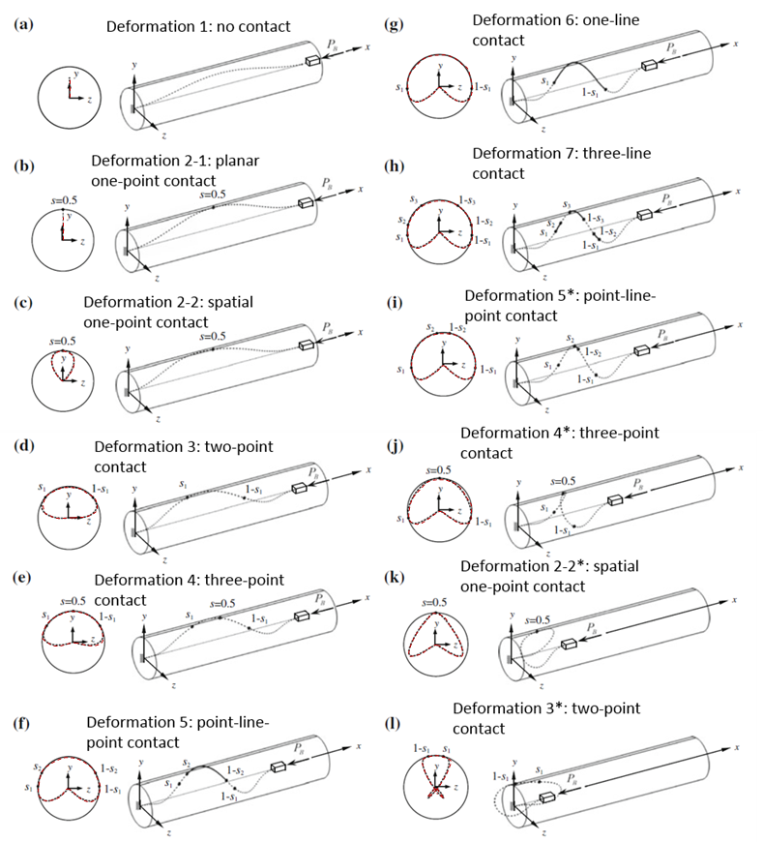

Fig. 1: Theoretical prediction (reproduced from [[42](#_ENREF_42" \o "Fang, 2013 #12)]): Decreasing the distance between the ends of the clamped-clamped fiber results in stages (a) through (l), which involve seven different contact configurations.

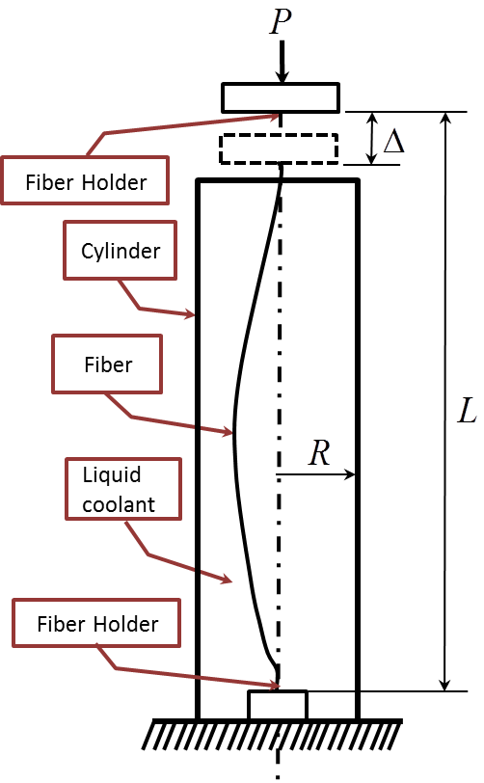

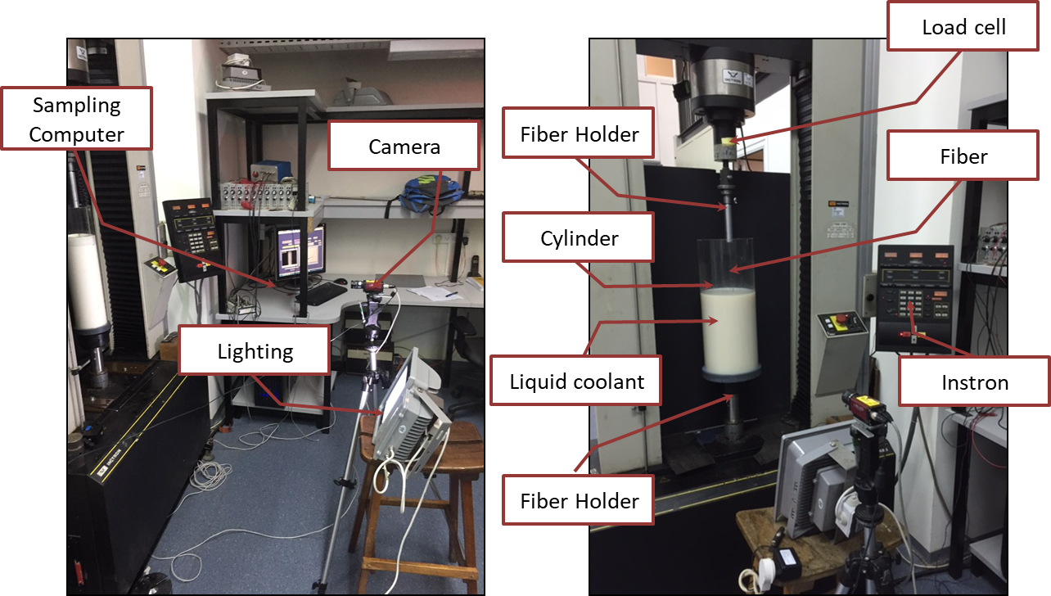

Fig. 2: (a) Schematic description of the main experiment,. (b) The experimental setup, with a cylinder

of  radius (left image), or (right image). In these images, the cylinder is not completely filled with an opaque milky fluid for the purpose of clarity.

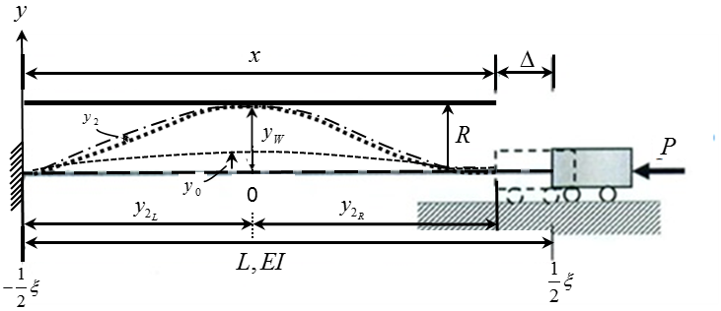

Fig. 3: Description of boundary conditions and post-buckling response of the fiber in this research

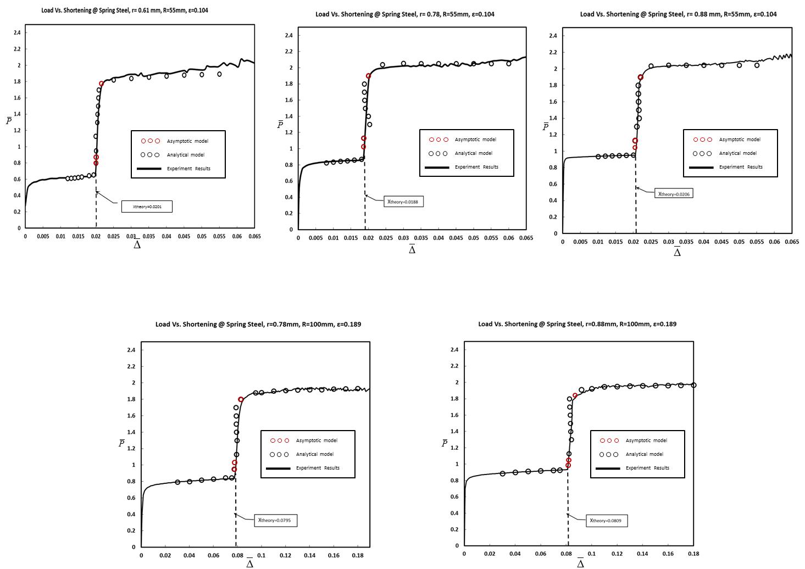

Fig. 4: Vertical force versus end shortening for:,,. The experiment compared to analytical model results (empty black circle).

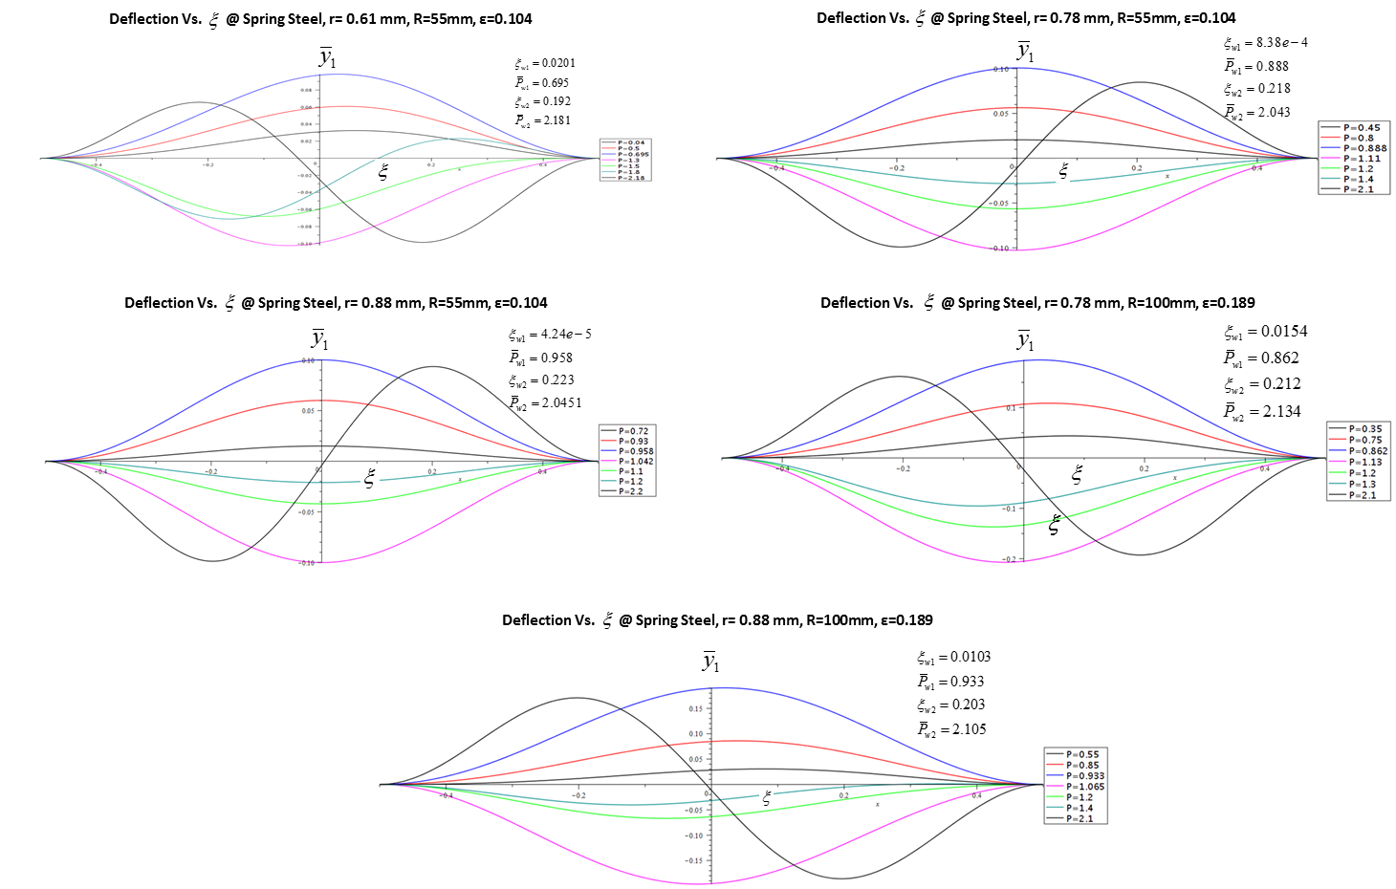

Fig. 5: Deflection curves from the expression  for:,,, for several values of and calculate of :

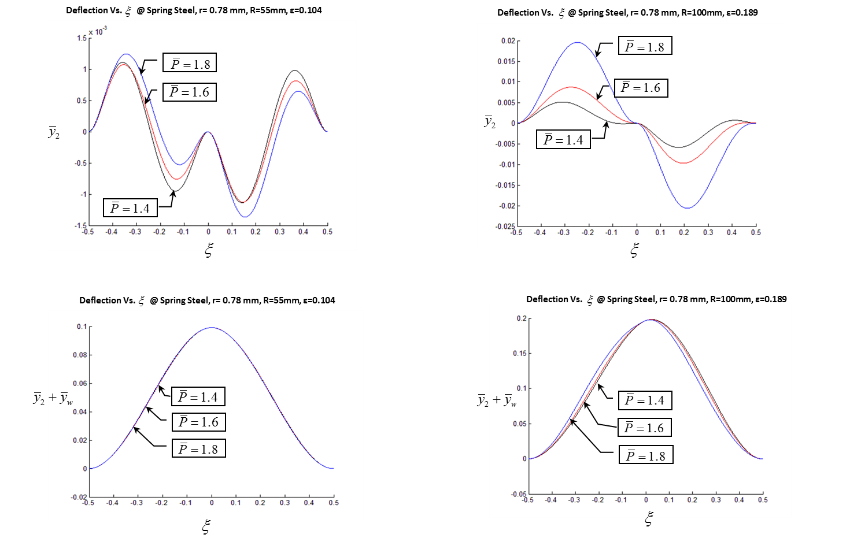

Fig. 6: Deflection curves from the expression  for:,,, for several values of 

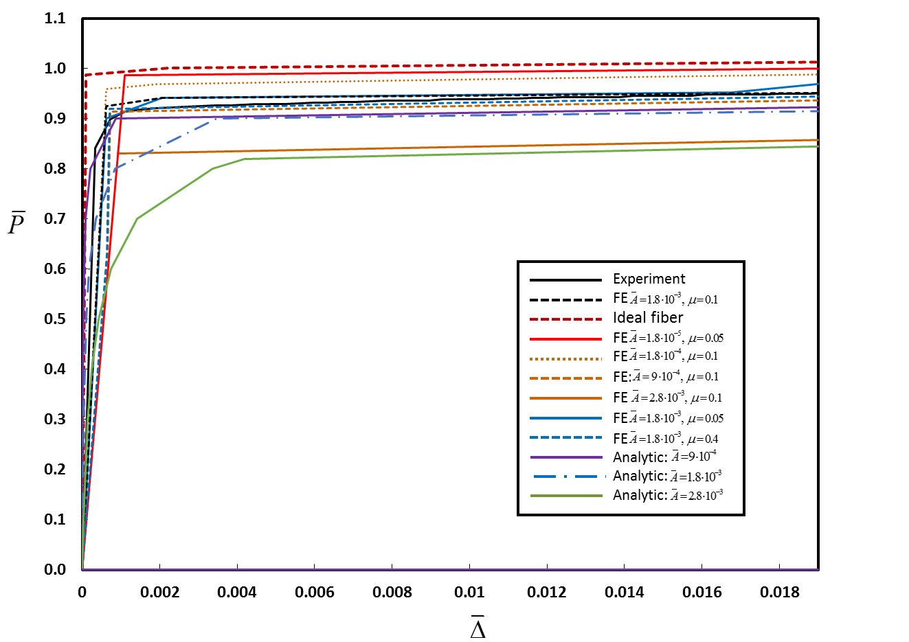

Fig. 7: Vertical force versus end shortening up to the first contact point of the fiber in the cylinder wall for:,,, ε≈0.104. The experiment, analytical model and Finite-element simulations results are compared to the theoretical predictions of [[42](#_ENREF_42" \o "Fang, 2013 #12)] (red dashed line). Finite-element results are shown for simulations with various values of  (amplitude of the deviation) and  friction coefficient).

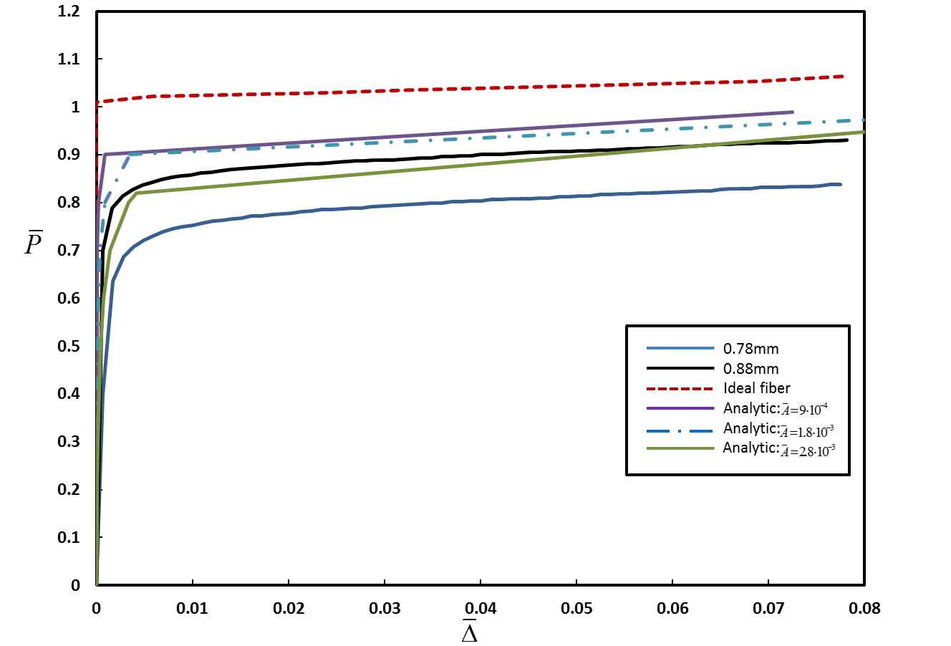

Fig. 8: Vertical force versus end shortening up to the first contact point of the fiber in the cylinder wall for:, ,, ε≈0.189. The experiment and analytical model results are compared to the theoretical predictions of [[42](#_ENREF_42" \o "Fang, 2013 #12)] (red dashed line).

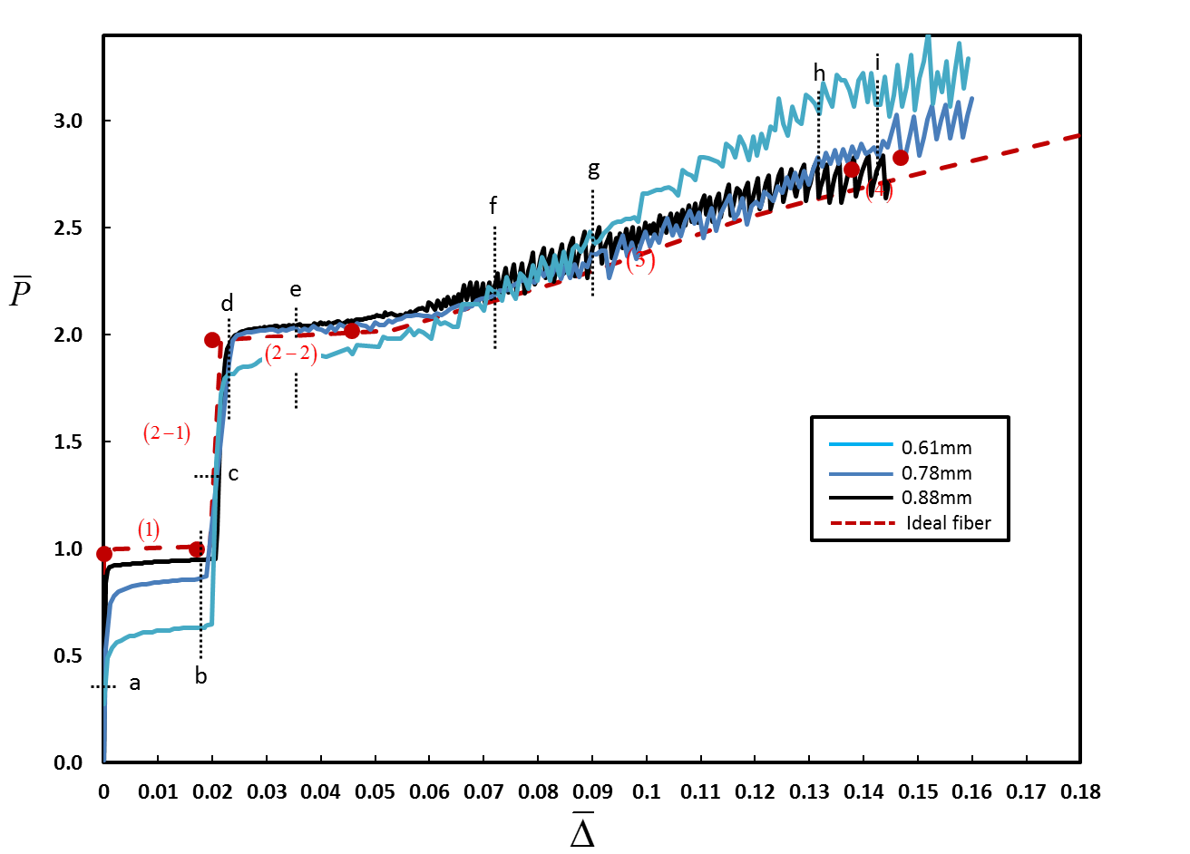

Fig. 9: Measured vertical force versus end shortening for three different fiber radii:, ,,, ε≈0.104. The experiment results are compared to the theoretical predictions of [[42](#_ENREF_42" \o "Fang, 2013 #12)] for ε=0.1 (dashed line). Numbers in parenthesis indicate the contact configuration in accordance with Fig. 1. Filled circles identify transition from one configuration to the next.

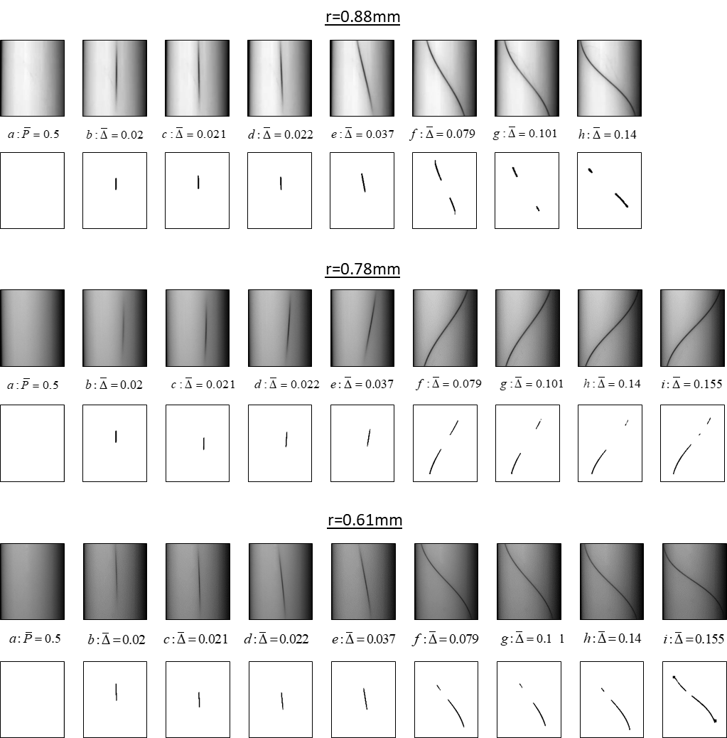

Fig. 10: Contact between the fiber and the cylinder wall at different stages of deformation for the fibers from Fig. 4 (ε≈0.104, ). For each fiber, the first row shows snapshots from the experiment at different levels of end shortening, while the second row show the same snapshot after applying the image-processing procedure. End shortening is indicated by the numbers between the two rows and also by the letters a-h that appear in the force-displacement curve, Fig. 9.

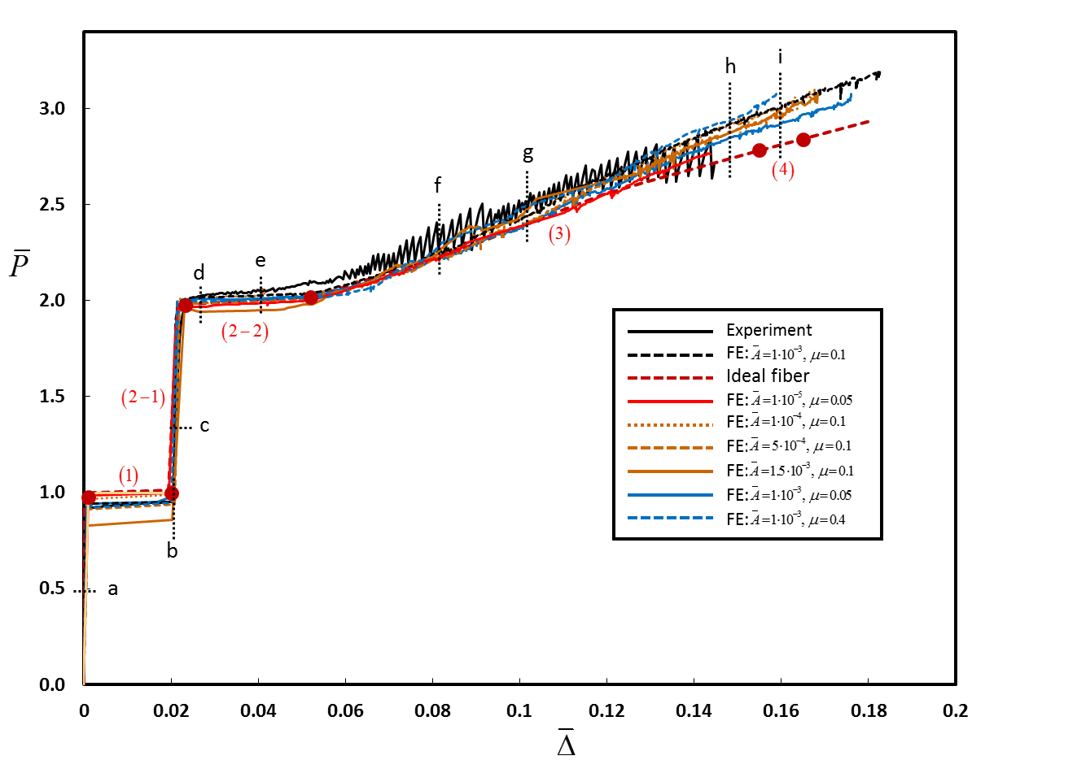

Fig. 11: Vertical force versus end shortening for:,,, ε≈0.104. The experiment and Finite-element simulations results are compared to the theoretical predictions of [[42](#_ENREF_42" \o "Fang, 2013 #12)] (dashed line). Finite-element results are shown for simulations with various values of  (amplitude of the deviation) and  friction coefficient). Numbers in parenthesis indicate the contact configuration in accordance with Fig. 1. Filled circles identify transition from one configuration to the next.

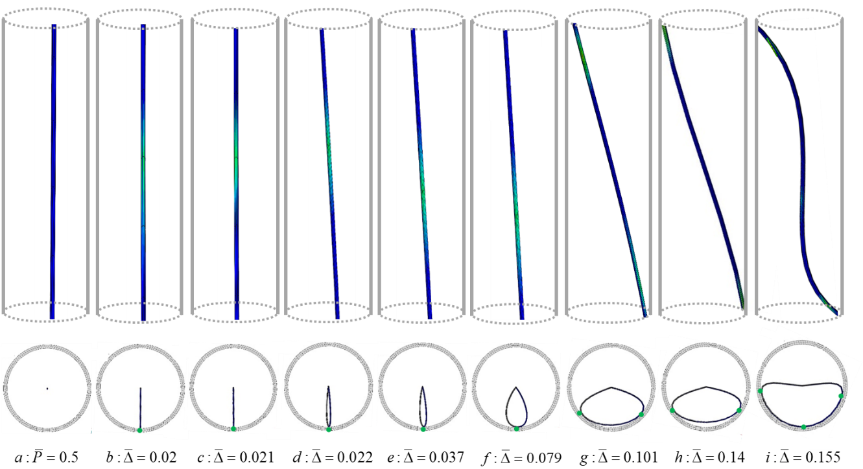

Fig. 12: Results of FE simulations showing the deformation of the fiber and contact with the cylinder wall, for:,, ε=0.104. First row: side view, where a lighter (greenish) color indicates interaction with the wall (in these images, the schematic cylinder is shown for clarity/orientation, but the images are not at identical scale in order to allow focusing on the contact region). Second row: top view (all images are at identical scale)

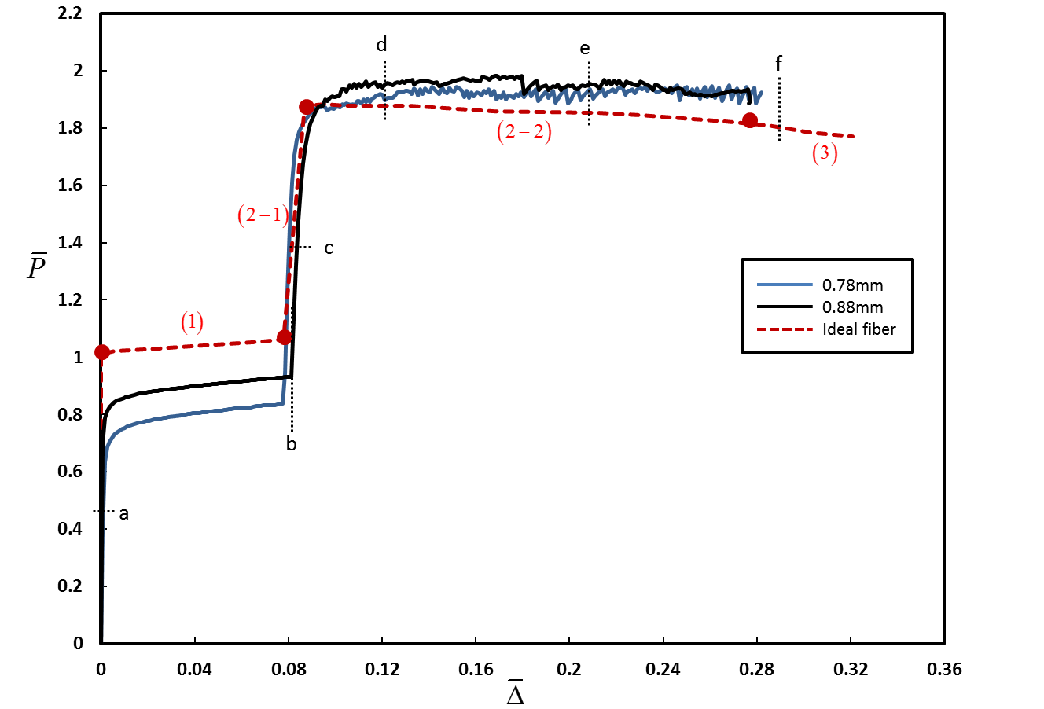

Fig. 13: Force-displacement relation. Measured vertical force versus end shortening for two different fiber radii: ,,, ε≈0.189. The experiment results are compared to the theoretical predictions of [[42](#_ENREF_42" \o "Fang, 2013 #12)] for ε=0.2 (dashed line). Numbers in parenthesis indicate the deformation stage described in Fig. 1. Filled circles identify transition from one deformation pattern to the other

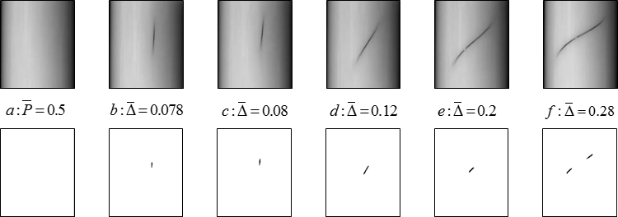

Fig.14: Force-displacement relation. Measured vertical force versus end shortening loading and unloading for:.,, ε≈0.189. The experiment results are compared to the theoretical predictions of [[42](#_ENREF_42" \o "Fang, 2013 #12)] for ε=0.2 (dashed line). Numbers in parenthesis indicate the deformation pattern described in Fig. 1. Filled circles identify transition from one deformation pattern to the other.