Negative pathology report following salivary gland surgery for suspected primary tumor – what went wrong?

Introduction

Salivary gland neoplasms constitute 3-4% of all head and neck tumors. Most are benign, with pleomorphic adenoma being the most common (1). The benign or malignant nature of the tumor may influence the patient consultation and decision-making process. It could also determine the extent of surgical resection and the ability to preserve the facial nerve.

Fine needle aspiration biopsy (FNAB) is often used for preoperative cytological diagnosis. This fast, simple procedure does not require general anesthesia, and facial nerve damage and tumor seeding along the needle pathway are extremely rare (2). Although FNAB is highly specific for malignancy (93%-100%), its sensitivity is not as good (83%-92%) (3,4,5).

While reviewing our database on patients following salivary gland resection, we noticed a small subgroup (3%) who were operated for diagnosed or suspected primary salivary gland tumor, but in whom no tumor was found on surgical pathology (negative pathology). This study goals are to review cases of negative surgical pathology in patients who undergo salivary gland resection for suspected salivary tumor and define the causes of such differnce in order to prevent such events in the future.

Methods

A retrospective review was performed of patients who had undergone resection of a major salivary gland in the otolaryngology department at Shaare Zedek medical center between January 2005 and December 2018. Data included: demographics, preoperative FNAB, surgical treatment and complications, surgical pathology results and follow-up. Cases with negative pathology were reviewed thoroughly, including investigation of the perioperative decision making and follow-up by telephone call when needed. Preoperative cytology and postoperative pathology samples were reviewed by an experienced pathologist. Some patients reffered to us following cytology sampled elsewhere, therefore not all samples where available for reevaluation.

Results

Overall, 312 patients underwent salivary gland resection in this period. FNAB sensitivity and specificity for malignancy were 76% and 93%, respectively. Ten patients (3.2%) (of whom eight had undergone parotidectomy and two submandibular gland resection) had no tumor on surgical pathology. A review of these patients revealed the causes for the negative pathology, which can be categorized as follows (table 1):

A) Surgical pathology error – the review uncovered a pathology misdiagnosis.

B) Surgical management error – a mistake in the preoperative decision making.

C) "Rule out" surgery – cases in which the possibility of negative pathology was known prior to surgery. These comprised two cases of completion surgery following a previous unsuitable resection, and two cases in which it was hard to rule out a tumor without surgery.

D) Unexplained – no explanation was found for the negative pathology.

1. Surgical pathology errors

Patient no. 1: an 18-year-old woman who had had a preauricular lump for the past year. Ultrasound (US) showed a 2.5 cm hyper-vascularized parotid mass. Computed tomography (CT) and magnetic resonance imaging (MRI) demonstrated "a similar solid mass" (based on records on admission: the original scans were not available). The two FNAB samples showed only blood and foam cells. During surgery the mass was identified and excised completely. Although no tumor was found postoperatively, pathological review of the specimen revealed an **arteriovenous malformation** (figure 1) in one of the original slides.

Patient no. 2: a 50-year-old man with a parotid swelling. US and CT showed a well-defined, mostly cystic mass. FNAB demonstrated only acinar cells with no tumor. The mass had grown on follow-up visits, and was therefore excised. The pathology report noted dilatation of the parotid ducts and “lipomatous infiltrations”, but no tumor. However, review of the histology found an **intraparotid sialolipoma** with secondary obstructed and dilated ducts (figure 2).

Patient no. 3: a 77-year-old man who had had a firm mass in the left parotid for the past 6 months. CT demonstrated a well-defined mass in the parotid, and FNAB led to a diagnosis of Warthin’s tumor. The mass was palpable during a superficial parotidectomy, but pathological examination showed only necrotic tissue and inflammation. Meticulous review of the slides revealed a **necrotic Warthin’s tumor** (figure 3), with the necrosis attributed to the preoperative needle biopsy.

1. Surgical management error

Patient no. 4: a 47-year-old man with swelling of the submandibular area. US and CT demonstrated enlarged lymph nodes and an only mildly enlarged submandibular gland. Two sequential FNABs were inconclusive. The patient underwent submandibulectomy, with negative pathology. Retrospectively, the lymph nodes were the source of swelling, and resection of the salivary gland was probably not indicated. In any case, no recurrence of swelling was reported at the 12-year follow up.

1. "Rule out" surgery

a) no definitive preoperative diagnosis

Patient no. 5: a 58-year-old man had temporary left facial nerve paresis followed by facial spasm. Six months later he had an abscess in the submandibular area on the same side, treated with incision and drainage. CT and MRI demonstrated a small, multi-cystic parotid mass, suggesting the differential diagnosis of neoplasm versus lymphatic malformation. FNAB showed “suspicious features” of Warthin’s tumor. In light of the inconclusive findings it was decided to perform parotidectomy for both diagnostic and therapeutic purposes. The pathology findings were parotid tissue with fibrosis and chronic inflammation. Follow-up, including US and MRI imaging, was normal, although facial spasm remained unchanged.

Patient no. 6: a 45-year-old man with a history of chemoradiation therapy for neck lymphoma had had a parotid mass for the previous 6 months. US and CT demonstrated a 1 cm mass in the superficial parotid lobe, with no neck lymphadenopathy. FNAB demonstrated a group of atypical cells and could not rule out neoplasm, due to the lack of architecture. The pathologic diagnosis was normal parotid tissue. Two years later, the patient had recurrent swelling in the parotid gland area, but there were only a few cells in the FNAB and the swelling resolved spontaneously. In the 8 years since then, he has been free of symptoms.

b) Completion surgery

Patient no. 7: a 50-year-old woman who had had a retroauricular mass for the previous ten years. It was diagnosed as skin tumor by the plastic surgeon, and an excisional biopsy was performed. The pathology finding was low grade mucoepidermoid carcinoma (MEC), not completely excised. MRI showed no gross residual tumor. A multidisciplinary team considered surgery versus radiation, taking the patient's preference into account, and superficial parotidectomy with selective (level II) neck dissection was eventually performed. No tumor was seen on pathology and there was no recurrence at long-term follow-up.

Patient no. 8: a 39-year-old man with an infra-auricular mass. Excisional biopsy was performed by a plastic surgeon; the histology showed a pleomorphic adenoma, not completely excised. No residual tumor was found after superficial parotidectomy.

1. Unexplained

Patient no. 9: a 66-year-old woman who had had a mass in the parotid gland for some years. US and CT revealed a solid, well defined parotid lesion. Two FNABs led to a diagnosis of pleomorphic adenoma. The surgeon's impression after performing a superficial parotidectomy was that all the mass had been excised. The pathologic diagnosis was parotid tissue with a few intraglandular reactive lymph nodes: no tumor was identified. Histologic review verified this finding. The FNA cytology was not available for review. Four years later the patient had recurrent swelling in the same place, with spontaneous resolution.

Patient no. 10: a 67-year-old man with submandibular swelling. US and CT showed a mixed cystic-solid mass in the submandibular gland. The first FNAB only revealed “suspected squamous cell carcinoma,” but a second FNAB led to a diagnosis of Warthin’s tumor. Review of the first FNAB led to a conclusive diagnosis of Warthin’s tumor, but surgical pathology found an unremarkable submandibular gland. The patient was lost to follow-up soon after the operation (in 2007), and he and his medical files are not available.

Discussion

Parotidectomy is a delicate surgical procedure. It is usually done under general anesthesia, and involves a significant risk of complications (6). The failure to find any tumor on surgery might be devastating for both patient and surgeon and could have medicolegal implications, yet no literature was found on this specific scenario. This led us to investigate the possible explanations for such an outcome.

The specificity and sensitivity of FNAB in salivary glands has been extensively investigated. A meta-analysis by Schmidt and coworkers found 79% sensitivity and 96% specificity (7). We found the sensitivity and specificity of our FNAB to be similar to those reported in the literature.

Surgical pathology errors, which are not uncommon, usually significantly influence postoperative management. Kronz et al. advocated the systematic review of the pathologic diagnosis of patients referred to a tertiary center, after finding 1%-2% diagnoses to be inaccurate (8). Peck et al. showed that head and neck pathology have a significantly higher rate of inaccurate pathological diagnosis in comparison to other anatomical sites (9). Westra at al. found that a second opinion of head and neck surgical pathology changed the diagnosis and resulted in major therapeutic and prognostic modification in 7% of cases, rising to 9% for the salivary gland (and 11% in major glands) (10).

In our study, 3 cases of negative pathology were explained by an inaccurate pathological diagnosis. Patient no. 1 had a vascular malformation, and review of the pathology only found the lesion in one slide. If more slides had been done, it is reasonable to assume that the malformation would have been detected. Nonetheless, the young age, female gender and two FNABs containing only blood cells should have raised suspicions in the patient’s preoperative management.

One case of necrotic Warthin’s tumor (patient no. 3) posed a real diagnostic challenge. Although described in the literature (11,12), widespread necrosis of Warthin’s tumor is extremely rare. This diagnosis should be considered in the event of negative surgical pathology after diagnosis of Warthin's tumor from the FNAB and the presence of classic clinical features (e.g. bilateral parotid mass, smoking history).

These two cases also demonstrate the possibility that cystic masses may shrink after excision, as well as the importance of performing more sections on the specimen if the pathology findings are negative.

Salivary gland fatty neoplasms (patient no. 2) are rare (13), however familiarity of the expert pathologist with this group of neoplasms may prevent inaccurate diagnosis.

Patients 5 and 6 had an unusual course of events prior to their operation. The FNAB for patient 5 was suspicious for Warthin’s, and patient 6 had a history of lymphoma; these were the main indications for surgical resection, even though the FNAB did not definitively diagnose a tumor. But should have we pursued a definitive diagnosis?

A study by Romano et al. demonstrated a high diagnostic value with selective use of core needle biopsy as an adjunct to FNAB in specific cases (sensitivity 100% and specificity 92%) (14). Complications of core needle biopsy are uncommon (15), therefore its utility in cases of uncertainty and its potential to obviate unnecessary surgery may outweigh its risks. Nevertheless, a definite preoperative diagnosis may not always be achievable, and clinical judgment is needed. It is of paramount importance to discuss this issue with the patient beforehand, and it should be completely understood that no tumor may be found postoperatively.

Two patients underwent completion surgery. Both had been assumed to have a skin lesion, and underwent local excision in other centers. Incomplete resection of malignant tumors excluded follow-up alone as an option. Despite good local control rates of radiotherapy for malignant salivary tumor and inadequate margins (16), the low-grade histology and the patient’s own preference favored surgery in the case of patient no. 7. Patient no. 8, with pleomorphic adenoma, was also consulted against follow-up. There is abundant literature evidence that enucleation of pleomorphic adenoma is a risk factor for recurrence and that surgery for recurrent tumor carries significant risks of complication, specifically facial nerve damage (17,18,19). In both these cases a superficial parotidectomy was performed, which was not a "true" revision parotidectomy because the facial nerve was not dissected in the first procedure. It should also be noted that as no serial sections of the original pathological specimen were performed, microscopic tumor tissue might have been missed.

Incomplete resection of salivary gland tumors does not always require completion surgery, and management may often be inconclusive. The possibility of negative pathology should therefore be discussed with the patient preoperatively.

In two cases no explanation was found for the negative pathology, and the patients were subsequently lost to follow-up, including the unavailability of their imaging data.

Conclusion

Negative pathology following salivary gland resection should raise the suspicions of both the surgeon and the pathologist. After thorough retrospective investigation, only 0.6% of cases (2/312) remained unexplained. In both 2 unexplained cases the retrospective investigation was not complete due to lacking medical record and unavailable histology for revision with the years past. We assume that immediate review would probably have found the cause in these cases too, and therefore stress an immediate multidisciplinary review of all data in the event of negative surgical pathology.

Figure 1. Arteriovenous malformation (arrow) and adjacent normal parotid gland tissue (arrowhead), H&E stain, original magnification ×12.5.

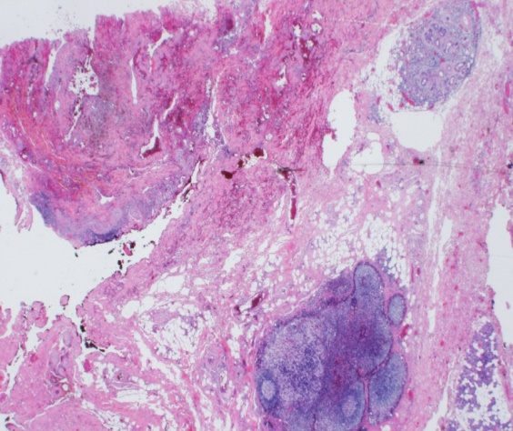

Figure 2. Intra-parotid sialolipoma. Left – lipoma (arrow) within normal parotid (asterisk), H&E stain, original magnification ×12.5; right – dilated excretory duct entrapped in the lipoma, H&E stain, original magnification ×40.

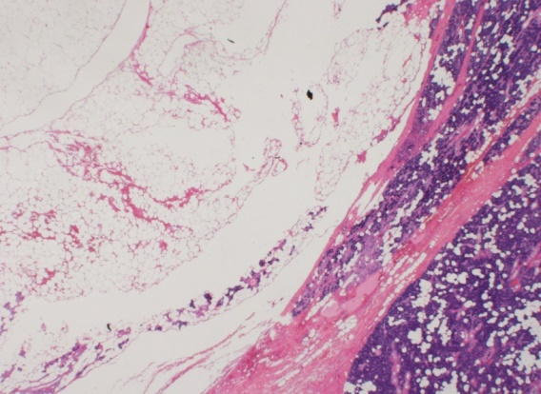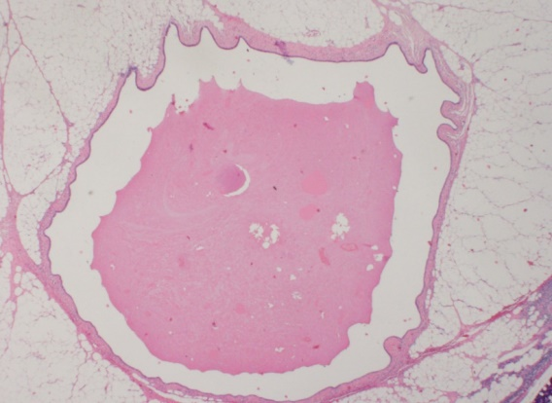

*

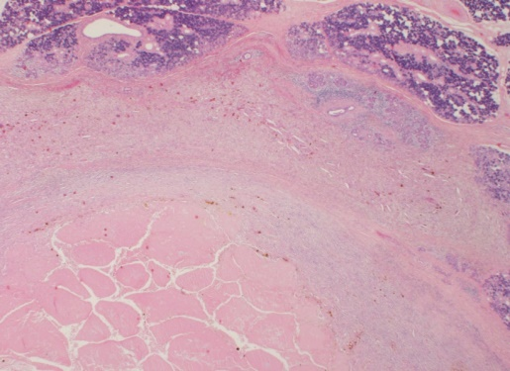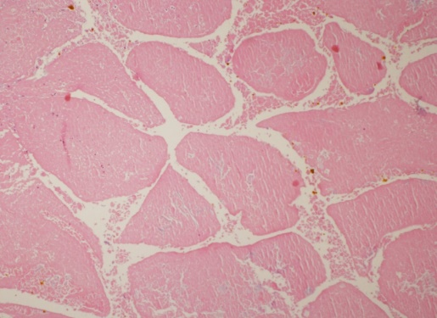

Figure 3. Warthin’s tumor showing extensive ischemic necrosis (resulting from fine needle aspiration), but still preserving its general papillary-cystic architecture. Left - H&E stain, original magnification ×12.5; right - H&E stain, original magnification ×40.

|  |  |  |  |  |  |  |  |  |
| --- | --- | --- | --- | --- | --- | --- | --- | --- |
| SUBGROUP | | PATIENT NO. | LOCATION | IMAGING | FNA | PREOPERATIVE CLINICAL DIAGNOSIS | SURGICAL PATHOLOGY | REVIEW OF SURGICAL PATHOLOGY |
| A. Surgical pathology error | | 1 | parotid | US - 2.5 cm hyper-vascularized mass.  CT + MRI - solid mass | blood and foam cells (x2) | unspecified tumor | normal salivary gland tissue | arteriovenous malformation |
| 2 | parotid | US + CT – well defined mass | normal acinar cells | suspected tumor | "lipomatous infiltration" – no tumor | intraparotid sialolipoma |
| 3 | parotid | CT – well defined mass | Warthin's tumor | Warthin's tumor | necrotic and inflammatory tissue only | necrotic Warthin's tumor |
| B. Surgical management error | | 4 | submandibular | CT - enlarged lymph node and mildly enlarged submandibular gland | inconclusive (x2) | suspected tumor | no tumor in submandibular gland | review of slides only – no tumor |
| C.  “Rule-out” surgery | No definitive diagnosis | 5 | parotid | CT + MRI – small multicystic mass | suspected Warthin's tumor | inconclusive: neoplasm? malformation? other? | fibrosis and chronic inflammation | no tumor was found |
| 6 | parotid | US + CT – solid mass in parotid | atypical cells –neoplasm not ruled out (x2) | suspected tumor | normal tissue – no tumor | not available |
| Completion | 7 | parotid (low grade MEC) | MRI – no residual mass |  | residual malignancy | no tumor |  |
| 8 | parotid (pleomorphic adenoma) |  |  | residual tumor | no tumor |  |
| D. Unexplained | | 9 | parotid | US + CT – solid, well defined mass | pleomorphic adenoma (x2) | pleomorphic adenoma | no tumor | surgical pathology: no tumor  FNA histology: pleomorphic adenoma |
| 10 | submandibular | US + CT – a solid cystic mass | suspected SCC | 1st – suspected SCC  2nd – Warthin's tumor | no tumor | FNA: both were Warthin's  Pathology slides: no tumor identified |

Table 1. summary of all patients with negative pathology. FNA – fine needle aspiration. US- ultrasound. CT – computed tomography. MRI- magnetic resonance imaging. SCC – squamous cell carcinoma.

References

1. Pinkston, John A., and Philip Cole. "Incidence rates of salivary gland tumors: results from a population-based study." *Otolaryngology–Head and Neck Surgery* 120.6 (1999): 834-840.

2. Shah, Keval SV, and Madan Ethunandan. "Tumour seeding after fine-needle aspiration and core biopsy of the head and neck-a systematic review." *British Journal of Oral and Maxillofacial Surgery* 54.3 (2016): 260-265.

3. Stein, Andrew P., Christopher J. Britt, and Gregory K. Hartig. "The Diagnostic Accuracy of Fine-Needle Aspiration for Parotid Malignancy." *Otolaryngology—Head and Neck Surgery* 151.1_suppl (2014): P54-P54.

4. Liu, C. Carrie, et al. "Sensitivity, specificity, and posttest probability of parotid fine-needle aspiration: a systematic review and meta-analysis." *Otolaryngology--Head and Neck Surgery* 154.1 (2016): 9-23.

5. Stewart, C. J. R., et al. "Fine‐needle aspiration cytology of salivary gland: a review of 341 cases." *Diagnostic cytopathology* 22.3 (2000): 139-146.

6. Marchese-Ragona, R., et al. "Treatment of complications of parotid gland surgery." *Acta Otorhinolaryngologica Italica* 25.3 (2005): 174.

7. Schmidt, Robert L., et al. "A systematic review and meta-analysis of the diagnostic accuracy of fine-needle aspiration cytology for parotid gland lesions." *American journal of clinical pathology* 136.1 (2011): 45-59.

8. Kronz, Joseph D., William H. Westra, and Jonathan I. Epstein. "Mandatory second opinion surgical pathology at a large referral hospital." *Cancer: Interdisciplinary International Journal of the American Cancer Society* 86.11 (1999): 2426-2435.

9. Peck, Martyn, et al. "Review of diagnostic error in anatomical pathology and the role and value of second opinions in error prevention." *Journal of Clinical Pathology* 71.11 (2018): 995-1000.

10. Westra, William H., Joseph D. Kronz, and David W. Eisele. "The impact of second opinion surgical pathology on the practice of head and neck surgery: a decade experience at a large referral hospital." *Head & Neck: Journal for the Sciences and Specialties of the Head and Neck* 24.7 (2002): 684-693

11. Eveson, John W., and Roderick A. Cawson. "Warthin's tumor (cystadenolymphoma) of salivary glands: a clinicopathologic investigation of 278 cases." *Oral surgery, oral medicine, oral pathology* 61.3 (1986): 256-262.

12. Kern, S. B. "Necrosis of a Warthin's tumor following fine needle aspiration." *Acta cytologica* 32.2 (1988): 207-208.

13. Huerta, Elba Leyva, et al. "Sialolipoma of minor salivary glands: presentation of five cases and review of the literature with an epidemiological analyze." *Indian Journal of Otolaryngology and Head & Neck Surgery* 67.1 (2015): 105-109.

14. Romano, Erica B., et al. "Fine‐needle aspiration with selective use of core needle biopsy of major salivary gland tumors." *The Laryngoscope* 127.11 (2017): 2522-2527.

15. Robertson, E. G., and G. Baxter. "Tumour seeding following percutaneous needle biopsy: the real story!" *Clinical radiology* 66.11 (2011): 1007-1014.

16. Garden, Adam S., et al. "Postoperative radiotherapy for malignant tumors of the parotid gland." *International Journal of Radiation Oncology* Biology* Physics* 37.1 (1997): 79-85.

17. Buchman, Craig, et al. "Pleomorphic adenoma: effect of tumor spill and inadequate resection on tumor recurrence." *The Laryngoscope* 104.10 (1994): 1231-1234.

18. Witt, Robert L. "The significance of the margin in parotid surgery for pleomorphic adenoma." *The Laryngoscope* 112.12 (2002): 2141-2154.

19. Wittekindt, Claus, et al. "Recurrent pleomorphic adenoma of the parotid gland: analysis of 108 consecutive patients." *Head & Neck: Journal for the Sciences and Specialties of the Head and Neck* 29.9 (2007): 822-828.