 |  |  |  |  |  | 001-583 -341572967-1/4
 | Israel Electric Corporation, Ltd.
 | Bi-monthly Invoice
Electric Corporation |  |  |  |  |  |  |  | Page
 |  |  |  |  |  |  |  | 1/2
 |  |  | Tax Invoice/Receipt – Original 2020-461815935
To: | 583 |  | Company Number: 520000472
Cohen, Hila and Daniel |  |  | Reports to consolidated businesses № 558418570
AH5 |  |  | Netiv Haor 1. Haifa
Rakefet 2017500 | 200-211-000 |  | Contract invoice number: 341572967
 |  |  | Invoice period of 49 days
For mail return: 16 Haharoshet St., Carmiel |  |  | from 28/10/2020 until 15/12/2020
 |  |  | Date of invoice preparation |  |  | At your service, 24 hours a day:  The company’s website:  www.iec.co.il  Where you can pay the invoice, enter a meter reading, and get information on various topics.
 |  |  | 16/12/2020
Consolidated Invoice
Charge for consumption – Total of 1262 kWh |  |  | 565.88 |  |  | 103 Service  To report faults, for invoicing and consumer services:
Payment in respect of capacity (KVA) |  |  | 4.38
Fixed charge |  |  | 32.08
Various debits and credits |  |  | 3.84
Total before VAT |  |  | 598.50 |  |  | Landline & cell phone – 103
VAT at 17.00% |  |  | 101.75 |  |  | Fax: 1800-200-103
Total including VAT for billing period |  |  | 700.25
 |  |  |  |  |  | Call 103 Center from any phone – free.
 |  |  |  |  |  | Do not pay this invoice
 |  |  |  |  |  | Your bank account will be charged on 05/01/2021
 |  |  |  |  | S.C | Account № to charge:
Total payment (NIS) |  |  | 700.25 |  |  | Ending in digits 9374.
 |  |  |  | Your electricity consumption
 |  |  |  | compared to average consumption in your residential area |  |  | kWh
Notifications |  |  |  |  |  |  | 2,800
■ For your attention!!! |  |  |  | 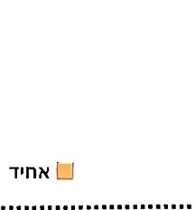  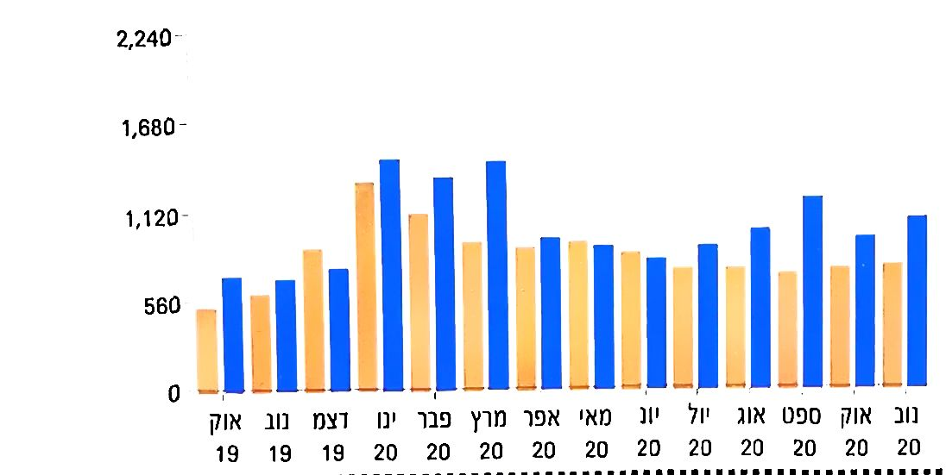
You can now pay with your credit card even sums greater than NIS 10,000.
Payment by credit card for sums greater than NIS 10,000 will be charged an NIS 8 fee, for each NIS 1,000 (from first Agurah above 10,000).
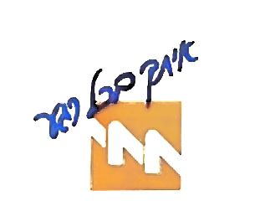
Electric Corporation
Consumer’s name:
Cohen, Hila and Daniel |  | Voucher/Credit Notice |  |  |  | 2020-461815935
 |  |  | Contract account number: 341572967 |  |  | Periodic invoice  from 28/10/2020 until 15/12/2020
Amount to be paid in NIS |  |  | Not for payment |  |  | Do not pay this invoice
Invoice charged by standing order
Bank account number charged ends with digits 9374

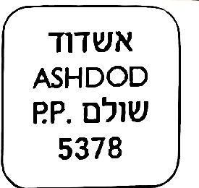 |  |  |  |  |  |  | To: |  |  |  |  |  |  |  |  |  |  |  |  |  | 3643
 |  |  |  |  |  |  | Cohen, Daniel and Haklili Hila
 |  |  |  |  |  |  | M.P. Misgav P.O.B. 165 |  |  |  |  |  |  |  |  |  |  |  |  | 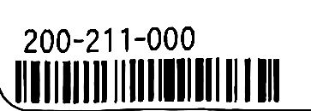
 |  |  |  |  |  |  | Rakefet 2017500
In case of non-delivery, please return to the Misgav Regional Council, Treasury Department.
 |  |  |  |  |  | (Periodic Invoice)
 |  | 5736870 |  |  |  |  |  |  | 58372962) |  |  |  |  |  |  |  | 11/20 |  |  |  |  |  | 23/11/20
 |  | Voucher № |  |  |  |  |  |  | Household № |  |  |  |  |  |  |  | Tax Period |  |  |  |  |  | Print Date
 |  | Rakefet – Lot 192 Rakefet |  |  |  |  |  |  |  |  |  |  |  |  |  | 321920/1 |  |  |  |  |  |  | 210.65
 |  | Property address |  |  |  |  |  |  |  |  |  |  |  |  |  | Property № |  |  |  |  |  |  | Property Area
 |  | Billing code |  |  |  | Payment Description |  |  |  |  |  |  |  |  |  |  |  |  |  |  |  |  |  | Amount in NIS
 |  | 1 |  |  |  | Property Tax: 206.63 m², Residential – A |  |  |  |  |  |  |  |  |  |  |  |  |  |  |  |  |  | 666.45
 |  | 2 |  |  |  | Arnona 4.02 m², Auxiliary Buildings, Residential – A |  |  |  |  |  |  |  |  |  |  |  |  |  |  |  |  |  | 12.12
 |  | 1010 |  |  |  | Consolidated collection discount |  |  |  |  |  |  |  |  |  |  |  |  |  |  |  |  |  | -13.60
 |  | Payment arrears will be charged interest and linkage |  |  |  |  |  |  |  |  |  |  |  |  |  |  |  |  |  |  |  |  |  | 665.00
 |  | Place cashier’s signature and stamp here |  |  |  |  |  |  |  |  |  |  | 10/12/20 |  |  |  |  |  |  |  |  |  |  |  | Please note that a permanent order payment earns 2% discount on the property tax!
 |  |  |  |  |  |  |  |  |  |  |  |  | Last payment date
Postal Bank account № |  |  |  |  |  |  |  |  |  |  |  |  | 5-31711-9 |  |  |  |  |  |  | (Debit balance for this asset without the current voucher |  |  |  |  |  |  | 0.30
 |  |  |  |  |  |  |  |  |  |  |  |  |  |  |  |  |  |  |  | Amount does not include legal handling debt
Notices
 |  | The Council's payment website: www.misgav.org.il
 |  | Telephone response, Council Treasurer 04-9902357
־ ־ —
Periodic Invoice |  |  |  |  |  |  |  |  |  |  |  |  |  |  |  |  |  |  |  |  |  |  |  |  |  |  |  | Credit notice
Misgav Regional Council, Non-profit Organization № 500224563, M.P. Misgav 2017900,  Tel: 04-9902357; Fax: 04-9902096, www.misgav.org.il |  |  |  |  |  |  |  |  |  |  |  |  |  |  |  |  |  |  |  |  |  |  |  |  |  | To pay by mail and at all bank branches
 |  | Cohen, Daniel and Haklili Hila |  |  |  |  |  |  |  |  |  |  | M.P. Misgav P.O.D. 165, Rakefet
 |  | Payer’s name |  |  |  |  |  |  |  |  |  |  | Address
 |  | 5736870 |  |  |  |  |  |  |  |  |  |  | 321920/1 |  |  |  |  |  |  | 10/12/20 |  |  |  |  |  |  | Place cashier’s signature and stamp here  After payment, this voucher serves to credit your account. Therefore, do not tear it off from invoice body and no changes may be made.
 |  | Voucher № |  |  |  |  |  |  |  |  |  |  | Property № |  |  |  |  |  |  | Last payment date
 |  | 5-31711-9 |  |  |  |  |  |  |  | Your account will be paid by standing order
 |  | Postal Bank account №
 | ** Not for payment ** |  |  |  |  |  |  |  |  |  |  |  | 61/54587 |  |  |  |  |  |  | 11/20
 |  |  | Amount to be paid |  |  |  |  |  |  |  |  |  | Beneficiary's code |  |  |  |  |  |  | Tax Period


