**Intellectual life and its effects on construction renaissance in Egypt during the periods of the two caliphs al-Āmir Bi-Aḥkām Allah and al-Ḥāfiẓ li-Dīnillāh (1101-1149 AD)**

**Abstract**

This study sheds light on Fatimid society and administration, with a focus on architecture and intellectual life. I argue that the distinctiveness of Fatimid culture led to the development of religious and scientific institutions that represent an enlightened period of Islamic construction history.

This study presents the scientific, social and political changes that occurred in the religious ideological philosophy during the era of the two caliphs al-Āmir Bi-Aḥkām Allah and al-Ḥāfiẓ li-Dīnillāh (1101-1149). Ideological tolerance prevailed across the Fatimid caliphate during this period. The study also focuses on the special distinction of religious, educational and social life, investigating how it had an effect on the architectural renaissance, and the development of ornaments for religious and scientific institutions. How did religious, educational and social life have a role in the design of mosques, Mashads, educational institutions and their architectural style? And how did the innovative construction and its design play a role in the religious, social and scientific life in this era?

**Keywords**: Fatimid Dynasty, Constructional Renaissance, Ideological Tolerance, Architecture, Ornaments, Egypt.

**Introduction**

During the Fatimid era, Egypt was characterized by widened scientific, religious and cultural movements that brought about the establishment of intellectual institutions and buildings, including libraries, science houses, Mashads and mosques.[1] Schools and science houses played an important role in developing the scientific and cultural process. Similarly, mosques and Mashads played an important role in disciplining doctrinal differences and social and political conflicts. The Fatimid era, during the time of the two caliphs, al-Āmir Bi-Aḥkām Allah and al-Ḥāfiẓ li-Dīnillāh (1101-1149), witnessed ideological and architectural changes which formed an important part of Egyptian history. The social and scientific climate of this period played a key role in the intellectual and constitutional renaissance. The caliphs’ financial support to scientists and scholars[2] contributed to administrative, scientific and religious institutions, which developed intellectual endeavors generally.[3]

**Administrative and social conditions in the era of the two caliphs al-Āmir Bi-Aḥkām Allah and al-Ḥāfiẓ li-Dīnillāh**

Fatimid rule during the era of the caliphs al-Āmir Bi-Aḥkām Allah and al-Ḥāfiẓ li-Dīnillāh was known to be the rule of weak caliphs who ruled nominally.[4] The actual authority during the Āmir caliphate was in the hands of the minister, the army commander and the supervisor of state affairs al-Afḍal ibn Badr El-Jamālī (the period of his ministry 976-1121),[5] the latter succeeded by the minister al-Maʼmūn Abī Abd Allah ibn Abī Shujāʻ al-Baṭā’iḥī (in office 1121-1125).[6] During the era of the caliph al-Ḥāfiẓ, the administration was in the hands of the minister Abā Alī Ahmad ibn al-Afḍal (assassinated 1131 and succeeded by Yaʼnis).[7] This situation of authority in the hands of ministry officials burdened the Fatimid caliphate with the preoccupations of   
political, intellectual and religious conflicts, leaving the Fatimid state vulnerable to attack from the   
Abbāsid state, the Qarāmiṭah, the Suljūqs and the Crusaders.[8]

From the perspective of religion, Fatimid society was divided into a number of sects: Sunni Muslims, Shi’is, believers in the oneness of God, Christians, and Jews. The Fatimid state made efforts to spread Ismaʼilī Shiite beliefs among Sunnis.[9] The hostility between Shi‘is and Sunnis created a favorable climate for the integration of Christians and Jews into state institutions.[10] The era of the caliphs al-Āmir Bi-Aḥkām Allah and al-Ḥāfiẓ li-Dīnillāh was characterized by the integration of Christians and Jews into state institutions; they were valued for their administrative and intellectual efforts.[11] For Jews, the Fatimid era was a period of prosperity, and they practiced their social and religious life in complete freedom.[12] The Geniza documents show that Jews were craftsmen working in industry and trade.[13] Of course, from the revelation of Islam in the seventh century CE, Dhimmis (‘People of the Book’) were permitted autonomy and the right to elect community leaders, as approved by Muslim authorities.[14]

Social life in the era of these two caliphs was characterized by developments in the craftsmanship of clothing, food, orchards, fences, architecture and decoration. People showed interest in all matters related to social appearances.[15] One important facility was the “Dār Aḍ-Ḍarb” (Bureau of Money Engraving and Printing), built in 1122 by al-Āmir Bi-Aḥkām Allah in the vicinity of the Daraq treasury.[16]

**Intellectual life and architecture in the era of al-Āmir Bi-Aḥkām Allah and al-Ḥāfiẓ li-Dīnillāh.**

During the Fatimid period, Egypt was characterized by a wide intellectual, scientific, and cultural movement. In addition to spreading a faith culture related to Ismaʼilī doctrines, the Fatimids’ interest in building scientific and cultural institutions and mosques also emerged .[17]

Al-Azhar Mosque had a significant impact on the promotion of cultural life. The period of al-Āmir Bi-Aḥkām Allah and Al-Ḥāfiẓ li-Dinillah’s rule throughout Egypt, but particularly in Cairo, was characterized by the renovation and building of mosques with the distinct ornament styles of bowls and geometric ornaments.[18] The minarets had risen above two of the mosque pillars. Most of these mosques were built of stone and limestone, and the walls were covered with a layer of gypsum and ornamented with Kufic writings.[19] The Fatimid period was characterized by converting some mosques to schools surrounded by students’ accommodations. Religious architecture developed during the Fatimid period,[20] as demonstrated by al-Azhar Mosque, the seven mosques, Aqmar, and Aṣ-ṣāliḥ Ṭalāʼiʻ Mosque.[21] The seven mosques lay between the mountain and the Qarāfa, the first being the Mashad of Sayyida Zaynab and the last the Mashad of Sayyida Kalthūm.

The Fatimids also introduced Mashāhid, a religious structure developed between the years 1121-1154, erected over the graves of members of the Ahl al-Bayt (the family of the Prophet Muḥammad (S)) and Imam ʼAlī ibn Abī Ṭālib (A)[22]. Some of the most important of these shrines are those of Sayyida Roqyah, Sayyidna al-Ḥusayn, and Sayyida Zaynab[23]. These three shrines were built to mark the graves of these members of Ahl al-Bayt, all descended from Fāṭimah al-Zahra (A), to whom the Fatimid state was assigned. The Caliphs’ objective in building the Mashāhid was to highlight the religious Shiite doctrine of the state, thus achieving their political and propaganda goals. The Shiite religious tradition of visiting graves derives from the words of Prophet Muhammad (S) to ʼAlī (A).

Oh Abā al-Ḥusayn, God made your grave and the grave of your child parts of Paradise, and God has made the hearts of the offspring of his creation and the elite of his slaves crave you while bearing humiliation and hurt, so they frequently visit to draw closer to God and to show their love for His Messenger. Oh ʼAlī, they are marked for my intercession, incoming to my basin. Oh ʼAlī, they are my visitors and neighbors tomorrow in Paradise. Whoever visits your graves gets the reward of seventy pilgrims, canceling his sins and returning from your visit like he has just been born. Call your followers and loved ones to blessings that have never been seen by an eye, heard by an ear, or thought of by any human. But vile people will discredit the visitors of your graves for doing so, as the adulteress is discredited for her deeds. Those are the misguided of my people and they will not get my intercession, or come to my basin.[24]

Visiting the Mashad was associated with some seasons and holidays, such as the day of Ashura, and the anniversaries of the birth of ʼAlī (A), Ḥasan, Ḥusayn, Fāṭimah (A), and others. On these occasions, especially on Ashura, shops and markets were shut down, and people gathered around the Mashads. Maqrīzī gives a detailed description of this day, writing, “a significant number of Shiites and their followers departed to the tombs of Umm Kalthūm and Nafīsa, accompanied by a group of Moroccan Knights, their men moaning and crying in memory of Ḥusayn.”[25]

Visitation of Mashads started early, becoming a firm Shiite tradition during the Fatimid era. In the year 1123 AD, al-Ma`mūn al-Baṭā’iḥī ordered the Caliph’s minister, deputy Abā al-Barakāt Mohamad Ibn ʻuthmān, to renovate and repair the seven mosques, installing on top of each Mashad a sheet of marble with his name and the date of renovation.[26] During the era of al-Ḥāfiẓ li-Dinillah, the vault of the Sayyida Nafīsa Mashad was renovated, as well as the Mashad of Sayyida Ruqayya and the Noor Mashad, which is the shrine for Sayyida Miryam, the daughter of Abdullah ibn Ahmad ibn Ismaʻīl ibn Ar-Rasiyy ibn Ṭabāṭabā. Noor Mashad (Noor meaning ‘light’) acquired its name, according to the stories of the people of Giza, because people saw a light at night in the shape of a column. The caliph, al-Ḥāfiẓ li-Dīnillāh, ordered the place excavated. Then the tomb was revealed, with a marble slab on top of it inscribed with the name of Sayyida Miryam. The caliph ordered the building of this Mashad with a vault on top of it.[27]

The Fatimids were unique for their construction of educational institutions, including public libraries and schools. One of the most notable is the house of science, built by the Caliph al-Āmir Bi-Aḥkām Allah, as well as the Ḥāfiẓiyya School which was established by Caliph Al-Ḥāfiẓ li-Dīnillāh in Alexandria.

The house of science was built in 1123 near the Daraq treasury, which is located near Az-Za`farān cemetery, during the era of the Caliph al-Āmir Bi-Aḥkām Allah, and it remained functional until the end of the Fatimid state. At the same time that the new house of science was built, the house of science in the western palace was closed because it was used as a center for those who opposed the Fatimid Caliphate.[28] The reason behind closing the house of science in the western palace was political. The establishment of a new science house far from the palace was an attempt to separate political activity from scientific endeavors.

**al- Azhar Mosque[29]**

Al-Azhar Mosque was established by Jawhar Aṣ-Ṣiqillī between the years 970-972 “on Saturday, the sixth of Jumāda al-Awwal, 359 Hijrī (Islamic calendar), the ninth of Ramādan, 361 Hijrī.“[30] Al-Azhar was named after Fāṭimah Az-Zahra and became famous as a center for spreading the Shiite doctrine. The building of al-Azhar mosque is representative of Islamic building history in Egypt during the Faṭimid period.

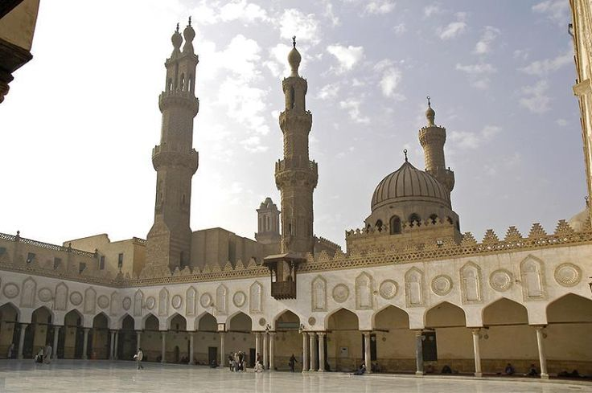**Figure 1: al-Azhar Mosque**

The mosque consists of a large, open central courtyard (20X69 meter) surrounded by three corridors from east, north and south, the eastern big campus corridor (85X24 meter) is divided into 5 halls facing the Qibla wall by four squadrons of arches supported by marble columns and Corinthian crowns taken from Roman and Byzantine buildings.[31] The campus is divided in its center by a high transept. The vaults and ceiling are higher than the level of the rest of the halls. The insides of the vaults were decorated with Quranic verses written in Kufic script, and the facades of the vaults were decorated with floral motifs. From the courtyard to the Qibla wall, at its end, a dome rises above the Miḥrāb (niche) decorated with carvings of leaflets shaped like half-fan palms and writings of Flowered Kufic script. A leaf in the form of fan palms topped with another leaf in the form of an inverted lamp is located at the top-center of the Miḥrāb. Two vaults are located in the sides of the first hall adjacent to the Qibla wall.[32]

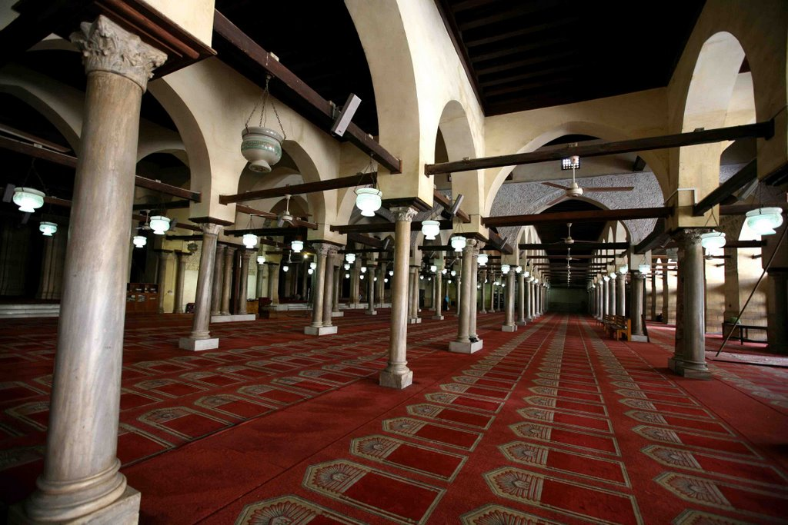**Figure 2: al- Azhar interior**

Both the northern and southern corridors are divided into three halls each. The main door, which is topped by the lighthouse, is located in the center of the western side of the mosque. The walls of the mosque are characterized by a new engineering art where the gypsum windows were opened in geometric forms, separated by fillings, surrounded by friezes decorated with Quranic verses written in Kufic script.[33] The Fatimid caliphs showed great interest in the architecture of al-Azhar Mosque, and in the year of 997 AD, the Caliph al-Āmir Bi-Aḥkām Allah ordered the building of a house for scholars of the Shiite doctrine next to the mosque.[34] The Caliph Al-Hakim bi Amr Allah also added a wooden Miḥrāb decorated with carvings of leaflets and numbered with Kufic script, as well as the date of completion: 519 Hijrī / 1125 CE.

The Caliph Al-Ḥāfiẓ li-Dīnillāh (1131-1149 CE) sponsored important architectural works and added a corridor to the mosque overlooking the courtyard of the four sides.[35] He also established a vault inscribed with Quranic inscriptions in Kufic script, and the Fāṭimah Zahra compartment next to the western door.[36]

The Azhar Mosque had a significant impact on the development of cultural, intellectual, and religious life in Egypt, due to the scientific assemblies held in it where doctrinal and Islamic judiciary issues were taught. The al-Azhar Mosque contributed to the development of educational and scientific progress in many intellectual fields, including religion, Arabic linguistic studies, life sciences, literature, art, engineering, and philosophy. This led to the evolution of scientific and intellectual institutes, continuing until the end of the Fatimid period.[37]

**al-Aqmar Mosque**

al-Aqmar Mosque was built during the era of Caliph al-Āmir Bi-Aḥkām Allah (519 Hijrī/1125 CE). He ordered its building, and it was established by his minister Mohamed ibn Fātik al-Baṭā’iḥī, according to the inscription in Kufic script on the front of the mosque that mentions the name of the caliph and the name of the minister.[38] The Mosque was built in the form of a regular quadrature rectangle from the inside and a trapezoid from the outside. Cabins and minaret ladders were built from the western and northern sides in order to make the front parallel to the street. The Mosque has a square open courtyard (10 × 10 m) surrounded by four corridors with orthogonal axes. Each corridor is built with convex vaults.[39] These vaults are supported by poles of marble, except the four corners of the courtyard, where the vaults are supported by four square-shaped columns.[40] The vaults were decorated with inscriptions in Kufic script, floral motifs, and medallions with geometric motifs. Three corridors are covered with small domes, while the fourth corridor, the Qibla corridor, is the largest and is covered with small shallow domes. The rear roof is covered with wood[41]. The western facade is the main facade of the mosque, divided into three sections. The middle represents the front of the main entrance, centered by the door of the mosque, and it stands out slightly from the other two sections. Its facade is adorned by carvings of three types of Kufic inscriptions. The door vault demonstrates master artistry, its interior decorated in parallel ribs that spread light from a round plate (medallion) engraved in its center with the names “Muḥammad” (S) and “’Alī” (A). This medallion is framed with a strip of floral motifs. The mosque interior is topped with a written strip stalactite entrance with four moments of stalactites inside an ornamental frame, topped by two small cavities held on attached columns which is one of the most important features of Islamic architecture.[42]

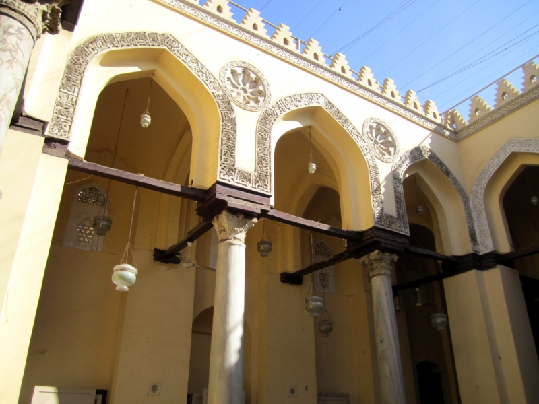

**Figure 3: al-Aqmar**

The other two parts of the facade are similar, centered by a door topped by a shining ribbed bonnet identical to the entrance bend bonnet, with a round hub inscribed in its center with the name of “’Alī” (A) surrounded five times by the name “Muḥammad” (S). In front of the bonnet, there is a double vault decorated with serrated motifs in the form of stalactites. It is topped with a gypsum decorative vicious round window shrouded from both sides with a window in the form of a niche. Its vault is based on two columns, with a lamp hanging from the top between the columns, which is considered the main surviving example of Egyptian Islamic architecture.[43]

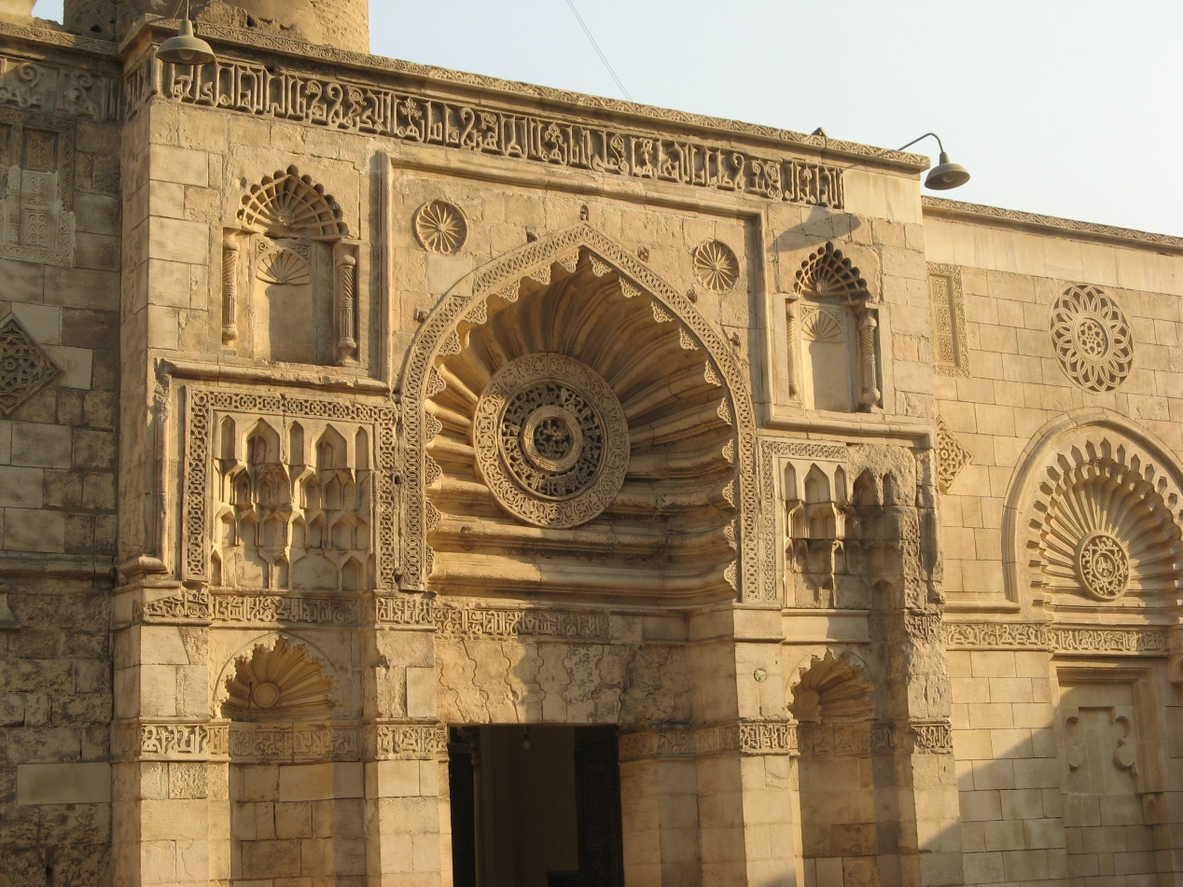

**Figure 4: al-Aqmar facade**

This facade was considered an architectural masterpiece, one of the most beautiful stone facades of mosques in Egypt. Some researchers assume that the reason for this decorative enrichment is because the Caliph al-Āmir Bi-Aḥkām Allah himself was preaching and leading the Muslims in the collective prayers like in al-Azhar mosque, entering the mosque from the main door, which was next to his palace’s eastern door.[44]

Al-Aqmar Mosque is considered one of the most beautiful mosques from the Fatimid era in Egypt. It testifies that geometric art, architectural motifs, floral and written inscriptions engraved in stone in the late Fatimid era had been mastered[45].

**Summary**

Generally, the Fatimid state was characterized by unstable rule, figurehead caliphs coming to power in childhood, their mothers and ministers carrying out administration of the state. It is worth mentioning that the caliphs’ army, especially in the period of the Caliph al-Ḥāfiẓ li-Dīnillāh, was interfering in state affairs. This led to an armed martial conflict between troops, resulting in the looting of shops, markets and houses in the city of Cairo.[46] This incident had a negative impact on both domestic and foreign policy.

Despite these difficult circumstances, the Fatimid caliphs al-Āmir Bi-Aḥkām Allah and al-Ḥāfiẓ li-Dīnillāh succeeded in preserving the achievements of the earlier Fatimid caliphs. These two caliphs succeeded in developing Egypt economically and made it the most important commercial center around the Mediterranean Sea. This had a positive impact on scientific and social life, causing a construction boom, and contributing to the integration of all segments of society, Muslims and Dhimmis, in administrative, economic, scientific and social life.

The Fatimids supported writers and scientists in Egypt generally, and especially during the reign of caliphs al-Āmir Bi-Aḥkām Allah and al-Ḥāfiẓ li-Dīnillāh.[47] They also sponsored thinkers, novelists, poets and calligraphers, and science councils in schools. The Fatimids were unique in building educational institutions and establishing public libraries that contain books from different cultures. Most notable Islamic intellectuals were influenced by Fatimid ideology and philosophy, and many of them, such as al-Fārābī, Ibn-Sīna, Ibn Ḥawqal, Ibn al-Haytham and Ikhwan As-Safa in Basra, were in contact with the ruling family in Cairo.

Foremost among the many reasons behind the building of schools in the late Fatimid era, was spreading and establishing Fatimid ideas. This was partly a response to the challenge of Dhimmis, such as the Armenians, Jews, and Christian Copts who had come to power, especially during the era of Bahrām al-Armanī (1135-1137).[48]

The caliphs al-Āmir Bi-Aḥkām Allah and al-Ḥāfiẓ li-Dīnillāh showed great interest in renovating and building mosques. First and foremost is the building of al-Aqmar Mosque.[49] Al-Aqmar Mosque is considered one of the most beautiful mosques of the Fatimid era in Egypt. It is a stunning example of Fatimid art, engineering, and architecture, characterized by floral motifs and written inscriptions engraved in stone. Second, the al-Azhar Mosque came to represent authentic Islamic style, as reflected in its architectural divisions, decorations at the top of the vaults, balconies with stairs that culminate in the walls of the courtyard, and building vaults decorated with Quranic verses written in Kufic script. These inscriptions are considered the most beautiful Kufic script styles from the Fatimid era.

The planning of both al-Azhar and al-Aqmar Mosques, with their different sections, was carried out in accordance with their everyday usage in the fields of science, literature, and religion. In addition to writing, religious lectures in mosques and other religious institutions were also important modes of communication. One of the most important factors that led to a cultural, philosophical and constructional renaissance, was the mosques’ role in forming and conducting study circles that involved intellectuals from all over the world. Ideological tolerance spread through the Fatimid state, prompting many prominent intellectuals from other Islamic countries to leave their homeland and move to Cairo to escape political pressures and ideological prosecution.

1. Kharanbeh 2015, p.145
2. Scientists and scholars were granted monthly salaries and housing was established for them (see: Ibn Abī Uṣaybi‘ah 2010, p. 105). Also calligraphers, readers and scholars of Fiqh, grammar, language and modern history, astronomy, physics and chemistry were supported (see: Tamer 1980, p. 15).
3. al-Maqrīzī, al-khi ṭaṭ (The plans), vol. 1, p. 416; Zakī 1937, p.74.
4. About the lives of al-Āmir and al-Ḥāfiẓ (Kharanbeh 2015, p.22-26)
5. Ibn Maysir, al-Muntaqā min akhbār Misr, p.11; Sayyid 2000, p.227
6. Ibn Aṭ-Ṭuwayr, Nuzhat al-Muqlatayn, p.10. The minister al-Maʼmūn was killed in 1128 AD by the Caliph al-Āmir (see Ibn Maysir, al-Muntaqā min akhbār Misr, p.107).
7. al-Maqrīzī, al-khi ṭaṭ, vol. 2, p. 345-418; Zakī 1937, p.74.
8. Saʻd 1979, p.28
9. An-Nuwayrī 2002, Nihāyat AL- ʼ arab, vol.26, p.90.
10. al-Maqrīzī, al-khi ṭaṭ, vol. 2, p. 378; See also Barkāt A 1998, p.27-28; Kharanbeh and Hamad 2016, p. 1-4.
11. al- Qalqashandī, Subḥ al-A’shā, vol.6, p.460-461.
12. al-Maqrīzī, al-khi ṭaṭ, vol. 2, p. 471.
13. Barkāt A 1998, p.34-43.
14. Goitein 1980, p.54-60; Gil 1983, p.419-421.
15. al-Maqrīzī, al-khi ṭaṭ, vol. 1, p. 240-416
16. Uthmān 2006, vol.1, p.185.
17. Goitein 1955, p.80-82.
18. Tiraz is an epigraphy above or around the mosque door. The Jamah is an epigraphy sculpture in the middle of Islamic epigraphy.
19. Ukāshah 1994, p.77
20. Creswell 1949, vol.1, p.16-39.
21. For the history and the building of the seven mosques see: al-Maqrīzī, al-khi ṭaṭ, vol. 2, p. 442; Māhir 1996, vol.1, p.97, vol.2, p.112-123; for the history of building al-Aqmar Mosque see al-Maqrīzī, al-khi ṭaṭ, vol. 2, p. 290, It-tiʻāẓ al-Ḥunafā` vol.2, p.191; Māhir 1996, p.324; Muʼnis 1981, p.257.
22. Williams 1985, p.39.
23. Māhir 1996, vol.2, p.126-129.
24. Dujaylī 1999, vol.3, p.41
25. Maqrīzī, Al-khiṭaṭ, vol. 1, p. 340-341.
26. Kharanbeh 2015, p.148
27. Ibn Uthmān, p.192; As-Sakhaw ī 1986, p.315-316; Maqrīzī, Al-khiṭaṭ, vol. 2, p. 448.
28. Maqrīzī, Al-khiṭaṭ, vol. 1, p. 484
29. This mosque was also known as Cairo Mosque.
30. Maqrīzī, Al-khiṭaṭ, vol. 2, p. 233-273.
31. Rabbāt 1996, p.47-48.
32. Creswell 1949, vol.1, p.16
33. Ukāshah 1994, p.184
34. Maqrīzī, Al-khiṭaṭ, vol. 2, p. 370
35. Rabbāt 1996, p.47
36. Umarī and Ṭāyish 1999, p.68.
37. Kharanbeh 2015, p.146; Today, and with the additions that occurred after the Fatimid era such as the building of the administration of the mosque and its windows “al-Arabisk” and the building of the new Azhar mosque hospital, the mosque has lost a lot of its Fatimid beauty, but efforts continue to preserve its characteristic original Islamic construction traits, as reflected in the architectural divisions and decorations.
38. Behrins-Abū yūsif 1992, p.29,
39. Convex vaults had not been seen in prior Islamic construction, apart from the shaykh Yūnis dome which had been built by the army commander Badir Aj-Jamālī. (Creswell 1949. Vol 1. p.26)
40. Williams 1983. Vol. 1.Fig. 1. P.48. and Naoko 2017, Vol. 52:93-118.
41. Creswell 1949.Vol 1. Pp.26
42. Ukāshah 1994, p.196-197.
43. Creswell 1949.Vol 1. Pp.26-27. Some researchers think that this design was adopted from, or influenced by, Suljūk ornamentation (Yassin 2002, vol. 791, p.1)
44. Creswell 1952. Vol. 1, pp. 247. Al-Aqmar Mosque is located inside Cairo, in the Naḥḥāsīn area on the eastern side of al-Mu`izz street, adjacent to the great eastern palace from the eastern and southern sides, and from the northern and western sides it is bordered by two streets. Maqrīzī, Al-khiṭaṭ, vol.2, p.290).
45. Muʼnis 1981, p.257;Māhir 1996, p.324
46. Maqrīzī, It-tiʻāẓ al-Ḥunafā, vol.2, p.231-233.
47. Maqrīzī, Al-khiṭaṭ, vol.1, p.158; Srūr 1970, p.178.
48. Ibn Maysir, al-Muntaqā, p.122; Maqrīzī, It-tiʻāẓ al-Ḥunafā ` vol.3, p.159
49. Aṭallah 1958, p.719.