**What Do Children Know About Theatre? Elements of the Semiotics of Children’s Theatre**

**Smadar Mor and Shifra Schonmann**

*She killed him, but it wasn’t really a man, because they used one of those black capes, and then they added a doll’s legs, and put shoes on it and everything. It wasn’t really a man, and when they made it dark they took – they took the things that were there and replaced them with other things, like the broken house, you can’t really break it, you just take it, just break everything… You can’t, so they turned off the lights and then turned them on again.*

This is how Canaan, a five-year-old from Ra’anana, Israel, explains that there is a language of signs in theatre, a language of make-believe: *“It wasn’t really a man.”* We must seek to understand this language based on its conventions. Canaan says: *“They made it dark… took the things that were there and replaced them with other things…”* Using simple words, he expresses a widely used theatrical convention, whereby darkening the stage allows the narrative to overcome a technical difficulty that exists because theatre is a fictional performance that is in dialogue with reality. Canaan grasps astutely that in order to advance the plot taking place onstage, something must happen that will allow the scenery to be changed, and these actions must take place in darkness, since *“you can’t really break it… so they turned off the lights and then turned them on again.”* That is, signs are used to communicate with the audience: darkness signifies concealment, and light signifies advancing the plot. The technique described by the child is, in fact, a theatrical convention.

It is interesting to note in this context that children often make use of the word “just,” meaning “simply” (in Hebrew *pashut*). Ori explains, *“Now the sky is gray… because the lights, they just turned them off and turned on a gray light.”* Michal explains the source of the light on the stage: *“They just put up a few spotlights and turned them on.”* When Smadar tries to understand why children yell out during the performance, Dana explains: *“I guess they just wanted to shout something to them during the play, they simply wanted to tell them something.”*

But is it really so “simple”? What do children understand about theatre? Upon what is this understanding based? What do they experience? What do children understand when they say “just” or “simply” – that we adults do not understand?

Semiotics, the theatre’s language of signs, is not a “simple” language at all; it is the foundation of theatrical communication between stage and audience, and creates the viewing experience. To understand the theatrical viewing experience is to understand the manner in which a theatre performance is received as well as the comprehension process that enables the viewer to derive meaning and enjoyment. In this article we will focus on the viewing experience of children in kindergarten (aged 5–6) to identify reception processes based on semiotics and grounded in notions of aesthetic distance. In what follows, we will examine the manner in which kindergarten children make use of signs when they speak about their theatrical experience.

**Semiotics in Children’s Theatre**

Semiotics is the study of signs and signification systems. In the 21st century, semiotics has become one of the leading tools to understand our cultural lives, which take shape through signs and codes that must be deciphered. Theatre studies have gone through significant shifts in their relation to the language of signs. The initial reception to semiotics, in the 1960s, was rather hesitant, but in the 1980s and 1990s this initial approach gave way to vibrant research, attempting to ground theatrical understanding in deciphering predefined semiotic systems. By the beginning of the 21st century, the study of theatrical reception had almost completely invalidated the semiotic approach. The present study seeks to return to the early stage in theatre studies, and particularly to the unique theatrical semiotic taxonomy suggested by Kowzan (1968), which includes thirteen components that appear on stage during a performance. Eight of these components relate directly to the actor: word, tone, mimicry, gesticulation, movement, makeup, hair design, and costume. Five additional components are non-actor related: props, scenery, lighting, music, and sound effects.

In Kowzan’s semiotics, the actor is understood as the text’s main representative, a position which leads many contemporary scholars to consider the approach to be dated. Today, theatrical performance can be interpreted using complex expressions that do not privilege the actor with a central role. Theatre may nowadays be seen more as a performance than as a play. The decreasing importance of semiology in theatre studies can be explained by this development, characteristic of postmodern theatre, as well as by the position adopted by a group of scholars according to whom semiotics has reached an impasse and cannot enable the field to develop further.

We, the authors, disagree with this approach, and consider semiotic analysis to be a valuable tool for understanding any performance. Theatre, and above all children’s theatre, but also any other art form, will always “speak” in a language of signs that must be deciphered, which is the main reason why so many scholars first turned to semiotics. Scholars of children’s theatre, who have researched the reception of plays by young children, have remarked that Kowzan’s semiotic elements allow children to speak about their experience naturally and easily, deriving meaning and satisfaction.

**Aesthetic Distance in Children’s Theatre**

Aesthetic distance, a central term in semiotics derived from aesthetics, refers to the psychological position of a person enjoying an aesthetic experience. In 1912, Edward Bullough coined the term “psychical distance,” which later also became known as “aesthetic distance.” This term seeks to describe a conscious or unconscious psychological phenomenon that takes place when watching a natural phenomenon or a work of art, enabling an aesthetic experience whose purpose is pleasure. In theatre, “aesthetic distance” describes the viewer’s position in the cognitive range stretching between two poles: a complete identification with the events transpiring on stage – a point at which the boundaries between fiction and reality blur, and dissociation and/or alienation from the theatrical scenario.

The difficult and elusive nature of aesthetic distance is a topic of controversy among scholars, who debate whether it can be used to examine the manner in which children comprehend theatre. Schonmann, in her reading of Bullough (Schonmann 2006), stated that creating the “optimal aesthetic distance,” although paradoxical, is nonetheless possible. She argues that the child must be able to temporarily renounce the connection to reality in order to enter into the diegetic world unfolding on the stage, while at the same time remaining in reality, that is, aware of being seated in the theatre. As we currently lack a theory to understand the way in which children are involved in creating the fiction of theatre, Schonmann suggested constructing an index to measure maintenance of aesthetic distance during children’s theatrical viewing process. Based on multiple observations of children’s theatre, she established four criteria**: the child’s body language, overt expressions of emotions, words spoken by the child, and the child’s reaction to his or her environment**. These organizing criteria enable a three-tiered interpretive structure for understanding the relationship between aesthetic distance and the presence or absence of pleasure:

**Under-distance:** A state of viewing in which the child is so involved in the diegetic events that he treats it as the real world in which he is living.

**Over-distance:** A state of viewing in which the child is entirely uninvolved in the diegesis.

**Optimal distance:** A state of viewing in which the child shows the correct degree of involvement in the theatrical events, thereby achieving a sense of release that gives him aesthetic pleasure, (Schonmann 2005, pp. 72-74).

During the play, the child may transition from one level of aesthetic distance to another, at times lacking distance, at other times too distant, and at times in a state of optimal distance. This is a psychological mechanism through which the viewers’ emotions and thoughts fluctuate during viewing. People differ from one another in their ability to react to fictions. In order to fully understand theatrical viewing, we must understand the central role played by movement along the aesthetic distance scale.

**The Study of Theatre Viewing**

In this article we present a reworking of some of the findings of Smadar Mor’s doctoral dissertation, completed under the supervision of Shifra Schonmann (Mor 2015). The research was conducted in four cities in Israel; 24 kindergarten children, aged 5-6, watched two plays performed in large repertoire theatre halls or civic cultural centers. Participating children were selected by their kindergarten teachers, and all were all capable of verbal expression. Each child watched two of the following four plays, offered by the Israeli *Sal Tarbut* (a cultural program run by the Israeli Ministry of Education):

1. “Datia’s Shtuzim Warehouse”: A play by poet Datia Ben Dor, who also wrote the songs and composed the music, directed by Yaki Mahraz and produced by Orna Porat with the participation of Nava Productions. The play invites the audience (children aged 3-6) into the poet’s “shtuzim warehouse” (“shtuz” is a nonsensical term, and “shtuzim” is its plural). There, they meet the Shtuzniks: Shtuza, Shtuzit, and Shtuzi Tapuzi (Orange Shtuzi), who teach a pizza delivery boy to invent rhyming nonsensical phrases. The delivery boy, who only appears on stage to deliver a pizza to Ben Dor, meets Grandma Mina from Binyamina, the Girl with the Umbrella, the Mixed-Up Colors, and the Naughty Ones in Bed, and a host of other colorful characters hiding away in the mysterious boxes inside her warehouse.
2. “The Wizard of Oz”: An adaptation of the play by Daniel Efrat and Gilad Kimhi, and directed by the latter. The production is a joint enterprise by the Mediatheque Theatre and the Beit Lessin Theatre. The play is a new production that includes an original musical score with new lyrics, alongside the familiar songs associated with L. Frank Baum’s classic book. It is intended for children aged 4 to 9. The plot takes the viewers on a coming of age journey that demonstrates the power of true friendship, goodness, and innocence. It is the story of Dorothy, who goes on an adventure-packed journey in the Magical Land of Oz, with her dog Toto, and three friends she meets along the way: a scarecrow with no brain, a heartless tinman, and a cowardly lion. At the end of their journey, the group finds the Wizard, who shows them that they have already obtained what they had set out to find.
3. “The Necklace”: Written and directed by Michal Rubin, this original fairytale concerns a royal necklace and a chain of lies. It tells the story of a beloved princess, who tries on a royal necklace that only the queen is allowed to touch. The princess unintentionally tears the golden thread that holds the beads together, and they scatter on the floor. In an attempt to repair matters, the princess is forced into a series of lies. When the chain of lies tightens around her she flees the castle and goes on a journey that leads her to the truth.
4. “The Frog Prince”: A new adaptation of the Grimm Brothers’ fairytale by the same name, written by Ilan Savir and Ofira Archoni, who also directed. In this production, produced by the Mediatheque Theatre, the actors use puppets, masks, and pantomime to enact the legend of the prince who was turned into a frog by a witch, and can only be turned back by a princess’s kiss. It is an allegorical play that, at first glance, may appear to be an innocent children’s story but which contains multiple and layered meanings.

As mentioned above, the present study involved observing the children during the course of two viewings. The first viewing took place in the kindergartens, as part of the *Sal Tarbut* programming*,* which provides children in the Israeli educational system the opportunity to partake in cultural events. The second viewing occurred in the presence of the children’s parents. All of the children who participated in the study had previously visited the theatre.

Our research tools were direct observation, Theatre Talks, drawings made by children during these conversations, and personal interviews.

Although observations took place inside the darkened theatre halls, it was nonetheless possible to document the children’s authentic verbal and physical reactions. This research was carried out according to Spradley’s (1980) classic approach.

The Theatre Talks were conducted according to the method developed by Sauter (2000), whose primary principle is free conversation between viewers who have all watched a single theatrical piece. The group conversation creates a high degree of willingness among participants to examine new ideas and their consequences. Each conversation lasted between 30 and 45 minutes. In order to focus the discussion, the children were shown pictures from the program, booklet, or leaflet produced by the theatre.

We also used drawing as a tool through which the children could express their experience of the plays. According to Malchiodi (2004), drawing gives children an opportunity to explain the elements they chose to draw from their own vantage point. While drawing, the children discussed what they were doing amongst themselves, and this discussion clarified the contours of their common experience, as well as the idiosyncratic ways each child had experienced the play.

Semi-structured personal interviews were an opportunity for every child to develop their own personal statement. A personal questionnaire was composed for each child, based on their behavior during viewing and things they had said in conversation and while drawing. An analysis of the children’s statements collected during the research stage necessitated the use of the ATLAS.ti program, which performs analytical manipulation that allows the data to be analyzed from new and unpredictable perspectives.

Research ethics in studies on young children are a particularly sensitive topic. The necessary permits were obtained from the office of the Head Scientist at Israel’s Ministry of Education, from parents, and from kindergarten teachers. We also kept the identities of the children and their kindergartens confidential. Moreover, although many researchers do not do so, we requested approval from the children, making clear to them that at any given moment they may choose to withdraw from the study. Our main ethical principle was to maintain the balance between research needs and the welfare and privacy of the participants.

**What do Children Know?**

Based on Kowzan’s thirteen semiotic components and Schonmann’s aesthetic distance scale discussed above, we sought to answer the following question: How does the theatrical semiotic system function in kindergarteners’ viewing experience? How is aesthetic distance in theatre connected to the language of signs that allows communication between the children viewing the play and the action taking place on stage? Our guiding question was: What do the children understand and how do they express it?

**The Semiotic Systems**

**Dramatic Discourse: Language, Words, Tone**

We found that the most influential semiotic system affecting the kindergarteners’ reception of the play was related to dramatic discourse, which plays an important role in constructing meaning and understanding. As N. explained in the Theatre Talks, *“We need to see the plays to understand what they are saying,”* or as D. said, *“The words, the words, ‘we are shtuzonim’ – so we know they are shtuzonim.”* The more highly developed the children’s linguistic capacities, particularly among children nearing their sixth birthday, the more we found increased use of verbs related to “saying” (the Hebrew root A.M.R.) to describe the play. This is evidence of an ability to follow and decipher the plotline:

*And they said “Oh, here’s the good witch,” and she said “You could’ve gone home a long time ago.” And she said “The answer has been under your nose, or really under your feet.” And she said “Yes! That’s right! The shoes!”* (A., from the N. kindergarten in Ra’anana, in a Theatre Talk)

Developmental psychologists assert that linguistic abilities developed at kindergarten age contribute to communicating complex meanings. The children’s growing ability to understand the verbal communication of their daily lives draws their attention to the diegetic discourse – the word, its tone and pitch, the linguistic sequence, and intonation all draw the children’s attention: *“You have to do the right voice, you have to make a girl’s voice, even if you are a boy actor”* (T., from kindergarten A. in Kfar Saba).

The younger children tended to use linguistic expressions representing actions rather than discourse: *“Why were they crying? Because he went (…) I don’t know why he went. Because he also wanted to dress up as a Shtuzon,”* (5-year-old A., from the P. kindergarten in Tel Aviv).

The children used the characters’ words to characterize them. When asked how we knew if a character was bad, D., from N. kindergarten in Ra’anana, replied: *“Because he said not nice words to that woman,”* adding that vocal characteristics, in this case the voice’s volume, were indicative of the character’s bad nature: *“Because she said ‘Wait for me there,’ like she was screaming.”* A. from the B.B. kindergarten in Kfar Saba added that characterization relied not only on words but also intonation, or “*the way she talked.”*

In the narrative parts of the plays, the children easily followed the verbal action, and readily interpreted what had taken place on stage in their own words: *“It was because she wanted to bring her mother a necklace, her necklace. But the necklace – she just wanted to try it on, just for a second, but it didn’t come off, and she pulled and pulled, and it tore, and then she hid it. In a pillow”* (R. from the S.S. kindergarten in Rishon LeTsiyon).

In comparison, when the action was communicated through song, accompanied by music that might have drowned out the words, the children experienced some difficulties comprehending the action. Many children seemed to treat the songs as a kind of break in concentration. *“It’s not really important,”* said T. from the N. kindergarten in Ra’anana. Our observations showed that while listening to musical songs, the children relaxed their bodies and leaned back:

[During to the song “Porcupine on the Beard.”] She leans back, slipping a bit off the chair. Withdraws into herself, pulling in her limbs. She gets back into a relaxed position against the back of the chair. Moves her body forward on the seat. (Observation notes on T., from the M.K. kindergarten in Rishon LeTsiyon)

**The Appearance of the Stage: Scenery, Lighting, Props**

In analyzing the children’s responses to the plays, we found that the second largest semiotic system affecting the reception was related to visual elements of the stage. The children mentioned the props and recreated them in drawing. They explained what they had chosen to draw: *“I’ll draw you a box”* (Theatre Talk, P. kindergarten in Tel Aviv), or, “*I’m starting [to draw]… I started with the slide and the boxes. I’m starting with the objects […] the ones that don’t move”* (M., from the B.B. kindergarten in Kfar Saba). Oftentimes they added a description of the action that accompanied the object: *“Now I’m drawing the letter that flew away”* (Theatre Talk, A. kindergarten, Kfar Saba). In Fig. 1, S. has drawn the stage: the characters, the costumes, the lighting, and the props.

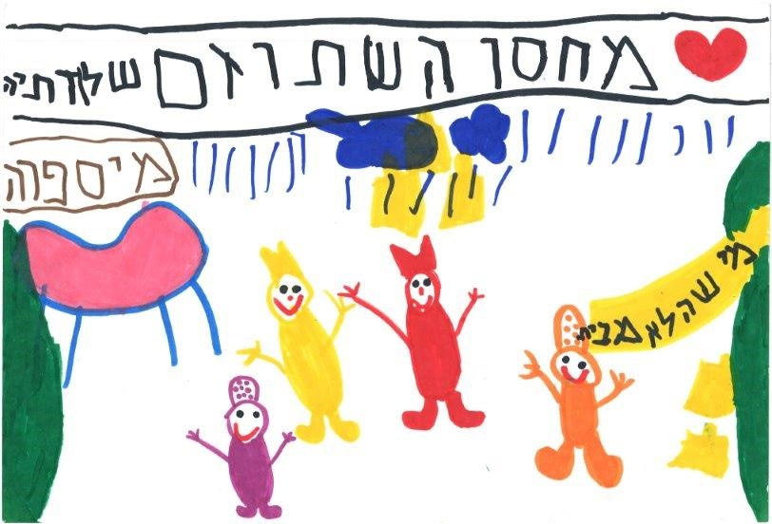

**Fig. 1: S., from D. kindergarten in Ra’anana, “The Shtuzim Warehouse”**

Numerous statements collected in this study attest to the importance of the semiotic system concerning “the appearance of the stage” and its contribution to the children’s understanding of meanings represented on stage.

Below are several examples that demonstrate the central role of props in children’s understanding of the play. A prop could define a character*: “Because she has a shawl, she has a purse like a lady’s, like a grandma, and she had things that grandmas have”* (H. from the H.G. kindergarten in Tel Aviv). A prop might create gender distinctions between characters: *“The boys have the hat with the pointy tips, and the girls have the round hat”* (D. from the B.B. kindergarten in Kfar Saba). Props could also be part of a character’s costume: *“A crown is also part of the costume”* (N. from H.G. kindergarten in Tel Aviv). Some children were able to discern when a prop had become part of the scenery: “*They took it [the letter] and made it kind of big, and wrote on it with a black pen, and cut it up […] so they could make a play”* (R. from the S.S. kindergarten in Rishon LeTsiyon). This is a fine distinction, evidence of an understanding similar to that which examines the important role of props in directing the viewers emotions: *“Maybe they found it in their house, and brought it to the play to be funny”* (A. from P. kindergarten in Tel Aviv).

The children understood that the props and scenery were not real:

*Smadar: Was the sun real?*

*R.: No.*

*Smadar: It wasn’t real… How do you know it wasn’t?*

*R.: Because they kept moving it around, turning it around, and you can’t have a real sun inside the…*

*Smadar: Inside of the what?*

*R.: Inside a room.* (R. from S.S. kindergarten in Rishon LeTsiyon)

The children referred to the scenery, a central element in stage design, while drawing, (see Fig. 2). They tried to draw the scenery as it had been on stage, selecting appropriate colors: *“Now I’m doing the benches, we need brown… Now we’ll draw the man on the bench”* (D., from B.B. kindergarten in Kfar Saba).

It was apparent that the children, even the youngest among them, were aware that the scenery represented reality, but that it was not itself real:

*A.: (Draws the sky) Here’s the sky.*

*O.: But they weren’t outside.*

*A.: It’s make-believe, but there was a sky in the play*. (Theatre Talk, P. kindergarten, Tel Aviv)

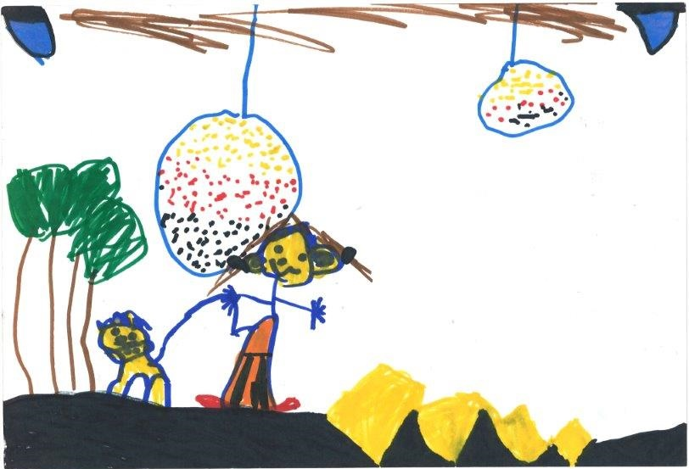

**Fig. 2: M. from A. kindergarten in Kfar Saba. “The Wizard of Oz”**

The children were aware of the reasons for the scenery changes: *“The princess lives in a castle, and if you want to move… [to go to] a place where I need to go for a walk, then you make a black screen, you set the scenery, and then you lift the screen”* (D., from B.B. kindergarten in Kfar Saba). D. used professional words like “black screen,” to “set the scenery,” and to “lift the screen,” and her speech showed that she understood the function of scenery. At the same time, it was clear that this understanding did not spoil the illusion created by the scenery, nor did it interfere with her viewing experience.

Some children referred to scenery changes as though the play’s producers wanted to create a magical effect: “*They wanted it to be like magic, so they just built it, so the sun, they just put it there, and there was another string connecting it, and they put it – there was a fishing line, and they just turned it upside down, and at the same time those who were on top also turned it upside down*” (M. from A. kindergarten, in Kfar Saba). Another child said, *“What came down was really paper […] They couldn’t bring real snow […] It would all melt by the time they got to, from the Hermon [mountain in Northern Israel] to Tel Aviv […] If they brought real snow they would just be spilling snow-water, and all the actors would get wet*” (C., N. kindergarten, Ra’anana).

The children paid relatively little attention to the lighting in comparison with other semiotic elements. However, Fig. 2 shows a reference to the stage lighting in the upper part of the drawing (in blue.) Children who mentioned the role of lighting did so clearly: “*Then they turned out all the lights, because if they [the audience] saw them going to lie down, they would think the play had already started… So they turned off the lights so they wouldn’t see…*” (A., from A. kindergarten in Kfar Saba); “*When they’re in the dark, it’s like they want to do something that they don’t want the audience to see […] And then it’s like the house is broken.. It’s like Houdini,”* (C., from N. kindergarten in Ra’anana). These statements reflect the children’s insight into how truth is enacted on stage. They attributed the power of advancing the plot to the lighting, particularly by turning it off, and replacing the scenery: *“You can’t really break it […] You can’t, so they turned off the lights and turned them on again”* (C. from N. kindergarten in Ra’anana).

Another important role that testifies to the fine distinction drawn by some of the children were expressions related to the way lighting sets the mood: *“When there was that storm, then it was dark inside”* (O. from N. kindergarten in Ra’anana). The children attributed the change in lighting to the actors: *“The actors must have gotten behind the curtain, and when we didn’t notice they just moved the lights a little bit”* (S. from D. kindergarten in Ra’anana). These statements demonstrate how logic, intuition and accrued knowledge come together in an impressive understanding of the roles of lighting in theatre, even if only a few of the children remarked on these details.

**The Actor’s Appearance: Makeup, Hair Design, Costumes**

Children understood that costumes serve the actor: *“They only dressed up because they’re actors”* (R., from S.S. kindergarten in Rishon LeTsiyon). The children understood that *“a princess’s costume means that she is a princess. A clown’s costume means that it’s a clown. The audience knew who everyone was”* (D. from B.B. kindergarten, Kfar Saba). Kindergarteners understood thatcostumes were required *“in order to look like someone else”* (M., from B.B. kindergarten, Kfar Saba), and *“By wearing the clothes he can be a Shtuzon”* (O. from P. kindergarten in Tel Aviv).

The children used their knowledge of color symbolism to decipher characters’ personality and role: black signifies the villain, while the hero or heroine often wears white. *“The good-guys also wear it like this [demonstrates], but nicer-looking, with flowers… And the witch has only black. But hers is with flowers, because she was good”* (O., from D. kindergarten in Ra’anana). The children discerned the messages encoded in the costumes, which wordlessly transmit information about character and plot. Using their knowledge of articles of dress, along with conventions of signification concerning superheroes familiar to them from television, the children deciphered the characters and their nature: *“Because the bad-guys have a black cape. But Batman also has a black cape, but he has a sign that he’s good, he has a bat”* (C., from N. kindergarten in Ra’anana). In understanding characters based on their appearance, children also make use of their experience playing socio-dramatic games in kindergarten.

**Bodily Expression: Mimicry, Gesticulation, Movement**

The children readily understood the role of bodily expressions in characterization. When asked how one would be able to identify a character without hearing their words, O., from N. kindergarten in Ra’anana, replied: *“We’d be able to see from the way they act,”* and in another conversation she added, *“He did bad movements, so he’s bad.”* The children easily grasped mimicry, gestures, movement on stage, and characterization techniques employed to advance the narrative or set a mood. For example, J., from M.K. kindergarten, enjoyed the slapstick elements and said, mimicking the motion, *“This [motion] always makes me laugh, always.”* O. from B.B. kindergarten in Kfar Saba explained what he had to do when he took part in a play in kindergarten:

*O.: I did special movements.*

*Smadar: What kind of movements?*

*O.: Like this. I went into the castle like this [stands up straight, walks slowly, with his head held high].*

The children also used body language, or lack thereof, as a semiotic system with which to interpret the play. *“I thought it would end sadly, because she didn’t kiss him the whole play, only at the end”* (A., from H.G. kindergarten, Tel Aviv). N., from H.G. kindergarten in Tel Aviv, explained that she knew the play was over because the actors bowed. The children seemed to enjoy watching the bodily gestures and motions of the actors on stage and emulating them: *“They do everything lightly, like this [stands on bench], that’s how they get up, they just stand right up.”* And further on: *“It’s fun to dance”* (D. from B.B. kindergarten in Kfar Saba). Based on these observations, we can assert that kindergarten children decipher narrative with the help of body language. Whether they explained it verbally or showed it through mimicking the movements, children clearly were aware of the role that body language played in creating characters, communicating the plot, and directing the emotions of the viewers.

**Sounds: Music and Sound Effects**

In comparison with other semiotic systems, such as dramatic dialogue or props, the children made few references to the music, demonstrating the relatively secondary importance they attributed to this system. At the same time, they were aware of music’s role with regards to the events on stage, namely, advancing the plot and symbolizing or representing the general mood of the characters and the play: *“It’s supposed to show something sad”* (O. from N. kindergarten in Ra’anana). The children understood music, particularly its intensity and volume, as having a physical effect, whose source was its emotional power: *“If it [the music] is really, really loud, then I feel it in my throat, and it’s really-really, it’s really like it’s going like this [points to throat]. And if it’s quiet, then I hear it normally”* (O. from N. kindergarten in Ra’anana).

The children also understood the role of sound effectsin creating illusion: *“I can hear the storm, so they don’t have to say anything, because I can hear it”* (A. from P. kindergarten, in Tel Aviv). The children then looked for logical explanations as to how the sounds were formed, that is, they accepted the sounds as part of the play’s greater signification system: *“The rain is just an example, and, the – what’s it called? – the thunder, it’s just a radio they put on the roof […] and there’s a kind of electrical wire going from the radio to the warehouse”* (N., from H.G. kindergarten in Tel Aviv).

**Interim Summary: What do Children Understand of Semiotic Systems?**

It seems that, without knowing it, kindergarten children naturally speak in terms remarkably evocative of Kowzan’s writings. While viewing the play, they actively decoded the texts and the actors’ appearance and body language. They discerned the appearance of the stage and functions of the props, the scenery, and the lighting. They were attentive to the sights and sounds, and enjoyed the diegetic reality, whose revelation sets their imaginations in motion. In other words, the children understood that the signs they saw on stage were representations of reality and function metaphorically*: “Because red means… Ummm… Something like blood, and this kind of red means fire, as if something is burning, or something bad is happening”* (O. from N. kindergarten in Ra’anana). By assembling several semiotic systems, the children deciphered the metaphorical world constructed on stage: *“If there weren’t any of the things [props], then how could they do the play? What, they’d just talk?”* (H., H.G. kindergarten, Tel Aviv). As reported by Reason (2010), the children used semiotics to create meaning. Their semiotic understanding seemed to be, in part, an expression of their level of cognitive development, in part an expression of emotional and social abilities acquired by roleplay, and in part an expression of cultural ability acquired by watching television or theatre.

## Aesthetic Distance

In seeking to understand the children’s viewing experience not only from a semiotic perspective but also an emotional one, we examined a number of issues related to aesthetic distance. One of the emotions that can be awakened by events unfolding onstage is fear:

*We look at the stage really carefully, and if we’re afraid, then we’re afraid, and if we’re not afraid, we’re not afraid, [but sometimes] we are afraid [smiles], oh well, what can you do? Maybe it’s a scary play […] If, for example, there’s a part that scares me […] I can be really, really, really, scared, like, not really, but a little […] scared.* (A. from P. kindergarten in Tel Aviv)

When children are situated at the optimal aesthetic distance, i.e. on the one hand, believing the illusion onstage is real but on the other hand understanding that the diegetic reality is fictional, then a situation in which they feel scared may actually provide them with a sense of overcoming their fears. When the fear becomes tolerable, and even to a degree pleasurable, then we can say with certainty that the child understands that the staged events represent reality but are not reality itself. Optimal aesthetic distance provides the children with an aesthetic enjoyment derived both from their audio and visual sensations, and from the decoding and re-encoding of these signs within their consciousness. The child can say: *“Nothing is real, but they [the actors] are real.”* The study’s findings emphasize the possibility that even kindergarten children, whose artistic perception is in its initial stages, can develop an “optimal aesthetic distance.”

We found that the children were largely aware of the conventions of “make-believe.” By enlisting knowledge from familiar semiotic systems, the children could adjust their degree of aesthetic distance. Using familiar semiotic systems allowed the children to formulate phrases such as: *“Because if he were a real magician who was playing an actor, then he could really fly without ropes […] He isn’t a real magician, so he needs ropes”* (A. from A. kindergarten, in Kfar Saba).

Children in earlier stages of development, who have not yet fully accepted the convention of the suspension of disbelief, at times justify the breaking of natural laws by a belief in magic, in order to create order in their reality. Thus, they may enjoy the play even if they have failed to achieve optimal aesthetic distance: *“Right, it really was a real magician […]. Yes. Without a wand”* (Y., from the M.K. kindergarten in Rishon LeTsiyon). Fig. 3 illustrates a child’s understanding of aesthetic distance, expressed in the physical separation between the stage and the audience:

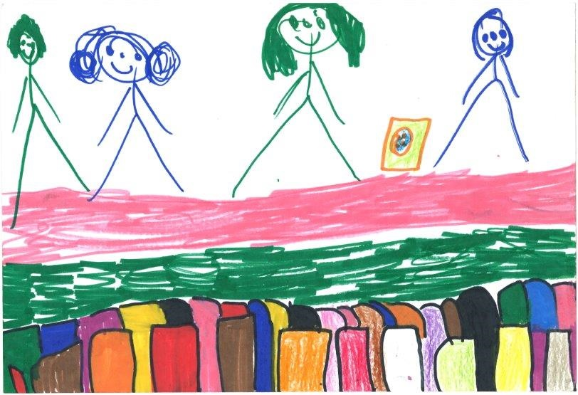

**Fig. 3: N. from N. kindergarten in Ra’anana, “The Shtuzim Warehouse”**

The variability, a dimension coined by Bullough, enables us to introduce gradations into conceptions of aesthetic distance in two ways: under-distance and over-distance. We found that over-distancing did not keep the children from enjoying the play. They were aware of the ways in which the play’s creators produced the show, changing costumes and stage settings, but this knowledge did not detract from their enjoyment of the experience. On the contrary, it helped the children concentrate on the play. In this sense, kindergarten children understood what we as adults tend to forget, that the optimal aesthetic distance transpires when the viewer is aware of the illusion: *“But the lion wasn’t scary for me […] A lion should go like this and like that [demonstrates], and he didn’t have any feet and wasn’t real”* (O., from D. kindergarten in Ra’anana). The children were even aware that overcoming their fears by means of over-distancing is linked to development: *“Babies are the most scared. They’re scaredy-cats. Because they are little […] so they cry [demonstrates]”* (O. from D. kindergarten in Ra’anana).

The children’s body language, as observed in the theatre, reflected the tensions they were exposed to during the play as well as their level of aesthetic distance on the scale mentioned above. Their bodily movements also disclosed physical reactions that point to stress and concentration:

A. lifts his hands up, places them behind his head, and then leans forwards in his chair, with a hand on the backrest of the seat in front of him. He stretches, moving side-to-side. He turns to me with a worried face: “But in the end the princess will kiss him, right?” He wiggles a bit in his chair, leaning onto the chair in front of him. Then he shifts about, moving to the edge of his seat, and leaning onto the backrest in front of him. He bends sideways, into the gap between the two chairs, keeping his head upturned towards the stage, his body slanting downwards. His mouth is agape.(Observation notes from the H.G. kindergarten in Tel Aviv, “The Shtuzim Warehouse”)

The children were aware of the tensions they felt while viewing the play, and in their interviews explained the reasons for their emotions: *“I thought the end would be sad, but in the end it was happy”* (A. from H.G. kindergarten in Tel Aviv). The children easily grasped what researchers have tried to formulate again and again. They simply said that in the play: *“Lots of stuff isn’t real, almost nothing was real”* (A., the H.G. kindergarten in Tel Aviv). In Fig. 4, we can see the child’s journey to transition from reality to fiction:

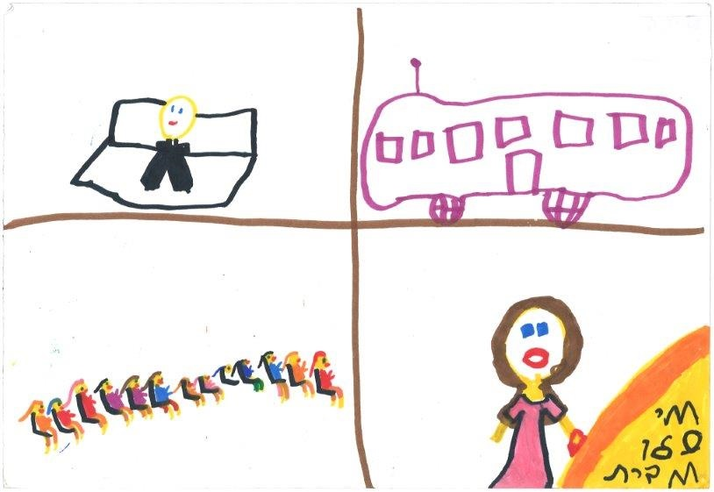

**Fig. 4: M., from the B.B. kindergarten, in Kfar Saba. “The Shtuzim Warehouse”**

Many researchers agree that the distinction between imagination and reality develops as children grow older; this study confirms that there are noticeable age-related differences in the ways in which kindergarteners understood diegetic reality. Younger children, at the beginning of their fifth year, were still visibly confused, unable to consistently suspend their disbelief. At times it seemed as though they understood and accepted theatrical conventions, but at other times they seemed to understand what transpired on stage as reality itself. While one child claimed the witch *“was not real,”* another explained, *“There is such a witch, I have a witch like her at home and I caught her”* (Theatre Talk, S.S. kindergarten, Rishon LeTsiyon).

Kindergarteners vary in their ability to accept, speak, and enjoy conventional theatrical language. We argue that enjoyment of the play depends on consciousness of the imaginary nature of the staged events. Children who were able to appreciate this register, were also willing to accept being “cheated” a little: *“It’s okay if they lie a little… It’s okay because that’s how they show us the play”* (C. from N. kindergarten in Ra’anana).

The reception of the play is a complex matter. Children who succeeded in dealing with the excitement generated by the play– the “thrill” or “fear” it may have evoked – vacillated during viewing between degrees of aesthetic distance. Their level of aesthetic distance could be ascertained from their physical reactions:

A.: Mouth hanging open, hyper-focused, with her feet on the seat, without her sandals. Knees lifted up. Still gaping.

H.: Entirely focused on the stage. Mouth closed, focused. Body leans forwards.

N.: Focused on the stage, she props her head up with her hand, and smiles slightly. She leans against her mother. (Observation notes from the H.G. kindergarten, The Frog Prince)

When the children understood what was portrayed on stage as a threatening reality, they tended to cling to their parents, hug them, close their eyes, and/or cover their ears. Children may even cry or ask to leave the performance. These were common responses, indicative of a lack of aesthetic distance. The suspension of disbelief is a mental practice that becomes easier the more skill and experience one has with it. Young children, who cannot yet grasp the difference between reality and fiction, will therefore not be able to enjoy the play as a work of art.

In this study, we found that most kindergarteners who understood the conventions of “make-believe” were able to make a complete distinction between the actors and the characters they played, and these children enjoyed the play. One of them explained: *“He is a Shtuz, and he is a man. In the costume he is Shtuzi Tapuzi”* (N., from H.G. kindergarten in Tel Aviv). The children even formulated a rationale by which to differentiate between actors and characters, *“They can’t really bring a man who’s a scaredy-cat, because then he would be afraid of the audience”* (C., from N. kindergarten, in Ra’anana).

Younger children found it easier to perceive an image as fictional when it had visual markers, such as a costume, makeup, or special props. A character that appeared to be a normal person from the neighborhood might sometimes be perceived as a part of everyday reality: *“Well, there was one man from the pizza shop”* (Y., from M.K. kindergarten, Rishon LeTsiyon). Similarly, we observed that it was easier to accept the conventions of “make-believe” when the character performed an act that would be impossible in reality, for example, a character that pretended to be asleep in bed while standing on the stage. The act that does not exist in reality – sleeping standing up – helps the children to accept that make-believe nature of the play: *“When someone is standing, they can’t sleep… But they weren’t lying down because it was just a play. It wasn’t for real”* (R. from S.S. kindergarten, Rishon LeTsiyon). Some children, however, described the action in a manner that demonstrated that they were not yet able to distinguish clearly between fiction and reality:

*R.: They stood and slept.*

*Smadar: Ah, so they slept standing up?*

*R.: Yes.* (Theatre Talk, S.S. kindergarten, Rishon LeTsiyon)

**Interim Summary: What Do Children Understand About Aesthetic Distance?**

A child enjoying a theatre performance may shift between a range of aesthetic distances: under-distance, over-distance, and optimal distance. Kindergarteners grasped aesthetic distance both cognitively and with their senses, which confirmed to them that they were watching something artificial, something that represented reality but was not reality itself. Even if they did not know how to formulate this understanding, the very fact that they remained seated in the theatre and reacted to events transpiring on stage makes it clear that the children felt the safety necessary to derive meaning from the play and enjoy it.

**Children Understand Things that Adults Do Not**

*“So that’s why we said all those things”*

The differences among children’s perceptions of diegetic reality show how elusive the separation between fiction and reality may be. Within the confines of the present study, it was not possible to determine whether differences in reception arose from age variances, developmental level, cultural and environmental contexts, or all of these factors combined. This is a question for future research. In this paper we sought to establish the importance of accepting the theatrical conventions and their relationship to semiotic signs, on the one hand, and aesthetic distance, on the other. We presented findings that support the position that kindergarteners can understand and decode signs and metaphors used by theatre directors, and that they understand the medium’s semiotic language and even speak it, to varying degrees. We argued that the greater the children’s mastery of this language, the more they will enjoy the performance. At the same time, we must emphasize that the enjoyment of the play is a subject for further research, which will rest upon insights gleaned from the present study.

The acclaimed Hebrew poet and children’s author Leah Goldberg mentions Antoine de Saint-Exupéry’s *The Little Prince*, addressing the frustrating reaction by adults to the six-year-old prince’s drawing of a boa constrictor digesting an elephant: When the prince asked whether the drawing frightened them, the adults replied: “Frighten! Why should anyone be frightened by a hat?” Only when he made another drawing, in which the snake’s stomach was transparent, revealing the elephant it had swallowed, did the grownups understand. “They always need to have things explained,” wrote Saint-Exupéry. Goldberg expanded on this thought, stating that a child possesses an active imagination, and will therefore see and feel things according to the intentions with which he imbues them (Goldberg, 1978). The present study’s findings demonstrate that children understand things that we, as adults, do not understand, because the child as a spectator, much like the child at play, sees and feels things according to the intentions with which he imbues them. The attempt made in this study to understand children and make space for their sensations, imagination, and thoughts, have led us to a conclusion that can be expressed in the children’s words themselves:

*A.: It’s not your eyes that see the play, it’s your brain that sees the play.*

*N.: My brain, everybody’s brain, watched the play, and we saw and understood that it was very pretty. Really very, very pretty.*

*A.: When I see a play, then it’s not my eyes that see it, it’s my brain that sees.*

*N.: The brain thinks, it doesn’t see.*

*A.: The brain is what lets the eyes see. The eyes don’t see the play, the brain does.* (Theatre Talk, H.G. kindergarten, Tel Aviv)

We conclude that kindergarteners can understand and enjoy theatre. As one child put it, *“At the end of the play, we understood that the play was really very, very pretty. That’s why we said all those things”* (Theatre Talk, H.G. kindergarten, Tel Aviv).

# **References**

**Hebrew**

Goldberg, L. (1978). *Bein Sofer Yeladim Lekor’av [Between a Writer of Children’s Stories and His Readers]* [Hebrew]. Tel-Aviv: Poalim Library.

Malchiodi, C. (2004). *Havanat Tziyurei Yeladim [Understanding Children’s Drawings]*, [Hebrew]. Translated by Batya Zisu Perlstein. Kiryat Bialik: Ach.

Mor, S. (2015). *Hitkablut shel Hatzagat Te’atron Al Yedei Kahal Tza’ir: Heker semioti bekerev yaldei hagan [The Reception of Theatre Plays by Children: A semiotic study of kindergarten children]*. Doctoral Dissertation, [Hebrew]. Haifa: Haifa University.

Schonmann, S. (2005). “Rohak esteti kemad eichut be’omanut ha’te’atron letzeirim” [“Aesthetic Distance as a Gauge of Quality in Theatre for Young People”] [Hebrew], *Klaim* (2), Sal Tarbut Artzi Ve Hevrat HaMatnasim, 66-77.

**English**

Bullough, E. (1957). Aesthetics: Lectures and essays. London: Bowes & Bowes.

Kowzan, T. (1968) The sign in the theatre. *Diogenes, 61*, 52-80.

Pavis, P. (1982). *Language of the stage: Essays in the semiology of the theatre*. New York: Performing Arts Journal Publications.

Reason, M. (2010). *The young audience: Exploring and enhancing* ***children's*** *experiences of* ***theatre****.* London: Trentham.

Sauter, W. (2000) *The theatrical event: Dynamics of performance and perception.* Iowa City, IA: University of Iowa Press.

Schonmann, S. (2006). *Theatre as a medium for children and young people: Images and observations.* Dordrecht, The Netherland: Springer.

Spradley, J. P. (1980). *Participant observation.* New York:Holt, Rinehart and Winston.

**Dr. Smadar Mor** is a scholar of children’s theatre, whose research focuses on reception among young audiences, primarily kindergarteners. Smadar is a pedagogical instructor and lecturer in children’s theatre at the Kibbutzim College’s Creative Education Program for Kindergartens, and a lecturer for theatre instruction at the teacher training program at Tel Aviv University.

E-mail: [Smadar.mor@smkb.ac.il](mailto:Smadar.mor@smkb.ac.il)

522253901Mobile: +972

**Professor Shifra Schonmann (emerita)**, is the Hanan Bar-Netzer Endowed Chair of Education, Society and Theatre for Young People, and head of the Laboratory for Research in Theatre/Drama Education, at the University of Haifa. She researches educational aesthetics, children’s theatre, drama in education, teacher training and curricula and has published widely on these subjects. She is a member of the Steering Committee of the UNESCO International Network of Research in Arts and Education, in whose framework she tries to promote the study and integration of arts into education around the world.

E-mail: shifras@edu.haifa.ac.il

Tel:  +972 (4) 833-6613 (h)