**What do Children Know about Theatre? Elements of the Semiotics of Children’s Theatre**

**Smadar Mor and Shifra Schonmann**

“She killed him, but it wasn’t really a man, because they used one of those black capes, and then they added a doll’s legs, and put shoes on it and everything. It wasn’t really a man, and when they made it black then they took, they took the things that were there and replaced them with other things like the broken house, you can’t really break it, just take it, just break everything… You can’t so they turn off the lights and then turned them on.”

This is how Canaan, from a kindergarten in Ra’anana, explains that there is a sign language in theatre, a make-believe language of “as-if”: in his words, “it wasn’t really a man.” We must understand this language against the backdrop of the conventions of which it is composed. Canaan says: “they made it black… took the things that were there and replaced them with other things…” Using simple words, he expresses a widely used theatrical convention, whereby the darkening of the stage allows the narrative to overcome a technical difficulty that exists because theatre is a fictional performance that corresponds with reality. Canaan grasps very astutely that in order to advance the action taking place on the stage, something must happen that will allow the scenery to be changed, and that these actions must take place in darkness, as “you can’t really break it… So they turn off the lights and then turned them on.” That is, they use signs to communicate with the audience: darkness signifies hiding, and light signifies advancing the plot. The technique that is described by the child is, in fact, a theatrical convention. It is interesting to note in this context that children often make use of the word “just” (*pashut,* which is “just,” or “simply.”)

Ori explains: “Now the sky is gray… because the flashlights, they just turned them off and turned on a grey light,” and Michal explains the source of the light on the stage: “they just put up a few flashlights and turned them on,” and when Smadar tries to find out why there are children who yell during the performance, Dana explains: “I guess they just wanted to shout something to them during the play, just because they wanted to tell them something.”

But is this “just” really so simple? What do children know about theatre? On what does this knowledge depend? What do they experience? What do children understand when they say “just” – an expression that we adults do not understand?

Semiotics, the sign-language of theatre, is not “just” a simple language, and lying at the basis of the theatrical communication between the stage and the audience, it is responsible for producing our viewing experience. To understand the theatrical viewing experience is to understand the manner in which a theatre performance is received, as well as the process of comprehension that enables meaning production and enjoyment. In this article we will focus on the viewing experience of kindergarten children (ages 5 to 6) in order to identify semiotic comprehension processes, on the basis of an “aesthetic distance.” In what follows, we will seek examine the manner in which kindergarten children make use of signs when they speak about their theatrical experience.

**Semiotics in Children’s Theatre**

Semiotics is the study of signs and signification systems. In the 21st century, semiotics has become one of the leading tools to understand out cultural lives, which take shape through signs and codes that must be deciphered. Theatre studies have gone through many changes in their relation to semiotics. The reception of semiotics, in the 1960s, was rather hesitant, but in the 1980s and 1990s this initial approach gave way to vibrant research, attempting to ground theatrical understanding in deciphering predefined semiotic system. By the beginning of the 21st century, theatrical reception studies had almost completely invalidated the semiotic approach. Our study seeks to return to the early stage in theatre studies, and particularly the unique theatrical semiotic taxonomy suggested by Kowzan (1968), which includes thirteen components that appear on stage during a performance. Eight of these components relate directly to the actor: word, tone, mimicry, gesticulation, movement, makeup, hair-design, and costume. Five additional components are non-actor related: props, scenery, lighting, music, and sound effects.

In Kowzan’s semiotics, the actor is understood as the text’s main representative, a position which leads many contemporary scholars to consider the approach dated. Today, we can interpret the theatrical performance using complex expressions that do not privilege the actor with a central role. We may see theatre more and a performance than as a play. The decreasing importance of semiology in theatre studies can be explained by this development, characteristic of postmodern theatre, as well as by the position adopted by a group of scholars according to whom semiotics has reached an impasse, and cannot enable the field to develop further.

We disagree with this approach, and consider semiotic analysis to be a valuable tool for understanding any performance. Theatre, above all children’s theatre, but also any other art form, will always “speak” in a language of signs that must be deciphered, which is the main reason why so many scholars first turned to semiotics. Scholars of children’s theatre, who have researched the reception of plays by young children, have remarked that Kowzan’s semiotic elements allow children to speak about their experience naturally and easily, deriving from it meaning and satisfaction.

**Aesthetic Distance in Children’s Theatre**

Aesthetic distance, a central term in semiotics derived from aesthetics, refers to the psychological position of a person enjoying an aesthetic experience. In 1912, Bullough coined the term “psychical distance,” that later also became known as aesthetic distance. This term seeks to describe a conscious or unconscious psychological phenomenon that takes place when watching a natural phenomenon or a work of art, enabling an aesthetic experience whose purpose is pleasure. In theatre, “aesthetic distance” describes the viewer’s position in the cognitive range stretching between two poles: a complete identification with the events transpiring on stage, a point at which the boundaries between fiction and reality blur, and dissociation and alienation from the theatrical situation.

The difficult and elusive nature of “aesthetic distance” is a subject for controversy between scholars, who debate whether it can be used to examine the manner in which children comprehend theatre. Schonmann, in her reading of Bullough (Schonmann 2006), states that creating the “optimal aesthetic distance,” although paradoxical, is nonetheless possible. She argues that the child must be able to temporarily renounce the connection to reality, in order to enter into the diegetic world unfolding on the stage, while at the same time remaining in reality, that is, knowingly sitting in the theatre. As we currently lack a theory to understand the way in which children are involved in creating the fiction that is theatre, Schonmann suggested constructing an index to measure the aesthetic distance of children during the viewing process. Based on multiple observations of children’s plays, she established four criteria**: the child’s body language, overt expressions of emotions, words said by the child, and the child’s reaction to the surrounding**. These organizing criteria enable a three-tiered interpretive structure for understanding the relationship between “aesthetic distance” and the presence of pleasure or its absence:

**Under-distance:** A state of viewing in which the child is so involved in the diegetic events that he treats it as the real world in which he is living.

**Over-distance:** A state of viewing in which the child is entirely uninvolved in the diegesis.

**Optimal distance:** A state of viewing in which the child shows the correct degree of involvement in the theatrical events, thereby achieving a sense of closure that gives him aesthetic pleasure, (Schonmann 2005, pp. 72-74).

During the play, the child may transition from one level of aesthetic distance to another, at times lacking distance, at other times being too distant, and yet at other being optimally distant. This is a psychological mechanism through which the emotions and thoughts of the viewers fluctuate during viewing, moving back and forth like the tides. People differ from one another in their ability to treat to fiction. In order to fully understand theatre viewing, we must understand the central role played by movement on the “aesthetic distance” scale.

**Studying Theatre Viewing**

In this article we present a reworking of some of the finding of Smadar Mor’s doctoral dissertation, completed under the supervision of Shifra Schonmann, (Mor 2015). The research was undertaken in four cities in Israel; as part of this research 24 kindergarten children, ages 5 to 6, watched two plays, that were performed in large repertoire theatre halls and civic cultural centers. The children chosen by the kindergarten teachers were all capable of verbal expression. Each child watched two of the following four plays, offered by the Israeli *Sal Tarbut* (a cultural program run by the Israeli Ministry of Education):

1. “Datia’s Shtuzim Warehouse”: a play by Datia Ben Dor, who also wrote the songs and composed the music, directed by Yaki Mahraz, and produced by Orna Porat with the participation of Nava Productions. The play invites the audience – children ages 3 to 6 – to come into the “shtuzim warehouse” (a nonsensical term) of the poet, author, and musician, Datia Ben Dor, where they meet the Shtuzniks: Shtuza, Shtuzit, and Shtuzi Tapuzi (Orange Shtuzi), who teach a pizza delivery boy to invent rhyming nonsensical phrases. The delivery boy, who only appears on stage to deliver a pizza to Ms. Ben Dor, meets Grandma Mina from Binyamina, the Girl with the Umbrella, the Mixed Up Colors, and the Naughty Ones in Bed, as well as others of Datia’s tunes and stories, that are hiding away in the mysterious boxes inside her warehouse.
2. “The Wizard of Oz”: an adaptation of a play by Daniel Efrat and Gilad Kimhi, and directed by the latter. The production is a joint enterprise by the Mediatheque Theatre and the Beit Lessin Theatre. The play is a new production that includes an original musical score with new lyrics, alongside the familiar songs associated with L. Frank Baum’s classic book. It is intended for children ages 4 to 9. The plot takes the viewers on a successful coming of age journey, that proves the power of true friendship, goodness, and innocence. It is a story about Dorothy, who goes on an adventure packed journey in the “Magical Land of Oz,” with Toto, her dog, and three friends she meets along the way: a scarecrow with no brain, a heartless tinman, and a cowardly lion. At the end of their journey, the group finds the magician, who shows them that they have already obtained that which they had set out to find.
3. “The Necklace,” written and directed by Michal Rubin, and produced by Goshen Theatre, is an original fairytale concerning a royal necklace and a chain of lies. It tells the story of a beloved princess, who tried on a royal necklace that no one but the queen was allowed to touch. The princess unintentionally tears the golden thread holding the beads together, and they scatter all over the floor. In an attempt to repair matters, the princess is forced into a series of lies. When the chain of lies tightens around her she flees the castle, and goes on a journey at whose end she finds the truth.
4. “The Frog Prince,” is a new adaptation of the Grimm’s Brothers’ fairytale by the same name, written by Ilan Savir and Ofira Archoni, who also directed. In this production, produced by the Mediatheque Theatre, the actors use puppets, masks, and pantomime to enact the legend of the prince who was turned into a frog by a witch, and can only be turned back by a princess’s kiss. It is an allegorical play, which shows the multiple and layered meanings of what may appear to be an innocent children’s story.

As mentioned above, the present study observed the children during the course of two viewings. The first viewing took place in the kindergartens, as part of the events belonging to the *Sal Tarbut,* which provides every child in the Israeli educational system with the opportunity to participate in cultural events. The second viewing was conducted in the presence of the children’s parents. For all of the children who took part in the study, this was not the first visit to the theatre.

Our **research tools** were direct observation, theatrical conversations, drawings executed during these conversations, and personal interviews.

Although our **observations** were carried out inside the darkened theatre halls, it was nonetheless still possible to document the children’s authentic verbal and physical and reactions in real time. This research action was carried out according to Spradley’s (1980) classic approach.

The **theatre conversations** were conducted according to the method of Sauter (2000), whose primary principle is a free conversation between a number of viewers who have all watched a single theatrical piece. The group conversation creates a high degree of willingness among participants to examine new ideas and their consequences. Each conversation lasted between 30 and 45 minutes. In order to focus the discussion, the children were shown pictures from the program, booklet, or leaflet produced by the theatre.

We also used **drawing** as another tool through which the children could express their experience of the plays. According to Malchiodi (2004), drawing gives children an opportunity to explain the elements they chose to draw from their own vantage point. While drawing, the children discussed what they were doing among themselves, and this discussion clarified the contours of their common experience, as well as the idiosyncratic ways each child had experienced the play.

Semi-structured **personal interviews** were an opportunity for every child to develop their own personal statement. A personal questionnaire was composed for each child, based on their behavior during viewing and certain things they had said in conversation and while drawing. The wealth of statements accrued during the research necessitated the use of the ATLAS.ti program, with which one can easily perform analytical manipulation that encourage viewing the data from new and unpredictable perspectives.

**Research ethics** in studies on young children are a particularly sensitive topic. We obtained the necessary permits from the office of the Head Scientist at the Ministry of Education, from parents, and from kindergarten teachers. We also kept the identities of the children and their kindergartens confidential. Moreover, although many researchers do not do so, we also requested approval from the children, making clear to them that at any given moment they may choose to withdraw from the study. Our main ethical principle was to maintain the balance between research needs and the welfare and privacy of the participants.

**What do Children Know?**

Based on Kowzan’s 13 semiotic components, and Schonmann’s scale of aesthetic distance discussed above, we tried to answer the following question: In what manner does the theatrical semiotic system function in the viewing experience of kindergarten children? How is “aesthetic distance” in theater connected to the language of signs that allows communication between the children viewing the play and the action taking place on stage? Our guiding question was: **What do the children understand and how do they express it?**

**The Semiotic Systems**

**The Dramatic Discourse: Language, Words, Tone**

We found that the most influential semiotic system affecting the reception of the play among kindergarten children was connected to the dramatic discourse, that plays an important role in understanding the play and its significance. As N., from the H.G. kindergarten in Tel-Aviv, explained in a theatre conversation: “We need to see the plays in order to understand what they are saying.” D., from the B.B. kindergarten in Kfar Saba, also emphasized the important role of words in the play: “the words, the words, ‘we are shtuzonim’ – so we know they are shtuzonim.” The more developed the linguistic capacities of the children were, particularly among children nearing the end of their fifth year, the more we found an increased use of verbs having to do with saying (the Hebrew root A.M.R.) to describe the play. This is evidence of an ability to follow and decipher the plot:

“And they said ‘oh, here’s the good witch,’ and she said ‘you coulda [sic] gone home a long time ago.’ And she said ‘the answer has been under your nose, or really under your feet.’ And she said ‘Yes! That’s right! The shoes!” (A., from the N. kindergarten in Ra’anana, in a theatre conversation).

Developmental psychologists provide evidence that linguistic abilities developed at kindergarten age contribute to communicating complex meanings. The children’s developing ability to better understand the verbal communication of their daily lives draws their attention to the diegetic discourse. The word, its tone and pitch, the linguistic sequence, and intonation all draw the children’s attention: “You have got to do the right voice, you have to make a girl’s voice, even if you are a boy actor,” (T., from kindergarten A. in Kfar Saba).

The younger children use linguistic expressions that represent actions rather than discourse: “Why were they crying? Because he went (…) I don’t know why he went. Because he also wanted to dress up as a Shtuzon,” (five-year-old A., from the P. kindergarten in Tel-Aviv).

The children use the characters’ words to characterize them. When asked how we know if a character is bad, D., from N. kindergarten in Ra’anana, replied: “Because he said not nice words to that woman,” adding that vocal characteristics, in this case the voice’s volume, are indicative of the character’s bad nature: “Because she said ‘wait for me there,’ as if she is screaming.” A. from the B.B. kindergarten in Kfar Saba added that in order to characterize a character, not only the words were important, but also the intonation, or “the way she talked.”

In the narrative parts of the plays, the children easily followed the verbal action, and readily interpreted what had taken place on stage in their own words: “It was because she wanted to bring her mother a necklace, her necklace. But the necklace – she just wanted to try it on, just for a second, but it didn’t come off, and she pulled and pulled, and it tore, and then she hid it. In a pillow,” (R. from the S.S. kindergarten in Rishon LeTsiyon.)

As opposed to this ready understanding of the spoken parts of the plays, in cases where the action was reported through songs, accompanied by music that could drown out the words, the children sometimes had comprehension problems. Many children seemed to treat the songs as a kind of break in concentration. “It’s not really important,” said T. from the N. kindergarten in Ra’anana. Our observations show that while listening to musical songs the children relax their bodies and lean back:

“While listening to the song ‘A Porcupine on the Beard’ she leans back, slipping a bit off the chair. She withdraws into herself, pulling in her extremities. Then she rises up a bit, pressing her back against the back of the chair, and rocking lightly. Finally she stretches, moving forward on the seat with her body,” (from an observation of T., in the M.K. kindergarten in Rishon LeTsiyon.)

**The Appearance of the Stage: Scenery, Lighting, Props**

In analyzing the children’s responses to the plays, we found that the second largest semiotic system affecting the reception had to do with stage-related visual elements. The children mentioned the props, and recreated them in drawing. They explained what they had chosen to draw: “I will draw you a box,” (theatre conversation, P. kindergarten in Tel-Aviv). Or: “I start drawing… I started with the slide and the boxes. I’m starting with the inanimate things […] the ones that don’t move,” (M., from the B.B. kindergarten in Kfar Saba.) Sometimes they added a description of the action the object accompanied: “Now I’m drawing the letter that flew away,” (theatre conversation, A. kindergarten, Kfar Saba.) In drawing no. 1, S. has drawn the stage: the characters, the costumes, the lighting, and the props.

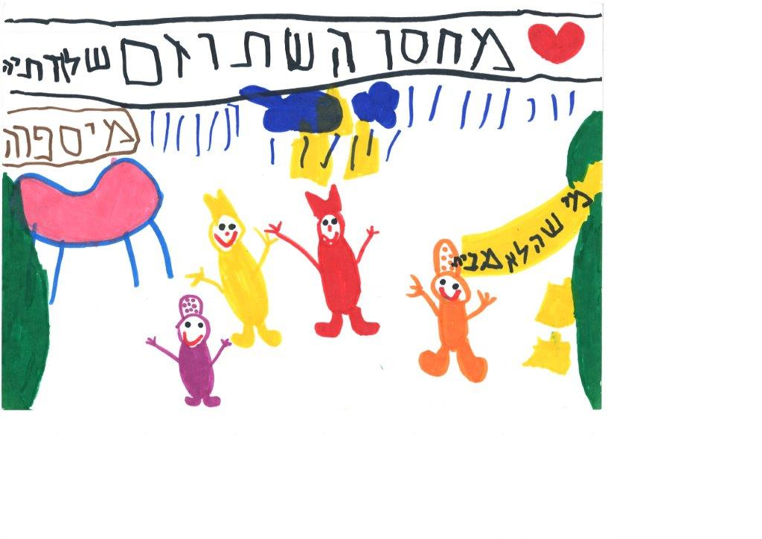

**Drawing no. 1: S., from D. kindergarten in Ra’anana, “The Shtuzim Warehouse”**

An impressively large cluster of utterances collected in this research attest to the importance of the semiotic system that concerns the “appearance of the stage”, and the manner in which it helps the children understand the meaning of the action taking place on stage.

Props play a central part in how children understand the play. Here are several examples of the importance often attributed to them. A prop can define a character: “Because she has a shawl, she has a purse like a lady’s, like a grandma, and she had things that grandmas have,” (H. from the H.G. kindergarten in Tel-Aviv). A prop can show gender distinctions between characters: “The boys have the hat with the pointy tips, and the girls have the round hat,” (D. from the B.B. kindergarten in Kfar Saba.) Props can also be part of a character’s costume: “A crown is also part of the costume,” (N. from H.G. kindergarten in Tel-Aviv.) Some children were able to discern when a prop has become part of the scenery: “They took it [the letter] and made it kind of big, and wrote on it with a black pen, and cut it up […] so they could make a play,” (R. from the S.S. kindergarten in Rishon LeTsiyon.) This is a fine distinction, evidence of an understanding similar to that which examines an important role of props in directing the viewers emotions: “Maybe they found it in their house, and brought it to the play to be funny,” (A. from P. kindergarten in Tel-Aviv.) The children understand that the props and the scenery are not real:

Smadar: “Was the sun real?”

R.: “No.”

Smadar: “It wasn’t real… How do you know it wasn’t?”

R.: “Because they keep moving it around, turning it around, and you can’t have a real sun inside…”

Smadar: “Inside of what?”

R.: “Inside a room,” (R. from S.S. kindergarten in Rishon LeTsiyon).

The children mostly referred to the **scenery**, a central element in stage design, while drawing, (see drawing no. 2). They tried to draw the scenery as it had been on stage, selecting appropriate colors: “Now I am doing the benches, we need brown… Now we will draw the man on the bench,” (D., from B.B. kindergarten in Kfar Saba).

It was apparent that the children, even the youngest among them, were aware that the scenery represented reality, but that it was not itself real:

A.: (Draws the sky) “Here’s the sky.”

O.: “But they weren’t outside.”

A.: “It’s make-believe, but there was a sky in the play,” (theatre conversation, P. kindergarten, Tel-Aviv.)

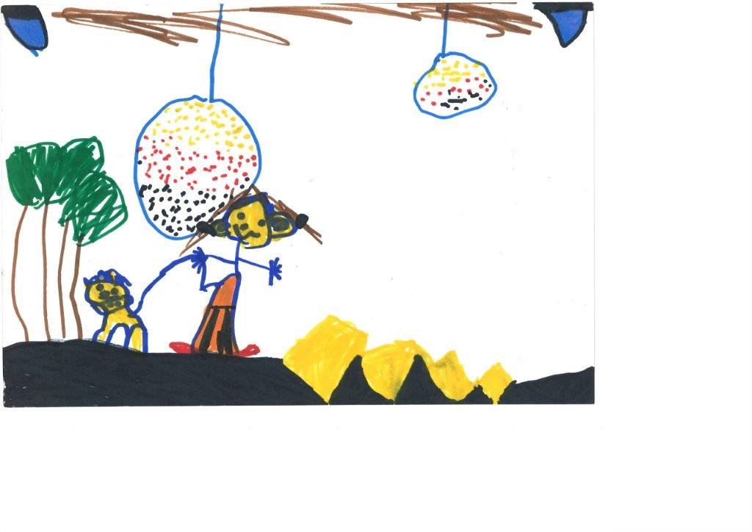

**Drawing no. 2: M. from A. kindergarten in Kfar Saba. “The Wizard of Oz”**

The children are aware of the reasons for the scenery changes: “The princess lives in a castle, and if you want to move… [to go to] a place where I need to go for a walk, then you do a black screen, you set the scenery, and then you lift the screen,” (D., from B.B. kindergarten in Kfar Saba.) D. used professional words like “black screen,” to “set the scenery,” and to “lift the screen,” and her speech showed that she understood the manner in which scenery functions. At the same time, it is also clear that this understanding did not spoiled the illusion created by the scenery, nor did it interfere with her viewing experience.

Some children referred to the manner in which the scenery was changed as though the play’s producers wanted to create a magical effect: “They wanted it to be like magic, so they just built it, so the sun, they just put it there, and there was another string connecting it, and they put it – there was a fishing line, and they just turned it upside down, and at the same time those who were on top also turned it upside down,” (M. from A. kindergarten, in Kfar Saba.) Another child said that: “What came down was really paper […] They couldn’t bring real snow, because instead of snow they would spill water, and all the actors would get wet,” (C., N. kindergarten, Ra’anana).

The children paid relatively little attention to the **lighting**, in comparison with the other semiotic elements. At the same time, in drawing no. 2 we can see a reference to the stage lighting in the upper part of the drawing (in blue.) Those children who mentioned its role did so clearly: “Then they turned out all the lights, because if they saw them going to lie down, then they thought the play had already started… So they turned off the lights so they wouldn’t see…” (A., from A. kindergarten in Kfar Saba). And also: “When they were in the dark, it’s like they wanted to do something that they didn’t want the audience to see […] And then it was like the house was broken […] It’s like Houdini,” (C., from N. kindergarten in Ra’anana.) Thus, the children succeeded in understanding the way truth is enacted on stage. They attributed the power of advancing the plot to the lighting, particularly by turning it off, and replacing the scenery: “You can’t really break it […] You can’t, so they turned off the lights and turned them on again,” (C. from N. kindergarten in Ra’anana.)

Some of the children’s statements attributed to the lighting the power to create an atmosphere. This is one of the important roles of stage lighting, and the ability to discern it is evidence of perceptive nature of some of the children. “When there was that storm, then it was dark inside,” (O. from N. kindergarten in Ra’anana.) The children attributed the change in lighting to the actors: “The actors must have gotten behind the curtain, and we didn’t notice, so they just moved the lights a little bit,” (S. from D. kindergarten in Ra’anana.) These statements show how logic, intuition and accrued knowledge come together in an impressive understanding of the roles of lighting in theatre, even if such details were only mentioned by several children.

**The Appearance of the Actor: Makeup, Hair design, Costumes**

Children understand that costumes are closely related to the roles of the actors: “They only dressed up because they are actors,” (R., from S.S. kindergarten in Rishon-LeTsiyon.) The children understand that “a princess’s costume means that she is a princess. A clown’s costume means that it is a clown. The audience knew who everyone was,” (D. from B.B. kindergarten, Kfar Saba.) Kindergarten children understand very well that “in order to look like someone else (M., from B.B. kindergarten, Kfar Saba),” costumes are required, and that “By wearing the clothes he can be a Shtuzon,” (O. from P. kindergarten in Tel-Aviv.)

The children use their knowledge about colors to understand the personality and role of the characters: black signifies the villain, while the hero or heroine often wear white. “The good-guys wear it like *this* [demonstrates], but prettier, with flowers… And the witch has only black. But hers is with flowers, because she was good,” (O., from D. kindergarten in Ra’anana.) The children easily receive the message encoded by the costume designers, who use this medium to wordlessly transmit information about the characters and the plot. Using their knowledge of articles of dress, along with conventions about superheroes familiar to them from the television, the children decipher the character and their nature: “Because the bad-guys have a black cape. But Batman also has a black cape, but he has a sign that he’s good, he has a bat,” (C., from N. kindergarten in Ra’anana.) In understanding the connection between the appearance of an actor and the character’s personality and role, the children also make use of their previous experience from the socio-dramatic games they play in the kindergarten.

**Bodily Expression: Mimicry, Gesticulation, Movement**

The children understood very readily the role bodily expressions play in characterization. When asked how we could identify a character if we couldn’t hear the words, O., from N. kindergarten in Ra’anana, replied: “We’d be able to see from the way they act,” and in another conversation she added: “He made bad movements, so he is bad.” The kindergarten children readily understood mimicry, gestures, and movement on stage, and the way they were used to characterize narrative roles, to advance the plot, or to set a mood. For example, J., from M.K. kindergarten, enjoyed the slapstick elements and said, while mimicking the motion which he was recalling, “This [motion] always makes me laugh, always.” O. from B.B. kindergarten in Kfar Saba, explained what he had to do when he took part in a play in kindergarten:

O.: “I made special gesture.”

Smadar: “What kind of gestures?”

O.: “Like so. I went into the castle like this [stands up straight, walks slowly, with his head held high].”

The children also used body language, or the lack thereof, as a semiotic system with which to interpret the play. “I thought it would end sadly, because she didn’t kiss him the whole play, only at the end,” (A., from H.G. kindergarten, Tel-Aviv.) N., from H.G. kindergarten in Tel-Aviv, explained that she knew the play was over because the actors bowed. The children seemed to enjoy watching the bodily gestures and motions of the actors on stage, and emulating them: “They do everything lightly, like this [stands on bench], they get up, they just stand right up.” And further on: “Its fun to dance,” (D. from B.B. kindergarten in Kfar Saba.) Based on these observations, we can assert that kindergarten children decipher the plot with the help of body language. Whether they can explain it in words, or if they show it through mimicking the movements, it is clear that the children are aware of the role played by body language in creating characters, understanding the plot, and directing the emotions of the viewers.

**Sounds: Music and Sound Effects**

In comparison with other semiotic systems, like the dramatic dialogue or the props, the children made only a small number of references to **music**. This shows the relatively secondary importance the children attributed to this system. At the same time, they were aware of the role music plays with regards to the events on stage, namely, advancing the plot and symbolizing or representing the general mood of the characters and the play: “It is supposed to show something sad,” (O. from N. kindergarten in Ra’anana.) The children understood music, particularly its intensity and volume, as having a physical effect, whose source its emotional power: “If it [the music] is really, really strong, then I feel it in my throat, and it’s really-really, it’s really like it’s going like this [points to throat]. And if it’s weak, then I hear it normally,” (O. from N. kindergarten in Ra’anana).

The children also understand the role **sound effects** playin creating an illusion: “I can hear the storm, so they don’t have to say anything, because I can hear it,” (A. from P. kindergarten, in Tel-Aviv.) The children then look for logical explanations as to how the sound was formed, that is, they accept the sounds as signs that are part of the play’s greater signification system: “The rain is just an example, and, the – what’s it called? – the thunder, it’s just a radio they put on the roof […] and there’s a kind of electrical wire going from the radio to the warehouse,” (N., from H.G. kindergarten in Tel-Aviv.)

**Interim Summary: What Part of Semiotic Systems do Children Understand?**

It seems that, without knowing it, kindergarten children naturally speak in term remarkably evocative of Kowzan’s. While viewing the play, they are actively decoding the text they hear, the appearance of the actors, and their body language. They discern the appearance of the stage and the function of the props, the scenery, and the lighting. They are attentive to the sights and sounds, and enjoy the diegetic reality, whose revelation sets their imaginations in motion. In other words, the children understand that the signs they see on stage are representations of reality, and function metaphorically: “Because red means… Emmm… Something like blood, and this kind of red means fire, as if something is burning, or something bad is happening,” (O. from N. kindergarten in Ra’anana.) Putting together several semiotic systems, the children decipher the metaphorical world constructed on stage: “If there didn’t have any of the things [props], then how could they do the play? What, they’d just talk?” (H., H.G. kindergarten, Tel-Aviv). As reported by Reason (2010), the children used semiotics to create meaning. Their semiotic understanding seems to be, in part, an expression of their level of cognitive development, in part an expression of their emotional and social abilities acquired by playing, and in part an expression of their cultural ability acquired by watching television or theatre plays.

## Aesthetic Distance

In seeking to understand the children’s viewing experience not only from a semiotic perspective, but also from an emotional one, we examined a number of issues related to aesthetic distance. One of the emotions which can be awakened by events unfolding on stage is fear:

“We look at the stage really carefully, and if we are afraid, then we’re afraid, and if we’re are not afraid, we’re not afraid, [but sometimes] we are afraid [smiles], what can you do? Maybe it’s a scary play […] If, for example, there is a part that scares me […] I can be really, really, really, scared, like, not really, but a little scared,” (A. from P. kindergarten in Tel-Aviv.)

It is possible that situations in which the children feels fear may actually provide them with a sense of overcoming their fears. This is particularly the case when the child is situated at the optimal aesthetic distance: on the one hand, the child believes the illusion is realistic, but at the same time understands that the diegetic reality is fictional. When the fear becomes tolerable, and even to a degree pleasurable, then we can say with certainty that the child understands that the staged events represent reality, but are not reality itself. The optimal aesthetic distance provides the children with an aesthetic enjoyment that is derived both from their visual and audio sensations, and from the decoding and re-encoding of these signs within their consciousness. The child can say: “Nothing is real, but they [the actors] are real.” The study’s findings emphasize the possibility that even kindergarten children, whose artistic perception is only in its initial stages, can develop an “optimal aesthetic distance.”

We found that the children were largely aware of the “as if” convention. By enlisting knowledge from semiotic systems to which they had been exposed, the children could influence their levels of aesthetic distance. Using the semiotic systems allowed the children to formulate phrases such as: “Because if he were a real magician who was playing an actor, then he could really fly without ropes […] He isn’t a real magician, so he needs ropes,” (A. from A. kindergarten, in Kfar Saba).

Children at early developmental stages do not yet fully accept the convention of the suspension of disbelief; at times they justify the breaking of natural laws by a belief in magic, in order to make order in their reality. In this manner, they may enjoy the play even if they fail to achieve an optimal aesthetic distance: “Yes, it really was a real magician […]. Yes. Without a wand,” (Y., from the M.K. kindergarten in Rishon LeTsiyon.) In drawing no. 3 we can see a child’s understanding of aesthetic distance, which is expressed in the physical separation between the stage and the audience:

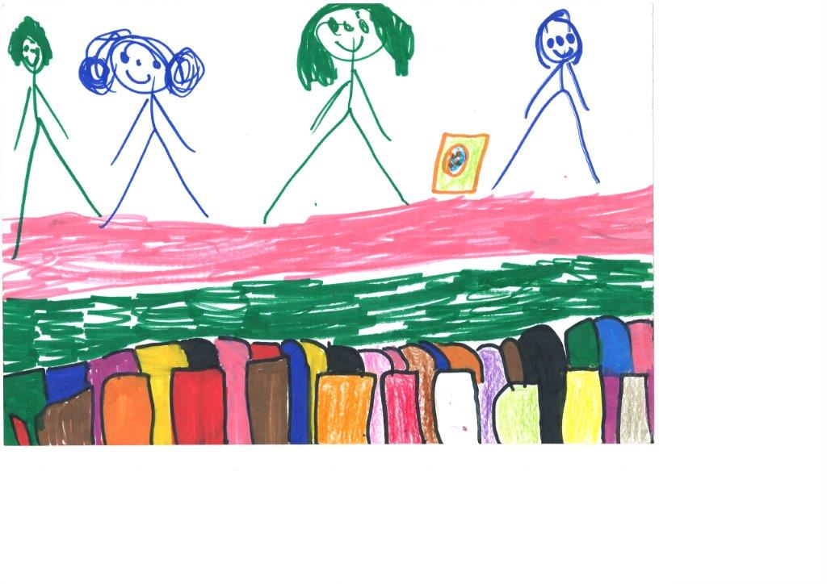

**Drawing no. 3: N. from N. kindergarten in Ra’anana, “The Shtuzim Warehouse”**

The variability, a dimension coined by Bullough, enables us to introduce gradations into conceptions of aesthetic distance in two ways: under-distance and over-distance. We found that over-distancing does not keep the children from enjoying the play. They are aware of the ways in which the play’s creators produce the show, changing costumes and stage settings, but this knowledge does not detract from their enjoyment of the play. Quite the opposite, it helps the children to continue concentrating on the play. In this sense, kindergarten children understand what we as adults tend to forget, that the optimal aesthetic distance transpires when the viewer it aware of the illusion: “But the lion wasn’t scary for me […] A lion should go like this and like that [demonstrates], and he didn’t have any feet and wasn’t real,” (O., from D. kindergarten in Ra’anana.) The children were even aware that the overcoming their fears by means of over-distancing is connected to development: “Babies are the most scared. They are cowards. Because they are little […] so they cry, [demonstrates],” (O. from D. kindergarten in Ra’anana.)

The children’s body language, as observed in the theatre, reflects the tensions they are subjected to during the play, and describes their level of aesthetic distance on the scale mentioned above. Their bodily movements also disclose physical reactions that point to stress and concentration:

A. Lifts his hands up, places them behind his head, and then leans forwards in his chair, lowering his arms onto the backrest of the seat before him. He stretches, moving sideways, and turns to me with a worried face: “But in the end the princess will kiss him, right?” He wiggles a bit in his chair, leaning onto the chair in front of him. Then he shifts about, scooching up to the edge of his chair, and leaning onto the backrest before him. He bends sideways, into the gap between the two chairs, keeping his head facing up, in the direction of the stage, and his body slanting downwards. His mouth is gaping wide, (from an observation of the H.G. kindergarten in Tel-Aviv, “The Shtuzim Warehouse.”)

The children are aware of the tensions they feel while viewing the play, and in their interview they explain the reasons for their emotions: “I thought the end would be sad, but in the end it was happy,” (A. from H.G. kindergarten in Tel-Aviv.) The children easily grasp what researchers have unsuccessfully tried to formulate again and again. They simply say that in the play: “Lots of stuff aren’t real, almost nothing was real,” (A., the H.G. kindergarten in Tel-Aviv). In drawing no. 4, we can see the complete journey undertaken by the child in his transition from reality to fiction:

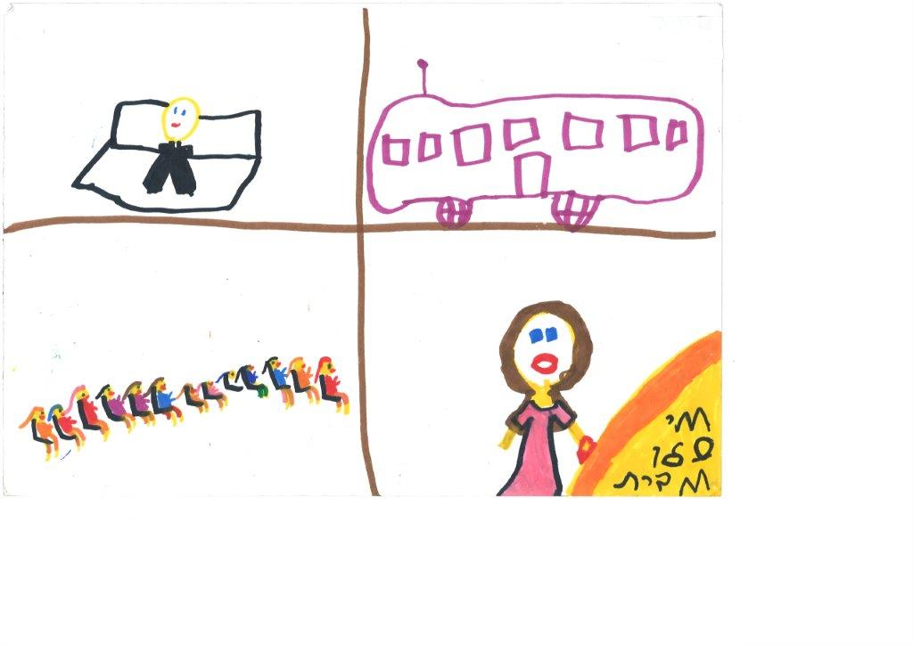

**Drawing no. 4: M., from the B.B. kindergarten, in Kfar Saba. “The Stuzim Warehouse”**

Many researcher agree that the distinction between imagination and reality develops as children grow older; this study confirms that there are noticeable age-related differences in the ways in which kindergarten children understand the diegetic reality. The younger children, at the beginning of their fifth year, are still visibly confused, unable to consistently suspend their disbelief. At times it seems as though they understand and accept the theatrical conventions, but at other times they seem to understand what transpires on stage as reality itself. While one child claimed the witch “was not real,” another explains that “there is such a witch, I have a witch like at home and I caught her,” (theatrical conversation, S.S. kindergarten, Rishon LeTsiyon.)

Kindergarten children vary in their ability to accept, speak, and enjoy conventional theatrical language. We argue that enjoyment of the play depends on being conscious of the imaginary nature of the staged events. Children who are able to appreciate this register, are also willing to accept being “cheated” a little: “It’s okay if they lie a little… It’s okay because that’s how they show us the play,” (C. from N. kindergarten in Ra’anana.)

The reception of the play is a complex matter. Children who succeed in dealing with the excitement a play may generate – the “thrill” or the “fear” it may evoke – vacillate during viewing between degrees of aesthetic distance. Their level of aesthetic distance can be ascertained from their physical reactions:

A.: Gapes at the stage, in hyper-attention, with her feet on the seat, without sandals. Still gaping, she lifts her knees.

H.: Entirely focused on the stage. Mouth closed, focused. Her body leans forwards.

N.: Focused on the stage, she props her head up with her hand, and smiles lightly. She leans against her mother. (From an observation in the H.G. kindergarten, The Frog Prince.)

When the children understand what is portrayed on stage as a threatening reality, they tend to cling to their parents, hugging them, closing their eyes, and covering their ears. Children may even begin to cry, or ask to leave the performance. These are common responses, indicative of a lack of aesthetic distance. The suspension of disbelief is a mental practice that becomes easier the more skill and experience one has with it. Young children, who cannot yet grasp the difference between reality and fiction, will therefore not be able to enjoy the play as a work of art.

In this study, we found that most of the kindergarten children who understoodnd the convention of “make-believe,” were able to make a complete distinction between the actors and the characters they played, and that these children enjoyed the play. One of them explained: “He is a Shtuz, and he is a man. In the costume he is Stuzi Tapuzi,” (N., from H.G. kindergarten in Tel-Aviv.) The children even formulated a rational by which to differentiate between actors and characters: “they cannot really bring a cowardly man, because then he would be afraid of the audience,” (C., from N. kindergarten, in Ra’anana.)

Younger children find it easier to perceive an image as fictional when it has some external markings, such as a costume, makeup, or special props. A character that appears to be a normal person, may sometimes be perceived as a part of everyday reality: “Well, there was one man from the pizza shop,” (Y., from M.K. kindergarten, Rishon LeTsiyon.) In the same manner, we understood that it is easier to accept the convention of “make-believe” when the character is performing an act that would be impossible in reality. For example, a character that pretends to be asleep in bed while standing on the stage. The act which does not exist in reality – sleeping standing up – helps the children to accept that make-believe nature of the play: “When someone is standing, they cannot sleep… But they weren’t lying down because it was just a play. It wasn’t for real,” (R. from S.S. kindergarten, Rishon LeTsiyon.) At the same time some children depicted the action in a manner that shows they are not yet able to distinguish clearly between fiction and reality:

R.: “They stood and slept.”

Smadar: “Ah, so they slept standing up?”

R.: “Yes.”

(Theatre conversation, S.S. kindergarten, Rishon LeTsiyon)

**Interim Summary: What do Children Know about Aesthetic Distance?**

A child enjoying a theatre play may shift between a range of aesthetic distances: under-distance, over-distance, and optimal distance. Kindergarten children grasp aesthetic distance both cognitively and with their senses, and these apparatuses confirm to them that they are watching something artificial, something that represents reality but is not reality itself. Even if they do not know how to formulate this understanding, the very fact that they remain seated in the theatre, and react to events transpiring on stage, makes clear that the children feel the safety necessary to produce meaning from the play and enjoy it.

**Children Who Understand Things that Adults Do Not**

“So that’s why we said all these things”

The differences between children regarding the perception of the diegetic reality show how elusive the separation between fiction and reality may be. Within the confines of the present study, it is not possible to determine whether the differences in reception have to do with age, developmental level, cultural and environmental contexts, or all of these factors together. This is a question for future research. In this paper we wanted to establish the importance of accepting the theatrical conventions, and their relationship to semiotic signs, on the one hand, and aesthetic distance, on the other. We presented findings that supporting the position that kindergarten children can understand and decode the signs and metaphors used by theatre directors, and that they understand this medium’s semiotic language and even, to varying degrees, speak it. We argued that the greater the children’s control of this language, the more they will enjoy the performance. At the same time, we must emphasize that the enjoyment of the play is a subject for further research, which will rest on the insights gleaned from the present study.

In discussing the disappointing reactions of adults to children’s imagination, Leah Goldberg, the important Hebrew poet and children’s author, mentions Saint-Exupéry well known *The Little Prince*. In this book, the little prince recollects the reaction of the adults upon seeing his drawing of a boa constrictor digesting an elephant. When he asked whether the drawing frightened them, the adults replied: “Frighten! Why should anyone be frightened by a hat?” Only when he made another drawing, in which the snake’s stomach was transparent, revealing the elephant it had swallowed, did the grown ups understand. “They always need to have things explained,” wrote Saint-Exupéry. Leah Goldberg continues his thought: A child possesses an active imagination, and will therefore see and feel things according to the intentions with which he imbues them, (Goldberg, 1978). The study’s findings show that children understand things that we, as adults, do not understand, because the child as a spectator, much like the child at play, sees and feels things according to the intentions with which he imbues them. The attempt made in this study to understand children and to make space fir their sensations, imagination, and thoughts, have led us to a conclusion that we may put in the children’s words:

A.: “It’s not your eyes that see the play, it’s your brain that sees the play.”

N.: “My brain, everybody’s brain, watched the play, and we saw and understood that it was very pretty. Really very very pretty.”

A.: “When I see a play, then it’s not my eyes that see it, it’s my brain that sees.”

N.: “The brain thinks, it doesn’t see.”

A.: “The brain is what lets the eyes see. The eyes don’t see the play, the brain does.” (Theatrical conversation, H.G. kindergarten, Tel-Aviv.)

If nothing else, we must realize that kindergarten children can understand and enjoy theatre. As one of them said: “At the end of the play, we understood that the play was really very very pretty. That’s why we said all these things,” (theatrical conversation, H.G. kindergarten, Tel-Aviv.)

# **Sources**

**Hebrew**

Goldberg, L. (1978). *Between a Writer of Children’s Stories and His Readers* [Hebrew]. Tel-Aviv: Poalim Library.

Malchiodi, C. (2004). *Understanding Children’s Drawings*, [Hebrew]. Translated by Zisu Perlstein. Kiryat Bialik: Ach.

Mor, S. (2015). *The Reception of Theatre Plays by Children: A Semiotic Study of Kindergarten Children*. Doctoral Dissertation, [Hebrew]. Haifa: Haifa University.

Schonmann, S. (2005). “Aesthetic Distance as a Gauge of Quality in Theatre for Young People” [Hebrw], *Klaim* (2), Sal Tarbu Artzi Ve Hevrat HaMatnasim, 66-77.

**English**

Bullough, E. (1957). Aesthetics: Lectures and essays. London: Bowes & Bowes.

Kowzan, T. (1968) The sign in the theatre. *Diogenes, 61*, 52-80.

Pavis, P. (1982). *Language of the stage: Essays in the semiology of the theatre*. New York: Performing Arts Journal Publications.

Reason, M. (2010). *The young audience: Exploring and enhancing* ***children's*** *experiences of* ***theatre****.* London: Trentham.

Sauter, W. (2000) *The theatrical event: Dynamics of performance and perception.* Iowa City, IA: University of Iowa Press.

Schonmann, S. (2006). *Theatre as a medium for children and young people: Images and observations.* Dordrecht, The Netherland: Springer.

Spradley, J. P. (1980). *Participant observation.* New York:Holt, Rinehart and Winston.

**Dr. Smadar Mor** is a scholar of children’s theatre, whose research focuses on reception among young audiences, primarily kindergarten children. Smadar is a pedagogical instructor and a lecturer in children’s theatre, in the Creative Education Program for Kindergartens at the Kibbutzim College, and a lecturer for theatre instruction at the teacher training program at Tel-Aviv University.

E-mail: [Smadar.mor@smkb.ac.il](mailto:Smadar.mor@smkb.ac.il)

522253901Mobile: +972

**Professor Schifra Schonmann (emerita)**, is the Hanan Bar-Netzer Endowed Chair of Education, Society and Theatre for Young People, and the head of the Laboratory for Research in Theatre/Drama Education, at the University of Haifa People. She researches subjects of educational aesthetics, children’s theatre, and drama in education, teacher’s training, and curricula, and has published widely on these subjects. She is a member of the Steering Committee of the UNESCO International Network of Research in Arts and Education, in whose framework she tries to promote the study and integration of arts into education around the world.

E-mail: shifras@edu.haifa.ac.il

Tel:  +972 (4) 833-6613 (h)