1. **Fiber small-deformation analysis**

In this section, we analyze the initial (planar) deformation stages of a fiber that is constrained by a flexible cylinder. To this end, we conceptually replace the cylinder with an equivalent spring that applies the same force to the fiber, see Fig. 20. For simplicity, and in accordance with the experimental results, it is assumed that the deflection of the fiber is small, , such that the behavior of the fiber is governed by the standard linear equations of bending. We denote this with as the initial fiber length, as the fiber diameter, and  as the inner radius of the flexible cylinder and the actual (current) distance between the location of the spring and the original location of the fiber. Hence, the original gap between the fiber and the constraining spring is , as shown in Fig. 20. The fiber is fixed at one end  and supported by a horizontally movable slider at the other . The fiber is subjected to an external compressive force  acting along its long axis that results in a horizontal displacement, , of one end. After buckling, the fiber deforms and makes contact with the cylinder/spring at the midspan  (see Fig. 20). Further increases in the external force (or alternatively of ) results in a larger deflection, which is governed by the resisting force of the spring. We note that a similar analysis was performed in [48-49] where a slender beam constrained by a sprung wall with linear behavior was studied theoretically and experimentally. Here, on the other hand, the force-displacement relationship of the constraining spring is cubic . Thus, we follow the analysis of [48] and extend it to account for the cubic behavior of the spring.

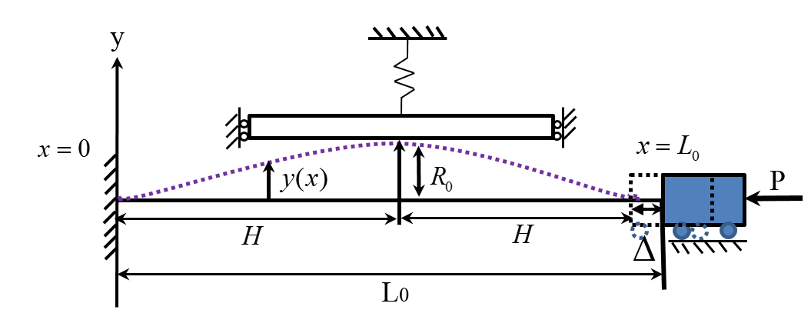

**Fig. 20:** A clamped fiber is subjected to an axial compressive forceand is subsequently constrained by the wall of a flexible cylinder, conceptually replaced with a spring here.

Treating the fiber as a thin line, , its vertical displacement at the contact point becomes:



In order to enable non-dimensional analysis, all lengths are normalized byand forces by . Accordingly, the deflection of the fiber is governed by the (non-dimensional) equation:



where boundary conditions depend on contact conditions, as discussed below. In addition, the horizontal displacement,, is found by:



Symmetry allows only half of the fiber, , to be considered.

**2.4.3.1 Pre-buckling of a clamped-clamped fiber analysis**

The solution of the buckling problem for a clamped segment with no contact is well established and is presented here for completeness. Three stages of the fiber behavior are considered, namely: before contact, during buckling of the fiber, and during the fiber-cylinder contact stage.

During the first stage, the fiber experiences a horizontal displacement, but does not flex and remains horizontal:



During the second stage, the force  reaches a critical buckling level, . The buckling of the fiber instantaneously occurs and the fiber “jumps” to just contact the non-deformed cylinder equivalent at the point , where  was defined earlier (see Fig. 20). The horizontal displacement  becomes:



During the third stage, displacement of the cylinder equivalent occurs due to contact with the fiber. A linear analysis of this process is presented in the next section.

**2.4.3.2 Point contact**

Once the fiber makes contact with the spring, the resistance of the spring to additional deflection needs to be taken into account. Thus, boundary conditions are:



Here,is the spring force , i.e:



Solving Eq. with boundary conditions (48), using Eq. leads to a relationship between .

From Eq. , the solution for  takes the form:



By substituting Eq.  into Eq. , all unknown coefficients are defined:



The equation of the elastic line is expressed as:



Note that , the force in the spring, is unknown. It can be a characteristic of the spring, namely  :



Therefore, spring force  in Eq., for a linear spring, when :



and for a non-linear spring, when :



Using the definition of the displacement from Eq.  and substituting Eq. and Eq. for a linear spring and Eq. (54) for non-linear spring, the normalized horizontal displacement becomes:



Fig.  shows a good agreement between the experimental results and the numerical calculation for a small-deformation analysis.

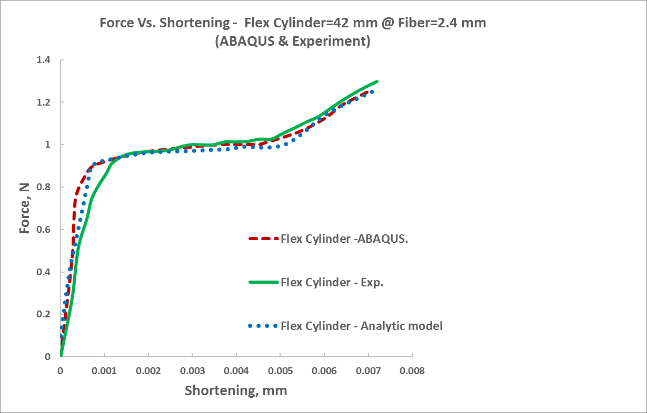





**Fig. 21:** The behavior predicted by small-deformation theory for the symmetrical case. Measured vertical force versus end shortening for a flexible-walled cylinder: , and fiber:. The experimental results are compared to FE simulations (red dashed curve) and an analytical model (blue curve).

Note that the fiber remains in the point contact configuration up to the moment when the internal bending moments at the fiber’s edges vanish. If the forceand the displacementare further increased, the onset of transition to the configuration in which a force is applied to the cylinder occurs.