**Signs and Symptoms of UTIs in Women**

If you’ve ever had a Urinary Tract Infection (UTI), you’ll know firsthand that there’s nothing more excruciatingly devastating than when something as natural as peeing becomes an ongoing nightmare. UTI’s occur when bacteria, usually the *E. coli* bacterium that lives in the intestines, find their way to the urinary system. As they begin to multiply in the bladder, it triggers an inflammatory response in the body, resulting in various UTI symptoms.

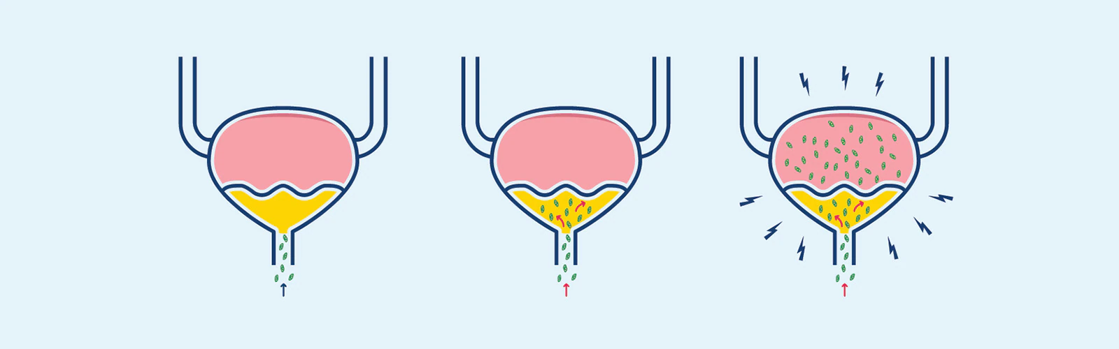

[Source](https://www.tena.co.za/women/about-incontinence/causes-of-female-incontinence/urinary-tract-infection-in-women)

**UTIs in women:**

Urinary tract infections are one of the most common bacterial infections worldwide, and especially among women. According to the [American Journal of Medicine](https://www.sciencedirect.com/science/article/abs/pii/S0002934302010549), more than half of women experience UTIs at least once in their lifetime. One in three have a clinically significant case by the age of 24, and one in four suffer from recurring infections. In fact, for 25% to 30% of women who have had a urinary infection before, [the infection is likely to return within six months](https://www.health.harvard.edu/bladder-and-bowel/when-urinary-tract-infections-keep-coming-back).



The reason women are much more likely to get urinary infections is mainly due to female anatomy. Women have a shorter urethra, which is the tube responsible for carrying urine out of the body from the bladder. This means that the urethral, vaginal, and anal openings are very close to one another, making it easier for bacteria to spread and ultimately enter the bladder.

**Top UTI symptoms:**

Although UTIs are remarkably common and can be incredibly painful, luckily they’re quite easy to recognize and treat. Between funky-looking wee and feeling as if your bladder might be killing you not so softly, here are the top warning signals of UTI’s so you can know when to seek treatment to get right back on track.

1. **Your urine is cloudy:** Also described as milky, foamy, or turbid white, cloudy urine is one of the first signs of an impending UTI. The cloudy appearance is usually caused by the discharge of either pus or blood following the infection. Alternatively, it could also be a buildup of white blood cells your body has produced in its effort to fight off the offending bacteria. So if you realize that your typically clear pee is murkier, it could serve as a red flag.

1. **You have red, pink, or cola-colored urine:**

Urine consists of an excess of water and waste products that the kidneys filter out from the blood. Ideally, your urine should be a clear, pale yellow color, indicating a healthy water-to-waste ratio. Sometimes your urine may appear darker and take on deeper, amber tones due to various factors like dehydration or certain types of foods and medications. However, if your urine appears bloody or reddish-colored, this can often indicate an underlying problem or infection.

When you have a UTI, the inflammation following the bacterial infection in the urinary tract’s lining causes red blood cells to leak into your pee. This condition is medically known as hematuria. A small amount of blood in your urine won’t be visible to the naked eye. But if there’s enough blood, it may effectively change your pee’s color. So, if you notice your urine turning bright pink, red, or dark brown, this could point to a possible UTI.



[Source](https://www.medicalnewstoday.com/articles/324469)

1. **You have to go *all* the time:**

The bladder and the brain have a very close relationship, and in normal conditions it’s natural to pee six to eight times a day. However, when inflamed, the pressure and the pain in your bladder will signal to your brain that it needs to go even if it’s far from full. As a result, you might find yourself rushing to the bathroom every few minutes only to have a few drops come out each time.



[Source](https://www.medicalnewstoday.com/articles/316669" \l "causes)

1. **You have an overpowering urge to pee:**

On top of frequenting the toilet multiple times a day, a UTI may have you running to the loo as if you’re running for dear life. So not only are you spending the entire day shuffling back and forth in an attempt to relieve yourself, you might sense that the urge to urinate is also overwhelmingly stronger.

1. **It burns when you wee:**

Perhaps the most notorious symptom of a UTI is the painful, burning sensation whenever you try to urinate. From the sensation of peeing prickling needles to feeling like there’s a blazing fire down there, passing water during a UTI can be painful. This is because the bacteria adhering to the lining of your urinary tract cause increased and continuous irritation. Ultimately, the urethra and bladder’s inflammation can make the typically mundane task of peeing an exceptionally excruciating experience.

1. **You have pain in the belly area:** Cramping, pressure, or tenderness in the abdomen and pelvic region are common with urine infections due to the bladder’s swelling. If you notice that the pain starts to move to your lower back, too, this could indicate that the infection has spread, so it’s essential to get checked straightaway.
2. 

[Source](https://www.raleighob.com/)

**Types of UTIs and their signs:**



A urinary tract infection can occur in any part of the urinary system, including the kidneys, ureters, bladder, and urethra. But how does the urinary system even work? It starts with the kidneys, which are located on either side of the lower spine and are responsible for removing toxins, excess minerals, and fluid from the blood by producing urine. The urine is then sent through two long tubes called the ureters to the bladder and is eventually excreted through another tube, the urethra.

Accordingly, there are three different types of UTIs depending on which part of the urinary tract is infected; the kidneys, bladder, and the urethra. Besides being determined by a particular section, each type is also associated with more specific symptoms and signs.

* **Urethritis (urethra)**: Urethritis refers to an infection of the urethra, the hollow tube that passes urine outside of the body. Since it is located close to the rectum area in the lowest part of the urinary tract, it typically develops when gastrointestinal bacteria spread from the anus to the urethra. Common symptoms of urethritis include that infamous burning sensation during urination, and cloudy urine caused by the discharge.

* **Cystitis (bladder):** [Cystitis](https://www.mayoclinic.org/diseases-conditions/cystitis/symptoms-causes/syc-20371306) is an infection of the bladder, the muscular balloon-like bag that stores urine from the kidneys. It occurs when bacteria, mainly the E.coli bacterium that thrives in the intestines, travel up the urethra, infect the urine, and cause inflammation in the bladder. Common cystitis symptoms include: pelvic pressure; cramping or discomfort in the lower belly; urine that looks cloudy, pink, or red or smells bad; and painful, frequent urination.

* **Pyelonephritis (kidneys):** Pyelonephritis refers to an infection of the kidneys. It is usually the result of a lower urinary tract infection, like urethritis or cystitis, that has spread up the tract. [Kidney infection](https://www.nhs.uk/conditions/kidney-infection/) is quite a severe condition and is, therefore, accompanied by more acute symptoms. These include: cramping or pain in the area above the waist, below the ribcage, or along both sides of the back; high fever, shaking and chills; and sometimes even nausea and vomiting.

**Diagnosis**

Although UTIs are not a dangerous condition, they can lead to severe complications if left untreated. Therefore, if your body is showing symptoms, the required course of action is to get diagnosed as soon as possible to get the most effective treatment.

One of the best ways to detect a UTI is through a simple urine test called a urinalysis. [Urinalysis](https://velieve.io/uk/info-center/uti-test) involves a dipstick designed to mark the presence of certain substances by changing color when dipped in a urine sample. The dipstick checks for three main components that could indicate an active bacterial infection, including leukocytes (white blood cells), nitrites, and traces of blood.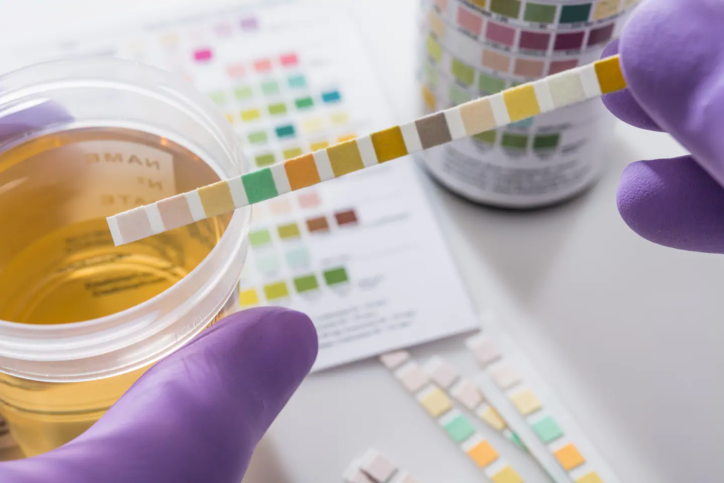

[Source](https://www.washingtonpost.com/health/ive-gained-my-life-back-new-tests-may-help-those-with-persistent-urinary-tract-infections/2019/06/28/f103e21e-65dc-11e9-a1b6-b29b90efa879_story.html)

This easy procedure can be done at the clinic or using a UTI self-test kit such as Velieve, which contains everything you need to quickly test and treat UTIs from the comfort of your home with your smartphone.

If opting for the self-test route, you can order the Velieve UTI Test Kit online and get it delivered directly to your door or access the service at your local pharmacy. Once you’re ready, download the Velieve app and follow the step-by-step instructions to complete the test. Then, scan your results, and within 30 minutes, you’ll receive an in-app diagnosis from a medical professional.



[Source](https://www.standard.co.uk/tech/uti-at-home-test-velieve-london-a4432076.html)

**Treatment:**

If your symptoms and urinalysis indicate that you probably have a UTI, you will be prescribed a standard treatment of a three- to seven-day course of antibiotics. Antibiotics act quickly, and symptoms often improve within a day or two. Nonetheless, it’s essential to take the entire course of antibiotics to ensure the infection has completely gone away. If the antibiotics don’t help and your symptoms aren’t improving after two to three days, you should contact your GP for further consultation. 

[Source](https://scopeblog.stanford.edu/2020/06/11/treatment-options-for-urinary-tract-infections-understanding-utis-part-5/)

**Prevention:**

In the meantime, there are several things you can do to relieve some of the discomfort caused by UTI symptoms, and habits you can adopt to help prevent future infections.

* **Stay hydrated and drink plenty** of water to help flush bacteria out of your bladder and reduce their ability to stick to cells lining the urinary tract.
* **Wipe from front to back** to prevent any harmful bacteria residing in the rectum area from working their way up into the urinary tract.
* Listen to your body and **maintain healthy bladder habits** such as peeing regularly, emptying completely every time you go, and not waiting too long to urinate or trying to hold it in.
* **Practice good sexual hygiene** and make sure you pee before and after sex to remain bacteria-free.
* **Avoid potentially irritating hygiene or feminine products** and opt for high-quality ones instead, preferably ones that are absorbent, hypoallergenic, and fragrance-free.