**From Redox Reactions to Nanomaterials: Visual Lab Activity for Exploring the Stabilization and Aggregation of Silver Nanoparticles**

Riam Abu-Much*

Department of Chemistry, The Academic Arab College for Education in Israel-Haifa, 22 Hachashmal Street, Haifa 33145, Israel.

Abstract

This study proposes a lab experiment consisting of three consecutive steps designed to expose undergraduate students to the fundamental aspects of nanoscience. Two different procedures for the reduction of silver ions were provided: The first resulted in a precipitate, and in the second reaction a colored solution of silver nanoparticles was obtained. Next, the students explored the aggregation process of silver nanoparticles by converting one solution to the other, which produced interesting color changes. The present discussion centers on the role of this lab activity as a visual means to introduce students to basic concepts related to nanomaterials: metal nanoparticles, colloidal suspension, colloid stability, surface plasmon resonance of metal nanoparticles, zeta potential, electric double layers, and the aggregation process. The experiments were carried out by a group of second-year college students majoring in chemistry.

Keywords

Second-Year Undergraduate, Laboratory Instruction, Interdisciplinary/Multidisciplinary, Hands-On Learning/Manipulatives, Aqueous Solution Chemistry, Colloids, Electrochemistry, Nanotechnology, Oxidation/Reduction, Solid State Chemistry, UV-Vis Spectroscopy.

Introduction

Nanoscience and nanotechnology are at the forefront of 21st century science. The study of nanoscience and nanotechnology deals with the creation of materials, systems, and devices having fundamentally new properties and functions.1 These new properties are utilized for developing novel applications that affect our daily lives and needs in different domains.2,3 In fact, the only criterion for a material to be considered a nanomaterial is size. By definition, a nanometer is a billionth of a meter (1 nm = 1 × 10-9 m), and a nanomaterial is a material with at least one dimension in the range from 1 to 100 nanometers. To put this in perspective and imagine structures at the nanoscale, the diameter of a living cell is several hundred nanometers, whereas coronavirus is composed of spherical particles of about 100 nanometers in diameter. On the other hand, the smallest objects that can be seen with the human eye are 10,000 nanometers in size. The importance and uniqueness of nanoscience stems from the fact that properties of materials at the nanoscale are different from their familiar physical and chemical properties at the macroscale.4

In recent years, there has been a growing demand to introduce nanoscience teaching in high schools and undergraduate courses. Roco described the importance of education for the development of this field (ref *5*, p 1247):

One of the grand challenges for nanotechnology is education, which is looming as a bottleneck for the development of the field.

Several publications in the last two decades have described attempts to introduce nanoscience and nanotechnology to K-12 and undergraduate students.6-11 All publications suggested lab experiments and activities to teach the basic concepts of nanoscience, including the preparation of various nanomaterials, which is defined as a separate field of science. In addition, several educational programs for different grades have been developed for teaching nanoscience and nanotechnology.12-16 Although nanoscience is considered a motivating interdisciplinary scientific field, it is not easy to integrate into teaching curricula.17

A colloidal suspension is defined as being composed of two phases: the dispersion phase and the dispersed phase. In the case of metallic nanoparticles, water or organic solvent is the dispersion phase in which metal nanoparticles are dispersed. A key feature in applications of metal nanoparticles is the stability of the colloid solutions. Due to the large surface area of materials at the nanoscale, attractive forces between the nanoparticles are very significant and may lead to the process of aggregation, that is, the nanoparticles cluster together to macroscale particles and precipitate. To prevent the nanoparticles from adhering to each other, three stabilization mechanisms are proposed: 1) electrostatic stabilization, in which the nanoparticles acquire electrostatic charge; 2) steric stabilization, which occurs by physical or chemical adsorption of polymers or surfactant molecules having long hydrocarbon chains on the surface of nanoparticles; and 3) depletion stabilization, which takes place in the presence of free long-chain polymers. The large dimensions of these chains can compete with possible attractive forces among the nanoparticles.18

The most effective way to stabilize metal nanoparticles in solution is based on the electrostatic stabilization mechanism, whereby the electric charge on the nanoparticle surface provides electrostatic repulsion between the nanoparticles and prevents aggregation. The distribution of different co-ions (ions of similar charge of nanoparticle surface), and counter ions (ions of opposite charge on the nanoparticle surface) onto the colloidal suspension produces a so-called electric double layer around each nanoparticle. Counter ions are ions with opposite charges that stay close to the nanoparticle surface due to the electrostatic attraction between them, forming a Stern layer. As we continue outwards, a diffuse layer is formed, which extends to some distance around the nanoparticle surface. The majority of ions in this layer are co-ions; counter ions are fewer. The potential (caused by the surface charges) at the edge of the Stern layer is called the Stern potential, while the potential at the edge of the diffuse layer (slipping plane) is called the zeta (ζ) potential. Zeta potential is an important concept, since it gives a relatively good indication of the nanoparticle’s surface charge. Experimentally, zeta potential can be measured in an adapted dynamic light scattering experiment where the electrophoretic mobility of the nanoparticles is translated into a zeta potential value.

In principle, the numerical value of the zeta potential is an indication of the stability of a colloidal suspension. Lower zeta potential values signify that the electrical charge is not sufficient to prevent attraction between nanoparticles. Higher zeta potential values indicate that the electrostatic repulsion forces between the nanoparticles in colloid solution can exceed the attractive forces. As a result, the colloid solution is stable. Basically, if the measured value of the zeta potential is more positive than (+25) mV, or more negative than (-25) mV, the nanoparticles are said to be colloidally stable over time. Figure 1 is a schematic illustration of the electric double layer of a negatively charged nanoparticle. The curve represents the electrical potential as a function of distance from the nanoparticle surface.19-20

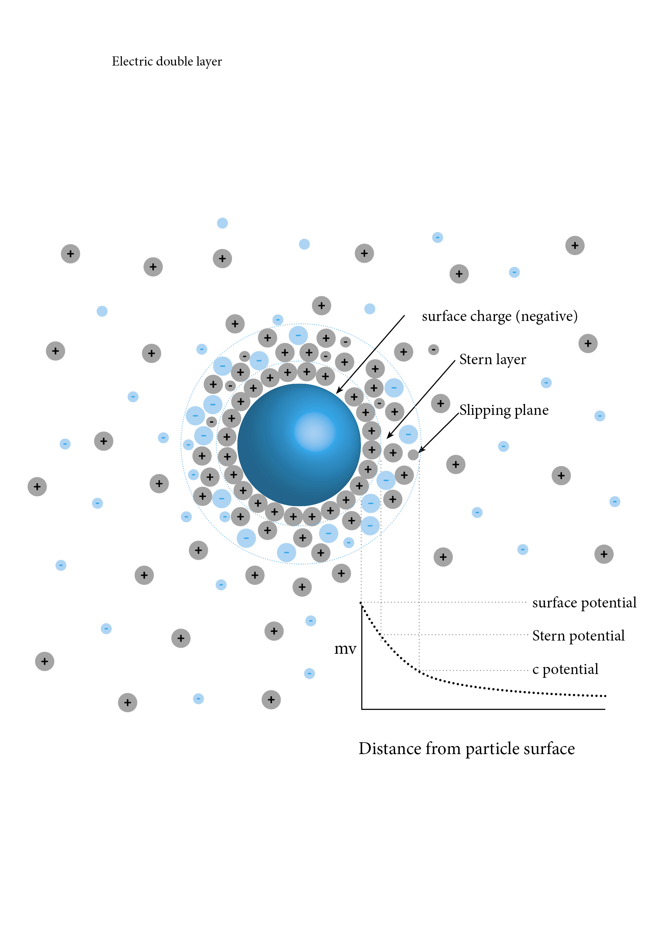

Figure 1. Schematic illustration of electric double-layer structure of negatively charged nanoparticle in colloidal suspension.

Among various nanomaterials, metal nanoparticles are of great importance due to their remarkable physical and chemical properties. They are distinguished from other nanomaterials by their bright colors, which arise from their optical properties. When metal nanoparticles (especially silver and gold nanoparticles) are irradiated using electromagnetic radiation, the wavelength of light becomes much longer than the nanoparticle size, causing the conduction electrons to oscillate upon interaction with the light. This oscillation around the surface of the nanoparticle causes a dipole oscillation towards the electric field of light. The amplitude of the oscillation reaches its maximum at a certain frequency, and is therefore known as localized surface plasmon resonance (LSPR). This phenomenon causes strong absorption of light, which can be measured using ultraviolet-visible (UV-Vis) spectrophotometry. Localized surface plasmon resonance is responsible for the unique and unusual colors of various metal nanoparticles. The size of the nanoparticles plays a crucial role in LSPR; for example, increasing the size of silver nanoparticles leads to a wider absorption peak in UV-Vis spectrophotometry and appears as a different color.21-22

The synthesis of metal nanoparticles by the reduction method has often been discussed in articles in this journal.8,23 This method is based on the reduction of metal ions, in particular, gold and silver ions, to produce solutions of metal nanoparticles. Most applications of metallic nanoparticles require preparing them in the form of aqueous colloidal suspensions called hydrosols.

Colloidal suspensions are differentiated from other types of solutions due to Brownian motion and Tyndall effect phenomena.Brownian motion is a random movement or zigzag-like motion of nanoparticles in colloidal suspensions that results from collisions between the nanoparticles and the molecules of the dispersion medium. The Tyndall effect is an optical property that arises from passing a beam of light through colloidal suspensions. When a light beam passes through a colloidal suspension, the light collides with the nanoparticles inside, resulting in light scattering in all directions. This phenomenon is represented by the appearance of a beam of light inside the solution. The light scattering is attributed to the size of the particles in the solution. In comparison, true solutions of ions or molecules have solute particles with sizes below 1 nm. This size is too small to lead to light scattering, and therefore no beam of light is detected.

The present study describes a simple laboratory activity composed of three successive experiments in which students explore the reduction preparation method of silver nanoparticles and their electrostatic stabilization. This series of experiments presents a new way to integrate the topics of nanomaterials with one of the basic subjects taught in chemistry, namely, reduction and oxidation reactions. Two well-known oxidation reduction reactions were presented and then tested in the lab to introduce the students to metal nanoparticle synthesis by the reduction method, electrostatic stabilization of metal nanoparticles, zeta potential, the Tyndall effect, and surface plasmon resonance. The proposed lab activity is unique in that it is based on visual and attractive color changes. Participating in the lab activity were second-year college students majoring in chemistry as part of a chemistry laboratory course.

Experimental Overview

The lab activity consisted of three parts. First, the students explored the known reduction of silver ions by copper metal, the formation of grey-black precipitate of silver atoms, and the color change of the solution from transparent to blue, which is typical of copper (Cu2+) ions. Second, synthesis of silver nanoparticles was done using a well-known method reported in the literature.24 This method is based on the reduction of silver ions by tri-sodium citrate, which acts both as a reducing agent and an electrostatic stabilizer. Tri-sodium citrate adsorbs to the surface of the silver nanoparticles produced and gives them a negative electrostatic charge. Third, the blue color solution of Cu2+ obtained initially was used to induce aggregation of silver nanoparticles by neutralizing their negative charges. All of the appealing visual color changes attributed to the lab activity were analyzed with a Malvern Zetasizer Nano UV-Visible spectrophotometer using the well-known dynamic light scattering (DLS) technique to determine the size of the silver nanoparticles and the value of zeta potential. A laser beam was used to observe the Tyndall effect.

Experimental section

Reduction of Silver Ions by Copper Disks

A solution of silver nitrate (1M) was prepared by dissolving 42.5 g of silver nitrate (AgNO3, 99%, Sigma-Aldrich) in 250 mL of double-distilled water. Ten copper disks (each with a mass of 1.5 g) were then added to the solution. Gradually, a grey-colored precipitate appeared, while the solution turned from transparent to blue. After 30 minutes, the blue-colored solution was separated from the silver precipitate by filtration and was set aside.

Synthesis of Silver Nanoparticles by the Reduction Method

The preparation of silver nanoparticles was based on the reduction of silver ions by tri-sodium citrate.24 An aqueous solution of silver nitrate (AgNO3, 99%, Sigma-Aldrich) was prepared by dissolving 0.0425 g of silver nitrate in 250 mL of double-distilled water. The solution was placed on a stirring hot plate and was heated to boiling. An aqueous solution of 1% w/w tri-sodium citrate dihydrate (HOC(COONa)(CH2COONa)2 ∙ 2H2O, Sigma-Aldrich) was prepared by dissolving 0.2 g in 20 mL of double-distilled water. Next, 5 mL of the tri-sodium citrate solution was added drop by drop to the boiled solution of silver nitrate while stirring vigorously. The mixture gradually turned from transparent to yellow-green, indicating the formation of a stable colloidal suspension of silver nanoparticles. The colloidal suspension was removed from the hot plate and allowed to cool.

Aggregation and Precipitation of Silver Nanoparticles by Copper Ions: Converting the Yellow-Green Solution to Blue

Four different mixed solutions were prepared by combining in different volume proportions the blue filtered solution of Cu2+ ions obtained in part 1 with the yellow-green solution of the silver nanoparticles obtained in part 2, as shown in Table 1.

|  |  |  |  |
| --- | --- | --- | --- |
| Table 1. Description of the volume proportions of four different solutions prepared. | | |  |
| *Number of solution* | *Volume of silver nitrate solution (mL)* | *Volume of filtered Cu2+*  solution (mL) | *Total volume of solution (mL)* |
| 1 | 60 | 0 | 60 |
| 2 | 40 | 20 | 60 |
| 3 | 30 | 30 | 60 |
| 4 | 20 | 40 | 60 |

The students observed the color changes and analyzed the mixed solutions with a UV-Visible spectrophotometer (Ultraspec 2100 pro, Amersham Bioscience) and a Malvern Zetasizer Nano ZS using dynamic light scattering to determine the size of the silver nanoparticles and the value of the zeta potential.

HAzards

Silver nitrate (AgNO3) can burn the eyes and skin. If exposed, the eyes should be flushed with plenty of water for at least 15 minutes. The same is true for tri-sodium citrate; if exposed, eyes should be immediately flushed with water for at least 15 minutes. All the other materials are non-toxic. During the lab work, students are required to wear protective glasses and lab coats. They are also cautioned not to look directly into a laser or shine the laser at another person.

experimental results and discussion

During the first experiment, the students reviewed the well-known reduction oxidation reaction between the silver (Ag+) ions and copper (Cu2+) disks. Based on the values of the standard reduction potentials (E0) of copper and silver ions,25 the students were able to estimate that Cu(s) can spontaneously reduce silver ions in aqueous solution (see Table 2).

|  |  |  |
| --- | --- | --- |
| Table 2. Values of Standard Reduction Potentials of Ag+ and Cu2+. | | |
| *Half-reaction* | *Standard reduction potential (V)* |
| Cu2+(aq) + 2e- Cu(s) | +0.34 |
| Ag+(aq) + e- Ag(s) | +0.80 |
| E0 for the reaction: |  |
| 2Ag+(aq) + Cu(s) 2Ag(s) + Cu2+(aq) | (+0.8)-(+0.34)= 0.46>0 |

The silver nitrate solution is initially colorless. After immersing the copper disks, the transparent solution gradually turns blue, accompanied by the appearance of a grey-black precipitate (Figure 2).

Figure 2. (A) Aqueous solution of silver nitrate with copper disks inside the beaker, (B) 30 min later, (C) after filtration and separation of the grey-black precipitate from the blue solution.

The yellow-green solution of silver nanoparticles is shown in Figure 3A. As described previously, its characteristic color is due to the phenomenon of localized surface plasmon resonance (LSPR). Figure 3B presents the UV-Visible spectrum for the as-prepared silver colloidal suspension. The plasmon resonance produces a peak near 400 nm that is typical of silver nanoparticles. The size measurements obtained by dynamic light scattering show a bimodal particle size distribution, which suggests the presence of two populations of silver particles, one having a size of 67 nm and the other 5.5 nm (Figure 3C). A stable colloidal suspension can be controlled by maximizing the repulsive forces between the nanoparticles in order to keep each one separate and prevent them from adhering to one other and aggregating. Electrostatic repulsion plays an important role in stabilizing colloidal suspensions. In our case, tri-sodium citrate has two functions: it is a reducer and a stabilizer. In addition to the reduction of silver ions, it adsorbs onto the surface of the silver nanoparticles produced to cause anionic repulsion between them. The anionic charge of silver nanoparticles was determined by zeta potential measurements and yielded a high negative value of -38.7 mV that indicates the adsorption of tri-sodium citrate ions onto the surface of silver nanoparticles. Moreover, it shows the high stability of the silver colloidal suspension. Figure 4 is a schematic representation of the silver nanoparticles capped by tri-sodium citrate and the zeta potential measurement.

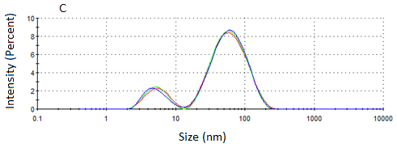

Figure 3. (A) Yellow-green colloid solution of silver nanoparticles, (B) UV-Visible absorption spectrum for the as-prepared silver colloid, and (C) Size distribution of the as-prepared silver nanoparticles.

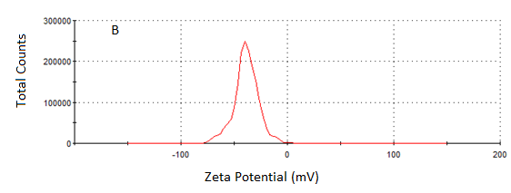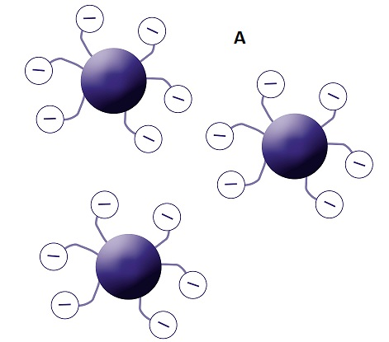

Figure 4. (A) Schematic illustration of silver nanoparticles stabilized by tri-sodium citrate, and (B) Zeta potential measurement of the as-prepared silver colloid.

During the first and second part of the lab activity, the students experienced two different reactions for the reduction of silver ions. In the first reaction, they produced macroscale silver precipitate, whereas in the second reaction, a colloidal suspension of silver nanoparticles was produced. The students were able to visually observe the different results, especially the role of tri-sodium citrate as stabilizer.

The blue filtered solution of Cu2+ ions obtained in the first part of the lab activity was used to induce the aggregation of silver nanoparticles. In the second part of the lab activity, silver nanoparticles were stabilized by the negative charge of the adsorbed tri-sodium citrate. The addition of the Cu2+ solution neutralizes the negative charge of the silver nanoparticles and then induces their aggregation.

As a first step, the students analyzed the various mixed solutions prepared, as shown in Table 1. These solutions consisted of different volume proportions between the silver colloidal suspension and the Cu2+ solution. Similarly, after adding the Cu2+ solution to the colloidal suspension of silver nanoparticles, the color turned from yellow-green to dark blue. The solutions were analyzed by their plasmon absorption using UV-Visible spectrophotometry. The UV-Visible spectra are presented in Figure 5. It is clear that increasing the volume proportion of Cu2+ solution resulted in decreased absorption intensity and absorption band broadening. This indicates the aggregation of silver nanoparticles. Due to the spontaneous attraction between the negative and positive charges, the added positively charged Cu2+ ions will be attracted directly to the surface of the silver nanoparticles, causing the reduction of its negative charge. This process enhances the attraction between the silver nanoparticles, resulting in the immediate change in the color’s solution, from yellow-green to dark blue. The broad and weak absorption band appeared after adding Cu2+, corresponding to the possible formation of Cu(H2O)6+2 complex.26

Comparison of the curves allowed the students to observe that increasing the volume proportion of the Cu2+ solution results in a decrease in the intensity of absorption, that is, increasing the number of Cu2+ ions leads to more aggregated silver nanoparticles.

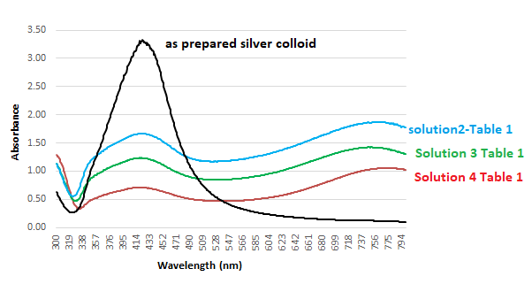

Figure 5. UV-Visible absorption spectra of the different solutions as shown in Table 1.

For the continuous analysis of the aggregation process of silver nanoparticles, the mixed solution of 40 mL of silver colloid and 20 mL of Cu2+ (Solution 2 in Table 1) was analyzed over time. The students monitored the visually and attractive color changes for 2 hours, and analyzed these changes by following the UV-Visible absorption spectra, particle size, and zeta potential. They found that the yellow-green color of the silver nanoparticle solution changed to a blue solution with a grey-black precipitate, just as the solution obtained in Part 1 of the experiment (Figure 6).

Figure 6. (a) Filtrate of the blue solution obtained in experiment 1, (b) Orange-green solution obtained in experiment 2, (c) Immediately after the addition of solution a to solution b, (d) 2 hours after the addition of solution a to solution b. Lower image: solution d after filtration.

To make the experiment more interesting, the students compared the color changes when mixing the yellow-green solution of the silver nanoparticles with an aqueous solution of blue food coloring, which yielded a light green-yellow solution (Figure 7). Examination of the chemical structure of blue food dye (Scheme 1) showed it is a negatively charged molecule just like the tri-sodium citrate; consequently, it increases the magnitude of the negative charge of the silver nanoparticles, and the colloidal suspension remains stable. The students were asked to explain the appearance of the light green-yellow color in terms of mixing the two colors together.

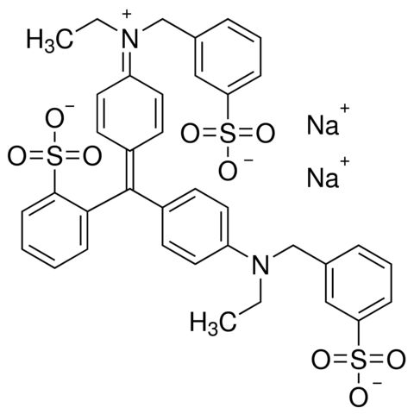

Scheme 1. Chemical structure of blue food dye.

Figure 7. (a) Solution of blue food color, (b) orange-green solution obtained in experiment 2, (c) solution obtained after the addition of solution a to solution b.

A laser beam was used as a simple way to distinguish between the different-colored solutions. The students could not detect anything in the solution of the Cu2+ions, whereas a red line could be seen in the solution of the silver nanoparticles when the laser beam was passed through it. In addition, the students were asked to monitor the changes that occurred when the two solutions were mixed. In this case, the red line was visible at the beginning but gradually disappeared. Conversely, the red line in the solution of the silver nanoparticles was not affected by the addition of the blue food coloring solution (Figures 8 and 9, respectively).

The Tyndall effect is a property of colloidal suspensions that distinguishes them from true solutions. This phenomenon is related to the particles’ size in solutions. When light is shined through a true solution, like the solution of the Cu2+ ions, the light passes cleanly through it. The size of the ions or molecules in true solutions is below 1 nm. However, the size of dispersed nanoparticles in colloidal suspensions is greater than 1 nm. When the light is passed through it, the nanoparticles scatter the light in all directions, making it immediately visible. Scheme 2 illustrates the changes in solute particle size during the aggregation process, which explains the observations shown in Figure 8.

Figure 8. Laser beam passing through: (a) Filtrate of the blue solution obtained in experiment 1, (b) yellow-green solution obtained in experiment 2, (c) immediately after addition solution a to b, (d) solution c after 3 hours.

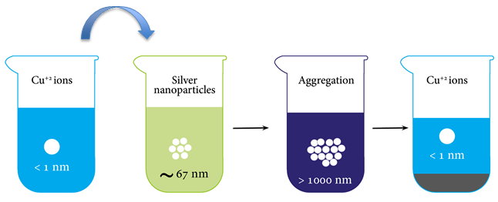

Scheme 2. Schematic illustration of the inside solutions through the aggregation process.

Figure 9. Laser beam passing through: (a) a solution of blue food coloring, (b) the yellow-green solution obtained in experiment 2, (c) the solution after adding solution a to b.

The students analyzed the visually colored aggregation process with time by monitoring the changes in silver particle size, value of the zeta potential, and UV-Vis absorption. As mentioned in the introduction section, zeta potential exhibits the electrical potential at the slipping plane of the electric double layer around each nanoparticle and provides indications as to colloid stability. The average value of zeta potential for the as-prepared silver colloidal suspension is -38.7 mV; this value signifies a stable colloidal suspension. After adding the Cu2+ solution, the zeta potential value decreases significantly to -7.4 mV, that is, the negative electric charge of the silver nanoparticles decreases. When Cu2+ solution was added to the silver colloid, the Cu2+ ions were attracted by the negative charged citrate anions adsorbed to the surface of the silver nanoparticles, and the ions tended to eliminate the repulsive electrostatic force. Therefore, silver nanoparticles aggregated, leading to increased particle size. Figure 10 presents the results of silver particle size measurements over time upon adding Cu2+.

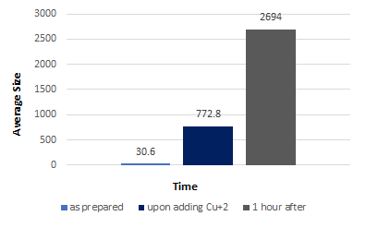

Figure 10. Average size of silver nanoparticles over time.

The aggregation process of silver nanoparticles was also monitored by UV-Visible absorption measurements for the as-prepared silver colloid (A) immediately after adding Cu2+ solution (B), 1 hour after adding Cu2+ solution (C), and after complete precipitation and turning the yellow-green silver solution to blue with a grey-black precipitate (D). The results clearly show that, over time, the intensity of absorption decreases, and absorption bands became more broadened (Figure 11). For comparison, the students conducted the UV-Visible absorption measurements for the mixed solution of silver nanoparticles with the blue food color solution. The resulting curve (Figure 11E) confirms that the silver nanoparticles were not affected by the addition of the blue food color. This result was confirmed by measuring the value of the zeta potential and the size of the silver nanoparticles. The higher negative charge value of the zeta potential was retained (-33.5 mV), and the average particle size is 46.44 nm.

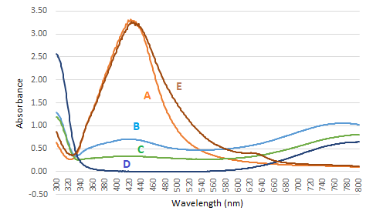

Figure 11. UV-Visible spectra of (A) as-prepared silver colloid, (B) immediately after adding Cu+2 solution, (C) 1 hour after adding Cu+2 ions, (D) after precipitation, (E) silver colloid after adding blue food color solution.

pedagogical assessment

This lab activity was designed to introduce undergraduate students to fundamental concepts related to nanomaterials, synthesis, and properties. By conducting the experiments, students could compare the properties of materials at the macro- and nanoscale. The students had a basic understanding of nanomaterials, that is, electrostatic stabilization of colloid solutions, aggregation of nanoparticles, optical properties, surface plasmon resonance of metal nanoparticles, electric double layers of electrostatically stabilized nanoparticles, and zeta potential.

The duration of the lab activity is four hours. The first hour is theoretical, consisting of a dialogue between the lecturer and the students on the basic concepts and aspects of nanomaterials. In the second hour, the students prepared the different solutions as reported in the experimental procedure, applied the reduction reaction of silver ions by copper metal to yield a grey-black precipitate of silver, and observed the reduction of silver ions by tri-sodium citrate and the formation of yellow-green solution of silver nanoparticles. In the last two hours, the students analyzed the as-prepared silver colloidal suspension by UV-Visible absorption, zeta potential, and particle size measurements. Next, they monitored the aggregation process and analyzed the process of visual color aggregation of the silver nanoparticles.

Student Learning Objectives

As a result of this lab activity, students learn:

* Oxidation reduction reaction between silver ions and copper metal
* Synthesis of silver nanoparticle solution by reduction method
* Electrostatic stabilization of metal nanoparticles
* Localized surface plasmon resonance of metal nanoparticles
* Double electric layer of electrically charged nanoparticles and zeta potential
* Aggregation process of metal nanoparticles

After applying the successive experiments, the students will be able to understand the role of tri-sodium citrate as a colloidal stabilizer capable of preventing the aggregation of silver nanoparticles. The students will explore the visual color changes that result from the addition of the blue solution prepared in the first part of the lab activity by UV-Visible absorption measurements, zeta potential, and measuring the changes in silver particle size.

As part of the course, “Chemistry in the Lab,” 36 college freshmen from The Academic Arab College for Education in Haifa, Israel, who are studying to be high-school chemistry teachers, participated in this lab activity. One week after the lab activity, the students were required to submit a laboratory report in which they responded to questions that aimed to assess their understanding of the concepts and characterization methods incorporated in the experiments. An optional question was provided to ask the students for their impression after completing the experiments.

Examples of students’ answers to this question are below:

Student 1: *“The experiments were amazing for me; I did not have any information about nanomaterials*

*before, during the lab activity, I learned new concepts that are related to materials at the*

*nanoscale. Converting the silver colloid solution obtained in the second experiment to blue*

*colored solution with grey black precipitate exactly like the solution obtained in the first*

*experiment* *was the most important section for me, I understand very well the scientific*

*explanation of it.”*

Student 2: *“The most interesting section of the experiment it was turning the silver colloid solution*

*to blue one. I learned new concepts that are related to nanomaterials.”*

Student 3: *“This is the first time that I learn about nanomaterials, I heard about it before, but I did not*

*have any knowledge about it. After the lab activity, the concepts of nanomaterials and colloid*

*solutions became much clearer.”*

Student 4: *“I liked the experiments very much, the precipitation of the “unseen” silver nanoparticles was*

*very interesting. In addition to the different analysis, the differentiation between the different*

*solutions by passing a beam of laser light was very interesting”.*

summary

This series of experiments constitutes a novel way to integrate an introduction to nanoscience into a basic lesson in chemistry. The lab activity is based on visual results for the students. The students found the lab activity very enjoyable, especially when converting one solution to another, accompanied by color changes. This made the students more curious about the different results, and enabled them to make the connection between various concepts in science. At the completion of the lab activity, the students learned new concepts of colloid solution, capping agent, zeta potential, surface plasmon resonance, and aggregation.

Associated content

Supporting Information

The Supporting Information is available on the ACS Publications website at DOI: 10.1021/acs.jchemed.XXXXXXX. [ACS will fill this in.] Example brief descriptions with file formats indicated are shown below; customize for your material.

Instructor (DOCX)

Student (DOCX)

AUTHOR INFORMATION

Corresponding Author

*E-mail: [riama@arabcol.ac.il](mailto:riama@arabcol.ac.il)

[riamab@gmail.com](mailto:riamab@gmail.com)

Notes

The Author declares no competing financial interests

Acknowledgments

The author is indebted to The Academic Arab College for Education for financial assistance. She also thanks the students who took part in the lab sessions during the chemistry laboratory course.

REFERENCES

1. Roco, M. C. From Vision to the Implementation of the U.S. National Nanotechnology Initiative. *J. Nanopart. Res*. **2001**,*3*, 5-11.
2. Roco, M. C. Nanotechnology’s Future. *Scientific American* **2006**,*293*, 39.
3. Menaa, B. The Importance of Nanotechnology in Biomedical Sciences. *J. Biotechnol. Biomater.* **2011**,*1* (5), 1000105e.
4. NAP, *Triennial Review of the National Nanotechnology Initiative*, Retrieved from Washington, DC. **2016.**
5. Roco, M. C. Converging Science and Technology at the Nanoscale: Opportunities for Education and Training. *Nature Biotechnology.* **2003**,*21,* 1247-1249.
6. Furlan, P. Y. Engaging Students in Early Exploration of Nanoscience Topics Using Hands-On Activities and Scanning Tunneling Microscopy. *J. Chem. Educ.* **2009**,*86* (6), 705.
7. Sharma, R. K.; Gultai, S.; Mehta, S. Preparation of Gold Nanoparticles Using Tea: A Green Chemistry Experiment. *J. Chem. Educ.* **2012**,*89* (10), 1316-1318.
8. Mulfinger, L.; Solomon, S. D.; Bahadory, M.; Jeyarajasingam, A.; Rutkowsky, S.; Boritz, C. Synthesis and Study of Silver Nanoparticles. *J. Chem. Educ.* **2007**,*84* (2), 322-325.
9. Zhang, X.; Wang, Z.; Xu, C. Demonstrating the Many Possible Colors of Gold-Supported Solid Nanoparticles. *J. Chem. Educ.* **2015**,*92* (2), 336-338.
10. Cooke, J.; Hebert, D.; Kelly, J. Sweet Nanochemistry: A Fast, Reliable Alternative Synthesis of Yellow Colloidal Silver Nanoparticles Using Benign Reagents. *J. Chem. Educ.* **2015**,*92* (2), 345-349.
11. Abu Much, R.; Hugerat, M. Fabrication of Electrically Conductive Thin Films Made of Silver Nanoparticles: A Case Study with Freshmen. *J. Nano. Educ.* **2016**,*8* (1), 22-29.
12. Jones, M. G.; Blonder, R.; Gardner, G. E.; Albe, V.; Falvo, M.; Chevrier, J. Nanotechnology and Nanoscale Science: Educational Challenges. *Int. J. Sci. Educ.* **2013**,*5*, 1490-1512.
13. Blonder, R.; Dinur, M. Teaching Nanotechnology Using Student-Centered Pedagogy for Increasing Students Continuing Motivation. *J. Nano. Educ.* **2011,** *3*, 51-61.
14. Delgado, C.; Stevens, S.; Shin, N.; Krajcik, J. A Middle School Instructional Unit for Size and Scale Contextualized in Nanotechnology. *Nanotechnol. Rev.* **2015**,*4* (1), 51-69.
15. Dori, Y.; Dangur, V.; Avargil, S., Peskin, U. Assessing Advanced High School and Undergraduate Students’ Thinking Skills: The Chemistry - From the Nanoscale to Microelectronics Module. *J. Chem. Educ.* **2014**,*91* (9), 1306-1317.
16. Hutchinson, K.; Bonder, G. M.; Bryan, L. A. Middle and High-School Students’ Interest in Nanoscale Science and Engineering Topics and Phenomena. *J-PEER*. **2011**,*1*, 30-39.
17. Sakhnini, S.; Blonder, R. Nanotechnology Applications as a Context for Teaching the Essential Concepts of NST. *Int. J. Sci. Educ.* **2016**,*38* (3), 521-538.
18. Hunter, R. J. *Foundation of Colloid Science*; Oxford University Press, 2001.
19. Helmut, B.; Richards, R. M. Nanoscopic Metal Particles - Synthetic Methods and Potential Applications. *J. Inorg. Chem.* **2001**,2001(10), 2455-2480.
20. Toshima, N.; Yonezawa, T. Bimetallic Nanoparticles—Novel Materials for Chemical and Physical Applications. *New J. Chem.* **1998**, 22 (11), 1179-1201.
21. Venkatesh, N.; Bhowmik, H.; Kuila, A. Metallic Nanoparticle: A Review. *Biomed. J. Sci. Tech. Res.* **2018**,4(2), 3765-3775.
22. Farinas, P. S.; Doimo, A. L.; da Silva, M. A.; Teixeira, I. F. Synthesis and Application of Ag Nanoparticles for an Undergraduate Laboratory: Ultrasensitive Method to Detect Copper (II) Ions. *J. Chem. Educ.* **2020**,97(10), 3771-3777.
23. Orbaek, A. W.; McHale, M. M.; Barron, A. R. Synthesis and Characterization of Silver Nanoparticles for an Undergraduate Laboratory. *J. Chem. Educ.* **2015**,*92* (2), 339-344.
24. Lee, P. C.; Meisel, D. Adsorption and Surface-Enhanced Raman of Dyes on Silver and Gold Sols. *J. Phys. Chem.* **1982**,86 (17), 3391-3395.
25. Vanýsek, P. Electrochemical Series. In *CRC Handbook of Chemistry and Physics*; CRC Press, 2000,8.
26. Ong, H. R.; Khan, M. M. R.; Ramli, R.; Du, Y.; Xi, S.; Yunus, R.M. Facile Synthesis of Copper Nanoparticles in Glycerol at Room Temperature: Formation Mechanism. *RSC Adv.* **2015,** *5*(31), 24544-24549.