Solar urban districts: A holistic generative cross-climatic method for solar-driven environmental design of dense urban fabrics

Part 3 - Detailed Description of Research Program
This project proposes a novel and robust approach for solar-driven urban design—one which aligns with the history of solar architecture, addresses the gaps in previous solar-envelope methods and satisfies the current needs by using cutting-edge computational methods for multi-objective environmental analysis and optimization.
- Scientific background
  - Solar design
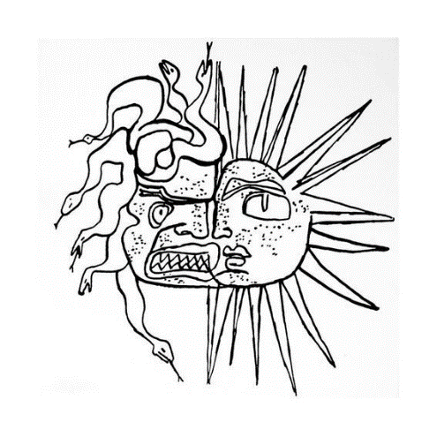Designing our built environment based on solar positioning can be traced from ancient history to the pre-air-conditioning era. The Sun is the main determinant of both thermal and visual comfort, so solar exposure determines the energy needed to deliver the requisite comfort level of any given setting. Until relatively recently, passive design has been the main strategy to harness or avoid the Sun’s energy to improve the environmental performance of buildings and cities. Today, although air-conditioning and artificial lighting have reached impressive technological levels, passive strategies remain the most effective to ensure both energy efficiency and thermal and visual comfort while also being cost-effective (the cheapest energy remains the energy not used). When solar-energy production, which has emerged as a key factor, is added to the equation, solar availability becomes even more important to consider and at the same time more subtle to evaluate because it is part of both the problem and the solution, especially in dense urban areas [1] (i.e., the problematic excess heat or glare of summer vs. the desirable heating, energy generation and daylight in winter). The ‘Mask of Medusa’ by Le Corbusier (Fig. 1) reflects this duality well, and the double impact of solar radiation has become an important departure point for several studies that explore the trade-offs between the pros and cons of solar performance in different temporal and spatial configurations and in different contexts.
In recent decades, with the rise of global urbanization rates to over 55% [2] and the recognition of cities as the main energy consumers and carbon emitters [3], we are witnessing a shift of focus in environmental design research from single buildings to urban districts and even to entire cities. Another important trend is the shift from the limited focus on evaluating energy efficiency and balancing between energy supply and energy demand towards zero-energy buildings and recently even further towards regenerative design, whereby buildings and districts enhance the environmental quality in and around them rather than just minimize the use of resources [4].
Fig. 1: The contrasting impact of the
Sun. The Mask of Medusa, by Le Corbusier
(1939).

  - Methods and tools for solar urban design
In the context of the trade-off between high density and environmental performance, both trends (i.e., zero-energy buildings and regenerative design) play an important role in state-of-the-art solar-driven urban design. The studies of Knowles [5,6] are among the earliest on methods and tools to explore solar exposure on the urban scale. During the 1970s, Knowles introduced the solar envelope (SE) concept, whereby a spatial boundary is designated for solar access to the built environment over a given time frame [5]. In other words, the SE method is a generative concept whereby the largest theoretical spatial boundaries are defined by the solar angles to ensure no over-shadowing of the surroundings over a specific time frame (e.g., the winter solstice, during which the Sun is at its lowest position). Knowles further developed this concept by adding shadow fences, which maximize this volume by defining the vertical height of an imaginary plane above which the solar exposure is desirable in neighbouring buildings [6] (Fig. 2). In related work, Capeluto et al. [7,8] developed the computational tool SustArc, which calculates the solar volume (Fig. 3)—a combination of both the solar-rights envelope (i.e., the maximal height that will not compromise the solar rights of neighbouring buildings) and the solar-collection envelope (i.e., the minimum height that respects the solar rights of a building). Stasinopoulos [9] explored the spatial impact of various criteria (e.g., plot size and proportion, orientation, ground slope) on solar envelope designs by using the solar volume coefficient, which is the volume of a solar envelope per unit plot area. Stasinopoulos concluded that solar-envelope methods generate lower densities than allowed by urban regulations, which in turn can be compensated by other locally based considerations, such as daylight, ventilation and views and generate so-called ‘solar cityscapes’.
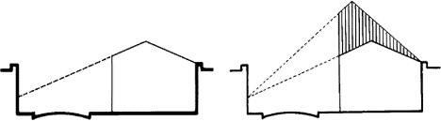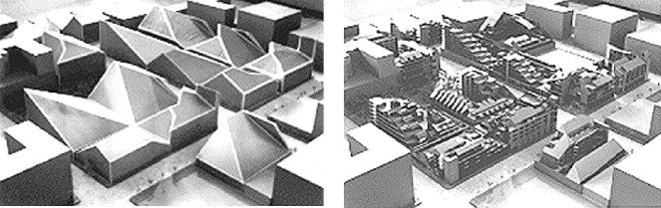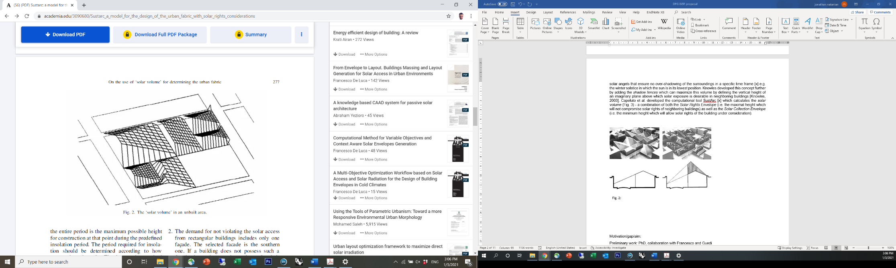
Fig. 3: The solar volume representing solar exposure considerations for both existing and new buildings [7].
Fig. 2: The solar envelope concept applied to a typical housing project (top) and space and time constraints for solar envelopes (bottom) [6].

The concept of the residential solar block (RSB), introduced by Okeil [10], focuses on an urban block typology that combines both winter exposure and summer shading in an attempt to offer a harmonized approach in which the advantages of the urban block are coupled with the energy performance advantages of the linear urban form (Fig. 4). Building on that concept, Vartholomaios presented the RSB envelope [11] in which, through a sequence of computational steps, the solar envelope and solar fan calculations are combined to define solar envelopes for urban blocks in which the spatial inputs for the solar calculations are based on the outputs of energy simulations (Fig. 5). These methods can be regarded as ‘static’, meaning that the solar envelope is separately calculated for each building according to the spatial (and sometimes temporal) input data and is thus restricted in its ability to explore a larger number of design variables.

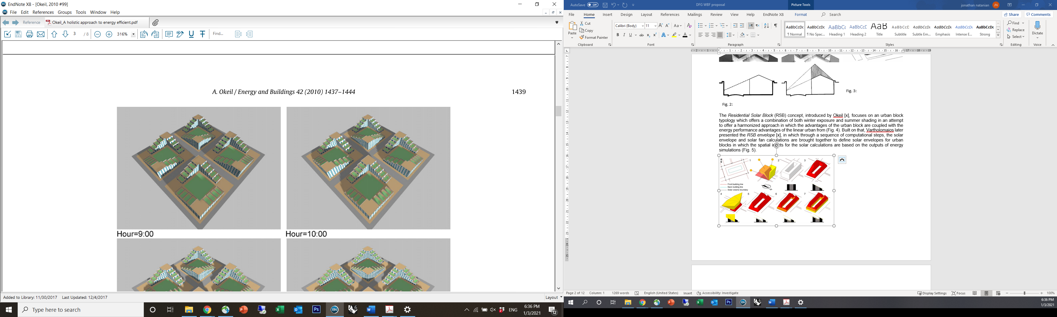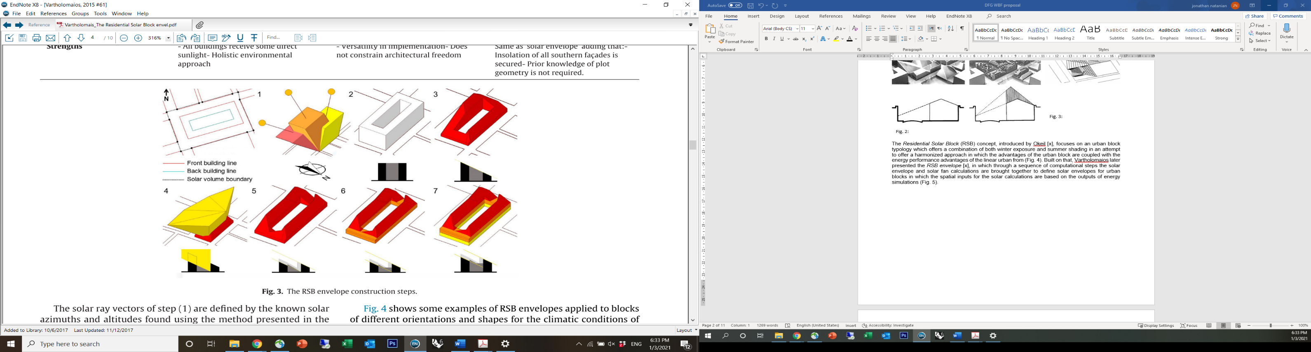
Fig. 5: Envelope concept for residential solar block (RSB) [11].
Fig. 4: Example of residential solar block (RSB) optimized for latitude 48.00 [10].

  - Advanced methods and parametric workflows
Solar-driven evaluation workflows have advanced due to recent advancements in digital workflows and parametric environmental assessment tools [12,13]. As an extension of Capeluto’s studies on the solar envelope, Capeluto and Plotnikov [14] introduced the rarametric solar-envelope concept, whereby the shape of the solar envelope is simultaneously and seamlessly generated with every modification of weather data, geometry, or programmatic requirements. De Luca devoted several studies to solar envelopes that used the Grasshopper parametric environment. These studies capitalized on the advanced capabilities of the parametric modelling environment to generate solar envelopes using customizable daylight requirements [15,16]. In a later study, De Luca et al. presented the reverse solar-envelope method [17,18], whereby advanced subtractive methods combined with reverse raytracing ‘curve’ out the built form in dense urban contexts to ensure the daylight potential of the surrounding environment (Fig. 6). A recent extension of this method generates a subtractive solar envelope with the support of geometric and radiometric properties stored in point cloud data [19].
These studies correlate well with recent trends in practice (Fig. 7) in which pixelated forms, driven primarily by climatic considerations, are becoming ever more frequently used in contrast with rigid or pure forms, thereby reducing flexibility and/or diversity. The shift from the building to the urban scale is another notable trend in advanced solar design studies, where solar availability at the pedestrian level is considered together with the solar availability on the building facade [20], the interdependencies between urban typology and solar potential are explored [21,22] and urban blocks are designed based on solar potential and energy systems using optimization methods [23].
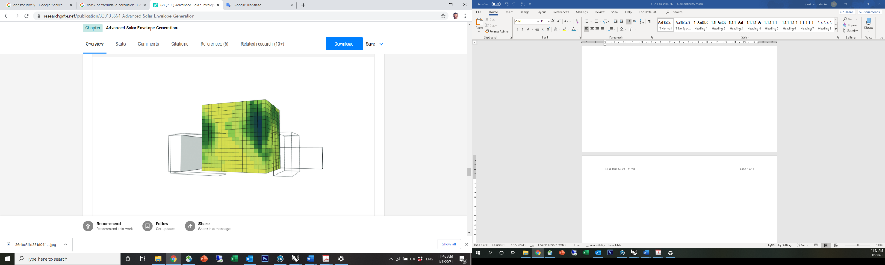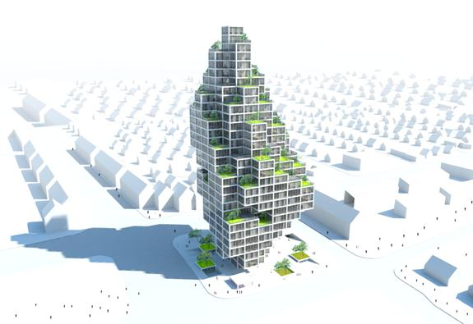
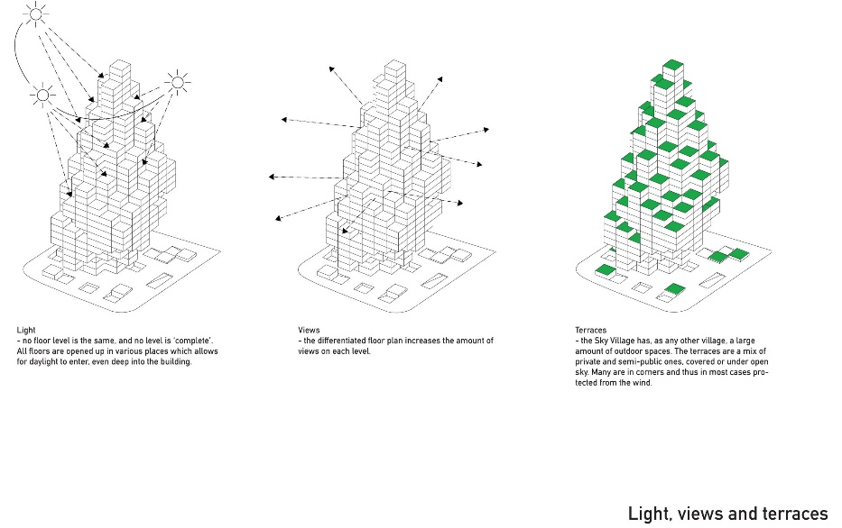

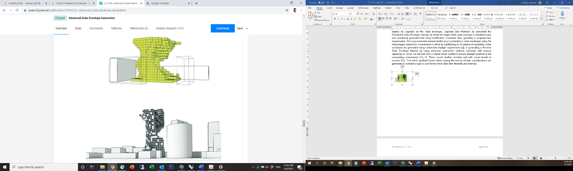

← Fig. 6: Reverse solar envelope method [17].

↑ Fig. 7: MVRDV’s ‘Sky Village’ design proposal for Copenhagen

  - Preliminary studies by the PI on urban environmental performance
My recent studies were dedicated to exploring holistic urban-scale environmental performance—beyond energy considerations—and asked whether both density and performance can be attained in hot climates by employing a method to balance urban form, energy supply, energy demand and environmental quality.
To answer this question, we established an automated Grasshopper-based workflow, which allows us to evaluate the environmental impact of a wide range of building and urban-scale design parameters, including typology and density [24, 25]. Figure 8 shows the potential of this methodology, which was explored in the context of a case study in Tel Aviv [26], where I used my workflow to test the environmental performance trade-offs of four different typological layouts designed by local architects. The results provide visual indications that help the architects recalibrate their forms based on environmental performance considerations. More recent developments of this workflow capitalize on the adaptive nature of Grasshopper to include several other key performance indicators (KPIs) [e.g., contact with nature (biophilia) [27], climatic resilience, outdoor comfort [4] ], as well as to couple different tools (e.g., for streaming microclimatic evaluation data as an input for energy evaluation [28] or to scale up outdoor comfort evaluation to annual temporal cycles [29]).
The latest addition to my workflow was done in collaboration with Professor Wortmann and focused on integrating an architectural design optimization module to highlight optimal design solutions based on environmental performance objectives. Our first findings were presented at the SimAUD 2020 conference, in which we introduced a benchmark for multi-objective optimization (MOO) of zero-energy urban blocks in the context of Shanghai [30]. Our latest publication in Energy and Buildings [31] introduces simplified solar and geometrical-based metrics for energy performance that are used for a MOO study of an urban district in Tel Aviv (Fig. 9). The results of running the optimization using these different metrics (Fig. 10) indicate that they are effective energy-performance indicators for optimization analyses to inform early-stage morphological decision-making. The dynamic nature of the computational evaluation approach I have developed allows it to expand and adapt to different scales and constraints. Thus, its integration into the SE approach, which currently is very limited in its performance-evaluation capacity, has a high potential benefit.
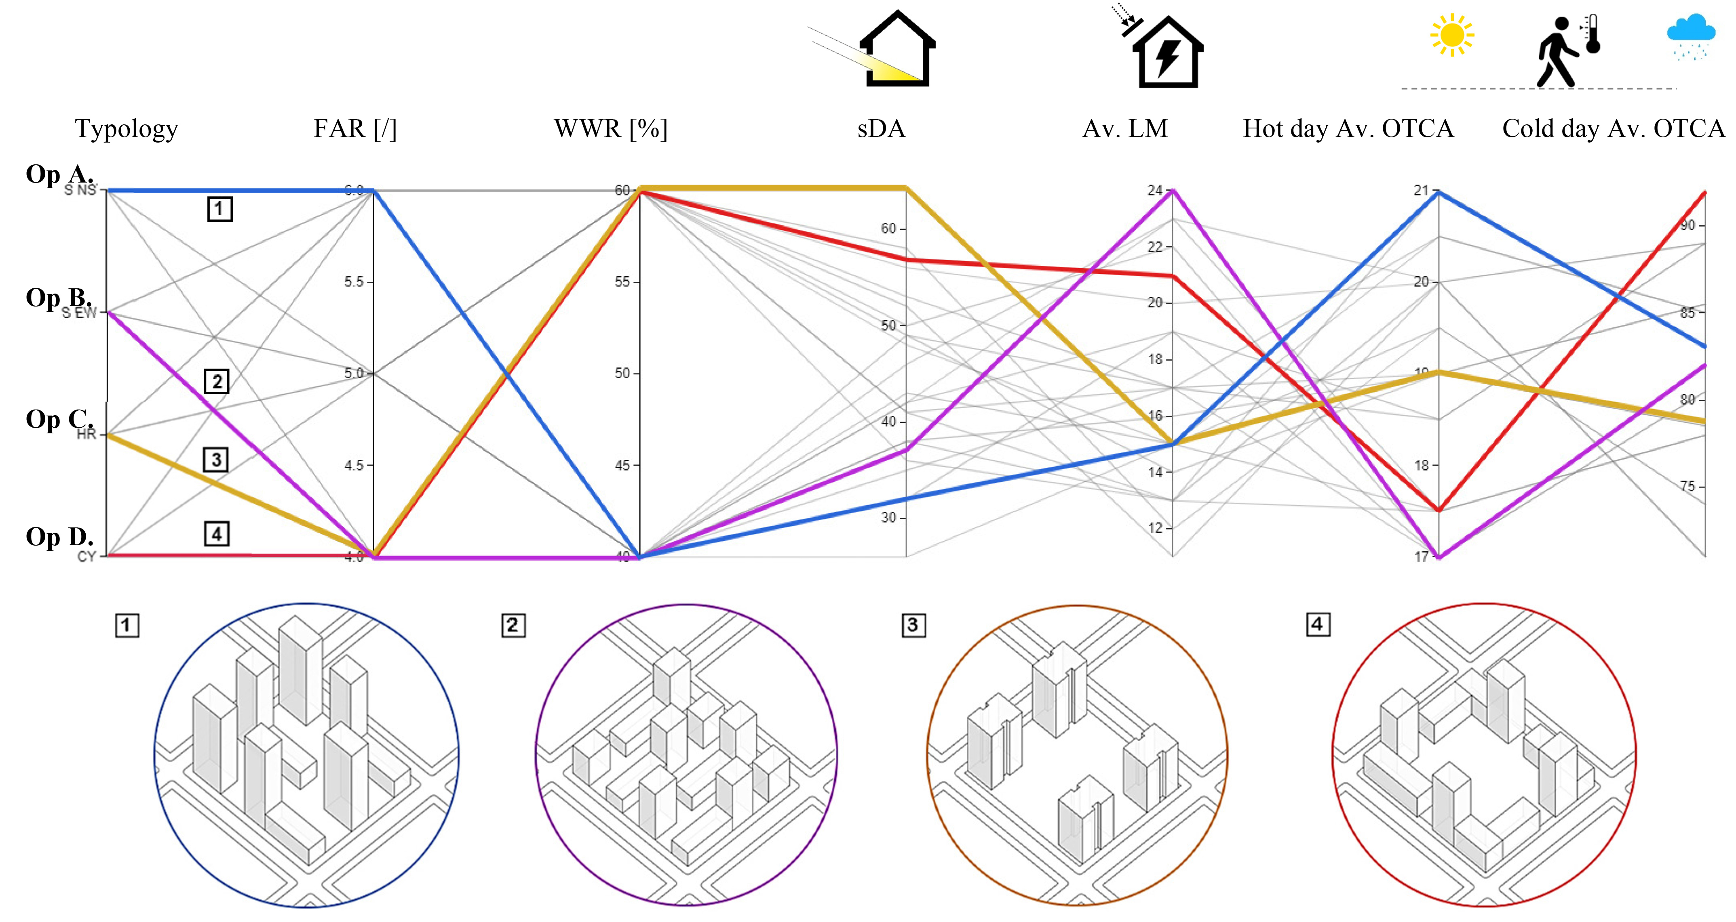

Fig. 8: Visual representation of energy, daylight and outdoor comfort simulation results for 24 iterations, including highlight of four optimization scenarios and their corresponding input parameters [26].

  - Scientific gaps
Despite these recent advancements powered by the integration of digital tools into SE workflows, the application of the SE concept still has several limitations: (1) the outputs of current SE methods include a theoretical spatial boundary, rather than an actual building mass, which is more useful for designers; (2) the SE boundary gives a very rough estimate of the trade-off between the desirable and undesirable impacts of solar radiation for a given boundary;

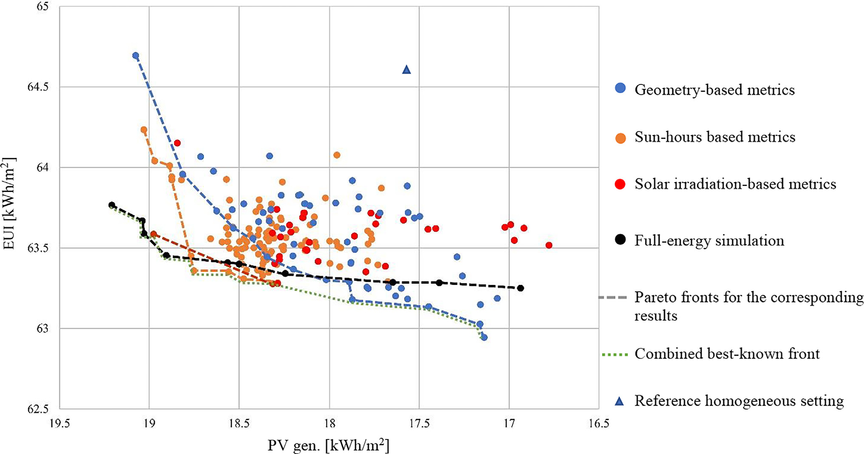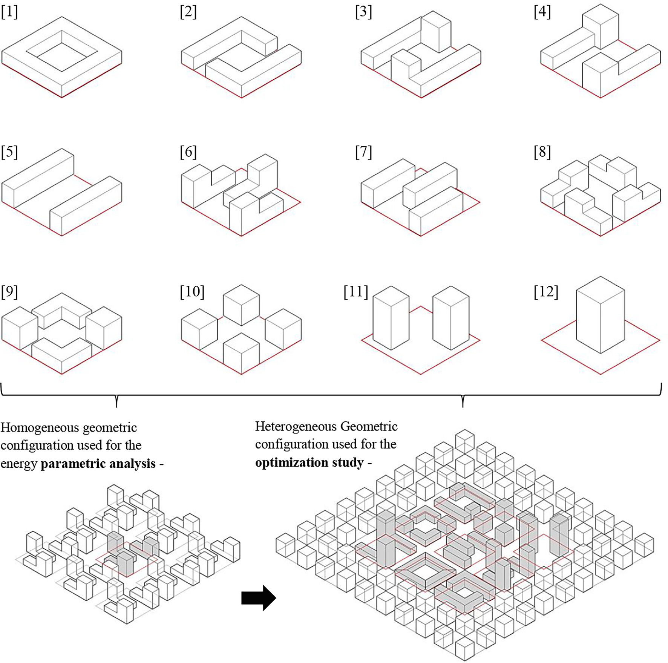
Geometry-based metrics

Sun-hours based metrics

Solar irradiation-based metrics

Full-energy simulation

Pareto fronts for the corresponding results

Combined best-known front

Reference homogeneous setting

← Fig. 9: Twelve different typologies in block scale and district scale configurations used for the parametric energy analysis and optimization studies [31].

↑ Fig. 10: Simulation results and Pareto front lines of the non-dominated solutions from MOO with prediction metrics (in color) and from a MOO run with full simulations
(black) [31].

Homogeneous configuration parametric analysis
Heterogeneous configuration optimization analysis

(3) the SE approach usually accounts for only the worst-case solar exposure and does not include other KPIs such as energy, daylight and outdoor comfort, or the trade-offs between those metrics; (4) the SE approach does not allow the evaluation of the mutual impacts of neighbouring solar envelopes on a larger scale.
Given the rapid global urbanization rates, especially in hot regions, the SE concept, in which a building form follows the boundaries defined by the solar rights of its surroundings, remains relevant. However, further development of environmentally driven design tools and workflows for solar architecture, especially on the urban scale, is still needed [32]. Therefore, given the recent developments in environmental standards and advancements in analytical tools, specifically approaches for evaluating urban environmental performance, the stage is set for further development of a new reliable and holistic SE approach.
- Research objective
The overarching aim of this study is thus to offer a holistic approach for generative solar design based on the capabilities of parametric geometry generation and optimization tools.
This proposal offers an alternative parametric workflow based on an additive voxelization method by which multiple solar-driven massing alternatives are generated for a given design challenge, either a building addition or a new building mass, corresponding to a variety of environmental KPIs to be defined by the user. In turn, the results from either the iterative parametric or an automated optimization process are seamlessly streamed and can be visually post-processed in the design or by the user. This project will explore new methods to use SEs on the district scale by harnessing the potential of optimization methods based on simplified indicators to highlight the best-performing solar masses for a given boundary condition. Additionally, the work plan goes beyond the traditional focus on energy KPIs towards the trade-off between several environmental KPIs in which energy performance and environmental quality interact.
  - Specific objectives
- Establish a digital workflow to holistically evaluate urban-scale environmental performance.
- Identify and evaluate solar-driven metrics to be used as environmental performance indicators for optimization.
- Evaluate the efficiency of optimization workflows and algorithms to screen best-performing solutions out of a large range of design variants.
- Explore the robustness of the approach by accounting for diverse constraints and compare with traditional SE methods.
- Detailed description
  - Working hypothesis
A new computational SE generative approach—the urban solar block—will provide a higher-performing, more holistic and robust outcome compared with traditional SE methods and in addition generate a diverse collection of design alternatives that will reinforce the interaction between environmental analysis and architectural design.
  - Research design and methods
Figure 11 describes the research design sequence, which is divided into four tasks (corresponding to the objectives above) gathered in two modules: the environmental analysis and the optimization module. The next sub-sections describe the tasks in detail, including the tools and methods applied in each task.
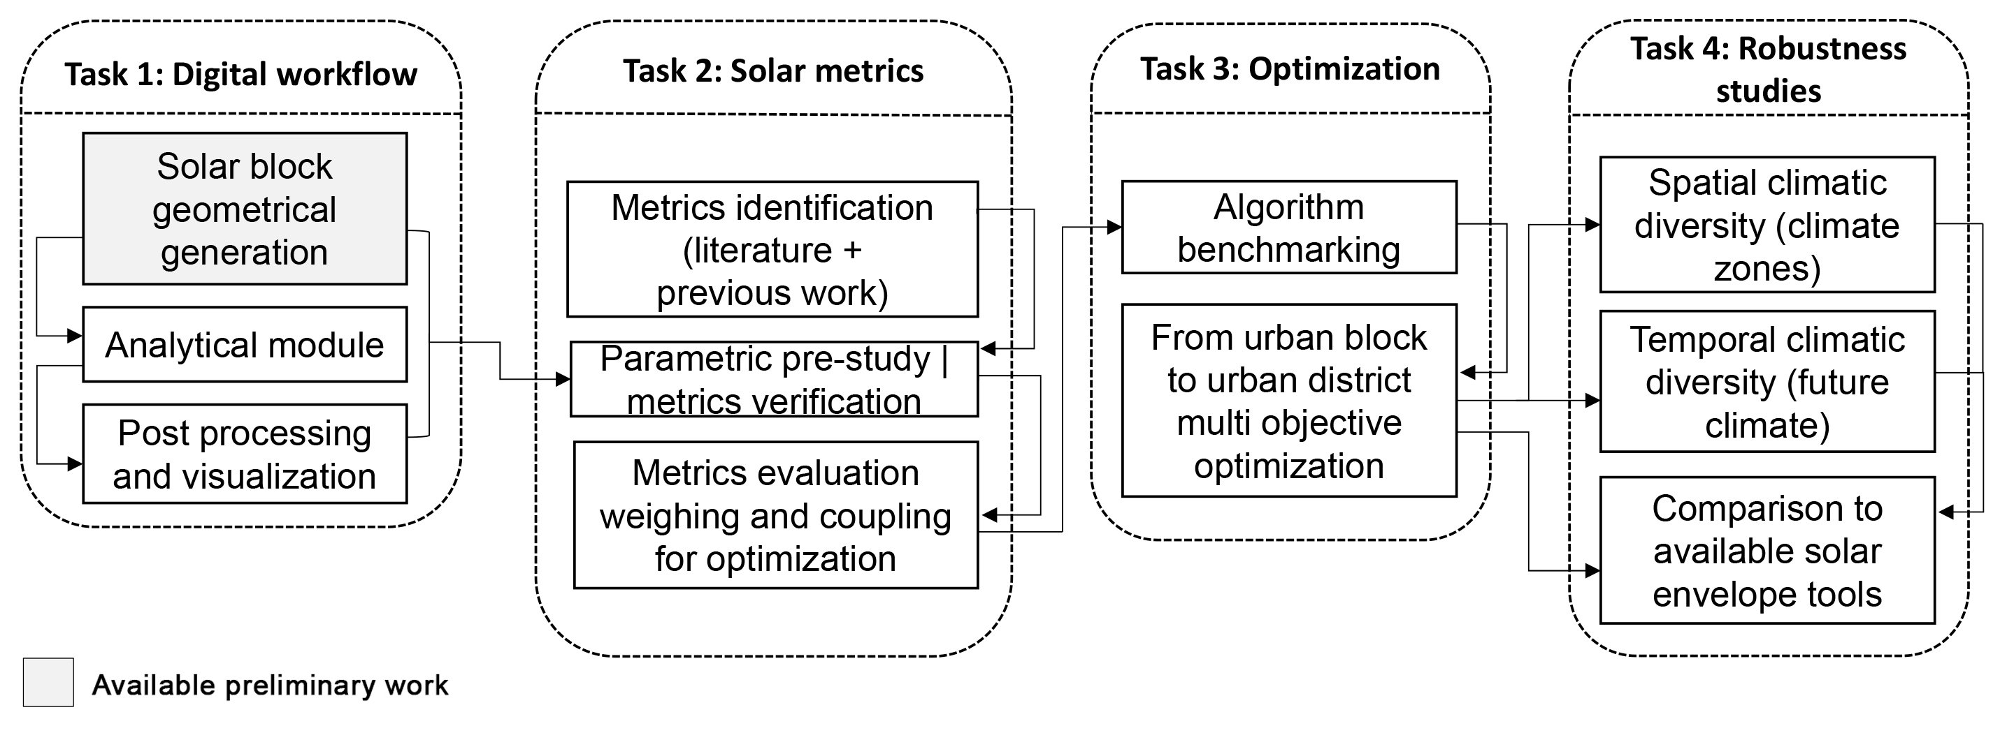

Fig. 11: Research design sequence for project.

    - Task 1: Establishing a digital workflow
This task focuses on establishing the computational foundation of the project, including the geometrical solar block generator, the analytical module and the visualization module. These three components interact seamlessly in Grasshopper [33]—a parametric interface for the three-dimensional computer-aided design program Rhino [34]. This segment of the work has already been constructed and tested by us (the PI and the project’s collaborators [35]; see also the preliminary results in Section 3.3).
Solar block generation is illustrated in Fig. 12. It is based on the user-defined inputs of building contour, height limit and module size. These inputs are automatically channelled in Grasshopper into a custom-made component in which the height of each corner of the building contour generates a morphed box that serves as a subtraction boundary to generate the solar masses (pixelated according to the predefined module size, e.g., 3 m). The boundaries of the design space are defined by the user’s inputs.
The analytical module receives the geometrical data for each iteration, samples the relevant numerical and geometrical inputs and streams the data to the relevant environmental simulation engines. This part is conducted using several components under the Ladybug Tools plugin [36] in Grasshopper, in which different environmental metrics (see task 2) are calculated by using the validated Radiance [37] and EnergyPlus [38] modelling engines.
Post-processing and visualization are then conducted by streaming the simulation outputs through dedicated Grasshopper components such as Colibri [39], which trigger the iterative process and automatically export the results to Excel in a way that facilitates reading and interacting through the online DesignExplorer platform [40].
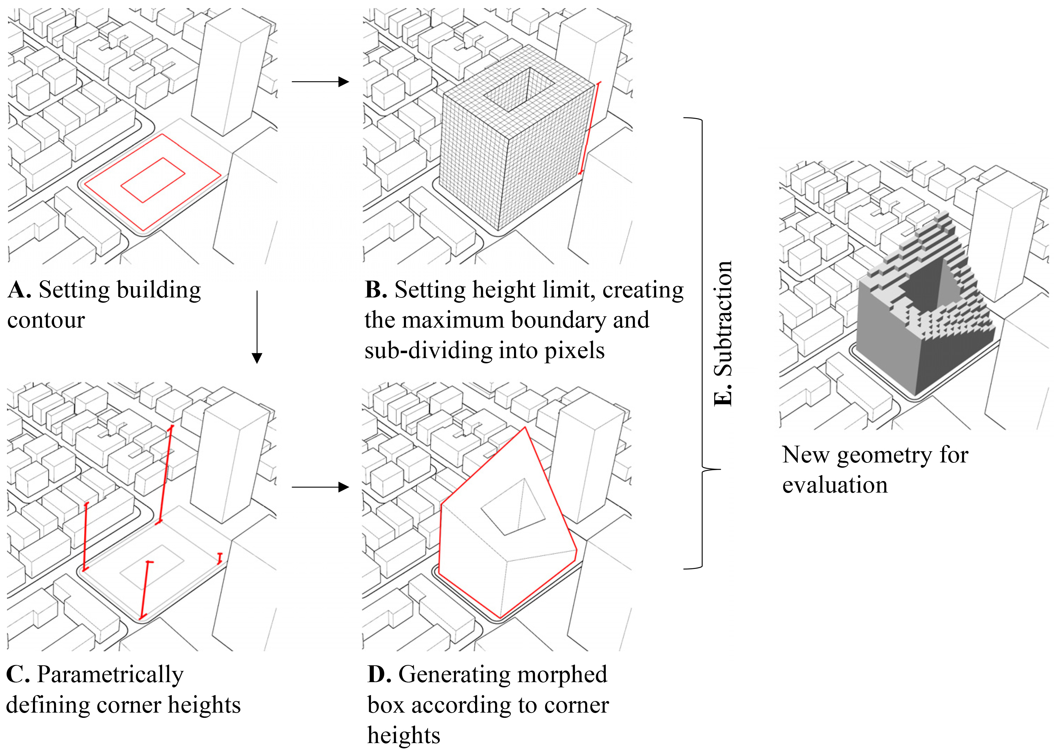

Fig. 12: Sequence of solar block generation (after Ref. [36]).

This computation workflow will be used for the next stages (tasks) of the project in which it will be applied on a district scale case study in the Tel Aviv area and in which the built area is projected to double to meet the local demographic challenge. Tel Aviv is categorized by a hot-summer Mediterranean climate [41] in which solar radiation plays a pivotal role in energy demand, energy generation potential and indoor and outdoor environmental quality. Thus, it serves as a suitable testbed for a harmonized approach to solar-driven urban design.
    - Task 2: Identifying and exploring solar-driven metrics
This task is dedicated to establishing suitable metrics for environmental performance evaluations. It starts with a wide literature review that helps identify the appropriate metrics used at similar scales and/or for similar solar-driven approaches. The preliminary research focused on [31] and used [35] solar-driven metrics and serves as a starting point for this task. These metrics (described in Table 1), correlate strongly with energy performance, visual comfort and thermal comfort and can be divided roughly into exposure and shading indices [35]. Two examples are the outdoor shading index, which stands for the annual shading coefficient of outdoor surfaces, and the context exposure index, which stands for the exposure ratio of the surrounding buildings.
Pre-study | The selection of performance metrics is not automatic but is based on re-evaluating the metrics based on a parametric sensitivity study. This preliminary study is conducted on a theoretical urban model and explores the efficiency of several solar-based metrics to serve as effective indicators for various environmental criteria (as done in previous work [31]).
Table 1: Solar-based metrics used for performance evaluation in a preliminary study by the PI [35].
Metric | Definition | Calculation method | Analysis period | Units
CEI | Context exposure index | The average solar exposure compliance in percent of the following surfaces according to the respective thresholds taken from Israeli standard SI 5281  Outdoor surfaces: 0.9 kWh/m² solar irradiation on at least 30% of surfaces  South facades: 1.26 kWh/m² solar irradiation  Roof surfaces: 4 hours of solar exposure on at least 50% of each roofs surface | outdoor surfaces \ south facades - 21st of December  08:00 – 16:00  roof surfaces - 21st of December  09:00 – 15:00 | [%]
NEI | New building exposure index
SE | Sky exposure | The average percentage of the sky visible from each test point across all the vertical surfaces, averaged between existing and new masses. | N/A | [%]
OSI | Outdoor shading index | The average of the annual irradiation ratio between exposed and obstructed configurations of each point across the outdoor surfaces (in and around the site), subtracted from 1 | Annual | [/]
FSI | East-west facades shading index | East and west facades’ summer irradiation values (in MW/m²), subtracted from 1 and averaged between existing and new masses. | 1st of June – 31st of October | [1-MW/m²]
The analysis of the generic run using correlation studies helps evaluate how metrics are related to each other and highlights couples of contrasting metrics based on the optimization analyses. A principal component analysis is then conducted (i) to downsize the number of objectives by analysing any overlaps between them and (ii) to generate weighted combinations between exposure and shading metrics. The additions brought by this project to our previous work in terms of upscaling to a full-scale district, the analyses of the various climatic conditions and the experimentation with weighting methods should enrich the discussion on solar-driven metrics and their effective use in optimization workflows.
    - Task 3: setting up an optimization workflow for solar-driven urban design
When considering several design parameters and upscaling the performance evaluation from one building to a series of solar buildings or urban blocks (i.e., to a solar district), the numerous possible iterations require that an optimization module be integrated into the evaluation workflow to automate the screening of the results based on selected objectives. Because a holistic approach is developed here, we incorporate a MOO, which involves at least two objectives.
Task 3, which also functions in this study as a research module, is dedicated to exploring optimization methods for solar-driven design. This task starts by setting up the optimization of the computational workflow in Grasshopper through the Opossum plugin for Grasshopper [42]. The Opossum components are connected to the performance evaluation workflow assembled in the previous tasks in Grasshopper to allow a seamless data flow between the optimization and the generation, analysis and visualization modules. Selecting the objectives for the MOO is based on the output of Task 2, and a series of sensitivity optimization studies will test different algorithms and explore their performance in the context of our optimization problem. Figure 13 illustrates one example sequence for processing the outcome of the optimization process: following the optimization run, the best solar district design configurations are automatically exported to Excel. Next, the non-dominated design configurations (on the Pareto-front graph) are highlighted and transmitted to the designer for visual screening based on the input (variables) and output (objectives) data graphs.
To test the optimization, we conduct full energy performance (supply and demand), daylight and outdoor comfort simulations using validated engines. This part of the research compares the best solutions (i.e., non-dominated) from the solar optimization study against a ‘standard’ redevelopment by using flat, rigid building volumes that shorten when considering the solar aspect.

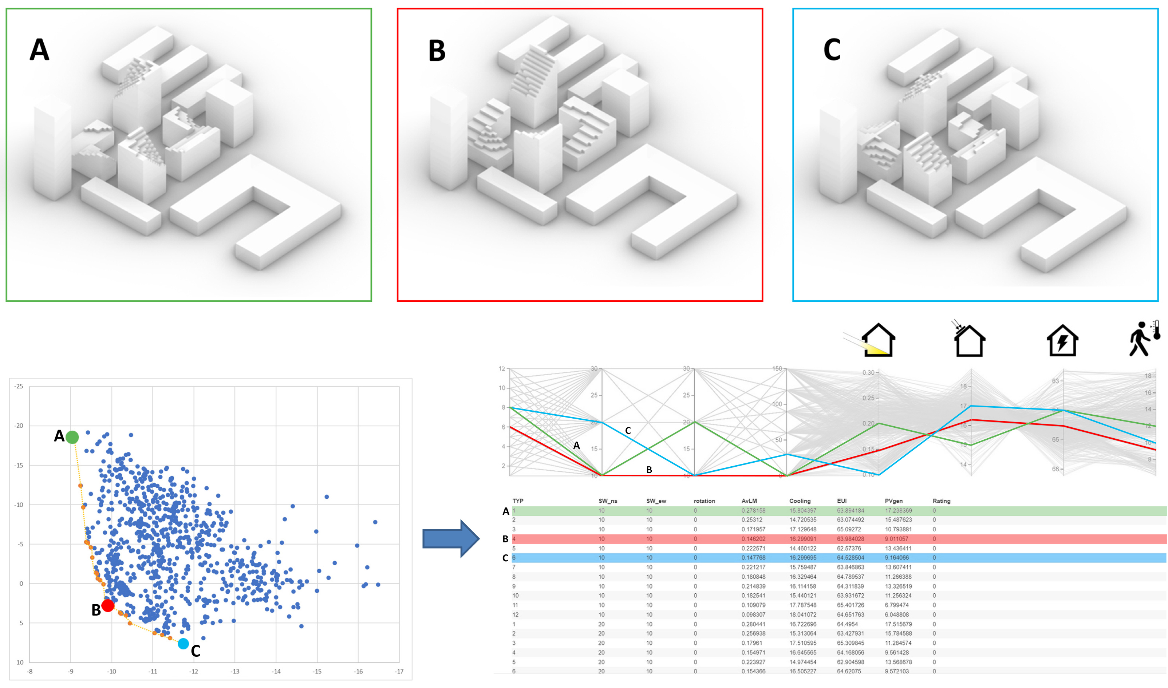

Fig. 13: Demonstration of the interface that will be used in this project to visualize the optimization results. Non-dominated design alternatives from the optimization run will be highlighted and streamed for visual selection.

    - Task 4: Towards a robust approach by comparing with traditional solar-envelope methods and exploring diverse urban and climatic conditions
The final task is dedicated to experimentation with the workflow in different climatic conditions (regional climates and future climates) and on different scales. This task should finalize the project with (i) observations on solar urban design, (ii) the integration of digital tools and optimization methods into the solar-driven design process and (iii) the robustness of solar urban design in different urban and climatic settings.
Climatic diversity | Given that the solar trade-off manifests itself differently in different climatic regions, an additional module uses the two sets of exposure and shading metrics in the same morphological and analytical configuration, but in four different climatic contexts (as defined by the Israel building code SI 1045 [43]). This part highlights insights regarding the robustness of the methodology and the metrics and/or their weights that require contextual adaptation. Additionally, a supplemental analytical climate module will be dedicated to future climate calculations by using a 2050 climate file approximated by the Meteonorm weather-generator software [44]. This approach should add the important perspective of climatic adaptation of the solar urban block and trigger the discussion of environmental performance and architectural form in a changing climate.
The results of all analytical scenarios are then compared with traditional solar-envelope methods by running the same urban or climatic scenario used herein with the help of the existing SE tools (e.g., the Parametric Solar Envelope [14] or the Reverse Solar Envelope [17] methods). The comparison should help establish a wide perspective of the challenges and opportunities of solar design and offer new directions for its future development.
  - Preliminary results
The solar block generation method used here was tested by Natanian, Wortmann, Francesco and Capeluto in a preliminary study [35] and focuses on establishing the computational workflow to automatically generate the voxelated forms in Grasshopper and analyse each iteration by using a combination of solar metrics. In this study, the method was applied to a redevelopment case study in Tel Aviv by using a parametric study that includes 6500 iterations. The best design configurations are illustrated in Fig. 14 and demonstrate the wide potential of solar block generation methodology to seamlessly generate a large design space, evaluate each iteration using different analyses and evaluation metrics and plot the results for visual selection by the designer.
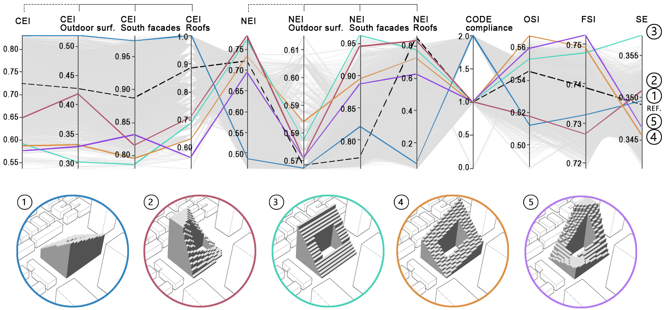

Fig. 14: Five block design alternatives from a 6500-iteration solar block parametric study [35].

Parallel research by Thomas Wortmann and myself [45] based on the same case study explored a MOO problem with two objectives: maximizing the density (floor area ratio) and the solar exposure of the surrounding buildings (context exposure index). Here we benchmarked seven different MOO algorithms for the same site in Tel Aviv (i.e., we evaluated the algorithmic performance) by comparing a courtyard typology to a high-rise solar building mass. The benchmark was acquired using convergence, robustness and Pareto-front comparisons (Fig. 15) for both the courtyard and the high-rise. This study produced two evolutionary algorithms HypE and SPEA2 and a model-based algorithm RBFMOpt as the most efficient and robust MOO algorithms for this type of work.
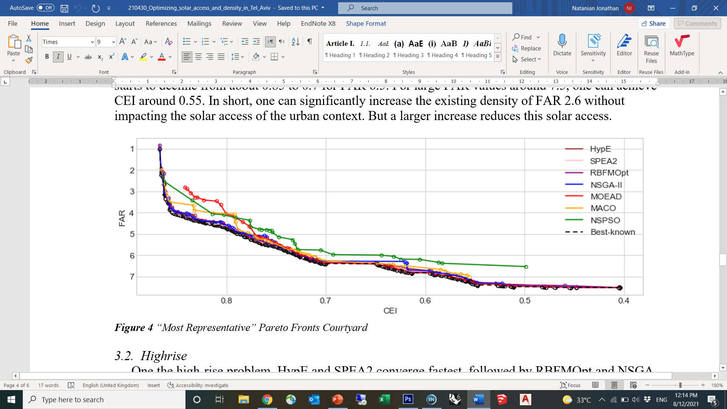

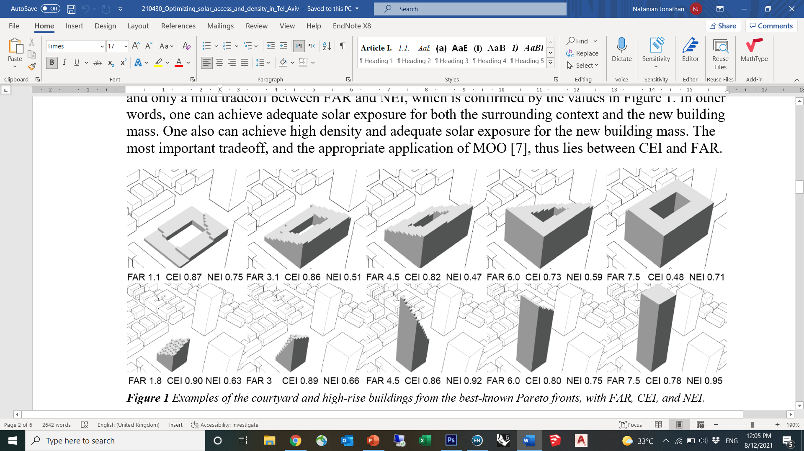

Fig. 15: Comparison of Pareto front comparison between seven different MOO algorithms for a solar driven courtyard block (top) and seven courtyard design alternatives from the best-known Pareto-fronts (bottom) [45].

Insights and methods from these past studies will serve as the foundation for this research in terms of the urban analytical approach, the choice of environmental metrics, the use of tools to evaluate these metrics and the optimization methods which will help screen the results.
  - Expected results and pitfalls
    - Expected results
We expect that the use of the proposed solar urban blocks computational workflow will increase the integration of environmental performance indicators into architectural design by establishing a generative approach in which performative insights directly influence the architectural form-finding process. We anticipate that the proposed approach will mark a new chapter in solar-driven design whereby the use of parametric tools powered by machine learning algorithms will open new possibilities to explore large design spaces, analyse several KPIs and efficiently screen and transmit the best-fit results to the designer. This adds new features to the existing solar envelope methodologies and offers a new horizon for the interaction between environmental engineering and architectural design, which can enrich the design outcome in terms of architectural form and the environmental performance of buildings and districts.
    - Expected pitfalls
Given that the geometrical workflow was already tested and performed well, it should not pose any unexpected issues. Some unexpected issues may arise if we add a new solar-based performance metric and find a poor correlation between that metric and the full simulation results, or if we discover that, in our new context, the metrics we use are unsuitable (i.e., one or more of the metrics may not be suitable for use in the optimization). In this case, we would apply a parametric sensitivity analysis of multiple small variations of the given metric to fine-tune it. If the sensitivity analysis still yields unsatisfactory results, we would likely not use that metric in our evaluation.
Another issue that might arise is the running time, mostly involving MOO runs. Fortunately, we have extensive cloud space through both institutional (Technion) and commercial cloud services and significant capabilities for physical computation (at Technion and TalTech). Additionally, we have experience splitting the optimization runs for several segments, which can serve as an additional solution to the running-time problem in case the substantial computer power we have at our disposal proves insufficient.
  - Resources available to the research team
- Pr. Jonathan Natanian (PI) is an experienced architect and environmental design researcher who specializes in computational methods for environmentally driven urban design. The Environmental Performance and Design Lab (EPDL) led by Pr. Natanian at Technion’s Faculty of Architecture and Town Planning is dedicated to exploring the boundary between environmental engineering and architectural design in a cross-contextual, multiscale and cross-disciplinary way. The lab’s equipment allows it to operate in three main clusters, which together form a triangle of knowledge: data acquisition (cutting edge sensors, remote sensing devices), computational analysis (strong analytical and data servers and cloud computing capabilities) and design interface (interactive screens combined with augmented reality and mixed reality devices).
- The research will be done at the EPDL with the help of a doctoral student who will be dedicated to the project and supervised by the PI. He or she will specialize in environmental design using computational tools. An M.Sc. or March student (with strong architectural design background) will complement the doctoral student by dealing with data collection and characterizing the design of the experiments. A post-doctoral fellow with a strong computational capability will join the effort in the third and fourth years of the project to focus on the optimization module.
- Thomas Wortmann is an Assistant Professor at the Institute for Computational Design and Construction (ICD) at the University of Stuttgart. He is an expert on computational design, building simulation and optimization. He will support the use of Opossum, an award-winning, machine-learning-based optimization tool to be used in this project. Additionally, Pr. Wortmann will support the optimization of the benchmarking tasks.
- Dr. Francesco De Luca is a renowned environmental design researcher from Tallin University of Technology (TalTec) who specializes in advanced SE methods and computational climatic design. In addition to his expertise in the field of computational methods for solar design, the project will benefit from the computational resources at his department at TalTech.
- Pr. Guedi Capeluto is a world-renowned expert in solar-based design and solar tools for architectural and urban design. Guedi leads the Climate and Energy Lab in Architecture (CeLA) at the Faculty of Architecture and Town Planning at Technion, which will support the project with the invaluable knowledge Pr. Guedi has accumulated on the integration of solar design concepts and approaches in architectural design and environmental policy.
  - Expected significance
This project introduces a pioneering perspective into the widely used ‘solar envelope’ method in the field of solar-driven architectural design. In a broader sense, the project will trigger new possibilities for both designers and analysts to realize the environmental potential of their designs and generate buildings and districts driven by a wide range of performance indicators. The scientific significance of the project also stems from several other novelties that it offers to the wider field of urban environmental performance through the following features: a holistic analytical approach that combines several environmental performance criteria; generative methods to generate new solar-driven typologies through a bottom-up approach; and the optimization module, which introduces new insights on selection criteria for multi-objective environmental optimization. Because this work contributes scientific innovation to the field of solar-driven urban design, it appeals to the scientific community, urban designers and policymakers and establishes a new link between them. In addition, through two test cases in Tel Aviv, this work diminishes the knowledge gap relative to urban environmental performance in hot climates, which is currently under-represented in contemporary research.

- Bibliography
[1] Compagnon, R. (2004). Solar and daylight availability in the urban fabric. Energy and buildings, 36(4), 321-328.
[2] United Nations, 2018 revision of world urbanization prospects.
[3] International Energy Agency, Energy Technology Perspectives 2016: Towards Sustainable Urban Energy Systems, OECD, 2016.
[4] Naboni, E., Natanian, J., Brizzi, G., Florio, P., Chokhachian, A., Galanos, T., & Rastogi, P. (2019). A digital workflow to quantify regenerative urban design in the context of a changing climate. Renewable and Sustainable Energy Reviews, 113, 109255.‏
[5] Knowles, R.L., 1981. Sun Rhythm Form. The MIT Press, Cambridge, Massachusetts.
[6] Knowles, R. L. (2003). The solar envelope: its meaning for energy and buildings. Energy and Buildings, 35(1), 15-25. https://doi.org/10.1016/S0378-7788(02)00076-2
[7] Capeluto, I. G., & Shaviv, E. (2001). On the use of ‘solar volume’ for determining the urban fabric. Solar Energy, 70(3), 275-280. https://doi.org/10.1016/S0038-092X(00)00088-8
[8] Capeluto, I. G., Yezioro, A., & Shaviv, E. (2003). Climatic aspects in urban design—a case study. Building and environment, 38(6), 827-835. https://doi.org/10.1016/S0360-1323(02)00063-X
[9] Stasinopoulos, T. N. (2018). A survey of solar envelope properties using solid modelling. Journal of Green Building, 13(1), 3-30.
[10] Okeil, A. (2010). A holistic approach to energy efficient building forms. Energy and Buildings, 42(9), 1437-1444. https://doi.org/10.1016/j.enbuild.2010.03.013
[11] Vartholomaios, A. (2015). The residential solar block envelope: A method for enabling the development of compact urban blocks with high passive solar potential. Energy and Buildings, 99(Supplement C), 303-312. https://doi.org/10.1016/j.enbuild.2015.04.046
[12] Jakica, N. (2018). State-of-the-art review of solar design tools and methods for assessing daylighting and solar potential for building-integrated photovoltaics. Renewable and Sustainable Energy Reviews, 81, 1296-1328.
[13] Horvat, M., & Dubois, M. C. (2012). Tools and methods for solar design–an overview of IEA SHC Task 41, Subtask B. Energy Procedia, 30, 1120-1130.
[14] Capeluto, I. G., & Plotnikov, B. (2017). A method for the generation of climate-based, context-dependent parametric solar envelopes. Architectural Science Review, 60(5), 395-407. https://doi.org/10.1080/00038628.2017.1331334
[15] De Luca, F., & Voll, H. (2017). Computational method for variable objectives and context aware solar envelopes generation. In Proceedings of the Symposium on Simulation for Architecture and Urban Design - SimAUD, Toronto, Canada.
[16] De Luca, F. (2017). From envelope to Layout. Buildings Massing and Layout Generation for Solar Access in Urban Environments. In Proceedings of the 35th eCAADe conference, Rome, Italy.
[17] De Luca, F., Dogan, T., & Sepúlveda, A. Reverse solar envelope method. A new building form-finding method that can take regulatory frameworks into account. Automation in Construction, 123, 103518. https://doi.org/10.1016/j.autcon.2020.103518
[18] De Luca, F. (2019). Advanced Solar Envelope Generation. In E. Naboni & L. Havinga (Ed.), Regenerative design in digital practice: a handbook for the built environment (pp. 123-128): EURAC Research
[19] Alkadri, M. F., De Luca, F., Turrin, M., & Sariyildiz, S. (2020). An integrated approach to subtractive solar envelopes based on attribute information from point cloud data. Renewable and Sustainable Energy Reviews, 123, 109742. https://doi.org/10.1016/j.rser.2020.109742
[20] Chatzipoulka, C., Compagnon, R., & Nikolopoulou, M. (2016). Urban geometry and solar availability on façades and ground of real urban forms: using London as a case study. Solar Energy, 138, 53-66.
[21] Lobaccaro, G., & Frontini, F. (2014). Solar energy in urban environment: how urban densification affects existing buildings. Energy Procedia, 48, 1559-1569.
[22] Lobaccaro, G., Lisowska, M. M., Saretta, E., Bonomo, P., & Frontini, F. (2019). A methodological analysis approach to assess solar energy potential at the neighborhood scale. Energies, 12(18), 3554.
[23] Waibel, C., Evins, R., & Carmeliet, J. (2019). Co-simulation and optimization of building geometry and multi-energy systems: Interdependencies in energy supply, energy demand and solar potentials. Applied Energy, 242, 1661-1682.
[24] Natanian, J., & Auer, T. (2018). Balancing urban density, energy performance and environmental quality in the Mediterranean: a typological evaluation based on photovoltaic potential. Energy Procedia,152, 1103-8.
[25] Natanian, J., Aleksandrowicz, O., & Auer, T. (2019). A parametric approach to optimizing urban form, energy balance and environmental quality: The case of Mediterranean districts. Applied Energy, 254, 113637.
[26] Natanian, J., & Auer, T. (2020). Beyond nearly zero energy urban design: A holistic microclimatic energy and environmental quality evaluation workflow. Sustainable Cities and Society, 56, 102094.
[27] Natanian, J. (2019). Communal and Biophilic Principles in Regenerative Projects. In E. Naboni & L. Havinga (Ed.), Regenerative design in digital practice: a handbook for the built environment (pp. 370-375): EURAC Research
[28] Natanian, J., Maiullari, D., Yezioro, A., & Auer, T. (2019). Synergetic urban microclimate and energy simulation parametric workflow. Journal of Physics: Conference Series, 1343, 012006.
[29] Natanian, J., Kastner, P., Dogan, T., & Auer, T. (2020). From energy performative to livable Mediterranean cities: An annual outdoor thermal comfort and energy balance cross-climatic typological study. Energy and Buildings, 224, 110283.
[30] Wortmann, T., & Natanian, J. (2020). Multi-Objective Optimization for Zero-Energy Urban Design in China: A Benchmark. In Proceedings of SimAUD 2020: Symposium on Simulation in Architecture and Urban Design, Vienna, Austria.
[31] Natanian, J., & Wortmann, T. (2021). Simplified evaluation metrics for generative energy-driven urban design: A morphological study of residential blocks in Tel Aviv. Energy and Buildings, 240, 110916.‏
[32] Kanters, J., Horvat, M., & Dubois, M. C. (2014). Tools and methods used by architects for solar design. Energy and Buildings, 68, 721-731.
[33] McNeel, R. (2010). Grasshopper generative modeling for Rhino, Computer software (2011b), http://www.grasshopper3d.com
[34] McNeel R. Rhinoceros 6. 2020. http://www.rhino3d.com/
[35] Natanian, J., De Luca F., Wortmann, T., & Capeluto G. (2021). The Solar Block Generator: an additive parametric method for solar driven urban block design. Journal of Physics: Conference Series, 2042 (In print).
[36] Ladybug Tools. http://www.ladybug.tools/
[37] Ward, G. J. (1994). The RADIANCE lighting simulation and rendering system. In Proceedings of the 21st annual conference on Computer graphics and interactive techniques (pp. 459-472).
[38] DOE. (2017). EnergyPlus. Retrieved from https://energyplus.net
[39] Core studio (2017). Colibri, in TT Toolbox for Grasshopper. Retrieved from Available from: http://core.Thorntontomasetti.com
[40] Tomasetti T. Core studio. Design Explorer; 2018. https://tt-acm.github.io/DesignExplorer
[41] Peel, M. C., Finlayson, B. L., & McMahon, T. A. (2007). Updated world map of the Köppen-Geiger climate classification.
[42] Wortmann, T. (2017). Opossum: OPtimizatiOn Solver with SUrrogate Models. https://aal.sutd.edu.sg/opossum/
[43] Standards Institute of Israel. SI 1045 - Thermal Insulation of Buildings.
[44] Meteonorm software (2021), version 8. https://meteonorm.com/en/meteonorm-version-8
[45] Wortmann, T. & Natanian, J. (2021). Optimizing solar access and density in Tel Aviv: Benchmarking multi-objective optimization algorithms. Journal of Physics: Conference Series, 2042 (In print).

