Professor Ichiro Kawachi, MD, PhD and Professor S.V. Subramanian, PhD,
Co-Editors in Chief of Social Science & Medicine,
Harvard University, T. H. Chan School of Public Health,
677 Huntington Avenue, 02115, Boston, Massachusetts, United States of America
September 10, 2021
Dear Prof. Kawachi and Prof. Subramanian,
I would like to submit a new manuscript entitled “Interactions among vaccine and individual characteristics impact vaccine hesitancy: Evidence from a conjoint experiment in Japan” for your consideration.
I can confirm that this is our original manuscript; it has not previously been published and is not under consideration for publication elsewhere. All participants provided informed consent, and the study was approved by the appropriate ethics review board. I have read and understood your journal’s policies, and I believe that no part of this manuscript violates any of these. There are no conflicts of interest to declare.
Regarding COVID-19 vaccine hesitancy, this study addresses how individual and group factors can interact with vaccine/vaccination-specific factors. The data come from a survey conducted in Japan during February 2021. Whereas previous studies have investigated these two types of factors separately, this study investigated their interactions by analyzing subgroups as part of randomized conjoint survey experiment. For example, we found that individual vaccination history, higher perception of COVID-19 risk, and trust made the uncertainty of vaccines acceptable. This study will contribute to the literature on vaccine hesitancy in a range of fields, including health behavior, health economics, health psychology, and public health. We anticipate that the findings will be of interest around the world to scholars in these fields, as well as to policymakers involved in vaccination promotion programs.
Three potential independent reviewers who have excellent expertise in the areas relevant to this manuscript are listed below; they are all authors of the most important articles referenced in our study.
Dr. Sarah Kreps, Cornell University, USA. Email: sarah.kreps@cornell.edu
Dr. Matt Motta, Oklahoma State University, USA. Email: matthew.motta@okstate.edu
Dr. Haoran Chu, Texas Tech University, USA. Email: haoran.chu@ttu.edu
I would very much appreciate it if you would consider our manuscript for publication. I look forward to hearing from you.
Yours sincerely,
Yoshiaki Kubo, PhD
Department of Law, Politics, and International Relations, Faculty of Humanities and Social Sciences, University of the Ryukyus, Sembaru 1, Nishihara, Nakagami, Okinawa 9030213, Japan.
Tel.: +81 098 895 8935, Fax.: +81 098 895 8935, Email: kuboy@cs.u-ryukyu.ac.jp
On behalf of my co-author:
Yanagi Itaru, PhD, College of Law, Ritsumeikan University, Japan. Email: i-yanagi@fc.ritsumei.ac.jp

Title
Interactions among vaccine and individual characteristics impact vaccine hesitancy: Evidence from a conjoint experiment in Japan

Authors
Yoshiaki Kubo^{a,b,c}, and Itaru Yanagi^{d}
ª Department of Law, Politics, and International Relations, Faculty of Humanities and Social Sciences, University of the Ryukyus, Sembaru 1, Nishihara, Nakagami, Okinawa 9030213, Japan, present address. kuboy@cs.u-ryukyu.ac.jp
^{b} Program on U.S.-Japan Relations, Weatherhead Center for International Affairs, Harvard University, 61 Kirkland Street, Cambridge, MA 02138, USA.
^{c} Department of East Asian Languages and Cultures, Hamilton and Lugar School of Global and International Relations, Indiana University Bloomington, 355 N Jordan Ave, Bloomington, IN 47405, USA.
d College of Law, Ritsumeikan University, 56-1 Toji-in Kitamachi, Kita, Kyoto 6038577, Japan. i-yanagi@fc.ritsumei.ac.jp

Corresponding author.
Yoshiaki Kubo
Department of Law, Politics, and International Relations, Faculty of Humanities and Social Sciences, University of the Ryukyus, Sembaru 1, Nishihara, Nakagami, Okinawa 9030213, Japan.
Tel.: +81 098 895 8935
Fax.: +81 098 895 8935
Email: kuboy@cs.u-ryukyu.ac.jp

Acknowledgments
We thank Ritumeikan University for a research grant from the Research Program for the Post-Corona Society, Visionaries for the New Normal; Isamu Okada and Hirokazu Kikuchi for joint research on the project and useful comments; and Yoshiko Saito, Masahiro Zenkyo, Masaki Hata, Go Murakami, Sae Okura, Koichi Kawai, Aya Goto, Kohta Suzuki, Yu’ichi Murakami, Stella Twumwaa Lartey, and Juhee Kang for their useful comments.

Declaration of interest: none.

Ethics declaration
This study was reviewed by the institutional review boards of Ritumeikan University (#衣笠-人-2020-35), Institute of Developing Economies, Japan External Trade Organization (IDE-JETRO), and the University of the Ryukyus (#32).

Author contributions
Yoshiaki Kubo: Conceptualization, Methodology, Software, Investigation, Resources, Data Curation, Writing (Original Draft), Visualization. Itaru Yanagi: Writing (Review and Editing), Supervision, Project administration, Funding acquisition.

Highlights (maximum 85 characters, including spaces, per bullet point)
- Individual and group characteristics interact with vaccine/vaccination-specific characteristics
- Vaccination history, perception of COVID-19 risk, and trust make scientific uncertainty acceptable
- Vaccine history, high perception of COVID-19 risk, trust, and high time preference lead individuals to rely on heuristics
- Vaccine history leads individuals to consider cost-effectiveness
- Multiple, mixed approaches are needed to promote vaccination

Word count: 8,866
Abstract: 291/300
Keywords: 13
Main body (except images): 7,876
Texts in images: 677 (146 + 149 + 43 + 36 + 149 + 56 + 47 + 51)

Abstract (291 words/up to 300 words)
To control the COVID-19 pandemic using vaccination, vaccination programs must proceed uniformly around the world. In practice, however, vaccine coverage varies across regions. As a critical factor in determining vaccine coverage at a population level, we investigated vaccine acceptance/hesitancy with respect to COVID-19 vaccination. We address how individual and group factors (e.g., past vaccination history, trust in healthcare/government officials, perception of COVID-19 risk, and time preference) impact vaccine/vaccination-specific factors (e.g., scientific credibility, heuristics that reduce uncertainty, and cost-effectiveness). The data were collected in Japan, which has experienced considerable vaccine hesitancy in recent decades and lags behind other developed countries in its COVID-19 vaccination rollout. We performed a population-based discrete choice experiment with a randomized conjoint design. The survey was conducted in February 2021. There were 4,140 observations in total (1,035 respondents × 2 profiles × 2 tasks). Regarding vaccine/vaccination characteristics, higher scientific credibility of vaccines, heuristics that reduce uncertainty, and various cost-effectiveness factors can mitigate vaccine hesitancy. Among individual and group characteristics, recent experience of influenza vaccination and greater trust in healthcare result in a greater willingness to get the vaccine, regardless of vaccine/vaccination characteristics. Most importantly, we found that individual and group factors impacted vaccine/vaccination-specific factors in three ways: (1) Vaccination history, perception of COVID-19 risk, and trust in government/healthcare authorities made scientific uncertainty acceptable; (2) vaccination history, perception of risk, trust, and time preference predicted use of heuristics that reduced uncertainty, and (3) vaccination history predicted the positive impact of cost-effectiveness. This is the first study to investigate the interactions among individual and group factors and vaccine/vaccination-specific factors. To rollout vaccination as rapidly and widely as possible, we should adopt a mixture of approaches that consider individual and group characteristics. Furthermore, to control the COVID-19 pandemic, we should acknowledge the limitations of vaccination and continue to use a combination of different measures.

Keywords (8 words / up to 8 keywords)
Vaccine hesitancy; COVID-19; Vaccination history; Risk perception; Trust; Time preference; Conjoint experiment; Japan

1. Introduction

To control the COVID-19 pandemic through vaccination, vaccination programs must proceed at a uniform pace worldwide, regardless of region. In practice, however, vaccination coverage varies across the world. The average proportion of the global population who had received at least one dose of vaccine as of 10 June 2021 was 20.32%; this proportion was much higher in North America (39.41%) and Europe (35.38%) but much lower in Africa (2.09%) and Oceania (13.56%), while the proportions in South America (22.03%) and Asia (20.62%) were similar to the global average (Our World in Data, 2021).
A crucial factor affecting vaccination coverage is vaccine hesitancy at the level of individuals, defined as a “delay in acceptance or refusal of vaccination despite availability of vaccination services” (MacDonald et al., 2015, p. 4163). Such vaccine hesitancy not only results in reduced willingness to be vaccinated but also means there is less pressure for vaccine development, early approval of vaccines, or improvements in supply and delivery infrastructure. Consequently, infections can spread both more rapidly and more widely, virus variants are more likely to emerge, and it is less likely that herd immunity will be achieved.
There are various reasons for vaccine hesitancy, and previous studies have investigated three types of factors: contextual, individual and group, and vaccine/vaccination-specific factors. These affect complacency, convenience, and confidence in vaccines to produce vaccine hesitancy. Contextual characteristics are “due to historic, socio-cultural, environmental, health system/institutional, economic or political factors.” Individual and group characteristics emerge “from personal perception of the vaccine or influences of the social/peer environment.” Vaccine/vaccination-specific characteristics are factors “directly related to vaccine or vaccination.” These factors have also been studied in relation to COVID-19 vaccination (for a review, see Sallam, 2021).
Unfortunately, one of the issues with studies of vaccine hesitancy is that most studies involve one of two different types of methodology that tend to be used separately: social surveys for exploring contextual and/or individual and group factors (e.g., Ward et al., 2020), and discrete choice experiments for studying vaccine/vaccination-specific factors (e.g., Motta, 2021). However, given that people have heterogeneous preferences for vaccination (Borriello et al., 2021; Chu and Liu, 2021; Leng et al., 2021), we should explore how contextual or individual and group factors interact with vaccine/vaccination-specific factors. This is consistent with the general argument that we should study the mix of factors that might increase confidence in vaccines (Larson et al., 2011).
In keeping with this, a remarkable study was performed in the USA, involving a conjoint experiment with subgroup analyses of vaccine/vaccination-specific factors that took socio-demographic factors into account as contextual factors (Kreps and Kriner, 2021). These authors reported heterogeneous effects of perceived vaccine efficacy by ethnicity and political partisanship, of approval procedure by age and gender, and of endorsement by political partisanship; furthermore, they explored the factors underlying such demographic differences and discovered that general concerns regarding vaccine safety varied by demographics as well.
By contrast, we address how individual and group factors interact with vaccine/vaccination-specific factors. Individual and group factors (e.g., trust in healthcare, perception of COVID-19 risk) are more dynamic than contextual factors (e.g., ethnicity, gender). This suggests that the interactions among individual and group factors and vaccine/vaccination-specific factors may be another key to understanding the variations in vaccine hesitancy across regions. It may also suggest how to reduce vaccine hesitancy for particular vaccines.
The data used in this study come from an original survey conducted in Japan during February 2021. As of 10 June 2021, among the G7 countries only Japan had a lower proportion of individuals who had received at least one dose of COVID-19 vaccine (15.57%) than the global average (20.32%). In other words, despite little variation in economic development, Japan lagged behind other developed countries in terms of COVID-19 vaccination coverage. One factor for the delay in approving and supplying vaccines was thought to be due to the high levels of vaccine hesitancy in recent decades (Figueiredo et al., 2020; Gilmour et al., 2013; Gordon and Reich, 2021). Japan was not included in a recent review of COVID-19 vaccine hesitancy (Sallam, 2021); however, it is important to explore vaccine hesitancy in Japan, as it is a country in which historically it has been difficult to proceed with new vaccination programs.

2. Background

2.1 Vaccination under uncertainty
This study starts from the assumption that individuals decide whether to get vaccinated under two important uncertainties. This becomes particularly salient during a pandemic caused by a novel virus such as SARS-CoV-2.
The first of these is uncertainty about infection. Epidemiologically, the nature of an infection (e.g., basic reproduction number, probability of severe disease or death) is not clear during the early stages of a pandemic. This uncertainty is likewise affected by human behavior, individual medical history, collective healthcare facilities, and the chance of virus variants emerging. These factors form the risk perceptions of an infectious disease at an individual level (for a review, see Ferrer and Klein, 2015). Consequently, risk perceptions affect individuals’ typical health behaviors, such as getting vaccinated (Brewer et al., 2007).
The second uncertainty is uncertainty about vaccines. Available vaccines are approved by public authorities based on scientific evidence of their efficacy and safety. Even when a vaccine is approved, however, its efficacy against virus variants and its safety in the longer-term remain uncertain. Therefore, how people perceive the uncertainty around vaccines is important when they are deciding whether to get the vaccine, as has been discussed in relation to the health belief model (HBM) (Becker, 1974; Carpenter, 2010; Harrison et al., 1992; Janz and Becker, 1984). This leads individuals to use heuristics that reduce uncertainty (e.g., public approval, public endorsements) to help them decide whether to get vaccinated.
It should be noted, however, that the effect of uncertainties is not constant but dependent on individual factors. The theory of planned behavior (TPB) posits that general intentions/norms to be vaccinated have a positive effect on vaccine acceptance (e.g., Gerend and Shepherd, 2012). A study in the Netherlands reported that vaccination intention was correlated with trust in government and perceived vulnerability, which varied with the escalating the H1N1 influenza pandemic (van der Weerd et al., 2011). Also, safety concerns are fewer and cost/logistical considerations are more salient among people intending to get vaccinated (Gerend et al., 2013) or when there is high availability of vaccines (Chu and Liu, 2021).
Based on the evidence outlined above, we have developed and tested hypotheses regarding both vaccine/vaccination-specific characteristics (H1–3) and individual and group characteristics (H4–7); we have also discussed their interactions. The hypotheses have been modified from the original pre-registered version < https://osf.io/nqk4m/?view_only=48ee56b0cb3d455aafd721371afe70c9 >, as described below, to clarify what is to be examined and the contribution of this study to the field.

2.2 Scientific credibility, heuristics for reducing uncertainty, and cost-effectiveness
Regarding vaccine/vaccination-specific characteristics, we predicted that people would prefer vaccines with more scientifically credible characteristics (H1), with heuristics reducing scientific uncertainty (H2), and/or with more cost-effective vaccination procedures (H3). These hypotheses were formulated by integrating previous studies of COVID-19 vaccination and are as follows.
H1) Higher scientific credibility of a vaccine, i.e., higher efficacy and/or lower risk of adverse reactions/side effects, will decrease vaccine hesitancy. This is the hypothesis most widely supported by previous studies (e.g., Chu and Liu, 2021; Kreps et al., 2020; Motta, 2021).
H2) Non-scientific parameters of vaccines will reduce scientific uncertainty and thus also reduce vaccine hesitancy. This includes factors such as standard procedures of approval (Kreps et al., 2021, 2020), origin from own country (Kreps et al., 2020; Motta, 2021; Kobayashi et al. (2021), on the other hand, argue that this is highly dependent on context), location of vaccination (Borriello et al., 2021; McPhedran and Toombs, 2021), public recommendations/endorsements (Kreps et al., 2020; McPhedran and Toombs, 2021), and higher vaccination coverage (Leng et al., 2021).
H3) Increased cost-effectiveness will decrease vaccine hesitancy. This takes into account both transactional costs, e.g., fewer doses required (Dong et al., 2020; McPhedran and Toombs, 2021; Motta, 2021), and economic costs, e.g., lower price (Borriello et al., 2021; Dong et al., 2020).

2.3 Vaccination history, risk perceptions, trust, and time preference
Regarding individual and group characteristics, people who recently received an influenza vaccination (H4), who perceive COVID-19 to present a high risk (H5), who have greater trust in healthcare/government (H6), or who have lower time preference (H7) will be more willing to have the vaccination. These hypotheses were formulated based on major existing theories about health behavior.
H4) Having had a recent seasonal influenza vaccine will positively impact vaccine acceptance, as a proxy of general intentions/norms to be vaccinated, as laid out in the TPB (Gerend and Shepherd, 2012; Shmueli, 2021). A history of previous vaccination means these individuals are more likely to accept the uncertainty around COVID-19 vaccination, despite it being a new vaccine. Indeed, several studies have reported a positive relationship between individuals who have received an influenza vaccine and their acceptance of COVID-19 vaccination (Al-Mohaithef and Padhi, 2020; Kreps and Kriner, 2021; Wang et al., 2021).
H5) Individuals who perceive there to be risks associated with COVID-19 infection will show a greater willingness to be vaccinated, according to the HBM (Shmueli, 2021; Wong et al., 2021; Zampetakis and Melas, 2021). Even in less theoretical studies, risk perceptions around COVID-19 are associated with psychological and demographic factors (Dryhurst et al., 2020), with higher perceptions of risk resulting in increased vaccination acceptance (Al-Mohaithef and Padhi, 2020; Dorman et al., 2021; Wang et al., 2021; Ward et al., 2020).
H6) Trust in healthcare or government will mitigate vaccine hesitancy, as a component of social capital (Gilson, 2003; Mohseni and Lindstrom, 2007; Nieminen et al., 2013). Vaccination is a health behavior requiring intervention by healthcare providers and/or government authorities. Consequently, greater trust in healthcare/government will result in less vaccine hesitancy. Previous studies have reported that COVID-19 vaccine hesitancy is mitigated by trust in the healthcare system (Al-Mohaithef and Padhi, 2020), the government (Lazarus et al., 2020), and other vaccines (Blair et al., 2017; Gilles et al., 2011; Hornsey et al., 2020; Karafillakis et al., 2019; Quinn et al., 2009; Vinck et al., 2019).
H7) Lower time preference, from the perspective of behavioral economics, i.e., lower value placed on immediate as opposed to future benefit, will decrease vaccine hesitancy. Although, a classic study reported that time preference has no effect on vaccination (Chapman and Coups, 1999), more recent studies have reported that higher time preference can result in greater vaccine hesitancy (Bradford, 2010). Nevertheless, this hypothesis has never been tested for COVID-19.

3. Methods

3.1 Survey procedure
We conducted a survey between February 15 and 18, 2021, in Japan. This period included the date when the COVID-19 vaccination program in Japan started, i.e., February 17 2021. Participants were recruited online by registered employees of the Rakuten Insight Inc. survey firm in Japan; a quota sampling approach was used to ensure the participants were nationally representative by gender, age, and geographical region (prefecture). Details of the procedure can be found in Appendix A. In total, 1,035 participants completed the survey (female, 51.2%; mean age =49.7, SD=16.5; Tokyo resident, 11.9%). The sample showed no significant deviation from the wider population. The questionnaire comprised five sections: socio-demographics; perceptions of COVID-19 and history of influenza vaccination; two paired conjoint experiment tasks ; time preference and trust measures using a seven-point Likert scale; and other relevant questions.

3.2 Conjoint design
We used a population-based discrete choice experiment with randomized conjoint design (Chu and Liu, 2021; Hainmueller et al., 2014; Kreps et al., 2021, 2020; Kreps and Kriner, 2021; Motta, 2021). The experimental section of the survey included two tasks for each respondent. A total of 4,140 responses were obtained (=1,035 respondents × 2 profiles × 2 tasks). When formulating profiles, the conjoint design was programmed using php to randomize the levels for each attribute and the order of attributes, with the exception of specific combinations to enable the respondents to understand the profiles more easily. Table 1 summarizes the conjoint design used to formulate the hypothetical profiles. The original Japanese version is shown in Appendix B, followed by an example of a task shown to participants. The total number of combinations was 36,864,000 (=2⁶ × 3² × 4⁴ × 5²). The rationale behind each attribute’s settings is described in the next section.

3.2.1 Scientific credibility
Attributes 1–2 were used to test H1: vaccines with higher efficacy or lower risk of harmful adverse reactions (side effects) would be more likely to be accepted. Efficacy: in Japan, three COVID-19 vaccines have been approved for use: those manufactured by Pfizer/BioNTech, Moderna, and AstraZeneca. The Pfizer/BioNTech and Moderna vaccines have an efficacy of about 95%, while the AstraZeneca vaccine has an efficacy of about 70%. In April 2020, the World Health Organization (WHO) stated the desired efficacy for COVID-19 vaccines to be at least 50%. Therefore, we included other hypothetical efficacies: 45%, a level below the WHO minimum recommendation, and “unknown”, as a way to consider cases where citizens have no information about vaccine efficacy. Adverse Reaction (Side Effect): we set hypothetical levels of adverse reactions, such as 1 in 1,000, 1 in 10,000, and 1 in 100,000, based on Kreps et al. (2020). We also added “unknown”, as a way to consider cases where citizens have no information about the risk of adverse reactions.

3.2.2 Heuristics reducing uncertainty
Attributes 3–9 were used to test H2: vaccines with characteristics including later approval date (more consideration time), standard approval procedure, mandatory/compulsory, administered at healthcare facility, manufactured in own country, recommended by the public sector, or higher coverage will be preferred. Approval Date: in Japan, the Pfizer/BioNTech vaccine was approved in February 2021. Starting with this date, we set three levels at six-month intervals. Approval Procedure: we set a level of the special approval system that simplifies the review process, which was indeed used to approve the Pfizer/BioNTech vaccine in Japan. The Moderna and AstraZeneca vaccines were approved by the same procedure. We added the standard procedure as the baseline. Mandatory Vaccination: Japan has no system to enforce vaccination. If there is any duty to get vaccinated, it is only a best endeavors obligation. Therefore, we set a level of a best endeavors obligation, and another level of optional/voluntary vaccination as the baseline. Location: in Japan, vaccines against diseases other than COVID-19 are usually received by individuals at healthcare facilities such as clinics and hospitals. However, in the case of COVID-19, local municipalities have provided other options, for example mass vaccination centers in locations such as city halls. We, therefore, set two levels accordingly to reflect this reality. Country of Production: Japan was used as a hypothetical level to examine the impact of domestically produced vaccines. The Pfizer/BioNTech and Moderna vaccines are produced in the US, while the AstraZeneca vaccine is produced in the UK. Russia and China are also hypothetical levels, as they are the major producers of other COVID-19 vaccines. Recommendation: based on findings from previous studies that have addressed the effects of recommendations by politicians and professional organizations (Kreps et al. 2020; McPhedran and Toombs 2021), we set three levels: governing politician; the MHLW (the Ministry of Health, Labor and Welfare of Japan), a professional organization at the national level; and the WHO, a professional organization at the international level). Additionally, we set local municipalities to represent politicians and professional organizations locally. The guidelines issued by these actors have all been widely referenced in Japan. Vaccination Coverage: since this conjoint experiment was designed before the COVID-19 vaccination program in Japan had begun, we had no data for the actual vaccination rates. Instead, we based our levels on the coverage of influenza vaccinations in individuals aged 65 or more, as part of the institutionalized seasonal vaccination program in Japan. We set a level of 50%, which was the approximate coverage reported by Japan since 2004 (OECD, 2021); we also included 20% as a lower level of coverage. We further considered that national coverage and local coverage would have different effects (Leng et al., 2021; Verelst et al., 2018), which is why we set a total of four levels based on two axes: 20% or 50%, and national or local.

3.2.3 Cost-effectiveness
Attributes 10–14 were used to test H3: vaccines requiring fewer doses, easier to book, at a lower price, and eligible for financial support or compensation in case of injury will be more appreciated. The last two attributes, cost per dose and compensation for injury, would also be heuristic factors for reducing scientific uncertainty (H2). Doses Required: all vaccines approved in Japan, i.e., Pfizer/BioNTech, Moderna, and AstraZeneca, require a two-dose vaccination schedule. We added a further hypothetical level of a one-dose vaccine, representing lower transactional costs. Reservation: the MHLW describes the general procedure of making appointment for vaccination in Japan, as follows: the local municipality sends vaccination coupons to citizens; then, citizens find a location where they can be vaccinated and make a reservation. In some municipalities, however, the local authority specifies the date, time, and location of vaccination (NHK, 2021). We set another hypothetical level, of not being required to make a reservation, representing lower transactional costs. Price per Dose: the price of the COVID-19 vaccine in Japan was set at 2,070 yen (approximately 20 USD), so we set the price at a level of 2,000 yen. We added another hypothetical level, where we doubled the price to 4,000 yen, representing a higher economic cost. Expense per Dose: the government pays the entire cost of COVID-19 vaccinations directly to institutions, so citizens pay nothing for their vaccination. To examine the effect of this, we set additional hypothetical levels with axes for the amount of co-payment for vaccination (half/full) and the payment process (payment directly to the institution or refunded later). Compensation for Injury: Japan has a system in which a patient is entitled to relief under the Immunization Act, if the MHLW certifies that they have suffered ill health as a result of their vaccination. Therefore, we set a level with compensation and a level without compensation, as the baseline.
Table 1. Here

3.3 Variables for subgroup analysis
We measured the individual and group characteristics of seven variables in total. The original pre-registered plan included an analysis of political partisanship, but this was excluded from the study. The reason for this was that by the time we had conducted our survey, a study exploring political partisanship in relation to COVID-19 vaccination had already been published (Kreps and Kriner, 2021).
Influenza vaccination: We asked participants whether they had received the influenza vaccine during the current influenza season to measure past vaccination history. The options were “Received”, “Not received, but I will get it,” and “Not received, and I will not get it”. As the survey was conducted near the end of the winter season, we assumed that the respondents who said “Not received, but I will get it” would not get the influenza vaccine this season.
To measure risk perceptions around COVID-19, we asked three questions. Infection Risk: the expected probability of infection within the next year (min=0, max=1, mean=0.35, median=0.31, SD=0.21). We categorized respondents who said they had an expected probability of infection higher than or equal to the median as “High” and those who said they had an expected probability of infection lower than the median as “Low.” Serious Risk: the expected probability of having serious symptoms within the next year (min=0, max=1, mean=0.24, median=0.19, SD=0.21). We categorized respondents who thought they would have a probability of serious symptoms within the next year higher than or equal to the median as “High” and those who said they had an expected probability lower than the median as “Low.” Discomfort: to measure the emotional aspects of perceived risks, we asked participants about their feelings when a person wearing a mask sneezes next to them, using a seven-point Likert scale (rescaled to 0 = “not at all uncomfortable” to 1 = “very uncomfortable,” mean=0.56, SD=0.26). We categorized respondents who had a result higher than the mean as “High” and those respondents who had a result lower than the mean as “Low.”
Trust Healthcare: we asked about trust in “Medical scientists or experts,” “Healthcare providers such as medical doctors/nurses,” and “Companies/manufacturers producing pharmaceuticals” using a seven-point Likert scale (rescaled from 0 = “Don’t trust at all” to 1 = “Trust entirely”). Using the first factor score from a factor analysis of these items as shown in Appendix C, we categorized respondents into those whose results were higher than or equal to the mean as “High” and those whose results were lower than the mean as “Low.” Trust Government: we also asked about trust in “The Government of Japan” and “Ruling politicians” using a seven-point Likert scale. Using the first factor score from a factor analysis of these items as shown in Appendix C, we categorized respondents into those whose result was higher than the mean as “High” and those whose result was lower than the mean as “Low.”
Time Preference: based on the questionnaires of the Japan Household Panel Survey on Consumer Preferences and Satisfaction (JHPS-CPS), we asked about four items using a seven-point Likert scale (rescaled from 0 = “Doesn’t hold true at all for me” to 1 = “Completely true for me”). Using the first factor score from a factor analysis of the four items as shown in Appendix C, we categorized respondents into those with a result higher than the mean as “High” and those with a result lower than the mean as “Low.”

3.4 Outcome variables
The survey consisted of four items: (1) A choice among three options: “Vaccine A,” “Vaccine B,” or “I would not like to get vaccinated with either vaccine”; (2) Rate the effectiveness of each vaccine; (3) Rate the safety of each vaccine, and; (4) A choice among two options: “Vaccine A,” or “Vaccine B.” Question (4) was presented only to respondents who chose “I would not like to get vaccinated with either vaccine” in question (1), 31.0% of 2,070 tasks in total.
Among the four questions, this study uses (1) and (4) as choice-based questions. The reason for this is that we are interested in the public’s preference for whether or not to accept a vaccine with specific attributes, similarly to previous related studies (e.g., Kreps et al., 2020; Leng et al., 2021), rather than their rating for each vaccine. Ratings of effectiveness and safety, such as obtained from items (2) and (3) above, are another important topic of investigation in the quest to identify the mechanisms underlying vaccine hesitancy (Figueiredo et al., 2020), which we shall examine in a future article.

3.5 Strategy assessment
We used indicators known as the marginal means (MM) and the uniform average marginal component effects (uAMCE) with linear models.
Hainmueller et al.’s classic study utilizing randomized conjoint analysis defined simple AMCE as “the marginal effect of attribute l averaged over the joint distribution of the remaining attributes” (Hainmueller et al., 2014, p. 10). AMCEs for each attribute are estimated as regression coefficients from a baseline by ordinary least squares regression with standard errors clustered by respondent, under three assumptions: stability and no carryover effects, no profile-order effects, and randomization of the profiles (ibid, pp.7–9).
MM is recommended for examining hypotheses, especially subgroup hypotheses, because AMCE depends on the specific level for assessment (Clayton et al., 2021; Leeper et al., 2020). Furthermore, AMCE relies on the distribution in conjoint design; therefore, a method to fill the gap between the uniform AMCE (uAMCE) with randomized distributions and the population AMCE (pAMCE) with actual distributions was developed for higher external validity (Cuesta et al., 2021).
Based on the above, we first estimated the difference in MMs and uAMCEs to examine vaccine/vaccination-specific characteristics (H1–3). The reason why we used uAMCE and not pAMCE is that the conjoint had been designed with randomized distributions before the vaccination program in Japan began. Second, we estimated the difference in MMs for each subgroup to examine individual and group characteristics (H4–7). Results were assessed as valid findings when not only was there a statistically significant difference but also either or both subgroup MMs diverged from random probability. All estimates were calculated using the cregg package in R software (Leeper, 2020). We used a p-value of <.05 to determine significant differences and two-tailed tests to examine hypotheses, with standard errors clustered by respondent. We did not correct the p-values for testing multiple hypotheses as detailed in the pre-registered plan.

4. Results

4.1 Main effects by vaccine/vaccination-specific factors
Figure 1 shows the marginal means (MM) and the uniform average marginal components effects (uAMCE; hereafter referred to as AMCE) of the probability that respondents would choose to have the vaccination, when three options were provided. The vertical lines show the random probability of choosing one of the three options (.33 in MM) and no causal effects (0 in AMCE). The points represent the estimate, and the whiskers indicate the 95% confidence intervals. The further those are from the vertical line, the more statistically confident the result is.
In the upper panels of Figure 1, the MMs show that the vaccines likely to be chosen are those with 95% or 70% efficacy and that have 1 in 100,000 harmful adverse reactions. Looking at the AMCEs, the probabilities of vaccines with 95% or 70% efficacy and vaccines with 1 in 100,000 harmful adverse reaction to be accepted are over 10 percent higher than the baselines. Therefore, respondents would prefer a COVID-19 vaccine that possesses scientifically credible characteristics, which supports H1.
In the middle panels, Country of Production has the largest variance in MMs between levels among all attributes. Respondents were most likely to choose vaccines manufactured in Japan (51.1%) and least likely to choose vaccines produced in China (14.8%). Vaccination Coverage also affects the probability of a vaccine being chosen; vaccines covering 50% of the country’s residents were more likely to be chosen, while vaccines that cover just 20% of the country’s residents were less likely to be chosen. Reviewing the AMCEs, these attributes are shown to have causal effects. Other attributes had no causal effects, although several MMs were statistically significant. In sum, respondents preferred a COVID-19 vaccine associated with certain heuristics that reduced scientific uncertainty, partially supporting H2.
In the lower panels of Figure 1, it can be seen that Compensation for Injury has a positive effect. The AMCEs suggest that vaccines that include compensation for injury are 8.8% more likely to be chosen than those that lack compensation for injury. Expense per Dose also affects the probability of a vaccine being chosen. Vaccines that come with no financial support are less likely to be chosen. This had causal effects reflected in the AMCEs. Interestingly, although the MMs of Dose Required, Reservation, and Price per Dose were statistically significant, they had little or no causal effects. Respondents preferred a lower-cost COVID-19 vaccine, in as much as it was a heuristic factor reducing scientific uncertainty. These results partially support H3.
Notwithstanding the results in Figure 1, analysis of the data collected from the two-option choice question (excluding the “neither vaccine” option) shows results that differ in three ways (Appendix D). First, the effects of Country of Origin and Vaccination Coverage were not observed. Second, Approval Date and Recommendation had some causal effects. Third, regarding Expense per Dose, full financial support without any transaction costs had the strongest effect of all attributes. The AMCE showed that it resulted in a vaccine being 17.2% more likely to be chosen.
Figure 1 here

4.2 Conditional effects by individual and group factors
We next turn to analyzing the differences in MMs for the subgroups, to test H4–7.
Figure 2 summarizes the differences based on respondents’ recent influenza vaccination history. Respondents who had received the influenza vaccination were more likely to seek vaccination against COVID-19, which supports H4. Nonetheless, there were no differences in the MMs of several attributes, including less harmful adverse reactions (1 in 100,000 or 1 in 10,000), being manufactured in China, Russia, or the US, recommended by the MHLW or governing politicians, covering local residents, the need to make a reservation individually, or full payment and half-refunded. These attributes were not conditioned by past vaccination history. Also, when analyzing a forced choice involving just two vaccines (see Appendix E), we did not observe any heterogenous effects from previous experience of the influenza vaccine.
Perceptions of risk relating to COVID-19, in contrast to H5, resulted in little difference in MMs (see Appendix F). However, three attributes were conditioned by perceptions of risk, as shown in Figure 3–4. Vaccines of lower scientific credibility were more likely to be chosen by respondents who perceived themselves to be at higher risk of serious symptoms (Figure 3, upper panel). A vaccine manufactured in Russia was also more likely to be chosen by respondents who perceived themselves to be at higher risk of serious symptoms (Figure 3, lower panel). These results extreme-partially support H6. However, Figure 4, which shows the analysis of two-option responses, suggests that vaccines that covered 50% of the local population were less likely to be chosen by respondents who had higher COVID-19 risk perception. This indicates that, contrary to H5, there is potential “free-riding” going on among individuals who have high risk perception but also high vaccine hesitancy .
Figure 5 summarizes the conditional effects by trust in healthcare. On the left, respondents with greater trust were around 10% more likely to get vaccinated, which supports H5. Nevertheless, there were no differences in the MMs of several attributes, such as unknown efficacy, risk of adverse reactions, having the vaccination at a mass vaccination center, recommendation by the MHLW, manufacture in China or Russia, coverage of 20% nationally, or full payment and full refund. Furthermore, two findings should be noted: (1) while vaccines with 95% efficacy were more likely to be chosen, high trust in healthcare had almost no impact on the likelihood of choosing vaccines with unknown efficacy/harmful adverse reactions and (2) mass vaccination has an inverse effect when interacting with trust in healthcare, i.e., it decreases the likelihood of choosing the vaccine in higher trust group, and increases the likelihood in the lower trust group.
In contrast, trust in government was less likely to condition the effects of attributes (see Appendix F), which in general does not support H6. However, three attributes were conditioned by trust in government, as shown in Figure 6: vaccines manufactured in the US, vaccines recommended by governing politicians, and vaccines requiring half/full payments were more likely to be chosen by those respondents who had more trust in government. These findings partially support H6.
Finally, we observed little difference in the MMs by time preference (Appendix F), which in general does not support H7. However, two particular attributes were conditioned by time preference, as shown in Figures 7 and 8. In Figure 7, which shows results from the forced choice between two vaccine options, respondents with a higher time preference were less likely to choose vaccines recommended by governing politicians, whereas they were more likely to choose vaccines recommended by their local municipalities. In Figure 8, regarding vaccine coverage, respondents with a higher time preference were less likely to choose vaccines that covered 20% of local residents, while they were more likely to choose vaccines that covered 20% of residents nationally. These results are ambivalent with regard to H7.
Figure 2-8 here

5. Discussion and Conclusions

Although the number of available vaccines is limited, vaccination coverage rates vary by region worldwide. In this study, we considered vaccine hesitancy to be a crucial factor in this variation and investigated how individual and group characteristics can interact with vaccine/vaccination-specific characteristics, by using a randomized conjoint experiment conducted in Japan.
Regarding vaccine/vaccination characteristics, a vaccine with more scientific credibility (H1) generally decreased vaccine hesitancy, while heuristics that reduced scientific uncertainty around vaccination (H2), and the cost-effectiveness of vaccines (H3), moderated several attributes of vaccine hesitancy (Figure 1). Furthermore, when considering individual and group factors, having a past vaccination history (H4) and higher trust in healthcare (H6) decreased vaccine hesitancy, whereas perceptions of risk (H5), trust in government (H6), and time preference (H7) had little effect on vaccine hesitancy (Figures 2–8). Most importantly, in this study we found that these individual and group factors interacted with vaccine/vaccination-specific factors in several ways. We will discuss them in this section, followed by a discussion of policy issues in the next section.

5.1 Vaccination history, perception of risk, and degree of trust make lower scientific credibility acceptable
Among available vaccines, there may be differences in their efficacy or safety. For example, in the case of COVID-19 vaccination in Japan, the efficacy of the Pfizer/BioNTech and Moderna vaccines is about 95%, while the efficacy of the AstraZeneca vaccine is 70%. What kind of person accepts a vaccine with lower scientific credibility? Our results indicate that vaccination history, higher perceptions of COVID-19 risk, and trust in healthcare/government make vaccines of lower scientific credibility acceptable.
First, people who have recently received an influenza vaccine were more likely to accept vaccines of lower efficacy or that were associated with more harmful adverse reactions. This indicates that general intentions/norms to get vaccinated lead to an acceptance of uncertainty around vaccines, even those that are relatively new. Second, perceptions of higher serious symptoms risk were related to the acceptance of less scientifically credible vaccines. Scientific uncertainty relating to COVID-19 vaccines, for example, was more likely to be accepted when people perceived that they were at higher risk of serious symptoms from COVID-19. Third, trust in healthcare professionals made little or no difference to the probability of vaccines of unknown efficacy or safety being chosen. This indicates the importance of disclosing scientific credibility for connecting trust in healthcare with vaccine acceptance.

5.2 Vaccination history, perception of COVID-19 risk, trust, and time preference lead individuals to rely on heuristics
Within the attributes we considered as heuristics reducing scientific uncertainty, Country of Production provided explicit findings. As shown in Figure 1, domestic vaccines (i.e., those manufactured in Japan) were more likely to be chosen, as shown by conjoint experiments in previous studies. Nonetheless, there was not uniform refusal of vaccines produced in other countries; vaccines from China or Russia were refused, whereas vaccines from the US or UK were accepted. This indicates that origin-based bias regarding vaccines depends on context, echoing the findings from a natural experiment that showed that country-based bias regarding COVID-19 vaccination is highly contextual (Kobayashi et al., 2021).
What makes an individual biased in favor or against vaccines based on country of origin? We found that past vaccination history, perceptions of risk, and trust in healthcare are associated with origin-based bias. First, vaccines from Japan or the UK were more likely to be chosen by individuals who had recently received an influenza vaccine, whereas there were no differences in vaccination history in those who refused vaccines from China or Russia, or accepted vaccines from the US. Second, a higher than average perception of COVID-19 risk led people to accept vaccines from Russia. Third, people who had greater trust in government were more likely to accept vaccines from the US. Hence, the effect of country of origin interacted with individual and group characteristics and varied according to the combination of producing and vaccinating countries.
As well as Country of Production, other effects of attributes regarding vaccination were associated with trust and time preference. First, vaccinations that took place at a mass center decreased the probability of people with higher trust in healthcare to get vaccinated, but increased this probability among people with lower trust. The effect of vaccination location (Borriello et al., 2021; McPhedran and Toombs, 2021) is highly conditioned by trust in the healthcare system. Second, vaccines recommended by governing politicians were more likely to be chosen by individuals with greater trust in government, but less likely to be chosen by those with higher time preference. The effects of political recommendations are limited to particular groups.

5.3 Vaccine history leads individuals to consider cost-effectiveness
In contrast to previous studies, our results showed that in Japan the effects of transaction/economic costs on reducing vaccine hesitancy were not very broad. By contrast, we found that larger impacts were made by the availability of financial support or a government-run compensation system. These attributes are related not only to cost-effectiveness but also to reducing scientific uncertainty, as discussed in the conjoint design section. This sheds new light on the function of systems that increase cost-effectiveness as a heuristic factor in reducing scientific uncertainty.
Among the individual and group characteristics, past vaccination history was associated with the effect of vaccine cost-effectiveness. Regarding economic costs, whereas the attribute of booking a vaccination individually showed no difference between subgroups, only those individuals who had recently received an influenza vaccination were more likely to get vaccinated when vaccinations were booked by an authority. Moreover, among attributes of economic cost, while Price and Compensation for Injury affected people who had recently received a flu shot, Financial Support was shown to have an effect among people who had not received a flu shot. These results indicate that the effectiveness of economic approaches to vaccination depends on people’s vaccination history.

5.4 Limitations
This study has some limitations. First, we used hypothetical vaccine profiles/distributions to conduct the conjoint analysis, an approach used in previous studies. However, for greater validity, our results will need to be corroborated using actual vaccine profiles and attribute distributions. Second, this is the first study to investigate how individual and group characteristics interact with vaccine/vaccination-specific characteristics. It will be necessary to accumulate further data from other countries and in different contexts, then integrate these data with our findings. Third, we did not analyze the interactions within vaccine/vaccination attributes or within variables that conditioned them. This needs to be investigated further in future research. Despite these limitations, our findings indicate that the effects vaccine/vaccination-specific characteristics were affected by past vaccination experience, trust in healthcare, and risk perception, both before and during the COVID-19 pandemic.

5.5 Concluding remarks
In this study, we have shed new light on the complex determinants, or multidimensionality, of vaccine hesitancy. We revealed that vaccine hesitancy depends on the interactions among vaccine/vaccination-specific characteristics and individual and group characteristics. No previous studies have explored these interactions, although there have been studies that have examined the interactions among socio-demographics as context factors and vaccine/vaccination-specific characteristics.
Our results have two important implications for policymakers and communicators involved in navigating the COVID-19 pandemic. First, for vaccination to proceed as rapidly and broadly as possible, we should utilize a mix of different approaches taking into account individual and group characteristics. Individuals have multidimensional vaccine hesitancy, interacting with specific vaccine/vaccination characteristics. The use of scientific communication to promote vaccination requires special considerations for each region and rollout program.
Second, to control the COVID-19 pandemic, we should employ a mixture of measures that do not rely solely on vaccination. Our findings in relation to vaccine coverage strongly indicate that, as vaccination progresses, free-riding behavior among specific groups may occur, which can cause delays in vaccination at the population level. This could result in the further spread of infections, the emergence of virus variants, and a failure to achieve herd immunity. To avoid such undesirable outcomes, we should consider the limitations of vaccinations and continue to implement other measures.

References
Al-Mohaithef, M., Padhi, B.K., 2020. Determinants of COVID-19 Vaccine Acceptance in Saudi Arabia: A Web-Based National Survey. J Multidiscip Healthc 13, 1657–1663. https://doi.org/10.2147/JMDH.S276771
Becker, M.H., 1974. The Health Belief Model and Sick Role Behavior. Health Education Monographs 2, 409–419. https://doi.org/10.1177/109019817400200407
Blair, R.A., Morse, B.S., Tsai, L.L., 2017. Public health and public trust: Survey evidence from the Ebola Virus Disease epidemic in Liberia. Soc Sci Med 172, 89–97. https://doi.org/10.1016/j.socscimed.2016.11.016
Borriello, A., Master, D., Pellegrini, A., Rose, J.M., 2021. Preferences for a COVID-19 vaccine in Australia. Vaccine 39, 473–479. https://doi.org/10.1016/j.vaccine.2020.12.032
Bradford, W.D., 2010. The association between individual time preferences and health maintenance habits. Med Decis Making 30, 99–112. https://doi.org/10.1177/0272989X09342276
Brewer, N.T., Chapman, G.B., Gibbons, F.X., Gerrard, M., McCaul, K.D., Weinstein, N.D., 2007. Meta-analysis of the relationship between risk perception and health behavior: The example of vaccination. Health Psychology 26, 136–145. https://doi.org/10.1037/0278-6133.26.2.136
Carpenter, C.J., 2010. A Meta-Analysis of the Effectiveness of Health Belief Model Variables in Predicting Behavior. Health Communication 25, 661–669. https://doi.org/10.1080/10410236.2010.521906
Chapman, G.B., Coups, E.J., 1999. Time Preferences and Preventive Health Behavior: Acceptance of the Influenza Vaccine. Med Decis Making 19, 307–314. https://doi.org/10.1177/0272989X9901900309
Chu, H., Liu, S., 2021. Light at the end of the tunnel: Influence of vaccine availability and vaccination intention on people’s consideration of the COVID-19 vaccine. Social Science & Medicine 286, 114315. https://doi.org/10.1016/j.socscimed.2021.114315
Clayton, K., Ferwerda, J., Horiuchi, Y., 2021. Exposure to Immigration and Admission Preferences: Evidence from France. Polit Behav 43, 175–200. https://doi.org/10.1007/s11109-019-09550-z
Cuesta, B. de la, Egami, N., Imai, K., 2021. Improving the External Validity of Conjoint Analysis: The Essential Role of Profile Distribution. Political Analysis 1–27. https://doi.org/10.1017/pan.2020.40
Dong, D., Xu, R.H., Wong, E.L., Hung, C.-T., Feng, D., Feng, Z., Yeoh, E., Wong, S.Y., 2020. Public preference for COVID-19 vaccines in China: A discrete choice experiment. Health Expectations 23, 1543–1578. https://doi.org/10.1111/hex.13140
Dorman, C., Perera, A., Condon, C., Chau, C., Qian, J., Kalk, K., DiazDeleon, D., 2021. Factors Associated with Willingness to be Vaccinated Against COVID-19 in a Large Convenience Sample. J Community Health. https://doi.org/10.1007/s10900-021-00987-0
Dryhurst, S., Schneider, C.R., Kerr, J., Freeman, A.L.J., Recchia, G., Bles, A.M. van der, Spiegelhalter, D., Linden, S. van der, 2020. Risk perceptions of COVID-19 around the world. Journal of Risk Research 23, 994–1006. https://doi.org/10.1080/13669877.2020.1758193
Ferrer, R.A., Klein, W.M., 2015. Risk perceptions and health behavior. Current Opinion in Psychology, Health behavior 5, 85–89. https://doi.org/10.1016/j.copsyc.2015.03.012
Figueiredo, A. de, Simas, C., Karafillakis, E., Paterson, P., Larson, H.J., 2020. Mapping global trends in vaccine confidence and investigating barriers to vaccine uptake: a large-scale retrospective temporal modelling study. The Lancet 396, 898–908. https://doi.org/10.1016/S0140-6736(20)31558-0
Gerend, M.A., Shepherd, J.E., 2012. Predicting Human Papillomavirus Vaccine Uptake in Young Adult Women: Comparing the Health Belief Model and Theory of Planned Behavior. Annals of Behavioral Medicine 44, 171–180. https://doi.org/10.1007/s12160-012-9366-5
Gerend, M.A., Shepherd, M.A., Shepherd, J.E., 2013. The multidimensional nature of perceived barriers: Global versus practical barriers to HPV vaccination. Health Psychology 32, 361–369. https://doi.org/10.1037/a0026248
Gilles, I., Bangerter, A., Clémence, A., Green, E.G.T., Krings, F., Staerklé, C., Wagner-Egger, P., 2011. Trust in medical organizations predicts pandemic (H1N1) 2009 vaccination behavior and perceived efficacy of protection measures in the Swiss public. Eur J Epidemiol 26, 203–210. https://doi.org/10.1007/s10654-011-9577-2
Gilmour, S., Kanda, M., Kusumi, E., Tanimoto, T., Kami, M., Shibuya, K., 2013. HPV vaccination programme in Japan. The Lancet 382, 768. https://doi.org/10.1016/S0140-6736(13)61831-0
Gilson, L., 2003. Trust and the development of health care as a social institution. Social Science & Medicine 56, 1453–1468. https://doi.org/10.1016/S0277-9536(02)00142-9
Gordon, A., Reich, M.R., 2021. The Puzzle of Vaccine Hesitancy in Japan. The Journal of Japanese Studies 47, 411–436. https://doi.org/10.1353/jjs.2021.0047
Hainmueller, J., Hopkins, D.J., Yamamoto, T., 2014. Causal Inference in Conjoint Analysis: Understanding Multidimensional Choices via Stated Preference Experiments. Political Analysis 22, 1–30. https://doi.org/10.1093/pan/mpt024
Harrison, J.A., Mullen, P.D., Green, L.W., 1992. A meta-analysis of studies of the Health Belief Model with adults. Health Education Research 7, 107–116. https://doi.org/10.1093/her/7.1.107
Hornsey, M.J., Lobera, J., Díaz-Catalán, C., 2020. Vaccine hesitancy is strongly associated with distrust of conventional medicine, and only weakly associated with trust in alternative medicine. Soc Sci Med 255, 113019. https://doi.org/10.1016/j.socscimed.2020.113019
Janz, N.K., Becker, M.H., 1984. The Health Belief Model: A Decade Later. Health Education Quarterly 11, 1–47. https://doi.org/10.1177/109019818401100101
Karafillakis, E., Simas, C., Jarrett, C., Verger, P., Peretti-Watel, P., Dib, F., De Angelis, S., Takacs, J., Ali, K.A., Pastore Celentano, L., Larson, H., 2019. HPV vaccination in a context of public mistrust and uncertainty: a systematic literature review of determinants of HPV vaccine hesitancy in Europe. null 15, 1615–1627. https://doi.org/10.1080/21645515.2018.1564436
Kobayashi, Y., Howell, C., Heinrich, T., 2021. Vaccine hesitancy, state bias, and Covid-19: Evidence from a survey experiment using Phase-3 results announcement by BioNTech and Pfizer. Social Science & Medicine 282, 114115. https://doi.org/10.1016/j.socscimed.2021.114115
Kreps, S., Dasgupta, N., Brownstein, J.S., Hswen, Y., Kriner, D.L., 2021. Public attitudes toward COVID-19 vaccination: The role of vaccine attributes, incentives, and misinformation. npj Vaccines 6, 1–7. https://doi.org/10.1038/s41541-021-00335-2
Kreps, S., Prasad, S., Brownstein, J.S., Hswen, Y., Garibaldi, B.T., Zhang, B., Kriner, D.L., 2020. Factors Associated With US Adults’ Likelihood of Accepting COVID-19 Vaccination. JAMA Network Open 3, e2025594–e2025594. https://doi.org/10.1001/jamanetworkopen.2020.25594
Kreps, S.E., Kriner, D.L., 2021. Factors influencing Covid-19 vaccine acceptance across subgroups in the United States: Evidence from a conjoint experiment. Vaccine 39, 3250–3258. https://doi.org/10.1016/j.vaccine.2021.04.044
Larson, H.J., Cooper, L.Z., Eskola, J., Katz, S.L., Ratzan, S., 2011. Addressing the vaccine confidence gap. The Lancet 378, 526–535. https://doi.org/10.1016/S0140-6736(11)60678-8
Lazarus, J.V., Ratzan, S.C., Palayew, A., Gostin, L.O., Larson, H.J., Rabin, K., Kimball, S., El-Mohandes, A., 2020. A global survey of potential acceptance of a COVID-19 vaccine. Nature Medicine 1–4. https://doi.org/10.1038/s41591-020-1124-9
Leeper, T.J., 2020. Simple Conjoint Tidying, Analysis, and Visualization [WWW Document]. URL https://thomasleeper.com/cregg/ (accessed 5.24.21).
Leeper, T.J., Hobolt, S.B., Tilley, J., 2020. Measuring Subgroup Preferences in Conjoint Experiments. Political Analysis 28, 207–221. https://doi.org/10.1017/pan.2019.30
Leng, A., Maitland, E., Wang, S., Nicholas, S., Liu, R., Wang, J., 2021. Individual preferences for COVID-19 vaccination in China. Vaccine 39, 247–254. https://doi.org/10.1016/j.vaccine.2020.12.009
MacDonald, N.E., SAGE Working Group on Vaccine Hesitancy, 2015. Vaccine hesitancy: Definition, scope and determinants. Vaccine, WHO Recommendations Regarding Vaccine Hesitancy 33, 4161–4164. https://doi.org/10.1016/j.vaccine.2015.04.036
McPhedran, R., Toombs, B., 2021. Efficacy or delivery? An online Discrete Choice Experiment to explore preferences for COVID-19 vaccines in the UK. Economics Letters 200, 109747. https://doi.org/10.1016/j.econlet.2021.109747
Mohseni, M., Lindstrom, M., 2007. Social capital, trust in the health-care system and self-rated health: The role of access to health care in a population-based study. Social Science & Medicine 64, 1373–1383. https://doi.org/10.1016/j.socscimed.2006.11.023
Motta, M., 2021. Can a COVID-19 vaccine live up to Americans’ expectations? A conjoint analysis of how vaccine characteristics influence vaccination intentions. Social Science & Medicine 272, 113642. https://doi.org/10.1016/j.socscimed.2020.113642
NHK, 2021. The COVID-19 Vaccination Process and Flow: How to Reserve? [In Japanese] [WWW Document]. URL https://www3.nhk.or.jp/news/special/coronavirus/vaccine/flow/ (accessed 7.15.21).
Nieminen, T., Prättälä, R., Martelin, T., Härkänen, T., Hyyppä, M.T., Alanen, E., Koskinen, S., 2013. Social capital, health behaviours and health: a population-based associational study. BMC Public Health 13, 613. https://doi.org/10.1186/1471-2458-13-613
Our World in Data, 2021. Share of people who received at least one dose of COVID-19 [WWW Document]. URL https://ourworldindata.org/covid-vaccinations (accessed 8.25.21).
Quinn, S.C., Kumar, S., Freimuth, V.S., Kidwell, K., Musa, D., 2009. Public Willingness to Take a Vaccine or Drug Under Emergency Use Authorization during the 2009 H1N1 Pandemic. Biosecurity and Bioterrorism: Biodefense Strategy, Practice, and Science 7, 275–290. https://doi.org/10.1089/bsp.2009.0041
Sallam, M., 2021. COVID-19 Vaccine Hesitancy Worldwide: A Concise Systematic Review of Vaccine Acceptance Rates. Vaccines (Basel) 9. https://doi.org/10.3390/vaccines9020160
Shmueli, L., 2021. Predicting intention to receive COVID-19 vaccine among the general population using the health belief model and the theory of planned behavior model. BMC Public Health 21, 804. https://doi.org/10.1186/s12889-021-10816-7
van der Weerd, W., Timmermans, D.R., Beaujean, D.J., Oudhoff, J., van Steenbergen, J.E., 2011. Monitoring the level of government trust, risk perception and intention of the general public to adopt protective measures during the influenza A (H1N1) pandemic in the Netherlands. BMC Public Health 11, 575. https://doi.org/10.1186/1471-2458-11-575
Vinck, P., Pham, P.N., Bindu, K.K., Bedford, J., Nilles, E.J., 2019. Institutional trust and misinformation in the response to the 2018–19 Ebola outbreak in North Kivu, DR Congo: a population-based survey. The Lancet Infectious Diseases 19, 529–536. https://doi.org/10.1016/S1473-3099(19)30063-5
Wang, J., Lu, X., Lai, X., Lyu, Y., Zhang, H., Fenghuang, Y., Jing, R., Li, L., Yu, W., Fang, H., 2021. The Changing Acceptance of COVID-19 Vaccination in Different Epidemic Phases in China: A Longitudinal Study. Vaccines 9, 191. https://doi.org/10.3390/vaccines9030191
Ward, J.K., Alleaume, C., Peretti-Watel, P., 2020. The French public’s attitudes to a future COVID-19 vaccine: The politicization of a public health issue. Soc Sci Med 265, 113414. https://doi.org/10.1016/j.socscimed.2020.113414
Wong, M.C.S., Wong, E.L.Y., Huang, J., Cheung, A.W.L., Law, K., Chong, M.K.C., Ng, R.W.Y., Lai, C.K.C., Boon, S.S., Lau, J.T.F., Chen, Z., Chan, P.K.S., 2021. Acceptance of the COVID-19 vaccine based on the health belief model: A population-based survey in Hong Kong. Vaccine 39, 1148–1156. https://doi.org/10.1016/j.vaccine.2020.12.083
Zampetakis, L.A., Melas, C., 2021. The health belief model predicts vaccination intentions against COVID‐19: A survey experiment approach. Appl Psychol Health Well Being 10.1111/aphw.12262. https://doi.org/10.1111/aphw.12262

Tables
Table 1. Conjoint design
 | Attribute | Level | Related hypothesis
1 | Efficacy | Unknown, 45%, 70%, 95% | H1
2 | Adverse Reaction  (Side Effect) | Unknown, 1 in 1,000, 1 in 10,000,  1 in 100,000 | H1
3 | Approval Date | February 2021, August 2021, February 2022 | H2
4 | Approval Procedure | Standard, special | H2
5 | Mandatory Vaccination | No (voluntary), yes (best endeavors obligation) | H2
6 | Location | Individual location such as a hospital,  mass vaccination center such as a city hall | H2
7 | Country of Production | US, UK, Japan, Russia, China | H2
8 | Recommendation | By governing politicians, by local municipalities, by MHLW, by WHO | H2
9 | Vaccination Coverage | 20% of national residents, 50% of national residents, 20% of local residents, 50% of local residents | H2
10 | Doses Required | One, two | H3
11 | Reservation | Not required, by the authorities, individually | H3
12 | Price per Dose | ¥4,000, ¥2,000 | H3
13 | Expense per Dose | Full payment, full payment and half refunded, half payment, full payment and fully refunded, no payment | H2, H3
14 | Compensation for Injury | No compensation, compensation | H2, H3
Note: Summary of attributes and levels in conjoint design. Baselines for the regression models are underlined. In the survey, two profiles were formulated using two types of randomization. First, the levels of attributes were randomly combined to create hypothetical vaccine profiles. Second, the order of attributes was randomly displayed, except for these combinations of attributes: Efficacy, Adverse Reaction (Side Effect), and Compensation for Injury; Approval Date, and Approval Procedure; Doses Required, Location, and Reservation; Price per Dose and Expense per Dose; Recommendation and Vaccination Rate. For randomization, we used the Qualtrics and Conjoint Survey Design Tool <https://github.com/astrezhnev/conjointsdt>, referring to the website of Dr. Jaehyun Song https://www.jaysong.net/, in Japanese.

Figures
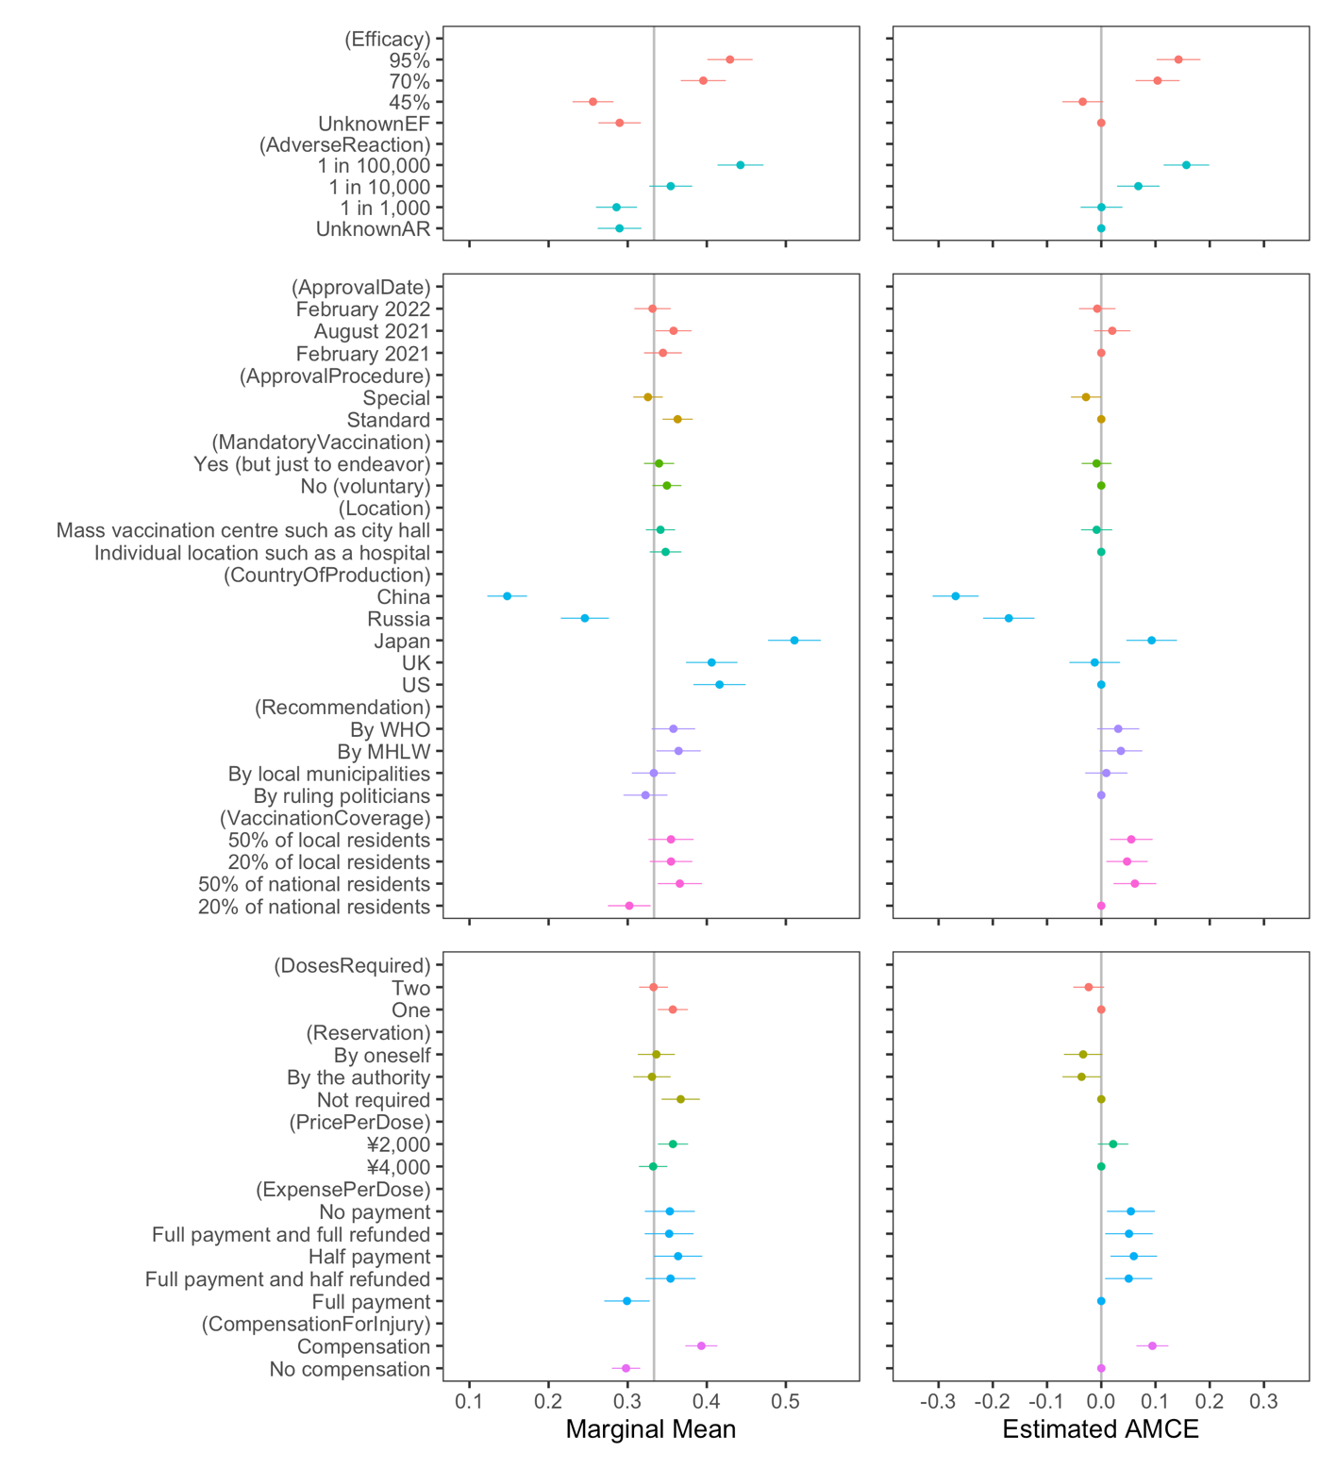
Figure 1. MMs and AMCEs of the probability of vaccines being chosen. The whiskers represent 95% confidence intervals. The vertical line in the left panels shows the random probability of the three options.
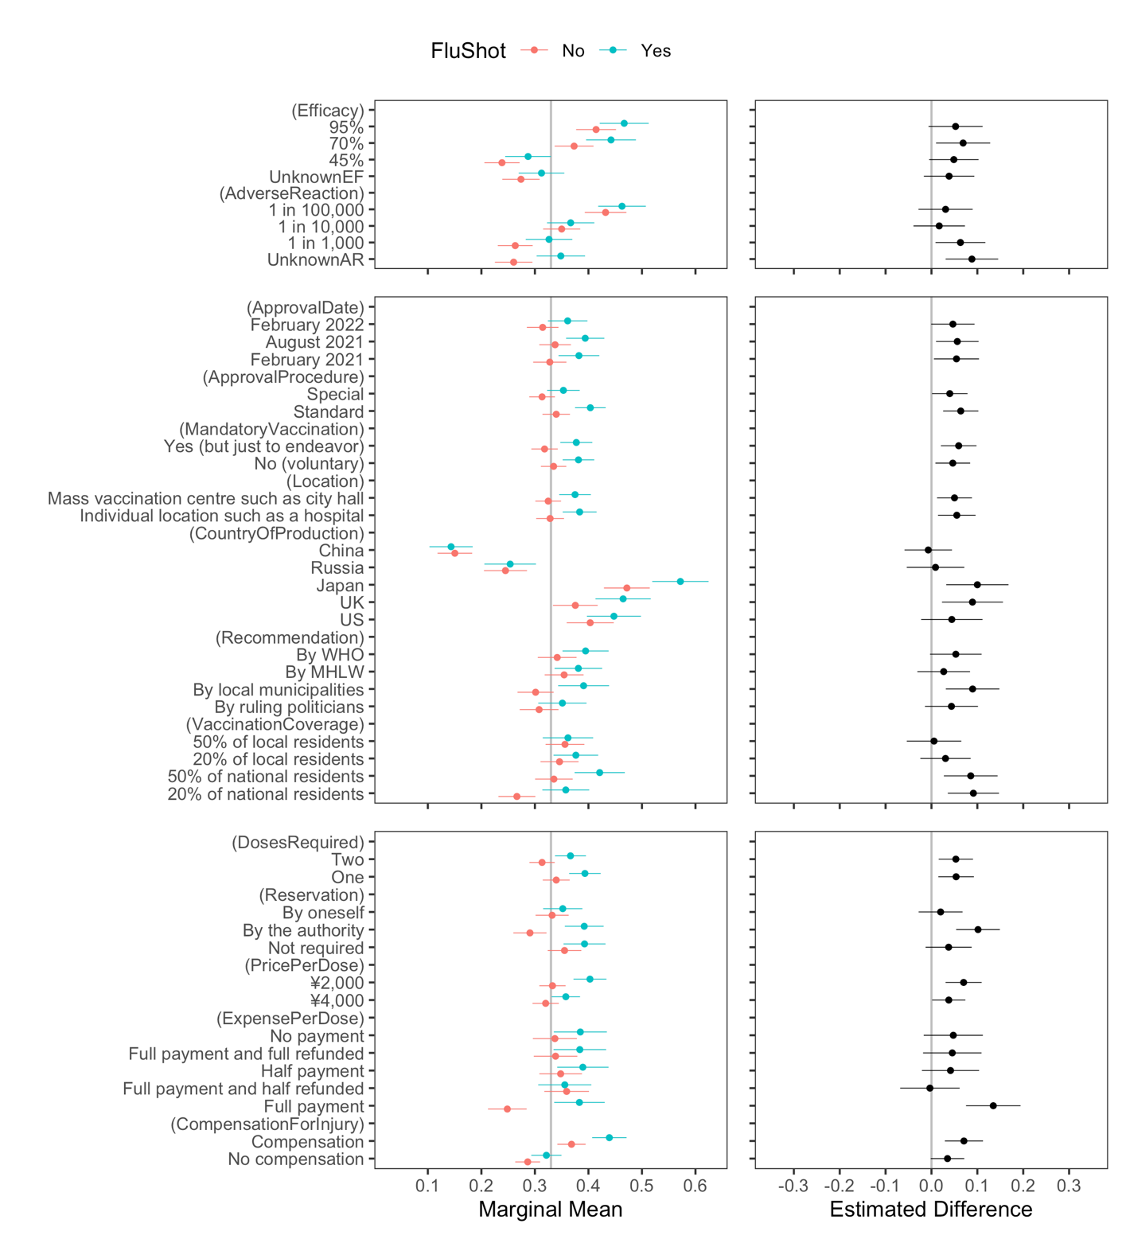
Figure 2. Conditional MMs and differences according to recent experience of having an influenza vaccine regarding the probability of a vaccine being chosen. The vertical line in the left panels shows the random probability for the three options.
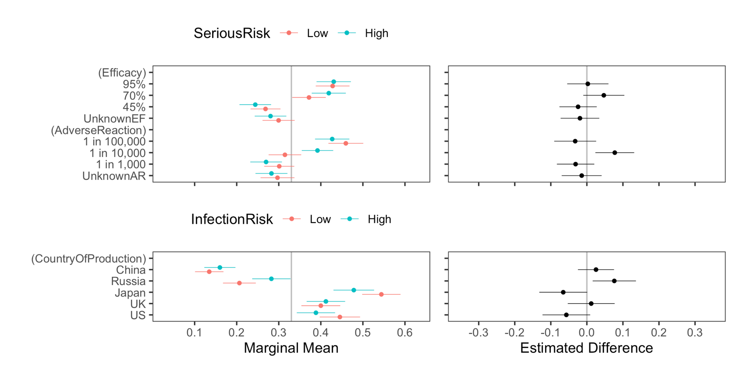
Figure 3. Conditional MMs and the differences in Efficacy, Adverse Reaction, and Country of Production by risk perception regarding the probability of a vaccine being chosen. The vertical line in the left panels shows the random probability for the three options.

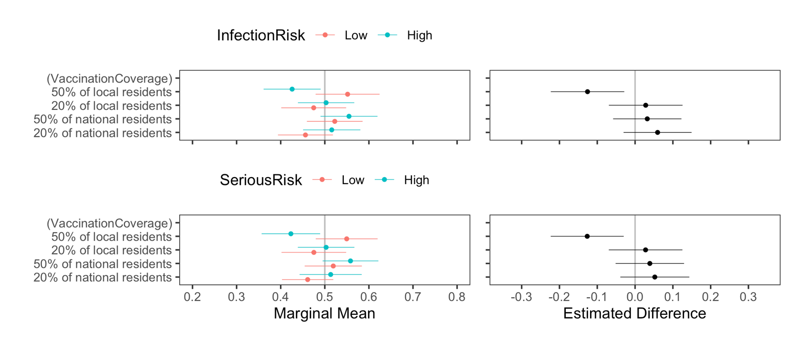
Figure 4. Conditional MMs and the differences in Vaccination Coverage by risk perception regarding the probability of a vaccine being chosen. The vertical line in the left panels shows the random probability for two options without “I would not like to get vaccinated with either vaccine.”

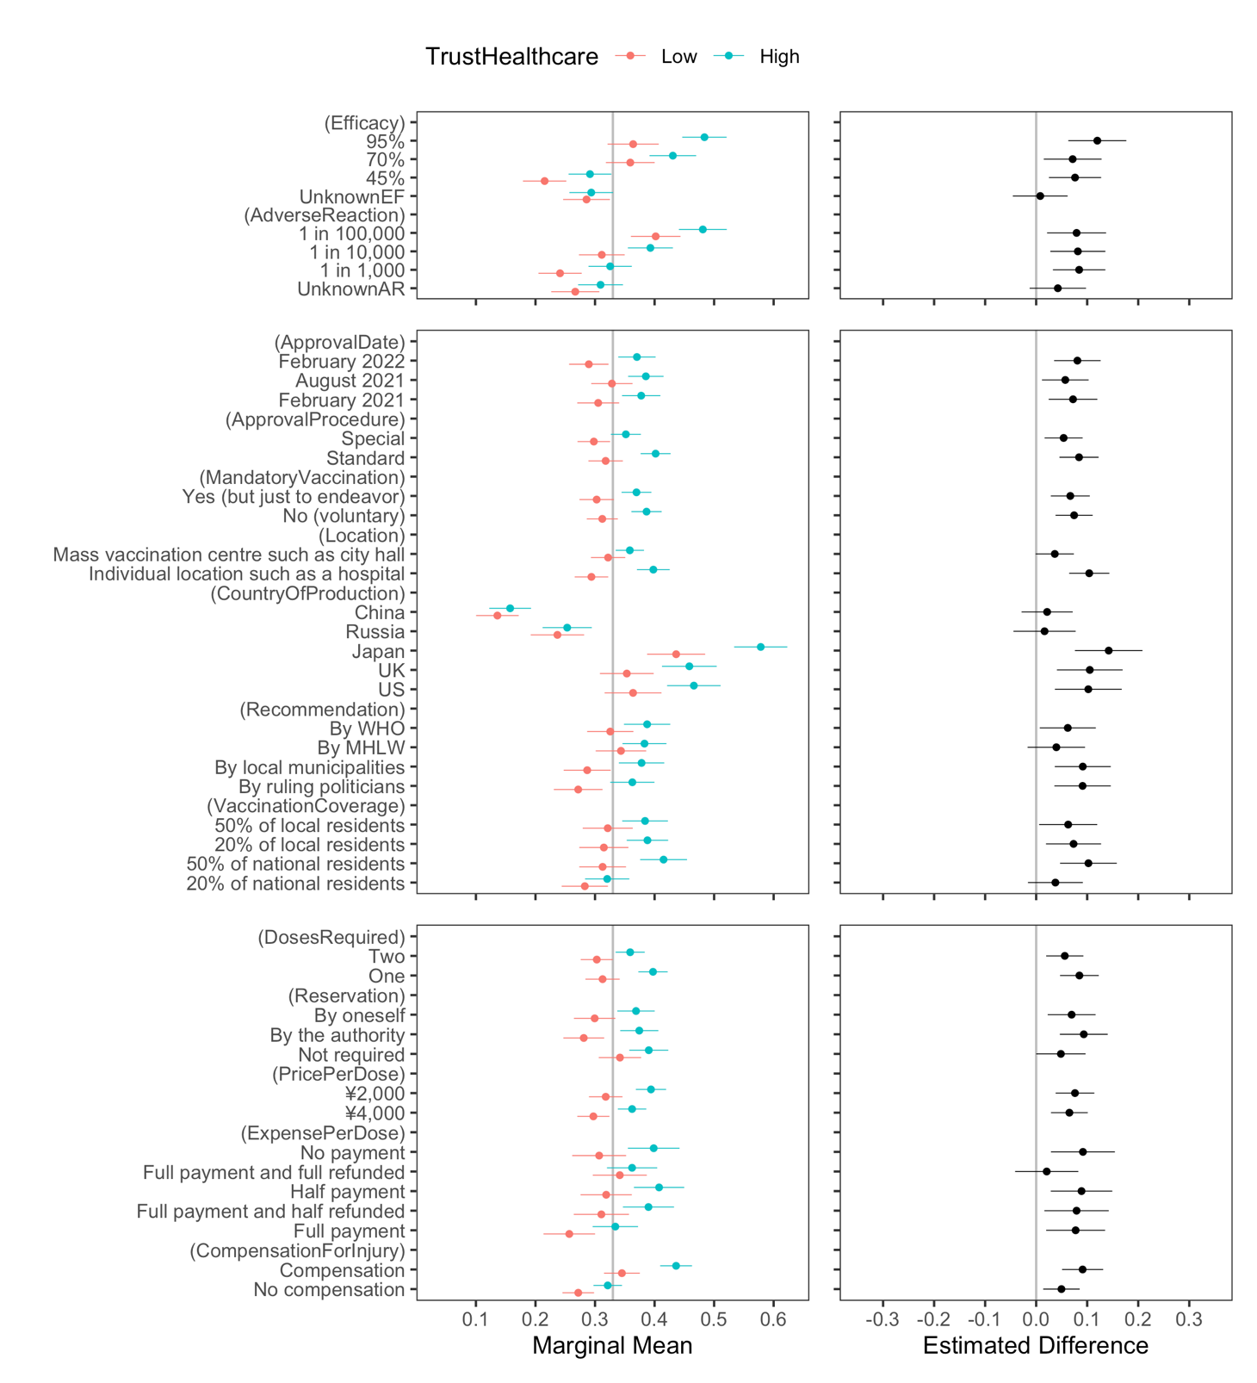
Figure 5. Conditional MMs and the differences by trust in healthcare workers regarding the probability of a vaccine being chosen. The vertical line in the left panels shows the random probability for the three options.
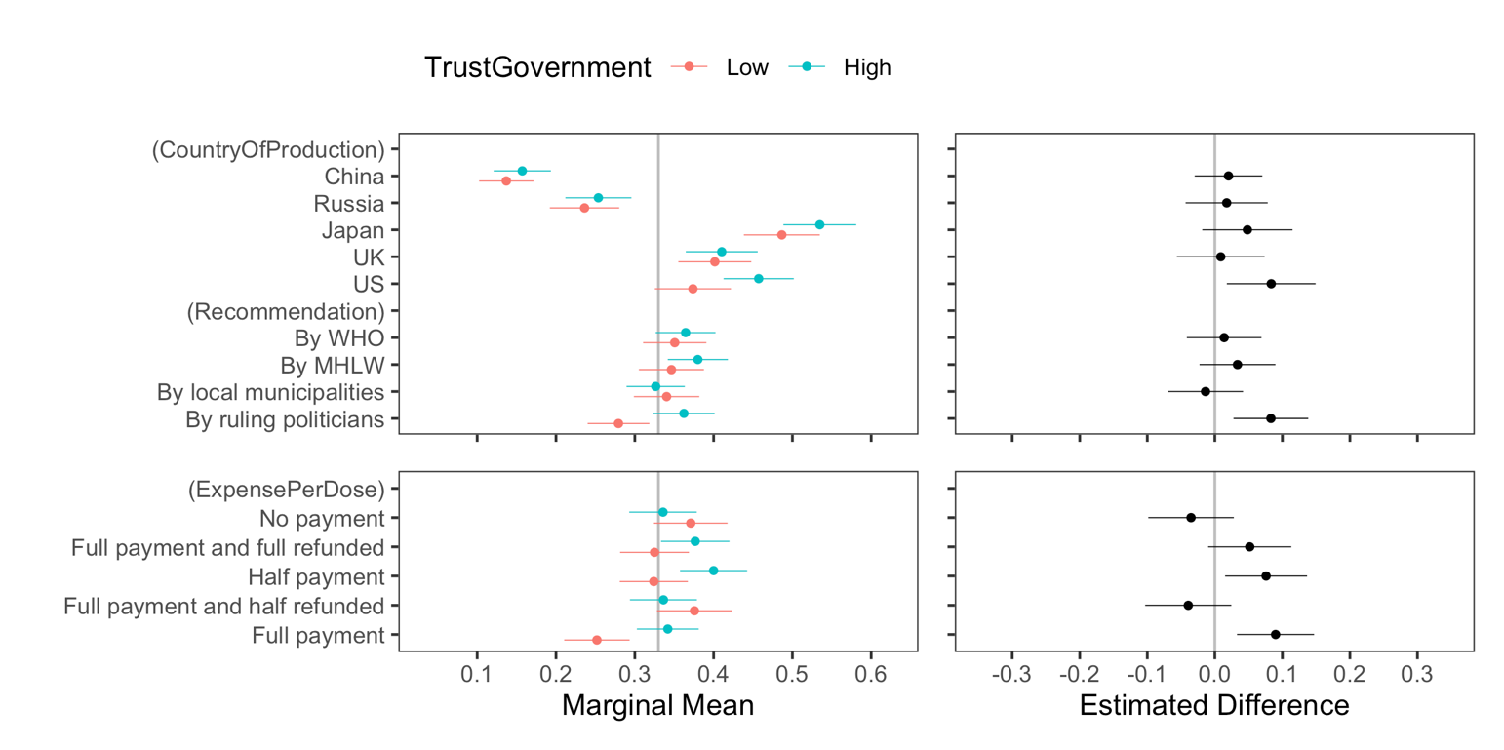
Figure 6. Conditional MMs and the differences in Country of Production, Recommendation, and Expense per Dose by trust in the government regarding the probability of a vaccine being chosen. The vertical line in the left panels shows the random probability for three options.

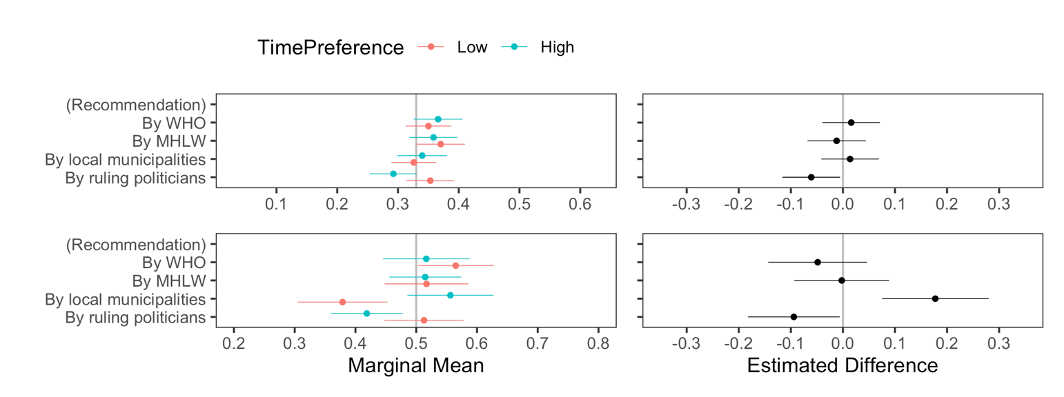
Figure 7. Conditional MMs and the differences in Recommendation by time preference regarding the probability of a vaccine being chosen. The vertical line in the left panel shows the random probability for three options in the upper panel and for two options in the lower panel.

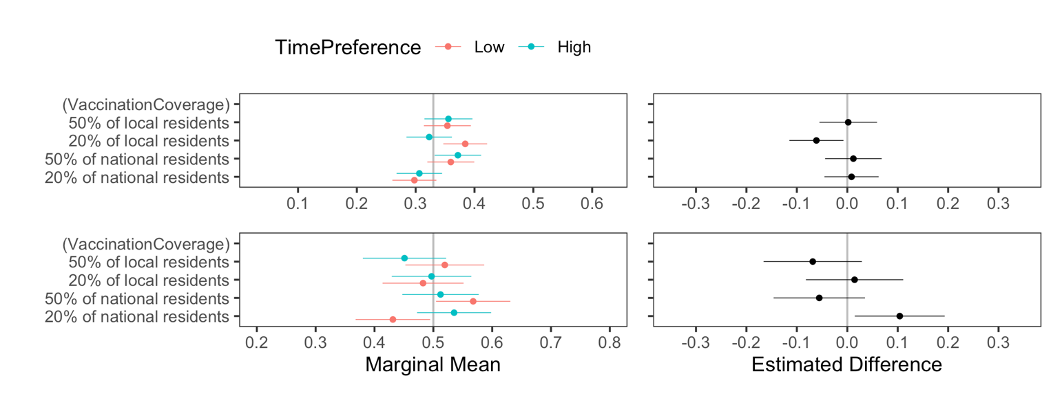
Figure 8. Conditional MMs and the differences in Vaccination Coverage by time preference regarding the probability of a vaccine being chosen. The vertical line in the left panel shows the random probability for three options in the upper panel and for two options in the lower panel.

Online Appendices

Appendix A. Survey procedure details
We planned to 1,000 responses was planned; 2,256 individuals accessed the first page, 1,966 began to respond, and 1,035 completed the survey. The survey company paid respondents in the form of redeemable points upon completion of the survey. Participants who did not complete the survey included 813 individuals who were screened out by way of an attention test administered on the first page; 1 who was excluded because they resided abroad; 4 who were screened out for ethical considerations (the respondents did not get the influenza vaccine during the previous season for religious or other faith-based reasons); and 37 who dropped out the survey. To study the public’s preferences, we also asked a question to screen out healthcare workers or officials, journalists, and stakeholders with the survey firm or this study, but none of the participants corresponded to any of these categories.

Appendix B. A table summarizing the attributes and levels of the conjoint design in Japanese, and an example of a conjoint experiment task.

 | Attribute | Level
1 | 臨床試験での有効率（感染リスク低下率） | 不明, 45%, 70%, 95%
2 | 有害な副反応（副作用）の発生率 | 不明, 千人に1人, 1万人に1人, 10万人に1人
3 | 承認時期 | 今年の2月, 今年の8月, 来年の2月
4 | 承認手続き | 他のワクチン同様に標準的な手続き,  特例的な手続き
5 | 接種義務 | なし（任意接種）, あり（努力義務）
6 | 接種方法 | 病院等での個人接種,  役所や役場等での集団接種
7 | 生産国 | 米国, 英国, 日本, ロシア, 中国
8 | 接種勧奨 | 与党の政治家が勧奨, 地方自治体が勧奨,  厚生労働省が勧奨, 世界保健機関：WHOが勧奨
9 | 接種状況 | 全国で20%の人が接種済み,  全国で50%の人が接種済み,  地元自治体で20%の人が接種済み,  地元自治体で50%の人が接種済み
10 | 接種回数 | 1回, 2回
11 | 予約方法 | 予約は不要, 接種機関が接種日を指定, 自分で予約
12 | ワクチンの価格 | 1回あたり4,000円, 1回あたり2,000円
13 | 自己負担額 | 窓口で全額支払う,  窓口で全額支払い、後日申請して半額返金,  窓口で半額支払う（残り半額は公費で直接補助）,  窓口で全額支払い、後日申請して全額返金,  窓口支払いはなし（全額公費で直接補助）
14 | 健康被害が生じた場合の救済制度 | なし, あり
Note: Summary of attributes and levels in conjoint design in Japanese. Baselines used for estimating uAMCE are underlined.

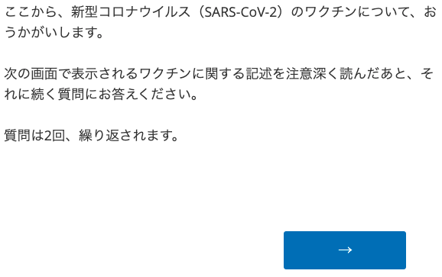
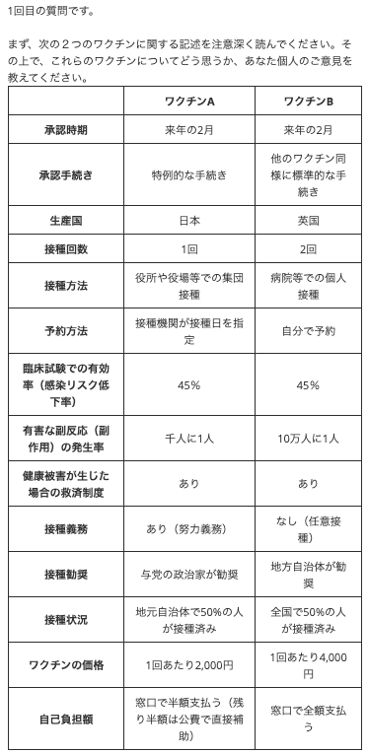
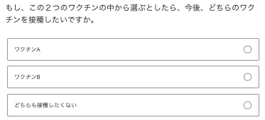

After asking to rate vaccines in terms of effectiveness and safety, the following question was presented to respondents who chose “I would not like to get vaccinated with either vaccine” (どちらも接種したくない):

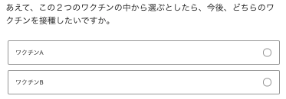

Appendix C. Factor analyses of trust in healthcare/government and time preference.
Original in Japanese | Translation | Factor loading
医療分野の科学者や専門家 | Medical scientist or expert | .579
医療サービスを提供する医師や看護師 | Healthcare provider, such as a medical doctor or a nurse | .597
医薬品を生産する企業やメーカー | Company or manufacturer producing pharmaceuticals | .555

Original in Japanese | Translation | Factor loading
日本政府 | The Government of Japan | .707
与党の政治家 | Governing politician | .707

Original in Japanese | Translation | Factor loading
明日に延ばしても大丈夫な仕事は明日する | If I have work that can wait to be done tomorrow, I wait until tomorrow to do it. | .464
計画を立ててもずるずると先延ばししてしまう | Even if I make plans, I end up procrastinating. | .541
いつも将来のことを考えて行動する | I always think prospectively before I act. | -.493
先のことは不確実だから考えても無駄だ | Since the future is uncertain, it is a waste of time to think about it. | .499

Appendix D. The MMs of and AMCEs of the probability of a vaccine being chosen. The vertical line in the left panels shows the random probability for the two options.
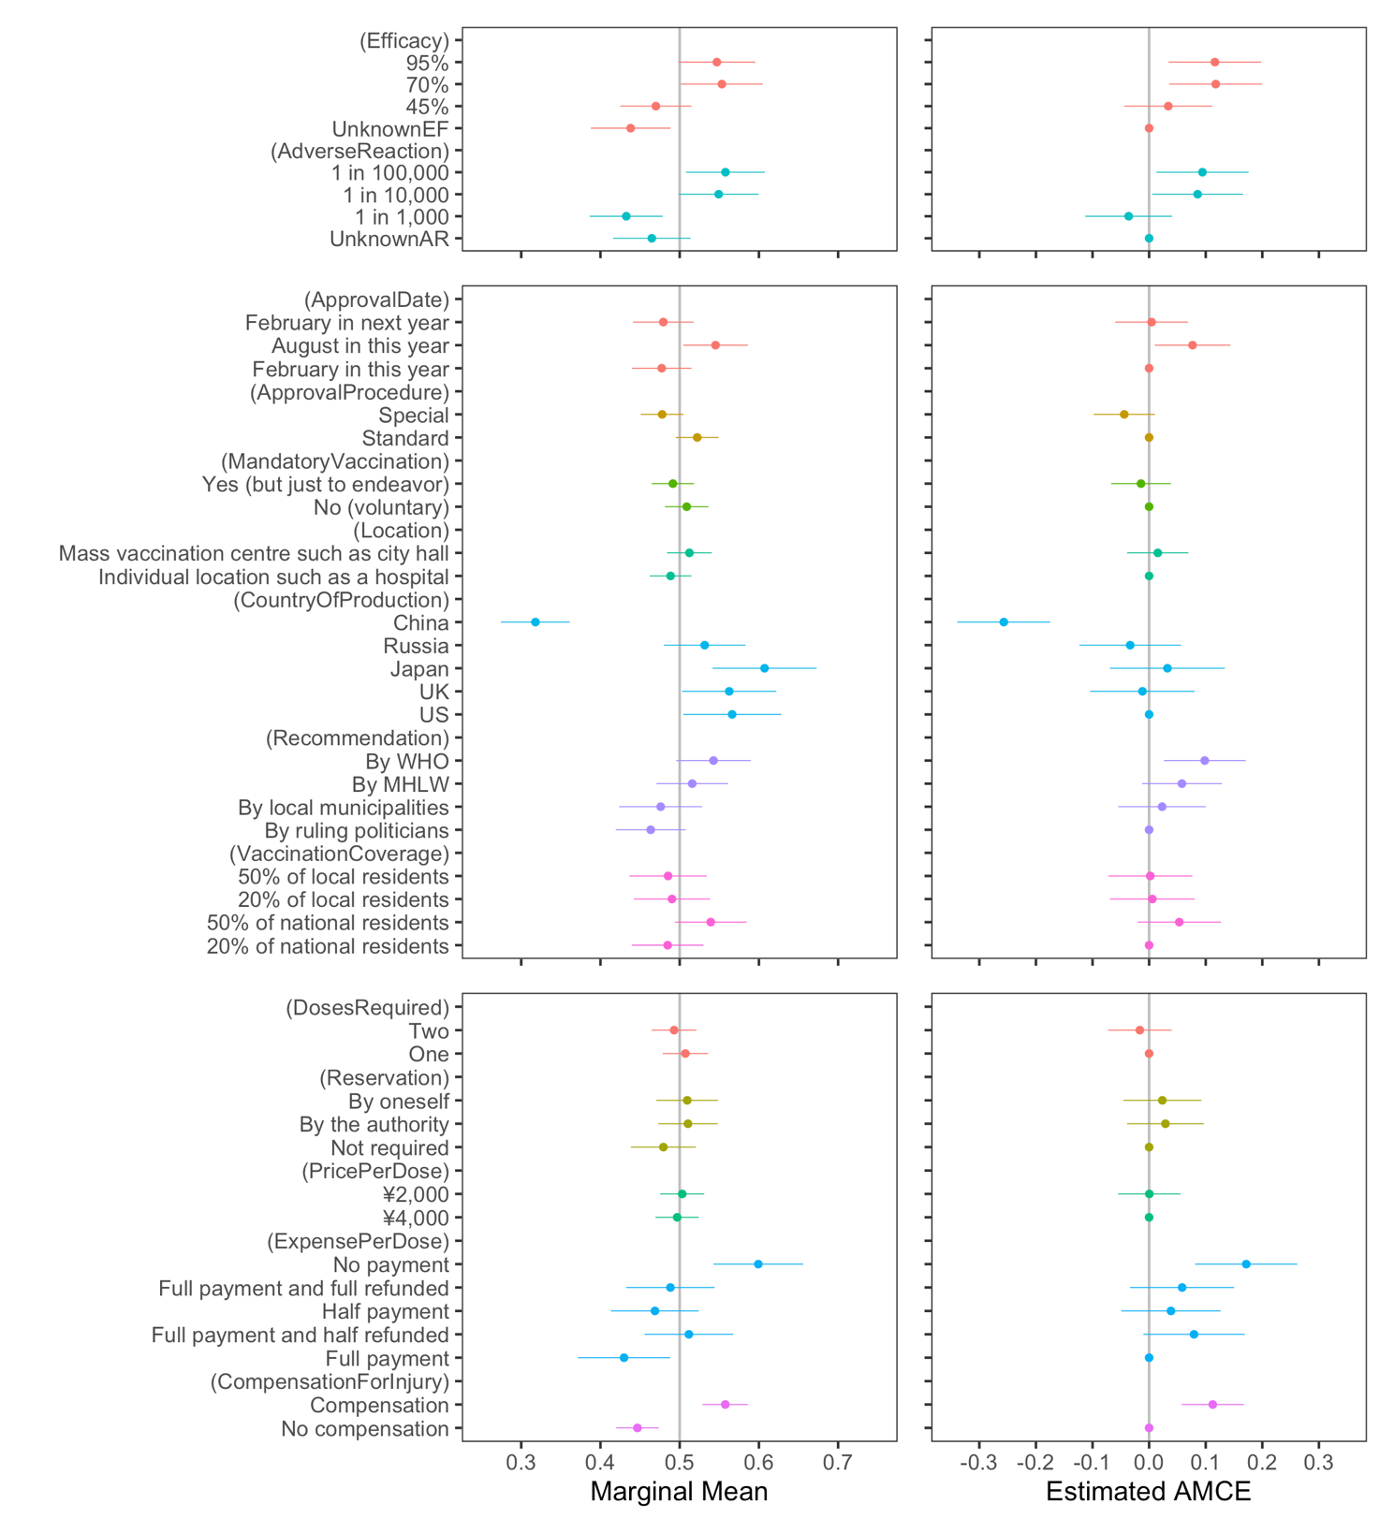

Appendix E. Conditional MMs and the differences in the probability of a vaccine being chosen. The vertical line in the left panels shows the random probability for the two options.
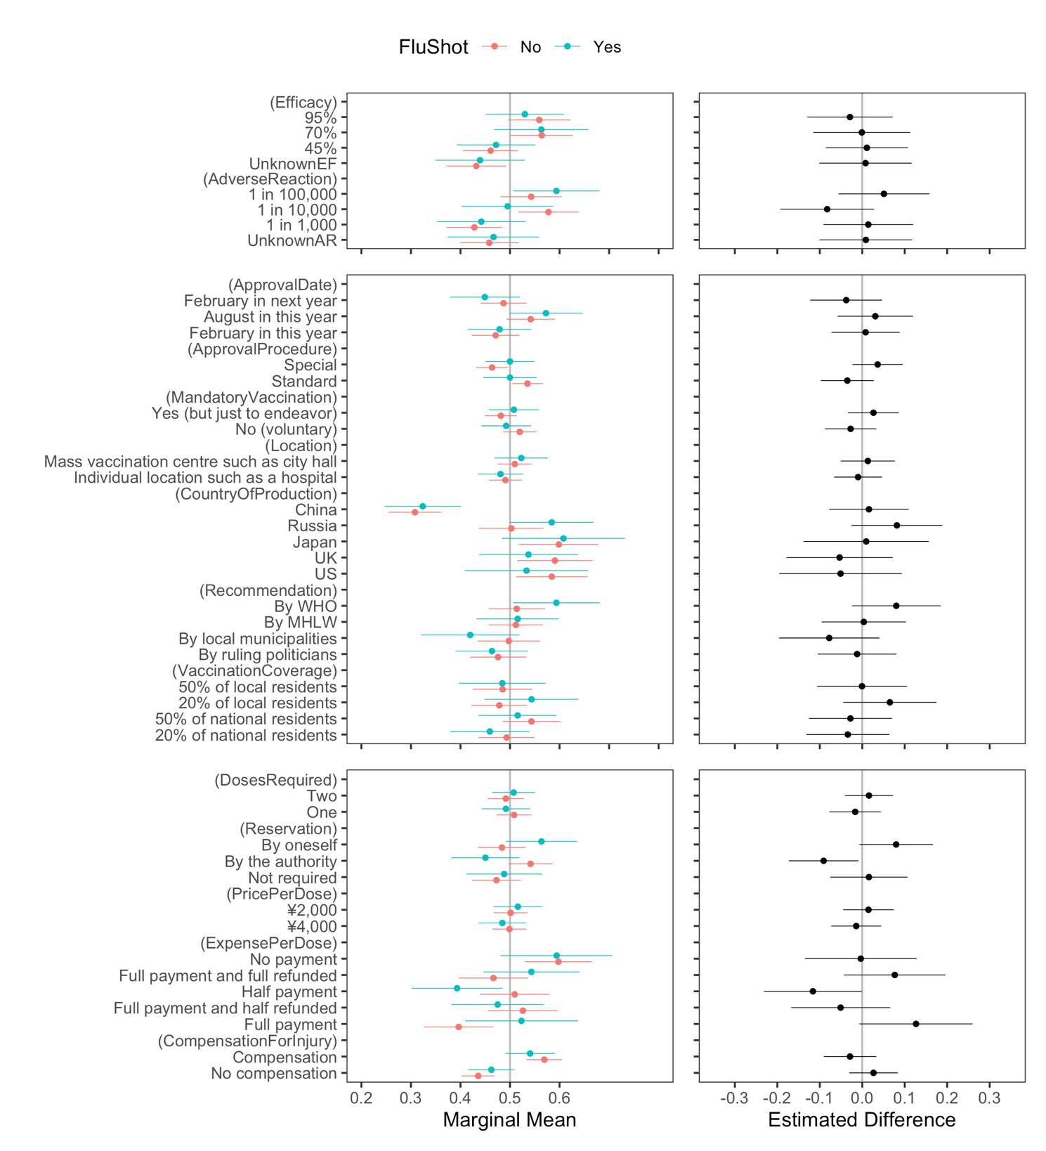
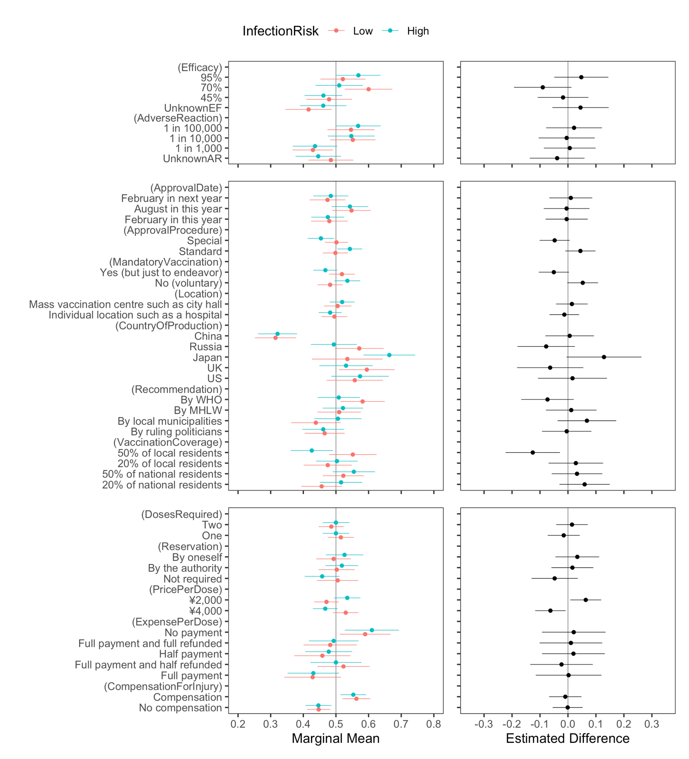

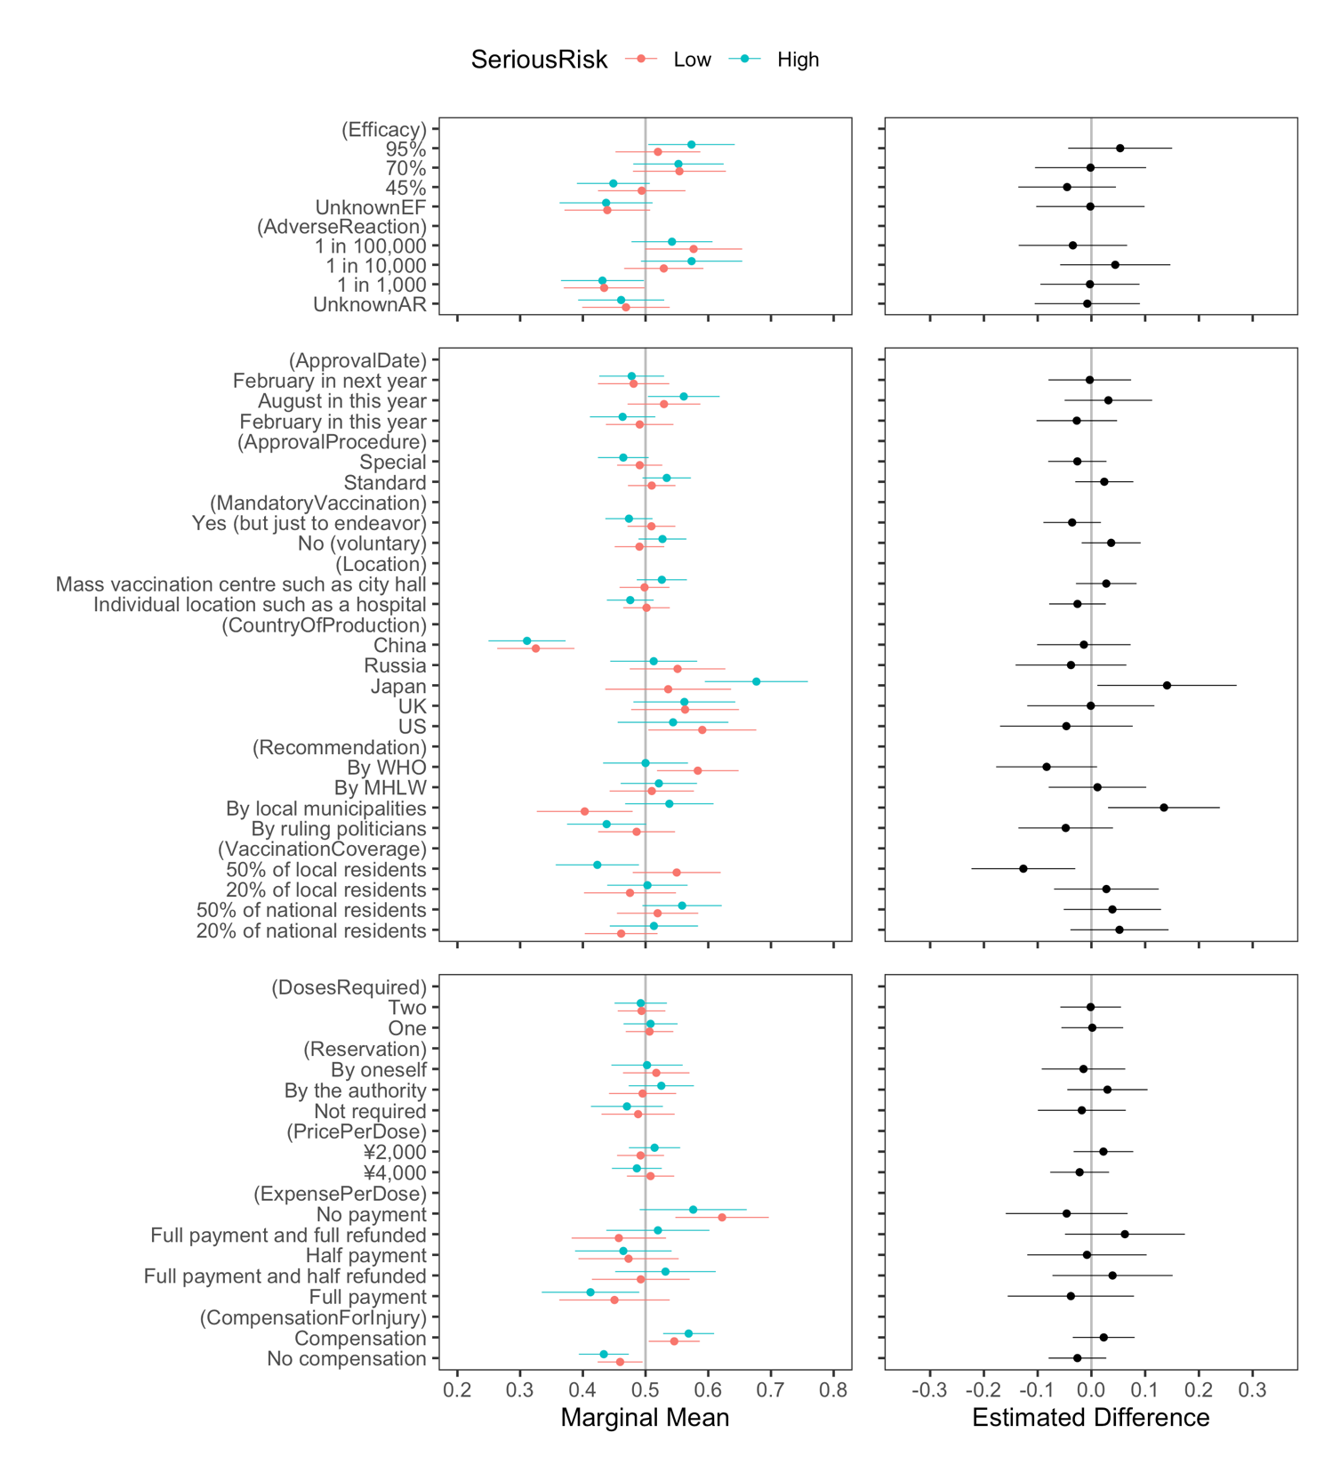

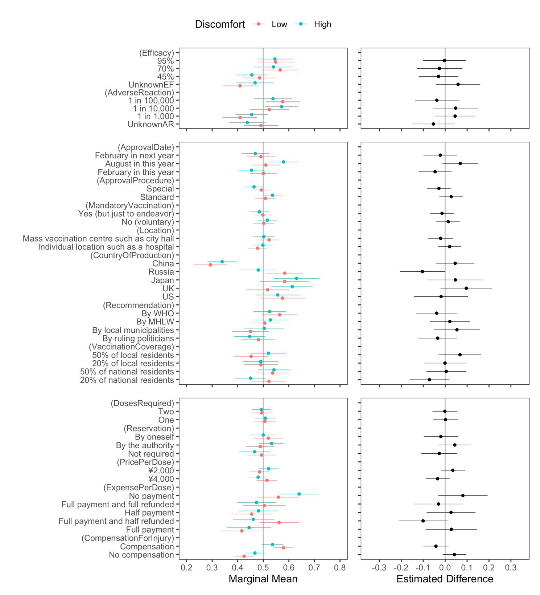

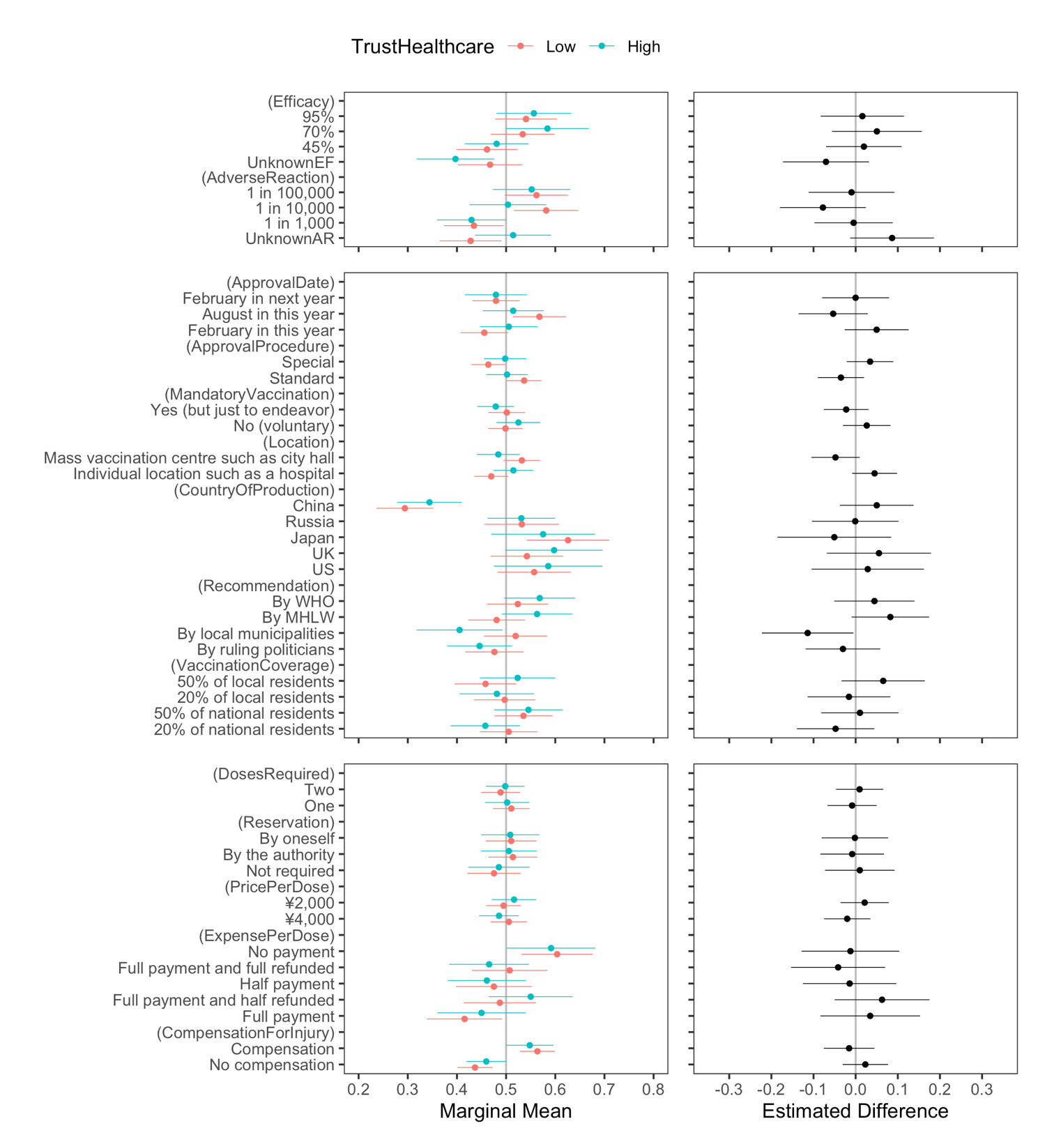
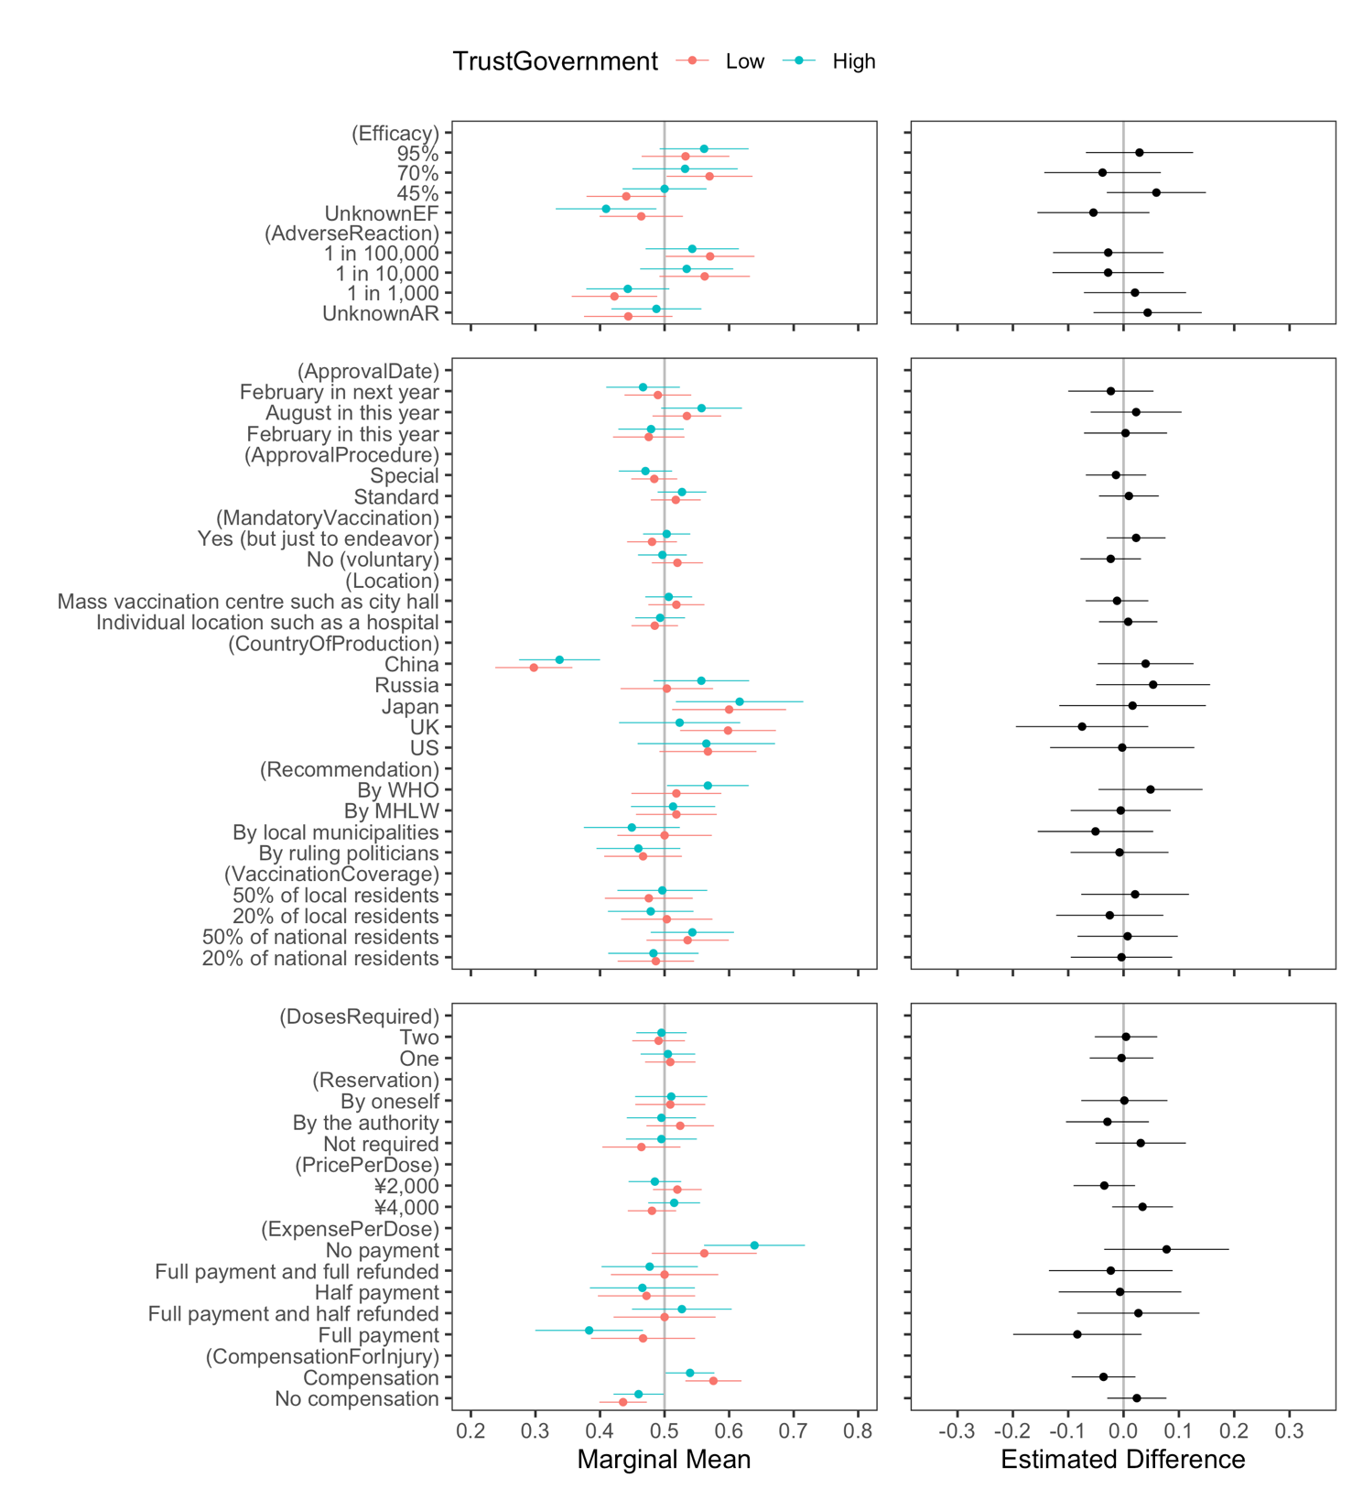
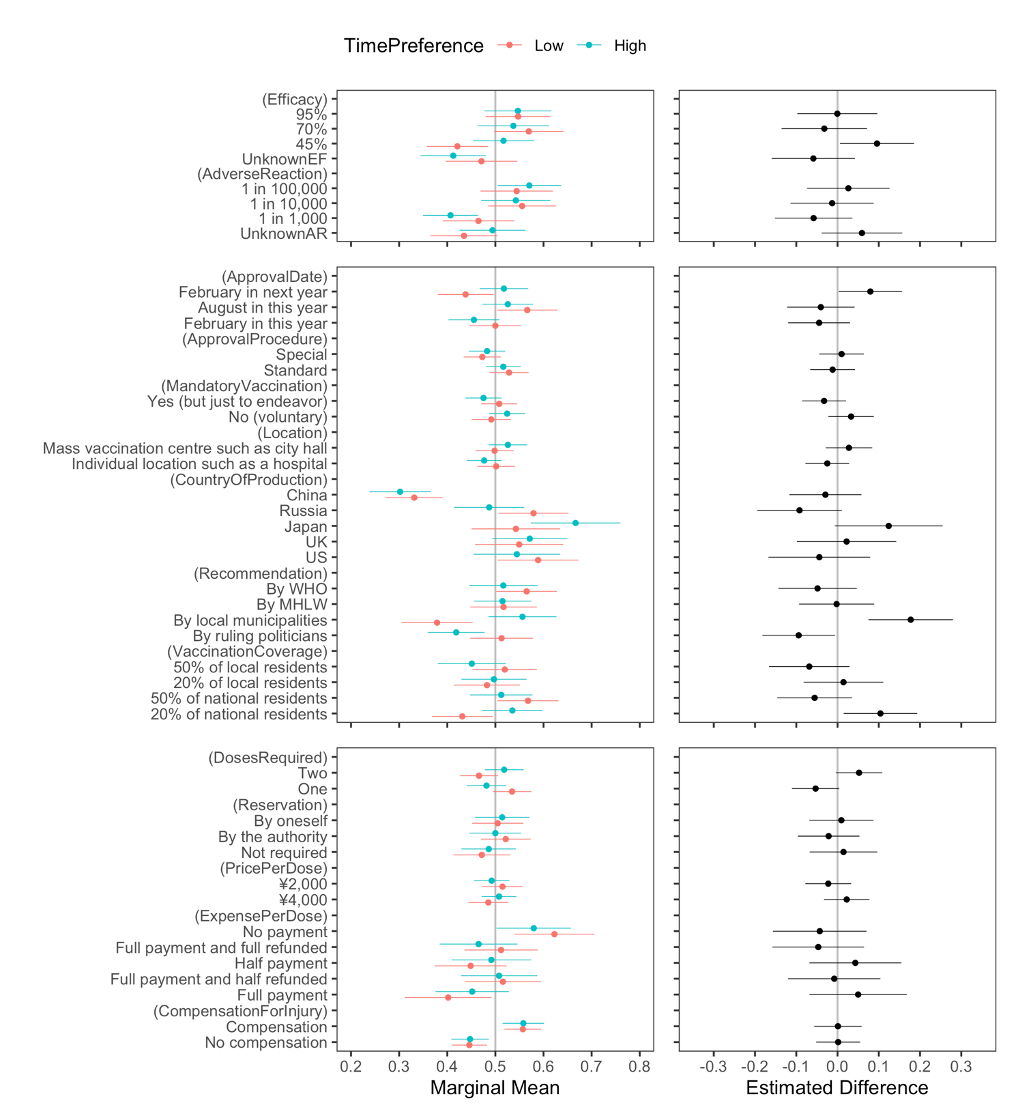

Appendix F. Conditional MMs and differences by subgroup analysis (other than those reported in the main manuscript). The vertical line in the left panels shows the random probability for the three options.
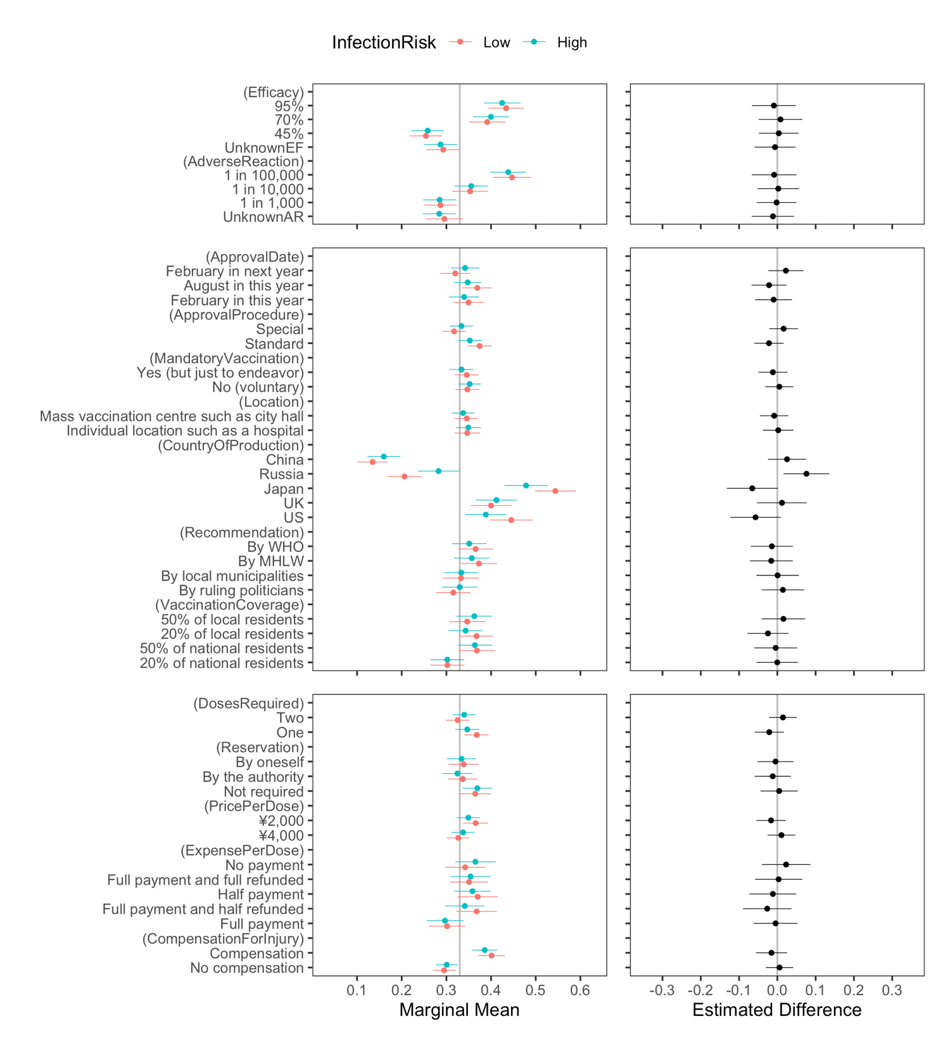
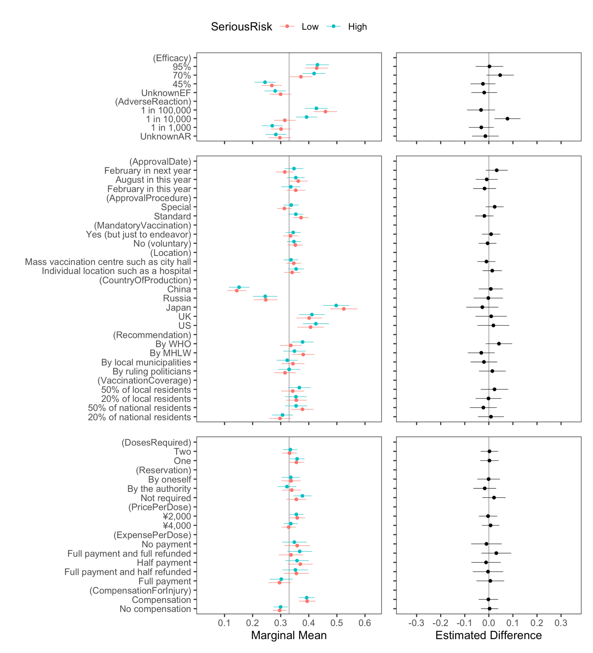
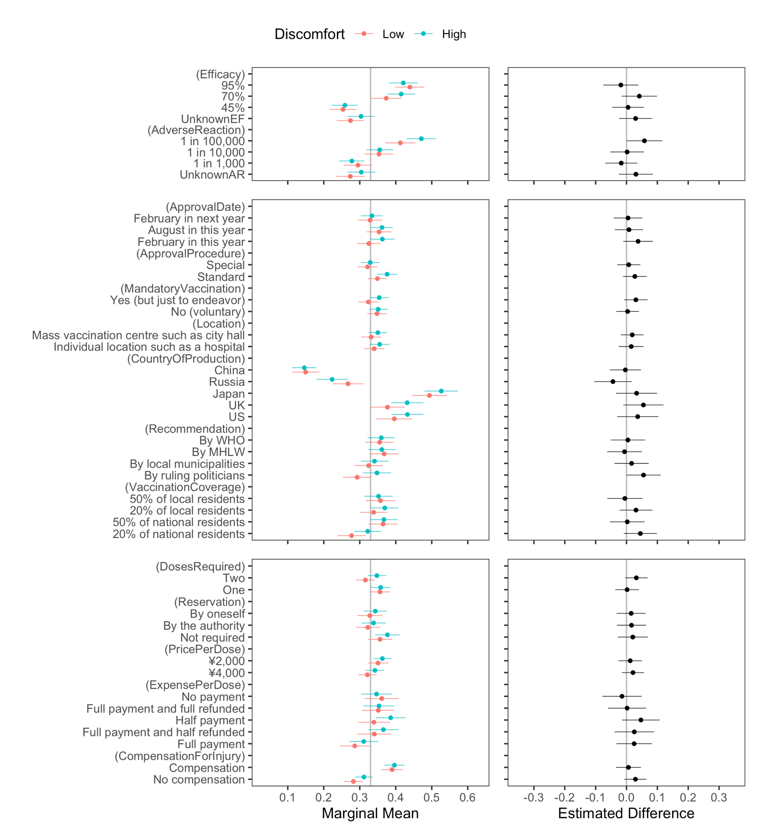

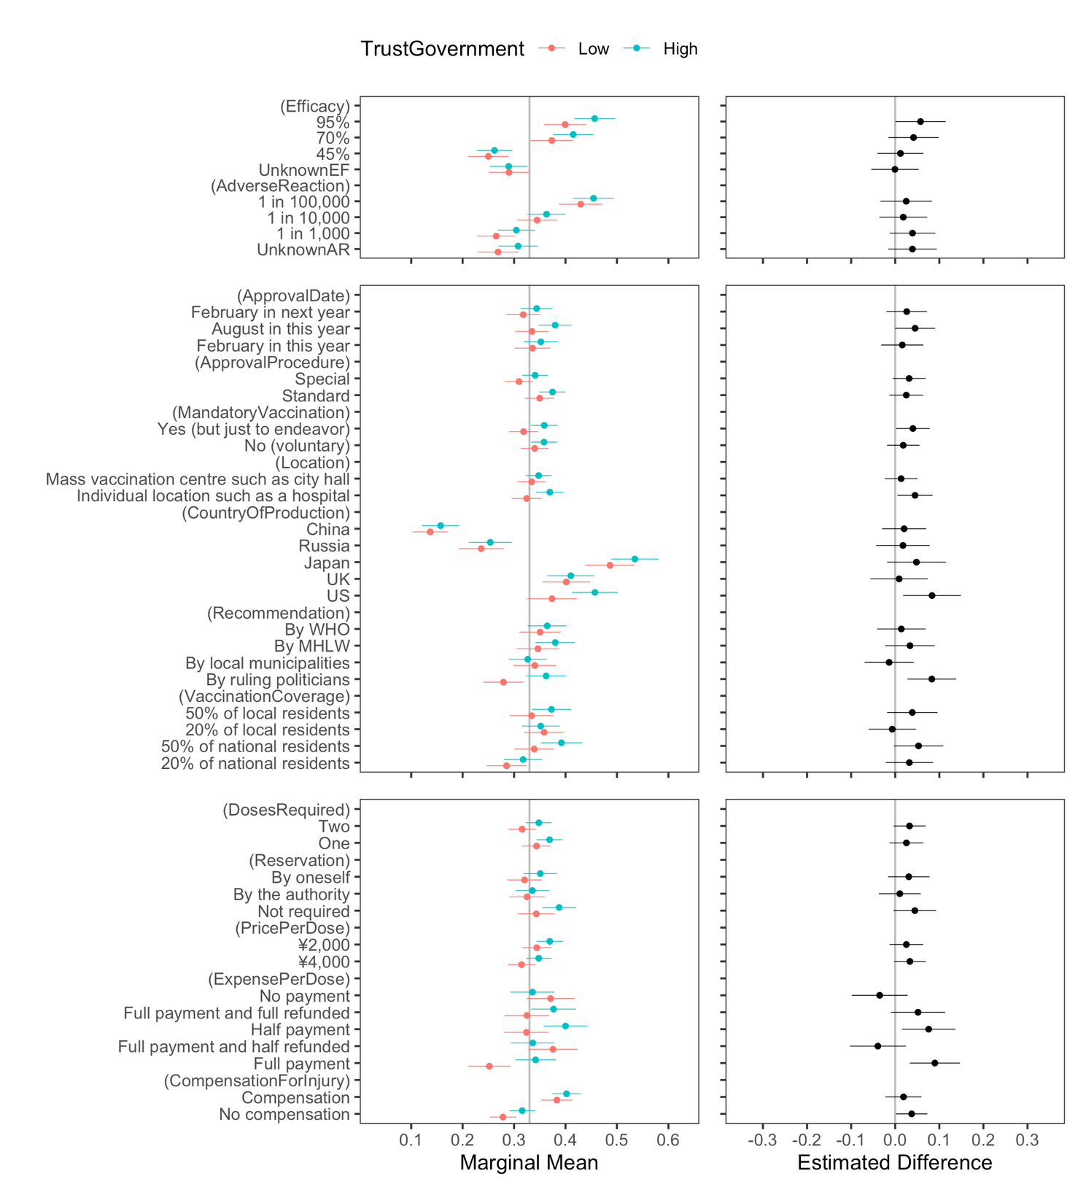
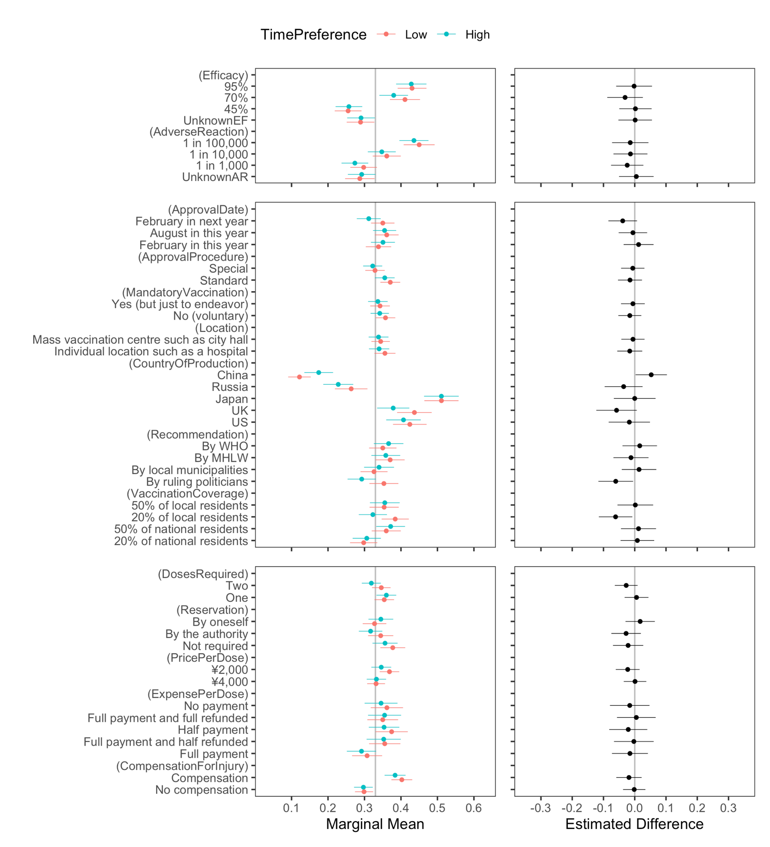

https://www.iser.osaka-u.ac.jp/survey_data/top_eng.html [this should go in the references list]

