**Substance and Behavioral Addictions among Jewish Israeli Adolescents during the COVID-19 Pandemic**

Yaniv Efrati

[Bar Ilan University](https://www.researchgate.net/institution/Bar_Ilan_University)

Keywords: substance use disorder, behavioral addictions, sociodemographic, self-reported, adolescents, pandemic.

**_____________________________________________________________________**

Corresponding author: Bar Ilan University, Faculty of Education, Ramat Gan, Israel.

Email: [ypefrati@gmail.com](mailto:ypefrati@gmail.com) Phone: +972-545-800094, ORCID <https://orcid.org/0000-0003-3176-3708>

**Abstract**

This study examines self-reported substance and behavioral addictions among Israeli youth during the COVID-19 pandemic, across different sociodemographic categories. The sample comprised 2,074 adolescents (40% males, 60% females) aged 12-19 years who completed the survey anonymously and with parental consent. Participants reported self-perceived addictions to social networks (70%), shopping (46%), uncontrolled binge eating (34%), gaming (30%), sex-related behavior (15%), psychoactive substance (31% including alcohol, tobacco, cannabis, and/or cocaine) and gambling (3%). Moreover, differences were found to be directly related to age, biological sex, religiosity, socioeconomic status (SES), and immigration status. From a lay epidemiological perspective, the current research expands knowledge about self-perceived addiction among adolescents during the COVID-19 pandemic, offering potential insights for clinical application.

**Substance and Behavioral Addictions among Jewish Israeli Adolescents during the COVID-19 Pandemic**

Adolescence is associated with high levels of risk-taking (Ciranka & van den Bos, 2021) with a peak in risky behaviors such as substance and behavioral addictions (Van Rooij et al., 2014). Substance and behavioral addictions are defined by functional impairment in daily life, increasing priority given to (and preoccupation with) substance use or specific behavior, and continuation or escalation of substance use or specific behavior despite the occurrence of negative consequences (Brand et al., 2020; Zou et al., 2017). To date, much of the research on substance and behavioral addictions among youth has focused on frequency and use behavior (see the Health Behaviour in School-aged Children study [HBSC]; Walsh et al., 2020). However, few studies have provided a broader view of self-perceived substance and behavioral addictions among adolescents. In the present research, I adopt a lay epidemiological approach which takes into account the phenomenological experiences of adolescents from the general population in Israel; I also examine common warning signs and symptoms of problematic substance abuse and behavioral addiction (Schluter, Hodgins, Wolfe, & Wild, 2018; Schluter, Hodgins, Konkolÿ Thege, & Wild, 2020; Hodgins, Wilson, & Schluter, 2022).

Lay epidemiology proposes that ‘fields of symptomatology, nosology, aetiology, and epidemiology have identifiable counterparts in the thoughts and activities of people outside the formal medical community’ (Davison, Smith, & Frankel, 1991 [p. 6]). From this perspective, the lay public’s conceptions of addiction can have important implications concerning whether or not an individual identifies themselves as an addict. Adolescents who use the term “sense of self” perceive their addiction as an extension of themselves because it reflects their sense of self-identity, which is tied up with how they want to present themselves to others (e.g., Jameel, Shahnawaz, & Griffiths, 2019). Wild and colleagues (2015) suggest that prevalence rates of self-attributed addiction problems exhibit a striking concordance with those obtained using expert-derived, formal diagnostic criteria. Therefore, the first aim of the current study is to examine adolescents’ self-reported substance and behavioral addiction.

In addition to this timely question, I am also interested in exploring substance and behavioral addictions during the COVID-19 pandemic in particular. Recent studies have found increased rates of addiction since the outbreak of the coronavirus among adults and youth: drugs (Mallet, Dubertret, & Le Strata, 2021; Cisneros & Cunningham, 2021; Nguyen & Buxton, 2021; Slavova, Rock, Bush, Quesinberry, & Walsh, 2020); alcohol (Kar, Tomfohr-Madsen, Giesbrecht, Bagshawe, & Lebel, 2021; Blithikioti, Nuño, Paniello, Gual, & Miquel, 2021); tobacco/vaping (Yang & Ma, 2021); marijuana/cannabis (Levy, Cohen-Louck, & Bonny-Noach, 2021); the Internet (Király et al., 2020; Islam et al., 2020; Oka et al., 2021); gaming (López-Cabarcos, Ribeiro-Soriano, & Piñeiro-Chousa, 2020); gambling (Wardle, Degenhardt, Ceschia, & Saxena, 2021; Brodeur, Audette-Chapdelaine, Savard, & Kairouz, 2021); shopping (Koch, Frommeyer, & Schewe, 2020; Moon, Choe, & Song, 2021); binge eating (Schulte, Kral, & Allison, 2022; Trott, Johnstone, Pardhan, Barnett, & Smith, 2021); pornography (Sallie, Ritou, Bowden-Jones, & Voon, 2021; Grubbs, Perry, Kraus, & Grant, 2021); sex-related behavior (Lehmiller, Garcia, Gesselman, & Mark, 2021; Döring, 2020), and social networks (Gómez-Galán, Martínez-López, Lázaro-Pérez, & Sánchez-Serrano, 2020; Luo, Chen, & Liao, 2021). A recent study involving Israeli youth indicates that 37% of young people aged 12-18 years have had to self-isolate since the pandemic began and 28.9% have been confined to their homes in a lockdown context more than once (Gewirtz-Meydan, Mitchell, Shlomo, Heller, & Grinstein-Weiss, 2021). Social distancing measures implemented to curtail the spread of COVID-19 have had a negative impact on the mental health of young people, who have shown higher rates of behavioral addiction enabled by the Internet (gaming, social media, etc.).

Research indicates that the average age of first substance use is 13–14 years, which applies mainly to alcohol and illicit substances (Nowak, Papiernik, Mikulska, & Czarkowska-Paczek, 2018). Moreover, previous studies have demonstrated that substance use before 16-18 years is associated with later substance abuse (Scholes-Balog et al., 2016; Jordan, & Andersen, 2017; Rioux et al., 2018; Brumback, Thompson, Cummins, Brown, & Tapert, 2021). Substance use and attitudes have changed over the decades, with reports indicating an increase in problematic consequences or a higher prevalence of addiction among young adults and adults (Deputy et al., 2021). For example, in a US-based review, Carliner, Brown, Sarvet, & Hasin (2017) found that since the early 2000s, adult and adolescent perception of cannabis use as risky has decreased. Over the same time, the prevalence of cannabis use among adolescents has changed little. However, adult cannabis use, disorders, and related consequences have increased. In the context of pornography use in adolescents, Farré and colleagues (2020) found that prevalence increases with older age. My prediction is that older adolescents will report a higher level of substance addiction and sex-related behavior, whereas other types of behavioral addiction (gaming, social networks, etc.) will not show any differences based on age.

Gender plays a key role in substance and behavioral addictions. For example, substance use disorders are more prevalent in boys than in girls (McHugh, Votaw, Sugarman, & Greenfield, 2018). In a survey conducted by the Center for Behavioral Health Statistics and Quality (CBHSQ, 2016) an estimated 47.4% of females aged 12 years and older reported past-month alcohol use, compared to 56.2% of males in the same age group. Females also displayed lower rates of binge drinking, heavy drinking, and alcohol use disorder (4.1%) than boys. Similarly, nicotine dependence was present in 52.3% of female habitual smokers and 9.7% of females overall. In the same report, 7.9% of females and 12.5% of males aged 12 years and older reported past-month illicit drug use; corresponding rates of illicit drug use disorders stood at 2% and 3.8% (CBHSQ, 2016). In Norway, cannabis use among university students met the criteria for cannabis use disorder in 6% of the population (3.8% females; 8.5% males) (Andreas et al., 2021). Gender differences are also common in behavioral addictions. For example, research indicates that male adolescents are exposed to pornography at an earlier age than girls, consume more pornography, and more often tend to describe themselves as being addicted to pornography (Kowalewska et al., 2020; Peter & Valkenburg, 2016). In addition, males in this age group show greater attentional bias toward sexual cues and a higher prevalence of compulsive sexual behavior disorder (Efrati & Amichai-Hamburger, 2021). With regard to gambling, the prevalence of gambling disorder in young people aged between 11 and 16 years was estimated at 4.6% (Calado, Alexandre, & Griffiths, 2017; Montiel et al., 2021), and more frequent in men than in women in the adult group (Ronzitti et al., 2016). Similarly, studies on gaming addiction have shown a higher prevalence in males than in females (Efrati, Kolubinski, Marino, & Spada, 2021). Conversely, some studies suggest that more females prefer to use the Internet for communication, while males privilege game playing (Mihara & Higuchi, 2017), and indeed social networking addiction has been shown to be more prevalent in adolescent females than in males (Peris, de la Barrera, Schoeps, & Montoya-Castilla, 2020). Meanwhile, in a meta-analysis of adult-representative studies, the pooled prevalence of shopping addiction in different populations was approximately 5%, with women showing higher percentages compared to men, a prevalence that has been increasing over the years (Maraz, Griffiths, & Demetrovics, 2016). Finally, Rodrigue, Gearhardt, & Begin (2019) have shown that binge eating is nearly as prevalent in young people as in adults. In Turkey, a study of 612 high school students revealed that 12.4% of the population had food addictions. Females were found to have a higher food addiction score than males (Candan & Küçük, 2019). Accordingly, my second hypothesis is that the prevalence of self-reported substance use, gambling, gaming, and sex-related addictions will be higher among male adolescents than among females of the same age. On the other hand, I predict that more girls will report having addictions to shopping, binge–eating, and social networks than boys.

Religious belief seems to be another factor that influences addictive behavorial patterns. Research indicates that religion is often seen as a buffer or deterrent against risk behavior and substance and behavioral addictions (see Grubbs & Grant, 2020; Connery & Devido, 2020). Religious adolescents and adults are less likely to experience substance addictions (Acheampong, Lasopa, Striley, & Cottler, 2016; Grim & Grim, 2019; Miller, Davies, & Greenwald, 2000). In some aspects of life, however, religious belief may promote

an inner struggle that might sustain an addictive behavior (Faigin, Pargament, & Abu-Raiya, 2014). According to the moral incongruence model (Grubbs, Kraus, Perry, Lewczuk, & Gola, 2020; Lewczuk, Glica, Nowakowska, Gola, & Grubbs, 2020; Grubbs, Kraus, & Perry, 2019) emotional and physical distress arises from the contradiction between a person’s moral beliefs and the behavior in which they engage. For example, there is incongruence between the natural sexual urges of an adolescent and the conservative principles endorsed by their religious leaders (e.g., a rabbi) and by the foundational literature, such as the Bible or the Talmud, in which sexual thoughts and behaviors are discouraged or even condemned. In keeping with this incongruence, a recent study on Polish adults with self-perceived behavioral addiction to pornography, internet use, social networking, or online gaming found that religiosity was uniquely, although weakly, connected to pornography addiction, but not to other types of addictive behaviors (Lewczuk, Nowakowska, Lewandowska, Potenza, & Gola, 2021). Therefore, my third prediction is that secular youth will report more self-perceived substance and behavioral addiction.

As regards socioeconomic status (SES) research indicates that there are associations between socioeconomic factors and substance abuse outcomes (Collins, 2016; Diala et al., 2004; Melchior et al., 2007). For example, previous research on tobacco found that low SES was associated with a higher prevalence and co-occurrence of risk factors (Wellman et al., 2018). Moreover, Petruzelka and colleagues (2020) found an interaction between socioeconomic status and substance and behavioral addiction (risky internet use, gambling) in adolescents. In their research on sex-related behavior, Efrati & Amichai-Hamburger (2021) found that adolescents who engage in both offline and online sexual activities have a lower economic status, on average, than those without sexual experience. Therefore, I hypothesize that adolescents with a low SES will report more self-perceived substance and behavioral addiction. Finally, with regard to immigration,research has indicated that young people from families with a more vulnerable immigrant status are at risk of immigration-related adversities and behavioral withdrawal, which in turn lead to difficulties of adjustment among youth and high substance use (Roche et al., 2021). In addition, among immigrant adolescents, there are more severe levels of problem-gambling and a higher distribution of at-risk and problem gamblers with respect to non-immigrant adolescents (Donati, Primi, Mazzarese, Sanson, & Leone, 2020). Therefore, my final prediction is that having a migration background is likely to increase the likelihood of self-perceived substance and behavioral addiction among adolescents.

In the current study, by administering a survey I investigate self-reported substance addiction (alcohol, tobacco, cannabis, and cocaine) and behavioral addiction (shopping, gaming, gambling, binge eating, sexual activity, and social networks) among Jewish adolescents in Israel, the largest population group in the country (74%) (Central Bureau of Statistics, Jerusalem, Israel, 2020). This is the first time that large-scale research in this specific area has been conducted in Israel. I have predicted that there will be noticeable differences based on the sociodemographic variables of age, gender, religiosity, SES, and immigration status. I focus in particular on religiosity due to the largely discrete levels of Jewish practice and identification in Israel that allow for easy categorization and comparison (Pew Research Center, 2016).

**Method**

**Participants**

The study population comprised 2,074 Jewish Israeli adolescents from the general community (825 males and 1,249 females), aged 12-19 years (M = 16.14, SD = 1.35), all enrolled in the eighth (n= 94), ninth (n= 317), tenth (n = 464), eleventh (n = 490), and twelfth (n = 682) grades. Most (96%) were native Israelis. Socioeconomically, 0.3% of participants described their level as being very bad, 3.8% bad, 61.7% good%, and 33.9% very good. In terms of religious affiliation, the sample consisted of 997 (48.1%) self-reported religious individuals, 391 (18.9%) traditional, 587 (28.3%) secular, and 99 (4.8%) ultra-orthodox.

**Measures**

**Sociodemographic**. Adolescents reported their age group (12-14, 15-17, 18-19 years), biological sex (male, female), religiosity (secular, traditional, religious, ultra-orthodox), immigration status (Israeli, immigrant), and socioeconomic status (or SES, divided into the categories of very good, good, bad, and very bad).

**The Screener for Substance and Behavioral Addictions (SSBA)** (Schluter et al., 2018). The SSBA is a brief screening instrument for measuring self-attributed addiction problems in the general population. The SSBA is comprised of four self-report items, each reflecting a distinct sign or symptom of potentially problematic involvement (“I did it too much;” “Once I started, I couldn’t stop;” “I felt I had to do it in order to function;” and “I continued to do it, even though it caused problems”), administered for each of four substances (alcohol, tobacco, cannabis, and cocaine), and six behaviors (gambling, shopping, videogaming, eating, sexual activity, and working [but in the present study, since the focus is on adolescents, I adapted the questionnaire to ‘social networking’ instead of ‘working’]). Participants were asked to rate each item in terms of frequency in the previous 12 months on a 5-point Likert scale: 0 = None of the time, 1 =Not much of the time, 2 = Some of the time, 3 = Most of the time, and 4 = All of the time. Two additional response options were available: “I didn’t do this at all” and “Don’t know/I prefer not to say.” Those who chose either of these latter response options were excluded from the analysis. Participants were also provided with brief definitions of each behavior. To reduce the risk that participants would misunderstand what types of problems the questions were meant to address, descriptions of excessive behavior were provided explaining the symptoms of certain disorders (namely related to food and sex). I calculated an average score for the four questions; participants who obtained an average score of 2 or higher for a self-perceived addiction were defined as having an addiction. Coefficient alpha was 0.85.

**Procedure**

The study was presented to participants as a research project on addiction in Jewish adolescents from various regions of Israel (males and females, secular and religious, from the eastern, central, southern, or northern parts of Israel). The participants constituted a convenience sample. They were recruited from a variety of sources (postings on bulletin boards and in online forums). Questionnaires were uploaded to Qualtrics – an online platform for questionnaires – and distributed by several research assistants. Parents of adolescents who agreed to participate in the study were contacted via email and/or phone and were asked to review the questionnaires and sign an informed parental consent form, which was sent back to the research assistants by email. Upon agreement, a link to the online survey was sent to the participant who was assured anonymity. Participants were then asked to complete the survey in private, in a quiet room in their home (without the presence of others). Following receipt of a signed informed consent form, questionnaires were presented in random order. All questionnaires were in Hebrew – the native language of Israel. Lastly, an online debriefing was given, and participants were thanked for their participation. The analysis was conducted during the COVID-19 pandemic from March 2021 to July 2021 in Israel. The procedure was approved by the Institutional Review Board (IRB).

**Data Analysis**

Rates of self-perceived addictive behaviors among Israeli youth – alcohol, tobacco, cannabis, cocaine, gambling, shopping, gaming, binge eating, sex-related behavior, and social networking – were reported accompanied by Blaker’s exact 95% confidence intervals (CIs). Differences in these rates by age (12-14, 15-17, 18-19 years), biological sex (males, females), religiosity (secular, traditional, religious, ultra-orthodox), immigration status (Israeli, immigrant), and socioeconomic status (SES: very good, good, bad, very bad) were determined by chi-square tests for independence of measures and odds ratios with 95% CIs. In religiosity the secular group was compared with the other groups when calculating the odds ratios, and in SES the ‘very good’ status group was compared with the other groups.

**Results**

**Overall rates of** **self-perceived addictive behaviors among Israeli youth during the COVID-19 pandemic**

Overall rates are presented in Figure 1. Results indicated that 70% of Israeli youth identified themselves as having an addiction to social networking during the COVID-19 pandemic. 46% stated that they have a shopping addiction, 34% reported that they suffer from uncontrolled binge eating, and 30% admitted to a gaming addiction. In addition, 15% stated that they have sex-related addictions, whereas between 31% acknowledged an addiction to a psychoactive substance (alcohol, tobacco, cannabis, and/or cocaine). Finally, three adolescents out of 100, on average, reported a gambling addiction.

**Differences related to age.** Age-related differences are presented in Figure 2 and Table 1. The analyses indicated that adolescents in the 15-17 years age group are 49% and 54% less likely to have alcohol and tobacco addictions, respectively, than those in the 18-19 years age group. Twelve-to-fourteen-year-olds are 87% less likely to have a self-attributed alcohol addiction. Plus, those in the 15-17 years age group are 31% less likely to have a sex-related addiction than the 18-19 years age group.

**Differences related to biological sex.** Sex differences are presented in Figure 3 and Table 2. The analyses indicated that female adolescents were less likely than males to identify themselves as having addictions to alcohol (69% less), tobacco (66% less), cannabis (47% less), gambling (77% less), gaming (73% less) and sex-related behavior (79% less). Females were more likely to report addictions to shopping (59% more likely), uncontrolled binge eating (59% more), and social networks (137% more).

**Differences related to religiosity.** Differences based on religiosity are presented in Figure 5 and Table 3. The analyses indicated that religious individuals from the sample were less likely than those adhering to the secular culture to identify themselves as having addictions to alcohol (42% less), tobacco (34% less), cannabis (53% less), gaming (37% less), and sex-related activity (36% less). Ultra-orthodox youth were 65% less likely than the secular category to perceive themselves as having an addiction to social networks.

**Differences related to SES.** Differences relating to SES are presented in Figure 5 and Table 4. The analyses indicated that youth with a ‘very bad’ SES were more likely to report having addictions to alcohol (by 617%), tobacco (by 1,636%), cannabis (by 2,212%), gambling (by 7,772%) and sex-related activities (by 1,269%) than youth in the ‘very good’ SES category. Adolescents with a ‘good’ or ‘bad’ SES were also more likely to identify themselves as having sex-related addictions (by 34% and 104%, respectively) than youth in the ‘very good’ SES group. Finally, youth in the ‘good’ SES category were also more likely to report uncontrolled binge eating (by 26%) and social networks addiction (by 44%) than youth in the ‘very good’ SES group.

**Differences related to immigration status.** Differences relating to immigration status are presented in Figure 6 and Table 5. The analyses indicated that immigrant adolescents were more likely to identify themselves as having alcohol (by 105%), tobacco (by 150%), cannabis (by 289%), and gambling (by 268%) addictions than native born Israelis.

**Discussion**

The current study highlights self-reported substance and behavioral addiction as a key factor that could contribute to prevention and disclosure of addiction among adolescents in Israel. In this research, I focused on two questions: (a) What is the prevalence of self-perceived substance and behavioral addictions in this population in the COVID-19 pandemic context? (b) Are there differences relating to age (12-14, 15-17, 18-19 years), biological sex (males, females), religiosity (secular, traditional, religious, ultra-orthodox), immigration status (Israeli, immigrant), and socioeconomic status (SES: very good, good, bad, very bad)? To this end, I conducted a large-scale study involving 2,074 Jewish Israeli adolesents from the general population.

Addiction among adolescents can be discussed using two levels of language: ‘social language’ and ‘mental health language’. Social language is commonly used in society and in online media; it is often guilty of overpathologizing in everyday life (Billieux et al., 2015). Using social language young persons can explore the theme of self and identify themselves or others as being in trouble and in need of eliminating addictive behavior. The problem is that ‘social language’ can be used by an individual to describe themselves as an addict when objective clinical measures contradict this. Conversely, an adolescent may not recognize that they have a clinically defined addiction, and this mistaken perception may lead to failure to take responsibility using an external rather than internal control focus. In addition, adolescence is a period of development, and it might be an appropriate time to detect disposition to addiction. ‘Mental health language’ is employed in discussions on “addiction” in research and in the setting of clinical criteria for the professional diagnosis and treatment of addiction. However, even if we speak of addiction in terms of ‘social’ or ‘mental health language’, the present study sheds further light on the self-perceived subjective aspects of addiction in the framework of a lay epidemiological approach, which can have clinical implications.

In keeping with predictions, participants reported a high prevalence of self-perceived addiction related to the use of screens and technology: social networks (70%), shopping (46%), gaming (34%), and sex-related behavior (15%). These levels of prevalence can be explained by the COVID-19 context. Indeed, it has been shown that the use of screen technologies has approximately doubled among children and teenagers since before the onset of the pandemic (Ophir et al., 2022; Li et al., 2021) and adolescents were confined to their homes for at least one lockdown period (Gewirtz-Meydan et al., 2021), triggering feelings of isolation. According to recent studies, the highest increase in screen use has been for the purposes of entertainment among young children and youth (Götz et al., 2020; Schmidt et al., 2020; Ophir et al., 2022). Moreover, with lockdown periods forcing young people to spend increased amounts of time at home, it is not surprising that the adolescents interviewed in this study reported an increase in binge eating (30%), since food and opportunities to eat became more accessible, and so-called ‘comfort eating’ can be a way of compensating for boredom or distress. In addition, I found that 31% of adolescents reported an addiction to a psychoactive substance (alcohol, tobacco, cannabis, and/or cocaine). In line with studies on the effects of substance use among adults during the COVID-19 pandemic (Nguyen & Buxton, 2021), participants who acknowledged self-perceived substance addiction also reported: increased use in riskier settings (taking drugs alone, higher consumption, or stockpiling of drugs); worsening mental health; covert and overt school dropout; increased risk of relapse after a period of abstinence; reduced access to both school counseling and social services; access to an increasingly toxic supply of drugs; and reduced tolerance when at risk of relapse and a return to regular use. Education, welfare, and healthcare policies should pay attention to these components when dealing with youth substance abuse.

Unsurprisingly, and in keeping with predictions, differences were found relating to age: older adolescents display higher rates of tobacco and alcohol addiction. In addition, the same age group was more likely to acknowledge sex-related behavior. Previous research has also shown that older adolescents report higher levels of addiction to substance use and pornography (Carliner et al., 2017; Farré et al., 2020). This finding may be explained by greater exposure to alcohol, tobacco, and sex-related behavior, all of which are more accessible in the context of social events attended by teenagers, reflecting social acceptance.

In general, males report a higher prevalence of substance and behavioral addiction than females based on a wide range of studies on adolescent populations (Schulte, Ramo, & Brown, 2009). As I predicted, in this research higher percentages of male participants identified themselves as having alcohol, tobacco, cannabis, gambling, gaming, and sex-related addictions. Females, however, were more likely than males to describe themselves as having addictions to shopping, uncontrolled binge eating, and social networks. These findings correspond with previous studies on adults indicating higher compulsive buying behavior scores among women (Maraz, Griffiths, & Demetrovics, 2016) and more severe dependence on cultural mechanisms among individuals living in developed countries (Black, Monahan, Schlosser, & Repertinger, 2001). Since Israel is categorized as a developed country, food can be used as a luxury. More females report binge eating than males because physiological development changes in the adolescent female body can result in preoccupations with ‘body image’ and issues with food. The problem is compounded by the cultural image of the “beauty model” which puts teenage girls under constant pressure to look a certain way, and may even lead to eating disorders. Finally, the COVID-19 pandemic has intensified the emotional and physical stress resulting from overeating as a form of compensation or escapism. Another major form of escapism during the COVID-19 pandemic has been social networking. Social networks are readily available and accessible and during lockdown periods provided a way of creating interpersonal connections and a forum for emotional support. Previous research studies already demonstrated that girls prefer to use the Internet for communication purposes (Mihara & Higuchi, 2017), which can explain why a recent study in Israel found that female adolescents report more severe social network addiction than males (Efrati et al., 2021).

The population of Israel is composed of different types of religious, traditional, modern, and ultra-Orthodox groups. In keeping with predictions, non-religious individuals (adhering to secular principles) showed a higher tendency to identify themselves as having an addiction to alcohol, tobacco, cannabis, gaming, or sex-related behavior. Previous studies have suggested that religion acts as a buffer or deterrent against patterns of substance use (Connery & Devido, 2020) and gaming (Lewczuk et al., 2021). Surprisingly, and in contrast to previous studies, secular youth reported a higher likelihood to describe themselves as being addicted to gaming and sex-related behavior. Explain for this finding, youth does not need to self-defined themselves as addicted to being bothered by thoughts of sexual behaviors. In this study, the term ‘self-perceived’ or ‘self-reported’ addiction allows for an individual’s recognition of the problem, and previous studies have shown that religious youth (Efrati, 2019; Efrati et al., 2021) suppress sexual thoughts and therefore report compulsive sexual behavior and psychopathology (Efrati & Dannon, 2018). Ultra-orthodox youth were less likely than secular youth to identify themselves as having an addiction to social networks. In ultra-Orthodox society, geographically concentrated in certain dense residential neighborhoods, children and adolescents are educated in institutions that are under constant supervision, and the experience of mobility is very limited (Rosenberg, Blondheim, & Katz, 2019).

Regarding SES, the results indicated that, in keeping with the prediction, youth with a ‘very bad’ SES were more likely to report problems with alcohol, tobacco, cannabis, gambling, and sex-related behavior. Previous research found that there is an increased risk of substance use among younger residents in both disadvantaged and middle-class neighborhoods (Karriker-Jaffe, 2013). This study proposes that environmental interventions targeting disadvantaged neighborhoods may help prevent substance use, gambling, and sex-related behavior. In particular, in lower-class neighborhoods, there are gaps in youth education regarding the issues of substance use, gambling, and sex-related behavior. Finally, I found that immigrant youth were more likely to report self-perceived alcohol, tobacco, cannabis, and gambling addictions than native born Israelis. This finding corresponds with other studies which revealed high substance use among immigrant youth (Roche et al., 2021) and high levels of gambling (Donati et al., 2020). Thus, these results support the culturally informed psychological theory that recognizes immigrant generational status as a social position variable i.e., a factor placing individuals in a social hierarchy which can set developmental risk processes in motion (García Coll et al.,1996; Stein et al., 2016).

**Limitations and future studies**

The results of the current study should be considered in light of its limitations. The study was based on self-report measures, which may have been subject to response bias. This is especially relevant for items that address intimate subjects, such as addiction behavior. The design was cross-sectional. Hence, causal relations between the study variables could not be inferred. Longitudinal studies are necessary to determine the directionality of the associations between psychological, cognitive, psychopathological, and cultural characteristics in self-reported addiction. Finally, the research population was comprised of Jewish adolescents from the general population of Israel. Future studies should examine various other ethnic and cultural populations to ascertain the replicability and generalizability of the findings.

To date, studies in Israel have examined the prevalence of substance and behavioral addiction (the HBSC; Walsh et al., 2020). In this study, for the first time in Israel I examine self-perceived addiction among adolescents especially during the COVID-19 pandemic. Unfortunately, a comparison before and during the COVID-19 pandemic is not possible, but future studies may examine self-reported substance and behavioral addiction after the COVID-19 pandemic.

Despite these limitations, the current study has revealed patterns of self-reported substance and behavioral addiction among Israeli youth. These tendencies are no doubt related to the ‘normal’, adventurous, and psychological developments that characterize adolescence. On the other hand, they might also help us to gain a better understanding of the likelihood probability factors for self-reported addiction among youth and its related negative outcomes, including increased risk factors for later adult life.

**Declarations**

**Ethical Approval**: The Institutional Review Board (IRB) determined this study was exempt from requiring IRB approval.

**Consent**: All information was recorded anonymously, and respondents were assured that personal information would be kept confidential.

**Conflict of Interest**: The authors have no conflicts of interest to declare that are relevant to the contents of this article.

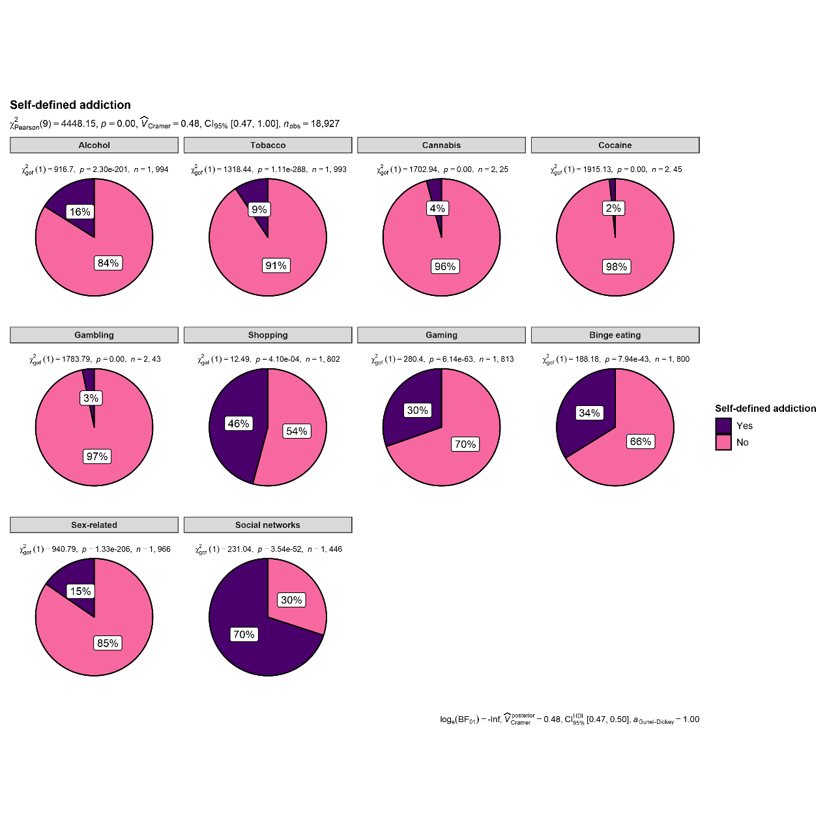

Figure 1. Rates of self-reported addictive behaviors among Israeli youth during the COVID-19 pandemic.

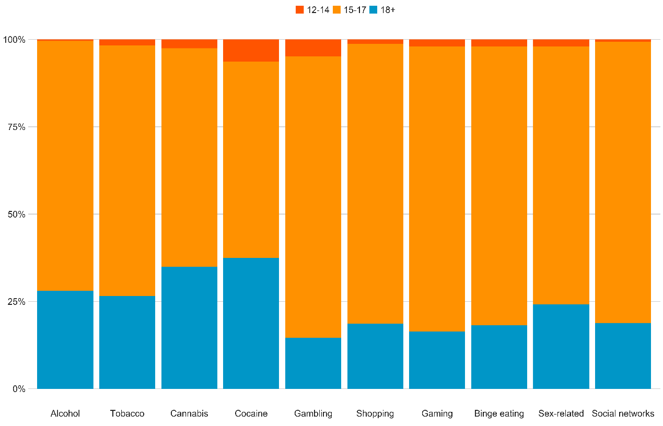

Figure 2. Differences in the rates of self-reported addictive behaviors by age groups (values are calculated as % out of those who identified themselves as addicts in each domain).

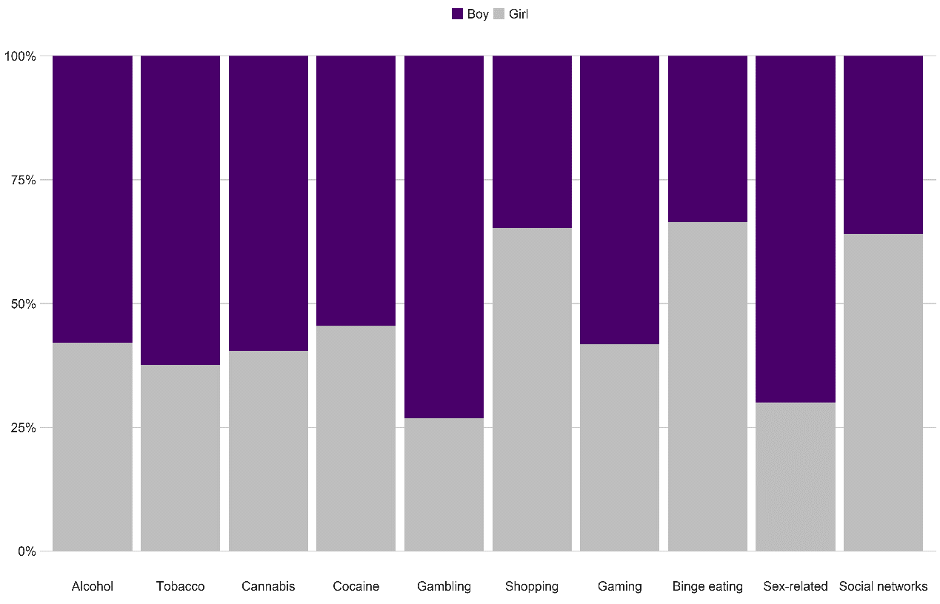

Figure 3. Differences in the rates of self-reported addictive behaviors by biological sex (values are calculated as % out of those who identified themselves as addicts in each domain).

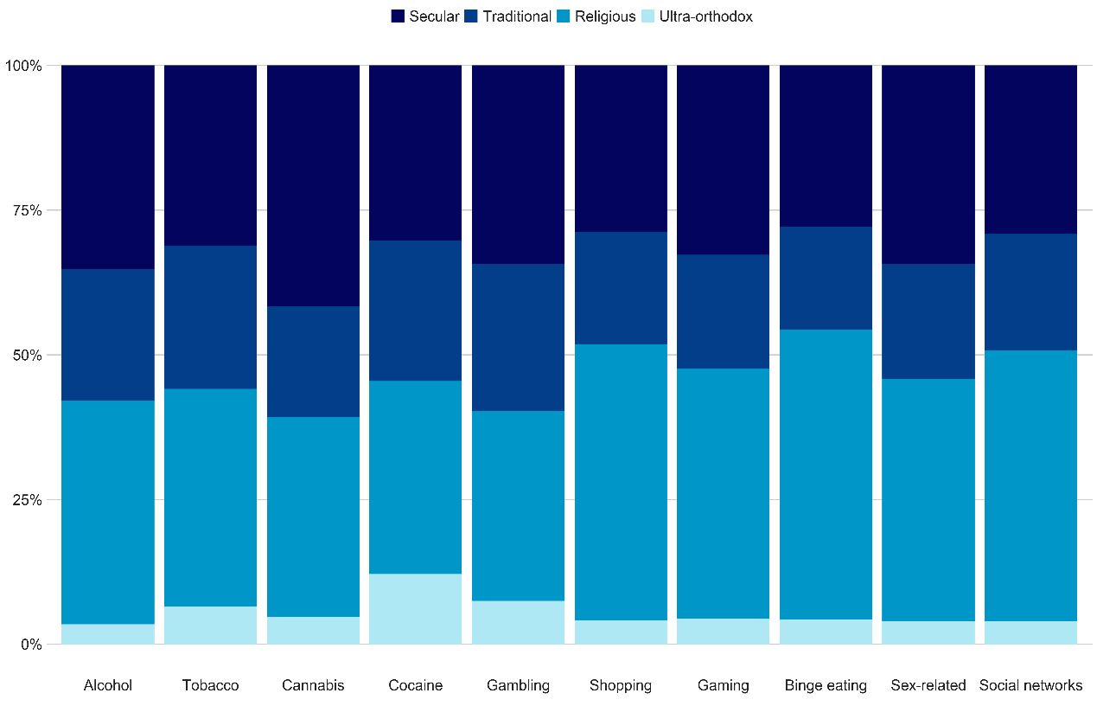

Figure 4. Differences in the rates of self-reported addictive behaviors by religiosity (values are calculated as % out of those who identified themselves as addicts in each domain).

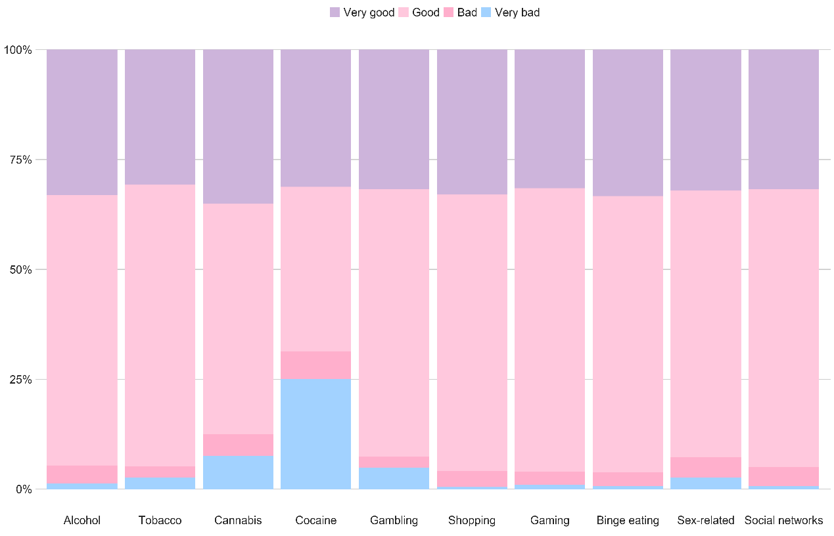

Figure 5. Differences in the rates of self-reported addictive behaviors by SES (values are calculated as % out of those who identified themselves as addicts in each domain).

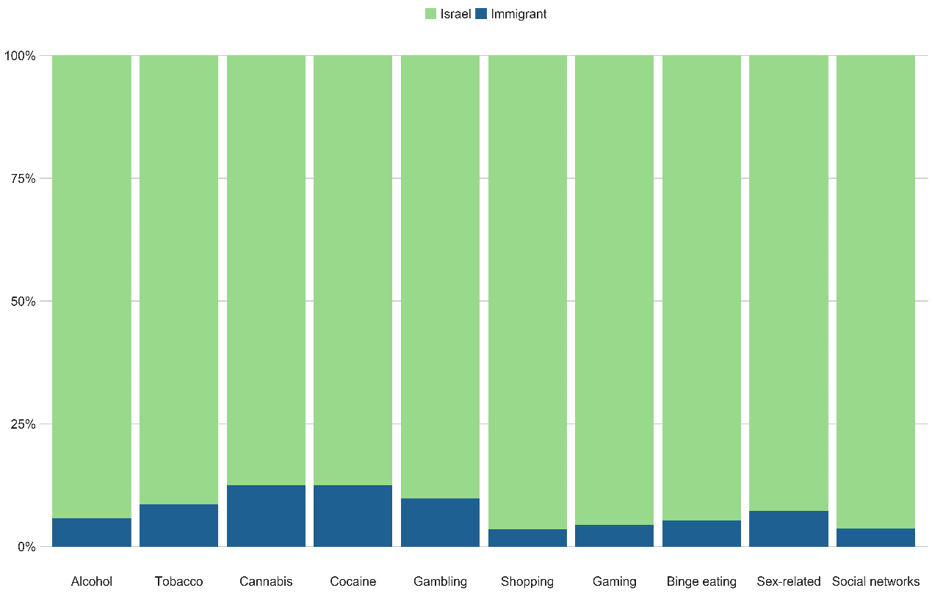

Figure 6. Differences in the rates of self-reported addictive behaviors by immigration (values are calculated as % out of those who identified themselves as addicts in each domain).

Table 1

Rates of self-reported addictive behaviors among Israeli youth as a function of age groups

|  |  |  |  |  |  |  |  |  |
| --- | --- | --- | --- | --- | --- | --- | --- | --- |
|  | 18+ | | 15-17 | | | 12-14 | | |
|  | *n* | *% (95% CI)* | *n* | *% (95% CI)* | *OR (95% CI)* | *n* | *% (95% CI)* | *OR (95% CI)* |
| Alcohol | 84 | 0.25 (.20, .30) | 234 | 0.14 (.13, .16) | 0.51 (.39, .68) *** | 1 | 0.04 (.00, .19) | 0.13 (.00, .80) * |
| Tobacco | 53 | 0.16 (.12, .20) | 130 | 0.08 (.07, .09) | 0.46 (.32, .66) *** | 2 | 0.08 (.02, .26) | 0.48 (.05, 2.06) |
| Cannabis | 21 | 0.06 (.04, .09) | 60 | 0.04 (.03, .05) | 0.58 (.34, 1.03) | 2 | 0.08 (.02, .26) | 1.41 (.15, 6.40) |
| Cocaine | 9 | 0.03 (.01, .05) | 20 | 0.01 (.01, .02) | 0.47 (.20, 1.18) | 3 | 0.12 (.03, .30) | 5.18 (.84, 22.81) |
| Gambling | 13 | 0.04 (.02, .06) | 51 | 0.03 (.02, .04) | 0.82 (.43, 1.67) | 2 | 0.08 (.02, .26) | 2.36 (.24, 11.47) |
| Shopping | 141 | 0.44 (.39, .50) | 673 | 0.46 (.44, .49) | 1.07 (.83, 1.38) | 10 | 0.45 (.26, .67) | 1.04 (.39, 2.71) |
| Gaming | 83 | 0.26 (.21, .31) | 455 | 0.31 (.29, .34) | 1.31 (.99, 1.74) | 10 | 0.43 (.23, .63) | 2.22 (.84, 5.71) |
| Binge eating | 111 | 0.35 (.30, .40) | 486 | 0.33 (.31, .36) | 0.94 (.72, 1.22) | 10 | 0.42 (.23, .63) | 1.33 (.51, 3.34) |
| Sex-related | 66 | 0.20 (.16, .24) | 232 | 0.14 (.13, .16) | 0.69 (.51, .95) * | 4 | 0.17 (.06, .37) | 0.82 (.20, 2.56) |
| Social networks | 171 | 0.66 (.60, .71) | 829 | 0.71 (.69, .74) | 1.30 (.96, 1.74) | 10 | 0.50 (.29, .71) | 0.52 (.19, 1.45) |

Note. 95% CI = 95% confidence intervals. OR = odds ratio. * *p* < .05, ** *p* < .01, *** *p* < .001. The 18+ group served as the reference group for the ORs.

Table 2

Rates of self-reported addictive behaviors among Israeli youth as a function of biological sex

|  |  |  |  |  |  |
| --- | --- | --- | --- | --- | --- |
|  | Males | | Females | |  |
|  | *n* | *% (95% CI)* | *n* | *% (95% CI)* | *OR (95% CI)* |
| Alcohol | 186 | 0.24 (.21, .27) | 135 | 0.11 (.09, .13) | 0.39 (.31, .51) *** |
| Tobacco | 116 | 0.15 (.13, .18) | 70 | 0.06 (.05, .07) | 0.34 (.25, .47) *** |
| Cannabis | 50 | 0.06 (.05, .08) | 34 | 0.03 (.02, .04) | 0.43 (.26, .68) *** |
| Cocaine | 18 | 0.02 (.01, .03) | 15 | 0.01 (.01, .02) | 0.53 (.25, 1.14) |
| Gambling | 49 | 0.06 (.05, .08) | 18 | 0.01 (.01, .02) | 0.23 (.12, .40) *** |
| Shopping | 287 | 0.39 (.36, .43) | 539 | 0.5 (.47, .53) | 1.59 (1.31, 1,93) *** |
| Gaming | 320 | 0.48 (.44, .52) | 230 | 0.20 (.18, .22) | 0.27 (.22, .33) *** |
| Binge eating | 204 | 0.28 (.25, .31) | 405 | 0.38 (.35, .41) | 1.59 (1.29, 1.96) *** |
| Sex-related | 212 | 0.28 (.25, .31) | 91 | 0.08 (.06, .09) | 0.21 (.16, .27) *** |
| Social networks | 364 | 0.59 (.55, .63) | 648 | 0.78 (.75, .80) | 2.37 (1.87, 3.00) *** |

Note. 95% CI = 95% confidence intervals. OR = odds ratio. * *p* < .05, ** *p* < .01, *** *p* < .001.

Table 3

Rates of self-reported addictive behaviors among Israeli youth as a function of religiosity

|  |  |  |  |  |  |  |  |  |  |  |  |
| --- | --- | --- | --- | --- | --- | --- | --- | --- | --- | --- | --- |
|  | Secular | | Traditional | | | Religious | | | Ultra-Orthodox | | |
|  | *n* | *% (95% CI)* | *n* | *% (95% CI)* | *OR (95% CI)* | *n* | *% (95% CI)* | *OR (95% CI)* | *n* | *% (95% CI)* | *OR (95% CI)* |
| Alcohol | 113 | 0.20 (.17, .24) | 73 | 0.20 (.16, .24) | 0.99 (.70, 1.39) | 124 | 0.13 (.11, .15) | 0.58 (.43, .78) *** | 11 | 0.12 (.06, .20) | 0.53 (0.25, 1.05) |
| Tobacco | 58 | 0.11 (.08, .13) | 46 | 0.12 (.9, .16) | 1.19 (.77, 1.83) | 70 | 0.07 (.06, .09) | 0.66 (.45, .96) * | 12 | 0.12 (.07, .20) | 1.19 (0.56, 2.37) |
| Cannabis | 35 | 0.06 (.04, .08) | 16 | 0.04 (.3, .7) | 0.67 (.34, 1.27) | 29 | 0.03 (.02, .04) | 0.47 (.27, .80) ** | 4 | 0.04 (.01, .10) | 0.68 (.17, 1.96) |
| Cocaine | 10 | 0.02 (.01, .03) | 8 | 0.02 (.01, .04) | 1.21 (.41, 3,43) | 11 | 0.01 (.01, .02) | 0.64 (0.25, 1.70) | 4 | 0.04 (.01, .10) | 2.47 (.55, 8.79) |
| Gambling | 23 | 0.04 (.03, .06) | 17 | 0.04 (.03, .07) | 1.13 (.56, 2.24) | 22 | 0.02 (.01, .03) | 0.55 (.29, 1.04) | 5 | 0.05 (.02, .12) | 1.33 (.38, 3.69) |
| Shopping | 238 | 0.48 (.44, .53) | 160 | 0.48 (.42, .53) | 0.98 (.73, 1.30) | 394 | 0.44 (.41, .48) | 0.86 (.68, 1.07) | 34 | 0.41 (.31, .52) | 0.75 (.45, 1.22) |
| Gaming | 180 | 0.36 (.32, .41) | 108 | 0.32 (.27, .38) | 0.84 (.62, 1.13) | 238 | 0.27 (.24, .30) | 0.63 (.50, .81) *** | 24 | 0.28 (.19, .38) | 0.67 (.38, 1.13) |
| Binge eating | 170 | 0.33 (.29, .37) | 108 | 0.34 (.29, .39) | 1.04 (.76, 1.41) | 305 | 0.35 (.32, .38) | 1.09 (.86, 1.39) | 26 | 0.31 (.21, .41) | 0.90 (.53, 1.51) |
| Sex-related | 104 | 0.19 (.16, .23) | 60 | 0.16 (.12, .20) | 0.81 (.56, 1.16) | 127 | 0.13 (.11, .15) | 0.64 (.48, .86) ** | 12 | 0.13 (.07, .22) | 0.66 (0.31, 1.27) |
| Social networks | 295 | 0.74 (.69, .78) | 204 | 0.75 (.69, .80) | 1.05 (.73, 1.52) | 473 | 0.68 (.65, .72) | 0.77 (0.58, 1.02) | 40 | 0.49 (.38, .61) | 0.35 (0.21, 0.58) *** |

Note. 95% CI = 95% confidence intervals. OR = odds ratio. * *p* < .05, ** *p* < .01, *** *p* < .001. The secular group served as the reference group for the ORs.

Table 4

Rates of self-reported addictive behaviors among Israeli youth as a function of SES

|  |  |  |  |  |  |  |  |  |  |  |  |
| --- | --- | --- | --- | --- | --- | --- | --- | --- | --- | --- | --- |
|  | Very good | | Good | | | Bad | | | Very bad | | |
|  | *n* | *% (95% CI)* | *n* | *% (95% CI)* | *OR (95% CI)* | *n* | *% (95% CI)* | *OR (95% CI)* | *n* | *% (95% CI)* | *OR (95% CI)* |
| Alcohol | 105 | 0.16 (.13, .19) | 195 | 0.16 (.14, .18) | 1.01 (.78, 1.33) | 16 | 0.22 (.13, .32) | 1.49 (.77, 2.75) | 4 | 0.57 (.23, .87) | 7.17 (1.19, 49.69) * |
| Tobacco | 53 | 0.08 (.06, .10) | 122 | 0.10 (.08, .12) | 1.28 (.90, 1.83) | 7 | 0.10 (.05, .19) | 1.30 (.48, 3.04) | 3 | 0.60 (.19, .92) | 17.36 (1.95, 211.73) ** |
| Cannabis | 28 | 0.04 (.03, .06) | 47 | 0.04 (.03, .05) | 0.92 (.56, 1.54) | 5 | 0.07 (.03, .15) | 1.68 (.49, 4.60) | 3 | 0.50 (.15, .85) | 23.12 (2.96, 180.71) ** |
| Cocaine | 11 | 0.02 (.01, .03) | 14 | 0.01 (.01, .02) | 0.69 (.29, 1.69) | 4 | 0.05 (.02, .12) | 3.32 (.75, 11.60) | 4 | 0.57 (.23, .87) | 78.72 (11.86, 593.10) *** |
| Gambling | 21 | 0.03 (.02, .05) | 40 | 0.03 (.02, .04) | 1.03 (.59, 1.86) | 2 | 0.03 (.00, .09) | 0.86 (.10, 3.62) | 4 | 0.67 (.27, .94) | 61.57 (8.31, 732.23) *** |
| Shopping | 267 | 0.44 (.40, .48) | 516 | 0.46 (.43, .49) | 1.09 (.98, 1.34) | 35 | 0.51 (.39, .62) | 1.30 (.77, 2.21) | 4 | 0.67 (.27, .94) | 2.53 (0.36, 28.15) |
| Gaming | 178 | 0.29 (.25, .32) | 346 | 0.31 (.28, .34) | 1.11 (.89, 1.39) | 19 | 0.29 (.19, .41) | 1.02 (.55, 1.84) | 6 | 1.00 (.59, 1.00) | Inf (2.87, Inf) |
| Binge eating | 191 | 0.31 (.27, .34) | 393 | 0.36 (.33, .39) | 1.26 (1.01, 1.56) * | 20 | 0.33 (.22, .47) | 1.14 (.61, 2.05) | 4 | 0.67 (.27, .94) | 4.53 (.64, .50.49) |
| Sex-related | 84 | 0.13 (.10, .15) | 199 | 0.16 (.14, .19) | 1.34 (1.01, 1.79) * | 16 | 0.23 (.14, .34) | 2.04 (1.04, 3.82) * | 4 | 0.67 (.27, .94) | 13.69 (1.93, 153.40) ** |
| Social networks | 315 | 0.65 (.60, .69) | 643 | 0.72 (.69, .75) | 1.44 (1.12, 1.83) ** | 44 | 0.77 (.64, .87) | 1.86 (.95, 3.87) | 6 | 0.86 (.45, .99) | 3.29 (0.39, 152.34) |

Note. 95% CI = 95% confidence intervals. OR = odds ratio. * *p* < .05, ** *p* < .01, *** *p* < .001. The ‘very good’ SES group served as the reference group for the ORs.

Table 5

Rates of self-reported addictive behaviors among Israeli youth as a function of immigration

|  |  |  |  |  |  |
| --- | --- | --- | --- | --- | --- |
|  | Israel | | Other | |  |
|  | *n* | *% (95% CI)* | *n* | *% (95% CI)* | *OR (95% CI)* |
| Alcohol | 300 | 0.16 (.14, .17) | 21 | 0.28 (.18, .39) | 2.05 (1.16, 3.51) ** |
| Tobacco | 171 | 0.09 (.08, .10) | 15 | 0.20 (.12, .30) | 2.50 (1.29, 4.58) ** |
| Cannabis | 74 | 0.04 (.03, .05) | 10 | 0.13 (.07, .23) | 3.89 (1.71, 8.01) *** |
| Cocaine | 29 | 0.01 (.01, .02) | 4 | 0.05 (.02, .13) | 3.70 (.92, 10.95) |
| Gambling | 59 | 0.03 (.02, .04) | 8 | 0.10 (.05, .19) | 3.68 (1.46, 8.14) ** |
| Shopping | 795 | 0.46 (.44, .48) | 30 | 0.43 (.31, .55) | 0.88 (.52, 1.46) |
| Gaming | 526 | 0.30 (.28, .32) | 22 | 0.34 (.23, .47) | 1.21 (.68, 2.10) |
| Binge eating | 576 | 0.33 (.31, .36) | 32 | 0.45 (.34, .57) | 1.64 (.98, 2.71) |
| Sex-related | 287 | 0.15 (.14, .17) | 16 | 0.22 (.13, .33) | 1.57 (.83, 2.81) |
| Social networks | 967 | 0.70 (.68, .72) | 42 | 0.67 (.54, .77) | 0.85 (.49, 1.53) |

Note. 95% CI = 95% confidence intervals. OR = odds ratio. * *p* < .05, ** *p* < .01, *** *p* < .001.

**References**

Acheampong, A. B., Lasopa, S., Striley, C. W., & Cottler, L. B. (2016). Gender differences in the association between religion/spirituality and simultaneous polysubstance use (SPU). *Journal of religion and health*, *55*(5), 1574-1584.‏

Andreas, J. B., Sivertsen, B., Lønning, K. J., & Skogen, J. C. (2021). Cannabis use among Norwegian university students: Gender differences, legalization support and use intentions, risk perceptions, and use disorder. *Addictive behaviors reports*, *13*, 100339.‏

Black, D. W., Monahan, P., Schlosser, S., & Repertinger, S. (2001). Compulsive buying severity: an analysis of compulsive buying scale results in 44 subjects. *The Journal of nervous and mental disease*, *189*(2), 123-126.‏

Blithikioti, C., Nuño, L., Paniello, B., Gual, A., & Miquel, L. (2021). Impact of COVID-19 lockdown on individuals under treatment for substance use disorders: Risk factors for adverse mental health outcomes. *Journal of psychiatric research*, *139*, 47-53.‏

Billieux, J., Schimmenti, A., Khazaal, Y., Maurage, P., & Heeren, A. (2015). Are we overpathologizing everyday life? A tenable blueprint for behavioral addiction research. *Journal of behavioral addictions*, *4*(3), 119-123.‏

Brand, M., Rumpf, H. J., Demetrovics, Z., MÜller, A., Stark, R., King, D. L., ... & Potenza, M. N. (2020). Which conditions should be considered as disorders in the International Classification of Diseases (ICD-11) designation of “other specified disorders due to addictive behaviors”?. *Journal of Behavioral Addictions*.‏

Brodeur, M., Audette-Chapdelaine, S., Savard, A. C., & Kairouz, S. (2021). Gambling and the COVID-19 pandemic: A scoping review. *Progress in Neuro-Psychopharmacology and Biological Psychiatry*, 110389.‏

Brumback, T., Thompson, W., Cummins, K., Brown, S., & Tapert, S. (2021). Psychosocial predictors of substance use in adolescents and young adults: longitudinal risk and protective factors. *Addictive behaviors*, *121*, 106985.‏

Calado, F., Alexandre, J., & Griffiths, M. D. (2017). Prevalence of adolescent problem gambling: A systematic review of recent research. *Journal of gambling studies*, *33*(2), 397-424.‏

Candan, H. D., & Küçük, L. (2019). Food addiction and associated factors among high school students in Turkey. *J Psychiatr Nurs*, *10*(1), 12-19.‏

Carliner, H., Brown, Q. L., Sarvet, A. L., & Hasin, D. S. (2017). Cannabis use, attitudes, and legal status in the US: A review. *Preventive medicine*, *104*, 13-23.‏

Center for Behavioral Health Statistics and Quality (2016). *2015 National Survey on drug*

*use and health: detailed tables*. Rockville, MD: S. A. a. M. H. S. Administration.

Central Bureau of Statistics, Jerusalem, Israel. (2020). *Statistical Abstract of Israel 2020*, no.71. https:// www. cbs.gov. il/ en/ publi catio ns/ Pages/ 2020/ Popul ation- Stati stical- Abstr act- of- Israel- 2020- No- 71. Aspx

Ciranka, S., & van den Bos, W. (2021). Adolescent risk-taking in the context of exploration and social influence. *Developmental Review*, *61*, 100979.‏

Cisneros, I. E., & Cunningham, K. A. (2021). Covid-19 interface with drug misuse and substance use disorders. *Neuropharmacology*, *198*, 108766.‏

Collins, S. E. (2016). Associations between socioeconomic factors and alcohol outcomes. *Alcohol research: current reviews*, *38*(1), 83.‏

Connery, H. S., & Devido, J. (2020). Spirituality/religion and substance use disorders. *Handbook of Spirituality, Religion, and Mental Health*, 119-138.‏

Davison, C., Smith, G. D., & Frankel, S. (1991). Lay epidemiology and the prevention paradox: the implications of coronary candidacy for health education. *Sociology of health & illness*, *13*(1), 1-19.‏

Deputy, N. P., Lowry, R., Clayton, H. B., Demissie, Z., Bohm, M. K., & Conklin, S. (2021). Initiation of nonmedical use of prescription opioids among high school students. *Substance Abuse*, 1-6.‏

Diala, C.C., Muntaner, C., Walrath, C., 2004. Gender, occupational, and socioeconomic

correlates of alcohol and drug abuse among U.S. rural, metropolitan, and urban

residents. Am. *J. Drug Alcohol Abuse 30* (2), 409–428.

Donati, M. A., Primi, C., Mazzarese, M., Sanson, F., & Leone, L. (2020). Immigrant status and problem-gambling severity in adolescents: Evidence for moderation by sensation seeking. *Addictive behaviors, 107*, 106395.‏

Döring, N. (2020). How is the COVID-19 pandemic affecting our sexualities? An overview of the current media narratives and research hypotheses. *Archives of sexual behavior*, *49*(8), 2765-2778.‏

Efrati, Y., & Dannon, P. (2018). Normative and clinical self-perceptions of sexuality and their links to psychopathology among adolescents. *Psychopathology*, *51*(6), 380-389.‏

Efrati, Y. (2019). God, I can’t stop thinking about sex! The rebound effect in unsuccessful suppression of sexual thoughts among religious adolescents. *The Journal of Sex Research*, *56*(2), 146-155.‏

Efrati, Y., Kolubinski, D. C., Marino, C., & Spada, M. M. (2021). Modelling the Contribution of Metacognitions, Impulsiveness, and Thought Suppression to Behavioural Addictions in Adolescents. *International Journal of Environmental Research and Public Health*, *18*(7), 3820.‏

Efrati, Y., & Amichai-Hamburger, Y. (2021). Adolescents who solely engage in online sexual experiences are at higher risk for compulsive sexual behavior. *Addictive behaviors*, *118*, 106874.‏

Faigin, C. A., Pargament, K. I., & Abu-Raiya, H. (2014). Spiritual struggles as a possible risk factor for addictive behaviors: An initial empirical investigation. *The International Journal for the Psychology of Religion*, *24*(3), 201-214.‏

Farré, J. M., Montejo, A. L., Agulló, M., Granero, R., Chiclana Actis, C., Villena, A., ... & Mestre-Bach, G. (2020). Pornography use in adolescents and its clinical implications. *Journal of Clinical Medicine*, *9*(11), 3625.‏

García Coll, C., Lamberty, G., Jenkins, R., McAdoo, H. P., Crnic, K., Wasik, B. H., et al. (1996). An integrative model for the study of developmental competencies in minority children. *Child Development, 67*, 1891–1914.

Gewirtz-Meydan, A., Mitchell, K., Shlomo, Y., Heller, O., & Grinstein-Weiss, M. (2021). COVID-19 among youth in Israel: Correlates of decisions to vaccinate and reasons for refusal. *Journal of Adolescent Health*.‏

Götz, M., Mendel, C., Lemish, D., Jennings, N., Hains, R., Abdul, F., Alper, M., Asgari, H., Babayaro, H., & Blaya, C. (2020). Children, COVID-19 and the media: A Study on the Challenges Children are Facing in the 2020 Coronavirus Crisis. *Televizion*, *33*(2020/E), 4-9.

Gómez-Galán, J., Martínez-López, J. Á., Lázaro-Pérez, C., & Sarasola Sánchez-Serrano, J. L. (2020). Social networks consumption and addiction in college students during the COVID-19 pandemic: Educational approach to responsible use. *Sustainability*, *12*(18), 7737.‏

Grim, B. J., & Grim, M. E. (2019). Belief, behavior, and belonging: How faith is indispensable in preventing and recovering from substance abuse. *Journal of religion and health*, *58*(5), 1713-1750.‏

Grubbs, J. B., Perry, S., Kraus, S. W., & Grant, J. T. (2021). Porndemic? A longitudinal study of pornography use before and during the COVID-19 pandemic in a nationally representative sample of Americans.‏

Grubbs, J. B., & Grant, J. T. (2020). Spirituality/religion and behavioral addictions. In *Handbook of Spirituality, Religion, and Mental Health* (pp. 139-157). Academic Press.‏

Grubbs, J. B., Kraus, S. W., Perry, S. L., Lewczuk, K., & Gola, M. (2020). Moral incongruence and compulsive sexual behavior: Results from cross-sectional interactions and parallel growth curve analyses. *Journal of Abnormal Psychology*, *129*(3), 266.‏

Grubbs, J. B., Kraus, S. W., & Perry, S. L. (2019). Self-reported addiction to pornography in a nationally representative sample: The roles of use habits, religiousness, and moral incongruence. *Journal of Behavioral Addictions*, *8*(1), 88-93.‏

Hodgins, D. C., Wilson, K. E., & Schluter, M. G. (2022). Validation and Performance of the Brief Screener for Substance and Behavioural Addiction (SSBA) Amongst University Students. *International Journal of Mental Health and Addiction*, 1-19.‏

Islam, M. S., Sujan, M. S. H., Tasnim, R., Ferdous, M. Z., Masud, J. H. B., Kundu, S., ... & Griffiths, M. D. (2020). Problematic internet use among young and adult population in Bangladesh: Correlates with lifestyle and online activities during the COVID-19 pandemic. *Addictive behaviors reports*, *12*, 100311.‏

Jameel, S., Shahnawaz, M. G., & Griffiths, M. D. (2019). Smartphone addiction in students: A qualitative examination of the components model of addiction using face-to-face interviews. *Journal of behavioral addictions*, *8*(4), 780-793.‏

Jordan, C. J., & Andersen, S. L. (2017). Sensitive periods of substance abuse: Early risk for the transition to dependence. *Developmental cognitive neuroscience*, *25*, 29-44.‏

Kar, P., Tomfohr-Madsen, L., Giesbrecht, G., Bagshawe, M., & Lebel, C. (2021). Alcohol and substance use in pregnancy during the COVID-19 pandemic. *Drug and Alcohol Dependence*, 108760.‏

Karriker-Jaffe, K. J. (2013). Neighborhood socioeconomic status and substance use by US adults. *Drug and alcohol dependence*, *133*(1), 212-221.‏

Király, O., Potenza, M. N., Stein, D. J., King, D. L., Hodgins, D. C., Saunders, J. B., ... & Demetrovics, Z. (2020). Preventing problematic internet use during the COVID-19 pandemic: Consensus guidance. *Comprehensive psychiatry*, *100*, 152180.‏

Koch, J., Frommeyer, B., & Schewe, G. (2020). Online shopping motives during the COVID-19 pandemic—lessons from the crisis. *Sustainability*, *12*(24), 10247.‏

Kowalewska, E., Gola, M., Kraus, S. W., & Lew-Starowicz, M. (2020). Spotlight on compulsive sexual behavior disorder: a systematic review of research on women. *Neuropsychiatric Disease and Treatment*, *16*, 2025.‏

Lehmiller, J. J., Garcia, J. R., Gesselman, A. N., & Mark, K. P. (2021). Less sex, but more sexual diversity: Changes in sexual behavior during the COVID-19 coronavirus pandemic. *Leisure Sciences*, *43*(1-2), 295-304.‏

Levy, I., Cohen-Louck, K., & Bonny-Noach, H. (2021). Gender, employment, and continuous pandemic as predictors of alcohol and drug consumption during the COVID-19. *Drug and Alcohol Dependence*, *228*, 109029.‏

Lewczuk, K., Glica, A., Nowakowska, I., Gola, M., & Grubbs, J. B. (2020). Evaluating pornography problems due to moral incongruence model. *The journal of sexual medicine*, *17*(2), 300-311.‏

Lewczuk, K., Nowakowska, I., Lewandowska, K., Potenza, M. N., & Gola, M. (2021). Frequency of use, moral incongruence and religiosity and their relationships with self‐perceived addiction to pornography, internet use, social networking and online gaming. *Addiction*, *116*(4), 889-899.‏

Li, X., Vanderloo, L. M., Keown-Stoneman, C. D., Cost, K. T., Charach, A., Maguire, J. L., ... & Birken, C. S. (2021). Screen use and mental health symptoms in Canadian children and youth during the CoViD-19 pandemic. *JAMA network open*, *4*(12), e2140875-e2140875.‏

López-Cabarcos, M. Á., Ribeiro-Soriano, D., & Piñeiro-Chousa, J. (2020). All that glitters is not gold. The rise of gaming in the COVID-19 pandemic. *Journal of Innovation & Knowledge*, *5*(4), 289-296.‏

Luo, C., Chen, A., Cui, B., & Liao, W. (2021). Exploring public perceptions of the COVID-19 vaccine online from a cultural perspective: Semantic network analysis of two social media platforms in the United States and China. *Telematics and Informatics*, *65*, 101712.‏

Mallet, J., Dubertret, C., & Le Strat, Y. (2021). Addictions in the COVID-19 era: Current evidence, future perspectives a comprehensive review. *Progress in Neuro-Psychopharmacology and Biological Psychiatry*, *106*, 110070.‏

Maraz, A., Griffiths, M. D., & Demetrovics, Z. (2016). The prevalence of compulsive buying: a meta‐analysis. *Addiction*, *111*(3), 408-419.‏

McHugh, R. K., Votaw, V. R., Sugarman, D. E., & Greenfield, S. F. (2018). Sex and gender differences in substance use disorders. *Clinical psychology review*, *66*, 12-23.‏

Melchior, M., Moffitt, T.E., Milne, B.J., Poulton, R., Caspi, A., 2007. Why do children

from socioeconomically disadvantaged families suffer from poor health when they

reach adulthood? A life-course study. *Am. J. Epidemiol. 166* (8), 966–974

Mihara, S., & Higuchi, S. (2017). Cross‐sectional and longitudinal epidemiological studies of Internet gaming disorder: A systematic review of the literature. *Psychiatry and clinical neurosciences*, *71*(7), 425-444.‏

Miller, L., Davies, M., & Greenwald, S. (2000). Religiosity and substance use and abuse among adolescents in the National Comorbidity Survey. *Journal of the American Academy of Child & Adolescent Psychiatry*, *39*(9), 1190-1197.‏

Montiel, I., Ortega-Barón, J., Basterra-González, A., González-Cabrera, J., & Machimbarrena, J. M. (2021). Problematic online gambling among adolescents: A systematic review about prevalence and related measurement issues. *Journal of behavioral addictions*, *10*(3), 566-586.‏

Moon, J., Choe, Y., & Song, H. (2021). Determinants of consumers’ online/offline shopping behaviours during the COVID-19 pandemic. *International journal of environmental research and public health*, *18*(4), 1593.‏

Nguyen, T., & Buxton, J. A. (2021). Pathways between COVID-19 public health responses and increasing overdose risks: a rapid review and conceptual framework. *International Journal of Drug Policy*, 103236.‏

Nowak, M., Papiernik, M., Mikulska, A., & Czarkowska-Paczek, B. (2018). Smoking, alcohol consumption, and illicit substances use among adolescents in Poland. *Substance abuse treatment, prevention, and policy*, *13*(1), 1-8.‏

Ophir, Y., Rosenberg, H., Efrati, Y., Tikochinski, R., (under review). Mothers’ Perceptions of Children’s Screen Use During the COVID-19 Lockdown in Israel.

Oka, T., Hamamura, T., Miyake, Y., Kobayashi, N., Honjo, M., Kawato, M., ... & Chiba, T. (2021). Prevalence and risk factors of internet gaming disorder and problematic internet use before and during the COVID-19 pandemic: A large online survey of Japanese adults. *medRxiv*.‏

Peter, J., & Valkenburg, P. M. (2016). Adolescents and pornography: A review of 20 years of research. *The Journal of Sex Research*, *53*(4-5), 509-531.‏

Petruzelka, B., Vacek, J., Gavurova, B., Kubak, M., Gabrhelik, R., Rogalewicz, V., & Bartak, M. (2020). Interaction of socioeconomic status with risky internet use, gambling and substance use in adolescents from a structurally disadvantaged region in Central Europe. *International journal of environmental research and public health*, *17*(13), 4803.‏

Peris, M., de la Barrera, U., Schoeps, K., & Montoya-Castilla, I. (2020). Psychological risk factors that predict social networking and internet addiction in adolescents. *International journal of environmental research and public health*, *17*(12), 4598.‏

Pew Research Center. (2016). Israel’s Religiously Divided Society. https:// www. pewfo rum. org/ 2016/ 03/ 08/ israe lsreligiously- divid ed- socie ty/

Rioux, C., Castellanos-Ryan, N., Parent, S., Vitaro, F., Tremblay, R. E., & Séguin, J. R. (2018). Age of cannabis use onset and adult drug abuse symptoms: A prospective study of common risk factors and indirect effects. *The Canadian Journal of Psychiatry*, *63*(7), 457-464.‏

Roche, K. M., White, R., Rivera, M. I., Safa, M. D., Newman, D., & Falusi, O. (2021). Recent immigration actions and news and the adjustment of US Latino/a adolescents. *Cultural Diversity and Ethnic Minority Psychology*, *27*(3), 447.‏

Rodrigue, C., Gearhardt, A. N., & Begin, C. (2019). Food Addiction in Adolescents: Exploration of psychological symptoms and executive functioning difficulties in a non-clinical sample. *Appetite*, *141*, 104303.‏

Rosenberg, H., Blondheim, M., & Katz, E. (2019). It’s the text, stupid! Mobile phones, religious communities, and the silent threat of text messages. *New Media & Society*, *21*(11-12), 2325-2346.‏

Ronzitti, S., Lutri, V., Smith, N., Clerici, M., & Bowden-Jones, H. (2016). Gender differences in treatment-seeking British pathological gamblers. *Journal of behavioral addictions*, *5*(2), 231-238.‏

Sallie, S. N., Ritou, V. J., Bowden-Jones, H., & Voon, V. (2021). Assessing online gaming and pornography consumption patterns during COVID-19 isolation using an online survey: Highlighting distinct avenues of problematic internet behavior. *Addictive Behaviors*, *123*, 107044.‏

Scholes-Balog, K. E., Hemphill, S. A., Evans-Whipp, T. J., Toumbourou, J. W., & Patton, G. C. (2016). Developmental trajectories of adolescent cannabis use and their relationship to young adult social and behavioural adjustment: A longitudinal study of Australian youth. *Addictive behaviors*, *53*, 11-18.‏

Schulte, E. M., Kral, T. V., & Allison, K. C. (2022). A cross-sectional examination of reported changes to weight, eating, and activity behaviors during the COVID-19 pandemic among United States adults with food addiction. *Appetite*, *168*, 105740.‏

Schulte, M. T., Ramo, D., & Brown, S. A. (2009). Gender differences in factors influencing alcohol use and drinking progression among adolescents. *Clinical psychology review*, *29*(6), 535-547.‏

Schluter, M. G., Hodgins, D. C., Wolfe, J., & Wild, T. C. (2018). Can one simple questionnaire assess substance‐related and behavioural addiction problems? Results of a proposed new screener for community epidemiology. *Addiction*, *113*(8), 1528-1537.‏

Schluter, M. G., Hodgins, D. C., Konkolÿ Thege, B., & Wild, T. C. (2020). Predictive utility of the brief Screener for Substance and Behavioral Addictions for identifying self-attributed problems. *Journal of Behavioral Addictions*, *9*(3), 709-722.‏

Schmidt, S. C. E., Anedda, B., Burchartz, A., Eichsteller, A., Kolb, S., Nigg, C., Niessner, C., Oriwol, D., Worth, A., & Woll, A. (2020). Physical activity and screen time of children and adolescents before and during the COVID-19 lockdown in Germany: a natural experiment. *Scientific Reports*, *10*(1), 1-12.

Slavova, S., Rock, P., Bush, H. M., Quesinberry, D., & Walsh, S. L. (2020). Signal of increased opioid overdose during COVID-19 from emergency medical services data. *Drug and alcohol dependence*, *214*, 108176.‏

Stein, G. L., Gonzales, R. G., García Coll, C., & Prandoni, J. I. (2016). Latinos in rural, new immigrant destinations: A modification of the integrative model of child development. In L. J. Crockett & G. Carlo (Eds.), *Rural ethnic minority youth and families in the United States* (pp. 37–56). Dordrecht, the Netherlands: Springer International Publishing.

Trott, M., Johnstone, J., Pardhan, S., Barnett, Y., & Smith, L. (2021). Changes in body dysmorphic disorder, eating disorder, and exercise addiction symptomology during the COVID-19 pandemic: A longitudinal study of 319 health club users. *Psychiatry Research*, *298*, 113831.‏

Van Rooij, A. J., Kuss, D. J., Griffiths, M. D., Shorter, G. W., Schoenmakers, T. M., & Van De Mheen, D. (2014). The (co-) occurrence of problematic video gaming, substance use, and psychosocial problems in adolescents. *Journal of behavioral addictions*, *3*(3), 157-165.‏

Walsh, S. D., Sela, T., De Looze, M., Craig, W., Cosma, A., Harel-Fisch, Y., ... & Pickett, W. (2020). Clusters of contemporary risk and their relationship to mental well-being among 15-year-old adolescents across 37 countries. *Journal of Adolescent Health*, *66*(6), S40-S49.‏

Wardle, H., Degenhardt, L., Ceschia, A., & Saxena, S. (2021). The Lancet Public Health Commission on gambling. *The Lancet Public Health*, *6*(1), e2-e3.‏

Wellman, R. J., Sylvestre, M. P., O’Loughlin, E. K., Dutczak, H., Montreuil, A., Datta, G. D., & O’Loughlin, J. (2018). Socioeconomic status is associated with the prevalence and co-occurrence of risk factors for cigarette smoking initiation during adolescence. *International journal of public health*, *63*(1), 125-136.‏

Wild, T. C., Hodgins, D., Konkolÿ Thege, B., Wolfe, J., Patten, S., Colman, I., ... & Schopflocher, D. (2015). *Measuring addictions and mental Health problems in Alberta*. Technical report of phase II activities. Retrieved from Edmonton.‏

Yang, H., & Ma, J. (2021). How the COVID-19 pandemic impacts tobacco addiction: Changes in smoking behavior and associations with well-being. *Addictive Behaviors*, *119*, 106917.‏

Zou, Z., Wang, H., Uquillas, F. D. O., Wang, X., Ding, J., & Chen, H. (2017). Definition of substance and non-substance addiction. *Substance and Non-substance Addiction*, 21-41.‏