**Sponsoring the project**

**A donation of $200,000 will enable TZOHAR to help 590 children of immigrants**

A donation of $200,000 will enable TZOHAR, together with its partner organizations (ITIM and Giyur Ka’Halacha) to convert 400 children to Judaism during the month of August and to introduce their families to a warm and welcoming conversion process. The Conversion Summer Camps, run in collaboration with TZOHAR, introduce the children to Jewish content, enabling them to quickly integrate into the conversion process. The program offers the children, who would otherwise would be wandering the streets unoccupied, subsidized activity during the summer months. It also introduces the children’s parents to a conversion solution, maximizing the conversion process, and expanding it to additional circles.

**In recognition of this generous donation, TZOHAR will include the donor's name on all printed materials pertaining to TZOHAR's Conversion Summer Camps Project and on the Tzohar website. Personalized reports on the progress of the project will be provided to the donor periodically.**

**why? - the need - Summer Camps in Cooperation with tZOHAR**

In Israel, there are approximately 500,000 immigrants from the former Soviet Union who are not considered Jewish according to Halacha (Jewish religious law); consequently, each year, some 5,000 children are born who are not halakhically Jewish.

This is a social ticking time bomb, an assimilationist threat, likely to strike a severe blow to the State of Israel.

Former Chief of the Mossad, Ephraim Halevy, has defined this danger as the largest existential threat to the State of Israel since Iran.

Giyur Ka’Halacha is a project established two years ago by a group of Rabbis, headed by Rabbi Nachum Rabinowitz, Rabbi David Stav, Rabbi Riskin, among others. TZOHAR has partnered with the ITIM Organization and Ohr Torah Stone, in an effort to centralize and fund the activity of Giyur Ka’Halacha.

During the past two years, there has been great trepidation among Former Soviet Union immigrants in Israel regarding the conversion process; most are apprehensive about entering into the conversion process.

Despite many attempts to publicize the process through the various media, only 250 children participate in the conversion process each year—much less than the expected 1000.

Consequently, the TZOHAR Organization reached the conclusion that in order to persuade Israel’s Russian population to join the conversion process, different and more creative steps were needed.

It was decided to use more sophisticated methods to reach the target population. In order to allay apprehension and doubts and to make the process more inviting and welcoming, the idea of running a conversion activity as part of summer camps was suggested.

**TZOHAR’s Conversion Summer Camps are the Solution**

A pilot was conducted during the past Passover vacation. Two camps that introduced Jewish concepts were run for children from FSU communities. The importance of the camp and its groundbreaking activity was a session with the parents during the course of the camp and at its end, which emphasized the importance of conversion.

The results were impressive; after these two camps were held, an additional sixty children entered the conversion process. In light of these results, we realized that this is the right formula, in two respects:

1. We succeeded in imparting Jewish values to these children.
2. Practically speaking, we succeeded in forming a relationship of trust with the parents; and consequently, we were able to convert their children.

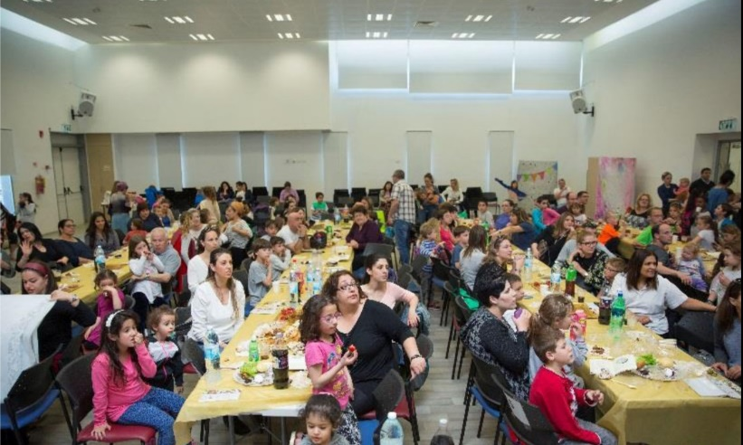

**Photo from the Passover pilot camp**

**Expanding the Pilot to a Summer Camp Program**

Beyond the acute need to expedite the conversion process for members of the FSU community, these families also require activities for their children during the lengthy summer vacation. Consequently, the Conversion Summer Camp Project not only solves the burning issue of conversion in Israeli society, but also provides the right solution for parents of disadvantaged families, busy supporting their families, and unable to stay at home with their children during the summer vacation—a solution which will prevent their children from wandering aimlessly on the streets. In order to provide a solution for both problems simultaneously, the Conversion Summer Camp Project was established for disadvantaged Russian families.

The subsidized summer camps will operate this summer in four areas – at two community centers in Lod and two community centers in Ashdod. They will be run during August of 2017—a period in which no other organized summer camps are available. Following the summer camps, we will continue the conversion process with the children’s families. The responsible organizations will meet with all of the parents of the children who attended the camp and continue the conversion process started during the camp. A few months after the end of the summer camp, the families will be summoned by the Rabbinical Court to complete the process.

In summary, this is a significant and highly important program with great potential to enlist conversion candidates following the summer programs.

**how- program description**

The program at the community centers will feature the following activities –

1. Social activity and outdoor games
2. A number of content-based and creative activities on the subject of summer and the upcoming holidays in the month of *Tishrei*.
3. Arts and crafts activities for the upcoming holidays of *Tishrei*, while introducing the customs related to these holidays, introducing the shofar, baking a honey cake, etc.
4. A musical activity that focuses on the subject of blowing the shofar.

The activity will be held daily from 8:00 to 17:00 and will include a morning snack, hot lunch and afternoon fruit. A special activity will be planned for the parents and children in the evening which will feature a simulation of the *Selichot* prayer service.

Field trips are also scheduled during the summer camp (4-6 hours each) such as an educational visit to Neot Kedumim, a nature hike in Nachal Ktalav, a trip to the Safari and a visit to the Etgarim Adventure Park.

**personal story**

During the Passover camp, one of the mothers was introduced to the Conversion Camp activity. Although her daughter did not even attend the camp, both mother and daughter came to the Giyur Ka’Halacha Rabbinical Court (sponsored by ITIM, TZOHAR and partners) this week, for the purpose of the conversion. From our standpoint, this is a success story that exceeds our greatest expectations, since the mother and daughter didn’t even participate in the camp and were introduced to the staff and the camp’s tolerant and pleasant process, in a very indirect manner. Consequently, the impact is much more extensive than anticipated and with wide circles of influence.