**Sponsoring the project**

**A donation of $200,000 will enable TZOHAR to help 590 children of immigrants**

A donation of $200,000 will enable TZOHAR, together with its partner organizations (ITIIM and Giyur Ka’Halacha) to convert some 400 children during the month of August and to introduce their families to a welcoming conversion process. The Conversion Summer Camps, run in collaboration with TZOHAR, introduce the children to Jewish content and enable them to quickly integrate into the conversion process. The program offers the children a subsidized activity for the summer months in which these children are likely to wander the streets aimlessly with nothing to occupy them; and it also introduces the children’s parents to a conversion solution, thereby maximizing the conversion process, expanding it to additional circles.

**In recognition of this generous donation, TZOHAR will include the donor's name on all printed materials pertaining to TZOHAR's Conversion Summer Camps Project and on the Tzohar website. Personalized reports on the progress of the project will be provided to the donor periodically.**

**why? - the need - Summer Camps in Cooperation with tZOHAR**

There are about 500,000 people who are not considered Jewish according to Halacha (Jewish religious law) living in the State of Israel; consequently, each year, some 5,000 children are born who are not Jewish.

This is a social ticking time bomb that is likely to strike a severe blow of assimilation to the State of Israel.

Former Chief of the Mossad, Ephraim Halevy defined this danger as the largest existential danger to the State of Israel since the Iranian threat.

Giyur Ka’Halacha is a project established two years ago by a group of Rabbis, headed by Rabbi Nachum Rabinowitz, Rabbi David Stav, Rabbi Riskin, among others. TZOHAR has partnered with the ITIM Organization and Ohr Torah Stone, in an effort to centralize and fund the activity of Giyur Ka’Halacha.

During the past two years, there has been great trepidation among the population of the Former Soviet Union regarding the conversion process. Most of the immigrants from the FSU are apprehensive about entering into the conversion process.

Following many attempts to publicize the process through the various media, only 250 children participated in the conversion process each year. The forecast was to reach 1,000 or more children.

Consequently, the TZOHAR Organization reached the conclusion that in order to persuade the Russian population to join the conversion process, we must take different and more creative steps that will offer a solution to the Russian population.

As a result, a decision was made to use more sophisticated methods in order to reach the target population; and while removing the apprehension and doubts and making the process more inviting and welcoming, the idea of running a conversion activity as part of summer camps was suggested.

**TZOHAR’s Conversion Summer Camps are the Solution**

A pilot was conducted during the Passover vacation. Two camps that introduced Jewish concepts were run for children from the FSU communities. The importance of the camp and its groundbreaking activity was a session with the parents during the course of the camp and at the end, which highlighted the subject of conversion.

The results were amazing, after these two camps were held, an additional sixty children entered into the conversion process. In light of these results, we realized that this is the right formula, from two aspects:

1. From a fundamental aspect, we succeeded in imparting Jewish values to these children.
2. From a practical aspect, we succeeded in forming a relationship of trust with the parents; and consequently, we were able to convert their children.

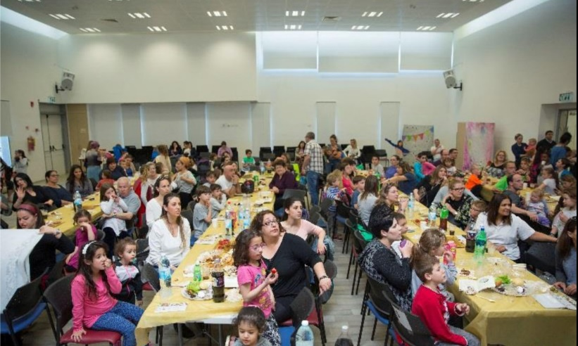

**Photo from the Passover pilot camp**

**Expanding the Pilot to a Summer Camp Program**

Beyond the acute need to expedite the conversion process for members of the FSU community, there is also a need among these families for a solution for their children during the lengthy school vacation. Consequently, the Conversion Summer Camp Project not only solves the burning issue of conversion in Israeli society, but also provides the right solution for parents of disadvantaged families, busy supporting their families; this solution will help them prevent their children from wandering aimlessly on the streets. In order to provide a solution to both these problems simultaneously, the Conversion Summer Camp Project was established for disadvantaged Russian families.

The subsidized summer camps will operate this summer in four areas – at two community centers in Lod and two community centers in Ashdod. They will be run during the period in which no organized summer camps are available; i.e. during August of 2017. Following the summer camps, we will continue the conversion process with the children’s families. The responsible organizations will meet with all of the parents of the children who attended the camp and continue the conversion process that had started. A few months after the end of the summer camp, the families will be summoned by the Rabbinical Court to complete the conversion process.

In summary, this is a significant and highly important program with a very strong potential for enlisting conversion candidates following the summer programs.

**how- program description**

The program at the community centers will feature various activities –

1. Social activity and outdoor games
2. A number of content-based and creative activities on the subject of summer and the upcoming holidays in the month of *Tishrei*.
3. Arts and crafts activities for the upcoming holidays of *Tishrei*, while introducing the customs related to these holidays, introducing the shofar, baking a honey cake, etc.
4. A musical activity that focuses on the subject of blowing the shofar.

The activity will be held daily from 8:00 to 17:00 and will include a morning snack, hot lunch and afternoon fruit. A special activity will be planned for the parents and children’s evening, which will feature a simulation of the *Selichot* prayer service.

Field trips are also scheduled during the summer camp (4-6 hours each) such as an educational visit to Neot Kedumim, a nature hike in Nachal Ktalav, a trip to the Safari and a visit to the Etgarim Adventure Park.

**personal story**

During the Passover camp, one of the mothers was introduced to the Conversion Camp activity. Although her daughter did not even attend the camp, both came to the Giyur Ka’Halacha Rabbinical Court (sponsored by ITIM, TZOHAR and partners) this week, for the purpose of the conversion of both mother and daughter. From our standpoint, this is a success story that exceeds our expectations, since the mother and daughter didn’t even participate in the camp and had just been introduced to the staff and the camp’s tolerant and pleasant process, in a very indirect manner. Consequently, the impact is much more extensive than anticipated and the circles of influence are very extensive.