Variable | Anderson-Darling test for normality | Ti |  |  | Zr
 |  | N | Mean  (SD) | P-value  M-W | N | Mean  (SD)
Torque | AD = 1.369 p<0.005 | 21 | 23 (7.029) | 0.0483* | 21 | 29.905 (11.458)
ISQ | AD = 1.431 p<0.005 | 21 | 62.095 (10.611) | 0.0296* | 21 | 69.429 (6.630)
Micromov X | AD = 5.339 p<0.005 | 20 | 93.5 (112.426) | 0.3867 | 20 | 94.450 (152.761)
Pearson correlation coefficient ISQ - micromov. |  | 20 | -0.673 |  |  | -0.007

Table 1: Descriptive statistics (mean and SD) of the dependent variables analyzed (insertion torque, resonance frequency analysis, and micromovement) and statistical significance of the differences between independent variables (titanium and zirconia) * Statistically significant (α=0.05; P<0.05).
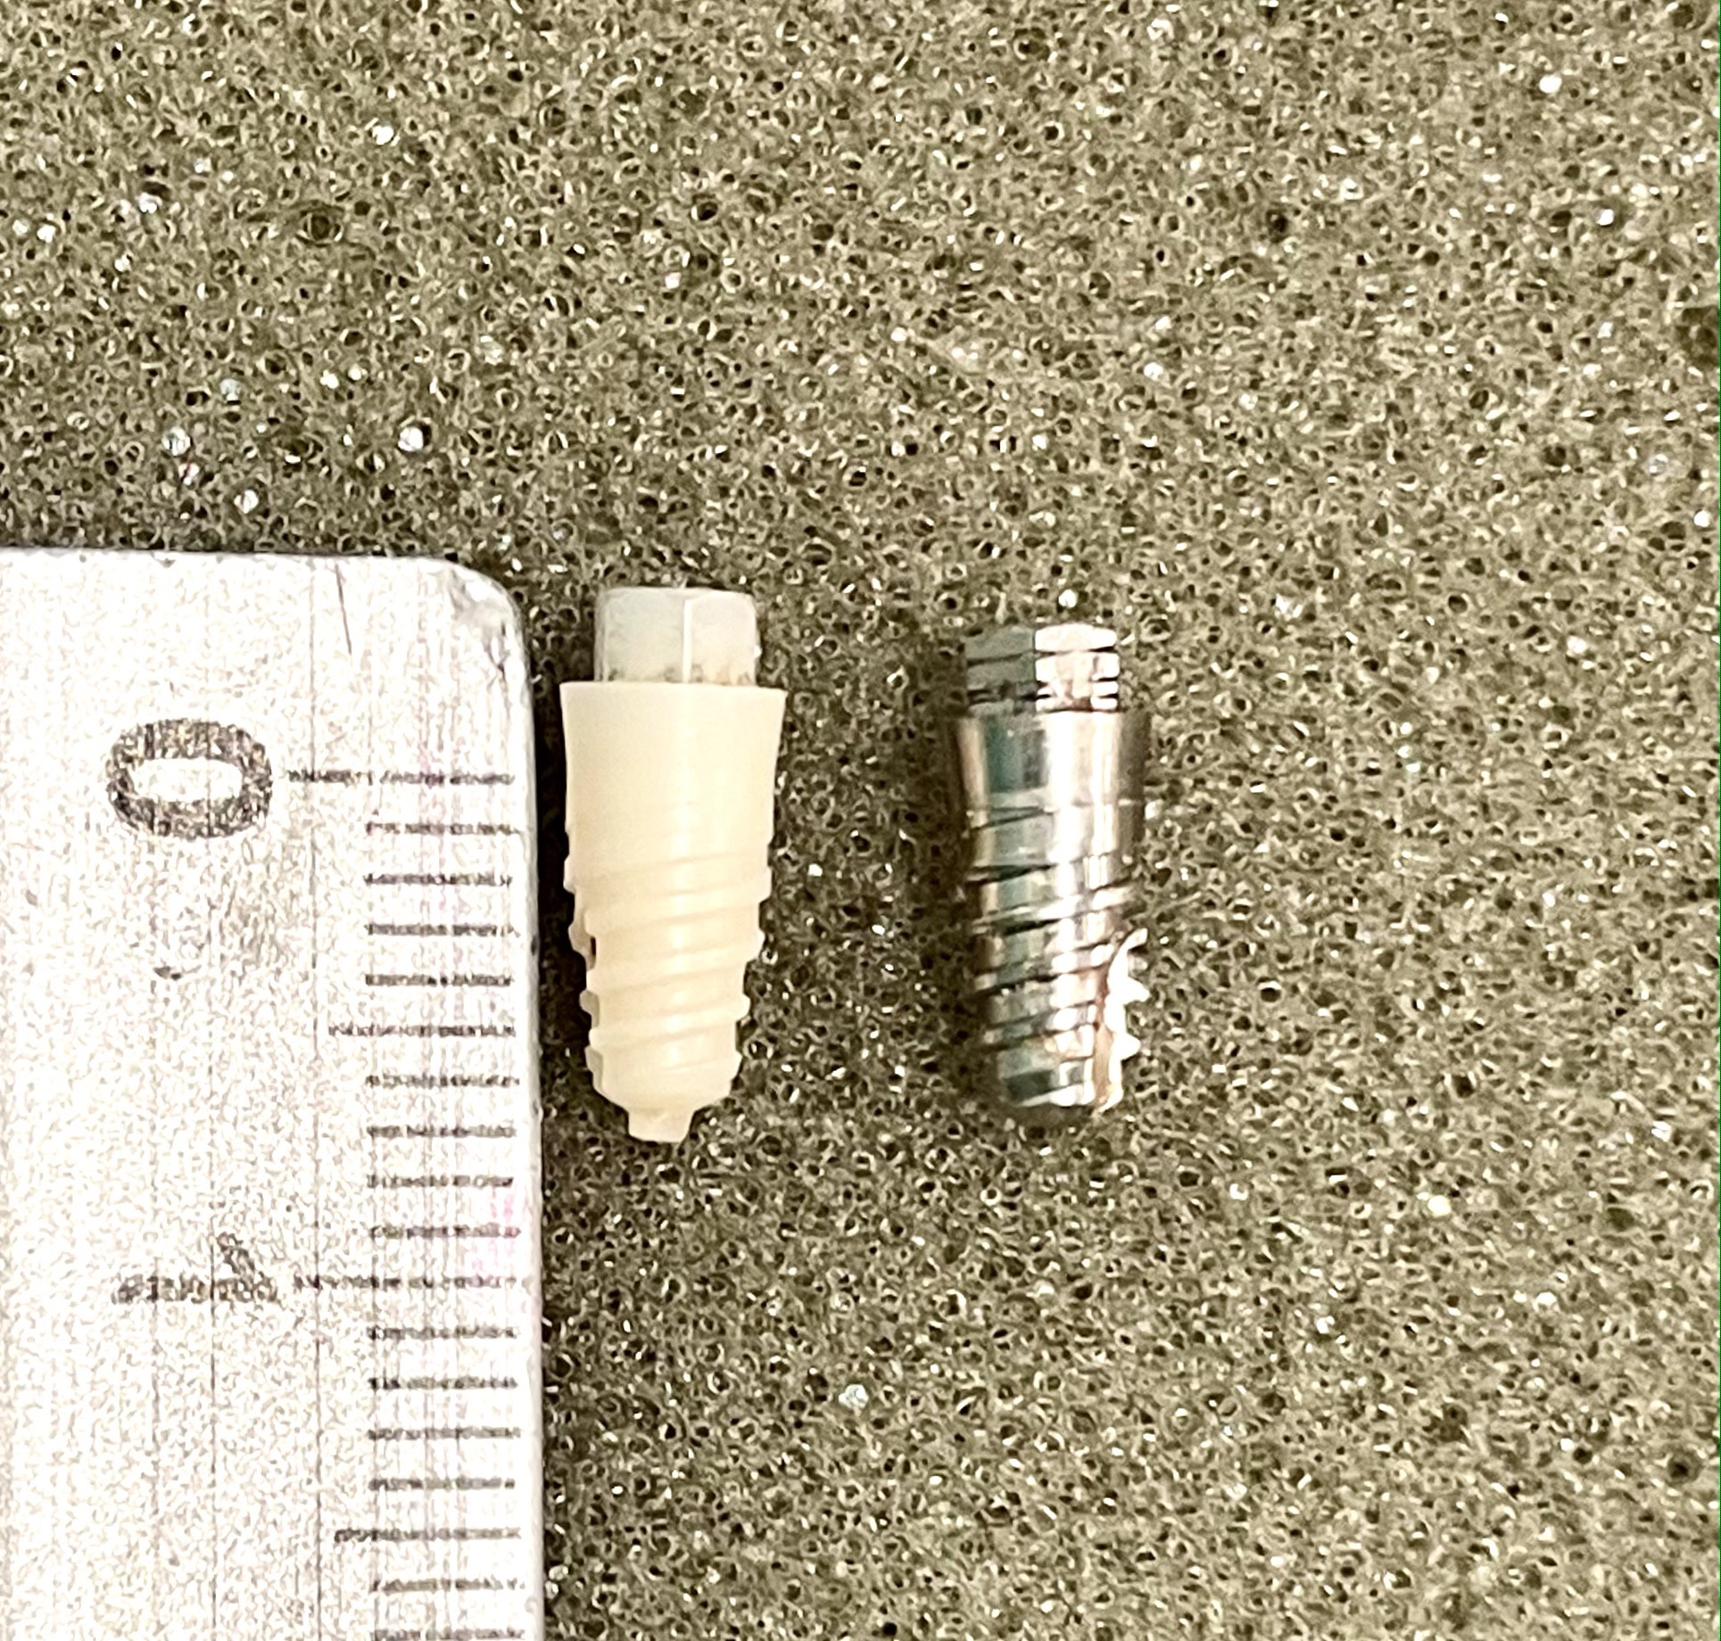
Fig. 1. Klockner External Hex SK2 implants, Zr and Ti, both with 3.8*8 buffed surface (Soadco S.L., Escaldes Engordany, Andorra)

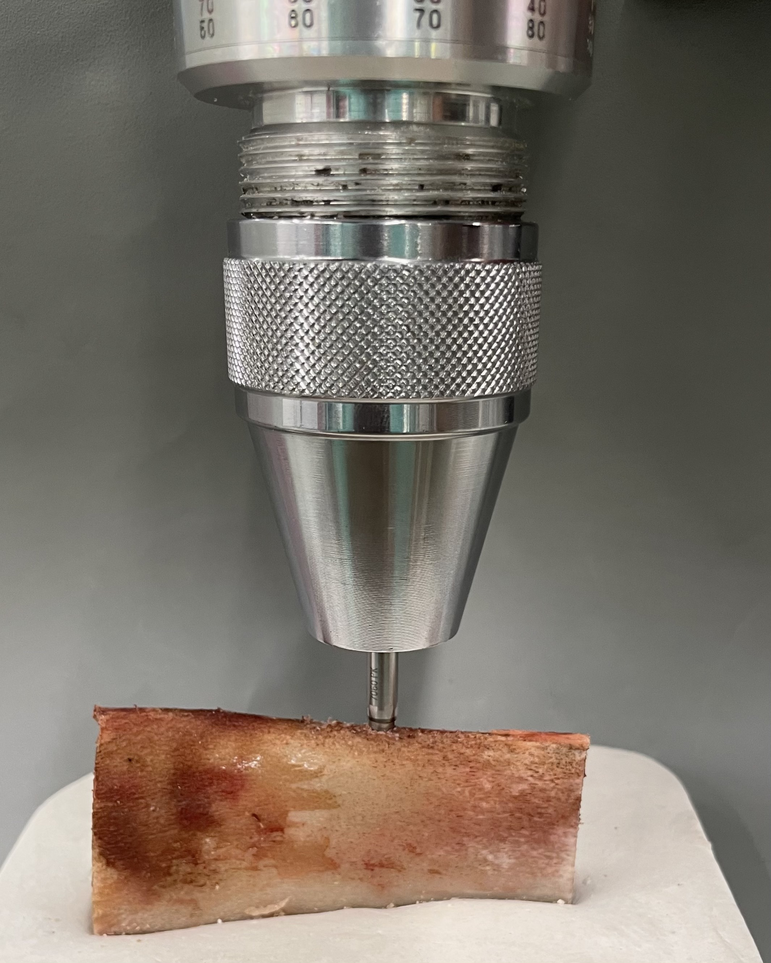
Fig. 2. Placement of the implant, in the surgically shaped bone bed, using a calibrated torque meter, to record the insertion torque in Ncm.

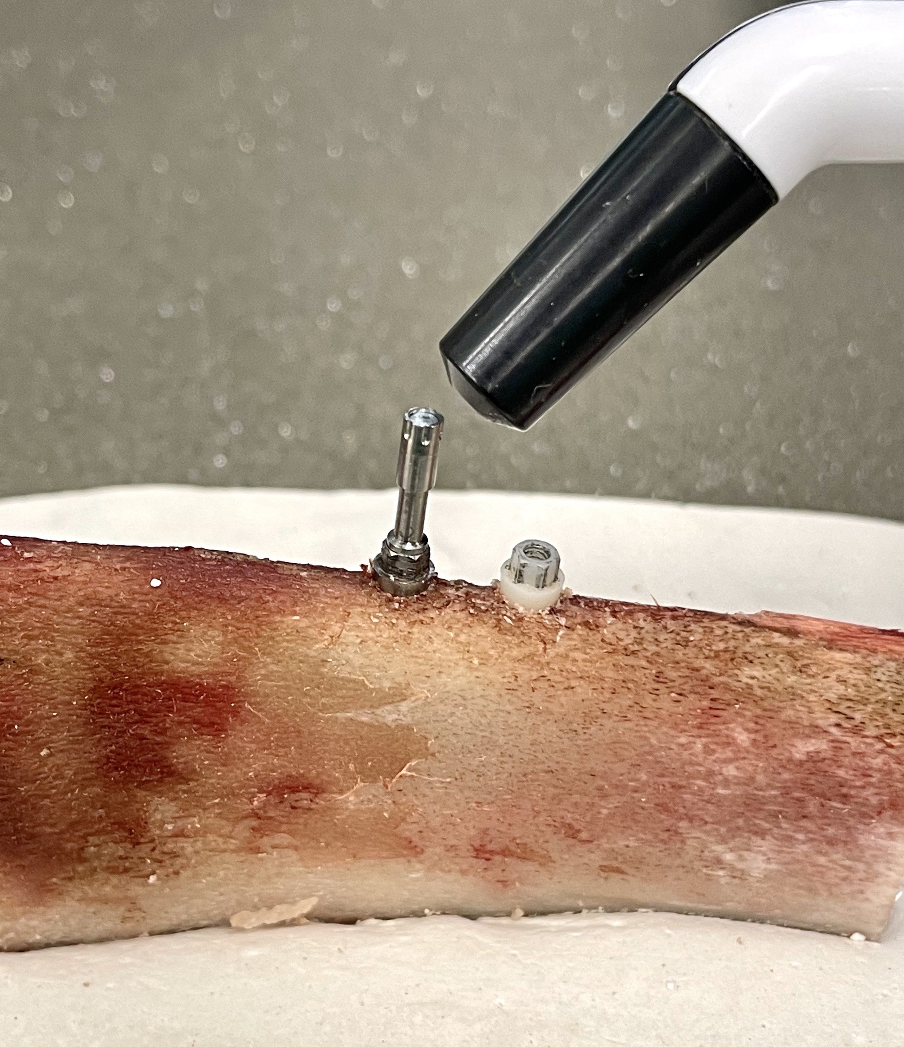

Fig. 3. Measurement of implant stability by resonance frequency analysis using a Penguin and its Multipeg transducer screwed to the zirconia implant, expressed in ISQ values. On the left, the titanium implant placed in the same rib can be seen.

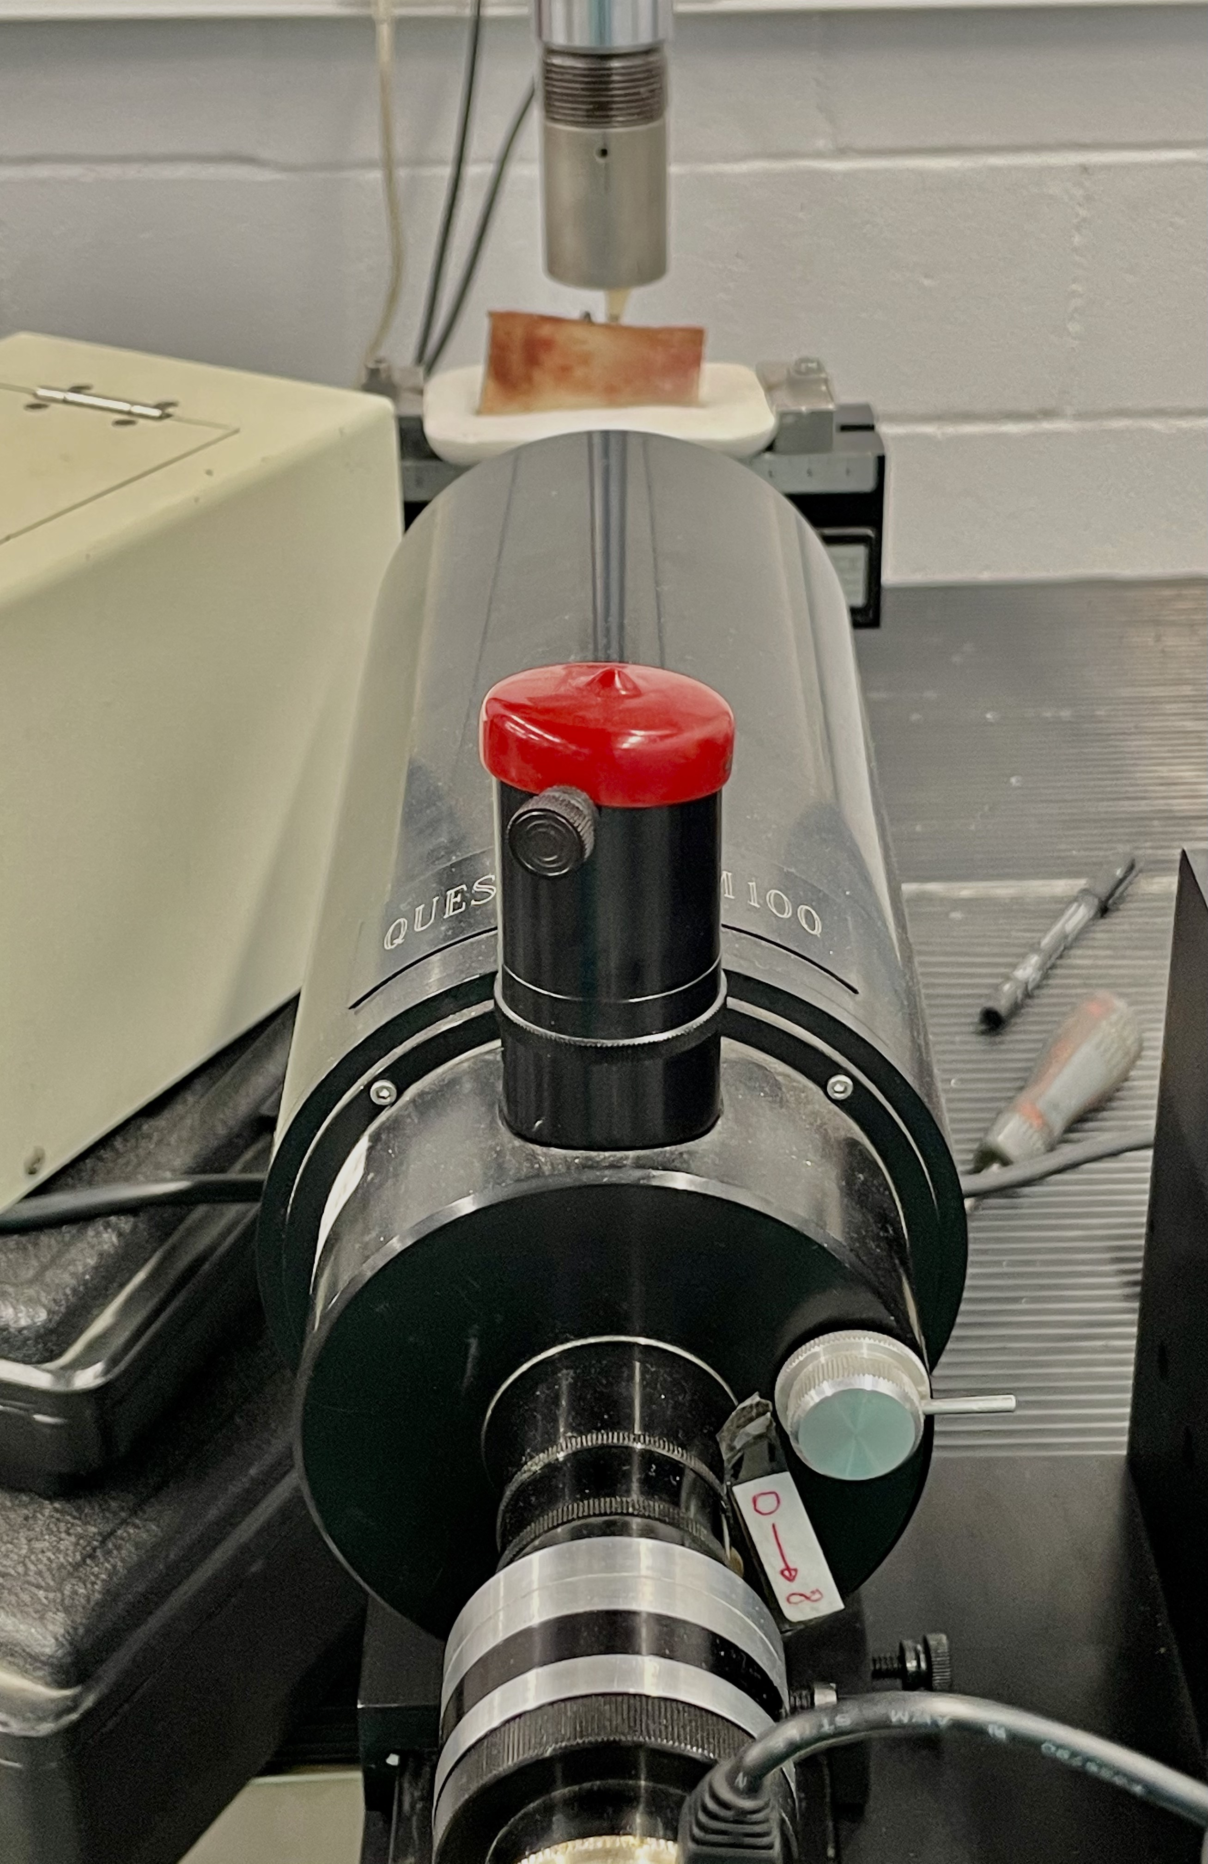
Fig. 4. Questar QM-100 long-distance microscope focused on one of the implants in the sample. In the background you can see a rib mounted on its plaster base and mechanized on the base of the load creep machine.

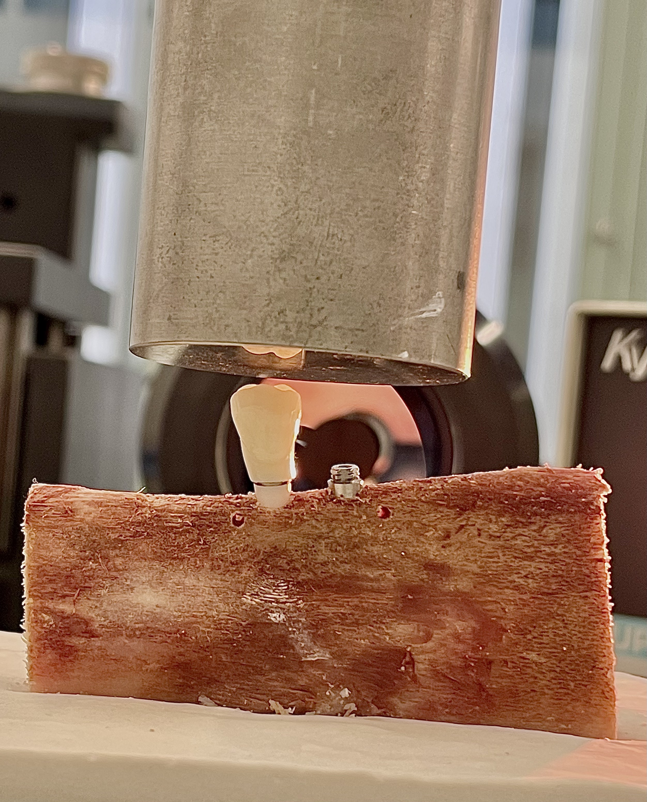

Fig. 5. Machining the external connection of the zirconia implant of a PMMA prosthetic crown, designed in the shape of a premolar, and mounting on the MTS Bionix 358 creep machine. In the background you can see the lens of the Questar QM-100 long-distance microscope.

.

Fig. 6. Detail of the microscopic analysis of the micromovement test. The figure on the left is the moment prior to loading (F=01), and the second during application of the 50 N load (F=1). In both images, the “a” indicates the reference mark added to the abutment and the red arrows indicate the transition area between the prosthetic abutment and the smooth collar of the implant.

