QUESTION 1 OF 280
DLBROTD01_E_Offen_leicht_F1/Lektion 01
What does the acronym CAD mean? Give two benefits of using CAD.

Computer aided drafting OR computer aided design (both are correct) (3 points)
Benefits of using CAD include time savings, cost savings, precision of work, ease in correcting, ease in redesign, share-ability of work among others in different locations. Any two will receive (3 points)

QUESTION 2 OF 280
DLBROTD01_E_Offen_leicht_F1/Lektion 01

Name two entities or situations when shop drawings are supplied by others.

When drawings are needed from specialty trades (3 points) or for prefabricated components (3 points)

QUESTION 3 OF 280
DLBROTD01_E_Offen_mittel_F1/Lektion 01


List two main drawing categories. Name a drawing type within each category. Then sketch an example and label it, identifying it as one of your specific types you identified within the category.

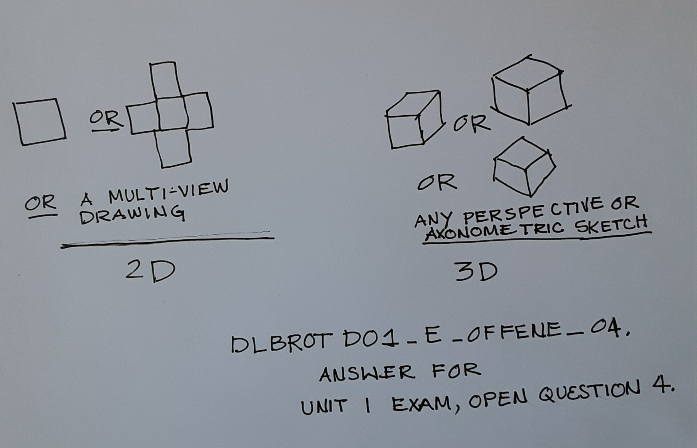
2-D, drawing types are orthographic, or multi-view drawings (2 points) and 3-D, drawing types are axonometric, or isometric, or perspective drawings (2points)

For correctly drawing and identifying the drawing, 2 points each for a total of 8 points possible.

QUESTION 4 OF 280
DLBROTD01_E_Offen_mittel_F1/Lektion 01

Name three types of triangles used by drafters. Give an example of the use of a 30-60 triangle in an axonometric drawing, naming the specific type of drawing. Explain the reason.

45⁰, 30⁰-60⁰, adjustable (3 points) The 30⁰-60⁰ degree or adjustable triangle is used to create sometric drawings (2 points) because the angles on both sides are 30⁰ from the baseline of the verticle axis. (3 points)

QUESTION 5 OF 280
DLBROTD01_E_Offen_leicht_F1/Lektion 01

Compare and contrast manual sketching and computer drafting giving three scenarios to explain the benefit of using sketches.

Idea or concept development - sketches are a way to quickly explore many ideas and sketching helps open the brain using both right and left sides whereas computer drafting relies mostly on left brain . (2 pts) In client meetings, sketching can be done by anyone, ideas quickly generated and shared. Clients may not be able to use co mputer drafting and therefore be excluded from expressing their ideas visually with computer graphics. (2 pts) Late in the design process, or even in the field, with changes that need to be made, the engineer can sketch a change to give to the drafter. If the engineer had to use the computer; it would take longer and fees would be charged for engineer time, so costs are saved by having the drafter make the change form the engineer sketch. (2 pts) Any similar sound reasoning citing benefits of manual sketching over computer drafting will earn 2 pts even if not identical to those shown. Total 6 points possible.

QUESTION 6 OF 280
DLBROTD01_E_Offen_leicht_F1/Lektion 01

Give three uses for technical drawing.

2 pts for any three of the following for 6 points total possible:
part of creative process, communicate ideas, analyze and solve problems, optimize design processes, serve as documentation for contracting and construction or fabrication, and most importantly, convey the intent of the designer

QUESTION 7 OF 280
DLBROTD01_E_Offen_leicht_F1/Lektion 01

Cite three strengths of sketching or manual drafting.

2 pts for any three of the following for a total of 6 points possible:
quick, enhance thought process or creativity, easily understood communication, off the grid back- up, better understanding of construction methods and design processes, personally rewarding.

QUESTION 8 OF 280
DLBROTD01_E_Offen_mittel_F1/Lektion 01

List three characteristics or benefits of isometric drawings, and give an example scenario explaining the reason to use isometric drawing.

Any three of the following will gain 2 pts each for a total of 6 points: 1. scaleable in all three axis 2. dimensionable in all three axis 3. easy to understand or "read" by most people 4. requires less space on a sheet than multi-view or orthographic drawings 5. based on 30⁰ angles from horizontal baseline is easy to draw with a 30/60 triangle. 6. saves time and costs 2 pts for scenario example with reasoning of one or more, such as SAVE SPACE on drawing sheet, SAVE TIME drafting ; SAVE COSTS drafting for BETTER UNDERSTANDING of design. Total 8 points possible.

QUESTION 9 OF 280
DLBROTD01_E_Offen_mittel_F1/Lektion 01

Describe four elements or practices of an ergonomically designed workspace.

2 pts each for any four of the following for a total of 8 points possible:
- good lighting
- adjustable chair, drawing table, or furniture
- good posture
- stretch breaks
- visual breaks allowing eyes to focus on larger and distant objects
- comfortable ambiance or temperature
- proper nutrition, hydration, or sleep habits.

QUESTION 10 OF 280
DLBROTD01_E_Offen_mittel_F1/Lektion 01

When deciding on which paper size and format, what are four things to consider?

2 pts each for any four of the following not to exceed a total of 8 points: Where the project is being built or manufactured; location of where it will be plotted; where product is designed; company or firm standards; jurisdictional or agency requirements, whether ISO or ANSI/ASME is used, country of origin or final production.

QUESTION 11 OF 280
DLBROTD01_E_Offen_mittel_F1/Lektion 01

The overall size of a drawing sheet and plan set depend upon several things. List four.

Scale of drawing, Number of drawings needed, space needed for dimenstioning, if notes are used, space available after border and title block are laid out, if BOM will be included. Any receive 2 pts each for a total of 8 points possible.

QUESTION 12 OF 280
DLBROTD01_E_Offen_schwer_F1/Lektion 01

Identify the meaning of FEA and explain its use.

FEA is finite element analysis (2 pots) used in 3-D modeling (2 pts) It is built-in the software for analysis (2 pts) With each reiteration of a model, another FEA may be used to optimize the design features. (2 pts) The final FEA leads to design deliverables which may produce an actual 3-D projduct or technical drawings. (2 pts)
A total of 10 points is possible.

QUESTION 13 OF 280
DLBROTD01_E_Offen_schwer_F1/Lektion 01

Sketch a sheet format layout for general use and identify 5 key areas of the title block required by ISO.

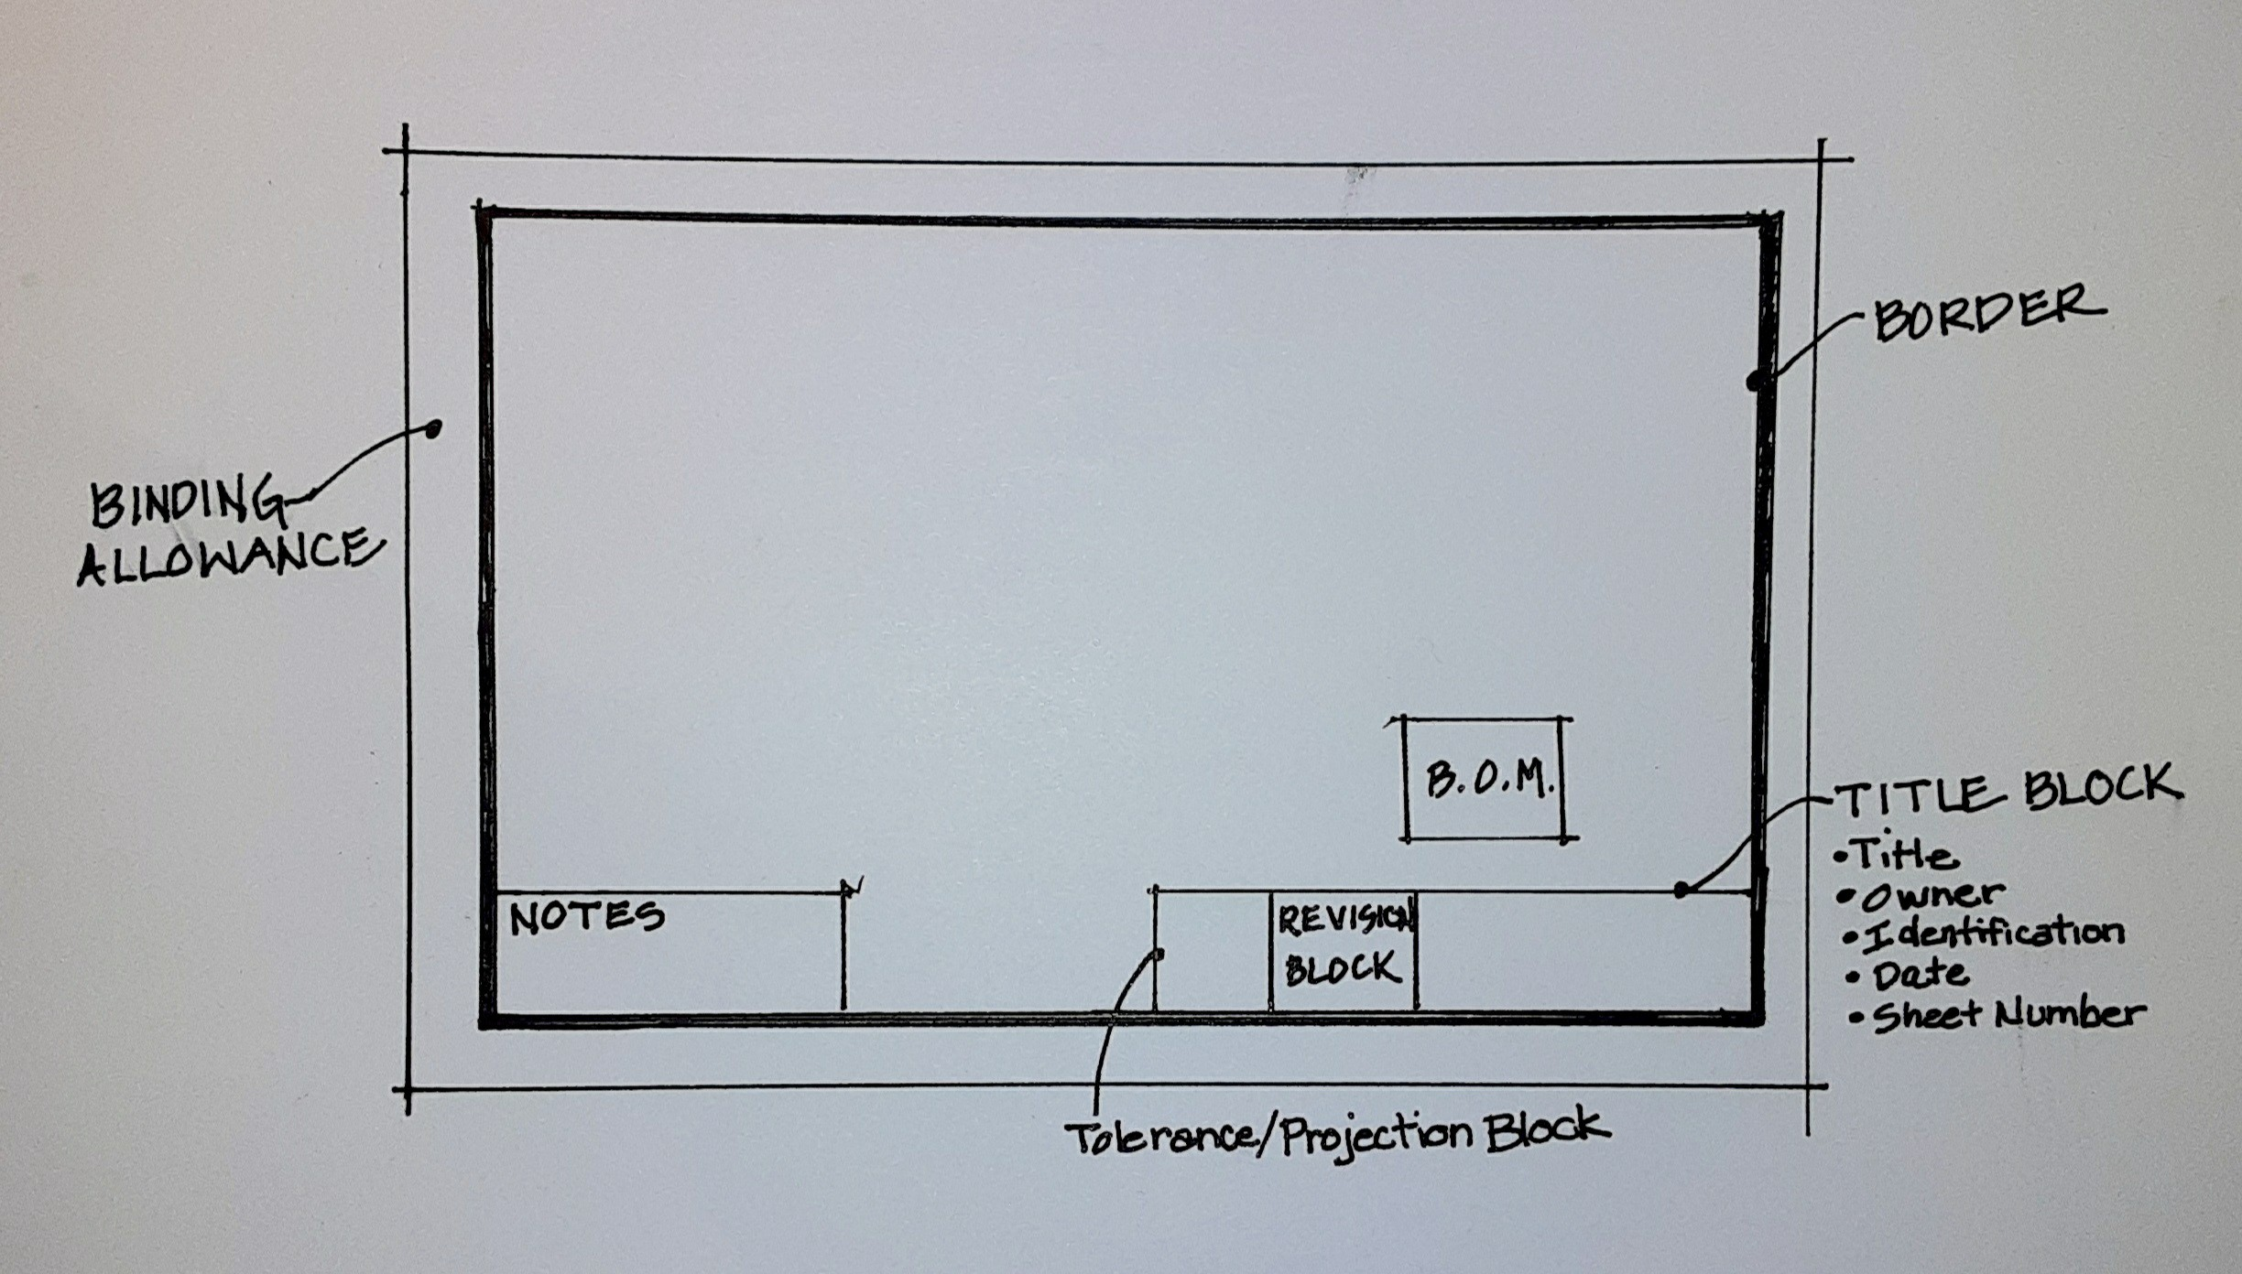
SKETCH MUST INCLUDE: Border (2 pts), Title Block with title, owner, identification or contact info, (1 pt)date of issue (1 pt), sheet number (1 points) and additional points for Revision Block (2 pts) Tolerance/Projection Block (1 pt), Notes (1 pt), Binding Area (1 pt) BOM (1 pt) Total of 10 points possible

QUESTION 14 OF 280
DLBROTD01_E_Offen_schwer_F1/Lektion 01

Discuss the use of 2-D and 3-D drawings, giving an example of when both might be used together.

Visualizing both 2-D and 3-D drawings for the same object helps the technical drafter to choose which is the best to use for a project. The type of drawing used needs to clearly identify parts and simplify processes and assemblies. The simplest and clearest drawings need to be chosen. A 3-D view provides quicker understanding of the item and may reduce the number of drawings needed. Saving drafting time and space on the sheet is a goal of the technical drafter. Both because time is money and also for clarity. At times, 2-D multi-view provide the information needed for dimensioning and is preferred even if it takes more time and drawing space. ( 2 pts for each of any 4 of the above ideas) If a 3-D view is desired, but has hidden features, then both the 3-D view and 2-D drawings may be used to show all features. (2 pts) A total of 10 points is possible.

QUESTION 15 OF 280
DLBROTD01_E_Offen_mittel_F1/Lektion 02

Name two axonometric drawings that are equally scaled on three axis. Draw an example of one and label it.

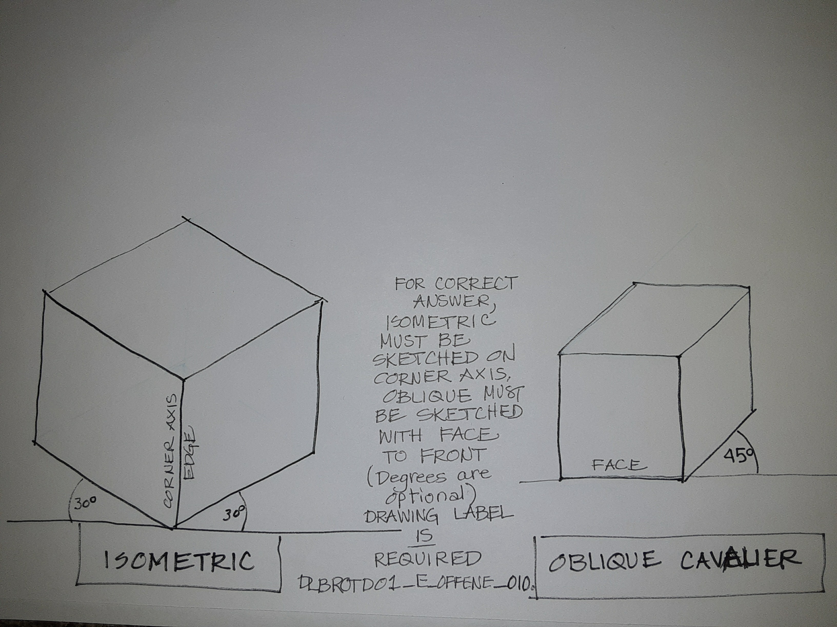
Isometric and oblique cavalier (3 points each) For correct drawing (2 points)

QUESTION 16 OF 280
DLBROTD01_E_Offen_schwer_F1/Lektion 02

Name four parts of a circle and identify on a sketch.

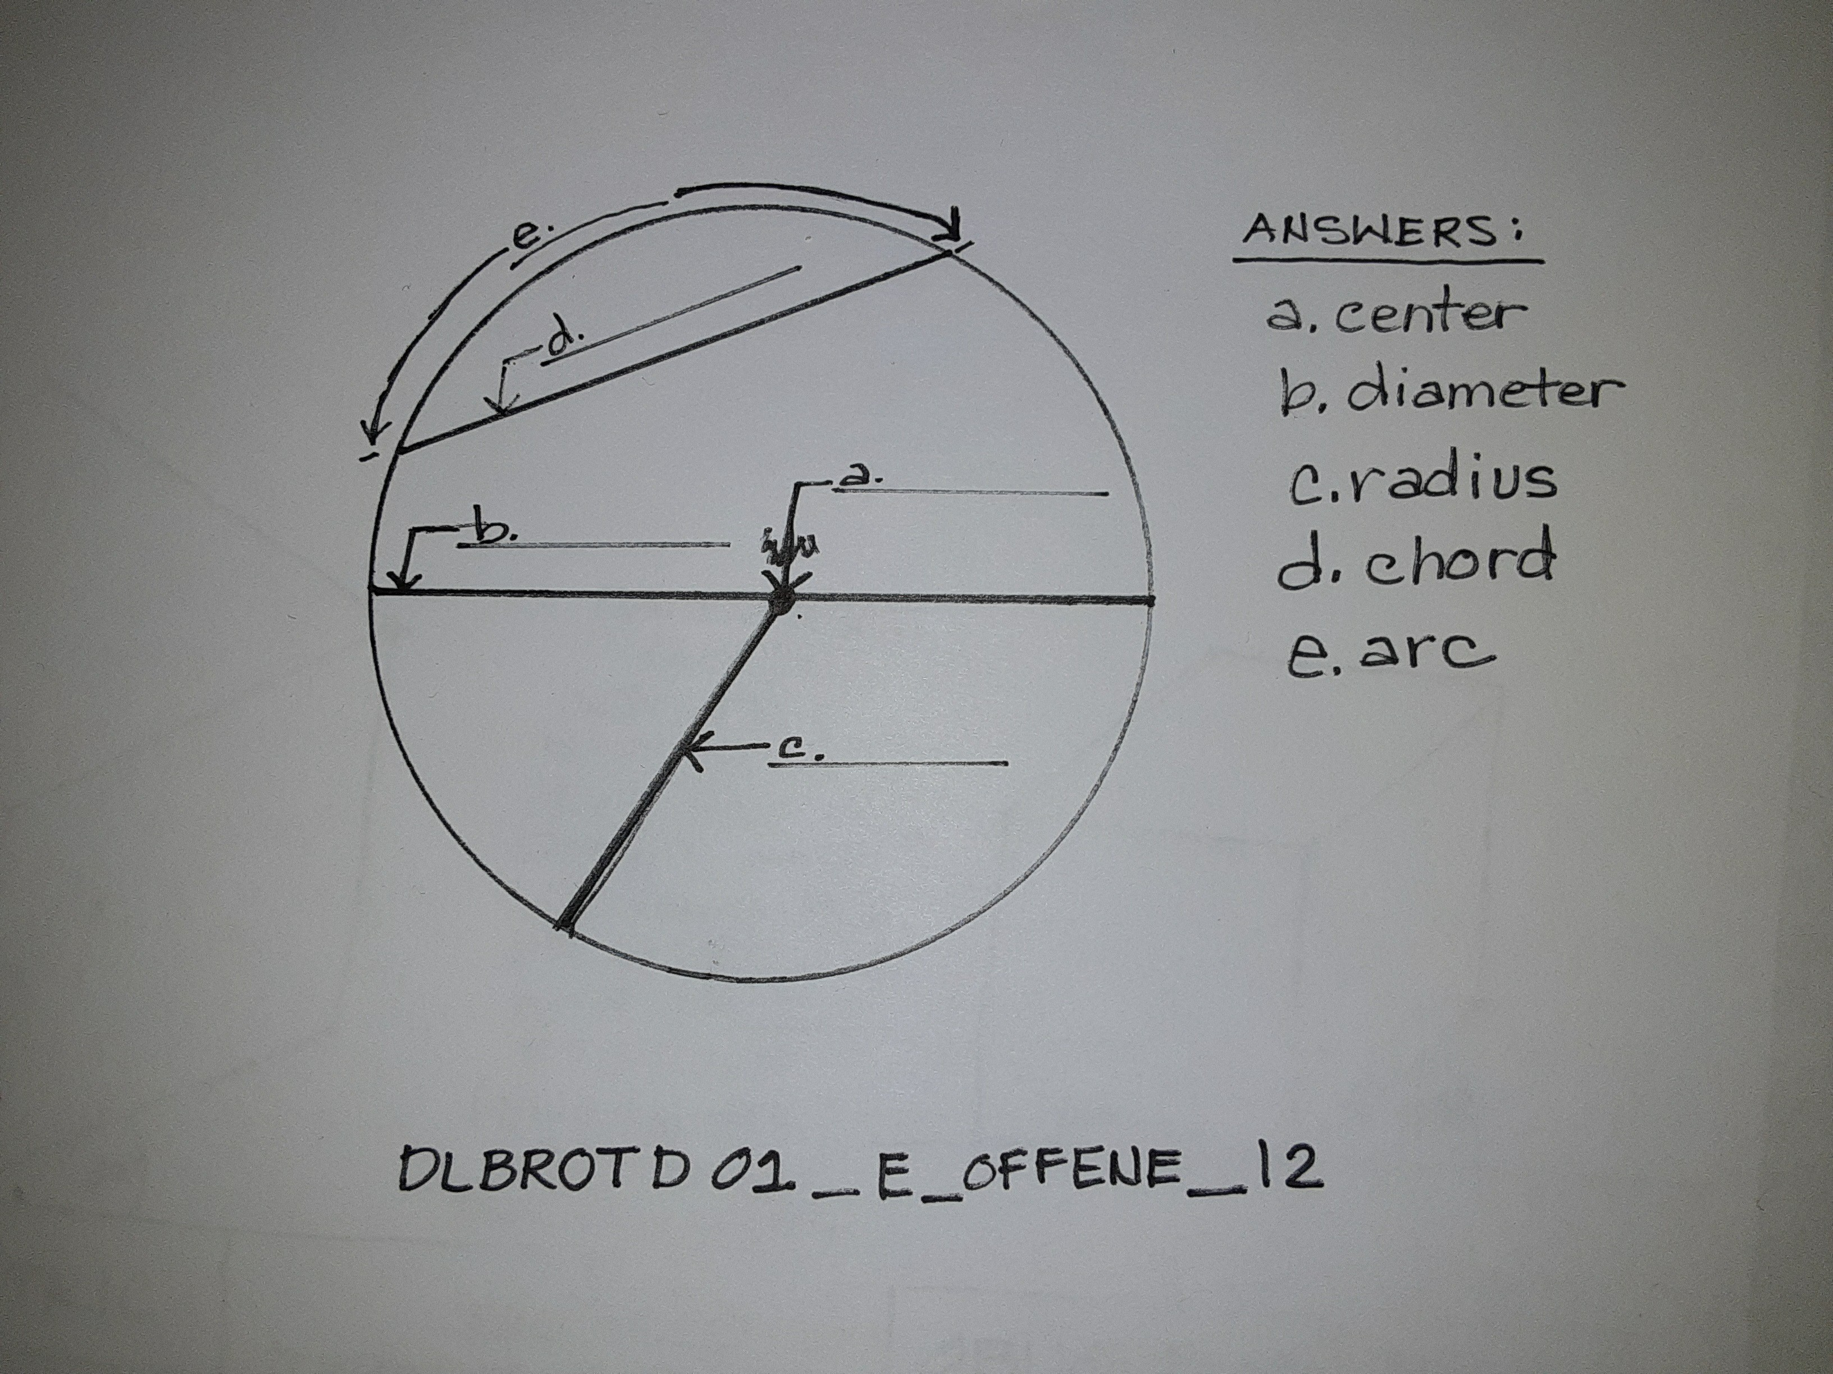
2 points for each correct answer for a total of 8 points possible.

QUESTION 17 OF 280
DLBROTD01_E_Offen_leicht_F1/Lektion 02

Describe what technical illustration entails, listing three types of items that can be a part of technical illustrations.

Technical illustration may be any drawing used to design. It can include charts, graphs, images, 2- D & 3-D drawings, schematics, diagrams. (2 pts for each, with 6 pts total possible)

QUESTION 18 OF 280
DLBROTD01_E_Offen_leicht_F1/Lektion 02

Describe three purposes for technical illustration.

The main purpose is as a tool for communication to convey the design intent. (2 pts) They accurately describe a plan, part or component pictorially. (2 pts) They can show relationship of parts (2 pts), illustrate how something fits together or operates (2 pts) or diagram a process (2 pts) Any three total 6 points possible.

QUESTION 19 OF 280
DLBROTD01_E_Offen_leicht_F1/Lektion 02

Explain foreshortening and compare how it varies for three main axonmetric projections.

When an object appears shorter than it is, or closer than it is, it is foreshortened. (2 pts) Isometric and Dimetric are equally foreshortened, (2 pts) but the trimetric is unequally foreshortened. (2 pts)

QUESTION 20 OF 280
DLBROTD01_E_Offen_leicht_F1/Lektion 02

Discuss three various techniques to improve hand sketching.

2 pts for each of the following, not to exceed 6 points total: learn to see and observe, develop visual acuity, notice shapes and compare sizes relative to each other, note proportion, note angles, observe how light and shadow change appearance of objects, learn proper selection, use, and care of tools

QUESTION 21 OF 280
DLBROTD01_E_Offen_mittel_F1/Lektion 02

Define "construction line" and give three examples of its use for technical drawing.

Construction lines are very thin, light, eraseable guidelines. (2 pts) a total of 6 additional points may be gained from any of the following: They can be used to block out shape, (2pts) to begin a sketch (2 pts), to sketch a layout (2 pts), to align vanishing points for a perspective. (2 pts) They can be erased or left showing to illustrate the construction method used. (2 pts) Total 8 points possible, 2 of which must be the description or explanation or definition of a construction line.

QUESTION 22 OF 280
DLBROTD01_E_Offen_mittel_F1/Lektion 02

List four items in the toolkit for hand sketching.

2 pts for any four: drawing board, parallel bar or T-square or straight edge, soft lead pencils (f-HB and 2B-4B), 2 triangles, paper or bumwad, erasers, optional ink pens

QUESTION 23 OF 280
DLBROTD01_E_Offen_mittel_F1/Lektion 02

Explain how creating technical drawings can help formulate product ideas.

A total of 8 points is possible from the following: Sketching can be used by a designer to explore ideas and enhance creativity, (2 pts) a communication tool to share ideas with a client or team, (2 pts) In schematics and design development, various drawings can explore different views and methods of assembly. (2 pts) Drawings can show how things fit together. (2 pts) Both sketching and axonometric drawings and perspectives can convey how something will look or operate. (2 pts) Problems can be seen in a drawing and corrected before an item is produced. (2 pts)

QUESTION 24 OF 280
DLBROTD01_E_Offen_schwer_F1/Lektion 02

Discuss the three main types of axonometric projection presented in the course and give a best use for each. What can be used to enhance axonometric drawings?

Isometric, Dimetric, Trimetric (2 pts) Isometric is good for dimensioning and is easily understood by all audiences because all three axis are to scale and has least foreshortening(2 pts) Dimetric has two axis of equal foreshortening and is good to show detail on one side. (2 pts) Trimetric has irregular foreshortening and is best used when dimensioning is not needed and to angle the drawing to feature one side. (2 pts) Color and shading can enhance the drawings. (2 pts)

QUESTION 25 OF 280
DLBROTD01_E_Offen_schwer_F1/Lektion 02

List three types of perspective drawings and explain the use of vanishing points and picture plane for each.

Required: Mention of 1, 2, and 3 point perspectives (2 pts)
8 additional points are possible from below: One and two point perspectives have the vanishing points on the horizon line (2 pts) while the 3- point perspective has an additional vanishing point either above or below the horizon line (2 pts) with picture plane above creating a bird's eye or below for a worm's eye view (2 pts) A one point perspective has the picture plane parallel to one face of the object (2 pts) the two point perspective has the picture plane facing the corner angle of the object (2 pts) 10 points total possible if all 3 types are included.

QUESTION 26 OF 280
DLBROTD01_E_Offen_schwer_F1/Lektion 02

Discuss the value of axonometric drawing for the field of technical drawing.

Technical analysis is required to visualize orthographic projections as 3-D components. (2 pts) Axonometric projections are easier to read and understand. (2 pts) Often, 3-d D axonometric views supplement multi-view orthographic drawings. (2 pts) There are three primary views of axonometric projection. (2 pts) Axonometric drawings may be scaled and so are valuable to technical drawing. (2 pts) 10 total points possible.

QUESTION 27 OF 280
DLBROTD01_E_Offen_leicht_F1/Lektion 03


To analyze complex forms and choose which views to use, describe three different considerations or questions to ask yourself before deciding which view to use.

Can an annotation serve to describe a thickness, eliminating the need for another view?, Which side or view has the longest and tallest dimensions?, Which side has the most features visible?, Which view shows what the other views do not?, Which two or three views can show all the information?, ( 2 points each not to exceed 6 points)

QUESTION 28 OF 280
DLBROTD01_E_Offen_mittel_F1/Lektion 03

Describe the main purpose of using a section cut. Name three types of section cuts and list one example use for each.

The main purpose of a section cut is to reveal hidden lines for dimensioning and to reveal features not shown in other views. (2 points) Full or Half for symmetrical, Aligned for asymmetrical, Removed for a portion cut away, Offset to show several features in one view, Full to show hidden features (2 points for each, not to exceed 8 points total)

QUESTION 29 OF 280
DLBROTD01_E_Offen_schwer_F1/Lektion 03


A drafter for an Asian project will draw views for an object with an inclined surface. Name the standard that will be used. Explain the reason.
Explain if it is allowable to draw visible projection lines and if so, name what view it would be allowed.

ISO (2 points), Because Asia uses ISO. (2 points) yes, it is allowable to draw visible projection lines in (3 points) the auxillary view (3 points)

QUESTION 30 OF 280
DLBROTD01_E_Offen_schwer_F1/Lektion 03


When dimensioning a section, a drafter dimensions to hidden lines. Give two reasons why this is incorrect.
Describe the types of features or lines the drafter will need to dimension. Explain the purpose for using a section cut.

Dimensioning to hidden lines is not allowed (3 points) and Hidden lines are revealed in section cuts, so no hidden lines are shown (3 points) The drafter will dimension to lines that are revealed or not hidden in the section - these could be objects or edges (1 points) The purpose for using a section cut is to reveal hidden areas or lines that are hidden or not shown in another view...to show internal features. (3 points)

QUESTION 31 OF 280
DLBROTD01_E_Offen_leicht_F1/Lektion 03

Explain "projection" in drawing. How many views are possible with a projection drawing?

A projection, in technical drawing, is a representation of one side of an object transferred (or projected) onto a flat surface perpendicular to it such as a picture plane. OR a 2-D representation of a 3-D object OR A 2-d image of a 3-D object perpendicular to a flat surface, such as a picture plane, is a projection of that object. (3 pts) Six views are typically identified, (3 pts) but more can be created when different angled or inclined parts require it.

QUESTION 32 OF 280
DLBROTD01_E_Offen_leicht_F1/Lektion 03

Name a common technical drawing layout for details created by projection. List which views it uses. Explain how the views relate to each other.

3 panel projection (2 pts); views are typically front, top and side (2 pts) each side aligns with a corresponding edge of an adjacent side. (2 pts) There is always one common dimension between views. (2 pts) Only 6 points possible using any three of those listed.

QUESTION 33 OF 280
DLBROTD01_E_Offen_leicht_F1/Lektion 03

List six primary views of a projection drawing.

Front, back, top, bottom, right side, left side (1 pt for each)

QUESTION 34 OF 280
DLBROTD01_E_Offen_mittel_F1/Lektion 03

List four benefits of knowing which view to use first.

2 pts each for the following:
save costs in time drawing and analyzing. simplify understanding of the object. eliminate duplicate information.
most clearly identify all aspects.

QUESTION 35 OF 280
DLBROTD01_E_Offen_mittel_F1/Lektion 03

With the use of 3-D modeling, in your opinion, what is the importance and value of a human drafter? Give four reasons for your opinion.

This is opinion based, so assessment may be lenient, but four reasons are required for full 8 points.. 2 pts may be given for each reason. The drafter still needs to know which views are needed. (2 pts) so that extra information or duplicate information does not clutter the drawing (2 pts). Also to make sure that the drawing generated will be the ones needed for clarity (2 pts) For analysis , the drafter or engineer is needed to evaluate (2 pts), For design optimization, (2 pts) to create the 3-D model ( 2pts)

QUESTION 36 OF 280
DLBROTD01_E_Offen_mittel_F1/Lektion 03

Explain what a projection line is and when to use projection lines and when not to use them in projection drawings.

Projection lines are very light lines that show the alignment between views, as projected. (2 pts) They may be optionally dashed. (2 pts) They are not shown on three panel projections but are shown with auxiliary views of inclined surfaces. (2 pts) Projection lines project from a centerline or edge. (2 pts)

QUESTION 37 OF 280
DLBROTD01_E_Offen_mittel_F1/Lektion 03

List 4 types of section cuts.

Full, Half, Offset, Aligned, Removed, Isometric, Architectural (2 pts for any 4 not to exceed 8 pts)

QUESTION 38 OF 280
DLBROTD01_E_Offen_schwer_F1/Lektion 03

List five questions to consider when analyzing complex objects for projection drawings.

Which side or view has the longest and tallest dimensions? Which side has the most features visible?
Which view shows what the other views do not?
Which two or three views can show all the information?
Can an annotation serve to describe a thickness, eliminating the need for another view?

2 points for any of the bulleted items above for a total of 10 pts total possible.

QUESTION 39 OF 280
DLBROTD01_E_Offen_schwer_F1/Lektion 03

Explain how 3-D modeling software is used to create three panel projection drawings. What other drawings can the software produce? Cite one great advantage of 3-D modeling software.

First a sketch is used to create the 3-D model. (2pts) From that model the software extrudes or extrapolates information from the model to show all the views. (2 pts) The drafter chooses which of the views are needed. (2 pts) The software can also produce section cuts and exploded assembly drawings among others. ( 2 pts for any one ) and 2 pts for listing ONE advantage: One advantagle is time and cost savings in drafting. Another is the ability to analyze movement and fit.

QUESTION 40 OF 280
DLBROTD01_E_Offen_schwer_F1/Lektion 03

Define an auxiliary view. Provide four examples of when an auxiliary view would be used.

Auxiliary views are extra views beyond the three-panel projection. (2 pts) An object that has angles not perpendicular to the 6 sides of a projection "box" would need an auxiliary view (2 pts) Inclined surfaces require an auxiliary view (2 pts) Commonly, an auxiliary view will be a partial view, only showing the shape of the inclined surface for correct dimensioning. ( 2 pts) A full auxiliary view would include hidden lines graphically explaining information already contained in the standard views parallel to one of the six primary views. (2 pts) Typically, there is no need for a full auxiliary view because it shows duplicate information. (2 pts) A cube with a corner cut off would require an auxiliary view (2 pts) 10 pts total are possible.

QUESTION 41 OF 280
DLBROTD01_E_Offen_schwer_F1/Lektion 03

Explain three different uses for exploded views and how they differ from cut- away views.

Exploded views show how parts or elements work together when grouped by function (2 pts) They can show alignment of parts (2 pts) they can show how something fits together or is assembled (2 pts) They can show relationship of parts and assembly processes (2 pts) They can itemize all the parts of a system or assembly (2 pts) Cutaway views show the entire assembly connected and do not describe the alignment of parts. Parts are shown together and are not separated. (2 pts) Total 10 points possible.

QUESTION 42 OF 280
DLBROTD01_E_Offen_mittel_F1/Lektion 04

Describe a cutting plan line and associated labeling and name the accompanying view.

Cutting plane line is wide &/or thick &/or heavy &/or primary (2 points) with two dashes and arrows indicating direction of cut. (2 points) The labeling with letters at end of each arrow is only required if there is more than one cut. (2 points) The accompanying view is a section drawing. (2 points)

QUESTION 43 OF 280
DLBROTD01_E_Offen_mittel_F1/Lektion 04


Upon checking a drawings dimensions and notes, the drafter discovers that the dimensioned area is accurately drawn and the numerical dimension correctly describes it.
However, the notes specify a longer dimension for that area. Explain what the drafter needs to do, and describe what changes need to be made, if any.

Check with or ask the designer to clarify which is correct. (2 points) and make changes to the drawing or notes accordingly (2 points) Change the drawing and numerical dimension (2 points) or change the notes (2 points). If the designer is not available, change the drawn line and numerical dimension to match the notes. ( 2points) (Not to exceed 8 points)

QUESTION 44 OF 280
DLBROTD01_E_Offen_mittel_F1/Lektion 04

Sketch a circle, indicate the center, and dimension it correctly, using basic line types. Imagine it has a radius of 0.5mm.

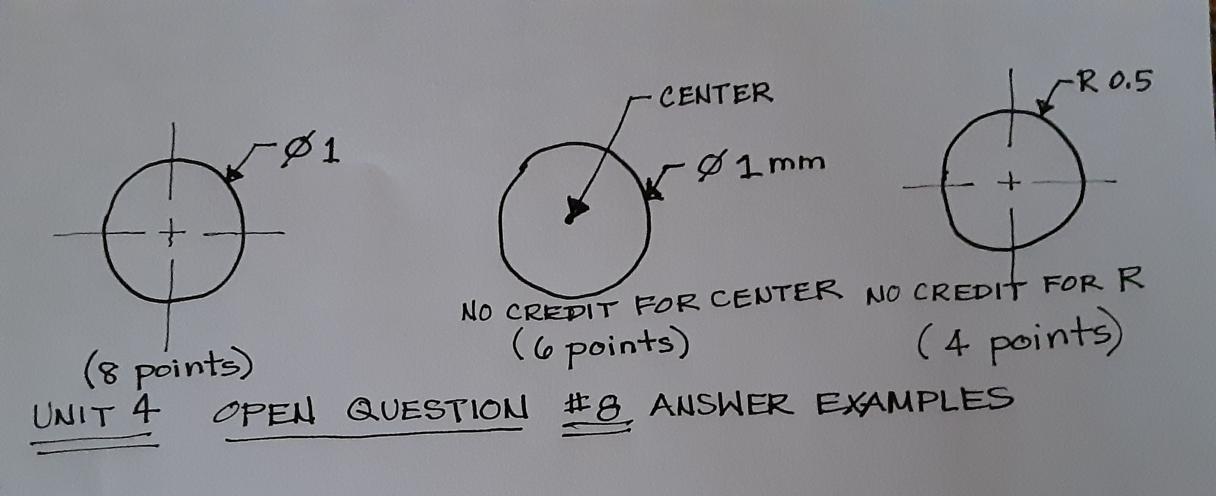
Correct line type, (primary for perimeter, secondary for dashed centerline) - 2 points for perimeter and 2 points for centerline. Show diameter sign Ø with leader line and arrrow (2 points) give diameter dimension of 1 - mm is optional. (2 points) see sketch of example answers

QUESTION 45 OF 280
DLBROTD01_E_Offen_schwer_F1/Lektion 04

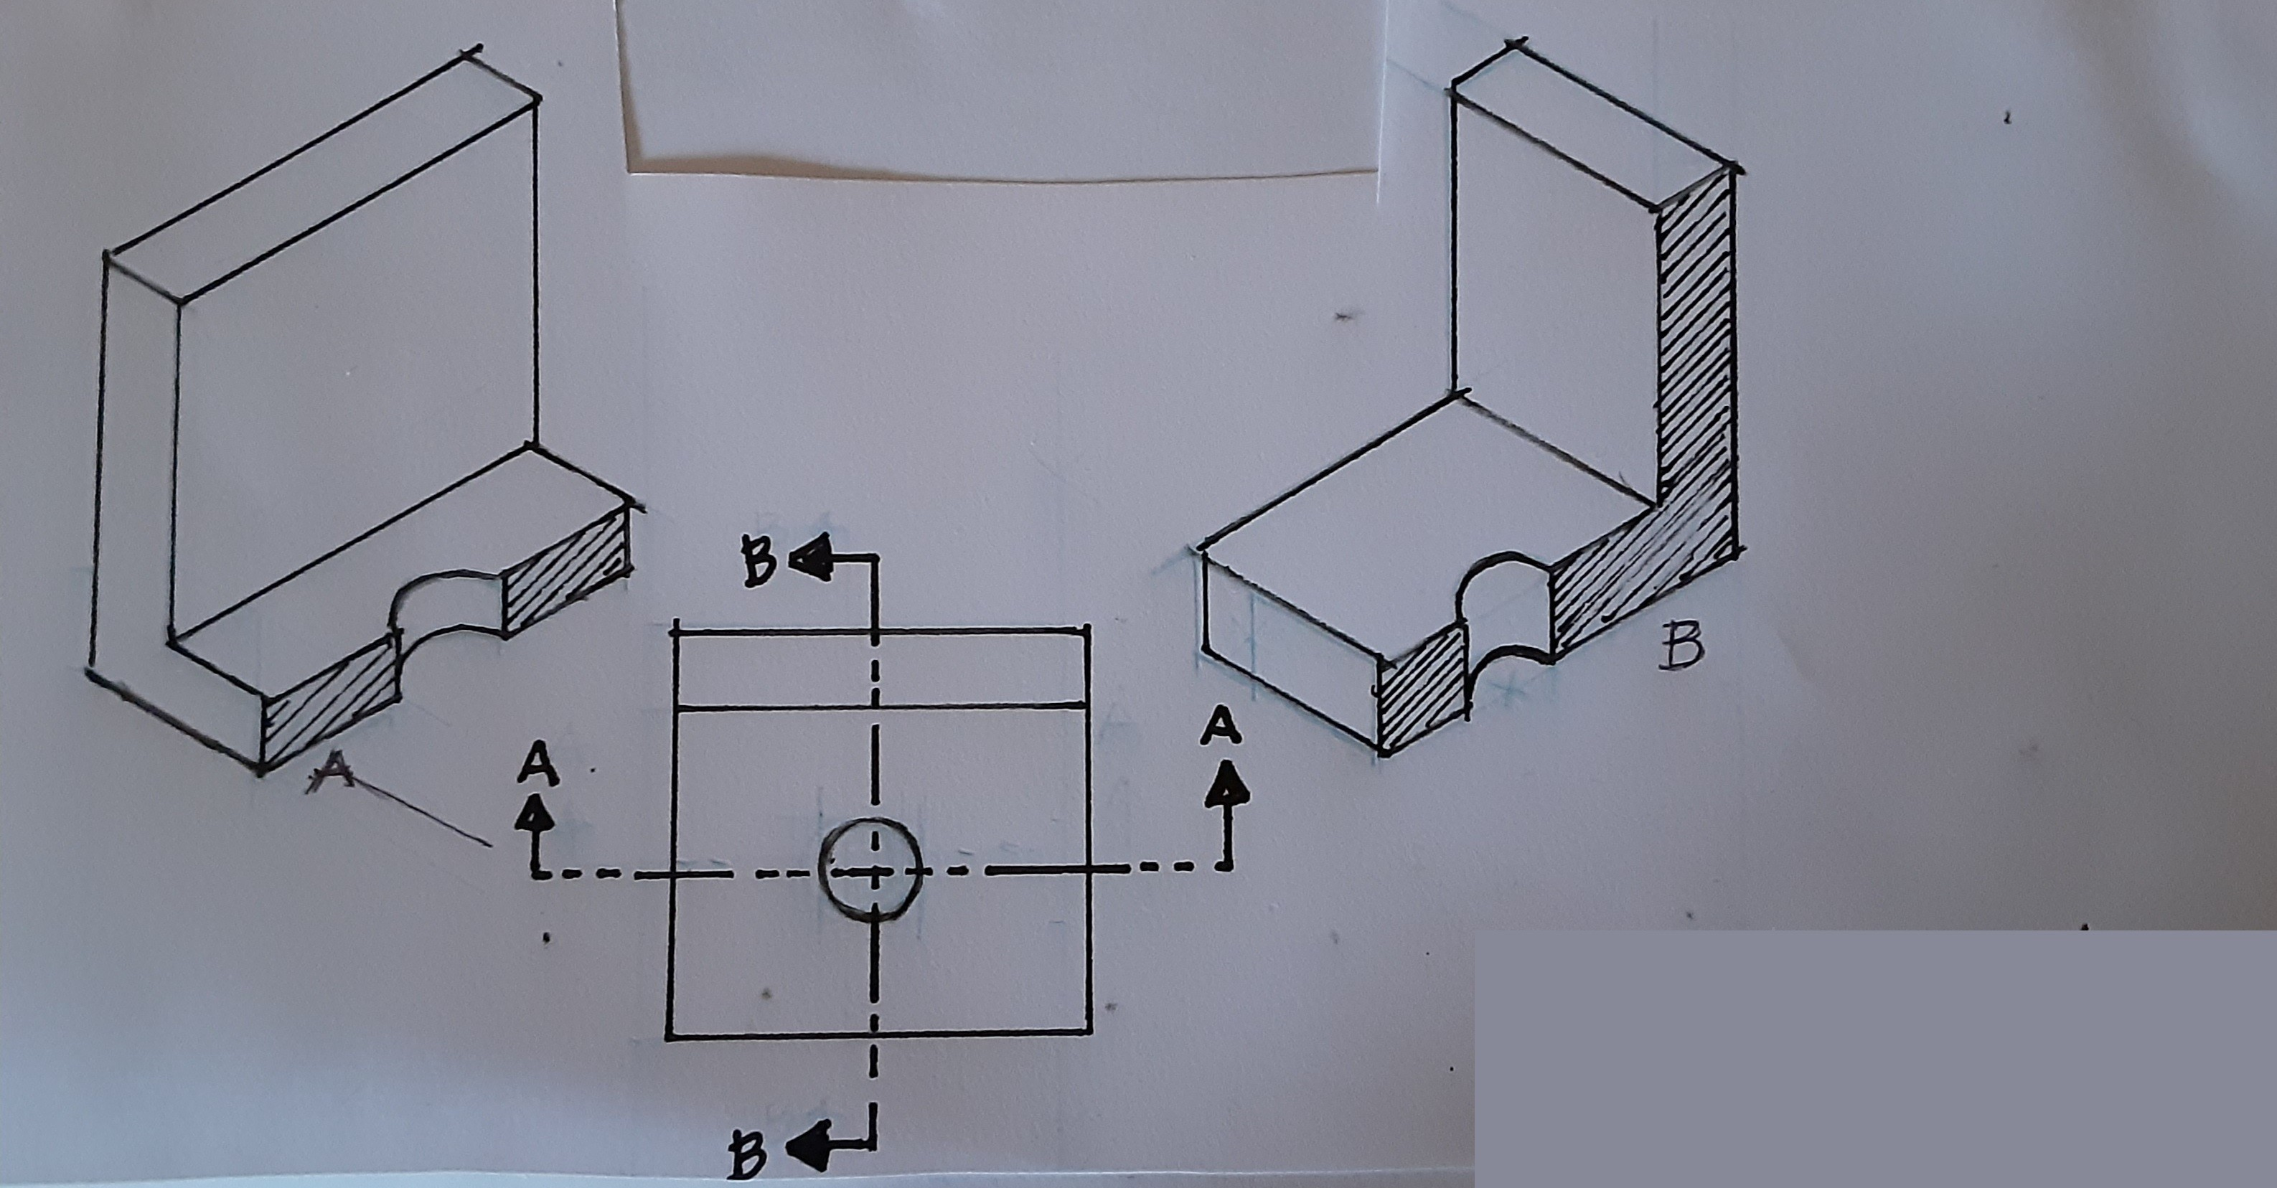
Sketch the orthagonal section drawings for AA and BB, and dimension them, assuming the object fits squarely and perfectly within a 4cm cube. Assume a diameter of 10mm for the hole with an 8mm depth. Label the drawings.

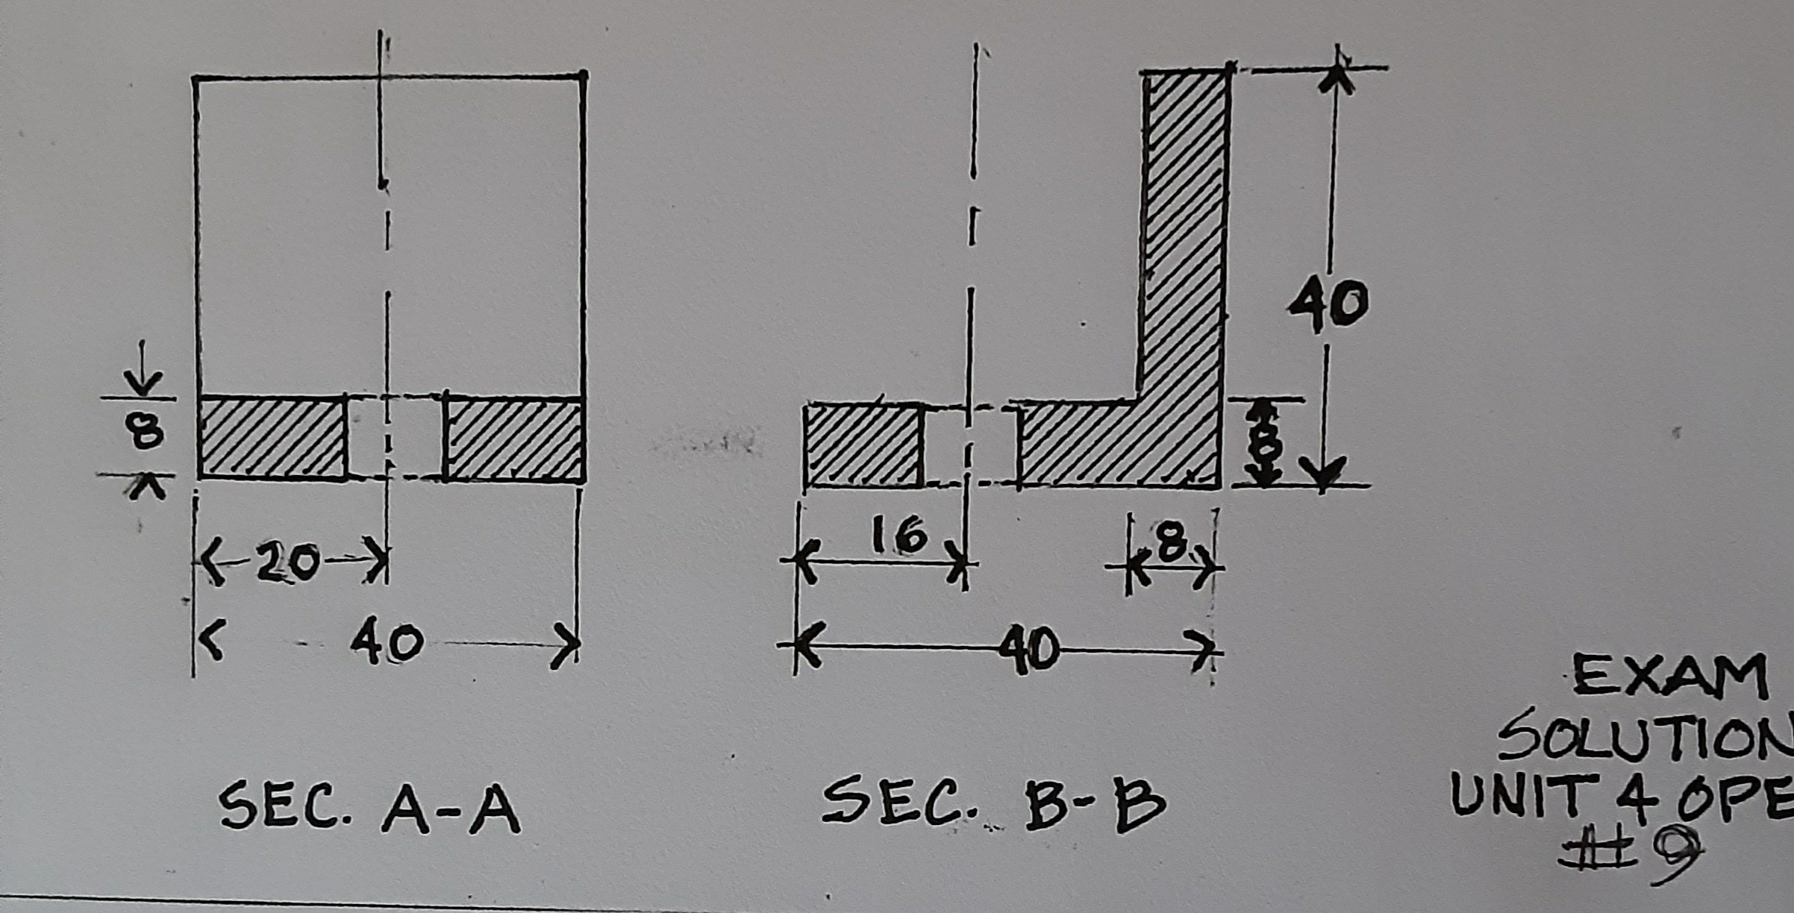
See drawing example answer: 2 points for correct labels, 2 points for correct shape for each drrawing, 2 points for correct dimension of hole location, 2 points for correct dimension size of piece, 2 points for correct use of dimension and extension lines and numerical notation.

QUESTION 46 OF 280
DLBROTD01_E_Offen_schwer_F1/Lektion 04

An engineer has limited paper space for dimensioning a simple workpiece without any hidden lines. Describe the drawing solution and state three reasons for your choice.

Isometric( 3 points) because it takes less space than an orthagonal or multi-view, (3 points) and can be dimensioned in all three axes ( 3 points) and it is easier to understand (1 point)

QUESTION 47 OF 280
DLBROTD01_E_Offen_leicht_F1/Lektion 04

Describe the phantom line and give an example of when it is used.

Phantom line is created with a light narrow line. (2 pts) 6H, .01 (0.3mm) width, thin light line similar to a cutting plane line but much lighter; usually with a long dash separated by two short dashes. (2 pts) It is used to indicate an alternate position, rotation, repetitive detail, or rounded edges. (2 pts for any uses)

QUESTION 48 OF 280
DLBROTD01_E_Offen_leicht_F1/Lektion 04

Explain the use of hidden lines and how they connect.

Hidden lines indicate edges not shown in the view, that are behind or hidden from the main view. (2 pts) They consist of medium weight lines of short dashes and when they meet or intersect, the dashes should connect. (2 pts) Any of the following may be included not to exceed a total of 6 points.: Hidden lines are only provided if they add clarity to the drawing. Avoid cluttering a drawing with lines that are not needed because they can add confusion and become problematic when dimensioning. Keep the following guidelines in mind when using hidden lines.
Visible object lines have priority, so always use a full dash on both sides of the visible line to “jump” over it.
Begin and end with a full length dash, only shortening or lengthening if absolutely necessary; except if it would appear as a continuation of a visible object line; do not join a hidden line to an object line if they do not actually connect.
Begin the hidden line with a gap if a visible object line and hidden line do appear as an extension of each other.
Use a dash when joining two hidden lines that do connect, continuing it around a corner where hidden lines turn a corner.
Offset or stagger two parallel hidden lines so they do not look like a bunch of equal signs. Avoid this: =======
Do not cross two dashes. For two crossing hidden lines, the closest line should be carried with the dash, while the farther line “jumps” over with a space on each side.
Begin a curved hidden line with a dash when it joins a straight hidden line. Begin a straight hidden line with a space when it joins a curved hidden line.
Allow a centerline to run through a hidden line dash, avoiding ending a hidden line dash on a center or other non-corner line.

QUESTION 49 OF 280
DLBROTD01_E_Offen_leicht_F1/Lektion 04

Give three rules regarding use of cutting plane lines.

A section drawing must accompany it. (2 pts) They only need a label if more than one (2 pts) They take precedence over centerlines. (2 pts)

QUESTION 50 OF 280
DLBROTD01_E_Offen_leicht_F1/Lektion 04

List three types of dimensioning.

2 pts for any three for a total of 6 points: chain, baseline, direct, running

QUESTION 51 OF 280
DLBROTD01_E_Offen_mittel_F1/Lektion 04

List four main basic rules of dimensioning.

Be clear and concise (2 pts) allow for only one correct interpretation (2 pts) Include everything without being redundant,(2 pts) yet do not exclude anything required. (2 pts) Do not duplicate (2 pts) Use a checklist (2 pts) Any four items for a total not to exceed 8 points are allowed.

QUESTION 52 OF 280
DLBROTD01_E_Offen_mittel_F1/Lektion 04

Explain the difference between dimensioning and arc and a circle. What rule is the same for both?

The circle is dimensioned with a diameter symbol (2pts) drawn from the edge or circumference of the circle (1 pts) and the arc is dimensioned with an R (2 pts) using the radius from the center point. (1pts) Both must be dimensioned on the view showing the curve. (2 pts)

QUESTION 53 OF 280
DLBROTD01_E_Offen_schwer_F1/Lektion 04

Name 5 line types and their associated use.

2 pts for any five line types and correct use: Visible or Object Line used to define object edges or outer edge of a part (part outlines) and lines closest to viewer, Hidden Line to indicate lines not shown in view, Section Line indicates where section is cut, Center Line used to indicate center, Dimension Line is used to show length of measure, Extension Line supports dimension line from object to dimension line, Cutting Plane Line indicates where cut occurs with direction of cut shown with arrows, Break Line shows where a view is "broken" , Viewing Plane Line (short or long) indicates where view is shown, Phantom Line indicates alternative locations of a moving part.

QUESTION 54 OF 280
DLBROTD01_E_Offen_schwer_F1/Lektion 04

How are angles measured? Explain the difference in numeral use for metric and inches.

Angles are measured in degrees, minutes, seconds and aligned with the dimension line. (3 pts) If the degree is finite, it is not necessary to include zeros. (3 pts) With metric measures, there is no trailing zeroes or decimals but a zero does preceed a decimal such as 0.9 rather than .9 as used for inches. (2pts) For whole inches, place a decimal and zero at the end such as 12.0 rather than 12 as in metric. (2 pts)

QUESTION 55 OF 280
DLBROTD01_E_Offen_schwer_F1/Lektion 04

Explain the importance of using a common datum line or reference point which can be from a surface edge, axis alignment, or centerline. Explain how a datum line is chosen for a mechanical workpiece.

The importance of using a common datum line or reference point in dimensioning is when a datum is critical to the functioning of the workpiece. (3 pts) The datum is chosen by selecting the edge (2pts) , axis, or centerline (2 pts) that will control the function of the feature. (3 pts)

QUESTION 56 OF 280
DLBROTD01_E_Offen_leicht_F2/Lektion 05

Define "surface" as it relates to mechanical engineering and list two examples.

Surface is “the part of a solid that represents the boundaries between the solid body and its environment.” OR Surface is the exposed plane or area. (2 points) Surface can be flat as a plane or curved as cylinders and cones. A surface can be the interior of a recessed area such as a hole, or the varied surface of a screw. Surface finish is texture or topography. ( 2 points for any two) Not to exceed 6 points.

QUESTION 57 OF 280
DLBROTD01_E_Offen_mittel_F2/Lektion 05

How can specifying surface tolerances save costs? Explain and then give 3 examples.

Specifying tolerances for surfaces can reduce overmachining which can be costly. (2 points) Interchangeability of parts ( 2 points) lifetime expectancy ( 2 points) performance criteria (2 points) reducing materials (2 points) not to exceed 8 points

QUESTION 58 OF 280
DLBROTD01_E_Offen_schwer_F2/Lektion 05

Explain the difference between roughness and waviness. Give an example of a roughness parameter. Describe how they differ in measurement. Give one cause for each.

Waviness is defined by long periodic intervals of surface deformation. A wavy surface can be smooth or have finer roughness irregularities along the wave. Roughness is finer in deviation than waviness having grooves and/or cones. (3 points) A roughness parameter can be Ra, Rq, or Rz. (1 points) Roughness height is measured in wavelengths and amplitude both in the µm-range, which is micrometers or micro inches. Waviness is measured in mm or inches and is larger than roughness. (2 points) Roughness can be caused by material responses to the manufacturing method such as the cutting process due to vibrations of the manufacturing operation or deformation of the workpiece from cutting forces, form of the tool, or feed rate. Machine straightness and accuracy may vary with machine calibration and cause roughness. Waviness can be caused by incorrect clamping, machine vibration, overheating, or warping. (2 points for listing any one cause for roughness + 2 points for listing any one cause for waviness.)

QUESTION 59 OF 280
DLBROTD01_E_Offen_mittel_F2/Lektion 05

Name four types of surface symbols and one example in each category.

FORM - straightness, flatness, roundness or circularity, cylinder or cylindricity (2 points for FORM
+ 1 example); PROFILE - Surface or Line (2 points for form + 1 example); ORIENTATION or DIRECTION - parallelism, perpendicularity, or angularity ( 2 points for orientation or direction + 1 example); LOCATION or DISPLACEMENT - Concentricity, Position, Symmetry (2 points for location or displacement + 1 example) Not to exceed 8 points

QUESTION 60 OF 280
DLBROTD01_E_Offen_schwer_F2/Lektion 05

Explain the purpose for roughness parameters. Name three parameters of roughness, describing each.

Roughness parameters are used to describe the extent of surface roughness and provide a quantitative measure to describe whether a surface is smooth or rough enough to fulfill a certain function. (3 points) Parameters are Ra, or the mean value of all heights; (2 points) Rz, the amplitude of five segments from the maximum to the minimum; or average peak to valley height, (2 points or 3 points if five is mentioned) and Rq, the root mean square of roughness.(2 points) Correct answers for Ra and Rq can be presented as formulas instead of a description. 10 points possible

QUESTION 61 OF 280
DLBROTD01_E_Offen_leicht_F2/Lektion 05

Describe the term "deviation" as it applies to mechanical engineering and tell what might cause them.

Deviations are surface discontinuities (2 pts) and edge irregularities (2 pts); machine processes (2 pts)

QUESTION 62 OF 280
DLBROTD01_E_Offen_leicht_F2/Lektion 05

Briefly describe two types of run-out.

Circular Runout only controls a cross-section. (3 pts )
Total Runout controls the entire surface of cylinders or planes. (3 pts)

QUESTION 63 OF 280
DLBROTD01_E_Offen_mittel_F2/Lektion 05

Explain where a surface texture symbol is placed and describe three pieces of information it can indicate or that can be included with it.

It is placed on the surface to which it applies or on a leader line or dimension line for that surface; (2 pts) and identifies if material is to be removed or not OR minimum material removal (2 pts) and whether or not machining is used OR manufacturing method - ie: milling (2 pts) and can indicate that all surfaces of the workpiece require the same surface texture (2 pts) surface parameter (2 pts) secondary surface parameter (2 pts) lay (2 pts) ONLY 8 total points are possible

QUESTION 64 OF 280
DLBROTD01_E_Offen_mittel_F2/Lektion 05

If a workpiece you are designing has two different and integral planes, what would you use where they meet, and give three benefits of its use.

A fillet (2 pts) -to ease the machining of inside corners (2 pts) to allow patterns to release more easily from castings and forgings (2 pts) to allow additional material on inside corners for stress relief. (2 pts)

QUESTION 65 OF 280
DLBROTD01_E_Offen_mittel_F2/Lektion 05

Explain the purpose of surface specifications, giving three examples of how they are used or the reason or benefit of using them.

Surface specifications assure a part is manufactured as intended (2 pts) They enable the machinist to fabricate the part or workpiece according to the desired intent of the engineer. ( 2 pts) Engineers need to make sure that pieces will fit together, even if made in different locations. (2 pts) Interchangeability of parts (2 pts) precision dimensioning and surface specifications that are carried out in production. (2 pts) Total 8 points possible.

QUESTION 66 OF 280
DLBROTD01_E_Offen_mittel_F2/Lektion 05

Explain the term "feature" as it relates to mechanical engineering or robotics, and provide three examples.

The physical shape of a part is called a feature. (2 pts) Examples of features are a surface, edge, hole or screw threads, axis, lines, or medians. (2 pts each) Total of 8 points possible.

QUESTION 67 OF 280
DLBROTD01_E_Offen_schwer_F2/Lektion 05

List three types of material properties, and identify which is measured nominally and evaluated with measurement instruments; and explain two major basic categories of nominal properties and how their measurements differ.

Mechanical, Chemical, Geometric properties ( 3 pts) Geometric properties are described nominally and evaluated with measurement instruments. ( 1 pt) In the metrology of geometric properties, nominal classification depends upon the level of measurement as either macro or micro. Macro measures from the micrometer to meter level. ( 3 pts) Micro refers to measures from the nanometer to millimeter level. ( 3 pts)

QUESTION 68 OF 280
DLBROTD01_E_Offen_schwer_F2/Lektion 05

Discuss "profile" as form deviation, explaining it in general terms; and define two types of profile.

Profile refers to a defined cross-section (profile surface) or a defined line (profile line) on the surface that features a defined geometry on the macro-level, but not a typical geometry like a circle or plane. Profile is used for a defined freeform surface that is specified with a profile or a cross section. Such features cannot be described with the “form” property as it only include straight and round geometries.
Use of a datum is optional. With a datum it can control size, form, and orientation of surfaces. LINE PROFILE (PFL)
Line profile refers to the line of the cross-section of a surface that is curved. The tolerance will be measured an equidistance on either side and follows the curvature of the nominal line profile.
SURFACE PROFILE (PFS)
Surface profile refers to the entire specified curvature as a profile of a plane. The tolerance zone follows the curvature of the entire plane equidistant from the nominal geometry.

Students must discuss profile in general terms using some or all of the information above ( 4 pts) and also identify differences for Line (3 pts)and Surface Profile. (3 pts)

QUESTION 69 OF 280
DLBROTD01_E_Offen_schwer_F2/Lektion 05

Explain what type of parts have "tribological properties" and three ways they relate to the science of surfaces.

Tribological properties are influenced by the micro-structure for moving parts, (1 pt) In the science of surfaces for moving parts, tribological properties relate to lubrication (3 pts), friction (3 pts), and wear (3 pts).
This answer may be brief because the student will need to have time to think through their understanding of the term to answer correctly.

QUESTION 70 OF 280
DLBROTD01_E_Offen_schwer_F2/Lektion 05

In your opinion, how can drafters or interns in the field of robotic engineering best prepare for their role in technical drawing for illustrating surface specifications? Give five suggestions.

Understanding terminology, recognizing symbols, familiarizing yourself with manufacturing processes , sketching and using visualization skills aids in understanding which specific condition requires which tolerances. Rely on engineers for guidance to specify such complicated tolerances, following best practices, education, professional attitude. This is an opinion question, so students may reasonably address any five points for full credit. Allow 2 pts for each separate point for a total of 10 points possible.

QUESTION 71 OF 280
DLBROTD01_E_Offen_mittel_F2/Lektion 06

Describe the precondition that is necessary for tolerancing a hole and shaft using ISO 286. Provide the two options. Explain which fit system you would most likely use and give the lowest limit of the hole.

Precondition is that both hole and shaft are identical or equal in nominal size (2 pts); Options are Hole Basis or Shaft Basis systems (2 pts); Hole Basis System (2 points); lower limit of hole is always considered at zero. (2 pts) Total of 8 points allowed.

QUESTION 72 OF 280
DLBROTD01_E_Offen_schwer_F2/Lektion 06

Which the system or standard is used to describe the grades of fits? List three types of fits and an example of when to use each.

International tolerance (IT) grades in ISO 286; (1 pt) Clearance for parts that run or slide against each other (3 points) , Location or Transition where slight clearance or partial interference is wanted (3 points) , Interference - where coupling of parrts requires greatest precision that cannot move during assembly such as engines with high torsion or friction forces. (3 points) (10 pts total possible)

QUESTION 73 OF 280
DLBROTD01_E_Offen_leicht_F2/Lektion 06

Describe what the ISO now uses the term "interval" for and explain its use.

Interval is the zone or tolerance zone. ( 2pts) It is the area in which a tolerance occurs between tolerance limits OR area of the feature within which tolerance occurs. (2 pts) if the tolerance is not measured on the entire feature, its location must be identified. You must identify exactly where the tolerance is measured on the datum feature. (2 pts)

QUESTION 74 OF 280
DLBROTD01_E_Offen_leicht_F2/Lektion 06

Explain the term "general tolerance" and how it compares to machine accuracy and how/where it is shown on a drawing.

A firm or production company employs general tolerances to eliminate opportunity for error and increase readability ( 2pts) General tolerances are equal to or larger than machine accuracy. (2 pts) A general note near to or part of the title block will specify which standard(s) are to be referenced on the drawing. (2 pts)

QUESTION 75 OF 280
DLBROTD01_E_Offen_leicht_F2/Lektion 06

State three reasons that brought about the need for limits and fits for machined workpieces.

The requirement for interchangeability between mass produced parts (2 pts) the inherent inaccuracy of manufacturing methods, (2 pts) “exactness” of size was found to be unnecessary for the most workpiece features. (2 pts)

QUESTION 76 OF 280
DLBROTD01_E_Offen_mittel_F2/Lektion 06

Discuss datum, giving three examples of what a datum may be and how they are selected. Also provide an example of something(s) that should not be used as a datum.

Datum is the ideal or nominal geometry to which the tolerance is referenced on a drawing. It indicates the place from where the measurement is taken. ( 2 pts) A datum is the “theoretically exact” geometrical reference (such as an axis, plane or straight line) to which toleranced features are related. (2 pts)
Prioritize datum selection according to the function of the part, and order of precedence for the controlling feature. ( 2 pts) When deciding where to locate datum, select actual physical surfaces of a part that will be accessible during manufacturing when at all possible. ( 2 pts)
While an axis could be used as a datum, centers of gravity or spheres are not physical nor accessible, so do not use them. (2 pts) A total of 8 points is possible.

QUESTION 77 OF 280
DLBROTD01_E_Offen_mittel_F2/Lektion 06

Explain the differences between three main types of fits.

Clearance – Provides a fit with space between two parts (clearance) permitting ease in fitting. With a Clearance fit, there is always clearance between parts with all tolerances.
Transition - A fit with enough space or clearance between two parts for ease in fitting yet providing a snug fit. It may have clearance or interference depending upon the range of limits for the toleranced parts.
Interference – A tight fit with no space between parts. This may even be so tight as to require pressure or force to fit the two pieces together. This results in minimum or no clearance, creating interference with all tolerances.
2 points for including all three and 2 points each for explanation for a total of 8 points possible.

QUESTION 78 OF 280
DLBROTD01_E_Offen_mittel_F2/Lektion 06

Since CAD can place GDT symbols quickly and easily, explain why it is important for drafters to learn about GDT.

CAD doesn't have the capability to select the correct standards and applications, (3 points) and even if it did, the drafter is responsible for checking to be sure the application is correct. ( 3 points) It is still the responsibility to follow best drafting practices, and comply with all applicable standards for tolerancing.(2 points)

QUESTION 79 OF 280
DLBROTD01_E_Offen_schwer_F2/Lektion 06

Draw or sketch a feature control frame and identify its parts. Also, identify the two minimially required pieces of information that must be included.

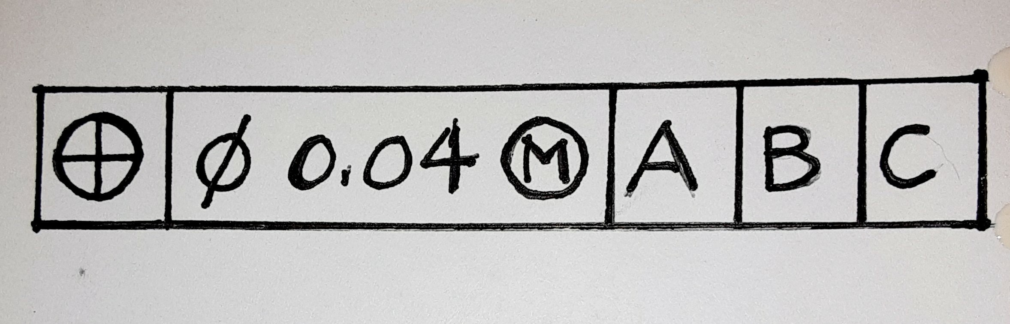
Draw the rectangular feature control frame and identify parts 1.geometric characteristic symbol (2 pts) 2. numerical tolerance value (2 pts) 3. Material Modifier (2 pts) 4. Datum Points - Primary,(1 pt) Secondary (1 pt), Tertiary (1 pt). The geometric characteristic symbol and the numerical tolerance are the two required pieces. (1 point) The image provided is only an example...student may provide differing information or omit the values. As long as the areas are divided and identified, give credit.

QUESTION 80 OF 280
DLBROTD01_E_Offen_schwer_F2/Lektion 06

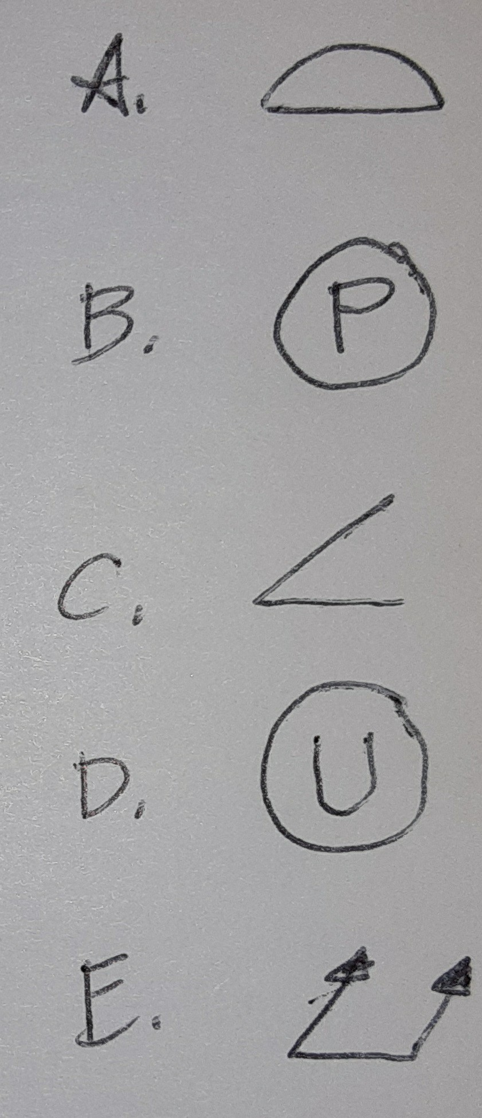Identify the symbols shown.

A. Profile B. Projected Tolerance Zone C. Angularity D. Unilateral E. Total Runout (2 pts each)

QUESTION 81 OF 280
DLBROTD01_E_Offen_schwer_F2/Lektion 06

Explain the purpose for ISO 286 and the main assumption requirement for its use. List which size features are included. Tell the main difference between ISO 286-1 and ISO 286-2.

ISO 286 establishes tolerances for linear sizes of features (3 pts) and assumes nominal sizes for hole and shaft are identical.(3 pts) Only two types of linear size features are included: the cylinder and two parallel opposite surfaces, defined by a linear dimension. (3 pts) ISO 286-1 defines basic concepts for the basis of tolerances, deviation, and fits and ISO 286-2 establishes tables of standard tolerance grades and limit deviations for holes and shafts. (1 pt)

QUESTION 82 OF 280
DLBROTD01_E_Offen_leicht_F2/Lektion 07

List three benefits of using standards.

Protect consumers, support International Trade; Best practices save time and money; societal benefits of sustainability, assist underdeveloped countries, reduce liability risks ( 2 points for each, total of 6 possible)

QUESTION 83 OF 280
DLBROTD01_E_Offen_leicht_F2/Lektion 07

Are ISO standards legally binding? Explain your answer.

NO, unless in a contract or jurisdictionally required; or YES, IF in a contract or jurisdictionally required. ( 3 points for answering yes or no, with 3 points for correct explanation totally 6 possible points)

QUESTION 84 OF 280
DLBROTD01_E_Offen_mittel_F2/Lektion 07

List four considerations when choosing to use a standard.

Does school or firm require and provide them?; does ISO have an applicable standard?; ASK project manager or expereinced colleague; where will product be manufactured?, does manufacturer supply a standard?; search the internet (2 points for each consideration for a total not to exceed 8 points)

QUESTION 85 OF 280
DLBROTD01_E_Offen_leicht_F2/Lektion 07

List three types of standard parts available.

Common standard parts include screws, nuts, bolts, using the basic shaft/basic hold concept. Fasteners of many kinds are used for fitting parts. CAD has even more options for standard parts. (2 pts for any 3)

QUESTION 86 OF 280
DLBROTD01_E_Offen_leicht_F2/Lektion 07

Where is it best to store a parts management system and what are two benefits?

They are best stored within the cad program used (2pts) Benefits are time saving (2 pts) and therefore cost savings (2 pts)

QUESTION 87 OF 280
DLBROTD01_E_Offen_leicht_F2/Lektion 07

List three classifications of ISO standards presented in this course.

Basic Rules; Imaging Features and Views; Geometry, Tolerancing and Fits ( 2 pts for each)

QUESTION 88 OF 280
DLBROTD01_E_Offen_mittel_F2/Lektion 07

Provide four benefits to using standards in technical drawing.

It saves time; It saves costs; It allows for interchangeablity;It improves communication; It assures that all are working with the same level of expectation. ( 2 pts for any four)

QUESTION 89 OF 280
DLBROTD01_E_Offen_mittel_F2/Lektion 07

If you are working on a project, explain the very best way to determine which standards to use. Name five other possible sources for knowing which standard to use.

ASK project manager at beginning of project; (3 points) knowledgeable colleague; local agency; industry professional, ISO handbook, internet as last resort ( 1 pt for each additional resource) Total 8 pts possible.

QUESTION 90 OF 280
DLBROTD01_E_Offen_mittel_F2/Lektion 07

Discuss interchangeability as it relates to standard parts, providing four aspects of benefits.

With standard parts, interchangeability can result in miniimized costs, international trade is supported, reliability, cost reduction, benefit to global supply chain. (2 pts for each aspect addressed)

QUESTION 91 OF 280
DLBROTD01_E_Offen_mittel_F2/Lektion 07

State four main disadvantages for using standard parts.

Cost, Lack of Innovation, Availability Issues, Quality Control (2 pts each)

QUESTION 92 OF 280
DLBROTD01_E_Offen_schwer_F2/Lektion 07

Define the term "standard" using three attributes that are required to be considered a standard.

A standard is a guide (3 pts) that an organization draws upon in order to facilitate clarity (1 pt)of communication. “A standard is a repeatable, harmonised, agreed (3 pts)and documented (1 pt) way of doing something. Standards contain technical specifications (3 pts) or other precise criteria designed to be used consistently (3 pts) as a rule, guideline, or definition.“ (What are Standards?) Standards are developed by many experts involving an industry or group of stakeholders with a common interest to create agreed upon (3 pts)terminology, symbology, and methods of working (3 pts) in their field. According to the International Organization for Standards (ISO), standards are "a formula describing the best way of doing something".(3 pts) This question asks the student to define the term. For full credit, the ideas in bold above should be part of the definition, in the student's own words, adding up to no morre than 10 possible points.

QUESTION 93 OF 280
DLBROTD01_E_MC_leicht/Lektion 01


What is the most important purpose of technical drawings?
Select one:
To convey the intent of the designer
To experience personal enjoyment To draw with precision
To understand the building process
The correct answer is: To convey the intent of the designer

QUESTION 94 OF 280
DLBROTD01_E_MC_leicht/Lektion 01


Choose the best word to complete the sentence. Drawing, fundamentally is
a (or an) …
Select one:
computer skill.
universal language. natural talent.
fine art.
The correct answer is: universal language.

QUESTION 95 OF 280
DLBROTD01_E_MC_leicht/Lektion 01

Persons undertaking technical drawing as a vocation are …
Select one:
dimensioners.
technicians. mechanicals. drafters.
The correct answer is: drafters.

QUESTION 96 OF 280
DLBROTD01_E_MC_leicht/Lektion 01


Technical drawings may also be called …
Select one:
scribbles or cartoons.
free-form or fine art drawings. mechanical or measured drawings. drafters or draughters.
The correct answer is: mechanical or measured drawings.

QUESTION 97 OF 280
DLBROTD01_E_MC_leicht/Lektion 01

Both manual and computer drafting requires access to a …
Select one:
computational slide rule.
compass. computer. calculator.
The correct answer is: calculator.

QUESTION 98 OF 280
DLBROTD01_E_MC_leicht/Lektion 01

Take-offs are derived from technical drawings including …
Select one:
quantities and measurements of materials.
standardized conventions of drawing symbols. views and notes for perspective sketches. fabrication and manufacturing processes.
The correct answer is: quantities and measurements of materials.

QUESTION 99 OF 280
DLBROTD01_E_MC_mittel/Lektion 01

Design process begins and ends with …
Select one:
drafter and engineer.
intention and purpose. scheduling and contracting. need and solution.
The correct answer is: need and solution.

QUESTION 100 OF 280
DLBROTD01_E_MC_mittel/Lektion 01

Two basic types of descriptive drawings in the field of technical drawing are
…
Select one:
one dimensional and multi-dimensional.
2-D and 3-D.
axonometric and symmetric. stick drawings and portraits.
The correct answer is: 2-D and 3-D.

QUESTION 101 OF 280
DLBROTD01_E_MC_mittel/Lektion 01


On a title block, a drafter includes the name of the designer, the drafter, and
leaves a space open for the person who approves the drawings. Also included are the date of issue, and the sheet number. What additional information is required by ISO in the title block?
Select one:
The title, owner's name and identification
Graphic symbols and scale
Number of sheets in the plan and the company logo Revision block and legend
The correct answer is: The title, owner's name and identification

QUESTION 102 OF 280
DLBROTD01_E_MC_schwer/Lektion 01

2-D or two-dimensional drawings include …
Select one:
orthographic projections and multi-view drawings.
isometric and oblique drawings. axonometric drawings only. exploded views and cut-aways.
The correct answer is: orthographic projections and multi-view drawings.

QUESTION 103 OF 280
DLBROTD01_E_MC_schwer/Lektion 01


When selecting paper size and creating a drawing format, the drafter needs
to take into account four major considerations: style and size of border, whether or not a binding will be used, the overall size of the drawing, and …
Select one:
the plotter requirements.
whether or not to include the company logo. what size paper was used on the last project. the size and location of the title block.
The correct answer is: the size and location of the title block.

QUESTION 104 OF 280
DLBROTD01_E_MC_schwer/Lektion 01

Axonometric and isometric drawings are …
Select one:
orthographic.
2-D.
3-D.
exploded.
The correct answer is: 3-D.

QUESTION 105 OF 280
DLBROTD01_E_MC_schwer/Lektion 01

Isometric, dimetric, and trimetric drawings are …
Select one:
exploded views.
assembly views. axonometric views. orthographic views.
The correct answer is: axonometric views.

QUESTION 106 OF 280
DLBROTD01_E_MC_leicht/Lektion 01

Drawings must provide all information necessary to…
Select one:
create perspective drawings or renderings.
enable marketing or advertising. fabricate a part or assemble parts.
thoroughly explain the function or purpose.
The correct answer is: fabricate a part or assemble parts.

QUESTION 107 OF 280
DLBROTD01_E_MC_leicht/Lektion 01

2-D drawings include which of the following?
Select one:
Axometric views of objects
Exploded views of assemblies
Isometric drawings for buildings or parts Plans and elevations for buildings
The correct answer is: Plans and elevations for buildings

QUESTION 108 OF 280
DLBROTD01_E_MC_leicht/Lektion 01

Orthographic projections are…
Select one:
either 2-D or 3-D.
3-D or single-view. 2-D or multi-view. 3-D axonometrics.
The correct answer is: 2-D or multi-view.

QUESTION 109 OF 280
DLBROTD01_E_MC_leicht/Lektion 01

ASME Y14.1 is a specification for…
Select one:
engineering paper sizes.
plotter configurations. international standards. architectural calibrations.
The correct answer is: engineering paper sizes.

QUESTION 110 OF 280
DLBROTD01_E_MC_leicht/Lektion 01

BOM refers to which of the following?
Select one:
Bid of Mechanics
Border of Marking Blocking of Measures Bill of Materials
The correct answer is: Bill of Materials

QUESTION 111 OF 280
DLBROTD01_E_MC_leicht/Lektion 01


Which advantage is mutual to both manual sketching and computer
drafting?
Select one:
easy to understand
quick, time-saving minimize errors cost savings
The correct answer is: quick, time-saving

QUESTION 112 OF 280
DLBROTD01_E_MC_mittel/Lektion 01

A 3-D object is represented by several 2-D drawings is a(n) …
Select one:
axonometric poly-view.
3-D projection. orthographic multi-view. 3-D - 2-D drawing.
The correct answer is: orthographic multi-view.

QUESTION 113 OF 280
DLBROTD01_E_MC_mittel/Lektion 01

An engineer asks the intern to create a drawing to represent the assembly of
a complicated system. Which is the best choice for the intern to create?
Select one:
Multi-view
Isometric view Exploded view Perspective view
The correct answer is: Exploded view

QUESTION 114 OF 280
DLBROTD01_E_MC_mittel/Lektion 01

A drafter is asked to make changes to a drawing. What needs to be included
on the corrected drawing?
Select one:
Revision block with date
Name of person requesting change Only the new information
Before and after views
The correct answer is: Revision block with date

QUESTION 115 OF 280
DLBROTD01_E_MC_schwer/Lektion 01

Which is the correct order of five phases in the design process?
Select one:
Specify need, concept, schematic, design development, construction drawings
Concept, specify need, schematic, design development, construction drawings Specify need, sketch, design development, schematic, construction drrawings
Specify need, preliminary design, concept, design development, construction drawings
The correct answer is: Specify need, concept, schematic, design development, construction drawings

QUESTION 116 OF 280
DLBROTD01_E_MC_schwer/Lektion 01

What are take-offs and how are they used?
Select one:
Information and notes removed from drawing; saved to file
Quantities and measurements of materials; estimating Drawings generated off of a model; for CAD
Start of initial project; kick-off meeting
The correct answer is: Quantities and measurements of materials; estimating

QUESTION 117 OF 280
DLBROTD01_E_MC_schwer/Lektion 01

As a designer, to alleviate stress and increase visualization, to open the
mind to imagination and enhance creativity, what is recommended?
Select one:
Stretching periodically to keep muscles loose
Relax, talk a walk, doodle, meditate, step back from work Alternate looking at close and distant views.
Sketch, evaluate, sketch, and repeat.
The correct answer is: Relax, talk a walk, doodle, meditate, step back from work

QUESTION 118 OF 280
DLBROTD01_E_MC_schwer/Lektion 01

Which statement is correct?
Select one:
Germany and Europe define the standards for ISO.
United States and Great Britain are the only full members of the ISO. India and Saudi Arabia are not official members of ISO.
Japan and China are not official members of ISO.
The correct answer is: Japan and China are not official members of ISO.

QUESTION 119 OF 280
DLBROTD01_E_MC_leicht/Lektion 02

What are the two most important main purposes of technical drawing cited in
your coursebook?
Select one:
To analyze expenses and project costs for estimator
Convey intent of designer and serve as tool for communication Represent object and explain details to builder
Optimizing solutions and problem solving
The correct answer is: Convey intent of designer and serve as tool for communication

QUESTION 120 OF 280
DLBROTD01_E_MC_leicht/Lektion 02

Sketches may be used to quickly analyze various options without extensive
detailing in which phase of the design process?
Select one:
Final drawings
Schematic
Needs identification Design development
The correct answer is: Schematic

QUESTION 121 OF 280
DLBROTD01_E_MC_leicht/Lektion 02

Use the best word to fill in the blank in the following sentence: Drawing well
is a ... skill.
Select one:
natural
technical learned mechanical
The correct answer is: learned

QUESTION 122 OF 280
DLBROTD01_E_MC_leicht/Lektion 02

For drawing and sketching the angle of the pencil to paper is best held at …
Select one:
90 degrees.
more than 90 degrees. less than 30 degrees. 45-60 degrees.
The correct answer is: 45-60 degrees.

QUESTION 123 OF 280
DLBROTD01_E_MC_leicht/Lektion 02

Which type technical drawings are more visually descriptive and easier to
understand?
Select one:
2-D drawings
Axonometric projections Orthographic projections Multi-view drawings
The correct answer is: Axonometric projections

QUESTION 124 OF 280
DLBROTD01_E_MC_leicht/Lektion 02

Which axonometric drawing is equally scaled on all three axis?
Select one:
Perspective
Isometric Dimetric Trimetric
The correct answer is: Isometric

QUESTION 125 OF 280
DLBROTD01_E_MC_mittel/Lektion 02

An object that appears closer in distance than in reality is …
Select one:
orthagonal.
equilateral. foreshortened. scaled.
The correct answer is: foreshortened.

QUESTION 126 OF 280
DLBROTD01_E_MC_mittel/Lektion 02

If the engineer asks for all the dimensions be included on one drawing,
which axonometric view must be used?
Select one:
Dimetric
Trimetric Oblique Isometric
The correct answer is: Isometric

QUESTION 127 OF 280
DLBROTD01_E_MC_mittel/Lektion 02

Illustrators benefit by developing…
Select one:
tactile ability.
good balance. visual acuity. sense of direction.
The correct answer is: visual acuity.

QUESTION 128 OF 280
DLBROTD01_E_MC_mittel/Lektion 02

Construction lines are used for what? Which pencil lead is used to create
construction lines?
Select one:
for definition, HB, F, .5
for dark lines, 2B, 4B, .7 for light lines, H- 2H,.3
for medium lines, HB-6B, .9
The correct answer is: for light lines, H- 2H,.3

QUESTION 129 OF 280
DLBROTD01_E_MC_schwer/Lektion 02

The physics of drawing suggests drawing a line for least effort by …
Select one:
using pencil pressure.
pushing the pencil. pulling the pencil.
moving the pencil back and forth.
The correct answer is: pulling the pencil.

QUESTION 130 OF 280
DLBROTD01_E_MC_schwer/Lektion 02

A shape is different from form because…
Select one:
shape is simple, forrm is complex.
shape is 2-D, form is 3-D. shape is curved, form is linear. shape is malleable, form is rigid.
The correct answer is: shape is 2-D, form is 3-D.

QUESTION 131 OF 280
DLBROTD01_E_MC_schwer/Lektion 02

For mechanical engineers of today, 3-D modeling software programs are …
Select one:
essential.
basic. cumbersome. optional.
The correct answer is: essential.

QUESTION 132 OF 280
DLBROTD01_E_MC_leicht/Lektion 02

Softest lead pencils of options listed here are …
Select one:
6H
6B F 2B
The correct answer is: 6B

QUESTION 133 OF 280
DLBROTD01_E_MC_leicht/Lektion 02

Pink erasers can be too … for use on tracing paper.
Select one:
colorful
abrasive ineffective mild
The correct answer is: abrasive

QUESTION 134 OF 280
DLBROTD01_E_MC_leicht/Lektion 02

Which paper is a good choice when reproducing drawings?
Select one:
Drawing
Bumwad Bristol Vellum
The correct answer is: Vellum

QUESTION 135 OF 280
DLBROTD01_E_MC_leicht/Lektion 02

To block out shapes or forms for a sketch before drawing in the object lines,
use …
Select one:
erasable ink.
light construction lines. fine line chalk.
a grid underlay.
The correct answer is: light construction lines.

QUESTION 136 OF 280
DLBROTD01_E_MC_leicht/Lektion 02

Which term best defines a graphic depiction of a 3-D object on a 2-D
surface?
Select one:
Axonometric projection
Rendered drawing Orthographic projection Detail sketch
The correct answer is: Axonometric projection

QUESTION 137 OF 280
DLBROTD01_E_MC_mittel/Lektion 02

Which statement best defines the term tooth as used in drawing?
Select one:
A torn pape edge
Serrated edge of a ruler
The texture of paper or its finish The grit of the pencil
The correct answer is: The texture of paper or its finish

QUESTION 138 OF 280
DLBROTD01_E_MC_mittel/Lektion 02

A humidifier and electrosonic cleaner are used for …
Select one:
mechanical pencils.
markers. compasses. technical pens.
The correct answer is: technical pens.

QUESTION 139 OF 280
DLBROTD01_E_MC_mittel/Lektion 02

Computerized sketching is a norm for use in …
Select one:
isometric representation.
3-D modeling.
multi-view orthographics. 2-D rendering.
The correct answer is: 3-D modeling.

QUESTION 140 OF 280
DLBROTD01_E_MC_mittel/Lektion 02

If your boss asks you to create a drawing using angles of 25 and 20 from a
horizontal baseline, you will be drawing which type of axonometric?
Select one:
Isometric
Anglemetric Dimetric Trimetric
The correct answer is: Trimetric

QUESTION 141 OF 280
DLBROTD01_E_MC_schwer/Lektion 02

Which statement best defines sketch?
Select one:
Doodle drawn on trace paper
Cartoons created for technical drawing Purposeful detailed renderings on bumwad
A quickly drawn freehand expression of an idea without the use of drafting tools
The correct answer is: A quickly drawn freehand expression of an idea without the use of drafting tools

QUESTION 142 OF 280
DLBROTD01_E_MC_schwer/Lektion 02

Which statement is true?
Select one:
Mechanical pencils are not recommended much anymore because they are rare and hard to
find.
A wood pencil sharpened with an electric sharpener is the best choice. A mechanical pencil may be preferred to a sharpened wood pencil.
Pencils should never be sharpened manually because it is too messy.
The correct answer is: A mechanical pencil may be preferred to a sharpened wood pencil.

QUESTION 143 OF 280
DLBROTD01_E_MC_schwer/Lektion 02

Which term best defines the drawing with two angles of a drawing equally
foreshortened, with a differing third angle?
Select one:
Dimetric
Foreshortened Trimetric Paraline
The correct answer is: Dimetric

QUESTION 144 OF 280
DLBROTD01_E_MC_schwer/Lektion 02


Which of the following are benefits of 3-D modeling software?
Select one:
Includes drawings for geometric dimensioning and tolerances, saving time and money
Generates numerous drawings including all of them on the sheet allowing a choice of which to dimension
The software recognizes mistakes in the initial computerized sketches so the drafter doesn't waste time drawing
Extrapolates axonometric drawings from the model and generates updated views when one view is changed
The correct answer is: Extrapolates axonometric drawings from the model and generates updated views when one view is changed

QUESTION 145 OF 280
DLBROTD01_E_MC_leicht/Lektion 03

Name three views of three-panel projection.
Select one:
Isometric, dimetric, trimetric
1-D, 2-D, 3-D
Side 1, side 2, side 3 Plan, elevation, section
The correct answer is: Plan, elevation, section

QUESTION 146 OF 280
DLBROTD01_E_MC_leicht/Lektion 03

Three panel projection is used to describe…
Select one:
2-D drawing in 3-D form.
one view in three panels.
three perspectives of same view. 3-D form in 2-D drawing.
The correct answer is: 3-D form in 2-D drawing.

QUESTION 147 OF 280
DLBROTD01_E_MC_leicht/Lektion 03

How many primary views are possible using the unfolding box method?
Select one:
Four (4)
Three (3)
Six (6)
One (1)
The correct answer is: Six (6)

QUESTION 148 OF 280
DLBROTD01_E_MC_leicht/Lektion 03

Two-panel projection can be used when an object is ….
Select one:
symmetrical.
offset. assymetrical. uneven.
The correct answer is: symmetrical.

QUESTION 149 OF 280
DLBROTD01_E_MC_leicht/Lektion 03

Two main projections methods are referred to as …
Select one:
2nd and 4th.
2nd and 5th. 4th and 6th. 1st and 3rd.
The correct answer is: 1st and 3rd.

QUESTION 150 OF 280
DLBROTD01_E_MC_leicht/Lektion 03

The solid cut area of a section is drawn with …
Select one:
diagonal section lines.
parallel hidden lines. vertical break lines. horizontal hidden lines.
The correct answer is: diagonal section lines.

QUESTION 151 OF 280
DLBROTD01_E_MC_mittel/Lektion 03

In projection drawings, the views are typically named according to …
Select one:
the view from the top.
the cardinal directions.
their relationship to each other. the view from the front.
The correct answer is: their relationship to each other.

QUESTION 152 OF 280
DLBROTD01_E_MC_mittel/Lektion 03

The ISO standard used by the majority of the world is …
Select one:
3rd angle.
1st angle. 2nd angle. 4th angle.
The correct answer is: 1st angle.

QUESTION 153 OF 280
DLBROTD01_E_MC_mittel/Lektion 03

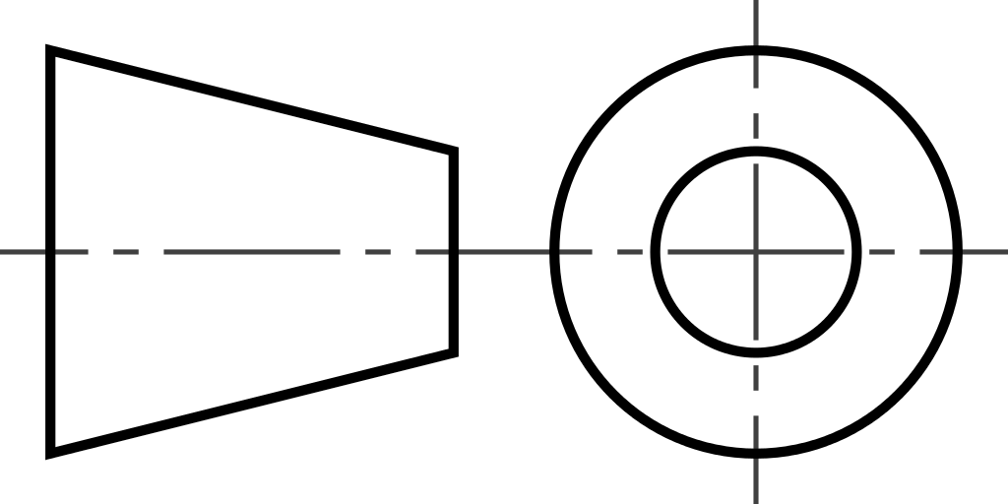
The drawing
identifies …
Select one:
2nd angle projection.
3rd angle projection. 4th angle projection. 1st angle projection.
The correct answer is: 3rd angle projection.

QUESTION 154 OF 280
DLBROTD01_E_MC_mittel/Lektion 03

Exploded views show….
Select one:
multiple views of the same part.
directions for interchangeability. relationship of three-panel views.
relationship of parts and assembly processes.
The correct answer is: relationship of parts and assembly processes.

QUESTION 155 OF 280
DLBROTD01_E_MC_schwer/Lektion 03

3-D modeling software can produce …
Select one:
only one model view.
3-D printed forms.
3-D orthographic views. 2-D orthographic views.
The correct answer is: 2-D orthographic views.

QUESTION 156 OF 280
DLBROTD01_E_MC_schwer/Lektion 03

In both 1st and 3rd angle projections, it is typical for the primary center view
to be the …
Select one:
top view.
bottom view. front view. largest side view.
The correct answer is: front view.

QUESTION 157 OF 280
DLBROTD01_E_MC_schwer/Lektion 03

Auxillary views are often used to show …
Select one:
oversized surfaces.
inclined surfaces. minimal surfaces. detailed surfaces.
The correct answer is: inclined surfaces.

QUESTION 158 OF 280
DLBROTD01_E_MC_schwer/Lektion 03

When creating a cut to dimension a circular object with asymmetrical holes,
the best section cut to use is the …
Select one:
aligned section cut.
removed section cut. half section cut.
full section cut.
The correct answer is: aligned section cut.

QUESTION 159 OF 280
DLBROTD01_E_MC_leicht/Lektion 03

Choose the answer that best provides the correct names for the three views
of a three-panel projection.
Select one:
Side 1, side 2, side 3
1-D, 2-D, 3-D
Isometric, dimetric, trimetric Top, front, side
The correct answer is: Top, front, side

QUESTION 160 OF 280
DLBROTD01_E_MC_leicht/Lektion 03

When objects are symmetrical, which drawing can be used?
Select one:
6 panel
2-panel 3-panel 4-panel
The correct answer is: 2-panel

QUESTION 161 OF 280
DLBROTD01_E_MC_leicht/Lektion 03

Which are three types of oblique views?
Select one:
Cabinet, cavalier, military
1point, 2point, 3point Isometric, trimetric, dimetric
Axonometric, orthographic, perspective
The correct answer is: Cabinet, cavalier, military

QUESTION 162 OF 280
DLBROTD01_E_MC_leicht/Lektion 03

1st angle projection is the standard for which organization?
Select one:
LEED
ANSI ISO ASME
The correct answer is: ISO

QUESTION 163 OF 280
DLBROTD01_E_MC_leicht/Lektion 03

In 3rd angle projection, the top view is located …
Select one:
below the front view.
above the front view. on the left side of front.
on the right side of front.
The correct answer is: above the front view.

QUESTION 164 OF 280
DLBROTD01_E_MC_leicht/Lektion 03

The purpose of sectioning is to …
Select one:
reveal hidden features for dimensioning.
open up the drawing for internal exposure.
add extra views to explain how a feature operates or connects. show the difference in between the internal and external materials.
The correct answer is: reveal hidden features for dimensioning.

QUESTION 165 OF 280
DLBROTD01_E_MC_mittel/Lektion 03

In a three panel projection, …
Select one:
each side aligns with a corresponding edge of an adjacent side.
each side aligns with the front.
each side aligns independent from other views. each side aligns with the opposite side of the view.
The correct answer is: each side aligns with a corresponding edge of an adjacent side.

QUESTION 166 OF 280
DLBROTD01_E_MC_mittel/Lektion 03

Which term describes a 2-D image of a 3-D object perpendicular to a flat
surface, such as a picture plane?
Select one:
1st angle projection
Multi-view drawing 3rd angle projection
Three panel projection
The correct answer is: Three panel projection

QUESTION 167 OF 280
DLBROTD01_E_MC_mittel/Lektion 03

Which are named for the quadrant in which the object is oriented to the
horizontal plane?
Select one:
3-panel projections
2-panel projections
1st and 3rd angle projections 2nd and 4th angle projections
The correct answer is: 1st and 3rd angle projections

QUESTION 168 OF 280
DLBROTD01_E_MC_mittel/Lektion 03

If your engineer says that only one section cut will be needed on a drawing,
you …
Select one:
will not have to label it.
will label it as 1-1.
will need to ask how it should be labeled. know to label it z-z.
The correct answer is: will not have to label it.

QUESTION 169 OF 280
DLBROTD01_E_MC_schwer/Lektion 03


Choose one answer that best describes one group of benefits that is a result
of knowing which view to use.
Select one:
Save costs in time drawing and analyzing; simplify understanding of the object; eliminate
duplicate information; most clearly identifed all aspects.
Saves drawing time; lessens the drafter's confusion; allows for duplicate information thereby double checking accuracy.
Omits need to check with engineer or designer; allows for 6 views plus additional angle views for the most complete identification and understanding of object.
Accuracy is checked; object is displayed in several ways; only featured aspects are identified; promotes visual acuity.
The correct answer is: Save costs in time drawing and analyzing; simplify understanding of the object; eliminate duplicate information; most clearly identifed all aspects.

QUESTION 170 OF 280
DLBROTD01_E_MC_schwer/Lektion 03

When analyzing complex objects, which question is good to consider?
Select one:
Does the engineer require duplicate information?
Can an annotation serve to describe a thickness, eliminating the need for another view? Which views could be used to show the least amount of information?
What is the purpose for whom is the drawing needed?
The correct answer is: Can an annotation serve to describe a thickness, eliminating the need for another view?

QUESTION 171 OF 280
DLBROTD01_E_MC_schwer/Lektion 03

When asked to develop a prelimary design concept, which of the following is
the often used and the best choice?
Select one:
Quickly sketch orthographic projections
Layout axonometric projections carefully Carefully sketch realistic perspectives Quickly sketch an isometric view
The correct answer is: Quickly sketch orthographic projections

QUESTION 172 OF 280
DLBROTD01_E_MC_schwer/Lektion 03


Detailed illustrations of individual parts and components are grouped
together according to their ... (1) in the mechanical engineering project plans (2) views show how they work together. They also show …(3).
Select one:
function (1), Exploded (2), relationship of parts and assembly processes(3)
materials (1), Axonometric (2), section cuts and breakouts (3) importance (1), Isometric (2), types of glues and adhesives (3) names (1), Multiple (2), multiple materials and connectors (3)
The correct answer is: function (1), Exploded (2), relationship of parts and assembly processes(3)

QUESTION 173 OF 280
DLBROTD01_E_MC_leicht/Lektion 04

The alphabet of lines consists of …
Select one:
lines of demarcation between technical drawings.
fonts used for technical drawing. linetypes for technical drawing.
letters identiying views for technical drawing.
The correct answer is: linetypes for technical drawing.

QUESTION 174 OF 280
DLBROTD01_E_MC_leicht/Lektion 04

Line weight refers to …
Select one:
darkness or lightness of lines.
measure of line length. manually drawn lines only. weight of drawing instrument.
The correct answer is: darkness or lightness of lines.

QUESTION 175 OF 280
DLBROTD01_E_MC_leicht/Lektion 04

Which lines are most important defining objects and edges?
Select one:
Primary, heavy
Secondary, medium Supplementary, light Tertiary, medium
The correct answer is: Primary, heavy

QUESTION 176 OF 280
DLBROTD01_E_MC_leicht/Lektion 04

Which two line types are necessary for a basic dimension?
Select one:
Dimension and extension
Leader and arrow Section and break
Primary and supplementary
The correct answer is: Dimension and extension

QUESTION 177 OF 280
DLBROTD01_E_MC_leicht/Lektion 04

The heaviest visible object line is created with … .
Select one:
a medium inked line of .5 width.
a fine linked line of .3 width. a F, H, or dull HB pencil.
a sharp, 2H-6H pencil.
The correct answer is: a F, H, or dull HB pencil.

QUESTION 178 OF 280
DLBROTD01_E_MC_leicht/Lektion 04

Which best describes the legal priority in the case of discrepencies in
dimensioning?
Select one:
Drawn line takes precedence over all.
Numeral notation has priority over written word. Drawn line has priority over numerical notation only. Priority stops with written word.
The correct answer is: Priority stops with written word.

QUESTION 179 OF 280
DLBROTD01_E_MC_mittel/Lektion 04

If there is a cutting plane line on a view, what must accompany it?
Select one:
An isometric drawing
A section drawing A detail drawing
A note of explanation
The correct answer is: A section drawing

QUESTION 180 OF 280
DLBROTD01_E_MC_mittel/Lektion 04

What linetype is shown to show alterrnate positions of a moveable part?
Select one:
Stitch
Viewing plane Phantom Hidden
The correct answer is: Phantom

QUESTION 181 OF 280
DLBROTD01_E_MC_mittel/Lektion 04

If the thread of a screw is engaging, the inner line is …
Select one:
not shown.
dashed. thick. thin.
The correct answer is: thick.

QUESTION 182 OF 280
DLBROTD01_E_MC_mittel/Lektion 04

Which type of dimensioning is not recommended for mechanical
engineering?
Select one:
Running
Direct Baseline Chain
The correct answer is: Chain

QUESTION 183 OF 280
DLBROTD01_E_MC_schwer/Lektion 04

Which is the proper way, using numerals, to notate on half mm?
Select one:
.5
½
1 half
0.5
The correct answer is: 0.5

QUESTION 184 OF 280
DLBROTD01_E_MC_schwer/Lektion 04

When dimensioning a feature which controls other parts of a workpiece,
which type of dimensioning is needed?
Select one:
Direct
Baseline Running Chain
The correct answer is: Direct

QUESTION 185 OF 280
DLBROTD01_E_MC_schwer/Lektion 04

When dimensioing arcs, notate with …
Select one:
R.
RAD.
chord. Ø.
The correct answer is: R.

QUESTION 186 OF 280
DLBROTD01_E_MC_schwer/Lektion 04

REF is used in dimensioning …
Select one:
for refining a workpiece.
to reference a duplicated dimension. to locate a control feature.
for Rough Edge Features.
The correct answer is: to locate a control feature.

QUESTION 187 OF 280
DLBROTD01_E_MC_leicht/Lektion 04

Only … carry precedence over dimension line information.
Select one:
written notes
drawn dimensions drawn lines written numerals
The correct answer is: written notes

QUESTION 188 OF 280
DLBROTD01_E_MC_leicht/Lektion 04

Which term best describes lines in technical drawing that are part of a
specialized graphic language that is standardized throughout industry?
Select one:
Line Types
Lines of demarcation List of Lines Alphabet of Lines
The correct answer is: Alphabet of Lines

QUESTION 189 OF 280
DLBROTD01_E_MC_leicht/Lektion 04

Which type of line is not typically considered as part of the alphabet of
lines?
Select one:
Border line
Title line Dimension line Phantom line
The correct answer is: Border line

QUESTION 190 OF 280
DLBROTD01_E_MC_leicht/Lektion 04

Edges of an object not visible to the view are indicated by …
Select one:
section lines.
phantom lines. hidden lines. construction lines.
The correct answer is: hidden lines.

QUESTION 191 OF 280
DLBROTD01_E_MC_leicht/Lektion 04


Which are two considerations when choosing dimensioning styles?
Select one:
Who will use the dimensioned drawing and what is the simplest & clearest method?

What is the purpose of the drawing and why is dimensioning necessary? Choose quickest method to save time and most money saving method.
Always use the dimension style that you are most familiar with to avoid errors and choose
style that won't waste time.
The correct answer is: Who will use the dimensioned drawing and what is the simplest & clearest method?

QUESTION 192 OF 280
DLBROTD01_E_MC_leicht/Lektion 04

Dimensions …
Select one:
define the relationship of parts.
take precedence over written or numerical notation. describe materials and methods of measuring. define form, size, orientation, or location.
The correct answer is: define form, size, orientation, or location.

QUESTION 193 OF 280
DLBROTD01_E_MC_mittel/Lektion 04

Different line widths, weights (darkness or lightness) and patterns compose
…
Select one:
object lines.
dimensions. breaks. linetypes.
The correct answer is: linetypes.

QUESTION 194 OF 280
DLBROTD01_E_MC_mittel/Lektion 04

If you are manually drafting, which pencil can be used that will not
reproduce?
Select one:
Erasable red
Mechanical pencil Non-photo red Non-photo blue
The correct answer is: Non-photo blue

QUESTION 195 OF 280
DLBROTD01_E_MC_mittel/Lektion 04

As a drafter, you have you decided not to use automatic dimensions in CAD
for which reason?
Select one:
It is easier to manually choose how to dimension.
Your team leader told you that they are only for the professional engineers to use. You would like to because there are good benefits, but you haven't learned how yet.
They can dimension to smaller units than necessary, and lead to confusing information and
errors.
The correct answer is: They can dimension to smaller units than necessary, and lead to confusing information and errors.

QUESTION 196 OF 280
DLBROTD01_E_MC_mittel/Lektion 04


Which answer choice best describes benefits of running dimensions?
Select one:
Allows very quick (like running) measurements to be taken and quickly recorded for
documentation of historical properties.
Allows a single measuring rod or tape to be placed and enables notations to be easily made in the field. Because no busts are possible it lessons probability of errors.
Notations are not needed with running dimensions saving time and costs, allowing more free space on the drawing sheet.
Only one person is needed to measure and dimension in the field which saves costs. Also, the measurements can be immediately entered into a computer program.
The correct answer is: Allows a single measuring rod or tape to be placed and enables notations to be easily made in the field. Because no busts are possible it lessons probability of errors.

QUESTION 197 OF 280
DLBROTD01_E_MC_schwer/Lektion 04

If you are a drafter in a mechanical engineer firm, and are asked to draw an
object with 2 equal halves, what line type is used consisting of two dark heavy bars perpendicular across the line?
Select one:
Line of Halves
Line of Symmetry Line of Division Line of Equals
The correct answer is: Line of Symmetry

QUESTION 198 OF 280
DLBROTD01_E_MC_schwer/Lektion 04

Which statement is true?
Select one:
If the thread of the boring hole is not engaged, a thin line is used for the outer line and a thick
line for the inner line.
If the thread of a screw is engaging, the inner line is thick.
When the boring hole is shaded, it indicates that the screw is engaged.
The line thickness does not provide information about whether or not the screw is engaging.
The correct answer is: If the thread of a screw is engaging, the inner line is thick.

QUESTION 199 OF 280
DLBROTD01_E_MC_schwer/Lektion 04

Why is chain dimensioning not recommended for mechanical engineering?
Select one:
Potential for duplicate dimensions, creating possible errors and confusion
Potential for lack of accuracy causing extra work and costing money
Potential for tolerance stacking resulting in tolerance build-up which is not desired Potential for dimensions to be wrong and need to revise dimensioning wasting time
The correct answer is: Potential for tolerance stacking resulting in tolerance build-up which is not desired

QUESTION 200 OF 280
DLBROTD01_E_MC_schwer/Lektion 04


Suppose you are the drafter doing the dimensioning. Choose one group of
information that could also be added with dimensioning.
Select one:
Provide multiple ways to measure, double checking to assure that all duplicate
measurements are dimensioned correctly, avoiding errors and confusion
Notes, material identification, references to details and other requirements for assuring the function of the piece or the intent of the design
Notes about the choice of dimensiong styles, and explanation for use of different styles within the drawing help to clarify the purpose and stress the importance of the dimensions
Owner's preferences or options for various sizes. Always leave space for notes that may be supplied later by the owner for these purposes
The correct answer is: Notes, material identification, references to details and other requirements for assuring the function of the piece or the intent of the design

QUESTION 201 OF 280
DLBROTD01_E_MC_leicht/Lektion 05

Which term best describes surface discontinuities and edge irregularites?
Select one:
Specifications
Finishes Determinations Deviations
The correct answer is: Deviations

QUESTION 202 OF 280
DLBROTD01_E_MC_leicht/Lektion 05

Tolerance is the difference between …
Select one:
the average from the mean.
the upper limit from the lower limit. the mean from the average.
the lower limit from the upper limit.
The correct answer is: the lower limit from the upper limit.

QUESTION 203 OF 280
DLBROTD01_E_MC_leicht/Lektion 05

Material properties relating to surfaces are chemical, mechanical, and …
Select one:
geometric.
mineral. metallic. physical.
The correct answer is: geometric.

QUESTION 204 OF 280
DLBROTD01_E_MC_leicht/Lektion 05

Properties relating to lubrication, friction, and wear are …
Select one:
triadic.
tribological. structural. geometric.
The correct answer is: tribological.

QUESTION 205 OF 280
DLBROTD01_E_MC_leicht/Lektion 05

Which are three fundamental roughness parameters?
Select one:
Initial, intermediate, final
Ra, Rq, Rz
Root, square, cubed x, y, z
The correct answer is: Ra, Rq, Rz

QUESTION 206 OF 280
DLBROTD01_E_MC_leicht/Lektion 05

Choose the correct two types of displacement.
Select one:
Directional orientation or location
Form or profile Roughness or waviness Total or partial
The correct answer is: Directional orientation or location

QUESTION 207 OF 280
DLBROTD01_E_MC_mittel/Lektion 05

Which is the type of geometry drawn for a workpiece?
Select one:
Necessary
Measured Actual or built Nominal or ideal
The correct answer is: Nominal or ideal

QUESTION 208 OF 280
DLBROTD01_E_MC_mittel/Lektion 05

If an engineer knows that manufacturing is having problems with excessive
machine vibration, overheating, and warping, (s)he needs to anticipate and specify tolerances for which?
Select one:
Waviness
Size Displacement Roughness
The correct answer is: Waviness

QUESTION 209 OF 280
DLBROTD01_E_MC_mittel/Lektion 05

If there is not enough space for a leader line on a drawing that requires a
surface texture symbol, where can the drafter place the symbol?
Select one:
On the dimension line
Next to the dimension line Under the dimension line Above the dimension line
The correct answer is: On the dimension line

QUESTION 210 OF 280
DLBROTD01_E_MC_mittel/Lektion 05

The engineer needs to consider all possible deviations that will be evaluated
with a profilometer or laser. These instruments will ultimately determine the
…
Select one:
nonimal deviation.
measured deviation. active deviation. ideal deviation.
The correct answer is: measured deviation.

QUESTION 211 OF 280
DLBROTD01_E_MC_schwer/Lektion 05

The engineer has asked the intern to examine a workpiece for deviations.
The intern ovserves that the piece is not straight as designed and has lost circularity. This type of deviation is categorized as …
Select one:
form.
displacement. profile. orientation.
The correct answer is: form.

QUESTION 212 OF 280
DLBROTD01_E_MC_schwer/Lektion 05

Roughness is measured in wavelengths for a part, but the inspection report
is incomplete. What else is needed?
Select one:
Velocity
Amplitude Micrometers Deformation
The correct answer is: Amplitude

QUESTION 213 OF 280
DLBROTD01_E_MC_schwer/Lektion 05

The intern notices that there is a circle placed over the joint of a leader line
on the sketch the engineer drew. This indicates to the drafter that …
Select one:
the surface will not be machined.
no material is to be removed from that area.
all surfaces will receive the same surface texture.
material removed from only one area needs to be specified.
The correct answer is: all surfaces will receive the same surface texture.

QUESTION 214 OF 280
DLBROTD01_E_MC_schwer/Lektion 05

Which characteristic of a roughness profile is analyzed with the parameter
Rq?
Select one:
Amplitude min-max
Arithmetic mean roughness Valley oil retention volume Root mean square roughness
The correct answer is: Root mean square roughness

QUESTION 215 OF 280
DLBROTD01_E_MC_mittel/Lektion 05

Which types of measuring instruments are typically applied to quantitavely
determine roughness or waviness?
Select one:
Stylus profilometers or microscopes
Refractometers or fringe projectors Atomic force microscopes or ellipsometers
Focused ion beam or scanning electron microscopes
The correct answer is: Stylus profilometers or microscopes

QUESTION 216 OF 280
DLBROTD01_E_MC_leicht/Lektion 05

Which best describes the term "deviations"?
Select one:
Topography and linear deformations
Surface finishes and textures
Surface discontinuities and edge irregularities Roughness and waviness
The correct answer is: Surface discontinuities and edge irregularities

QUESTION 217 OF 280
DLBROTD01_E_MC_leicht/Lektion 05

The lower limit from the upper limit describes which term?
Select one:
Tolerance
Deviation Displacement Variance
The correct answer is: Tolerance

QUESTION 218 OF 280
DLBROTD01_E_MC_leicht/Lektion 05

Select the best term to define the surface texture and finish.
Select one:
Required
Tribological Optional Topographical
The correct answer is: Topographical

QUESTION 219 OF 280
DLBROTD01_E_MC_leicht/Lektion 05

Which term describes Ra, Rq, and Rz?
Select one:
Roughness variables
Directional roughness attributes Fundamental roughness parameters Exponential roughness formulas
The correct answer is: Fundamental roughness parameters

QUESTION 220 OF 280
DLBROTD01_E_MC_leicht/Lektion 05

Target, nominal, or ideal identifies which type of geometry?
Select one:
Actual
Produced Drawn Measured
The correct answer is: Drawn

QUESTION 221 OF 280
DLBROTD01_E_MC_leicht/Lektion 05

Which does not require a datum?
Select one:
Form
Size Displacement Profile
The correct answer is: Form

QUESTION 222 OF 280
DLBROTD01_E_MC_mittel/Lektion 05

For which is a datum optional?
Select one:
Displacement
Profile Size Form
The correct answer is: Profile

QUESTION 223 OF 280
DLBROTD01_E_MC_mittel/Lektion 05

Where should the surface texture symbol be placed?
Select one:
On surface
Over dimension line Near the dimension line Under dimension line
The correct answer is: On surface

QUESTION 224 OF 280
DLBROTD01_E_MC_mittel/Lektion 05

Which term indicates root mean square roughness?
Select one:
Rz
Rs Ra Rq
The correct answer is: Rq

QUESTION 225 OF 280
DLBROTD01_E_MC_schwer/Lektion 05

Profile deviations are used for which shape?
Select one:
Circular
Straight Irregular Any shape
The correct answer is: Irregular

QUESTION 226 OF 280
DLBROTD01_E_MC_schwer/Lektion 05

If all surfaces are to receive the same texture, what is placed over the joint
of the leader line?
Select one:
Circle
Triangle Diamond Square
The correct answer is: Circle

QUESTION 227 OF 280
DLBROTD01_E_MC_leicht/Lektion 06

A tolerance is the difference of the allowable …
Select one:
upper limit from lower limit.
lower limit from upper limit. distance between parts. movement between parts.
The correct answer is: lower limit from upper limit.

QUESTION 228 OF 280
DLBROTD01_E_MC_leicht/Lektion 06

Choose best selection to fill the blank in the following sentence: A general
tolerance is … machine accuracy.
Select one:
equal to or less than
equal to or larger than never equal to
always equal to
The correct answer is: equal to or larger than

QUESTION 229 OF 280
DLBROTD01_E_MC_leicht/Lektion 06

What does GDT stand for?
Select one:
General Dimensions and Tolerances
Geometric Dimensioning and Tolerancing Geometrically Defined Technology Geodetic Dichromtic Technology
The correct answer is: Geometric Dimensioning and Tolerancing

QUESTION 230 OF 280
DLBROTD01_E_MC_leicht/Lektion 06

Select best term to describe the relationship between an external and
internal feature of size.
Select one:
Dimension
Fit Tolerance Limit
The correct answer is: Fit

QUESTION 231 OF 280
DLBROTD01_E_MC_leicht/Lektion 06

Select the best term to define an intentionally added amount of space
between parts.
Select one:
Interval
Accomodation Clearance Allowance
The correct answer is: Allowance

QUESTION 232 OF 280
DLBROTD01_E_MC_leicht/Lektion 06

Which are two ways to calculate tolerance accumulation?
Select one:
Algorithmic and stacking
Arithmetical and statistical Addition and subtraction General and specific
The correct answer is: Arithmetical and statistical

QUESTION 233 OF 280
DLBROTD01_E_MC_mittel/Lektion 06

Select the type of tolerance that may or may not use a datum.
Select one:
Location
Form Runout Profile
The correct answer is: Profile

QUESTION 234 OF 280
DLBROTD01_E_MC_mittel/Lektion 06

An interval refers to …
Select one:
allowance.
tolerance zone. material condition. interference.
The correct answer is: tolerance zone.

QUESTION 235 OF 280
DLBROTD01_E_MC_mittel/Lektion 06

Which is the most common system of fit for shaft and hole?
Select one:
H8/f7
Shaft Basis Hole Basis DIN 7154
The correct answer is: Hole Basis

QUESTION 236 OF 280
DLBROTD01_E_MC_mittel/Lektion 06

Which standard references the statistical calculation of tolerance chains?
Select one:
DIN 7154
DIN 7186
ASME Y 14.5
ISO 286
The correct answer is: DIN 7186

QUESTION 237 OF 280
DLBROTD01_E_MC_schwer/Lektion 06

Select the best option that may be included in the tolerance value area of
the feature control frame.
Select one:
Nothing else is allowed
Ø and material modifiers
Geometric symbol and feature modifiers Plus or minus signs
The correct answer is: Ø and material modifiers

QUESTION 238 OF 280
DLBROTD01_E_MC_schwer/Lektion 06

Select the best choice when ease of assembly and disassembly is a priority.
Select one:
Force interference fit
Loose clearance fit Locational Fit Allowance
The correct answer is: Locational Fit

QUESTION 239 OF 280
DLBROTD01_E_MC_schwer/Lektion 06

Select the best choice to minimize tolerance stacking.
Select one:
ISO 286
Chain dimensioning and tables
Chain dimensioning and arithmetical calculations Direct dimensioning and statistical calculations
The correct answer is: Direct dimensioning and statistical calculations

QUESTION 240 OF 280
DLBROTD01_E_MC_leicht/Lektion 06

Which term best describes the full range of different measure allowed
beyond the designed geometry for a workpiece.
Select one:
Allowance
Tolerance Difference Variance
The correct answer is: Tolerance

QUESTION 241 OF 280
DLBROTD01_E_MC_leicht/Lektion 06

Choosing the size of a tolerance is a tradeoff between …
Select one:
function and cost.
aesthetics and profit. interchangeability and single purpose. flexibility and rigidity.
The correct answer is: function and cost.

QUESTION 242 OF 280
DLBROTD01_E_MC_leicht/Lektion 06

Which best describes who uses GDT?
Select one:
Technicians & evaluators
Machinists & drafters Professional architects Participants in the supply chain
The correct answer is: Participants in the supply chain

QUESTION 243 OF 280
DLBROTD01_E_MC_leicht/Lektion 06

The relationship between the external and internal feature of size is the …
Select one:
fit.
runout. difference. basis.
The correct answer is: fit.

QUESTION 244 OF 280
DLBROTD01_E_MC_leicht/Lektion 06

Shaft and Hole Basis refer to …
Select one:
estimated tolerance.
datum feature. common sizes. common system of fit.
The correct answer is: common system of fit.

QUESTION 245 OF 280
DLBROTD01_E_MC_leicht/Lektion 06

What term best describes what happens when deviations add up?
Select one:
Displacement
Busts or breaks Tolerance stacking Failure of size
The correct answer is: Tolerance stacking

QUESTION 246 OF 280
DLBROTD01_E_MC_mittel/Lektion 06

Which term is defined as the physical or actual datum on a workpiece such
as a plane surface, edge, or hole, or axis.
Select one:
Feature of size
Fit Tolerance
Datum feature
The correct answer is: Datum feature

QUESTION 247 OF 280
DLBROTD01_E_MC_mittel/Lektion 06

Arithmetical and statistical are two ways to calculate which?
Select one:
Clearance separation
Differences of measure Allowance gaps Tolerance chains
The correct answer is: Tolerance chains

QUESTION 248 OF 280
DLBROTD01_E_MC_mittel/Lektion 06

Which best defines an allowance?
Select one:
Designed clearance
Unintended gaps Unintentionally added space Intentionally added space
The correct answer is: Intentionally added space

QUESTION 249 OF 280
DLBROTD01_E_MC_mittel/Lektion 06

Which is correct terminology for three types of fits?
Select one:
Loose, medium, tight
Space, separation, intentional Allowance, intermediate, tolerance Clearance, transition, interference
The correct answer is: Clearance, transition, interference

QUESTION 250 OF 280
DLBROTD01_E_MC_schwer/Lektion 06

Which term describes the geometrical shape defined by a linear or angular
dimension.
Select one:
Fixed feature
Feature of size Measured feature Form feature
The correct answer is: Feature of size

QUESTION 251 OF 280
DLBROTD01_E_MC_schwer/Lektion 06

Which standard defines basic concepts for the basis of tolerances,
deviations, and fits.
Select one:
ANSI 286-2
ISO 286-1
ISO 286-2
ANSI 286-1
The correct answer is: ISO 286-1

QUESTION 252 OF 280
DLBROTD01_E_MC_schwer/Lektion 06

A symbol of a circle with a capitol letter of L or M inside denotes which of
these?
Select one:
Material modifiers
Form descriptor Feature of size Geometric symbol
The correct answer is: Material modifiers

QUESTION 253 OF 280
DLBROTD01_E_MC_schwer/Lektion 06

What do direct dimensioning and statistical calculations minimize?
Select one:
Errors
Tolerance stacking Interference Allowances
The correct answer is: Tolerance stacking

QUESTION 254 OF 280
DLBROTD01_E_MC_leicht/Lektion 07

When specified in a contract, standards are …
Select one:
recommended.
optional. binding. ethical.
The correct answer is: binding.

QUESTION 255 OF 280
DLBROTD01_E_MC_leicht/Lektion 07

When no ISO standard is available for mechanical engineering, standards
from this orgnaization are usually accepted.
Select one:
ASHRAE
ISC IBC ASME
The correct answer is: ASME

QUESTION 256 OF 280
DLBROTD01_E_MC_leicht/Lektion 07

Which organization catalogues standards for ISO?
Select one:
ISC
DIN IBC ANSI
The correct answer is: ISC

QUESTION 257 OF 280
DLBROTD01_E_MC_leicht/Lektion 07

Who benefits most by the use of standard parts?
Select one:
Mostly, the engineer
The entire supply chain Mainly, the consumer Primarily, the drafter
The correct answer is: The entire supply chain

QUESTION 258 OF 280
DLBROTD01_E_MC_mittel/Lektion 07

Experts develop standards that are …
Select one:
agreed upon.
limited.
formally sanctioned. classified.
The correct answer is: agreed upon.

QUESTION 259 OF 280
DLBROTD01_E_MC_mittel/Lektion 07

Benefits of standards …
Select one:
create compliance.
minimize regulations. protect consumers. are universal.
The correct answer is: protect consumers.

QUESTION 260 OF 280
DLBROTD01_E_MC_mittel/Lektion 07

Advances in industrialization and technology have led to …
Select one:
CPS.
PSC.
values. ethics.
The correct answer is: CPS.

QUESTION 261 OF 280
DLBROTD01_E_MC_mittel/Lektion 07

A benefit of using standard parts relating to sustainability is …
Select one:
reliability
interchangeability. time saving
life-cycle costing.
The correct answer is: life-cycle costing.

QUESTION 262 OF 280
DLBROTD01_E_MC_schwer/Lektion 07

Which standard carries the most authority?
Select one:
Professional association
National Industry Firm
The correct answer is: National

QUESTION 263 OF 280
DLBROTD01_E_MC_schwer/Lektion 07

Which is a standard for technical drawing?
Select one:
ADDA 44
BS8888 ACADIA 1-10
AUGI 9000
The correct answer is: BS8888

QUESTION 264 OF 280
DLBROTD01_E_MC_schwer/Lektion 07

Which ISO standard establishes a code system for tolerances?
Select one:
ISO 7200
ISO 286
ISO 128
ISO 4753
The correct answer is: ISO 286

QUESTION 265 OF 280
DLBROTD01_E_MC_schwer/Lektion 07

A major disadvantage to using standards parts is …
Select one:
availability & lack of innovation.
costly in dollars & short-term benefit.
long-term sustainability & life-cycle costing. interchangeability & cost.
The correct answer is: availability & lack of innovation.

QUESTION 266 OF 280
DLBROTD01_E_MC_leicht/Lektion 07

What is a standard?
Select one:
Enforced regulation
Enforced recommendation
Agreed upon best way of doing something Rule defined by law
The correct answer is: Agreed upon best way of doing something

QUESTION 267 OF 280
DLBROTD01_E_MC_leicht/Lektion 07

Standards may be binding when included in a …
Select one:
agency.
guideline. log book. contract.
The correct answer is: contract.

QUESTION 268 OF 280
DLBROTD01_E_MC_leicht/Lektion 07

What is the purpose of the ISC?
Select one:
Catalogs DIN standards
Catalogs ISO standards Writes ISO standards Catalogs IBC standards
The correct answer is: Catalogs ISO standards

QUESTION 269 OF 280
DLBROTD01_E_MC_leicht/Lektion 07

The entire supply chain benefits by the use of …
Select one:
IBC standards.
cataloged standards. general standards. standard parts.
The correct answer is: standard parts.

QUESTION 270 OF 280
DLBROTD01_E_MC_leicht/Lektion 07

Which affects sustainability, technology, and interchangeability?
Select one:
Flexibilty of parts
Itemized standards Tolerances Standard parts
The correct answer is: Standard parts

QUESTION 271 OF 280
DLBROTD01_E_MC_leicht/Lektion 07

What do these standards have in common? ISO 128, 286 and 2768
Select one:
Foundational for architectural drafting
Necessary for tolerancing Sizing tables for standard parts
Critical for technical drawing for robotics
The correct answer is: Critical for technical drawing for robotics

QUESTION 272 OF 280
DLBROTD01_E_MC_leicht/Lektion 07

Standards that are made available to underdeveloped countries, benefit …
Select one:
liability risks.
consumer protection. international trade. those countries alone.
The correct answer is: international trade.

QUESTION 273 OF 280
DLBROTD01_E_MC_mittel/Lektion 07

Which group does AUGI provide support to?
Select one:
American User Group Inc.
AutoCAD users Affiliated Underwriters
Australian International Geoengineers
The correct answer is: AutoCAD users

QUESTION 274 OF 280
DLBROTD01_E_MC_mittel/Lektion 07

Which organization works closely with the International Electrotechnical
Commission (IEC) and the International Telecommunication Union (ITU)?
Select one:
ISO
IBC AUGI SASO
The correct answer is: ISO

QUESTION 275 OF 280
DLBROTD01_E_MC_mittel/Lektion 07

Which DIN standard addresses Form deviations; Concepts, Classification
System?
Select one:
30
7155
9000
4760
The correct answer is: 4760

QUESTION 276 OF 280
DLBROTD01_E_MC_mittel/Lektion 07

CPS is a result of advances in …
Select one:
industrialization and technology.
higher education. international standards. automated parts.
The correct answer is: industrialization and technology.

QUESTION 277 OF 280
DLBROTD01_E_MC_schwer/Lektion 07

If two standards conflict, which carries the most authority?
Select one:
ISO
Engineer's Company Standard MBN
IEC
The correct answer is: ISO

QUESTION 278 OF 280
DLBROTD01_E_MC_schwer/Lektion 07

BS888 is a standard for which?
Select one:
Statistical calculations
Tolerancing Standard parts Technical drawing
The correct answer is: Technical drawing

QUESTION 279 OF 280
DLBROTD01_E_MC_schwer/Lektion 07

ISO 286 establishes a code system for …
Select one:
robotics.
dimensioning. AutoCAD. tolerances.
The correct answer is: tolerances.

QUESTION 280 OF 280
DLBROTD01_E_MC_schwer/Lektion 07

DIN EN ISO 4753 standardizes fasteners and ends of parts with external
ISO …
Select one:
decimal threads.
metric shafts. decimal holes. metric threads.
The correct answer is: metric threads.

