TEXTILE INDUSTRY

**Spindle whorls**

Spindle whorls are tools used in the process of spinning and plying yarn: they help the spindle rotate and add a specific weight to maintain the tension of the fibres. They are pierced in the middle to enable the insertion of the shaft and can vary in shape, material, dimension and weight. They come in a wide array of shapes—discoid, cylindrical, spherical, plano-convex and conical—depending on technical requirements (i.e.the smaller the diameter, the quicker the rotation), sources of material (bone plano-convex whorls are generally made from animal epiphyses) or even fashion. They are most commonly made of wood (which rarely survives in archaeological contexts), bone, stone, pottery, metal and glass, and vary according to the chronology and geographical area under examination. Their size ranges from 8 mm to 8 cm in diameter, and their weight anywhere from 1 g (Liu 1978, 90) to 140-150 g (Gleba 2008, 106). Size and weight are the most important parameters since both deeply affect the final result: a small, light spindle whorl will produce a thin thread, while a heavy and large whorl will spin a thick one (Andersson Strand 2010, 13–14). This wide range in dimension and weight makes identification quite difficult, especially when need arises to distinguish them from beads, or, in the case of the largest and heaviest examples, from loom weights. Another important parameter is the diameter of their perforation, which must be large enough to permit the insertion of a shaft.

Hazor area M has yielded a very limited set of spindle whorls—only 18—in a great variety of shapes, though fairly homogenous in material and weight. Most of the objects belong to Iron Age II A and C, while a few date to the Late Bronze Age. Several of the shapes can be identified. Half of the whorls are of a plano-convex shape, while a few are conical and biconical. Single button, discoid and cylindrical whorls have come to light as well. Interestingly, the plano-convex whorls are not all made of bone; four are stone, while one is pottery. Stone is the dominant material here, with bone and pottery being less common. Weights range between 3 and 60 g, but a fairly large number of these whorls are lighter than 10 g. Another group has an average weight of between 10 and 30 g and only one specimen weighs 60 g (a biconical pottery whorl, which might in fact be a loom weight) (Cimadevilla 2012, 559). Even if the sample is too small to draw safe conclusions, it seems reasonable to conjecture that yarn production in Hazor area M tended towards medium-high quality.

**Perforated sherds**

Perforated sherds are reworked pottery sherds with a single hole in the middle that enables the insertion of a shaft and thus their use as spindle whorls. The many studies conducted on these simple tools offer evidence that they can serve quite effectively as spindle whorls (Shamir 1996, 150; Laurito, Lemorini, and Perilli 2014, 164; Rahmstorf et al. 2015, 271). Furthermore, they are cheap and easy to produce. However, not all perforated sherds should be considered whorls. In fact, the hole must pass straight through the sherd, be large enough for the shaft to enter, and possibly centred. Holes and shapes can vary tremendously as some sherds are perfectly round while other are roughly chipped into a rounded form. Holes can be perfectly cylindrical or hourglass-shaped, the latter being more problematic and requiring padding to prevent the whorl from wobbling during the spinning process.

Despite the fact that such pottery sherds are extremely common in the Levant as well as in Hazor (Cimadevilla 2012, 562), Area M shows a very limited use of them. Only 8 specimens, most dated to Iron Age IIC, have been identified here. Although this is a very limited sample, the sherds fall into every typology discussed above and range from well-rounded to roughly chipped. Their perforations are nearly all hourglass-shaped, with only one case of a cylindrical hole. Diameters span from 3 to 6.5 cm, and weight from 9.9 to 38.9g, thereby indicating that they could have served a significant variety of functions.

**Loom weights**

By 2014, a total of 48 loom weights had been found in Area M at Hazor. Nearly all of these were doughnut or spherical[1] in shape and made of poorly fired or unfired clay. Almost all come from Iron Age II levels.

An exception is a cylindrical object, roughly cut, but with a well-shaped cylindrical hole. Its dimensions and weight are compatible with those of a loom weight. Another interesting object is a broken weight that very likely served as a flat rectangular weight. It is made of baked clay and still retains part of one hole, while another can be conjectured.

The dimensions and weights of clay loom weights vary significantly. Many surviving weights are incomplete or crumbled (unbaked clay loom weights are generally poorly preserved), and such data can only be inferred. Those that have survived in a complete or nearly complete state reveal broad differences, especially in terms of weight. The largest loom weight has a diameter of 13.2 cm and a weight presumably close to one kg. Other loom weights do not exceed 300g but most such objects weigh around 400/500g. Height generally ranges from 3.5 to 6 cm, and diameter from 4.5 to 8.8 cm, with 8 cm being the norm. Weight distribution reveals that most of the objects are of medium measure, which makes them suitable for several warp settings. In fact, very light and very heavy loom weights allow for only specific warp settings and final products, while medium weights can be used for a broader range of products (Andersson Strand 2012, 211).

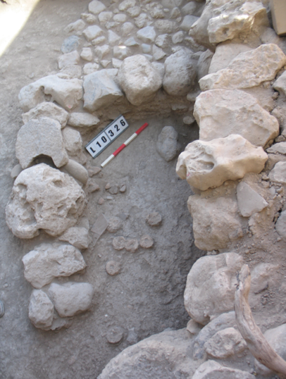Findspot

Most of the loom weights at Hazor com from scattered loci within the area and bear no connection to other textile-related tools. However, one group comes from an industrial area at the northern edge of the tell. It was here that a basalt vessel workshop (Ebeling and Rosenberg 2015; Rosenberg and Ebeling 2018), was identified outside a pillared building. The structure dates to the 9th century BCE, but was divided into smaller units in the 8th century, when the workshop was established. Three layers of beaten earthen floors have been identified in the workshop, and the fill contained ashes, organic materials, pottery sherds and pebbles. A square area delimited by two walls in the north-eastern part of the room had a dozen clay loom weights scattered on its floor (L. 10-306 and 10-326, fig. 4). Their distribution allows us to suppose that they were not being used in a loom at the moment of the building’s abandonment. Several stone installations were present in other parts of the room, along with two dozen unfinished basalt vessels, some tools and spindle whorls. Unfortunately, by the time they were studied, the loom weights had almost completely crumbled and, in most cases, did not enable a reconstruction. In Israel, the presence of textile tools in a workshop is not uncommon (Cassuto 2017, 193).

**Other tools: bone spatulae, spindles, needles**

Other objects, such as bone shafts and spatulas, can be linked to textile production. Bone shafts can be interpreted as tools used in spinning activities, as spindles or distaffs, or as object, like kohl sticks or hair pins, meant for other tasks (Peyronel 2004, 55; Sauvage 2014, 205). The discussion of their function has focused mainly on Syrian implements, but the southern Levant has yielded similar objects in Late Bronze and Iron Age contexts (Sauvage 2014, 198–200).

In Hazor, bone shafts from Area M are all datable to Iron Age II. They have diameters of between 0.7 and 1 cm, which makes them suitable as spindles/distaffs, but unfortunately are preserved in lengths of only a few centimetres, which makes their clear identification as such impossible. The fragments do not exhibit the typical decoration of lattice, herringbone and oblique patterns, but this is not surprising as the most frequently preserved part is the point of the shaft, while the decoration is generally placed on “top” of the shaft.

Bone spatulas may be connected to weaving as they could be used for packing weft and correcting small errors (Cecchini 1992, 16; Kemp and Vogelsang-Eastwood 2001, 358–73). In the Southern Levant, spatulas are particularly common in Iron Age contexts, and Hazor is no exception (Bechar 2012). They are made out of animal ribs, longitudinally cut in half, with one extremity cut to a point and the other flattened out or rounded. The points are generally short and triangular, but can take a pen-nib form as well. Implements from Hazor clearly show that they were generally not further refined but acquired smoothness through use. In fact, many objects have exposed, either rough or partly smooth cancellous bone, visible at the rounded end. The cancellous bone near the point is smoother or completely obliterated, suggesting that only the pointed part of the tool was used. Wear traces are compatible with the act of rubbing on soft materials, such as textiles and threads.

In conclusion, the textile industry in Area M appears quite modest and does not seem to indicate the presence of large workshops for the production of fabric. Tools are scattered throughout the area without indicating specific spaces for the production of textiles. The only cluster identified is that of a small number of loom weights, which suggests that they either pertained to a very small loom or were simply stored here while weaving occurred elsewhere. Most of the objects examined at the site have been dated to Iron Age II. A similar situation is evident at other Southern Levantine sites, where the largest number of recovered textile tools occur in Iron Age II contexts (*e.g*. Megiddo (Lamon and Shipton 1939, 93–95; Sass 2000, 372), such as the City of David (Shamir 1996, 135) or Tell el-Far’ah N (Chambon 1984, fig. 75). The typology of textile tools at Hazor is consistent with those found at other Levantine sites. In fact, the shapes and materials of the spindle whorls and loom weights here are comparable to those found at many other Levantine sites, such as Megiddo (Lamon and Shipton 1939, 93–95), Tell es-Safi (Cassuto 2018), the City of David (Shamir 1996), and Tel Miqne (Shamir 2007). The same holds true for the bone spatulas (e.g. Beth Shean, see Yahalom-Mack and Mazar 2006, fig. 13.10), which have likewise been unearthed in Megiddo (Lamon and Shipton 1939, 95–96) and Lachish (Sass 2004, fig. 28.12).

Fig. 1

|  |  |  |  |  |  |  |  |  |  |  |
| --- | --- | --- | --- | --- | --- | --- | --- | --- | --- | --- |
| No. | Object | Reg. No. | Chronology | Locus | Material | H. | D. | Hole | W. (g) | Notes |
| 1 | spindle whorl | 70416a | IA IIC | 6537 | ivory | 0.8 | 2.5 | 0.4 | 5.03 | dome (Cimadevilla 2012, fig. 12.2.11) |
| 2 | spindle whorl | 34618 | LBA destruction | 5571 | bone | 0.7 | 2.2 | 0.3 | 3.07 | dome |
| 3 | spindle whorl | 92956 | IA IIC | 13-522 | stone | 1.6 | 2.5 | 0.6 | 13.78 | dome |
| 4 | spindle whorl | 74688 | IA IIC | 09-345 | stone | 1.8 | 3.2 | 0.7 | 21.09 | dome |
| 5 | spindle whorl | 30891 |  | 5122 | stone | 1.4 | 2.7 | 0.4 | 11.69 | conical |
| 6 | spindle whorl | 34413 | LBA destruction | 5555 | stone | 0.9 | 2.1 | 0.25 | 5.55 | conical |
| 7 | spindle whorl | 37938 | LBA fill | 5797 | stone | 1 | 2.9 | 0.3 | 7.6 | dome |
| 8 | spindle whorl | 75485 | IA IIA-B | 10-320 | baked clay | 3.1 | 3.5 | 0.3 | 33.45 | biconical |
| 9 | spindle whorl | 76167 | IA IIA | 10-378 | bone | 0.9 | 2.4 | 0.3 | 4.48 | dome |
| 10 | prf. sherd | 38097 | IA IIC | 5784 | pottery | 0.9 | 3.4 | 0.25 | 13.8 |  |
| 11 | prf. sherd | 72359 | IA IIC | 07-332 | pottery | 0.9 | 5.3 | 0.5 | 32.65 |  |
| 12 | prf. sherd | 38800 | LBA fill | 5885 | pottery | 0.7 | 3.4x3.9 | 0.4 | 9.91 |  |

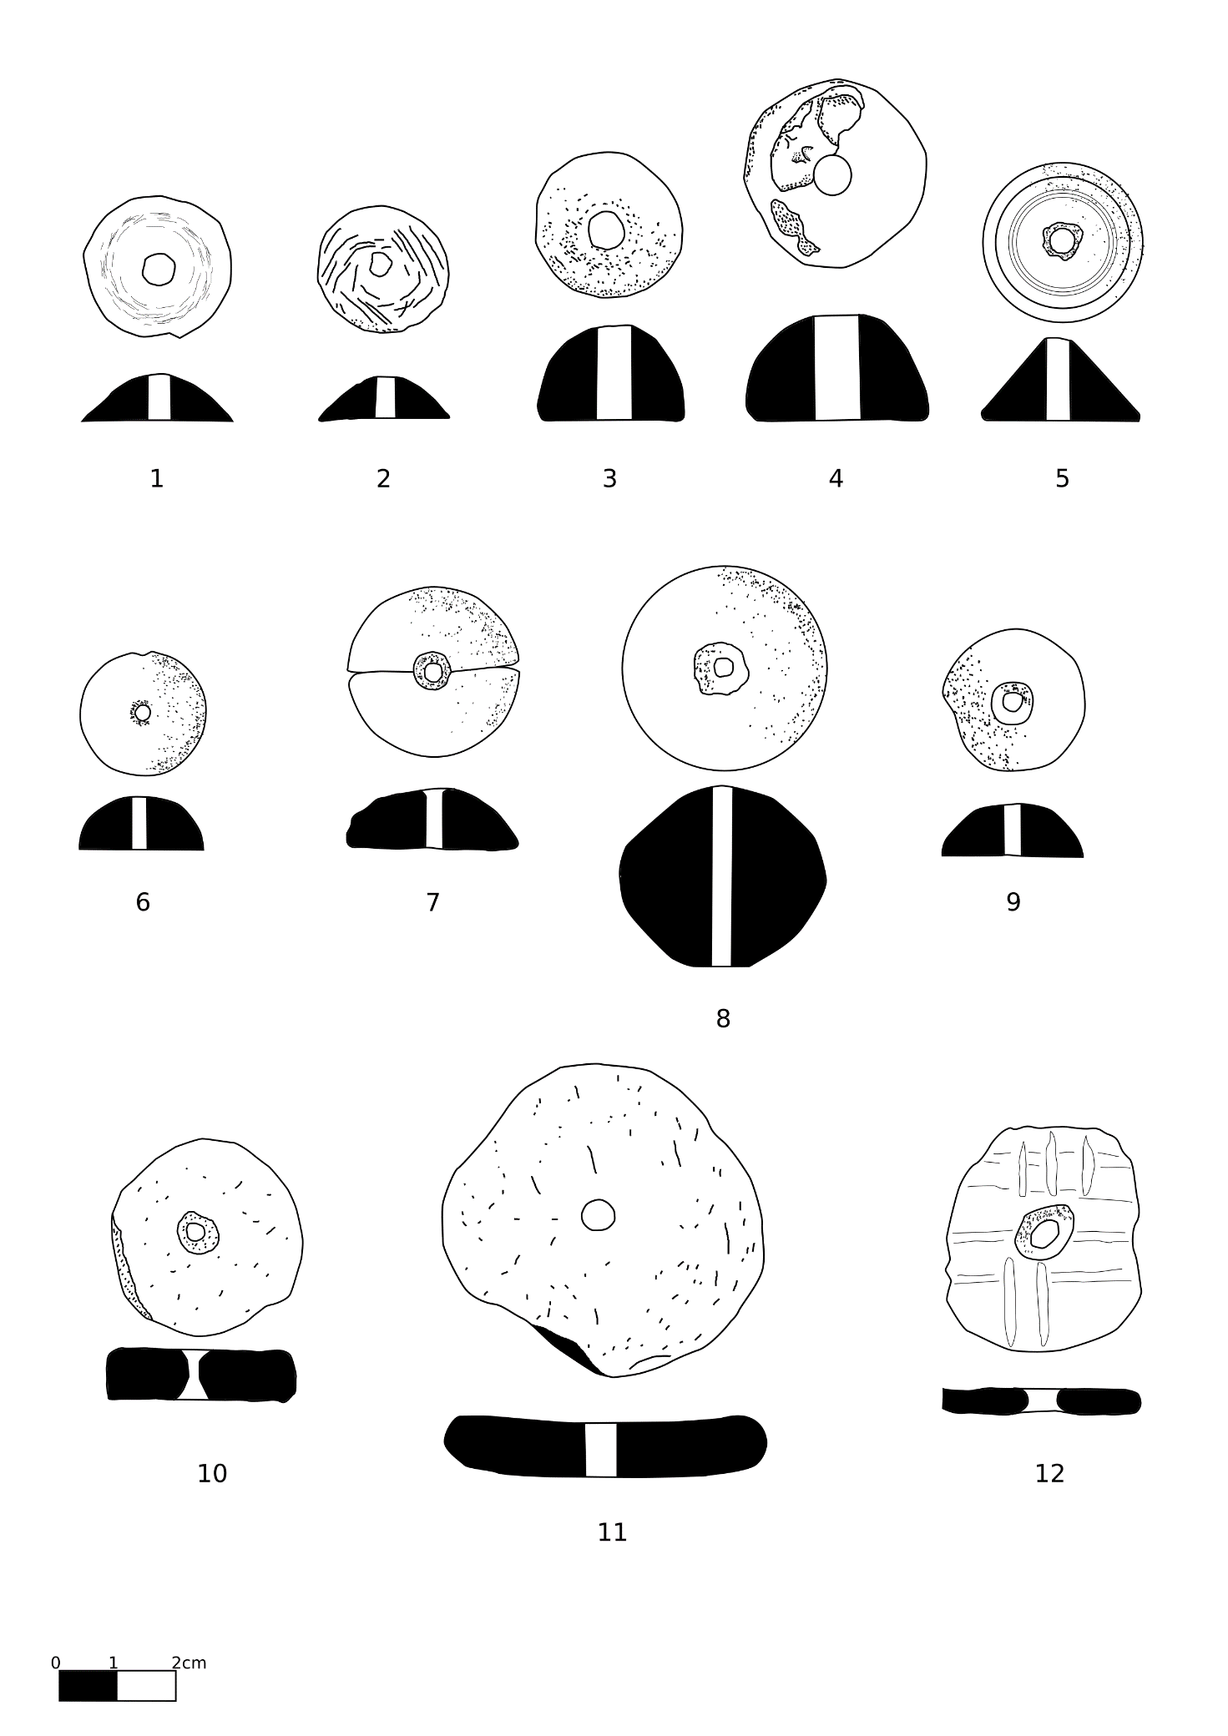

Figure 1 Spindle whorls and perforated sherds

|  |  |  |  |  |  |  |  |  |  |  |
| --- | --- | --- | --- | --- | --- | --- | --- | --- | --- | --- |
| Fig. 2 | |  |  |  |  |  |  |  |  |  |
| No. | Object | Reg. No. | Chronology | Locus | Material | H. | D. | Hole | W. (g) | Notes |
| 1 | loom weight | 34834 | baulk | 8M N 15-16 | baked clay | 4.1 | 6.4 | 1.7 | 140 | doughnut |
| 2 | loom weight | 30092 | IA IIC | 5016 | baked clay | 3.6 | 4.5 | 0.4 | 53+x | spherical |
| 3 | loom weight* | 37719 | Iron Age fill | 5772 | baked clay | 4.2 | 4.2x4.5 | 0.3 | 60.77 | biconical |
| 4 | loom weight | 37525 | Iron Age fill | 5777 | clay | 4.4 | 7.5 | 1.6 | 146+x | doughnut |
| 5 | loom weight | 70408 | LBA | 6533 | baked clay | 8.9 | 6.5 | 2.7 | 162+x | flat rectangular |
| 6 | loom weight | 72457 | IA IIC | 07-329 | baked clay | 5.1 | 5.9 | 0.6 | 148+x | spherical |
| 7 | loom weight | 72927 | IA IIC | 07-374 | baked clay | 5.9 | 8.3 | 1.3 | 233+x | spherical |
| 8 | loom weight | 73047 | IA IIC | 08-306 | baked clay | 5.3 | 7.9 | 1.5 | 232+x | spherical |
| 9 | loom weight | 76261 | IA IIC | 10-326 | clay | 3.5 | 7.5 | 1.8 | 141+x | doughnut |

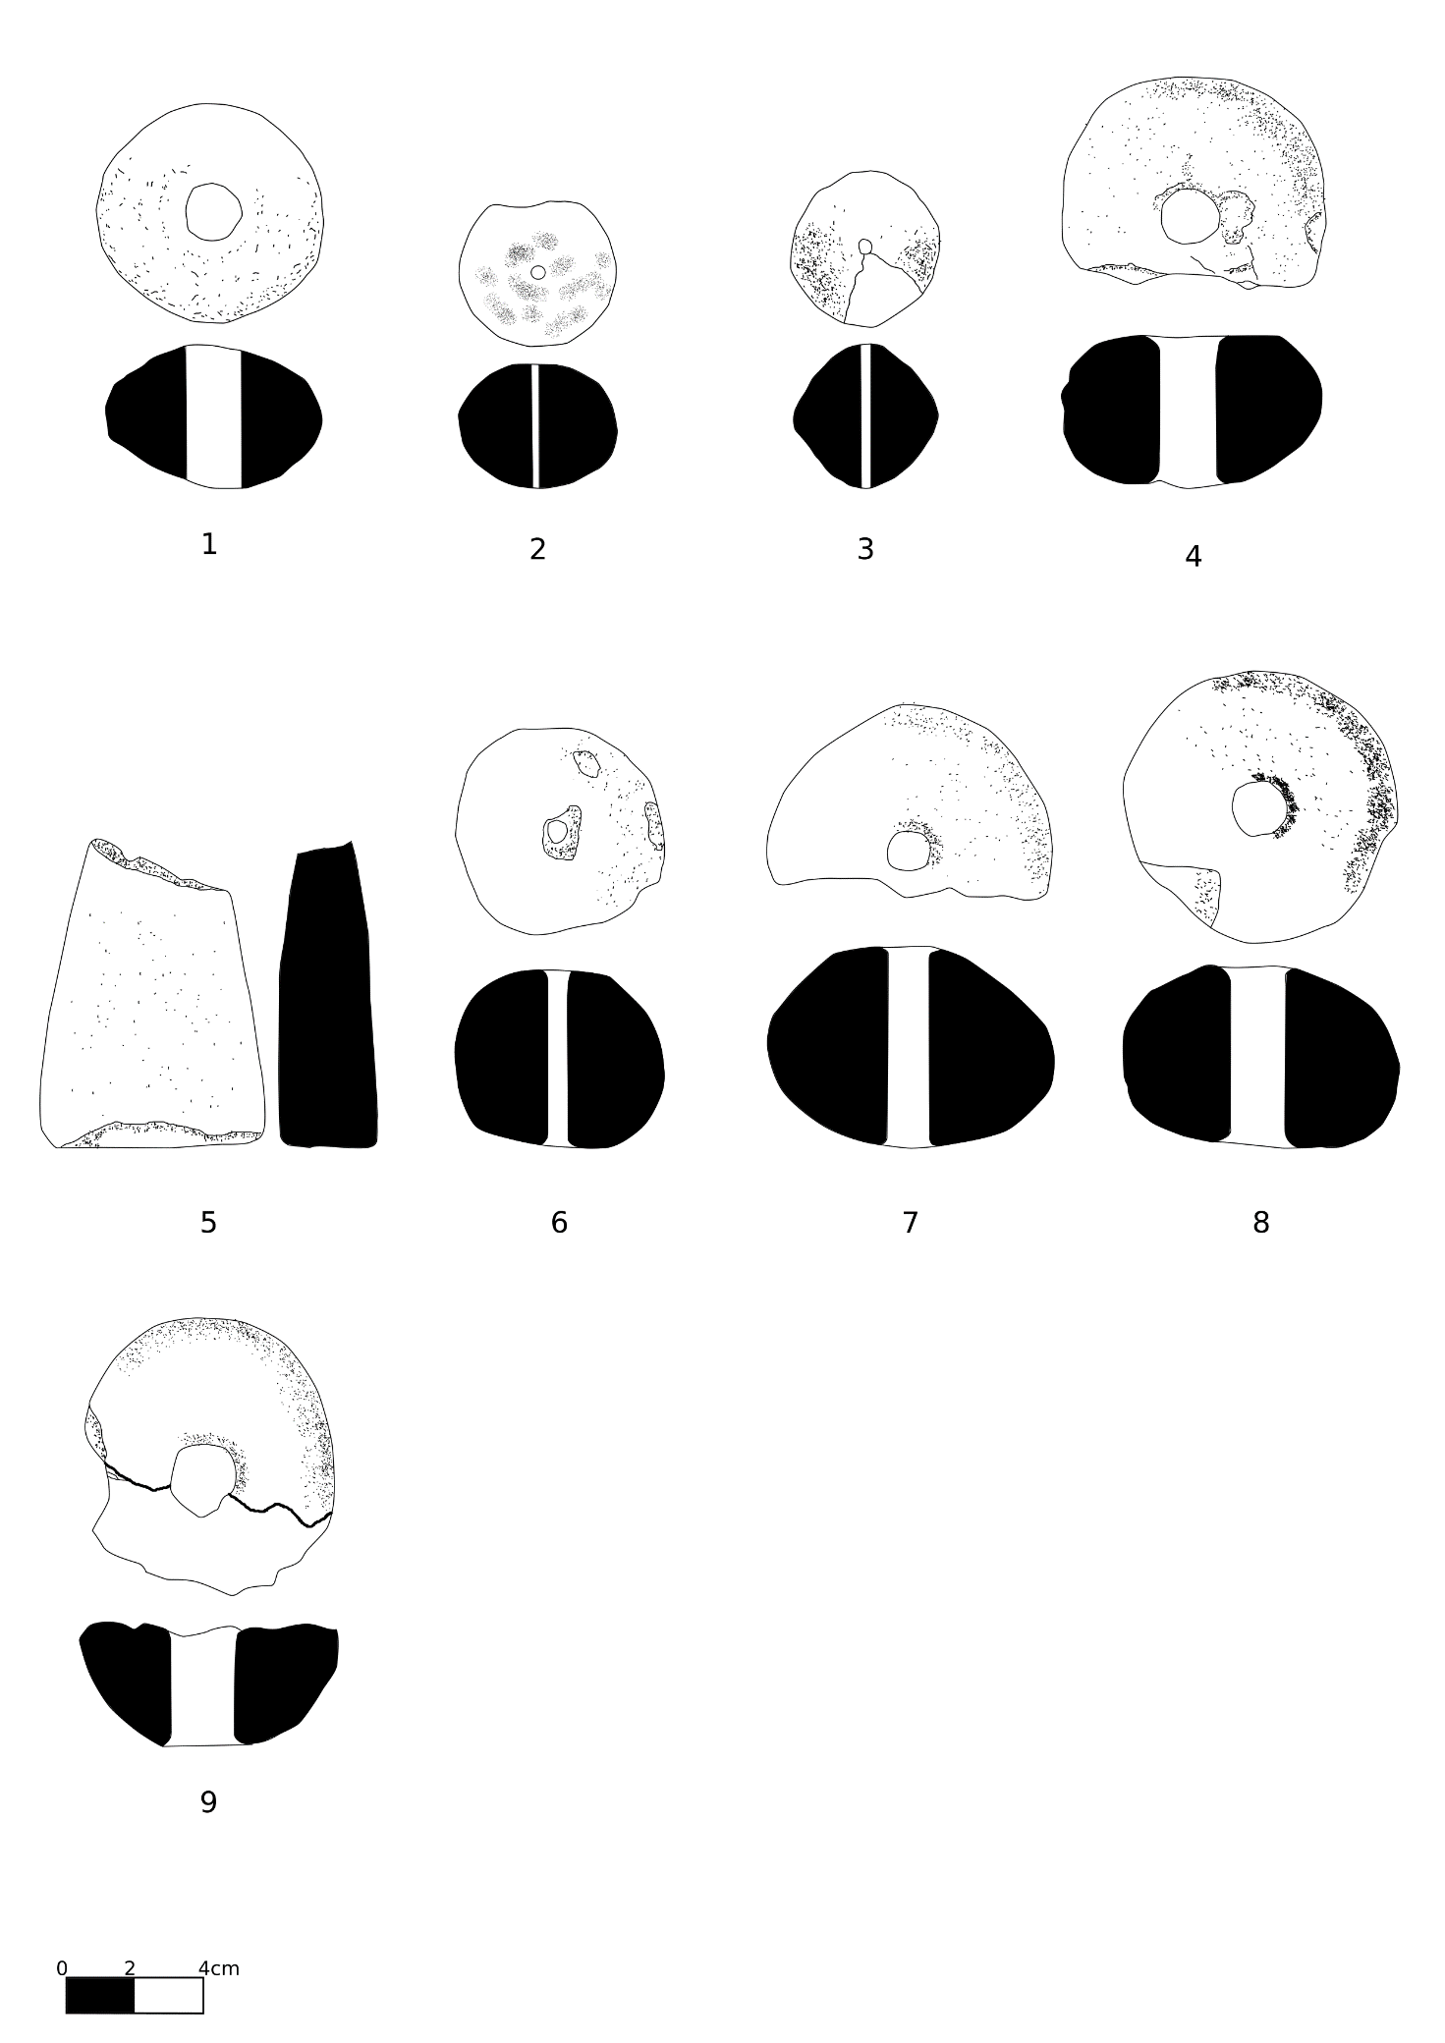

Figure 2 Loom weights

|  |  |  |  |  |  |  |  |  |  |  |  |
| --- | --- | --- | --- | --- | --- | --- | --- | --- | --- | --- | --- |
| Fig. 3 | | |  |  |  |  |  |  |  |  |  |
| No. | Object | Reg. No. | Chronology |  | Locus | Material | H. | D. | Th. | W. (g) | Notes |
| 1 | spatula | 78802 | IA IIC |  | 15-303 | bone | 4.7 | 1.8 | 0.2 |  |  |
| 2 | spatula | 74336 | IA IIC |  | 09-319 | bone | 4.1 | 1.9 | 0.1 |  |  |
| 3 | spatula | 38198 | LBA fill |  | 5801 | bone | 5.8 | 2.1 | 0.2 |  |  |
| 4 | spatula | 32407 | baulk |  | BM/L-10 | bone | 5.5 | 2.5 | 0.2 |  |  |
| 5 | spatula | 75009 | IA IIC |  | 09-350 | bone | 8 | 2.1 | 0.2 |  |  |
| 6 | spatula | 31802 |  |  | 5229 | bone | 11.9 | 2.6 | 0.2 |  |  |
| 7 | shaft | 93332 | IA IIC |  | 14-520 | bone | 4.6 | 0.7 |  |  |  |
| 8 | shaft | 73115 | 8th century fill |  | 08-316 | bone | 6.5 | 0.8 |  |  |  |
| 9 | shaft | 72378 | IA IIC |  | 07-329 | bone | 8.2 | 0.8 |  |  | floor above 10-326 |

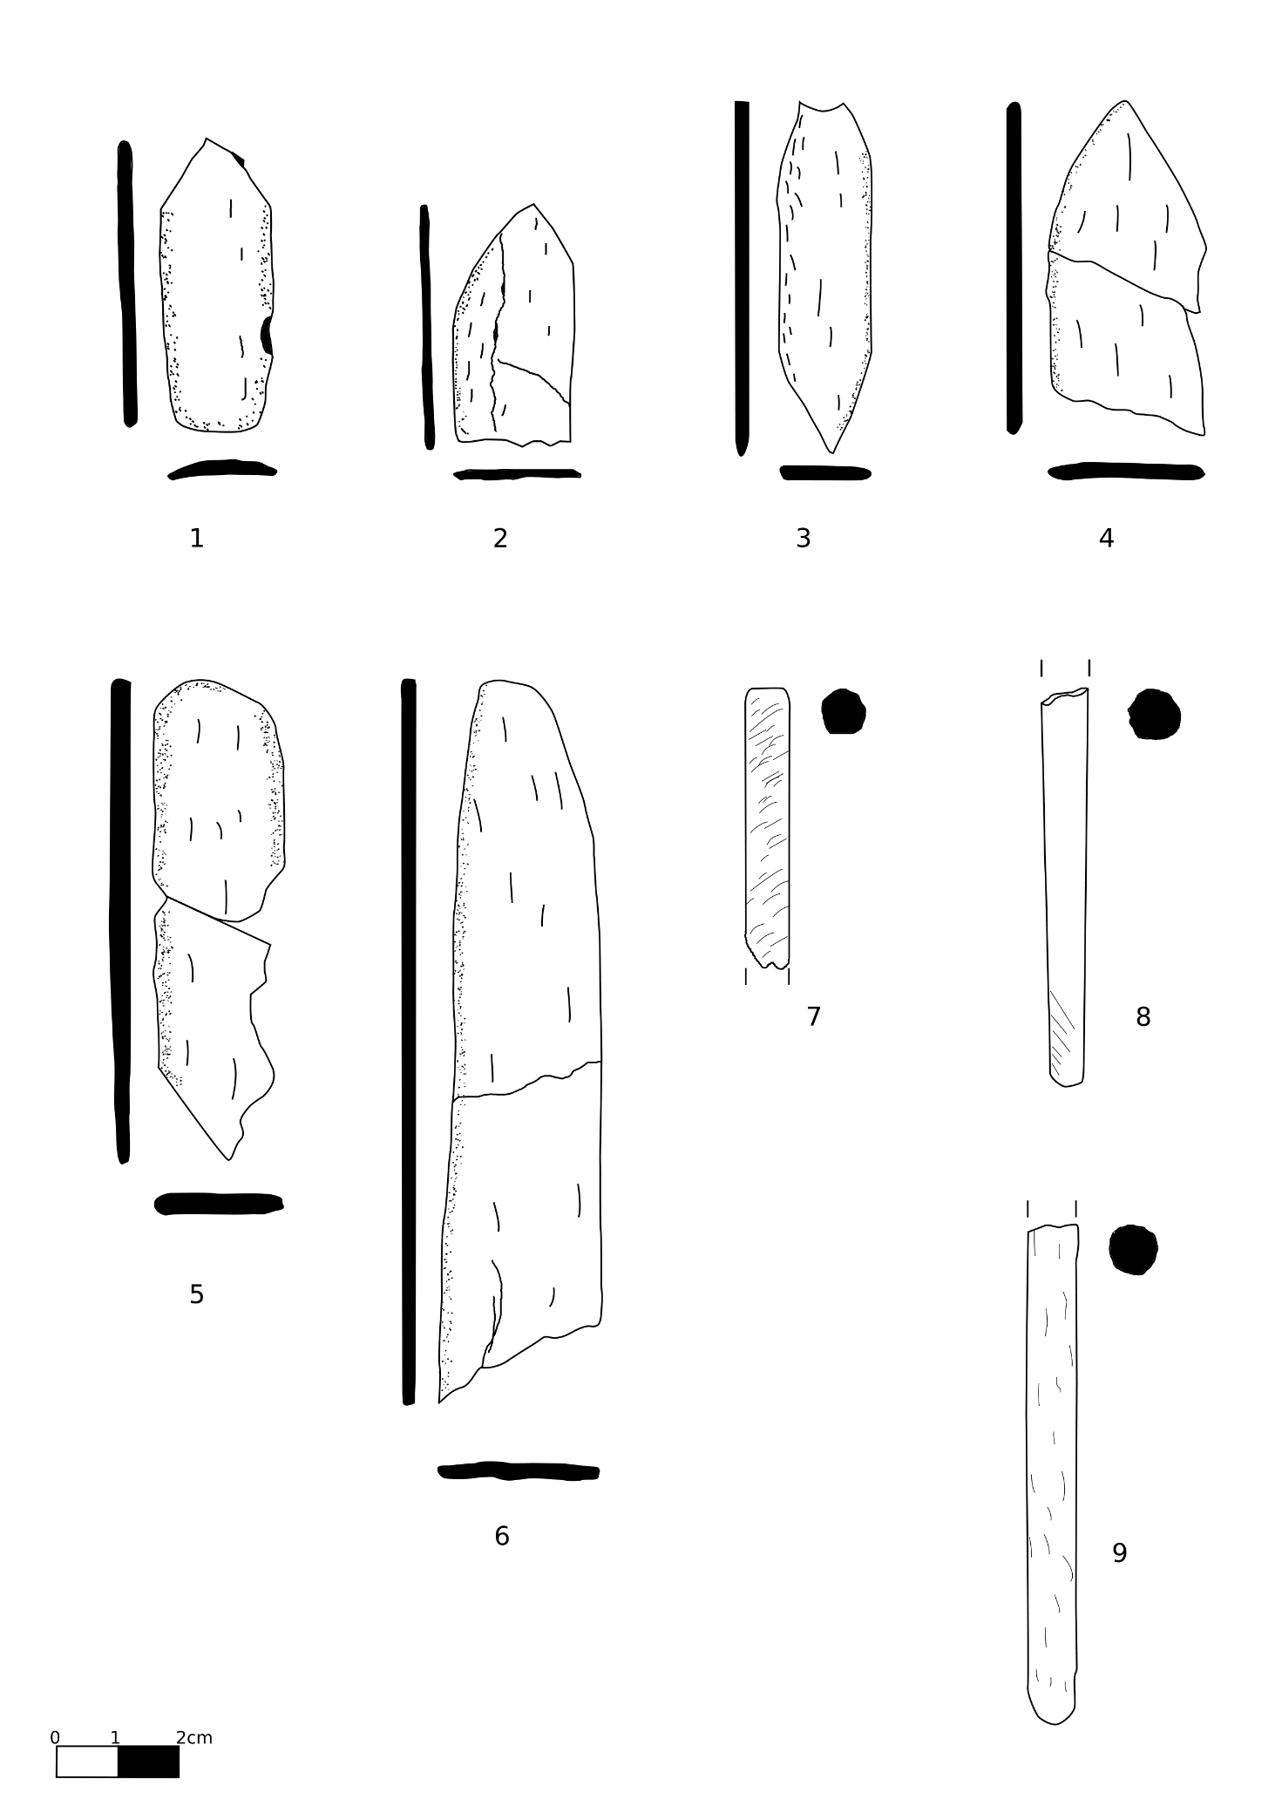

Figure 3 Bone shafts and spatulae

**Bibliography**

Andersson Strand, Eva. 2010. ‘The Basics of Textile Tools and Textile Technology’. In *Textile Terminologies in the Ancient Near East and Mediterranean from the Third to the First Millennia BC*, edited by Marie-Louise Nosch and Cécile Michel, 10–22. Oxford: Oxbow Books.

Andersson Strand, Eva. 2012. ‘From Spindle Whorls and Loom Weights to Fabrics in the Bronze Age Aegean and Eastern Mediterranean’. In *Kosmos: Jewellery, Adornment and Textiles in the Aegean Bronze Age”. Proceedings of the 13th International Aegean Conference (University of Copenhagen, Danish National Research Foundation’s Centre for Textile Research, 21-26 April 2010)*, edited by Marie-Louise Nosch and Robert Laffineur. Aegaeum 33. Liège: Peeters.

Bechar, S. 2012. ‘Worked Bone, Ivory and Horn Objects’. In *Hazor VI : The 1990-2009 Excavations: The Iron Age*, edited by Amnon Ben-Tor, Doron Ben-Ami, and Débora Sandhaus, 496–505. Jersualem: Israel Exploration Society.

Cecchini, Serena M. 1992. ‘Gli Avori e Gli Ossi. Appunti Sull’attività Tessile in Siria Del Nord Durante l’Età Del Ferro’. *Tell Afis e l’Età del Ferro* 2 (= Seminari di Orientalistica 2), 3–27. Pisa: Giardini.

Cimadevilla, Manuel. 2012. ‘Loom Weights and Spindle Whorls’. In *Hazor VI : The 1990-2009 Excavations: The Iron Age*, edited by Amnon Ben-Tor, Doron Ben-Ami, and Débora Sandhaus, 559–63. Jerusalem: Israel Exploration Society.

Ebeling, Jennie, and Danny Rosenberg. 2015. ‘A Basalt Vessel Workshop and its Products at Iron Age Hazor, Israel’. *Journal of Field Archaeology* 40 (6): 665–74.

Gleba, Margarita. 2008. *Textile Production in Pre-Roman Italy*. Oxford: Oxbow Books.

Kemp, Barry J., and Gillian Vogelsang-Eastwood. 2001. *The Ancient Textile Industry at Amarna*. London: Egypt Exploration Society.

Laurito, Romina, Cristina Lemorini, and Assunta Perilli. 2014. ‘Making Textiles at Arslantepe, Turkey, in the 4th and 3rd Millennia BC. Archaeological Data and Experimental Archaeology’. In *Wool Economy in the Ancient Near East*, edited by Catherine Breniquet and Cécile Michel, 151–68. Oxford: Oxbow Books.

Liu, Robert K. 1978. ‘Spindle Whorls. Part I: Some Comments and Speculations’. *The Bead Journal* 3: 87–103.

Peyronel, Luca. 2004. *Gli strumenti di tessitura dall’età del Bronzo all’epoca Persiana*. Roma: Università degli studi di Roma La Sapienza.

Rahmstorf, Lorenz, Małgorzata Siennicka, Eva Andersson Strand, Marie-Louise Nosch, and Joanne Cutler. 2015. ‘Textile Tools from Tiryns’. In *Tools, Textiles and Contexts. Investigations of Textile Production in the Bronze Age Eastern Mediterranean*, edited by Eva Andersson Strand and Marie-Louise Nosch, 267–78. Oxford: Oxbow Books.

Rosenberg, Danny, and Jennie Ebeling. 2018. ‘Romancing the Stones: The Canaanite Artistic Tradition at Israelite Hazor’. *Biblical Archaeology Review* 44 (1): 46–51.

Sauvage, Caroline. 2014. ‘Spindles and Distaffs: Late Bronze and Early Iron Age Eastern Mediterranean Use of Solid and Tapered Ivory/Bone Shafts’. In *Prehistoric, Ancient Near Eastern & Aegean Textiles and Dresses*, edited by Marie-Louise Nosch, Cécile Michel, and Mary Harlow, 184–226. Oxford: Oxbow Books.

Shamir, Orit. 1996. ‘Loomweights and Whorls’. In *Excavations at the City of David 4. 1978-1985: Various Reports.*, edited by Yigal Shiloh, Donald T. Ariel, and Alon de Groot, 1985:135–70. Jerusalem: The Hebrew University.

1. It does not seem necessary to separate these two typologies since all the shapes in between the two are represented in the corpus. A separation would be, in many cases, completely arbitrary.