A NEW PERSPECTIVE ON THE TIES BETWEEN MORAL CONVICTION, IDEOLOGY, EMOTIONAL INTENSITY, AND ACTION TENDENCIES

Thesis for the degree of Doctor of Philosophy

By Tziporit Glick

Submitted to the Senate of the Hebrew University of Jerusalem
March/2020

This work was carried out under the supervision of:
Prof. Eran Halperin and Prof. Maya Tamir.

Abstract
The emotions associated with moral convictions can have profound implications for societies, as they shape people’s action tendencies in response to moral events. It has been found that attitudes founded on strong moral convictions have strong ties to emotions. However, not every moral experience evokes an intense emotional reaction. In this investigation, I find that having an attitude founded on strong moral convictions is insufficient to amplify one’s emotions and influence subsequent action tendencies. Intense emotions arise in response to events that are relevant to an individual’s personal concerns, and they signal things of personal relevance. Accordingly, strong moral convictions are tied to intense emotions only when a specific situation is of personal moral relevance. In the context of intergroup conflicts, an individual’s or group’s political ideology determines their priorities with regards to their moral values, hence dictating personal moral relevance (Hibbing, Smith, & Alford 2013). The Moral Foundations Theory (MFT; Haidt & Graham, 2007; Haidt & Joseph, 2004) identifies which moral issues are personally relevant to individuals as a function of their political ideology. Building on MFT, I hypothesized that strong moral conviction would lead to intense emotional experiences and subsequent action tendencies only when an event is morally relevant to a person in terms of political ideology and based on the moral foundations endorsed by that person. This study relates to the context of intergroup conflicts. To test my model, I used validated moral scenarios, focusing on moral violations in the context of the Israeli–Palestinian conflict. These violations were based on a range of foundations and thus differed in their moral relevance to the political right and left. I found that political ideology moderated the link between moral conviction and emotional experience, with moral conviction leading to intense emotions among rightists and leftists only when it exposed them to a violation of their prioritized foundation. Additionally, I demonstrated that the
effects of moral conviction on political action tendencies are mediated by emotion, but this mediation is moderated by the match between political ideology and the moral foundation that was violated.
Keywords: Moral conviction, moral foundations, moral relevance, emotions, political action tendencies, intergroup conflict, political ideology

TABLE OF CONTENTS
Page | Section title |  | Section number
3 | Abstract |  | 1.
10 | Introduction........................................................................................................................... |  | 2.
11 | Intense Intergroup Emotions in the Context of Intergroup Conflicts......................... |  | 2.1
14 | The Relationship between Intergroup Emotions and Moral Convictions................... |  | 2.2
17 | Emotions, Moral Convictions, and Moral Relevance................................................. |  | 2.3
20 | Political Ideology, Moral Foundations, and Emotions in Intergroup Conflicts.......... |  | 2.4
23 | Current Research.................................................................................................................. |  | 3.
27 | Preliminary Study: Validation of Moral Foundation Scenarios........................................... |  | 4.
28 | Method......................................................................................................................... |  | 4.1
29 | Results........................................................................................................................... |  | 4.2
31 | Study 1.................................................................................................................................. |  | 5.
31 | Study 1A....................................................................................................................... |  | 5.1
32 | Method................................................................................................................. |  | 5.1.1
33 | Results.................................................................................................................. |  | 5.1.2
34 | Study 1B....................................................................................................................... |  | 5.2
34 | Method................................................................................................................. |  | 5.2.1
35 | Results.................................................................................................................. |  | 5.2.2
35 | Discussion........................................................................................................... |  | 5.2.3

Page
36 | Study 2.................................................................................................................................... |  | 6.
37 | Method.......................................................................................................................... |  | 6.1
38 | Results.......................................................................................................................... |  | 6.2
38 | Individualizing Moral Violation Scenario....................................................... |  | 6.2.1
42 | Binding Moral Violation Scenario.................................................................. |  | 6.2.2
45 | Discussion.................................................................................................................... |  | 6.3
46 | Study 3.................................................................................................................................... |  | 7.
47 | Method......................................................................................................................... |  | 7.1
48 | Results.......................................................................................................................... |  | 7.2
51 | Individualizing Moral Violation Scenario....................................................... |  | 7.2.1
55 | Binding Moral Violation Scenario.................................................................. |  | 7.2.2
61 | Discussion..................................................................................................................... |  | 7.3
62 | General Discussion................................................................................................................. |  | 8.
63 | Implications.................................................................................................................. |  | 8.1
66 | Limitations.................................................................................................................... |  | 8.2
67 | Conclusion.............................................................................................................................. |  | 9.
69 | References............................................................................................................................... |  | 10.

LIST OF FIGURES
Page
25 | Flowchart presenting the links between moral conviction, moral foundation, and emotions.................. | 1.
26 | Flowchart presenting the links oetween moral conviction, moral foundation, and emotions in the context of binding and individualizing moral violation............................................................... | 2.
30 | Perception of violation of binding foundation for all four scenarios............................................. | 3.
31 | Perception of violation of individualizing foundation for all four scenarios................................. | 4.
40 | Differences in the relationship between moral conviction and intergroup empathy for Palestinians among rightists and leftists....................................................................................... | 5.
41 | Differences in the relationship between moral conviction and conciliatory political action tendencies toward the Palestinians among rightists and leftists................................................. | 6.
43 | Differences in the relationship between moral conviction and intergroup anger toward Palestinians among rightists and leftists...................................................................................... | 7.
45 | Differences in the relationship between moral conviction and adversarial political reaction toward the Palestinians among rightists and leftists................................................................... | 8.
52 | Relationship between moral convictions and empathy following an individualizing violation for rightists and leftists................................................................................................................. | 9.
53 | Relationship between moral convictions and anger following an individualizing violation for rightists and leftists....................................................................................................................... | 10.
54 | Relationship between moral convictions and conciliatory political reactions following an individualizing violation for rightists and leftists......................................................................... | 11.
57 | Relationship between moral convictions and anger following a binding violation for rightists and leftists..................................................................................................................................... | 12.
58 | Relationship between moral convictions and empathy following a binding violation for rightists and leftists....................................................................................................................... | 13.
60 | Relationship between moral convictions and adversarial political reaction following a binding violation for rightists and leftists.................................................................................................. | 14.
LIST OF TABLES

30 | Means and standard deviations of moral violation of individualizing and binding moral foundation as a function of the article......................................................................................... | 1.
39 | Model statistics for the moderation model predicting intergroup empathy for the Palestinians.............................................................................................................................. | 2.
41 | Model statistics for the moderation model predicting conciliatory political action toward the Palestinians...................................................................................................... | 3.
43 | Model statistics for the moderated model predicting intergroup anger toward the Palestinians.................................................................................................................................. | 4.
44 | Model statistics for the moderated model predicting adversarial political action tendencies toward the Palestinians.............................................................................................................. | 5.
49 | Bivariate Relationships between Study 3 variables: binding scenario, rightists.................... | 6.
49 | Bivariate Relationships between Study 3 variables: binding scenario, leftists...................... | 7.
50 | Bivariate Relationships between Study 3 variables: individualizing scenario, rightists......... | 8.
50 | Bivariate Relationships between Study 3 variables: individualizing scenario, leftists........... | 9.
52 | Model statistics for the moderated model predicting intergroup empathy for the  Palestinians.............................................................................................................................. | 10.
53 | Model statistics for the moderated model predicting intragroup anger toward  Israelis....................................................................................................................................... | 11.
54 | Model statistics for the moderated model predicting conciliatory political action tendencies toward the Palestinians.............................................................................................................. | 12.
56 | Model statistics for the moderated model predicting intergroup anger toward the Palestinians.................................................................................................................................. | 13.
58 | Model statistics for the moderated model predicting intragroup empathy toward Israelis......................................................................................................................................... | 14.
59 | Model statistics for the moderated model predicting adversarial political action tendencies toward the Palestinians.............................................................................................................. | 15.

A New Perspective on the Ties between Moral Conviction, Ideology, Emotional Intensity, and Action Tendencies
The 2011 Social Protest (also known as the housing protest and the tent protest) was a series of demonstrations held throughout Israel that addressed socio-economic issues such as housing costs, rising food prices, and governmental cuts to social budgets. These protests were morally charged (a prominent slogan was “The people demand social justice”) and attracted wide participation, with a peak involvement of 400,000 demonstrators. A survey conducted by one of the most widely read Israeli newspapers (Yediot Achronot, 2011) found that 88% of the Israeli public supported the protests, indicating that it represented a broad and cross-sectoral (social and political) public moral issue. Nevertheless, not all Israeli citizens exhibited the same intensity in their emotional and behavioral responses regarding the protesting events. Among those who supported the protests, some felt outraged and acted accordingly, but others felt mere discomfort. Why?
Previous research has found that moral convictions, or the extent to which people’s evaluations of issues and events are imbued with a sense of morality (Skitka, Bauman, & Sagris, 2005), amplify people’s emotions, and, in turn, their behavioral tendencies (e.g., Skitka, 2010, 2014; see also Arsenio & Lover, 1995; Haidt, Skoe, Eisenberg, & Cumberland, 2002; Skitka & Wisneski, 2011; Tangney, Stuewig, & Mashek, 2007). However, in this study, I argue that stronger moral convictions are not necessarily linked to more intense emotional reactions. Instead, intense emotions are elicited by the subjective evaluation of a situation and signal things that are personally relevant to the individual (i.e., personally important to the individual or linked to significant personal values) (Lazarus, 1993; Smith & Ellsworth, 1987). Moral convictions are basic evaluations of what is moral or immoral, and "hat is right/ r wrong. Although." ty signal when a specific situation is morated to morality, , bu they do ecessarily signal personal relevance. That is T not every l conviction will lead leadse emotion. Instead, I suggest that it is only when an event is both morally related and personally relevant will that moral ction lead leads to in emotion.
However, in a given socio-political context, how can we know which events in particular will be of moral relevance? Political ideology reflects the values that are most significant to people and determines the extent to which issues and events are perceived as personally relevant. Moral Foundations Theory (MFT; Haidt & Graham, 2007; Haidt & Joseph, 2004) describes howdiffsonally-relevant moral issues are perto among diffnt indas a function of their ideology. The mapping Minge's moral re in line with M and as reflected by political ideology, would suggesthat moral convictions would translate iotional reactions and subsequent then a onlywnevent s of m relevance to the personindividual. Thevance stems from , as reflected by the thatel’s endorhrsed byt il and is reflected in his or her by political ideology.
Intense Intergroup Emotions in the Context of Intergroup Conflicts
Intergroup political conflicts are perceived as essential, irresolvable, and possessing enduring and destructive elements of mutual violence (Bar-Tal, 2007). Intense emotions such as anger and hate on the one hand, and compassion and empathy on the other, are an integral part of intergroup conflicts. It is customary to think that emotions involve a subjective reaction to a stimulus, and that they, rather than events per se, determine whether an emotion will be felt and which emotion it will be. Emotions arise in response to matters or situations people find personally significant and relevant (Roseman & Spindel, 1990). Thus, in the case of intergroup conflicts, intense emotions frequently surface around issues that people personally view as crucial and existential, and these emotions are potentially associated with attitudes and readiness to act.
Intergroup emotions are most prevalent in the context of intergroup conflict. They are experiences felt by individuals as a result of their belonging to or identifying with one social group, targeted at another social group (Smith et al., 2007; Smith & Mackie, 2008). Intense intergroup emotions typify intergroup conflicts and may be powerful engines contributing to their formation, preservation and escalation, as well as their resolution (Bar-Tal & Halperin, 2011, 2013; Halperin, Sharvit, & Gross, 2011; Maoz, 2011; Staub, 2005).
Research has shown that both negative and positive intergroup emotions serve as important factors in influencing political attitudes and behavior in the context of intergroup conflicts. Negative intergroup emotions such as fear (Lerner, Gonzalez, Small, & Fischoff, 2003; Maoz & McCauley, 2009), anger (Bar-Tal, 2007; Halperin, Russell, Dweck, & Gross, 2011), and hatred (Halperin, 2008; Maoz, Bar-On, & Yikya, 2007) were found to hinder progress toward conflict resolution and were associated with aggressive reactions and the escalation of political support for war (Lerner et al., 2003; Skitka, Bauman, Aramovich, & Morgan, 2006). Similarly, positive emotions such as hope (Cohen-Chen, Halperin, Crisp, & Gross, 2014), sympathy (Maoz & McCauley, 2005), and empathy (Stephan & Finlay, 1999) have been linked to reconciliatory behavior in conflicts.
The current study joins accumulated research (e.g., Halperin, 2016; Kamans, Zomeren, Gordijn, & Postmes, 2014; Maoz & McCauley, 2008; Porat, Halperin, & Tamir, 2016; Rosler, Cohen-Chen, & Halperin, 2017) in examining the role of intergroup emotions in the context of intergroup conflicts, and focuses on understanding the differing intensities of intergroup emotions in the context of intergroup conflict. In this study I focus on two intergroup emotions, anger and empathy, that play a prominent role in intergroup conflict. Anger, in the context of political conflict, is usually targeted at the perpetrators of various actions in the conflict, whereas empathy is targeted at the targets of such actions. (Gray & Schein, 2012). Past research has established that both anger and empathy are relevant at all stages of conflict, have high motivational potential, and may have a powerful influence on people’s political actions (e.g., Halperin, 2016; Halperin, Russel, Dweck, & Gross, 2011; Kamans et al., 2014; Maoz & McCauley, 2008; Porat, Halperin, & Tamir, 2016).
Anger erupts when individuals feel that the improper actions of others have unjustly prevented them from attaining a goal; yet they feel capable of altering the situation (Frijda, 2004). Empirical evidence has shown that intergroup anger promotes intergroup aggression (Lerner et al., 2003; Skitka et al., 2006), which is positively linked to the attribution of blame to the outgroup (Halperin, 2011), and to an unwillingness to reconcile with adversaries (Lerner et al., 2003). In contrast, empathy is generally regarded as an other-oriented cognitive and emotional response elicited by the need or distress of another person (Batson, 2008; Batson & Shaw, 1991). In the context of intergroup conflicts, research has shown that empathy toward the outgroup “breaks” emotional and cognitive barriers and predicates support for compromises (Maoz & McCauley, 2005, 2008), support for conciliatory actions (e.g., Pliskin, Bar-Tal, Sheppes, & Halperin, 2014), and less support for aggressive policies (e.g., Rosler et al., 2017).
Although research has established that intense emotions are embedded in intergroup conflicts and are influential factors in the cycle of intergroup conflict, the nature of this connection requires further scrutiny. In particular, it remains unclear what leads people to experience such intense emotions in this context? Why do people differ in the intensity of their emotions in reaction to emotionally charged events? How do these differences in emotional intensity translate into political reactions? Recent research on emotions in the context of intergroup conflict has focused on the associations between emotions and morality. Intergroup political conflicts are morally charged; they often pose moral issues and dilemmas that require people to concentrate on their morality (Lammers & Stapel, 2009). Therefore, examining the interplay between morality and emotion can potentially shed light on the role of emotions in the cycle of intergroup conflict.
The Relationship between Intergroup Emotions and Moral Convictions
The belief that emotions and morality are deeply interrelated has long-standing roots in both theories and research (for reviews, see Chapman & Anderson, 2013; Damasio, 1994; Eisenberg, 2000; Greene, 2008; Haidt, 2001; Nichols, 2004; Pizarro & Strohminger, 2014; Tangney, Stuewig, & Mashek, 2007). Emotions help us to distinguish the moral features of a given situation, they influence the link between moral features and moral standards, and they help us mobilize the resources needed for moral behavior (Ben Zeev, 1996). Thus, when we evaluate something as moral, our evaluation will often be accompanied by intense emotion. It has been found that emotions play a key role in how people form or strengthen morality, and provide the motivational force to do good and avoid wrongdoing (Kroll & Egan, 2004; Pagano & Huo, 2007).
Recently, researchers at the intersection of social and moral psychology focused on the associations between moral conviction and emotion, suggesting that moral conviction is associated with intensity of emotion (Skitka, Bauman, & Mullen, 2004, Mullen & Skitka, 2006). Moral conviction reflects the extent to which a person believes that a particular attitude is connected to his or her fundamental sense of what is right or wrong, moral or immoral (Skitka et al., 2005; Skitka & Morgan, 2014). Although everyone has moral convictions, the extent to which a particular attitude reflects a sense of moral conviction differs from person to person, so that even issues thought to be quintessentially moral are actually only vested with moral conviction in the eye of the beholder (Skitka, 2014).
A vast body of research has shown that attitudes vested with moral conviction differ from non-morally convicted attitudes (Skitka, Bauman, & Mullen, 2008). For example, moral convictions are often perceived to be objective, universal, independent of majority influence (Aramovich, Lytle, & Skitka, 2012), and independent of authority (Skitka, Bauman, & Lytle, 2009). One major contribution of moral conviction research highlights the unique associations between moral conviction and emotions. The Integrated Theory of Moral Conviction (Skitka et al., 2008) maintains that people who anchor moral conviction to their worldview and attitudes are more likely to experience intense negative and positive emotions in this regard (Skitka, Bauman, & Sagris, 2005). People’s core beliefs, values, and moral order give them a sense that their lives and experiences are stable and ordered (Pyszczynski, Solomon, & Greenberg, 2003), and that threatening these existential needs might lead to intense negative emotions like outrage, anger, and contempt. Conversely, if the issue corresponds to their deep-seated moral convictions, they experience it as validation and reassurance of their moral expectations, leading to an intensification of positive emotions. Emotions concerning moral violations are especially strong, since moral violations represent attacks on one’s underlying worldviews and sense of moral order (e.g., Tetlock, Kirstel, Elson, Green, & Lerner, 2000). One may feel outrage, contempt, and disgust when exposed to violations of one’s moral convictions (e.g., offensive graffiti on a house of prayer), but when exposed to a violation of strong, but non-moral, attitudes (e.g., offensive graffiti on an unauthorized wall in the street) such intense emotions will probably not arise.
Studies (Arsenio & Lover, 1995; Brandt, Wisneski, & Skitka, 2015; Mullen & Skitka, 2006; Skitka & Wisneski, 2011; Skitka, Hanson, & Wisneski, 2017) support the hypothesis that strong connections exist between moral conviction and emotions. For example, in a study that examined moral conviction regarding the Iraq War, Skitka and Wisneski (2011a) found that people whose moral opposition to the Iraq War was high rather than low experienced more negative emotions (i.e., anger and anxiety) with regard to America’s military response. In contrast, supporters whose moral conviction was high experienced more positive emotions (i.e., pleasure and satisfaction) with regard to America’s military response, compared to those low in moral conviction. These results emerged even when controlled for a variety of measures of attitude strength.
Researchers seem to agree that not only do attitudes vested with moral conviction predict intense emotions, but also that these emotions lead to subsequent action tendencies (Greenberg, Solomon, & Pyszczynski, 1997; Mullen & Skitka, 2006; Tetlock, Kirstel, Elson, Green, & Lerner, 2000). For example, the connection between the moral conviction of legalizing physician-assisted suicide and behavioral intent (i.e., willingness to engage in activism for or against physician-assisted suicide) was partially mediated – through negative emotions for opponents of physician-assisted suicide and positive emotions for supporters of physician-assisted suicide (Skitka & Wisneski, 2011). The mediation effect of emotions on the connection between moral conviction and behavior was replicated in the context of intergroup conflicts. Reifen-Tagar, Morgan, Halperin, and Skitka (2014) found that political-ideological differences (e.g., leftists, rightists) in acceptance of polarized policy preferences (e.g., collateral damage to civilians, support for retribution, and support for compromise) were significant only when people’s positions about the conflict were held with high moral conviction, and the presence or absence of emotion (guilt regarding harm) mediated the effects of moral conviction on policy preferences.
Though research has unequivocally demonstrated a strong interconnection between emotions and moral conviction, and has established that moral convictions amplify emotions and subsequent action tendencies, examining this interconnection in real-life events, such as in the context of political intergroup conflict, reveals a more nuanced picture. In a political context, we often see that though people hold moral convictions regarding political issues in general, when they encounter concrete events that are related to these general issues they respond with different emotional intensities. For example, most Israeli Jews hold strong moral convictions about the Israeli-Palestinian conflict. Despite that, intergroup conflict events such as the trial of Elor Azaria, or the visits of Israelis Knesset members to security prisoners, will evoke different intensities of emotional reactions; some feel intense fury and outrage toward the wrongdoers while others may feel mere dissatisfaction. Similarly, in these events, some Israelis feel deep sorrow and guilt for the victim while others will merely experience discomfort. If so, why do some people who perceive an issue as morally convicted react with emotional intensity, while others who see the issue as equally related to their moral conviction do not? In other words, what causes moral conviction to stimulate intense emotions in response to events of moral violation?
Emotions, Moral Conviction, and Moral Relevance
Appraisal theorists (e.g., Arnold, 1960; Frijda, 1986; Lazarus, 1991; Oatley & Roseman, 1979, 1984; Smith & Ellsworth, 1985), posit that emotions are elicited when a person evaluates an event or situation as important for his or her well-being and central concerns. Furthermore, they hold that the quality and intensity of the elicited emotion are not triggered by the ‘objective’ features of the situation itself, but by the person’s subjective evaluation of the situation, and that these personal appraisals are necessary to determine different emotional reactions toward a particular situation. This hypothesis is supported by empirical findings (e.g., Ellsworth & Smith, 1988; Folkman & Lazarus, 1985; Smith & Ellsworth, 1987; Smith & Lazarus, 1993).
A core assumption of appraisal theories of emotions is that when people experience an event, they evaluate its significance according to a number of criteria such as its importance and consequences for one’s well-being (e.g., Roseman & Smith, 2001). Lazarus (1991) distinguished between primary appraisal - people’s evaluation of whether the event is relevant or irrelevant for their well-being, and secondary appraisals - people’s evaluation of whether they can cope with it. The primary appraisal confers personal relevance and is related to the intensity and valence of the emotion. (Folkman & Lazarus, 1985; Lazarus, 1991). The intensity of emotions, therefore, depends on what is personally relevant to the individual. Not everyone and not everything has emotional significance for us. We may have opinions about many issues and events, but not every important issue per se will elicit intense emotions.
In line with this argument, possessing a moral conviction regarding a moral event/issue may not be enough to induce intense emotions. Moral convictions are basic evaluations about whether a particular issue or event is “right” or “wrong,” “moral,” or “immoral”, signaling whether the specific event is morally related or not, in the eye of the beholder. However, these moral evaluations are basic and generic and do not impinge on other aspects or characteristics of those issues (Graham et al., 2013). The ‘dogmatic’ nature of moral convictions is evident in research examining the frequency and targeting of moral conviction in everyday life. It has been found that people constantly moralize experiences and objects. People often even treat everyday objects (like refrigerators) as if they possess intrinsic moral qualities (Kreps & Bloom, 2008). In an ecological momentary assessment study, Hofmann, Wisneski, Brandt, and Skitka (2014) examined how often people, in their daily life, are exposed to issues or events and identify them as moral or immoral. For three days, each participant was randomly signaled five times daily to indicate whether they had been exposed to a moral/immoral act within the past hour. Out of 13,240 reports, in 28.9% of responses participants reported experiencing a moral/immoral event. Given the frequency and targeting of moral convictions, we can assume that moral convictions do not necessarily involve any intricate effortful analysis, but rather a quick and unidimensional evaluation of the “moralness” of things. This dogmatic nature of evaluation could also explain the findings showing that moral convictions are often perceived as objective and independent of majority influence (Aramovich, Lytle, & Skitka, 2012), and of authority (Skitka, Bauman, & Lytle, 2009). Moral convictions are therefore theoretically not sufficient to elicit intense emotions, as not every right and wrong is personally relevant.
As presented, moral convictions are broad and unidimensional. However, specific events that may be related to moral convictions are often richer, multifaceted, and can involve more complex moral meanings. The moral meaning of an event, the particular content and nature of the violation, shapes the personal relevance of the event. This can be clarified by examining the examples in the context of the Israeli-Palestinian conflict: Individuals holding strong moral convictions about the Israeli-Palestine conflict who are exposed to specific events such as Elor Azaria’s trial and Israelis’ Knesset members’ visits to security prisoners, might evaluate both events as moral concerns (meaning they are morally related, and they are either “wrong” or “right”). However, these judgments of “moralness” do not include evaluations of the nature of these moral events (meaning; what makes these events moral in the eyes of the beholder). What makes the specific event moral in the eyes of a specific person will determine its personal relevance. One might experience Elor Azaria’s trial as important and relevant to one’s most profound values, whereas Israeli Knesset members’ visits to security prisoners will not be of great personal relevance. Since only events of personal relevance will elicit intense emotions, we would expect that moral conviction regarding Elor Azaria’s trial would elicit strong emotions, but moral conviction regarding the Israelis Knesset members’ visits would not do so.
Therefore, I posit that in order for a moral event to elicit strong emotions the event will be both related to strong moral conviction and its prominent features will be personally relevant to an individual. Given that emotional experiences related to moral convictions must be directed to personal valences, in the context of intergroup conflicts, to understand how moral conviction shapes emotional reactions it may also be necessary to examine moral relevance as a potential explanation for these complex associations.
Political Ideology, Moral Foundations and Emotions in Intergroup Conflicts
Intergroup political conflict encompasses a broad range of moral situations that are translated into moral convictions. According to the Integrated Theory of Moral Conviction (Skitka et al., 2008), when people are exposed to political events related to their moral convictions they are expected to react with emotional intensity. However, as I have shown, these moral convictions are not necessarily linked to intense emotions. To understand and predict when moral convictions will be tied to intense emotions it is necessary to extract from within a particular event, those values that have the most significance and personal relevance for the individual. In the context of intergroup conflicts, political ideology is a useful tool for prioritizing personal moral concerns and attitudes.
Political ideology is defined as an “interrelated set of attitudes and values about the proper goals of society and how they should be achieved” (Tedin, 1987, p.65). Though there are numerous definitions of ideology (Gerring, 1997), the prevailing assumption is that political ideology is anchored in implicit evaluations that spring from deep psychological and dispositional mechanisms (Hibbing, Smith, & Alford 2013). As such, political ideology shapes and reflects people’s goals, expectations, and values, and determines the personal relevance of political-moral events. Moreover, in contrast to political worldviews and belief systems, political ideologies are concrete and specific (Keohane, 1976), content-laden, and context-dependent (Gerring, 1997), hence they are efficient tool for individuals to evaluate specific situations. Due to these characteristics, political ideology is perceived as a powerful and unique predictor of moral concerns (Graham, Haidt, & Nosek, 2009).
In this sense, political ideology is distinct from moral conviction (in a political context). While moral conviction is a basic moral evaluation characterized by valence (“right”/“wrong”, or “moral”/ “immoral”), political ideology is a more complex and differentiated evaluation and refers to the moral content of the event. Each ideology sets the hierarchy of values and attitude, which determines the personal relevance of the moral content in a particular event and its moral prominence. Therefore, differences in which moral issues and events are personally relevant to different individuals will be a function of their political ideological position. For instance, in the context of intergroup conflicts individuals might be exposed to moral events such as collateral damage and burning another nation’s flag and perceive them both as moral related. However, these evaluations of “moralness” involve different moral content; collateral damage is concerned with harm and unfairness to innocent victims, whereas burning another nation’s flag is concerned with degrading traditions, authorities, and symbols of nations. Conservative ideology versus liberal ideology might prioritize these events in a different moral order, thereby determining the different personal relevance of the event, and thus shaping the intensity of the emotional reaction.
There is a great deal of variation in the moral order posed by ideologies. One explanatory theory that lays out differences in which moral issues are personally relevant to different individuals as a function of their ideology is the Moral Foundations Theory [MFT] (Haidt, 2012; Haidt et al., 2004, 2007). MFT proposes that morality is organized, prior to the experience, by psychological mechanisms termed “moral foundations”. These moral foundations are thought to be innate and universal, and, at the same time, highly dependent on cultural institutions and practices (Graham et al., 2011). Each foundation represents a set of intuitions that have evolved to resolve certain social dilemmas. The MFT delineates five psychological moral foundations: (a) care/harm, (b) fairness/unfairness, (c) loyalty/betrayal, (d) authority/subversion, and (e) sanctity/degradation. These foundations are distinct from one another and appear regularly in many contexts (Graham et al., 2013).
MFT suggests that within different ideological positions, what will determine personal values are the moral foundations. Studies show that liberals and conservatives consider different moral foundations to be important and relevant (Haidt, Graham, & Craig, 2009; Haidt, Graham, & Joseph, 2009; Graham et al., 2011; Nilsson & Erlandsson, 2015). Liberals endorse the care/harm and fairness/unfairness foundations (individualizing foundations) more strongly than the other foundations. Conservatives endorse all five foundations, but the hierarchy of the foundations is less clear, and compared to liberals, conservatives endorse the loyalty/betrayal, authority/subversion, and sanctity/degradation foundations (binding foundations) more strongly (Graham et al., 2009).
MFT (Haidt & Graham, 2007; Haidt & Joseph, 2004) indicates a point of convergence linking the order of moral foundations and political ideology as “back-to-back” concepts, both seeking to define personal moral relevance. As described, political ideology is defined as an implicit evaluation that springs from deep psychological and dispositional mechanisms (Hibbing, Smith, & Alford, 2013), thus conceptualized as a psychological mechanism similar to how moral foundations are conceptualized, Given that, and in line with theories on moral emotions (Haidt, 2003; Tangney, Stuewig, & Mashek, 2007), and the Integrated Theory of Moral Conviction (Skitka et al., 2008), I propose that the intensity of emotional experiences associated with moral conviction will depend on the mapping of people’s moral relevance, in line with MFT and reflected by political ideology,
Up to now, theories on emotions and convictions proposed that when people are exposed to events related to their convictions, they could be expected to experience intense emotions. However, this convention does not fully represent the everyday moral dynamic. I propose that intense emotional reactions and subsequent tendencies of political action may depend both on moral conviction (what is right or wrong) and political ideology (as reflecting the endorsed moral foundations - what matters to me). Overall, I argue that when exposed to moral violations, people with strong moral convictions will not always have intense emotional reactions and subsequent action tendencies. Rather, these reactions will be moderated by people’s political beliefs that are connected to their fundamental moral beliefs.
Current Study
The mapping of conceptions of moral relevance, following MFT and as reflected in political ideology, suggests that moral convictions translate into emotional reactions and then to action tendencies only when the event’s most prominent features are morally relevant to a person’s endorsed moral foundations, as reflected in his or her political ideology. Figure 1 presents the proposed conceptual model, showing why and when moral conviction will or will not stimulate intense emotion in response to events of moral violation.
This investigation tests the hypothesized model in the context of intergroup conflicts. Because individuals who hold right-wing viewst(h conservative ideology) and those with left-wing viewsl(h liberal ideology) differ with respect to the roral foundations they endorse, I hypothesize that when a specific mvent cnvolves moral considerations aboutthpholding and binding thgroup (for example,suchwing loyalty to the in-group by protecting its positive image), strong moral conviction will wills to intnse emotional experiences among rightists but not among leftists. . In con leftiststrast, I that butt rightists, when moral evenidance and care for individuals (such as showing care for injured outgroup members), then strong moral conviction will lead leads to intense emotionnces, and in turn to respectively relant andets, but not a rightists. As suggested, moral releance is reflected reflects by a the correlation between ndation rvao the a specific event and the political ideology theividual holds. Figure 2 presents the proposed model in the context of binding and individualizing moral violations.

Life-Event/Issue
No
Yes
Is the foundation prominent in the event (Individualizing/Binding) is of a prioritized concern to me?
Yes
Personal moral relevance
Correspondinged action tendency
No moral relevance
Is it a moral event?
Do I hold moral conviction regarding it?
Intense emotion
Low emotion

Figure 1. Flowchart presenting the links between moral conviction, moral foundation, and emotions

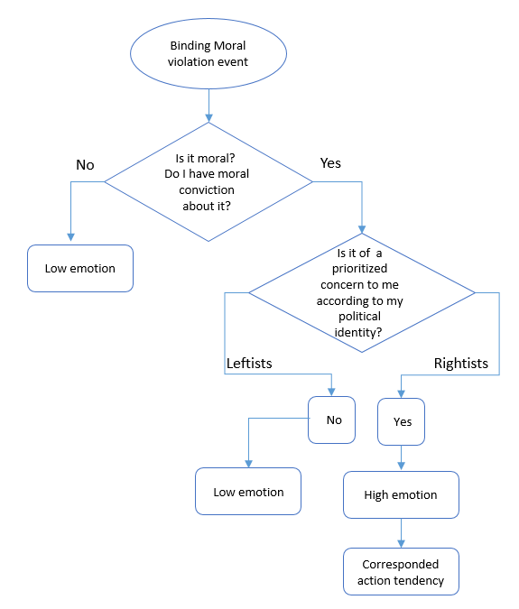
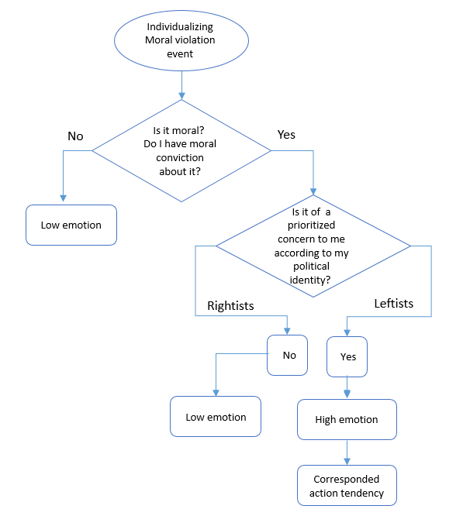

Figure 2. Flowchart presenting the links between moral conviction, moral foundation, and emotions in the context of binding and individualizing moral violation.

This study was conducted within the context of the Israeli–Palestinian conflict, which is persistent, violent, and perceived by most of those involved as irresolvable (Bar-Tal, 2013). This conflict is highly salient to the lives of Israelis, evoking vociferous divisions (including ideological divisions) within Israeli society due to its relevance to individuals’ primary and morally charged goals, values, and ideologies (Bar-Tal, 2013). In this context, moral events are more persistent, have robust emotional backing, and can be expected to have higher intensity. Moreover, in this context, moral events are characterized by the complexity and multiplicity of the moral considerations considered relevant; for this reason, differences in people’s sense of the relevance of certain moral considerations can be expected.
I conducted three studies to test the proposed model. I first conducted a Ppreiminary sStud to validate moral violation scenarios, ithe context of the Israeli-–Paestinian conflict, wh Study 1A (N = 120) and Study 1B (N = 84) ), examined the association between moral convictions and anger among rightists and among leftists in a binding moral violation scenario amon I also examined the association between moral convictions and empathy in an individualizing moral violation scenario. In Study 2 (N = 463), I replicated Study 1 and tsted e moderated-mediation model, using a representative sample offrom Jewis Israeli soiety, from across the entire politectrum. Additionally, I examined the downstreffect effeche moderated ties between moral conviction and emotion on relevant political action tendencies. Study 3 (N = 296) examined the full hypothesized moderated-mediation model and its downstream effects on political reactions, using complementary moral emotions as mediators (for rightists, anger towards toward alizing moral violators, ; for leftistleftishy towardstoward bindil casualties), showing the moderated-mediation effects of moral conviction on direct political reaction, indirect political reaction, and action tendencies.
Preliminary Study: Validation of Moral Foundation Scenarios
Before testing the hypothesized model, I conducted a preliminary study to validate four moral-political conflict scenarios that were developed as research stimuli. I wanted to ascertain that most Israeli Jews, regardless of their political ideology, would perceive the scenarios to be moral events that violated either binding or individualizing moral foundations (Haidt et al., 2007; Haidt et al., 2004).
Method
Participants
I recruited 328 Jewish Israelis (M_{age} = 35.67 years, standard deviation [SD] = 15.37, 61.1% females) to participate in an online study. Because I had four scenarios that I wanted to validate for both leftists and rightists, I asked a sample of 40 leftists and 40 rightists to read each article, resulting in a sample of approximately 320. This sample size was determined based on a power analysis that assumed 80% power to detect moderate differences between leftists and rightists (Cohen’s d = .6).
Procedure
Participants were randomly assigned to read one of four documents presented as news articles related to the Israeli–Palestinian conflict. Two of the articles described violations of binding foundations, and the other two described violations of individualizing foundations (specifically, the harm–care foundation). The two articles that featured a binding violation described 1) a speech by Palestinian president Mahmoud Abbas at the UN General Assembly where he accused Israel of conducting a “war of genocide” in Gaza and 2) a warning of rising numbers of illegal incursions by Palestinians into lands owned by Jews in the city of Jerusalem. The two articles that featured an individualizing violation described 1) an IDF shelling as part of Operation Protective Edge that caused the death of four innocent Palestinian children and 2) a Palestinian child living in Israel who suffers from cerebral palsy and has been expelled with her family to the Gaza Strip by the Israeli authorities. After reading one of the articles, participants were asked to indicate on a 6-point scale (from 1 = not at all to 6 = very much) the extent to which it described a moral violation with respect to each of the five foundations: care, fairness, loyalty, authority, and purity. Then, they provided socio-demographic information, including their political ideology (from 1 = extremely right to 7 = extremely left).
Measures
Classifying Moral Foundation. Participants assessed the degree to which each of the five moral foundations was violated in the scenario. Participants responded on a 6-point scale (1 – not at all; 6 – to a large extent).
Political Ideology. Participants reported their ideology using a single item that assessed their subjective political position regarding foreign policy and security (e.g., the military and international relations). Verbal anchors were extreme left (1) and extreme right (7), with a midpoint of the center (4).
Demographic Questionnaire. Participants completed a brief demographic questionnaire. Items included gender, age, education, employment, religiosity, and political party affiliation.
Results
To determine whether each article described a violation a moral foundation and which were violated, I computed the individual foundation violation based on the harm–care foundation and the binding foundation violation based on the loyalty, authority, and purity foundations. Then I performed a one-way ANOVA for each foundation, with the articles as a between-subjects variable. As expected, I found a significant main effect, F(3, 245) = 89.35, p < .001. Post-hoc analyses, testing the differences between the four articles, indicated that the two binding scenarios were perceived as a greater violation of binding foundations (Abbas’s speech and incursion into Jerusalem lands) compared to the other two scenarios (four children killed and a sick child). There was a similar pattern for the care foundation, such that the two individualizing scenarios (four children killed and sick child) were perceived to have violated the care foundation to a greater degree than the two binding scenarios (Abbas’s speech and Jerusalem lands) (Table 1, Figures 3 and 4). These results remained consistent when controlling for political ideology, and political ideology did not moderate the effects.

Table 1
Means and standard deviations of moral violation of individualizing and binding moral foundation as a function of the article.
 | Binding articles |  | Individualizing (care) articles
 | Abbas speech | Incursion into Jerusalem lands | Four children killed | Sick child
Individualizing | 4.22ª (1.22) | 4.04ª (1.47) | 5.14^{b} (1.21) | 4.70^{c} (1.39)
Binding | 4.08 ª (1.17) | 4.33ª (1.23) | 3.01^{d} (1.13) | 2.72^{d} (1.09)
Note. Different superscript letters signify values that are significantly different from one another (p < .05)

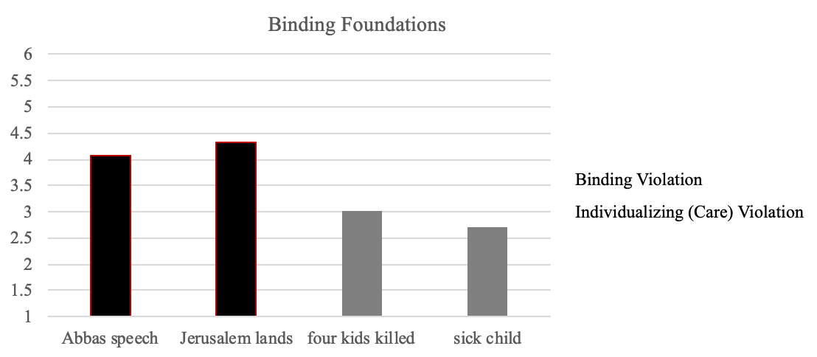
al
Figure 3. Perception of violation of binding foundation for all four scenarios.

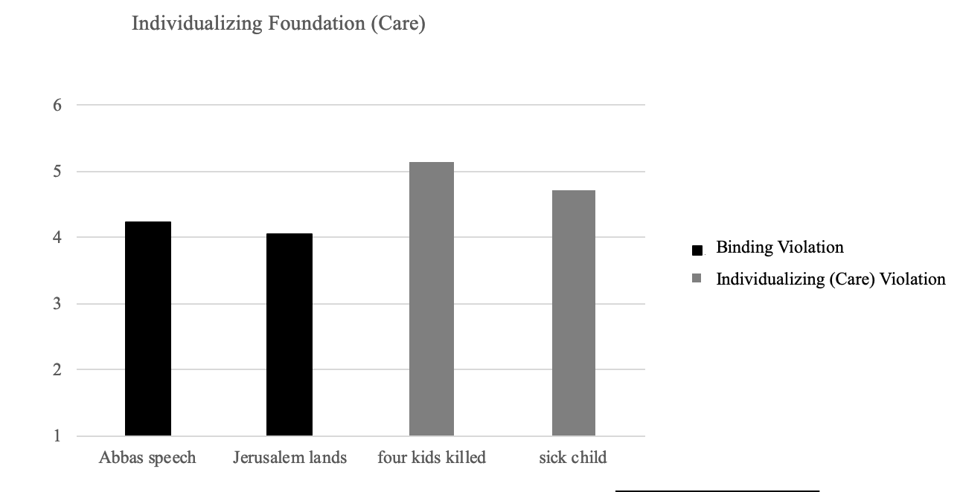

Figure 4. Perception of violation of individualizing foundation for all four scenarios.

Study 1
Study 1 was an exploratory study created to examine the effects of moral convictions in conflict with emotional experience and to test whether this relationship is moderated by moral foundation, as indicated by political ideology. Since these were pilot studies, I used convenience samples that were not based on power analysis. Specifically, I examined the association between moral convictions and anger in a binding moral violation scenario among rightists, and among leftists, I examined the association between moral convictions and empathy in an individualizing moral violation scenario. I used separate samples for the rightists and leftists to ensure that each sample focused on the relevant moral foundation.
Study 1A
In this study, I tested whether, among rightists, the strength of moral conviction would be positively associated with high intergroup anger toward the perpetrators of a binding violation. It was expected, that among rightists, who have high moral conviction, being exposed to a violation of binding moral foundations would lead to intense intergroup anger toward Palestinians, but being exposed to a violation of an individualizing foundation would not lead to intense intergroup empathy for Palestinians.
Method
Participants
The voluntary participants in Study 1A were 120 right-wing Jewish Israelis. The participants were recruited using snowball techniques. After the study, 15 participants were excluded from the data analysis because they failed to correctly answer the reading comprehension questions, resulting in a sample of 105 (M_{age} = 40.52 years, SD = 12.46, 47.6% females). A post-hoc sensitivity analysis indicated that this sample had 80% power to detect a correlation of r = .26.
Procedure
The participants were invited to take part in a study of attitudes and emotional responses in the context of the Israeli–Palestinian conflict. The participants indicated the extent to which their attitudes and emotions on the conflict are based on their moral convictions. They were then presented with two of the articles tested in the pilot study, the first on illegal incursions by Palestinians into Jewish lands in Jerusalem (a binding article) and a sick Palestinian child being expelled by Israeli authorities (an individualizing article). These relate to two crucial issues at the heart of the Israeli–Palestinian conflict: land disputes and the citizenship law. The two scenarios were presented to participants one at a time, and the order of presentation was counterbalanced across participants. After they read each scenario, the participants responded to two reading comprehension questions to ensure that they had read and understood the text. Then they rated their emotional reactions and provided socio-demographic information, including on their political ideology.
Measures
Moral conviction. The degree to which the participants viewed the Israeli–Palestinian conflict in general as an issue of moral conviction was assessed with three items: “To what extent are your attitudes about the Israeli–Palestinian conflict a reflection of your core moral values and convictions?”, “To what extent are your feelings about the Israeli–Palestinian conflict a reflection of your core moral beliefs and convictions?”, and “To what extent are your feelings about the Israeli–Palestinian conflict deeply connected to your beliefs about right and wrong?” Participants responded on a 7-point scale (from 1 = not at all to 7 = very much). Participants’ scores were averaged to create a single score for moral conviction (α = .82), with higher scores reflecting greater moral conviction on the Israeli–Palestinian conflict.
Emotional Reaction. Participants rated the extent (from 1 = not at all 7 = to a large extent) to which they experienced anger or empathy toward Palestinians in general.
Political Ideology. Participants reported their ideology using a single item that assessed their subjective political position on foreign policy and security (e.g., the military and international relations). The verbal anchors were extreme left (1) and extreme right (7), with a midpoint of the center (4).
Demographic Questionnaire. Participants completed a brief demographic questionnaire. Items included gender, age, education, employment, religiosity, and political party affiliation.
Results
As predicted, in the binding scenario, rightists’ moral convictions were significantly related to intergroup anger, such that rightists with stronger moral convictions experienced more anger toward Palestinians, r (105) = .246, p = .01. In the individualizing scenario, no correlation was found between moral conviction and intergroup empathy, r (105) = .024, p =. 81. These correlations persisted when the extremity of political ideology and sociodemographic variables (i.e., age, sex, education, and financial status) were controlled.
Study 1B
In study 1B I tested whether, among leftists, strength of moral conviction would be positively associated with high intergroup empathy toward the casualties of an individualizing violation. I expected that among leftists, strong moral conviction would lead to intense intergroup empathy for the Palestinians after exposure to a violation of individualizing moral foundations, but strong moral conviction would not lead to intense intergroup anger toward Palestinians after exposure to a violation of a binding foundations.
Method
Participants
The voluntary participants in this study were 84 left-wing Jewish Israelis (M_{age} = 33.89 years, SD = 9.5, 42.9% females). The sample size was given in accordance with the relative proportion of leftists in the Jewish Israeli population. The participants were recruited using snowball techniques. A post-hoc sensitivity analysis indicated that this sample gave 80% power to detect a correlation of r = .30.
Procedure
I used the same procedure as in study 1, except that I used an adapted binding article that I thought might be of more relevance to the topical events that were occurring at the time of the study and would be of interest to left-wingers. This binding article described a warning of a rise in calls in the Palestinian media denying Israel’s right to exist.
Measures
Moral conviction. Same as in Study 1A (α =. 77).
Emotional reaction. Same as in Study 1A.
Political ideology. Same as in Study 1A.
Demographic questionnaire. Same as in Study 1A.
Results
As predicted, in the individualizing scenario, moral conviction was considered to be significantly related to intergroup empathy, such that leftists with stronger moral conviction experienced more empathy for Palestinians, r = .31, p =.005. In the binding scenario, no correlation was found between moral conviction and intergroup anger toward Palestinians, r = -.18, p =.11. These correlations persisted when extremity of political ideology and sociodemographic measures (sex, age, and education) were controlled.
Discussion
Study 1 provided initial support for my first hypothesis, namely, in binding scenario, rightists’ strength of moral conviction was positively associated with intergroup anger toward perpetrators of boundary violations, but when exposed to an individualizing foundation violation scenario, the strength of moral conviction was not associated with intergroup empathy for the victims. Similarly, in the individualizing moral violation scenario, leftists’ strength of moral conviction was positively associated with high intergroup empathy for victims, but when exposed to a binding violation scenario, the strength of moral conviction was not associated with intergroup anger toward perpetrators.
Because studies 1A and 1B were exploratory studies, they were designed for separate samples, used specific individualizing and binding moral violation events, and did not allow for a test of an interactive model that could indicate whether, in response to a violation of moral foundations, moral conviction would only predict emotions depending on the relevance of the moral foundation to the ideology. Study 1 demonstrated associations between moral conviction and emotions, moderated by political ideology, but the second goal of examining the role of emotions in mediating political reactions was not tested.
Study 2
Study 2 was conducted to replicate and extend the findings of Study 1, with the aim of testing the full model. To do so, I (a) used a representative sample of Jewish Israeli society from across the political spectrum, (b) adopted the moral violation scenarios that had been validated in the pilot study but were not used in the previous study, and (c) measured moral conviction and ideology, separately from the manipulation, over three time points to ensure that they are not affected by the manipulation.
Study 2’s design also had the second goal of examining downstream effects of moderated ties between moral conviction and emotion on relevant political action tendencies. Specifically, I tested the full model to determine whether, in response to a specific violation, the ties between the moral conviction and intensity of intergroup moral emotions would be moderated by moral foundations and their differing moral relevance to political ideology and whether these emotions would mediate the effects of moral convictions on political action tendencies (e.g., political involvement and activism).
Method
Participants
The participants were 463 Jewish Israelis (M_{age} = 38.99 years, SD = 12.45, 47.1% females) who received monetary compensation for their participation. The given sample size was based on a power analysis, assuming a small effect size for the interaction between moral convictions and political ideology (change in r² = .02, when the interaction terms are added to the model), with 80% power. I used a nationwide sample that represented the diversity of Jewish Israeli society in its socio-demographic features and political ideologies. Of the participants, 50.6% were rightists, 30.6% were centrists, and 18.7% were leftists. This weighting represents the relative size of each group in the Jewish Israeli population.
Procedure
The data were collected as part of a large-scale survey. The participants were contacted for responses via email at three different time points. In the first assessment, the participants stated their political ideology and provided socio-demographic information. In the second assessment, participants rated their moral convictions in relation to their position on the Israeli–Palestinian conflict. Finally, in the third assessment, the participants were randomly assigned to read one of two scenarios previously tested in the pilot study: an article describing a speech by Palestinian President Mahmoud Abbas accusing Israel of a conducting a “war of genocide” (a binding scenario) and another describing an IDF shelling that caused the death of four Palestinian children (an individualizing scenario). After reading the article, the participants rated their emotional reactions to it and their support of aggressive or conciliatory policies toward the Palestinians.
Measures
Moral conviction. As in Study 1 (α =. 80).
Demographic questionnaire. As in Study 1.
Political ideology. As in Study 1.
Emotional reaction. As in Study 1.
Support for aggressive policies. The participants rated their support for aggressive or conciliatory policies toward the Palestinians on a four-item scale (α = .824). The items were general and were used for both binding and individualizing scenarios. An example of a general aggressive policy item was “The IDF should use violent means to disperse demonstrations by Palestinians because they are illegitimate”. Participants responded on a 6-point scale (1 = not at all to 6 = to a large extent).
Support for conciliatory policies. Participants rated their support for conciliatory policies toward Palestinians on a four-item scale (α = .702). The items were general and were used for both the binding and the individualizing scenarios. An example of a general conciliatory policy item was “Israel should promote joint economic and social projects by Israelis and Palestinians”. Participants responded on a 6-point scale (1 = not at all to 6 = to a large extent).
Results
Individualizing moral violation scenario
I tested my hypothesis that after exposure to a violation of individualizing moral foundations, moral conviction would be associated with intense intergroup empathy for the Palestinians and conciliatory political action tendencies only among leftists. However, I expected that among rightists, moral conviction would not be associated with intense intergroup empathy for the Palestinians and conciliatory political action tendencies. First, I examined the effects on intergroup empathy for the Palestinians using the Hayes PROCESS model 1. Significant direct effects were found for political ideology and moral conviction, and the interaction between moral conviction and political ideology was marginally significant. An analysis of simple effects revealed that for leftists, moral conviction was positively related to intergroup empathy. Among rightists, there was no significant effect of moral conviction on intergroup empathy (Table 2 and Figure 5).

Table 2
Model statistics for the moderation model predicting intergroup empathy for the Palestinians
 | b | 95% CI | SE | t | p
Moral convictions | 0.04 | [0.09, 0.71] | 0.16 | 2.55 | 0.01
Political ideology | -0.68 | [-2.32, -1.04] | 0.32 | -5.19 | < .001
Moral convictions × political ideology | -0.71 | [-1.45, 0.26] | 0.37 | 1.9 | 0.05
Simple effect of moral convictions for leftists | 0.93 | [0.28, 1.58] | 0.33 | 2.82 | 0.005
Simple effect of moral convictions for rightists | 0.22 | [-0.13, 0.57] | 0.03 | 5.67 | 0.22

Figure 5. Differences in the relationship between moral conviction and intergroup empathy for Palestinians among rightists and leftists.

Then, I examined the interaction with conciliatory political action tendencies. As before, there were significant direct effects of political ideology and moral conviction. The interaction between moral conviction and political ideology was also significant. An analysis of the simple effects showed that for leftists, moral conviction was positively related to conciliatory political action tendencies toward the Palestinians. However, among rightists, there was no significant effect of moral convictions (Table 3 and Figure 6).

Table 3
Model statistics for the moderation model predicting conciliatory political action tendencies toward the Palestinians
Variable | b | 95% CI | SE | t | p
Moral convictions | 0. 35 | [0.04, 0.71] | 0.16 | 2.25 | 0.03
Political ideology | -1.44 | [-2.32, -1.04] | 0.32 | -5.19 | < .001
Moral convictions × political ideology | -0.84 | [-1.59, -0.08] | 0.38 | -2.18 | 0.03
Simple effect of moral convictions for leftists | 1.00 | [0.31, 1.65] | 0.34 | 2.9 | < .001
Simple effect of moral convictions for rightists | 0.15 | [-0.22, 0.57] | 0.18 | 0.83 | 0.42

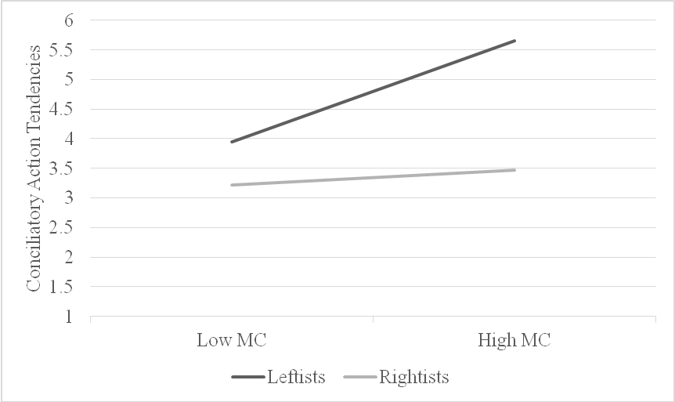

Figure 6. Differences in the relationship between moral conviction and conciliatory political action tendencies toward the Palestinians among rightists and leftists.

In the next step, I tested my full model, in which, within the individualizing scenario, the effects of moral conviction on political action tendencies are mediated by emotion (i.e., empathy for Palestinians) but that this mediation is moderated by political ideology and would only occur in leftists. Thus, I ran a moderated mediation analysis on conciliatory political reaction toward the Palestinians, considering moral conviction as the independent variable, political ideology as a moderator, and intergroup empathy for Palestinians as a mediator (using PROCESS model 8). The analysis revealed an indirect effect of moral conviction through intergroup empathy for Palestinians on conciliatory political reaction toward the Palestinians, but it appeared only among leftists (a*b = 0.27, SE = 0.126, CI = [0.603, 0.537]), not among rightists (a*b = 0.06, SE = 0.06, CI = [-.05, 0.19]).
Binding moral violation scenario
I tested my hypothesis that exposure to the violation of a binding moral foundations would lead to a similar process among rightists, using the same analytical strategy. Namely, I expected that moral conviction shoud be associated with intense intergroup anger toward the Palestinians, and susequeial political action tendencies toward tghtists. However, among leftists, it was expected that moral conviction would not be associated with intense intergroup anger towards he Palestinians and subsequent adveitical action tendencies. First, I examined intergroup anger towards toward stinians, and found a sgnificant direct effect of political ideology and a significant interaction between moral conviction and political ideology. Analysis of the simple effects revealed showed rightists, moral conviction was positively related to intergroup anger, whereas for leftists, there was no sigffect of moral conviction was seen (see Table 4 and re 7).

Table 4
Model statistics for the moderated model predicting intergroup anger toward the Palestinians.
Variable | b | 95% CI | SE | t | p
Moral convictions | 0.2 | [-0.11, 0.51] | 0.16 | 1.26 | 0.21
Political ideology | 0.28 | [0.61, 1.96] | 34 | 3.77 | < .001
Moral convictions × political ideology | -0.91 | [0.13, 1.70] | 0.4 | 2.3 | 0.02
Simple effect of moral convictions for rightists | 0.4 | [-0.22, 0.570] | 0.17 | 2.31 | 0.02
Simple effect of moral convictions for leftists | -0.51 | [-1.28, 0.19] | 0.36 | -1.43 | 0.16

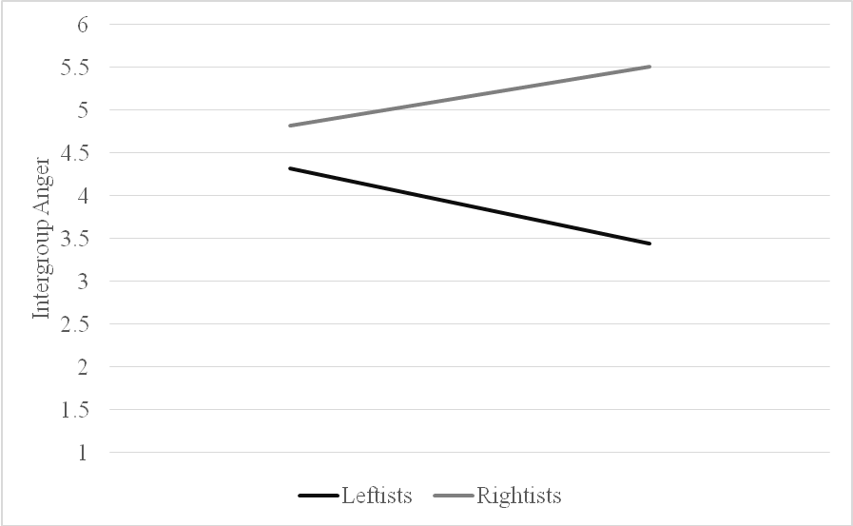

Figure 7. Differences in the relationship between moral conviction and intergroup anger toward Palestinians among rightists and leftists.

Next, I examined adversarial political action tendencies toward the Palestinians. There was a significant direct effect of political ideology but no significant direct effect of moral convictions. The interaction between moral convictions and political ideology was marginally significant. An analysis of the simple effects revealed that for rightists, moral conviction was positively related to adversarial political reaction tendencies toward the Palestinians. Among leftists, however, there was no significant effect of moral conviction (Table 5 and Figure 8).

Table 5
Model statistics for the moderated model predicting adversarial political action tendencies toward the Palestinians
Variable | b | 95% CI | SE | t | p
Moral convictions | 5. 14 | [-.04, 0.35] | 0.08 | 1.6 | 0.11
Political ideology | 0.28 | [4.97, 5.31] | 34 | 60.59 | < .001
Moral convictions × political ideology | 0.43 | [-0.69, 0.93] | 0.25 | 1.7 | 0.09
Simple effect of moral convictions for rightists | 0.25 | [0.04, 0.47] | 0.11 | 2.31 | 0.02
Simple effect of moral convictions for leftists | -0.18 | [-0.62, 0.27] | 0.23 | -0.77 | 0.44

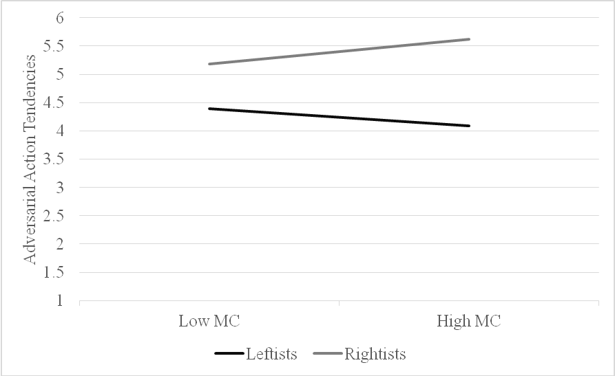

Figure 8. Differences in the relationship between moral conviction and adversarial political reaction tendencies toward the Palestinians among rightists and leftists.

In the next step, I tested the full model prediction that following a binding violation, the effects of moral conviction on political action tendencies would be mediated by emotion, in this case anger toward the Palestinians, but that this mediation would be moderated by political ideology and would only occur for rightists. Thus, I ran a moderated mediation analysis on adversarial political action tendencies toward the Palestinians, considering moral conviction as the independent variable, political ideology as a moderator, and intergroup anger toward Palestinians as a mediator (using PROCESS model 8). The analysis revealed an indirect effect of moral conviction through intergroup anger toward Palestinians on adversarial political reaction toward Palestinians, but only among rightists (a*b = 0.06, SE = 0.03, CI = [0.005, 0.1387]), not among leftists (a*b = -0.07, SE = 0.06, CI = [-.22, 0.029]).
Discussion
The findings of Study 2 both replicate the findings of Study 1 and provide initial support for the model, indicating that moral conviction is positively associated with moral emotion only when the moral events are perceived to be relevant to the participants’ moral foundations, and these ties shape the downstream effects on relevant political action tendencies. This was found using a representative sample of Jewish Israeli society from across the entire political spectrum, using scenarios that refer to moral issues that lie at the heart of the Israeli–Palestinian conflict.
Although the results of Studies 1 and 2 supported my hypothesis, these studies had several limitations. First, each examined only one emotion (e.g., anger toward binding violators and empathy for individualizing victims) for each moral scenario/political group, but no inverse emotions were tested (e.g., anger toward individualizing violators, and empathy for binding victims). This creates unnecessary potential confounding and might indicate a possible alternative effect of the mediation of political ideology on the ties between moral conviction and emotion. Second, the role of emotion in mediating political action tendencies was tested with only one political policy scale, meaning that only support for conciliatory policies was tested in the individualizing scenario, and only support for aggressive policies was tested in the binding scenario. Moreover, the scale items were general. They did not refer to the issues presented in each scenario. Study 3 was designed to address these issues.
Study 3
Study 3 examined the full model, using complementary moral emotions that were not tested in the previous studies as mediators. In this study, all participants, no matter their political affiliation, described their anger and empathy for victims and perpetrators, both in the individualizing and in the binding scenarios. Additionally, I expanded my examination of the effects of moral conviction on political action tendencies using measures for three political action tendencies: direct action, indirect action, and collective action.
Method
Participants
The participants were 296 Jewish Israelis (Mage = 39.68 years, SD = 12.92, 52.4% females) who received monetary compensation for their participation. The sample size was chosen based on a power analysis to detect a relatively small interaction (Cohen’s f = .03), at 80% power. I used a nationwide sample that represented the diversity of Jewish Israeli society in its socio-demographic features. Of the participants, 59.1% were rightists, and 40.9 % were leftists.
Procedure
The participants were invited to take part in a study on attitudes and emotional responses in the context of the Israeli–Palestinian conflict. The participants were presented with news items containing two scenarios: 1) Palestinian illegal incursions onto Jewish lands (a binding article) and 2) a sick Palestinian child being expelled by Israeli authorities (an individualizing article). The two scenarios were presented to participants one at a time, and the order of presentation was counterbalanced across participants. After they read each scenario, participants responded to two reading comprehension questions to ensure they had read and understood the text. Then, they rated their emotional reactions and their political action tendencies, and they indicated the extent to which they experienced the Israeli–Palestinian conflict as a moral conviction issue. Finally, the participants provided socio-demographic information, including on their political ideology.
Measures
Emotional reactions. Participants rated the extent (1 = not at all to 6 = to a large extent) to which they experienced anger and empathy toward Palestinians and Israelis in reference to each of the scenarios that they read.
Direct and indirect political action tendencies. Participants rated their support for adversarial and conciliatory policies toward the Palestinians on four items, two of which were specific to the scenario (example of a specific item: “President Abbas must be asked to retract his remarks as a condition for the transfer of funds”), and another two, which were general for all scenarios (example of a general item: “Israel must deal with this issue firmly”). The participants responded on a 6-point scale (1 = not at all to 6 = to a large extent).
Collective political action tendencies. Participants rated their willingness to be involved in political action (such as an on-line protest) in favor of Israelis or in favor of Palestinians. For each item, participants responded on a 6-point scale (1 = not at all to 6 = to a large extent).
Moral conviction. As in Study 2 (α =. 80).
Political ideology. As in Study 1.
Demographic questionnaire. As in Study 1.
Results
Tables 6–9 present the means, standard deviations (SDs), and simple correlations
among our key variables. As predicted, for both rightists and leftists, emotional intensity was associated with moral conviction following the scenario of the violation of their prioritized foundation. Also as predicted, associated with the scenario of the violation of their prioritized foundation, both rightists and leftists reported emotional intensity and moral conviction associated with the action tendencies relevant to each. When exposed to scenarios of violation that did not affect their prioritized foundation, leftists’ emotional intensity was not associated with moral conviction. As for rightists, emotional intensity was not associated with moral conviction and the relevant action tendencies regarding the Palestinians, but the emotion related to Israelis was associated with moral conviction.

Table 6
Bivariate relationships between Study 3 variables: binding scenario, rightists (N = 168)
 | M (SD) | 1 | 2 | 3 | 4
1. Political ideology | 2.14 (0.57) | -
2. Moral conviction | 4.98 (0.97) | -.08 | -
3. Anger with Palestine | 5.14 (1.43) | .01 | .19* | -
4. Empathy for Israelis | 4.87 (1.56) | -.05 | .16* | .39** | -
5. Adversarial political action tendencies toward Palestinians | 4.84 (0.94) | -.19* | .39** | .19* | .18*
*p < .05, **p < .01

Table 7
Bivariate relationships between Study 3 variables: binding scenario, leftists (N = 128)
 | M (SD) | 1 | 2 | 3 | 4
1. Political ideology | 5.80 (0.51) | -
2. Moral conviction | 5.11 (0.93) | .18 | -
3. Anger with Palestine | 2.93 (1.45) | -.50** | -.15 | -
4. Empathy for Israelis | 2.69 (1.30) | -.47* | -.11 | .51** | -
5. Adversarial political action tendencies toward Palestinians | 2.86 (1.20) | -.62** | -.26* | .59** | .37**
*p < .05, **p < .01

Table 8
Bivariate relationships between Study 3 variables: individualizing scenario, rightists (N = 168)
 | M (SD) | 1 | 2 | 3 | 4
1. Political ideology | 2.14 (0.57) | -
2. Moral conviction | 4.98 (0.97) | -.08 | -
3. Empathy for Palestinians | 2.02 (1.31) | .17 | -.04 | -
4. Anger with Israelis | 1.63 (1.18) | .09 | -.16* | .26** | -
5. Conciliatory political reaction tendencies toward Palestinians | 1.99 (0.95) | .21** | -.09 | .62** | .27**
*p < .05, **p < .01

Table 9
Bivariate relationships between Study 3 variables: individualizing scenario, leftists (N = 128)
 | M (SD) | 1 | 2 | 3 | 4
1. Political ideology | 5.80 (0.51) | -
2. Moral conviction | 5.11 (0.93) | 0.17 | -
3. Empathy for Palestinians | 4.36 (1.47) | .40** | .38** | -
4 Anger with Israelis | 3.77 (1.68) | .34* | .21* | .63** | -
5. Conciliatory political reaction tendencies toward Palestinians | 4.02 (1.24) | .49** | .33** | .68** | .60**
*p < .05, **p < .01

Results for the individualizing moral violation scenario
I tested my hypothesis that after exposure to a violation of individualizing moral foundations, moral conviction is associated with intense intergroup empathy for the Palestinians, intense intragroup anger toward the Israelis, and conciliatory political action tendencies only among leftists. However, I expected that among rightists, moral conviction would not be associated with intense intergroup empathy for the Palestinians nor with intense intragroup anger toward the Israelis and subsequent conciliatory political action tendencies. First, I examined the effects on intergroup empathy for the Palestinians using the Hayes PROCESS model 1. There was no significant direct effect of political ideology on intergroup empathy for Palestinians, but there was a significant direct effect for moral conviction. The interaction of moral conviction and political ideology on intergroup empathy for Palestinians was significant. An analysis of the simple effects revealed that for leftists, moral conviction was positively related to intergroup empathy. Among rightists, there was no significant effect for moral conviction on intergroup empathy (Table 6 and Figure 9). I repeated these procedures to test the hypothesis that in the individualizing scenario, moral conviction is only positively related to intragroup anger toward Israelis for leftists. As expected (Table 6), the interaction between moral conviction and political ideology on intragroup anger toward Israelis was significant. Analysis of the simple effects revealed that, moral conviction was only positively related to intragroup anger toward Israelis for leftists (Table 7 and Figure 10).
Then, I examined the interaction among conciliatory political action tendencies. Similarly, there were marginally significant direct effects of political ideology and moral conviction. The interaction between moral conviction and political ideology was also significant. An analysis of the simple effects revealed that moral conviction was only positively related to conciliatory political action tendencies toward the Palestinians for leftists. However, among rightists, there was no significant effect for moral convictions (Table 8 and Figure 11).

Table 10
Model statistics for the moderated model predicting intergroup empathy for the Palestinians
Variable | b | 95% CI | SE | t | p
Moral convictions | 1.33 | [0.77, 1 .87] | 0.28 | 4.74 | <.001
Political ideology | 1.24 | [-0.45, 2.93] | 0.86 | 1.44 | 0.15
Moral convictions × political ideology | -0.69 | [-1.02, -0.36] | 0.17 | -4.12 | <.001
Simple effect of moral convictions for leftists | 0.63 | [0.34, 0.89] | 0.13 | 4.99 | <.001
Simple effect of moral convictions for rightists | -0.06 | [-0.27, 0.15] | 0.11 | -0.55 | 0.58
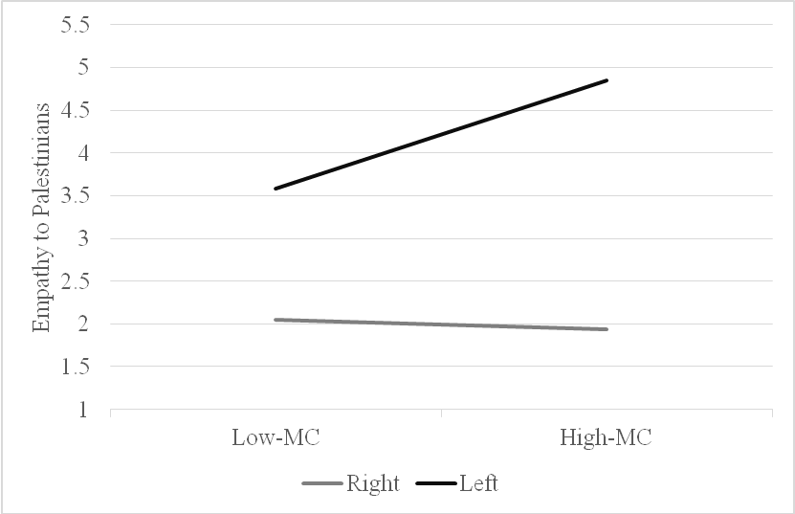

Figure 9. Relationship between moral convictions and empathy following an individualizing violation for rightists and leftists.

Table 11
Model statistics for the moderated model predicting intragroup anger toward Israelis
Variable | b | 95% CI | SE | t | p
Moral convictions | 0.95 | [0.38, 1.51] | 0.28 | 3.33 | <.001
Political ideology | 0.71 | [-1.01, 2.44] | 0.88 | 0.81 | 0.42
Moral convictions × political ideology | -0.56 | [-0.90, -0.22] | 0.17 | -3.29 | <.001
Simple effect of moral convictions for leftists | 0.38 | [0.13, 0.64] | 0.13 | 2.92 | 0.004
Simple effect of moral convictions for rightists | -0.18 | [-0.39, .04] | 0.11 | -1.63 | 0.1

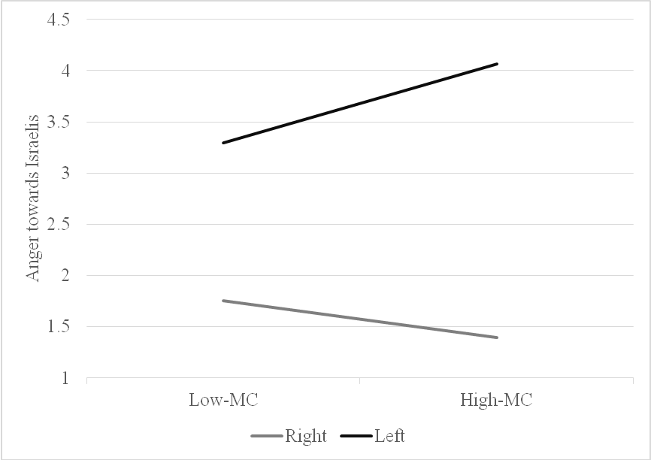

Figure 10. Relationship between moral convictions and anger following an individualizing violation for rightists and leftists.

Table 12
Model statistics for the moderated model predicting conciliatory political action tendencies toward the Palestinians
Variable | b | 95% CI | SE | t | p
Moral convictions | 0.98 | [0.54, 1.40] | 0.22 | 4.46 | <.001
Political ideology | 0.68 | [-0.65, 2.00] | 0.13 | -1.03 | 0.32
Moral convictions × political ideology | -0.71 | [0.24, 0.64] | 0.37 | 1.9 | 0.06
Simple effect of moral convictions for leftists | 0.44 | [0.28, 1.58] | 0 | 4.39 | <.001
Simple effect of moral convictions for rightists | -0.09 | [-0.25, 0.76] | 0.08 | -1.06 | 0.29

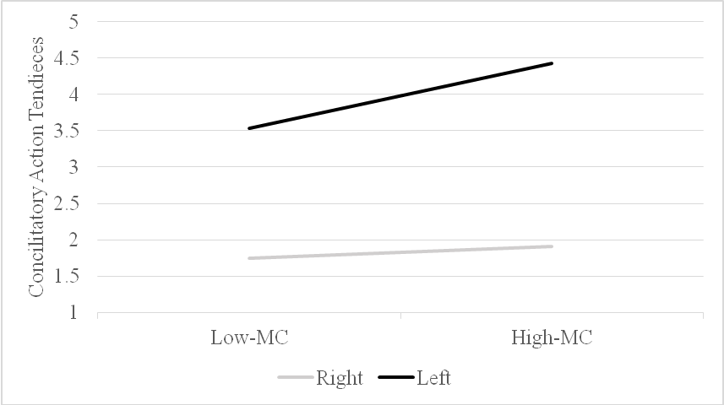

Figure 11. Relationship between moral convictions and conciliatory political reactions following an individualizing violation for rightists and leftists.

In the next step, I tested the full model, according to which, within the individualizing scenario, the effects of moral conviction on political action tendencies are mediated by emotion (i.e., empathy for Palestinians) but that this mediation is moderated by political ideology and only occurs for leftists. Thus, I ran a moderated mediation analysis on conciliatory political reaction toward the Palestinians, considering moral conviction as the independent variable, political ideology as a moderator, and intergroup empathy for Palestinians as a mediator (using PROCESS model 8). The analysis revealed an indirect effect of moral conviction through intergroup empathy for the Palestinians on conciliatory political reaction toward the Palestinians, but it was only found among leftists (a*b = -0.03, SE = 0.05, CI = [-0.13, 0.06]).
Additionally, I tested my full moderated mediation model for the complementary moral emotion, in this case, intragroup anger toward Israelis. Using the same procedure, I found that, as expected, there was an indirect effect of moral conviction through intragroup anger toward Israelis on conciliatory political action tendencies toward the Palestinians among leftists (a*b = 0. 13, SE = 0.07, CI = [0.02, 0.30]). Contrary to my predictions, I found an effect among rightists, but in the opposite direction (a*b = -0.06, SE = 0.03, CI = [-.13, -0.00]).
Results for the binding moral violation scenario
I then tested the hypothesis that exposure to a violation of binding moral foundations would lead to a similar process but among rightists, using the same analysis strategy. Namely, among rightists, moral conviction should be associated with intense intergroup anger toward the Palestinians and with more intense intragroup empathy for the Israelis, as well as adversarial political action tendencies toward the Palestinians. However, among leftists, moral conviction would not be associated with intense intergroup anger toward the Palestinians nor with intense intragroup empathy for the Israelis or adversarial political action. First, I examined intergroup anger toward the Palestinians and found that no significant direct effect of political ideology on anger toward Palestinians but a significant direct effect for moral conviction. The interaction between moral conviction and political ideology for intergroup anger toward Palestinians was significant. An analysis of the simple effects showed that for rightists, moral conviction was positively related to intergroup anger toward Palestinians, whereas for leftists, there was no significant effect of moral convictions (Table 9 and Figure 12).

Table 13
Model statistics for the moderated model predicting intergroup anger toward the Palestinians
Variable | b | 95% CI | SE | t | p
Moral convictions | 0.76 | [-0.24, -1.28] | 0.26 | 2.88 | < .001
Political ideology | 0.26 | [-1.55, -2.08] | 0.92 | -0.29 | 0.77
Moral convictions × political ideology | -0.5 | [-0.84, -0.14] | 0.18 | -2.74 | < .001
Simple effect of moral convictions for leftists | -0.22 | [-0.50, 0.05] | 0.14 | -1.6 | 0.11
Simple effect of moral convictions for rightists | 0.27 | [0.05, 0.50] | 0.11 | 2.4 | 0.02

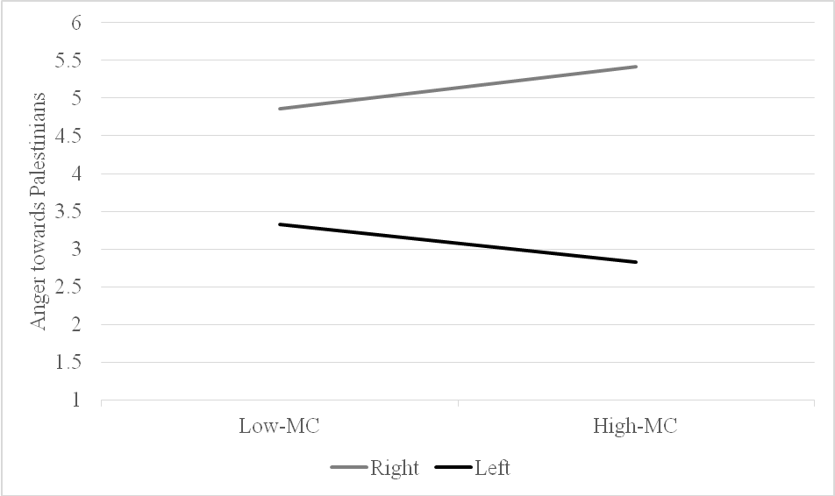

Figure 12. Relationship between moral convictions and anger following a binding violation for rightists and leftists.

In addition, I found that taking interaction into account, there was a significant direct effect of political ideology on intragroup empathy for Israelis, and there was a marginal significant direct effect for moral conviction. As expected, the interaction between moral conviction and political intragroup empathy for the Israeli stance was significant. Analysis of the simple effects revealed that for rightists, moral conviction was positively related to intragroup empathy for Israelis, but among leftists, there was no significant relationship between moral conviction and intragroup empathy for Israelis (Table 10 and Figure 13).

Table 14
Model statistics for the moderated model predicting intragroup empathy toward Israelis
Variable | b | 95% CI | SE | t | p
Moral convictions | -0.58 | [-0.19, .03] | 0.31 | -1.87 | 0.07
Political ideology | -0.07 | [-1.96, 1.81] | 0.96 | -0.07 | 0.94
Moral convictions × political ideology | 0.42 | [.05, 0.78] | 0.19 | 2.22 | 0.03
Simple effect of moral convictions for leftists | -0.17 | [-0.45, 0.48] | 0.14 | -1.17 | 0.25
Simple effect of moral convictions for rightists | 0.25 | [0.02, 0.48] | 0.12 | 2.01 | 0.04

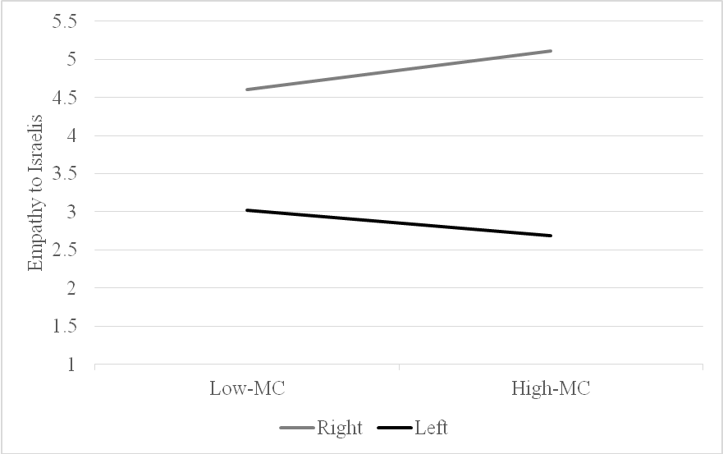

Figure 13. Relationship between moral convictions and empathy following a binding violation for rightists and leftists.

As expected, I also found that taking into account the interaction, there was a significant direct effect of political ideology on adversarial political action tendencies toward the Palestinians, and significant direct effect of moral conviction. The interaction between moral conviction and political ideology on adversarial political action tendencies toward the Palestinians was significant. Analysis of the simple effects revealed that for rightists, moral conviction was positively related to adversarial political action tendencies toward the Palestinians. Among leftists, there was also a significant relationship between moral conviction and adversarial political action tendencies toward the Palestinians, but in the opposite direction (Table 11 and Figure 14).

Table 15
Model statistics for the moderated model predicting adversarial political action tendencies toward the Palestinians
Variable | b | 95% CI | SE | t | p
Moral convictions | -1.06 | [-1.47, -0.64] | 0.21 | -5.05 | <.001
Political ideology | -1.61 | [-2.88, -0.34] | 0.64 | -2.51 | 0.01
Moral convictions × political ideology | 0.71 | 0.47, 0.96] | 0.12 | 5.7 | <.001
Simple effect of moral convictions for leftists | -0.34 | [0.21, 0.53] | 0.01 | -3.53 | <.001
Simple effect of moral convictions for rightists | 0.37 | [0.21, 0.53] | 0.08 | 4.66 | <.001

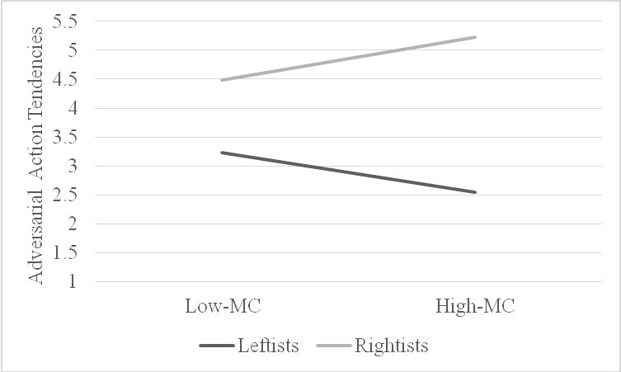

Figure 14. Relationship between moral convictions and adversarial political reaction following a binding violation for rightists and leftists.

In the next step, I tested the full model to determine whether after a binding violation, the effect of moral conviction on political action tendencies is mediated by emotion, in this case, anger toward Palestinians, but this mediation is moderated by political ideology and only occurs for rightists. Thus, I ran a moderated mediation analysis on adversarial political action tendencies toward the Palestinians, considering moral conviction as the independent variable, political ideology as a moderator, and intergroup anger toward Palestinians as a mediator (using PROCESS model 8). The analysis revealed that an indirect effect of moral conviction through intergroup anger toward Palestinians on adversarial political action tendencies toward the Palestinians, but it appeared only among rightists (a*b = 0.07, SE = 0.04, CI = [0.01, 0.15]), not among leftists (a*b = -0.06, SE = 0.04, CI = [-0.15, 0.001]).
Additionally, I tested my full model to see whether the effects of moral conviction on political action tendencies are mediated by emotion, in this case, the complementary moral emotion, intragroup empathy for Israelis, and whether this mediation would be moderated by political ideology and occurs only for rightists. Thus, I ran a moderated mediation analysis on adversarial political action tendencies toward the Palestinians, considering moral conviction as the independent variable, political ideology as a moderator, and intragroup empathy for Israelis as a mediator (using PROCESS model 8). The analysis of adversarial political action tendencies toward the Palestinians revealed no indirect effect of moral conviction through intragroup empathy for Israelis on adversarial political action tendencies toward the Palestinians among rightists (a*b = 0. 04, SE = 0.02, CI = [-.00, .08]). As expected, there was no indirect effect for leftists (a*b = 0.03, SE = 0.02, CI = [-0.08, 0.01]).
Discussion
The results of Study 3 give a more nuanced picture than that provided by the first two studies. Study 3 fully examined my model for ties between moral conviction and emotions. Across all analyses, I found the effects as predicted, with the exception of one specific case: after exposure to a binding violation, I found no indirect effect among rightists of moral conviction through intragroup empathy for Israelis on adversarial political action tendencies toward the Palestinians. This makes sense, as anger toward the moral violator is a central moral emotion in the context of conflict and can be expected to be more predictive of adversarial action than empathy for the victim of moral violation (e.g., Breugelmans & De Cremer, 2007, Cheung-Blunden & Blunden, 2008; Huddy et al., 2007; Reifen-Tagar, Frederico, & Halperin, 2011). These findings suggest that assessment of the moral emotions tested in the previous studies together with the inverse emotions produces a similar pattern of results, thus helping to eliminate the possible confounding of the different emotions measured in the binding versus individualizing scenarios in the previous studies.

General Discussion
Do attitudes that are held with great moral conviction always have strong ties to intense emotional reactions and action tendencies? Morality models have generally posited that moral conviction elicits intense emotions, which shape behavioral reactions. The model presented here suggests that this assumption does not always hold true, and people’s moral convictions will not always be tied to intense emotions. Differences in emotional reactions to moral events may lead to mutual accusations of a lack of concern for morality and constitute a site of tension and conflict between people and groups in society. My research, drawing from theories of moral emotions (Haidt, 2003; Tangney, Stuewig & Mashek, 2007), ITMC (Skitka et al., 2008) and MFT (Haidt et al., 2007, 2004), provides an explanation for the variety of intensity in emotional reactions to moral events. Using these theories, I developed a model showing that political beliefs, which are connected to fundamental moral foundations, moderate the ties between moral conviction and emotions.
I tested the validity of the model in the context of ideological intergroup conflicts, and specifically with regard to the Israeli–Palestinian conflict. I examined the ties between moral conviction and emotional reaction among rightists and leftists, referring to typical moral events in the context of the Israeli–Palestinian conflict. My finding in studies 1–3 demonstrates that different prioritizations of moral foundations, as reflected by political ideology, shape ties between moral conviction and emotions in reaction to either individualizing or binding moral violations. Thus, both rightists and leftists with strong moral convictions react with emotional intensity to a moral event only when that event is relevant to the moral foundations that each political group most values. These findings shed light on the mechanisms that can explain why and how people differ in their emotional reactions to moral events. Although the investigation was conducted in the context of a political intergroup conflict, based on the theoretical model, I believe that my findings can be generalized beyond a given particular context and across samples. Building on these findings, in the future, it would be important to test the generalizability of the model to other social contexts.
Implications
This study has both theoretical and methodological implications for research in moral and political psychology. Prior work on moralization has often used concepts of moral convictions, moral foundations, and political ideologies (as well as moral mandates, moral beliefs, and moral intuitions) as intertwined concepts, and has not adequately distinguished between them (Haidt, 2007; Mullen & Skitka, 2006; Skitka, 2015; Wright, Cullum, & Schwab, 2010). These moral processes were described as having similar traits, such as (a) personal and intuitive evaluations (e.g., Haidt, 2001; Skitka et al., 2005), (b) influenced by context (e.g., Haidt, 2007; Skitka, 2014), (c) tightly connected to emotions (Skitka, Bauman, & Sargis, 2005), and (d) motivational force leading to correspondent behavioral reactions (Graham et al., 2009; Skitka & Wisneski, 2011). The model presented here suggests that moral conviction, moral foundations, and political ideology are simply different segments of the moral judgment system, signaling related but distinct paths to moral judgments. One way to differentiate between these paths is to categorize them in terms of valence or content. The moral conviction path is directed toward the valence of things, intended to answer the question of whether the event or issue is moral, or is right or wrong. It is a broad and general evaluation, comparable to a binary judgment that can be resolved with a quick yes-or- o assessment. On the other hand, the path of the moral foundation’s paals with the content of things and indicates their importance for people. This e undation ai used to capture the moral meaning of an event, and to to a by what s is this mormmoral?'. This pth is rootein a specific- and diversified conxt, often rich in details and values (especially in social and political contexts), and it can be guided by the five moral foundations (Graham et al., 2013). . The presented modelecognizes the different unique role th path paths andmes toth paths each are is e elicliciting intense s in reaction to moral events. This line of argument also leaions concerning on the nature tionship between moral conviction and moral foundations, and future research is required in order to establish itfurther unelationship.
Next, my model offers a novel framework for the concepts of moral foundations and political ideology. The dominant view in moral and political psychology is that moral foundations and political ideology are indissoluble. MFT has strongly established a correlation between moral foundations and ideology (e.g., Haidt, 2012; Nilsson & Erlandsson, 2015), and the extensive research that has applied MFT has shown that moral foundations reliably predict political attitudes and action tendencies (e.g., Clifford, 2017; Franks & Scherr, 2015; Graham et al., 2009; Haidt, 2012; Inbar, Pizarro, & Bloom, 2009, 2012; Schein & Gray, 2015). Moreover, some models suggest a causal explanation, positing that moral foundations govern political ideology; counter theoretical models suggest the opposite causal path, that is, that moral foundations are driven by political beliefs (Hatemi, Crabtree, & Smith, 2019) and exist to justify preexisting social and political beliefs. This investigation follows the predominant norm, assuming an intertwined relationship between moral foundations and ideology. However, rather than examining the dichotomous chicken-or-egg question (do moral foundations underlay political ideology, or des political ideology shape moral foundations?), I refer to moral foundations in a political context and to political ideology as a tightly closed concept that eventually determines one's prioritized moral concerns regarding a specific moral event. Both concepts might provide the same 'content' f judgmes (foundations' affiliation and foundations' foundationa underpin moral judgments.
In relation to intergroup relations, my findings are of interest in the context of accumulated research examining the moral judgments of liberals and conservatives. In many of these studies, two major approaches are used; one claims inherent intergroup differences between rightists and leftists (Altemeyer, 1988; Jost, Glaser, Kruglansky, & Sullway, 2003; Kugler, Jost, & Noorbaloochi, 2014; Matar, 2006). The other suggests that differences in the emotional and behavioral reactions of liberals and conservatives to moral events arise from the differing moral values each group endorses (e.g., Caprara, Schwartz, Capanna, Vecchione, & Barbaranelli, 2006; Graham et al., 2009; Janoff-Bulman, 2009). My investigation supports the MFT approach and the context-dependent approach (Kessler, Proch, Hechler, & Nagler, 2015). According to my findings, although liberals and conservatives rely on different sets of moral foundations and may differ in the content of the issues they believe to be morally relevant (Graham et al., 2009; Hofmann et al., 2014), the processes underlying moral judgment in the context of political conflicts appear to be similar. Both conservatives and liberals, when exposed to related moral events, use their hierarchy of moral values to single out the most relevant moral events to be emotionally addressed. These findings join other studies (e.g., Skitka & Washburn, 2016, 2018) that indicate that the psychological processes of liberals and conservatives are more similar than past research had typically believed. Understanding the similarities and differences across the ideological spectrum should reduce mutual alienation and hostility and may improve our understanding of different emotional and behavioral reactions to moral–political events.
Limitations
The present research had several noteworthy limitations: First, my proposed model assesses one potential mechanism, namely, the prioritization of moral foundations as reflected in one’s political ideology, which shapes the ties between moral conviction and emotion. This explanation cannot rule out an alternative explanation for the demonstrated findings. The findings hat mnstead rely berstood usinguse on the ptl group conflict hypothesis (Frimer, Gaucher Gaucchaefer, 2014). ),, which The itcal grological differences in moral foundations are not necessarily due to differences in moral values per se but are driven by in-group- versus- outgrou out-grupzations. In this sense, in-gchof competing political groups might be the cause of the obdifferes in the studies.
The scenarios used in this investigation exhibited systematic differences between the foundation that was violated and the conditions, in terms of the perpetrators and victims, such that the binding violation was always a violation committed by Palestinians against Israelis, and the individualizing violation was always a violation by Israelis against Palestinians. This limitation was linked to a general identified aim to tease apart the unique effect of the moral foundations and minimize the potential confound of the target groups. The built-in content of the moral foundations may have been confounded with stereotypes and reactions toward specific target groups, as shown in other studies (Voelkel & Brandt, 2018).
Moreover, this methodological limitation rests on a more in-depth theoretical issue: what is the nature of the relationship between people’s moral and social identities? Are moral foundations stronger or weaker, than group identification? Although this investigation favors the position that moral foundations should be above and beyond the identity of the target of the moral violation, the influence of the target’s group identity should not be ignored. Strengthening this claim requires more research that would examine the relationship between moral foundations and different target groups and the effect of these relationships on moral convictions and moral emotions.
The second limitation of the moderated–mediation model is that although I suggested that moral conviction, moderated by the moral foundations, would elicit intense emotions, I did not note any causal influence of moral conviction on anger and empathy, the emotionsIexamined in the study. Si the absence of no cal evidence is cannot rule thata third factor that could explain why someone on may have has both high moconvictions and intense emotional reactions, and the particular nature of these relationships remains unclear. As mentioned noted y previous studies have referred to the intertwine inter ties betwen moral convicts, and behavior behavior, but givfficulties of manipulating moral convictions, they have measured rather than manipulated moral convictions and relied on correlational methods (e.g., Skitka et al., 2005; Skitka, Bauman & Mullen et al., elkell & Brandt, eren, Postmes Postmes, & Spears, 2ture studies should try to manipulate the causal effects of moral convon emotions and test its potential causad its subsequent behavioral effects.
Third, I measured both emotional reactions and political action tendencies using self-reports. Although such measures do have established validity, (e.g., Batson et al., 1997; Jost, 2006), given that the issues presented in the scenarios are politically charged, the participants may have responded according to how their political group is expected to respond (Farwell & Weiner, 2000). Thus, it might be that stereotyping influenced the results. Future studies could utilize measures of emotional experiences that do not rely on self-reporting and assess actual aggressive or conciliatory actions within the political context.

Conclusion
Research on ties between morality and emotions has been shaped by the idea that moral conviction elicits intense emotions and subsequent behavioral reactions (Skitka, 2010). By contrast, my work proposes that moral conviction may not always be tied to intense emotions and that moral relevancy will moderate the ties between moral convictions and emotions. I demonstrated that, in the context of an intractable conflict, the differing prioritization of moral foundations by rightists and leftists, as reflected in their political ideologies, shapes the ties between moral convictions and emotional reactions to moral events. These results emphasize the key role of moral relevancy in translating moral conviction into intense emotion and may articulate, in part, an explanation for when and why people differ in their emotional reactions to a moral event.

References
Bar-Tal, D. (2007). Socio-psychological foundations of intractable conflicts. American Behavioral Scientist, 50(11), 1430-1453.
Bar-Tal, D. (2013). Intractable conflicts: Socio-psychological foundations and dynamics. Cambridge, UK: Cambridge University Press.
Batson, C. D. (2008). Empathy-induced altruistic motivation. Paper presented at the Inaugural Herzliya Symposium on Prosocial Motives, Emotions, and Behavior, Israel.
Batson, D., Polycarpou, M. P., Harmon-Jones, E., Imhoff, H. J., Mitchener, E. C., Bednar, L. et al. (1997). Empathy and attitudes: Can feeling for a member of a stigmatized group improve feelings toward the group? Journal of Personality and Social Psychology, 72 (1), 105-118.

Ben-Nun Bloom, P. (2013). The public’s compass: Moral conviction and political attitudes.

American Politics Research, 41(6), 937-964.
Bloom, P. (2016). Against empathy: The case for rational compassion. New York, NY: Harper Collins.
Brandt, M. J., Wisneski, D. C., & Skitka, L. J. (2015). Moralization and the 2012 presidential election campaign. Journal of Social and Political Psychology, 3, 211-237.
Cohen-Chen, S., Halperin, E., Crisp, R. J., & Gross, J. J. (2014). Hope in the Middle East: Malleability beliefs, hope, and the willingness to compromise for peace. Social Psychology and Personality Science, 5, 67-75.
Coleman, P. T., Vallacher, R. R., Nowak, A., & Lan Bui-Wrzosinska, L. (2007). Intractable conflict as an attractor: A dynamical systems approach to conflict escalation and intractability. American Behavioral Scientist, 50, 1454-1475.
Crawford, J. T., & Pilanski, J. M. (2013). Political intolerance, right and left. Political Psychology, 10, 1467-1492.
Ellsworth, P. C., & Smith, C. A. (1988). From appraisal to emotion: Differences among unpleasant feelings. Motivation & Emotion, 12(3), 271-302.
Fischer, A. H., & Roseman, J. (2007). Beat them or ban them: The characteristics and social functions of anger and contempt. Journal of Personality and Social Psychology, 93(1), 103-115.

Frijda, N. H. (2004). Emotions and action. In A. S. R. Manstead, N. Frijda, & A. Fischer (Eds.), Feelings and emotions: The Amsterdam symposium (pp. 158–173). Cambridge, UK: Cambridge University Press.
Gerring, J. (1997). Ideology: A definitional analysis. Political Research Quarterly, 50, 947-994.
Graham, J., Haidt, J., & Nosek, B. (2009). Liberals and conservatives use different sets of moral foundations. Journal of Personality and Social Psychology, 96, 1029-1046.
Haidt, J. (2001). The emotional dog and its rational tail: A social intuitionist approach to moral judgment. Psychological Review, 108, 814-834.
Haidt, J., & Graham, J. (2007). When morality opposes justice: Conservatives have moral intuitions that liberals may not recognize. Social Justice Research, 20, 98-116.
Haidt, J., Graham, J., & Joseph, C. (2009). Above and below left-right: Ideological narratives and moral foundations. Psychological Inquiry, 20, 110-119.
Haidt, J., & Joseph, C. (2004). Intuitive ethics: How innately prepared intuitions generate culturally variable virtues. Daedalus, 55-66.
Halperin, E. (2008). Group-based hatred in intractable conflict in Israel. Journal of Conflict Resolution, 52, 713-736.
Halperin, E. (2011). Emotional barriers to peace: Emotions and public opinion of Jewish Israelis about the peace process in the Middle East. Peace and Conflict: Journal of Peace Psychology, 17, 22-45.
Halperin, E. (2016). Emotions in conflict: Inhibitors and facilitators of peace making. Oxford, UK: Routledge.
Halperin, E., Porat, R., Tamir, M., & Gross, J. J. (2013). Can emotion regulation change politcial attitudes in intractable conflicts? From the labratory to the field. Psychological Science, 24, 106-111.
Halperin, E., Russell, A. G., Dweck, C. S., & Gross, J. J. (2011). Anger, hatred, and the quest for peace: Anger can be constructive in the absence of hatred. Journal of Conflict Resolution, 55(2), 274-291.
Hatemi, P. K., Crabtree, C., & Smith, K. B. (2019). Ideology justifies morality: Political beliefs
predict moral foundations. American Journal of Political Science, 63(4), 788–806. https://doi.org/10.1111/ajps.12448
Hofmann, W., Wisneski, D. C., Brandt, M. J., & Skitka, L. J. (2014). Morality in everyday life. Science, 345, 1340-1343.
Iyer, R., Graham, J., Koleva, S., Ditto, P., & Haidt, J. (in press). Beyond identity politics: Moral psychology and the 2008 Democratic primary. Analyses of Social Issues and Public Policy.
Jost, J. T. (2006). The end of the end of ideology. American Psychologist, 61(7), 651-670.
Kamans, E., Zomeren, M., Gordijn, E. H., & Postmes, T. (2014). Communicating the right emotion makes violence seem less wrong: Power-congruent emotions lead outsiders to legitimize violence of powerless and powerful groups in intractable conflict. Group Processes & Intergroup Relations, 17(3), 286–305.
Lazarus, R. S., & Alfert, E. (1964) Short-circuiting of threat by experimentally altering cognitive appraisal. Journal of Abnormal and Social Psychology, 69, 195–205.
doi: 10.1037/h0044635.
Lerner, J. S., Gonzalez, R. M., Small, D. A., & Fischhoff, B. (2003). Effects of fear and anger on perceived tasks of terrorism: A national field experiment. Psychological Science, 14, 144-150.
Maoz, I. (2011). Does contact work in protracted asymmetrical conflict? Appraising 20 years of reconciliation-aimed encounters between Israeli Jews and Palestinians. Journal of Peace Research, 48(1), 115-125.
Maoz, I., Bar-On, D., & Yikya, S. (2007). “They understand only force”: A critical examination of the erruption of verbal violence in a Jewish-Palestinian dialogue. Peace and Conflict Studies, 14(2), 27-48.
Maoz, I., & McCauley, C. (2005). Psychological correlates of support for compromise: A polling study of Jewish-Israeli attitudes toward solutions to the Israeli-Palestinian conflict. Political Psychology, 26, 791-808.
Maoz, I., & McCauley, C. (2008). Threat, dehumanization and support for retaliatory-aggressive policies in asymmetric conflict. Journal of Conflict Resolution, 52, 93 – 116.
Maoz, I., & McCauley, C. (2009). Threat perceptions and feelings as predictors of Jewish-Israeli support for compromise with Palestinians. Journal of Peace Research, 46, 525−539.
Pliskin, R., Bar-Tal, D., Sheppes, G., & Halperin, E. (2014). Are leftists more emotion-driven than rightists? The interactive influence of ideology and emotions on support for policies. Personality and Social Psychology Bulletin, 40, 1681-1697.
Porat, R., Halperin, E., Tamir, M. (2016). What we want is what we get: Group-based emotional preferences and conflict resolution. Journal of Personality and Social Psychology, 110(2), 167-190.
Reifen-Tagar, M., Halperin, E., & Frederico, C. (2011). The positive effect of negative emotions in protracted conflict: The case of anger. Journal of Experimental Social Psychology, 47, 157-163.
Reifen-Tagar, M., Morgan, G. S., Skitka, L., & Halperin, E. (2014). Moral conviction in the context of protracted intergroup conflict: When ideology matters in the Israeli-Palestinian conflict. European Journal of Social Psychology, 44(2), 117-125.
Roseman, I. J., & Spindel, M. (1990). Appraisals of emotion-eliciting events: Testing a theory of discrete emotions. Journal of Personality and Social Psychology, 5, 899-915.
Rosler, N., Cohen-Chen, S., & Halperin, E. (2017). The distinctive effects of empathy and hope in intractable conflicts. Journal of Conflict Resolution, 6(1), 114-139.
Salomon, G. (2004). A narrative-based view of peace education. Journal of Social Issues, 60(2), 273-288.
Shiffman, S., Stone, A. A., & Hufford, M. R. (2008). Ecological momentary assessment. Annual Review of Clinical Psychology, 4, 1–32.
Shweder, R. (2002). The nature of morality: The category of bad acts. Medical Ethics Journal, 9 (1), 6-7.
Skitka, L. J. (2010). The psychology of moral conviction. Social and Personality Psychology Compass, 4, 267-281.
Skitka, L. J. (2014). The psychological foundations of moral conviction. In J. Wright & H. Sarkissian (Eds.), Advances in Moral Psychology (pp. 148-166). New York, NY: Bloomsbury Academic Press.
Skitka, L. J., & Bauman, C. W. (2008). Moral conviction and political engagement. Political Psychology, 29, 29-54.
Skitka, L. J., Bauman, C. W., Aramovich, N. P., & Morgan, G. C. (2005). Moral conviction: Another contributor to attitude strength or something more? Journal of Personality and Social Psychology, 88(6), 895-917.
Skitka, L. J., Bauman, C. W., Aramovich, N. P., & Morgan, G. C. (2006). Confrontational and preventative policy responses to terrorism: Anger wants a fight and fear wants “them” to go away. Basic and Applied Social Psychology, 28, 375–384.
Skitka, L. J., Bauman, C. W., & Mullen, E. (2008). Morality and justice: An expanded theoretical perspective and review. In K. A. Hedgvedt & J. Clay-Warner (Eds.), Advances in group processes (Vol. 25, pp. 1-27). Bingley, UK: Emerald Publishing Group.
Skitka, L. J., Hanson, B. E., & Wisneski, D.C. (2017). Utopian hopes or dystopian fears? Understanding the motivational underpinnings of morally motivated political engagement. Personality and Social Psychological Bulletin, 43,177-190.
Skitka, L. J., & Morgan, S. (2014). The social and political implications of moral conviction. Advances in Political Psychology, 35(1).
Skitka, L. J., & Wisneski, D. C. (2011). Moral conviction and emotion. Emotion Review, 3, 328-330.

Skitka, L. J., Wisneski, D. C., & Brandt, M. J. (2017). Attitude moralization: Probably not intuitive or rooted in perceptions of harm. Current Directions in Psychological Science, 27, 9-13. doi.org/10.1177/0963721417727861
Smith, E. R. (1993). Social identity and social emotions: Toward new conceptualization of prejudice. In D. M. Mackie, & D. L. Hamilton (Eds.), Affect, cognition and stereotyping: Interactive processes in group perception (pp. 297-315). San Diego, CA: Academic Press.
Smith, E. R., & Mackie, D. M. (2008). Intergroup emotions. In M. Lewis, J. M. Haviland-Jones, & L. F. Barrett, (Eds.), Handbook of emotions (3rd ed., pp. 428-439). New York, NY: Guilford.
Stephan, W. G., & Finlay, K. (1999). The role of empathy in improving intergroup relations. Journal of Social Issues, 55, 729-743.
Ugazio, G., Lamm, C., & Singer, T. (2011). The role of emotions for moral
judgments depends on the type of emotion and moral scenario. Emotion. Advance online publication. doi: 10.1037/a0024611
Van Bavel, J. J., Packer, D. J., Haas, I. J., & Cunningham, W. A. (2012). The importance of moral construal: Moral versus non-moral construal elicits faster, more extreme, universal evaluations of the same actions. PLOS ONE, 7(11), e48693.
Van Zomeron, M., Postmes, T., Spears, R., & Bettache, K. (2011). Can moral convictions motivate the advantaged to challenge social inequality?: Extending the social identity model of collective action. Group Processes and Intergroup Relations, 14, 735-753.
Wisneski, D. C. & Skitka, L. J. (2017). Moralization through moral shock: Exploring emotional antecedents to moral conviction. Personality and Social Psychological Bulletin, 43, 139-150.
Wrigh, C., & Nicholas, C. (2008). The cognitive and affective dimensions of moral conviction: Implications for attitudinal and behavioral measures of interpersonal tolerance. Personality and Social Psychological Bulletin, 34, 1461-1476.
Zaki, J. (2014). Empathy: A motivated account. Psychological Bulletin, 140(6), 1608-1647.

On March 24, 2016, a Palestinian assailant who stabbed an Israeli soldier was shot, wounded and “neutralized”. He was then shot again in the head by Elor Azaria, an Israeli Defense Forces (IDF) soldier, as he lay wounded on the ground.
Israeli Knesset members, mostly from the BLD Party, visit terrorists in prison, such as Hassan Salameh, one of the planners of the attack on Bus Line 18 in Jerusalem, in which 46 people were murdered.
The individualizing foundation should theoretically be based on the care and fairness foundations but because it is difficult to encompass both foundations in one scenario and the harm foundation is most relevant to the intergroup context, the scenarios focused only on care issues, and therefore I focused only on the care foundation.
Moral conviction measures invite assessments of the conflict in general rather than reactions to the particular scenario that the participants read.
Study 2 was a part of a large-scale survey conducted in Germany, the United States, and Israel, using two additional conditions: a neutral text condition and an external text condition. The results of that study have been published elsewhere. For this study, I have used only the relevant data from that previous work.

