The Code of John: Revelation of the Stargazers[1]

*Astrological and spiritual symbolism in the Book of Revelation*

**Introduction**

The symbolism of the last book of the New Testament, the Book of Revelation (or The Apocalypse of John), written at the end of the 1st century AD, is impossible to comprehend without taking into account the circumstances that formed the particular context within which it must be interpreted. These circumstances are as follows:

1. The Book of Revelation is, among other things, an astro-symbollic chronology of the early life of Jesus of Nazareth and of the Holy Family.
2. This chronology is based on Jesus’s birth taking place on the 27th of July, 7 BC.[2]
3. The Christmas event takes place on the first day of the Hebrew month of Av, according to the Hebrew calendar
4. On the 9th of Av, 70 AD, the Second Temple in Jerusalem was destroyed by the forces of the Roman emperor Titus.
5. The events recounted in the Book of Revelation correspond with the memorial days and religious holidays of the Jewish calendar, all of which involve spiritual processes.

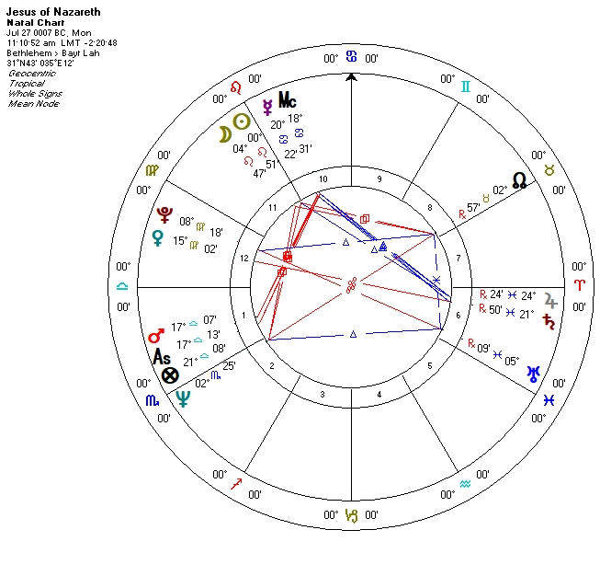

**Why is the book titled “Revelation”?**

*“Then Jesus went out and departed from the temple, and His disciples came up to show Him the buildings of the temple. And Jesus said to them, “Do you not see all these things? Assuredly, I say to you, not one stone shall be left here upon another, that shall not be thrown down.”[3]*

On the 9th of Av (*Tish’a BeAv*), 70 AD, the armed forces of the Roman emperor Titus destroyed the Second Temple in Jerusalem. This event was a colossally tragic cataclysm in the historical and spiritual destiny of the Jewish people. The Jewish sages point to a “wanton hatred” which had instilled itself among the people as the spiritual cause of the catastrophe.[4] From that distant epoch to this very day, on the eve of *Tish’a BeAv*, the Jews declaim the *Parashat Mas’ei*—the weekly Torah portion[5] recounting the 42 stations on the road to the Promised Land and the death of the High Priest Aaron which took place on the 1st of Av, 1273 BC.[6] The death of Aaron is the only death mentioned in the Torah for which we are given the exact date. We do not know the date of Abraham’s death, nor the date of Moses’s death. The reading of *Parashat Mas’ei* intends to remind worshipers of the lessons of Aaron, of whom the sage Hillel the Elder said: “Be of the students of Aaron, loving peace and pursuing peace, loving people and bringing them closer to Torah.”[7]

The Sabbath preceding *Tish’a BeAv* is a special day. It is called *Shabbat Hazon*, the Sabbath of Vision or the Sabbath of Revelation. On that day, worshippers read passages from the book of Isaiah.[8] The visions of the prophet Isaiah remind listeners of the fulfillment of prophecy, of the Almighty’s wrath, the punishment for breaking commandments and the possibility of mending one’s ways.

“Now a great sign appeared in heaven: a woman clothed with the sun…”[9]

On Jesus of Nazareth’s natal chart, Virgo is positioned above the horizon, on the day side.

“Then being with child…”[10]

The ruler of the 1st house is in the 12th house, in Virgo.

“…the moon under her feet…”[11]

“…she cried out in labor and in pain to give birth…”[12]

“And another sign appeared in heaven: behold, a great, fiery red dragon … And the dragon stood before the woman who was ready to give birth, to devour her Child as soon as it was born.”[13]

On the birth chart, the Moon is *not* situated under the woman’s (Virgo’s) feet. The apocalyptic picture of the heavens doesn’t describe the event of Christ’s birth, but something else. What then could this other event be, and how is it related to the birth of Christ? Let us allow the moon to move from its natal spot following the Zodiac circle. At some point, the moon will pass through Virgo to join Venus. After that it will enter Libra and at some point find itself “under the feet” of the Virgo constellation. And here, on the “Via Combusta”, it is bound to join Mars, the only planet aspecting the moon in the natal chart. This conjunction will take place in the 21st degree of Libra, on the 1st of August (6 of Av), at sunset.[14] (Let us note that on this transitory chart, Venus is diametrically opposed to Saturn).

Taking this into consideration, why then does the author, rather than describing the day of Christ’s birth, point to a different day, one in which the moon is under the Virgo’s feet? What event took place in Jesus’s life five days after his birth? The answer to this question is unknown. However, we do know what happened on the Saturday preceding the 9th of Av every year since the 77th year after Christ’s birth. And it so happens that the 1st of August, 7 BC (which is the precise day when the moon descends “under her [Virgo’s] feet”) was a Saturday. In the future, this Saturday would become *Shabbat Hazon*, the Sabbath of Revelation.

This raises the question of what could have motivated the author of Revelation to mark this date at the time? 7 BC was a relatively peaceful year and nothing about portended an impending catastrophe. However, since our author is writing the book *after* the great tragedy, he makes the connection of the birth and destiny of the Messiah, who predicted the destruction of the Temple, with the events of the 9th of Av 70 AD. Could things have turned out any other way, with the Messiah born on the 1st of Av, on Aaron’s Yahrzeit (day of death), a week before the tragic date? John seeks to reflect the meaning of future historic events in the astrological context the historic events of the past. The most significant of such events, preceding the destruction of the Temple, for John would undoubtedly have been the birth of Christ.

1. The present paper is a follow-up to the article “The Maternus Code: The Gospel of the Stargazers,” published in *ISAR International Journal*, Vol. 48, N3, December, 2019, pp. 22-36.
2. The starting point of our investigation is the hypothesis regarding Christ’s birth encoded in the *Mathesis* tractate written by the 4th century Roman astrologer Julius Firmicus Maternus. *Mathesis* , Ed. and Trans.J.H. Holden (Tempe: American Federation of Astrologers, 2011), Book VIII, XXV, 6, p. 512.
3. *Mt. 24:1-2*

  
4. Babylonian Talmud, Yoma, 9b.
5. The Torah, or the Pentateuch, is comprised of the first five books of the Old Testament.
6. Numbers 33:1–36:13.
7. Mishnah, Pirkei Avot, 1:12.
8. Isaiah 1:1-27.
9. Rev 12:1.
10. Rev 12:2.
11. Rev. 12:1.
12. Rev. 12:2
13. Rev. 12:3–4
14. At the moment of the moon’s conjunction with Mars, the sun is situated one and a half degrees above the descendant. Virgo is the 8th house. This is not the “woman clothed with the sun” (Rev. 12:1), but rather the “arrayed in purple and scarlet, and adorned with gold” (Rev. 17:4). The author of the Book of Revelation here gives a strikingly symbolic depiction of a sunset in its characteristic purple, scarlet and gold tones.