The Code of John: Revelation of the Stargazers[1]

*Astrological and Spiritual Symbolism in the Book of Revelation*

**Introduction**

The symbolism of the last book of the New Testament, the Book of Revelation (or The Apocalypse of John), written at the end of the 1st century AD, is impossible to comprehend without taking into account the circumstances that formed the particular context within which it must be interpreted. These circumstances are as follows:

1. The Book of Revelation is, among other things, an astro-symbollic chronology of the early life of Jesus of Nazareth and of the Holy Family.
2. This chronology is based on Jesus’s birth taking place on the 27th of July, 7 BC.[2]
3. According to the Hebrew calendar, the Nativity event takes place on the first day of the Hebrew month of Av.
4. On the 9th of Av, 70 AD, the Second Temple in Jerusalem was destroyed by the forces of the Roman emperor Titus.
5. The dates of the events recounted in the Book of Revelation correspond to the memorial days and religious holidays of the Jewish calendar, all of which involve spiritual processes.

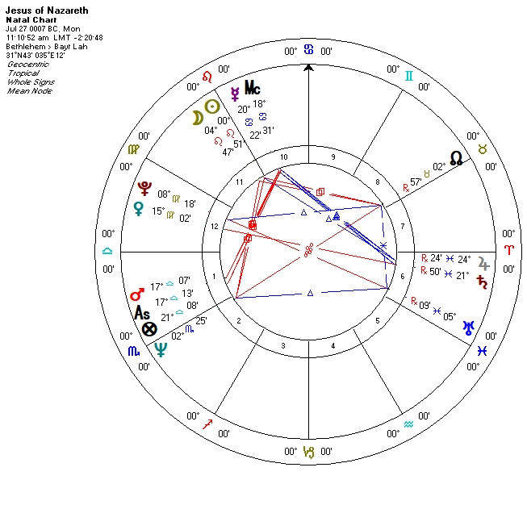

**Why is the book titled “Revelation”?**

On the 9th of Av (*Tish’a BeAv*), 70 AD, the armed forces of the Roman emperor Titus destroyed the Second Temple in Jerusalem. This event was a colossally tragic cataclysm in the political and spiritual history of the Jewish people. The Jewish sages point to a “wanton hatred” which had instilled itself among the people as the spiritual cause of the catastrophe.[3] From that distant epoch to this very day, on the Sabbath of the 43rd week, the Jews declaim the *Parashat Mas’ei*—the weekly Torah portion[4] recounting the 42 stations on the road to the Promised Land and the death of the High Priest Aaron which took place on the 1st of Av, 1273 BC.[5] The death of Aaron is the only death mentioned in the Torah for which we are given the exact date. We do not know the date of Abraham’s death, nor the date of Moses’s death. The reading of *Parashat Mas’ei* intends to remind worshipers of the lessons of Aaron, of whom the sage Hillel the Elder said: “Be of the students of Aaron, loving peace and pursuing peace, loving people and bringing them closer to Torah.”[6]

The Sabbath of the 44th week, the one preceding *Tish’a BeAv*, is a special day. It is called *Shabbat Hazon*, the Sabbath of Vision or the Sabbath of Revelation. On that day, worshippers read passages from the book of Isaiah.[7] The visions of the prophet Isaiah remind listeners of the fulfillment of prophecy, of the Almighty’s wrath, the punishment for breaking commandments and the possibility of mending one’s ways.

Let us now turn to the Book of Revelations. In his account of the Nativity, John unfolds the following vision: “Now a great sign appeared in heaven: a woman clothed with the sun, with the moon under her feet, and on her head a garland of twelve stars. Then being with child, she cried out in labor and in pain to give birth.”[8] On Jesus of Nazareth’s natal chart, Virgo is positioned above the horizon, on the day side. The ruler of the 1st house is in the 12th house, in Virgo. However, on the birth chart, the Moon is *not* situated under the woman’s (Virgo’s) feet. It stands to reason therefore that the apocalyptic picture of the heavens doesn’t describe the Nativity event, but something else. What then could this other event be, and how is it related to the birth of Christ?

Let us allow the Moon to move from its natal position following the Zodiac circle. At some point, the Moon will pass through Virgo to conjoin with Venus. After that it will enter Libra and at some point find itself “under the feet” of the Virgo constellation. And here, on the “Via Combusta,” it is bound to encounter Mars, the only planet aspecting the Moon in the natal chart. This conjunction will take place in the 21st degree of Libra, on the 1st of August (6th of Av), at sunset.[9] (Let us note that on this transition chart, Venus is in opposition to Saturn.)

Therefore, rather than describing the day of Christ’s birth, the author points to a different day, one in which the Moon is under the Virgo’s feet. From the annals of Jesus’s life, we have no knowledge of any event taking place five days after his birth. However, we do know what happened on the Saturday preceding the 9th of Av in 70 AD, seventy-seven years after Christ’s birth, and every year since. And it so happens that the 1st of August, 7 BC (which is the precise day when the Moon descends “under her [Virgo’s] feet”) was a Saturday. In the future, this Saturday would become *Shabbat Hazon*, the Sabbath of Revelation.

This raises the question of what could have motivated the author of Revelation to mark this date at the time? 7 BC was a relatively peaceful year and nothing about it portended an impending catastrophe. However, since our author is writing the book *after* the great tragedy, he makes the connection of the birth and destiny of the Messiah, who predicted the destruction of the Temple, with the events of the 9th of Av 70 AD: “Then Jesus went out and departed from the temple, and His disciples came up to show Him the buildings of the temple. And Jesus said to them, ‘Do you not see all these things? Assuredly, I say to you, not one stone shall be left here upon another, that shall not be thrown down.’”[10]

Could things have turned out any other way, with the Messiah born on the 1st of Av, on Aaron’s Yahrzeit (day of death), a week before the tragic date? John seeks to reflect the meaning of future events in the astrological context of the historic events of the past. The most significant of such events, preceding the destruction of the Temple, for John, would undoubtedly have been the birth of Christ.

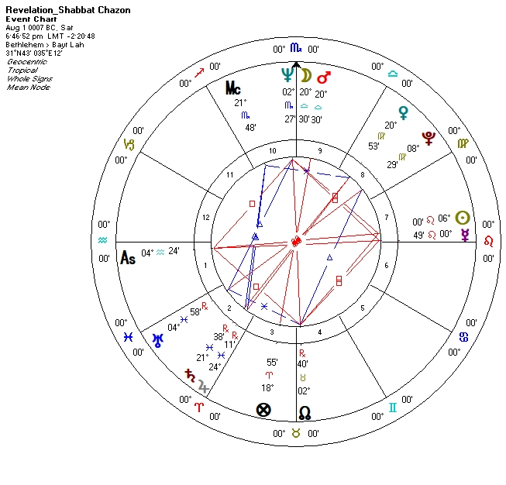

**The Maternus code: birth of the Messiah**

The birth of the Messiah was an attempt to forewarn of the tragic unfolding of events and to thwart them, to put an end to the “wanton hatred,” and to remind the people of the warnings of Isaiah and the counsels of Aaron. If all else failed, the Messiah Himself would become the sacrificial lamb of atonement. This is the framework within which John might have considered the Messiah’s life and destiny. He may also have had additional thoughts on the matter: “Jesus answered and said to them, ‘Destroy this temple, and in three days I will raise it up.’ Then the Jews said, ‘It has taken forty-six years to build this temple, and will You raise it up in three days?’ But He was speaking of the temple of His body.”[11]

According to Jewish religious custom, eight days after the Nativity, [12] the Holy Infant should have undergone ritual circumcision—the *Brit Milah*, symbolizing the Jews’ covenant with God: “And you shall be circumcised in the flesh of your foreskins, and it shall be a sign of the covenant between Me and you.”[13] In our case that would make Jesus’s circumcision fall on the 9th of Av. The Sages of the Talmud pronounced that the Messiah would be born on the 9th of Av.[14]

The celestial and astro-symbollic dynamics of the first nine days following the physical incarnation of the Son of God manifest a mysterious process, one that could be seen as a process of preparation for the conclusion of the Messianic Covenant. This process starts with Aaron’s Yahrzeit, continues through to *Shabbat Hazon* and culminates with the *Brit Milah* ritual on the 9th of Av.

Entering the 22nd degree of Libra, the Moon will nestle into Libra’s Northern Scale. On the 3rd of August, Mars will align precisely with the Northern Scale and stay in that degree until August 4th (the 9th of Av). Libra’s Northern Scale is the star of the “immortal name.”[15] On the same day, the waxing Moon, having fallen under the rule of Mars in Scorpio, will make a trine with Jupiter in Pisces. According to Maternus: “If Jupiter comes into aspect with the waxing Moon, this will create men of almost divine and immortal nature.”[16] Let us note that the Messiah completed his earthly mission on the 9th of April 30 AD (the 17th of Nissan in the Hebrew calendar). On this day, the Moon and Jupiter were situated in the same celestial positions as on the 4th of August 7 BC (the 9th of Av).

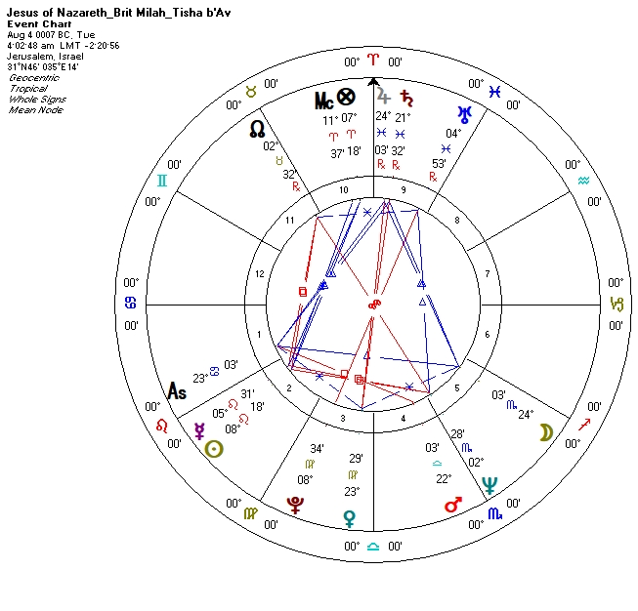

**The return from Egypt**

After Christ is born, Joseph is instructed to uproot his family and seek refuge in Egypt: “An angel of the Lord appeared to Joseph in a dream, saying, ‘Arise, take the young Child and His mother, flee to Egypt, and stay there until I bring you word; for Herod will seek the young Child to destroy Him.’”[17]

King Herod the Great died in the spring of 4 BC, and so in December of 4 BC, 42 months after the birth of Jesus, the Holy Family was allowed to return from their forced Egyptian exile: “‘Arise, take the young Child and His mother, and go to the land of Israel, for those who sought the young Child’s life are dead.’ Then he arose, took the young Child and His mother, and came into the land of Israel.”[18]

The Book of Revelation also makes reference to this period of time: “And he was given a mouth speaking great things and blasphemies, and he was given authority to continue for forty-two months.”[19] This passage is taken from the description of the Beast of the Sea, which represents Roman power, in our case—Herod the Great. We know this because it coincides directly with the amount of time Mary spends in exile: “Then the woman fled into the wilderness, where she has a place prepared by God, that they should feed her there one thousand two hundred and sixty days.”[20] Let us note that forty-two times thirty equals exactly one thousand two hundred and sixty days.

Their Holy Family’s return from Egypt coincides with Hanukah —the celebration of the cleansing of the Temple from pagan corruption after the Maccabees’ victory over the Greeks in 165 BC. During Hanukah (from 25 Kislev to 2 or 3 Tevet in the Hebrew calendar), eight candles are lit by the ninth and central candle of the Hanukiah menorah—one candle on the first day, two candles on the second day and so on until the eighth day. According to the teachings of the Kabbalah, the lit candles of the Hanukiah symbolize the different aspects of spiritual being known as the *sefirot*.[21] In addition, according to ancient Hebrew sources, the candles of the Hanukiah correspond to the different planets.[22]

The transit of the Moon from the 14th to the 21st of December symbolizes the period of exile and the return. Coming out of a volatile position in Libra on the 14th of December and escaping Mars, the Moon is in fall and under the control of Mars in Scorpio, traveling along the Via Combusta. Fortunately, however, it passes through, invisible to its ruler. Entering Sagittarius takes the Moon out of the danger zone.

Positive indicators include the benevolent rule of Jupiter, and the mutual reciprocity of the Moon with this planet. On the negative side, we have aversion. On the fifth day of Hanukah the Moon will be burned and renewed.

The next phase is the exile, under Saturn in Capricorn, the sign of a falling Jupiter. The Moon and Jupiter are in opposition here.

The Aquarius phase, under the rule of Saturn, will be easier and will constitute the final phase of the transition. Taking on the necessary restrictions dictated by the aspecting Saturn, the Moon finishes its Hanukah journey on the 21st of December.

On the 23rd of December, the day of the Winter Solstice, the Moon crosses the boundary of Pisces and forms a trine with its ruler, who is exalted in the Moon’s abode. Mars and Saturn form an exact opposition.

If we were to apply Kabbalistic terms to the Moon’s transit during the Hanukah period, we could describe it as the rise of the *Malkhut* (Kingdom) sefira into the *Bina* (Understanding) sefira. The work of the *Hessed* (Mercy) sefira consists of spiritually cleansing the *Malkhut* sefira and lifting its desires to a higher spiritual state of *Bina* which consists of renouncing egotism to become more God-like. The Moon is the astrological body corresponding to the *Hessed* sefira. Jupiter corresponds to *Malkhut*.[23]

Over the next two weeks the Moon will travel towards Jupiter and conjoin with it in the Moon’s abode. On that day will elapse the period of 1260 days since the birth of Christ.

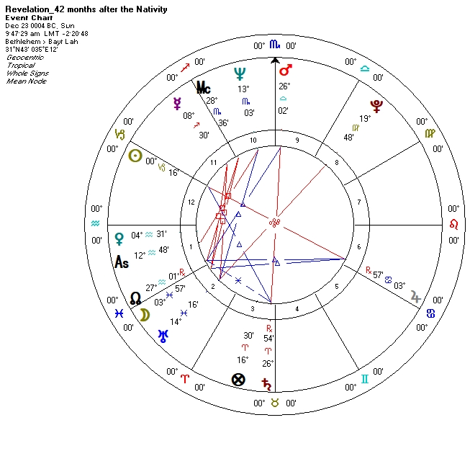

**Plus Ultra.**[24] **The Code of Jerahmeel: the lost tribes and the Crux Praestabilita.**[25] **Assemblage point.**

The findings of the present investigation lead us to several conclusions and possibly provide us with new research directions.

Let us remind ourselves that our point of departure is the hypothesis regarding the date of the Nativity encoded in the tractate of the 4th century astrologer Julius Firmicus Maternus.[26] Our assumption is that the real Nativity took place on the 27th of July, 7 BC, with the exact time of birth falling somewhere between 11:11 in the morning and midday. The ascending Zodiac sign at the time of birth was Libra.

The 27th of July, 7 BC was the first day of a new lunar month, the 1st of Av according to the Hebrew (lunar) calendar. This day is the anniversary of the death of the first High Priest Aaron. The tribe of Aaron is the Levi tribe, designated custodians of the Ark of the Covenant and of the Jerusalem Temple; the descendants of Aaron became the priest class—the Kohanim. Both apocryphal Qumran sources and canonical Christian sources tell us that the Messiah was not only a descendant of the royal house of David (of the tribe of Judah), but also a Kohen—a descendant of Aaron, “called by God, just as Aaron was.”[27]

If we turn to the traditional Hebrew sources, we find mention of two Messiahs. The first is a descendant of King David, *Mashiah ben David*. The second on the other hand is not a descendant of Aaron, as one may have surmised, but of Joseph, *Mashaih ben Yossef*. [28] Indeed, in the Biblical story, Joseph is separate from his brothers:

From there is the Shepherd, the Stone of Israel, by the God of your father who will help you, and by the Almighty who will bless you with blessings of heaven above, blessings of the deep that lies beneath, blessings of the breasts and of the womb. The blessings of your father have excelled the blessings of my ancestors, up to the utmost bound of the everlasting hills. They shall be on the head of Joseph, and on the crown of the head of him who was separate from his brothers.[29]

He sees dreams in which his brothers (represented by sheaves of grain) bow down to him. The brothers, knowing Joseph to be their father’s favorite, hate him and wish to kill him. They devise a cunning plan as a result of which Joseph is sold into slavery in Egypt, where, by the will of the Almighty, his prospects soar as a royal advisor to the Pharaoh. The tale ends with Joseph forgiving his brothers and making peace with them.[30]

There is no shortage of profound theological and Kabbalistic interpretations of this fascinating tale of Joseph and his brothers.[31] Our interest, however, lies in the astrological aspect of the story. The twelve tribes of Israel correspond to the twelve signs of the Zodiac. Each line of descendants of the forefather Jacob which received an earthly domain in the promised land, has its own “celestial domain.” With the exception of one—the Levites; they did not receive an earthly domain. This poses a problem. One can divide land into as many domains as one’s heart desires, but there are exactly twelve signs of the Zodiac, no more no less. However, because the Levi tribe was not meant to work the earth, but rather God and the facilities dedicated to His worship, they lived on the territories of other tribes and were the element that unified all of the tribes of Israel.[32]

The Torah proposes a solution to the numerical “shortage” of tribes endowed with their own domains. The number never changes—there are and have always been twelve tribes of Israel. The absence of the Levi tribe is compensated by changing the original composition of the list of tribes. That is to say, if the Levi tribe is crossed off the list, one of the remaining tribes must be split into two. This tribe is the tribe Joseph. It so happens that Joseph had two sons—Manasseh and Ephraim.[33] By Jacob’s decision, Joseph’s sons were designated to be the originators of two separate tribes.[34] This is why, when the Torah first lists the tribes of Israel the list includes the tribes of Joseph and Levi.[35] However, later enumerations of the tribes omit the tribe of Levi, for the reasons mentioned above, and list Manasseh and Ephraim in the place of Joseph.[36]

So much for the earthly representation of the tribes of Levi and Joseph. What is left to determine is how they are represented in the heavens. The case of the Levi tribe is rather straightforward: “Levi has no portion nor inheritance with his brethren; the Lord is his inheritance, just as the Lord your God promised him.”[37] In other words, Levi’s “celestial domain” is above the stars, it is God himself. But what of Joseph’s “celestial domain”?

In 12th century Spain, Jewish Apocrypha and legends were collected in a book called *Sefer ha-Zikhronot* (*The Book of Memories*), which later became known as *The* *Chronicles of Jerahmeel*. This tome contains a version of the second chapter of the book of Numbers, the chapter containing a description of the order of the tribes as they camp around the tabernacle: “Everyone of the children of Israel shall camp by his own standard, beside the emblems of his father’s house; they shall camp some distance from the tabernacle of meeting.”[38] The Bible remains silent on the subject of what the emblems of the houses of Israel might have been. However, the same cannot be said of *The* *Chronicles of Jerahmeel*. The apocryphal retelling of this event describes not only the standard and emblem of each tribe; far more intriguing, and pertinent to our present discussion, is the fact that the author of the tale attributes a Zodiac sign to each tribe as well.[39] These are attributed as follows:

|  |  |  |
| --- | --- | --- |
| Issachar – Aries  Reuben – Taurus  Ephraim – Gemini  Dan – Cancer | Judah – Leo  Simeon – Virgo  Manasseh – Libra  Asher – Scorpio | Zebulon – Sagittarius  Gad – Capricorn  Benjamin – Aquarius  Naphtali – Pisces |

We might ask what could be the principle behind these assignations? Let us first take into account that the tabernacle is surrounded on four sides, with three sides camping on each side. Each camp corresponds to the four elements. The distribution of the tribes inside the camps, and the element corresponding to each camp are as follows:

East: Judah, Issachar, Zebulon – Fire

South: Reuben, Simeon, Gad – Earth

West: Ephraim, Manasseh, Benjamin – Air

North: Dan, Asher, Naphtali – Water

The correlations between the tribes and the Zodiac signs and the order of the tribes inside the “elementary” camps follow the order of the sequence of signs in the Zodiac ecliptic. The only exception to this rule is that Aries and Leo switch places: Judah is the first tribe in the East-Fire camp, and the sign attributed to it is Leo rather than Aries—the first fire sign in the Zodiac circle. Conversely, Issachar is listed second but its designated sign is Aries rather than Leo—the second fire sign in the Zodiac circle. In the other camps, the order is preserved.

Jewish tradition skews towards the view that the Messiah from the Joseph tribe would be a descendant of Ephraim:

I will strengthen the house of Judah, and I will save the house of Joseph. I will bring them back, because I have mercy on them. They shall be as though I had not cast them aside; for I am the Lord their God, and I will hear them.Those of Ephraim shall be like a mighty man, and their heart shall rejoice as if with wine. Yes, their children shall see it and be glad; their heart shall rejoice in the Lord. [40]

If the order of correlations in *Sefer ha-Zikhronot* is to be believed, the house of Ephraim is ninth on our aforementioned natal chart and its ruler is situated on the MC. That is how things stand according to *The* *Chronicles of Jerahmeel*. However, there is another principle of assignation of Zodiac signs to the tribes of Israel in the Jewish tradition. It comes from the Aramaic translation of the Torah—the *Targum Pseudo-Jonathan* (1st century BC).[41] The order and distribution of the tribes within the elements are the same as in *The* *Chronicles of Jerahmeel*. The signs of the fixed cross are attributed to the first tribe in every camp: Judah – Leo, Reuben – Taurus, Ephraim – Aquarius, Dan – Scorpio. Nothing is said about the other correlations. We might suppose that the signs of the cardinal cross are attributed to the second tribe in every camp, and the signs of the mutable cross to the third. We would then obtain the following layout:

|  |  |  |
| --- | --- | --- |
| Issachar – Aries  Reuben – Taurus[42]  Benjamin – Gemini  Dan – Scorpio | Judah – Leo[43]  Gad – Virgo  Manasseh – Libra  Asher – Cancer | Zebulon – Sagittarius  Simeon – Capricorn  Ephraim – Aquarius  Naphtali – Pisces |

The Sun sign on the natal chart of the Holy Infant is Leo—the sign of Judah, the tribe of David. The ascending sign, Libra, in both of the variants we have seen, is the sign of Manasseh, one of the sons of Joseph.[44] However, there is another possibility: we could assign the signs of the mutable cross to the second tribe in every camp, and the signs of the cardinal cross to the third. That would make Benjamin Libra and Manasseh Gemini.[45] In this case, Manasseh becomes the ninth House, whose ruler is positioned on the MC. The Sun and ascending signs correspond to Judah and Benjamin—the tribes of the kings of Israel, and the progeny of David.[46] Benjamin was Joseph’s only full (maternal and paternal) brother.[47] The Apostle Paul emphasized his provenance from the tribe of Benjamin.[48]

The House of Ephraim, Aquarius[49] in all variants, is fifth. Its ruler, Saturn, is positioned in the neighboring Pisces[50] and conjoined with Jupiter. Saturn is the *Yessod* sefira, “Mashiah Ben Yossef.” Jupiter—the *Malkhut* sefira, “Mashiah Ben David.”[51] That is how things stand in the *Targum Pseudo-Jonathan*.

The tribe of Manasseh is mentioned in the Book of Revelation, but not the tribe of Ephraim. Instead the book talks about “the tribe of Joseph.”[52] It is beyond the scope of the present paper to perform an in-depth analysis of the fine theological distinctions between Ephraim and Manasseh. Let us only note that it was Joseph’s wish for Jacob to bestow the first blessing on his firstborn, Manasseh, however Jacob placed his right hand on the head of Ephraim. Manasseh received the blessing from the left hand.[53]

*And from the grave on the third day I'll rise.   
Then, like a fleet of barges down the stream,   
The centuries will float forth from the night*

*And make their way before my judgment seat.[54]*

*Dixi et Vale!*

© *Vadim Krakovsky*

All Rights Reserved

1. The present paper is a follow-up to the article “The Maternus Code: The Gospel of the Stargazers,” published in *ISAR International Journal*, Vol. 48, N3, December, 2019, pp. 22-36.
2. The starting point of our investigation is the hypothesis regarding the Nativity date encoded in the *Mathesis* tractate written by the 4th century Roman astrologer Julius Firmicus Maternus. *Mathesis*, Ed. and Trans.J.H. Holden (Tempe: American Federation of Astrologers, 2011), Book VIII, XXV, 6, p. 512.
3. Babylonian Talmud, Yoma, 9b.
4. The Torah, or the Pentateuch, is comprised of the first five books of the Old Testament.
5. Numbers 33:1–36:13.
6. Mishnah, Pirkei Avot, 1:12.
7. Isaiah 1:1-27.
8. Rev 12:1–2.
9. At the moment of the moon’s conjunction with Mars, the sun is situated one and a half degrees above the descendant. Virgo is in the 8th house. This is not the “woman clothed with the sun” (Rev. 12:1), but rather the “arrayed in purple and scarlet, and adorned with gold” (Rev. 17:4). The author of the Book of Revelation here gives a strikingly symbolic depiction of a sunset in its characteristic purple, scarlet and gold tones.
10. Mt. 24:1–2.
11. John 2:19-21.
12. In the Gospel of Luke, in original Greek, it is written: “ὅτε ἐπλήσθησαν ἡμέραι ὀκτὼ” [“after eight days”] (Luke 2:1).
13. Genesis17:11.
14. Jerusalem Talmud, Berachot 2:4; Eichah Rabbah 1:51.
15. Ebertin, R., Hoffmann, G., *Fixed Stars and Their Interpretation*, trans. I. Banks and L. Kratzsch (Tempe: American Federation of Astrologers, 2001), p. 65.
16. Maternus, Julius Firmicus, *Ancient Astrology Theory and Practice: Matheoseos, Libri VIII*, trans. J.R. Bram (Park Ridge: Noyes Press, 1975), Liber Tertius, III, 9, p. 80.
17. Mt. 2:13.
18. Mt. 2:20-21.
19. Rev. 13:5.
20. Rev. 12:6.
21. *Zohar* I, 51a, in Matt, D. (ed.), *Zohar*, trans. and comm. D. Matt, 12 Vols (Stanford: Stanford University Press, 2003-2019); Laitman, M., Rav, *Introduction to the Book of Zohar: The Science of Kabbalah*, 2 Vols, Bnei Baruch (Toronto: Laitman Kabbalah Publishers, 2005).
22. Bekkum, W.J. van, *Hebrew Poetry in Late Antiquity: Liturgical Poems of Yehudah*, Critical Edition with Introduction and Commentary (Leiden: Brill Publishers, 1998), pp. 124-125. One mustn’t confuse the nine-candle Hanukiah menorah, which is used only during the Hanukah ritual, with the seven-candle Menorah. The latter was a constant fixture of the Temple in Jerusalem; its candles symbolize the seven lower *sefirot*—from *hessed* to *malkhut*—and correspond to the same five planets and two celestial lights as the Hanukiah candles. See Parsha *Terumah*; *Zohar* II, 157b; Josephus Flavius, *Jewish War*, Book 5, Ch. 5:5; *Jewish Antiquity*, Book 3, Chs. 6:7, 7:7; Philo of Alexandria, *Moses*, 2, 102-103; *Questions and Answers on Exodus*, 2, 73-79; *Who is the* *Heir*, 43:216-46:229. “Then I turned to see the voice that spoke with me. And having turned I saw seven golden lampstands, and in the midst of the seven lampstands One like the Son of Man, clothed with a garment down to the feet and girded about the chest with a golden band” (Rev 1:12–13).
23. *Tikkunei ha-Zohar*, no. 70 (128b), in Kiener, R.C., “The Status of Astrology in the Early Kabbalah: From the ‘Sefer Yesirah’ to the ‘Zohar,’” *Jerusalem Studies in Jewish Thought*, no. 3–4 (1987), p. 40. The *Bina* sefira, and the degree directly above it, *Hokhma*, are symbolized by the Hanukah candles but have no planetary “representative.” *Hokhma* and *Bina* are “serviced” by the sefirot below them. The highest of these is the *Hessed* sefira.
24. “Further beyond” *(Latin).*
25. “Pre-established cross” *(Latin).*
26. The Maternus Code: The Gospel of the Stargazers, *ISAR International Journal*, Vol. 48, N3, December, 2019, pp. 22–36.
27. Heb. 5:4; Brook, G.J., ‘The Messiah of Aaron in the Damascus Document’, *Revue de Qumrân*, Vol. 15, No. 1/2, 57/58 (September, 1991), pp. 221-223; Hilhorst, A., Puech, É., Tigchelaar, E.J.C. (eds.), *Flores Florentino: Dead Sea Scrolls and Other Early Jewish Studies in Honour of Florentino Garcia Martinez* (Leiden: Brill Publishers, 2007), p. 212; Roberts, A. and Donaldson, J. (eds.), *The Testaments of the Twelve Patriarchs*, trans. R. Sinker, in *Ante-Nicene Fathers*, Vol. 8 (Buffalo: Christian Literature Publishing Co., 1886), 2:5, 5:5, 7:5, 8:5-6, 9:8, 11:19.
28. Zech.12:10;Babylonian Talmud, *Sukkah* 52a, 52b; Mitchell, D.C., *Messiah ben Joseph* (Newton Mearns: Campbell Publications, 2016); Sigvartsen, J.A., *Messiah ben Joseph: A Type in both Jewish and Christian Traditions* (Wilmore, KY: GlossaHouse, LLC, 2018); Bakst, J.D., *The Secret Doctrine of the Gaon of Vilna, 2 Vols.,* (Colorado Springs: City of Luz Publications, 2013).
29. Gen. 49:24–26.
30. Gen. 37–50.
31. *Zohar* I:25b; ibid. II:120a, III:153b, 246b, 252a. В каббале ‘Машиах бен Йосеф’ и ‘Машиах бен Давид’ символизируют великие силы исправления мира и раскрытия Творца. See Laitman, M., Rav, *Introduction to the Book of Zohar: The Science of Kabbalah*; Scholem, G., *The Messianic Idea in Judaism* (New York: Schocken Books, 1995).
32. Deut. 8:9–10, 18:1–8; Num. 18:20–23.
33. Gen. 41:50–52, 46:20; Num. 26:28.
34. Gen. 48:5.
35. Gen. 49:1–33.
36. Num. 1:10, 47; Josh. 14:1–4.
37. Deut. 10:8–9.
38. Num. 2:2.
39. Gaster, M. (ed.), *The Chronicles of Jerahmeel,* trans. M. Gaster (Germany: Jazzybee Verlag, 2012), pp. 177–180.
40. Zech. 10:6–7. The prophet Hosea predicts that there will come a time when, as punishment for apostasy, the “spring” of Ephraim “shall become dry” (Hosea 13:15). However, there will also come a time of redemption when “I will heal their backsliding, I will love them freely, for My anger has turned away from him” (Hosea 14:4). The prophet Ezekiel transmits the Lord’s demand to the people that the kin of David and of Joseph—the tribes of Judah and Ephraim— should unite (Ezekiel 37:15–21). See *Targum* *Yehonathan* on Exodus 4:11; *Zohar* II:120a; ibid. 153b, 194b, 243b.; Midrash *Tehulim* 60:3; Torrey, C.C., ‘The Messiah, son of Ephraim,’ *Journal of Biblical Literature,* Vol. 66, No. 3, Sep., 1947, pp. 253-277; Heinemann, J., ‘The Messiah of Ephraim and the Premature Exodus of the Tribe of Ephraim,’ *The Harvard Theological Review,* Vol. 68, No. 1, Jan., 1975, pp. 1-15.
41. Besides the Torah translation, *Targum Pseudo-Jonathan* also contains additional information from other sources. In older scientific literature, this text is referred to as *Targum* Jonathan Ben Uzziel or the *Palestinian Targum*. Initially it was known as the *Jerusalem Targum,* and there was a time when the text had been the subject of heated scholarly debate. See Etheridge, J. W (ed.), The Targums of Onkelos and Jonathan Ben Uzziel. On the Pentateuch With The Fragments of the Jerusalem Targum From the Chaldee, Vol. 2, trans. J. W. Etheridge (London: Longman, Roberts and Green, 1865), pp. 343–345.
42. In Deuteronomy, Joseph is compared to a bull (Deut. 33:17). Nevertheless, as we see here, it is objected to the murder of Joseph (Gen 29:32, 37:18, 37:22), which is what saved Joseph’s life. The House of Reuben is eighth on our natal chart. Its ruler, Venus, also rules the ascending sign. In other words, it rules life and death. Venus is positioned in the twelfth house. See Hamaker-Zondag, K., *The Twelfth House: The Hidden Power in the Horoscope*, trans. Translate Ltd. (York: S. Weiser, 1992), pp. 43–54.
43. In a classic text of Kabalistic literature, the *Sefer Yetzirah* (2nd–4th century AD), the Zodiac signs are attributed to the tribes in the order of the signs’ positions on the elliptic, and taking into account the distribution of the tribes inside the warrior camps, but without making the connection between the camps and the elements. In this instance, Judah is Aries, Issachar is Taurus, etc. We encounter the same order is *Yalkut Shimoni* (11th-13th century AD). The association of the Judah tribe with Aries has certain Christian theological foundations. However, it is unlikely that this connection has anything to do with the symbolism found in *Sefer Yetzira*. In our opinion, the approaches found in *Sefer ha-Zikhronot* and *Targum Pseudo-Jonathan* seem closer to authenticity, due to their comprehensiveness. Judah is, therefore, undoubtedly Leo.
44. There is also evidence that points to Libra being the sign of the antediluvian patriarch Enoch, son of Jared, grandson of Methuselah. Jared is associated with Virgo, while Methuselah is associated with Leo. Enoch is credited with the authorship of the three Books of Enoch: “By faith Enoch was taken away so that he did not see death, “and was not found, because God had taken him”; for before he was taken he had this testimony, that he pleased God” (Heb 11:5). See Jud. 1:14–15; Gen. 5:18–24; Lk.3:37; Schiffman, L.H., *Texts and Traditions; A Source Reader for the Study of Second Temple and Rabbinic Judaism* (Hoboken, NJ: KTAV Publishing House, 1998), pp. 472–473.
45. The stories of Benjamin and Manasseh are somewhat similar. The dynasty of Kings from the tribe of Benjamin couldn’t secure a foothold on the throne of Israel (King Saul). It was dethroned by the dynasty from the tribe of Judah (King David). Similarly, Joseph’s first son Manasseh didn’t receive the blessing of his grandfather, Jacob, first. The first, and more “prestigious” blessing was reserved for Joseph’s younger son, Ephraim.
46. The first king of Israel, King Saul (1079–1010 BC), hailed from the tribe of Benjamin (1 Kgs 9:1–2, 15–17).
47. Gen. 30:22–24, 35:16–20.
48. Rom. 11:1; Phi. 3:5.
49. According to Abraham Ibn Ezra (early 12th century AD), “Aquarius is the sign of Israel.” Christianity, on the other hand, is associated with Leo. For a more detailed discussion of Ibn Ezra’s views on the matter, and his biography, see Shlomo Sela, *Abraham ibn Ezra and the Rise of Medieval Hebrew Science* (Leiden-Boston: Brill Publishers, 2003), pp. 290–295.
50. Pisces is attributed to the Naphtali tribe who shared the Galilee region with the Zebulon tribe (Isa 9:1–2; Mt. 4:13–20; Jos 19:10–16, 32–39; Josephus Flavius, *Jewish Antiquities*, Book 5, Ch. 1:22, 24). Both tribes are associated with Jupiter.
51. *Tikkunei ha-Zohar*, p. 40; Laitman, M., Rav, *Introduction to the Book of Zohar; ‘*That is why there are two Messiahs. The first one is Messiah Ben Yosef (the degree of Yesod). His mission is to raise the humanity to the level of bestowal for the sake of bestowal, the property of Bina, the property of Hasidism. Yosef is the righteous (Tzadik) who doesn’t work with the egoistic properties and corrects only altruistic ones. With his help we attain not love, but the correct relationship with each other without mutual integration. The second one is Messiah ben David (the degree of Malchut) who enables us to correct our most egoistic desires to reception for the sake of bestowal, that is, to attain love, adhesion with each other and with the Creator. We have to be in this state already. However, in order to fully reach it, there is still a lot to be done.’ (Laitman, M., Rav, *The* *Eras of Two Messiah*, 5 March, 2017, <https://laitman.com/2017/03/the-eras-of-two-messiahs/>).
52. Rev. 7:8.
53. Gen. 48:1–21.
54. Boris Pasternak, *Gethsemane’s Garden*, trans. Christopher Barnes, Toronto Slavic Quarterly, <http://sites.utoronto.ca/tsq/10/barnes10.shtml>