**The Effect of Heparin and Peptide Conjugation on the Structure and Functional Properties of Alginate in Solutions and Hydrogels**

Nir Goldberg,a Olga Kryukov,b Dina Aranovich,a Smadar Cohen,b Ronit Bittona,c,*

a Department of Chemical Engineering, Ben-Gurion University of the Negev, Beer-Sheva 84105, Israel

b Avram and Stella Goldstein-Goren Department of Biotechnology Engineering and Regenerative Medicine and Stem Cell Center, Ben-Gurion University of the Negev, POB 653, Beer-Sheva 84105, Israel

c Ilze Kats Institute for Nanoscale Science and Technology, Ben-Gurion University of the Negev, Beer-Sheva 84105, Israel

* Corresponding author at: Department of Chemical Engineering, Ben-Gurion University of the Negev, Beer-Sheva 84105, Israel. E-mail address: rbitton@ bgu.ac.il (R. Bitton).

**Abstract**

Alginate decoration with more than one type of biomolecule is becoming a prevalent process in the pursuit to turn alginate hydrogels into synthetic extracellular matrices (ECMs). Here we present a systematic study of the structural-physical properties-function relationship of alginate-G4RGDY-heparin aqueous solutions and hydrogels. Small-angle X-ray scattering (SAXS) and rheology were used to characterize the systems’ nanostructure, viscosity of the solutions, and storage modulus of the hydrogels. The bioactivity of these gels was explored by evaluating their ability to sustain the release of vascular endothelial growth factor (VEGF). We show that the mode and order of conjugating the heparin and the peptide to the alginate backbone greatly affect the modified alginate hydrogels’ structure-properties-function relations. Moreover, we show that a detailed structural analysis of the conjugated architecture in solution can be used as a tool to adapt the properties of alginate-heparin-peptide hybrid hydrogels.

1. **Introduction**

Alginate is a linear, hydrophilic, polysaccharide biopolymer consisting of β-D mannuronic and α-L guluronic acid blocks, which occur in the cell walls of brown seaweed.1 Alginate hydrogels have been proven to be promising scaffolds for tissue regeneration and repair2-4 for bone,5 skin,6 and nerve regeneration.7-8 An emerging trend in designing such scaffolds is recapitulating the natural extracellular matrix (ECM) traits by installing motifs capable of providing biochemical stimuli.9-10

Functionalization of alginate hydrogels is often achieved by covalently attaching bioactive molecules (e.g., peptides, proteins, etc.) to the alginate backbone.11-13 The pioneering work in creating alginate synthetic ECMs focused on binding single peptides to the alginate backbone, the first being the G4RGDS peptide;12 nowadays, researchers focus on creating multifunctional hydrogels by functionalizing the alginate with more than one type of biological molecule.14

The amount and identity of the attached biomolecules are crucial for the scaffold’s bioactivity; however, they are not the only factors determining its functionality. The scaffold’s stiffness as well as the ligand’s availability (e.g., density) have been shown to dictate the magnitude and arrangement of intracellular forces, hence affecting the materials’ cellular response to them.11,15-16 Therefore, understanding the structure-function relationship of multicomponent alginate hydrogels is an important step toward bettering their rational design.

In previous studies, we have shown that covalently linking a peptide that contains RGD to an alginate backbone affected the conformational state of the individual chain as well as chain assemblies of alginate in aqueous solutions.17-18 We have shown that the amount of bound peptide determines the behavior of polysaccharide-peptide conjugates in solution, regardless of the specific nature of the polysaccharide.18 Furthermore, we have demonstrated that the sequence of the conjugated peptides is a significant factor in tuning the stiffness of the alginate/peptide hybrid hydrogels.19

Here, we aim to study the structure-function relationship of multifunctional alginate hydrogels, i.e., hydrogels composed of an alginate chain decorated with more than one type of biomolecule. To this end, we chose to covalently bind to the alginate backbone both the G4RGDY peptide and heparin.

Heparin is a glycosaminoglycan (GAG), a stiff linear polysaccharide consisting of 1 to 4 linked disaccharide repeating units of uronic acid and glucosamine residues.20-21 It has been shown to stabilize growth factors from denaturation while increasing the affinity of the complex to cell receptors, an important trait for tissue engineering applications.11-13 A variety of methods have been used for the covalent immobilization of heparin into hydrogels in the production of ECM-mimetic materials.22-23 Recently, conjugation of heparin to polysaccharides (i.e., alginate14 and Chitosan24) has been suggested to improve their performance as synthetic ECMs.14,25 It has been suggested that when designing a hydrogel for promoting cell adhesion, growth, and function, synthesizing a surface that contains both RGD and heparin would provide a more desirable biomimetic material than hydrogels containing only one of the individual components.26-27 However, optimizing the function and physical properties of these multicomponent hydrogels could be a rigorous process; a better understanding of the interplay between the building block’s structure and the properties of the resulting hydrogels may be used to simplify it.

Here, we present a systematic study of the structural-physical properties-function relationship of alginate-G4RGDY-heparin aqueous solutions and hydrogels. Using small-angle X-ray scattering (SAXS) and rheology to characterize the systems’ nanostructure, the viscosity of the solutions, and the storage modulus of the hydrogels, we show that attaching heparin to an alginate-peptide molecule greatly affects its physical properties. Moreover, we show that a detailed structural analysis of the conjugated architecture in solution can be used as a tool to adapt the properties of alginate-heparin-peptide hybrid hydrogels.

1. **Materials and methods**
   1. **Materials**

Alginate (HF420RBS 70% guluronate, sodium salt, $\overline{Mw}$ =475 kDa) was a kind gift from FMC Biopolymers (Dramen, Norway). Heparin (183 USP units/mg, $\overline{Mw}$ =18 kDa), ethylenediamine (EDA, technical 75–80%), NaOH, 2-[N-morpholio] ethanesulfonic acid (MES buffer), N-hydroxysulfosuccinimide sodium salt (sulfo-NHS), and N-(3-dimetylaminopropyl)-N'-ethylcarbodiimide hydrochloride (EDC) were purchased from Sigma-Aldrich. The peptides G4RGDY (80–90% grade) were purchased from Bio-Sight/American Peptide Company (Vista, CA). Vascular endothelial growth factor (VEGF) and the ABTS Enzyme-Linked Immune-Sorbent Assay (ELISA) Buffer Kit for VEGF were purchased from Peprotech Ltd.

* 1. **Synthesis of polymer-heparin-peptide**

Conjugation of heparin with alginate was performed following the literature28-29 with some modifications. To minimize hydrolysis of EDC, the reaction was carried out in a 0.1 M buffer of 2-morpholinoethane sulfonic acid (MES buffer). First, heparin sodium salt and sodium alginate (1:500 mg/mg heparin:polymer) were dissolved in an MES buffer at a concentration of alginate 10 mg ml−1 with overnight stirring at room temperature. Then, the carboxylic acid groups of alginate and heparin were activated using EDC and NHS (molEDC: molNHS = 0.6:1). After 5 min, ethylenediamine (3.1 × 10−2 M) was added to the solution under vigorous stirring at room temperature. After a reaction period of 4 h, the resulting polymer was dialyzed to remove excess unreacted EDC/NHS and aminated heparin molecules, using a SpectraPor dialysis membrane (3500 MWCO), against 1M NaCl for 24 h. The product was then frozen and lyophilized by freeze-drier for 72 h.

Conjugation of a peptide to the alginate was performed using carbodiimide chemistry, according to Rowley et al.12,30 Alginate-heparin was dissolved in the stock MES buffer (0.1 M) to give a 1% w/v aqueous solution followed by stirring for 24 h. Sulfo-NHS was added in an amount that would give a ratio of sulfo-NHS:EDC of 1:2. The peptide was added after 5 min (1:100 mg/mg peptide:polymer), and the solution was then stirred continuously for 24 h. Thereafter, the solution was dialyzed against triply distilled water in 3500 MWCO dialysis tubes for 96 h and then lyophilized for 72 h. For analysis, the requisite amount of the dried conjugated polymer was dissolved in triply distilled water (18.2 mU/cm).

**FTIR**

For FTIR analysis, native and modified polysaccharide samples were prepared as thin films to verify the conjugation of heparin and peptide to alginate chains. Measurements were performed in transmission mode on a Nicolet IS10 infrared spectrometer. The FTIR spectrum was taken in the range of 400–4000 cm−1 by collecting and averaging 32 spectra at a resolution of 4 cm−1.31

**XPS**

X-ray photoelectron spectroscopy (XPS) is a complementary technique yielding information about the atomic composition of a material’s surface; thus, it can quantify the extent of protonation of sulfate and amino groups through examination of the sulfur and nitrogen narrow scan. XPS was performed using an ESCALAB 250. The Avantage data system allows processing and analysis of all types of data.

**Viscosity measurements**

Viscosities of the polysaccharide solutions were determined using a HAAKE RotoVisco 1 (Thermo Scientific), equipped with an extended temperature cell for temperature control and a stainless steel cone-and-plate (d=60 mm and θ=0.5˚). The viscosities of the polysaccharide solutions were measured at constant room temperature (22 ± 1˚C) as a function of the shear rate in an upward sweep from 1 s-1 to 1000 s-1.

* 1. **Gel preparation**

Alginate was dissolved in double-distilled water; modified alginate concentration in the gel was 1.5% wt/vol. A calcium source in the form of a pre-prepared 40mM CaCO3 solution was introduced next, followed by a fresh GDL solution. GDL induces the slow release of calcium ions from the CaCO3 complex, allowing the gelling of the alginate solution. The Ca2+: GDL molar ratio was 1:1. Rheology and SAXS measurements were done at least 12 h after GDL addition, to allow for the alginate solution to gel completely.32

**Small angle X-ray scattering (SAXS)**

Small angle X-ray scattering patterns of the polymer solutions and hydrogels were obtained with a SAXSLAB GANESHA 300-XL. CuKα radiation was generated by a Genix 3D Cu-source with an integrated monochromator, 3-pinhole collimation and a two-dimensional Pilatus 300 K detector. The scattering intensity q was recorded at a range of 0.012 < q < 3 Å-1 (corresponding to lengths of 10–800 Å). Measurements were performed under vacuum at ambient temperature. The scattering curves were corrected for counting time and sample absorption. Hydrogel specimens were placed in stainless steel sample cells with entrance and exit windows made of mica. Data analysis was based on fitting the scattering curve to an appropriate model by software provided by NIST (NIST SANS analysis version 7.0 on IGOR)33 and model plot.34

**Rheology**

The dynamic viscoelastic properties of the modified alginate gel samples were characterized by determining the frequency dependence of the storage and loss moduli, G'(ω) and G''(ω) at T=250C after inducing the gelation. Measurements were carried out with a Reologica StressTech HR stress-controlled rheometer equipped with an extended temperature cell for temperature control and stainless steel parallel plate (d=40 mm). The samples were allowed to equilibrate at room temperature for at least 12 h before the rheological tests were performed.

**Release studies and VEGF analysis by Enzyme Linked Immuno-Sorbent Assay (ELISA)**

VEGF 1*10-4% w/v was added to the modified alginate solutions before the addition of the cross-linking agents.

Modified alginate gels containing VEGF were placed in Dulbecco’s modified eagle medium (DMEM) with 0.1% w/v bovine serum albumin (BSA, pH 7.2) and incubated on an incubator at 370C. The supernatant was collected and replaced by fresh DMEM with 0.1% BSA at scheduled time points and kept frozen at –800C until all samples were collected and the amount of VEGF in releasing media was determined by an ELISA. The ELISA was performed following the manufacturer’s instructions (Human VEGF165 Standard ABTS ELISA Development Kit, ABTS ELISA Buffer Kit, Peprotech Ltd.).

1. **Results and discussion**
   1. **Synthesis of alginate-peptide-heparin**

Conjugation of a peptide and/or heparin to the alginate backbone was performed using carbodiimide chemistry as described in section 2.2. Four molecules were synthesized: alginate-G4RGDY (Alg-RGD); alginate-heparin (Alg-Hep); alginate-G4RGDY-heparin (Alg-RGD-Hep), where heparin was conjugated to Alg-RGD molecules; and alginate-heparin-G4RGDY (Alg-Hep-RGD), where the peptide G4RGDY was conjugated to Alg-Hep molecules. In addition, a mixture of Alg-Hep and Alg-RGD (denoted as Alg-RGD+Alg-Hep) was prepared.

The binding of the heparin and the peptide to the alginate was confirmed by FTIR spectroscopy (Fig. S1) and XPS (Table S1).

* 1. **Viscosity and nanostructure of modified alginate solutions**

Alginate solutions were prepared by dissolving alginate powder in milli-Q water so the final concentrations were 2% w/v alginate.

Differences in the polymer network features are manifested in the polymer’s rheological behavior. Thus, the steady shear viscosity as a function of the applied shear rate was monitored for the polysaccharide’s aqueous solutions. Viscosity measurements of 2%wt of polysaccharide (natural and modified) in aqueous solution are displayed in Figure 1. As can be seen, all tested polymers exhibit shear thinning behavior typical of viscous polymers at the semi-dilute concentration regime,18,35-37 in which a Newtonian plateau (low shear rate) region is followed by a viscosity gradual decrease (higher shear rate). The lowest shear rate at which the decrease of viscosity becomes apparent is called the critical shear rate (͘c).

Shear thinning of fluids and weak gels can be described by (1) =k͘n-1, where  is the viscosity (Pa*s), ͘ is the shear rate (s-1), n is the power law exponent (for a Newtonian fluid n = 1), and k is a consistency index which is numerically equal to the viscosity at 1 s-1 (Fig. S2, Table S2).38

Alg-Hep behavior is similar to that of alginate. In agreement with our previous work,19 Alg-RGD shows a much higher k and a smaller n, indicating a more pronounced shear thinning behavior (i.e., more entanglements). The scan of Alg-Hep-RGD lies between those of Alg-Hep and Alg-RGD, indicating both molecules are affecting the polymers’ behavior. Moreover, comparing the viscosity of Alg-RGD-Hep and Alg-Hep-RGD to the viscosity of a mixture of Alg-Hep and Alg-RGD (denoted as Alg-RGD+Alg-Hep) suggests a synergistic effect rather than an additive one, likely due to intermolecular interactions between Alg-RGD and Alg-Hep that are not manifested when the heparin and RGD are bound to the same alginate. The order of the molecules’ conjugation (i.e., peptide before heparin or heparin before peptide) also had a significant effect on the solution’s viscosity; fitting the data to a power-law model yielded higher k and lower ͘c (Table S2) for the molecules in which the peptide was the last conjugated molecule, suggesting a more entangled network if formed.

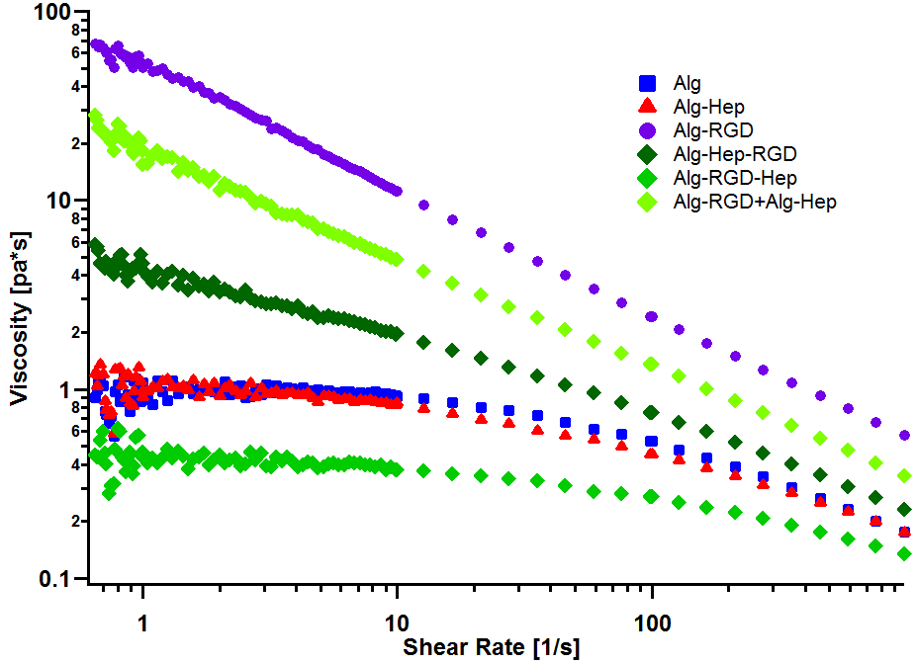

**Figure 1:** Steady shear viscosity as a function of the applied shear rate modified alginate in water. Alg ( ), Alg-Hep ( ), Alg-RGD ( ), Alg-Hep-RGD ( ), Alg-RGD-Hep ( ), Alg-RGD+Alg-Hep ( ).

Differences in the rheological behavior of polymer solutions are usually manifested by differences of the structural features of the polymer’s network. Thus, SAXS measurements of the modified alginate in aqueous solution were conducted. The SAXS patterns of all of the investigated molecules are presented in Figure 2. The visible differences between the scattering curves indicate that indeed, there are structural differences between the tested solutions.

Horkay and Hammouda39 described the scattering pattern of polyelectrolyte in salt-free solutions as the result of three contributions: spatial concentration fluctuations (clustering), which are apparent as an upturn in the low q range; thermal concentration fluctuations (high q); and a characteristic correlation peak (mid q) with a maximum, q0, corresponding to an average distance, d0=2/q0, which represents an average distance between the charged domains. This scattering pattern can be described by

(2) $I\left(q\right)=\frac{A}{q^{n}}+\frac{C}{1+(\left|q-q_{0}\right|ζ)^{m}}$

where n and m are the clustering and solvation Porod exponents, respectively; q0 is the peak position, if it can be resolved; and ζ is a correlation length that corresponds to an average distance between neighboring entanglements within the same domain.39 The best fits to Equation 2 are presented as a black solid line in Figure 2, and the best-fit parameters are summarized in Table S3.

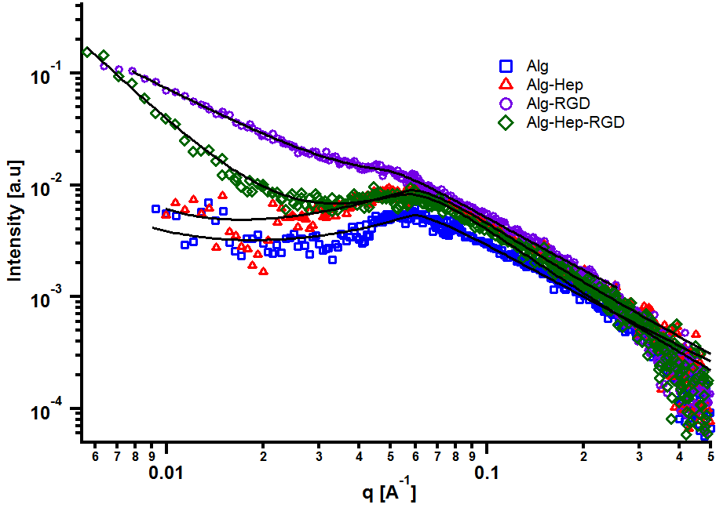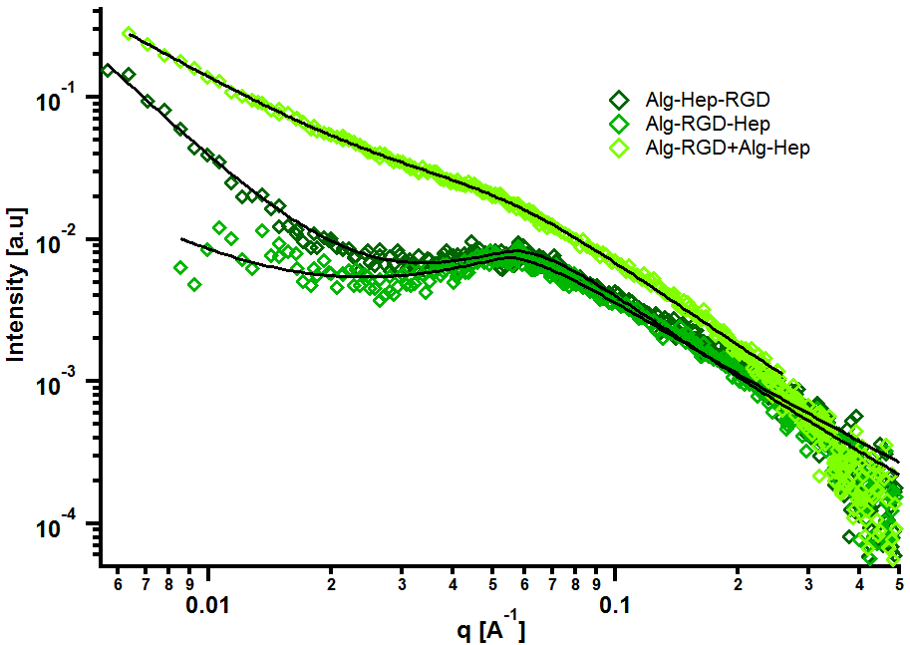

**A**

**B**

**Figure 2:** Small-angle X-ray scattering curves of alginate solutions: (A) modified alginate in water, (B) heparin and G4RGDY conjugation to alginate in a different order in water. *Alg ( ), Alg-Hep ( ), Alg-RGD ( ), Alg-Hep-RGD ( ), Alg-RGD-Hep ( ), Alg-RGD+Alg-Hep ( ).* The solid black lines represent fits to the model described by the Horkay and Hammouda model (see supplementary).

As can be seen in Figure 2, the most pronounced differences between the scattering curves are in the mid- and low q-regimes. The characteristic correlation peak (mid-q) is clearly seen in the scattering pattern of alginate, Alg-Hep, Alg-Hep-RGD, and Alg-RGD-Hep; however, for Alg-RGD and Alg-RGD+Alg-Hep, while the correlation peak clearly exists, it could not be well resolved. Fit of the data to Equation 2 shows that conjugating both peptide and heparin to alginate chains did not significantly change the value of d0. The larger d0 value obtained for Alg-RGD+Alg-Hep is likely due to the fact that the correlation peak could not be well resolved and is not a true representation of the average distance between the charged domains.

(table S3). The feature that is most affected by the alginate modification is the clustering. Alg-Hep-RGD, Alg-RGD, and the Alg-RGD+Alg-Hep mixture all exhibit a clear upturn in the low q range. The clear distinction between the upturn and the correlation peak in the Alg-Hep-RGD curve is an indication that the clusters and the distance between the charged domains are of different length scales. The overlapping between the peak and the upturn in the scattering patterns of Alg-RGD and those of the Alg-RGD+Alg-Hep indicates the presence of clusters of various sizes, including some similar in size to d0.

The SAXS and viscosity measurements show that conjugating a peptide, heparin, or both to an alginate backbone affects the alginate’s spatial organization in aqueous solutions. Moreover, the results suggest that the order of the peptide conjugation plays a significant role in determining the network’s structure.

Comparing the shear-dependent viscosity to the SAXS patterns of each molecule, one can see that the solutions with the higher viscosities exhibit an upturn in the low q range of their scattering patterns. This observation implies that the higher viscosity of Alg-Hep-RGD, Alg-RGD+Alg-Hep, and Alg-RGD is due to the presence of large, dense clusters and not a homogeneous denser network. Thus, we propose a spatial organization for the chain assemblies of modified alginates in aqueous solutions (Fig. 3). Formation of large clusters is due to attractive inter-particle interactions. Large clusters are observed only for Alg-RGD and Alg-RGD+Alg-Hep, indicating that these interactions are either between two G4RGDY peptides or, more likely, between the peptide and the alginate backbone. Possible attractive interactions between the two molecules are hydrophobic interactions and hydrogen bonding, typical to polyphenol/polysaccharide interactions between the peptide’s tyrosine and the alginate.17 However, for these interactions to take place, the tyrosine needs to be accessible to the neighboring molecules. In the case of Alg-RGD-Hep and Alg-Hep-RGD, one would expect the stronger electrostatic repulsion between the molecules, as a result of the presence of heparin, to prevent the formation of RGD-induced clusters.40-41 The fact that some clusters are formed in the latter (Alg-Hep-RGD) suggests that some of the peptides may have bonded to the heparin instead of the alginate as a result of the peptide’s glycine conjunction to the carboxyl group on the heparin. Alg-Hep has a similar structure to unmodified alginate, since conjugation of heparin to the alginate backbone did not affect the electrostatic repulsion between the chains, as heparin is also a polyanion.

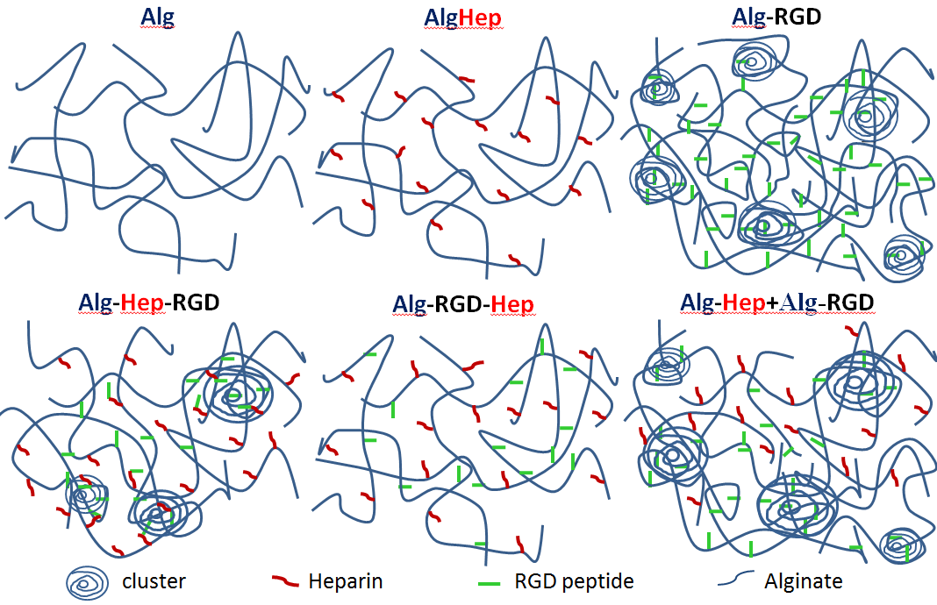**Figure 3:** Illustration and characterization of the proposed structure of the RGD (green) and heparin (red) cross-linked to alginate (blue) in aqueous solutions. The order of the peptide conjugation has a significant role in determining the network’s organization.

* 1. **Mechanical properties and nanostructure of modified alginate hydrogels**

Alginate hydrogels were prepared as described in section 2.3; CaCO3 and GDL were added to the alginate solutions so that the final concentrations were 1.5% w/v alginate, 40 mM CaCO3, and 40 mM GDL. The gels were equilibrated for 12 h before any measurements were performed.

Rheological measurements were performed to quantify the mechanical properties (i.e., gel stiffness) of the different hydrogels. Frequency sweep scans of modified alginate hydrogels are presented in Figure 4A. As expected from a gel’s frequency sweep scan, both moduli G' and G'' are independent of the frequency of oscillation, and G'>G'' (Fig. 4A); that is, the elastic nature of the sample is stronger than its viscous nature. Typically, gel stiffness is represented by its storage modulus G'. A difference in G' values of the different gels is clearly apparent (Fig. 4B), indicating that conjugation of heparin and G4RGDY affected the gels’ mechanical properties, with Alg-RGD and Alg-RGD+Alg-Hep being much stiffer than the rest of the gels.

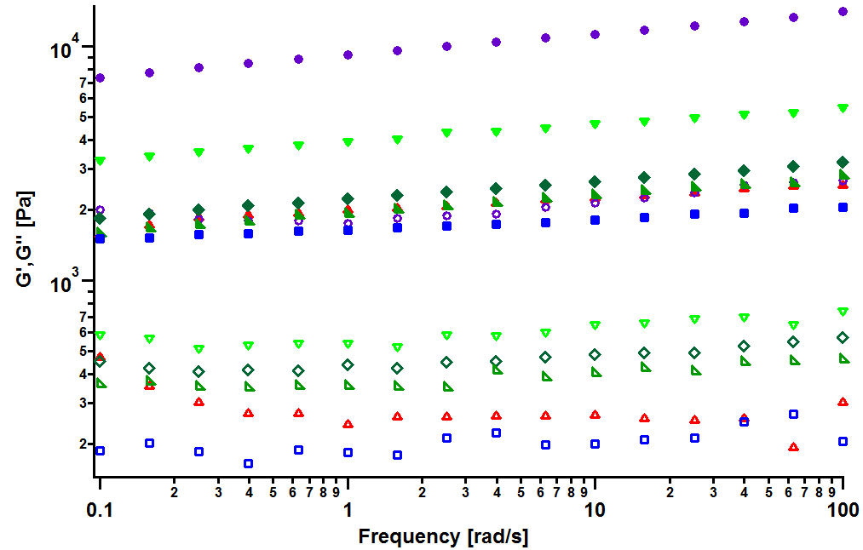

**A**

**B**

**Figure 4:** (A) Frequency sweep experiment curves of alginate gels. G'(full), G''(empty). Alg ( ), Alg-Hep ( ), Alg-RGD ( ), Alg-Hep-RGD ( ), Alg-RGD-Hep ( ), Alg-RGD+Alg-Hep ( ). (B) Storage modulus (G') of alginate modified in the frequency of 10 red/s.

In a previous study of alginate-peptide gels, we attributed the increased stiffness of the gels to the presence of additional junction zones formed due to attractive interactions between the alginate and neighboring peptides.17 The existence of these junction zones was revealed by SAXS, and more precisely by following the methodology of plotting the scattering curves of the alginate-peptide gels in a Kratky form,33,42 where a peak represents the presence of frozen inhomogeneities in the gel network. To identify whether the cause for the increased stiffness of the Alg-RGD and Alg-RGD+Alg-Hep also stems from the presence of additional/larger junction zones, we performed SAXS measurements and presented the scattering curves of all gels in a Kratky plot (Fig. 5).

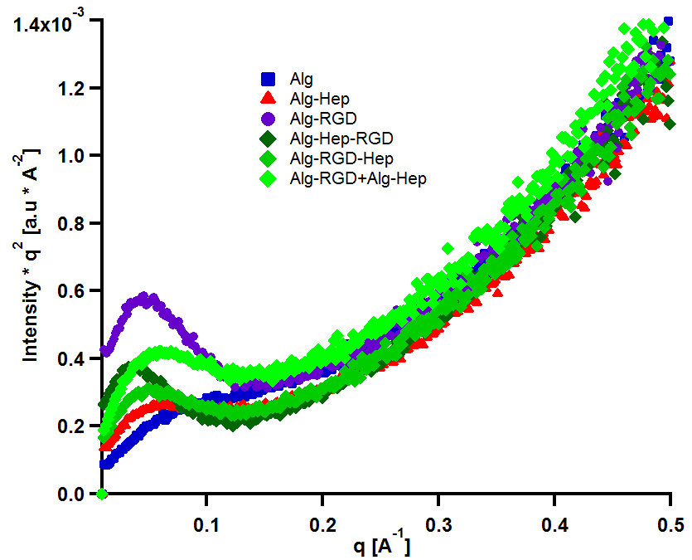

**Figure 5**: Kratky plot of 1.5% alginate hydrogels. Alg ( ), Alg-Hep ( ), Alg-RGD ( ), Alg-Hep-RGD ( ), Alg-RGD-Hep ( ), Alg-RGD+Alg-Hep ( ).

The similarity between the scattering curves of alginate, Alg-Hep, and Alg-RGD-Hep gels suggests that the modification to the alginate backbone does not interfere with the formation of calcium junction zones. The absence of a distinct peak implies that these junction zones are relatively small and evenly distributed.12,43-45 Contrarily, the pronounced peak of the Alg-RGD and Alg-Hep-RGD gel scattering curves is evidence of the existence of additional (non-calcium) larger zones.

The scattering curve of the Alg-RGD+Alg-Hep gels is comparable to a mathematical addition of the scattering curves of Alg-RGD gel and Alg-Hep gel (Fig. S3), suggesting the less pronounced peak is not due to the absence of large non-calcium junction zones but rather to an interpenetrating network structure where the Alg-RGD and Alg-Hep gels coexist without affecting one another. Not surprisingly, there is a correlation between a peak in the Kratky plot and the higher value of a gel’s storage modulus. Though the conclusion of additional junction zones is similar to that of our previous study, it should be noted that the nature of these junction zones is different. G4RGDY does not form micelles in water; thus, the junction zones are not similar to those suggested for Alg-V6KRGDY or Alg-A6KRGDY. However, it is also shorter and stiffer than the G6KRGDY; thus, it does not disrupt the continuity of G blocks and hence does not prevent the formation of a large calcium junction zone. Here, the additional junction zones are most likely the clusters formed by the attraction interactions (described above) between the RGD peptide and the alginate.

Taken together, our results thus far indicate that the structural features of the modified alginate solutions persist even after the gelation process, producing a correlation between the solution’s and the gel’s mechanical properties.

* 1. **Kinetics of VEGF release**

The structural features and mechanical properties of alginate hydrogels designed as ECM mimetics have been shown to affect their functionality (i.e., bioactivity).46 The presence of heparin within the hydrogels was expected to affect the capture and release of growth factors incorporated within the gel due to affinity binding of VEGF to the heparin residues.26,47 Thus, in order to examine the structure-properties-function correlation in our system, we investigated the release rate of VEGF from the different hydrogels. VEGF was incorporated into the hydrogels during their gelation process, and release of the growth factor was monitored during a period of 7 days (Fig. 6B).

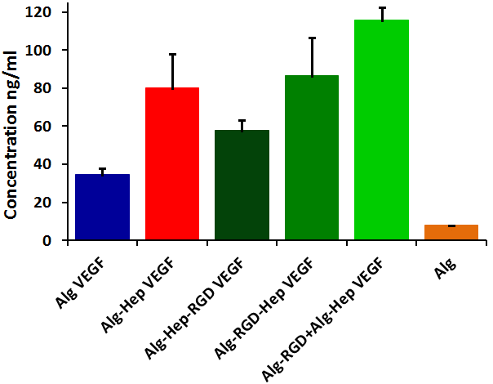 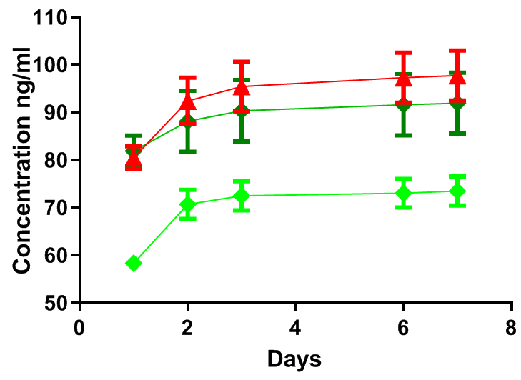

**B**

**A**

**Figure 6**: (A) The initial VEGF amount in the hydrogels (t = 0); (B) Release profiles of VEGF from the Alg-Hep gel ( ), Alg-RGD-Hep gel ( ), and Alg-RGD+Alg-Hep gel ( ).

As expected, the presence of heparin affected the initial amount of VEGF captured in the hydrogels (Fig. 6A). Moreover, the order of the molecules’ conjugation (i.e., peptide before heparin or heparin before peptide) also had an effect on the VEGF initial amount. While our intention was to monitor the VEGF release from all five gels, two of them, alginate and Alg-Hep-RGD hydrogels, disintegrated after 48 h.48-49

The disintegration of ionically crosslinked alginate hydrogels is typically attributed to the presence of calcium chelators, monovalent ions, and non–cross-linking divalent ions present in the tissue culture medium.48-49 Here, it implies that the interactions with accessible heparin and the VEGF are essential for these hydrogels’ stability in medium.

Due to the decomposition of alginate and Alg-Hep-RGD hydrogels, VEGF release profiles were obtained only from Alg-Hep, Alg-RGD-Hep, and Alg-RGD+Alg-Hep gels (Fig. 6B). In all three gels, most of the encapsulated VEGF was released within 3 days. The Alg-RGD+Alg-Hep gels showed lower VEGF release in the duration of the study compared to the two other gels. Comparing the release profiles of Alg-Hep and Alg-RGD-Hep shows that the release of VEGF from Alg-Hep is slightly faster than from Alg-RGD-Hep.

The differences in the release rates can be attributed to the presence of clusters in the gels, since there is an inverse correlation between the two (i.e., the slowest release was from the gels with the highest density of clusters). Diffusion of the growth factors through the clusters may be inhibited due to the high polymer density.

1. **Conclusions**

We explored the conjugation manner of alginate modified with both heparin and the G4RGDY peptide. SAXS and rheology measurements showed that large clusters were formed only in the systems in which RGD was accessible to easily interact with a neighboring alginate backbone (i.e., Alg-RGD and Alg-RGD+Alg-Hep). These large clusters also led to higher viscosity and a more pronounced shear thinning behavior of those solutions, indicating that the order of heparin and peptide conjugation to the alginate backbone plays a significant role in determining the structural-mechanical property relations of these modified alginate solutions.

SAXS of the modified alginate gels shows that the large clusters formed in solutions remained intact during the calcium-induced gelation process, leading to gels with a higher storage modulus and slower release rates of the VEGF incorporated within them. Therefore, the mode and order of conjugating different molecules to the alginate backbone should be considered when designing such multicomponent alginate hydrogels. A detailed structural analysis of the conjugated architecture in solution can be used as a tool to adapt the properties of alginate-heparin-peptide hybrid hydrogels.

**References**

1. Coviello T, Matricardi P, Marianecci C, Alhaique F. Polysaccharide hydrogels for modified release formulations. J Controlled Release. 2007;119(1):5-24.

2. Borselli C, Cezar CA, Shvartsman D, Vandenburgh HH, Mooney DJ. The role of multifunctional delivery scaffold in the ability of cultured myoblasts to promote muscle regeneration. Biomaterials. 2011;32(34):8905-14.

3. Freeman I, Cohen S. The influence of the sequential delivery of angiogenic factors from affinity-binding alginate scaffolds on vascularization. Biomaterials. 2009;30(11):2122-31.

4. Kolambkar YM, Dupont KM, Boerckel JD, Huebsch N, Mooney DJ, Hutmacher DW, et al. An alginate-based hybrid system for growth factor delivery in the functional repair of large bone defects. Biomaterials. 2011;32(1):65-74.

5. Dittrich R, Tomandl G, Despang F, Bernhardt A, Hanke T, Pompe W, et al. Scaffolds for hard tissue engineering by ionotropic gelation of alginate–influence of selected preparation parameters. J Am Ceram Soc. 2007;90(6):1703-8.

6. Shi L, Xiong L, Hu Y, Li W, Chen Z, Liu K, et al. Three‐dimensional printing alginate/gelatin scaffolds as dermal substitutes for skin tissue engineering. Polymer Engineering & Science. 2018;58(10):1782-90.

7. Szarek D, Marycz K, Bednarz P, Tabakow P, Jarmundowicz W, Laska J. Influence of calcium alginate on peripheral nerve regeneration: in vivo study. Biotechnol Appl Biochem. 2013;60(6):547-56.

8. Hashimoto T, Suzuki Y, Suzuki K, Nakashima T, Tanihara M, Ide C. Review Peripheral nerve regeneration using non-tubular alginate gel crosslinked with covalent bonds. J Mater Sci Mater Med. 2005;16(6):503-9.

9. Uto K, Tsui JH, DeForest CA, Kim D. Dynamically tunable cell culture platforms for tissue engineering and mechanobiology. Progress in polymer science. 2017;65:53-82.

10. Sapir Y, Kryukov O, Cohen S. Integration of multiple cell-matrix interactions into alginate scaffolds for promoting cardiac tissue regeneration. Biomaterials. 2011;32(7):1838-47.

11. Andersen T, Auk-Emblem P, Dornish M. 3D cell culture in alginate hydrogels. Microarrays. 2015;4(2):133-61.

12. Rowley JA, Madlambayan G, Mooney DJ. Alginate hydrogels as synthetic extracellular matrix materials. Biomaterials. 1999;20(1):45-53.

13. Censi R, Di Martino P, Vermonden T, Hennink WE. Hydrogels for protein delivery in tissue engineering. J Controlled Release. 2012;161(2):680-92.

14. Jeon O, Powell C, Solorio LD, Krebs MD, Alsberg E. Affinity-based growth factor delivery using biodegradable, photocrosslinked heparin-alginate hydrogels. J Controlled Release. 2011;154(3):258-66.

15. Trappmann B, Chen CS. How cells sense extracellular matrix stiffness: a material's perspective. Curr Opin Biotechnol. 2013;24(5):948-53.

16. Janson IA, Putnam AJ. Extracellular matrix elasticity and topography: Material‐based cues that affect cell function via conserved mechanisms. Journal of Biomedical Materials Research Part A. 2015;103(3):1246-58.

17. Ochbaum G, Bitton R. Effect of peptide self-assembly on the rheological properties of alginate-peptide conjugates solutions. Polymer. 2017;108:87-96.

18. Bernstein-Levi O, Ochbaum G, Bitton R. The effect of covalently linked RGD peptide on the conformation of polysaccharides in aqueous solutions. Colloids and Surfaces B: Biointerfaces. 2016;137:214-20.

19. Ochbaum G, Davidovich-Pinhas M, Bitton R. Tuning the mechanical properties of alginate–peptide hydrogels. Soft matter. 2018;14(21):4364-73.

20. Liang Y, Kiick KL. Heparin-functionalized polymeric biomaterials in tissue engineering and drug delivery applications. Acta biomaterialia. 2014;10(4):1588-600.

21. Rabenstein DL. Heparin and heparan sulfate: structure and function. Nat Prod Rep. 2002;19(3):312-31.

22. Nie T, Akins Jr RE, Kiick KL. Production of heparin-containing hydrogels for modulating cell responses. Acta biomaterialia. 2009;5(3):865-75.

23. Nie T, Baldwin A, Yamaguchi N, Kiick KL. Production of heparin-functionalized hydrogels for the development of responsive and controlled growth factor delivery systems. J Controlled Release. 2007;122(3):287-96.

24. Boddohi S, Moore N, Johnson PA, Kipper MJ. Polysaccharide-based polyelectrolyte complex nanoparticles from chitosan, heparin, and hyaluronan. Biomacromolecules. 2009;10(6):1402-9.

25. Baldwin AD, Kiick KL. Polysaccharide‐modified synthetic polymeric biomaterials. Peptide Science: Original Research on Biomolecules. 2010;94(1):128-40.

26. Adil MM, Vazin T, Ananthanarayanan B, Rodrigues GM, Rao AT, Kulkarni RU, et al. Engineered hydrogels increase the post-transplantation survival of encapsulated hESC-derived midbrain dopaminergic neurons. Biomaterials. 2017;136:1-11.

27. Tiwari A, Salacinski HJ, Punshon G, Hamilton G, Seifalian AM. Development of a hybrid cardiovascular graft using a tissue engineering approach. The FASEB journal. 2002;16(8):791-6.

28. Wissink M, Beernink R, Pieper JS, Poot AA, Engbers G, Beugeling T, et al. Binding and release of basic fibroblast growth factor from heparinized collagen matrices. Biomaterials. 2001;22(16):2291-9.

29. Zuo Q, Guo R, Liu Q, Hong A, Shi Y, Kong Q, et al. Heparin-conjugated alginate multilayered microspheres for controlled release of bFGF. Biomedical Materials. 2015;10(3):035008.

30. Daoud M, Cotton JP, Farnoux B, Jannink G, Sarma G, Benoit H, et al. Solutions of flexible polymers. Neutron experiments and interpretation. Macromolecules. 1975;8(6):804-18.

31. Josef E, Bianco-Peled H. Conformation of a natural polyelectrolyte in semidilute solutions with no added salt. Soft Matter. 2012;8(35):9156-65.

32. Polyak B, Geresh S, Marks RS. Synthesis and characterization of a biotin-alginate conjugate and its application in a biosensor construction. Biomacromolecules. 2004;5(2):389-96.

33. Stokke BT, Draget KI, Smidsrød O, Yuguchi Y, Urakawa H, Kajiwara K. Small-angle x-ray scattering and rheological characterization of alginate gels. 1. Ca− alginate gels. Macromolecules. 2000;33(5):1853-63.

34. Kline SR. Reduction and analysis of SANS and USANS data using IGOR Pro. Journal of applied crystallography. 2006;39(6):895-900.

35. Liberman GN, Ochbaum G, Arad SM, Bitton R. The sulfated polysaccharide from a marine red microalga as a platform for the incorporation of zinc ions. Carbohydr Polym. 2016;152:658-64.

36. Tuinier R, Zoon P, Stuart MC, Fleer GJ, De Kruif CG. Concentration and shear‐rate dependence of the viscosity of an exocellular polysaccharide. Biopolymers: Original Research on Biomolecules. 1999;50(6):641-6.

37. Rubinstein M, Colby RH. Polymer physics. Oxford university press New York; 2003.

38. Steffe JF. Rheological methods in food process engineering. Freeman press; 1996.

39. Horkay F, Hammouda B. Small-angle neutron scattering from typical synthetic and biopolymer solutions. Colloid Polym Sci. 2008;286(6-7):611-20.

40. Rodríguez-Rivero C, Hilliou L, del Valle, Eva M Martín, Galán MA. Rheological characterization of commercial highly viscous alginate solutions in shear and extensional flows. Rheologica acta. 2014;53(7):559-70.

41. Ma J, Lin Y, Chen X, Zhao B, Zhang J. Flow behavior, thixotropy and dynamical viscoelasticity of sodium alginate aqueous solutions. Food Hydrocoll. 2014;38:119-28.

42. Maki Y, Ito K, Hosoya N, Yoneyama C, Furusawa K, Yamamoto T, et al. Anisotropic structure of calcium-induced alginate gels by optical and small-angle X-ray scattering measurements. Biomacromolecules. 2011;12(6):2145-52.

43. Saffer EM, Lackey MA, Griffin DM, Kishore S, Tew GN, Bhatia SR. SANS study of highly resilient poly (ethylene glycol) hydrogels. Soft Matter. 2014;10(12):1905-16.

44. Zaragoza J, Babhadiashar N, O’Brien V, Chang A, Blanco M, Zabalegui A, et al. Experimental investigation of mechanical and thermal properties of silica nanoparticle-reinforced poly (acrylamide) nanocomposite hydrogels. PLoS One. 2015;10(8):e0136293.

45. Pashuck ET, Cui H, Stupp SI. Tuning supramolecular rigidity of peptide fibers through molecular structure. J Am Chem Soc. 2010;132(17):6041-6.

46. Ahearne M. Introduction to cell–hydrogel mechanosensing. Interface focus. 2014;4(2):20130038.

47. Freudenberg U, Hermann A, Welzel PB, Stirl K, Schwarz SC, Grimmer M, et al. A star-PEG–heparin hydrogel platform to aid cell replacement therapies for neurodegenerative diseases. Biomaterials. 2009;30(28):5049-60.

48. Martinsen A, Skjåk‐Bræk G, Smidsrød O. Alginate as immobilization material: I. Correlation between chemical and physical properties of alginate gel beads. Biotechnol Bioeng. 1989;33(1):79-89.

49. LeRoux MA, Guilak F, Setton LA. Compressive and shear properties of alginate gel: effects of sodium ions and alginate concentration. Journal of Biomedical Materials Research: An Official Journal of The Society for Biomaterials, The Japanese Society for Biomaterials, and The Australian Society for Biomaterials and the Korean Society for Biomaterials. 1999;47(1):46-53.