The Adverse effects of Unenforceable Contract terms: experimental evidence

Meirav Furth-Matzkin*

Increased public awareness that sellers routinely insert one-sided or exploitative terms into their boilerplates has resulted in growing pressure throughout the world for broader substantive regulation of consumer contracts. However, recent evidence suggesting that sellers and landlords routinely contravene these regulatory measures by inserting unenforceable terms into their contracts casts doubt on the effectiveness of such regulatory changes. This Article empirically demonstrates the implications of this continuous practice for the non-drafting parties. Building on previous research showing that residential rental agreements often contain unenforceable terms, this Article explores how such terms influence tenants’ post-contract decisions and behavior. The experimental studies reported here expose the harmful effects of unenforceable terms, revealing that tenants are significantly more likely to bear costs that the law imposes on the landlord after reading an unenforceable term as opposed to an enforceable term or even a silent lease. These findings lead to a troubling conclusion: While consumers generally enter into contracts without reading them, and thus do not notice any unenforceable terms, these same terms may adversely affect consumers ex post, when a problem or dispute with the seller arises and they then consult the contract. This new evidence suggests that even substantive regulation of consumer markets could fail to achieve its objectives as long as it relies on uninformed consumers to enforce their mandatory rights and protections. The Article discusses the significance of these findings for public policy and regulation.

Table of Contents
Introduction 3
I. Background 7
A. Traditional and Behavioral Consumer Market Failures 7
B. Regulatory Solutions 7
1. The Promise and Failure of Disclosure 7
2. The Shift towards Substantive Interventions 7
C. Preliminary Evidence of Non-Compliance 7
II. What are the Implications For Consumers? 10
A. Imperfect Information, Legal Misperceptions, and Intuitive Formalism in Contracts 10
B. Non-Reading Ex Ante and Reading Ex Post 10
III. Experimental Methods and Results 11
A. Study 1: The Effect of Unenforceable Terms 11
1. Sample 11
2. Experimental Design 12
3. Results 15
B. Study 2 (Part I): The Moderating Role of Legal Information 17
1. Sample 23
2. Experimental Design 23
3. Results 24
C. Study 2 (Part II): Bargaining in the Shadow of the Lease 28
1. Motivation and Design 28
2. Results 28
D. Study 3: Negative Framing and Legal Fallback Language 28
1. Sample 28
2. Experimental Design 28
3. Results 28
IV. Discussion and Implications 28
A. Summary of Findings 28
B. Drafters’ Incentives to Use Unenforceable Terms 28
C. Policy Implications 30
1. Unfair and Deceptive Acts or Practices Statutes 30
2. Statutory Form Leases 31
3. Class Actions 35
4. Public Enforcement Mechanisms 37
Conclusion 38
Appendix 40
A. Materials for Study 1 40
B. Materials for Study 2 41
C. Materials for Study 3 42

Introduction

Realizing that consumers almost never read or take account of the fine print in legal documents before signing or clicking through them, firms and businesses continuously load their standardized agreements with one-sided or exploitative terms, thus depriving consumers of their most basic rights and remedies. Such terms may include liability or warranty disclaimers, waivers of the consumer’s right to a jury trial, class action waivers, and choice-of-law or choice-of-forum clauses.

As David Hoffman recently noted, “in an online ‘orgy of contract formation,’ firms have seized new opportunities to shift risks to consumers by imposing unread terms.” In her new book, Boilerplate: The Fine Print, Vanishing Rights, and the Rule of Law, Margaret Radin has similarly observed that, “mass-market systems of form contracts that restructure the rights of users of products and services operate to undermine or cancel the rights of users granted by legislatures.” Radin labels this problem democratic degradation, since standard form contracts can essentially “delete rights that are granted through democratic processes, substituting for them the system that the firm wishes to impose.” Consumer contracts therefore present a challenge to classical theories of contract law, which typically view consent, the so-called “meeting of the minds,” as the basis for creating legally binding agreements. With lengthy standard form contracts now being presented regularly to consumers, who click through them without so much as a glance, assent has generally become less informed and less meaningful.

Recognizing the risks and threats that standard form contracts pose to non-reading consumers, as well as the inadequacy of the current regulatory regime in protecting consumers, scholars and commentators have consistently called for stronger, more substantive, regulation of the content of these standardized agreements. And indeed, regulators have followed suit by adopting substantive regulation prohibiting sellers from including certain specified terms, deemed unfavorable to non-drafting parties, in their contracts. Substantive regulation has already been adopted in multiple consumer sectors, including the credit card market, the rental housing sector, the mortgage industry, the market for the sale of goods, and the insurance industry.

Nonetheless, despite these regulatory efforts to protect consumers, new evidence suggests that businesses and firms often contravene these mandatory protections by inserting terms that are essentially unenforceable and void into their boilerplates. In particular, this author has recently found that residential rental agreements often contain unenforceable terms, including overbroad liability disclaimers and clauses purporting to limit or negate the landlord’s warranty of habitability.

These findings shed light on a particular pattern of contracting behavior that has not been adequately studied to date. The literature on consumer contracts has generally focused on the drafters’ incentives to include enforceable, albeit egregiously one-sided terms, or terms that, while enforceable, exploit consumers’ cognitive biases. However, little attention has been devoted to the possibility that these contracts include terms that simply contravene the law or misinform consumers about their legal rights and remedies, and empirical investigation into this phenomenon has been particularly scarce.

In light of recent evidence suggesting that unenforceable terms abound in consumer contracts and leases, it is essential to explore empirically the implications of this drafting practice for the non-drafting parties. This Article studies the adverse effects of unenforceable terms, using the residential rental sector as a test case. Building on previous work demonstrating that unenforceable terms are regularly inserted into residential agreements, the Article examines, for the first time, the role that these terms play in shaping tenants’ post-contract decisions and behavior.

This Article reports on a series of experiments. Participants, all tenants in Massachusetts, were instructed to assume that they were looking for an apartment in Boston before being randomly assigned to read through and sign residential lease agreements containing different types of contractual provisions. They were then instructed to assume that a particular tenancy-related problem had arisen, and were asked how they would behave under the described circumstances. The experimental findings revealed that tenants reading contracts including unenforceable terms were substantially harmed, as they were ten times more likely to bear costs that the law imposed on the landlord than were tenants with contracts containing enforceable terms.

This Article is divided into four parts. Part I provides background, reviewing the current problems and challenges that consumer contracts pose for consumer protection and regulation. Surveying the regulatory solutions that have been adopted to date to address these issues, this section describes the policy shift from reliance mainly on disclosure mandates to the adoption of stronger, more coercive, interventions in consumer markets. It proceeds to review the increasing evidence suggesting that sellers and landlords often fail to comply with these substantive mandatory requirements by continuing to insert unenforceable terms into their boilerplate agreements. Part II elaborates upon the study’s goal of identifying the implications of this deceptive contracting practice for consumers. It reviews the literature documenting that consumers are typically uninformed about their rights and remedies as buyers, as well as the growing evidence that consumers hold formalistic preconceptions about contracts and the law. This Article suggests that consumers’ ignorance of the law, combined with their formalistic legal intuitions, may lead them to perceive unenforceable contract terms as enforceable and binding and consequently to relinquish valid legal rights and claims.

Part III then presents and reports the results of three controlled experiments designed to thoroughly test how the content of standardized agreements and, in particular, the presence or absence of unenforceable contract terms, affects the tenants’ post-contract decisions. While the first two experiments focused on comparing the impact of unenforceable terms to that of enforceable provisions and silent leases, the third experiment expanded the scope of inquiry, exploring the role of other potentially deceptive drafting patterns in shaping tenants’ decisions. The findings suggest that these drafting practices and the use of unenforceable terms in particular, have an adverse effect on tenants’ post-contract decision making and perceived bargaining positions. Part IV discusses the implications of these findings for public policy and regulation.

I. Background

Substantive Regulation of Consumer Contracts and Leases

Recent decades have witnessed a growing worldwide trend of enhancing consumer protection through the adoption of stronger, more substantive, interventions in consumer markets and contracts in tandem with less aggressive disclosure requirements. These stronger interventions typically take the form of mandatory restrictions on permissible contracting, either by deeming certain contract terms unenforceable and void as against public policy, or by requiring drafting parties to include in the fine print specified terms aimed at safeguarding the non-drafting parties.

Substantive ex ante regulation of the content of standard form consumer contracts has become increasingly widespread in numerous consumer markets. For example, the Magnusson-Moss Warranty Act of 1976 prohibits sellers from disclaiming the implied warranties set forth in the Uniform Commercial Code. Similarly, the United States Credit Card Accountability Responsibility and Disclosure Act of 2009 introduced substantive restrictions, including price caps and other prohibitions, into the credit card market, and federal agencies have recently asserted authority under the Dodd-Frank Act and the Social Security Act to authorize regulations that prohibit mandatory arbitration clauses in certain types of consumer contracts. The practice of door-to-door selling is also regulated in numerous jurisdictions. In the insurance sector, all fifty states have adopted comprehensive compulsory systems mandating the terms of insurance policies. Finally, the residential rental sector is subject to heavy regulation in all jurisdictions across the United States, including anti-discrimination laws, the imposition of an implied warranty of habitability, regulation of the landlord’s power to evict tenants or to disclaim negligence liability, and a variety of other rules aimed at providing tenants with enhanced protections.

Evidence of Non-Compliance

Although these substantive regulatory measures seem promising, new findings reveal that drafting parties continue to use unenforceable terms in their standardized agreements. In particular, it has been found that insurance policies frequently contain terms deemed unenforceable and void, such as coverage exclusions or coverage grants for punitive damages or intentional torts. Similarly, sellers often use overly broad exculpatory clauses without narrowing them to include only negligence, and there is evidence suggesting that employers use over-reaching arbitration and non-competition clauses in employment agreements. Finally,

an empirical study of residential lease agreements recently revealed that these contracts also frequently contain unenforceable terms, such as overly broad liability waivers, disclaimers of the landlord’s warranty of habitability, and clauses purporting to shift the landlord’s mandatory maintenance and repair duties onto the tenant.

II.

This Article

This Article empirically explores the possibility that landlords, through the use of unenforceable contract terms, could mislead tenants about their rights under the law, and consequently adversely affect their decisions at the post-contract stage. By relying on their contracts as accurate sources of information about these rights and remedies, tenants (and consumers more generally) could be led to believe that the law grants them fewer protections than it actually does. They are likely to arrive at this conclusion simply because they may misperceive their contract terms as enforceable and binding, failing to realize that landlords can benefit from including unenforceable clauses in their contracts. Consequently, tenants might forego pursuing their valid legal rights and claims.

Do Tenants Read Leases?

It is important to emphasize at the onset that the use of unenforceable terms may affect tenants’ perceptions and decisions only to the extent that they rely on their contracts to ascertain their rights and remedies. Unenforceable terms will have little meaning or impact if they remain unread. Therefore, an important question is whether tenants actually read their residential lease agreements. This question is especially pertinent in view of the mounting evidence that consumers do not read or pay attention to the fine print before making their purchasing decisions. However, it is important to note that survey evidence suggests that, in contrast to most types of consumer contracts, residential leases are often read by a considerable proportion of tenants prior to signing.

More importantly, as this author has observed elsewhere, a distinction must be made between reading a contract ex ante and ex post. Namely, even if tenants do not necessarily read their leases before renting the apartment, they are nonetheless likely to look at their contracts at a later stage when seeking to verify their rights and duties as renters, typically after a problem occurs or a dispute with the landlord arises. Indeed, a recent survey of tenants from Massachusetts has found that fifty-one percent of those who reported experiencing a rental problem also reported looking at their leases as a direct result of the problem.

In light of these findings,

this Article examines how the inclusion of unenforceable terms, regardless of the legal ramifications of these terms, affects non-drafting parties’ post-contract perceptions and decision making.. Based on recent evidence that residential rental agreements in Massachusetts routinely included unenforceable terms, such as terms misinforming tenants about their legal rights and remedies, the experimental studies described below explore how such contract terms influence tenants’ perceptions and decisions when responding to rental problems they incur.

Study 1: How do Unenforceable Terms Affect Post-Contract Decisions?

Sample and Design

The study consisted of 397 participants, fifty-three percent male—all Massachusetts residents—recruited using the Amazon Mechanical Turk labor pool. Participants’ responses were confidential and anonymous. The questionnaire was programmed in Qualtrics and took, on average, nine minutes to complete.

Participants were asked to assume that after searching for a new apartment in Boston, they had finally found one that they liked and that met their budget. They were then randomly assigned to read and sign one of three residential lease agreements. These agreements were based on a standard form lease drafted by the Greater Boston Real Estate Board, and were completely identical, with the exception of one contract term. One third of the contracts contained an enforceable liability provision, one third contained an unenforceable liability disclaimer, and one third contained no term on the subject.

Participants assigned to the enforceable term condition read a contract containing a clause acknowledging the landlord’s liability in negligence for damage caused to the tenant or third parties in the leased premises. Those assigned to the unenforceable term condition read a contract containing a clause disclaiming the landlord’s liability for any damage to property or personal injury caused to the tenant or to third parties on the leased premises, including damage caused by the landlord’s negligence or misconduct. Finally, participants assigned to the no term condition read a contract that said nothing about the landlord’s liability for loss or damage to the tenant. Instead, the contract contained a clause pertaining to the apartment’s keys and locks.

The no term condition facilitated the testing of tenants’ background assumptions about their legal rights and obligations when no information is provided in their contracts. As my previous study of residential leases revealed, residential rental contracts are often silent about tenants’ various rights and remedies under the law. In the particular context of landlords' liability for loss or damage caused to tenants or third parties on the leased premises, sixteen percent of the sampled leases did not mention the issue at all. It was therefore important to test tenants’ assumptions and behavior when encountering a silent contract.

After signing, participants were asked to download their contracts and keep a copy for their records. They were advised that they “may want to view this file later.” After being presented with some photos of the apartment, participants were asked some filler questions as well as an attention check question targeted at determining whether they had read their lease agreements.

Subsequently, participants read a scenario describing a rental problem and were asked to answer a series of follow-up questions. In the scenario, participants were asked to assume that two months after complaining to their landlord about a leak in the roof, rain water seeped in from the leaking roof and ruined their television. They were instructed to assume that the cost of repairing the TV was $200, and the cost of replacing it with a new one was $400. (The full text of the scenario is reproduced in the Appendix.)

The scenario was based on an actual case from 2011, in which the plaintiff sued her landlord for damage caused as a result of a leak in the roof of the rented premises. In that case, the Supreme Judicial Court of Massachusetts held the landlord liable for the damage caused to the plaintiff as a result of the landlord’s failure to fix the leaking roof, in contravention of the contractual language requiring such a repair. The court held that the landlord had a statutory duty to fix the leaking roof after receiving notice, and that the law prohibited the landlord from disclaiming liability for loss or damage to the tenant or third parties as result of failure to do so. Indeed, the law in Massachusetts obliges residential landlords both to maintain all structural elements of the apartment, including the roof, and to ensure that the premises are protected from wind, rain, and snow. The law further deems any lease clause purporting to disclaim the landlord’s liability for loss or damage to tenants or third parties in the leased premises as a result of the landlord’s negligence as void and unenforceable.

After reading the scenario, respondents were asked to evaluate how they would behave under the defined circumstances. Two independent coders, blind to the study’s hypotheses and design, coded participants’ open-ended responses. The coders were instructed to classify participants’ responses into one or more of the following categories:
(1) Search for Information: in cases where participants indicated that they would search for more information about their rights, remedies, or obligations, by searching the web or by consulting with family, friends, or other tenants;
(2) Contact Landlord: in cases where participants indicated that they would discuss the issue with the landlord, negotiate, or demand that the landlord make or pay for the required repairs;
(3) Relinquishment: in cases where participants indicated that they would bear the repair or replacement costs by themselves;
(4) Extralegal Action: in cases where participants indicated that they would withhold rent, contact inspection authorities, or tarnish the landlord’s reputation;
(5) Legal Advice: in cases where participants indicated that they would seek legal services;
(6) Legal Action: in cases where participants indicated that they would initiate proceedings against the landlord.

Results

The findings reveal that the content of the residential lease agreement significantly affected tenants’ behavioral intentions. First, the contract terms that tenants were assigned to read had a significant impact on their intentions to capitulate and bear the repair expenses themselves: While only two percent of the respondents who read an enforceable term (acknowledging the landlord’s negligence liability) intended to bear the repair expenses themselves, sixteen percent of those in the no term condition intended to do so, and as many as twenty-two percent of the participants intended to bear the burden and costs of repair after reading an unenforceable lease provision, disclaiming the landlord’s negligence liability. Figure 1 illustrates these results.

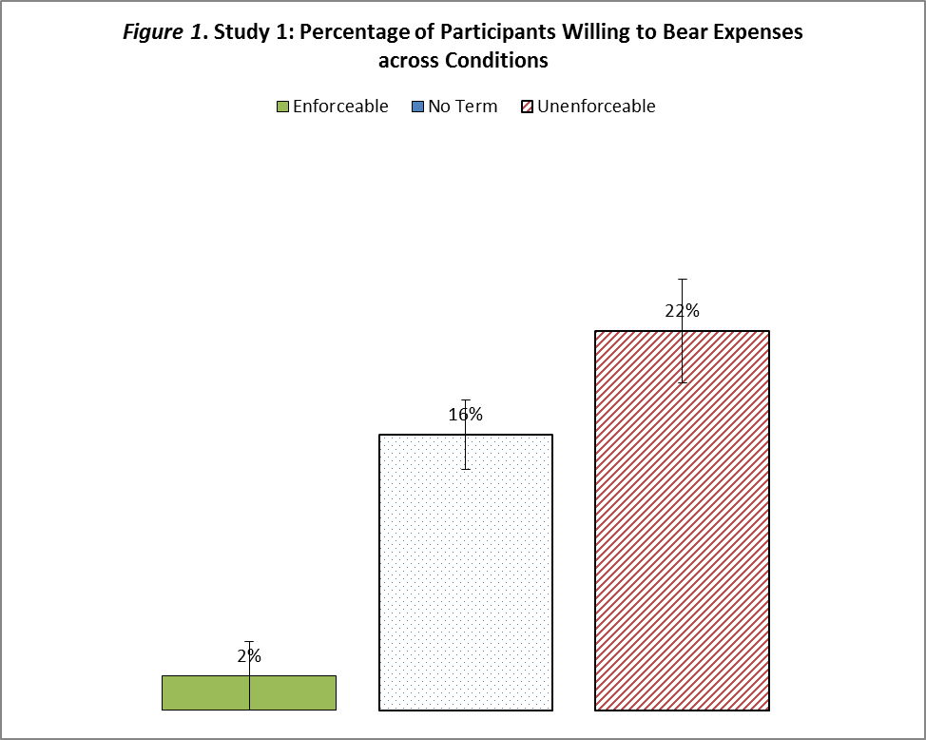

Second, the content of the lease agreement significantly influenced participants’ intentions to contact the landlord. While seventy-five percent of the participants intended to contact the landlord after reading an enforceable term acknowledging the landlord’s negligence liability and sixty-one percent indicated they would do so after reading a contract lacking any liability clause, less than half of the participants, forty-eight percent, intended to contact the landlord after reading an unenforceable clause.

At the same time, the contents of the residential lease agreements did not significantly affect participants’ intentions to search for more information, seek legal advice, or take legal or extralegal action.

Remarkably, collapsing across conditions, only eight percent of the participants indicated that they would ask friends or relatives for advice or search the internet for information about their legal rights and remedies. These findings are surprising in light of the ease and accessibility of online information. Indeed, as Eyal Zamir and Yuval Farkash observed, “in recent years, the Web . . . has emerged as a primary source of information. Even if people do not read standard-form contracts ex ante, they might read them and seek additional information once they are dissatisfied with the transaction.” This study’s findings, however, indicate that a substantial proportion of tenants rely on their contracts as their only source of information and seldom search the internet to verify their legal status when a rental problem occurs.

Of course, if the stakes are higher, tenants may be more inclined to invest time, energy, and resources in seeking out more information about their rights and remedies. However, the findings point to the troubling conclusion that even when the costs are substantial, tenants may not seek out information beyond the confines of their contracts.

Study 2: Could Online Information Help?

Study 1 demonstrated that tenants who read unenforceable lease terms were adversely affected, in that they were significantly more likely to bear costs that the law actually imposed on the landlord than were tenants who read an enforceable term or a silent lease. These results raise the inevitable question of whether the adverse consequences resulting from the unenforceable fine print could be mitigated by tenants’ learning about the law.

It is plausible that information about the law could counteract the negative impact of the unenforceable fine print by correcting tenants’ misperceptions. If uninformed tenants are likely to relinquish valid rights and claims because they erroneously believe that unenforceable terms negating or restricting their legal rights and remedies are enforceable and binding, then informing them about the legal rules might offset the deceptive, and consequently deterrent, effect of the unenforceable fine print.

A primary source of information about tenants’ rights and remedies is the internet. Although participants in Study 1 showed little intention of searching online to learn more about their rights and remedies, and were reportedly inclined to rely on their leases instead, some participants did express an interest in searching the web for more information. Study 2 was designed to explore what happens when tenants conduct online searches about their rights and remedies. More specifically, Study 2 focused on tested two main questions:

(1) Can unenforceable terms reduce tenants’ propensity to search online for more information compared to silent contracts?
(2) Can information obtained online mitigate the effect of unenforceable terms when tenants actually do search the web?

Sample and Design

The study consisted of 107 participants, fifty-three percent male, all Massachusetts residents, recruited using the Prolific Academic labor pool.

Participants were randomly assigned to read and sign one of three contracts as before and read the same leaking roof scenario as in Study 1. However, in Study 2, they subsequently read the following:

“Assume that your landlord’s failure to fix the leaking roof was negligent. Could you find out if your landlord has to pay for the TV’s repair or replacement? You can use any resources you like to try to find out, including the web. If you answer correctly, you will receive a $4 bonus, twice as much as you will be paid otherwise! Does your landlord have to pay for the TV’s repair?”

After this yes or no question, participants were asked to explain in their own words why they had answered the way they did. They were also asked what steps they had taken in order to answer the question. Those who reported searching the web were subsequently asked how much time they had spent on their searches. Finally, they were asked various questions about their demographic characteristics.

Results

Seventy-seven percent of the participants passed the attention check. The results reported below include only the participants who passed the attention check, although the results do not significantly differ with those participants who did not pass the attention check question.

As the next figure illustrates, the content of the lease agreements significantly shaped participants’ legal perceptions. When encountering an enforceable liability provision, eighty-six percent of the participants indicated that the landlord would be liable for the TV’s repair. In contrast, sixty-eight percent of those encountering a silent lease so indicated, and only thirty-one percent of those encountering an unenforceable liability disclaimer thought that the landlord would be liable to pay for the TV’s repair.

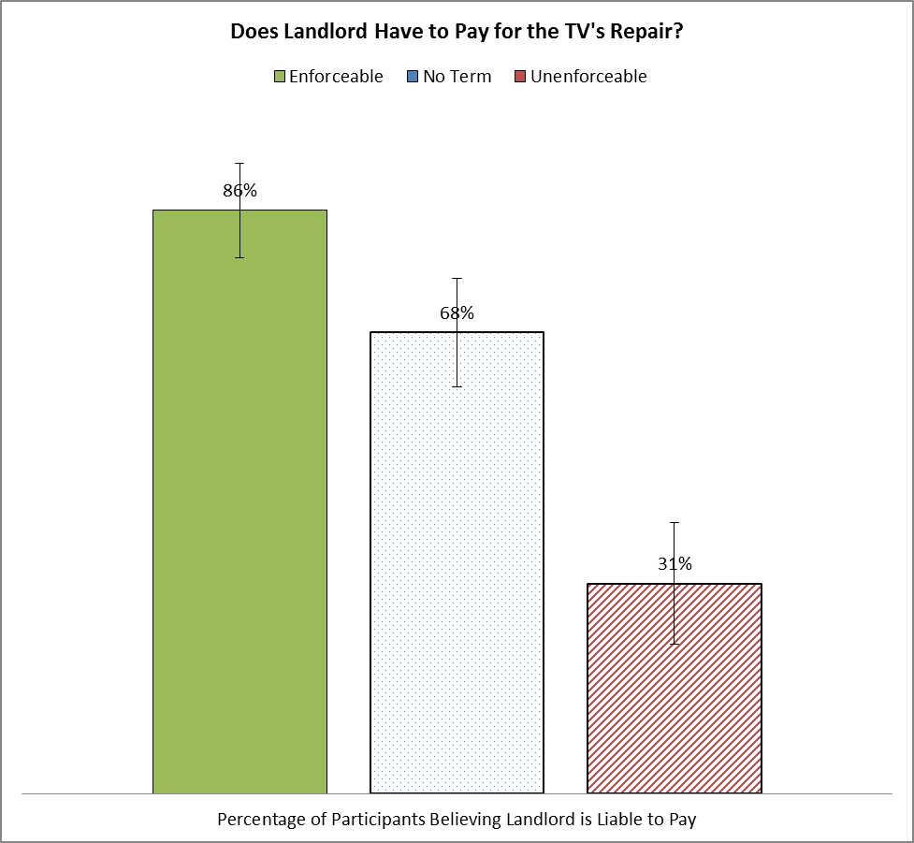

The experimental condition also significantly affected participants’ propensity to search the web for more information, with unenforceable terms significantly decreasing tenants’ search rates. While ninety-two percent of the participants searched the web after encountering a silent lease, only sixty-two percent of the participants searched online after encountering a lease containing an unenforceable liability disclaimer.

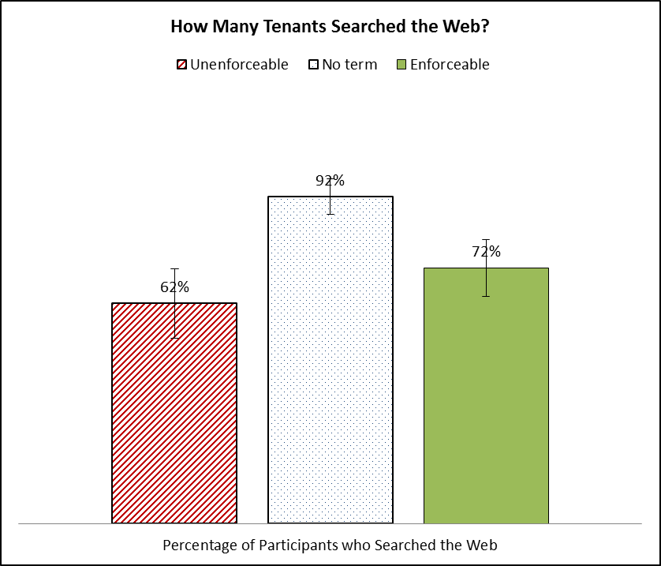

As expected, participants who did not search the web were significantly less likely to realize that the landlord was liable for the TV’s repair expenses than were those who searched online. Collapsing across contract conditions, only forty-five percent of the participants who did not search online realized that the landlord was liable, compared to seventy-two percent of the participants who conducted online searches.

Importantly, and consistent with this study’s expectations, there was a significant correlation between the experimental condition and participants’ decisions to conduct online searches, in that the contractual provisions participants were assigned to read had a significantly greater impact on participants who did not search the internet than on those who did conduct online searches. Within the group of participants who reportedly did not conduct online searches, eighty-eight percent thought that the landlord was liable to pay for the repairs after reading an enforceable liability clause and fifty percent so believed after encountering a silent lease, while none of those encountering an unenforceable liability disclaimer believed that the landlord had to pay. The differences across conditions within participants who searched the web were significantly smaller. While eight-six percent of the participants reading an enforceable liability clause thought that the landlord was liable to pay for the TV’s repair, only seventy percent of those encountering a silent lease thought that landlord was liable, compared to fifty percent of those encountering an unenforceable term.
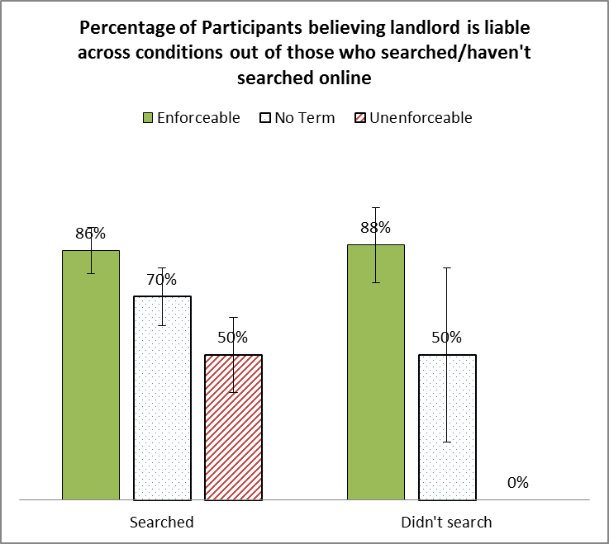
To summarize the findings of Study 2, online information searches significantly mitigated the adverse effect of unenforceable terms on tenants’ legal perceptions, increasing the percentage of participants realizing that the landlord was liable for the repairs from zero to fifty. At the same time, even among those participants who conducted online searches, the differences between participants who read an unenforceable term and those who read enforceable clauses or silent leases remained quite large. Fifty percent of the participants who searched the web still wrongfully assumed that the landlord was not liable for the TV’s repair expenses after reading an unenforceable liability disclaimer, compared to only fourteen percent of those reading an enforceable liability provision and thirty percent of the participants who encountered a silent lease.
Admittedly, most of the participants who searched the web did not spend more than ten minutes searching for online information. In real life, when the stakes are higher, people’s incentives to invest more resources in searching for information are greater. But the study’s findings can be cautiously taken to suggest that unenforceable terms reduce tenants’ propensity to search for more information, and adversely affect the legal perceptions of those who do make the effort to conduct online searches.

Study 3: Could Disclosure Help?

Study 2 showed that online searches for information could prove effective in reducing the adverse effect of the unenforceable fine print, but they did not entirely eliminate the problem, partly because online legal information is relatively complex and hard to locate and process. Furthermore, the study’s design did not allow for observation of the type of information that participants found and were exposed to. It is probable that participants differed in terms of the websites they surveyed and the types of information they obtained. Study 3 was meant to address these limitations by directly exploring whether providing clear and concise legal information to tenants could help eliminate the adverse effects of the unenforceable fine print.

    - Sample and Design

The study consisted of 793 participants, fifty-two percent male, all Massachusetts tenants, recruited using the Amazon Mechanical Turk labor pool.

As in Studies 1 and 2, participants were randomly assigned to one of three contract term conditions, an “enforceable term,” an “unenforceable term,” or “no term.” They also read the same scenario presented in the first two studies. However, in this study, participants were also randomly assigned to one of two information conditions: “no information” and “legal information.”

Participants assigned to the “no information” condition received no further information, whereas participants assigned to the “legal information” condition were informed that the law places mandatory repair duties on the landlord, and that the landlord’s liability for loss or damage caused by the landlord’s negligence, or failure to perform these duties, cannot be disclaimed in any lease agreement (the full text is reproduced in the Appendix).

Participants were then asked an open-ended question about their behavioral intentions in these circumstances, and two independent coders coded their open-ended responses.

Subsequently, participants were asked to assume that they had decided to contact the landlord, who refused to cover the TV’s repair expenses. They were then asked to indicate, on a seven-item scale (1 = extremely unlikely; 4 = neither likely nor unlikely; 7 = extremely likely), how likely they believed it was that a housing court would rule in their favor if they decided to initiate legal proceedings against their landlords. This question was included to measure the effects of the contract terms and the disclosed information on participants’ legal expectations. This question is important, because even if tenants are unlikely to take the landlord to court, their estimations of their probabilities of succeeding at trial are likely to affect their perceived bargaining positions vis-à-vis the landlord.

Results

The results of Study 3 revealed, once again, that unenforceable terms adversely affected tenants’ post-contract decisions. Yet, they also demonstrated that information about the law succeeded in mitigating the adverse effect of the unenforceable fine print. When tenants received information about the law, the difference in their reported intentions to relinquish their rights across contract term conditions became negligible and insignificant. In effect, informed tenants encountering an unenforceable term were not significantly more likely to bear the repair expenses themselves than were tenants reading an enforceable term or a silent lease. Similarly, providing tenants with information about the law also significantly affected their legal predictions. In fact, when participants received legal information, there were no significant differences in legal predictions across contract term conditions.

Figure 2 below compares participants’ reported intentions to bear the repair expenses, as well as their legal predictions, across contract term conditions, with and without legal information.

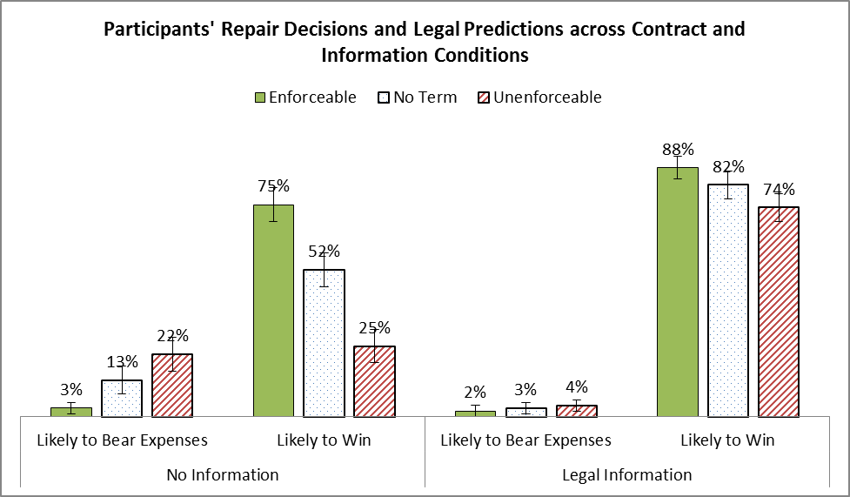

Notably, participants who read an unenforceable term were deeply affected by the presence or absence of legal information. While twenty-two percent of these participants intended to relinquish their rights when they had no information about the law, only four percent intended to do so after learning that the landlord was prohibited from inserting such clauses. In a similar vein, participants encountering an unenforceable term were significantly less optimistic about their chances of winning in court when no information about the law was provided than when such information was supplied. While only twenty-five percent of the participants who encountered an unenforceable term estimated they would be slightly to extremely likely to win in trial, as much as seventy-four percent so believed after obtaining information about the law.

Tenants who encountered a silent lease were also significantly affected by the information provided to them about the law. While thirteen percent of the tenants who read a silent lease intended to relinquish their rights when they had no information about the law, only three percent so intended after learning the truth about the legal situation. These participants also became significantly more optimistic about their likelihood of prevailing at trial, from fifty-two percent in the no information condition to eighty-two percent in the legal information condition.

These findings suggest that tenants are often uninformed about their legal rights, such that both unenforceable terms and non-disclosure have a detrimental impact on their judgments and decisions.

Summary of the Findings

The studies reported on in this Article demonstrated that the content of the contractual agreement significantly influenced non-drafting parties’ post-contract decisions. In particular, the findings revealed that the inclusion of unenforceable terms in contracts was detrimental to tenants, as it was likely to adversely affect their behavior and decisions in several ways. First, the inclusion of an unenforceable term significantly increased the probability that tenants would bear the repair expenses themselves without even contacting the landlord. While the majority of participants indicated that they would contact the landlord when encountering a rental problem of the kind described in the scenario, participants were about ten times more likely to bear the expenses themselves after reading an unenforceable, as opposed to an enforceable, lease provision.

Second, the presence of an unenforceable term significantly reduced tenants’ inclination to search for information about their rights and remedies outside the four corners of their lease agreements. In particular, the results of Study 2 revealed that while as many as ninety-two percent of the participants encountering a silent lease searched online for legal information, only sixty-two percent did so after encountering an unenforceable liability disclaimer.

Third, the content of the lease agreement shaped tenants’ perceived bargaining positions. Participants who had read an unenforceable term reported being significantly less optimistic about their likelihood of succeeding in a trial against the non-cooperative landlord than did participants who had read an enforceable provision or simply a silent lease. These results suggest that unenforceable terms may discourage tenants from taking legal action against a non-compliant landlord.

Admittedly, there may be various reasons, including the costs associated with legal recourse, for tenants’ disinclination to initiate proceedings against their landlords, including even those landlords refusing to comply with enforceable and binding contractual terms. Yet, the findings suggest that when tenants are presented with unenforceable rather than enforceable lease provisions, they may be significantly more reluctant to pursue a claim against their landlords. These results strengthen the proposition that unenforceable lease terms play an autonomous role, serving as distinct barriers to litigation when reinforced by tenants’ formalistic preconceptions.

Importantly, the findings demonstrate that when tenants are provided with information about applicable law, the adverse effects of these deceptive drafting patterns are significantly reduced. When participants who encountered unenforceable terms were provided with legal information, they were almost as unlikely to bear the repair expenses themselves as were participants encountering enforceable lease provisions, and were almost as optimistic as their counterparts about their chances of winning in court. These findings illustrate the important role of information about the law in shaping tenants’ post-contract decisions.

However, it should be noted that outside the lab, even if tenants have reasons to believe that a certain lease term is unenforceable, they may still be deterred from taking action by the mere presence of a dubious term in the contract. Indeed, Wilkinson-Ryan recently demonstrated that even when participants were asked to assume that a certain insurance policy clause rested on questionable legal grounds, they nonetheless reported a low willingness to pursue a claim in court when the clause was included in the contract. These results suggest that non-drafting parties might fear the possibility, however slight, that a dubious contractual term will nonetheless be enforced. Second, the presence of an unenforceable term in their leases might signal to tenants that the landlord will refuse to compensate them, and, seeking to avoid disputes, they might refrain from taking action even if they believe that the law is on their side. Finally, tenants could be motivated to relinquish their rights by the fear of undermining their relationship with the landlord and thereby needing to move to a new apartment.

IV. Discussion and Implications

Drafters’ Incentives to Use Unenforceable Terms

As the findings suggest, absent specific information to the contrary, tenants believe that their lease provisions are enforceable and binding, even if the terms are clearly void under the law. Consequently, they may relinquish valid rights and claims when tenancy-related problems emerge.

The residential rental market, like many other types of consumer markets, is characterized by asymmetric and imperfect information. Notwithstanding that both parties may be imperfectly informed, landlords typically know more about their contract terms and the attendant regulatory rules than do their tenants, or at least landlords may find it relatively easier and less expensive to become informed. As this research demonstrates, when landlords misstate the law in their leases, most tenants assume that their leases accurately reflect the law and rely on the deceptive information provided to them in the contract rather than try to obtain information independently.

In markets characterized by imperfect and asymmetric information, the potentially adverse effect produced by the inclusion of unenforceable terms may actually provide a distorted incentive for drafting parties. Sophisticated landlords, for example, might realize that they can leverage their superior knowledge of the law to their advantage by drafting contracts that are unlikely to affect tenants’ ex ante renting decisions, but are likely to affect tenants’ perceptions of their legal rights, and thus their ex post decisions, after a contract has been signed. Therefore, it is perhaps not surprising that there is increasing evidence of the prevalence of unenforceable and deceptive terms in consumer contracts and leases.

Sophisticated sellers and landlords are likely to understand that even if consumers suspect that a clause is unenforceable, they may still be deterred from contravening the contractual agreement to which they had “voluntarily” consented or from challenging its enforceability in court. Non-drafting parties might be discouraged from pursuing their rights in court in light of their perception of the probability, however low, that the contractual clause in question will be upheld.

The low costs of non-compliance can further aggravate the situation. When a seller includes an unenforceable term, a disapproving court will typically invalidate the term but not the contract. The seller in such a case does not bear substantial costs or risks. As a result, sellers may be incentivized to include unenforceable terms in their contracts. Indeed, even if drafting parties do not actively choose to use legally invalid terms, they may simply lack the incentive to ensure that their contracts comply with the regulatory requirements.

Policy Implications

The observed market failure is harmful to tenants. Regulatory solutions are therefore considered below.

Unfair and Deceptive Acts or Practices Statutes

Unfair and Deceptive Acts or Practices Statutes (hereinafter UDAP laws) have been adopted in all states in the United States. These laws are considered “the main lines of defense protecting consumers from predatory, deceptive, and unscrupulous business practices.” Although UDAP laws vary widely from state to state, all of them prohibit deceptive practices in consumer transactions. Some UDAP laws contain a general prohibition on deception, some prohibit misstatement of fact, and some address both misstatements of fact and law.

Examples of the latter type, addressing both misstatements of fact and law, include the West Alaska Unlawful Acts and Practices Act, which determines that the term “unfair or deceptive acts or practices” includes, inter alia, “representing that an agreement confers or involves rights, remedies, or obligations that it does not confer or involve, or that are prohibited by law”; and the Massachusetts Consumer Protection law, deeming the inclusion of certain unenforceable clauses, such as a tax escalator clause not in conformity with the applicable law or a clause requiring advanced payments in excess of those allowed by the law, as “unfair or deceptive acts or practices.”

This Article proposes that UDAP laws which refer only to misstatements of fact, or only generally refer to deceptive statements, should be similarly interpreted as incorporating a prohibition on misrepresentations of law.

Importantly, tenants are unlikely to file UDAP violation claims as long as they remain uninformed of their legal rights and remedies. Therefore, disclosure regulation should be considered, as discussed below.

Statutory Form Leases

The problem that consumers face when confronted by unenforceable contract terms consists of three interrelated elements: Consumers are typically ignorant of the law determining their rights and duties as buyers; they often rely on their contracts to ascertain their rights and duties; and they usually presume that their contractual terms are enforceable and binding. Understanding that the problem of unenforceable contract terms is most onerous when all three preconditions are met may help suggest a path for its solution. This study’s findings illustrate that providing information about the law to tenants notably reduces the adverse effect produced by unenforceable contract terms. In fact, informed participants facing an unenforceable term were not significantly more likely to bear the repair costs themselves than were participants reading an enforceable lease provision.

As acknowledged earlier, the experimental findings should be interpreted with caution. The disparity between people’s ability to process simplified information conveyed to them in a survey and their ability to process information in real time should not be discounted or ignored. However, the study’s findings can at least be taken to suggest that information about the law, if adequately designed and conveyed, may improve the non-drafting party’s positions in post-contract negotiations.

Disclosure mandates are already widely used in various consumer sectors, in part because disclosure regulation is considered less intrusive than other regulatory measures. Notably, however, disclosure mandates are typically designed to alert consumers about non-salient features of the transaction (in response to the concern that consumers might not notice or fully take certain attributes into account when making their purchasing decisions). For example, suppliers are required to disclose in a salient manner the conditions of the product’s warranty, or the circumstances under which the contract might be terminated or altered unilaterally. This Article seeks to advocate for a different type of disclosure: disclosure of information on consumers’ rights and remedies under the law. For example, landlords could be required to disclose their maintenance and repair duties, or their liability for loss or damage caused to the tenants or third parties as a result of their negligence, in their lease agreement.

Admittedly, disclosure regulation is mainly justified when sellers have more accurate information than do consumers, and when they are unlikely to disclose said information voluntarily. While sellers presumably have better information about their products’ attributes, and sometimes even about consumers’ product use patterns, consumers and tenants are presumed to have an equivalent access to information about the law governing their transactions. Yet, as the study’s findings suggest, tenants rarely search for information about their legal rights and remedies, and often perceive their contracts as accurate sources of information about the legal state of affairs.

Landlords, in turn, lack any incentive to voluntarily inform tenants about their mandatory protections in the leases they offer. In fact, they have a contrary incentive. A recent study provides evidence supportive of this proposition. In an interview with a housing lawyer from Philadelphia, the latter confirmed that he deliberately refrained from disclosing information about the tenant’s rights and remedies in the leases he drafted, explaining that “the law applies whether it’s in the lease or not, but if you put it in the lease, you draw the tenant’s attention to it.”
In light of landlords’ superior information and negative incentives to disclose information about the law to tenants, mandated disclosure may be warranted. In particular, regulators may consider compelling landlords to use one of several pre-approved leases. Such forms would accurately reflect the law, informing tenants’ of their mandatory rights, duties, and remedies. At first glance, such a solution may be perceived as an excessive intervention in the market, but it should be kept in mind that the law already imposes multiple substantive obligations and liabilities on the landlords. A statutory form lease will merely disclose the mandatory obligations that the regulator has already chosen to impose. Therefore, obliging landlords to use statutory form leases can be seen as a form of comprehensive disclosure mandate, rather than as a stronger, more coercive, intervention in the market.

Notably, as this study’s findings demonstrate, silent leases, and not only leases containing unenforceable terms, can prove harmful to tenants. When leases are silent about a certain aspect of the landlord-tenant relationship, tenants—who are often unaware of their rights and remedies—are more likely to bear costs that the law imposed on the landlord than are tenants with a lease agreement containing an enforceable term, accurately informing them of their legal rights and remedies.

Since evidence suggests that the vast majority of the tenants’ rights and remedies are almost never mentioned in the leases currently used in the market, requiring landlords to use one of several statutory form leases may substantially enhance tenants’ protections at a relatively low administrative cost. Notably, such a solution has already been adopted in the insurance sector, and should be seriously considered in the residential rental market as well.

Yet, it is important to highlight several caveats here. First, landlords might fail to use the required statutory form leases, just as they currently fail to meet the substantive and disclosure obligations that the law now imposes. Therefore, these regulatory measures should be backed up with strong enforcement mechanisms, both public and private, as discussed below.

Second, tenants could suffer from information overload, rendering disclosure of such information useless or even harmful. It is thus essential to design “smart statutory leases,” which disclose the legal information in a simple and salient manner. Such disclosures should include only the necessary information in order to make the processing of the relevant information in real time easier. This means, for example, that it may be desirable to focus on only the most important rights and remedies granted to tenants under applicable law. In addition, the information should be conveyed in easily comprehensible language, without complex legal jargon or unfamiliar terminology. Finally, the information should be prominently disclosed so that tenants will be made aware of it. For example, regulators could use a “warning box” of the type recently proposed by Ian Ayres and Alan Schwartz.

The third caveat is that landlords might use deceptive drafting techniques in order to misinform tenants about the law without exposing themselves to legal sanctions. As Michael S. Barr, Sendhil Mullaintahan, & Eldar Shafir recognized, “whatever gave the discloser incentives to confuse consumers remains in the face of the regulation. While officially complying with the rule, there is market pressure to find other means to avoid the salutary effects on consumer decisions that the disclosure was intended to achieve.” This caveat is real, but it may be possible to overcome it, at least to a certain extent, by launching government information campaigns in addition to requiring landlords to disclose the relevant information in their contracts.

Admittedly, many of the existing disclosure mandates are poorly designed and are consequently ineffective. Yet, this Article’s findings suggest that disclosure policies may be useful and are not inevitably doomed to fail. Smart and simplified disclosure regulation is evolving gradually and has proven to be effective at least to some extent in different consumer markets.

Class Actions

Class actions can be effectively used to combat the inclusion of unenforceable terms in consumer contracts. A class action is an efficient tool, enabling consumers to obtain redress by aggregating multiple individualized claims when the dollar amount per person is relatively small, thereby overcoming one of the obstacles to an individual action. Additionally, resorting to class actions can help solve the problem of relying on misinformed tenants to bring claims to court by incentivizing lawyers to inform tenants about their rights. From the landlord’s perspective, this mechanism strengthens deterrence not only by increasing the probability of detection, but also, and perhaps primarily, by increasing the expected magnitude of the sanction.

In the specific context of residential leases, many jurisdictions in the United States allow tenants to bring class action suits based on the inclusion of unenforceable terms in rental agreements, provided that the class of tenants suffered a “similar injury” as a consequence. However, courts in many jurisdictions have adopted a hostile approach towards the class action mechanism. In Massachusetts, for example, the Supreme Judicial Court held that: “a plaintiff bringing an action for damages [. . .] must allege and ultimately prove that she has, as a result, suffered a distinct injury or harm that arises from the claimed unfair or deceptive act itself.” This ruling bars tenants from pursuing claims against their landlords for including unenforceable terms in their leases unless they can prove actual harm. In a similar vein, the Second Appellate District Court in Los Angeles County recently upheld a lower court’s decision to deny class certification to a group of tenants asking to bring a class action suit. The court determined that the claim for breach of the warranty of habitability was too individualized for class certification.

Such decisions severely harm tenants’ ability to sue their landlords by undermining the class action mechanism, which is one of their strongest tools. Given such rulings, tenants are forced to sue and resolve rental disputes individually and are likely to be discouraged from filing such suits in light of the attendant litigation costs. Perhaps even more problematic is the fact that sellers and landlords often insert class action waivers, choice-of-law clauses, or arbitration provisions into their boilerplate agreements. These clauses are generally enforceable, and may therefore be used by sellers and landlords to shield themselves from class actions. It is therefore essential to complement private enforcement with strong public enforcement mechanisms.

Public Enforcement Mechanisms

Public enforcement mechanisms could be applied both ex ante and ex post. With regard to ex ante enforcement, regulators can require landlords to receive pre-approval for their standard form leases before using them. This could be achieved by establishing a special judicial tribunal that is authorized to pre-approve standard form leases, or, alternatively, by turning to an administrative agency with a similar regulatory power. Landlords using leases without judicial or administrative approval could then be subject to relatively high sanctions. Conversely, landlords using contracts that have been pre-approved could so indicate on their forms, thereby endowing their leases with the benefit of a strong presumption of enforceability or even immunity from judicial intervention.

In the United States, several states require pre-approval of certain insurance policy forms by the regulator. This solution may be less suitable for the residential rental market, however, as the rental market consists of both residential rental companies and individual landlords that own and operate only a few apartments. It might therefore be perceived as too burdensome and costly, both for the individual landlords and for the state, which would incur the costs of administrative or judicial review, to require each and every landlord to have his or her lease approved before using it.

With regard to ex post solutions, public agencies could be authorized to file claims against non-compliant landlords on behalf of tenants. Such a solution is not unrealistic. Section 5 of the Federal Trade Commission Act already authorizes the Federal Trade Commission (FTC) to take appropriate action when unfair or deceptive acts or practices are discovered, and sets out the FTC’s investigative powers and enforcement authority. The FTC is authorized to enforce the requirements of consumer protection laws by both administrative and judicial means. In a similar manner, the FTC could be authorized to ensure landlords’ compliance with the substantive requirements under landlord and tenant law. State-level agencies with similar authority already exist in some jurisdictions. In Massachusetts, for example, the Attorney General is authorized by law to bring claims against any landlord suspected of engaging in unfair or deceptive acts or practices.

Conclusion

In view of the accumulating evidence that the inclusion of unenforceable contract terms in standardized agreements is prevalent in consumer markets, this Article explored the implications of this drafting practice for consumers. Building on previous work demonstrating that unenforceable terms are regularly included in residential rental agreements, this Article sought to elucidate the role that these terms play in shaping tenants’ post-contract decisions and behavior.

The experimental findings presented in this Article suggest that if tenants are uninformed of the law governing their relations with landlords, they are likely to be adversely affected by the inclusion of unenforceable terms in their lease agreements, as they are generally apt to perceive terms embedded in contracts as enforceable and legally binding. Consequently, while tenants are not necessarily inclined to take the fine print into account before making their renting decisions, they are nonetheless likely to be affected by the fine print ex post, after a tenancy-related problem or a dispute arises. Consequently, tenants, and consumers in general, are prone to relinquish their legal rights and remedies. In this study, for example, participants reading an unenforceable term were approximately ten times more likely to bear repair expenses that the law imposed on the landlord than participants reading an enforceable lease term.

While these findings appear disturbing in terms of protecting consumers, there is also cause for optimism. Informing non-drafting parties about their rights under the law substantially mitigates the harm generated by the presence of unenforceable contract terms. Therefore, solutions based on increasing consumer awareness of the legal environment, combined with strong public enforcement and access to class action mechanisms, may help overcome these deceptive market practices.

Appendix

Materials for Study 1

Stimuli

Assume that you have been searching for an apartment, and have finally found one that you like and that meets your budget. You recently moved to this apartment, after signing a lease agreement with your landlord. One day, you notice that the roof in your apartment is leaking. You call your landlord and you tell him about the leak. Your landlord does nothing in response, even after you send him a letter of complaint asking him to fix the leaking roof. Two months later, rain water falls from a leak in the roof and damages your television. The cost of repairing it is $200, and the cost of replacing it with a new one is $400.

[Participants were then randomly assigned to one of three conditions:]

Condition | Text
Unenforceable Term | You look at your lease, and you notice that it contains a clause titled “Loss or Damage,” stipulating as follows: “Landlord will not be liable for any damage to property or personal injury caused to the tenant or to third parties on the leased premises (including damage caused by the landlord’s negligence or recklessness).”
Enforceable (Compliant) Term | You look at your lease, and you notice that it contains a clause titled “Loss or Damage,” stipulating as follows: “Landlord will be liable for any damage to property or personal injury caused to the tenant or to third parties on the leased premises by the landlord’s negligence or recklessness.”
No Term | You look at your lease, but it says nothing about the landlord’s liability for loss or damage to the tenant.

Dependent Measures

After reading the scenario, respondents were asked an open-ended question: “What would you do under these circumstances?”

Materials for Study 2

Stimuli

Assume that you have been searching for an apartment, and have finally found one that you like and that meets your budget. You recently moved to this apartment, after signing a lease agreement with your landlord. One day, you notice that the roof in your apartment is leaking. You call your landlord and you tell him about the leak. Your landlord does nothing in response, even after you send him a letter of complaint asking him to fix the leaking roof. Two months later, rain water falls from a leak in the roof and damages your television. The cost of repairing it is $200, and the cost of replacing it with a new one is $400.

[Participants were then randomly assigned to one of three contract conditions and to one of two information conditions:]

Contract Condition | Text
Unenforceable Term | You look at your lease, and you notice that it contains a clause titled “Loss or Damage,” stipulating as follows: “Landlord will not be liable for any damage to property or personal injury caused to the tenant or to third parties on the leased premises (including damage caused by the landlord’s negligence or recklessness).”
Enforceable (Compliant) Term | You look at your lease, and you notice that it contains a clause titled “Loss or Damage,” stipulating as follows: “Landlord will be liable for any damage to property or personal injury caused to the tenant or to third parties on the leased premises by the landlord’s negligence or recklessness.”
No Term | You look at your lease, but it says nothing about the landlord’s liability for loss or damage to the tenant.

Information Condition | Text
No Information
Legal Information | Assume that you search the web, and you read that according to the law in your state, the landlord is obligated to maintain and repair all structural elements of the apartment, including the roof, ceilings and windows, so that wind, rain and snow are excluded. You also read that the landlord cannot disclaim liability for loss or damage caused by landlord’s negligence or misconduct under a lease agreement.

Dependent Measures

After reading the scenario, respondents were asked an open-ended question: “What would you do under these circumstances?”

Materials for Study 3

Stimuli

Assume that you have been searching for an apartment, and have finally found one that you like and that meets your budget. You recently moved to this apartment, after signing a lease agreement with your landlord. One day, you notice that the roof in your apartment is leaking. You call your landlord and you tell him about the leak. Your landlord does nothing in response, even after you send him a letter of complaint asking him to fix the leaking roof. Two months later, rain water falls from a leak in the roof and damages your television. The cost of repairing it is $200, and the cost of replacing it with a new one is $400.

[Participants were then randomly assigned to one of four conditions:]

Enforceable and Positively Framed Term Condition | Now assume that you look at your lease and you notice that it contains a clause entitled “Loss or Damage” stipulating that: “Landlord will be liable for any damage to property or personal injury caused to the tenant or to third parties on the leased premises by the landlord’s negligence.”
Enforceable and Negatively Framed Term Condition | Now assume that you look at your lease and you notice that it contains a clause entitled “Loss or Damage” stipulating that: “Landlord will not be liable for any damage to property or personal injury caused to the tenant or to third parties on the leased premises, unless caused by the landlord’s negligence.”
Unenforceable Term Condition | Now assume that you look at your lease and you notice that it contains a clause entitled “Loss or Damage” stipulating that: “Landlord will not be liable for any damage to property or personal injury caused to the tenant or to third parties on the leased premises (including damage caused by the landlord’s negligence).”
Unenforceable Term with Legal Fallback Language | Now assume that you look at your lease and you notice that it contains a clause entitled “Loss or Damage” stipulating that: “Subject to applicable law, landlord will not be liable for any damage to property or personal injury caused to the tenant or to third parties on the leased premises (including damage caused by the landlord’s negligence).”

Dependent Measures

After reading the scenario, were asked how likely they would be to bear the TV’s repair expenses themselves, without contacting the landlord, as measured on a seven-item scale (1 = extremely unlikely; 7 = extremely likely).

Appendix 2: Questionnaire

Please read the following scenario carefully and answer the following questions. Thank you for your cooperation.

Assume that you have been searching for an apartment and have finally found one that you like and that meets your budget. It’s a two-bedroom apartment in Boston, MA.

After contacting the landlord, you receive the attached lease agreement. Please read it and then sign it in order to move into the apartment.

MASSACHUSETTS FIXED TERM RESIDENTIAL LEASE AGREEMENT

Tenant Copy

1. Parties
The parties agree as follows: The tenant rents the leased premises in Boston, Massachusetts from the landlord.

2. Term of Lease
The lease shall last for a term of 12 months, beginning on May 1, 2018 and ending on April 30, 2019.

3. Rent
The tenant agrees to pay rent to the landlord at the rate of $2000 (two thousand dollars) per month on the first day of each and every month in advance so long as this lease is in force and effect.

4. Pets
No pets or animals shall be kept in the leased premises without the landlord’s prior written consent.

5. Keys and Locks
Locks shall not be changed or replaced by tenant without the written permission of the landlord. Any locks installed with the landlord’s permission shall become the property of the landlord and shall not be removed.

[Unenforceable Condition:
5. Loss or Damage
The landlord will not be liable for any damage to property or personal injury caused to the tenant or to third parties on the leased premises, including damage caused by the landlord’s negligence or recklessness.

Enforceable Condition:
5. Loss or Damage
The landlord will not be liable for any damage to property or personal injury caused to the tenant or to third parties on the leased premises, unless caused by the landlord’s negligence or recklessness.]

6. Compliance with Laws
The tenant shall not make or permit any use of the leased premises which will be unlawful, improper, or contrary to any applicable law or municipal ordinance, or which will make voidable or increase the cost of any insurance maintained on the leased premises by the landlord.

7. Assignment and Subletting
The tenant shall not assign this Agreement, or sublet or grant any license to use the premises or any part thereof without the prior written consent of the landlord.

8. Early Termination
If the tenant does not comply with any obligation imposed on the tenant under this lease, the landlord may terminate the lease by notification to the tenant. The termination will become effective seven days after the notice is given, except when the tenant has failed to pay rent, in which case the termination will become effective 14 (fourteen) days after the notice is given.

9. Entire Agreement
This document constitutes the entire Agreement between the parties. Any modifications to this Agreement must be made in writing and signed by the landlord and the tenant.



Please download the attached lease agreement and keep a copy for your records. You may want to view this file later.

Congratulations! Here are some photos of your new apartment:

[Filler questions]

Now assume that you want to adopt a pet and bring it to the apartment. Are you allowed to bring a pet to the apartment?

- Yes
- Only with the landlord’s written consent
- No

Now assume that after moving in, you notice that the roof of your apartment is leaking. You call your landlord and report the leak.

Your landlord does nothing in response, even after you send a letter of complaint requesting that the leaking roof be repaired.

Two months later, rain water enters the apartment from the leak in the roof and damages your television. The cost of repairing it is $200 and the cost of replacing it with a new one is $400.

Assume that your landlord's failure to fix the leaking roof was negligent. Would you be able to ascertain if your landlord is legally obligated to pay for the TV's repair or replacement? You can use any resources you like, including the web, to try to find this information.

If you answer correctly, you will receive a $2 bonus, twice as much as you would be paid otherwise!

Does your landlord have to pay for the TV's repair?
- Yes
- No

Please explain briefly why or why not:

What did you do in order to answer this question? Please check all that apply [randomized order]:
- Searched the web
- Called a friend
- Read the lease
- Relied on my intuition
- Relied on my previous knowledge
- Other:

[If “searched the web” is selected:]

How long did you search the web?
- 10 minutes or less
- 10–20 minutes
- 20–30 minutes
- 30 minutes or more

[Demographics]

* John M. Olin Fellow and Lecturer in Law, University of Chicago Law School and S.J.D. candidate, Harvard Law School. I am deeply indebted to Oren Bar-Gill for multiple conversations and invaluable advice. I wish to thank Netta Barak-Corren, Omri Ben-Shahar, Lisa Bernstein, Richard Craswell, Yuval Feldman, Oliver Hart, Dave Hoffman, William Hubbard, Louis Kaplow, Ori Katz, Jeffrey Mann, Florencia Marotta-Wurgler, Ariel Porat, Robert Post, Judith Resnik, Steve Shavell, Cass Sunstein, Doron Teichman, Tess Wilkinson-Ryan, Eyal Zamir, Aluma Zernik, the participants at the NYU Empirical Contracts Workshop (2018), the Harvard Law & Economics Seminar (2018), the Yale-Humboldt Consumer Law Lectures (2018), the Conference on Empirical Legal Studies Europe (CELSE, 2018), the Bar-Ilan University Empirical Research Workshop (2018), the DMEP-RATIO Workshop on Law, Ethics and Decision-Making (2018), the Penn Empirical Contracts Workshop (2017), the Harvard Program on Negotiation Workshop (2017), and the Hebrew University Empirical Studies Workshop (2017) for invaluable comments and suggestions. Colby Wilkinson and Laura Ash Smith provided excellent research assistance. This project enjoyed the generous financial support of the Program on Negotiation, the Mind, Brain and Behavior Program, and the John M. Olin Center for Law, Economics, and Business, Harvard Law School.
See, e.g., Yannis Bakos, Florencia Marotta-Wurgler, & David R. Trossen, Does Anyone Read the Fine Print? Consumer Attention to Standard-Form Contracts, 43 J. Legal Stud. 1 (2014) [hereinafter Bakos et al.] (finding that only one or two out of every one thousand retail software buyers will examine the license agreement before making the purchase); Omri Ben-Shahar & Carl E. Schneider. More Than You Wanted to Know: The Failure of Mandated Disclosure (2014) [hereinafter Ben-Shahar & Schneider] (surveying the multiple evidence that consumers do not read the fine print); Eyal Zamir, Contract Law and Theory: Three Views of the Cathedral, 81 U. Chi. L. Rev. 2077, 2102–05 (2014) [hereinafter Zamir] (surveying the empirical evidence suggesting that consumers barely read the fine print); David Gilo & Ariel Porat, The Hidden Roles of Boilerplate and Standard-Form Contracts: Strategic Imposition of Transaction Costs, Segmentation of Consumers, and Anticompetitive Effects, 104 Mich. L. Rev. 983, 984 (2006) [hereinafter Gilo & Porat] (observing that “most consumers do not read boilerplate provisions or, if they do, find them hard to understand.”); Ian Ayres & Alan Schwartz, The No-Reading Problem in Consumer Law, 66 Stan. L. Rev. 545 (2014) [hereinafter Ayres & Schwartz] (proposing a solution to the “no-reading” problem in consumer contracts); Tess Wilkinson-Ryan, The Perverse Behavioral Economics of Disclosing Standard Terms, 103 Cornell L. Rev. 117, 118 (2017) [hereinafter Wilkinson-Ryan 2017] (suggesting that “serious observers of modern contracting concede that the current state of the world is disclosure overload”); David A. Hoffman, From Promise to Form: How Contracting Online Changes Consumers, 91 N.Y.U. L. Rev. 1595, 1595–96 (2016) [hereinafter Hoffman] (“Consumers see a larger number of contracts daily than they used to, with longer terms and under novel conditions.”).
See, e.g., Margaret J. Radin, Boilerplate: The Fine Print, Vanishing Rights, and the Rule of Law (2013) [hereinafter Radin] (noting that non-negotiable boilerplate terms regularly deprive non-drafting parties of their most basic rights); Edith Warkentine, Beyond Unconscionability: The Case for Using “Knowing Assent” as the Basis for Analyzing Unbargained-for Terms in Standard Form Contracts, 31 Seattle U. L. Rev. 469, 515 (2007) (observing that drafting parties often hide one-sided terms in their boilerplates); Error: Reference source not foundOren Bar-Gill, Seduction by Contract: Law, Economics, and Psychology in Consumer Markets (Oxford U. Press 2012) [hereinafter Bar-Gill] (showing how sellers exploit consumers’ bounded rationality and systematic cognitive biases through contract design); Russell Korobkin, Bounded Rationality, Standard Form Contracts, and Unconscionability, 70 U. Chi. L. Rev. 1203 (2003) [hereinafter Korobkin] (arguing that drafting parties have an incentive to introduce self-serving terms in view of the non-drafting parties’ bounded rationality); Richard Craswell, Taking Information Seriously: Misrepresentation and Nondisclosure in Contract Law and Elsewhere, 92 Va. L. Rev. 565, 591 (2006) (“[I]f consumers . . . have no information (or only poor information) about the effect of the contract terms used by any individual seller, each seller will . . . have an incentive to degrade the “quality” of its terms.”); Nancy S. Kim, Wrap Contracts: Foundations and Ramifications 29 (2013) (suggesting that sellers use one-sided clauses, such as dispute resolution provisions, to hinder buyers’ access to the judicial system). For a similar claim, see J. Maria Glover, Beyond Unconscionability: Class Action Waivers and Mandatory Arbitration Agreements, 59 Vand. L. Rev. 1735 (2006).
See, e.g., Radin, supra note Error: Reference source not found, at 4–9 (surveying the different terms that firms use in order to deprive consumers of their legal rights and remedies).
Hoffman, supra note Error: Reference source not found, at 1596.
Radin, supra note Error: Reference source not found, at 16.
Id.
Fried, 2015
See, e.g., Radin, supra note Error: Reference source not found, at 246 (“State legislatures should consider including in their consumer protection legislation explicit disallowance of waiver of important recipient rights, as legislatures have done in provisions regarding residential leases.”); Korobkin, supra note Error: Reference source not found, at 1294 (arguing that the proper policy response to non-drafting parties’ bounded rationality is greater use of mandatory contract terms and judicial modification of the unconscionability doctrine); W. David Slawson, The New Meaning of Contract: The Transformation of Contracts Law by Standard Forms, 46 U. Pitt. L. Rev. 21, 23 (1984) [hereinafter Slawson] (proposing that the “reasonable expectations” of the parties be enforced); Todd Rakoff, Contracts of Adhesion: An Essay in Reconstruction, 96 Harv. L. Rev. 1174, 1262 (1983) [hereinafter Rakoff] (suggesting that “invisible terms” in adhesion contracts should be presumptively unenforceable); Eyal Zamir & Yuval Farkash, Standard Form Contracts: Empirical Studies, Normative Implications, and the Fragmentation of Legal Scholarship, 12 Jerusalem Rev. Legal Stud. 137, 162–67 [hereinafter Zamir & Farkash] (expressing support for “mandatory regulation of the content of standard-form contracts through statutory or judicial invalidation of some types of clauses or by positively dictating others”); Gilo & Porat, supra note Error: Reference source not found, at 985 (“There is ample writing discussing the justifications for legislatures’ and courts’ intervention in consumer standard-form contracts.”).
See Part I.B.2., infra, for a brief overview of the substantive regulation adopted in the United States.
Id. Substantive regulation has been adopted in the labor market as well. See, e.g., Juan C. Botero et al., The Regulation of Labor, 119 Q.J. Econ. 1339 (2004).
See Part I.C., infra, for an overview of existing evidence for non-compliance with substantive regulation.
Meirav Furth-Matzkin On the Unexpected Use of Unenforceable Contract Terms: Evidence from the Residential Rental Market, 9 J. Legal Analysis 1 (2017) [hereinafter Furth-Matzkin] (finding, based on a sample of lease agreements from Massachusetts, that residential leases regularly include unenforceable terms).
See, e.g., Rakoff, supra note Error: Reference source not found (arguing that standard form terms are often unfair and one-sided); Radin, supra note Error: Reference source not found, at 4–7 (suggesting that boilerplate provisions often excessively negate or restrict people’s rights). For research suggesting that drafting parties exploit consumers’ cognitive biases, see, e.g., Korobkin, supra note Error: Reference source not found, at 1206; Bar-Gill, supra note Error: Reference source not found, at 15–16.
The few studies that addressed the use of unenforceable terms in standard form contracts have so far generally relied on anecdotal evidence and on sellers’ incentives to include such clauses in their contracts. See Bailey Kuklin, On the Knowing Inclusion of Unenforceable Contract and Lease Terms, 56 U. Cin. L. Rev. 845, 845 (1988) [hereinafter Kuklin] (stating that “[c]ontracts and leases commonly include terms that are unenforceable” and referring to a few anecdotal examples of unenforceable terms); Charles A. Sullivan, The Puzzling Persistence of Unenforceable Contract Terms, 70 Oh. St. L.J. 1127, 1128–31 (2009) [hereinafter Sullivan] (admitting that “there are few empirical studies of the frequency within which unenforceable-as-written clauses appear in contracts,” but adding that “the phenomenon is common enough to raise questions as to why it persists,” and continuing the analysis by taking “the invalidity of particular clauses as a given”).
See Part I.C., infra.
See Furth-Matzkin, supra note 7, at 24 (finding that “a total of fifty-one leases, constituting 73 percent of the sample, included at least one unenforceable clause”).
See Part III.D., infra.
Error: Reference source not found
Error: Reference source not foundError: Reference source not found
Error: Reference source not foundError: Reference source not found
Error: Reference source not found
Error: Reference source not foundError: Reference source not found
Error: Reference source not found
Error: Reference source not found
Error: Reference source not found
Error: Reference source not found
Error: Reference source not found
Error: Reference source not found
Error: Reference source not found
Error: Reference source not foundError: Reference source not foundError: Reference source not found
Error: Reference source not foundError: Reference source not found
Error: Reference source not found
Error: Reference source not found
Error: Reference source not foundError: Reference source not found
Error: Reference source not found
Error: Reference source not found
Error: Reference source not found
Error: Reference source not foundError: Reference source not found
Error: Reference source not foundError: Reference source not found
Error: Reference source not found
Error: Reference source not found
Barr et al., supra note Error: Reference source not found, at 1 (“By contrast to disclosure regulation, usury laws and product restrictions start from the idea that certain prices or products are inherently unreasonable, and that consumers need to be protected from making bad choices.”); Zamir & Farkash, supra note Error: Reference source not found, at 167 (observing that “European and other legal systems have long realized that since lack of available information is not the sole or even primary impediment to fair and efficient transactions, the solution cannot be only information-based” and advocating for mandatory policing of standard-form contract terms); Doron Teichman, Too Little, Too Much, Not Just Right: Seduction by Contract and the desirable Scope of Contract Regulation, 9 Jerusalem Rev. Legal Stud. 52, 54–60 (2014). For an overview of the various legal tools used by courts to address unfavorable terms in boilerplates, see Robert A. Hillman & Jeffrey J. Rachlinski, Standard Form Contracting in the Electronic Age, 77 N.Y.U. L. Rev. 429, 456–60 (2002).
Restatement of Consumer Contracts, supra note Error: Reference source not found, at 4.
See, e.g., Radin, supra note Error: Reference source not found, at 220–32; Zamir & Farkash, supra note Error: Reference source not found, at 167 (distinguishing between “two paradigms of content regulation—ex post judicial supervision based on vague standards such as unconscionability, and ex ante statutory or administrative supervision through the invalidation or prohibition of incorporation of certain terms in contracts, or even dictating certain terms,” and suggesting that “the latter appears to be much more effective”).
See Magnusson-Moss Warranty-Federal Trade Commission Improvement Act, 15 U.S.C. §§ 2301–2312 (1976).
See the CARD Act, supra note Error: Reference source not found. These substantive restrictions include the prohibition against allocating payments to low-interest balances first. See, e.g., Bar-Gill, supra note 2, at 105.
See, e.g., Dodd-Frank Wall Street Reform and Consumer Protection Act, Pub. L. No. 111–203, § 921, 124 Stat. 1376 (2010) (codified in Titles 7, 12, and 25 of the U.S. Code) (authorizing the Securities Exchange Commission to regulate broker-dealers’ use of arbitration in consumer contracts); id. § 1028 (authorizing the Consumer Financial Protection Bureau to regulate firms’ use of arbitration agreements in financial markets); id. § 1057(d) (banning arbitration of certain whistleblower claims under the Dodd-Frank Act); id. § 1414 (prohibiting the use of arbitration provisions in residential mortgage agreements). For an overview of the regulation of agreements to arbitrate in recent years, see, e.g., David L. Noll, Regulating Arbitration, 105 Cal. L. Rev. 985, 987 (2017).
Radin, supra note Error: Reference source not found, at 220.
The Affordable Care Act, for example, requires insurance policies to provide specified health benefits, deemed essential, to insured consumers. See 42 U.S.C. § 18022(b). Some jurisdictions also prohibit insurers from excluding coverage in specific circumstances. See, e.g., Robert L. Tucker, Disappearing Ink: The Emerging Duty to Remove Invalid Policy Provisions, 42 Akron L. Rev. 519, 523–524 (2009) [hereinafter Tucker] (discussing various cases in which courts invalidated certain exclusions of, or restrictions on, insurance coverage). For an overview of mandatory policing of insurance contract terms in the United States, see, e.g., Tom Baker & Kyle D. Logue, Mandatory Rules and Default Rules in Insurance Contracts, forthcoming in The Law & Economics of Insurance (2018).
See, e.g., Furth-Matzkin, supra note 7, at 9–10 and citations therein; Edward H. Rabin, Revolution in Residential Landlord-Tenant Law: Causes and Consequences, 69 Cornell L. Rev. 517 (1984); Roger A. Cunningham, The New Implied and Statutory Warranties of Habitability in Residential Leases: From Contract to Status, 16 Urb. L. Ann. 3 (1979).
Kuklin, supra note 9, at 845 (observing that “contracts and leases commonly include terms that are unenforceable as contrary to common or statutory law”); Sullivan, supra note 9, at 1137 n.34 (presenting preliminary evidence that employers often draft overly broad non-competition clauses); Curtis J. Berger, Hard Leases Make Bad Law, 74 Colum. L. Rev. 791, 791 (1974) (finding that residential landlords continued to use form leases containing invalid clauses even though they lost a majority of the cases in which such clauses were at issue).
Tucker, supra note Error: Reference source not found, at 526.
See, e.g., Broadley v. Mashpee Neck Marina, Inc., 471 F.3d 272, 276 (1st Cir. 2006) (striking down an overly broad exculpatory clause, observing that “[a]ny competent lawyer could write a straightforward exclusion of liability for negligence that we would sustain”).
Sullivan, supra note 9, at 1147–57 (finding that with both “postemployment noncompetition clauses and arbitration agreements, employers often draft language that they know will not be enforced as written”); Catherine L. Fisk, Reflections on the New Psychological Contract and the Ownership of Human Capital, 34 Conn. L. Rev. 765, 782–83 (2002) (observing that employers in California often use unenforceable covenants not to compete). According to a recent report, companies include provisions in their arbitration agreements that they know their arbitrator refuses to enforce. See Jeff Sovern, Report that Companies Include Provisions in Arbitration Clause that They Know the Arbitrator Won’t Enforce—But That Might Suppress Claims Even More, (Mar. 8, 2018), http://pubcit.typepad.com/clpblog/2018/03/report-that-companies-include-provisions-in-arbitration-clause-that-they-know-the-arbitrator-wont-en.html.
Furth-Matzkin, supra note 7 (finding that residential leases from Massachusetts regularly include unenforceable terms).
Error: Reference source not found
Error: Reference source not found
For a similar proposition, see Mueller, supra note 62, at 274 (“It is possible that the tenant . . . finds it difficult to see any logic in filling a lease form with legally worthless verbiage.”).
See, e.g., Bakos et al., supra note 1; Blaszczak-Boxe, supra note Error: Reference source not found; Hoffman, supra note Error: Reference source not found.
For example, in the specific context of residential rental contracts, fifty-seven percent of the respondents in Warren Mueller’s classic study reported to have thoroughly read their rental contracts before renting an apartment. See Mueller, supra note 62, at 256.
Furth-Matzkin, supra note Error: Reference source not found, at XX.
Furth-Matzkin, supra note Error: Reference source not found, at 39.
Id. at 25–26.
Participants’ ages ranged from twenty to eighty-six, with a mean age of 36. Sixty-two percent of the participants were Caucasian, twenty-four percent were Asian, five percent were African-American, five percent were Hispanic, and the remainder identified as a mixture of different categories. Ten percent of the participants had obtained a high school degree or less than a high school education, fifty-one percent had obtained a college degree, twenty-three percent had begun but had not finished college, fourteen percent had advanced degrees, and two percent had professional degrees. Four percent of the sample’s participants had an advanced law degree. Regarding income, thirty-five percent reported an annual income below $30,000, twenty-four percent reported an annual income between $30,000 and $50,000, thirty percent reported an annual income between $50,000 and $100,000, and eleven percent reported an annual income above $100,000. With regard to political affiliation, nineteen percent viewed themselves as Republicans, thirty-nine percent as Democrats, and thirty-five percent as Independents, with four percent reporting that they had no preference, and three percent identifying as “Other.” In terms of ideology, twenty-three percent perceived themselves as slightly, somewhat, or extremely conservative, thirty-four percent as moderate, and forty-four percent as slightly, somewhat, or extremely liberal.
In order to ensure that participants were indeed Massachusetts residents, the MTurk System Qualification for location (and subdivision) was used.
MTurk is commonly used by researchers to recruit participants in exchange for small sums of money. Tess Wilkinson-Ryan explains: “[Mturk] has been studied extensively at this point. Its advantages are that populations recruited via Turk are more representative of the national population than convenience samples (e.g., undergraduates) and that a variety of experimental findings have been replicated using MTurk. . . . There is also evidence, both systematic and anecdotal, that Turk subjects are particularly attentive, perhaps due to the formal mechanisms available for giving them feedback that affects reputation ratings. The disadvantage of MTurk as compared to the sample procured by a commercial survey firm is the young and leftward skew of the population. Turk respondents are ‘wealthier, younger, more educated, less racially diverse, and more Democratic’ than national samples.” Wilkinson-Ryan 2017, supra note Error: Reference source not found, at 150 n.162 (internal citations omitted). See also Kristin Firth, David A. Hoffman, & Tess Wilkinson-Ryan, Law and Psychology Grows Up, Goes Online, and Replicates, Fac. Scholarship 1884 (2017) (concluding that MTurk samples are highly reliable and useful).
Furth-Matzkin, supra note 7, at 25–29 (noting, for example, that “most of the mandatory rights granted to tenants were not mentioned in any of the sampled leases” and that “the landlord’s warranties and covenants were also rarely mentioned in the leases”).
Id. at 25 (eleven out of seventy leases, or sixteen percent, did not contain any clause related to the landlord’s liability, while sixteen out of seventy leases, or twenty-three percent, included an unenforceable liability disclaimers).
Bishop v. Tes Realty Trust, 942 N.E.2d 173 (Mass. 2011) [hereinafter Bishop v. Tes Realty Trust] (holding the landlord liable for injury caused to the tenant when ceiling plaster fell into her eye as a result of a leak in the roof).
Id. at 180–81.
Mass. Gen. Laws ch. 186, § 19 (2016) (determining that the landlord owes a duty to “exercise reasonable care” to remedy an “unsafe condition” upon notice, and that “the tenant or any person rightfully on said premises injured as a result of the failure to correct said unsafe condition within a reasonable time shall have a right of action in tort against the landlord or lessor for damages.” A landlord may not obtain a waiver of this duty in any lease or other rental agreement; any such waiver “shall be void and unenforceable”); see also Consumer Affairs & Business Regulation, A Massachusetts Consumer Guide to Tenant Rights and Responsibilities, Mass.Gov (May 2007), http://www.mass.gov/ocabr/docs/tenantsrights.pdf.
Mass. Gen. Laws ch. 186, § 15 (2016) (determining that any lease provision indemnifying or exonerating the landlord from liability arising from the landlord’s negligence on any part of the leased premises or common areas is “against public policy and void”). Note that, as the Supreme Court of Massachusetts explains in Bishop v. Tes Realty Trust, this statute “did not expand the scope of a landlord’s liability beyond the common law; it merely declared void any attempt by a landlord to nullify by contract the already narrow scope of common law liability.”’ Id. at 177; see also Norfolk & Dedham Mutual Fire Insurance Co. v. Morrison, 924 N.E.2d 260, 266 (Mass. 2010). The Uniform Residential Landlord and Tenant Act (URLTA)—a sample law governing residential landlord and tenant exchanges, established in 1972 by the U.S. National Conference of Commissioners on Uniform State Laws, also follows this approach (see URLTA §1.403(a)(4) (1972)). The URLTA has been adopted (in whole or in part) by most states.
Participants who failed to respond or whose responses were unintelligible were excluded from the analysis (n = 14). The two coders were in agreement eighty-eight percent of the time. In cases when the two coders were not in agreement about the proper code to assign to a response, a third independent coder was asked to code the response. In these cases, the minority vote was excluded and the coding chosen by the two-person majority was used for the purposes of the analysis.
All categories were developed by the principal investigator, except for the “extralegal action” category, which was proposed by one of the coders based on participants’ responses.
Seventy-three percent of the participants passed the attention check. The analysis was conducted both with and without the participants who failed the attention check. The results excluding these participants are reported in the main text, and the results including these participants are reported in the Appendix.
According to a chi-square test, this effect was significant: χ²(2) = 8.5913, p < 0.05.
According to a chi-square analysis, χ²(2) = 29.25, p < 0.001.
Regarding intentions to search for more information (either by searching the web or by asking friends for advice), ten percent with the unenforceable term condition, seven percent with the no term condition, and two percent with the enforceable term condition so intended, χ²(2) = 2.9506, p = 0.229.
Regarding intentions to seek legal advice, sixteen percent with the unenforceable term condition, twenty-one percent with the no term condition so intended, and eleven percent with the enforceable term condition so intended, χ²(2) = 2.096 p = 0.351. Admittedly, these rates of self-reported intentions to seek legal advice may be higher than the rates of tenants who would actually seek legal advice under these circumstances in practice. People tend to be overly optimistic about the likelihood that they will take action, while, in reality, inertia and procrastination often dominate.
Regarding intentions to take legal action, eight percent with the unenforceable term condition, two percent with the no term condition so intended, and seven percent with the enforceable term condition so intended, χ²(2) = 2.1539, p = 0.341; Regarding intentions to take extra-legal action, four percent with the unenforceable term condition, four percent with the no term condition so intended, and two percent with the enforceable term condition so intended, χ²(2) = 0.2442, p = 0.885.
Zamir & Farkash, supra note Error: Reference source not found, at 159. For a similar assertion, see Shmuel I. Becher & Tal Z. Zarsky, E-Contract Doctrine 2.0: Standard Form Contracting in the Age of Online User Participation, 14 Mich. Telecom. & Tech. L. Rev. 303, 320–27 (2008) (suggesting that the web “facilitates the construction of communities in which users can both seek out knowledge and provide responses, while minimizing time and attention constraints”).
Participants’ ages ranged from eighteen to seventy-one, with a mean age of thirty-three. Sixteen percent of the participants had obtained a high school degree or less than a high school education, forty-one percent had obtained a college degree, twenty-seven percent had begun but had not finished college, fifteen percent had advanced degrees, and one percent had professional degrees. Five percent of the sample’s participants had an advanced law degree. Regarding income, twenty-four percent reported an annual income below $30,000, twenty-seven percent reported an annual income between $30,000 and $50,000, twenty-seven percent reported an annual income between $50,000 and $100,000, and twenty-two percent reported an annual income above $100,000. In terms of ideology, ten percent perceived themselves as slightly, somewhat, or extremely conservative, fifteen percent as moderate, and seventy-five percent as slightly, somewhat, or extremely liberal.
To ensure that participants were indeed Massachusetts residents, the pre-screening tool Academic Prolific was used. Academic Prolific assured the author that it has a variety of mechanisms in place to vet participants and minimize fraud. For example, the platform works with an online trust and verification startup (www.smyte.com), which uses a variety of techniques to catch fraud. The platform also limits the number of accounts that can use the same IP address and prevents duplicate accounts. In addition, all participants need to verify their identity with a mobile phone number that cannot be used across multiple accounts. Finally, participants cannot immediately change their prescreening responses, and may only re-enter them after the currently active studies are completed.
Add explanation about prolific.
In an attention check question, participants were asked whether their lease agreements permitted them to bring pets into the apartment. Participants who answered correctly by checking checked the box indicating that the lease allowed pets in the apartment only with the landlord’s written consent, were included in the statistical analysis.
χ²(2) = 31.5844, p = 0.000.
χ²(2) = 6.47, p = 0.04. Interestingly, seventy-two percent of the participants reading an enforceable liability clause also searched the web, suggesting that even when encountering an enforceable term, tenants were still unsure that the landlord would be liable for the TV’s repair.
χ²(2) = 7.1169, p = 0.008.
χ²(2) = 14.2708, p = 0.001.
χ²(2) = 5.5191, p = 0.06.
Error: Reference source not found
Participants’ ages ranged from 19 to 98, with a mean age of 37. Sixty-four percent of the participants were Caucasian, twenty percent were Asian, five percent were African-American, five percent were Hispanic, and the remainder identified as a mixture of different categories. Fourteen percent of the participants had obtained a high school degree or less than a high school education, forty-five percent had obtained a college degree, twenty-five percent had begun but had not finished college, fourteen percent had advanced degrees, and two percent had professional degrees. Five percent of the participants had an advanced law degree. Regarding income, thirty-six percent reported an annual income below $30,000, twenty-three percent reported an annual income between $30,000 and $50,000, thirty-two percent reported an annual income between $50,000 and $100,000, and nine percent reported an annual income above $100,000. With regard to political affiliation, twenty-one percent viewed themselves as Republicans, forty-one percent as Democrats, and thirty-two percent as Independents, with five percent reporting that they had no preference, and two percent identifying as “Other.” In terms of ideology, twenty-four percent perceived themselves as slightly, somewhat, or extremely conservative, thirty-one percent as moderate, and forty-five percent as slightly, somewhat, or extremely liberal.
The two coders were in agreement eighty-seven percent of the time. As before, in cases when the two coders were not in agreement about the proper code to assign to a response, a third independent coder was asked to code the response. In these cases, the minority vote was excluded and the coding chosen by the two-person majority was used for the purposes of the analysis.
In terms of intentions to resign and bear the repair expenses, three percent of the participants assigned with the enforceable term so intended, compared to thirteen percent in the no term condition and twenty-two percent in the enforceable term condition, χ²(2) = 17.5628, p = 0.000. In terms of legal predictions, seventy-five percent of the participants assigned to the enforceable term believed they were slightly to extremely likely to win, compared to fifty-percent with the no term condition and twenty-five percent with the unenforceable term condition, χ²(2) = 50.0708, p = 0.000.
Two percent of participants indicated intention to bear the repair expenses with the enforceable term condition, three percent with the no term condition, and four percent with the unenforceable term condition: χ²(2) = 0.8004, p = 0.67.
χ²(2) = 4.5105, p = 0.105, F(2, 191) = 1.11, p = 0.3333.
χ²(1) = 9.1377, p = 0.003.
χ²(1) = 5.6324, p = 0.018.
Wilkinson-Ryan 2017, supra note Error: Reference source not found, at 117.
See, e.g., Dennis P. Stolle & Andrew J. Slain, Standard Form Contracts and Contract Schemas: A Preliminary Investigation of the Effects of Exculpatory Clauses on Consumers’ Propensity to Sue, 15 Behav. Sci. & L. 83, 91 (1997) [hereinafter Stolle & Slain] (finding that exculpatory language had a deterrent effect on participants’ willingness to seek legal recourse).
These findings are consistent with previous research showing that consumers may refrain from filing meritorious suits if their contracts include dubious terms. See, e.g., Stolle & Slain, supra note Error: Reference source not found.
See Part I.C., supra.
See, e.g., Wilkinson-Ryan 2017, supra note 1, at 165 (noting that “a policy’s inclusion in a form contract may reduce the likelihood that consumers will challenge a practice using market power, informal dispute mechanisms, the court system, or the political process.”). See also Zamir & Farkash, supra note Error: Reference source not found, at 158 (observing that “even legal experts sometimes find it hard to predict whether a court would enforce a certain term or declare it unenforceable, especially when the applicable legal norms are vague and the legal precedents vary”).
The deterrent effect of the fear of losing in court, despite the unenforceability of the contractual provision in question, has been recognized in numerous contexts. In the case of employment agreements, for example, several scholars have suggested that unenforceable non-compete clauses can induce employees to reject job offers from competitors in order to avoid the risk of a lawsuit (see, e.g., Harlan M. Blake, Employee Agreements Not to Compete, 73 Harv. L. Rev. 625, 632–37 (1960); Stewart E. Sterk, Restraints on the Alienation of Human Capital, 79 Va. L. Rev. 383, 410 (1993)). This effect is exacerbated by the American rule that all litigants must bear their own attorneys’ fees and expenses (under some statutes, tenants are entitled to attorneys’ fees, but even when tenants are aware of this policy, they may be reluctant to expend the necessary resources to defend their rights and remedies, for fear of the risk, however slight, that the court would refuse to strike down the objectionable lease provision).
See, e.g., Wilkinson-Ryan 2017, supra note 1, at 171 (“[I]f the worst thing that could happen is that the term will get thrown out, there is no reason not to include it and hope for the best.”).
See, e.g., Carolyn L. Carter, Consumer Protection in the States: A 50-State Report on Unfair and Deceptive Acts and Practices Statutes (February 2009).
West Alaska Unlawful Acts and Practices Act (AS § 45.50.471, AK ST § 45.50.471 sec. b (14).
Mass. Gen. Laws ch. 93A § 2(a), (c) (2016) (declaring that “unfair or deceptive acts or practices in the conduct of any trade or commerce” are unlawful, and authorizing the Attorney General to enact rules and regulations determining which acts fall under this definition); 940 Mass. Code Regs. § 3.17.3 (2017) (setting forth a non-exhaustive list of clauses whose inclusion would constitute an unfair or deceptive act or practice. This list currently includes relatively few provisions: a penalty clause or a tax escalator clause not in conformity with the applicable law and a clause requiring advanced payments in excess of those allowed by the law). The law similarly determines that failure to disclose the legal requirements governing the hold and return of security deposits also constitutes an unfair or deceptive act or practice. Id. at § 3.17.3(b)(3).
See, e.g., Bar-Gill, supra note Error: Reference source not found, at 32 (describing disclosure mandates as “the least intrusive form of regulation”); Bubb & Pildes, supra note 37, at 1595 (describing “smart disclosure” and default rules as “minimalist forms of government action that preserve freedom of choice”); Ben-Shahar & Schneider, supra note 1, at 5 (observing that mandated disclosure “seems to regulate lightly” because it “lets sellers sell and buyers buy, as long as buyers know what sellers are selling”).
See, e.g., Bar-Gill, supra note 2, at 34 (noting that “existing and proposed disclosure mandates focus solely on product-attribute information”); Zamir & Teichman 2018, supra note 137, at 34 (“properly designed disclosures can highlight important attributes of the contract, and help consumers make informed decisions that best serve their interests”). Note that in recent years scholars have also begun calling for another type of information disclosure: disclosure of product-use information. See, e.g., Oren Bar-Gill & Oliver Board, Product Use Information and the Limits of Voluntary Disclosure, 14 Am. L. & Econ. Rev. 235 (2012).
See, e.g., Zamir & Teichman 2018, supra note 137, at 34.
This idea is not revolutionary. In fact, minimal disclosure obligations to disclose information about the law already exist. For example, the law in Massachusetts requires landlords to disclose information concerning the hold and return of security deposits, information about notice periods before termination of the lease due to non-payment, and so forth. See Furth-Matzkin, supra note 7, at 27.
See, e.g., Bar-Gill, supra note 2, at 34–35.
Furth-Matzkin, supra note 7, at 40 (suggesting that “the drafters of these leases intentionally refrain from using any term that might armor tenants with information that could backfire against the landlord.”).
Nora Crawford, Filling in the (Unenforceable) Blank: A Case Study of The Philadelphia Rental Market (Aug. 1, 2015) (unpublished seminar paper, Penn University) (on file with author).
This solution has been previously proposed by several scholars and commentators. See generally Allen Bentley, An Alternative Residential Lease, 74 Colum. L. Rev. 836 (1974); David Kirby, Contract Law and the Form Lease: Can Contract Law Provide the Answer, 71 Nw. U. L. Rev. 204 (1976); Kurt Olafsen, Note, Preventing the Use of Unenforceable Provisions in Residential Leases, 64 Cornell L. Rev. 522 (1978).
Furth-Matzkin, supra note 7, at 27–29 (finding, based on sample of seventy leases from Massachusetts, that the landlord’s warranties and covenants were rarely mentioned in the leases. In a similar vein, most of the mandatory rights granted to tenants were not mentioned in any of the leases, and some were occasionally mentioned in a small subset of leases).
See, e.g., Daniel Schwarcz, Reevaluating Standardized Insurance Policies, 78 U. Chi. L. Rev. 1263 (2011).
See, e.g., Ben-Shahar & Schneider, supra note 1.
See, e.g., Ellen Peters et al., Less is More in Presenting Quality Information to Consumers, 64 Med. Care Res. & Rev. 169 (2007); Korobkin, supra note 2, at 1222–25; Lauren E. Willis, Decisionmaking and the Limits of Disclosure: The Problem of Predatory Lending: Price, 65 Md. L. Rev. 707, 767–68 (2006); Zamir & Teichman 2018, supra note 137, at 5 (“[I]n any given unit of time, there is a limit to the amount of information people can perceive and process, and once this limit is surpassed, the quality of decisions tends to deteriorate.”).
See e.g., Cass Sunstein, Nudges.Gov: Behaviorally Informed Regulation, in The Oxford Handbook of Behavioral Economics and the Law (2014), 719, 727–33; Bar-Gill, supra note 2, at 37 (“To be effective . . . disclosures must be kept simple.”).
See, e.g., Bar-Gill, supra note 2, at 37 (“A disclosure that is simple enough for consumers to understand will inevitably exclude some relevant information.”).
Ayres & Schwartz, supra note 1, at 553.
Barr et al., supra note Error: Reference source not found, at 7.
See text and footnotes of Section I.B.1, supra.
See, e.g., Bar-Gill, supra note 2, at 33.
As Congress has recognized, class action lawsuits “permit the fair and efficient resolution of legitimate claims of numerous parties by allowing the claims to be aggregated into a single action against a defendant that has allegedly caused harm.” See Class Action Fairness Act of 2005, § 2(a).
See, e.g., Mass. Gen. Laws ch. 93A, § 9(3); 940 Code of Massachusetts Regulations 3.17, which states that the inclusion of an unenforceable term in a rental agreement constitutes an “unfair or deceptive act or practice” under the Consumer Protection Act. Upon finding that a landlord knowingly or willfully engaged in such an act, the court may award each injured tenant actual damages or twenty-five dollars, whichever is greater.
Tyler v. Michaels Stores, Inc., 984 N.E.2d 737, 744 (2013).
See Hendleman v. Lost Altos Apartments, L.P., 160 Cal. Rptr. 3d 730 (2013).
It is well-known that litigation costs often deter consumers from filing individual claims. See, e.g., Lisa Bernstein & Hagay Volvovsky, Not What you Wanted to Know: The Real Deal and the Paper Deal in Consumer Contracts—Comment on the Work of Florencia Marotta-Wurgler, 12 Jerusalem Rev. Legal Stud. 128, 129–30 (2015) [hereinafter Bernstein & Volvovsky] (“Given the dollar value of the harm a typical individual (as opposed to business) consumer would be likely to suffer from such a breach, almost any individual lawsuit a consumer could file would have a negative expected value. . . .”).
See, e.g., Myriam Gilles, Opting Out of Liability: The Forthcoming, Near-Total Demise of the Modern Class Action, 104 Mich. L. Rev. 373, 402–04 (2005).
See AT&T Mobility LLC v. Concepcion 131 S. Ct. 1740 (2011). For an analysis of the decision and its implications, see, e.g., Jean R. Sternlight, Tsunami: AT&T Mobility LLC v. Concepcion Impedes Access to Justice, 90 Or. L. Rev. 703 (2012). Recall, however, that federal agencies have recently asserted authority under the Dodd-Frank Act and the Social Security Act to authorize regulations prohibiting mandatory arbitration clauses in certain types of consumer contracts. See footnote Error: Reference source not found and the citations there.
See, e.g., Radin, supra note 2, at 147; Clayton P. Gillette, Pre-Approved Contracts for Internet Commerce, 42 Hous. L. Rev. 975 (2005) [hereinafter Gillette].
See Gillette, supra note Error: Reference source not found, at 984–85.
See, e.g., Spencer L. Kimball & Werner Pennigstorf, Legislative and Judicial Control of the Terms of Insurance Contracts: A Comparative Study of American and European Practice, 39 Ind. L.J. 675 (1964). A pre-approval process of standard form contracts also exists in Israel: The Israeli Standard Contract Law of 1982 allows sellers to submit a standard form contract for pre-approval by a special tribunal, established pursuant to this law. Such approval exempts the contract from scrutiny for a five-year period. See, e.g., Sinai Deutch, Controlling Standard Contracts: The Israeli Version, 30 McGill L.J. 458, 473–75 (1985). For a critical review of the Israeli tribunal’s work and limited success, see, e.g., Eyal Zamir & Tal Mendelson, Three Modes of Regulating Price Terms in Standard-Form Contracts: The Israeli Experience, Hebrew Univ. Jerusalem Legal Studies Research Paper Series No. 17-40, 1, 4-6 (2017) (explaining that “firms rarely applied to have their contracts validated, because the prospect of five-year immunity was not worth the risk of invalidation of their contract terms” and that “over time it became evident that the Tribunal’s actual impact on the formulation of standard-form contracts in Israel was negligible, while its operation was rather costly”); Sinai Deutch, Standard Contract Act: Failure and Recommendation, 1 Mehkarei Mishpat (Bar-Ilan L. Rev.) 62, 69 (1980) (in Hebrew).
Federal Trade Commission Act of 1914, 15 U.S.C. §§ 41–58 (2012).
See Mass. Gen. Laws ch. 93A, §4 (“Whenever the attorney general has reason to believe that any person is using or is about to use any method, act, or practice declared by section two to be unlawful, and that proceedings would be in the public interest, he may bring an action in the name of the commonwealth against such person to restrain by temporary restraining order or preliminary or permanent injunction the use of such method, act or practice.”).

