**The Impact of the COVID-19 Crisis on Quality Management in Organizations**

Sharon Anker1,2

1Department of Management, Ben-Gurion University of the Negev, Beer-Sheva 8410501, Israel

2Shimon Peres Negev Nuclear Research Center, Beer-Sheva 8419001, Israel

*Corresponding author. Email: [sharon_anker@hotmail.co.il](mailto:sharon_anker@hotmail.co.il)

Sharon Anker has an MSc in Environmental Engineering from Ben-Gurion University of the Negev. He is currently Manager of Quality/Organizational Excellence at the Shimon Peres Negev Nuclear Research Center. He holds certifications from the Israel Society for Quality (ISQ) and the American Association of Quality (ASQ)

# **ABSTRACT**

This paper focuses on the particular impact of the COVID-19 pandemic on the field of quality management within organizations. There have been several cases of product quality failures in Israel and abroad over recent years. This problem has become even more acute during the COVID-19 pandemic, which has changed the patterns of daily life, especially in the work environment. The pandemic has had a strong impact on quality engineers, who must find creative ways to ensure that they are meeting quality standards and adjusting their products to meet their customers’ needs. The issue is addressed here first through a conceptual framework, followed by a presentation of an empirical study using a quantitative method.

This is a two-phase study: first a survey was conducted among local professionals, followed by an international survey. Based on open-ended questions among quality engineers, over 81% of respondents claimed that the role of a quality engineer is dependent on organizational culture. Responses to open-ended questions about the meaning of organizational culture referred to the elements of support from management, a supportive quality management framework, and the value a quality engineer added to the organization. Over 70% of respondents believed that the status of quality professionals has remained unchanged since the COVID-19 pandemic, raising issues such as presence in the workplace, status, authority, job description, and the importance the organization attributes to quality. Some of the respondent quality engineers reported having received additional responsibilities arising from the pandemic, including implementing COVID-19 prevention guidelines. Additionally, over 70% of respondents claimed that their status in the organization had not changed within the last five years.

A Match Quality assessment of the statements was performed to analyze the results of the opinion survey. It was found that most quality professionals who had worked at their places of employment (and not from home) during the pandemic lockdowns felt that the status of their roles had not changed with regard to their organizational and professional status, job description, and the importance of quality in the organization. In contrast, those who had worked off-site during the pandemic lockdowns reported that the status of their role had changed and had declined.

The research hypothesis was also tested among quality professionals abroad. Due to a low response rate, it was not possible to perform a full analysis of the opinion survey. However, it is possible to identify similar trends among these quality professionals as well.

**KEYWORDS**: quality; quality engineer; organization culture.

# **INTRODUCTION**

Over the last few years, there have been several cases of product quality failures in Israel and abroad, and these events have affected daily product consumption and damaged the companies’ reputations and profits. One of the most well-known and deadly events occurred in 2013, when the Remedy company changed their herbal formula without following the established quality control process. Other such events have made it even more difficult for quality engineers to carry out their duties, especially in light of the fact that their status varies from one organization to another, depending on differing organizational cultures. The COVID-19 crisis, changing how we live and work by imposing the need to engage in remote behavior and practices, has also intensified the obstacles faced by quality engineers. They must now find creative ways to ensure compliance with quality standards and the adaptation of products to customer needs under suddenly new working conditions. For example, tests, which until recently were carried out on-site, must now be conducted remotely.

To date, no research has been performed on the impact of the COVID-19 crisis on quality management in Israeli organizations. In order to answer this question, and to examine whether there is a variance in quality practices between Israel and other countries, quality engineers in Israel and abroad were asked to complete a questionnaire.

# **Aim**

This work seeks to examine the impact of the COVID-19 crisis on quality management in organizations in the framework of two key concepts: quality engineers and organizational culture. The research hypotheses were formulated based on a literature review of these two concepts. The question of status will also be examined in terms of recognition and professional experience. The study examines the following hypotheses:

1. H1: A quality engineer’s status depends on the corporate culture;
2. H2: A quality engineer’s status is influenced by unexpected events;
3. H3: There has been a decline in quality practices in organizations in recent years.

The research hypotheses were examined quantitatively through a questionnaire sent to quality engineers in 2020 through various media: the Israeli Quality Association website, an email to quality engineers, and online platforms (Facebook, LinkedIn, and WhatsApp).

# **Quality Engineers**

In Israel, strict quality standards and more stringent customer demands have prompted organizations to appoint quality engineers, even when not required to do so. In general, the quality systems that organizations adopt usually operate according to a matrix system. A variety of managerial and technical measures are applied. Typically, a quality engineer is responsible for implementing the quality system and ensuring excellence in the organizational units, where, in most cases, theoretical knowledge and qualifications are required. In this context, the quality engineering profession in Israel has evolved with very little intervention by the authorities and without input from academic experts.

A quality engineer can learn the profession through two tracks: (a) by attending quality management colleges and receiving certification; (b) by taking the academic-scientific track and earning a specific university degree. Because there are no official criteria to enter the profession, quality engineering is considered a profession that requires "soft skills" only; there are no restrictions in terms of education, training, and professional background for people to enter the profession. This is reflected in the fact that their status may differ depending on the organizational culture.

One of the key factors in not institutionalizing the role of a quality engineer and in the skills required him, is the vague, and sometimes ambiguous, nature of the job. It has been found that in order to successfully influence the company’s profitability, the quality engineer must recognize and apply different communication styles across the organization. For example, when the degree of success depends on motivating people to implement changes, the quality engineer must become an assertive leader and supporter.

The prominent actors in the field of quality engineer, most especially the Israeli Director of the Quality and Accreditation Division of the Standards Institution of Israel (the Standards Institute), have addressed the issue of the professionalization of quality engineering. The Standards Institute has identified three main characteristics of a quality engineer: (a) relevant knowledge in the form of a professional background relevant to the organization; (b) the ability to work on a team, including the ability to establish good communications with all interested parties in the organization; and (c) extensive knowledge of the quality profession. It has also been recommended that there should be formal certification conferring a recognized diploma for the profession as a certified quality engineer (CQE) (Gitai, 2001).

In addition to this core set of requirements for a quality engineer, the Standards Institute noted other important skills needed: analytical skills (the ability to quickly identify problems and their causes); critical thinking (the ability to offer solutions to problems and ways to improve, including the ability to offer a fresh and creative perspective on a procedure or problem); attention to detail; communication skills (the ability to convey complex ideas to all stakeholders); teamwork skills; and more. On the correlation between professionalism and success, Avigdor Sonnenschein wrote, “It is true that a quality engineer will be a professional in the fields of quality; he will have the skills to convince all stakeholders to implement quality processes. He must focus on the areas of professional excellence" (Sonnenschein, 2016). Despite the above observations, to date, it has been difficult to determine a correlation between an individual’s background and degree of success on the job, or to conclude decisively that a professional, authoritative quality engineer will reduce and/or prevent adverse events (Ericsson, 2007), or that the degree of success of a quality engineer relies heavily on support from management and the organizational culture. Until now, researchers have not examined the correlation between professionalism and success in this field. Because there are no uniform requirements for the job, Ekroni and Milo (2012) found that many quality engineers did not necessarily actively choose this career development track, but took on these positions by chance, so while many of them are highly qualified for the role, others lack professional knowledge in quality management.

# **Quality Engineers and Authority**

In this author’s view, while the responsibility for product quality lies with everyone who helped produce a product, a quality engineer must be versed in quality management, standards and laws. Product quality is an “informal” responsibility for the entire organization. Without this specialized knowledge, the cost of repair and crisis management following a quality failure is higher than when a mistake is made at an earlier stage of production.

There are three main types of organizations that employ quality engineers. First are the organizations that must comply with government regulations (for example, pharmaceutical companies). In such organizations, the quality engineer is involved in almost all processes, enjoys a high level of authority (conferred by clearly defined laws and standards), and is unlikely to meet organizational opposition. The second type includes organizations involved in the food industry and non-pharmaceutical cosmetics and biomedical industries. Here, too, the quality manager is involved in many processes and has a strong standing, albeit with less authority than in pharmaceutical companies. Organizations of the third type, namely industrial firms and service providers, constitute approximately 75% of all organizations. Here, the quality engineer or manager is often considered a burden and may be ignored or side-lined for business reasons.

Today, the role of the quality engineer is one of the most challenging in any organization. Unlike other positions, it is multidisciplinary and requires an understanding of all aspects of the company’s activities (marketing, production, maintenance, R&D, and more). Therefore, being a good quality engineer or manager is no simple matter. The quality engineer makes a vital contribution to a company’s profitability and commercial success, but must avoid being viewed as a control department or, worse, as an “enemy.” The professional quality engineer should actually be viewed as an important and trustworthy partner in the company’s development and business achievements who can increase a company’s profitability.

It is arguable that in order for a quality engineer to act effectively, his or her status should not depend on the organizational culture. Improving the status of the quality engineer may attract better qualified recruits, reducing the frequency with which unqualified employees accept the position because they are dissatisfied with their existing roles or perceive it as a way to improve their status.

Without authority, the quality engineer will have difficulty performing the job optimally. Indeed, this role is all too frequently perceived as increasing paperwork and wasting time for stakeholders, despite their belief that the quality of processes and products is paramount (Ekroni, 2016). Authority for engineers should be conferred by a regulator, and as Ekroni and Milo have found, professional associations should help companies encourage the building of a supportive organizational culture.

# **Organizational** **Culture**

Organizational culture, a key concept in the social sciences, is a cognitive system that incorporates beliefs, attitudes, values, norms of behavior, assumptions, and shared expectations that shape the way people act and interact in the organization (Parker, 2000). It can be analyzed on three levels: (a) a basic culture (employees’ behavior towards colleagues and the environment ); (b) values of the organization or surrounding culture; and (c) basic organizational assumptions (transparency, teamwork, environmental protection, safety, etc.) The organizational culture is the glue that connects employees to each other, to the organization itself, and to its external environment.

Researchers have recognized four dominant types of organizational cultures : (1) Sales; (2) Clan; (3) Hierarchy; and (4) Adhocracy.

In Israel, most organizations have a hierarchical culture. A set of values represents part of the strategy, mission and vision dictated by senior management, which influences the goals of the organization and guides its members in decision making. An organization whose managers lead and instill these values by setting a personal example will create an organizational norm in which quality is in the public domain.

Organizational culture is the most important way to distinguish between an organization that strives for excellence, gives real value to its customers and will therefore succeed over time and an organization that does the bare minimum, neglects to provide real value to customers and will probably, as a result, not survive long. Indeed, organizations that have been able to promote quality and innovation have managed to maximize their profits.

A quality engineer’s degree of success in a job depends largely on the organizational culture, which is based on values, beliefs, worldview, and behavioral norms, with an emphasis on the issue of behavior.

# **Methods**

This study examined the impact of the COVID-19 crisis on the quality engineering profession and its relationship to organizational culture. Although there was some assessment of the situation abroad, the study focused primarily on the Israeli context.

After studying the literature, a questionnaire was designed and divided into three parts: items examining the perception of the job, its structure, and its limits from the point of view of quality engineers; items examining quality engineers’ perceptions and expectations of their roles within a field of knowledge; and items collecting background data.

The questionnaire was built using Google Forms and was sent to participants as a link via the Israeli Quality Association website, emails to the attendees of quality management conferences, Facebook, LinkedIn, and WhatsApp. The questionnaire took an average of 10 minutes to complete. Data was analyzed with SPSS software using the chi-square test.

A pilot study involved 30 respondents with experience in quality engineering management. We used language familiar to such professionals to minimize errors that could result from the format, tool, or order of questions. The pilot examined the wording of the questions and their clarity.

Use of the questionnaire provided uniformity, as the participants were asked the same questions in the same order, and the closed nature of the items made it possible to draw meaningful comparisons between responses. The data analysis was performed using SPSS statistical software.

# **Study Participants**

The questionnaire was returned by 137 quality professionals: 58 women (42%) and 79 men (58%). Respondents held a variety of titles: VP of Quality, Global Quality Manager, Quality Engineer, Quality Manager, Quality Manager and Excellence, etc. Of the total, 124 respondents (90%) held full-time quality management positions and 14 worked part-time in quality while holding additional roles (e.g., quality and safety officer).

**General findings**: The survey results showed that 76% of the quality professionals were present at work during closures due to COVID-19. A correlation analysis found that no significant difference between the sexes among those who were present during the closures (53% vs. 47%).

# **Findings**

### ***H1: The status of a quality engineer depends on the corporate culture.***

This hypothesis was examined using the following questions (Appendix A):

1. Does the role of the quality engineer depend on the corporate culture? Yes/No
   1. If you marked yes, is this reflected in your organization?
2. Has the importance of quality in your organization changed as a result of the COVID-19 crisis? Yes/No
   1. If yes, how so?

Survey results showed that more than 81% of respondents thought that their role depended on the organizational culture, rather than on the position or the organization itself (see Figure 1). The participants’ answers suggest that management that incorporates and reinforces a supportive organizational culture influences the status of the quality engineer and promotes quality as a business strategy.

A strong correlation was found between those who thought that their status was not declining and those who believed their status depended on the organizational culture. Eighty-two percent of respondents reported that the importance of quality did not change during the COVID-19 crisis.

The participants who answered that the status of the quality engineer depends on the organizational culture gave the following explanations: promoting quality requires the backing of management (eight replies); an organizational culture should support, influence and promote the quality system (eight replies); the quality role must provide added value (five replies); the quality engineer must be securely positioned within the organizational structure (four replies); and there must be a general awareness of and importance given to quality (four replies).

There are times when a quality engineer must use remote testing to ensure that product quality is not compromised. A strong correlation was found between those who thought the status of quality engineers had not changed due to the COVID-19 crisis and those who believed their role and status depended on the corporate culture, a result that is consistent with this author’s previous findings (2019).

The participants who answered that the importance of quality in the organization had changed following the COVID-19 crisis gave the following explanations: there was increased emphasis on safety and a COVID supervisor has been appointed (four replies); there was increased emphasis on quality (three replies); there was increased awareness of process risk management/safety (three replies); and there was increased quality control of processes (XX replies).

This was reinforced by responses obtained from quality professionals abroad (see Figure 2).

**In conclusion**, the results of the data comparison test and the statistical analysis clearly show that the quality management profession both in Israel and abroad depends on the corporate culture.

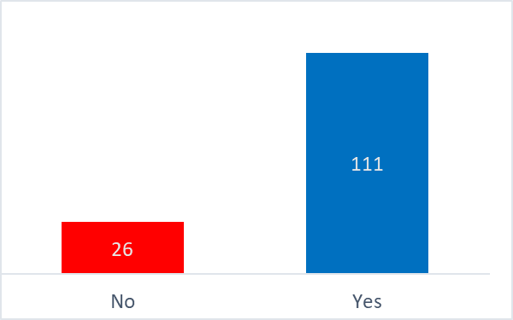

Figure 1: Does the status of the quality professional depend on the organizational culture? (respondents in Israel)

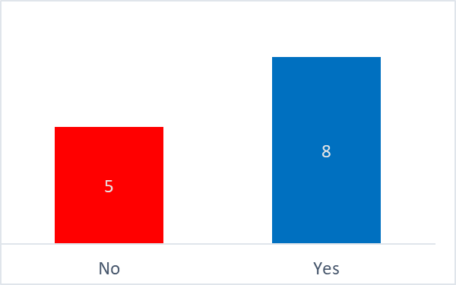

Figure 2: Does the status of quality professional depend on the corporate culture? (respondents abroad)

### ***H2: The status of a quality engineer is influenced by unexpected events.***

This hypothesis was examined using the following questions (Appendix A):

1. Were you present at work during the COVID-19 closures? (Yes/No)

2. Has your job status changed as a result of the COVID-19 crisis?

1. Unchanged 2. Improved 3. Worsened/Decreased 4. Other

3. Has your authority changed as a result of the COVID-19 crisis? (Yes/No)

4. Has your job description changed during the COVID-19 crisis? (Yes/No)

* 1. If yes, how did it change?

1. Has the importance of quality in your organization changed during the COVID-19 crisis? (Yes/No)
   1. If yes, how so?

Survey results showed that more than 76% of the quality professionals who were present at work thought that their status had not changed, while those who did not come to work (or were placed on unpaid leave or fired) thought that their status had been damaged.

Overall, about 78% of the respondents replied that the status of their job had not changed (Figure 3), about 85% believed their authority had not changed, and about 84% thought their job description had not changed during the COVID-19 crisis. Those who answered that their job descriptions had changed during the period gave the following explanations: additional duties had been assigned by the COVID supervisor (14 replies); they lost their jobs (3 replies); their job description changed only in part (XX times).

The participants who answered that the importance of quality had changed in the organization as a result of the COVID-19 crisis gave the following explanations: there was an increased emphasis on the importance of safety with the appointment of a COVID supervisor (four replies); there was increased emphasis on quality (three replies); there was increased awareness of process risk management/safety (three replies); there was increased quality control of processes (XX replies).

A strong correlation was found between those who thought their authority and job description had not changed during the COVID-19 crisis and those who were present at work.

This was reinforced by responses obtained from quality professional abroad. Survey results showed that more than 82% of respondents who remained present at work during the crisis believed that their status had not changed as a result of the COVID-19 crisis (Figure 4) and 81% thought that their job status had not changed. More than 73% of the participants reported that their authority had not changed and over 91% believed that their job descriptions had not changed as a result of the crisis.

**In conclusion**, the results of the data comparison test and the statistical analysis clearly show that the emphasis on quality did not change during the COVID-19 period, while additional roles or positions were created to handle the crisis.

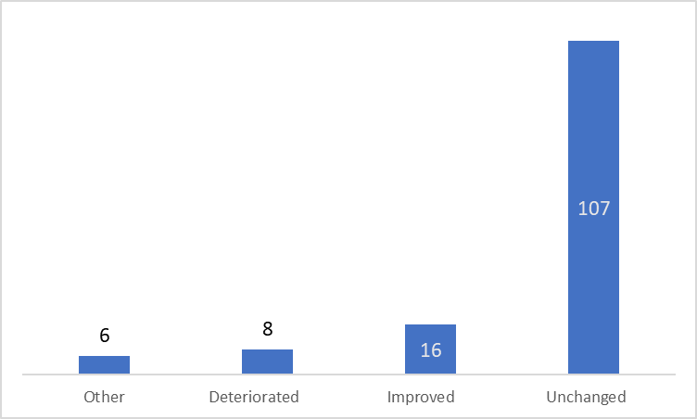Figure 3: Has your job status changed as a result of the COVID-19 crisis? (respondents in Israel)

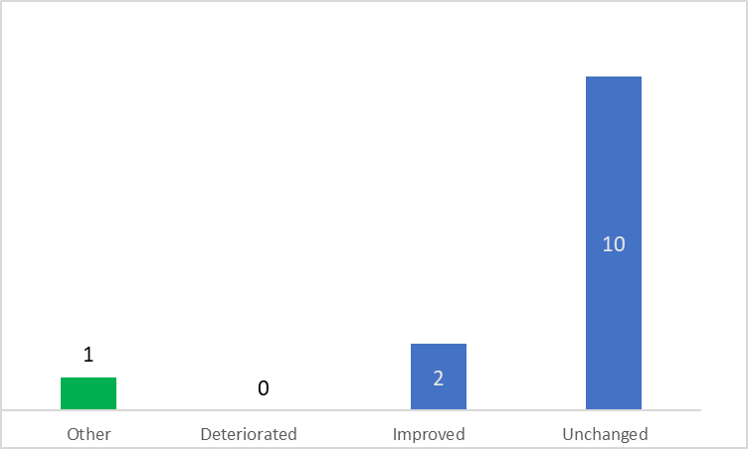

Figure 4: Has your job status changed as a result of the COVID-19 crisis? (respondents abroad)

### ***H3 There has been a decline in the status of quality engineers in recent years.***

We examined this hypothesis using the following questions.

1. Do you think the status of quality engineers is declining? Yes/No
   1. If yes, what do you think are the reasons for this?
2. Has the status of quality engineers in your organization been declining in the last 5 years? Yes/No
   1. If yes, how so?

Survey results showed that about 72% of the respondents believed that the status of quality engineers has not been declining (Figure 5). In addition, more than 81% reported that their status in the organization in which they work had not changed, meaning that there is a quality-friendly organizational culture. The remaining respondents believed that had been a decrease in status (unclear customer requirements, unprofessional quality managers, lack of authority, etc.). The participants who reported a decline in status gave the following explanations: lack of management support in light of the COVID-19 crisis (six replies); decreased product quality and timeliness (four replies); decreased emphasis on quality, with a focus instead on survival (three replies); and the status of the quality engineer was not legally defined (XX replies).

Those who reported a decline in status over the last five years gave the following explanations: reduced commitment from management (15 replies); lack of expertise, professionalism and authority ( replies); decrease in product quality and timeliness (four replies); a requirement to reduce both quality and timeliness (three replies); and no change (X replies).

A strong correlation was found between participants who thought that their status had not been declining and those whose status had not changed. This was reinforced by the survey responses obtained from quality engineers abroad. Overall, about 55% of respondents believed that the status of quality engineers had not declined.

In conclusion, the results of the data comparison examination and the statistical analysis clearly show that quality engineers believe that the status of their profession is not declining either within or outside their organizations.

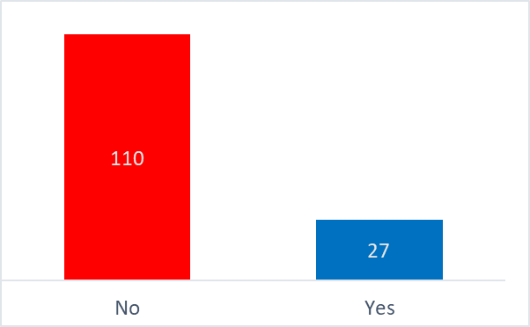

Figure 5: Has the status of quality engineers in your organization declined in the last five years? (respondents in Israel)

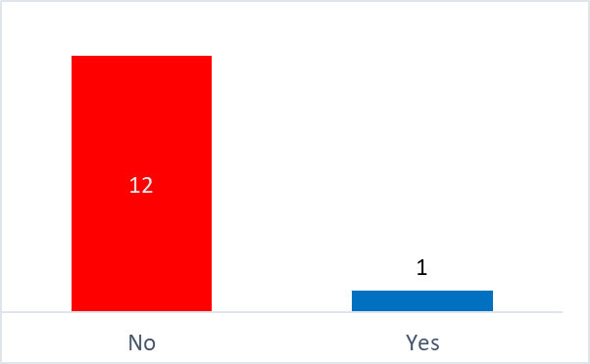

Figure 6: Has the status of quality engineers in your organization declined in the last five years? (respondents abroad)

# **Discussion and Conclusions**

This study examines the impact of the COVID-19 crisis on the quality management profession based on the experience of quality engineers in the context of two key terms: organizational culture and professional status. The findings show that the status of the quality engineers depends on the organizational culture, regardless of position or company and that promoting quality requires the backing of management and an organizational culture that supports and influences the quality system. Quality engineers who remained at work during the COVID-19 crisis reported that their status had not changed, while those who were not present at work believed it had. It was found that most quality engineers agreed that the status of their positions, their authority, and their job descriptions had not changed during the COVID-19 crisis, although some of them had been assigned additional, COVID-related duties to prevent damage to product quality.

For the most part, respondents did not believe that the status of quality professionals had changed during the COVID-19 crisis, either inside or outside their organizations.

Those who did believe that their status was declining attributed this to decreased commitment by management, unprofessional quality personnel, an organizational focus on survival, a demand for reduction in CA, and the lack of regulations to anchor the status of quality engineers.

Replies obtained from quality professionals abroad were similar. They reported that their status did not depend on the organizational culture, regardless of their position and company. They also replied that the status of their position, their authority, and their job descriptions had not changed during the COVID-19 crisis.

The following are some suggestions made by the participants to improve their status generally: quality training for senior managers in the organization; raising the professionalism and skill of quality engineers; expanding the field of quality beyond product quality to include organizational excellence, operational excellence, engineering factors, risk management, user regulations and safety.

# **Research Limitations**

These findings may not apply to all quality professionals in Israel and abroad, as we were only able to reach a small sample. Also, the study lasted for months.

# **REFERENCES**

Abbott, A. (1988). *The System of Professions: An Essay on the Division of Expert Labor*. Chicago, IL: University of Chicago Press.

Halevi. A. (2017*). Assimilation of knowledge and quality methods in industry*, the 35th annual conference of the Israeli Tel Aviv Quality Association, November 2017

In principle, and in full (2012). With the face forward. Quality: Journal of Quality and Excellence of the Israeli Quality Association, 51, 26–29.

In principle, and in full, (2012). Challenges and ways to empower the quality manager. Journal of Quality and Excellence of the Israeli Quality Association, 50, 12–14.

Anchor, S. (2019) Expertise and authority in the work of a quality engineer. Thesis submission work.

Questionnaire for research work in Hebrew - the role of the dealer in the quality of Google Forms

[Questionnaire about the position of quality engineers - Google Forms](https://docs.google.com/forms/u/1/d/1w1CsWusm3yygHIlSPTLK5cT6vrypQTWaT64g13PZNQY/edit?usp=drive_web) - Google Forms

Ekroni, M. (2012). ‘Facing Forward to Quality’, *Quality and Excellence Journal of the Israeli Society for Quality*, 51: 26–9 [Hebrew].

Ekroni, M. (2012). ‘Challenges and Ways to Empower the Quality Manager’, *Quality and Excellence Journal of the Israeli Association for Quality*, 50: 12–14 [Hebrew].

Etzioni, A. 1969. *The semi-professions and their organisation*: Teachers, nurses, social workers. New York: Free Press

Giddens, A. (1984). *The Constitution of Society: Outline of the Theory of Structuration*. Cambridge: Polity Press.

Ronen, Z. (2013). ‘Does Your Company Need Quality Management?’ *Business Excellence*, May 5 <https://business-excellence.co.il/blog/126-do-you-need-a-quality-manager> accessed 7 September 2019.

State of Israel v. Bar-Ilan et al. (2000). <[shalhevetold.co.il/pub//psak%20din/psak_makabiya.doc](https://www.google.co.il/url?sa=t&rct=j&q=&esrc=s&source=web&cd=1&ved=2ahUKEwi3tfqf0vfdAhXRMewKHcuYBI0QFjAAegQIAhAC&url=http%3A%2F%2Fshalhevetold.co.il%2Fpub%2F%2Fpsak%2520din%2Fpsak_makabiya.doc&usg=AOvVaw0KpnL6wMbHbnK2eBEv3gY1)> accessed 7 September 2019.

Weber, M. (1968). *Economy and Society*. Berkeley, CA: University of California Press.

Zonnenschein, A. (2016). ‘We Must Uproot the Culture of the Loose Slapdash in the Food Industry’, *The Marker* <https://www.themarker.com/opinion/1.3103885> accessed 7 September 2019.