The Individual, Society and the Mask – in the paintings of Chaya Agur

Date of submission:

Dr. Bina Nir

The Department of Communication. Director, Honors B.A. Program the Academic College of Emek Yezreel, Israel

Contact Information. Cell Phone: 972-50-5649898; Home phone: 04-6492553; email: [binan@yvc.ac.il](mailto:binan@yvc.ac.il)

The Individual, Society and the Mask – in the paintings of Chaya Agur

Date of submission: 31/8/19

Abstract

The culture of consumer capitalism encourages authentic individualism on the one hand, but, on the other, also promotes the tendency towards conformity. “Identity”, has never been so “fashionable”. Consumer society allows us to change identities in an instant, and as a result, any identity we assume is subjected to a constant onslaught of skepticism and uncertainty. Consumerism puts at our disposal such a wide range of possible identities as to make the whole question of identity seem almost arbitrary. In this article, I will examine various examples of simulated identity, as expressed in the paintings of the contemporary artist Chaya Agur. The discussion on the role of the “mask”, as “persona” will be critical.

**Keywords**: Mask, Persona, Loneliness, Identity.

THE INDIVIDUAL, SOCIETY AND THE MASK – IN THE PAINTINGS OF CHAYA AGUR[1]

INTRODUCTION

The social group is a double-edged sword: on the one hand, it gives us a frame of belonging and provides us with womblike protection and a sense of security; on the other hand it deprives us of the independence, uniqueness, and richness of being alone (Fromm 1977, XX). Belonging and fitting in with others is important to us for survival, and therefore, the rise of the individual as distinct from the tribe throughout the cultural history of the West has created conscious tension between the individual and society.

Although scholarly consensus credits the Renaissance with the birth of modern individualism in the West (see Burckhardt 1944), in the sense of humanity emerging from a state of pre-unitary existence to a state of full self-awareness of the human being as a distinct entity (Fromm 1977, XX; Debord 1995, XX), we must insist, along the lines laid out by Shanahan (1992, XX), that the Renaissance saw the renewal – rather than the invention – of individualism and humanism. There is evidence of personality being viewed as distinct throughout the Middle Ages (see for example Arbel 2002); in fact, signs of individualism can be traced as far back as antiquity.

Since the advent of individualism in its modern incarnation, human beings have become freer, but also lonelier. Many are still willing to sacrifice their privacy, liberty, independence, and right to free thought and self-determination, all for the sake of a perceived sense of identity and belonging to the herd, rather than suffer loneliness (Fromm 1977, XX). Humans are constantly in search of simulated identity, argues Sartre, out of the fear of singularity – they are creatures of the masses. No matter how low he has to stoop, man will take every measure so as not to stand out from the crowd, else he might find himself facing his own image (Sartre 1956, XX).

Individualism is generally considered a central component of Western culture (Huntington 1997, XX). Nevertheless, despite the value attached to individualism, people cannot completely separate themselves from the collective consciousness, for only in relation to the social framework can they understand their world and themselves. Therefore, the struggle to become a self-conscious being with a high level of personal and social awareness often generates significant tension between the individual and society. In fact, we could say that an individual is a person who sees themselves as responsible for analyzing and privately or publically reformulating the basic scientific, political and sociological assumptions they are exposed to. This person’s individual stances are not necessarily aligned with the precepts of their social group and they might agree with society’s political and religious worldviews or, on the contrary, oppose them (Raby 2009, XX). However, even a self-aware mind has, according to Jung, unconscious underpinnings. The individual never exists as an entirely separate entity; we are social creatures, and therefore, the mind is as much a collective as an individual phenomenon (Jung 1916, XX).

With the democratization of political regimes in the West, a process which has anchored anthropocentrism as the dominant worldview in Western culture, the question arises whether individualism is a true expression of freedom, allowing each person to fully experience their uniqueness; or whether it is a mere illusion, an example of wishful thinking, or an unconscious mask we don to protect ourselves from loneliness. In today’s capitalist society, with social networks giving us endless possibilities for self-expression, the individual claims to strive towards self-actualization. Eva Illouz argues that we are in fact actualizing a kind of “generalized self” that is not really us. The culture of consumer capitalism encourages authentic individualism, but at the same time promotes a tendency towards conformity. “Identity” has never been so “fashionable”. Consumer society allows us to change identities in an instant, and as a result, any identity we assume is subjected to a constant onslaught of skepticism and uncertainty. Consumerism puts at our disposal such a wide range of possible identities as to make the whole question of identity seem almost arbitrary (Illouz 2002, XX). In this article, I will examine various examples of simulated identity, focusing on the role of the “mask” (the image we strive to present to the world) as a shield against loneliness – as expressed in the paintings of contemporary artist Chaya Agur.

LONELINESS, THE INDIVIDUAL AND SOCIETY

Loneliness is generally perceived as a psychological state of sadness and melancholy due to a lack of company. Robert Weiss points out that loneliness is not caused by one’s state of solitude, but by a life that lacks fulfilling social relationships (Weiss 1975, XX). Loneliness is a subjective experience that is not paramount to social isolation; rather it stems from a deficiency in the individual’s social connections. Solitude can be good when it is intermittent, when this private domain exists alongside friendship ties, when it does not take over a person’s life, but is rather a coveted and voluntarily chosen part of it.

In contrast, Schopenhauer, takes the extreme view, ignoring our social need to belong and presenting solitude in a positive light: in his eyes, only when man is alone can he be wholly himself. Man is only free when he is alone. From this radical position, Schopenhauer views social man as dull-witted, spiritually sterile, and boorish (Schopenhauer 1969, XX).

Nietzsche is another avid proponent of extensive solitude. To lead a full inner life, one has to retire from the herd into individuality: “Would you go into isolation, my brother? Would you seek the way to yourself?” (Nietzsche 2003, 47). However, the way to the self is anything but straightforward: “But the worst enemy you can meet will always be yourself; you lie in wait for yourself in caves and forests… You must be willing to burn in your own flame: how could you become new unless you had first become ashes?” (48–49).

Unlike Schopenhauer and Nietzsche, who disregard the social need to belong and instead advocate creative solitude, Spinoza argues that the worthy life is one that maintains an equilibrium between the two. As long as man inhabits the solitary realm of the self while belonging in parallel to the realm of the many, taking responsibility for his actions, operating out of full awareness, and leading productive, collaborative, and creative discourse with his social group, his solitude will be a tonic to him, with no loss of freedom or identity (Harpaz 2013, XX).

Like Spinoza, Russell teaches that a proper balance must be found between belonging and separateness, or aloneness, rather than a clear-cut decision in favor of one or the other. He writes that human life must contain a wide space which is ruled by what is known as the “herd instinct”, but it also must delimit a narrow space where this instinct is barred from entering (Russell 1996, XX). This narrow space belongs to the private domain. It is not only an intellectual domain, but also a physical and emotional one. Only through the fully led “me-life”, through the hours of aloneness and separateness, through opening up to the rich spheres of existence, through creativity and imagination, through personal pleasures of the body and the mind – only through these can man glimpse the full scope of his personality, and with it the need to discover and fulfill himself.

In summary, just as individuals need the public domain in numerous aspects of their lives, they also need the private domain for other aspects. However, the encounter with the other is also important for the creation of the individual self. Emanuel Levinas emphasizes the importance of this relationship between individual and society for self-development. He defines the self as a subjectivity, as a subject, an “I”, precisely because it is exposed to the other (Levinas 1986, XX). In his conception, it is impossible to create a deep bond of sharing and openness with the other unless we undertake the voyage into the depths of our own souls (Levinas and Melville 1978, XX). The process of revealing one’s self to the other is accompanied by discomfort and sometimes pain. The other is not just another person located outside of the self, but the internalized other who resides in the hidden regions of the I-experience. The interaction created between the “I” and the “other” begins with recognizing the “I” as an individual, as the self. The general mechanism through which the self can develop is reflexive – it is the ability to examine one’s self through the eyes of others (Hollis 1993, XX; Ritzer and Goodman 2003, XX).

Existentialism, on the other hand, tends to regard the tension between individual and society as a healthy one that we as humans must learn to navigate, a tension between our cultural heritage and our capacity to reflect upon it with a critical eye (Strenger 2010, XX). Human individuality is the result of internalizing these tensions and attempting to live them in a fulfilling and meaningful way. Nevertheless, the reflexivity essential to the individual’s development is often accompanied by shame, anxiety, and struggle, which may lead to self-alienation, disingenuousness, and an unhealthy dependence on the “mask”.

THE INDIVIDUAL, SOCIETY AND THE MASK

Jung utilizes the term “persona”, which in Latin designated a theatrical mask, to refer to the social face that an individual presents to the world. The persona, he argues, is but a fragment of the collective mind that one puts on (and struggles to remove) in order to create a false impression of individuality. The persona is not real – it is a compromise between the individual and the way society dictates a person should appear (Jung 1916, XX). People rely on the mask of the persona to play their social role. The mask allows them to be part of society and to escape loneliness. Similarly, existentialist philosophy deals with self-alienation and the masks that individuals don in society out of shame and out of fear of the gaze of the other, as Sartre illustrates in his play *No Exit* (1989).

Jung warns against overreliance on the persona device, which could lead to the loss of an individual’s true personality in favor of their persona. That individual risks being swallowed up by this simulated image and becoming an artificial being, a victim of their own undoing (Jung 1916, XX). Those who are too good at fabricating their persona doom themselves to living with a conflicted soul (XX). From early childhood we learn to wear masks, to hide our true or imagined weaknesses in order to protect ourselves from rejection by others. Although at times we might mistake our persona for our true selves, just a passing glimpse of what’s behind the mask elicits a sense of meaning. Such revelations can happen when we take the time to look inwards, when we are exposed to the ideas of great thinkers or even during an honest conversation with another individual (Cohen 2005, XX). These revelations relate to our inner strength: the more we learn to see individuality as an expression of our uniqueness, the more we can become ourselves.

The mask also protects us from the fear of emptiness and meaninglessness. This cold shadow of existential dread sometimes manifests itself as a loss of interest in life, brought on by such causes as a crisis of faith, a shattered dream or a romantic breakup. The sense of emptiness hangs over and threatens our existence (Tillich 1952, XX). One of the ways of escaping this void is to assume an identity, a protective persona that gradually solidifies and becomes permanent. According to Jeansen, as long as the social “actor” wearing an artificial mask is aware they are playing a role, everything is ostensibly fine. However, if the person underneath forgets that the mask is a fiction, they will no longer be able to fully grasp or fulfill themselves, and over time will come to realize their fundamental loneliness and – even more so – their falseness (Jeansen 1960, XX).

THE MASK IN THE PAINTINGS OF CHAYA AGUR

Art, according to Nietzsche, protects man from existential dread and the horror of dealing with an absurd reality. The artistic act is also the mark of the authentic person – the one who inhabits, creates, and refines themselves. In this act of creating one’s self, the creator and the work merge and there is no more distance between them. The role of art is therefore not merely to imitate nature or reality, but to serve as a metaphysical complement to this reality and to overcome it (Nietzsche 1999, XX). Similarly, Marcuse views art as having the power to negate the given reality; as such, it has an important place in the expression of social criticism, one of the drivers of individual consciousness (Marcuse 1977, XX). This recognizes the political potential of art: any authentic work of art constitutes a questioning of perception and understanding, a denunciation of institutionalized reality, and therefore could be considered revolutionary. The negation Marcuse speaks of is, in fact, the contrast between the autonomous world of art and the existing reality (XX).

The “Masks” series, produced by painter Chaya Agur between 2001 and 2004, addresses the intricate relationship between the individual’s inner personality and their social mask by exploring, with a critical eye, the wide variety of “masks” used in different social situations; they are in fact images of the “masks of the soul” donned by the individual (Jennings and Minde 1993, XX). The mask, as depicted in ten works from Agur’s “Masks” series, represents the simulated identity behind which the individual is hiding, having lost sight of their authentic identity. Through these works, Agur issues a criticism of contemporary society and cautions against overusing the persona device, which, echoing Jung’s warning, could cause us to lose our true personality and become an artificial being.

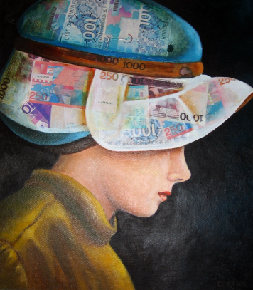“Expensive Hat”, collage and oilpaints, 30x40

This painting depicts a woman whose face is partially obscured by the titular “expensive hat”, representing capitalism. The image criticizes the overabundance of identities proffered to us in the age of consumerism – identity becomes yet another product for people to consume. In some senses, individualism too has fallen victim to the influence of the identity market in which the “I” is traded like so many other consumer goods (Strenger 2010, 42). The person becomes a brand, and identity becomes a “false need” that the person assimilates without even realizing it (Marcuse [1964] 2006, XX). In his critique of consumerist ideology in the capitalist age, Marcuse argues that manufacturers no longer address people’s real needs; instead advertising creates the illusion of necessity in order to persuade people to buy products they do not actually need. These “false needs” perpetuate injustice, aggression, wastefulness, and obsession with work. They prevent change from happening because change is only driven by real needs (XX).

These needs have societal content and function, and it does not matter how much they have been internalized by the individual, nor how much that person truly identifies with them or finds personal fulfillment in their satisfaction – “they continue to be what they were from the beginning—products of a society whose dominant interest demands repression”(7). In the past, Marcuse contends, human freedom was limited by a lack of means to satisfy basic needs. Nowadays, however, just as the exercise of freedom is so readily within reach, it is curbed by the framework of modern capitalist society, which manages to suppress even the potential of liberation. When there is no true critical dimension, man finds himself living a “one-dimensional” existence. “One-dimensional” denotes a situation in which negation is rooted out of the forces that are supposed to oppose the existing system. For all intents and purposes, it consists of the disappearance of the private, subjective dimension (12–13). The “one-dimensional” man is trapped in a state of false consciousness and in the race for social success and achievement.

Horkheimer and Adorno also see the race for external capitalist success as today’s only measure of self-existence. They maintain that the agencies of cultural production are particularly adept at impressing “standardized behavior on the individual as the only natural, decent, and rational one. Individuals define themselves now only as things, statistical elements, successes or failures” (Horkheimer and Adorno 2002, 21). Slavoj Zizek presents an even more extreme position with regard to the individual’s behavior in capitalist society. In his view, today’s accepted cultural norms have a tinge of social imperative that can sometimes border on the totalitarian. The “you can” becomes “you must”, an imperative that ignores true needs and demands compliance (Zizek 2000, 44). By choosing not to follow the norms, which have become totalitarian, the individual may pay the heavy price of social loneliness and therefore prefers to adopt the accepted values – represented in the painting as a hat made of banknotes – at the cost of losing identity (the faceless woman).

“Variations on Zoomorphism” (Cow-man), black and white drawing (46x33)

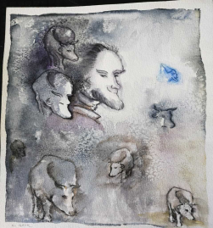

This humorous study by Agur is the visual interpretation of the literary device of “zoomorphism” – or “rhinomorphism” as it appears in Eugène Ionesco’s *Rhinocéros* ([1962] 2014), a play that focuses on the scientifically proven phenomenon of conformity (Allen and Levine 1969, XX). Ionesco expresses his dread of ideological conformity by presenting it in its extreme with his theater of the absurd. The play portrays a society that causes people to voluntarily relinquish independent thought, to assimilate in order to belong rather than feel excluded. Agur, in turn, presents a visual criticism of this modern herd mentality. Conformism can cause a person with a “human” face – a face that represents humanist values – to undergo a gradual and imperceptible metamorphosis into a cow (or a rhino…). As Zizek warns, contemporary society, which is based on market forces rather than humanist values, can only move in the direction of easy, animal-like pleasures, and therefore its values are bound to degenerate (Zizek 2002, XX).

This criticism of the herd mentality is nothing new; it was already masterfully expressed by Roman philosopher Lucius Seneca in the first century AD:

YOU ask me to say what you should consider it particularly important to avoid. My answer is this: a mass crowd… I never come back home with quite the same moral character I went out with; something or other becomes unsettled where I had achieved internal peace, some one or other of the things I had put to flight reappears on the scene... Associating with people in large numbers is actually harmful... The larger the size of the crowd we mingle with, the greater the danger. (Seneca 1969, Letter VII)

In order to retain a fragment of individuality, Seneca encourages us to embrace positive solitude and to withdraw from the crowd once in a while. He advises against following the crowd but also against despising the crowd, and suggests that we look inwards as much as possible and consort with people who have a positive effect on our virtues (Seneca 1969, Letter VII).

This, then, raises the question of whether today, in the age of social networks, it is still possible to detach from the collective, “inclusive” element of our natures; and whether the possibility for individuals to define themselves separately from the herd still exists.

For Eran Kimchi, social network users tend to believe it is possible to become fully acquainted with another person based on a concise list of their basic characteristics (Kimchi 2010, XX). Today we find ourselves in a new social state called “alone-together”. This is a social illusion which allows the individual to feel connected to society when in fact this connection is superficial and vague – a substitute for authentic and intimate interpersonal conversation. The individual chooses the precise extent to which they reveal themselves (Turkle 2011, XX).

“Every fisherman has his fish”, watercolors (40x50)

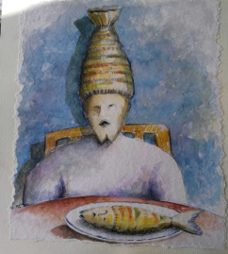

This humorous visual criticism also relates to modern consumerism. The old adage “you are what you eat” is transformed into a metaphorical commentary on the consumption of social and cultural content. The “individual” chooses or “fishes” his food without realizing he is internalizing the “mask” of the thought habits he is taking in. The critique places the responsibility on the shoulders of the person who consumes content indiscriminately and internalizes it as if it had been self-created – social content becomes part of the person’s identity and a delusional shield against singularity and loneliness. The implication of this responsibility is best summarized by Sartre, for whom man is nothing but what he makes of himself. Man is free. Man is freedom (Sartre 1973, XX).

“Carnival”, oil on canvas 40x60

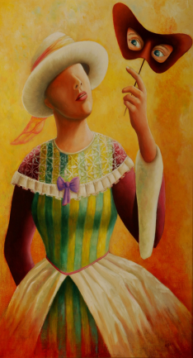

“Carnival”, oil on canvas 40x60

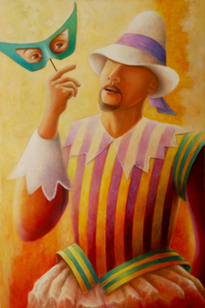

In this diptych, both the woman and the man are dressed in Renaissance clothing. The eye masks they hold are typical of the Venetian carnival. When the masks are removed, they have no face – the eyes continue to look at the world through the perspective of the artificial persona. The masks therefore represent the element of the assumed persona – made to impress and meet social expectations. For Agur, the faceless figure behind the fixed, simulated identity of the mask is a recurring motif. The mask is personality, but it is also the illusion of identity, as revealed by Luigi Pirandello in the series of plays entitled *Naked Masks* (1957). For the Italian playwright, man is always wearing a mask, without meaning to and without being aware of it, yet the mask itself is naked, because nothing about it is real (Pirandello 2005, XX).

“Carnival” expresses the idea that society gives us the mask, but also the chance to escape by means of the carnival, an event celebrated all over the world. The carnival allows the individual to step out of their everyday personality in order to identify with that which they are not – it is a game in the theater of life. The struggle for survival makes life oppressive, while the carnival offers relief from the stress of it all. It is liberation, Nietzsche’s Dionysus. The carnival in Venice and in other places is not a religious holiday so much as it is a response to a human need. This temporary transformation of life into art corresponds to Nietzsche’s insistence that the principle of creativity is what gives life value (Nietzsche 1974, XX).

Cited by the Greeks as the dual source for their art, Apollo and Dionysus represent opposing styles engaged in almost constant conflict: “In order to gain a closer understanding of these two drives, let us think of them in the first place as the separate art-worlds of *dream* and *intoxication*. Between these two physiological phenomena an opposition can be observed which corresponds to that between the Apolline and the Dionysiac” (Nietzsche 1999, 14–15). Apollo is “the magnificent divine image” – the supreme truth, the god of true recognition (17). Dionysian art, in contrast, is based on fun, intoxication, and ecstasy: “we catch a glimpse of the essence of the Dionysiac, which is best conveyed by the analogy of intoxication. These Dionysiac stirrings, which, as they grow in intensity, cause subjectivity to vanish to the point of complete self-forgetting” (17).

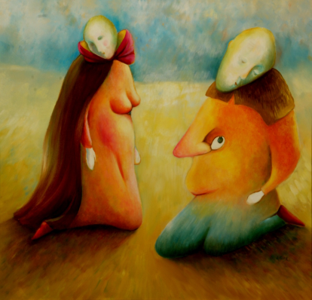“Body Language”, oil on canvas, 50x60

In this painting, Agur explores the truth of the body as opposed to that of the conscious mind – the human body has the ability to express nature’s “truth” even when our consciousness attempts to hide it. Our basic survival impulses, or the vulnerability of our subconscious when it feels threatened, express themselves in uncontrolled emotions such as anger, shame, and lack of confidence, all of which burst out into the open as “body language”, sometimes betraying the mask we wear on our faces. As Samy Molcho points out, we have control over our faces and our speech (for instance, we are able to smile while we are angry), but the body is the reflection of the soul and its language speaks from the heart. Our inner feelings, emotions, and desires are expressed through our bodies. We immediately respond physically to the difference between desired value and actual value without our conscious intervention. Molcho also notes that people from all walks of life and social circles react similarly, if not identically, to stimuli at the primal level of physical signals (Molcho 1985, XX). This is unlike the persona, which varies across cultures, social classes and individual personalities. In the painting, this idea is expressed through the bodies depicted as the actual true “face” of the person, speaking its own language, while the faces on the couple’s heads are drooping, lifeless masks. Any real communication between the two takes place by way of their bodies.

“The Mask as an Escape from the Other’s Gaze”, oil on canvas, 50x70

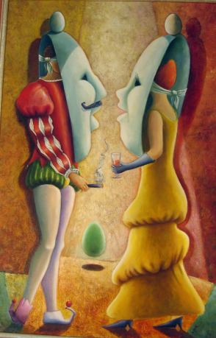

The couple in the painting are acutely aware of the existence of the giant masks they are hiding behind. Their real identities are purposefully concealed at the moment of contact because they are afraid to reveal their true selves. As Jung has argued, the persona is a complicated relationship between an individual consciousness and society, a kind of mask to impress those around us, on the one hand, and to hide our true natures, on the other (Jung 1916, XX). Our intense desire to belong to the other in a meaningful relationship makes us afraid of revealing our true identities and causes us to hide behind a giant mask that we wield like a shield against loneliness. An egg – an emblematic and recurring symbol for the painter – is poised at the top of each mask as a metaphor for the delicate balancing act required to prevent the fragile load from falling and breaking, while an additional egg between the two figures symbolizes the relationship they seek to found and fertilize. Both partake in the finest of social mannerisms, represented by the glass of wine and the cigar; however, the concealment of their selves remains complete. Social interactions require people to act out a variety of roles on a variety of stages. Goffman terms this phenomenon “audience segregation”, referring to a situation in which an “actor” has to present different but coherent self-images to different audiences (Goffman 1956, XX).

Social psychologist Mark Snyder also found interpersonal differences in the extent to which we change our behaviors to suit the various audiences in our social circle – a phenomenon he calls “self-monitoring” (Snyder 1974, XX). Someone with a high degree of self-monitoring will adapt their behavior to the given situation, acting in accordance with the impression they are trying to give. Such individuals, he continues, are highly motivated to behave in a way that is perceived as appropriate by others.

Fear of potential loneliness is not the only emotion an individual experiences in the encounter with the other; shame too is a sensation inextricably linked with the other’s gaze. It is the discomfort created when a person feels themselves transformed into an object. According to Sartre, the man who is ashamed is stripped of his humanity because he is denied the independence of being the looking subject rather than the looked-upon object (Sartre 1956, 287–289), an idea which also appears in his famed play *No Exit* (1989). The play takes place in a room which, as it turns out, is located in hell. The three characters are led into the room at different points in time. The door is then locked and all three of them expect their torturer to arrive imminently – however, no one else enters the room. As their conversation evolves, it becomes clear that their vastly different worldviews and value systems make them insufferable company for one another. The unrelenting gaze of the others makes this situation a hell because of the fear of being exposed. For a real human connection to be established, we must reveal our real selves, the inner part of ourselves of which we are often ashamed. We are terrified by the thought that there might be something about us which, when seen or discovered by others, will make us unworthy of human bonding.

“Face Fan”, oil on canvas, 50x70

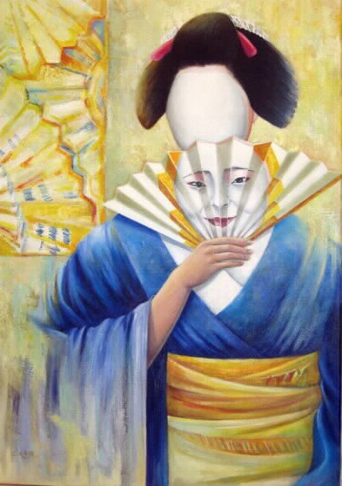

In this painting, the mask, the fan, and the traditional Japanese costume represent a highly polite and ritualized culture, one that prescribes strict rules of behavior in all aspects of life, which is why the persona appears attached to the fan. The mask here illustrates the ritual dimension of society. In this critique, Chaya Agur represents a faceless figure under the mask, a figure devoid of a unique identity, signifying that in a society which imposes its rules on the individual, it is challenging for the individual to make the distinction between societal and personal values.

“Eve”, oil on canvas, 50x70

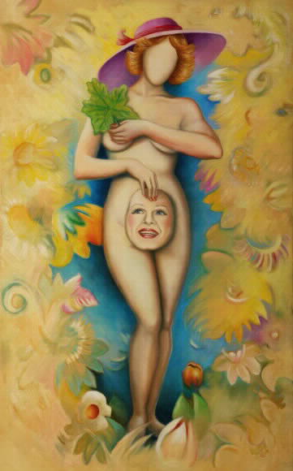

Eve is a universal symbol – she represents the primordial shame of being aware of one’s genitals, which in this case, are symbolic of personal exposure. The figure in the painting is a modern Eve (judging by her hairstyle and hat) hiding her nakedness with a mask of personality rather than a fig leaf. Here, the painter makes the distinction between physical nudity, which can be concealed with a garment or a fig leaf, and our primal need to conceal our inner nudity from the world with a protective persona. The Garden of Eden is a formative myth in Western culture; it symbolizes the beginning and the aftermath, the origin of foundational patterns and their violation, the space of sin, retribution, and longing. Moreover, this myth touches upon basic universal questions, including that of the relationship between the individual and society, and the process of revealing one’s self to the other, which is always accompanied by discomfort and even pain (Ritzer and Goodman 2003, XX). This painting depicts, on the one hand, the origin of shame as bound up with self-knowledge, the same knowledge that is the source of pain in life outside the Garden: “And the Lord God commanded the man, saying: of every tree of the garden thou mayest freely eat;but of the tree of the knowledge of good and evil, thou shalt not eat of it: for in the day that thou eatest thereof thou shalt surely die” (Genesis 2:16–17). On the other hand, with her modern-day styling, the Eve in the painting represents sexual liberation and freedom from the need to hide one’s nudity. And yet, for Agur, despite being free of the requirement for bodily concealment, the persona is more indispensable than ever. Modern Eve represents the awareness of nudity in its inner sense, the exposure of one’s soul that no clothes can hide.

“Changing Faces”, oil on canvas, 60x80

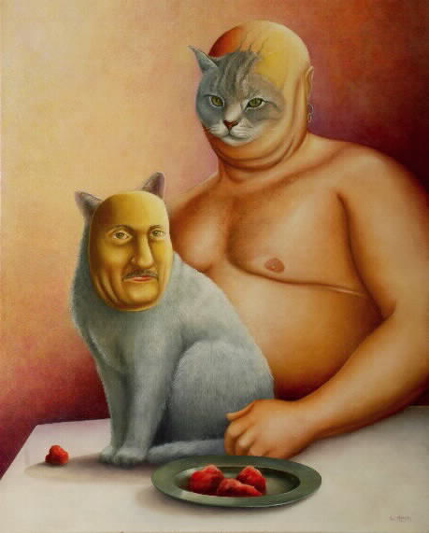

This painting represents our ability to adapt to our surroundings and the general flexibility of our psyche. While some identities are fixed around a central trait that precludes adaptability (such as power, control, etc.), posing a challenge both for the individual and for the outside world, the fact remains that our psyche has great capacity for flexibility, which can widen the rigid borders of the “self”. This is evident in relations based on love and mutual trust.

In “Changing Faces”, Agur presents a comical depiction of a cat and its owner as a couple who have adapted to each other. A couple often creates a common identity that includes identical social preferences, reactions, values, tastes, and lifestyles – all of which attest to a deep physical and mental adaptation to each other, but at the same time a loss of individual identity. The man trains the cat to act more human, while he takes on catlike traits. Both are depicted eating the same food, which happens to be raw meat.

EPILOGUE

In ancient Greece, the mask was a requisite theatrical convention that visually symbolized the art of disguising one’s self as another. This phenomenon was also prevalent in theaters of the Far East. Masks had a social, ritual, and theatrical role in the cultural history of different regions around the world (Mack 1994; Hershman 2014). Today, the mask is still a staple of global culture in theater, festivals, and holidays, but over the years it has also become a metaphor for the variety of roles humans assume in society. As Jung argues, the social mask is what one dons in order to play a social role successfully (1916, XX). In the social context, it is difficult for a person to be entirely their “true self” and so they adopt a “persona” which is in fact a “false self”. Every person has a set of masks through which they live. These are different types of roles that allow them to adapt to a particular social environment, and perhaps there is nothing wrong with that – that is until the mask takes over. The “false self” – the “social self” – may become dominant if the “true self” is neglected long enough.

In this article, we examined ten paintings by artist Chaya Agur in order to find a contemporary, critical outlook on the role of the mask in the relationship between the individual and society, focusing in particular on modern humanity’s alienation from the “self”. As we saw, the faceless face and the perpetual mask are recurrent motifs in Agur’s paintings. The mask meant to serve individuals only in their relations with others ends up becoming part of their personality, to the point where they have no idea who they are behind the mask. Agur covers the faceless face of a woman with a hat made out of banknotes as a criticism of borrowed identity in the capitalist age, where the only success is financial success. In today’s herd mentality, made ever stronger by social networks, individuals are “zoomorphized” by Agur’s brush, echoing Ionesco’s “rhinomorphism”. In the sketch in question, humanity is a conformist herd of identical members devoid of any uniqueness or authenticity; just like the man who “fishes” his values indiscriminately and whose face becomes identical to the fish, symbolizing the fact that his values are those of the herd.

In “Body Language”, the painter locates our true selves on our bodies rather than on the masks we put on our faces. The human body has its own “truth”, and it cannot hide it the way we can hide our faces or act a part by controlling our facial expressions. “The Mask as an Escape from the Other’s Gaze” likewise depicts a man and a woman who are hiding their true identities. If, in this painting, the couple are aware that they are putting on masks, the couple in “Carnival” are oblivious to their disguises, which become their unconscious identity (symbolized by the faceless faces). In the next painting, the Japanese fan-mask highlights the universality of social masks across different cultures. Agur is suggesting that the more institutional and cultural restrictions prevent the individual from freely creating their true authentic self, the more permanent the persona becomes. Eve too represents universality as well as the concealment of one’s inner being. The fig leaf symbolizing bodily concealment cannot cover our souls from society, and we instead use the persona to place a protective barrier between ourselves and others. Finally, “Changing Faces” represents an alternative to the “fear from the other’s gaze”. Mutual trust made the partners undergo a loss of their unique identity and widen their “self’s” borders to include the other within it. We all suffer from the same “human condition”, with its unavoidable fears of loneliness and meaninglessness. If human society could embrace the humanist way and learn to lessen the pain by developing a wider “self-identity”, we would no longer be limited within the borders of an individual “self”, fighting a losing battle to keep wearing the masks of an illusionary, naked personality.

NOTES

BIBLIOGRAPHY

Allen, Vernon L., and John M. Levine. “Consensus and Conformity.” *Journal of Experimental Social Psychology* 5, no. 4 (1969): 389–399.

Arbel, Binyamin. *The Italian Renaissance: The Emergence of Secular Culture*. Hebrew. Tel Aviv: Ministry of Defense Press, 2002.

Burckhardt, Jacob. *The Civilization of the Renaissance in Italy.* Translated by S. G. C. Middlemore. London: Phaidon Press, 1944.

Cohen, Adir. *The* *Thousand Faces of Me*. Hebrew. Haifa: Mifgash Press, 2005.

Debord, Guy. *Society of the Spectacle*. Translated by Donald Nicholson-Smith. New York: Zone Books, 1995.

Fromm, Erich. *Escape from Freedom*. New York: Avon Books, 1977.

Goffman, Erving. *The Presentation of Self in Everyday Life*. New York: Doubleday, 1956.

Harpaz, Amos. *The Falsity of Individualism: Spinoza, Hegel and the False Image of Modern Man*. Hebrew. Tel Aviv: Resling, 2013.

Hershman, Debbie. *Face to Face – The Oldest Masks in the World, Muze’on Israel Catalogue Vol. 612*. Jerusalem: Muz’eon Israel, 2014.

Hollis, Martin. “Of Masks and Men.” In *The Category of the Person*, edited by Michael Carrithers, Steven Collins, and Steven Lukes. Cambridge, UK: Cambridge University Press, 1993. XX–XX.

Horkheimer, Max, and Theodor W. Adorno. *Dialectic of Enlightenment*. Edited by Gunzelin Schmid Noerr. Translated by Edmund Jephcott. Stanford, CA: Stanford University Press, 2002.

Huntington, Samuel P. *The Clash of Civilizations and the Remaking of the World Order*. New York: Touchstone, 1997.

Illouz, Eva. *The Culture of Capitalism*. Hebrew. Tel Aviv: Universita Meshuderet – Ministry of Defense Press, 2002.

Ionesco, Eugène. *Rhinocéros*. Stuttgart: Gallimard, 2014 [1962].

Jeansen, Francis. *Sartre Par Lui-même*. Paris: Seuil, 1960.

Jennings, Sue, and Åse Minde. *Art Therapy and Drama Therapy: Masks of the Soul*. London and Philadelphia: Jessica Kingsley Publishers, 1993.

Jung, Carl Gustav. *Psychology of the Unconscious*. Translated by Beatrice M. Hinkle. New York: Moffat, Yard, 1916.

Kimchi, Eran. *The Internet: What is New in the Emergence of Novelty?* Hebrew. Tel Aviv: Resling, 2010.

Levinas, Emmanuel. “The Trace of the Other.” In *Deconstruction in Context*, edited by Mark C. Taylor. Chicago: University of Chicago Press, 1986. XX–XX.

Levinas, Emmanuel, and Stephen Melville. “Being and the Other: On Paul Celan.” *Chicago Review* 29, no. 3 (Winter 1978): 16–22.

Mack, John (ed). *Masks – The Art of Expression*. London: The British Museum Press, 1994.

Marcuse, Herbert. *The Aesthetic Dimension.* Boston, MA: Beacon Press, 1977.

---. *One-Dimensional Man*. London and New York: Routledge, 2006 [1964].

Molcho, Samy. *Body Speech*. New York: St. Martin’s Press, 1985.

Nietzsche, Friedrich. *The Gay Science*. Translated by Walter Kaufman. New York: Vintage Books, 1974.

---. *The Birth of Tragedy and Other Writings*. Edited by Raymond Geuss and Ronald Speirs. Translated by Ronald Speirs. Cambridge, UK: Cambridge University Press, 1999.

---. *Dionysus and Apollo*. Hebrew. Translated by Ya’akov Golomb. Tel Aviv: HaKibbutz HaMeuhad, 2001.

---. *Thus Spake Zarathustra*. Translated by Thomas Wayne. New York: Algora Publishing, 2003.

Raby, Lior. *The Burden of Individuality: The Sources of New Ideal of Individuality in Modern Times*. Hebrew. Haifa: Pardes, 2009.

Ritzer, George, and Douglas J. Goodman. *Sociological Theory (6th edition)*. Boston: McGraw Hill, 2003.

Russell, Bertrand. *The Spirit of Solitude 1872–1921*. New York: Free Press, 1996.

Pirandello, Luigi. *Naked Masks: Five Plays*. Edited and translated by Eric Bentley. New York: Plume, 1957.

---. *One, None and A Hundred-Thousand.* Translated by Samuel Putnam. Whitefish, MO: Kessinger Publishing, 2005.

Sartre, Jean-Paul. *Being and Nothingness: An Essay on Phenomenological Ontology*. Translated by Hazel Barnes. New York: Philosophical Library, 1956.

---. *Existentialism and Humanism*. Translated by Philip Mairet. London: Eyre Methuen, 1973.

---. *No Exit and Three Other Plays*. Translated by S. Gilbert. New York: Vintage International, 1989.

Schopenhauer, Arthur. *The World as Will and Representation*. Translated by E. F. J. Payne. Mineola, NY: Dover Publications, 1969.

Seneca, Lucius Annaeus. *Letters from a Stoic*. Edited and translated by Robert Campbell. Harmondsworth: Penguin Books, 1969.

Shanahan, Daniel. *Toward a Genealogy of Individualism*. Amherst, MA: University of Massachusetts Press, 1992.

Snyder, Mark. “Self-monitoring of Expressive Behavior.” *Journal of Personality and*

*Social Psychology* 30*,* no. 4 (1974): 526–537.

Strenger, Carlo. *The Self, A Branding Project – Individualism and Meaning in the Global Age.* Hebrew. Tel Aviv: Kineret Zmora Bitan, 2010.

Tillich, Paul. *The Courage to Be*. New Haven: Yale University Press, 1952.

Turkle, Sherry. *Alone Together: Why We Expect More from Technology and Less from Each Other*. New York: Basic Books, 2011.

Weiss, Robert Stuart. *Loneliness: The Experience of Emotional and Social Isolation*. Cambridge, MA: MIT Press, 1975.

Zizek, Slavoj. *On Superego and Other Ghosts*. Hebrew. Translated by Daria Kassovsky. Tel Aviv: Resling Press, 2000.

---. *Welcome to the Desert of the Real*. London and New York: Verso, 2002.

1. The painter Chaya Agur, was born in Israel and lived in the Netherlands for 35 years. Since 1978 she has exhibited her paintings regularly in the Netherlands (Amsterdam, The Hague and Rosendale) and throughout Europe (Paris: The World Center for Contemporary Art, Nancy: Galerie Poirel, Barcelona: Marlborough Art Gallery). In Israel, Agur exhibited at the Municipal Gallery in Afula in 2009 and at the Jerusalem Theater for the Performing Arts in 2010. From 2002 to 2007, she ran a private gallery in central Amsterdam, “The Crane”, and taught painting and drawing in her private studio in The Hague for many years. Agur uses mixed techniques, oil paints, watercolors and drawings. Her art is influenced by Dali and Chagall and her style can be called symbolic surrealism.