**Introduction**

1. **Bone marrow transplants**

Since 1957, when the first successful bone marrow transplant was performed by Thomas et al.,1­ transplants have played a central role in the treatment of a large number of inherited and non-inherited hematological diseases. In some cases, a transplant is the only treatment option. Bone marrow transplants utilize the ability of hematopoietic stem cells to regenerate a damaged immune system. Hematopoietic stem cells are taken from the patient (in the case of autologous transplants) or from a donor (allogeneic transplants). Prior to the transplant, the patient receives preparatory treatment (conditioning) using chemotherapy, often combined with total body irradiation. Following conditioning, the cells are transplanted by intravenous injection.­­­2­

Autologous transplants are used today to treat a number of hematological malignancies, primarily non-Hodgkin’s lymphomas and multiple myeloma. The effectiveness of autologous transplants against tumor cells is based on a powerful conditioning protocol. Thanks to the transplant, it is possible to administer the highly toxic treatments in doses and combinations that would be fatal were they administered without being followed by the cell transplant.

Allogeneic transplants enable treatment of a number of hereditary, hematological (sickle-cell anemia, thalassemia and others) and immune (severe combined immunodeficiency, leukocyte adhesion deficiency) diseases, however the most common implementation of allogeneic transplants is for the treatment of hematological malignancies such as acute myeloid or lymphoblastic leukemia, myeloproliferative diseases or myelodisplastic syndrome (MDS). In contrast to autologous transplants, the anti-tumor effect of allogeneic transplants relies not only on chemical conditioning, but also on the action of the graft against the tumor, known as the graft versus leukemia effect (GvL), based on the fact that the transplanted immune system identifies the tumor as a foreign body and attacks it. Thus, allogeneic transplants provide one of the first examples of immune treatment against cancer (immunotherapy).

Thanks to the GvL effect, allogeneic transplants are generally more effective than self-transplants for aggressive, acute diseases. Unfortunately, the immune effect of the graft is not limited to the tumor alone, and in many cases an immune response towards the patient’s body develops. This phenomenon is known as graft versus host disease (GvHD). This disease is characterized by damage to the skin, digestive system and liver in the acute stage and to many other organs in the chronic stage. At low-severity stages, GvHD is a welcome phenomenon, indicating that the graft is active, however, in more severe cases it becomes a life-threatening disease.

* 1. **Choice of donor for allogeneic transplant**.3 In order to facilitate acceptance of the graft and prevent development of severe GvHD, tissue matching between the graft donor and the recipient must be performed. In the first stage, we search for a donor from among the patient’s siblings. There is a preference for a matched related donor (MRD) rather than an unrelated donor. Each brother or sister has a 25% chance of being a matched donor. The patient and the potential donor undergo a process of tissue typing using PCR, and the various alleles of the six HLA genes are examined. If a matched donor cannot be found among the patient’s siblings, we search for a matched unrelated donor (MUD) in the international bone marrow transplant registry that contains a large number of HLA typed volunteers. In cases where a matched donor is not found within the family or from the transplant registry, it is possible to approach a partially matched donor (mismatched unrelated donor, MMUD). The use of umbilical cord blood from a public bank or transplant from a HLA half-matched related donor, such as a parent or sibling (haploidentical transplantation) may also be considered.
  2. **Source of the graft in allogeneic transplants.** During the first days of bone marrow transplantations, the only way of producing the graft was direct extraction of bone marrow, usually from the rear pelvic bones, under general anesthetic. This method still has an important role today, but in most cases the graft for transplant is now taken from peripheral blood stem cells (PBSCs). Hematopoietic stem cells are recruited from the bone marrow of the peripheral blood after administration of granulocyte colony stimulating factor (G-CSF) followed by collection of the cells and their separation by pheresis. The amount of mature immune cells in the graft from peripheral blood is larger, therefore the risk of developing GvHD is higher, but in most patients there is no difference in survival following the transplant between the two graft sources.4

Since 1988, a third possible source for transplant emerged, when the first successful hematopoietic stem cell transplant was performed using a graft from umbilical cord blood.5 It was discovered that umbilical cord blood has a high hematopoietic stem cell content. Similarly, the level of immune stimulus of these cells is relative low, due to immaturity of the immune system. Therefore, the required level of matching between the donor and the recipient in umbilical cord blood transplants is lower than that required for other sources. In recent years, a number of public registries for umbilical blood have been established; they enable convenient use of umbilical cord blood for transplants in cases where a matched donor cannot be found within the family or the voluntary registry.6 In the past, the low number of cells collected from each unit of umbilical cord blood enabled this kind of transplant only in children; this problem was partly solved by transplanting two different units, enabling the current use of these grafts in adults as well.7

* 1. **The conditioning protocol for allogeneic transplants.** The aim of conditioning for the transplant is two-fold – maximal removal of the cells of the recipient’s hematopoietic system to enable better acceptance of the graft and immune suppression to decrease the risk of its rejection. Concurrently, in the case of transplants for treating malignant diseases, the conditioning treatment facilitates elimination of the tumor cells. Understanding the mechanism of action of GvL enabled development of low-intensity conditioning protocols (reduced intensity conditioning, RIC), in which the main anti-cancer activity is based on the activity of the graft immune system and not on the conditioning protocol.8 Thanks to the use of these protocols, it is now possible to perform allogeneic transplants in older patients or in those with background diseases. In young patients without background diseases, we mostly use full-intensity protocols that contribute to better acceptance of the graft and reduce the chances of relapse of the disease.
  2. **Rehabilitation of the hematopoietic system following transplant.** Following conditioning and transplantation, the grafted stem cells require time to rehabilitate the damaged hematopoietic system of the recipient’s body. The amount of time that passes until graft acceptance and rehabilitation varies among the different blood components. In a study performed on 5,246 patients who received a transplant from an unrelated donor, it was found that the amount of external time to rehabilitation of the myeloid system was approximately 18 days, while approximately 32 days were required for the level of platelets to exceed 50,000.9 In contrast, the recovery time of the lymphoid system is longer. For NK cells the time required was approximately one to two months. However rehabilitation of T cells generally requires a number of months (for cytotoxic T cells) or even years (helper T cells). B cells are rehabilitated within a number of months, but in patients with GvHD a low level of these cells may be expected even years after the transplant. We note that in the case of low-intensity transplants, a complete reduction in cell count does not occur, therefore, recovery after the transplant is faster.

1. **Graft versus Host Disease**

Transplant recipients are exposed to a large number of life-threatening complications: graft rejection, infections, sinusoidal obstructive syndrome (SOS), pneumonitis, and in the cases of transplants following malignancies, return of the disease.2­­­­­

One of the more severe complications is graft versus host disease (GvHD). GvHD is more prevalent among patients without full tissue matching, but the disease also appears among 40% of patients undergoing a transplant with full matching, due to differences in other proteins that are not checked during tissue typing – these are called minor histocompatibility complexes.11

GvHD may appear as an acute or chronic disease. Traditionally, the acute disease was defined as appearance of the disease during the first 100 days after the transplant. However, the accepted practice today is to classify GvHD according to the organs involved and the characteristics of the disease. There is also a mixed state that combines components of both the acute and chronic versions of the disease.12

**2.1 Pathogenesis.** The accepted approach is to divide the development of acute GvHD into three stages.13 In the first stage, due to tissue damage caused by conditioning as well as exposure of the immune system to bacterial antigens following damage to colon integrity, there is a release of inflammatory cytokines such as IL-6, IL-1 and TNF-α and duplication of the patient’s antigen presenting cells (APCs).

In the second stage, the APCs stimulate the T cells originating from the graft and cause them to be duplicated, a process that requires high levels of the IL-2 cytokine. Acute GvHD is mediated mainly by Th1 cells, that secrete characteristic cytokines such as TNF-α and INF-γ, and by Th17 cells that require high levels of IL-6 to proliferate and secrete cytokines such as IL-17, IL-21 and IL-22. It also possible that Th2 cells play a role in the development of the acute disease, mainly in the skin. In contrast, Treg cells are able to control the inflammatory process and weaken it. These cells secrete IL-10 and require a low level of IL-2 to proliferate.

In the third stage of disease pathogenesis, the activated immune cells cause damage to the patient’s tissues, accompanied by apoptosis of the tissue cells. The inflammatory process is accompanied by a cytokine storm, dominated mainly by TNF-α and IL-1 cells, but it seems that IL-6 cells also have a role to play in this stage of the process.

In contrast to the acute disease, the pathophysiology of chronic GvHD development is far less understood, due to a lack of good research models in this field. It is known that the main damage to tissues is characterized by fibrosis and it is estimated that there is much greater involvement of Th2 cells.

**2.2 Clinical manifestation of the disease.** AcuteGvHD appears in approximately 40-60% of patients receiving allogeneic bone marrow transplants.14 It involves the skin, digestive system and liver. In the skin, GvHD appears as a rash, which may be maculopapular or accompanied by blisters and peeling skin. In the digestive system, there may be involvement of the upper digestive system (nausea, vomiting weight loss), but the more severe manifestation is expressed in the lower digestive system, mainly as severe diarrhea that may be accompanied by bleeding or pain. Manifestation in the liver is rare, and is accompanied by an increase in bilirubin and alkaline phosphatase. The differential diagnosis of GvHD in the liver is broad, and includes the effect of conditioning, viral outbreaks and SOS of the liver. Manifestation of chronic GvHD is more diverse, and includes involvement of additional organs including the respiratory system, genital organs, eyes, salivary and tear glands and bone marrow, as well as its manifestation in the skin and damage to the digestive system and liver.2

**2.3 Preventative treatment.** All patients undergoing an allogeneic bone marrow transplant also undergo preventative treatment via immunosuppressive therapy to prevent GvHD. The accepted therapy includes calcineurin inhibitors (Cyclosporine A or Tacrolimus) combined with Methotrexate or Mycophenolate Mofetil (MMF). In high-risk patients it is possible to integrate Antithymocyte Globulin (ATG) during conditioning, which also acts on the patient’s cells and amplifies immune suppression, and continues to act on the donor T cells and thus plays a role in the prevention of GvHD.11 Treatment with ATG was shown to reduce the rate of GvHD, but in parallel the incidence of post-transplant lymphoproliferative disease increased, and no difference in survival rate was observed.15

**2.4 Treatment of disease onset.**16 Initial treatment following appearance of the disease involves administration of steroids at a dose of 1-2 mg/kg per day in addition to the preventative therapy. If the patient has already been weaned off preventative therapy, a return to treatment with a calcineurin inhibitor may be considered. Unfortunately, less than half those suffering from acute GvHD respond fully to treatment. In these patients, the prognosis is very bad and the death rate is 80%. Different treatments have been tried for steroid-resistant acute GvHD, including Sirolimus, MMF, ATG, Imanitib, TNF inhibitors, extracorporeal phototherapy and many others, however no clear preference has been given for one treatment over others, and the success rate for all of them is low. Similary, in steroid-resistant chronic GvHD an effective treatment has yet to be found, despite attempts with different treatments including Azathioprine, Thalidomide, MMF, Hydroxychloroquine and others.2 In recent years there have been increasing attempts to treat patients exhibiting steroid resistance using cell therapy with mesenchymal stem cells (MSCs).

**3. Mesenchymal stem cells (MSCs)**

In the light of high death rates and a lack of unequivocal therapeutic guidance for steroid-resistant GvHD, the development of innovative options for treating the disease is of paramount importance. One of the treatments at the frontier of current research in this field is administration of mesenchymal stem cells (MSCs).

MSCs are stem cells that belong to the bone marrow stroma. In addition, these cells are the progenitors of a range of mesenchymal cells, such as fibroblasts, bone cells, cartilage, fat and others.17 MSCs may be found in almost all of the body’s connective tissue, however today these cells may be isolated mainly from bone marrow, fat tissue, placenta or umbilical cord blood. Since there is no single clear indicator for identifying the cells, their isolation is based on the expression of CD105, CD73 and CD90, a lack of characteristic indicators of the hematopoietic system (such as CD34, CD45 and others) and their ability to stick to plastic and to differentiate into bone cells, fat cells and cartilage.18 MSCs express low levels of HLA molecules; therefore, these cells have low immunogenesis, and there is no need for tissue-matching tests between the donor and the recipient when they are administered as cell therapy.19

The different characteristics of mesenchymal cells have led to broad research in an attempt to understand their clinical potential. In bone marrow, MSCs have an important role in creating a suitable environment for the development of hematopoietic cells. Therefore, the first attempted clinical use of these cells was for improving graft acceptance in patients undergoing bone marrow transplants.20 Thanks to the broad differentiative potential of these cells, the regenerative ability of MSCs is being examined, and great efforts are currently being devoted to attempts to use these cells for regenerating different tissues, for example, regenerating brain or heart tissue following a stroke or myocardial infarction.21

In addition to these characteristics, MSCs also have a mitigating influence on the activity of immune cells, via both secreted substances and direct contact. Among other effects, MSCs inhibit activation and proliferation of T lymphocytes. Similarly, they have the ability to suppress secretion of the inflammatory cytokines IL-17, IL-22, INF-γ and TNF-α, and to promote secretion of IL-10 that accompanies differentiation to Treg cells. In addition, they reduce the secretion of inflammatory cytokines by NK cells and suppress the proliferation of B cells and the ripening of dendritic cells.22

The effect of MSCs on the immune system depends on their surrounding environment. In an inflammatory environment, in the presence of cytokines such as INF-γ, TNF-α and IL-1 their influence on the immune system is mitigating. In contrast, it seems that in an environment with a low level of inflammatory cytokines MSCs have an inflammatory effect. Thus, MSCs act as a controlling factor on inflammatory activity within tissues.22

Thanks to their immunomodulatory effect, MSCs have the potential to be used in cell therapy for various diseases that involve over-activation of the immune system, such as GVHD, multiple sclerosis, inflammatory bowel diseases, rheumatoid arthritis and others.23 In 2004, the first case of such treatment was published; the patient was a nine-year-old boy suffering from highly-resistant acute GvHD who responded well to treatment with MSCs.24 Since then, many studies have been conducted in this field. A phase-II, multi-center study on 55 patients showed a full or partial response to treatment in 39 of them.25 Another study demonstrated a particularly high response rate among children, where 32 of 37 children suffering from steroid-resistant GvHD that were treated with MSCs showed full or partial response to treatment.26 However, despite the positive initial results, a small number of additional studies reported mixed results27,28; a phase-III study conducted using MSCs, the full results of which have yet to be published, showed a response in only some of the patients.29

**4. Research objective**

The objective of this study is to identify the immune, hematological, and biochemical characteristics that characterize the population of GvHD patients responding to MSC therapy, relative to non-responder patients.

**Importance of the research.** Finding the characteristics that distinguish between the two patient populations is important for three main reasons. First, understanding the biological mechanism through which mesenchymal cells affect GvHD may be beneficial for improving cell therapy and for developing other solutions for treating GVHD. Second, identifying the characteristics shared by patients who responded to treatment may facilitate early prediction of success or failure of the treatment, and subsequently, improved selection of patients for treatment. We note that since this treatment entails limited availability and high costs, the correct selection of patients for treatment is of utmost importance. In addition, identification of changes in the immune system in response to the treatment, that appear together with clinical improvement of the patients, may provide a basis for better follow-up and monitoring of patients during the course of their treatment.

In summary, steroid-resistant GvHD is one of the most significant causes of mortality following allogeneic bone marrow transplants. Despite the many treatments that have been tried, the mortality rate remains high. Treatment with MSCs seems to be a promising solution however the results from clinical studies are still unequivocal. Understand the mechanism of action of the cells on GvHD, more intelligent selection of candidate patients for treatment and improving monitoring of patients following MSC administration can increase treatment effectiveness and provide a basis for improved treatment of GvHD.

**Materials and Methods**

**1. Study population**

The study included all the patients receiving allogeneic bone marrow transplants who contracted GvHD and were treated with MSCs in the Department for Bone Marrow Transplants at the Hadassah Medical Center in Ein Kerem, between November 2011 and February 2014. The total number of patients included in the study was 26, comprising 7 children and 19 adults. The median age at the time of treatment administration was 31. Twenty-one patients required a transplant due to hematological malignancies, and 5 patients received transplants following hereditary diseases. All the patients who received transplants due to non-malignant diseases underwent high-intensity conditioning prior to the transplant, while among the patients with malignant diseases, six underwent reduced-intensity conditioning and the others underwent full-intensity conditioning (**Table 1**).

All the patients suffered from steroid-resistant GvHD. Steroid resistance was defined as progress of the disease three days after steroid treatment or a lack of improvement after a week of treatment. All the patients received preventative therapy for GvHD using Cyclosporine with the addition of MMF. In addition, all the patients who received transplants from a mismatched unrelated donor (MMUD) were treated with ATG as part of the conditioning. Since MSC treatment is not defined as a first-line or even second-line treatment for GvHD, following appearance of the disease all patients received, in addition to steroids, one or more of the following treatments: Cyclosporine, MMF, Tacrolimus, Sirolimus, Azathioprine, Mesalazine (5-ASA), Sandostatin, Thalidomide, ATG and extracorporeal photopheresis.

Most of the patients were treated with MSCs following acute GvHD at a high stage of severity (3 and above). Four patients were treated for the chronic disease. The chronic disease was defined as GvHD up to 100 days after the transplant, except for one isolated case (patient no. 5) for whom the clinical evaluation by the attending doctors was that despite the continuation of the disease it was still in the acute stage, without the transition to the chronic stage.

The stage of GvHD was determined according to a clinical evaluation of the target organs (appearance of a rash on the skin, involvement of additional organs), liver and albumin function and biopsies of the involved organs where conducted, according to the criteria for determining GvHD as defined by the European Society for Blood and Marrow Transplantation (EBMT).16 In four cases the treatment was administered to GvHD patients at a low to medium stage of severity (1-2). Two of these patients were defined as stage 1, but were treated following significant diarrhea. In the first case (patient no. 2) the patient suffered significant bloody diarrhea, and therefore received cell therapy, however the biopsy confirmed a low severity of GvHD. In the second case (patient no. 4), acute manifestation of gastrointestinal symptoms appeared, but the patient responded rapidly to the administered treatment and was therefore defined by the doctors as suffering from a low-severity stage of the disease.

In addition to the abovementioned patients, three other bone-marrow transplanted patients were included in the study – two children and one adult – they did not suffer from GvHD or require MSC therapy, and were used as a control group (patient nos. 27-29).

**Table 1**.

**2. Study design**

On the day of MSC therapy, as well as one day and one month after therapy, blood samples were taken and the levels of hemoglobin, number of leucocytes, composition of the white cell populations and number of platelets were examined. Similarly, the levels of bilirubin were examined to evaluate the level of GvHD in the liver. Additional blood samples were taken on these days to analyze immune cells using flow cytometry (FACS) and the levels of cytokines secreted into the blood using a cytokine array. For the control group blood samples were taken once only, and tests of cytokine levels were not conducted.

An evaluation of the response to therapy was conducted at the end of the experimental period, within a range of 4-31 months after MSC therapy (median = 17 months). The evaluation was conducted by a discussion with the doctor treating the patients and examination of the patients’ files and the routine medical follow-up. The patients were defined as “responding” or “not responding” to therapy according to the criteria for determining the severity of GvHD as determined by EBMT.16

**3. Preparation and treatment with MSCs**

**Isolation and culturing the cells from the bone marrow:** Between 60 and 120 ml of bone marrow cells were extracted according to accepted practice from the pelvic bone of healthy donors. After collection, the bone marrow was filtered through nylon syringe filters of 21G and 23G diameter. Subsequently, the cells were re-suspended in DMEM medium enriched with 15% fetal bovine serum (FBS), 1% glutamine and 1% antibiotics (3x108 cells per bottle). The cells were transferred to 25-ml culture bottles and kept at a temperature of 37 ⁰C in saturated air and 5% CO2, as described in the study by Resnick et al.30

Mononuclear cells were separated using a ficoll gradient (1.077 g/dl) (Lymphoprep, cat. 1114547, Fresenius Kabi Norge AS, Norway) or by washing with phosphate-buffered saline (PBS). The cells were re-suspended in media bottles (107 cells per bottle) and transferred to 25-ml bottles.

One of the characteristics of MSCs in culture is their tendency to stick to the walls of the culture vessel, while the other blood cells remain suspended in the medium. Therefore, when the medium is rinsed and replaced, the cells in suspension are removed, and thus the culture is enriched by the MSCs stuck to the walls. The medium was replaced twice a week. When the cells filled the circumference of the bottle (confluence) they were separated by addition of trypsin, re-suspended in medium and reseeded for further enrichment. This process took place three times during preparation of the cells.

**Quality control:** Donors underwent the accepted serological examination for blood group and infections for bone marrow donors. Subsequently, we ensured that the cells were sterile of gram-positive, gram-negative, anaerobic bacterial infections and fungal infections in all the samples used for treatment, before and after freezing. The cells were examined by fluorescence in-situ hyrbidization (FISH) in some of the cultures and no chromosomal disorders were observed. All the cultures were examined by light microscopy and exhibited a characteristic fibroblastic structure. In addition, MSCs were characterized using fluorescent antibodies and examination by FACS. It was proven that the culture contained a homogeneous population of 99% MSCs with suitable characteristics.

**Freezing and defrosting:** The cells were frozen in freezing medium comprising low-glucose DMEM with 80% FBS and 10% DMSO. The samples were partially defrosted in a water bath at 37 ⁰C, re-suspended in low-glucose DMEM, 35% FBS, 1% glutamine with added penicillin, streptomycin and nystatin, 1% of each (Biological Industries, Beit HaEmek, Israel), centrifuged at 800 rpm for 10 minutes and then washed with PBS.

**Cell administration:** The cells were centrifuged, washed a second time using normal saline and suspended in 15-20 ml normal saline prior to injection, in order to prevent agglutination. Subsequently, the cells were administered intravenously at a slow rate into a central or peripheral vein. The patients were treated with a cell dose of 0.59 to 1.8 million cells per kg (median = 1.06). One patient (patient no. 14) received two cell doses in the space of two days.

**4. Blood samples**

Standard blood samples were taken from each of the research subjects, as part of the accepted follow-up procedure in the Department for Bone Marrow Transplantation, including blood count and blood biochemistry. The samples were tested at the central laboratory of Hadassah Medical Center, Ein Kerem. Blood count and white blood cell distribution were examined using a Coulter LH 750 Analyzer (Beckman Coulter, Miami, USA) and bilirubin levels were measured using a Cobas C analyzer (Rosch/Hitachi, Manheim, Germany). In addition, two other blood samples were taken in a heparin test tube for flow cytometry using FACS and in a gel test tube for cytokine analysis.

**5. Flow cytometry**

The samples taken for FACS were centrifuged, the supernatan was removed and the cells were frozen in a medium comprising DMSO 10% + FBS 20% + 70% cRPMI. Subsequently, the cells were defrosted in warmed medium test tubes in a bath, centrifuged, the supernatant was removed and the cells were suspended in FACS medium. After defrosting a cell count was carried out using a counting cell under a microscope. The cells were divided into samples of 1 million cells per sample and were cold-incubated with fluorescent-labeled antibodies against: CD3, CD4, CD8, CD25, CD45RA, CD45RO, CD19 and CD56 (Beckman Coulter, Marseille, France) for 45 minutes. Subsequently, the samples were washed, filtered and read with a Miltenyi aMACSQuant FACS (Biotech, Germany). Data processing was conducted using FCS Express V3 software.

**6. Cytokin analysis in serum**

The blood sample taken in the gel test tube was centrifuged for 15 minutes at 3500 rpm at room temperature; only the serum was collected, and frozen at -80 ⁰C. Subsequently, the samples were defrosted, and the level of cytokines in the serum was measured using a human FlowCytomix™ Th1/Th2/Th9/Th17/Th22 13plex kit (catalog no. BMS817FF, eBioscience, San Diego, USA) according to the manufacturer’s instructions.

The kit contains a mixture of different-sized blood cells to which various anti-cytokine antibodies (IL-1β, IL-2, IL-4, IL-5, IL-6, IL-9, IL-10, IL-12(p70), IL-13, IL-17A, IL-22 ו- IFN-γ), linked to biotin, are attached. One blood cell mixture was added to each of the samples. The blood cells bound the cytokines from the serum and were then centrifuged and washed. In the second stage a fluorescent-labeled streptavidin solution (PE-streptavidin, included in the kit) was added. In this way it is possible to measure the amount of cytokines in the serum according to the level of PE staining. The sample was analyzed with a aMACSQuant FACS (Miltenyi Biotech, Germany), and the levels of cytokines in the samples were calculated according to the size of the blood cells and the strength of the fluorescent labeling using FlowCytomixTM Pro software.

**7. Statistical methods**

In order to compare the relationship between qualitative variables and the research groups we used the chi-square test or Fisher’s exact test. Comparison of a quantitative variable between two independent groups was done using the non-parametric Mann-Whitney U test. Comparison of a quantitative variable among three groups was done using the non-parametric Kruskal-Wallis test with multiple paired comparisons and correction of the significance level according to the Bonferroni test. The Wilcoxon test was applied to test the change between two time periods for a quantitative variable. Non-parametric tests were used because of the small sample size. All the statistical tests were two-tailed, and a p-value of 0.05 or less was considered to be statistically significant.

**8. Ethical considerations**

MSC therapy for treatment of GvHD after bone marrow transplants was authorized by the Helsinki Committee in 2008. Subsequent treatment is authorized privately for each patient (IRB). All of the patients signed a consent form for cell therapy. Similarly, all the patients who participated in the research signed a consent form for continued monitoring of graft acceptance and rehabilitation of the immune system as part of the transplant process.

**Results**

**The effect of patients’ clinical characteristics on the type of response to therapy**

Among the 26 patients who were examined, 13 patients were defined by their doctors as responders and 13 patients were defined as non-responders. The survival rate of responder patients 40 days after therapy was significantly higher than among non-responder patients (**Table 2**).

A number of variables that characterized the patients were examined to determine whether there is a relationship between said variables and the type of response to therapy (**Table 2**). No significant difference among groups was found with respect to the origin of the graft, however it can be seen that two patients who received transplants originating from umbilical cord blood did not respond.

In addition, no significant differences were found with respect to the patient’s gender, indications for transplantation, conditioning protocol, donor, type and severity of GvHD, time from transplant until MSC therapy and the proportion of patients with involvement of the liver.

We note that with respect to the patient’s age, although no significant difference in response to therapy was found between children and adults, probably due to the small sample size, it can be seen that the response rate among children was better than among adult patients, a trend that is in line with previous studies in this field (**Figure 1**).25

The control group included three recipients of allogeneic bone marrow transplants who did not suffer from GvHD; no significant differences were found between this group and the treatment group with regard to the abovementioned characteristics. Of course, the survival rate 40 days after therapy is irrelevant for this group as it did not receive therapy.

|  |  |  |  |  |  |
| --- | --- | --- | --- | --- | --- |
|  | | | **Not responding** | **Responding** | **P value** |
| **Gender** | Men | | 6 (46.2%) | 4 (69.2%) | 0.43 |
|  | Women | | 7 (53.8%) | 9 (30.8%) |
| **Age** | <18 | 2 (15.4%) | | 6 (46.2%) | 0.2 |
|  | >18 | 11 (84.6%) | | 7 (53.8%) |
| **Indication for transplant** | Malignant disease | 10 (76.9%) | | 11 (84.6%) | >0.99 |
|  | Non-malignant disease | 3 (23.1%) | | 2 (15.4%) |
| **Conditioning protocol** | Full intensity | 10 (76.9%) | | 11 (84.6%) | >0.99 |
|  | Reduced intensity | 3 (23.1%) | | 2 (15.4%) |
| **Donor** | MRD | 3 (23.1%) | | 4 (30.8%) | 0.78 |
|  | MUD | 5 (38.5%) | | 3 (23.1%) |
|  | MMUD | 5 (38.5%) | | 6 (46.2%) |
| **Origin of graft** | Peripheral blood | 9 (69.2%) | | 8 (61.5%) | 0.22 |
|  | Bone marrow | 2 (15.4%) | | 5 (38.5%) |
|  | Umbilical cord blood | 2 (15.4%) | | 0 (0%) |
| **Type of GvHD** | Acute | 11 (84.6%) | | 11 (84.6%) | >0.99 |
|  | Chronic | 2 (15.4%) | | 2 (15.4%) |
| **Level of severity of GvHD** | 1-2 | 2 (15.4%) | | 3 (23.1%) | >0.99 |
|  | 3-4 | 11 (84.6%) | | 10 (76.9%) |
| **Time since transplant (days)**  **Median (range)** |  | 74 (27-1074) | | 46 (28-216) | 0.39 |
| **Involvement of liver** | With | 2 (15.4%) | | 4 (30.8%) | 0.64 |
|  | Without | 11 (84.6%) | | 9 (69.2%) |
| **Survival 40 days after therapy** | Yes | | 4 (30.8%) | 11 (84.6%) | 0.015 |
|  | No | | 9 (69.2%) | 2 (15.4%) |

**Table 2:** Characteristics of responder patients versus non-responder patients. In parentheses – the proportion of patients among those responding or not responding to therapy.

Abbreviations:

MRD – matched related donor; MUD – matched unrelated donor; MMUD – mismatched unrelated donor.

**Figure 1:** Proportion of responders to MSC therapy is higher among children than among adults (P = 0.2).

**Patients with high lymphocyte counts before MSC therapy responded better to therapy**

One of the challenges in MSC therapy is the selection of suitable patients for therapy. In order to determine which characteristics can be used to predict a good response to therapy, blood samples were taken from all of the patients prior to therapy, and were examined for blood count, composition of white blood cells (differential count) and bilirubin levels. In addition, the cells were kept for characterization by fluorescent antibody marking and examination by FACS and serum in order to measure cytokine levels. The various examined characteristics were compared retrospectively between responder patients and non-responder patients.

In the blood count it was found that the level of lymphocytes in the peripheral blood prior to therapy among responder patients was significantly higher than that of non-responder patients (**Figure 2a**). An examination of the cell populations by FACS demonstrated a higher proportion of T cells (CD3, **Figure 2b**) and NK cells (CD56, **Figure 2d**) among the total white blood cell count of the responders. In addition, a higher proportion of B cells (CD19, **Figure 2c**) was also found, however this result was only marginally significant (P = 0.071). Both groups of treated patients had a low level of lymphocytes compared to transplant patients without GvHD (the control group) (**Figure 3**).

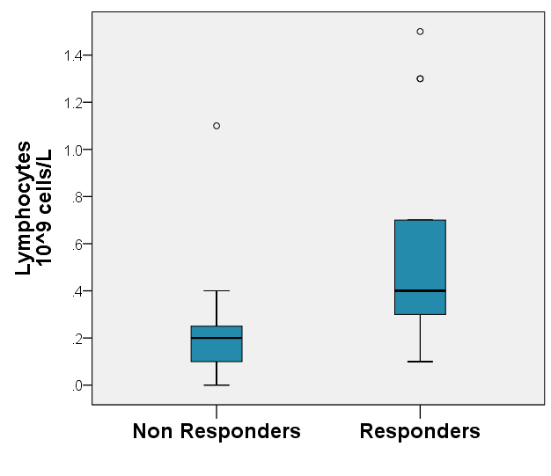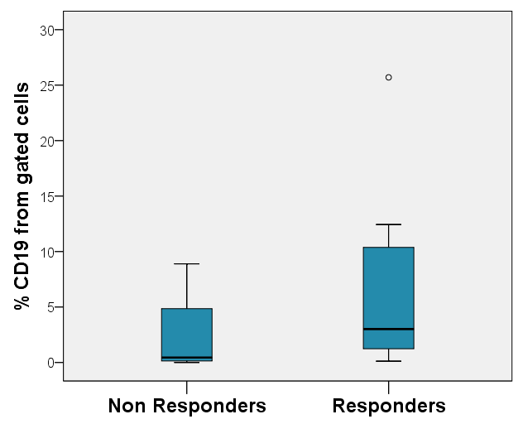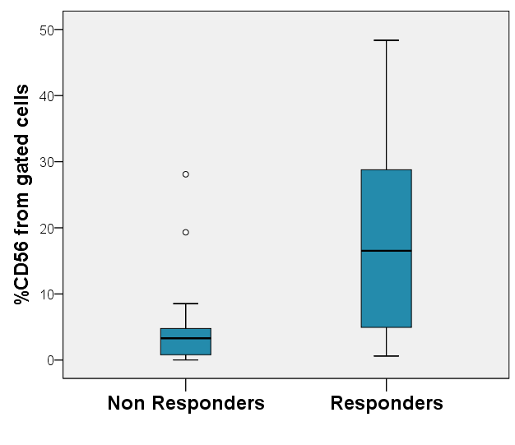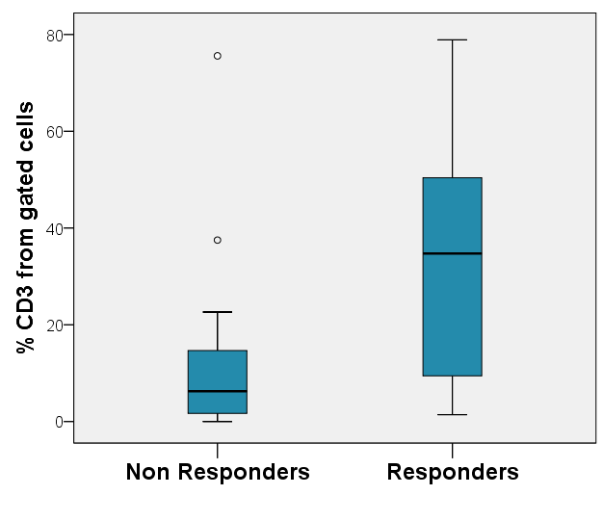

**b**

**b**

**c**

**d**

**c**

**a**

**d**

**Figure 2:** A high level of lymphocytes in peripheral blood prior to MSC administration among GvHD patients who responded to therapy. Blood samples were collected prior to therapy. The lymphocyte level was measured in the blood count. The difference between the groups is significant (P = 0.01) (**a**). Proportion of CD3 cells (P = 0.022) (**b**), proportion of CD19 cells (P = 0.64) (**c**) and proportion of CD56 cells (P = 0.01) (**d**) from the total white blood cell count as measured by flow cytometry.

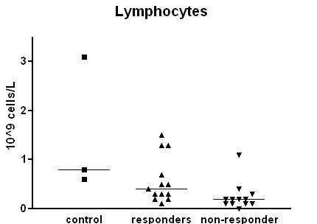

**Figure 3:** Levels of lymphocytes before MSC administration among responder patients, non-responder patients and bone marrow transplant recipients without GvHD (control group). Samples were collected from bone marrow transplant recipients suffering from GvHD prior to MSC administration and from three transplant recipients who did not suffer from GvHD, and were examined by blood count and differential count. Three-way comparison among the groups (P = 0.032).

**Increased lymphocyte level one month after MSC therapy in responder patients**

In order to examine whether the differences among the groups that were sampled prior to MSC therapy are also expressed by their response to the therapy itself, blood counts from the day of therapy were compared to blood counts conducted one week and one month after therapy. No difference was observed after a week, however when comparing lymphocyte levels prior to therapy with those obtained one month after therapy, a significant increase could be observed among responder patients (**Figure 4**). This increase reinforces the higher initial level of lymphocytes in this group. A similar increase among non-responders was not observed; however, we note that the sample size of non-responders one month after therapy was relatively small (four patients) due to early mortality of these patients.

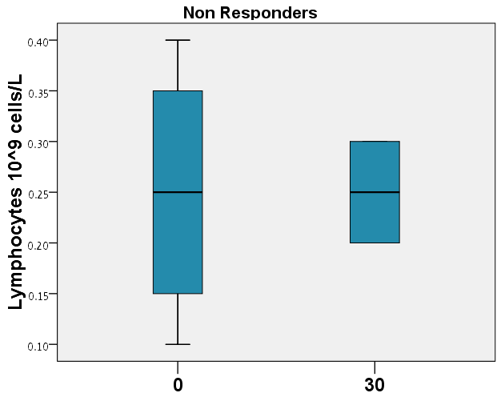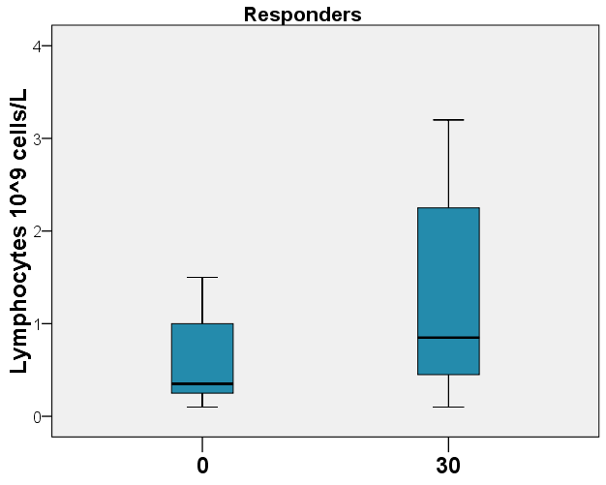

**Figure 4:** The change in lymphocyte level 30 days after MSC therapy. Samples were taken from GvHD patients prior to therapy and 30 days after therapy; blood count and differential count were examined. The change in responder patients appears on the right (p = 0.037) and among non-responder patients on the left (p = 0.74).

**Patients with a high platelet count prior to MSC therapy responded better to the therapy**

The level of platelets after allogeneic bone marrow transplant is a very sensitive measure of the activity of the hematopoietic system of the graft. In many transplant patients, platelet recovery is slow, and may be delayed by several months. In the measurement of platelet level prior to therapy, significantly higher platelet levels were observed among patients who responded to MSC therapy (**Figure 5**).

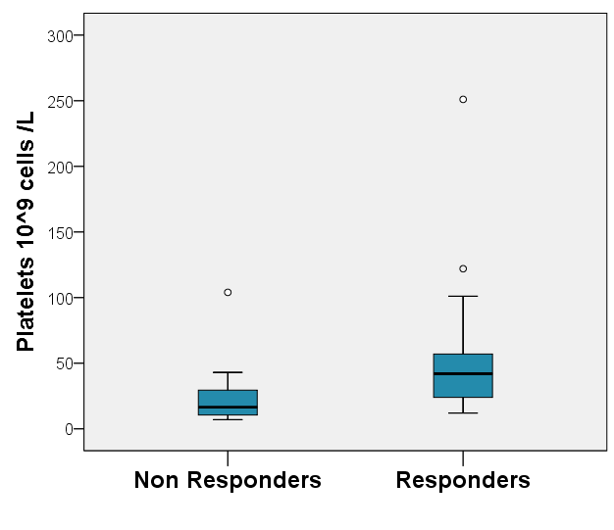

**Figure 5:** Platelet level prior to therapy in patients who responded to MSC therapy versus patients who did not respond (p = 0.01).

**Anti-inflammatory cytokine profile in serum of responder patients**

In addition to the change in the cell population, the level of cytokine expression in serum was measured before and after therapy. Prior to therapy, we observed a lower level of IL-6, a known pro-inflammatory cytokine, and IL-22, which is secreted mainly by Th17 cells, among responder patients (**Figure 6a**). One week after therapy, we measured higher levels of IL-10, a known anti-inflammatory cytokine that is secreted by Treg cells, and lower levels of IL-22, in the serum of responders compared to non-responders (**Figure 6b**). When comparing levels of IL-2, an important component of the inflammatory response, prior to therapy and one month after therapy, a significant decrease was observed among responder patients but not among non-responder patients (**Figure 6c**).

**Day 0**

**a**

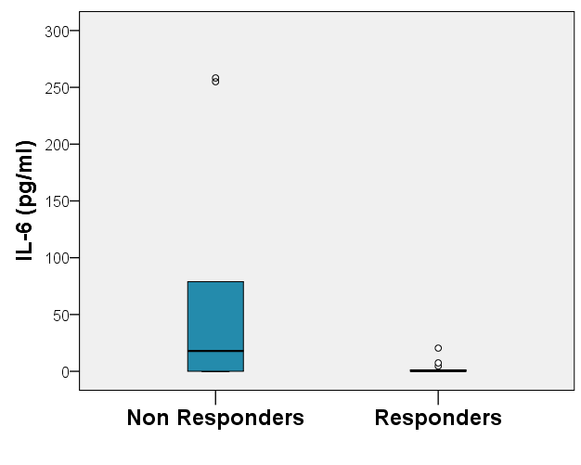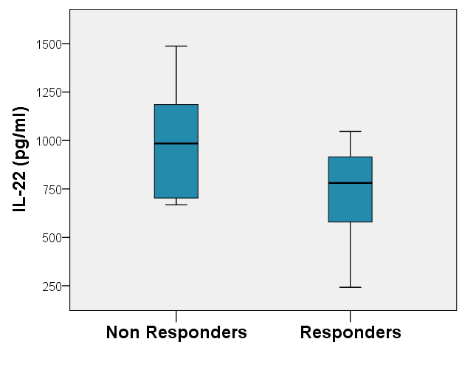

**Day 7**

**Day 30**

**Day 7**

**b**

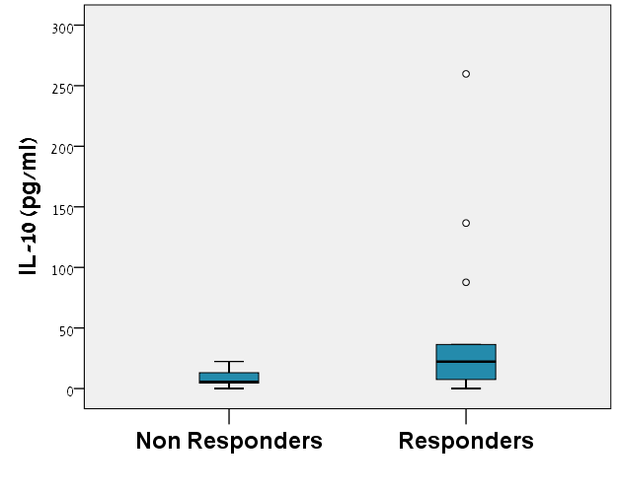

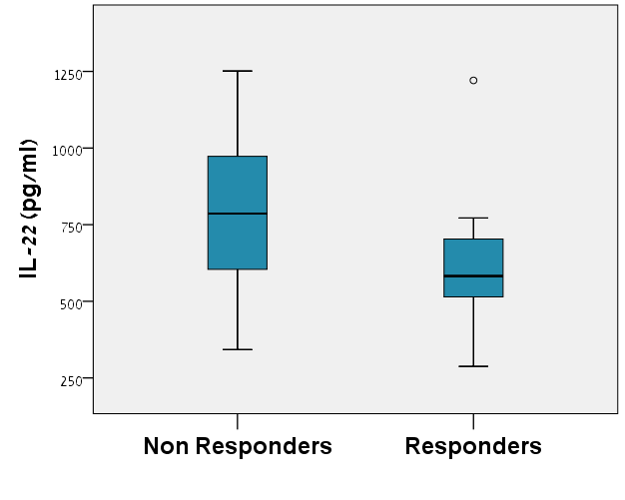

**c**

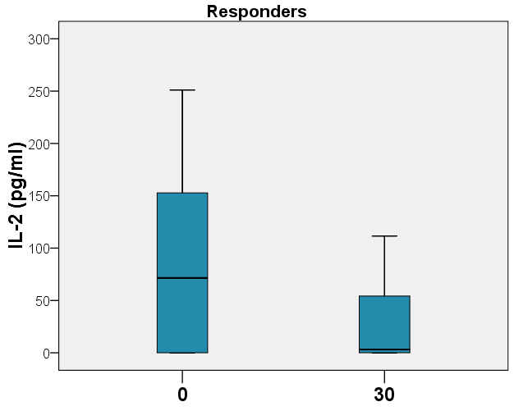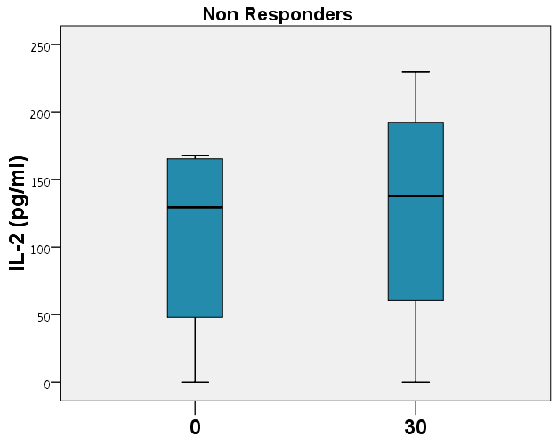

**Figure 6:** Cytokine profile of treated patients. Blood samples were collected prior to therapy, one week and one month after therapy. Samples were examined by cytokine array. Difference in levels of IL-6 (p = 0.03) and IL-22 (p = 0.026) among patient groups prior to therapy (**a**), difference in levels of IL-10 (p = 0.071) and IL-22 (p = 0.071) among patient groups one week after therapy (**b**). The change in IL-2 levels one month after cell therapy in responder patients (p = 0.04) and non-responder patients (p = 0.285) (**c**).

**High bilirubin levels prior to therapy in non-responder patients**

High levels of bilirubin in the blood of transplant patients point to GvHD activity in the liver. When measuring bilirubin levels prior to therapy, a higher level of bilirubin was found among non-responder patients (**Figure 7**). Subsequently, an increase in bilirubin levels was observed among non-responder patients approximately one week after therapy in comparison to the levels measured prior to therapy. This increase was not observed among responders (**Figure 7b**). A significant increase in bilirubin levels among responders was observed only one month after therapy. Among non-responders an increase in bilirubin was observed in the measurements conducted one month after therapy, however this was only marginally significant (p = 0.066), probably due to the small number of patients in this group that survived for a month after therapy (**Figure 7c**).

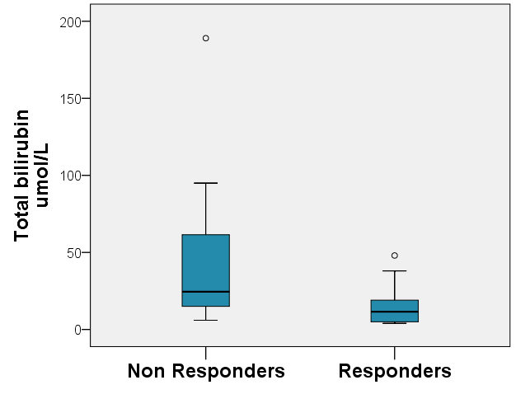

**a**

**Day 0**

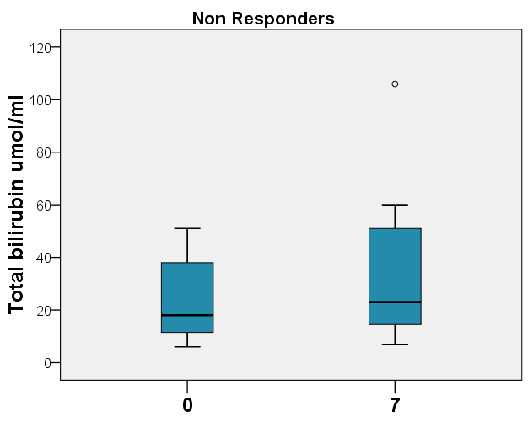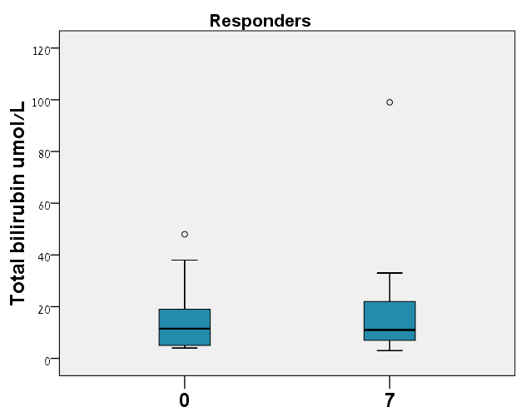

**b**

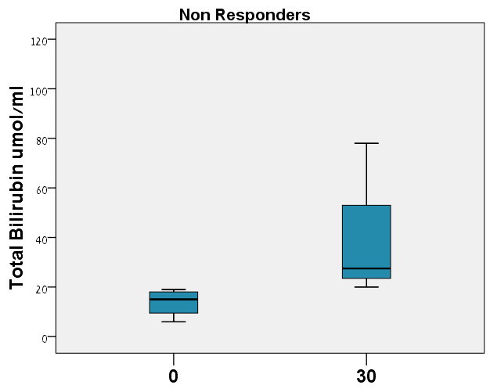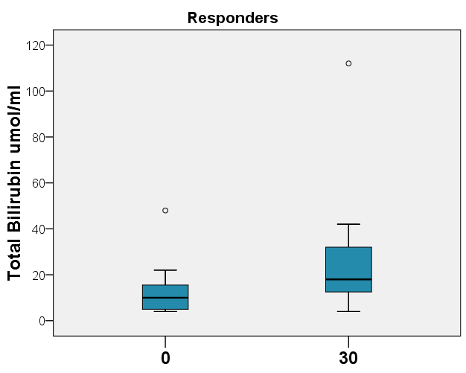

**c**

**Figure 7:** Bilirubin levels in treated patients. Blood samples were collected prior to therapy, one week and one month after therapy and blood bilirubin level was measured. Bilirubin levels prior to therapy in responder patients versus non-responder patients (**a**). Change in bilirubin level one week after therapy in non-responder patients on the left (p = 0.03) and in responder patients on the right (p = 0.798) (**b**). Change in bilirubin level one month after cell therapy in non-responder patients on the left (p = 0.066) and responder patients (p = 0.021) (**c**).

**Discussion**

MSC therapy is an innovative and promising approach to treating GvHD following allogeneic bone marrow transplant however recent studies in this field have presented mixed results. Since this is the situation, it is very important to improve the effectiveness of therapy, identify suitable patient populations and strengthen our understanding of the mechanism of action of MSCs.

This study examined immune, hematological and biochemical characteristics of GvHD patients who received MSC therapy. The different characteristics were compared between the populations of responder patients and non-responder patients, with the aim of finding characteristics that would enable better selection of patients for therapy as well as those that could provide a basis for better follow-up and monitoring of patients during therapy. Such a comparison could even contribute to our understanding of the biological mechanism by which MSC affect GvHD.

In the study we found that a high level of lymphocytes, in particular T (CD3) and NK (CD56) cells, may predict a good response to cell therapy. The increase in lymphocyte counts among responders was maintained even one month after therapy. High lymphocyte levels may indicate better recovery from the transplant and acceptance of the graft. We found a similar relationship for rehabilitation of the hematopoietic system in general, as expressed by the platelet levels among transplant patients. In addition, the fact that the two study patients who were transplanted with a graft originating in umbilical cord blood did not respond to therapy may arise from the known tendency of grafts of this origin for slower acceptance and rehabilitation.31

No significant difference was found among patient groups with respect to time since transplant; therefore, it seems that the responder group was characterized by better acceptance and recovery of the graft compared to the non-responder patients, independent of the time that elapsed since the transplant.

MSC require an inflammatory environment for their immunomodulatory action. Secretion of inflammatory cytokines by T and NK cells promotes the moderating action of MSCs on the immune system.32 In this light, it is possible that the increase in therapy effectiveness among patients with high T and NK lymphocytes may arise from better activation of the MSC cells in these patients. A recent study conducted in our laboratory33 as well as other studies34 demonstrated that preliminary treatment of MSC cells using inflammatory cytokines may eliminate the requirement for an inflammatory environment in the patient, and thus improve therapy effectiveness.

In patients without GvHD we observed higher lymphocyte levels than in GvHD patients. Although the lack of GvHD may be related to incomplete graft acceptance, GvHD may itself cause a decrease in blood counts as shown by Nash et al.,35 at least with respect to the recovery of platelet numbers. In other words, the development of GvHD is a two-edged sword that on one hand improves graft acceptance, and on the other hand may cause a decrease in blood counts. It is possible that the higher lymphocyte number within the control group in this study arises from better recovery from the transplant among non-GvHD patients, and is in line with the trend observed among therapy responders. We must account for the fact that since the control group comprised only three patients, a broader sample is required in order to confirm our conclusions on this issue.

Th17 cells contribute to the development of GvHD in both animal models and humans.36 In this study a better response to MSC therapy was observed among patients who expressed low levels of IL-6 and IL-22 prior to therapy. IL-6 is an important cytokine for the development of the Th17 immune response, when IL-22 is expressed by these cells.37 We may conclude that MSCs are more effective at treating GvHD characterized by low levels of the Th17 immune response. Accordingly, one week after therapy a lower level of IL-22 was still observed among responder patients, a fact that may indicate a lower level of Th17 cell activity, also as a response to the therapy. These results reinforce the results obtained from para-clinical trials that point to suppressed secretion of cytokines related to the Th17 response, including MSC-induced IL-22.

A number of studies have shown a relationship between MSC activity and the anti-inflammatory cytokine IL-10.22 In this study, higher levels of IL-10 were observed one week after therapy among responder patients. IL-10 is secreted by a number of cells in the immune system that cause suppression of the immune response, including Treg and Breg cells and regulatory dendritic cells,39 and it has an important role in the activity of MSCs.40 Another cytokine affected by MSC therapy is IL-2. Following therapy there was a decrease in IL-2 levels among responder patients. IL-2 at high levels acts as an inflammation-promoting cytokine; however, at low levels it is essential for the development of regulatory T cells.41 Together, these results strengthen the evidence for the contribution of Treg cells to the action of MSCs on GvHD.

A number of studies published in recent years examined the response of the immune system to MSC therapy. A study by Dander et al.42 demonstrated a decrease in Th1 and Th17 cells and an increase in Treg cells in responder patients. These results are in line with the results of the present study. We note that in the study by Dander no relationship was found between the level of IL-10 cytokines and response to therapy; however, this study included only 10 patients, and it is likely that due to the larger patient sample size in the current study, this difference could be detected and presented.

The study by Jitschin et al.43 examined immune characteristics of GvHD patients who received cell therapy in comparison with patients who received a placebo, however the distribution of clinical patient responses was not presented; therefore, no comparison was made between groups prior to therapy. Their study found a shift of the immune response in the direction of Th2 and a decrease in the proportion of Th17 cells. Their results with respect to Th17 cells are in line with the results presented in the present study. The relationship with the Th2 response completes the broad picture with respect to the immune response, probably by simultaneous suppression of the Th1 response. In their study, as in the study by Zhao et al.,44 an increase in the proportion of CD4 cells relative to CD8 cells was observed after therapy in comparison to patients who did not receive cell therapy, however in both of those cases no comparison was made with non-responding patients. It is interesting to note that in the study by Jitschin an increase in IL-2 was observed in patients receiving cell therapy. However, considering the fact that the increase was demonstrated in comparison with patients who did not receive cell therapy, it is possible that the treatment itself causes an increase in IL-2, however an extreme increase causes an inflammatory response characteristic of the non-responder patients, while a moderate increase contributes to differentiation of the cells to regulatory T cells that are linked to a positive response to therapy.

In the study by Jitschin a decrease in NK cells was observed 90 days after theray, while in the present study we saw that patients with a high level of NK cells responded better to therapy. However, in the current study, cell characteristics were not examined after a time period longer than one month, and it is possible that although NK cells are important for the initial activity of MSCs, at later stages, due to the activity of various types of regulatory cells, there is actually a decrease in the number of NK cells.

In a study that examined immune characteristics in patients with chronic GvHD who received MSC therapy, published by Peng et al.,45 an increase in IL-10-secreting regulatory B cells was demonstrated. These results are in line with the increase in IL-10 observed in the present study. Similarly, it is possible that they contribute to understanding the trend of better response to cell therapy among patients with higher levels of B cells prior to therapy as observed in the present study.

In addition to parameters related to the immune system, we found another characteristic that may contribute to predicting success of therapy. Although from a clinical point of view there was no difference in liver involvement in GvHD between responder patients and non-responder patients, patients with high levels of bilirubin prior to therapy showed a poorer response. Even after therapy, these patients were characterized by a more rapid increase in bilirubin levels. High levels of bilirubin in patients after bone marrow transplant may arise from GvHD in the liver, and it may be that the increase in bilirubin is a bad prognostic indicator for therapy response and an indication for development of liver disease even at the sub-clinical level. However, we must remember that an increase in bilirubin in patients following bone marrow transplant has a broad differential diagnosis, including side effects of the chemical treatment, viral hepatitis and SOS of the liver. In order to accurately identify the relationship between liver disease and the response to MSC therapy, there is a need for more comprehensive research including accurate characterization of the patients’ liver disease using additional means, such as serology, imaging and even biopsy.

While conducting this research, a study by Te Boome et al.29 was published; this study also examined biological indications that may predict a good response to MSC therapy in GvHD. We note that in their study, no relationship with the response to MSC therapy was demonstrated for the biological indicator ST2, which is known to be a bad prognosis predictor for GvHD.46 Their results hint that biological indicators have limited effectiveness for predicting the response to therapy; therefore, it makes sense to invest research efforts in identifying the cellular characteristics of the immune response of patients before and after therapy, as done in the present study. In their study, the relationship between T and B cell levels prior to MSC therapy and the response to therapy was not significant; however, they did not consider the total cytokine levels or those of NK. Likewise non-immune indicators such as bilirubin or platelet levels, as examined in the present study, were not examined in their study. Also, in their study, the sample size was small, and it is possible that the difference in results arises from the different sample sizes in the two studies; a larger study could strengthen the conclusions of both these studies.

The advantages of the research presented in the present study arise from the combination of clinical evaluation of laboratory variables and the use of a range of methods for evaluating the immune system (blood count, use of flow cytometry and cytokine evaluation) as well as the examination of a large number of different types of variables. Similarly, this study provides a broad picture of the response to therapy, by comparing patient characteristics before and during therapy. However, we must remember that due to the small number of patients and the infancy of research in this field, the present study examined a relatively heterogeneous patient population, including a number of patients with chronic GvHD. The control group was relatively small and it may have been possible to learn more about the response to cell therapy by comparing the responder patients to a larger group of transplant patients without GvHD. Similarly, a large number of non-responder patients unfortunately did not survive until the end of the follow-up period, and as a result it was more difficult to compare the responses of the two treatment groups over time.

The conclusions of the present study may provide a basis for the use of lymphocyte counts as a possible tool for selecting patients to receive MSC therapy for GvHD. With respect to the higher platelet levels among responder patients, this change may be related to recovery of the hematopoietic system from the transplant. Therefore, we may consider evaluation of recovery and graft acceptance as a condition for cell therapy. Similarly, this study demonstrates the importance of monitoring the Th17 immune response in patients before and during therapy. We saw that high activity of these cells may harm the response to therapy, and also that the therapy itself affect the cytokines that are linked to this response. It may be possible in the future to characterize different populations of GvHD patients by the mixed immune response and to determine treatment accordingly.

This study demonstrated, for the first time, the relationship between bilirubin levels and the response to MSC therapy, a finding that may act as a starting point for additional studies to improve our understanding of the effect of MSC therapy on GvHD in different systems, and be used as a tool for monitoring patient responses to therapy.

An improvement in treatment of steroid-resistant GvHD is an essential requirement for reducing mortality rates following allogeneic bone marrow transplants as much as possible. MSC therapy is one of the promising tools for dealing with this severe disease, however this treatment entails high costs and low availability; therefore, correct selection of patients and intelligent use of cells are of paramount importance. Similarly, the timing of therapy relative to the appearance of the disease and the optimum number of treatment doses are not known, thus additional research is required to improve the quality of the cells and their preparation for inducing a regulatory effect on the immune system. The results of this study may facilitate early identification of responder patients and non-responder patients and development of research tools for evaluating cell activity and improving their action.