Surface Acoustic Wave Mitigation of Precipitate Deposition on Solid Surfaces

Yifan Li

Abstract

The evaporation of a solvent containing a nonvolatile solute leaves a solid deposit on a surface after the liquid recedes. One of the best examples of this is the ring-like coffee stains left after coffee dries. This deposition phenomenon is universal, but it is challenging to study thoroughly, as it relates to the fluid mechanics of liquid and gas, the surface tension of the phase boundary, a phase change from a liquid to gas, and the precipitation of a solute. It plays a crucial role in different fields, such as a self-assembly mico-structure, ink printing, and membrane formation. There are different approaches to manipulating deposition because of its importance, and the introduction of acoustic energy is one of the best candidates.
We demonstrate the application of a 20-MHz surface acoustic wave (SAW) to mitigate and finally eliminate the deposition on a surface supporting the wave by redirecting the deposition of precipitating mass onto a nearby surface. In our experiment, we confine a solution of polymethylmethacrylate (PMMA) polymer and a volatile toluene solvent between two substrates. We use the surface of the acoustic actuator and hydrophobic coated glass, together with a U-shaped thin polymer film, and form a micro-chamber to hold the solution. We design and create a resin stage to fix the micro-chamber and support the power for the SAW via the electrons inside the stage. We transfer the high-frequency current generated by the signal generator to an amplifier and provide it to the acoustic actuator to introduce a SAW into the micro-chamber.
In the absence of a SAW, most of the polymer deposits on the underlying substrate after the evaporation. The application of a propagating SAW in the substrate supporting the acoustic wave mitigates the deposition of the polymer on its surface. Instead, the polymer precipitate deposits on the upper inert substrate. Above a certain SAW power threshold, the polymer deposits solely on the upper substrate, avoiding polymer deposition on the underlying surface.

In order to show our results quantitatively, we employ two different methods to process the data. First, we investigate the images of a surface taken by a light microscope by calculating the polymer coverage ratio. We transfer the original image into a binary map with the help of Otsu’s method and calculate the ratio between black and white. To do so, we built a MATLAB code, which takes images of the surface and returns the corresponding polymer coverage.
Second, we study the effect of a SAW on polymer patterns by analyzing the data collected with the profilometer. We convert the data into the frequency domain using a fast Fourier transfer and fit it with the Boltzmann distribution function using the least-square method to find the most crucial pattern frequencies (that is, the largest distance between parallel stripes). Our self-built MATLAB code does this as well: it takes a two by n matrix of microtopographic data and returns the dimensionless best-fitting parameters with the function.

Chapter 1

Introduction

The drying of solution or colloidal suspension containing non-volatile solutes is a widely studied phenomenon related to many applications. The solutes left can be either prob- lematic for us or functional. So people kept trying to understand and control phenom- ena of this kind. People have two different attempts about the deposition in different situations: Controlling deposition formation into an organized structure. For example, there are studies on fabrication producing data storage media [30], sensor [7, 37], or other complex and functional nano/microstructure [36, 34]; On the other hand, we need the prevention of deposition in other fields of application, and this is the primary goal of our investigation.
Our work is triggered by the fact that many types of equipment employing liquid inside often suffer from precipitation. It is common for equipment to have pipes for flow, surface contacting with storage liquid, even reactors for chemical reactions. One common example is domestic furniture with function of heating liquid such as water heaters, dishwashers, coffee machines. Such equipment often meets the problem of the accumulation of minerals on the surface that meets the liquid. Some industry-based unit operations associate with patterning surfaces via participation in an organic solvent like in fabrication or photolithography [31, 9]. In this case, people want to remove the deposition on a certain place. Even the piping system that provides us water every day suffers from the problem caused by mineral accumulation, such as the ’red water’ effect. [19]

Two approaches people are trying to get rid of deposition we mentioned above: removing or preventing. We use chemical softeners or ion exchanges agent to remove precipitate on the surface. The other option is to prevent deposition by modifying the surface into a less favorable surface. The former solution requires regular maintenance of equipment. The most common example of this is cleaning our domestic water heaters with acid or other agents. Preventing deposition is another good option with some drawbacks - we will introduce this kind of self-clean surface modification method in the following subsection.

1.1 Self-cleaning surfaces

A self-cleaning surface is made of a class of materials with the inherent ability to remove any debris or bacteria from their surfaces in various ways. The most common one for us is passive self-cleaning surfaces such as some leaves in nature that keep dry in the rain by repelling the attachment of droplets. The studies of them concentrated on superhydrophobic surface properties [38]. People made superhydrophobic surfaces with rough surface morphology and low-surface-energy coatings, supporting the Casi-Baxter wetting state.
In such kind of surface, the contact angle hysteresis is approximately proportional to mechanical resistance to the motion of a drop along a surface [10]. The dirt/liquid removal mechanism can be explained as follows: When the surface’s tilt with respect to the horizon renders the roll of drops, the liquid collects particulates and dirt in their path. However, this fine surface roughness can be harmed by mechanical impact and abrasive elements. Moreover, should a drop attain the more thermodynamically stable Wenzel wetting state, where the drop attaches directly to the rough solid, the drop will stick to the solid at greater adhesion energy than it will to a flat surface of the same chemistry. Those two drawbacks make us consider other options for the self-cleaning surface.
Here we investigate active mechanical stimuli to have similar properties of self- cleaning on flat surfaces. Several studies [20, 11, 21, 35] considered the active stimuli to increase the three-phase contact angle hence introduce cleaning properties. There

are studies of the active mitigation of contact angle hysteresis by oscillating external force [25]: A simple explanation for this mechanism is the reduction of the effective friction between two vibrating solids. SAWs are one of the best candidates for such a kind of application of mechanical vibration. Similarly, microfluid is currently using SAWs as the power to generate flow inside some small device. [32, 26, 5, 6, 28] We will give a detail explanation in the section later.

2.1 ’Coffee ring effect’ and suppression it

At the beginning of the introduction, we mentioned the process of the drying of solution or suspension containing non-volatile solutes. One of the common phenomena is the pinning and moving of contact lines during evaporation. These two motions cause some orderly pattern. If the geometry of evaporating solution is a sessile droplet, ring-like residues may be found, which is called coffee-ring. About 25 years ago, the heated discussion of the ’coffee ring’ effect was triggered and studied carefully. [13, 8, 15, 1, 3] The complexity of this phenomenon laid on the different flow due to different reasons: high evaporation flux near the edge [13], pining of contact line due to hysteresis, Marangoni effect lead by the heat change of evaporation [18] and much other reason that we are not able to cover totally.
As a result of the ubiquitous effect, we are hard to avoid the ’coffee ring’ effect, but there are many different manners that were found to suppress it with the help of knowledge people found. Those applications include the manipulation in different aspects [23]:
- Change the contact angle hysteresis by modifying the surface into hydrophobic and changing the pinning situation. It causes a smooth receding of the contact line and removes the coffee ring effect.
- Manipulate the flow inside the liquid to control the evaporation and deposition pro- cess.
- Control the particle movement directly or change the interaction between particles and liquid.
Some methods may be related to more than one of the mentioned factors, like the SAW we are using, which can change contact angle hysteresis and introduce flow simultane-

ously.

Why SAW at 20MHz

There may be concern about the necessity and advantage of SAW in the application mentioned above. We may show the advantage of it in the following aspects: Economical/Highly accessible device: The price and related industry of the SAW device is cheap and highly available now and in the future. The application of SAW devices in wireless communications is widespread with the rapid growth of smart devices.[16, 33] The ability to receive and sending a signal or communicating with the Internet or other device is available with the help of different kinds of SAW filters. As a result of its extensive use, the production line is sufficient and mature. [22] And because currently there is no alternative for the usage of SAW technologies in a mobile device, we can safely expect a highly stable and inexpensive supply in this decade. [33]
High energy efficiency in transferring process: When compared with current other technologies manipulating liquid/particle in the liquid on a small scale, SAW have a large advantage in transferring energy directional. Most of the SAW energy will be transferred to the destination via the surface of the substrate without affecting nearby components. [16]
Energy efficiency for microfluid: Because of the low Reynolds in the microfluid field, the introduction of fast fluidic actuation or large forces on particles in a liquid is much harder.[16] As the property of high-frequency SAW, the small wavelength of SAW help the introduction of energy into such a small microfluid system. [17]
The advantages above trigger the thought to utilize high-frequency SAW to apply microfluid devices or another device. It may be possible to control the liquid/particle inside or outside of the system, such as preventing the coagulation of particles on some delicate surface, driving flow to microreactor, even controlling flow in a gravity-free environment, with the help of high-frequency SAW. As stated in the previous section, our research was conducted in order to control the deposition with high-frequency SAWs.

4.1 Objective and goal of research

We start this research with the goal of the manipulation of polymer deposition via application of SAW base on the following few reasons: Firstly, it is reported that the effect of SAW suppresses the formation of deposition of dye solution and changes the regularity of pattern strips[27]. We are interested in the effect of it on larger size polymer. At the same time, as the information in the last section, there are lots of advantages to applying high-frequency SAW in devices.
So the first and significant goal for us is to prepare a well-defined system for re- producible results and better analysis. After enough experiments around appropriate conditions, we will investigate and explain the experimental result with the help of the different tools. We will have a better understanding of the effect of SAW on the deposition of the polymer during evaporation in a confined micro-chamber.

Chapter 2

Experimental Methods

1.2 Experimental System set-up

We build up our micro-chamber in figure 1.2a and 1.2b from a glass cover, an underlying substrate that may support SAWs, and a thin layer of a spacer. The glass cover is ren- dered high surface energy (hydrophobic) by a coating of fluorine-doped tin oxide (TISX 001, Techinstro). The underlying substrate is an acoustic actuator, which is comprised of 5 nm titanium / 1µm aluminum interdigitated electrodes (IDT), patterned using a standard lift-off photolithography atop a 5.0 mm thick, 128◦ Y-cut, X-propagating, single-crystal lithium niobate (LiNbO3) piezoelectric substrate. The two surfaces are separated by a 75 µm thickness gap using polyimide (Kapton, DuPont) ‘U’ shaped spacer.
The resulting micro-chamber is open on one side, and the opening is towards the source of the propagating SAW on the acoustic actuator (the comb-like electrodes). To confine the acoustic actuator and connect the latter to power, we design and 3D-print an elastomeric stage (shown in figure 1.2c). Using pogo pins (BC201403AD, Interconnect Devices, INC.), we connected the electrodes on the actuator to a signal generator (R&S SMB100A microwave signal generator) and an amplifier (Model A10150, Tabor Electronics Ltd.) via cable. We generate the SAW by imposing continuous sinusoidal voltage with different strength levels to the IDT with a fixed frequency of 20 MHz. The integrated system with the power supply can be found in the following figure 2.2.

The micro-chamber and heater is placed inside of fume hood because of the hazard of organic solvent we are using.
Using a scanning laser Doppler vibrometer (MSA-500, Polytech), we measured the corresponding average displacement amplitude (particle displacement of the SAW) over a surface area of approximately 1 × 1 mm2 near the electrodes. After the measurement, we can represent the strength of SAW applied to the system by average displacement amplitude. Moreover, we verified that the SAW in our system is a propagating wave. The displacement may be translated to a corresponding normal surface particle velocity by multiplying the given displacement amplitudes by 2π × 20 MHz.

2.2 Procedure of experiment

At the beginning of our experiments, we injected a solution of PMMA (Average Mw 350,000 Da by GPC, 9011-14-7, Sigma-Aldrich) and toluene (AR-b, ,7%.99 108-88-3, Bio-Lab Ltd.) into the chamber through its open side. We employed a solution concen- tration of 10g/ml, which gives consistent patterns [4] for the same physical parameters. We set the ambient temperature and relative humidity in the laboratory at approxi- mately 20◦C and 50% using a dedicated air conditioning system. We further employed a hot plate (DBD-001, MRC Ltd-Laboratory Equipment) to maintain our experimental system at a temperature of 35◦ ± 1◦C. We measured the temperature using an infrared thermometer (RAYMT4U, Raytek) near the opening of the microchamber before and after the experiment. Before every experiment, we firstly employed toluene to rinse the different parts of the disassembled system. Then the pieces were fully submerged in toluene in an ultrasonic cleaner (AC-200H, MRC Ltd-Laboratory Equipment).
Next, we rinsed every part for 30 seconds by 5 different solvents in the following order: toluene (AR-b, ,7%.99 108-88-3, Bio-Lab Ltd.), acetone (AR-b, ,8%.99 67-64-1, Bio-Lab Ltd.), 2-propanol (AR-b, ,8%.99 67-63-0, Bio-Lab Ltd.), ethanol (CP-p, 96%, 64-17-5, Bio-Lab Ltd.), and water (HPLC plus,7732-18-5, Sigma-Aldrich). Finally, we dried the different parts using airflow.
Before measurement, we assembled the system in the manner given in figure 1.2,
2.2. Every test started by checking the evaporation process to assess the integrity of the

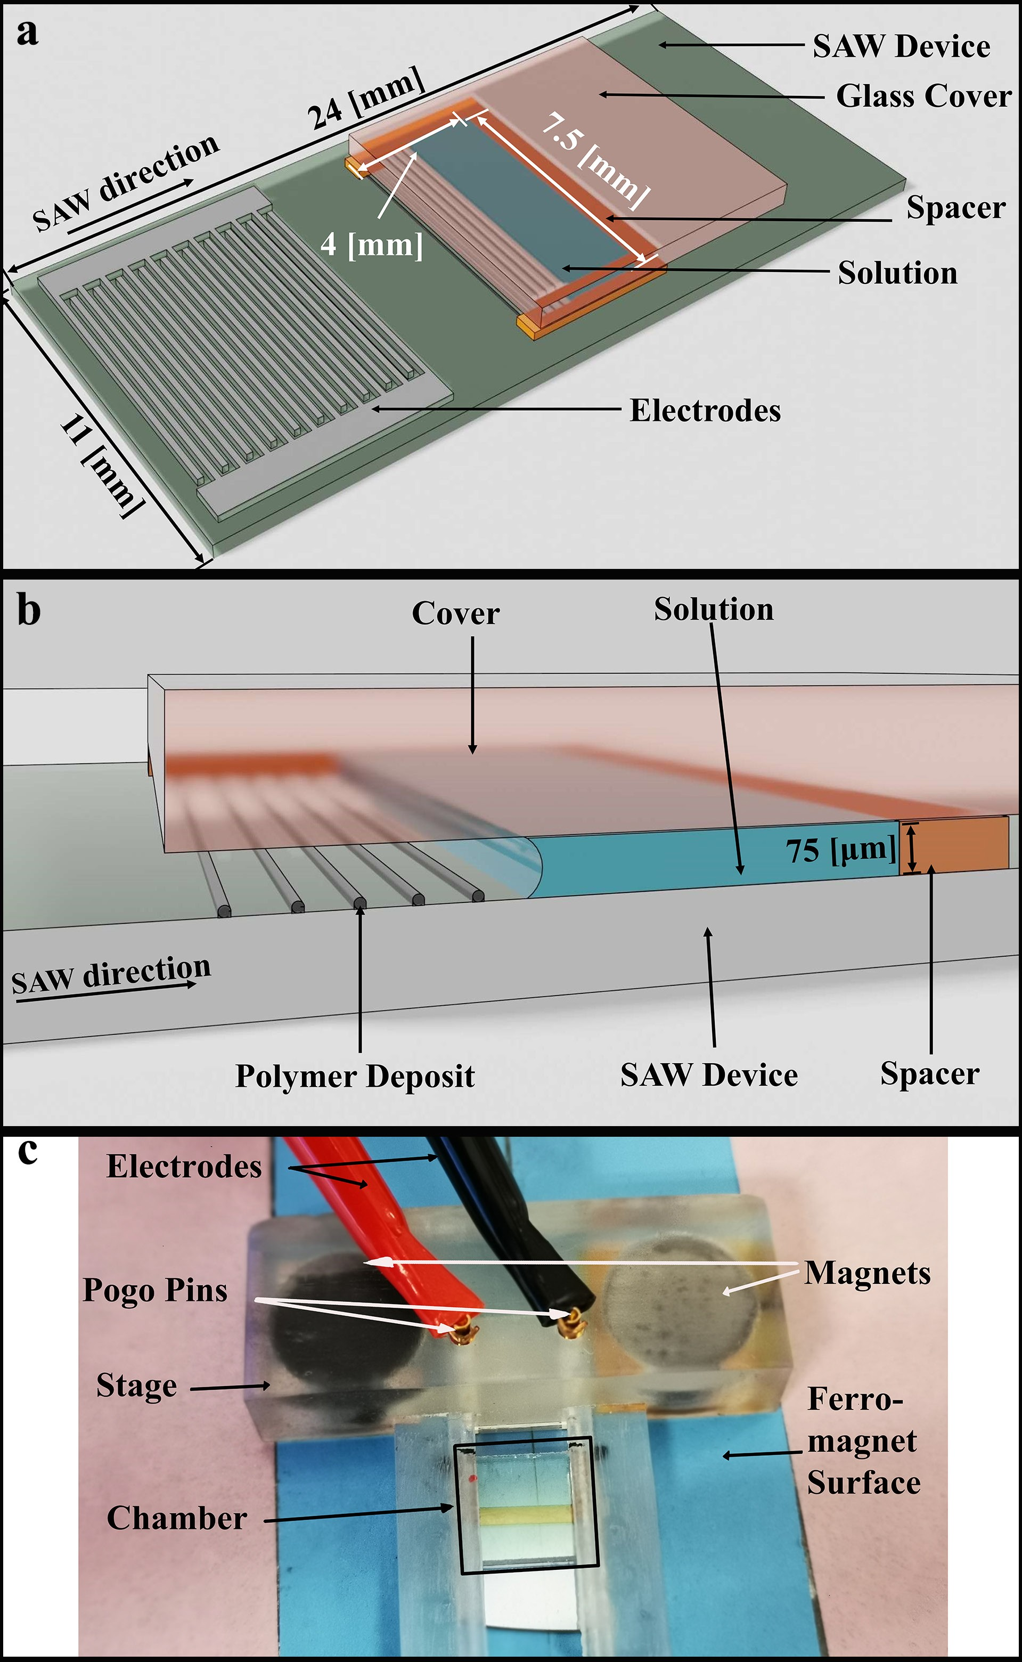

Figure :1.2 (a) An upper and (b) side views of an illustration of a micro-chamber, which is fabricated atop an acoustic actuator (a SAW device) and contains a volatile PMMA/toluene solution, where the evaporation of the latter leaves patterned deposits of PMMA in the chamber, and (c) an image portraying a view from above of the inte- grated microfluidic platform (chamber + actuator + power connection) on a dedicated stage.

system.pdf system.bb
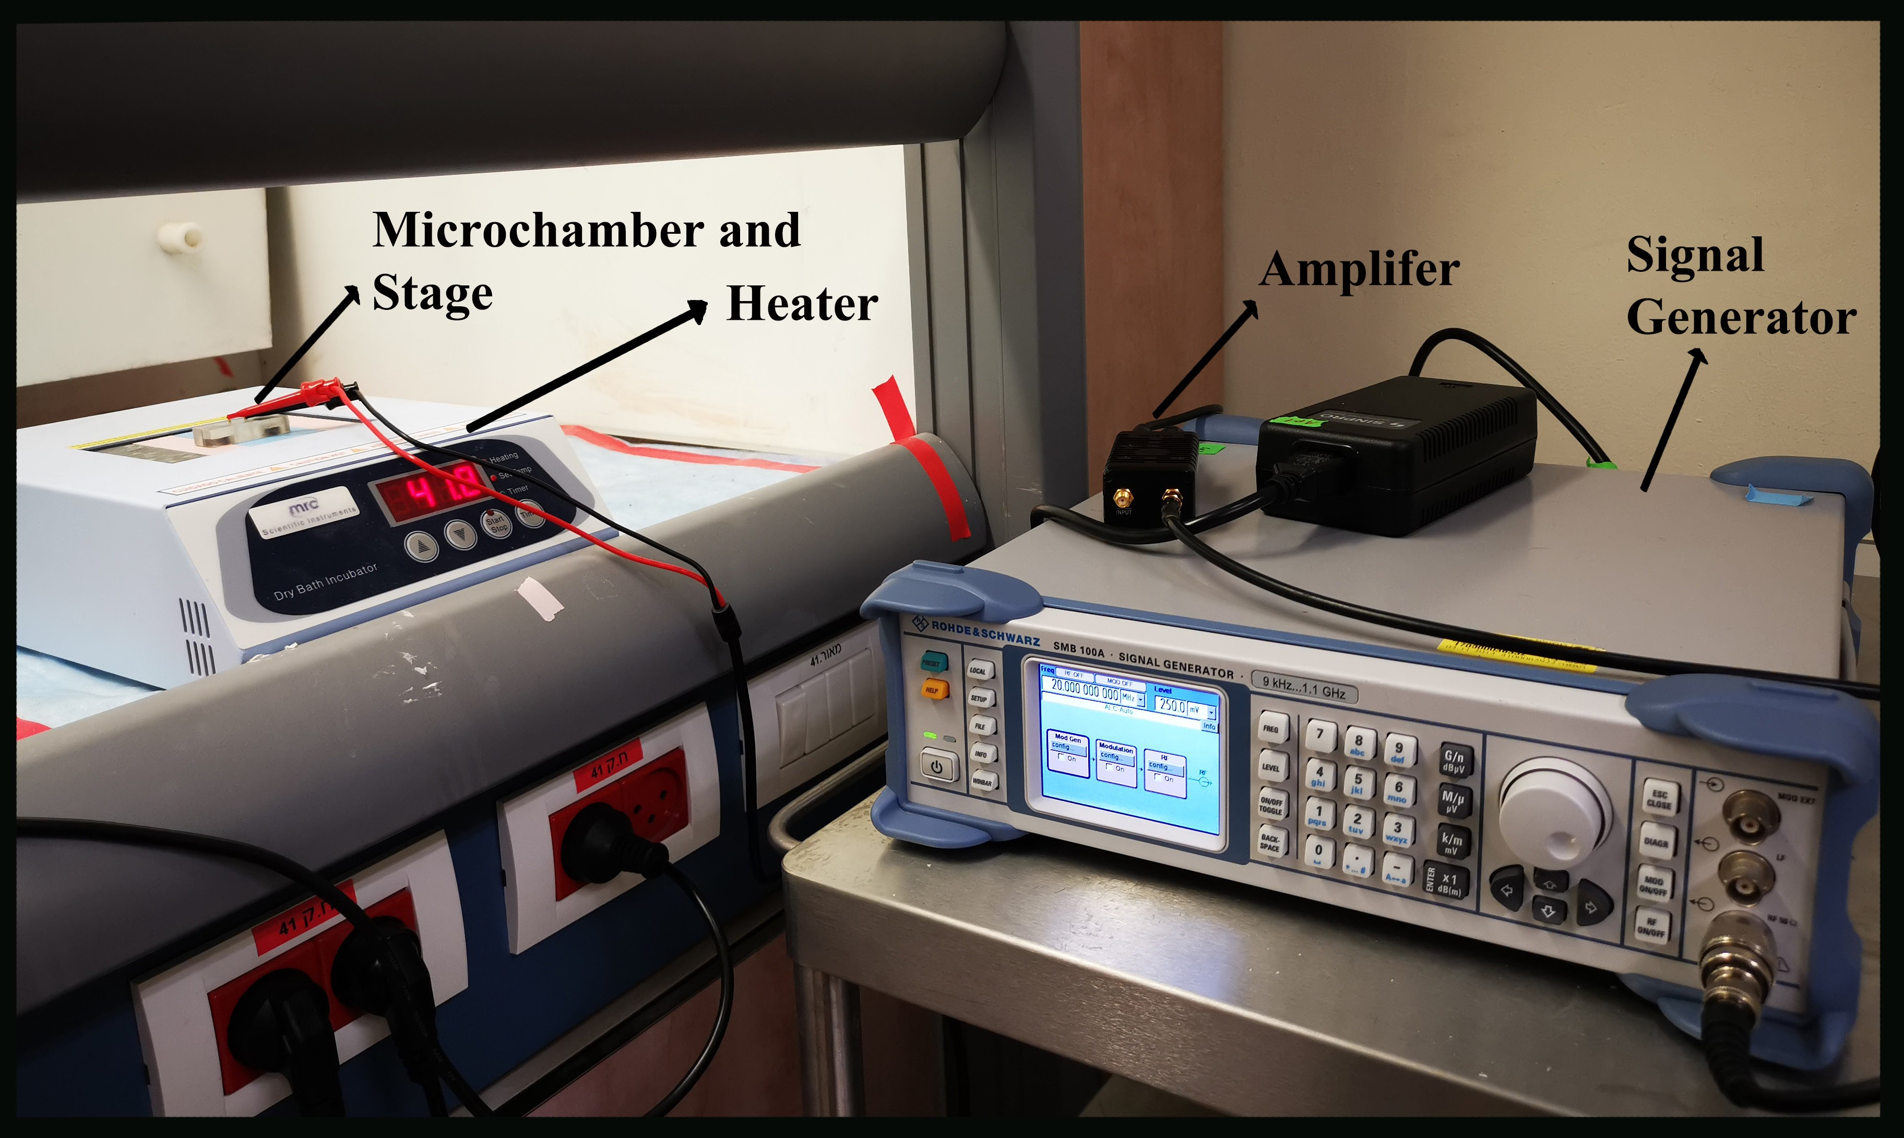
Figure :2.2 The experimental system with the power supply. Following parts listed in order from left to right: Micochamber and stage ontop of heater and connecting with cable; Heater holding the chamber; Amplifier enlarging the current generated by signal generator; Signal generator generating 20MHz current to support the SAW actuator

microchamber. We injected 10µl of pure toluene into the micro-chamber and observed the motion of the meniscus of the volatile liquid. We further verified the presence of SAW before each experiment by positing a single drop of toluene atop the acoustic actuator and monitor the displacement of the drop under SAW excitation. Following these assessments, we let the SAW microfluidic platform rest for 20 minutes before the actual experiments to ensure the full evaporation of the pure toluene.
We kept the conditions the same during each measurement, except for the voltage applied from the signal generator. In our experiments, we firstly generated SAW by turning on the power supply; then, we injected the micro-chamber with 10µl PMMA- toluene solution rendering the micro-chamber devoid of bubbles. The evaporation of toluene lasted for several minutes during the measurement. As a precaution, we arrested the generation of SAW and disassembled the platform after 25 minutes.
Following disassembling the platforms, we measured the two surfaces in question (upper cover and underlying substrate) using light microscopy (Eclipse Ni-E, Nikon) and a profilometer (Dektak, Bruker). Overall, we employed nine different unique power levels of SAW in our experiments. For each unique level, we performed at least three

repeated experiments to assess the consistency of the results.

We analyzed the experimental data using a conceptional ‘observation window’ at the area of 1mm×1mm in the middle of the microchamber, 1mm and 2 mm from the rear and front (open) sides of the chamber, respectively, to avoid possible side effects.

3.2 Decision for experimental parameters

Before our experiment, there are the previous experiments by Mohammad [3, 1]. They found the motion regimes of this kind of polymer-organic solvent deposition in micro- chamber (not in the same size as ours) are highly related to different parameters such as temperature, particle size, the concentration of polymer solution. The motion regimes are [1] strongly related to the final deposition pattern of the experiment. We do not care much about the type of deposition in our experiments. At the beginning of this study, our main purpose was to find the effect of SAWs on the deposition. Obviously, it is good to have a clear and continuous stripes pattern because it will be easier to analyze patterns with more regularity.
To find the best conditions for us, we employed experiment conditions that they used to generate clear and continuous stripe patterns. (Mw = 350 000 Da, T = 25 ◦± 1◦C,C = 3 mg/mL) We changed the condition in our experiment. Those parameters can be found in the previous section. The principle for those changes is to find the condition that generates repeatable clear stripes pattern, and it also will be explained in the following subsection.

4.2 Improvement of experiment

At the beginning of our test, we choose the conditions that can generate clear and continuous stripes patterns like the 3.2a shown. The two major changes between the previous experiment and ours are the size and types of the substrate surface. We re- duced the size of the microchamber for the SAW device, and the substrate surface where the deposit is left changes into the SAW device also. By repeating a similar

experiment, we corrected the conditions in our equipment. Employing the new con- ditions, we can generate similar clear and continuous stripes patterns in our setting. Though good results could be approached in such a case, there are some problems in that experiment setting. The pattern with parallel strips is not generated consistently, just like 3.2b.
During the experiment, the three-phase contact line recedes inward the micro- chamber as the evaporation of the solvent. However, any minor difference in the height/force combining the system makes the contact line distributed not parallel. Here are two sets of images 4.2 showing the situation of contact line parallel to the upper edge of spacer or not. The pattern formation will not be ideal like 3.2b when the contact line is not parallel to the upper edge of the spacer. This parallel pattern is problematic because it is one of the most common reasons for failure in our experiments at the beginning stage of research.
We try different approaches before the final set up. Firstly, three parts forming the micro-chamber: spacer, glass cover and substrate are combined via common transparent adhesive tape. Underlaying substrate, thin spacer and glass cover position at place one by one manually. And then we twine the tape around the chamber to connect them. However, because the size of our micro-chamber is reduced, this experiment is hard to handle. We believe we may find the result as figure 4.2 (A-D), when force is applied on the glass cover unevenly. This nonparallel stripes not appreciated for analysis later.
Then another piece of advice came up. The alternative option to tape is a stage above to fix the microchamber at the place. The following stage in 5.2 was 3D printed and applied to the system. The overall structure of the stage is a capital ‘H’ with a hollow in the middle for observation. We use the bridge of the hollow part to fix the glass cover firmly above the spacer and substrate. We also twine white paper tape around the hollow to make sure the height of the arch is appropriate to press the chamber. The wire is glued and connect to the lower pogo pins of the stage to provide the power of the acoustic actuator. On the other side of the stage, four magnets are glued in a reserved place to fix the stage. Two gold pogo pins is place in the middle of stage. It will connect with the electron on the substrate and supply enough power to generate SAW on the surface. A magnetic metal surface is placed under the substrate

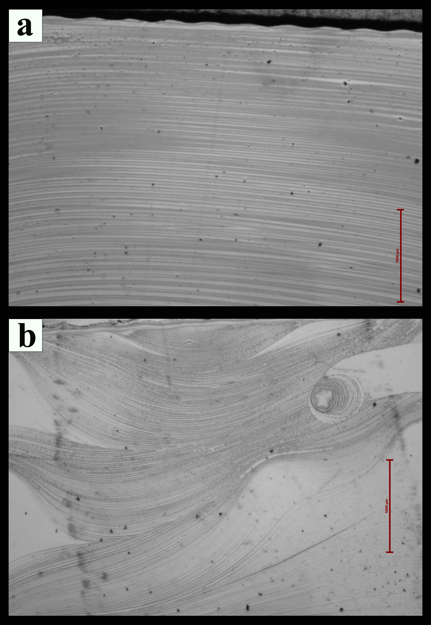

Figure :3.2 Microscope image of polymer pattern after solvent evaporated(a) The pat- tern of the polymer deposit is regular parallel strips (b) Random pattern generate in same equipment due to uneven force applied during the evaporation

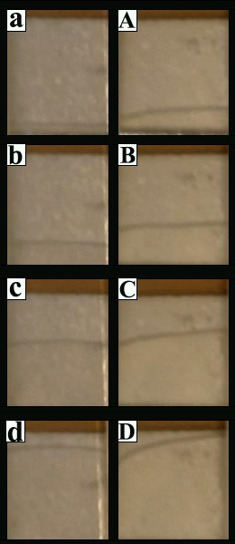

Figure :4.2 Two arrays of images showing contact line movement during the evaporation process, where (a-d),(A-D) come from the same experiment in a different time frame: (a-d) The contact line recedes with the evaporation of solvent; the line keeps a parallel during the evaporation. (A-D) The contact line recedes with evaporation while the curvature also increase during this process

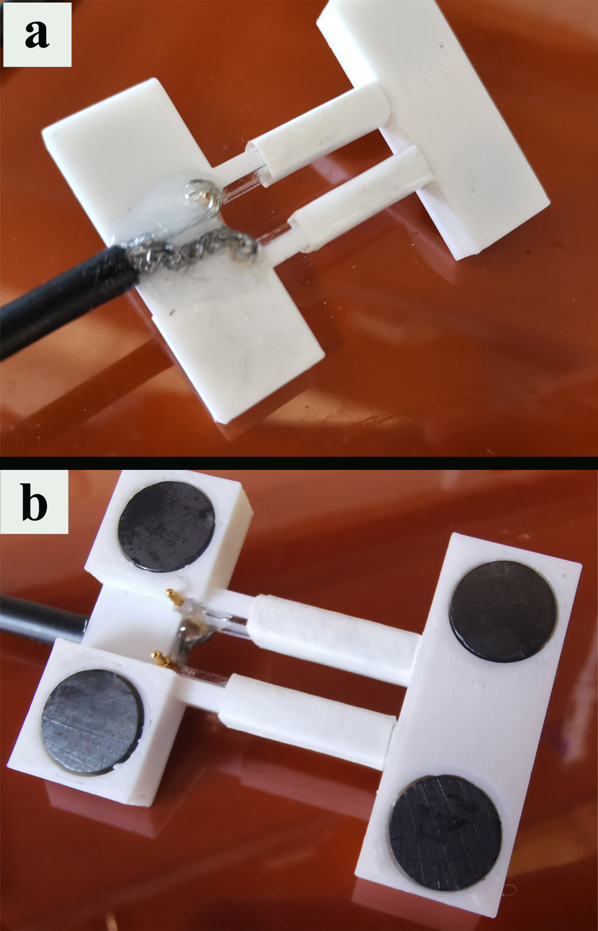

Figure :5.2 Top view and back view of the first stage in the experiment (a)Top view of the 3D printed stage with shape of capital ’H’ with a hollow in the middle, one side of it is connected with the dark wire to supply power to SAW device. (b) Bottom view of the stage. Four magnets are fixed in the four corners of the stage. The golden Pogo pins connecting with the wire and attach the IDT(Interdigital transducer) when the system is built. White paper tape changes the high of the bridge in the middle to maintain an appropriate force to the glass cover.

to ensure the force placed on the chamber is uniform during the experiment. In the experiment, we build the same microchamber manually above the metal plate and place the stage above it.
We have a better successful rate, but it is not good enough for repeat experiments; more than half of the deposit stripes after the experiment are not parallel. We believe the positioning of the microchamber causes the undesired geometry of the chamber. In the current cases, the aligning of the microchamber is done manually. We then design the stage that can automatically align every part to remove such uncertainty led by the human factor.
In the 6.2 we can find the image of this stage, the major change of it is the design of ladder-like part. There are three levels of ladder in the hollow part. The width of the corresponding ladder is designed for the width of substrate and glass cover respectively. The micro-chamber will be inlaid in the stage perfectly after we build up the integrated system. And the pogo pin spring end shrinks and contact with the IDT of SAW device to make sure the best connection. We remove the human factor (Including the positioning of micro-chamber and electronic connection) out the experiment in this way in our maximum extent. After this improvement, we are able to generate highly reliable result in a stable way.

5.2 Image analysis of light microscopy

Two images from the microscope were used for analysis for every single experiment, focusing on the center of the two surfaces in question. (cover and substrate) ImageJ calculated the ratio between pixels and length. We calculate the coverage of polymer in figure 2.3 by a self-written code in MATLAB A. The algorithm for it is described as follow:
Firstly we rotated the image at an angle range of −10◦ to 10◦. We calculate the average gray value of each row of every rotated image and store it in an array. (Gray value represents the brightness of the image). Totally we collect 21 arrays representing 21 different angles. Notably, for the default image, we receive an array with the size of
.310 And if the image is rotated, the size decreases because of the shrinkage of rotation.

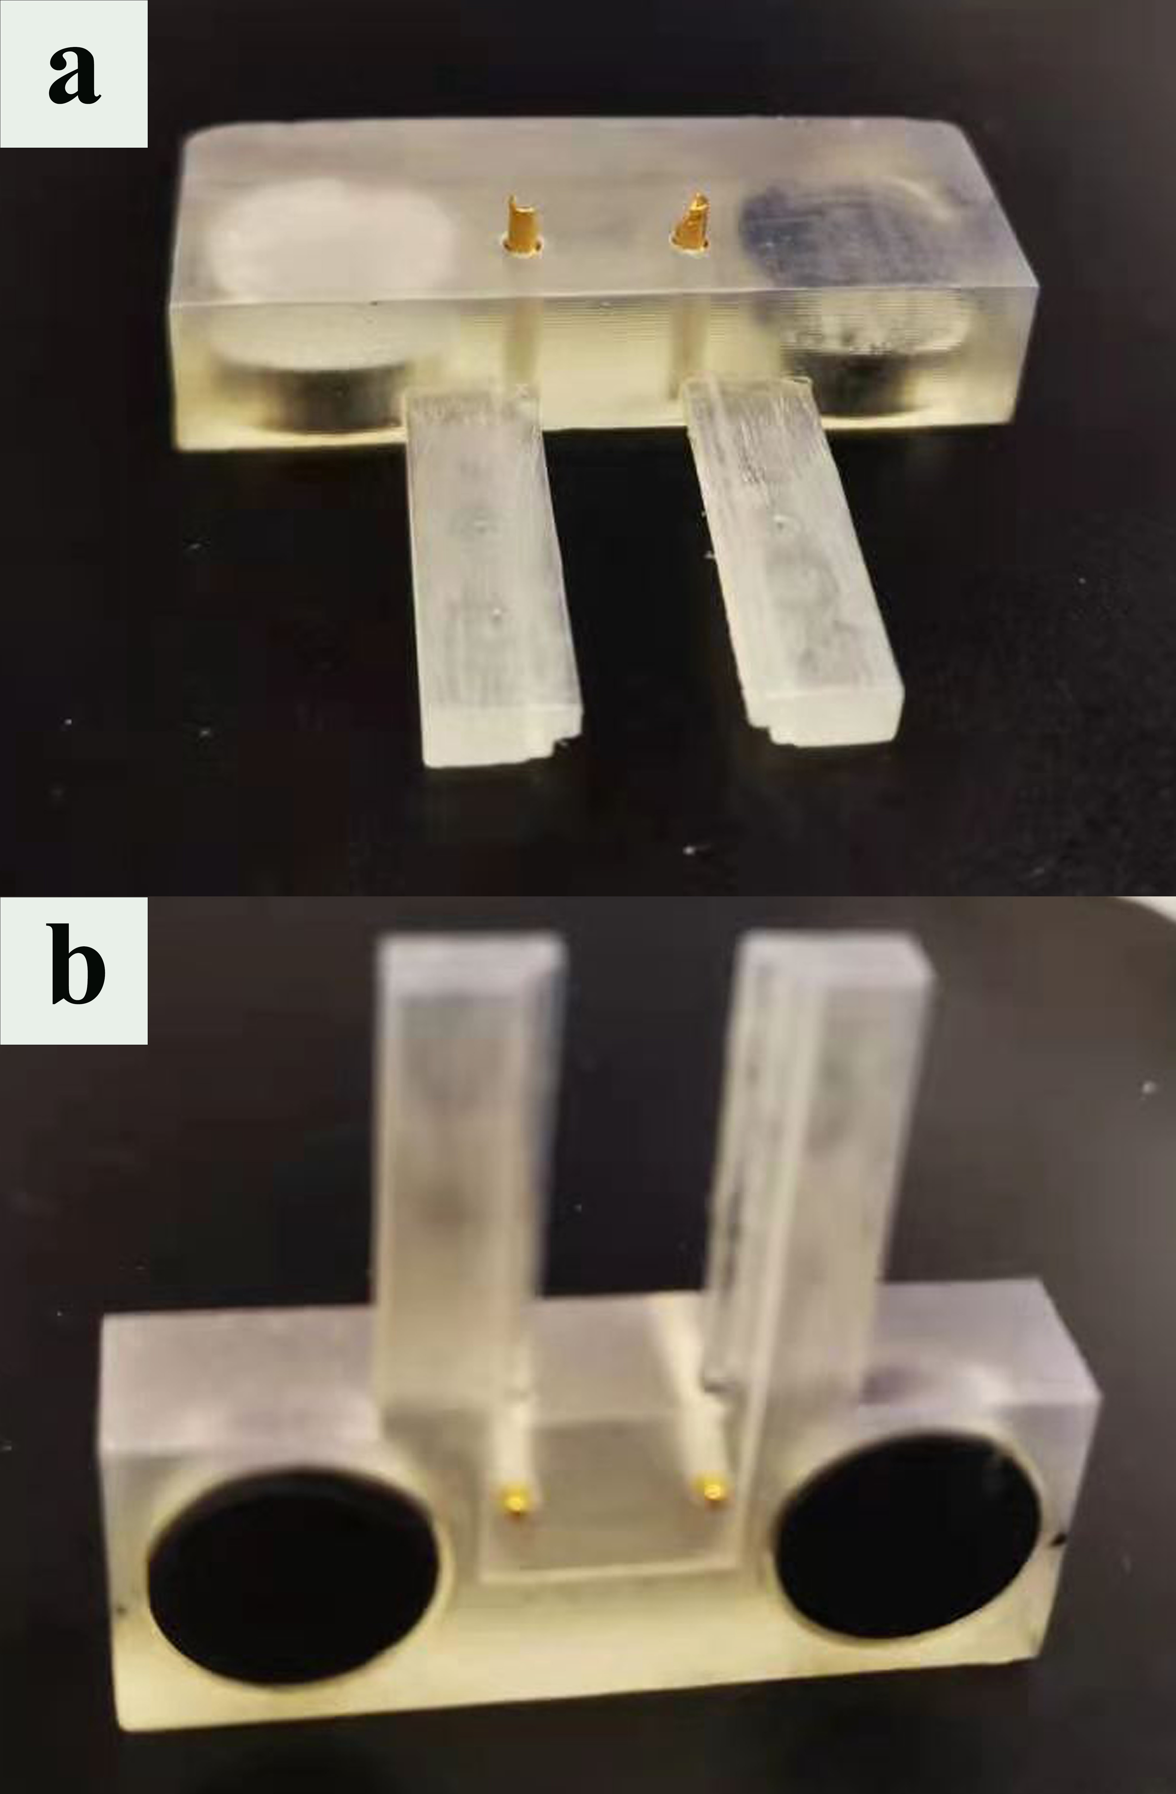

Figure :6.2 Oblique and bottom view of second edition of stage: (a) Oblique view of the stage, overall structure of capital ’T’ with hollow in the bottom. Two pogo pins placed in the hole pierce the stage. (b) Bottom view of the stage. Three-tiered ladder designed to contact and fix the position with glass cover, substrate and metal plate separately. The spring end of pogo pin in the middle of image. Two magnet glued in the the stage.

Then the standard deviation of the elements in an array was calculated. We expect a greater deviation for the picture with stripes parallel to the top and bottom edge of the image. We call this deviation value ‘parallel factor.’ We chose the rotated image with the largest parallel factor for analysis later because they possess the best performance of showing stripes in parallel.
The next parameters we calculated for the processed images are Otsu’s threshold [29]. A threshold is a number in the range of gray values of the image, and it is used for filtering the original images into a binary color scheme. Otsu’s method separates the range of gray value histogram into two sections and minimizes the intra-class variance of those sections. The intra-class variance σ_{w}(t), indicating the performance of separation, is defined as σ² (t) = ω²(t)σ²(t) + ω²(t)σ²(t), where σ₁(t) and σ₀(t) are the sum of
w 0 0 1 1
probabilities (integral of probabilities) of two sections and ω²(t) and ω²(t) are the
1 0
variances of these sections. This algorithm exhaustively goes over all the possible t (the value of threshold) and finds the minimal σ_{w}(t) and corresponding t_{f} as the final threshold by filtering the images with their corresponding t_{f} . We convert the pixels value above t_{f} as 1 (white), below as 0 (dark). Then we transfer the images into binary images, where one color gives polymer coverage, and the other color gives the bare surface of the substrate.
Before we calculated the cover ratio from the binary images, one more check was applied. We want to make sure the resulting image is not affected by the titled light source of the light microscope. In figure 7.2, we can see the difference between a ideal and non-ideal result. The significant difference between them is the uneven distribution of the dark/light region over the image. To get rid of it, We compared the difference between the sum of the average gray values between top-half with bottom-half, left-half with right-half. If the sum of this value is greater than 5.0 (based on the comparison between surfaces with polymer deposits and surfaces without polymer deposits), we will avoid the quantitative analysis of the corresponding image. Where our images passed this test, we calculated the polymer cover ratio Ratio = S₀/S_{total}, where S₀ is the total number of pixels with a value of 0 (dark, representing polymer) and S_{total} is the total number of pixels in the image.

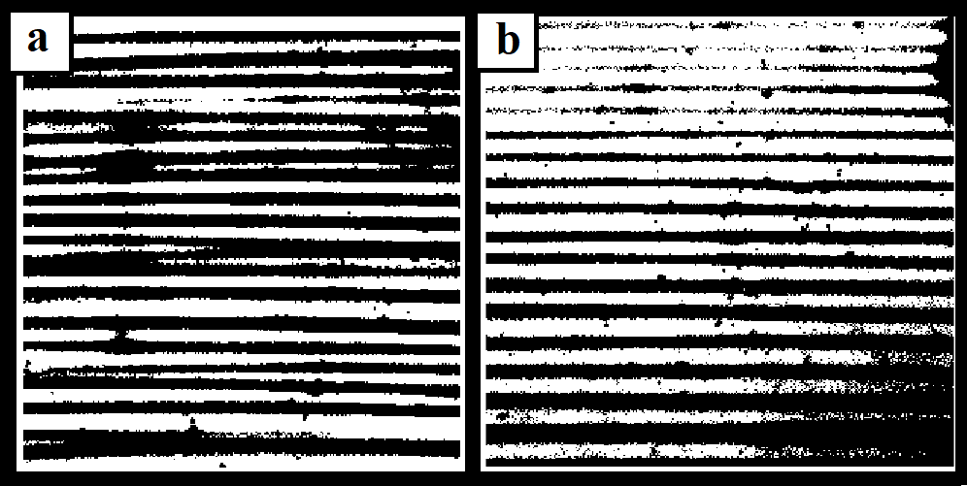
Figure :7.2 Grayscale image of images taken from the cover surface, where we can see (a)Ideal binary map indicating the polymer with the dark region and (b)Not ideal binary map that affected by the light source titled leading a darker region in the right down corner and lighter part in the left top corner.

6.2 Frequency Analysis of Microtopographic Data

We utilized microtopographic data by profilometer in the observation window (Line of interest) and summarized the characteristic properties out of data by MATLAB codeB, which can be found in supporting information. The study of microtopographic data starts from the whole line topographic data measured by a profilometer.
We collect the topographic information of two surfaces after every experiment. The surfaces are placed in the profilometer and measured. We received a 2 × n array will from a single acquisition. That is the data collecting height and position information from the entrance of the microchamber to the end, vertical to the stripe’s direction, and horizontal to the SAWs propagation direction. We do the measurement three times for a single surface in the one-fourth, middle, and three-fourths of the microchamber. Every line of data will be measured three times for accuracy. But we only use the data from the middle of the microchamber, where is our observation windows located. For example, figure 3.3.a is an example of line topographic data I mention. This particular example is extracted from the surface of the substrate when no SAW is applied. Starting from position 2mm, we can find the pattern with regular peaks and valleys. The first peak stands for the entrance of the microchamber.
The wavy microtopographic data last a total length of 4mm as the length of the

microchamber for evaporation. At the end of data, position 6mm, a height peak in- dicates the end of the chamber, the spacer with a height of 75µm. The marked data (observation windows) from figure 3.3.a with a length of 1mm will be extracted as fig- ure 3.3.b. by MATLAB code. Because this microtopographic data from 1mm length is an array of height versus position, we can find the distance between peak to peak is around 05mm.0 and height about 4.0µm. And it is the input data of discrete Fourier transform by MATLAB build-in FFT function. Following the transformation of the profilometer data to the frequency domain using FFT, we obtained a discrete power spectrum of the different frequencies in the partnered stripe deposits. The maximum power in the FFT spectrum represents the most common repeating wavelength in the deposit.
We compare the FFT spectrum of the surface with/without stripes and realizee the power spectrum from the surface with regular stripes form a spectrum with a single peak located over zero. The surface without regular stripes has a power spectrum that peak very close or at zero frequencies and decreases exponentially. After investigation, we understood the reason we have such a figure in the power spectrum of the surface without stripe is pink noise from the measurement. Pink noise is one of nature noise in a modern system also in our system. [40] One source of the noise is the electronic circuit our output signal goes through. The dirt, scratch on the surface, hardware, and software problem of the profilometer increase the error also. Noise to signal increase because of the deviation stripes distance, further reduces the clearness of the FFT power spectrum.
To summary the information collected from power spectrum, we assumed, in every specific pattern, the distances between nearby stripes should be close to some average value with deviation. By observation of results in the frequencies domain, we believe it looks like some distribution. This was the derivation of our thought of fitting the FFT power spectrum.
To assess the most common frequnecy in the FFT power spectrum, we employed

least square fit of the latter to the distribution function
( )− −

y = p₁(x − p₃)2

exp
(x p₃)2

(2p²)
(x > p₃)

y = 0 (x < p₃)
2

where p₁, p₂, p₃ are three fitting parameters. The corresponding frequency around the maximum power value in the distribution function is taken to be the main repeating spatial frequency for this sample.
MATLAB. code as equation follow:

By simply mathematical calculation, the simplified derivative of the original equa- tion are as follows:

y′ =
p₁(x − p₃)(2p² − (x − p₃)2)

2
2 2p
2
−(x − p₃)2

e 2 (x > p₃)
(2 2p )

y′ = 0 (x < p₃)

Where for x>p₃, the sign of y’ only relate to the value of (2p² − (x − p₃)2) because rest of equation always stay positive. We can easily find out the local maximal of our fitting result, as following equation:
2

xmax = p3 + 20.5p2

This x gives us the local maximal of the fitting equation. However, because I mentioned above the noise peaks and the weakening of wanted peaks, some justification was needed for the fitting process.
After changing the initial guess and MATLAB reporting the convergence result (Not trivial/extreme values report for the parameters) of the fitting, we checked the validity. The calculated local maximal result should lay on the positive side of the x-axis. If the peak locates at negative or zero, it tells us noise peaks overlay our wanted information. If the result was not valid, a peak elimination was done as follows: Part of the source data was cut manually. The rule for this cutting is to find out the abnormal high peak and eliminate it. The data before and after this elimination were pasted and processing

the FFT again. This checking and elimination could be done at most three times. If the fitting was not converged (reported by MATLAB) until three eliminations, we would not report the result of the source data. In this way, we calculated and collected the value of the fitting result can call this value the ’characteristics frequencies’ of this power spectrum and result. These values showed the spatial feature of a surface covered by stripes polymer deposition in figure 4.3.

Chapter 3

Result and discussion

We employ a 20 MHz SAW to affect the deposition of PMMA from a volatile solution of the polymer in toluene onto a solid substrate in a small confined micro-chamber as described in the experimental part2. All the experiments were done in this integrated experimental system1.2,reffgr:whole system. The void in the micro-chamber is 5.7 mm wide, 4 mm long, and 75 µm thick, consisting of an underlying active substrate and a glass cover above. We choose the same observation window to extract the data.
Before the quantitative analysis, we descript the most intuitive result in this ex- periment by observation the image of the light microscope. The deposition change dramatically with the increment of the acoustic power: The deposit under the surface substrate disappears/suppress, and regular stripes deposit appears on the upper glass surface. This is different from previous similar experiments, so we show the following methods to prove the change and further analysis the effect of SAW.

1.3 Microscopy observation

After every single experiment is done (when the toluene in the integrated experiment system is fully evaporated), we capture and record the image of the underlying substrate (acoustic actuator) and on the glass cover of the micro-chamber by light microscope 1.3).

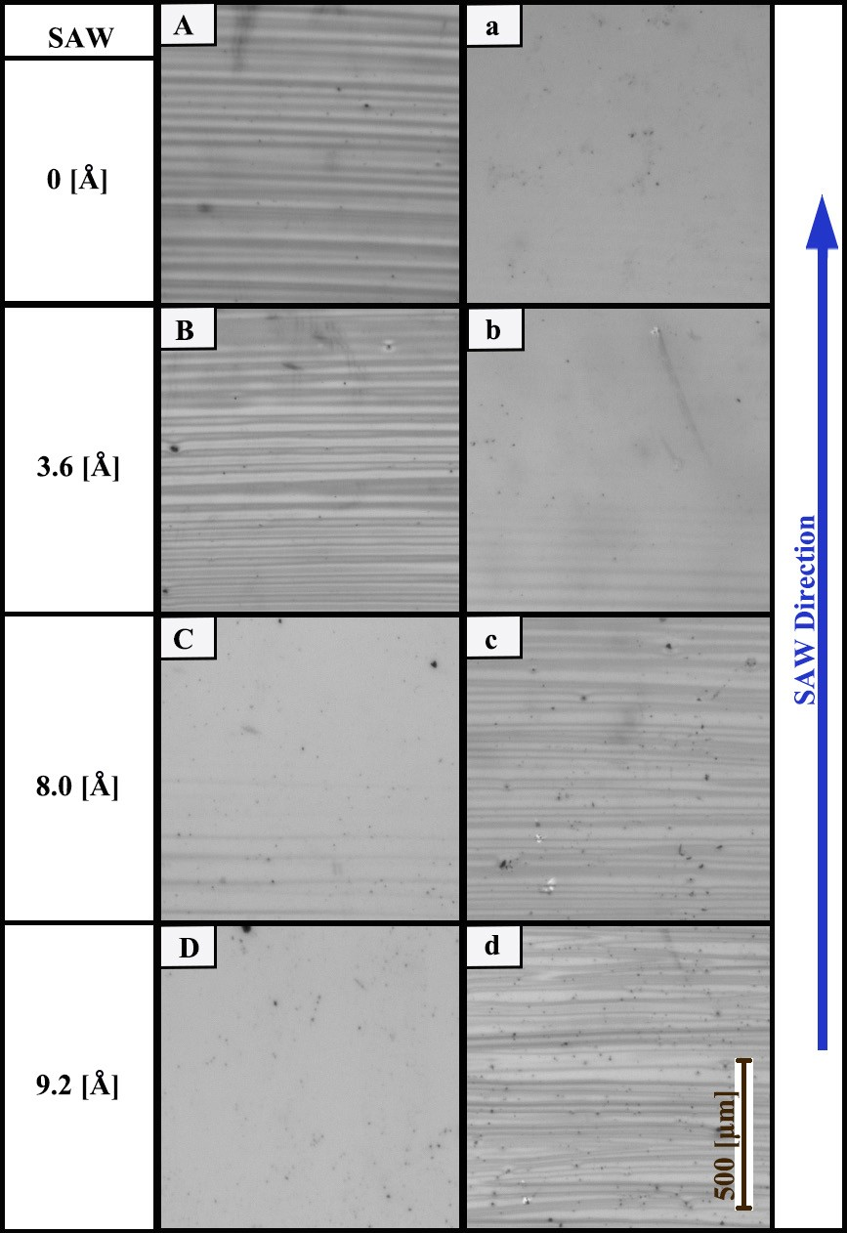

Figure :1.3 A sequences of top view images, which portray (A-D) the surface of the underlying substrate, which may support a SAW, and (a-d) the surface of an upper glass cover, following the full evaporation of a PMMA/toluene solution; the latter is initially confined between the two surfaces. The results are given for different levels of the SAW normal particle displacement at the surface of the underlying substrate, where the dark stripes are PMMA deposits and bright parts are devoid of deposits. The mass of polymer deposit on the underlying and upper substrates decreases and increases with increasing the acoustic power (SAW particle displacement).

In figure 1.3, we show the deposit of PMMA polymer left on these two surfaces: Some parallel stripes patterns were generated, they are parallel to the open of micro- chamber/upper edge of the spacer. When SAW is absent in the experiment (figure
1.3 (A,a)), the PMMA deposit appears on the lower substrate of the chamber but the upper glass cover. By comparing the result from the capital column (A-D), we show the increasing the power of SAW makes the pattern on substrate weaker and even disappear. On the other hand, PMMA mass starts to deposit on the upper cover as parallel strips. At sufficient acoustic power (around 8Å), we do not observe PMMA deposits on the underlying substrate, and a clear pattern can be found on the cover surface. Notably, the appearing and disappearing of the deposit pattern seem to relate to the source of acoustic energy.
We can find a typical pattern in this confined micro-chamber in the images with strip patterns 1.3A,d. The formation of this kind of parallel stripe is well explained and test by the pioneer. [4, 2, 39] When not SAW is applied, the preference of deposition is related to the contact angle between solution, vapor, and two surfaces (upper glass and lower substrate). In our case, the substrate has a smaller three-phase contact angle with the substrate below, resulting in deposition on the substrate below. There are also different types of strips can be found. [14, 12] Here, we control our experimental conditions to form a clear parallels strips pattern.
By comparing microscope images from the lower substrate, we highlighted that the application of acoustic energy in this system renders and finally eliminates the polymer deposit on the substrate surface. This part fits the previous experiment utilizing SAW to suppress the ’coffee ring’ effect. Mampallil et al. [24] experimented that SAWs inhibit the coffee ring effect following the evaporation of a sessile drop of volatile solution. Mhatre et al. [27] shown a similar observation by confining the liquid in a rectangular chamber. The geometry of their chamber is similar to the one employed here. In their experiment, the internal thickness of the chamber was 1 mm (instead of 75 µm in the current study). Mhatre et al. further employed the deposition of medium- sized molecules (instead of polymer in the current study). Both studies reported that the originally patterned deposits (in the absence of SAWs) change into homogeneous coatings in the presence of SAWs.

What we found on the opposite surface looks contradictory to the demonstration above: A similar parallel pattern starts to generate on the upper glass cover with the introduction of a stronger SAW. We can tell the difference in the previous experiment setting from ours: In the experiment presented by Mampallil et al. for the volatile sessile drop, no such kind of contradict surface/upper surface exist; In the following experiment done by Mhatre et al., the thickness of chamber is ten times larger than our experiment. Both experiments have not confined the thickness of the upper surface in a small enough range under the effect of 20MHz SAW: The wavelength of ultrasound leakage off for it is approximately 80 µm. This is similar/larger than the thickness of the current micro-chamber. So the formation of a pattern on the upper surface may relate to the wavelength of SAW leakage into liquid. On the other hand, the pattern change starting from the source of SAW generation may also prove that the effect on both surfaces is related to the ultrasound leakage into liquid and the decay over transfer distance.

Gray value analysis

We also show the phenomenon that we found in a more objectively way, instead of picking out some typical experiment image. We provide the ratio between the area covered by polymer between total observation area from the microscope image in fig- ure 2.3. Using gray value evaluation to show result from 1.3 quantitatively. In the experimental section, we provide the details of the image analysis algorithm employed on the images.
In figure 2.3, we can find the collected data of image analysis. We can find there are two blocks for the result from two surfaces: 2.3 a stands for data from substrate data, and 2.3 b stands for the result from the upper glass surface. We estimate that the uncertainty of our results is around 10% caused by dirt, polymer block (both black dots in the image), and light tilting of the light source of our light microscope. In the upper part of the figure, we show a relatively stable cover ratio before SAW displacement reaches a value of 6Å. It turns down and reaches zero eventually. We can find two guiding lines draw by hand to show the trend of the image. SAW displacement of 6Åis a crucial threshold value for us: Below the threshold, PMMA deposit covers

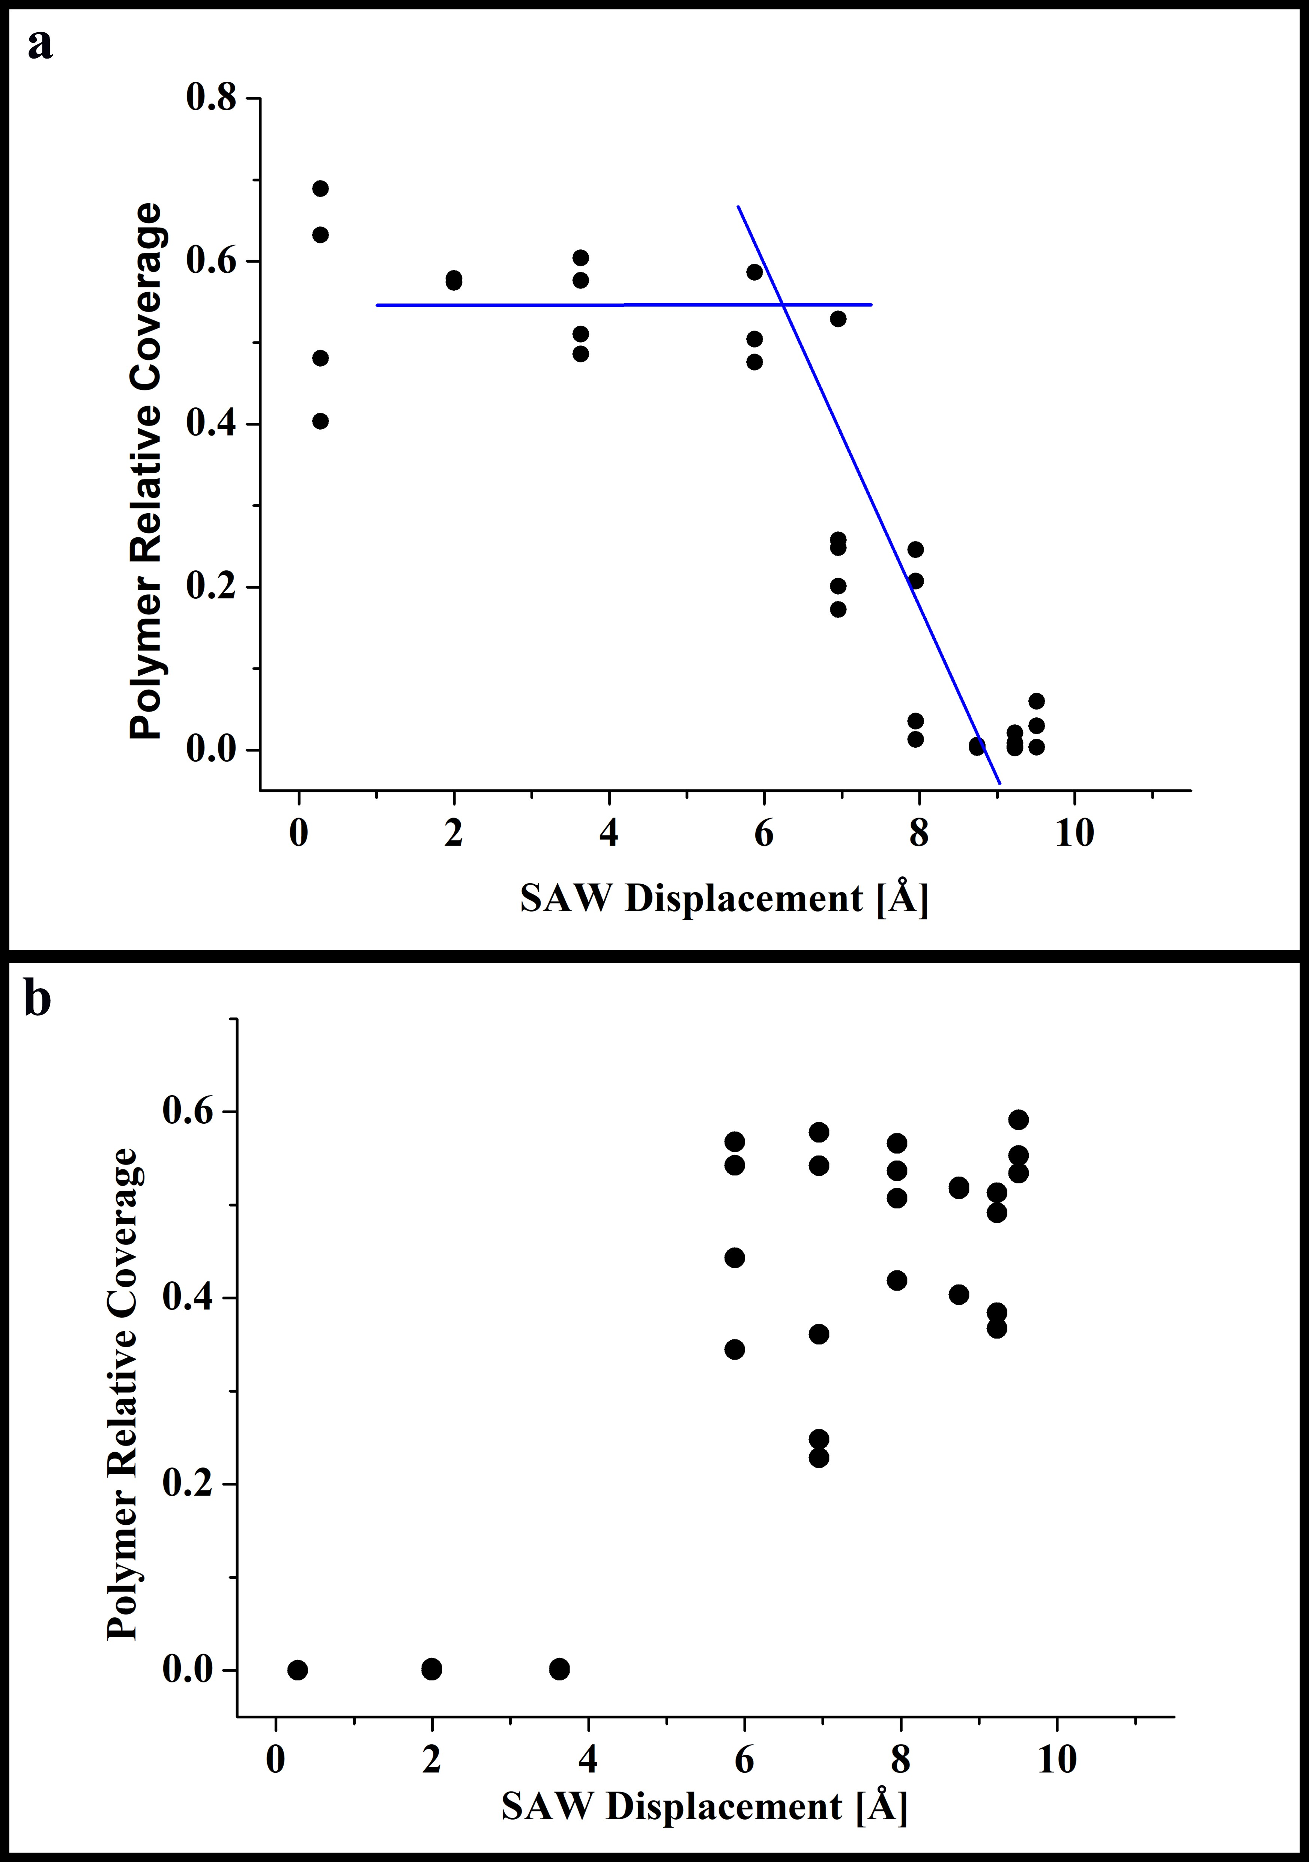
Figure :2.3 SAW particle velocity displacement variations of the relative coverage (dark parts divide by the full area of captured light microscopy images, as in figure 1.3), atop
    - the underlying substrate of the chamber (which may supports the SAW) and (b) the upper glass cover of the chamber. The solid lines in (a) are a guide to the eye. The characteristic error in the data obtained by image analysis is 10%.

approximately 50% to 60% of the underlying substrate. Above the power threshold, the polymer cover ratio is reduced sharply and even reaches zero. On the other hand, a reverse trend is found on the opposite upper glass surface. Below 6Å, no PMMA deposition is found via image analysis. And a scatter of PMMA cover ratio around 6.3-0.0 is found to prove the polymer deposition atop the upper glass surface.
We show the result quantitatively in this section and emphasize the found on the opposite surface: SAW renders and eliminates the polymer deposition on the substrate surface while triggering the deposition atop the upper glass surface. But the change may not be similar: we find more linear change on the substrate surface result and a jump change in the upper glass.

3.3 Microtopographic data analysis

The microtopographic result from the profilometer was used for the analysis of the regularity of our stripe’s pattern. In the experimental section, we give a detailed ex- planation for it. And in figure 3.3, we show the process intuitively, including cutting observation window (a-b), fast Fourier transform (b-c), and finally fitting the result with a Boltzmann distribution function via least-square fitting to find the most impor- tant skeptical frequency of the stripe deposits in our every experiment. In figure 4.3, we show the resulting characteristic spatial frequency of the deposit to the strength of acoustic power (SAW displacement). There is not a lot of trends can be found in this frequency analysis. It may indicate there is no significant correlation between the effect of SAW on pattern deposit to the repeatability of strips itself. Another possible reason for this is we are not able to reveal the regularity out of noise by current tools, like in chapter2.

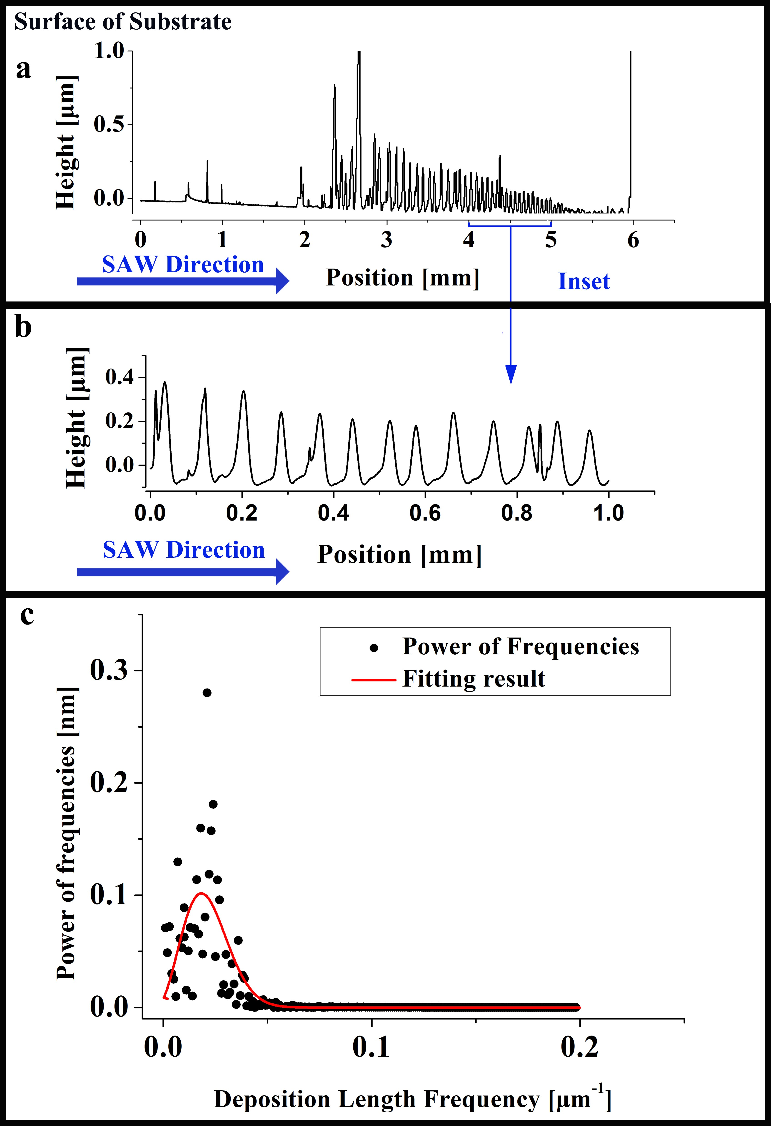
Figure :3.3 An illustration of capturing the characteristic length frequency of the stripe deposition of PMMA, where we show (a) raw date of the stripe deposit (side view) obtained by profilometry, (b) the part of the data analyzed which is chosen far from the sides of the micro-chamber, and (c) fast Fourier transform (FFT) of the data in image b (black dots) and a least square data fit of the data to corresponding distribution function (red solid line) whose maximum gives the characteristic frequency of the deposit (See 2).

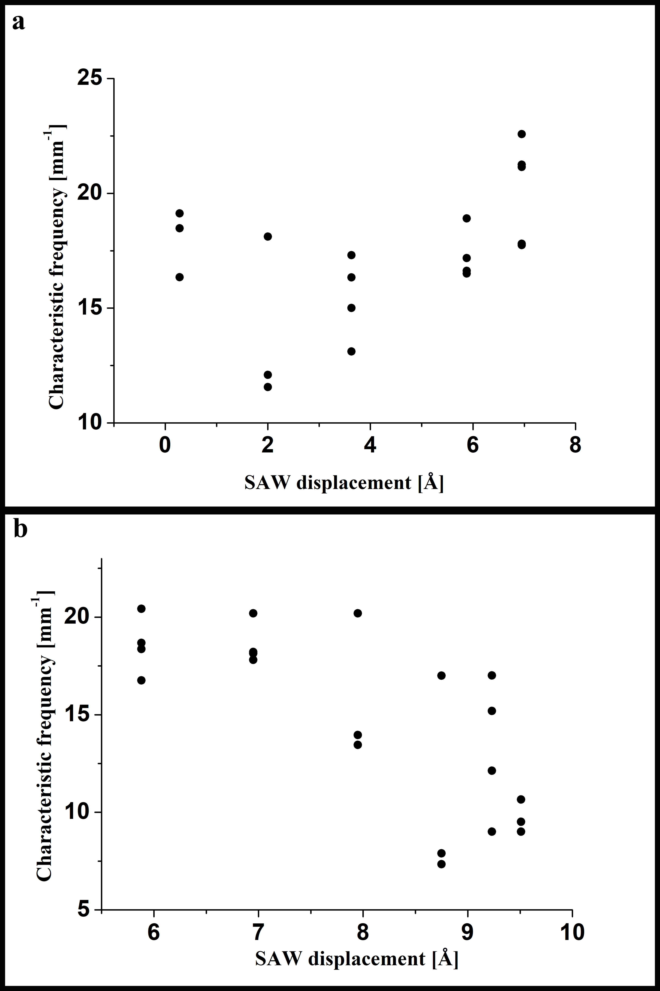
Figure :4.3 SAW particle velocity displacement variations of the characteristic spatial frequency of the stripes in the PMMA deposit, obtained according with the demonstra- tion in 3.3, atop (a) the underlying substrate of the chamber and (b) the upper glass cover of the chamber. The data for SAW particle amplitude above and below 7Å in (a) and (b), respectively, does not appear due to luck of stripe-patterned PMMA deposits in these cases.

Chapter 4

Conclusion

In our experiment, we demonstrate the application of a 20M-Hz SAW to mitigate the deposition of a PMMA polymer during the evaporation of a volatile solution of PMMA in a micro-chamber. To perform this experiment, we designed and built a well-defined, integrated experimental system to ensure the geometry of the micro-chamber remains constant during the experiment (see Chapter 2). We used a light microscope and profilometer to collect the image and profile data and then analyzed the data with the help of our code.
After a detailed study of our results, we are able to share the following conclusions:

In the default case in which no SAW was applied, the polymer is deposited on the substrate surface, and no polymer is left on the upper glass surface due to the relative contact angle between materials.
The application of a SAW renders and eventually eliminates the deposition of PMMA on the substrate surface supporting the SAW. Simultaneously, the deposition of PMMA appears on the surface of a close enough solid surface. With the help of image analysis, we proved that a change occurred in the polymer cover ratio on those two surfaces when we introduced enough acoustic energy.
We also analyzed the spatial characteristic frequency on the profile data of strips taken by the profilometer. However, we failed to reach a significant conclusion based on this analysis. The analysis process is worthy of further study.

We believe the distance between two surfaces in the micro-chamber is crucial for what we found: we built up the micro-chamber of our system with a thickness of less than the wavelength of ultrasonic leakage. This may be the reason for the formation of the deposition on the upper glass cover.

1.4 Potential application

One of the motivators of this investigation was to control the deposition pattern by introducing SAWs. Eventually, we may find a new approach to protect some delicate surfaces from unwanted deposition. We can utilize our findings of redirecting the depositing surface by SAWs. For example, to protect a surface from the harm of deposition, we could introduce a SAW above a threshold energy and place an absorbing surface close enough to the protected surface. The deposition will occur on the sacrificial surface to protect the surface supported by the SAW.
There are two advantages to this approach. First, there is no need to modify the protected surface, and second, the mature technic of SAWs. The SAW actuator is placed in the periphery of the protected surface, and the only requirement for the surface is to be able to transfer the SAW. Furthermore, as mentioned in Chapter 1, the current market is strong enough to support such an emerging industry.

2.4 Open questions

During our experiment, we expended a great deal of effort in investigating the relation between the SAW and the characteristic spatial frequencies of strip patterns. Based on our observations of our results, the distance between strips increases with the power of acoustic energy. However, we did not prove this conclusion. Either we formed an incorrect conclusion due to observer bias, or we failed to extract the proof from our current results. The latter possibility lays on the influence of pink noise, and the uncertainty of the profilometer, as we discussed in Chapter 2. Thus, the first open question for us relates to the effect of SAWs on pattern frequencies during the evaporation of the polymer solution.

and how we can improve the analysis of such a regular pattern.

Furthermore, we hope our research will serve as a base for future studies on the modeling of this question. Currently, we did not build a model for such a close surface deposition under the effect of the SAW leakage question. It will be helpful to have an appropriate model to describe what we found.

