# Course Book

## Performance Marketing: Search and Social

**DLMOMPMSS01_E**

**8** Introduction

### Learning Objectives

###### Introduction **9**



In the area of performance marketing, online marketing instruments are used to obtain measurable responses from users, e.g., downloads, app installs, or transactions. The most common areas of online marketing are presented during this course with a focus on their potential applications.

Additional aspects of the online marketing mix and thus of performance marketing, are also discussed and include search engine optimization, search engine advertising, social media, and mobile marketing.

Alongside the specific features of performance marketing, such as its measurability, modularity, optimizability, and crosslinking, the various performance marketing instruments are also presented. Furthermore, after working through this course book, you will be able to strategically integrate performance marketing instruments into the marketing mix with a particular focus on increasing conversion, as well as monitoring, measuring, and controlling.

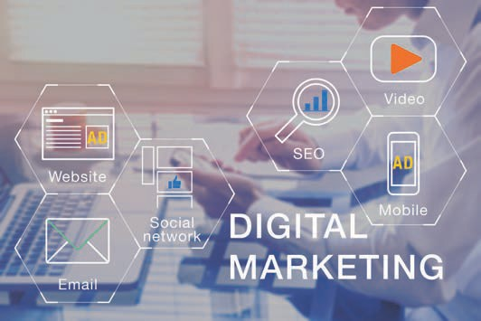

# Unit 1

## Fundamentals of Performance Marketing

##### STUDY GOALS

On completion of this unit, you will be able to ...

... understand the fundamentals of performance marketing as well as its individual performance aspects.

... classify and differentiate performance marketing as part of the marketing mix.

... characterize the various features of performance marketing.

... understand how key instruments of performance marketing function and apply them.

DL-D-DLMOMPMSS01_D-L01

### Fundamentals of Performance Marketing

#### Introduction

Corporate communication has undergone radical changes in recent decades. In this context, we speak of the *push* and *pull* communication directions. *Push* means that media are actively conveyed to the recipients, whether they want it or not. For example, traditional advertising, such as TV commercials and ads in newspapers, falls into this category. In contrast, online communication channels belong more to the *pull* category. In these cases, people actively search the internet for information, products, or services and then voluntarily click on the search hits and ads that appear. Others follow brands or companies on Instagram and Twitter, or they sign up for newsletters. Nevertheless, *push* communication also exists in online marketing. This can be in the form of banners that are placed and embedded among digital texts, such as those found the SPIEGEL media brand website. Overall, the trend is now moving away from *push* and increasingly toward *pull* (Beilharz, 2021). The combination of both communication directions certainly makes sense and as a result, companies and brands are increasingly utilizing the numerous possibilities offered by the world wide web.

As a global communications medium, the internet offers nearly unlimited space for managing goods, services, or brands in communications (IHK für Rheinhessen, n.d.). A major advantage in online marketing is the measurability ofcampaigns. For example, it is possible to track how often an internet ad is clicked and how many people buy a product or service after coming across a particular website via an ad in a search engine such as Google.

GAFAM

The GAFAM acronym refers to the world's largest IT companies: Google (Alphabet Inc.), Amazon, Facebook (Meta Inc.), Apple and Microsoft, all of which have a significant impact on the economy and society.

Above all, interactivity gives users the opportunity to freely choose the scope, as well as the type, time, and duration of interactive exchanges with websites, web stores, apps, social media, or other online marketing instruments (Walsh et al., 2020, p. 539). The **GAFAM** corporations, i.e., Google, Amazon, Facebook (which now calls itself Meta), Apple, and Microsoft dominate much of the western world's online content. This is because these companies also own YouTube, Google Maps, Instagram, WhatsApp, iTunes, Windows, Office, Teams, and LinkedIn (Beilharz, 2021). This means that anyone seeking to properly implement online marketing cannot avoid engaging with these companies, as well as their methods and offers.

Although traditional marketing measures such as advertising space in public places, direct marketing, PR, TV, newspaper, and radio advertising are still effective, online marketing measures are becoming increasingly relevant in the digital environment. It is to be noted here that digital marketing, internet marketing, and online marketing are terms that can be used synonymously.

The traditional advertising measures mentioned above are dwindling in their significance, which has resulted in a shift in marketing budgets toward digital media. In the course of digital transformation processes, online marketing has become a key success factor in reaching people where they now spend an increased amount time — namely on the internet.

Fundamentals of Performance Marketing

Naturally, companies should therefore orient their communication activities toward reaching their customers exactly where they are. The figure below summarizes the online marketing instruments and arranges them into two areas: the activities that are visible to users and those that take place in the background, i.e., are not visible to users .

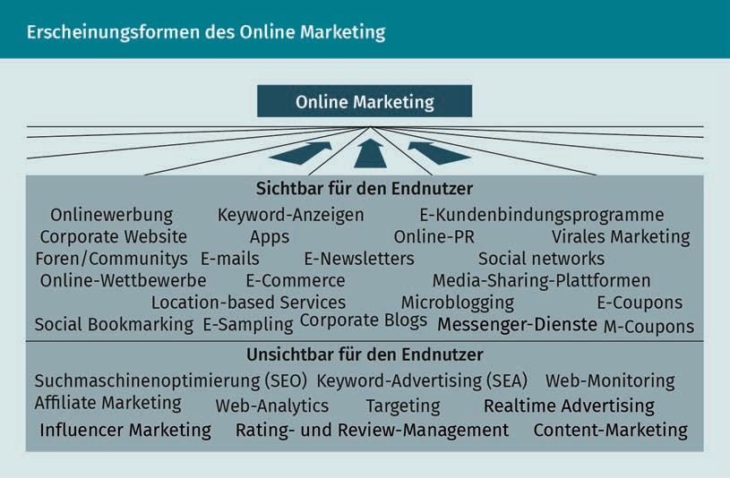

It is essential for companies to direct as many visitors as possible to their website or to encourage them to use the company's app. This is referred to as traffic. Felix Beilharz divides *traffic* into the following categories: E*arned traffic*, i.e., merited or provided traffic that companies or brands do not pay for directly. This is also referred to as *organic traffic,* since it is generated automatically, e.g., users reach a company's website via search engines such as Google or Bing, via Facebook or Instagram, via LinkedIn, or via links in online editions of newspapers or online portals. In contrast, *paid traffic* is generated through advertising on the internet. In addition, there is also *owned traffic,* e.g., traffic related to the possession of newsletter recipients’ email addresses. All three types of traffic are important, but it is to be emphasized here that companies should pay particular attention to owned traffic (Beilharz, 2021).

Various instruments can be applied to succeed in this endeavor, all of which are designed to achieve measurable reactions or even transactions with the respective users. Online marketing is constantly evolving and gives particular rise to another important term that comes into play: *performance marketing*.

It is therefore important to ask the following questions:

* What is performance marketing?
* What is meant by the terms *search* and *social* in the context of performance marketing?
* How can performance marketing be defined as part of the marketing mix, as well as be distinguished from and supplemented by traditional online marketing?
* What are the specific features of performance marketing?
* What are the various instruments used in performance marketing?

#### Performance marketing as part of the marketing mix

Measurable reactions and/or transactions

Such measurable reactions or transactions include clicks on advertising banners, registration for newsletters, or the purchase of a product in an online shop.

Performance marketing is a strategy in online marketing in which marketing measures lead to **measurable reactions and/or transactions** (Auler & Huberty, 2019, p. 137).

To be able to classify online marketing as well as performance marketing, it is necessary to take a closer look at the marketing instruments that form what is known as the marketing mix. The marketing mix is essentially comprised of four different instruments, the so-called *4-P's* (Meffert et al., 2019, p. 20):

1. Product policy (product)
2. Pricing policy (price)
3. Distribution policy (placement)
4. Communication policy (promotion)

Online marketing and performance marketing fall into the area of communication policy (promotion).

As a further *P*, the traditional marketing mix concept these days is often supplemented by the *people* aspect in order to adequately represent the increasing importance of employees to their company’s success on the market (Kreutzer, 2021, p. 50).

While product policy involves product quality, product design, and product range planning, the scope of pricing policy involves decisions on market-oriented pricing that also includes consideration of the business environment. Distribution policy is to be understood as a significant cost factor and encompasses all sales activities and decisions as well as sales channels, choice of sales partner, and logistics.

Since 2000, advertisers have been able to place ads for specific terms in the search results on Google using the AdWords system. Thanks to extensive statistics, the results can be evaluated and optimized to an extremely high degree (Kamps & Schetter, 2020, p. 4).

Fundamentals of Performance Marketing

Since Google Ads (formerly known as Google AdWords) plays a decisive role in online and performance marketing, we will briefly discuss it at this point. As an example, if the term *snowboard* is searched via the Google search engine, the following situation presents itself: To be positioned in the first three ads, for which the advertisers must pay and are marked with the word *Ad*, the companies Blue Tomato, Warehouse One, and Euroskateshop offer money (bid) to the company Alphabet Inc. (which owns Google). The company that is willing to pay the most per click, i.e., per visitor who arrives at the corresponding company’s internet presence via the ad, is placed at the very top and above the organic, i.e., the *normal*, search results.

Performance marketing is positioned within the **communication policy** and in connection with digital media, it is referred to as a component of the marketing mix. Performance marketing serves both customer acquisition and customer retention and is applied with the goal of achieving measurable reactions and/or transactions with users. Customers and interested parties are approached in a highly targeted manner, even on an individual basis when possible, to achieve the greatest possible interaction with users.

The German Association for the Digital Economy (BVDW – Bundesverband Digitale Wirtschaft) particularly founded a specialist group for this in April 2005 and describes the instruments of performance marketing as follows: search engine marketing, web marketing, email marketing, affiliate marketing, online cooperations, and mobile marketing. (Fortmann, 2006). Thus, the question of what is meant by performance marketing is answered. But what do the terms *search* and *social* mean in this context? The term *search* refers to search engines. This is where companies and agencies spend a great deal of money to make products, services, and brands findable – quickly and easily. The term *social* refers to social media, which play a significant role in the western world in the form of Instagram and Facebook, among others. In China, the WeChat and Sina Weibo companies have a similar role.

A key feature of performance marketing is the performance-based remuneration paid to the media within the framework of success-based models: performance marketing services can be defined as clicks (e.g., when referring visitors to websites) or as the generation of **leads** or sales, which also gives rise to specific forms of remuneration (Lammenett, 2019, p. 43). Examples of remuneration in performance marketing include remuneration per sale achieved (pay-per-sale) or remuneration per click generated (pay-per-click) (Kreutzer, 2021, pp. 111-112).

A rethinking of the traditional marketing approach is now necessary, since information and communication technologies in particular are in a constant state of change. The new digital possibilities and ways of addressing intended audiences inevitably result in changed marketing strategies and thus also in adapted measures and marketing goals that can ensure long-term success in the market.

Communication policy

All communication measures are planned, implemented, and evaluated in this area

Leads

In the context of sales, leads refer to data sets (e.g., name, address, email address) for customers who might be interested in a company's respective offer.

Performance marketing ties in with the key points of today's marketing in which digital corporate activities are professionalized and made measurable. In practice, this means that it is no longer simply the placement of online ads that is to be paid for, but rather the leads or customers acquired as a result (Kreutzer, 2021, p. 28). The targeted use of the services available on the web is pursued through the application of performance marketing, making it an integral part of the overall marketing mix (Lammenett, 2019, p. 39).

Performance marketing thus aims to achieve measurable reactions among the recipients of advertising messages. It is therefore particularly suitable as a results-based approach to marketing activities when considering the following goals:

* Reach – number of users who see a website or use an application (app).
* Interaction – how users interact with a website or an app. Examples include users playing Candy Crush, checking their account balance on their bank's online app, or consuming third-party posts on YouTube or LinkedIn.
* Transaction – what users actually do on a website or within an app? An example here would be an order placed with Amazon.

To fully exploit the potential of online marketing mix instruments, they must be implemented holistically within the marketing concept so that the vital synergy effects of an integrated communication do not go untapped (Kreutzer, 2021, p. 29). If this can be achieved, then the use of performance marketing can have positive effects on the overall performance of a company. A holistic overview of the effectiveness of the measures can be created through:

* a clear transparency of the online marketing measures carried out,
* their measurability, and
* the option of a success-based remuneration.

While companies can often only assume that their online advertising will lead to action on the part of their customers, performance marketing can be used to quickly check what effect it actually has. Ongoing advertising campaigns can therefore be continuously improved on this basis. The reactions achieved and thus the advertising success can be quantified and the achievement of goals can be documented with absolute figures (Kamps & Schetter, 2018, p. 6). Sought-after actions on the part of the advertising recipients and the subsequent results include:

* interactions (such as a click on the corresponding advertising material) and their resulting sales and purchase transactions,
* the recovery of customers, and
* strengthening existing customer relationships.

To initiate the corresponding actions sought, it is necessary to implement a highly targeted and, if possible, even an individual customer approach to achieve maximum interaction with the respective user(s) (Lammenett, 2019, p. 43).

Fundamentals of Performance Marketing

It is now clear that in performance marketing, the actual activity only begins after an advertising campaign is put into action. Continuous optimization of a campaign can then bring about a convergence toward the established goals until these are ultimately achieved (Kamps & Schetter, 2018, p. 6).

Although the term *performance marketing* was introduced as such in 2008, the practice of response-driven online marketing campaigns was established long beforehand (Kamps & Schetter, 2018, p. 4).