**Tracking the growth of mathematical ideas in a professional development program for preschool teachers**

**ABSTRACT**

The professional development (PD) program can provide a basis for mathematical knowledge growth. This study was conducted during preschool teachers' participation in a PD program, using argumentative discourse during the whole-class discussion as a means of promoting geometric knowledge. In order to follow the evolution of the participants’ mathematical ideas, we adopted the Documenting Collective Activity (DCA) framework. This approach allowed us to identify normative ways of reasoning that function as-if-shared during the research participants’ collective argumentation discourse in the PD program.

**1. Introduction**

Tracing the travel of ideas in the classroom community, e.g. the emergence, travel, and shifts of learners’ ideas, in classroom communities are challenges that still need to be achieved (Saxe et al., 2009). In recent years, studies stressed the importance of considering mathematics classrooms as learning communities rather than as individuals (e.g., Hodge, 2008). Thus, there have been a growing number of studies exploring the collective mathematical activity of a learning community (e.g., Rasmussen, Wawro, & Zandieh, 2015). The collective activity of mathematics learning refers to the normative ways of reasoning that develop as learners work together to explain their thinking, present their ideas, solve problems, etc. (Cobb, Stephan, McClain & Gravemeijer, 2001).

Although the aforementioned studies explore the collective activity of mathematical learning, there is still a need for studies that focus on preschool teachers. PD programs can provide a basis for the mathematical knowledge growth necessary for teaching (Tirosh, Tsamir, Levenson & Tabach, 2011). The main goal of this study is to identify and understand the learning processes in the PD program for preschool teachers by tracking the growth of their mathematical ideas. We investigated preschool teachers’ argumentative discourse during whole-class discussions about three-dimensional (3D) shapes.

**2. Theoretical and methodological framework**

***2.1 Knowledge development in the classroom***

Over the last few years, research has increasingly focused both theoretically and methodologically on knowledge development during the learning process. Cobb and Bauersfeld (1996) provided a basis for this development by presenting research on mathematical learning from the psychological and sociocultural perspectives and proposed a theoretical-methodological framework to study the mathematics classroom. Nonetheless, learning mathematics via social interaction is an integral part of the sociomathematical approach to learning.

From the sociomathematical perspective, which is based on constructivist theory, the development of mathematical reasoning from the social and psychological perspectives is the focus of any study. From these perspectives, students learn the classroom’s prevailing sociomathematical norms with other students (Cobb & Yackel, 1996). Cobb et al expanded on the significance of mathematical knowledge’s development in the classroom (Cobb et al., 2001), and their main aim was to study mathematical knowledge’s classroom development as it is expressed in the growing collective activity of the classroom community. This social perspective stresses the mathematical practices that have become normative ways of reasoning in the classroom community and were constructed through the students’ ongoing interaction. These are practices that are taken-as-shared in the classroom community. The psychological perspective relates to the students’ qualitative development in terms of their ability to reach logical conclusions, that is to say, to reorganize their activity and the world in which they function, and emphasizes the way in which different students in the classroom community participate in these activities. Meanings or mathematical activities are defined in the classroom as either taken-as-shared or not taken-as-shared, since different students think differently.

Subsequently, we describe the theoretical-methodological framework that analyzes the discussions that take place in the whole-classroom discussion. This framework is the focus of this paper, and it will enable us to clarify how the students’ justifications or warrants actually influence classroom practice.

***2.2 Documenting Collective Activity (DCA)***

Collective activity is a social phenomenon that addresses the constitution of ideas through patterns of interaction. Or, to explain it in greater detail, it is defined as a social phenomenon, which allows mathematical ideas to become both normative ways of reasoning and established in the classroom community through student interaction. As the students present their ideas, explain their thinking behind them, and more, the ideas crystallize.

A mathematical idea or way of reasoning is considered to be normative when there is empirical evidence, that it functions in the classroom as if it were shared (FAIS: Function as if shared) via an argumentative process that reaches logical conclusions using language, tools, symbols, and gestures. As applied to mathematical ideas, the phrase “function as if shared” means that the mathematical ideas and ways of reasoning function in the classroom discourse “as if” everyone in the classroom community was a factor in their creation, and the concept “shared” is introduced in order to create a closer connection to the empirical approach which establishes when certain ways of reasoning become normative. The empirical evidence, which establishes the ideas, functions as if it was garnered through the argumentation model (Rasmussem & Stephan, 2008; Stephan & Rasmussen, 2002) developed by Toulmin (Toulmin, 1969), assuming that there are differences in how mathematical ideas and reaching conclusions are perceived by different individuals in the classroom.

Toulmin (1969) created a model (see Fig.1 below) to depict the structure and function of the argumentation, called the core of the argument, which is composed of at least three parts: the data, the claim, and the warrant.

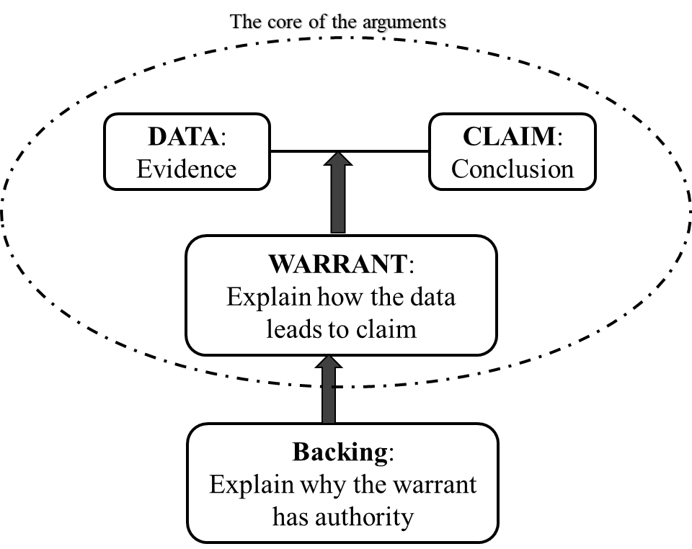

Fig. 1 Toulmin’s model of argumentation

In the argument, the speaker makes a claim and presents evidence or data to support his claim. The data is usually composed of facts or procedures that lead to a conclusion.

If one of the students does not understand how the data leads to the conclusion, he is supposed to ask the speaker (who made the argument) to clarify why and how the data leads to the conclusion. In order to strengthen the claim, the speaker often provides a clarification that fills the role of the warrant, connecting the data to the claim. Nevertheless, it is not unusual for rebuttals to be made or qualifiers to be raised after the claim is made, the data is given, or the warrant is provided. The rebuttals and qualifiers help advance the claim.

Sometimes the listener understands why the data supports the conclusion but disagrees with the warrant the speaker produced. Or, in other words, it is possible to call into question the authority or credibility of the warrant so that the speaker must provide a rebuttal in order to explain why the warrant and the core of the argument are valid.

If one of the students understands why the data supports the conclusion but disagrees with the contents of the warrant advanced by the speaker or he disagrees with the claim made, he can make rebuttals or offer counter-arguments that testify to his disagreement. When this type of objection is made oftentimes a qualifier is provided as a way to offer specific conditions under which the claim is true.

Finally, the argumentation may also be comprised of backing, which demonstrates why the warrant has the authority to support the data-claim pair.

We will now turn to the DCA’s stages. The first stage begins by employing Toulmin’s model in order to create a sequence of argumentation schema for the discussions taking place in the whole-class discussion. This will eventually lead to the construction of an argumentation log for all the discussions that take place in the whole-class discussions. The following stage is a review of the argumentation log as data in order to identify which mathematical ideas became accepted as part of the normative ways of reasoning (NWRs: Normative Ways of Reasoning), that is to say, became part of the normative ways of justification in the classroom community and function as if shared (FAIS: function as if shared).

Stephen and Rasmussen (2008) defined criteria for determining when the classroom community’s ways of justification or their mathematical ideas become normative in the classroom:

* Criterion No. 1 – Drop Off: When the backings and/or the warrants for an argument stop being mentioned in the students’ explanations (they are hinted at, instead of being explicitly asserted; not even one community member challenges the argument, and/or if a student objects to the argument, the challenge is refuted). We conclude that within the classroom community the mathematical idea at the heart of the argument has become obvious. That is to say, this criterion (No.1) is fulfilled when the same conclusion is discussed in more than one lecture or more than once in the same lecture, and in the subsequent events, the backings or the warrants are omitted.
* Criterion No. 2 – Position Shift: One of the parts of Toulmin’s Argumentation Model (Toulmin, 1969), the warrant, claim, data, or backing, changes its role during the lecture or afterward. That is to say, every time one of these components changes its role in the argument later and no one objects (or, if someone objects, the objection is refuted), we may conclude that the mathematical idea has become normative in the class and it functions as if shared. For example, when a student employs a claim that was justified earlier as one of the components (data, warrant, or backing) in his current argument, we can almost certainly conclude that the mathematical idea expressed in the claim has become one of the normative ways of justification in the classroom.
* Criterion No. 3 – Repeated Use: When the same data or warrants are employed for different arguments, that is to say, when a certain idea is recycled either as data or as a warrant (Cole et al., 2011).

**3. Methodology**

***3.1 The research questions***

The main goal of this study is to identify and understand the learning processes in a PD program for preschool teachers by tracking the growth of their mathematical ideas. Hence, we must use a methodology that can analyze data from the whole-class community. This overall goal can be expressed by the following research question: How can we describe and characterize the learning process of teachers who participated in the PD program?

***3.1 Research setting***

The data reported in this paper was collected as part of a larger study based on a PD program for preschool and first and second-grade teachers about two-dimensional (2D) and three-dimensional (3D) shapes in geometry. Due to space limitations, we focus on the preschool teachers' PD program which included twenty preschool teachers and met for ten, three-hour PD sessions. Study data sources included video recordings of every class session from a single camera that focused on whoever spoke during whole-class discussions.