**Action Plan for Restoring Open Spaces and Improving Their Ecological Function and Accessibility in the Climate Change Era**

**Table of Contents**

**1.0 Background**

**1.1 Vision and goals**

**1.2 Trends in Israel affecting open spaces**

1.2.1 Demographics and Development

1.2.2 Climate change

1.2.3 Management of open spaces in Israel

1.2.4 The 2040 Strategic Plan—the open spaces chapter

**1.3 Areas for improvement in function and work methodology**

**2.0 Mapping, characterizing, and prioritizing open spaces for improving ecological function**

**2.1 Mapping the existing situation**

* Land designations (statistics)
* Uses
* Physical condition
* Habitat type
* Stakeholders
* Nearby populations (size, proximity, accessibility)

**2.2. Prioritizing sites for treatment (ecological track and social track)**

* Climate benefits
* Ecological benefits
* Social benefits
* Applicability and realization potential
* Ranking the sites in descending order of priority for the two separate tracks

**3.0 Desired action pathways for sites ranked higher than X**

* Planning sketches
* Management recommendations
* Possible funding methods for establishment and maintenance (horizontal and specific recommendations)
* Physical actions needed to be performed

**4.0 Multiyear plan and recommendations for implementation**

* Recommendations for preparing project portfolios
* Recommendations for stakeholder coalitions in the selected sites
* General recommendations for nationwide policies and actions

**1.0 Background**

Israel is experiencing rapid population growth at a rate of almost 2% per year. This demands rapid development to accommodate the increasing number of people and enhance their quality of life. Undoubtedly, as Israel’s population expands and the country becomes more crowded, the preservation, restoration and accessibility of its open spaces will become increasingly vital. These spaces must provide a high-quality response to ecosystem function and serve public needs. To achieve this, we must broaden the existing paradigm that primarily focuses on preserving areas of exceptional ecological importance or outstanding natural beauty within nature reserves, national parks, and protected forests. We need to take a more holistic view of open spaces, an approach that involves taking action to improve the ecological function of open spaces and increase their accessibility to the public.

Generally, open spaces serve many beneficial purposes for both ecosystems and humans. These include facilitating the physical existence of ecosystems, sequestering carbon, reducing flood damage, mitigating heat islands, and absorbing air pollutants. They also provide a space for human leisure, including community, social, recreation, and tourism activities, and more. From an economic perspective, proximity to open spaces encourages higher population density in towns and cities, increases real estate values, and may help stimulate local nature-based and agricultural economic activity. Open spaces also provide a physical buffer between different populated areas, which both helps preserve local identities and maintain the ecological continuity of the open spaces.

In this era of climate change, enhancing the ecological function of open spaces has become a pressing issue. Functioning ecosystems can help mitigate the effects of climate change, and may even help reduce the dangers of extreme weather events.

If open spaces are not managed optimally, and if no thought is invested in developing their ecological function or social benefits, the public may start to view them as “backyards.” Open spaces may become inaccessible, or even have negative effects on humans and biological diversity (e.g., through invasive species and infections). Such open spaces are sometimes found on the outskirts of cities, in infrastructure zones, or within agricultural areas. Despite their low ecological functioning, their inherent potential may nevertheless be of great ecological and social value. Consequently, preserving and restoring them, and making them accessible to the public, should be treated as a national project that will reap many and diverse benefits.

**1.1 Vision and goals**

In light of the above, the vision of this work is **to maximize the benefits of the network of open spaces in Israel in an era of climate change by opening ecological bottlenecks, undertaking ecological restoration, and making open spaces accessible to the public.**

Two goals arise from this vision, which sometimes overlap and at other times may be in conflict:

1. Improving the ecological functioning of an array of open spaces.

2. Rehabilitating, making accessible, and developing open spaces for the benefit of the public well-being and mitigating the effects of the climate crisis.

The subgoals relate to both the ecological and social aspects of the project:

1. Improving the passage of animals in ecological bottlenecks
2. Restoring ecosystems that have ecological bottlenecks
3. Improving the functioning of damaged ecosystems
4. Improving the agroecological functioning of agricultural systems
5. Increasing the number of natural open spaces that are accessible to the general public for leisure and recreation
6. Strengthening the social and economic resilience of people living close to the open spaces
7. Reducing visitor congestion in sensitive open spaces.

**1.2 Trends in Israel affecting open spaces**

**1.2.1 Demographics and development**

Israel is suffering from an increasing shortage of land as a result of population growth. In response, the country is experiencing significant and rapid development of housing units and related infrastructure.

According to Israel’s Central Bureau of Statistics (CBS), as of December 31, 2022, Israel’s population was estimated at some 9.6 million. In 2022, the population increased by 2.2%. This growth rate was high compared to the previous year, and very high compared to other developed countries. The CBS does not expect this growth rate to slow significantly in the foreseeable future; and as a result, Israel’s population will likely double within the next 25–35 years.

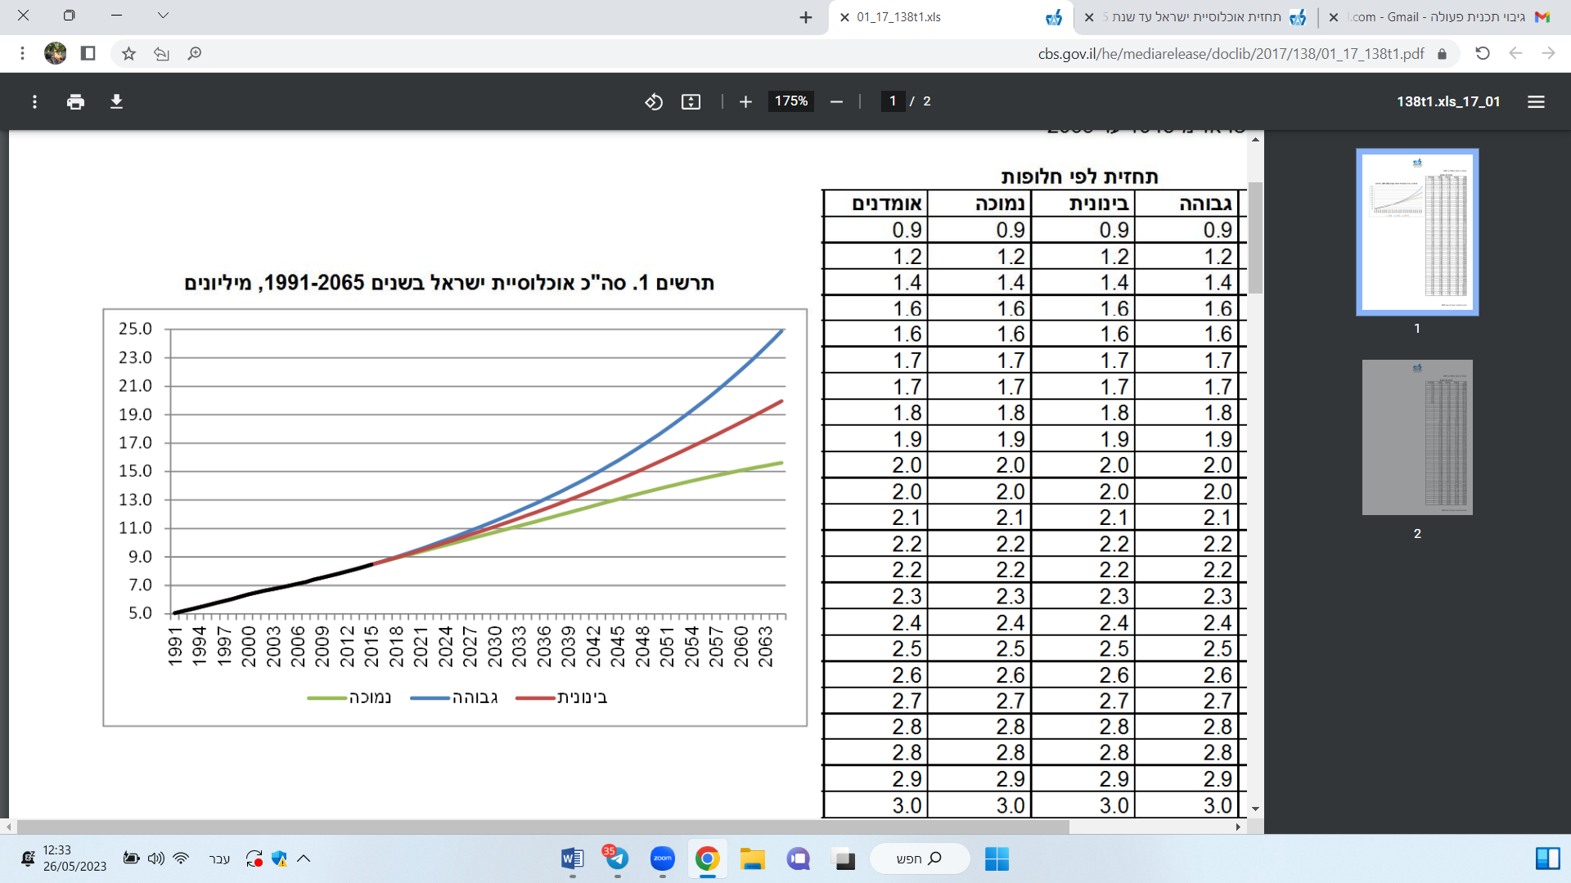

**Three alternative scenarios for Israel’s population growth (1991–2065)**

(source: CBS website)

In order to respond to this rapid population growth, the Israeli government approved Resolution 2754 in 2017 and Resolution 1772 in 2022, which set targets for the approval of the construction of housing units across the country by 2040. The total target currently stands at about 2.6 million housing units (the annual target changes and currently exceeds 100,000 housing units per year). Around 50,000 housing units have already been constructed, according to data from the Ministry of Housing and Urban Development. The graph below shows the government’s targets for constructing housing units and the number of housing units that have already been constructed in line with this target.

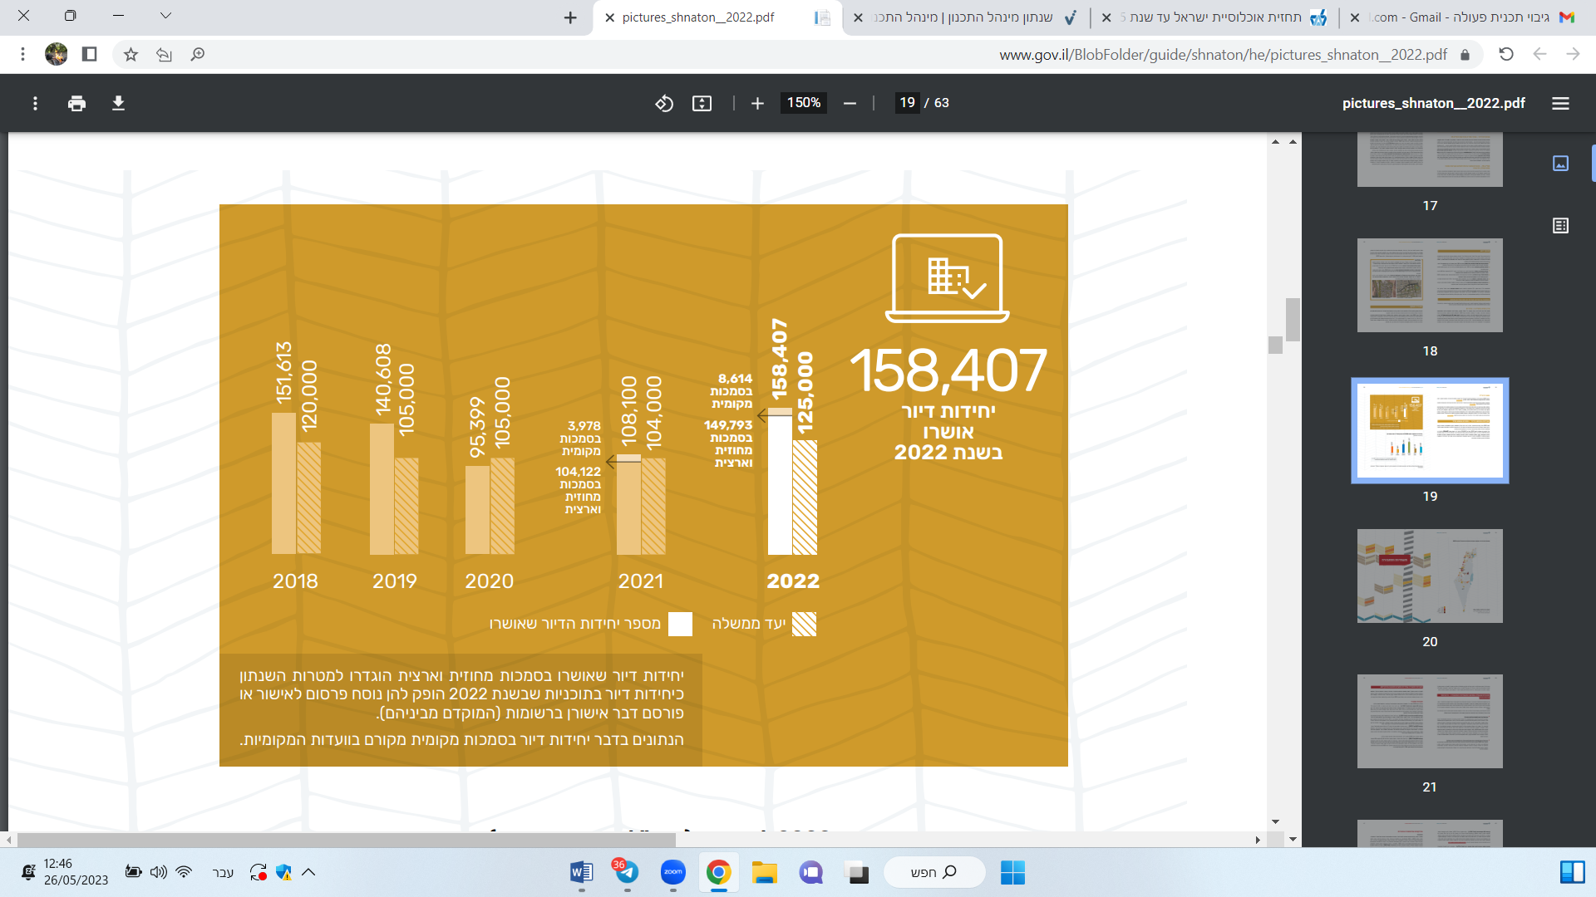

**Scope of housing units approved versus government targets**

(Source: Planning Administration Yearbook, 2022)

Alongside this intensive construction activity, which is expected to accelerate, additional development has used land and disrupted Israel’s network of open spaces, including employment and commercial zones, various services and other land uses, and related energy, water, transportation and other infrastructure facilities.

As a result of this trend, as can be seen from the map below, non-built-up areas in Israel are relatively limited and fragmented. Found mainly in the north and center of the country, these are frequently threatened by development. Protected nature reserves and designated and approved national parks constitute 26.1% of the total land area of the country. However, some of these reserves are also used as military firing ranges and for other purposes.

According to data from Hamaarag, Israel’s National Ecosystem Management Assessment Program’s State of Nature Report 2022, despite the approval of new nature reserves and national parks in recent years, the rate of deforestation of Israel’s open spaces (natural, forested, and agricultural areas) continues to be high. In 2017–2020, an average of around 30 square kilometers per year of open spaces were lost to development. This was mainly for construction, agriculture, transportation, quarrying, or solar energy fields. This decline is also occurring in ecosystems, which are underrepresented in protected areas in Israel (see graph below).

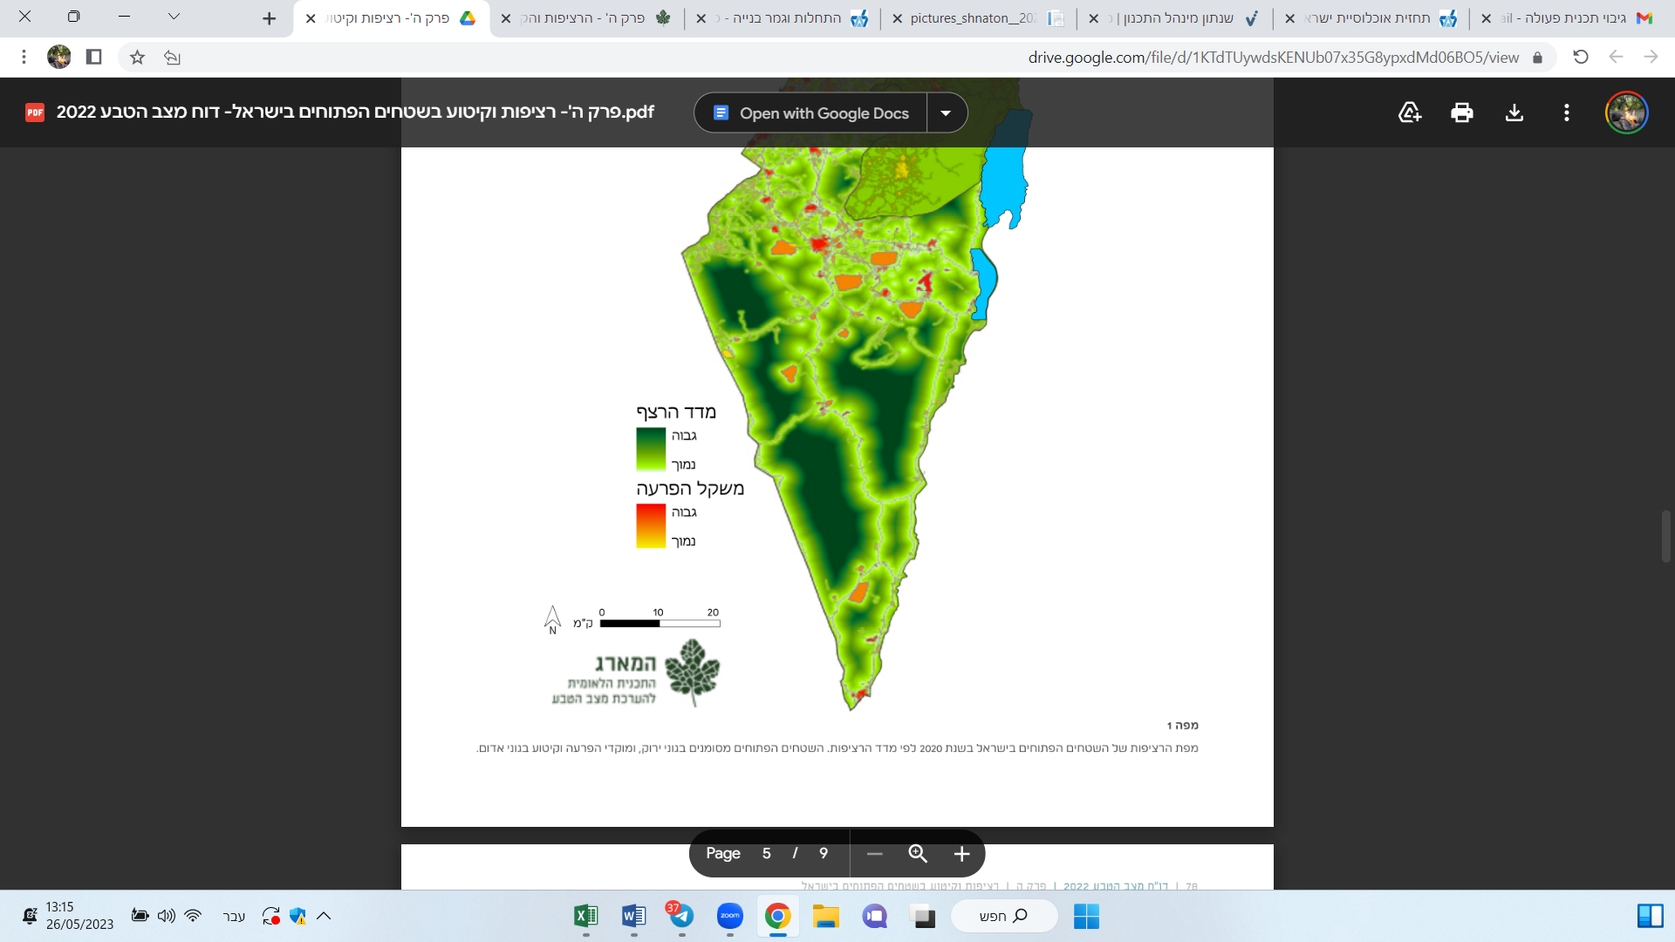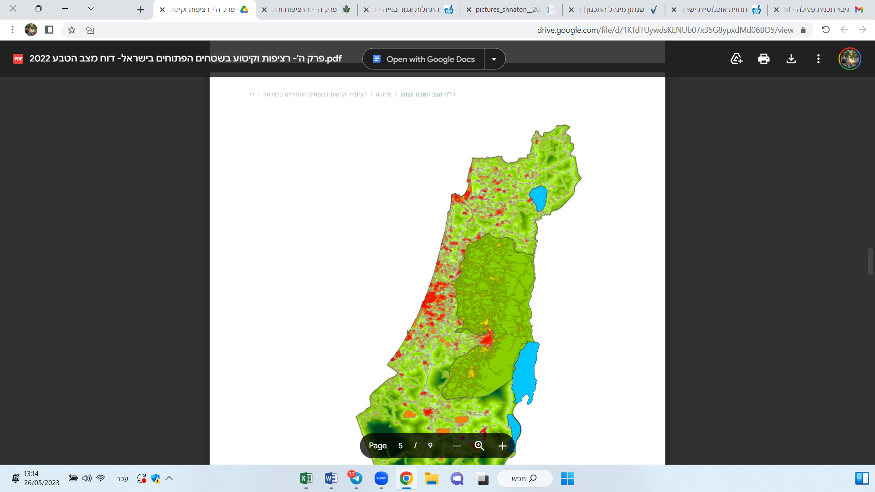

**Continuity map of open spaces in Israel, 2020**

(source: Hamaarag, State of Nature Report 2022).

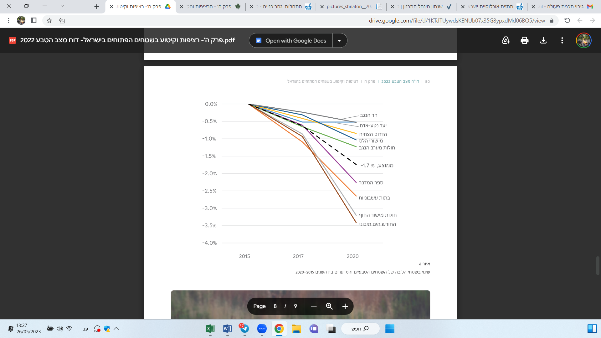

**Change (degradation and damage) in the core areas of natural and forested areas, 2015–2020**

(Source: Hamaarag, State of Nature Report 2022)

In light of this, and of other, non-chartable threats to natural resources and open spaces (e.g., littering, hunting, and other environmental violations), Israel is facing the challenge of how to maintain an adequate, high-quality, continuous supply of ecologically functional, publicly-accessible open spaces that can provide a multifunctional response to short- and long-term environmental and societal needs. However, it is clear that current spatial planning and statutory protections are insufficient to achieve this goal. In practice, it will be necessary to restore and manage the open spaces in question.

**1.2.2 Climate change**

**Global trends (the climate crisis)**

The United Nations Intergovernmental Panel on Climate Change (IPCC) has determined that the primary cause of climate change is the emission of greenhouse gases (GHG) resulting from human activity. Global GHG emissions have been on the rise since the industrial revolution, leading to the highest concentrations of greenhouse gases in the atmosphere in 800,000 years, mainly carbon dioxide (CO2) and methane (CH4). These elevated concentrations of GHG have caused the warming of the Earth’s atmosphere and oceans on a global scale (IPCC Climate Change, 2014). This warming has had a complex, powerful, and multisystemic effect on the entire climate system and other natural systems, that have ensured stable living conditions for people for hundreds of thousands of years.

The Middle East, particularly Israel, is considered a climate change hotspot, i.e., an area where climate change is most evident and significant (Waha et al., 2017). The region is expected to suffer from warming, desertification, rising sea levels and surface temperatures, and increased risks of flooding and wildfires compared to the global average.

**The importance of ecosystems in the context of the climate crisis**

For thousands of years, natural ecosystems have facilitated climate stability and life on Earth, producing oxygen, absorbing carbon, purifying and supplying water, food, energy, and more. The resilience of an ecosystem, and that of its living components, increases its ability to cope successfully with environmental pressures, such as extreme temperatures, resource scarcity, and pollution. Having a high level of fitness for dealing with environmental pressures helps the species within an ecosystem to successfully survive extreme events. This then contributes to maintaining their role in the ecosystem, and supports the continued existence of other species dependent on them, the recycling of materials, and the provision of ecosystem services that regulate the environment.

The greater the diversity of species, the higher the rate of interactions and interrelationships between a habitat’s various components, and the more complex the influence of the ecosystem’s components on each other. When one or more of an ecosystem’s components are damaged or experience a significant change in function, the dynamics between the components in the ecosystem change, as may the functioning of the entire ecosystem and the useful services it provides, including to humans.

According to several studies, nature restoration is a prerequisite for achieving the goal of keeping global warming below 2°C. Decreasing GHG emissions from degraded land and increasing natural GHG sinks are widely regarded as having the potential to contribute up to 30% of the GHG mitigation needed by 2050 (Seddon et al, 2021: Costa Domingo & Aubert, 2022). Natural Climate Solutions (NCS)—a term for a wide range of land management practices that conserve, restore, or sustainably manage natural ecosystems and working lands—could limit global warming by an additional 0.3°C by the end of the century, if fully implemented in conjunction with the rapid decarbonization of all sectors needed to achieve the IPCC emission scenario corresponding to the goals of the Paris Agreement (Rockström et al., 2021: Costa Domingo & Aubert, 2022).

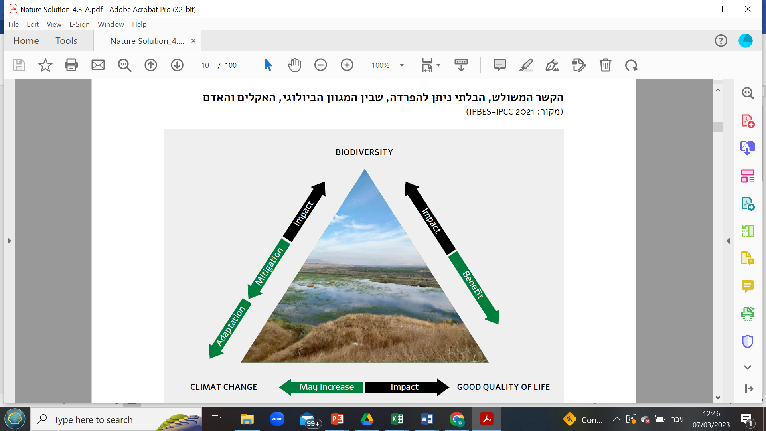

**The triple connection between biodiversity, climate, and humans.**

(Source; IPBES-IPCC 2021 Climate Change).

**Climate change and its effects on open spaces in Israel**

In light of the decrease in the amount of annual precipitation and rising average temperature in Israel, significant damage is expected `to freshwater habitats, such as streams, springs, and winter pools. Other sensitive zones include the areas between the desert belt and the Mediterranean belt, and areas with cool temperatures, such as the high Negev mountains and Mount Hermon. Groves, forests, and scrubland are also expected to be damaged by prolonged droughts and the expected increase in the frequency of wildfires. Changes in rainfall periods, a succession of dry years, and rising temperatures are also expected in Israel’s desert areas, which will affect flora and fauna, as noted in the State of Nature Report 2022 (edited by Ben-Moshe and Ranan).

The State of Nature Report (2022) also found that the frequency of wildfires in Israel is on the increase. Israel’s Mediterranean region now experiences a delay in the arrival of its first annual rainfall compared to the past. Dry periods are getting longer, and the number of hot days accompanied by strong easterly winds are increasing in frequency and intensity. Frequent wildfires cause significant damage to ecosystems and make it hard to restore them. Beyond the damage these phenomena cause to the ecosystems themselves, they also directly affect humans. Therefore, improving the functioning of open spaces will significantly contribute to the mitigations and adaptations required to address the climate crisis.

**1.2.3 The management of open spaces in Israel**

Israel’s open spaces vary widely in terms of the statutory protections that apply to them, their land designations, their uses, and, of course, the bodies that manage them. Some open spaces are intensively managed, while others are not systematically managed at all. Land management is divided among different bodies, each with different authorities and responsibilities, which sometimes result in geographical overlaps between them. Below is an overview of the main bodies that manage Israel’s open spaces and the type of sites they manage.

**The Israel Land Authority (ILA)**

The Israel Land Authority (ILA) was established in 1961 as the Israel Land Administration, as stipulated in the Israel Land Administration Law 1960. The ILA is empowered by law to manage Israel’s lands, the Jewish National Fund (KKL), and the Israel Development Authority, which together constitute about 90% of the territory of the State of Israel (around 22 million dunams). In 2010, the body was renamed the Israel Land Authority as part of a reform that was completed in August 2011. The ILA manages the land in accordance with policies set by the Israel Land Council (ILC). In addition to determining land policy, the ILC, chaired by the Minister of Construction and Housing, supervises the ILA’s activities and manages its budget. The ILA’s main areas of activity include managing the land inventory, creating reserves of publicly-owned land for national purposes, marketing lands and allocating them to various uses, dealing with leaseholders and residents, and supervising different land uses.

The Israeli Open Spaces Conservation Fund operates under the auspices of the ILA. It finances activities to aid the preservation, environmental development, and improvement of open spaces outside of built-up urban areas. These include those that are important for preserving biological diversity and ecosystems in Israel, as well as parks, recreation, and leisure areas. The Open Spaces Conservation Fund also assists other parties working to achieve its goals. Its budget is set at 1% per annum of the ILA’s total revenue in that year, meaning that the budget changes depending on the ILA’s revenue in a particular year.

To allocate a budget for its operations, each year the Open Spaces Conservation Fund publishes calls for proposals for various tracks (planning, execution and surveys, land acquisition, accessibility, and climate). Government ministries, statutory authorities, local authorities, government companies, and other bodies (which vary depending on the subject matter under consideration) may respond to these calls. The ILA has a division responsible for the appropriate and effective protection of Israel’s lands, which operates according to enforcement policies established by law and the instructions of Israel’s Attorney General. The main goals of this division are:

1. Preservation of Israel’s lands as a national, public resource for all the purposes of the ILA, and as a reserve for the benefit of the public, the environment, and future generations;

2. Supervision of the various activities carried out on Israel’s lands and to monitor their compliance with contracts and authorizations issued by the ILA and in accordance with the decisions of the ILC.

The division cooperates at the national and regional levels with various enforcement bodies, including the State Attorney's Office, the Unit for the Supervision of Open Areas (the Green Patrol), the Coordination and Enforcement Unit of the Israel Police, the Construction Supervisory Unit of the Ministry of the Interior, the supervision units of the Planning and Construction Committees, the Green Police of the Ministry of Environmental Protection, and the Ministry of Environmental Protection’s Supervisory Units.

**The Israel Nature and Parks Authority**

The Authority for Nature Conservation and National Parks (INPA) is a statutory corporation that began operating under the National Parks and Nature Reserves Law 1963 (amended in 1998 to the National Parks, Nature Reserves, National Sites, and Memorial Sites Law 1998). Some of INPA’s powers are derived from this law, which also sets out the process of declaring nature reserves, and the existence and composition of the Council of National Parks and Nature Reserves.

INPA’s main role is to protect nature, with an emphasis on natural habitats, the functioning of ecological systems, and fauna and flora biodiversity in nature reserves, national parks, and open spaces. INPA also works to protect treasures of human heritage and culture in Israel’s national parks and nature reserves, while nurturing and promoting these sites, and making them accessible to the public.

As part of its work, INPA determines which open spaces are worthy of conservation, promotes their official designation as nature reserves and national parks, and manages them. INPA is also involved in overall policy planning for Israel’s open spaces and ecological corridors. Furthermore, INPA works to conserve species by dealing with local endangered species and invasive species.

INPA is also responsible for safeguarding protected natural treasures, which are animal and plant species declared as protected by the Minister of Environmental Protection due to the value inherent in preserving them, or due to threats of their extinction.

INPA has been granted supervisory and enforcement powers throughout Israel. The powers granted to its inspectors are similar to those of police officers, including the power to perform arrests, searches, confiscate property, and file reports, and to investigate individuals who are suspected of violating the laws that INPA is responsible for enforcing.

INPA manages over 400 nature reserves, national parks, and heritage sites throughout Israel. These areas encompass a wide variety of ecosystems, such as forests, deserts, humid habitats, and coastal areas. Currently, nature reserves and parks comprise around 26% of Israel’s total land area.

In addition to conservation and ensuring public access, INPA carries out various activities to fulfill its mission. These include preventing illegal activities that harm the environment, raising public awareness and improving public education, supporting research and monitoring for nature conservation purposes, formulating conservation policies, promoting and managing visitor facilities and infrastructure in national parks and nature reserves, enforcing related laws and regulations for nature conservation, including protecting wildlife, and preventing illegal hunting and unauthorized construction in protected areas.

**The Jewish National Fund (KKL-JNF)**

The Jewish National Fund (KKL-JNF) is a nonprofit organization established in 1901 with the aim of acquiring and developing land in Israel for Jewish settlement, reforestation, and the general advancement of the Jewish state. After the establishment of the State of Israel, KKL-JNF continued its work, and its activities now include land acquisition, afforestation, water resource development, infrastructure projects, and community development.

KKL-JNF plays a central role in afforestation in Israel. As the body responsible for forestry in Israel, KKL-JNF has planted over 240 million trees across some 920,000 dunams, and manages about 800,000 dunams of natural woodland and pasture. The organization is also involved in the development of water reservoirs, irrigation systems, parks, and more.

In terms of the environment, KKL-JNF is currently focused on developing hiking trails, forestry, and research, and making forests accessible to a diverse public with changing needs. In addition to its environmental work, KKL-JNF is involved in various social and community projects.

**Regional councils**

Israel’s 54 regional councils are local authorities that encompass a number of rural settlements within a specific geographical area. Since the councils include several settlements, including the areas between and around the settlements, the regional councils control vast areas of open spaces—around 85% of the total area of open spaces in Israel. These spaces are managed in part by external bodies, including the KKL-JNF, the INPA, and various agricultural associations.

In 2015, the Federation of Regional Councils, in partnership with various central and local government and civil society organizations, published a “Guide to Planning and Managing Open Spaces for Regional Councils” (<https://moazot.files.wordpress.com/2015/09/main-guide_h_lowres.pdf>). The guide was intended to serve as an “innovative tool designed to enhance opportunities and reduce threats to open spaces by creating an operative ‘toolbox’ for planning and managing open spaces at a regional level, under the leadership of the regional councils.”

According to the late Shmulik Rifkin, then the CEO of the Federation of Regional Councils, the guide was intended as a tool not for taking ownership of open spaces, but rather for taking responsibility for them. It includes various mechanisms for intervening in open spaces, and each authority can choose which are relevant according to its specific needs, the issues arising in each open space, the importance of a particular open space, and the authority’s ability to manage the array of open spaces within its designated territory.

**Drainage** **authorities**

Israel’s drainage authorities are independent statutory bodies established in accordance with the Drainage and Flood Control Law 1957, which defined their role as regulating drainage infrastructures in their specific designated areas. Until 1996, 26 drainage authorities were operating, covering 40% of the country’s area. In 1996, following lessons learned from the winter floods of 1991–1992, the drainage authorities were reorganized. Currently, there are 11 drainage authorities operating across the whole of Israel.

The Minister of Agriculture is responsible for implementing the Drainage and Flood Control Law 1997, and, in conjunction with the Water Commissioner, has supervisory authority over the drainage authorities. The jurisdiction of the drainage authorities is determined by decree of the Minister of Agriculture in consultation with the Minister of the Interior.

The current boundaries of each drainage authority were determined according to a basin concept that refers to a natural and complete drainage basin shared by all areas from the watershed inward.

In addition to structural changes, the drainage authorities’ powers have been expanded. Since 2003, the Minister of Environmental Protection, by virtue of authority granted by the Streams and Springs Authorities Law 1965, assigned the functions of stream authorities to most of the drainage authorities in Israel.

The tasks of the drainage authorities include preventing flood damage, performing maintenance operations on Israel’s streams to allow free flow, preserving the landscape and nature along the stream, and restoring and regulating the flow of channels in the streams. The authorities also actively participate in the deliberations of planning bodies regarding the upkeep of Israel’s streams and preventing their blockage and diversion, as well as plan and develop parks and trails along river channels.

Authorities with powers as both drainage and river authorities operate by virtue of the Drainage and Flood Control Law 1957, the Drainage Order 1960, the Drainage Proclamation 1996, the Streams and Springs Authorities Decree 2003, the Streams and Springs Authorities Law 1965, and the Rivers and Springs Authorities Decree 2003, which assigned river authority powers to the drainage authorities.

**River Authorities**

Israel’s river authorities are statutory bodies established according to the Rivers and Springs Authorities Law 1965 and in accordance with government decree. The river authorities operate under the auspices of the Ministry of Environmental Protection, and focus mainly on programs and projects for river restoration, public access, and prevention of river and tributary pollution.

Israel’s river authorities incorporate various public bodies, including local authorities that are located along the river, government ministries, and other bodies. There are a limited number of independent river authorities in Israel today (Kishon, Yarkon).

**Local Authority Clusters**

Local authority clusters are voluntary associations of adjacent local authorities that have decided to cooperate to take advantage of opportunities of scale. The clusters have a number of goals, including streamlining the provision of municipal services by pooling resources, making new services accessible by increasing regional entry thresholds, regional management of areas that cross municipal borders, and advancing regional development by leading and incorporating regional activities across a variety of areas. A secondary goal is to strengthen regional cohesion by working to reduce disparities and cultivating shared living space between communities.

The clusters have undertaken preliminary work around open spaces in recent years, leading to the preparation of master plans and management strategies for these spaces, including in the Eastern Negev, Western Negev, and Golan Heights. In recent years, some clusters have developed strategic plans and action plans to prepare for climate change. Clusters in rural areas are also engaged with regional, national, and global trends, such as climate change, structural changes, and global processes. Given these concerns, and in light of the increasing importance of discussions around food security, there is an opportunity for clusters to become involved in food security and agriculture while also situating their open spaces as sustainable tourism sites. This regional perspective, which views open spaces as providing multi-benefit opportunities, can drive sustainable management thinking around open spaces that are not protected sites (see the Negev Climate Change Assessment Program, Western Negev Cluster, Rural Spaces chapter).

**Regional Management**

Occasionally, open spaces have regional administrations that were established in part by other bodies, such as the river and drainage authorities. The HaShikma Park Administration is an active example of this the in HaShikma Basin area. This area is managed in practice and defined statutorily by District Outline Plan 43/14/4, with the aim of preserving and maintaining valuable content for open spaces. It is also tasked with preserving an open and continuous chain of open spaces as much as possible.

Approved in 2012, the District Outline Plan stipulated the creation of a joint administration of all stakeholders working in the field to develop the concept of spatial and basin development in the region. HaShikma Park covers around 330,000 dunams and is spread over six regional councils: Sha’ar HaNegev, Hof Ashkelon, Lachish, Merhavim, Shapir, and Bnei Shimon. Ninety-three percent of HaShikma Park comprises natural or agricultural lands that form a natural ecological corridor and are a vital and continuous green lung for the area.

The Yeruham Lake Park Administration, operated by the HaShikma-Bashur Drainage and Streams Authority, is responsible for managing the Yeruham Lake Park, as well as raising funds for the park and managing its operational and maintenance budgets. It is also responsible for promoting projects within the park, including establishing a walking and cycling trail and an overnight parking lot and campsite, restoring bodies of water in the park, and creating a conference center. Active partners include the KKL-JNF, the Yeruham Local Council, the Economic Society for the Development of Yeruham, and the HaShikma-Bashur Drainage Authority. Other partners include the Ministry of Environmental Protection, the Ministry of Tourism, the Israel Government Tourist Company, the Ministry of Agriculture, the Ministry for the Development of the Negev and the Galilee, and the Ministry of the Interior.

**Biosphere Reserves / Spaces**

Biosphere reserves are sites that encourage solutions to help bridge the gap between biodiversity and development needs. Such sites can gain international recognition from UNESCO after they have been designated as biosphere reserves by the country in which they are located. Biosphere reserves are intended to fulfill three basic roles, which complement and reinforce each other:

1. Conservation—contributing to the preservation of landscapes, ecosystems, species, and genetic diversity;

2. Development—encouraging economic and human development that is sustainable from a sociocultural and ecological point of view;

3. Logistics—providing support for research, monitoring, education, and information exchange on conservation and development issues at the local, national, and global levels.

The concept of biosphere reserves was developed by UNESCO in the 1970s to establish a scientific basis for improving the relationship between humans and their environment. Sites are declared biosphere reserves by UNESCO in light of their ecological and biogeographical uniqueness, and based on a combination of community needs and nature conservation. Unlike protected areas such as nature reserves, parks, and forests, biosphere reserves are not granted statutory protection, and there is no obligation to earmark them on urban building plans.

In 1997, following the Carmel Forest fire, the government declared Israel’s first biosphere reserve in Mount Carmel and Carmel Beach, covering an area of 266,600 dunams. In addition to Carmel Park and the populated areas on Mount Carmel (excepting Haifa) it incorporates the coastal strip and the southern area of Mount Carmel.

Israel’s second biosphere reserve, Ramat Menashe (Megiddo) in northern Israel, gained international recognition from UNESCO in June 2011. This reserve, covering 197,000 dunams, includes pastures, agricultural fields, planted and natural oak forests, a variety of plants, and rare natural vegetation. All 13 of the Megiddo Regional Council’s settlements are located within the Megiddo Biosphere Reserve, and include nine kibbutzim, three moshavim, and one moshava.

Israel intends to declare a third area, the Judean Lowlands in the southern central part of the country, as a biosphere reserve. This area boasts three national parks rich biological diversity, over 1,300 archeological and heritage sites, and branched habitable cave systems. The area is sparsely populated and most of it is covered in natural and planted forests.

**Private Management—Ramat Hanadiv Park**

Israel also has a few examples of private entities that manage open spaces, including the Yad Hanadiv Foundation, which manages the Ramat Hanadiv Park. This nature park combines the preservation of natural treasures, the landscape, and heritage sites with activities and access for the public, research, and education. Ramat Hanadiv Park covers about 4,500 dunams and contains natural Mediterranean vegetation along with pine and cypress groves that were planted in the 1970s and 1980s by the KKL-JNF. When the KKL-JNF managed the park during the 1970s, it planted pine and cypress groves on more than 18% of its area. The restored habitat is now open to researchers and students, as well as for public leisure and recreation activities.

The idea of transforming the area into a nature park that would be accessible to the public free of charge was developed in the 1980s, when the Society for the Protection of Nature (SPNI) partnered with Yad Hanadiv to develop a sustainable approach to the park’s interface and development. Since then, the park’s management has been based on pursuing four main goals that continue to guide it today:

1. Conducting surveys and studies to gather basic knowledge about the ecosystem Ramat Hanadiv;

2. Conducting archaeological excavations and uncovering ancient sites within the park;

3. Establishing an infrastructure for hiking and cycling.

4. Engaging in interface (active management) to preserve and cultivate various habitats to support a rich and attractive biological diversity. Various active management activities were undertaken in the park, including introducing grazing herds of cattle and goats, manually removing bushes, constructing fencing to protect rare plant species, and restoring and resettling endangered species.

**Management of agricultural lands**

In addition to the many diverse bodies noted above, there are a number of additional entities that are responsible for managing agricultural lands, and that have a significant impact on areas beyond these lands. These include the agricultural committees that sit within the regional councils (some of these are unstaffed), agricultural organizations (such as Moshavei Hanegev and Hadod Moshe), businesses (such as Dorot Control Valves and Yad Mordechai), sectoral organizations (such as the Israeli Association of Field Crop Farmers and the Israel Fruit Growers Association), various local associations (rural tourism), and private individuals (commercial farmers and estate owners).

**1.2.4 The 2040 Strategic Plan—Open Spaces Chapter**

Over the years, various dedicated statutory plans for Israel’s open areas, such as nature reserves, forests, river areas, and more, have been incorporated within other plans, such as National Outline Plan 35 and various district outline plans. However, managing open spaces through statutory plans is challenging unless management mechanisms have been embedded within the plans, as is the case with HaShikma Park.

In the years 2017–2022, the 2040 Strategic Plan was developed by the Israel Planning Administration in collaboration with other government and civil society organizations. The Open Spaces Chapter was developed within this framework. As a non-statutory project, it also included recommendations and intentions for other areas.

The Open Spaces Chapter is concerned with ensuring the existence of natural and cultural resources in Israel’s open spaces, and the provision of a wide range of services, functions, and uses for human well-being, health, social resilience, a stable environment, and a strong economy. The chapter includes four key issues within its long-term vision:

* Ecology (biodiversity resources);
* Water (water resources);
* Culture (heritage, landscape, and leisure);
* Agriculture (ensuring the quality, availability, and accessibility of agricultural produce for the whole population).

The chapter includes a draft, an explanatory document, and policy documents for the four key issues (ecology, water, culture, and agriculture). It divides open spaces into two main categories:

* Protected spaces;
* Multifunctional areas within designated open spaces.

The Open Spaces Chapter has two main strategic roles:

* Maintaining the quality of open spaces;
* Directing sustainable development and optimizing land use. This includes locating and defining valuable open spaces that are rich in natural and cultural resources, and defining other open spaces as multifunctional, with the aim of creating shared dynamic space for land use, processes, activities, and stakeholders.

The strategic plan has been discussed on several occasions in regional and national planning bodies. At a meeting on November 16, 2021, Israel’s Sub-Committee for Principled Planning Issues (VALNTA) decided, among other things, to promote various aspects around the issue of open spaces, including:

* Promoting nature sites and green infrastructure in cities;
* Promoting cultural complexes;
* Promoting a master plan for hiking trails;
* **Locating areas of strategic importance for scenic and/or ecological restoration;**
* Promoting a masterplan for agricultural lands.

**Insights from the Trends Chapter**

Israel is a densely-populated country, and its rate of construction and development is increasing. These trends increase pressure on natural resources and harm open spaces. At the same time, climate change imposes an additional burden on Israel’s open spaces and ecosystems, which must adapt to these developments. Despite these challenges, there is no single body in charge of managing the array of different lands in Israel. Instead, land management occurs in various “silos” depending on the purpose of the land, the type of area, and the body in charge of managing it. Each land management body then advances issues it deems relevant to its interests. As a result, it has been difficult to create collaborations, advance a focused and effective enforcement policy, or establish common positions. There have also been difficulties in overcoming municipal boundaries to promote shared goals. The resources for managing open spaces are limited, and even when a particular open space is heavily used by the wider public, the burden of maintaining it falls mainly on the regional council, which has no dedicated budget or government support for this matter.

The conclusion is that without meaningful action to ensure the integrated and efficient management of Israel’s open spaces, the rate of species extinctions will accelerate and ecosystem function will continue to deteriorate. Meanwhile, the benefits and ecological services these open spaces provide for human well-being, including mitigating the effects of climate change, will likely shrink.

Good management can help make Israel’s open spaces accessible to the public, according to their capacity, sensitivity, and proximity to populated areas. This will directly contribute to residents’ well-being, and indirectly reduce the burden posed by visitors to sensitive open spaces of high ecological value.

**1.3 Open spaces in which ecological function and work methodology can be improved**

Defining which of Israel’s open spaces are suitable for improvement in terms of their ecological function is a complex task. Some argue that most of Israel’s open spaces have been ecologically damaged, and thus can and should be restored. Others contend that only open spaces that have been blatantly harmed, or even built on, should be considered damaged. While some seek to prioritize the social aspects of open spaces, others emphasize focusing on ecological aspects.

In this effort, we decided to act along two tracks. First, an ecological track—improving the ecological function of open spaces, locating ecological bottlenecks, and finding other open spaces whose ecological function can be improved. Second, a social track—rehabilitating and improving access to open spaces close to populated areas, which will create a distinct social benefit.

To improve our understanding of both these tracks, we gathered information and data on them. For the ecological track, we obtained data on ecological bottlenecks as mapped by the Israel Parks Authority and other bodies. We also gathered data on open spaces that require restoration based on the work of the Society for the Protection of Nature in Israel (SPNI), the Open Landscape Institute (OLI), the Israel Parks Authority (IPA), and recommendations from the clusters. For the social track, we collected data on open spaces recommended for restoration by the clusters and other bodies operating in the field.

To carry out this work, we issued an appeal to all local authority clusters via the regional council center. Several clusters responded to our appeal. Following conversations and preliminary meetings with the clusters, we decided to choose four pilot areas for further work. The criteria for selecting the clusters were as follows:

1. Willingness of the cluster to actively engage with the work;

2. Diversity among the partner clusters in terms of geography, function, types of settlement, types of open spaces, and types of population;

3. The cluster’s existing work on the subject;

4. The presence of a contact at the cluster with whom we could work;

5. Examination of a representative area, from which it would be possible to extrapolate to other areas in the country. For example, a cluster that deals with the link between agricultural issues and natural treasures;

6. Connection to areas where many surveys had been conducted (by the Open Landscape Institute, the Israel Parks Authority, and other bodies), from which it is possible to begin work on thematic thinking from various directions.

The clusters we selected for the pilot were the Southern Sorek cluster, the Kinneret Valleys cluster, the Eastern Negev cluster, and the Western Negev cluster. The work in each cluster was undertaken slightly differently in each cluster and in varying time frames. The work was adapted to suit the characteristics of the cluster’s own work and in response to additional data collected in the process (such as surveys).

Below is a diagram of our work methodology. The table in Appendix A describes the process in more detail.

**Work methodology: Collection and analysis (in green), summary of steps and actions (in red)**

Concentration of ecological bottlenecks

Spaces suggested for restoration by individuals in the cluster (inc. farmers), from IPA, SPNI, Environmental Protection, JNF

Collating spaces from existing programs and surveys within authorities in clusters/OLI (according to cross-cutting issues)

Statutory planning and uses

Physical status

Stakeholders

Ecological treasures

Social treasures

Multiyear plan

Ranking sites for treatment

Current status of each site

Desired courses of action

Social benefits

Ecological benefits

Climate benefits

Implementation applications

**2.0 Mapping, characterizing, and prioritizing open spaces for improving ecological function**

Below is a list of all the sites that were received from various professionals, including both the ecological and social tracks, in a concise format documenting each site. A detailed page showing the current status of each site is attached in Appendix B:

Insert an initial table with Ya’ara from the mappings we started

|  |  |  |  |  |  |  |  |  |
| --- | --- | --- | --- | --- | --- | --- | --- | --- |
| Name of Site | Submitted By | Purpose  of Land | Uses  of Area | Physical  Condition | Habitat Type | Priority Ranking | Size & Proximity  of Population | Stake-  holders |
|  |  |  |  |  |  |  |  |  |
|  |  |  |  |  |  |  |  |  |
|  |  |  |  |  |  |  |  |  |
|  |  |  |  |  |  |  |  |  |
|  |  |  |  |  |  |  |  |  |

Below is a map of all the sites

Insert an initial table with Yaara from the mappings we started

Asaf, in fact this is where we have gotten to, but I have already continued to create a working template for the rest, we need to think about how to present it here, and if so, then how to tabulate Glazer’s report, and of course we still need to discuss it with partners.

**2.2 Prioritization of sites for restoration (ecological and social tracks)**

All the sites submitted by the various bodies were/will be analyzed to decide which are high priorities for investment in restoration and for which track (for example, social or ecological). Prioritization of the sites was carried out by […], as these two tracks sometimes, but not always, overlap. The sites were sorted into two tracks, one designated for ecological restoration and the other for social restoration and increased accessibility to the public. When prioritizing, we considered any climate, ecological, and social benefits, as well as the potential for improving the site. We created a prioritization table that includes all the sites. Those deemed the highest priority for restoration are listed first, followed by those of lower priority and/or potential. The importance of restoration is assessed by considering the following factors: the name of the site, climate benefits, ecological benefits, and social benefits, and the potential for realization.

|  |  |  |  |  |  |  |  |  |  |
| --- | --- | --- | --- | --- | --- | --- | --- | --- | --- |
| Importance of restoration | Name of site | Climate benefits | | Ecological benefits | | | Social benefits | | Potential for realization |
| Carbon fixation/reducing heat islands | Preventing runoff | Rare habitat | Valuable habitat | Priority status | Size of nearby population | Distance of nearby population |
|  |  |  |  |  |  |  |  |  |  |
|  |  |  |  |  |  |  |  |  |  |
|  |  |  |  |  |  |  |  |  |  |
|  |  |  |  |  |  |  |  |  |  |

**3.0 Optimal courses of action for sites rated above x**

To focus on the optimal courses of action and make recommendations for funding methods and physical operations for each site, we needed to create a design study for high priority sites. Based on these studies, we made recommendations for the management, funding methods, and physical operations to be carried out for each site. Funding methods are divided into site-specific and systemic methods.

Below is a design study, specific funding methods, and physical operations needed to complete each site.

Site 1:

Site 2:

Site 3:

**Recommendations for systemic funding tools**

The following are funding recommendations relevant for a large number of sites. Because these are systemic tools, we recommend promoting them in a systemic manner to relevant parties.

**4.0 Multiyear plan and recommendations for implementation**

Below are the project files for each site, which also include the relevant partnerships.

Comprehensive recommendations for national-level policies and actions.

**Appendices**

**A. Detailed methodology**

The main goals are to improve the ecological function of open spaces and the accessibility and development of open spaces to promote the population’s well-being and address climate change.

Sub-goals include improving the transfer of fauna in ecological bottlenecks, restoring ecological bottlenecks, improving damaged ecosystems’ function, improving agricultural systems’ agroecological functioning, increasing the inventory of natural open spaces accessible to the public for leisure (e.g., recreation or hiking), strengthening the socioeconomic resilience of those living near open spaces, and reducing visitor load on sensitive open spaces.

Mapping involves creating an "if" map that includes potential bottlenecks and accepting spaces for consideration by IPA, SPNI, OLI, as well as clusters, including all proposals for open spaces requiring improved ecological functioning. This is done in collaboration with the Planning Administration, IPA, JNF, drainage authorities, and OLI. Another "if" map is created that includes areas for enhancing accessibility and improving human well-being, to be determined by local authority clusters, councils, and bodies working with them.

The physical condition of each site is being documented again, focusing on existing infrastructure and condition, accessibility, and natural treasures (as a site card, with assistance from the OLI). Depending on the quantity identified, prioritization may be needed at this stage.

A sorting step will be taken if required, which will include documenting physical barriers, directional documentation, access roads, proximity to populated areas, and actual uses (promenades, bicycles, picnics, and so on).

Stakeholder mapping and characterization will also be performed. A set of recommendations to improve function and restoration will be formed. At this stage, efforts will be made to examine the extent of the impact of restoration to optimally address the climate crisis. The open space and programmatic content will be categorized.

A work plan will be formed and implementation mechanisms with the cluster (execution, management, economic tools) will be built. A five-year plan for implementation (prioritization and funding methods for implementation) will be prepared.

|  |  |  |  |  |  |  |  |  |  |  |  |  |  |
| --- | --- | --- | --- | --- | --- | --- | --- | --- | --- | --- | --- | --- | --- |
| Stage in process | Aim for 1 | | | | Notes | | | | Aim for 2 | | | | Notes |
| Setting main goals | Improving ecological function of open spaces | | | |  | | | | Improvement, accessibility and development of open spaces for the well-being of population and for addressing climate crisis | | | |  |
| Setting sub-goals | Improving transfer of fauna in ecological bottlenecks | Restora-  tion of ecological bottlenecks | Improving function of damaged ecosystems | Improving agroecological functioning of agricultural systems |  | | | | Increasing inventory of natural open spaces accessible to public for leisure/ recreation hiking | Strengthening socioeconomic resilience of those living near open spaces | Reducing visitor load from sensitive open spaces | |  |
| Mapping | Creating an “if” map that includes potential bottlenecks | | Accepting spaces for consideration by IPA, SPNI, OLI, clusters to create “if” map including all proposals for open spaces requiring improved ecological functioning | | In collaboration with Planning Administration, IPA, JNF, drainage authorities, OLI | | | | Creating an "if" map including areas for accessibility and improving human well-being | | | | TBD by local authority clusters & councils & bodies working with them |
| Validation of bottlenecks and additional open spaces identified as potentials with the Planning Administration | | | |  | | | |
| Documenting the physical condition of each site: nature, landscape, heritage, uses, purposes, hazards  (as a site map, with assistance of the OLI) | | | | Depending on quantity identified, may need prioritization at this stage | | | | Documenting physical condition of each site: existing infrastructure & condition, accessibility, natural treasures  (as a site map, with assistance of the OLI) | | | | Depending on quantity identified, may need prioritization at this stage |
| Sorting step if required | | | | | | | | | | | | |
|  | Documenting physical barriers | | | | |  | | | Directional documentation, access roads, proximity to populated areas, actual uses (promenades, bicycles, picnics, and so on) | | |  | |
|  | Stakeholder mapping | | | | | | | | | | | | |
| Characterization | Form set of recommendations to improve function / restoration | | | | | | At this stage, effort will be made to examine extent of impact of restoration to optimally address the climate crisis | Characterize the open space and programmatic content | | | | At this stage, effort will be made to examine extent of impact of restoration to optimally address the climate crisis | |
| Form work plan | Build implementation mechanisms with cluster (execution, management, economic tools) | | | | | | | | | | | | |
| Prepare five-year plan for implementation (prioritization & funding methods for implementation) | | | | | | | | | | | | |

**Appendix C: Details of the current status of each site**

**Name of site:**

**Submitting body:**

**Land designation:**

**Uses:**

**Physical condition:**

**Habitat type:**

**Priority status:**

**Extent and proximity of population:**

**Stakeholders:**