Figure 1: Study subjects

Control group (term)

N=82

Completed questionnaire

52

No questionnaire

30

LFT

42

No LFT

10

Late preterm

N=134

Completed questionnaire

86

No questionnaire

48

LFT

65

No LFT

21

LFT, lung function testing

Table 1: Demographics

|  |  |  |  |  |
| --- | --- | --- | --- | --- |
| Statistical significance  (P-value) | Term | Late preterm |  | |
| N (%) | N (%) |
| 0.38 | (56.1) 46 | (50) 67 | Male | Gender |
| (43.9) 36 | (50) 67 | Female |
| 0.30 | (100) 81 | (97) 130 | Arab | Ethnicity |
| (0) 0 | (0.7) 1 | Jewish |
| (0) 0 | (2.2) 3 | Other |
| <0.001 | (53.1) 43 | (16.5) 22 | Christian | Religion |
| (46.9) 38 | (82) 109 | Muslim |
| (0) 0 | (0.8) 1 | Jewish |
| (0) 0 | (0.8) 1 | Druze |
| <0.001 | (68.3) 56 | (40.6) 54 | Urban | Type of residence |
| (31.7) 26 | (59.4) 79 | Non-urban |
| 0.30 | (54.7) 29 | (52.3) 45 | Employed | Father’s Occupation |
| (43.4) 23 | (39.5) 34 | Self-Employed |
| (1.9) 1 | (8.1) 7 | Unemployed |
| <0.001 | (67.9) 35 | (46.5) 40 | Salaried worker | Mother’s occupation |
| (11.3) 6 | (3.5) 3 | Self-Employed |
| (20.8) 11 | (50) 43 | Not working |

Table 2: Neonatal Course

|  |  |  |  |  |
| --- | --- | --- | --- | --- |
| Statistical significance  (P-value) | Term | Late preterm |  | |
| N (%) | N (%) |
| <0.001 | (3.7) 3 | (22.4) 30 | Complicated Pregnancy | |
| 0.01 | (0) 0 | (50) 17 | Gestational Hypertension | Pregnancy complications (if present) |
| (66.6) 2 | (11.7) 4 | Gestational Diabetes |
| (33.3) 1 | (38.2) 13 | Other |
| 0.02 | (7.3) 6 | (18.7) 25 | Maternal comorbidities | |
| 0.003 | (17.1) 14 | (26.1) 35 | Winter | Birth season |
| (12.2) 10 | (28.4) 38 | Spring |
| (25.6) 21 | (16.4) 22 | Summer |
| (45.1) 37 | (29.1) 39 | Fall |
| <0.001 | (71.6) 58 | (41) 55 | Normal - Vaginal | Birth method |
| (22.2) 18 | (35.8) 48 | Planned Caesarean Delivery |
| (2.5) 2 | (20.1) 27 | Emergent Caesarean Delivery |
| (3.7) 3 | (3) 4 | Vacuum-Assisted |
| 0.18 | (92.6) 75 | (80.9) 106 | Cephalic | Fetal presentation |
| (7.4) 6 | (16.8) 22 | Breech |
| (0) 0 | (2.2) 3 | Other |
| <0.001 | (100) 82 | (64.2) 86 | Yes (Twins) | Multiple gestation |
| (0) 0 | (33.6) 45 | No |
| (0) 0 | (2.2) 3 | Triplets |

Table 3: Neonatal course

|  |  |  |  |
| --- | --- | --- | --- |
| Statistical significance  (P-value) | Term | Late preterm |  |
| N (%) | N (%) |
| <0.001 | 0 (0) | (14.9) 20 | Respiratory complications |
| 0 (0) | (6.7) 9 | RDS |
| 0 (0) | (5.2) 7 | TTN |
| 0.002 | 0 (0) | (15.8) 21 | Oxygen use |
| 0.53 | 0 (0) | (0.7) 1 | Treatment with surfactant |
| 0.20 | 0 (0) | (3) 4 | Mechanical ventilation |

RDS, neonatal respiratory distress syndrome; TTN, Transient tachypnea of the newborn

Figure 2: Neonatal Course

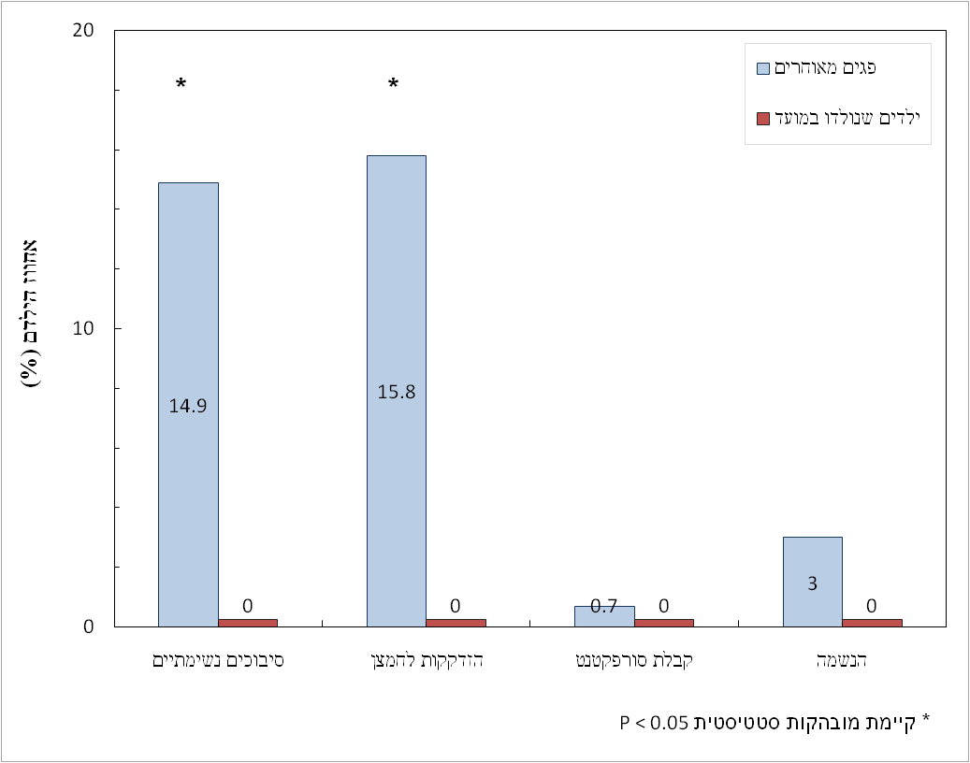

Table 4: Health data

|  |  |  |  |
| --- | --- | --- | --- |
| Statistical significance  (P- value) | Term | Late preterm |  |
| N (%) | N (%) |
| 0.71 | (2.04) 16.21 | (2.5) 16.38 | BMI |
| 0.045 | (63.5) 33 | (79.1) 68 | Use of inhalation device |
| 0.79 | (55.8) 29 | (58.1) 50 | Treatment with systemic corticosteroids |
| 0.01 | (17.3) 9 | (37.2) 32 | Diagnosis of asthma by physician |
| 0.97 | (15.4) 8 | (15.1) 13 | Prophylactic treatment for asthma |
| 0.03 | (3.8) 2 | (16.3) 14 | Hospitalization with respiratory problems |
| 0.10 | (7.7) 4 | (16.3) 14 | ER visits for respiratory problems |
| 0.35 | (7.7) 4 | (12.8) 11 | Recurrent ear infections |

BMI, body mass index; ER, emergency room

Table 5: Family history of Allergy and Asthma

|  |  |  |  |
| --- | --- | --- | --- |
| Statistical significance (P value) | Term | Late preterm | Family history: |
| N (%) | N (%) |
| 0.28 | (7.7) 4 | (3.5) 3 | Asthma – Father |
| 0.82 | (3.8) 2 | (4.7) 4 | Asthma - Mother |
| 0.66 | (19.2) 10 | (16.3) 14 | Asthma - Siblings |
| 0.77 | (9.6) 5 | (8.1) 7 | Allergic Rhinitis - Father |
| 0.59 | (13.5) 7 | (10.5) 9 | Allergic Rhinitis- Mother |
| 0.30 | (3.8) 2 | (1.2) 1 | Allergic Rhinitis - Siblings |
| 0.08 | (0) 0 | (5.8) 5 | Atopic Dermatitis – Father |
| 0.58 | (9.6) 5 | (7) 6 | Atopic Dermatitis – Mother |
| 0.06 | (13.5) 7 | (4.7) 4 | Atopic Dermatitis – Siblings |

Table 6: Lung Function Tests

|  |  |  |  |
| --- | --- | --- | --- |
| Statistical significance (P value) | Term | Late preterm |  |
| Mean (%) ±SD | Mean (%) ±SD |
| 0.007 | 15± 99 | 11± 92 | FEV1 |
| 0.007 | 13± 99 | 12± 98 | FVC |
| 0.69 | 6± 90 | 6± 91 | FEV1/FVC |
| 0.008 | 29± 102 | 17± 90 | FEF25-75 |

FEV1, forced expiratory volume at 1 second; FVC, forced vital capacity; FEF25-75, forced expiratory flow at 25% to 75% of FVC

Figure 3: Lung function Testing

