Cashless payments: where is Japan now, and where does it need to go?

　　　　　　　　　　　　　　　　　　　　　　Yuri Okina, Chairperson of the Institute The Japan Research Institute, Limited.

**Why is Japan encouraging cashless payments?**

The current Japanese government is promoting cashless payments as a growth strategy. There are three reasons for this. First, cashless transactions make life more convenient for consumers and stimulate consumption. Public transportation is much easier to use with prepaid transportation cards; foreign tourists spend more when they have payment options other than cash; and so on. Second, cashless transactions lead to improved productivity in small and medium enterprises. For understaffed small and mid-sized restaurants and stores, closing the cash register is a labor- and time-intensive task. Cashless payments can ease some of that burden. Finally, cashless payments yield data about the purchase history of individuals that is increasingly leveraged by a range of promising services. Overseas e-commerce platforms like Amazon and Alibaba collect "big data" about the online purchases and behavior of individual customers. They then analyze that data and use it to provide shoppers with customized and convenient services.

**Government indicators and the current state of the cashless economy**

In its *Investments for the Future Strategy* document, the Japanese government outlined plans to double the percentage of cashless payments from the current 20% to 40%. This 20% includes only credit cards, debit cards, and e-money, and is calculated using total household spending as the denominator. The government prefers this calculation method because it results in a number that can be used for international comparisons. Based on this number alone, however, Japan ranks second to last among advanced countries for use of cashless payment methods, ahead of only Germany. The Ministry of Economy, Trade and Industry has always highlighted four issues with the 20% figure. The first issue is that the denominator includes imputed rent of homes. Second, the 20% figure does not include transfers of money between bank accounts. Third, it also does not include services that use smartphone apps to facilitate transactions. Fourth, the figure includes the use of corporate credit cards.

To make a more accurate assessment of the current state of the cashless economy in Japan, we conducted a questionnaire survey of 3,000 individuals in August 2018 (contract research by the Nippon Institute for Research Advancement (NIRA) for Nikkei Research Inc). We collected responses until we achieved ratios of participants that matched those in the Basic Residents Register in terms of gender, age, place of residence, and similar indicators. We divided the items in the National Survey of Family Income and Expenditure into 38 categories of goods and services, then asked our survey participants to report on their consumption of these goods and services and how they paid for them. Participants also reported characteristics such as employment status and household income. This survey found that about 50% of purchases made for private consumption were paid for using cashless methods (Figure 1), validating the four concerns raised above. These results cannot be compared to figures from other countries, so they do not provide definitive proof. However, in combination with the fact that Japan was a forerunner in the development of interbank remittance services for payment of tuition fees, electricity bills, and similar, our results suggest that Japan may not be lagging behind other countries for cashless payments.

(Figure 1) Percentage of cashless payments by payment method

|  |  |
| --- | --- |
| Percentage of cashless payments | 51.8 |
| Credit cards | 31.4 |
| Direct debit | 10.5 |
| Prepaid e-money | 5.0 |
| Online banking | 1.4 |
| Cash card transfers | 0.9 |
| Debit cards | 0.8 |
| Cryptocurrency | 0.7 |

**Where are cashless payments slow to gain traction?**

The survey revealed some other interesting trends. First, a closer look at the use of cashless payment methods by annual household income reveals that individuals with more disposable income make a higher percentage of payments using cashless methods (Figure 2). A regression analysis of the results also reveals that individuals who are in regular employment and have a high educational background pay with credit cards more often. This suggests that the increase in cashless transactions in Japan is driven by individuals who enjoy a stable socio-economic position that allows for easy use of credit cards.

(Figure 2) Percentage of cashless payments by annual household income

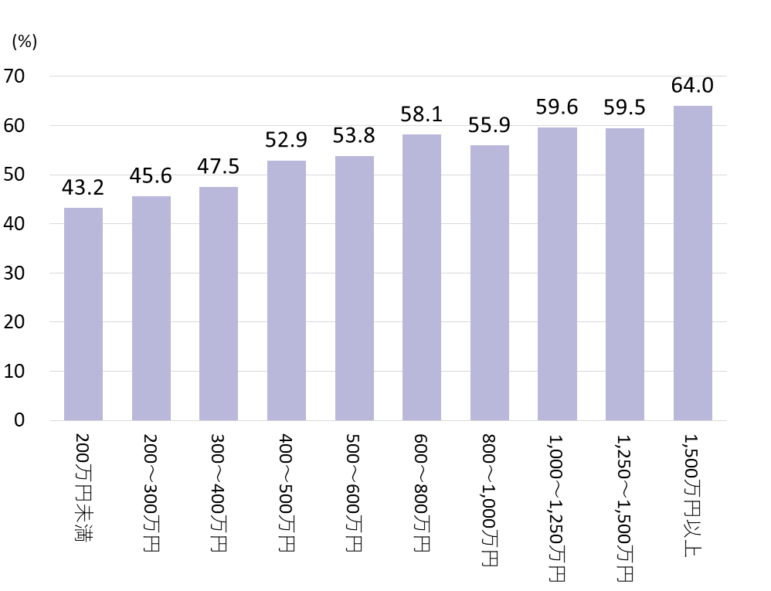  
An analysis of the percentage of cashless payments by region revealed that residents of urban areas, such as the Tokyo metropolitan area, frequently pay cashless. The percentage of cashless payments is lower among residents of the Hokuriku region, the island of Shikoku, and the Kinki region (except the Osaka, Kyoto, and Kobe metropolitan area). The results do show that cashless payments have become more prevalent in the Hokuriku region over the last three years (Figure 3). This is most likely because of tourism-boosting measures such as the introduction of e-money and prepaid transportation cards. Such initiatives may close regional gaps in the use of cashless payment methods.

(Figure 3) Percentage of cashless payments by region

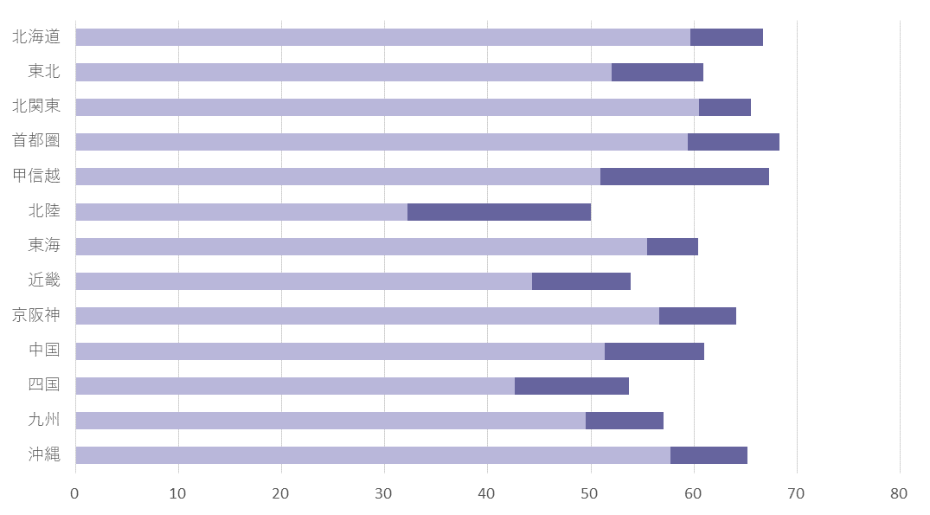

　(Note) The lighter bar shows the percentage of cashless payments three years ago.

**Japan remains a cash-oriented society**

Figure 4 shows which goods and services are often paid for in cash in Japan. Cash is still frequently used to facilitate exchanges of money between individuals, for example, for ceremonial occasions, remittances, pocket money, and gifts to family members. Individuals also turn to cash to pay for public services, including postal services, nursing care, and medical care.

(Figure 4) Consumption items frequently paid for in cash

|  |  |  |
| --- | --- | --- |
| Consumption item | | Percentage |
| 1 | Alms, expenses for ceremonial occasions | 93.1 |
| 2 | Postal and shipping costs | 91.7 |
| 3 | Remittances, pocket money, gifts to family | 85.9 |
| 4 | Hairdressing, perms, haircuts | 78.8 |
| 5 | Taxi fares | 73.4 |
| 6 | Medical and nursing care | 71.5 |
| 7 | Other services (housework, etc.) | 66.1 |

Another notable result is that approximately 36% of individuals actively prefer to pay for daily goods and services in cash. This indicates that consumers still have a strong preference for cash, particularly those in lower income segments. When asked why they favor cash, many consumers reported security concerns related to credit cards. Many also voiced fears that credit cards would lead them to spend more than their income allows (Figure 5). Resolving these concerns may increase the number of consumers comfortable with cashless payments.

(Figure 5) Reasons for preferring cash to make payments (%)

|  |  |
| --- | --- |
| Reason | % |
| I don't feel like I'm spending anything if I can't touch the money, so cashless payment methods make me overspend | 57.2 |
| I worry how secure cashless payments are | 34.7 |
| I don't need to make any cashless payments | 27.8 |
| I worry about loss or theft when the money is not in cash | 13.9 |
| Cashless options are difficult to use because I need to manage my balance and my passwords | 13.2 |
| Cashless payment procedures are cumbersome | 8.7 |
| I'm not often in situations where I can use payment methods other than cash | 5.8 |
| I want to use cashless payments but don't know how | 2.2 |
| I don't have a smartphone, computer, etc. | 0.8 |

**We need to understand how consumers use cashless payments**  
This analysis of the current state of the cashless economy and consumer sentiment toward cashless payments reveals that acceptance of cashless payment methods depends on income level, region of residence, and type of employment. To further popularize cashless payments throughout Japan, the government needs to ensure that individuals experience cashless payment systems as both secure and highly convenient. This requires forming a clear picture of consumers' current use of cashless payment methods, including via banks and fintech services. It also requires nurturing private businesses that can respond to consumer needs and alleviate consumer anxieties. Finally, the government must monitor the evolving situation on the ground at fixed intervals.

**Can a reward points system boost the spread of cashless payments?**

To reduce the impact of the October 2019 increase in consumption tax, the Japanese government introduced a reward points program. To promote use of cashless payments in small- and medium-sized enterprises, the government will shoulder the cost of a system in which consumers can earn reward points for cashless payments that can then be redeemed in the form of discount tokens usable upon a next purchase at the store. The system can lead to substantial discounts that somewhat alleviate the cost increases that consumers face after the tax hike. It simultaneously encourages shoppers to pay cashless. Notably, Japanese e-commerce platforms such as Rakuten and the SoftBank Group have begun creating digital point systems that let consumers pay in points for a range of day-to-day products and services. These systems have popularized the concept of paying with points, which function as a kind of corporate currency. Indeed, points are increasingly functioning like regular currencies. Many points can be exchanged for different points or converted into cash, and recent years have seen the development of systems to use points for investment purposes. The Japanese Financial Services Agency encourages these initiatives. Naturally, points still lack much functionality that would be expected of a currency. Many are only valid for a limited time, for example, or can only be used as a means of exchange in particular stores. Still, consumers are increasingly embracing points systems as a part of the economy. It is worth emphasizing here that promotion of points systems is part of the range of policy measures used by the Japanese government to encourage cashless payments, that these points are being used as a form of virtual currency, and that the concept of a currency is becoming increasingly diversified.

**Areas of competition and cooperation for private companies involved in payment systems**

The survey results presented in this study show that consumers largely eschew cashless payments when making personal remittances or paying for public services such as postal, municipal, medical, and nursing services. On the other hand, a plethora of payment services have sprung up in Japan. From a user perspective, the lack of interoperability between these services is a serious issue.

In 2012, major banks in Sweden developed and released a small mobile service for interbank money transfers called Swish. Swish played a significant role in promoting the use of cashless payments in Sweden. Users of Swish can send small remittances, for free and instantaneously, simply by entering the receiving party's cellphone number. Today, Swish has evolved into a highly interoperable network for small remittances that is used by about 70% of Swedes. The banking community is adding value to the service by enabling use of Swish in e-commerce payment services. The key to widespread adoption of Swish was BankID, which was developed in Sweden in 2011. BankID is a mobile banking ID that can be linked to a phone number, allowing easy identification of individuals. In Singapore, the United Kingdom, Australia, and other countries, banks also offer mobile transfer systems for small remittances. These developments indicate that while encouraging competition between private businesses leads to more user-friendly services, businesses also need to cooperate to build infrastructure for authenticating users and sending payments. Japan is also in urgent need of a mobile system for transferring small remittances that is highly convenient, low-cost, and safe and secure. Such a network will become a cornerstone of the infrastructure Japan needs to allow use of digital currencies.

References