**Post-contact behavior of an axially compressed**

**fiber inside flexible cylinder –**

**Experimental and numerical investigations**

Yossi Dayan†, David Durban**, Sefi Givli†*

†Faculty of Mechanical Engineering, **Faculty of Aerospace Engineering, Technion – Israel Institute of Technology, Haifa 32000, Israel

*Corresponding author, email: [givli@technion.ac.il](mailto:givli@technion.ac.il)

**Journal of Applied Mechanics, Copyright © 2020 by ASME**

# **Abstract**

The post-buckling behavior of a clamped-clamped elastic fiber constrained inside a flexible circular cylinder is analyzed theoretically, numerically and experimentally. The focus is on characterizing the contact configuration between the fiber and the flexible cylinder wall in diverse shortenings of the elastic fiber up to its elasticity limit, in which a segment of the fiber makes contact with the cylinder wall until the stage where its deformation becomes three-dimensional.

This is the first time a fiber behavior study has been done in a flexible cylinder, where an in-depth analysis of the fiber deformation has been performed at different load. The analysis was performed using various tools, including representative experiments, image processing for the experimental results, analysis of the finite elements (FE) of the experimental system, and analytical models for all stages. To this end, we employ a novel experimental setup consisting of a flexible cylinder.

This represents the first time in experimental work where one can observe experimental compression on a flexible fiber within a cylinder with flexible walls.

combined with image processing and synchronized force measurements.

Additionally, using image processing, the movement within the flexible cylinder’s centerline was measured as a function of the force placed upon the fiber.

The results agree with published theoretical predictions that are based on a simplified theoretical model assuming a perfect fiber and no friction under the restriction of initial diminutive geometrical imperfection. The study provides insights regarding the influence of relevant parameters on the behavior of such systems that may have practical implications in the fields of stent procedures, medical endoscopy, deep drilling, and the mechanics governing the growth of roots and plants, which characterize the flexible fiber’s movement within a flexible medium. This differs from research work carried out using a rigid cylinder that does not best simulate the behavior in the aforementioned systems.

# **Introduction**

The post-buckling behavior of an elastic fiber subjected to lateral constraints is of practical importance in a variety of fields that require access to enclosed spaces with an elastic fiber. They range from medical procedures (such as in vivo diagnosis) to engineering applications. In the field of oil drilling, the drilling accomplished by using a very long cylinder that serves to drill holes [1-4]. When the fiber is subjected to the load of the drill, it may buckled and touch the wall of the borehole. Examples of applications in the realm of medical procedures include inserting fibers for the purpose of medical imaging or cardiac catheterization. One of them is the treatment of artery disease patients in which a long catheter is inserted into the patient's blood vessel for the deploy stents [5-8]. When the leading end of the catheter encounters a narrow lesion, the catheter will bend too much and may touch the arterial wall. In invasive microsurgery, flexible catheters are manipulated in order to reach the organs that require treatment [9-10]. In these applications, there are interactions between the elastic fiber and the environment that is affected by the elastic fiber's behaviors. The simplest mechanical model for oil drilling is a thin winding fiber contained within a rigid cylinder with a circular cross-section. Research of this problem began as early as the 1950's and has accumulated many publications. Contrastingly, in applications involving an artery and human tissue as in the development of filopodia in living cells [11-14] it is not enough to assume that the cylinder is rigid. According to a review of articles about a fiber contained within an elastic cylinder, it appears that no relevant experimental research exists. This article aims to substitute a cylinder with an elastic wall for the cylinder with a rigid wall as in the experimental study [15]. As described in previous works regarding cases where the fiber is helix, it is possible to use an energy system to predict the relationship between the applied load and the size of the helix [16-19]. In inclined [20-25] and horizontal [26-31] cylinders, gravity pulls the fiber on the lower side of the cylinder. This stabilizes the fiber and allows it to withstand a significant amount of load. In curved cylinders [32-34] it was found that the load of buckling that causes the sinusoid shape and helix of the fiber at the time of buckling is usually much greater than those in straight cylinders. Using precise geometrical calculations, the theory of elasticity [35-40] was developed among other things to investigate the post-buckling behavior of the fiber moved along the cylinder wall. The end effects of the post-buckling behavior of a contained bent fiber that is subject to a load at the end are discussed [41]. While this work refers only to the final stage of deformation, which is a point-line-point connection. It has been reported in the literature [42-45] that before reaching a point-line-point deformation, the fiber passes through different deformation patterns, when all previous studies assumed a rigid cylinder wall. However, in the real world there is no such thing as a totally rigid cylinder. In certain applications, an elastic cylinder wall would be a better model, especially in biological and medical applications as previously noted. This article aims to abandon the assumption of a rigid cylinder as in previous studies [45] in favor of an elastic one. There are existing works in the literature [12, 46-50] that deal with the behavior of a fiber within an elastic wall but the subject has not yet examine the issue thoroughly empirically in three-dimensional and numerical investigation of the fiber's deformation within an elastic cylinder. The intention is to test the cylinder's sensitivity to failure after loads are applied to the wall by means of the fiber, to confirm the theoretical results in [46] empirically and numerically, and try to find an analytical model that will describe the problem.

# **Description of the problem**

In cases where the fiber is threaded into the cylinder and begins to have two-dimensional deformation up to its contact with the cylinder wall, it is assumed that the wall exerts a reactive force in the radial direction whose intensity is relative to the radial movement of the wall. We assume that the cylinder wall behaves similarly to the base of the spring as appears in the study [51], with the spring constant β. The spring model as it appears in the study [51] is very basic to a fiber on an elastic wall, but it simplifies our problem. The spring constant is not a value that is usually measured, but we assume that there is a good proportional relationship between the spring constant and Young's modulus of the material the elastic wall is made of and, as a close approximation, will be chosen as our spring constant. Similarly, to the possible scenario description [46], in the case of oil drilling, we assume that the outer and inner radii of the drill casing are 0.125 m and 0.04 m respectively. The length of the drill casing between the two stabilizers is 50 m [52]. Let us assume that the drill casing and the borehole walls are made of steel, with a Young's modulus of 200 GPa. According to these assumptions, β is approximately 1010. If the wall of the borehole is made of shale, with a Young's modulus of 20 GPa [53], then β is approximately 109. In these cases, it is likely that the elasticity of the cylinder wall is neglected. Now let us take the case of a stent deployment application, with one of the areas with the highest risk of the formation of a fatty layer in the blood vessels in heart disease patients being along the main left artery and the frontal left descending artery [54] with a total length of about 45 mm [55]. The Young's modulus of the artery is approximately 1.2 MPa [56-57]. For the fiber with which the stent is to be inserted, its radius is 0.18 mm and its Young's modulus is 200 GPa. With these rough estimates, the dimensionless spring constant β is on the order of 104. In this case, it will probably be necessary to take the elasticity of the arterial wall into account. In this research, we wish to carry out for the first time, a large number of experiments. In these experiments, thin fiber is subject to load, is exposed to the wall of an elastic cylinder [58], and continues to exert load on it, as in the case of the treatment of blood vessels and other tissues in the human body. Afterwards the results of these experiments are to be compared to numerical research of similar cases, in an attempt to find an analytical model that will describe the process of failure of the wall of the elastic cylinder, following the continued application of load by the fiber after its contact with the wall. With the help of the results of this research project, we will be able to better understand the characteristics of the failure and how it may be prevented.

# **Goal, Motivation and Achievement**

The goal of this study is to test the behavior of a fiber threaded into a flexible cylinder using axial force. The motivation for the study is to conduct a broad empirical, numerical investigation to find solutions for preventing damage/injury to a fiber in the wall of a flexible cylinder such as in the case of blood vessels, tissues, and similar engineering applications (deep drilling, etc.) Achievements resulting from this project would be: a comprehensive empirical investigation of the behavior of the fiber and the flexible cylinder, finite element simulations, comparisons with the literature, and adaptation to a dimensionless basic analytical model that may best help achieve the objective of this work. In the case of a fiber within a flexible cylinder, we expect to see two types of deformation of the external cylinder: Type 1 "Local" deformation, which causes changes in the shape of the cross-section in the area in which the fiber makes contact with the cylinder, and Type 2 "Global" deformation -- a global change in the shape of the cylinder, specifically: the axis of the cylinder that was straight becomes crooked. To date, no work has been published regarding a flexible cylinder, except for one [46] -- in which a limit case was studied, where only Type 1 deformation was involved. Specifically, the assumption there was that the cylinder was actually a two-dimensional deformation and not a three-dimensional one. In other words, when the fiber makes contact with the cylinder, the cylinder exerts reactive force in the area of contact that is proportional to the extent of "penetration" of the fiber beyond the surface of the cylinder. This is of course an unrealistic case, as the cylinder is not treated as a real elastic structure/body. That is, there is no effect/ coupling between the radial sliding only at point A and the sliding at point B, even if it is very close to it. However, this is a good limit case in the sense that it enables significant simplification of the analysis, focusing only on Type 1 (local) deformation. Another important point is that [46] carries out only numerical analysis (no finite elements, but rather the solution of a set of nonlinear differential equations). In addition, [46] has no element of experiment. In view of the great complexity of the general problem of a fiber within a flexible cylinder, we would also like to execute a "small step," one that would enable analysis of a problem that is a littler simpler than the most general case, but still allows for insights. Based on these insights, we would then be able to continue on to more general and complex cases. Therefore, for our study, we have selected a "reverse" limit case from that of [46]. We will examine the case in which only Type 2 deformation occurs, i.e. global deformation of the cylinder, while any local deformation is negligible. This is actually the case in which the circumferential/tangential stiffness of the cylinder is very large in relation to the lengthwise stiffness. This means that these cylinders do not allow a local change of shape/size of the cross-section, but do enable global deformations of the cylinder, where the cylinder changes from straight to curved. For the experiments, we use non-standard cylinders, which are actually commonly used for cladding/protection of another cylinder that is inserted into them. The flexible cylinders to be used are made of polymeric material, but a thin rigid material fiber passes helically in their circumference, See Figure 1a. In terms of simulations of finite elements -- to create a model of the cylinder, we use a composite material that is very rigid in the circumferential direction. Another benefit of taking on this problem (there are only global deformations), is that it is highly likely that a relatively simple mathematical model can be sketched, which may even allow analytical insights, at least regarding the first deformations. Specifically, the flexible cylinder can be modeled as a beam. The fiber that is inside makes contact in its center and exerts force on it. This results in deformation in the flexible cylinder like a beam that exerts force on it in the middle of the opening. Another practical advantage of performing experiments with the flexible cylinders described above is the fact that they can be obtained without initial curvature--unlike other flexible cylinders that usually come with uniform initial curvature (rolled up) -- see Figure 1b. Another important point, the numerical study in this case is not for the purpose of confirming the experiments. It is rather an inseparable part of the investigation: the process involves performing experiments. From these experiments, we can derive graphs of force versus shortening, and also information regarding the response of the flexible cylinder. Contrary to experiments with a rigid cylinder, we cannot gather information regarding the behavior of the fiber inside. To obtain understanding of the behavior of the fiber, we use finite element simulations. In the first stage, we want to make sure that the response we receive indeed corresponds to the one we measured in the experiments with respect to the force-shortening graph and the response of the external cylinder. Once it seems that there is correspondence such that we can say that the simulations indeed model the behavior very well, we can complete the picture of the experiment. Using the simulations, we can represent the behavior of the fiber within the cylinder: where there is contact, what type of contact like point, linear, planar or three-dimensional deformation, etc. This research project is original in that there is no known publication/project that has dealt with the investigation of the combined behavior of a fiber within a flexible cylinder, except for [46], which only involved numerical research, based on assumptions that significantly simplified the subject, i.e. it involved only local deformation with no coupling. Our work is expected to be innovative in several ways: it is the first systematic empirical investigation with flexible cylinder, the first time there is treatment of global deformation of the cylinder, and the first time there is a combination of experiments, finite element simulations, and a simple analytical model, which enables the creation of a complete picture of the behavior of a fiber inside a flexible cylinder, the response of the flexible cylinder, and the interaction between them.

# **Materials and methods**

# **Description of system**

The theoretical predictions assume the following: the thin elastic fiber of length with circular cross-section is inextensible and unshearable; the fiber is uniform in mechanical properties along its length  and is stress-free when it is straight and untwisted, the fiber deformation is constrained inside a flexible cylinder with diameter , and the centerline of the constraining flexible cylinder coincides with the unstressed straight fiber. The diameter  of the fiber cross-section is negligible compared to that of the flexible cylinder. We consider the deformation of the fiber when it is subject to prescribed edge-thrust and under the constraint of the cylinder. It is assumed that the fiber is completely fixed at one end and not allowed to rotate about the longitudinal axis. At the other end, the fiber is clamped laterally but is free to slide longitudinally. According to small-deformation theory, the 1-point contact deformation only exists in planar form; while in the elastica model, the 1-point contact deformation of the spatial form also exists. Also, as the radius of the constraining cylinder increases, the deformation patterns become less complicated and the number of deformation patterns before the two end clamps meet decreases. As expected, the difference between the small-deformation theory and the elastica model grows as the radius of the constraining cylinder becomes larger.

# **Experimental system**

Experiments were performed with an Instron 4483 machine, on which the designated experimental system was installed, see**Error! Reference source not found.**a. The experimental system includes a CSN EN 10270-1 steel wire fiber with length of long and fiber diameter  inside a flexible cylinder with diameter and rigid cylinder with diameter.

Flexible cylinders come in large rolls from the manufacturing plant. Therefore, curvatures exist in tubes of short lengths as can be seen in Figure 1b. During the experiment, a small torque was applied to their ends in an attempt to align them without stretching them.

During the first stage, compressing and stretching experiments were carried out on the cylinders, without fibers, to examine their characteristics. The cylinders, without fibers, were bound at their ends, and then stretched and compressed using an Instron.

In order to carry out the first stage of the experiments, a dedicated array was set up, as described in Figure 1, with grabbers adjusted to hold only the flexible cylinder, which could be than stretched or compressed, without needing to compress the fiber.

For the experiments where the fiber is compressed, which constitute the bulk of the study, special adapters were designed and installed to impose clamped boundary conditions at both ends of the fiber. Then, the lower adapter was fixed to the cylinder while the upper one was attached to the moving arm of the Instron machine, so the fiber coincided with the symmetry axis of the cylinder at the start of the experiment.

כמתואר בציור 2.

During the experiment, the distance between the two ends of the fiber was slowly decreased, upon lowering the upper end, by the Instron machine; this process resulted in the bending deformation of the fiber constrained by the flexible or rigid cylinders. Our method in which the distance between the two ends of the fiber is shortened while the length of the fiber remains constant differs from the method in [1], where the fiber is injected from the left to the right and pulled over two feeder rollers through a slave injector and forms a slack loop and then is pulled through a primary injector into the constraining glass cylinder. It can be said that an experimental method in this study has advantages over previous systems, including minimal friction and greater precision in measuring the fiber force. In our experiments reaction forces are transmitted over an air bearing slider to the force sensor. The fiber is then pulled through a channel by an idler wheel and a drive wheel that is driven by a servo-stepper motor close-up of an acrylic clamp holding the pipe in place. The deformation is examined for fiber diameter  and for some different inner radii and flexibility value of the flexible cylinders as mentioned above. Here  is the free length of the fiber in the initial unloaded state, i.e., the distance between the two clamping points at the beginning of the experiment. Ends shortening (decrease in the distance between the two clamps) was determined by the displacement of the upper clamp that is controlled by the Instron machine using the displacement control method. In this configuration, loads are applied to a part based on the displacement, and the displacement is determined using an Encoder installed on the Instron. In this method, the displacement changes incrementally while the reaction force results depend on the stiffness of the structure. Edge-thrust (axial compressive force) applied on the fiber was measured by a static load cell, and together with displacement both were synchronized with a digital camera (MAKO G-223 with CMOSIS/ams CMV2000 sensor, global shutter; 50 frames per second) that was used to record the experiment. The maximum level of ends shortening was restricted by software to prevent plastic deformations.

In each experiment, two complementing characteristics of the response were recorded: the force displacement relation and details of cylinder movement . In order to determine these features the axial force was applied to the fiber along with the corresponding ends shortening. The analysis of the force-displacement relation provides the core information on the fiber loading process, revealing important aspects of the fiber behavior. The details of the effect on the fiber caused by the flexible cylinder's deformation were determined by analyzing the successive frames taken by the camera and complemented with MATLAB® assisted image processing, that allows clearly represent the distance between the centerline flexible cylinder and initial centerline of the constraining flexible cylinder. Synchronization between the camera and the Instron machine enables the contact configuration to be identified and related directly to the force-displacement relation. This synchronization enables qualitative and quantitative comparison between the behavior observed in the experiment and the structural response predicted by FE simulations and by the Analytical model.

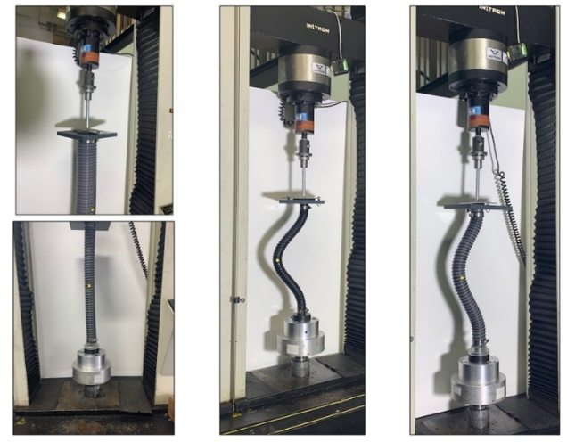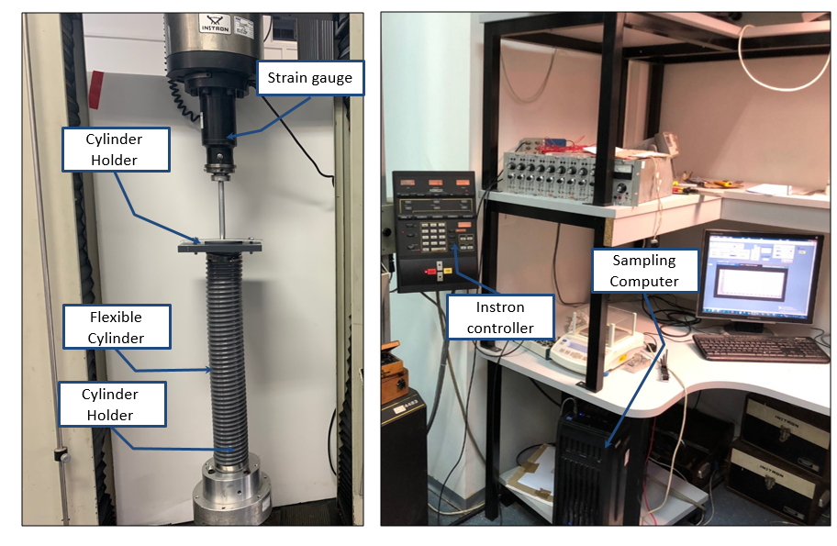

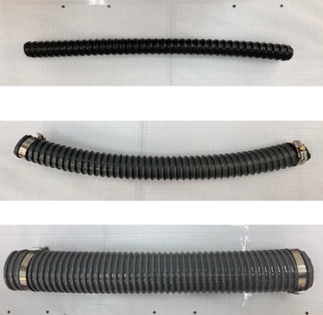

**Fig. 1:** (a) The tensile and squeeze experimental setup, with a flexible cylinder of diameter. (b) Flexible cylinder with diameter pictures on the page embedded in order to assess the curvature of the cylinder.

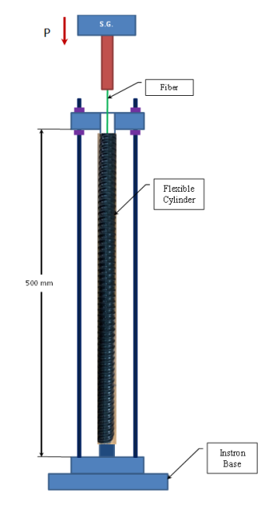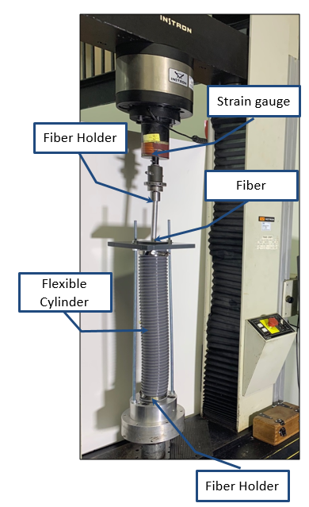

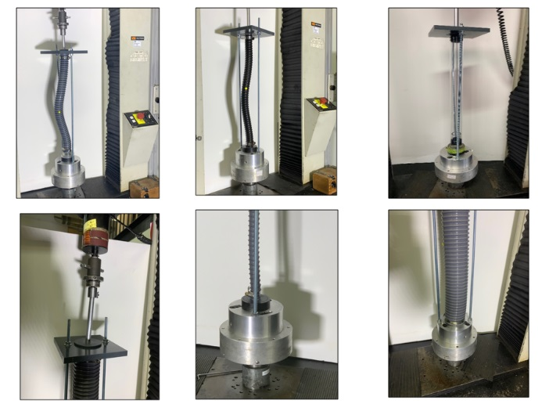

**a**

**b**

**Fig. 2:** (a) Schematic description of the main experiment and system components. (b) The experimental setup, with a flexible cylinder with diameter.

# **Finite-element simulations**

FE simulations were performed with the commercial FE software ABAQUS FEA. A static analysis was designed to simulate the experimental system, which includes a 500 mm fiber that is clamped at both ends and is laterally constrained by flexible and rigid cylinders. A static stress analysis is used when inertia effects can be neglected, can be linear or nonlinear and ignores time-dependent material effects, but takes rate-dependent plasticity and hysteretic behavior for hyperelastic materials into account. The model of fiber is meshed with hexahedral solid elements, type C3D8R (8-node brick, accounting for geometrical nonlinearity), with over 50 elements in the fiber cross-section and a total of 2800 elements in the fiber. A Young’s modulus of  was assigned to the fiber, in accordance with tensile experiments that were performed with the Instron machine and orthotropic characteristics for flexible and polycarbonate for rigid cylinders. Preliminary analyses with high-order brick elements and with a larger number of elements in the mesh have resulted in similar results. Boundary conditions were implemented by defining zero-displacement of all degrees of freedom associated with the nodes at the two ends of the fiber. The only exception is the vertical displacement of the upper end, which was gradually increased during the simulation. As shown in Fig. 3, the fiber at the end of one side (on the side where no force is applied) is fixed to the x, y, and z axes for both displacement and rotation around each axis. At the other end of the fiber, where the force is applied, the fiber is fixed to rotate on the three axes and does not have the ability to rotate around them. On the two other axes that are not parallel to the movement of the end of the fiber, the fiber’s end is fixed and cannot move in the direction of these axes. On the axis that is parallel to the movement of the end of the fiber, the fiber’s end has a constraint that enables it to move in parallel to the axis for a defined displacement of 15 mm, as the motion occurred in the experiment.

During a static step you assign a time period to the analysis. The “time” increments are then simply fractions of the total period of the step. In some geometrically nonlinear analyses, buckling or collapse may occur. In these cases a quasi-static solution can be obtained only if the magnitude of the load does not follow a prescribed history; it must be part of the solution. When the loading can be considered proportional (the loading over the complete structure can be scaled with a single parameter), a special approach called the “modified Riks method”, can be used. The Riks method is generally used to predict unstable, geometrically nonlinear collapse of a structure, can include nonlinear materials and boundary conditions, often follows an eigenvalue buckling analysis to provide complete information about a structure's collapse. Geometrically nonlinear static problems sometimes involve buckling or collapse behavior, where the load-displacement response shows a negative stiffness and the structure must release strain energy to remain in equilibrium. One is to treat the buckling response dynamically, thus actually modeling the response with inertia effects included as the structure snaps. some simple cases displacement control can provide a solution, even when the reaction force is decreasing as the displacement increases. You can control the time incrementation in a quasi-static analysis directly, or it can be controlled automatically by ABAQUS. Automatic incrementation is preferred in almost all cases.

In the numerical analysis, the vertical displacement represents the shortening between the two ends of the fiber, as described in Section ‎2.1. The vertical force on the upper end of the fiber, which is the force applied by the Instron machine in the experiment, was determined in the simulation. The shortening rate of the ends was , which is comparable to the rate at which the experiments were performed. Preliminary FE simulations showed that lower rates produce similar results, that means that our system behave as a quasi-static system. In the numerical analysis, a contact between the cylinder and the fiber was defined using penalty stiffness in the normal direction of the contact surfaces (pressure-overclosure with "hard" contact and no penetration).

ציור המתאר מערכת הצירים ואת חלוקת האלמנטים בצילינדר ובסיב

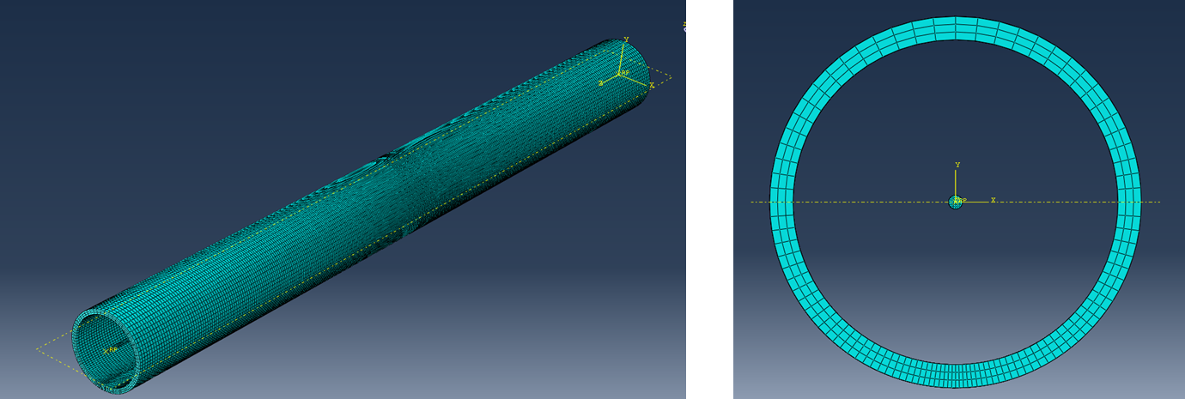

**Fig. 3:** Mesh model at ABAQUS software towards making a HEX element analysis

**2.3.1. ABAQUS Simulations Flexible Wall Cylinder results**

Figure 4 present the results of a simulation for a flexible cylinder with a diameter of 42 mm and fibers with diameters of 1.8 and 2.4 mm. The graph describes the force that develops at the end of the fiber on which pressure is applied as a function of its shortening. In order to examine whether hysteresis exists in the ideal state, force was applied repeatedly on the fiber. The results of these repeated applications can also be seen in Figure 4. Here, the simulation helps identify and explain what forces are acting upon the cylinder wall, as well as analyze the nature of the contact. This process is critical, as, the cylinder is opaque, and information can therefore be obtained only through a simulation. The letters (a)-(h) refer to developing deformation stages in the cylinder and the fiber as can be seen in Figure 5. The maximum force on the flexible cylinder wall, as obtained in the simulation, is: 4.6 N for a fiber of 1.8 mm diameter and 6.5 N for a 2.4 mm diameter fiber.

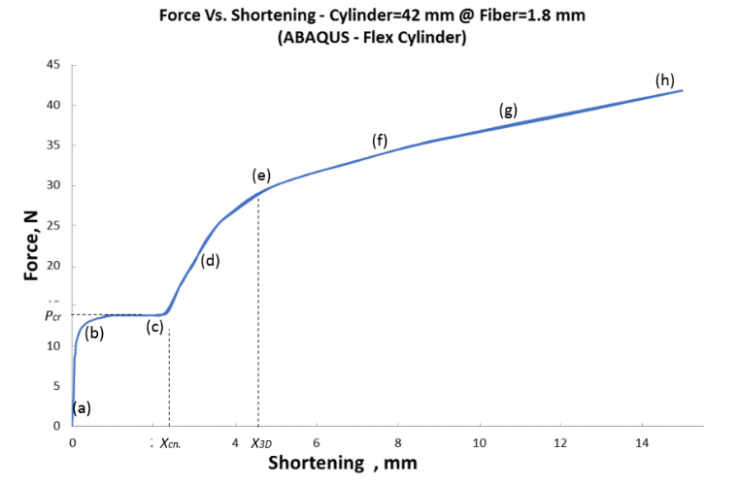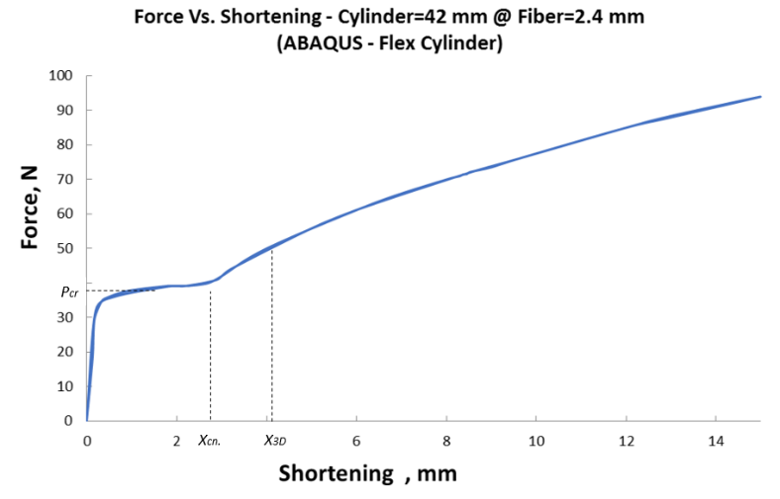

**b**

**a**

**Fig. 4:** Vertical force versus end shortening - FE simulations results for flexible cylinders : (a). (b) .

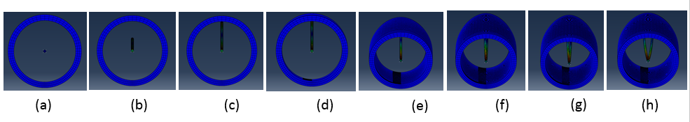

Fig. 5: Results of FE simulations showing the deformation of the fiber and contact with the flexible cylinder wall, for:,. top view (all images are at identical scale).

**2.3.2. ABAQUS Simulations Rigid Wall Cylinder**

In order to carry out a comparison of the behavior of a fiber and a flexible cylinder, a simulation was performed on a stiff cylinder with a diameter of 42 mm together with a fiber with a diameter of 1.8 mm. Figure 6 describes the force that develops at the end of the fiber on which pressure is applied as a function of its shortening. The letters (a)-(h) refer to developing deformation stages of the fiber. The letters (a)-(h) refer to developing deformation stages in the cylinder and the fiber as can be seen in Figure 7. The maximum force on the flexible cylinder wall, as obtained in the simulation, is 8.7 N, which is greater than for the flexible cylinder.

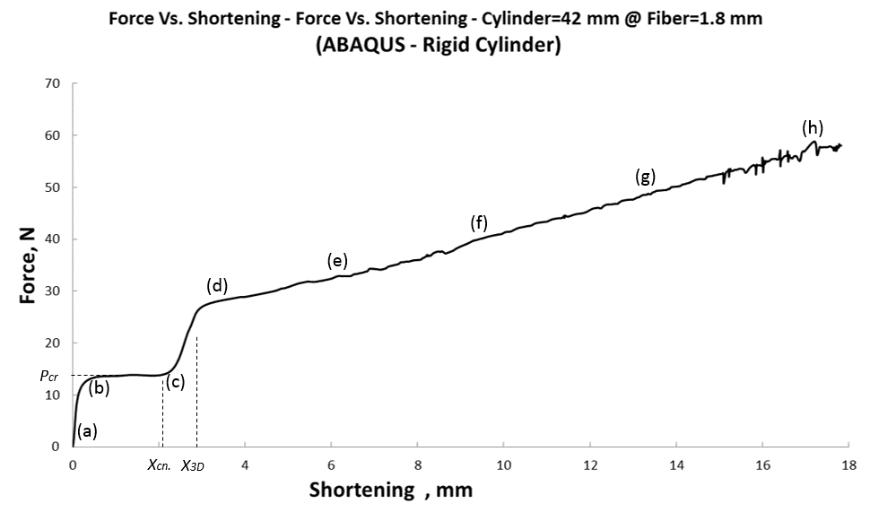

**Fig. 6:** Vertical force versus end shortening - FE simulations results for rigid cylinder:

.

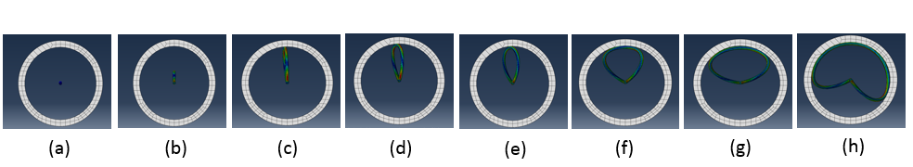

Fig. 7: Results of FE simulations showing the deformation of the fiber and contact with the rigid cylinder wall, for:,. top view (all images are at identical scale)

# **Analytical insights from initial imperfection analysis**

In this section, we present analytical derivations for three key features associated with the behavior of the fiber. The first and second features are the end displacement (shortening) of the fiber at the onset of first contact between the fiber and the cylinder with symmetric and anti-symmetric imperfections as illustrated in **Error! Reference source not found.**, and the third is the load at which the transition from 2D (planar) to 3D deformation occurs. The analysis assumes linear stress-strain relation (Hooke’s law).

**2.4.1 End displacement for first contact**

The analysis in this section is based on a well-established elastic solution of a clamped-free fiber [17] (see Fig. 11).

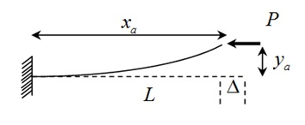

**Fig. 8:** Description of elastica problem for a clamped-free fiber

There,

(1)

where

 (2)

and are the complete elliptic integrals.

We donate  as the lateral displacement at the middle of the fiber, as illustrated in the Fig. 9.

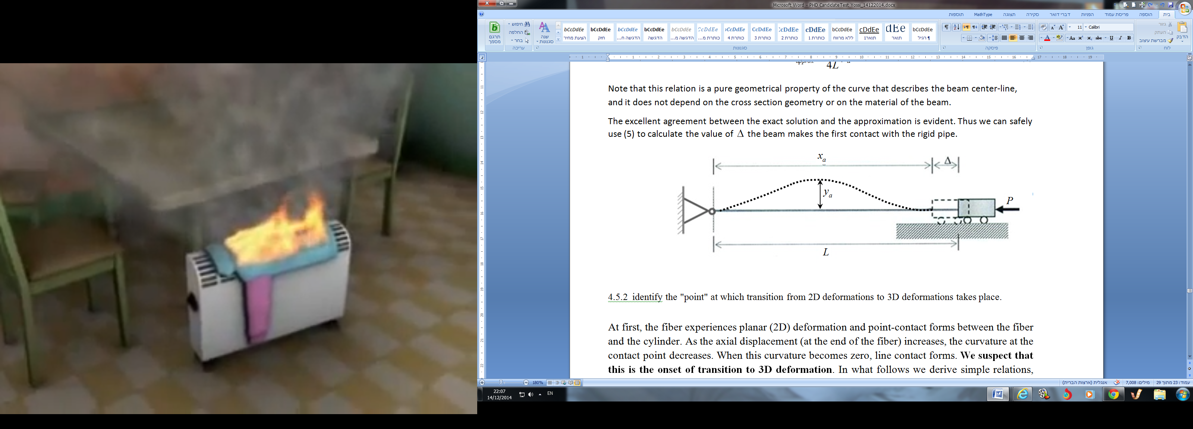





**Fig. 9:** Description of boundary conditions and post-buckling response of the fiber in this research

In order to obtain the lengths of segments , let ****represent the [arc length](http://en.wikipedia.org/wiki/Arc_length) given by



(3)

where  is the vector defining the location on the fiber and  is the angle of the tangent at this point with respect to a constant direction, e.g.  .

Boundary condition (6)-(8) is used in solving the clamped-free problem by inserting the following relations into the solution of the clamped-free problem:

 (4)



(5)



(6)

The parameters are unknown; however the following conditions must exist:

* 1. Identical load in both segments:



(7)

* 1. Identical bending in the intersection of two segments:



(8)

Equations (3) (combined with (6)-(8)) can be viewed as providing the relation between  through a single parameter. In other words, for a given value of , each member of the triad

 can be easily calculated. This approach can be used to drawas a function of.

(9)

In addition, a similar approach can be used to plot the elastic solution for the relation between  and. (Details are not provided here, but are derived with Maple):



(10)

This relation is a geometrical property of the curve that describes the fiber center-line, and it does not depend on the cross section geometry or on the material of the fiber. The agreement between the exact solution and the approximation is evident. Thus, (11) can be used safely to calculate the value of  where the fiber makes the first contact with the stiff cylinder.

(11)

Figure 10 shows the computation results for the mathematical model of the fiber's first contact with the cylinder wall. The curves describe the shortening of the fiber as a function of the cylinders radius; that is, the shortening required for a first contact with the cylinder wall to occur for cylinder of various radii. There are two curves. The first curve was made according to a full computation, including employing elliptic integrals. The second curve represents an approximate computation without using these integrals.

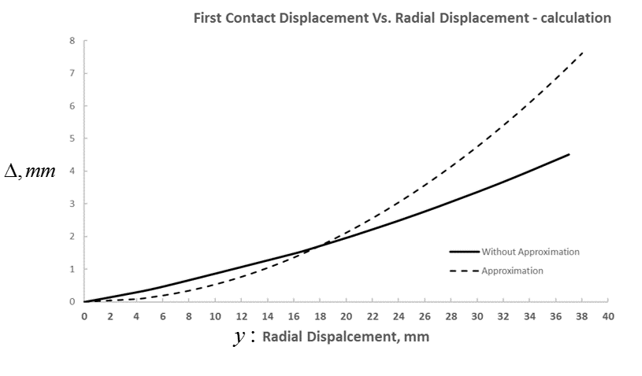

**Fig. 10:** End shortening versus radial displacement – compared analytical model results,

approximation and without approximation model calculation.

**2.4.2 Small-deformation analysis**

In this section, we consider the case of small deformations. That is, we assume that the beam deflection,, is much smaller compared to the beam length . In addition, differentiation with respect to the arc-length, s, can be replaced with differentiation with respect to , which measures the distance from the left end of the beam projected on . The fiber experiences planar (2D) deformation and point-contact forms between the fiber and the cylinder. As the end displacement (at the end of the fiber) increases, the curvature at the contact point decreases. When this curvature becomes zero, line contact forms. This is the onset of transition to 3D deformation. Simple relations are then derived, based on small-deformation analysis, to identify this transition. We denote and as the fiber length and  as the flexible cylinder radius that is clamped at one end () and supported at the other end (). Due to an axial load, that results in a horizontal displacement  of the right end, the fiber deforms and makes contact with a surface (Flexible cylinder wall) at point (see Fig. 11).

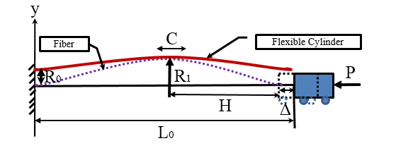

**Fig. 11:** A clamped fiber subjected to an axial compressive force P and delimited between a flexible walls.

H sets the x axis position so that the elastic fiber touches the inner wall of the flexible cylinder. The inner radius R1 of the cylinder is prescribed, thus the vertical displacement of the fiber at the point of contact is known as well, i.e.:

 (12)

Where is related to the inner radius of the cylinder and  is the vertical displacement (deflection) of the fiber that is governed by the bending equation for each fold takes the following form [48]:



(13)

where different contact conditions yield different boundary conditions. Once  is obtained, the horizontal displacement  is calculated by

 (14)

Here, H is the length of one fold projected on ,  is the compressive strain, and  is the mode number. It is useful to introduce the non-dimensional displacement and (square-root) axial force [59]:

 (15)

In addition, we define the non-dimensional spring stiffness and spring force:

 (16)

Above, the spring stiffness is normalized by the bending stiffness of the beam, while the reaction force is normalized by the lateral force associated with an end deflection . Using these definitions and we write:

 (17)

Finally, the energy stored in the system,, includes the contributions of axial compressions and bending of the beam as well as the energy stored in the spring, i.e.,

 (18)

where is the beam cross-section area. Next, we analyze the various equilibrium configurations based on the above relations.

**2.4.2.1 Buckling of a clamped-clamped segment**

The solution for the buckling problem of a clamped-clamped segment with no contact has been well established, yet we present it here for the sake of completeness. Here, the boundary conditions for Eq. (13) are

 (19)

Where  is the length of the initially straight segment. It can be shown that the first buckling force satisfies

 (20)

From Eqs. (15) and (20), after replacing  with , it can be seen that the beam first buckles when. After buckling takes place, the mid-span of the beam makes contact with the other wall and point-contact forms, Fig. 11.

**2.4.2.2 Point contact**

Once a point-contact forms between the beam and the moving wall, the beam includes two equal folds. Both folds are subjected to the same forces and moments, and thus to the same boundary conditions. The boundary conditions for one fold are

 (21)

Where  is the mode number. It is assumed that the length of the fold remains unchanged while it bends. Solving Eqs. (13) with (21) using (15), (16), and substituting the fold length  lead to the equation

 (22)

Where  Calculating (14) with Eqs. (22), (15), and (16) yields

 (23)

where . The gap between the two walls is calculated by substituting  in Eq. (22):

 (24)

In turn, the spring force is found from Eq. (17):

 (25)

Finally, the energy stored in the system is obtained from Eqs. (18) together with (22) and (24):

 (26)

where

 (27)

is the energy scale set by the compressive energy. The point contact configuration persists as long as the internal bending moments at the edges of the fold do not vanish. This occurs if  is further increased, defining the onset of transition to line contact configuration.

**2.4.3 Large-deformation analysis**

The small-deformation analysis provides important insights and intuition regarding the behavior of the system. Yet it is limited and cannot describe the complete range of behavior. In this section, we examine the large deformation behavior based on the elastica model, providing general insights and numerical examples. To this end, consider the half-fold segment illustrated in Fig. 12 (the other half is identical by symmetry). As in the small deformation analysis, the solution for one fold is extended to the entire beam since all folds are subjected to the same end conditions. In what follows, subscript H refers to a fold having a projected length on the x-axis that is equal to[48].

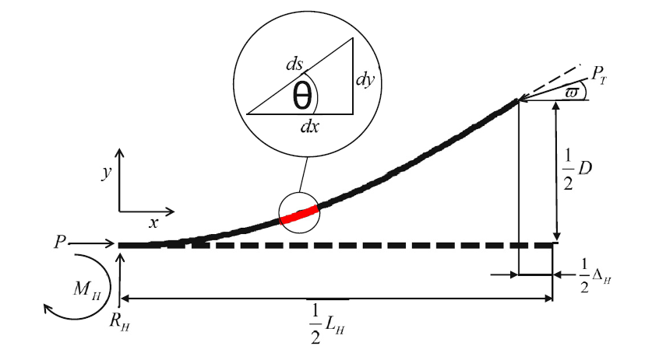

**Fig. 12:** Free body diagram of a half-fold.

The internal bending moment at the mid-span of the fold vanishes due to symmetry, and simple force balance considerations lead to

 (28)

Where  is the lateral force acting on the fold, and  is the angle of the (internal) force at the mid-span of the fold. Also, the spring force is equal to

 (29)

Combining Eqs. (28), (29) with definition (15) we obtain

 (30)

where throughout the text a tilde appearing above a letter denotes normalization by  , e.g., The governing differential equation is formulated by writing a moment balance equation for a segment of length s of the half-fold:

 (31)

Above, θ is the angle that the beam tangent creates relative to the x-axis. Differentiating Eq. (31) with respect to s leads to

 (32)

In order to solve this equation, it is useful to define the following variables and relations:

 (33)

 (34)

Accordingly,

 (35)

 (36)

where the subscripts 0 and 1 indicate evaluation at locations  and , respectively. Using these definitions and some algebraic manipulations, Eq. (32) can be integrated to take the form of a separable first order differential equation (see [48]):

 (37)

Where . Furthermore, the horizontal displacement  is calculated by

 (38)

where  is the strain in the (straight) line-contact segments, and  is the strain in the fold:

 (39)

 (40)

**2.4.3.1 .Point contact**

After beam buckles and makes contact with the moving wall, it includes two equal folds (or more generally  folds). Each fold is subjected to the same end conditions, as described above, and has a length of . Integrating Eq. (37) over the entire domain of integration (half-fold) with the aid of boundary conditions Eq. (36), we write

 (41)

where  and  are the complete and incomplete elliptic integrals of the first kind, respectively. In addition, multiplying Eq. (37) by  or by  and performing a similar integration we find that:

 (42)

 (43)

where  is the incomplete elliptic integral of the second kind, and relations  and  have been used. If the problem was statically determinate, i.e., if the lateral force  (or alternatively) was prescribed, solving Eq. (41) for β would be the standard procedure for expressing the boundary condition at  in terms of . Once  is obtained, the solution of the differential Eq. (37) is readily found. In particular, the end displacements  and  are calculated explicitly from Eqs. (42) to (43). In our case, the reaction force is unknown, but Eq. (30) relates between ϖ and the end deflection. Thus, Eqs. Eqs. (41) and (42) must be solved simultaneously in order to find  and the lateral force. To this end, we plug into Eq. (41) the fold length , appropriate for point-contact configuration, and write the non-dimensional form of Eqs. (41) and (42) [48]:

 (44)

 (45)

Where  is a non-dimensional resultant force, and Eq. (44) was substituted into Eq. (42) in deriving Eq. (45). Similarly, the displacement,, is obtained from Eq. (38) with  (no line-contact segments):

 (46)

Finally, from (36) we write

 (47)

Note that relation (47) is not limited to point-contact configuration. Increasing the edge thrust will eventually result in the formation of line-contact segments.

# **Results**

**3.1. Preliminary experiment: Tensile and Squeezing Flexible Cylinder**

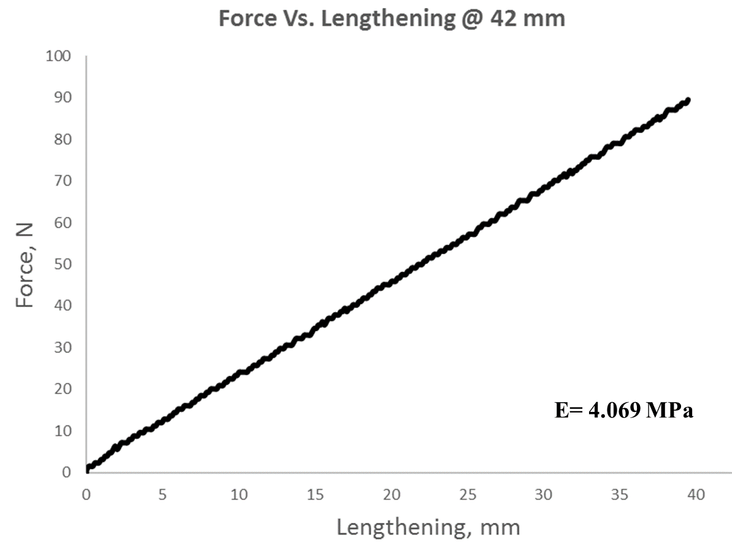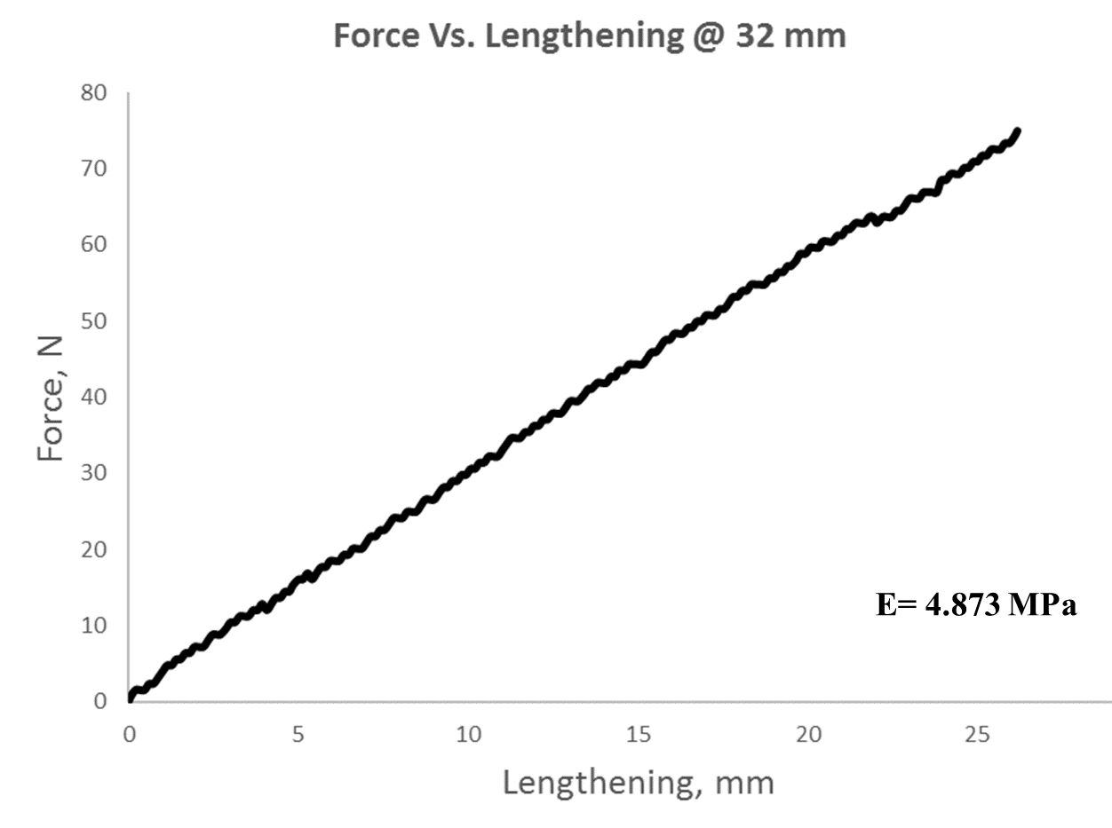During the first stage of this research, compressing and stretching experiments were carried out on the cylinders without fibers to examine the characteristics of the cylinder material. Figure 13 presents the results of stretching experiments on the flexible cylinders. Figure 14 presents the results of compression experiments on the flexible cylinders.

**a**

**b**

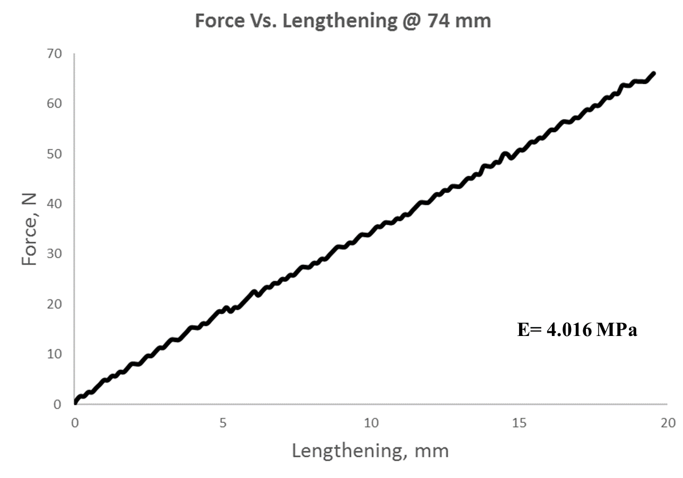

**c**

**Fig. 13:** Vertical force versus cylinder end lengthening for flexible cylinder in tensile experiment, (a).(b). (c).

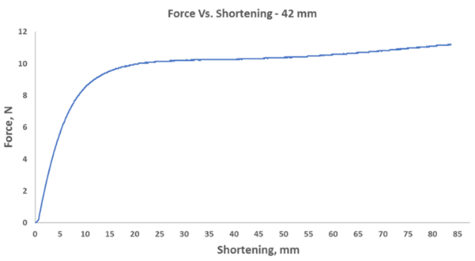

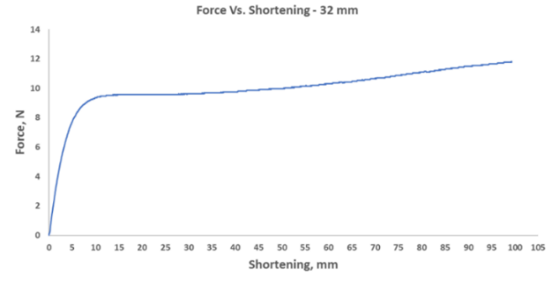

**b**

**c**

**a**

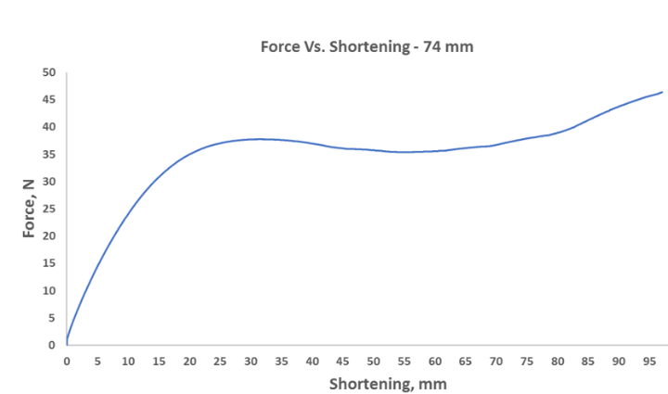

**Fig. 14:** Vertical force versus end cylinder shortening for flexible cylinder,  in squeeze experiment.

**Comparison of compression experiments on the cylinder:**

One can observe in Figure 15 that a cylinder with a diameter of 74 mm, requires greater force in order to obtain similar shortening. Cylinders with diameters of 32 and 42 mm exhibit similar behavior.

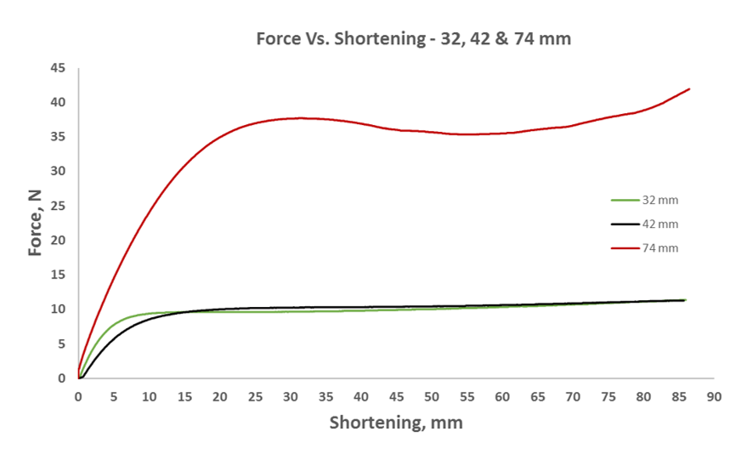

**Fig. 15:** Vertical force versus end shortening for flexible cylinders, in squeeze experiment – compared results.

**3.2. Shortening Fiber Experiments**

**3.2.1. Examining the critical loading on a fiber before it contacts the**

**cylinder wall**

During the second stage of the research, experiments were carried out with fibers. Compression (shortening) experiments were conducted with fibers having diameters of 1.8 and 2.4 mm, and with three different cylinder diameters of 32, 42, and 74 mm, as can be seen in the experiment results in Figures 16 and 17. In these experiments, these fibers were shortened up to 15 mm, the specific shortening determined by examining the critical load on a fiber before its contact with the cylinder wall. Each experiment was carried out in three times to test for hysteresis; that is, until reaching the required fiber shortening and then releasing it to the starting point with zero shortening. In all the experiments with the fibers, the reaction force at the end of the fiber resulting from its shortening was measured, with the distance between the two ends of the cylinder remaining unchanged.

The initial contact with the cylinder wall on its return to the starting state is the result of the 74 mm diameter cylinder's visco-elastic behavior, causing a disengagement between the fiber and the tubing with a descending value different than the ascending one.

**Xcn.**=First Contact

**Pcr**=Critical Buckling (Euler)

**X3D**=Three-Dimensions Deformation

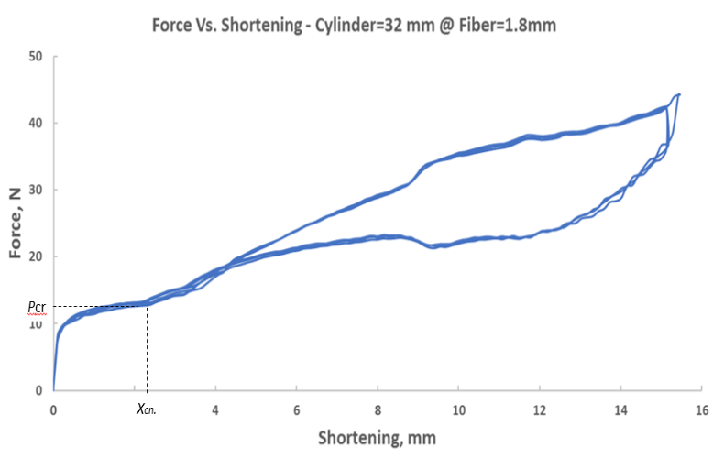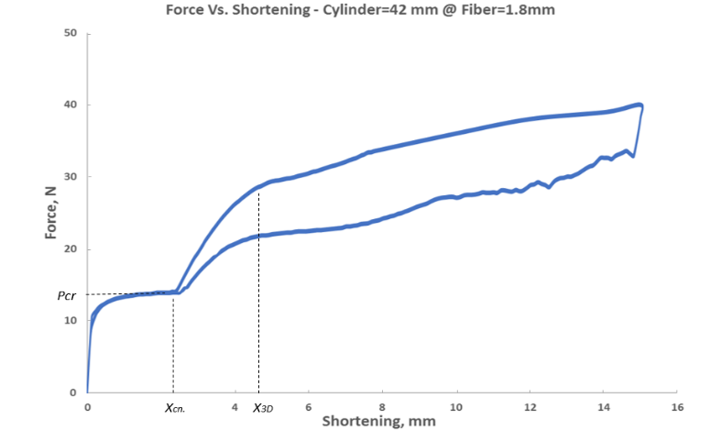

**b**

**a**

**c**

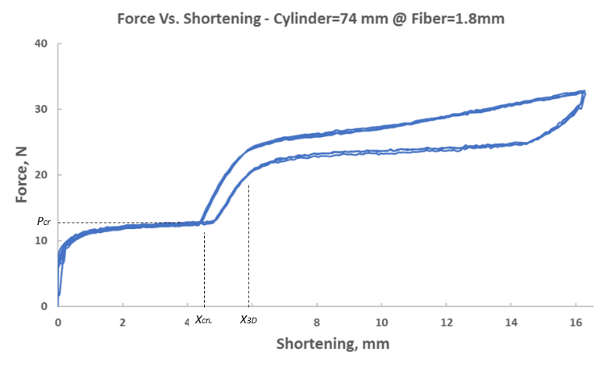

**Fig. 16:** Measured vertical force versus end shortening for  and three different flexible cylinders:  (a) . (b) . (c) .

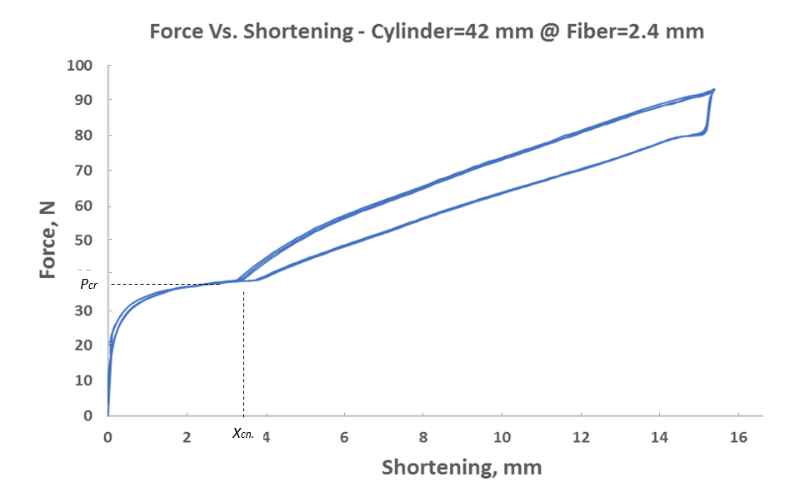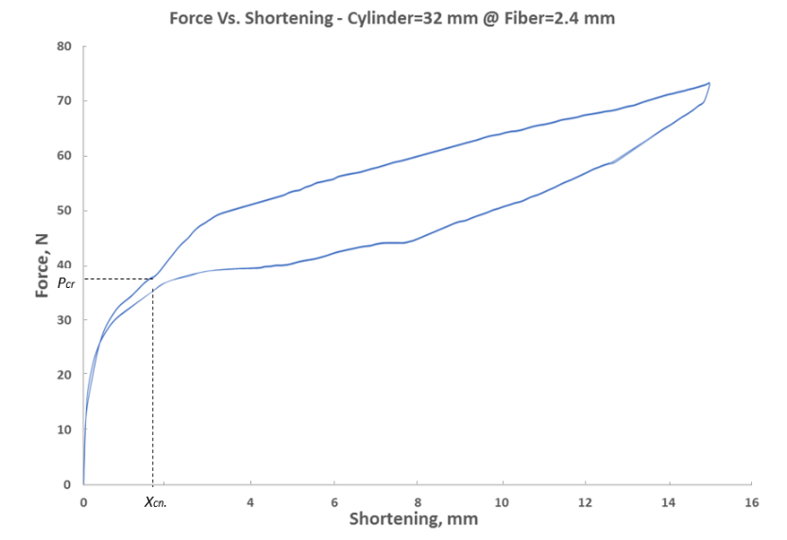

**b**

**a**

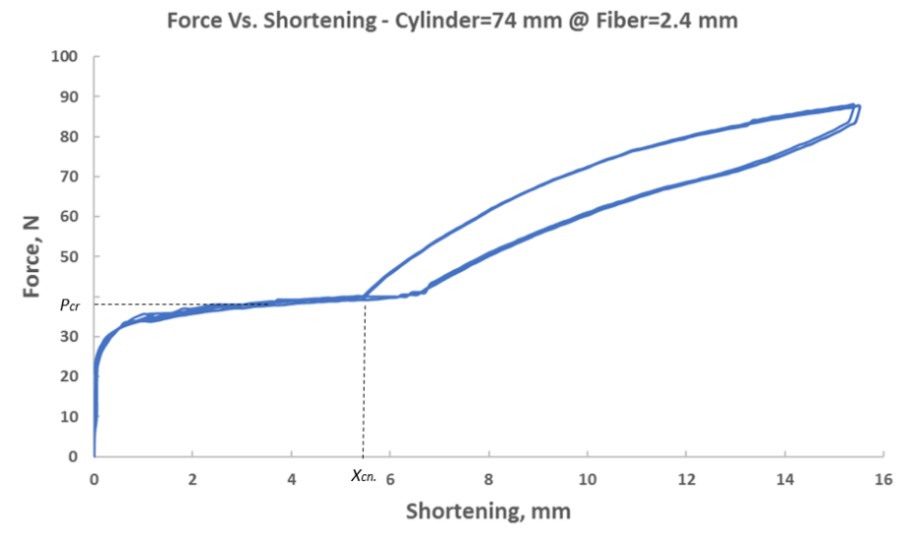

**c**

**Fig. 17:** Measured vertical force versus end shortening for  and three different flexible cylinder:  (a) . (b) . (c) .**3.2.2. Analysis of fiber and cylinder behavior through experimental compression of the fiber and image processing**

In the fourth stage of the research, an analysis of the cylinder's behavior was conducted while implementing a compression experiment with fibers of 1.8 and 2.4 mm, using three different flexible cylinders with diameters of 32, 42, and 74 mm, and shortening the fiber up to its elasticity limit in order to prevent plastic effects of the fiber on the results, which can be seen in Figures 18–23. An analysis of the cylinder’s behavior was carried out by image processing of the video from the cylinder’s center. This analysis can indicate the amount of movement at the cylinder's center from its centerline, where the experiment began. Consequently, the mutual effect the fiber has on the cylinder and vice versa can be observed. The points (a)-(f) marked on the graph are deformation stages of the fiber and the cylinder and are visually described in the respective pictures labeled with these letters.

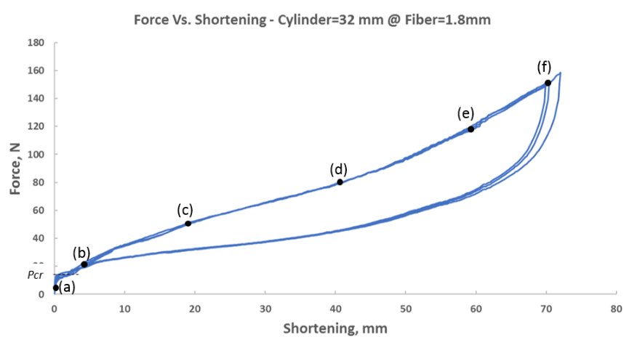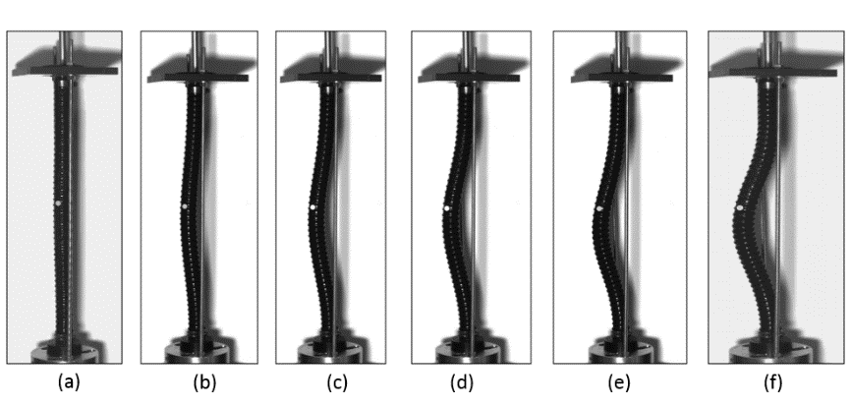

**c**

**b**

**a**

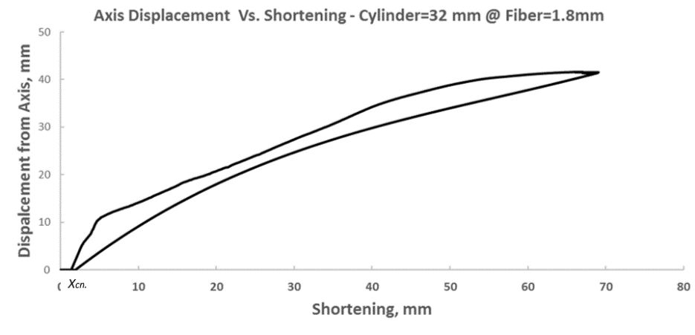

**Fig. 18:** (a) Measured vertical force versus end shortening for fiber: and flexible cylinder:. (b) Snapshots from the experiment at different levels of end shortening. End shortening is indicated by letters a-f that appears in the force-displacement curve (a). (c) Displacement from axis measured by image processing versus end shortening for same system.

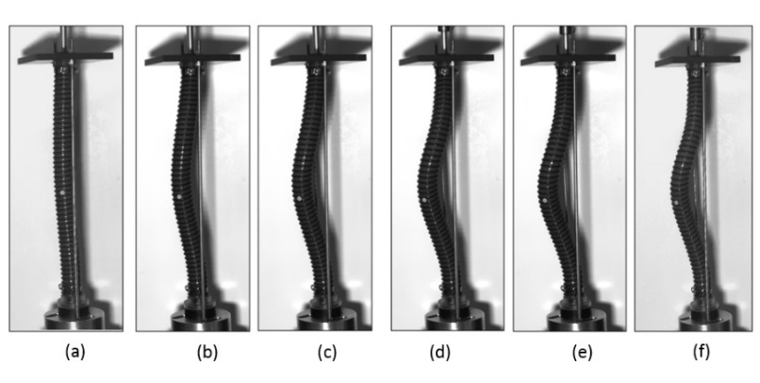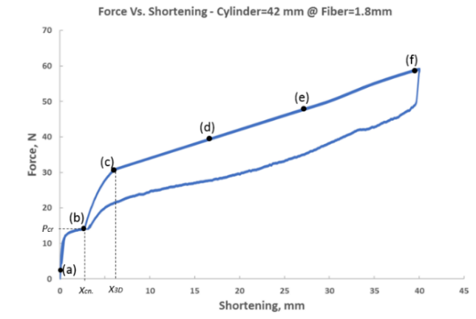

**b**

**a**

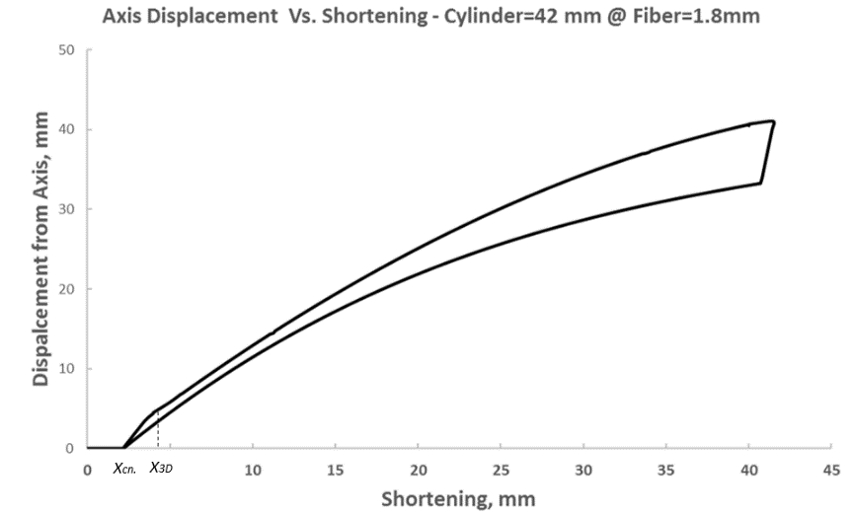

**c**

**Fig. 19:** (a) Measured vertical force versus end shortening for fiber: and flexible cylinder:. (b) Snapshots from the experiment at different levels of end shortening. End shortening is indicated by letters a-f that appears in the force-displacement curve (a). (c) Displacement from axis measured by image processing versus end shortening for same system.

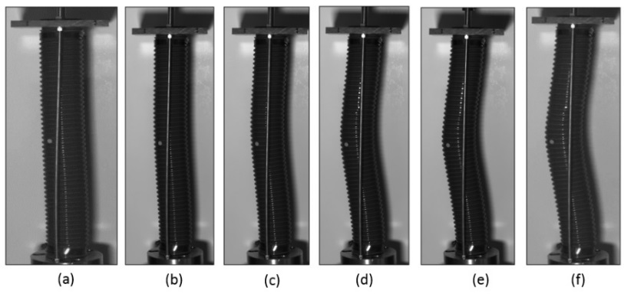

**b**

**a**

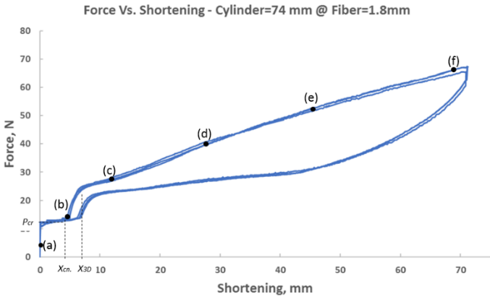

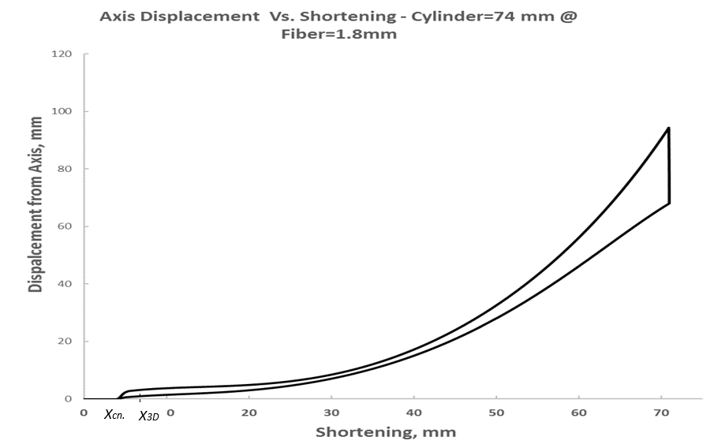

**c**

**Fig. 20:** (a) Measured vertical force versus end shortening for fiber: and flexible cylinder:. (b) Snapshots from the experiment at different levels of end shortening. End shortening is indicated by letters a-f that appears in the force-displacement curve (a). (c) Displacement from axis measured by image processing versus end shortening for same system.

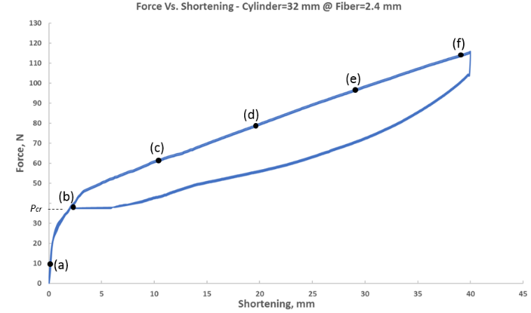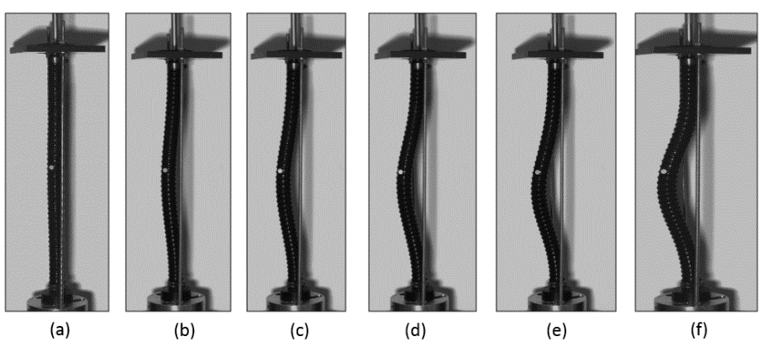

**a**

**b**

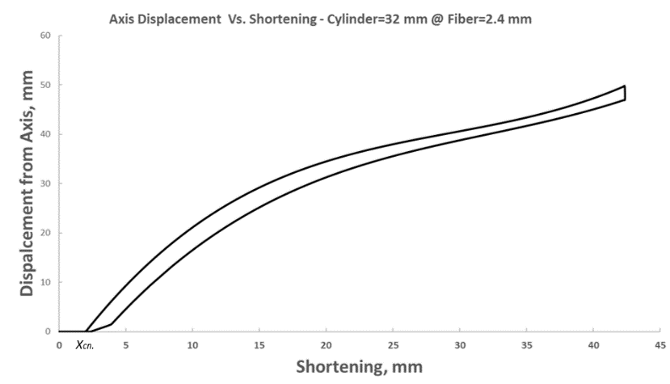

**c**

**Fig. 21:** (a) Measured vertical force versus end shortening for fiber: and flexible cylinder:. (b) Snapshots from the experiment at different levels of end shortening. End shortening is indicated by letters a-f that appears in the force-displacement curve (a). (c) Displacement from axis measured by image processing versus end shortening for same system.

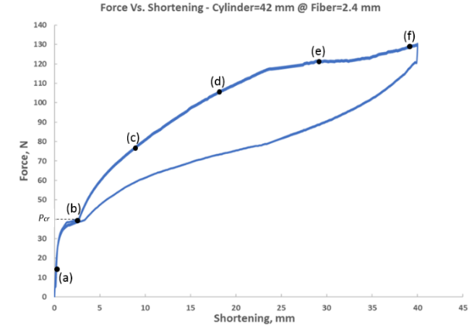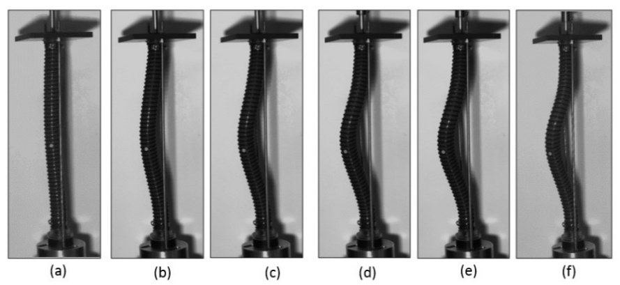

**a**

**b**

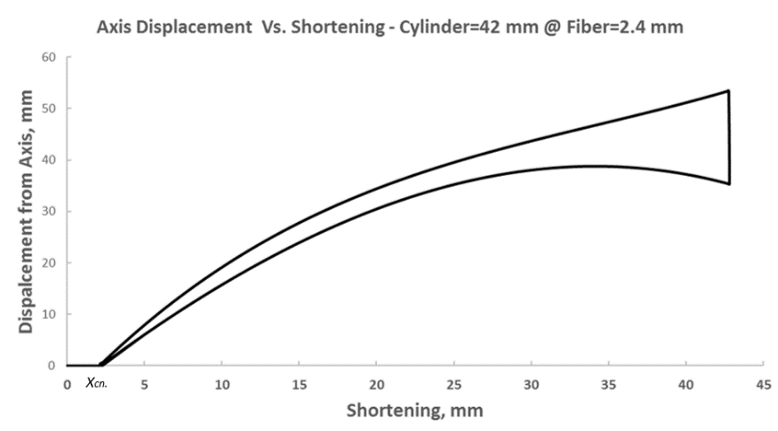

**c**

**Fig. 22:** (a) Measured vertical force versus end shortening for fiber: and flexible cylinder:. (b) Snapshots from the experiment at different levels of end shortening. End shortening is indicated by letters a-f that appears in the force-displacement curve (a). (c) Displacement from axis measured by image processing versus end shortening for same system.

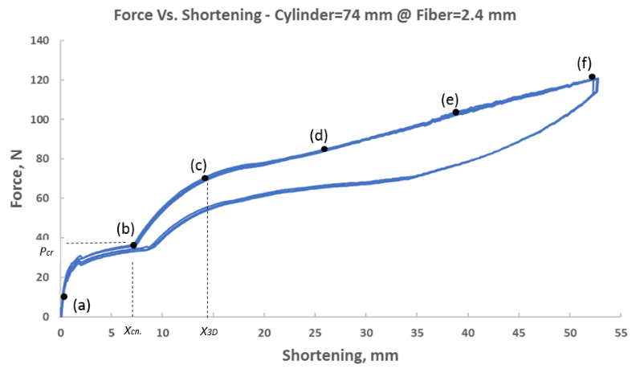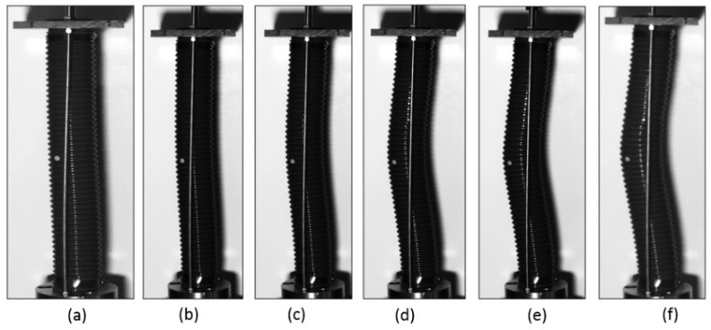

**a**

**b**

**c**

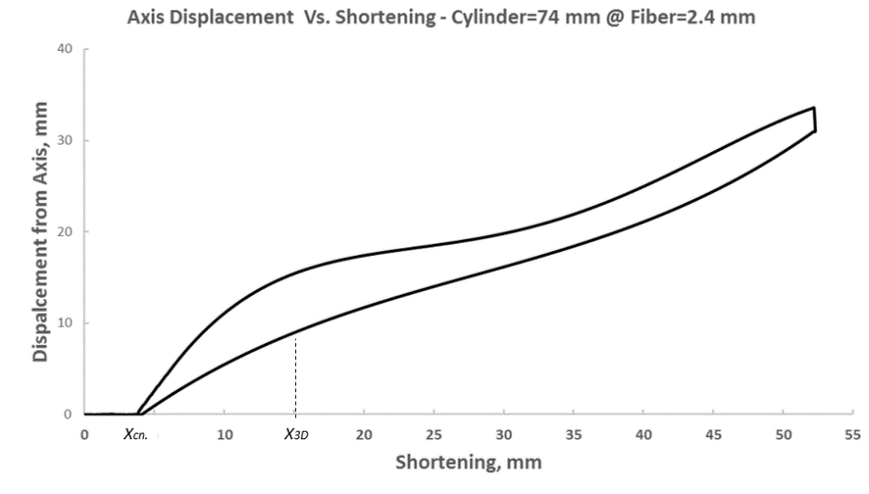

**Fig. 23:** (a) Measured vertical force versus end shortening for fiber: and flexible cylinder:. (b) Snapshots from the experiment at different levels of end shortening. End shortening is indicated by letters a-f that appears in the force-displacement curve (a). (c) Displacement from axis measured by image processing versus end shortening for same system.

**3.2.3. Analysis of fiber behavior through experimental compression of the fiber in a stiff cylinder**

Since a flexible cylinder is not transparent, description of the point where the fiber undergoes deformation from one plane to a three-dimensional deformation can be determined both by comparing fiber behavior in a stiff transparent cylinder with a 42 mm diameter, and from the results of a simulation made with an ABAQUS, as will be presented below. For the purpose of comparing the behavior of the fiber inside a stiff cylinder to its behavior in a flexible one, as presented earlier, experiments were carried out in a stiff cylinder. These results can be seen in Figure 24. The graphs with results from the two types of cylinders are presented below.

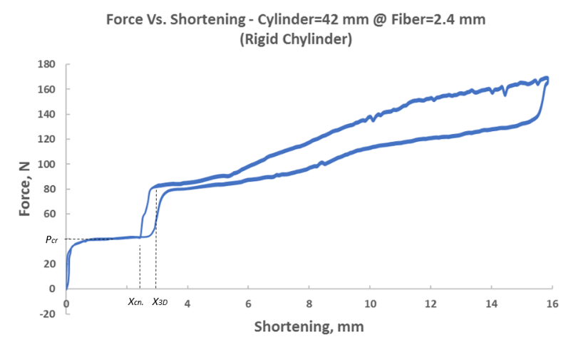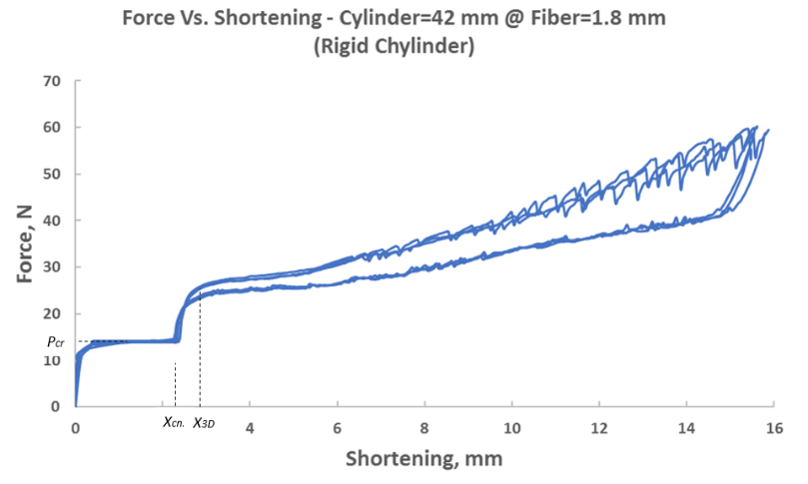

**b**

**a**

**Fig. 24:** (a) Measured vertical force versus end shortening for rigid cylinder:  and fibers: (a) . (b) 

**3.2.3. *{md ???}* Analysis and comparison of experiment results and image processing**

Figure 25 shows that cylinders with diameters of 42 and 74 mm exhibit similar behavior at the cylinder contact stage. In a cylinder with a diameter of 32 mm, the cylinder adjusts itself to the fiber's (Ø1.8 mm) movement and there is no rapid rise in force at the fiber's end. Therefore, there is a steep slope, as can be seen in cylinders with a diameter of 42 and 74 mm. The highest value for force at the end of the fiber is obtained with cylinders having a 32 mm diameter and can reach double that of other cylinders. Since the cylinder diameter is smaller than the others, with greater shortenings, it resists the fiber more strongly. Therefore, there is more force at the fiber's end.

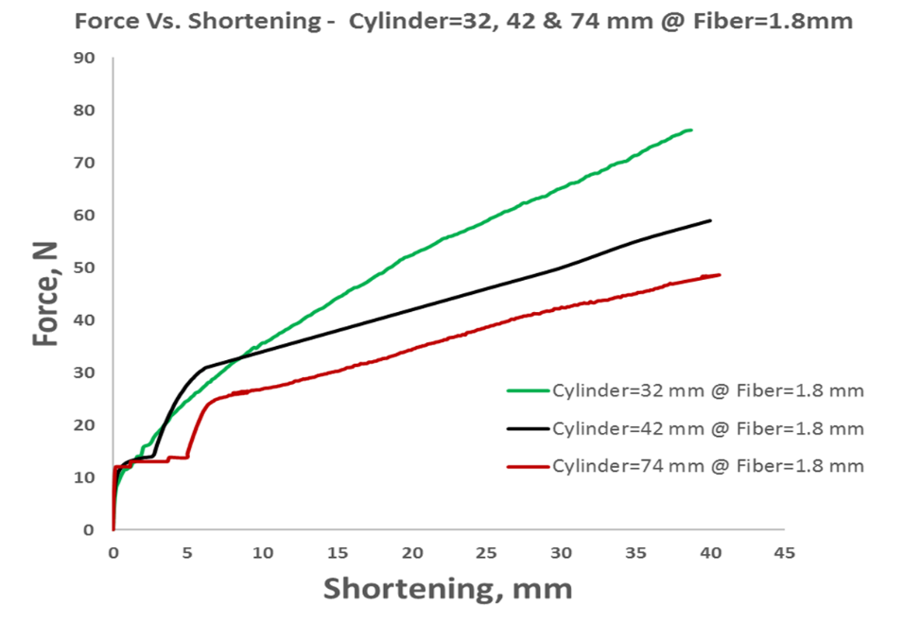

**Fig. 25:** Measured vertical force versus end shortening for  and three different flexible cylinders:  – compared results.

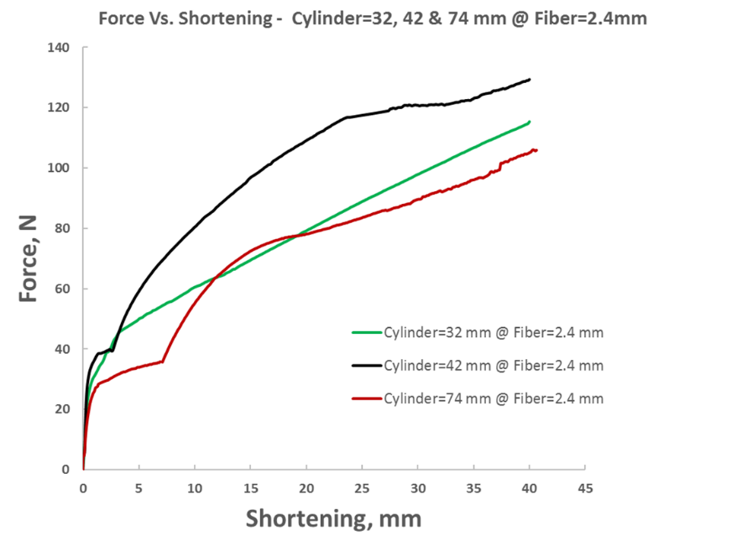**Figure 26** shows that in cylinders with diameters of 42 and 74 mm, there is similar behavior at the cylinder contact stage. In a cylinder with a diameter of 32 mm, the cylinder adjusts itself to the fiber's (Ø2.4 mm) movement. There is a moderate rise for small shortenings but there is no quick rise in force at the fiber's end. Therefore, there exists a steep slope as it appears in cylinders with a diameter of 42 and 74 mm. The highest value for force at the end of the fiber is obtained with cylinders having a 42 mm diameter, reaching up to 1.2 times that of other cylinders. Unlike experiments with fibers of 1.8 mm diameter, here, in experiments with fibers with a diameter of 2.4 mm, there is a greater effect on cylinders with a diameter of 42 mm.

**Fig. 26:** Measured vertical force versus end shortening for  and three different flexible cylinders:  – compared results.

**Figure 27** shows the movement in the center of the cylinder as a function of the fiber’s shortening in cylinders with diameters of 32 and 42 mm, which is very similar to that of a cylinder of 74 mm diameter when experimenting with a 2.4 mm diameter fiber. That is, the movement at the cylinder center’s axial shift in a 74 mm diameter cylinder can be up to one fifth of that of cylinders with diameters of 32 and 42 mm.

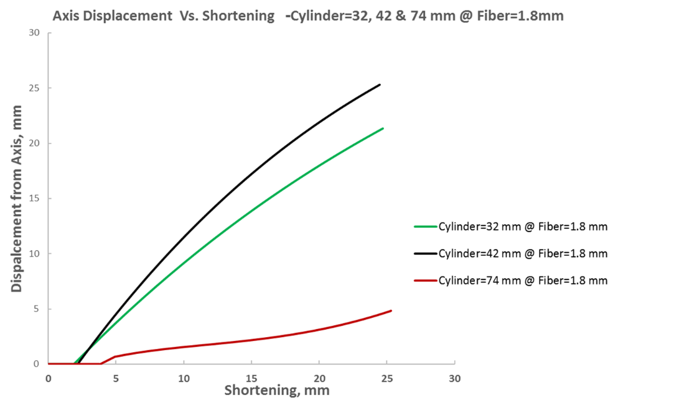

**Fig. 27:** Displacement from axis measured by image processing versus end shortening for fiber: and three different flexible cylinders:  – compared results.

**Figure 28** shows that the movement in the center of the cylinder as a function of the fiber’s shortening in cylinders with diameters of 32 and 42 mm is very similar in comparison to a cylinder of 74 mm diameter in experiments using a 2.4 mm diameter fiber. That is, the movement at the cylinder center’s axial shift in a 74 mm diameter cylinder, can be up to four times greater than that of cylinders with diameters of 32 and 42 mm. Similar behavior can be observed in a fiber of 1.8 mm diameter.

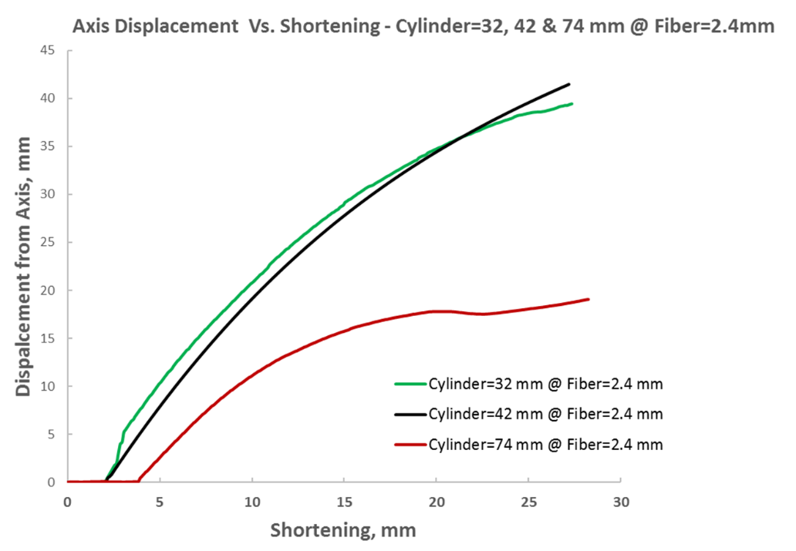

**Fig. 28:** Displacement from axis measured by image processing versus end shortening for fiber: and three different flexible cylinders:  – compared results.

**Figure 29** shows that more than double the force is required for a fiber with a diameter of 2.4 mm to reach a similar shortening as does the 1.8 mm diameter fiber in experiments with flexible cylinders.

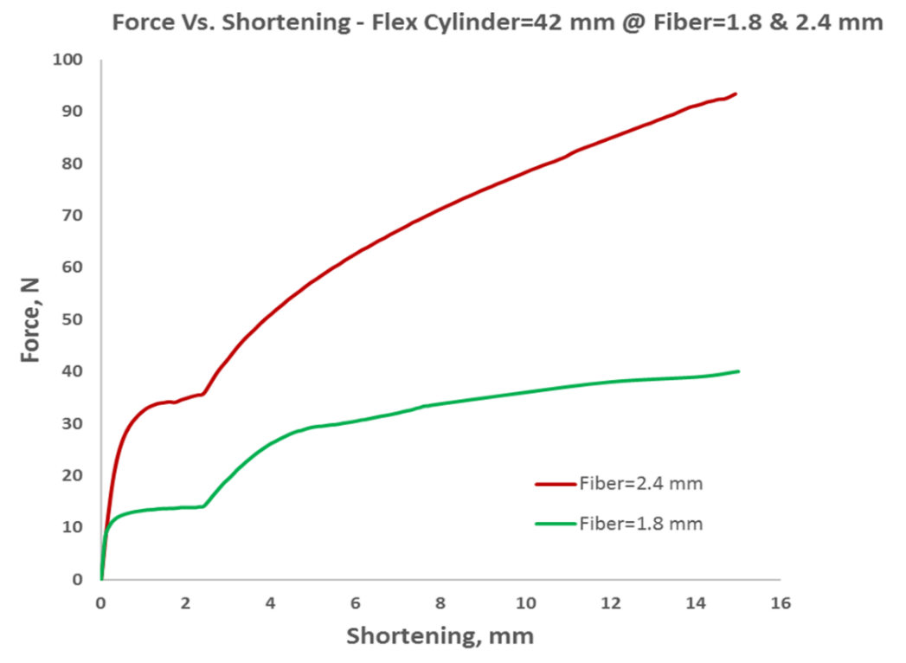

**Fig. 29:** Measured vertical force versus end shortening for flexible cylinder: , and two different fibers:– compared results.

**Figure 30** shows that more force is required for a fiber with a diameter of 2.4 mm to reach a similar shortening as the 1.8 mm diameter fiber, including in experiments with stiff cylinders.

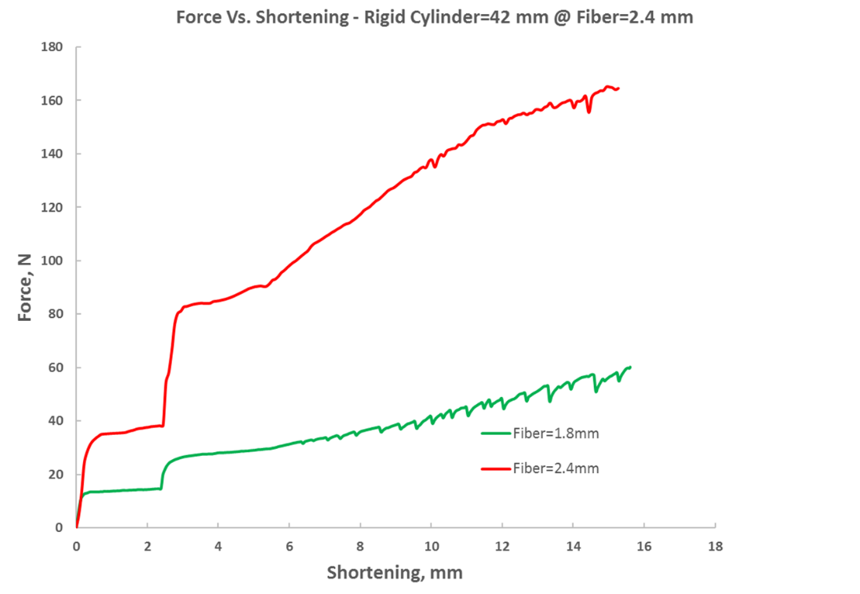

**Fig. 30:** Measured vertical force versus end shortening for rigid cylinder: , and two different fibers:– compared results.

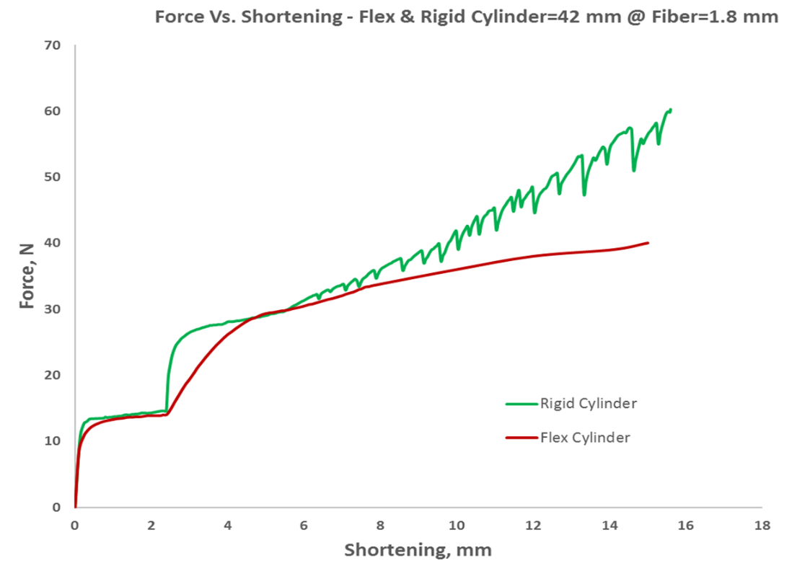 **Figure 31** shows that a 1.8 mm diameter fiber exhibits different behavior when it is within a flexible or a stiff cylinder, both at the first contact stage, and subsequently, when there are greater shortening values.

**Fig. 31:** Measured vertical force versus end shortening for rigid and flexible cylinders: , and fiber:– compared results.

**Figure 32** shows that a 2.4 mm diameter fiber exhibits greatly different behavior when it is within a flexible or a stiff cylinder, both at the first contact stage, and subsequently, when there are greater shortening values.

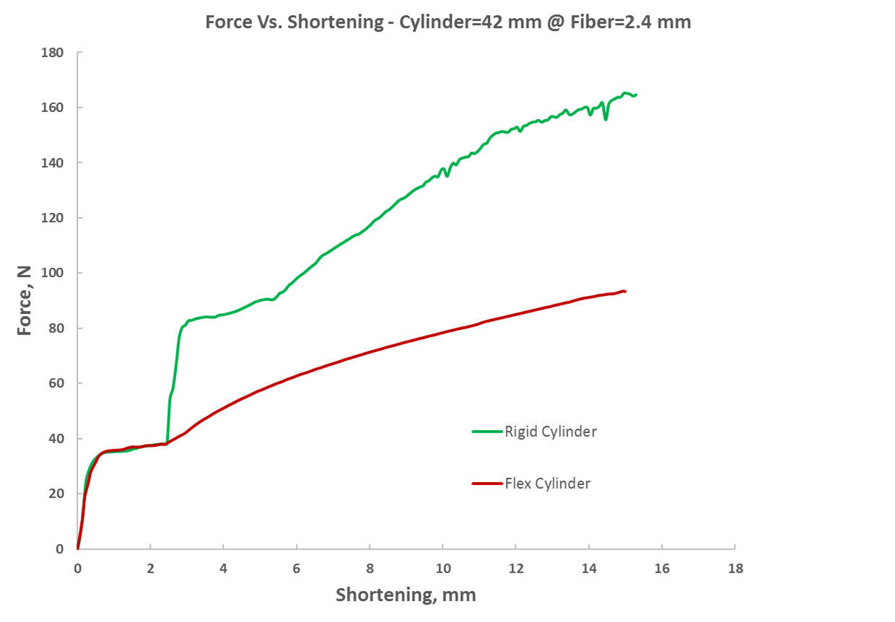

**Fig. 32:** Measured vertical force versus end shortening for flexible and rigid cylinders: , and fiber:– compared results.

**3.2.4. Analysis and comparison of experiment results and numerical simulation**

**Figure 33** shows that there is compatibility between the experiment and the numerical simulation. That is, the experimental results with a flexible cylinder can be fairly well predicted using the ABAQUS program for a 1.8 mm diameter fiber.

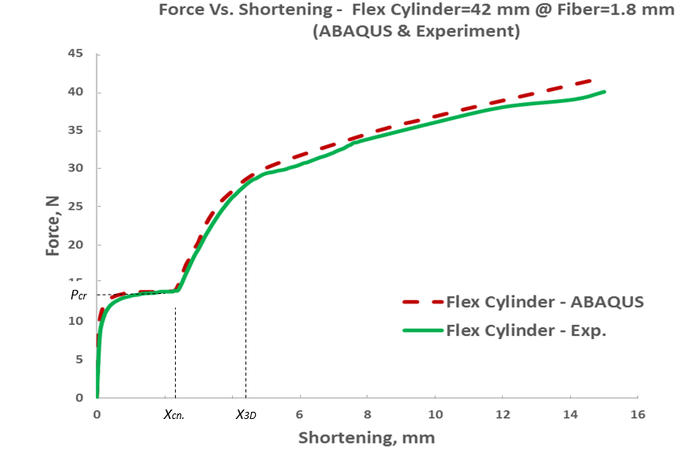

**Fig. 33:** Measured vertical force versus end shortening for flexible cylinder: , and fiber:. The experimental results are compared to FE simulations results (red dashed curve).

**Figure 34** shows that there is compatibility exists between the experiment and the numerical simulation.That is, the experimental results with a flexible cylinder can be fairly well predicted using the ABAQUS program with a 2.4 mm diameter fiber.

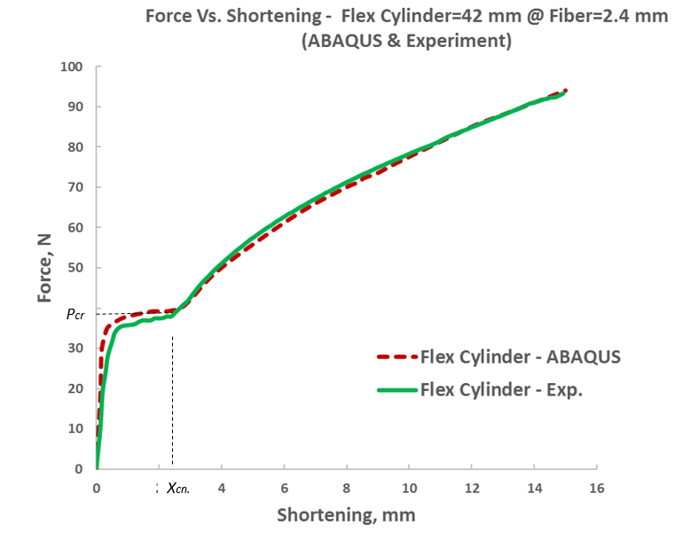

**Fig. 34:** Measured vertical force versus end shortening for flexible cylinder: , and fiber:. The experimental results are compared to FE simulations results (red dashed curve).

**Figure 35** shows that there is compatibility between the experiment and the numerical simulation for stiff cylinders. That is, here too, the experimental results with a stiff cylinder can be fairly well predicted using the ABAQUS program.

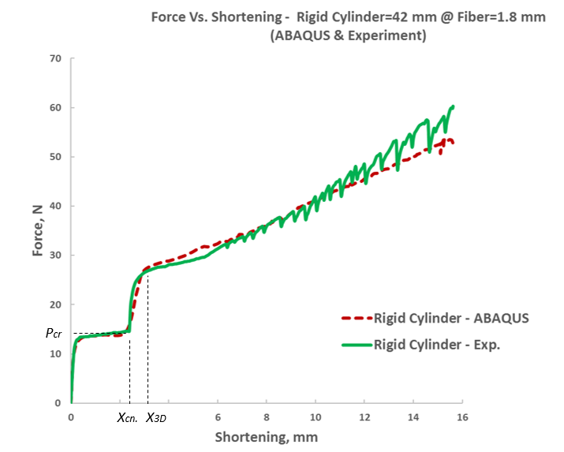

**Fig. 35:** Measured vertical force versus end shortening for rigid cylinder: , and fiber:. The experimental results are compared to FE simulations results (red dashed curve).

**Figure 36**, illustrates a numerical simulation of the presence of different behavior for a fiber having a 1.8 mm diameter similar to what happens in the experiment when it is within a flexible or stiff cylinder, both at the first contact stage, and subsequently, when there are greater shortening values.

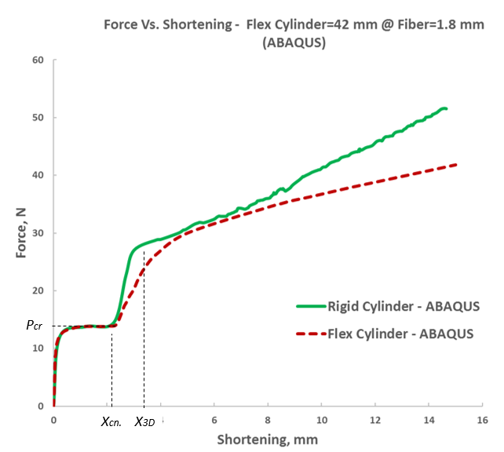

**Fig. 36:** Vertical force versus end shortening - FE simulations results for flexible and rigid cylinders: , and fiber:.

**3.2.5. Analysis and comparison of experiment results and the analytical model**

# **Summary and conclusions**

We investigate experimentally and numerically the post-buckling behavior of an elastic clamped-clamped fiber constrained inside a flexible cylinder. By using a novel experimental setup, which uses a flexible cylinder, combined with image processing and synchronized force measurements, we study quantitatively the evolution of contact between the fiber and the constraining cylinder.

In contrast, this paper presents experimental results for the evolution of deformation and contact configuration in the initial stages of deformation Supported by FE simulations and analytical modeling, we determine the contribution of geometrical imperfection.

In addition, this study of fiber behavior considers a fiber in a flexible cylinder and includes an in-depth analysis of the fiber deformation stages at different loads. Various tools are used for the analysis, including representative experiments, image processing of the experimental results, finite elements analysis used to simulate the experimental system, and analytical models for all stages of deformation from the onset of fiber load until after the transition to 3D deformation. The main contribution of this work is that it now becomes possible to characterize similar problems with a fiber in a flexible cylinder in various engineering fields and to better understand the modes of failure and how to obtain a more suitable system.

Future research should study the behavior of fibers subjected to boundary conditions different from those considered herein and extend the investigation to a range of sizes for the constraining cylinder. It is also desired to use larger fiber-tip displacements than those used herein to examine more complicated contact configurations. In principle, this can be done by using cylinders and/or fibers made from several types of materials and controlling their surface roughness, or perhaps by changing the fluid inside the cylinder.

**Acknowledgments**

This work was partially supported by the Israel Science Foundation grant ISF 581/17 to S.G.

The financial support to Y.D. by RAFAEL is gratefully acknowledged.

|  |
| --- |
| **References** |

1. A.Lubinski, “A Study of the Buckling of Rotary Drilling Strings. Drilling and Production Practice,” American Petroleum Institute, Washington, D.C., 1950.
2. A. Lubinski and K. A. Blenkarn, "Buckling of Tubing in Pumping Wells, Its Effects and Means for Controlling It (includes associated paper 1053-G)," 1957/1/1/ 1957.
3. T. Seldenrath and A. W. Wright, "Note on Buckling of Tubing in Pumping Wells," *AIME Journal of Petroleum Transactions,* vol. 213, pp. 369-399, 1958.
4. J.-P. Liu*, et al.*, "Post-Buckling Analysis of a Rod Confined in a Cylindrical Tube," *Journal of applied mechanics* vol. 85(7), 2018.
5. S. Ito*, et al.*, "A case of fractured guide wire perforating the coronary artery and ascending aorta during percutaneous coronary intervention," *Journal of Cardiology Cases,* vol. 7, pp. e137-e141, 2013.
6. C.-W. Liu and J.-S. Chen, "Effect of Coulomb friction on the deformation of an elastica constrained in a straight channel with clearance," *European Journal of Mechanics - A/Solids,* vol. 39, pp. 50-59, 2013.
7. J. R. López-Mínguez*, et al.*, "Rupture and Intracoronary Entrapment of an Angioplasty Guidewire With the X-Sizer Thromboatherectomy Catheter During Rescue Angioplasty," *Revista Española de Cardiología (English Edition),* vol. 57, pp. 180-183, 2004/02/01/ 2004.
8. P.A. Schneider, “Endovascular Skills: Guidewire and Catheter Skills for Endovascular Surgery,” Marcel Dekker Inc, New York, 2003.
9. F. V. Katopodes*, et al.*, "Torsional deformation of an endoscope probe," *Proceedings of the Royal Society of London. Series A: Mathematical, Physical and Engineering Sciences,* vol. 457, p. 2491, 2001.
10. M. Mahvash and P.E. Dupont, “Stiffness control of surgical continuum manipulators,” IEEE Trans. Robot. 27, 334–345, 2011.
11. P. K. Mattila and P. Lappalainen, “Filopodia: molecular architecture and cellular functions,” *Nature reviews. Molecular cell biology,* vol. 9(6), pp. 446-454, 2008.
12. S. Pronk*, et al.*, "The Limits of Filopodium Stability,” *Physical Review Letters,* vol. 100, p. 258102, 2008.
13. N. Leijnse*, et al.*, "Helical buckling of actin inside filopodia generates traction," *Proceedings of the National Academy of Sciences,* vol. 112, pp. 136-141, 2015.
14. A. Mogilner and B. Rubinstein, "The Physics of Filopodial Protrusion,” *Biophysical journal,* vol. 89(2), pp. 782-795, 2005.
15. X. C. Tan and B. Forsman, "Buckling of slender string in cylindrical tube under axial load: Experiments and theoretical analysis," *Experimental Mechanics,* vol. 35, pp. 55-60, 1995/03/01 1995.
16. A. Liakou, "Constrained Buckling of Spatial Elastica Application of Optimal Control Method," *Journal of applied mechanics,* vol. 85(8), 2018.
17. A. Lubinski and W. S. Althouse, "Helical Buckling of Tubing Sealed in Packers," *Society of Petroleum Engineers,* vol. 14, pp. 655-670, 1962/6/1/ 1962.
18. R.F. Mitchell, “Buckling behavior of well tubing: the packer effect,” Soc. Pet. Eng. J. 22, 616–624, 1982.
19. J.B. Cheatham, Pattillo, P.D. “Helical postbuckling configuration of a weightless column under the action of an axial load,” Soc. Pet. Eng. J. 24, 467–472, 1984.
20. P. R. Paslay and D. B. Bogy, "The Stability of a Circular Rod Laterally Constrained to Be in Contact With an Inclined Circular Cylinder," Journal of Applied Mechanics, vol. 31, pp. 605-610, 1964.
21. R. Dawson and P.R. Paslay, “Drillpipe buckling in inclined holes,” J. Pet. Technol. 36, 1734–1738, 1984.
22. X. C. Tan and P. J. Digby, "Buckling of drill string under the action of gravity and axial thrust," *International Journal of Solids and Structures,* vol. 30, 2675-2691, 1993/01/01/ 1993.
23. J. Wu and H.C. Juvkam-Wold, “Helical buckling of pipes in extended reach and horizontal wells. Part 2. Frictional drag analysis,” ASME J. Energy Resour. 115, 196–201 , 1993.
24. S. Miska, and J.C. Cunha, “An analysis of helical buckling of tubulars subjected to axial and torsional loading in inclined wellbore,” In: Proceeding SPE Production and Operations Symposium, SPE 29460, Oklahoma City, OK, April 2–4, 1995.
25. N. C. Huang and P. D. Pattillo, "Helical buckling of a tube in an inclined wellbore," *International Journal of Non-Linear Mechanics,* vol. 35, pp. 911-923, 2000/09/01/ 2000.
26. A. Martinez*, et al.*, "Experimental Evaluation of the Lateral Contact Force in Horizontal Wells," *Journal of Energy Resources Technology,* vol. 122, pp. 123-128, 2000.
27. I. McCourt, *et al.*, “Penetration of tubulars drill pipes in horizontal oil wells,” Proc. Inst. Mech. Eng. Part C J. Mech. Eng. Sci. **216**, 1237–1245, 2002.
28. J. T. Miller*, et al.*, "Buckling of a thin elastic rod inside a horizontal cylindrical constraint," *Extreme Mechanics Letters,* vol. 3, pp. 36-44, 2015/06/01/ 2015.
29. J. T. Miller*, et al.*, "Buckling-induced lock-up of a slender rod injected into a horizontal cylinder," *International Journal of Solids and Structures,* vol. 72, pp. 153-164, 2015/10/15/ 2015.
30. J.-P. Liu, *et al.*, “Buckling of a slender rod confined in a circular tube: theory, simulation, and experiment,” Int. J. Mech. Sci. 140, 288–305, 2018.
31. J. Xiao, *et al.*, “Three dimensional buckling beam under cylindrical constraint,” Int. J. Mech. Sci. 150, 348–355, 2018.
32. J.-S. Chen and C.-W. Li, "Planar elastica inside a curved tube with clearance," International Journal of Solids and Structures, vol. 44, pp. 6173-6186, 2007.
33. J. Wu and H.C. Juvkam-Wold, “The effect of wellbore curvature on tubular buckling and lockup,” J. Energy Resour. Technol. 117, 214–218, 1995.
34. E. Kuru, *et al.*, “The buckling behavior of pipes and its influence on the axial force transfer in directional wells,” ASME J. Energy Resour. 122, 129–135 , 2000.
35. V. Denoël and E. Detournay, “Eulerian formulation of constrained elastica,” *International Journal of Solids and Structures,* vol. 48, pp. 625-636, 2011.
36. S. P. Timoshenko and J. M. Gere, “Theory of elastic stability,” McGraw-Hill Book, 2009.
37. G.H.M. van der Heijden, “The static deformation of a twisted elastic rod constrained to lie on a cylinder,” Proc. R. Soc. Lond. A 457, 695–715, 2001.
38. G.H.M. van der Heijden, *et al.*, “Spatially complex localisation in twisted elastic rods constrained to a cylinder,” Int. J. Solids Struct. 39, 1863–1883 , 2002.
39. G.H.M. van der Heijden, “Helical collapse of a whirling elastic rod forced to lie on a cylinder,” ASME J. Appl. Mech. 70, 771–774, 2003.
40. J.M.T. Thompson, *et al.*, “Helical post-buckling of a rod in a cylinder: with applications to drill-strings,” Proc. R. Soc. A 468, 1591–1614 , 2012.
41. K.G. Sorenson and J.B. Cheatham Jr., “Post-buckling behavior of a circular rod constrained within a circular cylinder,” ASME J. Appl. Mech. 53, 929–934, 1986.
42. J.-S. Chen and H.-C. Li, "On an Elastic Rod Inside a Slender Tube Under End Twisting Moment," *Journal of Applied Mechanics,* vol. 78, p. 041009, 2011.
43. J.-S. Chen and J. Fang, "Deformation sequence of a constrained spatial buckled beam under edge thrust," *International Journal of Non-Linear Mechanics,* vol. 55, pp. 98-101, 2013.
44. S.-Y. Li and J.-S. Chen, "A twisted elastica constrained inside a tube," *European Journal of Mechanics - A/Solids,* vol. 44, pp. 61-74, 2014/03/01/ 2014.
45. J. Fang*, et al.*, "On a compressed spatial elastica constrained inside a tube," *Acta Mechanica,* vol. 224, pp. 2635-2647, 2013.
46. J.-S. Chen and D.-W. Chen, "Deformation of a spatial elastica constrained inside a springy tube," Acta Mechanica, vol. 230, pp. 4303-4310, 2019.
47. S. Manning and G. B. Bulman, " Stability of an elastic rod buckling into a soft wall,” Proceedings of the Royal Society, pp. 2423-2450, 2005.
48. S. Katz and S. Givli, "The post-buckling behavior of a beam constrained by springy walls," *Journal of the Mechanics and Physics of Solids,* vol. 78, pp. 443-466, 2015/05/01/ 2015.
49. S. Katz and S. Givli, "The Post-buckling Behavior of Planar Elastica Constrained by a Deformable Wall," j*ournal of applied mechanics,* vol. 84 (5), 2017.
50. R. Vetter, et al., "Morphogenesis of filaments growing in flexible confinements," Computational Physics for Engineering Materials, 1-7.
51. M. Hetenyi, “A General Solution for the Bending of Beams on an Elastic Foundation of Arbitrary Continuity," journal of applied physics, vol. 21, 1949.
52. J.D. Jansen, “Non-linear rotor dynamics as applied to oil well drillstring vibrations,” J. Sound Vib. 147, 115–135, 1991.
53. E. Rybacki, *et al.*, “What controls the mechanical properties of shale rocks? Part I: strength and Young’s modulus,” J. Pet. Sci. Eng. 135, 702–722, 2015.
54. A. Gholipour, *et al.*, “Nonlinear biomechanics of bifurcated atherosclerotic coronary arteries,” Int. J. Eng. Sci. 133, 60–83, 2018.
55. D. Craiem, *et al.*, “Coronary arteries simplified with 3D cylinders to assess true bifurcation angles in atherosclerotic patients,” Cardiovassc. Eng. 9, 127–133, 2009.
56. T. Hirai, *et al.*, “Stiffness of systemic arteries in patients with myocardial-infarction–a noninvasive method to predict severity of coronary atherosclerosis,” Circulation 80, 78–86, 1989.
57. J.S. Tran*, et al.*, “Uncertainty quantification of simulated biomechanical stimuli in coronary artery bypass grafts,” Comput. Methods Appl. Mech. Eng. 345, 402–428, 2019.
58. J.-S. Chen and L.-C. Wang, “Contact between two planar buckled beams pushed together transversely,” *International Journal of Solids and Structures,* vol. 199, 181-189, 2020.
59. H. Chai, "The post-buckling response of a bi-laterally constrained column," *Journal of the Mechanics and Physics of Solids,* vol. 46, pp. 1155-1181, 1998/07/01/ 1998.