February 23, 2017

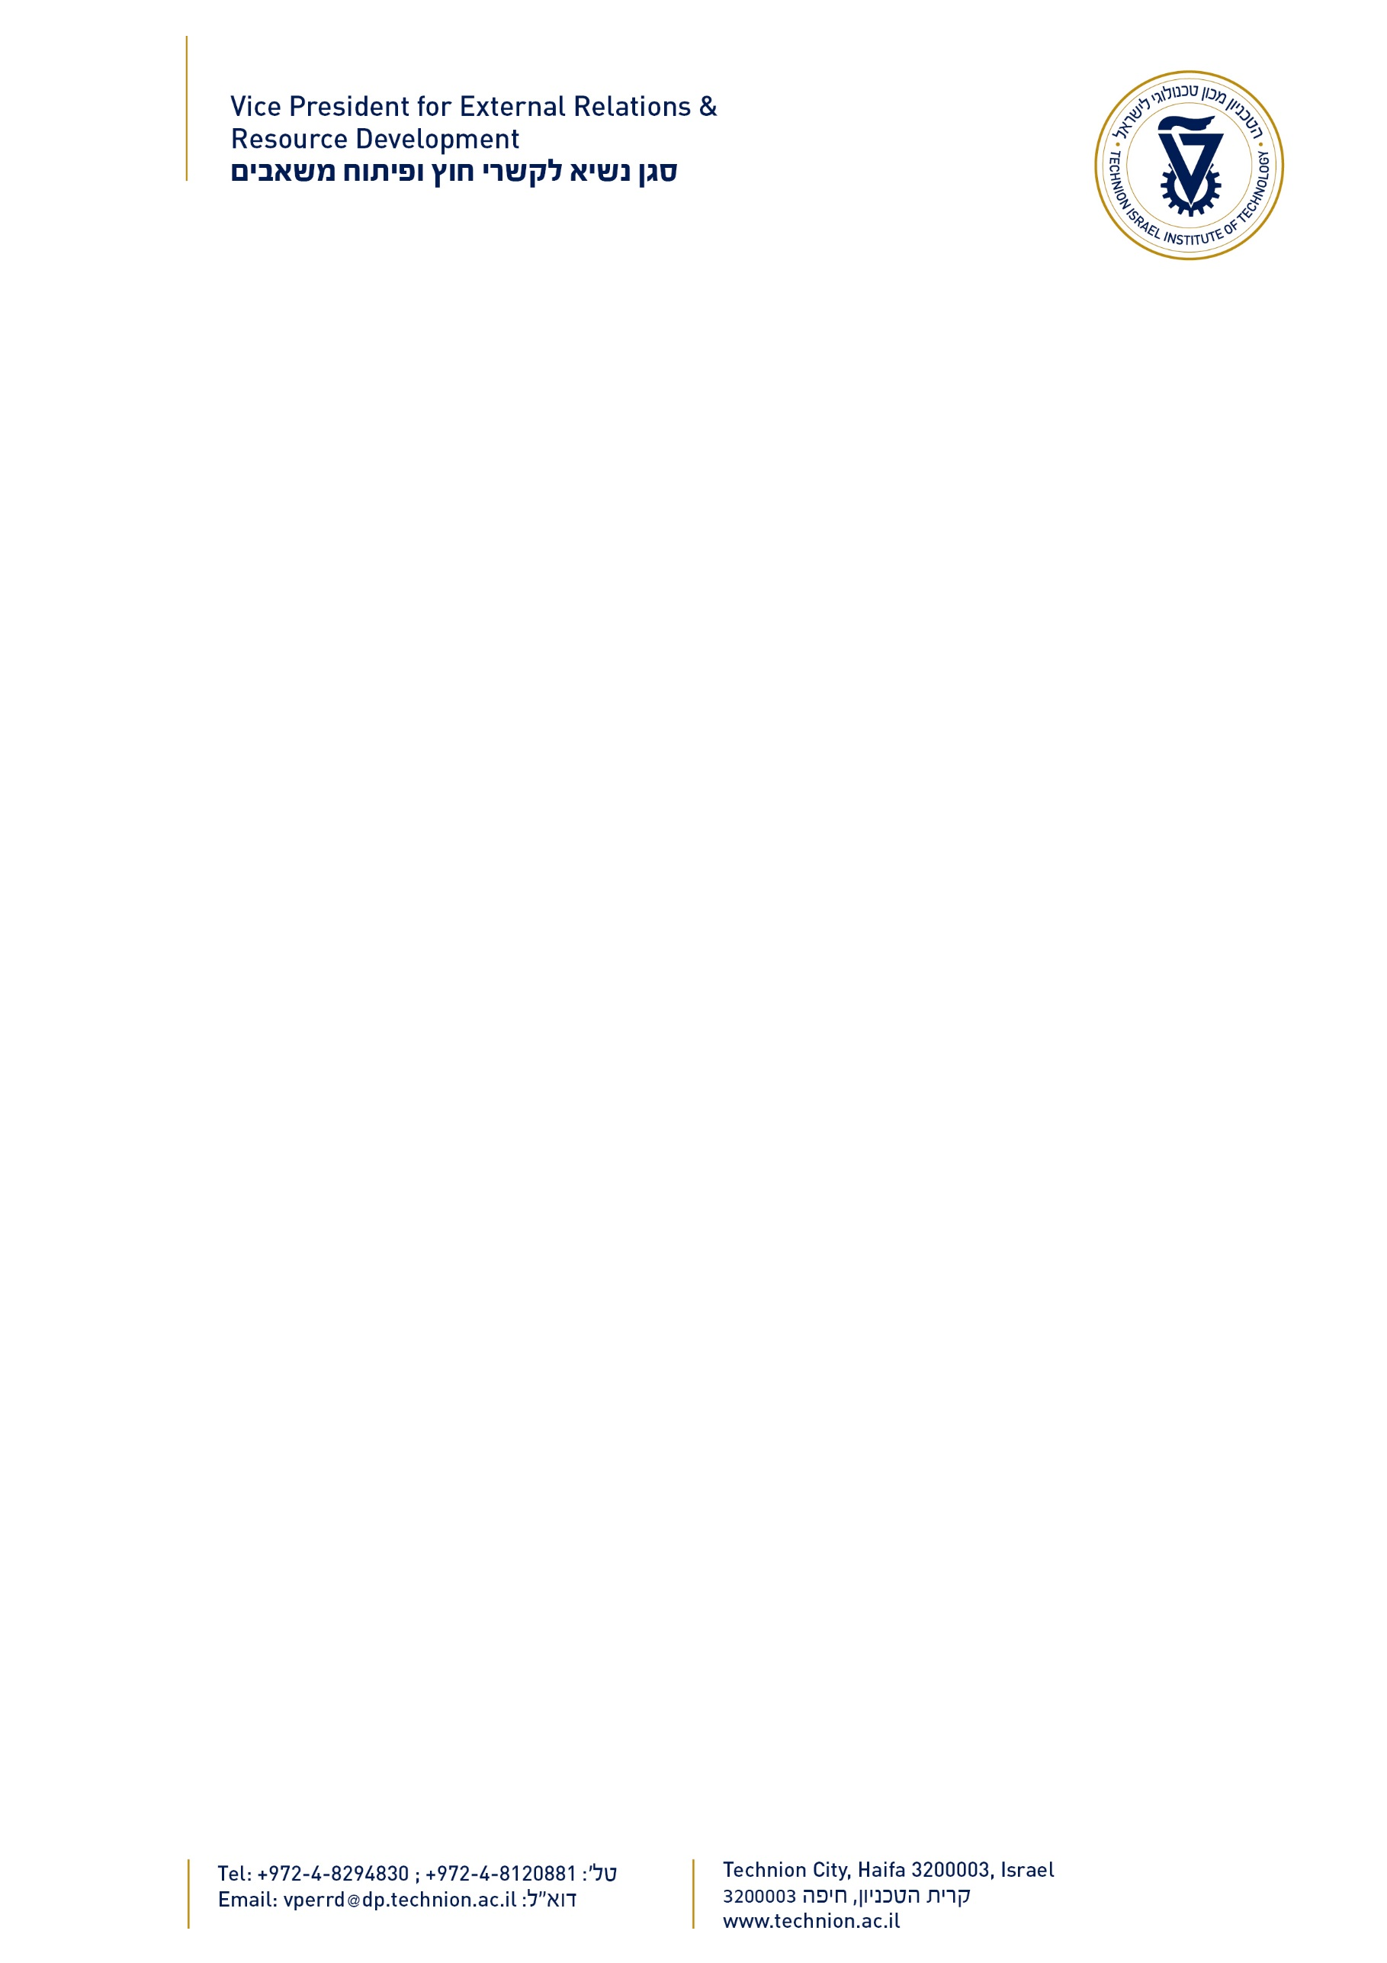

Mr. Stanford Rubin

Trudy Mandel Louis Charitable Trust Loeb & Loeb LLP

10100 Santa Monica Blvd #2200 Los Angeles, CA 90067

USA

Dear Stan,

I’m delighted to forward you the enclosed report by Prof. Meir Orenstein, on the recent activities supported by the **Trudy** **Mandel** **Louis** **Charitable** **Trust** **Nanophotonics** **Research** **Fund.**

As you can see from the report, Prof. Orenstein and his colleagues have achieved some excellent research results, some of which may have substantial impact on MRI development.

It is always a pleasure to acknowledge the commitment and dedication of the Trudy Mandel Louis Charitable Trust. The Technion is a leader in its field as an institute of technology. It is at the cutting edge of scientific, technical and medical advancements throughout the world. Your generous contribution enables it to remain there.

Yours sincerely,

Prof. Boaz Golany Vice President

External Relations & Resource Development

*SS/2017*



Trudy Mandel Louis Charitable Trust

Nanophotonics Research Fund

**2016** **Annual** **Report**

*Report* *by* *Prof.* *Meir* *Orenstein,* *Head* *of* *the* *Program*

**Research** **Progress**

This year, thanks to the generosity of the Trudy Mandel Louis Charitable Trust, important progress was made in several areas: including unique nanophotonic, or extremely small scale, detectors, light emitters and sensors.

The group of professors, Meir Orenstein, Gad Eisenstein, Dan Ritter, David Gershoni, Nir Tessler, Gad Bahir and Gitti Frei devoted substantial research efforts towards the design implementation and measurement of specialized detectors and sensors, based on nanophotonic technologies, or the ability to squeeze light into a small volume to be detected by a sensor. Some of our research last year attracted the attention of the Israeli Defense Ministry, who began funding the application of this new technology. This year, we had a breakthrough using a new nanostructure shape of detectors and light emitters that is showing extreme promise.

Groups at the Technion headed by Professors Meir Orenstein, Erez Hassman, Guy Bartal have continued to develop nanostructures. Our superb results in this field were recognized by publications in the most prestigious scientific journals, and several applications have already been demonstrated, including the development of very small instruments to measure sugar concentration.

Professors David Gershoni, Eyal Bucks and Meir Orenstein made substantial progress in making nanophotonic arrangements around diamond color centers. These are very small defects in diamonds that are extremely sensitive to magnetic fields and can therefore be used in miniature MRIs, brain magnetic imaging and similar applications.

To promote this research, we devoted the main part of the generous **Trudy** **Mandel** **Louis** **Nanophotonics** **Fund** to the most successful integrated work, where the research was performed by a collaboration of two or more principle investigators.

**Use** **of** **the** **Trudy** **Mandel** **Louis** **Charitable** **Trust** **Grant**

1. As reported last year, the money allocated by the fund for the first year was part of the purchase price of the electron beam lithography machine, a critical tool in the nanophotonics development.
2. This year, 70% of the money was allocated towards assistance in collaborative research of the nanophotonics group, including the research of Professors Dan Ritter and Meir Orenstein on detectors and light emitters based on “nanoflag” structures.
3. Professors Nir Tesler and Gitti Frei worked on creating an organic semiconductor that offers more sensitive and improved light detectors on an imaging device, (chip) that would enable cheaper imaging at extended wavelengths.
4. Professors David Gershoni and Eyal Bucks focused on superconductor based light detectors.
5. Twenty percent of the annual allocation was devoted to the establishment of the scientific infrastructure to take in a new faculty member, Alex Hayat, who is doing advanced research in nano opto-electronics.
6. Ten percent of the funding was devoted to maintenance and operational costs of equipment in the Technion micro-nano fabrication facility.

**THANK** **YOU!**