ENHANCEMENT AND REVITALIZATION OF PUBLIC SPACES IN THE HISTORIC CENTRE OF THE CITY OF GUAYAQUIL

Abstract
The public spaces of Euromerican and Latin American cities differ in terms of their defining characteristics. A United Nations study presented at Habitat III breaks down public spaces into three categories: streets, effective public spaces and public facilities. This research takes as its subject the effective public spaces in the Historic Centre of the city of Guayaquil (Ecuador), which have lost their power to bring people together as a result of internal migration from the city centre to the suburbs. Also causing the deterioration of these public spaces is the preservation- and isolation-focused municipal ordinance for Urban Regeneration, which has set limits on their use and does not resolve conflicts in the social relations between users and their environment. The aim of this research is to interrelate and reintegrate the various public spaces scattered throughout the Historic Centre, and assign them the fundamental role of promoting their importance during the process of urban planning. The proposed empowerment and revitalization of these public spaces calls for the identification of the urban element, an analysis of each of its element, and the design of both material and immaterial connectors that will lead to the proper interrelation of the public spaces of Guayaquil.
Keywords: revitalization of public spaces, historic city centre, delimitation of historical spaces, urban landmark legislation.

Introduction

In the interest of revitalizing and enhancing the public spaces of the Historic Centre of the city of Guayaquil (HCCG), the present study develops an urban design based on material and immaterial connectors. The various approaches proposed by prominent scholars such as Allán (2011), Borja (2003), Vicherat (2007) and Hakim (2007) can be integrated to define public space as one in which the inhabitants of a city built over time with a socially diverse population can freely circulate, socialize and seek recreation All this encompasses features such as accessibility, continuity within the urban environment, design and multi-functionality, security and democratic use – characteristics that together are responsible for the citizen's quality of life (tangible or intangible).
Face-to-face monitoring conducted in the first half of 2016 (7 hours per day/5 days per week), provided evidence of a loss of empowerment among inhabitants with respect to the public spaces of the city of Guayaquil. Despite being oriented towards the preservation of patrimonial value (Urban Regeneration Ordinance), the regulations established by local governments have imposed limitations that, along with a lack of regulations regarding formal and informal commerce as well as inadequate use of public spaces in the sector, have led to its loss. Previous studies on urban regeneration and social exclusion carried out in the city of Guayaquil show that the accelerated and disorganized growth of the city has isolated public spaces from each other, diminishing their public quality, and even transformed the image of the city and relationships between its users (Allán 2011).
This research establishes that if urban strategies oriented towards the interconnection of the public spaces of the HCCG are correctly applied, they can help empower and revitalize these spaces for the benefit of the community. The work of architect Melvin Hoyos as premised in his Two Centuries of Urban Evolution (Hoyos 2010) on the urban projects of Guayaquil, will be points of reference for this research. Before dealing with the problem, the present paper presents:
- A social initiative to promote urban regeneration of the HCCG through citizen participation.
- A technical proposal to use material (green corridors, urban furniture, etc.) and immaterial (referential) connectors to link existing public spaces in the Historic District.
In terms of methodological strategy, the two proposals will be achieved in three stages. The first stage consists of establishing the limits of the Historical Centre on the basis of patrimonial architectural structures and the public spaces of the city of Guayaquil. For this purpose, cartographic, sociological and historical data (Hoyos 2010) are compiled and analysed. The current situation of the sector is studied through a photographic survey and a technical-urban analysis of mobility and connectivity as well as the relationship between full and empty spaces (Nolli map), the width of roads and sidewalks, and the frequency of the Historic District's use. Evaluated too are statistics collected by two governmental institutions – the National Institute of Statistics and Censuses (INEC, 2010), and the National Institute of Cultural Heritage (legal document: DR5-2016-0268-0) – in relation to the level of inclusion in public spaces as well as technical data sheets on properties considered assets. Finally, a QGIS program is used to prepare a GIS map of the Historic District based on a geographical database, geographical charts, and urban plans of specialized institutions in the city of Guayaquil, (QGIS, 2017).
In the second stage, the types of businesses present in the study sector are identified and compared to those of other Latin American cities in order to consider the possibility of incorporating and/or modifying their compatibility in terms of land use with an emphasis on public spaces. This entails formulating strategies for revitalizing commercial corridors in such a way that the main role played by this sector of the city is not lost. Also proposed is the incorporation of an urban green infrastructure that will interconnect the most representative ecological elements in the city centre (e.g. Parque Forestal, Cerro del Carmen and Cerro Santa Ana).
In the third stage, the design of the master plan for regeneration is carried out. This consists of a document-based draft of a law that defines municipal ordinances on the subject under consideration as well as a technical proposal that facilitates the urban regeneration of the sector. The technical proposal includes possible solutions for connecting the public spaces. Research developed inter- institutionally belongs to a line of research known as sovereignty over the rights and technologies of territorial and environmental rules for construction.

In the third stage, the design of the master plan for regeneration is carried out. A technical proposal for facilitating the urban regeneration of the sector is prepared. The technical proposal includes possible solutions for connecting the public spaces and serves as a draft for elaborating a legal document that will define the municipal ordinances on the subject in question, such that the research developed inter-institutionally will belong to a line of research known as sovereignty over the rights and technologies of territorial and environmental regulations for construction.

Historical development of the Historic Centre

The Latin American city was built on a grid organized into planes with a seemingly unlimited capacity for growth and expansion. The centre of the city served as a reference point for the areas bordering it, implicitly defining the historical superstructure through its centrality. Concentrated in it are all the buildings with artistic value, as well as streets and buildings constructed prior to the Industrial Revolution. Geographically speaking, the city of Santiago de Guayaquil is located to the east of the Guayas river, to the west of the Estero Salado and the Blue and White Hills, to the south of the mouth of the Puntilla de Guayaquil river that runs as far as Puná Island, and to the northwest of the beginning of Cordillera Chongón-Colonche (Figure 1, left), (Municipality, 2016). The area of the Historic District as defined by patrimonial architectural structures and the public spaces of the city has been set as that lying between Calle Venezuela and Calle Dr. Julián Coronel Oyarvide, and from Avenida Quito to Avenida Malecon Simón Bolívar, encompassing a total area of 3.7 km² and seven out of the twenty-one parishes that constitute the canton of Guayaquil (parishes: Carbo, Rocafuerte, Olmedo, Bolivar, Ayacucho and Ximena) (Figure 1, right) (Hoyos, 2010).
Fig. 1
A chronological representation of the main squares and parks existing in the sector under study is presented in Figure 2. In 1881, French artist Aime A. Millet designed the layout of the city, breaking it down into 156 blocks and incorporating the principal squares of the city that define the city's earliest public spaces. Unfortunately, a significant part of the built heritage, 20% of the homes as well as many historical records regarding the physical boundaries of the Historic Quarter were lost in the fire of 1896 (according to the records of the Territorial Infrastructure Department of the Decentralized Autonomous Government of the Municipality of Guayaquil).
Fig. 2
Since 1972, the city's public spaces have undergone no change in terms of form. In 1999, the project known as Malecón 2000 initiated a process of regeneration to improve the urban image of the city. In 2000, the city consolidated the parks, squares and other public spaces of its historic centre. These are the subject of this study. Table 1 presents a chronological summary of public spaces.
Table 1

Delimitation strategy

In order to define the urban reality of the Historic District, five elements (land distribution and use, population density, urban facilities and mobility) are established as indicators and described below.
Distribution and use of land.
The Territorial Plan of the Municipality of Guayaquil (SNI, 2011) classifies the city according to the predominating land use in each sector. As can be seen in Figure 3, residential use predominates within the boundaries of the city. In the Historic District, land is subdivided into seven zones. The central zone (1,507,758.34 m²) corresponds to 42.76% of the Historic District, in which the consolidation of the business sector and the presence of commerce leads to greater vehicular and pedestrian occurrence, and thus to the reduction of residential land use (Allán, 2011).
Fig. 3
Population density
Between 2010 and 2013 the city of Guayaquil experienced fluctuation in the population density of all its parishes, as indicated in Figure 4. The migration of inhabitants to areas of expansion within the city and the consequent change in land use in the Historic Quarter (from residential to commercial or administrative) have been taken into account in the analysis of the commercial corridors. Such change in use has modified the activities of users, generating much activity during work hours but reducing it outside of these hours and on holidays and thus increasing risk and insecurity. (SNI, 2011).
Fig. 4
Urban facilities
The urban layout of the Historic Quarter is consolidated and compact, setting limits on the size and numbers of public spaces within. As 42.76% of the area corresponding to the central district of the city of Guayaquil is located in the Historic Quarter, approximately 90% of the facilities registered for education, administration, worship, markets and health are located in this area (Figure 5). (SNI, 2011). On the other hand, the location of Malecón 2000 in a plot within the Historic Quarter and its proximity to Centennial Park define the starting point of the referential axis along which the various facilities of the Quarter will be interconnected
Fig. 5
Mobility
The urban mobility of the city of Guayaquil is organized according to a primary and secondary network of roadways that facilitate access to the various zones of the city, which suffers from considerable traffic congestion (Figure 6). Road congestion is a factor that negatively impacts pedestrians, cyclists, residents and even drivers. According to Zambrano et al., (2014), the city of Guayaquil is home to approximately 380,000 vehicles, of which only 4,000 are urban buses, 405 belong to the system of Metro Vía, and the remaining 375,595 are private vehicles.
Fig. 6

The heritage
In the city of Guayaquil, a heritage building is defined as one that is at least 100 years old, grants historical character to the centre of Guayaquil and has a positive impact on the city. The architectural patrimony makes it possible to reconstruct the trajectory of the sector, observe its historical stages, and see the different types of construction used over time. In 2017, the structures that survived the fire of 1826 were designated as heritage buildings and are now regulated as assets that safeguard the history of that era. Currently, 210 heritage buildings have been identified as such in the historic centre of Guayaquil (National Institute of Cultural Heritage).

Process to include new spaces

Whenever the historical and cultural importance of a historic centre is restored, the safe and comfortable transit of its users, the preservation of green spaces and their inherent virtues, and the process of transforming space become a challenge (Laub, 2007). Urban regeneration is usually perceived as the economic recovery of an urban sector and is referred to by terms such as rehabilitation, renovation and revitalization, with the common denominator of referring to already urbanized projects. It is thus necessary to consider urban regeneration as a means of economic recovery that also guarantees a model based on sustainability and the integration of social, economic and environmental features (Sevilla et al., 2014).
The proposed urban regeneration of the Historic District of the city of Guayaquil is based on the construction of material and immaterial connectors. A material connector refers to any linear piece of land or apparatus that links urban nodes, neighbourhoods, squares and parks, improving conditions for people and preventing their displacement (City, 2016). Material connectors include urban furniture, cycle paths and green infrastructure.
Green infrastructure or a multifunctional network of ecosystems (e.g. parks and gardens, streets and squares with trees, decks, green facades, bodies of water, playgrounds, etc.) improve bio-urban capacity. In addition, such infrastructure supports the development of territorial and sectoral policies (governing energy, climate change, biodiversity, public space, etc.) that help create environments that improve the physical and mental health of their inhabitants and contribute to the development of a green and sustainable economy (GIEC, 2013). Examples of such undertakings include the Green and Biodiverse Plan of Barcelona 2020, the National Ideas Competition for urban renewal in the central area of San Isidro, Argentina, the international competition for the treatment of public spaces in the historic centre of Lima; the proposed urban revitalization of la Calle General Jofré in the Vicuña Mackenna neighbourhood of Santiago de Chile, et al.
Intangible connectors, on the other hand, create intangible links between the city and its users, ones that lead to order, restriction, purchases and sales, guidelines as well as education about the city's cultural and historical referents. They are characterized by the interrelation of signs that unconsciously create imaginary paths, nodes of convergence, and collective memories that allow citizens to coexist in and take possession of these spaces. A variety of urban signs fills the city with codes that inhabitants must assimilate and creates itineraries (or marks imposed on urban space) for their use or enjoyment (Certeau, 1999).

Analogous models of revitalization of public spaces as benchmarks for intervention

Since 1980, urban revitalization has been proposed as a mechanism for intervening in the central areas of cities that show signs of deterioration or abandonment. Improving the urban landscape and the quality of life of its inhabitants demands a social, economic and cultural understanding of the city (Allán, 2011).
Urban dynamics (day and night activities) with facilities that provide social services generally play a key role in urban revitalization. In Latin America, for example, the Santiago Patrimonial project has created an itinerary through the centre of this Chilean city, installing metal plaques on the ground that allow users to rediscover the heritage of their city. The plaques are meant to incorporate interactive information points that will provide users with a full tour of the historic centre.
In Europe, studies of the city of Copenhagen suggest that half of its inhabitants regularly use bicycles to get to work or school, something that is not farfetched for a city with a cycling culture. As a result, a green circuit is being planned with the objective of demonstrating that one key to a more sustainable city is the provision of means that ensure walking, cycling and public transport and reduce the need for private transport (Martinez, 2014).
In order to guarantee that urban intervention in the Historic Centre in Guayaquil is properly conducted, Territorial Planning needs to be paired with strategies that enable the implementation and management of approved proposals for urban revitalization, rehabilitation and regeneration, as has been done in certain Latin American countries and 59% of European countries. Successful examples such as that of Copenhagen, indicate that this kind of incorporation makes it possible to strengthen social and administrative cohesion during sustainable development and facilitates the private sector’s participation in the processes of urban transformation.

Design of the proposed intervention

Neglected spaces (squares, parks, among others) lead to a lack of a sense of belonging among inhabitants of the sector. As the importance of public spaces in cities is related to the cultural, physical and recreational development of the people who spend time in them, their appropriation by users is one of the most important phenomena to demand consideration (Fonseca, 2015). Factors that influence the appropriation or control of public spaces correspond to the realization that cultural, social, sports or recreational activities in them; forming from the necessity or preference of use part of the sociohistorical construction of territoriality (Nieto 2007). Factors that influence the appropriation of public spaces correspond to the realization that cultural, social, sporting or recreational activities in public spaces form part of the socio-historical construction of territoriality based on the need and desire to control property (Nieto 2007).
This study analyses user behaviour of appropriate public spaces with respect to the following factors: green areas, physical barriers, proximity to public administration facilities, type of design, continuity with the environment and timeframe of usage. Information is collected through interviews and surveys, and is evaluated according to the following criteria: knowledge, management and delimitation of public space in the Historic Centre; frequency of use, motivation and factors that encourage the use of existing public spaces in the Historic District. After this information is processed, a hierarchy is established with regard to the level and reasons for the use of public spaces, as well as the use and availability of green infrastructure in these public spaces. Finally, an economically and technically viable, sustainable and effective solution that grants empowerment to citizens with regard to public spaces is developed.
In order to strengthen and revitalize the Historic Quarter, three fundamental issues must first be defined: the ordinances that regulate it, strategies of empowerment and revitalization, and the validation of the strategic proposal in the context under study.

Legal context of intervention strategies: basic document of the bill defining municipal ordinances with respect to the topic treated here
Any approach to urban problems requires formulating strategies to resolve the deficiencies caused by a lack of or poor planning. In addition, a legal frame of reference (municipal ordinance) is required to act on any area that has been previously delimited and classified according to use, etc. In Guayaquil, however, such an ordinance was not defined until December 2016 despite its indispensability to the application of the urban strategies proposed in this study.
According to the legal framework, the Organic Law of the Municipal Regime (Article 263), the Cultural Heritage Law (Article 6), the Organic Code of Territorial Organization, Autonomy and Decentralization (Art. 7), the Organic Functional Regulation of the Illustrious Municipality of Guayaquil, the Ordinances of Guayaquil, and the Cabildo of Guayaquil, regulate the use, enjoyment, protection and conservation of municipal property. Taking into account the similarities of the urban contexts within the HCCG that are regulated by the Ordinance of Guayaquil, the Ordinance for the Control and Administration of the Historic Centre of the city of Cuenca (Cuenca, 2016) and the Ordinance Regulator of the Historic Centre of the city of Santa Ana (Mendoza, 2012), a basic proposal is made for developing the municipal ordinance according to an urbanistic approach.
The legal framework must preserve the integrity of the public areas of the Historic District (in the event of an improper use that could lead to their deterioration and destruction), as well as guarantee special protection in the case of mass public gatherings, among other events. In establishing the guidelines for authorizing activities and projects to be carried out in the HCCG, the priority is to protect cultural heritage and enhance tourism as well as the artistic, commercial, urban and economic development of the city's citizens. The field of application defines the natural and legal persons, public or private, who carry out projects within the area delimited as the Historic Quarter.
The proposed delimitation of the HCCG is described with the aid of Fig. 7, in which a dashed line connects primary and secondary points (labelled in red as 1-7, labelled as a-m, n-o, p-s).
Fig. 7
The proposed delimitation for the HCCG is subject to approval by the National Institute of Cultural Heritage and represents the first step in the regulation of urban and architectural actions in the sector. After its approval, regulations will be promoted to the management process of the Historical Centre, which, on the basis of urban or architectural elements, will regulate:
- Buildings classified as monuments and used for community, administrative, religious and cultural activities.
- Simple polarizing buildings that in their organization of space, form and function conform to and delimit entire blocks.
- Complex polarizing buildings formed by the integration of several simple polarizing elements.
- Other buildings of monumental value.
With regard to the management of the Historic Centre, the national and regional institutions must have special and technical competences, according to the Law of Cultural Heritage (LCH), the Organic Law of Municipal Regime (OLMR) as well as the Municipal Ordinance (MO) derived from this proposal. The basic document of the bill that defines municipal ordinances was contextualized in accordance with the following stipulations:

- to ensure the association of the pertinent parts of LCH and OLMR to the municipal ordinance;
- to incorporate into the framework of the LCH and OLMR all the architectural and urban interventions that public and private institutions as well as citizens in general can carry out;
- to declare streets, buildings, urban elements, and architectural details of a public or private nature as property belonging to the cultural heritage sector that merits preservation whether or not they are included in the protection zones, as stipulated by the LCH and the National Cultural Heritage Institute;
- to request the Illustrious City Council to carry out a plan to preserve protected areas and to execute it in a programmatic manner, in accordance with preservation and restoration policies;
- to maintain a register of citizen requests, restorations, maintenance work, conservation, consolidation, new constructions, total or partial demolition, etc., intended to be carried out by the municipal body in buildings within the protected zone and its area of ​​influence;
- to regulate land use in the protected zone and its area of ​​influence subject to the current Master Plan of Urban Development so that the vital and traditional activities of the same are not affected and distorted by new uses, especially those that promote speculation on urban property or affect its social use;
- to indicate rules and measures that safeguard the integrity of sites and monumental property that has been or could be altered by changes or aggregates;
- to recommend to or inform the Illustrious City Council of the need to repair, consolidate, restore, or maintain urban or architectural elements;
- to conduct regular campaigns that evaluate and disseminate information on what constitutes the cultural property of the HCCG and the parishes of the canton, while providing information on the policy and the plan of action realized by the Municipality;
- to elaborate and periodically update the list of buildings and structures that deserve to be considered by the Council as beneficiaries of the incentives contemplated by the LCH;
- to promote public and private, national and foreign participation in the creation of a foundation for restoration work in the Historic Quarter;
- to establish agreements with state and private institutions, national or foreign, in order to undertake actions aimed at preserving the Historic Centre and areas declared as cultural property;
- to present a glossary with the following definitions in order to avoid incorrect interpretations by professionals in other areas who are involved in the elaboration of ordinances: "announcement," "authorization," "eaves," "building height," "use," urban design," "ground," "appraisal," "pedestrian street," "poster" or "signage," "mapping," "trade," "compatibility of uses," "commercial" and "service" corridors, "public space," "urban image," "construction line," "factory line," "porch line," "construction permit," "special plans," "squares" and "parks," "porch," and "land use."
- to define guidelines for urban planning and the protection of cultural heritage in terms of the classification of land use.
- to define guidelines for urban planning and the protection of cultural heritage with respect to the classification of the use of public spaces;
- to regulate permission for the operation of different activities in public spaces depending on type of use. To this end, a tourism-culture-oriented proposal must be presented and certified by the Directorate of Culture and Civic Promotion, and contain at least one of the following options: exhibitions of photographs, paintings, sculpture, poetry, or anything else that promotes culture, a sense of citizenship, and tourism among the city's inhabitants;
- to establish the work and types of intervention to be done on monumental properties of the Historic District, such as preservation, conservation, consolidation, restoration, restitution, reconstruction, demolition, new construction;
- to create norms for the conservation, preservation, protection, urban and architectural action within the Historic Centre and its buildings that take into account their historical, artistic and environmental value and guarantee homogeneity and architectural-urban integrity;
- to regulate commercial activity, the occupation of roads and the installation of signs, advertisements and propaganda in public spaces, streets and on urban monuments;
- to regulate procedures and permits for actions that affect the urban image of the Historic Quarter;
- to define penalties for the infraction of the effective ordinances.
The entity responsible for managing and enforcing these regulations will submit periodic reports and follow-up that allow for updates and regulation of the Historic Quarter's well-being.

Strategies for the empowerment and revitalization of public spaces in the Historic Quarter of Guayaquil.
The strategies developed are of an integrative nature, designed to physically and visually link the urban environment and promote optimal mobility. The delimitation of the Historic Centre should be evaluated at each historical moment, enabling the establishment of relations with the dynamics of change in the rest of the city, granting specific social content to geographic places, and integrating historical elements of the city with activities and symbolic functions.
This research identifies and analyses the features and social characteristics as well as the uses and activities that citizens associate with the Historic Quarter; additionally it verifies that no material delimitation has been established by municipal or governmental entities and that no immaterial delimitation exists in the minds of its users.

Described below are the uses of both material connectors (longitudinal and transverse) as agents of urban revitalization and immaterial connectors as agents of identity-enhancement.
As the material connector in the Historic District, the urban green infrastructure seeks to strengthen the hitherto scarce presence of green spaces. Green areas within the district were estimated at 2.58 m²/hab, as compared to the 9 m²/hab required by the World Health Organization. Proposed therefore is an increase in the presence of green infrastructure by approximately 4 m²/hab (an increase of 53%).
Strategically, the tree is assumed to be the main element of the urban landscape because it benefits the ecosystem and cities (Wiesner 2000). In addition, the incorporation of vegetation on urban paths allows for links to be made between various parks and squares of the city of Guayaquil and thus create a green network.
If green infrastructure were implemented longitudinally, it could interconnect two large ecological systems of the city (Forest Park and Santa Ana Hill). The proposal therefore calls for the use of tree species such as Acacia Amarilla and Jacaranda, which due to the colour of their flowers, abundant foliage and low height, will improve the urban image of the Historic Quarter (Figure 8). Among the benefits of these species are:
Fig. 8
- Reducing environmental noise pollution based by the relationship between the center of the cup of tree/ tree height (Posada et al., 2009). The mitigation effect generated by green corridors in cities amounts on average to a reduction of between 5 and 10 dB (Figure 9, above).
- Improvement in environmental conditions in the city through the reduction of temperature; an increase of 10% in tree coverage can decrease room temperature in a city by 3-4°C, according to data compiled in the United Kingdom by the United Nations Environment Program (Fernández 2013), (Figure 9, below).
Fig. 9
The proposed road within the longitudinal connector is meant to prevent the current problem of vehicles parking on the streets of the Historic District, thereby granting streets the status of public spaces par excellence, making them more comfortable for pedestrians. The goal is to broaden the Avenida Quito, which cuts through the west side of the Historic District from 3 to 8 meters and increase its current width on one side by 5m along its 2.76-km route (from Forest Park to Santa Ana Hill).. The sidewalk destined exclusively for pedestrian traffic would be 3.30m wide; a strip of vegetation with the tree species and urban furniture designated for each sector would be 1.50 m wide; an adjoining strip of vegetation that incorporates a bi-directional cycle path would occupy another 2.50; and the final strip would consist of a 0.70m plant border that serves as a protective barrier between the main road and cycle route (Figure 10). Theoretically, such a solution would make it possible to increase the amount of effective public space in the Historic Quarter by 38% (Garau, 2016).
Fig. 10
A view of the plan (Figure 11) shows the first longitudinal axis at the intersection of Avenida Quito, including the distribution of the road cycle, tree coverage area, the five channels of vehicular circulation, the pedestrian crossings, and the changes of direction in the sidewalks, etc.
Fig. 11
A second longitudinal axis would lie to the east of the Historic Centre, where, drawing on the concept of an urban path, the proposal would strengthen the urban axis by interconnecting urban ecosystems (Parque Forestal to the south of avenida Quito, and Carmen hill to the north of it). Urban analysis confirms that this sector would facilitate a connection between urban health facilities, administration, and Victoria Square. The proposal calls for a two-line bike path with a green border separating it from the avenue – a strip of afforestation that would interconnect the Historic Quarter's ecological systems.
Following the guidelines of the green infrastructure and the expansion of public space, the proposal has determined that the intervention be done on Calle Luque as it has an average sidewalk width of 2.00 meters in addition to buildings with arcades. The second story begins at the height of approximately 4.00 meters, and thus allows for the incorporation of small tree species (Samán and Acacia morada). Figure 12 shows both the longitudinal and transverse network of vegetation interconnecting the public spaces that will generate comfort for users of the Historic District as they circulate along different routes.
Fig. 12
In this study, the immaterial connectors serving as agents that enhance the district's identity correspond to the parks and squares, buildings and areas of great patrimonial wealth that create connections and generate a feeling of belonging or historical remembrance among the city's residents as well as visitors along the various routes through the old section of the city of Guayaquil.
Alternative immaterial connectors would include tourist corridors along four routes:
Route of the Churches (blue line). This would traverse the most significant centres of worship in the area. An immaterial corridor is proposed for these connections (N-S, E-O). It would start at La Catedral, at the intersection of Calle Clemente Ballén and Calle Chile. The physical barriers of Seminary Park would be eliminated in order to appropriate this public space, its surroundings, and the corridors created by the urban proposal (Figure 13, below). Churches 1 to 5 follow a chronological order (see Table 1).
Fig. 13
Route of the Independence (pink line): The axis formed by Avenida Malecón Simón Bolívar and Avenida Eloy Alfaro would be reinforced (Figure 14). This is the historical area where the city of Guayaquil achieved independence. The points indicate the buildings where meetings were held prior to the declaration of independence. The route is closely related to the circulation of branch 1 of Metro Via.
Fig. 14
Patrimonial Route (yellow line): Identified with the help of the National Institute of Cultural Heritage, the heritage buildings located within the Historic District of the city of Guayaquil will be traversed by this route (Figure 15). Although there are 276 heritage buildings in the centre of the city, the patrimonial route will only connect 243 buildings (the more symbolic ones) according to data compiled by the National Institute of Cultural Heritage.
Fig. 15
Commercial Route (fuchsia line): This route will be defined by an analysis of the relationship between commercial activities (low, medium and high intensity) and vegetation in this sector, as well as the level of satisfaction among and demand by users (residents of the sector, tourists, visitors, etc.) with respect to the analysed relationships. The Historic District presents a mixed use of land, with some sectors marked by commerce in clothing and appliances. The inclusion of an urban green plan in the routes identified as high-intensity (Avenidas 10 de Agosto and Sucre, between stretches of Calles Quito and Boyacá), will generate an immaterial connection if intersected with another avenue of similar characteristics, such as Boyacá.
The elaboration of a commercial route (Figure 16) and proposal to regulate the urban approach would help transform compatible land use. In addition, night-time commercial activities could be developed to revitalize the HCCG. Due to the importance of recovering housing in the Historic District, the upper floors of buildings should be allocated for domestic use and the lower floors for commerce, with pleasant store fronts that improve the sector's urban image. These would enable and revitalize the area's partial pedestrianization.
Fig. 16

Validation of the proposal

To corroborate the proposed routes of this research, a model of the morphological configurations of the city has been made using the Space Syntax program (SSNetwork, 2017). Through probabilistic analysis, a Space Syntax model determines natural movement; its application in the study of public spaces allows us to see how the physical environment influences the development of human activity (Arnaiz et al. 2013). Such an analysis of the different patterns of movement among users of the Historic Centre has determined the different routes that can serve as connecting axes.
Space Syntax offers two theories for analysing the urban morphology of a city. In this research the choice theory was used to measure the socioeconomic relationship of the routes with a direct focus on city-scale urban interventions. The integration theory was then used to calculate the proximity of each element to the rest of the system's components.
An axial map based on streets, squares, and parks was used to perform a spatial analysis of the HCCG (Figure 17). Assisted by an axial map, Space Syntax determined connections between the various axes, and quantified the degree of the urban frame's accessibility through axial distance (the distance between two elements of the spatial network such that the number of changes in direction from one to the other is minimal). In addition, it performed corrections based on how each change in direction occurred, thereby defining a normalized magnitude (angular normalization). Normalization applies to the analysis of choice and integration (Al Sayed et al., 2014)

Fig. 17
The sum of all the axial distances between an origin element and all the other elements within the system is known as the total axial distance. The lower total axial distance has connections with the lower angle of rotation and thus improves accessibility. Such normalization applies to both choice and integration. When determining proximity between components of the system, the accessibility of each segment to the rest and as well as its potential as a destination of movement must be assessed. Fewer changes in direction between elements of the system indicate greater integration of the elements (Arnaiz et al. 2013). Using a colour code associated with a numerical scale, Space Syntax indicates the range of interconnectivity in each segment studied, as shown in the legend of Figure 18. The results obtained from the axial categorization of the sector under study indicate the total number of segments that define connectivity as well as their percentage weight (Figure 17, below).
Spatial analysis continues with the application of choice theory. Space Syntax uses the standardized measure of choice (NACH) and by means of a colour code associated with a numerical scale, indicates the range of segments of greater value in relation to the urban plot of the Historic Centre, allowing us to identify the routes most suitable for urban intervention within it (Figure 18, above). The results obtained from this assessment of connectivity in the sector indicate the total number of segments defining connectivity value (Figure 18, below) as well as its percentage weight.
Fig. 18
The choice analysis categorizes the accessibility of the segments by distributing them in ranges. Ranges from -2.49 to 1.34 correspond to segments less travelled by users; those between 1.34 and 1.52 correspond to segments suitable for boosting urban interventions; and those between 1.52 and 9.32 correspond to segments that already possess all the accessibility conditions proposed by the natural movement theory of Space Syntax.
The choice analysis revealed that only 16% of the routes under study have a high connectivity index. Additionally, the Avenidas Quito, Chimborazo and Malecón were identified as the Historic District's most suitable routes for a south-north connection, while Calles El Oro, Venezuela and Carlos Gómez Rendón were identified as the most suitable routes for a west-east connection (Figure 19, left). These routes are therefore fundamental to socioeconomic relations with the Historic Centre. The relation between the socioeconomic reality and mobility of the sector under study was achieved by field work and corroborated through the use of Space Syntax modelling with the goal of proving a high level of accuracy (100%), In Figure 19 (right), one can see the ways in which the different routes (Heritage, Commercial, Independence and Church) overlap and complement each other in the established network.
Fig. 19
The incorporation of the proposed routes allows for the integration of the south, south-central and north zones of the Historic Centre (Figure 20, above). They would serve as the main axes for the enhancement of the road and pedestrian system and increase the connectivity index of the Historic Centre by 38% (Figure 20, below) if this model for empowering the Historic Centre with material and immaterial connectors achieves its goal. In addition, they would correct the interconnection between the Centre's public spaces.
Fig. 20

Conclusions

The urban image of the city of Guayaquil has been undergoing transformation in the last two years as a result of new urban models and urban regeneration programs. A lack of adequate legislation regarding historical and patrimonial elements, however, has made progress difficult. According to this New Urban Agenda, if the safety and functionality of components were included in the proposed municipal ordinances, the responsibilities of different fields in the Historic District would be strengthened.
The proposed intervention of the Historic Centre would help restore the city to its users, directly promote their feeling of belonging to the city and improve social interaction in the district's spaces. The sensations generated by the various corridors would lead to greater public recognition of the city's heritage.
The integration of material and immaterial connectors would generate sensations that strengthen coexistence, improve the quality of the various spaces within the district, restore to public spaces their function as meeting points by concentrating in them multiple activities, and encourage the use of complementary spaces in daily activities, thereby providing well-being and security.
The incorporation of urban green infrastructure in the district's various sections as outlined by this proposal would generate great environmental and social benefits, including noise mitigation and a reduction in temperature thanks to the characteristics, structure and density of the selected tree species. The proposal of green corridors seeks to reduce the impact of the car park by harmonizing its relationship with pedestrians, cyclists and residents.
On the other hand, the use of tree species of low height and broad coverage in active urban nodes would draw greater concentrations of people and thus lead to greater security. Finally, because the southern area of the district has few green areas and is densely populated, the proposal calls for rectification through the incorporation of vertical gardens and green roofs.
It is essential that the delimitation of the Historic Centre be evaluated at each historical moment so that it can establish relations with the dynamics of change in the rest of the city, offer specific social content to the geographic area, as well as integrate the historical elements of the city, its activities and symbolic functions.

List of references

Al Sayed, K., Turner, A., Hillier, B., Iida, S. and Penn, A. (2014) Space Syntax Methodology. 4th ed. London: Bartlett School of Architecture, UCL.

Alcaldía (2000) Ordenanza de Regeneración Urbana para la ciudad de Guayaquil M. I. Municipalidad de Guayaquil. http://guayaquil.gob.ec/Ordenanzas. Consulta junio 2017, accessed 20 November 2018.

Allán, H. (2011) Regeneración Urbana y exclusión social en la ciudad de Guayaquil: el caso de la playita Del Guasmo, Pobreza Urbana en América Latina y El Caribe. Argentina: CLACSO, pp. 69-104.

Arnaiz, M., Ruiz, B. and Ureña, J. (2013) El análisis de la traza mediante Space Syntax. Evolución de la accesibilidad configuracional de las ciudades de Toledo y Alcalá de Henares. ZARCH: Journal of interdisciplinary studies in Architecture and Urbanism 1: 128-141.

Borja, J. (2003) La ciudad conquistada. Madrid: Alianza S.A.

Certeau, M., Giard, L., Mayol, P., and Pescador, A. (1999). La invención de lo cotidiano 2. Habitar, cocinar. México D.F: Universidad Iberoamericana, Departamento de Historia.

Cuenca (2016) Ordenanza para el Control y Administración del Centro Histórico de la Ciudad de Cuenca. GAD MUNICIPAL DEL CANTÓN CUENCA. www.cuenca.gov.ec/?q=node/8747, accessed June 2017

Fernández, A. (2013) Árboles en las ciudades: seis razones para querer más. EROSKI CONSUMER. www.consumer.es/web/es/medio_ambiente/naturaleza/2013/01/10/215304.php, accessed 19 April 2017.

Fonseca, J. (2015) La importancia y la apropiación de los espacios públicos en las ciudades, PAAKAT
Revista de Tecnología y Sociedad: pp. 4-7

Garau, P. (2015) Global public space toolkit: from global principles to local policies and practice, United Nations Human Settlements Programme (UN-Habitat), Editor Dominic O’Reilly GOP-Kenya.

8-GIEC, 2013. La Infraestructura Verde: concepto, multifuncionalidad y escalas. In La Infraestructura Verde Urbana de Vitoria-Gasteiz. Vitoria-España: Centro de Estudios Ambientales Ayuntamiento de Vitoria-Gasteiz, pp. 6-7.

Hakim, B. (2007) Generative processes for revitalizing historic towns or heritage districts. Urban Design International 12: 87-99. https://doi.org/10.1057/palgrave.udi.9000194, accessed 20 November 2018.

Hoyos, M. (2010) Los Planos de Guayaquil - Dos Siglos de Evolución Urbana. Guayaquil: Poligráfica.

INEC (2010) Resultados del censo 2010. Instituto Nacional de Estadísticas y Censos. www.ecuadorencifras.gob.ec/resultados/, accessed 30 May 2017.

Laub, C. (2007) La ciudad, los miedos y la reinstauración de los espacios públicos. In Olga Segovia (ed.), Espacios públicos y construcción social, hacia un ejercicio de ciudadanía, Chile. Edited by Ediciones SUR, pp. 49-56.

Martínez, C. (2014) Los planes que desarrollará Copenhague como Capital Verde Europea 2014. Plataforma Urbana. www.plataformaurbana.cl/archive/2014/03/27/los-planes-que-desarrollara-copenhague-como-capital-verde-europea-2014/, accessed May 2017.

Mendoza, E. (2012) Ordenanza Reguladora del Centro Histórico de la ciudad de Santa Ana. Diario Oficial, vol. 126, no. 400, pp. 29-40 Rep. Salvador. http://www.diariooficial.gob.sv/diarios/do-2013/07-julio/10-07-2013.pdf, accessed May 2017.

Municipality (2016) Geografía de Guayaquil. IMG. http://www.guayaquil.gob.ec/geograf%C3%ADa-de-guayaquil, accessed 14 February 2017.

Nieto, C. (2007) Comunicación alternativa para la movilización ciudadana: un parque mil voces. Revista académica del foro Iberoamericano sobre estrategias de la comunicación 1/6: 3-23.

Posada, M., Arroyave, M. and Fernández, C. (2009) Influencia de la vegetación en los niveles de ruido urbano. Revista EIA Escuela de Ingeniería de Antioquía 12: 79-89.

QGIS Quantum GIS Development Team (2017) Quantum GIS Geographic Information System, Open Source Geospatial Foundation Project. http://qgis.osgeo.org, accessed 20 November 2018.

Sevilla, A., Castrillo, M., Matesanz, Á. and Sánchez, D. (2014) ¿Regeneración urbana? Deconstrucción y reconstrucción de un concepto incuestionado. Papeles de relaciones ecososiales y cambio global 126: 129-139.

SNI (2011) Ordenanza que incorpora a la normativa municipal el plan de desarrollo del cantón Guayaquil. Sistema Nacional de Información. app.sni.gob.ec/sni-link/sni/PORTAL_SNI/data_sigad_plus/sigadplusdiagnostico/0960000220001_DOCUMENTO%20PDOT_13-03-2015_10-28-09.pdf, accessed March 2017.

SSNetwork Space Syntax Network (2017) Version 027. The Space Syntax Laboratory, www.spacesyntax.net/software/, accessed 20 November 2018.

Vicherat, D. (2007) ¿Qué tienen en común la identidad, el espacio público y la democracia?: In Olga Segovia (ed.), Espacios Públicos y Construcción Social. Hacia un ejercicio de ciudadanía. Chile: Ed. SUR. http://hdl.handle.net/1814/8517, accessed 5 September 2017.

Wiesner, D. (2000) Metodología para la definición de una Estrategia de Arborización. Foro de Arborización Urbana, Bogotá.

Zambrano M. and Gavilánez P. (2014) Análisis de competitividad del transporte público y el transporte privado en la ciudad de Guayaquil – sector Sauces. MSc Thesis Pontificia, Univ. Católica de Guayaquil, pp 35-36.

Word count: 7990
Date of manuscript: 20 April 2018

Tables, figures and plates

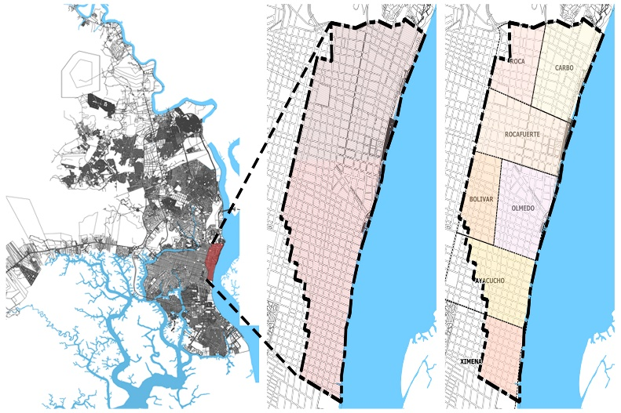

Fig. 1: Location of the study area (left); Location of the city of Guayaquil; (right) Parishes that make up the Historic Quarter (Adapted from Cartography of Guayaquil, 2015)

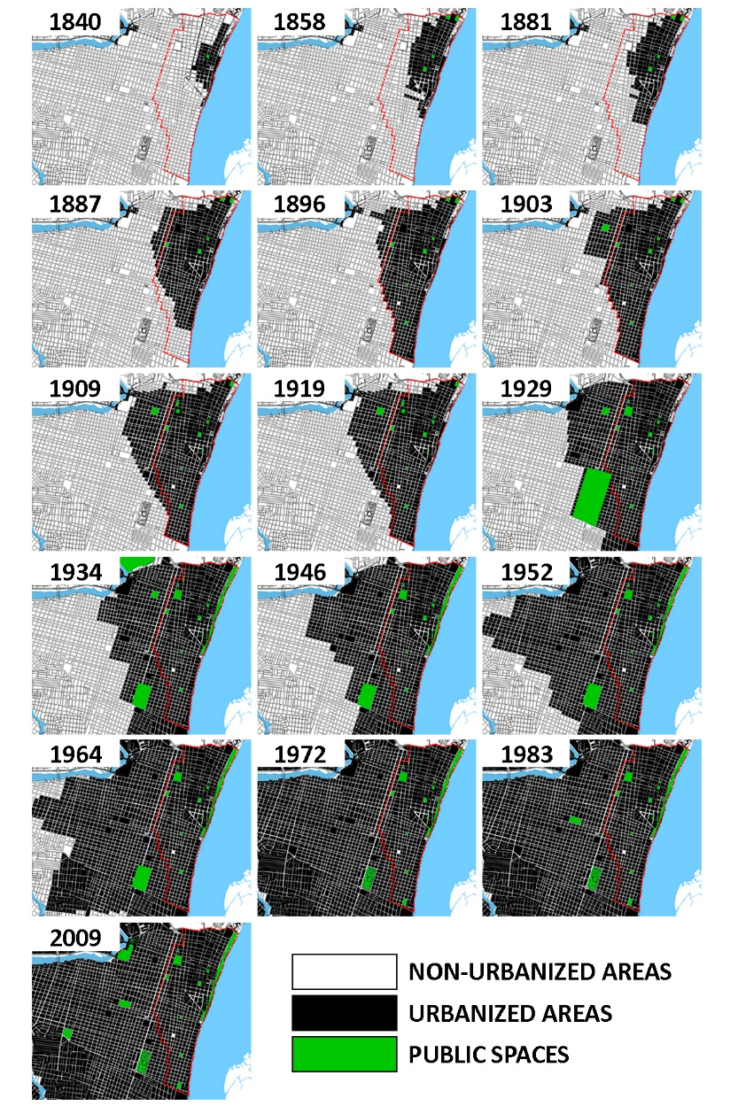
Fig. 2: Nolli map of the Old Town, (Adapted from Hoyos, 2010).

MUNICIPALITIES WITHIN GUAYAQUIL’S HISTORICAL CENTER
Municipalities | Date | Parks | Squares | Heritage Buildings and Neighborhoods
GUAYAQUIL | 1740 |  |  | Las Peñas neighborhood  El Astillero neighborhood  Church of Santo Domingo de Guzmán  Church of San Francisco
CARBO | 1840 |  |  | Church of La Merced
 | 1858 |  | San Agustín square  La Parroquia Square  Santo Domingo square | Artillery barracks
 | 1881 |  |  | Church of La Concepción
 | 1909 |  | Pedro Carbo Square
OLMEDO | 1840 |  |  | Governorate  Cathedral  Municipal  Market
 | 1858 |  |  | El Astillero
 | 1881 |  |  | Amphitheater
 | 1887 |  |  | Hippodrome
 | 1909 | Montalvo Square (Juan Montalvo Park)
 | 1934 | Olmedo Park
BOLÍVAR | 1887
ROCAFUERTE | 1840 |  | San Francisco square
 | 1858 | Cathedral square (Seminario Park)
 | 1887 | Victoria plaza (Victoria Park) |  | Victoria church
 |  | Chile square (Parque Chile)
 | 1909 | La Independencia square (Centenario Park)
AYACUCHO | 1896 | República plaza (España park)
ROCA | 1934 | 24 de Mayo plaza (Mother’s park)  San Agustín park |  | Municipal Park (Forest Park)
XIMENA | 1972 | Armada’s park |  | Abdon Calderon Museum

Table 1: Chronological synthesis of public spaces
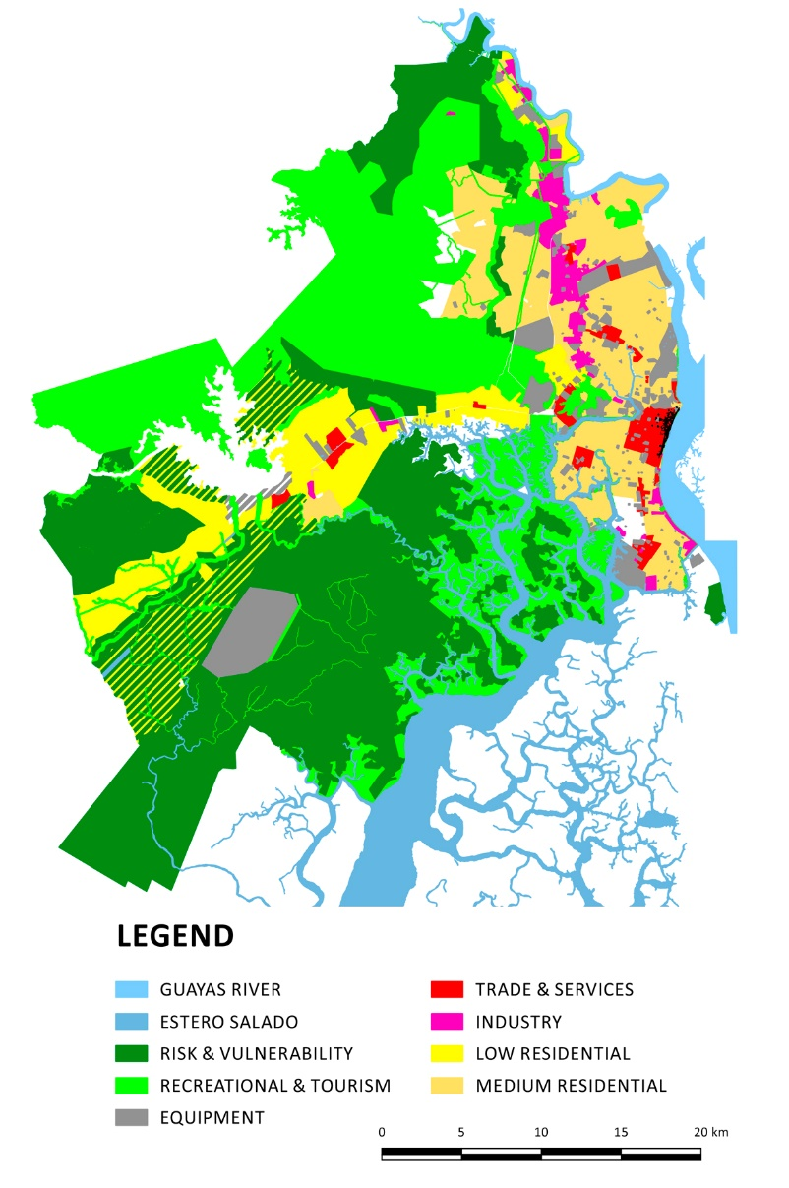
Fig. 3: Prevailing land use by sector (Cartography of Guayaquil, 2015).

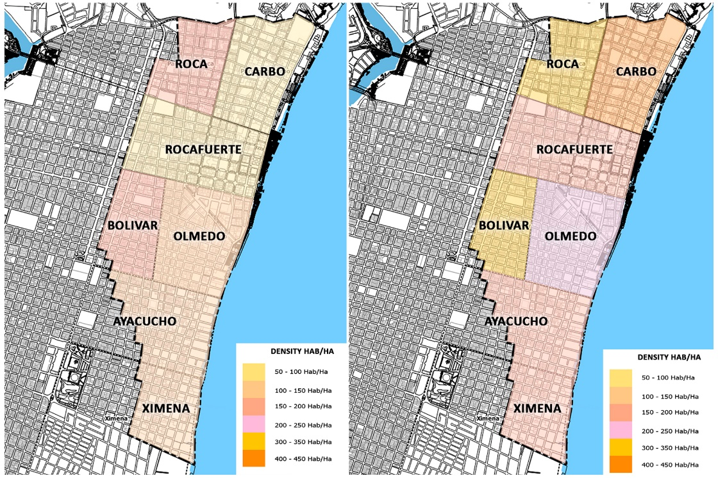
Fig. 4: Variation in population density by parish (Adapted from the Cartography of Guayaquil, 2015).
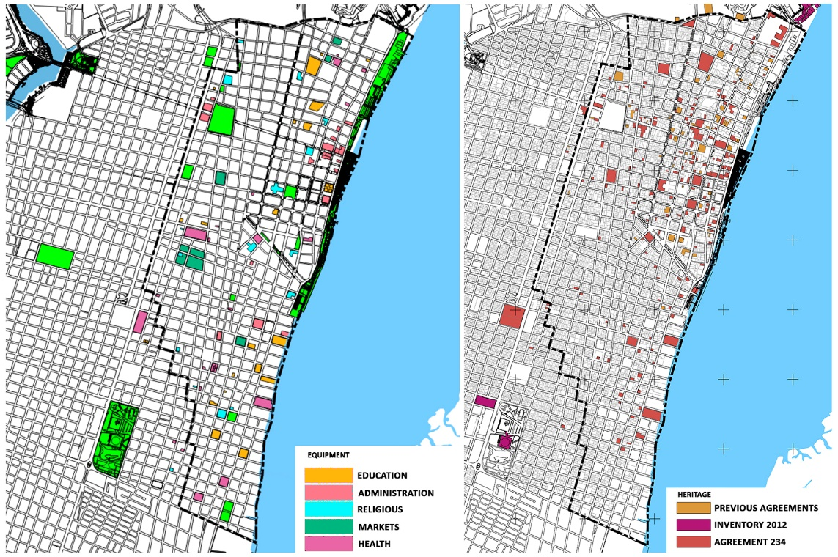
Fig. 5: (right) Facilities; (left) Properties listed as heritage (Adapted from the Cartography of Guayaquil, 2015).
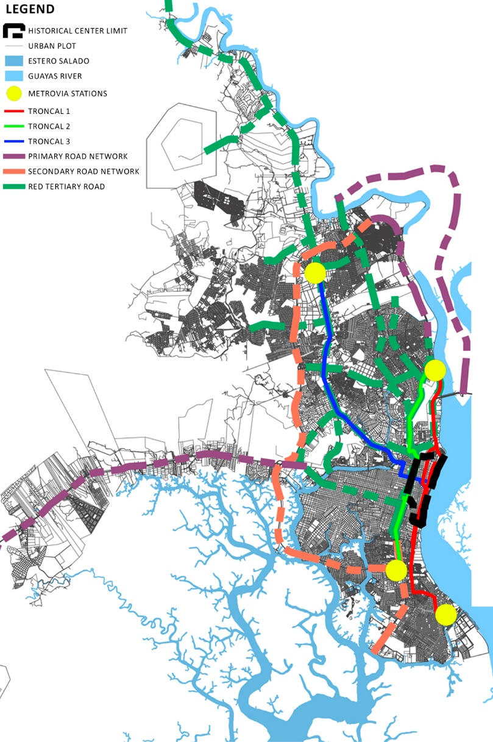
Fig. 6: High- to low-intensity vehicular roads within the Historic District (Cartography of Guayaquil, 2015).

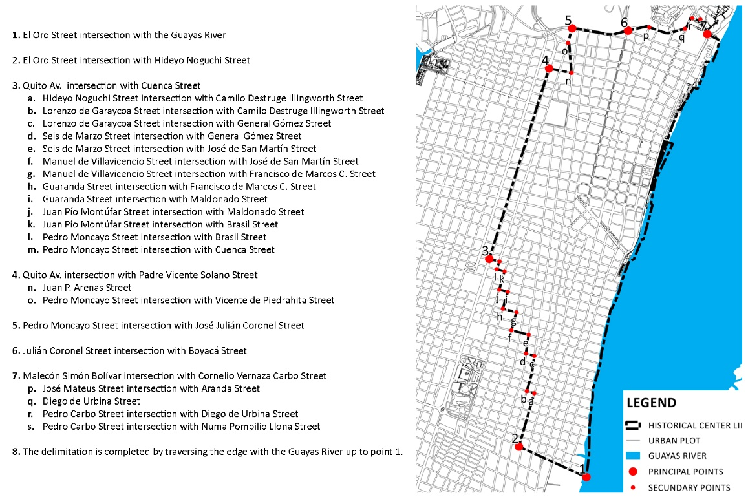
Fig. 7: Borders of the Historic Center

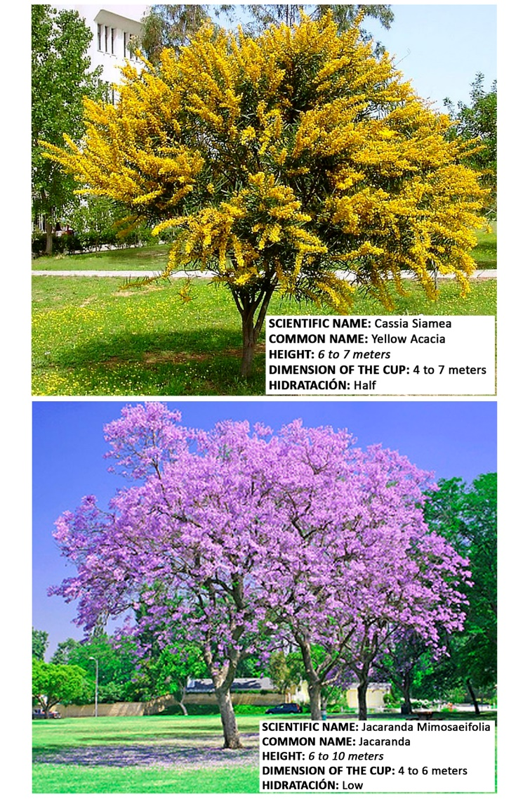
Fig. 8: Characteristics of tree species (Jardin, Copyright © 2011-2015 Verde Jardín. Template designed by ThemeXpose)

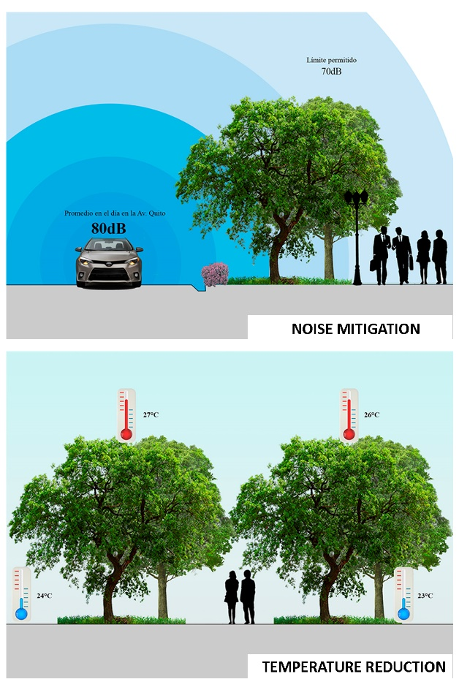
Fig. 9: Benefits to the city caused by these select species: (above) mitigation of noise; (below) reduction in temperature (Usvat, 2014 Copyright Liliana Usvat. Simple theme. Theme images by konradlew. Powered by Blogger.)
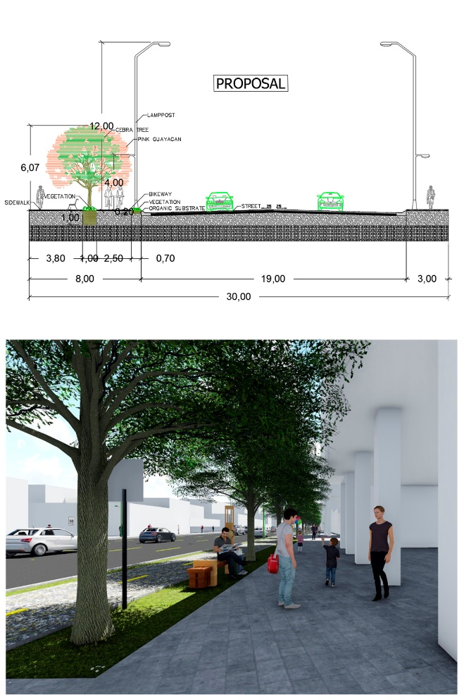
Fig. 10: Proposal for the green urban infrastructure (above). Cross view of Avenida Quito (below.) 3D projection.

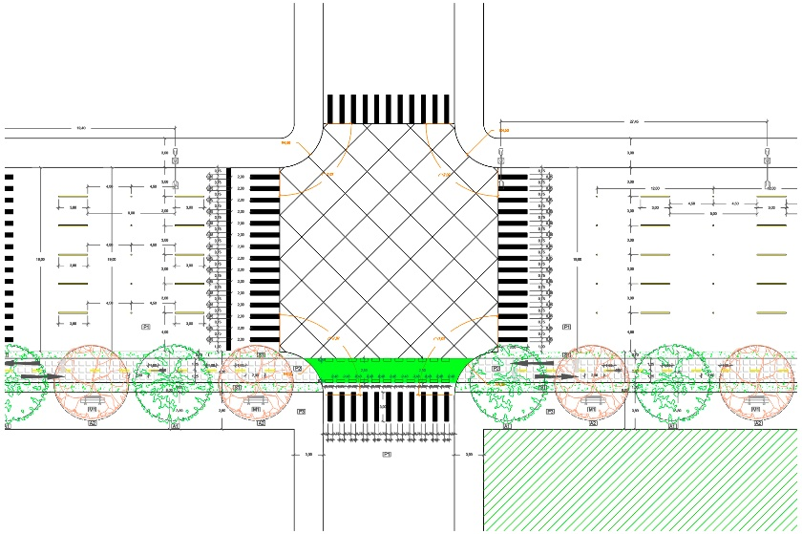
Fig. 11: Plan view of Avenida Quito
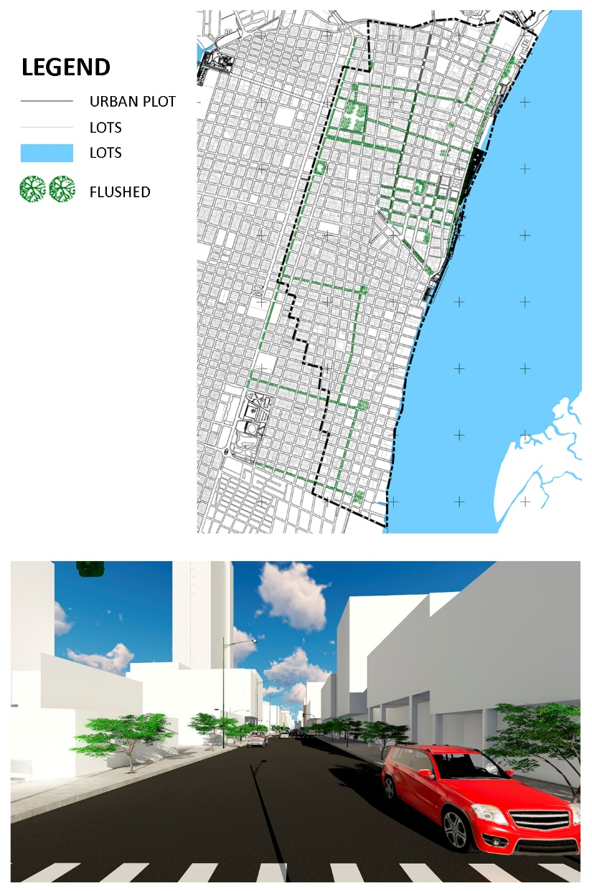

Fig. 12: Proposed incorporation of trees on Calle Luque (above). Street view of the proposed green corridor (below).
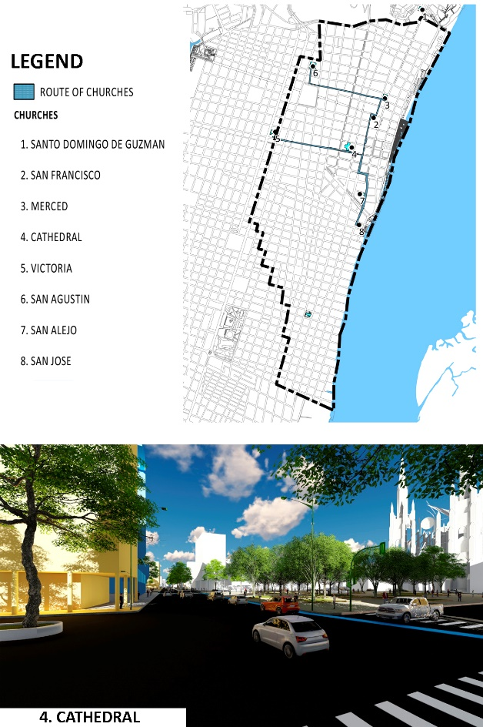
Fig. 13: Route of the Churches (above). Street view of the route of the churches in the urban proposal (below).

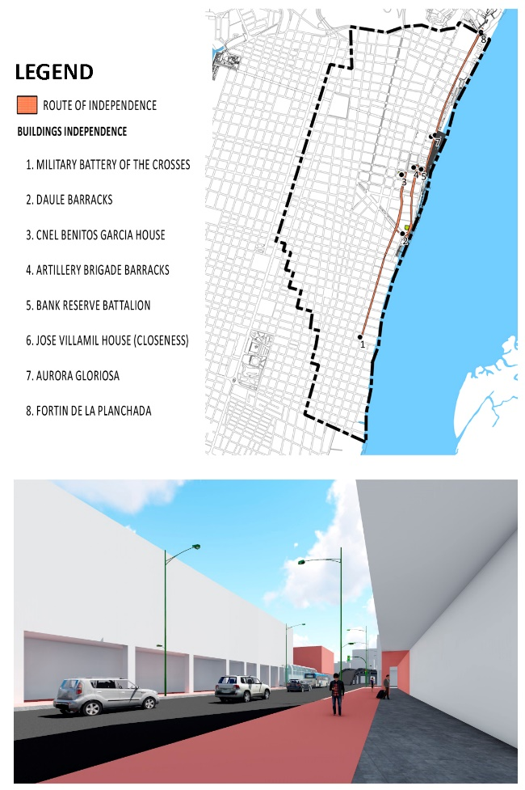
Fig. 14: Route of independence (above). Street view of the route of independence in the urban proposal (below).
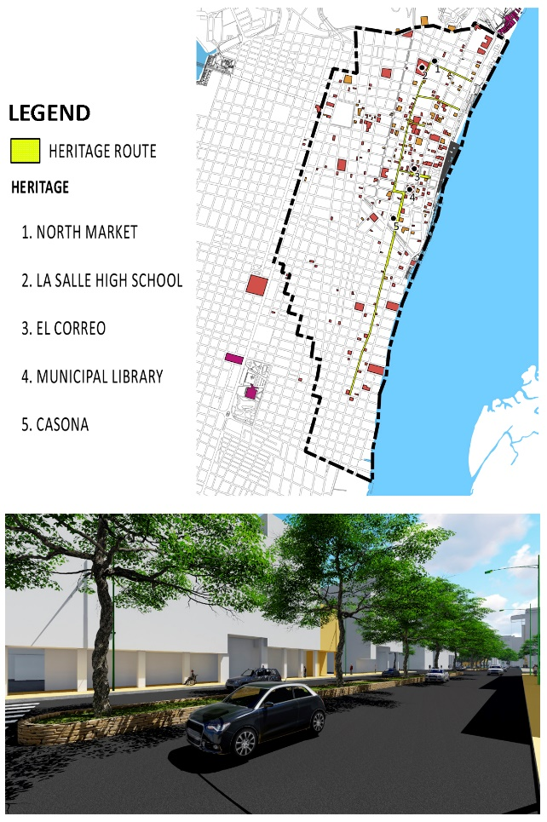
Fig. 15: Proposal for a heritage route (above). Street view of the patrimonial route within the urban proposal (below.)
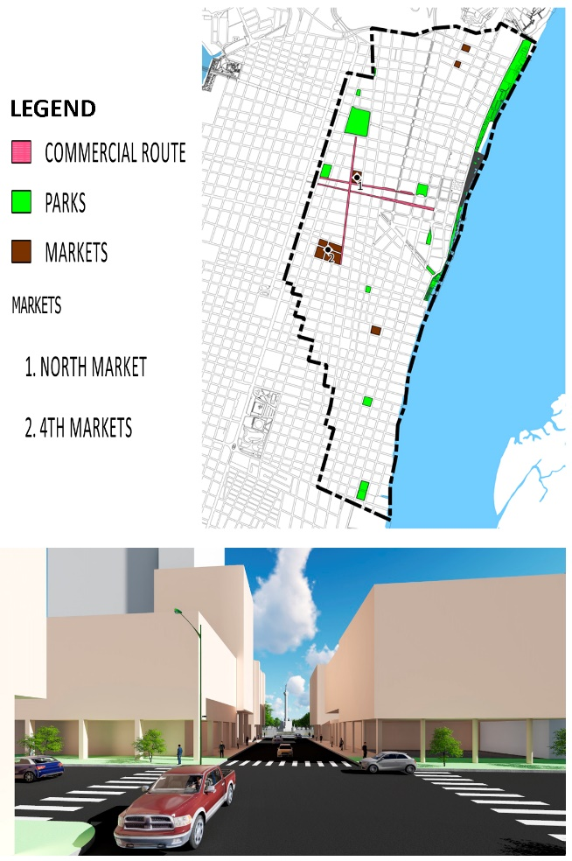
Fig. 16: Proposal for the commercial route (above). Street view of the commercial route in the urban proposal (below.)
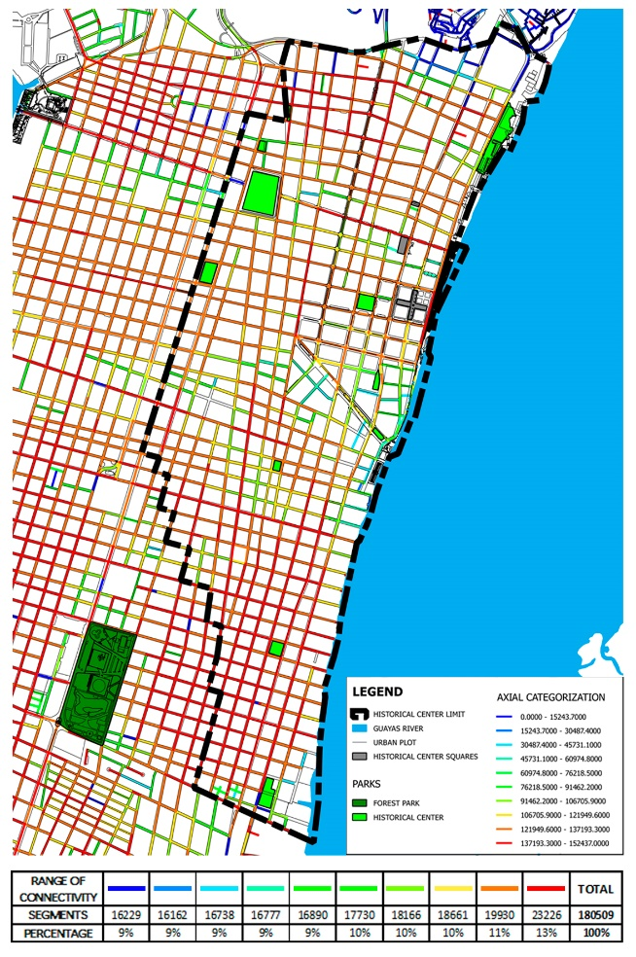
Fig. 17: Axial map
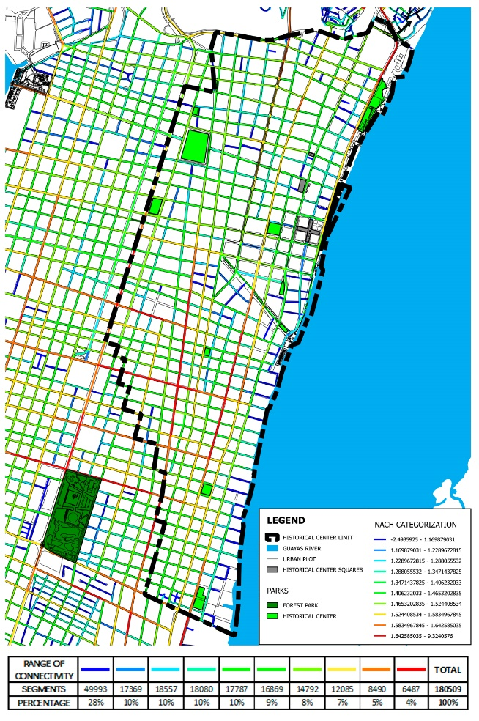
Fig. 18: Select analysis
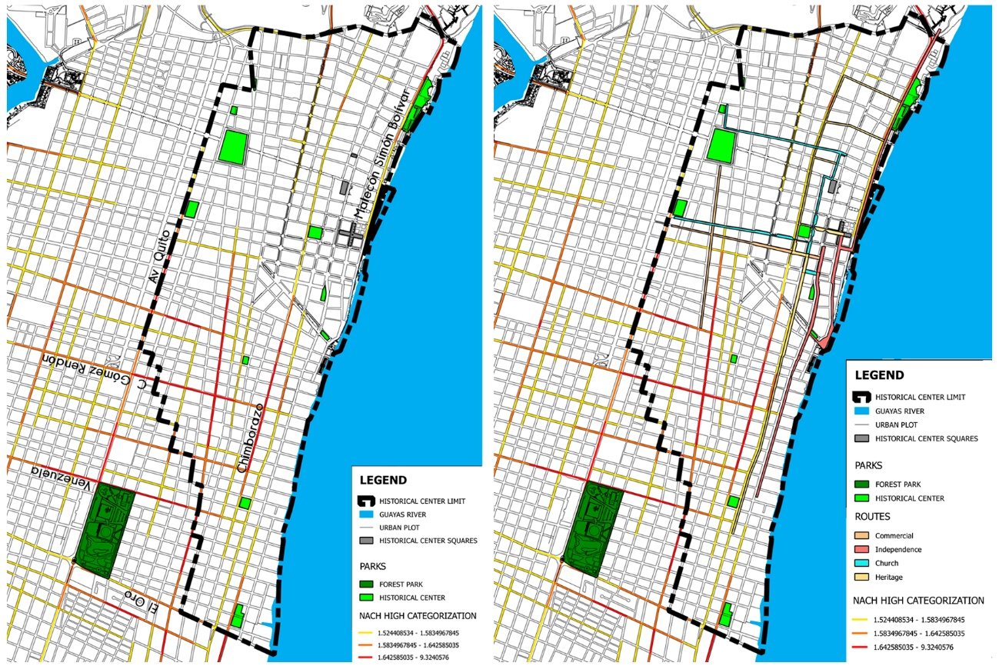
Fig. 19: (left). High analysis choice; (right) Routes high integration analysis

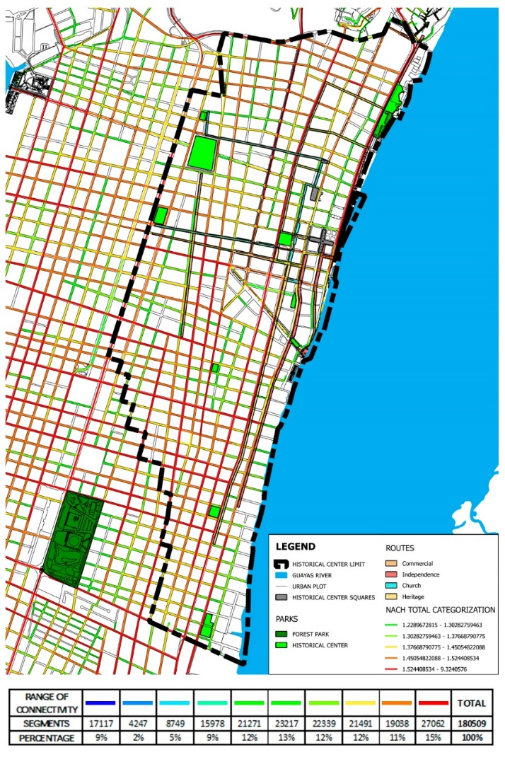
Fig. 20: Final analysis (above); range of connectivities (below)

