Water Confinement in Small Acenes

Alon Zamir,1 Estefania R. Molina, 1 Musahid Ahmed, 2 Tamar Stein*1

1 Fritz Haber Research Center for Molecular Dynamics, Hebrew University of Jerusalem, Jerusalem 9190401, Israel

2 Chemical Sciences Division, Lawrence Berkeley National Laboratory, Berkeley, California 94720, USA

*Corresponding author: tamar.stein@mail.huji.ac.il

Abstract

The ability to confine water molecules is important in many fields, from biology to nanotechnology. We report a computational study of the confinement of water clusters inside polycyclic aromatic hydrocarbon (PAHs) dimers, which can serve as model systems for larger carbon allotropes and are important for understanding the molecular level interactions in confined systems. The conditions allowing confinement in small, monomeric, or dimeric PAHs are not clear and are crucial for understanding confinement in larger systems. Here, we shed light on the size and structural parameters necessary for water confinement, ,and demonstrate how these parameters operate in various acene systems. We show that optimal OH···π interactions between the water clusters and the PAH dimer are crucial for optimal confinement to occur, with the lack of such interactions leading to the formation of CH···O interactions, and less ideal confinement. Confinement of layered clusters of water within discrete acene frameworks is also possible, provided that the optimal OH···π interactions are conserved.

The ability of water to be confined in nonpolar pores is of significant interest in a variety of fields, including in biology, nanotechnology (including nanofluids), and electrical engineering.[1, 2] Nonpolar cavities can often be found in the vicinity of a protein’s active site, and the presence of water in such cavities directly enables many biological processes to occur.[3] Interestingly, when we study the flow of water through such hydrophobic pores or cavities at the nanoscale, we observe markedly lower wall friction and a higher flow rate than what is observed macroscopically. This nanoscale flow, therefore, such as in the case of water confined in a carbon nanotube (CNT), has significant potential beyond what is achievable based on macroscopic water flow alone. This potential is even greater when one realizes that the confined water displays properties which differ significantly from those of bulk water, due to the fact that the confined water cannot form a full complement of hydrogen bonds (leading to it being called “frustrated water” or “high energy water”).[13, 14] Moreover, such unique properties have even greater potential applications when combined with CNTs, which are of interest in a variety of applications including gas sensing, water purification, and hydrogen production.

The interaction between graphene (i.e., sp2-hybridized carbon) allotropes, including graphite, CNTs, and fullerene, with water has been widely studied using both computational and experimental methods. Computationally, the adsorption of water molecules on the outside of a carbon surface was modelled using *ab-initio* methods and density functional theory (DFT) calculations.[15-19] Water confinement inside carbon nanotubes has also been studied computationally with DFT methods, which led to the conclusion that water molecules cluster near the inner CNT wall due to favorable OH···π interactions between the water and the π cloud of the CNT. [20] Interestingly, molecular dynamic simulations revealed the importance of the orientation of the water molecules in determining the properties of such water, with an orientation that facilitates OH···π interactions being highly favorable for both adsorption on a surface and confinement in a cavity. [19, 21, 23-25]

Experimentally, the unique nature of the hydrogen bonding in water molecules inside CNTs was demonstrated by using vibrational spectroscopy, which showed two types of hydrogen bonds: those that exist from the OH group to a single aromatic ring, and those that include more than one aromatic ring in their hydrogen bonding.[21] In addition to studying the effects of confinement on the aqueous hydrogen bonding capabilities, the effects of confinement on water diffusion and charge migration within an aqueous medium were also studied. [22] Finally, both experimental [26] and theoretical [27] works have shown that for the confinement of water in extremely small cavities (up to 1 nm in diameter), the water cluster can arrange into either a monolayer or bilayer.[28, 29]

Overall, previous computational work, particularly the *Ab-initio* calculations that provided information about the molecular-level interactions, emphasized the importance of the relative orientations between the carbon surfaces and the water molecules and the effects of such orientations on the binding energies (BE).[20, 30, 31] Notably, much of this previous work focused on polycyclic aromatic hydrocarbons (PAHs) as model systems for the larger and more intractable graphene and CNT, and attempted to determine their interaction with water.[23, 32, 33] In one example, Hirunsit *et al*. modelled the confinement of two to four water molecules within both a benzene and a naphthalene dimer,[34] and determined that a water cluster with up to four water molecules cannot be confined within the naphthalene dimer. Of note, this result is likely influenced by the constraints that were imposed on the system to enable more efficient computational analysis. When optimizing the structures without these artificial constraints, water molecules moved to the side of the naphthalene, where they formed CH···O interactions. In related recent work, Molina *et al.* studied an anthracene dimer complexed to water clusters that contained up to four water molecules.[33] In the case of one to three water molecules, confinement of the water within the dimer was not observed, and the optimal (i.e., most energetically favorable) structures were those with the water in a side orientation with respect to the anthracene. In the case of four water molecules, confinement was observed when the anthracene dimers were in a cross (i.e., perpendicular) configuration, a geometry which enabled optimal OH···π interactions to form. As anthracene and naphthalene are made up of three and two linearly fused benzene rings, respectively, we can conclude that the additional aromatic ring plays an important role in determining whether a particular PAH can complex water clusters, and what is the size of the water cluster that can be confined.

In the work of Molina et al, various complexes of water and anthracene dimers were compared, leading to the conclusion that there is a strong tendency for water molecules to remain clustered within themselves. Among the different possible structural isomers that were tested, the only one that was found in which water was successfully complexed in the dimer was the case of four water molecules inside the perpendicular-configured anthracene dimer.

In this study, we wish to explore the conditions that enable water confinement inside small PAH systems. Consequently, herein we focus only on the isomers that show confinement of water molecules within the PAHs, without any artificial constraints.

We begin by comparing the ability of different PAH dimers to confine water clusters with four water molecules, as optimal OH···π interactions in the four-water case have been demonstrated to achieve confinement in the anthracene dimer case. We next studied the effect of reducing the number of waters on the confinement as the infrastructure of optimal OH···π interactions is not attainable on lower amount of water molecules. We additionally report the interaction between water clusters containing five and six water molecules and layered water clusters containing 8 and 12 water molecules with various acenes of different sizes and structures. We reveal the size and structural motifs enabling confinement at the molecular level, which is crucial for obtaining an understanding of the confinement of water in larger systems such as a CNT.

To quantify the confinement, we measured the BEs of the system to determine the energetic favorability of confinement. Additionally, we check whether there is a tilting angle between the confining dimers to determine the geometry of the PAH dimeric structure, noting that this geometry can have a significant effect on the ability of water molecules to complex in the dimer.

Calculations were performed using density functional theory (DFT) calculations with the $ωB97X-V$ functional, which is able to account for van der Waals interactions and is thus suitable to study cluster systems.[35] Structures were optimized using the cc-pVTZ basis set[36] followed by frequency calculations to verify that they are minima on the PES. To calculate BEs, we performed single-point calculations using $ωB97X-V$ with the aug-cc-PVTZ[37] basis set. All reported structures exhibit negative BEs, and as we increase the size of the water clusters, the BE increase significantly. For comparison purposes, we normalized the BEs by dividing by the number of water molecules and report the absolute values of the normalized BE (*n*BE). All calculations were performed with the Q-Chem 5.4 software package.[38] To study the possibility of confinement, we started with different dimer structures with water confined inside them, and then performed structural optimization from that starting point. We concluded that in cases where the water stays within the dimer after optimization, that confinement is indeed possible.

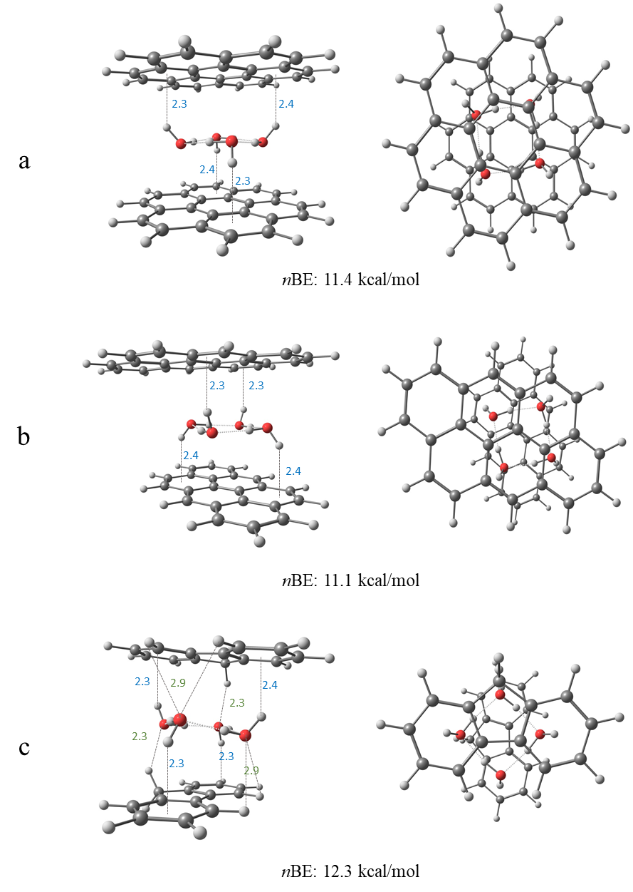

Figure 1: Side (left panel) and top view (right panel) of four-water clusters confined within two coronenes (a), two anthanthrenes (b) and two fluorenes (c). All reported bond lengths are in Å. The blue numbers mark the OH···π bond lengths, and the green numbers mark the CH···O bond lengths.

We have optimized dimer structures of coronene, anthanthrene and fluorene with four water molecules, as shown in Figure 1. Similar to the case of anthracene reported by Molina et al.,[33] coronene (Figure 1a) and anthanthrene (Figure 1b), which also have a large, planar surface area, can ideally confine the clusters within the dimer. The confinement is achieved due to the formation of optimal OH···π interactions between the non-contiguous hydrogens and the π clouds of the acenes. Interestingly, both perpendicular (Figure 1b) and parallel (Figure S1a) configurations enable confinement in anthanthrene, as anstabilizing interactions are possible in both cases. Both coronene and anthanthrene exhibit similar *n*BEs, of 11.4 kcal/mol and 11.1 kcal/mol, respectively, likely due to their similar sizes. Ideal confinement of four water molecules was also observed in the case of a pyrene dimer, as shown in the SI Figure S1c.

Likewise, confinement was possible in the case of fluorene (Figure 1c), albeit in this case with a slight tilting angle between the two monomers. Due to the nonlinearity of the structure and its non-planar hydrogens, additional stabilizing CH···O interactions between the oxygen of two of the water molecules and hydrogens in the bay region of the acenes were also observed, leading to a tilting angle of 10.3˚. Despite the non-optimal confinement, additional stabilization is obtained via the CH···O interactions. In this case, the close CH···O interactions (distances of 2.3 Å between H and O) result in a *n*BE of 12.3 kcal/mol, the highest value among all molecules presented in the manuscript, likely due to the unique stabilizing interactions possible in this case. In the case of phenanthrene (Figure S1b), the additional CH···O interactions also led to a tilting angle of 11.2° and a favorable *n*BE of 11.3 kcal/mol, which is somewhat lower than the *n*BE observed for fluorene.

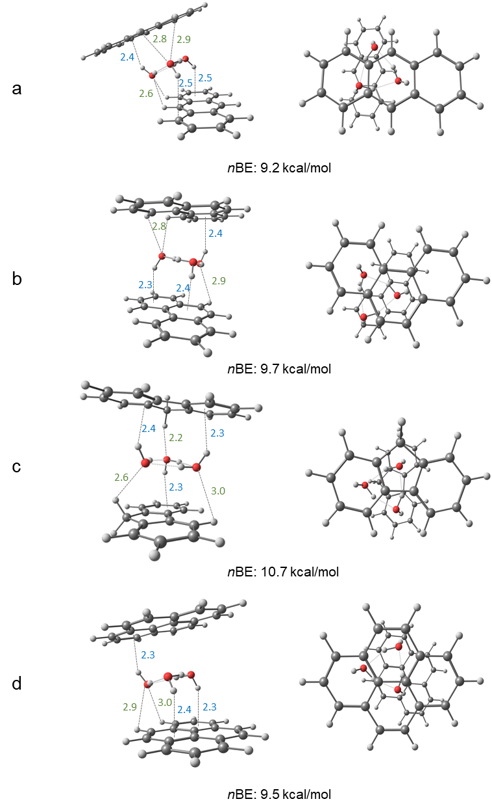

Figure 2: Side (left panel) and top view (right panel) of three-water clusters confined within anthracenes (a), phenanthrenes (b), fluorenes (c) and pyrenes (d) from the side view (left panel) and top view (right panel). All reported bond lengths are in Å. The blue numbers mark the OH···π bond lengths, and the green numbers mark the CH···O bond lengths.

In the next step, we analyzed the confinement of water clusters containing three water molecules within anthracene, phenanthrene, fluorene, and pyrene, as shown in Figure 2. We do not expect ideal confinement of the water cluster in this case, as two contiguous hydrogens point upward and one points downward, thus leading to a non-symmetrical structure and a likely preference for one side. These features are seen in the case of anthracene dimer shown in Figure 2a. Upon energy optimization of the anthracene dimer with a three-water molecule cluster, the water cluster moves to form CH···O interactions, leading to a movement of the top anthracene, and resulting in a large tilting angle of 18.5˚. In this case, confinement is weakened severely, and the quantitative measure of this weakening is in the low *n*BE of 9.2 kcal/mol. `

Figures 2b and 2c show the confinement of the water cluster inside phenanthrene and fluorene, respectively. The PAHs are similar in length and shape; however, fluorene is not aromatic due to the presence of a saturated methylene group. As seen in Figure 2, both molecules show tilting angles, of 6.7˚(phenanthrene) and 9.1˚(fluorene). In the case of phenanthrene (Figure 2b), two hydrogens of the water molecule point downward and interact with the bottom PAH via OH··· π interactions. Interaction with the top PAH occurs via one OH···π interaction, and additional CH···O bonds in the bay region (of length 2.8Å). Due to the position of the oxygen involved in the formation of the CH···O bond, effective confinement is possible. In the case of fluorene, (Figure 2c) confinement is enabled by strong CH···O interactions, which form due to the small distances between the hydrogen atoms in the middle ring and the oxygen atoms in the water clusters. The strong CH···O interactions lead to a large *n*BE of 10.7 kcal/mol, in comparison to 9.7 kcal/mol in the case of phenanthrene. The difference between phenanthrene and fluorene validates the importance of the PAHs geometry in determining the ability of PAH dimers to confine water clusters, particularly as it relates to the presence of nonaromatic C-H groups and their participation in intermolecular non-covalent interactions.

As shown in Figure 2d, pyrene, although similar to phenanthrene in length, does not form additional CH···O interactions due to the lack of the bay region, and the resulting *n*BE is 9.5 kcal/mol. Overall, the structures confining three water molecules have lower *n*BEs than those confining four water molecules, due to the lack of additional OH···π interaction, which could lead to further stabilization.

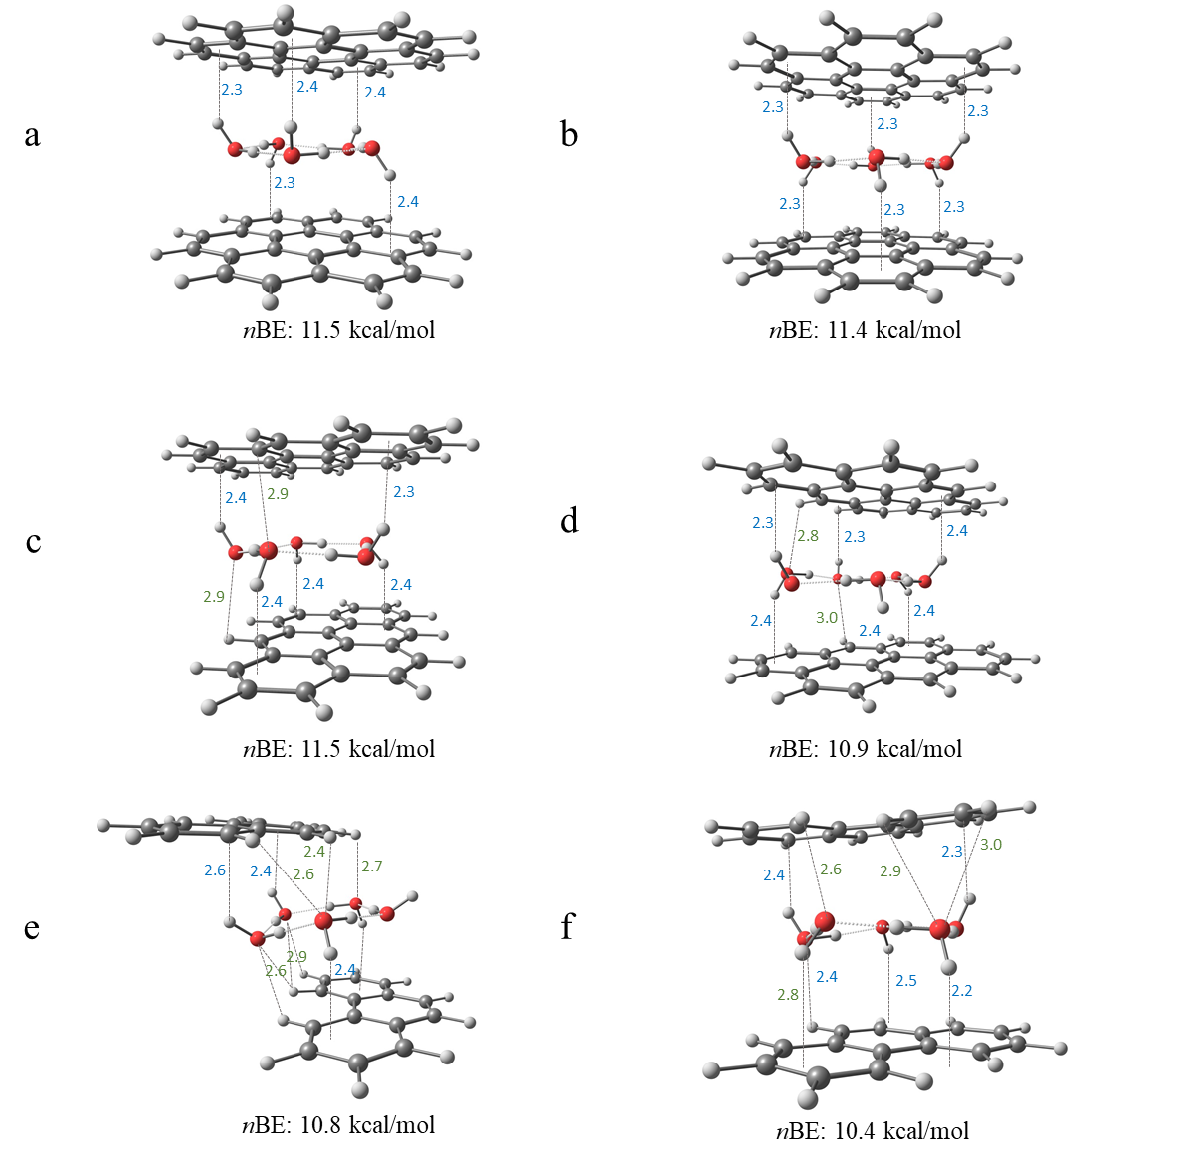

Figure 3: Side views of five-water and six-water clusters confined within coronenes (a,b), anthanthrenes (c,d), and five water molecules with two conformers of phenanthrenes (e,f). All reported bond lengths are in Å. The blue numbers mark the OH···π bond lengths and the green numbers mark the CH···O bond lengths. Top views are included in Figure S2.

Next, we demonstrate the confinement of five and six water molecules, as shown in Figure 3. Coronene (Figures 3a, 3b) is large enough so that the confinement of water clusters with five and six water molecules are optimal. These water cluster-coronene dimers do not exhibit tilting angles, and the optimal confinement is evidenced via their large *n*BEs of 11.5 kcal/mol and 11.4 kcal/mol for the five and six water clusters, respectively. Similarly, anthanthrene is large enough to contain a five-ringed water cluster (Figure 3c) with optimal confinement observed. Once again, no tilting angle was observed, and the calculated *n*BE is 11.5 kcal/mol, indicating strong confinement. In the case of confinement of six waters in the cluster (Figure 3d), due to the relative sizes of the water clusters and the dimer, some of the water molecules are partially sticking outside the dimer, resulting in less optimal OH··· π interactions and a lower *n*BE of 10.9 kcal/mol.

A water cluster with five water molecules can form within the phenanthrene dimer, and the optimized structure is shown in Figure 3e. Formation of optimal OH··· π interactions is prohibited due to the small size of the PAH, resulting in a shift of one of the rings to enable those interactions together with CH···O. The resulting structure does not confine the water and the *n*BE is 10.8 kcal/mol. A second energy minimum was found (Figure 3f), in which the cluster is partially confined although, due to the size of the PAH some of the waters are sticking out, forming CH···O interaction. This structure results in a tilting angle of 11.2˚ and *n*BE of 10.4 kcal/mol, which is a smaller value than the *n*BE value observed in previous cases. Similar trends are observed for the case of six waters confined within the phenanthrene dimer, the results of which are presented in Figure S3b.

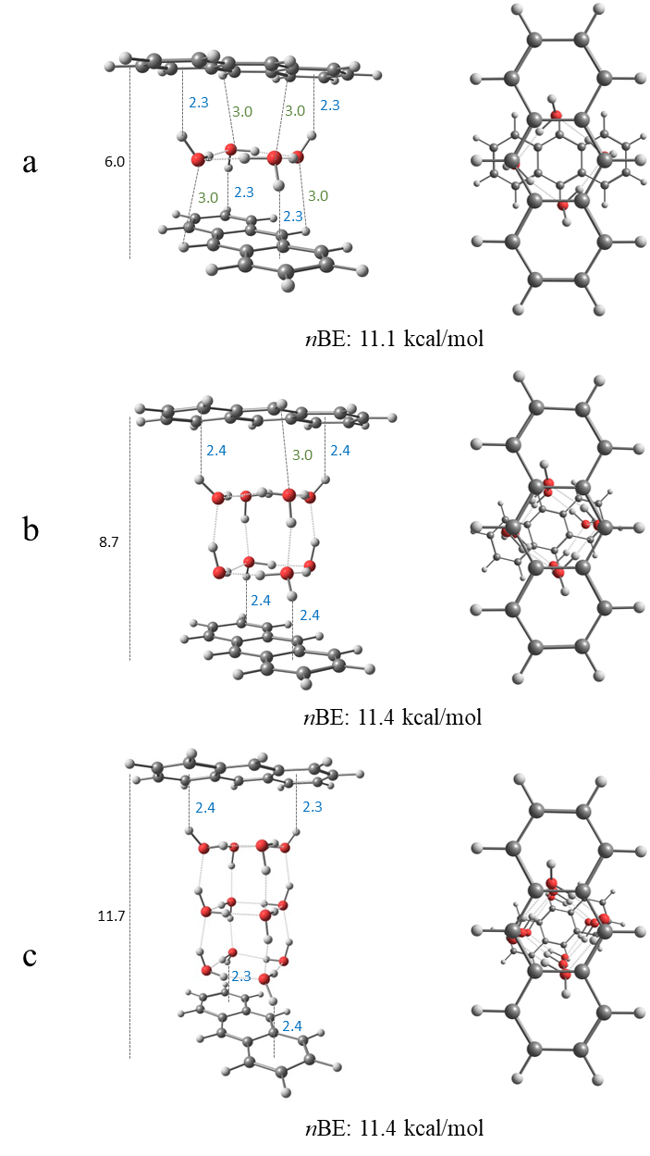

Figure 4: Side (left panel) and top view (right panel) of four (a), eight (b) and twelve (c) water clusters confined within anthracene dimers from the side view (left panel) and top view (right panel). All reported bond lengths are in Å. The blue numbers mark the OH···π bond lengths, the green numbers mark the CH···O bond lengths and the black number shows the overall distance between the anthracenes.

As previously mentioned, confined water molecules between graphene sheets may arrange in a monolayer and up to a bilayer with a distance of 1 nm between the sheets. We demonstrate the confinement of eight and twelve water molecules within anthracene, resulting in two and three layers of four water molecules, as seen in Figures 4b and 4c, respectively. We observe that the bilayer is optimal at a distance of 0.87 nm between the layers, while three water layers are optimal at a distance of 1.14 nm between the layers. Similar to graphene, it is feasible to confine additional water molecules by allowing the arrangement of several layers, preserving the ideal OH···π interactions. In terms of *n*BE, the four-water cluster confined within the dimer shows 11.1 kcal/mol, while the *n*BEs of eight water cluster and twelve water clusters are 11.4 kcal/mol.

In conclusion, there are key similarities between the confinement of water within PAHs and confinement of water within low- dimensional carbon surfaces, as both relate to the underlying intermolecular interactions between the polar water molecules and the non-polar aromatic surfaces. In this work, we demonstrate the key role of the molecular orientation in enabling stabilizing OH···π interactions to occur. Nonetheless, there are noticeable differences, including the fact that unlike in low-dimensional carbon surfaces such as graphene, discrete PAH dimers benefit from CH···O interactions, whereas in graphene-like materials, these interactions are negligible. Even though a tilting angle reduces the optimal OH···π interactions between the water and the dimers, these interactions may be compensated by additional CH···O interactions, as demonstrated through the quantitative *n*BE values reported herein. While the BE increases with the addition of water molecules, the *n*BE value shows consistency along the series of studied systems with values ranging mostly between 9-12 kcal/mol. From these results, we can generalize that cases of ideal confinement due to OH···π interactions result in *n*BE values of approximately 11.5 kcal/mol, with the distance of 2.3-2.4 Å required for said interactions. The water cluster size, and its relative size to the dimers has a direct effect upon the interactions mentioned above and directly determines whether confinement will occur. It is also possible to confine two or three layers, provided that the optimal OH···π interactions are preserved, as demonstrated for the anthracene case. These results will guide future experiments using vibrational spectroscopy as recently demonstrated for pure water clusters [39-41] to probe the stability and structure of PAH water clusters, which in turn is expected to shed insight into the confinement of water: its mechanism, energetics, and geometry of the resulting complexes. Furthermore, the ideas of confinement developed in this work could potentially benefit an understanding of anthracene cluster interactions with water ice [42] and in anthracene dimer exciplex formation in solution,[43] both of which have relevance in a broad variety of sub-disciplines.

Acknowledgments:

TS, AZ and ERM are supported by The Israel Science Foundation under Grant No. 1941/20. MA is supported by the Director, Office of Science, Office of Basic Energy Sciences, of the US Department of Energy under Contract No. DE-AC02-05CH11231 through the Gas Phase Chemical Physics Program, Chemical Sciences Division.

1. Rasaiah, J.C., S. Garde, and G. Hummer, *Water in Nonpolar Confinement: From Nanotubes to Proteins and Beyond.* Annual Review of Physical Chemistry, 2008. **59**(1): p. 713-740.

2. Giovambattista, N., P.J. Rossky, and P.G. Debenedetti, *Computational Studies of Pressure, Temperature, and Surface Effects on the Structure and Thermodynamics of Confined Water.* Annual Review of Physical Chemistry, 2012. **63**(1): p. 179-200.

3. Bellissent-Funel, M.-C., et al., *Water Determines the Structure and Dynamics of Proteins.* Chemical Reviews, 2016. **116**(13): p. 7673-7697.

4. Hummer, G., J.C. Rasaiah, and J.P. Noworyta, *Water conduction through the hydrophobic channel of a carbon nanotube.* Nature, 2001. **414**(6860): p. 188-190.

5. Kalra, A., S. Garde, and G. Hummer, *Osmotic water transport through carbon nanotube membranes.* Proceedings of the National Academy of Sciences, 2003. **100**(18): p. 10175-10180.

6. Majumder, M., et al., *Enhanced flow in carbon nanotubes.* Nature, 2005. **438**(7064): p. 44-44.

7. Holt, J.K., et al., *Fast Mass Transport Through Sub-2-Nanometer Carbon Nanotubes.* Science, 2006. **312**(5776): p. 1034-1037.

8. Miller, S.A., V.Y. Young, and C.R. Martin, *Electroosmotic Flow in Template-Prepared Carbon Nanotube Membranes.* Journal of the American Chemical Society, 2001. **123**(49): p. 12335-12342.

9. Guo, Y., et al., *Co2P–CoN Double Active Centers Confined in N-Doped Carbon Nanotube: Heterostructural Engineering for Trifunctional Catalysis toward HER, ORR, OER, and Zn–Air Batteries Driven Water Splitting.* Advanced Functional Materials, 2018. **28**(51): p. 1805641.

10. Marbach, S. and L. Bocquet, *Osmosis, from molecular insights to large-scale applications.* Chemical Society Reviews, 2019. **48**(11): p. 3102-3144.

11. Chin, H.-T., et al., *Ferroelectric 2D ice under graphene confinement.* Nature Communications, 2021. **12**(1): p. 6291.

12. Dillon, A.C., et al., *Storage of hydrogen in single-walled carbon nanotubes.* Nature, 1997. **386**(6623): p. 377-379.

13. Li, Q., et al., *Two-Dimensional Material Confined Water.* Accounts of Chemical Research, 2015. **48**(1): p. 119-127.

14. Park, H.G. and Y. Jung, *Carbon nanofluidics of rapid water transport for energy applications.* Chemical Society Reviews, 2014. **43**(2): p. 565-576.

15. Kysilka, J., et al., *Accurate Description of Argon and Water Adsorption on Surfaces of Graphene-Based Carbon Allotropes.* The Journal of Physical Chemistry A, 2011. **115**(41): p. 11387-11393.

16. Freitas, R.R.Q., et al., *DFT Studies of the Interactions of a Graphene Layer with Small Water Aggregates.* The Journal of Physical Chemistry A, 2011. **115**(44): p. 12348-12356.

17. Feller, D. and K.D. Jordan, *Estimating the Strength of the Water/Single-Layer Graphite Interaction.* The Journal of Physical Chemistry A, 2000. **104**(44): p. 9971-9975.

18. Feller, D., *Strength of the Benzene−Water Hydrogen Bond.* The Journal of Physical Chemistry A, 1999. **103**(38): p. 7558-7561.

19. Pertsin, A. and M. Grunze, *Water−Graphite Interaction and Behavior of Water Near the Graphite Surface.* The Journal of Physical Chemistry B, 2004. **108**(4): p. 1357-1364.

20. Tripathy, M.K., D.K. Mahawar, and K.R.S. Chandrakumar, *Effect of nano-confinement on the structure and properties of water clusters: An ab initio study.* Journal of Chemical Sciences, 2019. **132**(1): p. 7.

21. Byl, O., et al., *Unusual Hydrogen Bonding in Water-Filled Carbon Nanotubes.* Journal of the American Chemical Society, 2006. **128**(37): p. 12090-12097.

22. Muñoz-Santiburcio, D. and D. Marx, *Confinement-Controlled Aqueous Chemistry within Nanometric Slit Pores.* Chemical Reviews, 2021. **121**(11): p. 6293-6320.

23. Wu, Y. and N.R. Aluru, *Graphitic Carbon–Water Nonbonded Interaction Parameters.* The Journal of Physical Chemistry B, 2013. **117**(29): p. 8802-8813.

24. M, R. and K.G. Ayappa, *Enhancing the Dynamics of Water Confined between Graphene Oxide Surfaces with Janus Interfaces: A Molecular Dynamics Study.* The Journal of Physical Chemistry B, 2019. **123**(13): p. 2978-2993.

25. Laage, D. and W.H. Thompson, *Reorientation dynamics of nanoconfined water: Power-law decay, hydrogen-bond jumps, and test of a two-state model.* The Journal of Chemical Physics, 2012. **136**(4): p. 044513.

26. Bampoulis, P., et al., *Hydrophobic Ice Confined between Graphene and MoS2.* The Journal of Physical Chemistry C, 2016. **120**(47): p. 27079-27084.

27. Koga, K., X.C. Zeng, and H. Tanaka, *Freezing of Confined Water: A Bilayer Ice Phase in Hydrophobic Nanopores.* Physical Review Letters, 1997. **79**(26): p. 5262-5265.

28. Cicero, G., et al., *Water Confined in Nanotubes and between Graphene Sheets:  A First Principle Study.* Journal of the American Chemical Society, 2008. **130**(6): p. 1871-1878.

29. Eslami, H. and N. Heydari, *Hydrogen bonding in water nanoconfined between graphene surfaces: a molecular dynamics simulation study.* Journal of Nanoparticle Research, 2013. **16**(1): p. 2154.

30. McKenzie, S. and H.C. Kang, *Squeezing water clusters between graphene sheets: energetics, structure, and intermolecular interactions.* Physical Chemistry Chemical Physics, 2014. **16**(47): p. 26004-26015.

31. Rubeš, M., et al., *Structure and Stability of the Water−Graphite Complexes.* The Journal of Physical Chemistry C, 2009. **113**(19): p. 8412-8419.

32. Xu, B., et al., *Probing solvation and reactivity in ionized polycyclic aromatic hydrocarbon–water clusters with photoionization mass spectrometry and electronic structure calculations.* Faraday Discussions, 2019. **217**(0): p. 414-433.

33. Rossich Molina, E., et al., *A combined theoretical and experimental study of small anthracene–water clusters.* Physical Chemistry Chemical Physics, 2022.

34. Hirunsit, P. and P.B. Balbuena, *Effects of Confinement on Small Water Clusters Structure and Proton Transport.* The Journal of Physical Chemistry A, 2007. **111**(42): p. 10722-10731.

35. Mardirossian, N. and M. Head-Gordon, *[small omega]B97X-V: A 10-parameter, range-separated hybrid, generalized gradient approximation density functional with nonlocal correlation, designed by a survival-of-the-fittest strategy.* Physical Chemistry Chemical Physics, 2014. **16**(21): p. 9904-9924.

36. Dunning , T.H., Jr, *Gaussian basis sets for use in correlated molecular calculations. I. The atoms boron through neon and hydrogen.* The Journal of Chemical Physics, 1989. **90**(2): p. 1007-1023.

37. Kendall, R.A., T.H.D. Jr., and R.J. Harrison, *Electron affinities of the first‐row atoms revisited. Systematic basis sets and wave functions.* The Journal of Chemical Physics, 1992. **96**(9): p. 6796-6806.

38. Shao, Y., et al., *Advances in molecular quantum chemistry contained in the Q-Chem 4 program package.* Molecular Physics, 2015. **113**(2): p. 184-215.

39. Zhang, B., et al., *Infrared Spectroscopy of Neutral Water Dimer Based on a Tunable Vacuum Ultraviolet Free Electron Laser.* The Journal of Physical Chemistry Letters, 2020. **11**(3): p. 851-855.

40. Zhang, B., et al., *Infrared spectroscopy of neutral water clusters at finite temperature: Evidence for a noncyclic pentamer.* Proceedings of the National Academy of Sciences, 2020. **117**(27): p. 15423-15428.

41. Li, G., et al., *Infrared spectroscopic study of hydrogen bonding topologies in the smallest ice cube.* Nature Communications, 2020. **11**(1): p. 5449.

42. Chakraborty, S., A.D. Stubbs, and T.F. Kahan, *Direct Observation of Anthracene Clusters at Ice Surfaces.* Journal of the American Chemical Society, 2022. **144**(2): p. 751-756.

43. Das, A., et al., *Dynamics of Anthracene Excimer Formation within a Water-Soluble Nanocavity at Room Temperature.* Journal of the American Chemical Society, 2021. **143**(4): p. 2025-2036.