Gender Differences in the Portrayal of the Teacher:
From Pre-State to Post-State Israeli Films, 1932–1956

Abstract
This article deals with the reflection of the feminization of teaching in Israeli films before and after the establishment of the state. The research explores the diverse constructions of the cinematic gender roles of teachers. It is based on a qualitative analysis of six full-length films released between 1932 and 1956 featuring a teacher as one of the main characters. The growing presence of female teachers in Hebrew films during those years mirrored the global and local process of women’s entry into the educational labor market. While the figure of the male teacher was held up as a spiritual leader and a military commander, the female teacher was constructed as an apprentice, a secretary to her male counterpart or a surrogate mother. Despite the Zionist ethos of equality, these distinct portrayals echo uneven social power and, in turn, contribute to the construction of traditional gender roles and the declining status of teaching in Israel.

1. Introduction: Teachers in Palestine—the Pre-State Era

The Zionist revolution and the ideology that defied Diaspora Judaism anticipated a utopian future world. The future state was envisioned as an egalitarian, Jewish, scientific and humane society. More than other institutions, the education system was mobilized to fulfill these goals. Although Jewish settlement in Palestine lacked sovereignty, after the First World War the Histadrut–General Federation of Labor established an education department that governed the schools of the main Zionist political streams. This department itself was subordinate to the institutions of the Zionist movement.

During the First and the Second Aliyas, the immigration waves of 1882–1914, teachers regarded themselves as active and essential partners in the national revival. Their vigorous activities can be viewed as part of the attempt to change their position within society, since historically they compared themselves to Eastern European rabbi-teachers—a traditionally low-status occupation. Teachers stood at the forefront of the struggle to revive the Hebrew language and to form a Zionist curriculum. For this endeavor, the public rewarded them with admiration and support.
One example of their role in reviving Hebrew was the “war of language” in 1913 Palestine.
That year, the management of the Ezra Society, a German Jewish organization, decided to raise funds for the establishment of the first institute of higher education in Eretz Israel, the Technion. It was agreed that German would be its language of instruction rather than Hebrew. In response, the teachers at Ezra’s schools launched a strike in support of their demand that the language of instruction countrywide be none other than Hebrew; the walkout expanded to all schools in the yishuv community.
This was to be the first and last teachers’ strike to receive mass support, with university students, industry and agricultural workers, intellectuals and artists all united in backing it.
During the 1940s, teachers grappled with how to broaden nationalism and to incorporotate into every discipline, from geography and demography to physical education. They considered themselves obligated to associate each subject they taught to national issues
and to demonstrate its necessity for and affiliation with the Zionist Movement and Eretz Israel.
The education system was the most important and effective tool of this ideological socialization, and the teachers themselves were the spokespersons of the revolution.

1.1 Transition to a State: A Decline in the Status of Teachers

During revolutions in general, the importance of teachers tends to rise; they are considered proxies of social change and agents entrusted with transferring and interpreting national symbols. When matters calm down, the political significance of the teacher decreases, resulting in dwindling influence and decline in status. Indeed, in Israel beginning in the late 1960s, the occupational prestige of teaching suffered a substantial decline. The deflation of the teachers’ status was observed not only through subjective indicators such as social standing but also by quantitative data such as wages. The existing literature indicates that individual occupations tend to maintain similar levels of social prestige over time. According to research conducted on occupational prestige, no other profession in Israel experienced such a dramatic “fall from grace” as teaching. Several explanations have been offered for this loss of prestige. One historical explanation maintains that the assimilation of all political educational streams within a single national education system in the 1950s led to the separation of teachers from the political elites.
Surprisingly, a similar process has been reported from Europe, with Antonio Nóvoa stating that from the 1930s onward, teachers moved from the center of the public sphere to its margins; the discourse about national mission weakened. In his words, “A cloak of silence has fallen on teachers.… The profession of teacher was adapted to a feminine identity, and this brought with it essentially private images.”
Another explanation for the deterioration in teachers’ status focuses on its demographics, contending that the decline in the occupational prestige of teachers resulted from the entry of lower social strata and minority groups into the profession. Further explanations highlight the inherent tension between the academic role of teachers and that of socializing children, as well as the perceived lack of professionalism among teachers. However, the main and most contentious explanation is the “feminization” of teaching as a cause and outcome of the teacher’s declining status.

1.2 Feminization of Teaching in the Western World and in Palestine

International comparisons indicate that feminization has occurred throughout the Western world but at different rates. In England, from the moment the state introduced primary education in 1870, it was considered a women’s task. In 1900, women constituted the majority of teachers in primary schools in Europe. The process began in elementary schools and spread into other levels of the education system such as high schools and principalships. Today, 80 percent of elementary school teachers in the United States, England, other parts of Europe and Israel are female.
Historical comparisons between various countries in Europe and North America reveal a complex set of factors that shaped the feminization of teaching. The primary factor was the increased demand for education generated by nation-states.
The strong demand for teachers, coupled with women’s eagerness to take their place in the labor force and their limited possibilities of doing so, was a major cause of the feminization of teaching. This was only compounded by women’s willingness to work for low pay and the attraction that this held for the institutions that footed the bill.
A more thorough analysis shows that a cluster of structural factors intervened in the progression of the feminization process, such as the relative availability of workers in the labor market and the extent to which more attractive careers were open to men, as well as urbanization and industrialization—the expansion of which occurred alongside the increased confidence in women’s suitability for teaching. Other variables determining the extent of femininization were the level of institutionalization and bureaucracy of the education system, as well as formal and informal elements, such as bans on married women working as teachers or requirements for teaching certificates.
These are the main variables used in the literature to explain the process of feminization of teaching as a general trend. When accounting for variations among countries and regions, attention is drawn to their unique social or cultural features. For example, in late nineteenth-century Germany, teaching enjoyed a particularly high level of prestige that preserved men in profession and postponed the entry of women. Or consider the U.S. South, where black men remained in the profession in the early twentieth century due to their limited options in a racist labor market. Hence, the process of feminization of teaching was a mixture of large-scale social forces combined with historically specific trends. This applied to the pre- and post-Israeli statehood education system as well.

1.3 Feminization Pre- and Post-Israeli Statehood

The Zionist ethos and the writings of certain Zionist leaders promised equal rights to women, yet despite the ethos of equality and despite the advance of the women’s labor movement, gender gaps were widespread throughout every occupational sector during the pre-state era. Women’s ability to earn a living and their employment opportunities were reduced compared to those of men.
In Palestine in 1928, approximately 20 percent of the teachers were women, and 80 percent were male. This gender makeup demonstrated the high status of teaching; teaching was perceived as a social or ideological pursuit, a respected profession and a credit to its holder. In 1936, the number of female teachers doubled to approximately 40 percent while the rate for men fell to 60 percent. This trend accelerated during World War II: wars typically produce a boost to women’s penetration into the labor market. The ongoing process suffered a dramatic blow with the declaration of the establishment of the state in 1948 and the massive immigration that followed. The vast number of Jews migrating from Arab countries to Israel in the 1950s tripled, even quadrupled, the number of pupils in the education system. This major demographic shift required the mass recruiting of teachers, and in turn crushed the prestige of teaching as an elite occupation of a selected few. The education system needed a cheap, available labor force. Women were available and readily entered teaching.

Comparing rates of women in teaching throughout the Western world demonstrates certain shared trends that point to the agency of large social forces, such as economic changes and mandatory education laws. During the pre- and post-Israeli statehood eras, the global trend was modified by conditions unique to the country. The exceptional circumstances included the Zionist ethos that considered teaching to be a means of achieving Zionist vision, the war of 1948and the mass immigration from Arab states that followed the war. To the list of factors that shaped the Israeli version of women in teaching, one must add Israel’s circumstances as a besieged society. Living in the shade of constant conflict nurtured a militarist culture, which tends to marginalize women and to polarize gender roles.

During the 1950s, shortened courses, lasting only a few months, were conducted as a means of training teachers. Young women, high school graduates, and new immigrant teachers were called upon, and the female teacher-soldiers were introduced to the system. In the days to come, public criticism was voiced over the fact that such an important role was handed to uneducated women who received inadequate training; the difficulty of dismissing them from the education system, as they were protected by strong labor unions, also was criticized. At that time and for a certain period, the proportion of male teachers increased due to the recruitment of teachers from among the newcomers arriving in Israel as part of the mass immigration.
During the 1950s and 1960s, Israeli industry burgeoned: large factories were built, private enterprises flourished and the public sector expanded. These changes provided men with opportunities to hold other posts, thus “vacating” teaching positions for women. In contrast, women’s opportunities were quite limited, and teaching was considered a legitimate occupation available to them at the time.
As with any profession that undergoes feminization, teaching went through a series of supervision and standardization processes, alongside a decrease in self-government, wages and status. In 1965, teaching gained the definition of a feminine profession, as 70 percent of the people then employed in this field were women. To conclude: women were drawn into an occupation in which they were subjected to a gender hierarchy and relatively low pay. Yet, one should keep in mind that teaching afforded many women the ability to achieve economic independence through self-realization and social prestige.

1.4 Pre- and Post-State Israeli Cinema:
From “Zionist Realism” to the “National Heroic” Film

Until the establishment of the state, most of the movies filmed in Palestine were short documentaries and propaganda pieces funded by Zionist institutions. Making movies was seen as part of the political and cultural activities of organizations like the Histadrut (organization of trade unions) and the Keren Kayemet Le-Israel (the Jewish National Fund). The name given to this movement in Israeli cinema is “Zionist Realism,” a paraphrase of Soviet “Socialist Realism.” As in the Soviet model, these Zionist films were loaded with ideological statements and were intended to raise financial and human support for the country in its infancy. The films were imbued with messages of national mission such as making the desert bloom, absorbing new immigrants, building roads and creating settlements. Stylistically, the inspiration of the Soviet cinema was reflected in dramatic speeches given by the heroes or an authoritarian, male narrator describing the scenes in pathos. In terms of content, the films presented a clear set of values through a dichotomous presentation of reality: before and after, few versus many, David against Goliath, peacemakers versus the malevolent, from wasteland to gardens, from Jew to Hebrew.
With the establishment of the state and the appearance of private initiative in the film industry, we witness a change in tone from deep pathos to a rhythmic, dramatic storyline and romance. Still, many of the previous themes were maintained. Plots focused on the Zionist enterprise, and the main character appears as a positive hero, a man of integrity and courage, whose individual story realizes national goals.

2. Research Question
Through the prism of historical events—nation-building, mass immigration, constant war, and the feminization process of teaching—this study seeks to explore how the first teachers were represented in the fictional cinematic imagery of the country’s early years. It addresses

the following questions:

  - How were male and female teachers represented in the pre-state era, as compared with the post-state era? What was their role? Was there a difference in their representation?
  - How has the representation of female teachers in this period contributed to the construction of the image of the teaching profession, particularly as a feminine one?

Only sixteen feature films were produced in Palestine and later in Israel between 1932 and 1960. The size of the Jewish population was too small to allow development of a full-fledged commercial film industry. As mentioned, most of the film productions were newsreels and documentaries made at the invitation of the Zionist organizations. The newsreels were presented in theaters before the feature films, and documentaries were also screened in the Diaspora among Jewish communities to encourage immigration and fundraising.

The six films analyzed in this article belong to different genres. The first two films, Oded the Wanderer (1932) and Upon the Ruins (1938), are among the few narrative films created during this period. Both were adaptations of literary works written by the author Tzvi Lieberman , and in both, Nathan Axelrod was involved as a private producer and director. The following two films in the corpus are docudramas. Tomorrow’s a Wonderful Day (1947) depicts Ben Shemen’s boarding school and its efforts to integrate young Holocaust refugees. House on a Hill (1950) tells the story of the Hebrew University and its role before and during the war of Independence. The last two films, both from the post-state period—Faithful District (1952) and Dan & Saadia (1956)—are narrative feature films, produced in the state period as commercial ventures. From the language perspective; the picture is mixed. Oded the Wanderer is a silent film with Hebrew and French subtitles; the two docudramas are narrated in English, apparently aimed for Jewish communities and fundraising. The other films use Hebrew, except Faithful District (1952) which was filmed in English to appeal to a Diaspora audience. Thus the six films that make up the corpus belong to a mixture of different genres—drama and docudrama—and languages—Hebrew, French and English.

2.1 Research Methods

The method chosen for this research was a qualitative analysis of six full-length films (ranging in length from 30–85 minutes), released between 1932 and 1956 and featuring a teacher as one of the main characters. The corpus of study contained three films from the pre-state period and three from the post-state period. Among them were four commercial dramas and two docudramas (see Table 1).
The films were viewed at the Spielberg Archive in Jerusalem. I transcribed and analyzed the scenes that included dialogues with the teachers’ characters. The textual analysis regards text as a means of examining social phenomena external to the text itself. The purpose of analyzing feature films is to explore the differences in the perception of teachers and the status of teachers and teaching over time. The analysis is thematic rather than aesthetic; I refer to the cinematic text as an original source or an ethnographical document that allows the deciphering of the scope of speech, symbols, images and codes related to teachers in Israel. I take into account the historical context while observing common patterns and evaluating the cinema’s role in the formation of social identity.

Table 1: Films Analyzed in this Study

Language | Length | Genre | Director | Name of Film | Year
Silent movie with  Hebrew subtitles | 70 minutes | Drama: adventure;  silent movie | Chaim Halachmi | Oded the Wanderer  (Oded Ha-noded) | 1932
Hebrew | 70 minutes | Drama: historical | Nathan Axelrod | Upon the Ruins  (Me’al Ha-khoravot) | 1938
Narrator– two versions: Hebrew and English | 47 minutes | Docudrama | Helmar Lerski | Tomorrow’s a Wonderful Day  (Makhar Yom Khadash) | 1947
Narrator–English | 31 minutes | Docudrama | George L. George | House on the Hill  (Bayit al Giva’a) | 1950
English | 85 minutes | Drama: war | Directed by Josef Leytes | Faithful District  (Kirya Ne’emana) | 1952
Hebrew | 81 minutes | Drama: detective, children | Nathan Axelrod | Dan & Saadia  (Dan Ve-Saadia) | 1956

3. Findings
3.1 Oded the Wanderer: The Teacher as a Spiritual Leader

Oded the Wanderer (Oded Ha-noded; 1932), a silent movie, is considered to be the first full-length feature film produced in Israel during the pre-state era. A teacher in the village of Nahalal takes Oded, his classmates, and an American tourist on a field trip (see Figure 1). As the tour begins, the teacher gathers the children for a panoramic view from a mountain slope and positions himself above them. He is photographed from a low angle and in a way that accentuates his fair complexion and dark hair. The teacher points his finger at the valley below and the tourist, who has come to witness the life of the pioneers in Israel, offers the children his binoculars. The subtitle reads, “Look children, and learn. The valley spreads before us. Years ago, this place was forsaken and desolate. Then your parents arrived, and with their toil and enthusiasm they revived it and transformed it into a heart of life and subsistence.”
The teacher’s hands, pointing to the physical expanse of the country, attest to the transformation. This is the resurrection not merely of the land but also of the whole nation. The teacher stands as upright as a palm tree. The contrasting light and shadow chisel his face. He points out the view in dramatic wide gestures, occasionally stroking the children’s heads as they listen and gaze in the direction he is pointing. His gestures trace a line, connecting the children and the surrounding view. The audience perceives the teacher, situated at the center of the film’s frame, as if he is standing directly in front of them, giving a speech. Thus, the impression given is that he is the teacher of not only of that school class, but of us all.
The choice to center the plot on a field trip in Israel bears ideological significance. In those days, good teaching was not confined only to the classroom and the lab, but rather extended outdoors. An outing provided the means of knowing the country in a profound, almost biblical, sense. In addition, students on a trip gained the benefit of physical exercise, which stood in stark contrast to the scholarly reclusion of Diaspora Jews. Meir Shalev notes that the distinguished teachers of the Jezreel Valley area, on whom he based the character of Pinnes, the teacher in his book A Russian Novel, were inquisitive collectors of natural objects, and regarded nature and Bible studies as paramount.
The figure of the American tourist provides an external point of view and an antithesis to the teacher. He holds a cigar, wears a colonial khaki suit and a panama hat, and rides a donkey, whereas the teacher wears a simple, light cotton shirt and has a rope tied around his waist. Society’s profound respect for teachers in the pre-state era is evident through the contrasting figures of the teacher and the tourist. The teacher is knowledgeable, a noble persona with visionary ideas. While the teacher is part of the commune and epitomizes it, the tourist is an outsider. The teacher’s bond with nature and the soil is harmonic, yet the tourist needs a donkey to traverse the earth from which he is detached.
Upon learning that Oded is missing, the teacher is overcome with grief and agony. His eyes are worried, and with a contemplative gaze he caresses the head of one of the girls. After returning to the village, he reassures Oded’s mother (played by Shifra Ashman), as the subtitle indicates: “I give you my oath that I shall not return home until I bring back the child.” He then shakes hands with the boy’s father (played by Shimon Finkel) and leaves on horseback with a group of villagers, all of them men, to search for Oded. The commitment expressed by the teacher reflects his anguish and concern for his pupils. The search for Oded constructs the teacher’s character as a shepherd seeking his lost flock. This metaphor elevates the teacher to the rank of a spiritual leader and associates him with the biblical ancestors.
It comes as no surprise that the teacher’s role in Oded the Wanderer (1932), as seen later in other films, conveys caring and fatherly concern. In times of national revolutions, political and military leaders and key players are perceived as father figures. This perception of the teacher is part of the ideology that regards the entire nation as an extended yet close-knit family, its every extension a great and benevolent parent.

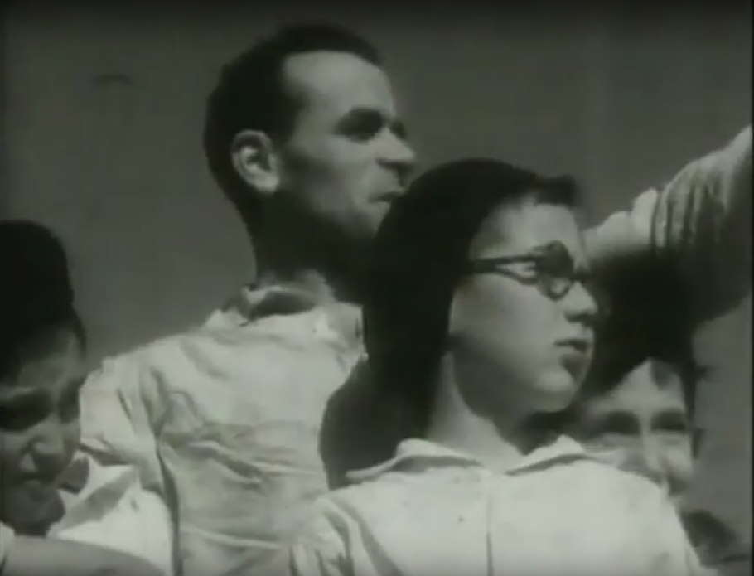
Figure 1. Moshe Horgel as the teacher in the film Oded the Wanderer (1932),

directed by Chaim Halachmi

3.2 Women Enter the Scene: Teachers Conceived as Parents

In Oded the Wanderer, the only female character is Oded’s anxious mother, who is promised by the teacher that he will bring back her child. Six years later, women begin to appear as semi-professional teachers and tutors. Upon the Ruins (Me’al Ha-khoravot; (1938) is set at the “Nakhalat Yeladim” (Children’s Village) Youth Village, with a parallel plot taking place at an ancient Hebrew village in the days of the Second Temple (1st century BCE to 1st century CE). A group of war-refugee orphans refuses to participate in the Bikurim (harvest festivities); “one asks, “How could we sing and rejoice while our parents remain in concentration camps in Germany?” As a relief, the teacher offers a story about the courage of a few children who banded together during the Roman occupation to rebuild their village, which was destroyed. The teacher compares the rebuilding of the country in the present and in the past, proposes an explanation and reasoning for their parting from their parents, and provides motivation and purpose. In the film’s final scene, two teachers– one male and one female, accompany the children who are clad in white, carrying bouquets and baskets filled with fruit, in the Bikurim pageant. The pair of teachers walk side by side, like proud parents leading their own “Bikurim”—the schoolchildren, to the festivities. The pair of teachers in this scene is displayed as surrogate parents, which was plausible given that the children were indeed refugees. Their role as teachers is both a parental and an integrative one, bringing together the newly arrived immigrants and the native Sabras.
Ten years later, in 1947, the role of the female teacher expands and broadens. “Tomorrow’s a Wonderful Day” [Makhar Yom Khadash] is a docudrama, shot at the Ben Shemen agricultural boarding school. The plot focuses on Benjamin, a fifteen-year-old boy who faces difficulties in shaking off the horrors of war and getting his life back on track. Every event and each object bring back bad memories. The staff is empathic and understanding, as are the other kids. Thanks to the therapeutic effect of working the land, the lad recovers, and becomes part of the group. In the first scene where the class is revealed, some twenty pupils are seated in two rows; they form a swarm of kids speaking a mélange of foreign languages: Italian, Russian, German, and English. The sense of chaos and crowding evaporates when the two teachers, one male and one female, walk about the classroom. The male teacher calls upon each pupil to describe their previous level of schooling, while the female teacher takes notes. The teachers maintain a sense of order and quiet in the classroom, enabling every pupil to tell their story. Through these voices unfolds a story of a whole generation that lost its childhood to persecution, having to hide, and living in fear and hunger.
The task of eliciting the students’ stories is divided between the teachers according to the pupil’s language. The male teacher addresses the children who speak Polish and Italian, while the female teacher addresses those who speak French, and both in turn address the English and Dutch-speaking children. The fact that the teachers demonstrate multilingual skills is important, since in coming years, erudition would completely disappear from the representation of teachers in the Israeli media: this wealth of knowledge would be replaced by a futile void. But in 1947, the character of teachers enables the story of the survivors to be heard in public, and with their solemn expression, they affirm the collective acknowledgment of the survivors’ suffering.

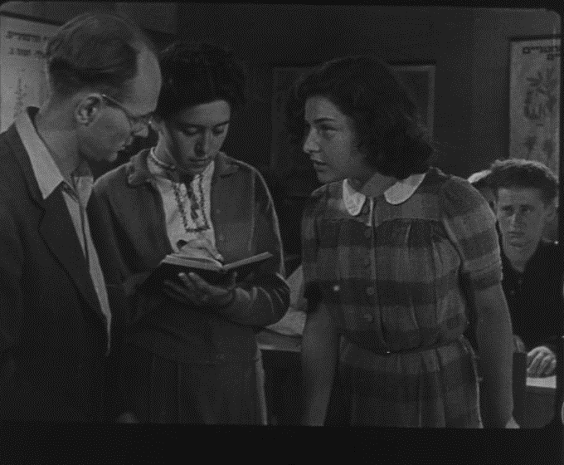
Figure 2. A scene from Tomorrow’s a Wonderful Day (1947). Teachers interviewing students
Spielberg Jewish film archive

Although both teachers work as a team in the classroom, the male teacher initiates more verbal contacts with the pupils, asking the questions, whereas the woman stands beside him and records their answers in her notebook. Their physical positioning in the scene reinforces gender distinctions and the construction of the male teacher as “the boss,” while the female teacher is interpreted as female secretary.
Later in the film, the leading character, Benjamin, hides loaves of bread in his satchel in the closet. The bag’s contents are scattered when the closet is opened. When the teachers discover this, the male teacher leans over to pick up the bread and returns it to its hoard; as he does so, he says to the female teacher, “Look, he carries this from the camp, he doesn’t trust us enough to give him ample food. We won’t say a thing, we won’t embarrass him.” She answers, “Poor lad.” This scene demonstrates a pattern noted in many studies on women’s representation in the media: when a man and a woman share a scene, he gets to play the active part, whereas she acts out the emotional expression. At a later stage in the film, Benjamin tells us that he was astonished when Shmuel, the male teacher, chose him as the annual ceremony’s torchbearer, with the duty of carrying it from the Maccabi tombs in Modi’in to the Youth Village in Ben Shemen. The teacher assumes the power and authority of appointing the crown, just as the biblical Samuel had.

3.3 Teaching Under Fire

The first appearance of a female in an actual teaching role, in the sense of transferring knowledge, is observed in the docudrama The House on the Hill (Bayit al Giva’a; 1950). The film revolves around the 25th anniversary of the founding of the Hebrew University of Jerusalem. The context of the story is presented by an elegant professor, who is asked to speak to an audience of distinguished guests and explain the significance of the institution he represents. He chooses to focus on three students. A slow close-up shot lingers on each of their faces, as they look at the Dead Sea Scrolls. The narrator describes them in English: “This is Rachel, born in Jerusalem, she is sober and reliable. This is David, an American, an enthusiastic new immigrant. And Yohanan, born in Israel, is a Sabra who gladly joined the other two.” One can understand the choice of presenting the students in front of the Dead Sea Scrolls, as what could better prove the Jews’ return to our ancestral land than these scrolls? They provide the starting point, the linkage to both the language’s origins and the history of the Jewish people, and embody the very legitimacy of the Jewish presence in the land.
It is important to note how the three students are described. The woman’s characteristics are recounted by the speaker, describing her as sober and reliable, yet the personal attributes of the men are not given in detail since their presence needs no justification.
After a while, David and Yohanan silently leave the room. The narrator comments: “It seems as though they find more interest in the future than in the past.” Meanwhile Rachel continues to listen attentively. Later the film depicts David’s expedition in search of a vaccine for malaria and Yohanan’s travels throughout Israel to assist the settlers in water drilling. In contrast, Rachel joins the effort of teaching Hebrew to the new immigrants’ children. The narrator carries on: “At our experimental school, Rachel teaches Hebrew to children from several different countries. These children, coming from abroad, find their ancient and traditional language to be unfamiliar and strange.”
The film presents a class of twenty children, aged six and seven, who emigrated from several different countries. One child, at the center of the classroom, wears a black yarmulke; this scene reinforces that the class is a melting pot. The children, clean and well behaved, attentively follow Rachel’s words. Names of objects— a flower, a tree, a scissors—are written on the blackboard behind the teacher. A poster showing the Hebrew alphabet is hung above the blackboard. All of a sudden, the window is shattered with a blast. The children and the teacher recoil, and for a moment, there is fear in their eyes. But soon enough, Rachel regains her composure, calms the children with a smile and asks one of the girls to fetch the bullet’s casing from the floor. She holds the casing (see Figure 3) and teaches the children a new word, “bullet”!
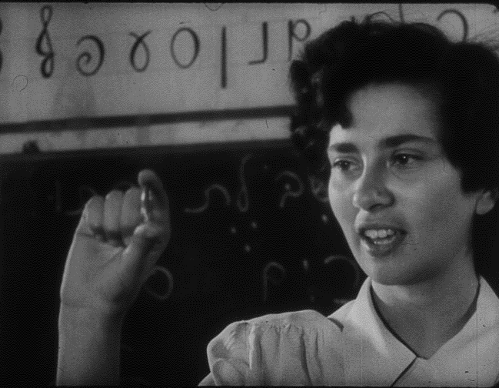
Figure 3. A scene from the film The House on the Hill (1950): The teacher holding a bullet.
Steven Spielberg Jewish film archive.

Rachel, the teacher, is portrayed as a positive figure. She contributes to imparting the Hebrew language to the new immigrants, while at the same time enculturating them into regarding the security threat as a part of life, as something to adapt to. We witness a young teacher smiling with courage at the risk and becoming a role model for her pupils. As t
he narrator recounts, “At first we tried to ignore the disruptions, we then tried to include the problems in the curriculum. We had to teach them what is a child, a flower, a dress, a quarry, a jug, a dog and a bullet—a word that they would probably use often enough, just like a vase.”
A motif is revealed here, and it would be repeated in later “teacher” films: teaching under fire. When teaching is performed under battle, the teachers’ task is expanded to act as soldiers and protectors of the children, both physically and mentally. When the classrooms’ very existence is put under threat, the whole nation becomes an army: the men actively fight in combat while the women take the children into shelter and calm and encourage them.
The film shifts to describing the battles of the War of Independence and the participation of Rachel, David, and Yochanan in the fighting for Jerusalem. A collage of battle scenes is shown, complete with smoke, gunfire and evacuation of the wounded. Rachel, the teacher, wears khakis, talks on the wireless and tends to communication and devices; indeed, the signal corps was made almost solely the responsibility of women soldiers during the war.
The last part of the film describes the return of life back to normal. Now a student at the Hebrew University, Rachel the teacher searches for a book at the Terra Santa library, but the book had been left behind in the university building on Mount Scopus, which was evacuated during the war. Again, Rachel is presented as scholarly. She is interested in archaeology and is presented against the backdrop of the library. This scholarliness of teachers shows them in an intellectual light and supports their positive representation, as did the teachers’ multilingual skills in Tomorrow’s a Wonderful Day. However, this representation of intelligence would almost completely vanish from the imagery of teachers in later films. In the final scene, the professor makes a speech, talking about the eternal role of enlightenment in Jewish tradition. The film ends with a direct appeal for donations to academic institutions in Israel.
Another English-speaking film, Faithful District (Kirya Ne’emana; (1952), depicts students who volunteer as teachers. Studies at the Hebrew University have been halted because of the military tension in the days leading up to the War of Independence. Sam (played by Jimmy Smith), a student from America, decides to volunteer as a teacher at the school at Ramat Rachel, a kibbutz near Jerusalem. The staff faces complex educational challenges with the children, some of whom who are survivors of the Holocaust. As the war breaks out, the teacher instructs the children how to fortify the place, and joins the fight on the Palmach lines. At the height of the battles, Sam and the children manage to salvage a water supply truck and bring provisions to the school.
This film, in contrast to those preceding it, deals with pedagogic issues such as the appropriate strategies for children’s education. This new focus reflects the stages in the foundation of the Israeli education system. The film was produced after the War of Independence, when the fledgling state was contemplating the educational identity that its institutions would take.
The film presents two models of teachers. Sam is the demanding teacher, behind whose veil of sternness rests a heart of gold. The second model is portrayed by the institution’s staff—Tamar, the teacher, and Ezra, the headmaster who is a Holocaust survivor; these two demonstrate a tender and loving approach towards the children (see Figure 4). Sam complains to the superintendent: “Each time a kid here plays a prank, he’s rewarded with a kiss and a hug.” The following dialogue in an early scene shows his harshness, but also his willingness to change. Sam tells the children that, while staying at the Youth Village, they will have to take on jobs. Max, a troublesome boy, asks, “What is the wage?” The answer he receives is “There’s no pay, we’ll work in the mornings and study later!” In response Max decides to plan a strike, and stirs up resentment among the other kids. He asks Sam, “What about those who won’t work?” Sam replies, “Those who will not do their chores will not get any food!” Ezra, the headmaster, intervenes, saying, “Sam is just kidding you!” He then chastises Sam, “No one will use food as a threat, not on my watch.” Sam answers, “Of course, we’ll do this differently.”
This scene takes place early in the film. Later on, Sam will gradually soften his approach and gain some insight into teaching. In one of the later scenes, Sam’s watch and ring are stolen. He goes to the police station to identify his jewelry and sees that the thief is none other than one of his pupils. Realizing this, Sam lies to the British police officer, saying that he had given the boy the watch as a gift. In his kind and noble manner, he wins his students’ devotion. With his humane approach, he manages to alter their disposition, bringing about a transformation from the typical Diaspora Jewish inclination to avoid manual labor, engage in petty thievery and play cards, to an Israeli identity . Like Rachel, the teacher from The House on the Hill (1950), Sam abandons his duty only for the one thing that is more sacred than teaching—–enlisting in the army. A new characterization of teachers unfolds, one that is not as “spiritual” as the previous teachers, but rather a more material and militant figure.
The fact that the staff teacher Tamar (played by Rachel Marcus) has full, equal rights can be discerned from the way she is filmed and the number of lines she is given. Yet, despite her being a member of the staff and Sam serving only as a volunteer, he is the undisputed leader. When he returns to the kibbutz during a halt in the battles, her relief is apparent. For the children, Sam is the educational authority, as well as the leader handling logistics and security at the school. Faithful District was filmed after Israel was established as a state. This accounts for the relative weakness of the motifs described earlier. Bonding with the soil, which in most of the earlier films was transmitted by means of an educational institution, is absent. Rather, the notion of manual labor is introduced as a value. However, the “legitimacy” of the Jewish people’s presence in Israel is still a focus. Thus, for example, during the fighting, Tamar, the teacher, stands near a panel with an illustration of the Siloan Tunnel (Nikbat Ha-Shiloah). The tunnel is one of the only tangible, archaeological proofs of the biblical text’s validity. Discourse on the water issue in Jerusalem serves as an analogy between the Assyrian siege on Jerusalem in the days of the First Temple (late 8th or early 7th century BCE) and the Arab attack in 1948. Just as King Hezekiah fortified the city and provided water through the Siloan Tunnel, so too does Sam the teacher fortify the school and makes sure that the water supply truck reaches it. The teachers’ rapid transformation from their civilian role of teaching to a designated military role is one of the educational cadre’s characteristics in the 1950s film industry.

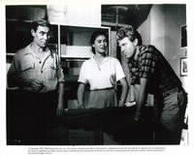
Figure 4. A Scenes from “Faithful District” (1952). The educational staff in consultation.

The pedagogic role of female teachers gains stature in the film Dan & Saadia (Dan Ve-Seadia] (1956), a popular spy kids film. Dan is an imaginative boy whose parents and teacher have sent him to a boarding school. His friend, Saadia, a Yemenite Jew, sneaks into the car that drives him there. Discovering the location of the Hagana’s weapons cache, together they rescue the boarding school from attack.
Early in the film, Dan’s parents meet with the teacher (see Figure 5). The father (played by Elimelech Ram) is wearing a white shirt, suit and tie. The mother is taciturn and elegant in a dark dress and a pearl necklace. The teacher who is counseling them is young, has short boyish hair, and is reserved but compelling. Dan’s parents complain about his wild imagination and the spy stories he reads, and she preaches to the helpless couple how they should handle him.
The father asks, “How could we cure the boy?” The teacher, with a didactical intonation, responds, “A lot of youngsters read spy stories, it’s not a problem. But once the reader begins to act out the events on a daily basis, this does turn into an illness… I suggest transferring him to a boarding school in one of the villages, where he would lead a healthy life and experience both work and studies which would eradicate his spy fantasies.”

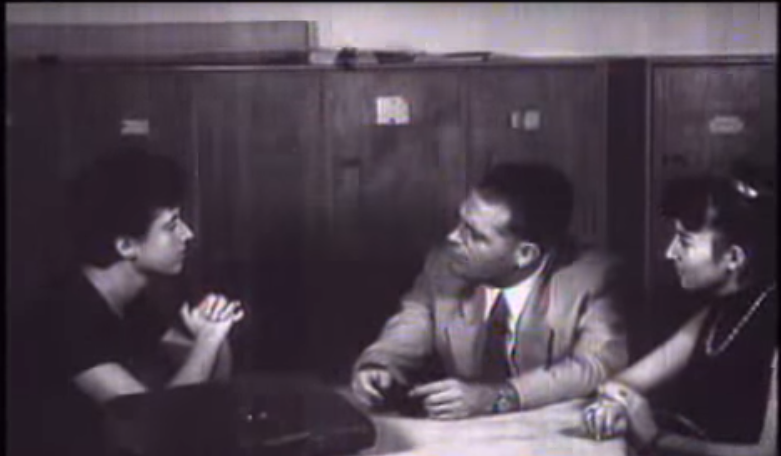
Figure 5. A scene from “Dan and Saadia” (1956). A medium shot on the teacher’s face and hands; she clasps her hands while diagnosing the problem and spreads them apart upon presenting the “cure.”
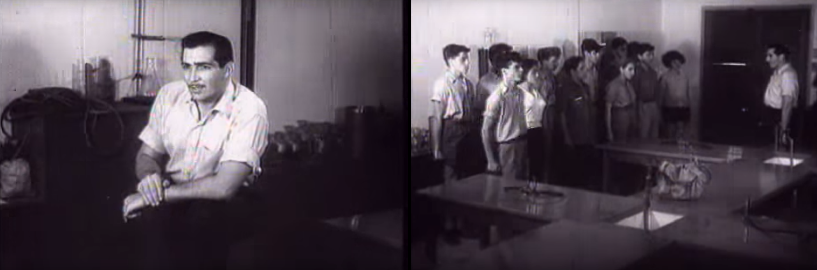
Figure 6. A scene from “Dan and Saadia” (1956) Dov, the male teacher in the boarding school, commanding the class as a military troop.

In contrast to the parents, the teacher is presented as a Sabra. While the mother’s jewelry and the father’s suit attest to their being bourgeois, she is plainly dressed in trousers and a shirt and has cropped hair and a direct demeanor. The parents are helpless and lack educational authority; only the teacher can diagnose the problem and suggest a cure. The parents have lost their way—allowing popular culture into their home and ruining the boy; the teacher, like a specialist doctor, provides knowledge and serves as a professional pedagogic authority. Within a decade, the character of the female teacher had significantly progressed and evolved into one that voices professional knowledge and a reasoned perspective.
According to the Zionist perception, agricultural training was essential for the pioneers and their children, as preparation for their resettling the State of Israel. Farming was perceived not only as a livelihood or even merely a vocation, but was elevated to a degree of sanctity. Tilling the soil was regarded as means of purging the ravages of exile in the Diaspora. Thus, the agricultural school is a recurrent backdrop for teachers in film. But there was a chasm between the lofty exhortations to work the land and what actually occurred, and eventually, fewer and fewer people farmed, instead turning to occupations requiring learning and skills. By the time the state was established, agricultural education was receiving little funding, and the type of students changed. From institutions for rearing the elites, the agricultural schools were transformed, from the 1950s on, to establishments for educating youth who had no family and for absorbing new immigrants. Consequently, agricultural education totally lost its shine.
The short dialogue between the teacher and Dan’s parents, described earlier, is in the beginning of the movie and precedes the appearance of the male teacher Dov, at the boarding school where Dan is sent (see Figure 6). Dov, with his mustache and broad shoulders, resembles Rhett Butler in Gone with the Wind (1939). He expresses yet another aspect soon to fade away from the portrayal of teachers—their sexual attractiveness. Dov is adored by all his pupils, both boys and girls, but for the latter, he is someone to fall in love with.
Dov has a place in his heart for everyone: for Dan with his spy dreams, for Saadia the shoe shiner, and for the nagging boy, whose only willing audience for his poems is the young calf in the cowshed. In days to come, teachers’ propensity to acknowledge each child’s uniqueness would utterly disappear from their portrayal in the cinema, but in 1956 this sensitivity to student’s needs remains the predominant image of teachers. As with other teachers in films set in the War of Independence, at wartime the teacher would transform his role from an educational one to acting as a military commander. At the eve of the declaration of the State of Israel, Dov gathers the school’s staff for a briefing. The headmaster tells
them in the staff room, “Listen closely, Dov would like to make an announcement.”
This scene indicates that, when a teacher serves as a commander, his status rises above that of the elegant headmaster. Dov informs the staff that the Arabs are amassing ammunition in anticipation of war. He suggests sending the younger students back home and training the older ones in handling guns. The next scene shows the teacher as he commands the class. Dov says to the senior class: “Company: Attention… Company: At ease… We have decided to speed up the training because there are rumors that the Arabs… Yoav will lead the class.” The word “class” in this dialogue alternates between its educational context meaning “classroom” or “grade” and the military term “squad.” All the teachers in this film are displayed as noble, reasonable, pragmatic and moral. This film in the year 1956 presents a positive portrayal of teachers and education, a portrayal due to vanish from Israeli cinema within a decade.

Table 2: Changes in Women Teachers’ Representation in Israeli Cinema, 1930–1960

Teacher’s role | Name of film | Year
No female teacher. A worried mother in a female role. | Oded the Wanderer  (Oded Ha-noded) | 1932
Silent female teachers who accompany the children together with the male teacher to Bikurim harvest festival. | Upon the Ruins  (Me’al Ha-khoravot) | 1938
Female teacher who approves of and strengthens the male teachers. | Tomorrow’s a Wonderful Day  (Makhar Yom Khadash) | 1947
Female teachers in children’s ulpan (language class) demonstrating courage in the face of a volley towards the class. | House on the Hill  (Bayit al Giva’a) | 1950
Female teacher next to a blackboard teaching about the subject of water in Jerusalem—a complementary female figure to a male teacher. Partner in various dialogues. | Faithful District  (Kirya Ne’emana) | 1952
Female teacher as an educational authority, whose judgment is superior to that of the parents. Appearance of a male teacher as a military commander in a Youth Village. | Dan & Saadia  (Dan Ve-Saadia) | 1956

4. Summary and Discussion

Table 2 summarizes the changes took place in the representation of women teachers in film, beginning with their absence in Oded the Wonderer (1932), to a figure of the woman who is silent and passive in Upon the Ruins (1938), through the presence of a teacher who makes minor and marginal remarks in the film Tomorrow’s a Wonderful Day (1947), to an assertive teacher raising her voice on a pedagogical issue in Dan & Saadia (1956). Clearly, the depiction of female teachers became more positive over this time. Two questions arise in relation to this assessment. First, is this a real change, or an optical illusion, an impression based on a very small number of cases? Second, assuming that there is a change in women teachers’ portrayal from 1932–1956, what may explain it?

Teachers’ representation in film went through several changes in the transition from the yishuv (pre-state community) to the state. In particular, the status differences between male and female teachers lessened over that time. In the pre-state era, one can detect two prominent roles held by women teachers in films. The first is that of a surrogate mother, in the sense of a complementary, silent figure next to the man. It can be traced to the Bikurim parade in the film Upon the Ruins (1938), where a male and female teacher, standing close to each other, lead a group of young children dressed in white. The Parsonsian schema of a family organized around an instrumental male leader and an expressive female leader notably corresponds with this depiction. The main function of the surrogate mother is to display concern and compassion. In Tomorrow’s a Wonderful Day (1947) when the teachers discover that a boy is hiding bread in the closet, the male teacher offers the professional assessment: “He brought it from the quarantine, we will not shame him.” The female teacher merely confirms his statement and reacts emotionally, saying, “Poor lad.” Another role for women teachers is as an apprentice or assistant for a male academic authority. In Tomorrow’s a Wonderful Day (1947), the female teacher stands next to Shmuel, a fellow teacher, and transcribes the details of the interviews with the students in a notebook. Positioning the female teacher as a secretary indicates a differential status within the school. The male teacher has the pedagogical authority to navigate the class, including the prerogative to choose which student will carry the torch from Modi’in, while the female teacher is assimilated into the background with a confirming smile. In films in the post-state era, status differentials are moderated. In House on the Hill (1950), Rachel is the sole teacher in a Hebrew class and in Faithful District (1952), Tamar teaches history in the absence of any male teacher. Both female figures are constructed as independent, strong individuals that fade only when the plot moves to battle scenes.
The second change that occurred in the portrayal of teachers is the appearance of dimensions of the educational profession. With the transition to a state, a new discourse rises around pedagogical issues. The main character in Dan & Saadia (1956) is a young boy engrossed in detective stories and popular culture. In a conference with his parents, his teacher suggests a remedy in the form of an agricultural boarding school far away in the country. This is a manifestation of her pedagogical expertise to which the parents comply. The staff at the educational institution for refugee children in Faithful District (1952) confront the question of the correct response to antisocial behavior. The young refugees have brought their delinquent behaviors of pickpocketing, card games, and sexual seduction from exile, and the staff wonders about the best approach to them. In terms of the visual language of the film, the photographic presentation of the educational team constructs a group, one body that joins forces to guide the children. In that team the women pose as an equal part of the group, not as the “mother.” Gender differences in authority and power are raised again with the sounds of the war’s siren, at which time the female teachers withdraw to their motherly protective role and the males go out to combat, accompanied by some male students.
All the teachers presented in the films of both pre- and post-Israeli statehood are young and white, but the image of students evolved to reflect a more pluralistic community. House on the Hill (1950) depicts an ethnically diverse Hebrew classroom, and in Faithful District (1952), one of the students bitterly declares, “It’s because I am Moroccan.” The multicultural society is also reflected in Dan and Saadia (1956), in which the educational staff steers Dan to engage in study, while Saadia, the Yemenite boy, is sent to work. The pluralistic images of the young generation reflect the melting pot vision of the new country. As in former films, notions of hierarchy and all conflicts between students and teachers are eliminated when a threat of war arises and they become one body serving one mission.
Another change occurring with the transition to statehood is that the figures of teachers in later film are constructed as humans, rather than as mere proxies of an ideology. In the pre-state era, teachers are a platform for nationalist ideas; for example, in Oded the Wanderer (1932), the teacher preaches to the children about their duty to continue the vision and mission of the pioneers. In Upon the Ruins (1938), the teacher draws a symbolic thread between the war against the Romans during the Second Temple era and modern enemies. Yet, after the founding of the state, the figures of the teacher are able to depart from the pathos that branded them. Sam, the teacher in Faithful District (1952), is able to apologize to his student after a sharp confrontation: “I don’t know how it happened, maybe you are right, it slipped out of me.” Rachel, the House on the Hill (1950), displays fear for a moment when a bullet is shot into her classroom, and in Dan & Saadia (1956), Dov, the handsome teacher, is gifted with humor and a baritone voice, lifting the atmosphere with his singing. The change in intensity of emotion is also reflected in the narrator’s intonation. While in Tomorrow’s a Wonderful Day (1947) the telling is full of pathos, the narrator in House on the Hill (1950) is calm and restrained; it is still a male voice, but much less theatrical. The decline in volume and the positions of human interaction and dialogue on behalf of big statements make it possible for female teachers to enter the frame.
To conclude, in the first three decades of the Israeli film industry, female teachers appear alongside their male colleagues, unevenly sharing symbolic resources; that is, screen time and significance in the plot. Over the years, women playing the role of teacher are increasingly shown in a less motherly and more professional portrayal. Yet, during the 1930s and 1940s, presenting women in an ideological and professional frame, even if second to men, was a progressive expression. Showing the integration of women in the labor market as teachers was a statement about their partnership in fulfilling the Zionist enterprise.
It is also important to remember that in all areas of society, women were excluded from the centers of power and from key positions of leadership. The basic conception about gender among the pioneers of European descent was patriarchal; historians have argued that the major mechanism responsible for constructing women’s roles as marginal was the perception that they were brought along with the pioneers as “imported luggage” from Europe. In addition, in the yishuv’s public discourse, gender-related issues were suppressed in favor of “urgent” matters such as settlement, defense and absorption of immigrants. Thus the cinema justifies men’s superiority in the staff room of the educational facility, arguing that in addition to their role as educators, they have to deal with the problematic group of the refugee children, to fortify the school and carry arms. Still, considering the time and place of the pre-state films, the figures of female teachers are a fresh portrayal of determined women.
Analysis of media content tends to demonstrate historical inaccuracies, whether it is a depiction of a minority group such as Native Americans in Westerns or professionals such as physicians in medical dramas. The aim of analysis is to detect biases in order to unveil social concepts; the discrepancies between fiction and reality are used as a tool in that procedure. Incongruences are assumed to teach more about the ideology held by producers than their actual declarations. In this study, the unequal gender representation in the fictional educational institutions and the promotion over time both demonstrate the common view about teachers and reflect historical trends. The feminization of teaching was a massive transformation that cannot be ignored.
The occupation of teacher has a “masculine” history, and teachers had prestige and influence because they were socializing agents. Women’s admission into teaching therefore is a progressive element, although it was the perception of teaching as an extension of domestic roles that allowed for their entry into teaching positions. As early as the pre-state era, teaching and nursing were regarded as appropriate occupations for women. Performing these tasks was considered a contribution to the community and fulfillment of the national vision, and was therefore appreciated. For women, holding such jobs resolved the tension between private and public spaces, and granted them social benefits. Women teachers’ expanding presence in the cinema is therefore drawn from real life and supported by social norms regarding “what is appropriate for women.”
The increase of women’s voices in film representations of teaching in the state era was a social achievement, after which teaching would become more feminine, in life as well as in cinematic venues. Women now constitute 86 percent of the workforce in primary schools and 78 percent of the secondary education workforce. Although all Western countries have experienced a feminization of teaching, the process in Israel was rapid and accompanied by a dramatic decline of status, as teaching became a gender enclave. Since the 1960s, occupational segregation in Israel, as in other societies, has been the very mechanism to produce inequality in wages and status. Consequently, women’s great achievement of breaking into teaching was also their greatest loss.
Several implications can be drawn from the portrayal of teachers in early cinema. The first one is the construction of a contrasting social view regarding males and females in teaching. While male teachers are framed as spiritual, charismatic leaders in whom military qualifications do not lessen their intellectual horizons, female teaching is a therapeutic profession that provides children with care. It is interesting to look at how ideological justification accomplishes an historical process. Women penetrate a male occupation and then the character of the profession changes and adjusts in a way that preserves and perpetuates traditional gender roles. In other words, when a man approaches teaching, it is from true commitment and leadership. When a woman is appointed to teach, it is because she can fulfill her prerequisite of taking care of children. The next evolution of this idea in Israeli public discourse is that women choose teaching out of opportunistic motives, in order to stay home with their own children and to enjoy short working days and long summer vacations.
In the following decades, the female presence in teaching would grow in parallel to their presence in the fictional world, until the mental picture of a teacher became fused with that of a woman. A reverse process would take shape: men who join teaching would be stigmatized as “feminine” and “losers.” The prominence and significance of teachers as national heroic icons would endure only as nostalgic memory and a symbol of faded times.

Notes

The paper is based on a chapter of the author’s PhD dissertation supervised by Prof. Dafna Lemish, Communication Department, Tel Aviv University.
Yuval Dror, “National Education” through Mutually Supportive Devices: A Case Study of Zionist Education (Bern: Peter Lang, 2007), pp. 42–43.
Yoav Silbert, “The Professional Status of Teachers in Eretz-Yisrael 1892–1913,” in Avner Ben-Amos and Yael Tamir (eds.), Teaching between Vocation and Profession (Tel Aviv: Ramot, 1995), pp. 45–59 (Hebrew).
Margalit Shilo, “The Language Controversy: A 'Popular Movement,'” Cathedra: For the History of Eretz Israel and Its Yishuv, 74 (1994), pp. 86–119. Retrieved 29 August 2017, from www.jstor.org/stable/23403557 (Hebrew).
Yonathan Shapiro, An Elite without Successors (Tel Aviv: Sifriat Poalim, 1984) (Hebrew), p. 66; Oz Almog, The Sabra: The Creation of the New Jew (Berkeley: University of California Press, 2000), p. 25; Tali Tadmor-Shimony and Nirit Raichel, “The Hebrew Teachers as Creators of the Zionist Community in (the Land of) Israel,” Israel Studies Review, 28, no. 1 (2013), pp. 120–141.
Rachel Elboim-Dror, Hachinnuch ha-ivri be-Eretz Israel (Hebrew Education in Palestine 1914–1920) (Jerusalem: Yad Izhak Ben-Zvi, 1990), pp. 350–358 (Hebrew). Not consistent. Here you’ve translated and transliterated title. Above you only translate.
Audrey Addi, Changes in Teachers’ Status during the Last 20 Years (Tel Aviv: Institute for Social Research, Department of Sociology and Anthropology, Tel Aviv University, 1992), pp. 10–12 (Hebrew); OECD, “Education at a Glance, OECD Indicators,” 13 August 2013. Retrieved 29 August 2017 from www.oecd-ilibrary.org/education/teachers-salaries_teachsal-table-en.
Shapiro, An Elite without Successors (above, note 5), pp. 71–73.
António Nóvoa, “The Teaching Profession in Europe: Historical and Sociological Analysis,” in E. S. Seing, J. Schriewer and F. Orivel (eds.), Problems and Prospects in European Education (Westport, CT: Praeger, 2000), pp. 45–71.
Addi, Changes in Teachers’ Status (above, note 7); Drora Kfir and Tamar Ariav, The Crisis in Teacher Education: Reasons, Problems and Possible Solutions (Tel Aviv: Van Leer Jerusalem Institute/Hakibbutz Hameuchad, 2008, pp. 23–24 (Hebrew).
Christine Skelton, “The 'Feminisation of Schooling' or 'Re-Masculinizing' Primary Education?” International Studies in Sociology of Education, 12, no. 1 (2002), pp. 77–96.
? Audrey Addi-Raccah, “The Feminization of Teaching and Principals in the Israeli Education System: A Comparative Study,” Sociology of Education, 75 (2002), pp. 231–248.
Sheelagh Drudy, “Gender Balance/Gender Bias: The Teaching Profession and the Impact of Feminization,” Gender and Education 20, no. 4 (2008), pp. 309–323; Esther Hertzog, “The Politics of Gender in Education: Who Benefits from Feminization?” in Esther Hertzog and Tsvia Walden (eds.), At Teachers’ Expense: Gender and Power in Israeli Education (Jerusalem: Carmel, 2010), pp. 37–73 (Hebrew).
Nóvoa, “The Teaching Profession in Europe”” (above, note 9), pp. 45–71; Susan Trouvé‐Finding, “Teaching as a Woman’s Job: The Impact of the Admission of Women to Elementary Teaching in England and France in the Late Nineteenth and Early Twentieth Centuries,” History of Education, 34, no. 5 (2005), pp. 483–496.
James C Albisetti, “The Feminization of Teaching in the Nineteenth Century: A Comparative Perspective,” History of Education, 22 no. 3 (1993), pp. 253–263.
Shaun Johnson, “The Woman Peril and Male Teachers in the Early Twentieth Century,” American Educational History Journal 35, no. 1 (2008), pp. 149–167.
Deborah Bernstein, The Struggle for Equality: Urban Women Workers in Pre-State Israeli Society (New-York: Praeger Publishers, 1987), pp. 4–6. ¹⁸ Rachel Elboim Dror, “Gender in Utopianism: The Zionist Case,” History Workshop Journal, 37 (1994), p. 110.
Tali Tadmor-Shimony, “Women Immigrant Teachers and State Formation in Israel, 1948–1959,” Journal of Women's History 26, no. 3 (2014), pp. 81–104.
Rela Mazali, “'And What about the Girls?' What a Culture of War Genders out of View,” Nashim: A Journal of Jewish Women's Studies & Gender Issues, 6, no. 1 (2003), pp. 39–50.
Tali Tadmor-Shimony, “Female Soldier-Teachers: Army, Education and a New State,” Israel Affairs, 16, no. 2 (2010), pp. 297–313.
Tali Tadmor-Shimony, “Immigrant and Veteran Teachers of the 1948 Generation: As Socialization Agents of the New State,” Israel Studies, 16, no. 3 (2011), pp. 97–122.
Audrey Addi-Raccah and Hanna Ayalon. “Gender Inequality in Leadership Positions of Teachers,” British Journal of Sociology of Education, 23, no. 2 (2002), pp. 157–177.
Addi-Raccah, Audrey. “Gender and Teachers’ Attrition: The Occupational Destination of Former Teachers,” Sex Roles, 53 (2005), pp. 739–750.
Ella Shohat, Israeli Cinema: East/West and the Politics of Representation (Austin: University of Texas Press, 1989), p. 16.
Nurith Gertz, “From Jew to Hebrew: The ‘Zionist Narrative’ in the Israeli Cinema of the 1940s and 1950s,” Israel Affairs, 4, no. 3–4 (1998), pp. 175–199.
Ariel Schweitzer, “The New Sensitivity: Modern Israeli Cinema in the 1960s and 1970s.” Tel Aviv: Babel and Third Ear, (2003), pp. 28–31 (Hebrew).
Shulamit Reinharz and Lynn Davidman, Feminist Methods in Social Research (Oxford: Oxford University Press, 1992), pp. 157–159; Gery W. Ryan and Bernard H. Russell, “Techniques to Identify Themes,” Field Methods, 15, no. 1 (2003), pp. 85–109.
Oded the Wanderer. Directed and produced by Chaim Halachmi. 1932. Israel, motion picture.
Nurit Gertz, “From Jew to Hebrew: The ‘Zionist Narrative’ in the Israeli Cinema of the 1940s and 1950s,” in Dan Urian and Efraim Karsh (eds.), In Search of Identity: Jewish Aspects in Israeli Culture (London: Frank Cass, 1999), pp. 175–200; Shohat, Israeli Cinema (above, note 24), p. 26.
Almog, The Sabra (above, note 5), pp. 30–31, 164.
Meir Shalev, Roman Rusi (Tel-Aviv: Am Oved, 1988). Translated as The Blue Mountain, trans. Hillel Halkin (New York: Aaron Asher, 1991).‏
? Upon the Ruins. Directed by Nathan Axelrod 1939. Israel, motion picture.
“Bikurim” are the first crops, or harvest, of the season. They are presented as offerings during the holiday of Shavu’ot.
Tomorrow's a Wonderful Day. Directed by Helmer Lerski. Produced by Greenwald Hazel. 1949. Israel, motion picture.
The House on the Hill. Directed by George L. George, 1950. Palestine Films production, motion picture.
Ornat Turin, “Where have All the Super-Teachers Gone?” in Raymond McCluskey, and Stephen J. McKinney (eds.), How the Teacher Is Presented in Literature, History, Religion, and the Arts: Cross-Cultural Analysis of a Stereotype, (Glasgow: Edwin Mellen Press, 2013), pp 289–301.
Faithful District. Directed by Josef Leytes, 1952. USA, RKO, motion picture.
Palmach was the precursor of the Israel Defense Forces.
? The House on the Hill (above, note 37).
Dan & Saadia. Directed by Nathan Axelrod, 1956. Israel, motion picture.
Elboim-Dror, Hebrew Education in Palestine 1854–1914 (above, note 6), p. 364.
Yuval Dror, “The Progressive and Non‐Formal Principles of Kibbutz Education in Israel,” History of Education, 33, no. 3 (2004), pp. 299–315.
Gone with the Wind. Directed by Victor Fleming, 1939. USA, Warner Brothers, motion picture.
In Hebrew, the same word—kitah—can be used for “class,” “grade,” and “squad.”
Talcott Parsons, “The Organization of Personality as a System of Action, in Talcott Parsons and Robert F. Bales (eds.), Family, Socialization and Interaction Process (London; Psychology Press: 1956), pp. 133–186.
Deborah Bernstein (ed.), Pioneers and Homemakers: Jewish Women In Pre-State Israel. (Albany: SUNY Press, 2012), p. 14.
? Elboim-Dror & Tlamim, “Israeli Education: Changing Perspectives” (above, note 42). ⁴⁸ Addi-Raccah, “The Feminization of Teaching and Principals in the Israeli Education System (above, note 12); CBS <AU: Please provide CBS cite.>

