|  |  |  |  |
| --- | --- | --- | --- |
| **Table 1: Clinical and Demographic Characteristics of the study population grouped according to Zoster exposure status** | | | |
| **Subject's characteristic** | **Non-HZ group**  N = 23,197 | **HZ group**  N = 23,197 | **P-value** |
| **Males,** % (n/N) | 35.4 (8,214/23,197) | 35.4 (8,214/23,197) |  |
| **Age at zoster**, years  Mean±SD (n)  Median  Min; Max | 42.3±20.2 (n=23,197)  39.0  0; 88 | 42.4±20.3 (n=23,197)  39.0  0; 88 | 0.883 |
| **Diabetes mellitus,** % (n/N) | 16.8 (3,891/23,197) | 16.8 (3,891/23,197) |  |
| **Hypertension,** % (n/N) | 27.1 (6,288/ 23,197) | 27.1 (6,288/ 23,197) |  |
| **Dyslipidemia,** % (n/N) | 6.9 (1,612/23,197) | 7.9 (1,830/23,197) | <0.001 |
| **Prior stroke,** % (n/N) | 0.3 (77/23,197) | 0.3 (70/23,197) | 0.563 |
| **Prior MI,** % (n/N) | 2.0 (474/23,322) | 2.7 (617/23,322) | <0.001 |
| **Smoking,** % (n/N) | 21.5 (2,2676/10,562) | 21.3 (2,109/9,895) | 0.769 |

|  |  |  |  |
| --- | --- | --- | --- |
| **Table 2: Post Zoster vascular event survival** | | | |
| **Parameter** | **Non zoster** | **Zoster** | **P-value** |
| **MACCE,** Survival %* ± SD (n) | 72.2% ± 0.02 (1,778) | 57.3%± 0.13 (1,988) | <0.001 |
| **Stroke,** Survival %* ± SD (n) | 95.6% ± 0.01 (319) | 93.1% ± 0.02  (364) | 0.068 |
| **Acute MI,** Survival %* ± SD (n) | 86.5% ± 0.26 (823) | 66.2% ± 0.13 (988) | <0.001 |

|  |  |  |  |  |  |  |  |  |  |
| --- | --- | --- | --- | --- | --- | --- | --- | --- | --- |
| **Table 3: Multivariable Cox regression for HZ exposure on the study outcomes** | | | | | | | | | |
|  |  | | Years from exposure to zoster | | | | | | |
|  | |  | | 1 | | 5 | | 15 | |
| MACCE | | | |  |  | |  | |
|  | | Hazard ratio (95% CI) | | 1.21 (1.04; 1.42) | | 1.01 (0.99;1.20) | | 1.05 (0.96; 1.14) | |
|  | | P value | | 0.016 | | 0.089 | | 0.280 | |
| Stroke | | | |  |  | |  | |
|  | | Hazard ratio (95% CI) | | 0.78 (0.50; 1.21) | | 1.03 (0.82; 1.30) | | 1.12 (0.93; 1.36) | |
|  | | P value | | 0.271 | | 0.791 | | 0.226 | |
| AMI | | | |  |  | |  | |
|  | | Hazard ratio (95% CI) | | 1.30 (0.95; 1.78) | | 1.07 (0.87; 1.33) | | 1.02 (0.85; 1.22) | |
|  | | P value | | 0.098 | | 0.486 | | 0.867 | |

* Multivariable regression is adjusted to gender, age, diabetes, hypertension, socioeconomic status, dyslipidemia, and prior AMI

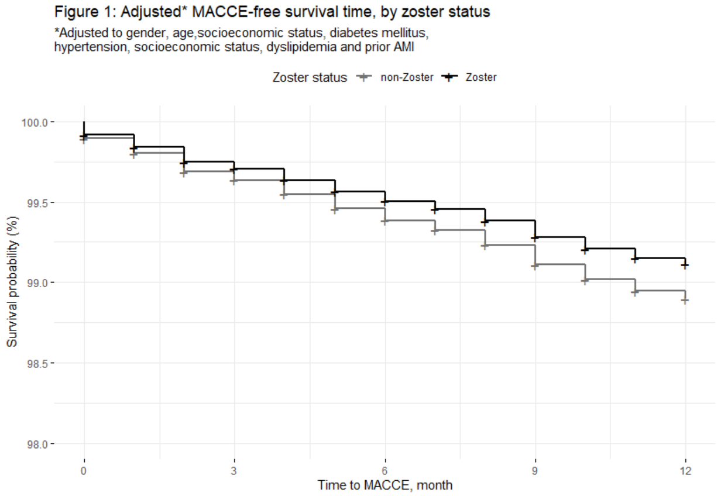

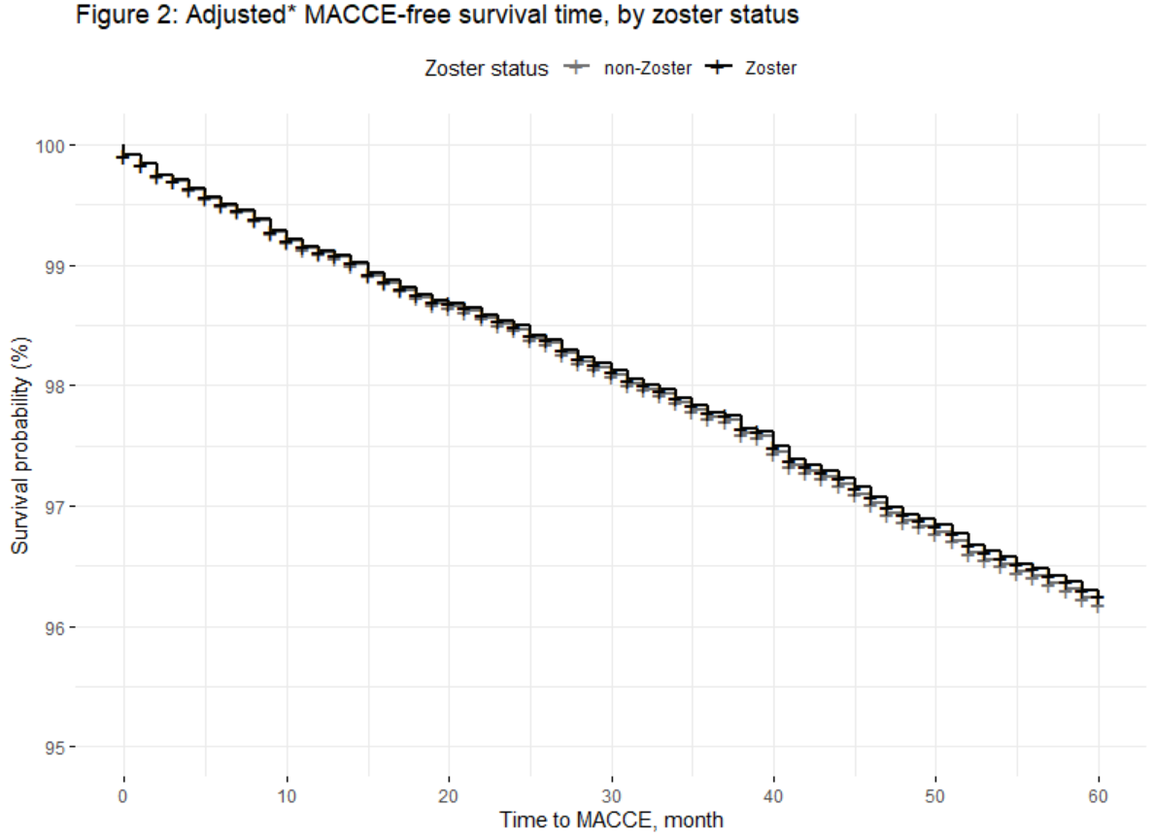

**Figure 3: Event-free survival in zoster subjects, by use of antiviral drug one month after exposer to zoster**

|  |  |
| --- | --- |
| **MACCE** | |
| p-value < 0.001 | |
| (a)  Without Anti-viral treatment  Anti-viral treatment | |
|  | |
| **Stroke** | **AMI** |
| p-value < 0.001 | p-value <0.001 |
| (b)  Anti-viral treatment  Without Anti-viral treatment | (c)  Without Anti-viral treatment  Anti-viral treatment |
| (a) Time to MACCE, (b)Time to stroke , (c) Time to AMI | |