**Layout schedule for lesson plans**

|  |  |  |  |  |  |  |  |  |
| --- | --- | --- | --- | --- | --- | --- | --- | --- |
| **8** | **7** | **6** | **5** | **4** | **3** | **2** | **1** | **Number of online rate** |
| Digestive System  (Shared task) | Digestive System | Respiratory system  (Shared task) | Respiratory system | States of Matter  (Shared task) | States of Matter | Animals  (Shared task) | Animals | **the subject of the lesson** |
| Forex Horizon Website  Digital Content Unit  (See screenshot No 8) | Forex Horizon Website  Digital Content Unit  (See screenshot No 7) | Forex Horizon Website  Digital Content Unit  See screenshot No 6) | Forex Horizon Website  Digital Content Unit  (See screenshot No 5) | Forex Horizon Website  Digital Content Unit  (See screenshot No 4) | Forex Horizon Website  Digital Content Unit  (See screenshot No 3) | Forex Horizon Website  Digital Content Unit  (See screenshot No 2) | Forex Horizon Website  Digital Content Unit  (See screenshot No 1) | **Learning materials** |
| 8  Digitized task in a collaborative door to arrange digestive system components  (See Exhibit ) |  | 6  Cooperative task  Shared Ward Page with Writing in Painting  (See Appendix) |  | 4  Task Panel Collaborative Examples of materials from different aggregate states  (See Appendix) |  | 2  Cooperative task  Google Docs Table for Animal Sorting  (See Appendix) |  | **Cooperative task**  **In the online lesson no.** |
| Appendix 4 | Appendix 4 | Appendix 3 | Appendix 3 | Appendix 2 | Appendix 2 | Appendix 1 | Appendix 1 | **Appendix to the detailed lesson plan** |

**An example of a planned lesson combined with communication**

**Online lesson plan number 1 + 2**

|  |  |
| --- | --- |
| Lesson planning | **component** |
| The fifth grade | **Class / target audience** |
| minutes two lessons 90 | **Time frame (minutes)** |
| The lesson belongs in a learning sequence in an animal world unit.  There will be lessons around animal placement, lessons about animal life characteristics, and lessons around all animals having subsistence needs.  Behind these lessons in terms of learning continuity will be the online lessons that belong to the topic of animal matches and to the invertebrate and invertebrate subject. | **Lesson-technological environment model in class** |
| Describe animal adaptations to the environment in which they live.  Describe common characteristics of insects and mollusks belonging to invertebrates.  Describe common traits for fish, amphibians, reptiles, birds and mammals – vertebrates.  Concepts:  Living environment, environment, body structure, behavior.  Invertebrates: Insect Department, Mollusc Group.  Invertebrates: Fish Department, Amphibian Department, Reptile Department, Poultry Department, Mammal Department. | **Content goals** |
| Using a variety of communication tools.  Media Literacy and Information (Finding Information / Assessing Information / Visualizing and Illustrating / Using Multiple Information Types: Text / Image / Voice / Copyright).  Communication Skills: (Email / Collaborative Editing).  Thinking and Solving Problems (Identifying a Problem / Defining the Need for Information to Solve the Problem / Displaying a Solution Space).  Interpersonal skills and collaborative work (collaborative editing, building common knowledge on file, on site, in a discussion group).  Independent learning and conduct while maintaining ethical and network-protected conduct (on Internet tasks: Independent learning / Learning while receiving feedback / Learning while building knowledge). | **21 st Century Skills** |
| Introducing the theme Environmentally Friendly for 5 minutes.  Intermediate summary 5 minutes.  Explanations frontal 10 minutes.  View animal examples 10 minutes.  Lesson 1 will be personal work for each student on the Horizon website http://ofek.co.il around a task in the digital content unit "Environmentally friendly animals", entering the Horizon website according to each student's personal password. 15 minutes.  Further to Lesson 1, lesson 2 will be the subject of this unit for animal sorting.  Lesson 2 will include two invertebrate and invertebrate tasks.  1.Mission on the Horizon website http://ofek.co.il- 15 minutes  2. Collaborative assignment for student groups, and at the end of the class students present their group product - 30 minutes. | **The structure of the lesson and the course and organization of the learners** |
| Thinking and Solving Problems (Identifying a Problem / Defining the Need for Information to Solve the Problem / Displaying a Solution Space).  Media Literacy & Information (Finding Information / Assessing Information / Visualizing and Illustrating / Using Multiple Information Types: Text / Image / Voice). | **Prior knowledge is required** |
| Online tasks the teacher prepares  1.Teacher sends students an assignment on the Horizon site: Students should submit to the teacher individually at the end of the lesson to receive feedback.  2. The teacher runs the student groups on a collaborative assignment, and they have to submit in a group,  And students will receive group feedback on their product, the product evaluation will reflect the attainment of lesson objectives in content and 21st century skills. | **The product of the lesson** |
| Incorporating multiple representations into the same information that addresses cognitive style variance  Providing different and ranked tasks  Application for continued learning and permission tasks at the Ofeck site | **Addressing the variance in the lesson** |
| Reference to Learning Outcomes and Learning Processes: Remarks for Teaching and Return to Teacher, Reflective Summary of the Learner, Peer Assessment in the Plenum, Evaluation Using the Product. | **Assessment method (learning and product)** |

**Screenshot No' 1**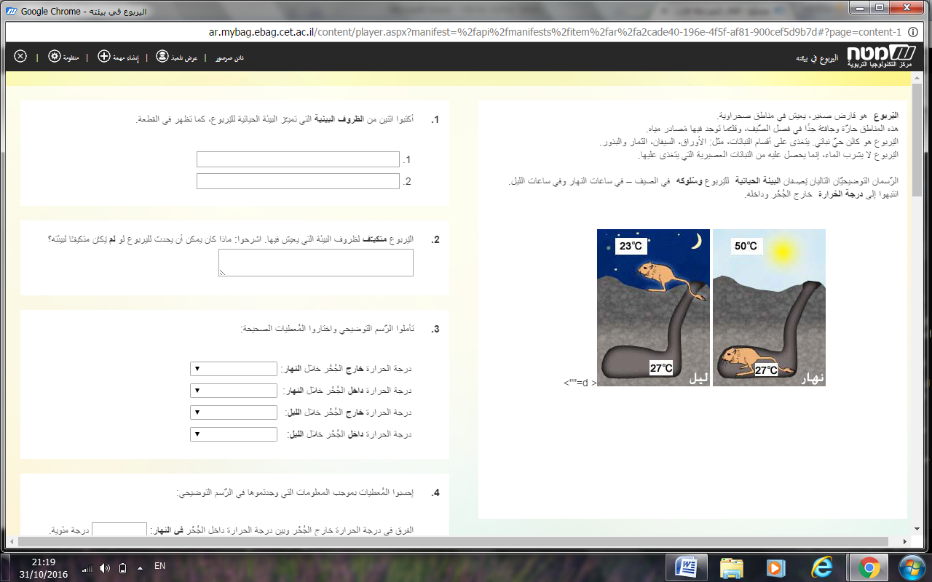

**Screenshot No' 2**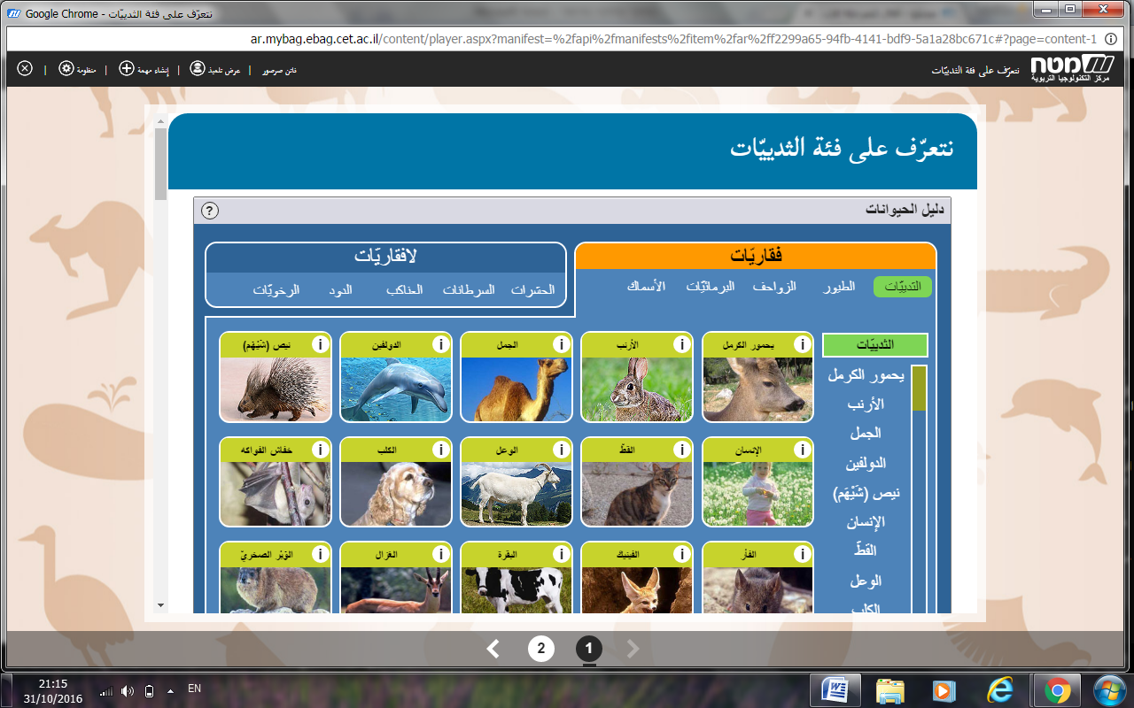

**Screenshot No' 3**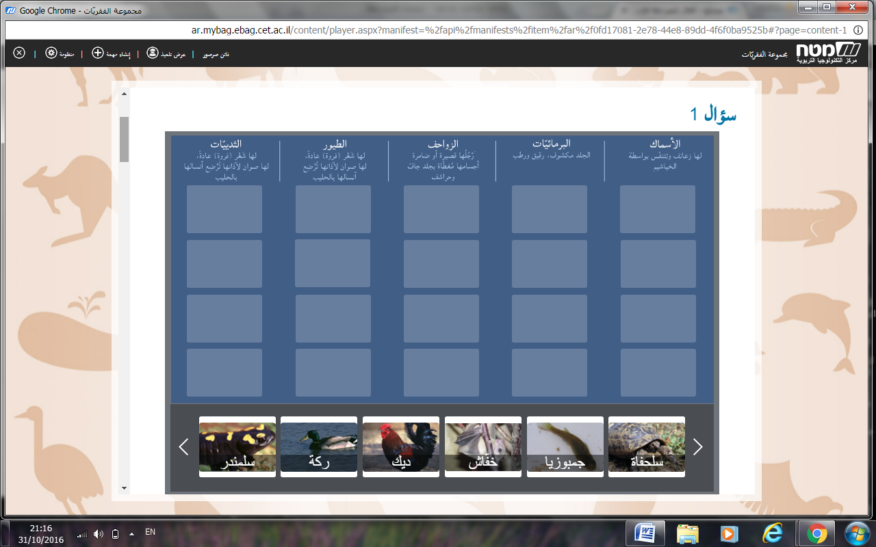

* **Animals (vertebrates, not vertebrates)**
* Each group chooses one of the following categories and classifies the animals that belong to it.
* 1-

A- Classify the following animals according to the appropriate category**:**  **Eagle, ant, snake, frog, comb, cat, bulb, salamandra, crocodile, mullet, dog, lioness, turtle, dory, cockroach, gymnast, toad.**

A- Add to your category the names of animals.

|  |  |  |  |  |  |
| --- | --- | --- | --- | --- | --- |
| **The birds** | **Reptiles** | **Fish** | **Amphibians** | **Mammals** | **Insects** |
|  |  |  |  |  |  |
|  |  |  |  |  |  |
|  |  |  |  |  |  |
|  |  |  |  |  |  |

**Screenshot No' 4**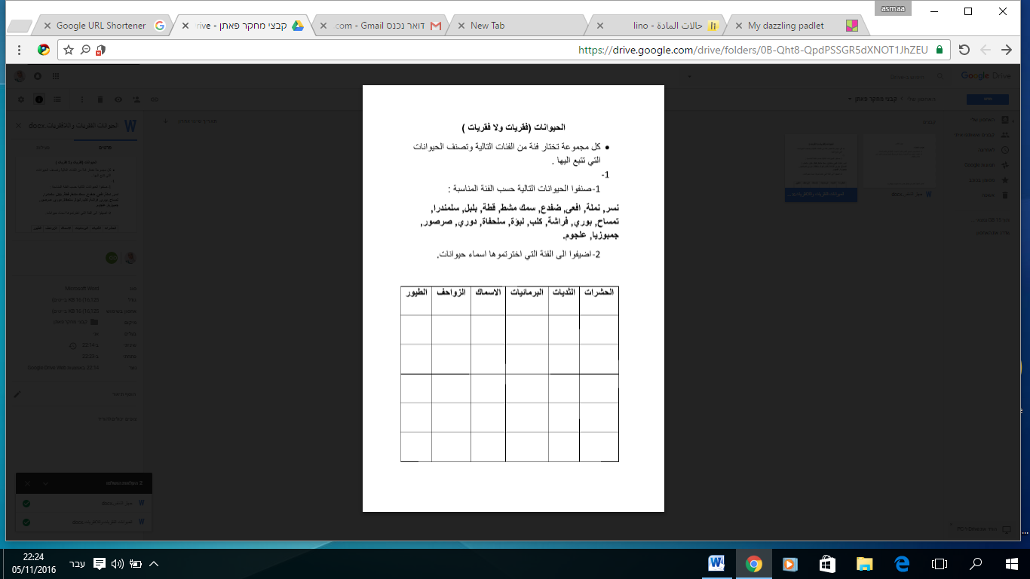

<https://drive.google.com/file/d/0B-Qht8-QpdPScklmZC1MWlFRM00/view?usp=sharing>

<https://goo.gl/DoBqwF>

Exhibit

**States of matter**

* Event Instructions:

**• Each group gives examples of solid, liquid and gaseous substances in the common board in the lino computerized instrument.**

**Screenshot No' 5**

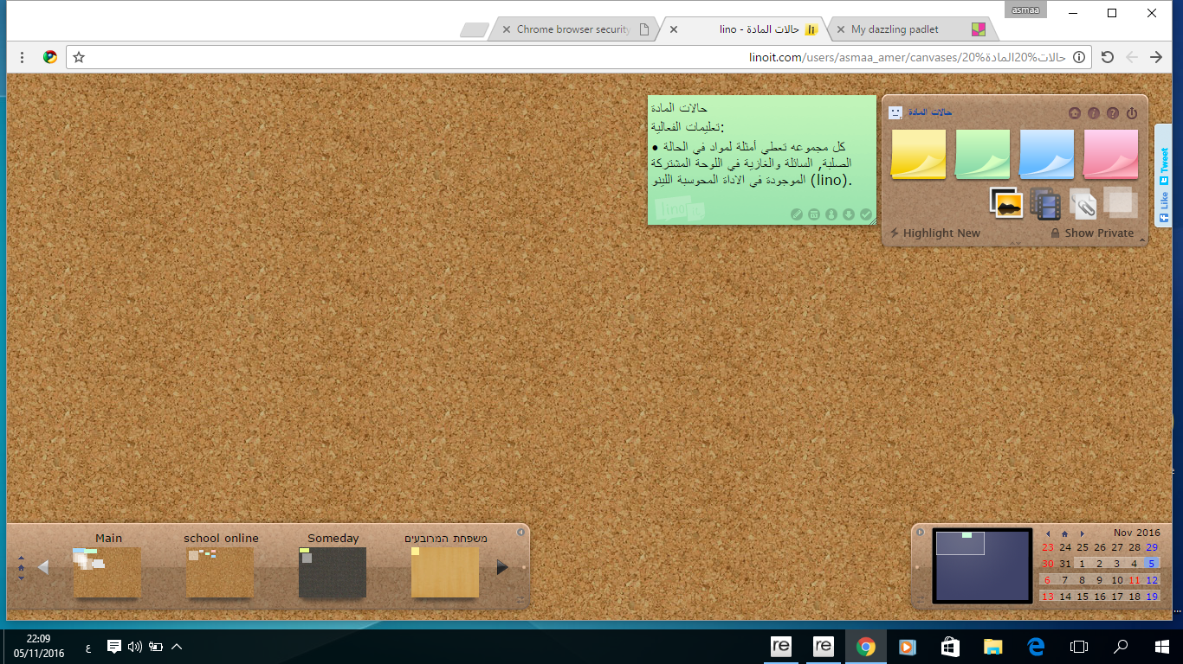

<https://goo.gl/k1rZBs>

**respiratory system**

**Event Instructions:**

1-In front of you is a picture of the respiratory system, write the following members in the appropriate place

2-Choose a member and search in the Google search engine and write about its structure and function

**\*Breathe image from Google Images, extend an arrow and an empty square**

|  |  |  |
| --- | --- | --- |
| **Occupation** | **Building** | **member name** |
|  |  |  |

**Screenshot No' 6**

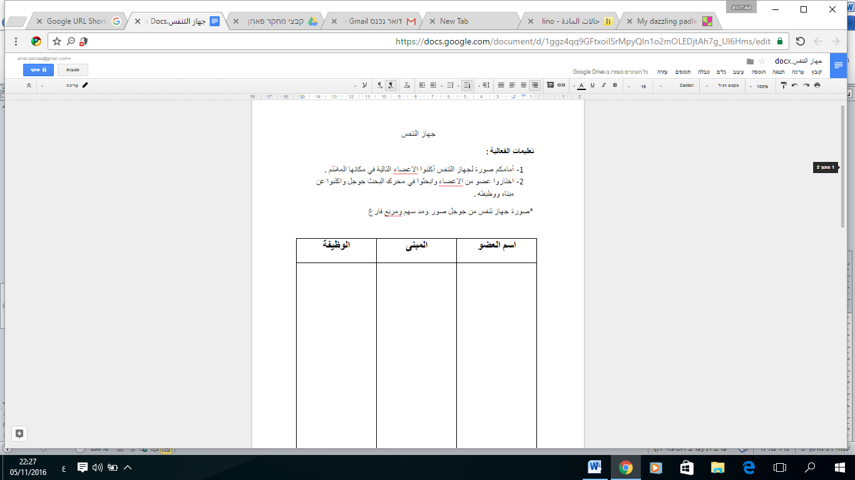

<https://goo.gl/II0JHC>

**Screenshot No' 7**

