**Technion – Israel Institute of Technology**

**ARCHITECTURE PROGRAM**

**FACULTY OF ARCHITECTURE**

# **and**

**TOWN PLANNING**

**Review Report 2021**

# **Table of content**

1. Introduction
2. Vision and plans for development
3. Program Description
4. Changes to the M.Arch 2 syllabus
5. Admission rules
6. Teaching infrastructure
7. Research achievements and infrastructure
8. Covid 19: effects on teaching and research

**Appendix**

A - Faculty members CV

B- Course syllabi

1. Introduction

1.1 The Technion

The Technion is one of seven public research universities in Israel and has three campuses: the 300-acre main academic and administrative Neve Sha’anan campus, the Faculty of Medicine in the Bat Galim campus, and the recently renovated Hadarion campus in historic HADAR in midtown Haifa. This is also the city-lab of the Faculty of Architecture & Town Planning, scheduled to host the second year of architecture and landscape studies starting from the 2021-2 academic year.

The Technion’s 18 academic units are divided into Faculties and Departments. There are 560 full-time and several hundred adjunct faculty members, as well as junior instructors, clinicians and practicing architects who are involved in teaching. Technion faculty members are associated with exceptional academic achievements, including three Nobel Prize laureates in chemistry: Distinguished Professors Abraham Hershko and Aaron Ciechanover of the Faculty of Medicine (2004), and Distinguished Professor Dan Schechtman of the Faculty of Material Science and Engineering (2011).

Since its founding, the Technion has defined its role to educate generations of leaders for Israeli industry and academia, laying the foundations of the country’s infrastructure and establishing its defense and high-tech industries. In the new millennium, the Technion is positioning itself at the forefront of the global network of science and technology. In 2013 the Technion, in collaboration with Cornell University, established The Jacobs Technion-Cornell Innovation Institute (JTCII) in New York City, as the cornerstone of Cornell Tech, to educate leaders in technology for the digital age. In 2014, the Technion established the Guangdong Technion Israel Institute of Technology (GTIIT), in cooperation with Shantou University (STU) in China.

1.2 The faculty

The Faculty of Architecture and Town planning includes four programs, referred to as ‘departments’: Architecture, Landscape Architecture, Urban and Regional Planning and Industrial Design. The Architecture program was established in 1924 as one of Technion's two initial programs. The Graduate Program in Urban & Regional Planning was founded in 1969. The Landscape Architecture program was established in 1975 and is the first, and only professional Landscape Architecture program in Israel. The graduate Program in Industrial Design was established in 1994. It was the first graduate program in Israel in Industrial Design.

Faculty in numbers:

There are currently 42 full time/part time academic faculty members. 22 in Architecture, 6 in Landscape Architecture, 10 in Urban and Regional Planning and 4 in Industrial Design. More information can be found in the [following link](https://architecture.technion.ac.il/member-category/faculty-members/).

There are currently (spring semester) 124 adjunct faculty members. 89 in the Architecture program, 24 in Landscape Architecture, 9 in Urban and Regional Planning and 2 in Industrial Design.

There are 829 students enrolled in the faculty: 498 in the Architecture (198 graduate students, 300 undergraduate students), 134 in Landscape architecture (20 graduate students, 114 undergraduate students), 134 in Urban and regional planning (graduate students), and 46 in Industrial design (graduate students).

The faculty has an administrative staff of 24. The full list can be found in the here.

The faculty current role holders can be found in the [following link](https://architecture.technion.ac.il/faculty/officeholders/).

## 

## **2. Vision and lines of development**

## 

**Faculty**

The design of cities, landscapes, human habitat and infrastructures requires addressing contemporary challenges by utilizing advanced knowledge, technologies and design methods in order to produce habitable and sustainable built environments for all.

The Faculty of Architecture and Town Planning at the Technion aims to become a leading academic institution in shaping the fields of design and spatial planning in Israel and around the world. In the densifying context of Israel, one of the crowdest urbanizing countries of the OECD, our faculty poses scholars and future-architects, planners and landscape architects with the challenge of creating knowledge and developing tools and technologies that would be able to give spatial and cultural answers to the leading challenges of our time in climate change, sustainable development and human health.

The legacy of our faculty, one of the two disciplines founding Technion, involves a historical role in modernizing the country and providing society with solutions based on advanced ways of thinking and technologies for the built environment. We aim to extend this legacy into the future by focusing on the following lines of development:

1. Rebuilding the faculty structure into a hub of design sciences in undergraduate and graduate programs with mutual core studies.
2. A focus on advanced graduate research that could benefit from the Technion scientific infrastructure.
3. Identifying society’s real-life challenges and addressing them via research and design education by recruiting research and adjunct faculty that will lead classic, action and practice/industry based design in these fields.
4. Developing the faculty infrastructure for advanced research - advancing the construction of the labs and developing the research support infrastructure.
5. Increase the diversity of graduate studies and faculty members, and international graduate students/faculty members.
6. Strengthening the connections/collaborations between the programs in the faculty.

In regards to the first line of development the faculty has started a process of developing a strategic plan for a new structure of its programs. The main suggested change that is being discussed calls for a shift towards 4 BSc undergraduate programs that lead to professional master’s degree for each program, as well as research oriented degrees for each. The initial structure of the new direction is expressed in the following diagram:

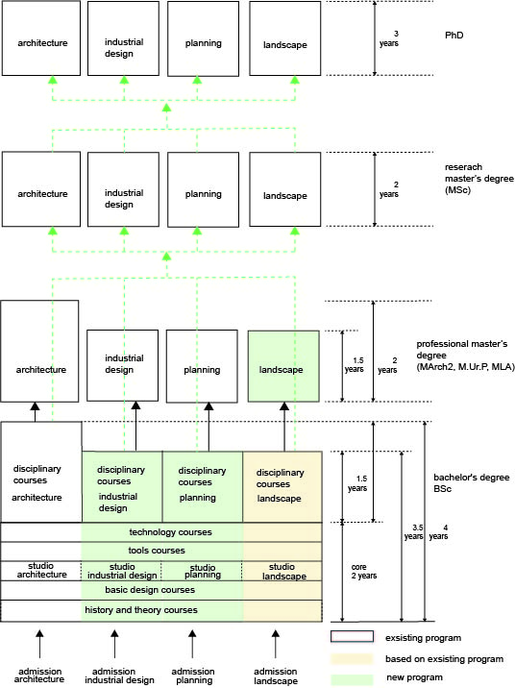

**Architecture program development plans:**

The Architecture program’s primary vision is to harness advanced architectural research to perpetually challenge architectural and environmental thinking and advance new, experimental ideas that challenge conventions of design of the physical environment for the benefit and well-being of future dwellers. The Program engages in developing new knowledge in the fields of architecture and the built environment employing architectural design’s vocabulary and traditions of workmanship alongside advanced research methods and scientific investigation.

Architecture is fundamentally an interdisciplinary endeavor, encompassing technological, functional, cultural and cognitive aspects that complement and complete one another. Designing the built environment requires equal consideration of historical knowledge, cultural sensitivity, technological advances, functional rationalization and an inclusive vision of the environment.

Identifying the key challenges facing humanity and Israeli society - among them the housing crisis, climate crisis, urban densification and under-advanced construction - we conduct collaborative research and design education in an ‘archipelago of research hubs’ across diverse disciplines. The program nurtures future architects and researchers by educating them towards multidisciplinary competencies, while as well as to create new, multi-contextual and multi-layered foundations of knowledge, based in a diversity of fields.

Within the above mentioned faculty lines of development the Architecture program’s main lines of development are:

1. Identifying the pressing current and future social / economic/environmental issues in Israel and around the world, which require creative spatial and architectural solutions such as crucial urban densification and well-being, climate change, Appropriate refugee solutions and more. Raising Architecture interdisciplinary knowledge, resources and cutting edge technology in favor of groundbreaking solutions in research and practice.
2. Strengthening the Architecture programs’ inter-relations with the industry and practice by recruitment of 2 additional leading practifractiones (the third is currently discussed), developing action and practice research programs with practice and industry.
3. Increase the number of graduate research students.
4. Increase the quality and number of research publications and grants.
5. Develop and launch a practice course (Practicum) as part of the BsC program
6. Strengthening the connections/collaboration between the programs in the faculty - develop mutual core studies with the landscape program. Reexamine the best practice of the basic design courses together with the industrial design program.

## **3. The Architecture Program**

#### **Background: Students**

#### There are currently 498 students in the architecture program. 319 undergraduate students and 198 graduate students. The graduate students comprise 181 masters students and 17 PhD students.

#### There are 124 Masters students that study professional March1 and 57 students in Msc and March2 programs.

#### Undergraduate students are divided to about 25% male and 75% female

#### Graduate students are divided to about 27 male and 73% female

#### The Technion does not allow faculties to map the number of students from various minority groups.

The faculty and the architectural program is actively trying to keep increasing the number of graduate research students (MSc+PhD). There are no current plans to increase the numbers of students in the professional track (BSc+ MAach1) due to space deficiency, increasing number of architectural schools in Israel and lack of incentive from the technion management.

The program is actively focusing on increasing the number of graduate research students from minorities. Besides affirmative action in the allocation of research scholarship by the Technion and the faculty, graduate students from minorities are given priorities in working as TA’s RA’s. Both the dean and the program head personally encourage undergraduate students from minorities to continue to a research degree in formal and informal meetings.

#### **Background: Faculty members**

The Architecture Program at Technion has a distinct composition of faculty, reflecting our research-oriented education and vision. A significant number of faculty in the program hold Ph.Ds in architecture, devoting much of their time to advancing the field and conducting cutting edge research in the scope of research labs and research groups. Architecture faculty publish widely, secure research funds from national and international grants, engage in research collaboration with colleagues in Europe, America Asia, and incorporate advanced research methods in the training of graduate and undergraduate students.

There are 22 faculty members in the architectural program. 12 full-time research faculty (3 new recruits are joining in October 2021/March 2022), 2 full time visiting professors (leaving in October 2021) , 5 half-time faculty and 3 leading practitioners in quarter time positions. This stands for 20.75 staff positions out of the current 39 positions in the Faculty.

In addition to full time faculty members, 89 adjunct faculty teach in the Program. They include mostly practicing architects who teach the various studios, building construction and technology courses, interior design. Some of our Ph.D students and recent graduates teach theoretical required, selective and elective courses.

A new call for 2-3 faculty members is planned for the end of 2021. The call looks for a replacement for two visiting faculty members (Assif, Angel) and a retiring faculty member (Aravot). The call will focus on researchers in the field of urban design, data science and history and theory of technology. Another search for a visiting professor of practice in half and a quarter position is currently taking place.

Following these recruitments we aim for the following structure of faculty members in Architecture: 17 researchers, 6 half time practitioners, 4 quarter time practitioners and one full time visiting professor.

In its 5-year development plan, submitted to Technion in 2019, the Faculty has requested an increase from 39 to 45 faculty positions, from which additional 2 positions are allocated to the architectural program.

#### 

#### **Degree programs in Architecture**

The Architecture Program offers the following undergraduate and graduate degrees, both academic and professional:

**Professional degrees**

* Bachelor degree in Architecture BSc (pre-professional)
* [Professional Master in Architecture and Urbanism 1 (Registered Architect, M.Arch.1)](https://architecture.technion.ac.il/academic-programs/architecture/master-of-architecture-and-urbanism-m-arch-1/)
* [Master in Architecture and Urbanism 2 (M.Arch.2)](https://architecture.technion.ac.il/academic-programs/architecture/master-of-architecture-and-urbanism-2-m-arch/)

**Research degrees**

* [Master of Science in Architecture and Urban Design (M.Sc.)](https://architecture.technion.ac.il/academic-programs/architecture/master-of-science-in-architecture-and-urban-design-m-sc/)
* [Doctor of Philosophy in Architecture (Ph.D.)](https://architecture.technion.ac.il/academic-programs/general-programs/phd-programs/)
* [Doctor of Philosophy in Environmental Studies (Ph.D.)](https://architecture.technion.ac.il/academic-programs/general-programs/phd-programs/)

###### **Bachelor degree in Architecture Studies (B.Sc)**

The 4 year undergraduate program in Architecture Studies (B.Sc) revolves around the studio setting and is intended to provide students with a broad theoretical education, so that they can understand, analyze and confront complex problems and develop their creative talents.

Among the primary fields of study in this program are architectural design, urban design, history and theory of architecture, interior design and furniture, building structures, building technology and industrialized buildings, environmental controls, lighting and energy considerations in design, people-environment relationships[DP1] , and the use of the computer in design.

The curriculum is divided into three clusters:

**Core curriculum**: In the first two years (four semesters), students study the core curriculum which includes 4 design studios, introductory courses to architecture, society and space, design methods, representation, interior design, mathematics and physics, history and theory, materials and technology. These courses gradually develop the students’ skills to deal with architectural challenges of different scale and detail.

**Advanced undergraduate courses**: In the third and fourth years the students can chose between specific thematic interests, with studios and seminars in digital design, sustainable architecture, conservation, and history, theory and criticism. These advanced courses are designed to allow students to deepen their education and design skills around fields which interest them individually. A broad choice of courses are offered from City Planning, Landscape Architecture and Industrial Design, taught by core faculty and adjunct teachers, as well as courses from outside the faculty.

***Undergraduate******Thematic studios***: Starting from the 5th semester, and after completing the core courses, students are offered a variety of thematic studios in four study “tracks”: (1) Sustainable Architecture, (2) History, Theory and Criticism (3) Digital Design and Fabrication, and (4) Preservation, Conservation and Renewal. These tracks provide students the opportunity to tailor their studies to their interests, while infusing the undergraduate program with research pursued by faculty and doctoral students. Students need to select 2 of the 6 thematic studios offered to complete the degree program (for a total of 6 studios in the undergraduate program).

In addition, students may choose a non-track studio such as the Design Built studio, where students have the opportunity to experience a complete design process from the conception, through detailed planning, working with consultants, to physical construction.

To strengthen the program’s relations with the architectural practice, we are currently developing an internship course (PRACTICUM) for students in the final year of the undergraduate degree. We expect to offer students the experience of working with selected architecture firms for a period of six months to one year. This collaboration will start operation in the upcoming academic year.

After completing four years of study and 160 credit points, students receive a Bachelor of Science in Architecture (B.Sc.), which is a non-professional bachelor's degree, as a milestone towards completing the professional degree. In addition to the option of proceeding to the professional degree in Architecture and Urbanism (M.Arch,) the bachelor's degree allows students to advance to a research based non-professional master's degree (M.Sc) in architecture, urban and regional planning, landscape architecture or industrial design. The non-professional degree is a stepping stone towards a PhD and a career in research. Alternatively, graduates of the B.Sc in architecture can pursue a studies at another institution in Israel or abroad.

###### **Professional Master degree in Architecture and Urbanism (M.Arch-1)**

The two-year M.Arch-1 graduate program emphasizes architecture’s professional aspects, deals with more complex problems than the undergraduate program does, and provides students with ample opportunity to specialize in selected sub-fields of research and design including (1) climatic design, (2) design computation, (3) history theory and criticism, (4) urban design, and (5) Heritage, Conservation & Regeneration.

The professional degree’s curriculum combines advanced architecture and urban design knowledge with current research knowledge required for professional practice and required for registration by the Registrar of Engineers and Architects in Israel.

The new professional master's program requires that students accumulate 80 academic credits.

In 2016, following extensive reconsideration, we transformed the training of architects from the 5-year B.Arch program to the 6-year B.Sc + M.Arch program. The goal of this initiative was to align our program with leading international professional programs and to transform the professional architectural training in Israel. This section describes the main elements and rationale of the program. Section 5 outlines the changes we have made after evaluating the first cycle.

The curriculum is divided into four main course clusters:

***Final project, Architectural Research course and Research Seminar:***

The M.Arch thesis project combines pedagogical collaboration of the Final Project design studio, a tailored Architectural Research course, and a Research Seminar, which together compose the core training of the M.Arch degree.   
Instruction is led by a principal supervisor who is a leading practitioner, a second supervisor identified with practice as well as academic research and a researcher exclusively affiliated with academic research (usually a doctoral student). Strengthening academia-practice relations, in the past two years we have recruited award winning practitioners as Visiting Professors to lead the professional master's degree advanced studio. Their interaction in the studio and with other faculty and students has incredible input to the design practices and the research orientation.

Following our aim to integrate research and design at the highest level of training, students are required to take research seminars offered across the Faculty, where they acquire cutting edge theory, research methods and skills relevant for their thesis.

***Thematic studios and affiliated theoretical courses****:*

M.Arch advanced studios are structured such that each is defined a ‘thematic studio’, namely exploring a clearly-defined contemporary design challenge, to be explored in a lab-like exploratory setting by students and instructors.

In accordance, each thematic studio is accompanied by a related theoretical course. Instructors offering thematic studios collaborate with researchers offering theoretical courses engaging advanced research conducted in faculty into the studio. The theoretical courses are open as elective courses for additional students that do not take the thematic studio, enriching the discussion in both class and studio settings.

**Studio Registrar: the INTEGRATIVE studio**

The Integrative studio is an advanced design studio, taking place in the first MArch.1 year. The aim is to design a large scale project from the conceptual stage up to the actual construction details, materials and all practical considerations. Compulsory selection from the Engineering Technology Workshop Group directly supports the Studio Registrar. The studio outcomes benefit from the strong cooperation between the studio masters and the technology workshop leaders.

.

***Practical courses:***

Advanced M.Arch studies are supported by various practice courses where students acquire a plethora of skills:  
Media workshops (1 + 2) - workshops include both digital media and architectural representation workshops (drawing, physical models, photography, video).

Compulsory selection from the Engineering Technology Workshop Group that directly supports the “Integrative Studio”: Studio Registrar. The courses given/offered in the professional master's degree program focus on advanced studio courses such as the integrative studio, to which an advanced technology workshop is attached so that the studio's products include work plans and details. Each studio group focuses on a different theme, such as ‘environments for the elderly’ or an ‘Urban Transit Hub’. Concluding with a large-scale highly detailed building compound generated in the urban environment; The advanced urban studio including an advanced urban design theoretical course. Two semesters of the final project are attached to a theoretical course and a research seminar that ensure the strengthening of the theoretical aspect to the practical aspect. These courses are led by leading architects practitioners from relevant field expertise to the project. In addition, students study a series of courses coordinated with the Registrar of Architects

These courses give students tools as well as an important perspective on the connection to work in practice.

In order to clearly differentiate the undergraduate and graduate studies, and in accordance with M.Arch students’ active internships in the practice, we concentrated the professional master's degree in two days a week only. M.Arch studios are given on the same days as other Graduate programs in the faculty, allowing students to combine their studies with the rest of their life assignments, enjoy a richer range of elective courses (also from the other programs in the faculty) and be part of a group of graduate students.

###### **Post-Professional Master degree in Architecture (M.Arch-2)**

The program is aimed at graduates of the professional degree in architecture (B.Arch from Technion or other schools) who are interested in enriching their knowledge in theoretical fields or specializing in various fields, typically after several years of practice.

Currently, one such program is offered: a specialization in Green/sustainable Architecture, offered since 2012, with 15 graduates so far. We plan to revive a specialization in Conservation, previously offered at the Sarona Tel-Aviv Technion campus..

***Modes of Teaching in the Architecture Professional Program***

In addition to common modes of teaching, such as lectures and studios, our program promotes some alternate modes of instruction:

* Design studios integrating VR systems as an interface for the design development in addition to more traditional interfaces.
* Consultancy workshops Currently we applied a workshop to all advanced studios, introducing A workshop that reinforces significant skills and aspects for any planning process that is not always possible during the semester curriculum. From strengthening constructive aspects with focused advice from construction engineers, consulting skilled landscape architects, consulting on facades design, materials and more, where . Students have the opportunity to receive criticism from a variety of counselors from the practice, which better simulates the work in the real world. We plan to continue and further develop this initiative.
* Technological-engineering workshops in which students apply theoretical knowledge of materials and structures to design exercises related to the studio curriculum.
* Mentorship in architecture: a framework which allows a mentor student and a mentee student to deepen both students’ learning of architectural design through dialogue and experience in instruction.
* Vertical studio, which allows students from the third and fourth years to study together in the same studio.
* Research-based support courses that accompany and enrich the thematic studios with up-to- date theoretical knowledge.
* Thematic studios implement “research by design” approach to deal with critical issues and require original design thinking.

● Design-build projects where students work with underserved communities, design a small building for the community and construct the building during the semester break.

* Design studios and support courses focused on Community-Collaborative agenda, supported by the [Technion Social Hub](https://socialhub.technion.ac.il/en/database/classes/) incubator.

***Collaborative Studies in the Architecture Professional Program***

The Architecture Program collaborates with the other programs within the Faculty and the Technion. We value the cross pollination of such exchanges and expanding this is one of our aims for the future. Current collaborations include:

* Materials course and laboratory (Civil Engineering)
* Joint mandatory basic design studios with Landscape Architecture (Introductory studio in the 1st semester, and Urban Design studio in the 4th semester and an introduction to Landscape Architecture course). In addition, elective design and art courses.
* Selective and Elective courses offered by other programs at the Faculty, at the undergraduate and the graduate levels.
* Joint courses with other units at the Technion (for example, Advanced BIM course, with Civil Engineering), art and foreign languages taught at the Technion department of Humanities.
* Graduate architecture students can choose to study advanced courses offered at Cornell-Tech

***International Exchanges in the Architecture Professional Program***

The Technion has an extensive exchange program with universities from all over the world. Undergraduate architecture students are the largest group traveling abroad within this exchange program. About 30 students in their 3rd or 4th year of studies spend a semester (two in exceptional cases) abroad, each year. The Program recognizes comparable courses taken at accredited universities as credits towards graduation.

Important collaborations include:   
The Politecnico di Milano,   
The Politecnico di Torino,   
Sapienza University of Rome,   
ETSAM Universidad Politécnica de Madrid,   
Universitat Politècnica de Valènciaת,   
Technische Universität Berlin (TUB),   
Technische Universität München (TUM),   
Delft University of Technology,   
Monash University (Melbourne Australia),   
University of San Diego,   
University of British Columbia,.

***International courses***

The Architecture Program includes several elective courses involving study trips abroad,.   
In the past two years study trips to Uganda, Japan, Cuba, Rome,and Hamburg.

In addition, several faculty members collaborate with colleagues worldwide in joint international courses, supported by funding from Technion, Politechnico di Milano, and the Azrieli Foundation. These include the Global Studio at the North Pole, and International Housing Course and graduate courses in Cornell-Tech..

**Research programs**

###### The Architecture Program prides itself on its internationally recognized research program, the most established in Israel, in the various subfields of architecture. Research training in the framework of M.Sc and Ph.D has produced a real impact on the professionalization of the discipline in Israel. Introducing knowledge-based design principles to the fields of climatology, history and theory, preservation, fabrication, computation, simulation and design education, research conducted by graduate students, working in our research labs, research centers and research groups, impacts both the training of Israeli architects and the international academic field.

###### Our graduate research program follows the European model (rather than the American model), focusing on the student’s individual research from the early stages of training, conducted closely with PIs within research groups and research labs. Research seminars and courses are taken parallel to conducting research, following the approval of the students’ research proposal by the program’s Research Committee. Students with approved research programs are eligible for scholarships for between 24 - 48 months.

###### 

###### Graduate students are supported in presenting and publishing their research outputs in international conferences and journals. Support includes workshops in academic writing, financing for travel and editing, and cross-faculty annual research forums. Students in our research program are encouraged to present conference papers and publish in leading journals in their fields.

###### 

###### Recent placement ratios for our PhD graduates in academia are high, with 10 recent PhD graduates winning Post-Docs in leading foriegn universities such as University College London (UCL), Cornell-Tech. NYC, Technical University Munich (TUM), ETH Zurich and more.

###### **Master degree in Architecture (M.Sc)**

The M.Sc Program in Architecture focuses on developing research skills in architectural research methods, and on the theoretical foundations central to architectural inquiry and to the cultural and physical context of Israel’s built environment.

Students working towards a thesis are required to take 24 academic credits including required courses in research design and ethics, as well as seminars relevant for their research topic. Students not interested in the thesis are required to take 44 academic credits.

Thesis students approach research faculty related to their field of interests,, and work in any of the PI-led research labs and research groups on writing their research proposal. Upon approval, they engage in independent research guided by their advisors. M.Sc thesis are required to demonstrate research capabilities, evaluated by a committee of internal and external evaluators.

The program accepts students who have a 5-year undergraduate degree in Architecture (B.Arch), or a professional Master degree in Architecture from the Technion (M.Arch-1 or M.Arch-2), whose GPA is 85 or better.

Candidates who do not hold a degree in Architecture may enroll in the general M.Sc and Ph.D programs, subject to taking additional courses to complement their knowledge regarding research in Architecture.

###### **Ph.D. in Architecture**

The Ph.D program is intended for qualified students to conduct innovative research in areas that are at the professional or theoretical core of architecture. PhD at the Technion is expected to break the existing border of human knowledge. We encourage PhD students to present their research in international conferences and report their findings in academic journals. The Technion, faculty and the research centers cover students travel to conferences and support language editing of papers.

Admission to the Ph.D program is subject to similar criteria as other Ph.D programs at the Faculty and the Technion, and include having a Master’s degree in Architecture or other relevant domains; demonstrating outstanding achievements in research and in studies (thesis score and a grade point average of 85 or above); 2-3 letters of recommendation from other universities or from the professional domain, preferably from those holding advanced academic degrees; and finding an advisor from among the Architecture faculty. Applicants holding a Master’s degree in other fields of study may be required to undertake supplementary studies according to their scope of research and their academic background.

Graduates of non-research Master degree programs are required to carry out exploratory research approved by the Graduate School. The exploratory research is led by an academic advisor potentially being the Doctoral advisor.

The degree reflects the Faculty’s and the Technion’s trend to promote and expand the range of study programs for advanced degrees.

The Ph.D program comprises 10-18 credit points, and includes the following requirements:

Research Preparation Course, Science philosophy course, Academic english course

Courses connected to individual research (decided in the admission committee), Workshop on research and publication arrange by the faculty, Mandatory Colloquium lectures

#### 

1. **Updates in the professional BSc+M.Arch 1 program**

This chapter outlines upgrades and changes to the curriculum of the professional degree in architecture, the rational and the course of studies. In addition we describe the changes we made after evaluating the first cohort.

The first cohort of students began studying in the new program in 2016. Fortunately, there was no decrease in the number of applicants for admission to the faculty following the transition to a six-year professional master’s degree program compared to the other schools left with the five-year Bachelor degree programs. Because the “new program” included updating and modifying more than 70 courses, it was decided to examine the success of the changes immediately upon their implementation as part of a program to monitor and test the program's achievements.

This program included an annual review, at the end of the academic year, of achievements and problems in courses and the entire system. This review is intended to apply the insights immediately the following year. The program also defined a broader examination of the program's achievements upon completion of the first cycle of the undergraduate degree and the first cycle of the professional master's degree.

4.1 Details of the changes made in the first four years of running the “new program” following the conclusions of the annual inspection

Adjustments in the design studios:

*Final project, Architectural Research course and the research seminar:*

The combination of a principal supervisor identified with a leading practice in the country, a second supervisor identified with practice but also with academic research and a researcher exclusively affiliated with academic research (usually a doctoral student at a faculty or other university) was found to be a good combination. The success of the move depends, of course, on the synergy between the 2 supervisors + researcher, in the studio. When the number of students in the course studying the final project justifies 5 separate studios the groups work separately. Over the years there have been situations where the number of students has not justified a division into five studio groups, each focusing on a specific field / path / topic. Adjustments were made so that even when there were 4 or even 3 groups, the students could still focus on a major area for which they would later receive the specialization certificate upon graduation.

*Thematic studios and affiliated theoretical courses:*

During the first years, each thematic studio had a related theoretical course. This course would directly support the knowledge and topics of the studio. The fact that each group of 12 students was also offered a theoretical course was found to be unreasonable in many respects, including the economic aspect to the faculty. Therefore, it was decided that those offering thematic studios would collaborate with researchers offering theoretical courses from a variety of paths (active research conducted in faculty) as well as try to combine one theoretical course for two studios in a particular path. In addition, the theoretical courses are open as elective courses for additional students that do not take the thematic studio. This move proved effective in most cases, depending on the willingness of the instructors in the studio and the lecturers from the theoretical courses to collaborate and coordinate the content so that they would truly be related to each other.

*Changes in practical courses:*

· Media workshops (1 + 2) - Each semester different workshops were offered to the students, both digital and those related to architectural representation (drawing, physical models, photography, video). Each year there was an attempt to balance the types of workshops but over time it was clear that most students are interested in the same workshops. Therefore the current workshops have become a course with regulated content (see below).

· Compulsory selection from the Engineering Technology Workshop Group 2 (2.5 credits) that directly supports the integrative studio (Studio Registrar) has moved to the professional master's degree and by increasing the weight to 3 credits.

*Changes in theoretical courses:*

· Space and text literacy - changes and adjustments were made each year in order to improve the connection between the course and Studio 1 (the first semester of study at the faculty).

· Introduction to the spatial professions - the conceptual basis for the course was to expand the new students' familiarity with the spatial professions taught in the faculty and in general with the emphasis on landscape architecture.

· Architectural Editing - In the first iteration the course was given as part of the urban design studio in the fourth semester. This did not work because the workload on the students was unbearable. Therefore, the course was defined as a separate course and was taught for several years under the leadership of various coordinators and teachers. The scope was set at 2 credits but since the requirements from the students were not balanced and demanded a massive investment of time, and as it also overlapped with the basic design courses and the studio, additional change was required.

· Materials course - one laboratory hour was canceled and the course moved to 2.5 credits.

· Introduction to Planning Methods, (2 credits) and the course Methods and Tools for Evaluating and Designing the Space (2 credits) have been canceled. New course called 'Methods in the Design of Theory and Tools' (3 credits) was added as a mandatory course.

4.2 Changes made to the program following the internal evaluation after completing the first cycle of the undergraduate program. (2020)

*General changes:*

It was decided to clearly differentiate the undergraduate and postgraduate studies. This move included changing the school days and especially the studio days of the first and second professional degree. Also, an attempt to concentrate the study days in the professional master's degree for two days a week only, with the understanding (and experience) that the students who reach the professional master's degree are already working and some of them already have families. Matching the two days, on the study days of all master's programs in the faculty, allow students to combine their studies with the rest of their life assignments, enjoy a richer range of elective courses (also from the other programs in the faculty) and be part of a group of graduate students.

· Courses that until now were defined as "compulsory by choice" but in practice functioned as compulsory courses (for example: basic design 1 and basic design 2, design mini-studio and technology workshop 1 offered by several groups in the catalog), changed their definition to a compulsory course. The students' choice of registering for groups in these courses was preserved.

· The change of definition from "compulsory choice" to "compulsory" apparently caused a change in the weight of the compulsory and elective courses but now it reflects the division as it was in practice. This change was made as a result of students' complaints about the reluctance resulting from the mandatory elective categories that do not offer a sufficient inventory of actual electives. Coordinating expectations between students and the "system" is also important and prevents misunderstandings. Eliminating most categories of mandatory selection increases system clarity for both students and faculty.

· Addition of an introductory course in landscape architecture - a compulsory course in semester 1: Until now, there has been little opportunity for students in the architecture track to study a course in landscape architecture. Accordingly, a compulsory course of "Introduction to Landscape Architecture" has been defined and thus all students from the Architecture and Landscape Architecture track study in a unified program in the first semester of their studies at the faculty.

· The synergy with the parallel tracks in the faculty was not reflected beyond a few individual examples. It was decided to place emphasis on collaboration between tracks to take advantage of the uniqueness of the entire faculty and possible collaborations. Additional courses were defined as elective courses for students in the Architecture track, both from the Urban Planning track and Industrial Design track. But some of them are also for undergraduate students in the advanced years.

*Changes in the design studios:*

The scope of the credit points of all studio courses was increased from the scope of 5 credits to 6 credits. The reason for the change involves the need to pinpoint the relative importance of these courses and the time students invest in their studios. Accordingly, this move made it possible to reduce the study load in each semester along the undergraduate and professional studies.

The research and specialization paths defined in the new program remain. Students who complete the professional master’s degree will be able to receive a specialist certificate in addition to the graduate certificate provided they have studied a certain scope of studio courses and a number of compulsory courses and choice in a particular path they have chosen during the Masters program. However, it is clear that the internship is not mandatory.

During the undergraduate studies, a "general thematic studio" was defined since not every thematic studio can be defined within a particular specialization / research path. A "general thematic studio" is defined as such when it can offer a theme (a leading theme), one that is not necessarily part of the paths defined at the time in the new program. This can allow for greater flexibility in terms of the themes defined and proposed in this framework of the thematic studio without the need to "make an effort" and belong to a particular research / specialization path.

It was decided to make a clear distinction between the undergraduate thematic studio courses and the thematic studio courses in the master's degree. Until update, the undergraduate and graduate thematic studios did not differ therefore many students studied the advanced "Integrative Studio" and advanced urban design studio during the undergraduate degree. In many cases this caused gaps in knowledge and abilities and interrupted the progress of the studio. It was therefore decided to clearly distinguish the undergraduate thematic studio from those of the professional master’s degree. The Integrative Studio ("Registrar Studio") and the Advanced Urban Studio can only be studied after the successful completion of 6 undergraduate studios.

These studio courses should be studied only after successfully finalyzing the undergraduate thematic studios and registration for the professional master's degree. In practice, outstanding students who have completed all the prerequisites can apply to study the advanced studio courses at the end of their undergraduate studies and provided that they do not impair the possibility of their admission to the professional master's degree.

The following diagram describes the course of studies in the studio after the update. During the first four semesters, the students study mandatory studios where each studio is led by one coordinator and divided into studio groups, each with a maximum 12 students per studiomaster. During the second phase, students select 2 out of 5-7 thematic studios (each semester) out of the five proposed paths. During Graduate studies, Students select one of the Integrative studios and one of the advanced urban design studios suggested and only after they will be accepted to the final project.

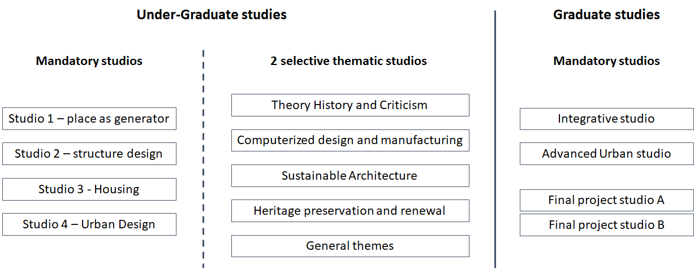

*Changes in practical courses:*

The engineering technology workshop was defined to accompany the professional master's degree as one of the compulsory courses that is related to the integrative studio ("RASHAM studio"). Currently , the scope of the workshop points was increased to reflect the level of investment required by the students (3).

In the undergraduate program - creating a continuity between the representation sampling courses (semesters 1 and 3) and the media workshops - basic media workshops (semester 2) and advanced media workshops (semester 4).

*Changes in theoretical courses:*

A number of courses have been added as compulsory courses in the master's degree such as an introduction to GIS, materials for construction (2), comprehensive building design and urban infrastructure.It has been decided that these subjects are necessary for every graduate.

A number of courses whose success was partial in their position in the curriculum or in their scope were moved to another time slot in the study sequence (space and text literacy that was 3 credits in the first semester and was excellent for students whose literacy was an integral part of their abilities, was reduced to 2 credits and moved so that it supports more advanced courses when even non-Hebrew speaking students will have an equal opportunity to succeed in the course). Other courses were canceled (for example: architectural editing that added an unusual load to studies despite the scope of 2 credits and also did not give the right impact in terms of output).

**Future updates and main challenges:**

* The first cohort of the “new program” has just recently successfully completed the curriculum of the “new program”. In accordance with the strategy for examining the new program changes we have developed, and similar to the we examined the program at the completion of the first cohort of BSc we plan to have an internal reevaluation of the program this year.
* One of the challenges of the program is the unbalanced workload between the BSc and the March program. It stands out in the relatively low workload in the first year of the master's degree in comparison to the first and second year of the BSc. We plan to examine if it is possible to reorganize some of the chains of courses (history and theory, structure, building details, basic design) to balance
* The curriculum of our basic design courses have not been re-examined for more than a decade. We plan to reexamine the structure and content of these courses. This will be done in collaboration with our industrial design and landscape programs in order to develop a strong basic design background for all three programs.
* We have invested great efforts to rebuild the theoretical and technological background of our students. We feel that there is still a gap in the architectural design development background of our students. We plan to re-examine the balance between the HTC, technology and other courses with an aim to see if there is a good balance between these courses.
* Studio culture - we have a good studio culture in the first two years, but during the last year of the BSC and especially during the graduate studies students tend to work at home. We wish to examine the potential to convince graduate students to work at the faculty or to modify the method of studio space distribution to better use the studio spaces (currently we allocate 24/7 studio space for all studios).
* Hadarion - our 2nd undergraduate year will start teaching at Hadarion next year. It is a great administrative and academic challenge. As the second year studiods focus on urban and residential studies and students do not have elective courses we believe it was a good decision, but we are going to closely monitor it during the coming academic year.
* We are starting an elective Prakticom course next year. We plan to develop it into a mandatory course.

Administrative main challenges:

* With the increase in student numbers due to the addition of the sixth year there is an increase in administrative work that is currently covered by hiring a coordinator based on the faculty operative budget. This is not sustainable in the long run. A request for additional funds has been submitted to the Technion.

# **Enrolment definitions for undergraduate and graduate studies**

| **Study tracks** | **Admission requirements** | **Additional notes** |
| --- | --- | --- |
| Professional track | | |
| **B.Sc.** | Israeli Psychometric tests  High School (Matriculation?) final exams Scores  Architecture Sorting Exam | Virtual honor-exam. |
| **M.Arch 1**  Professional Master in Architecture and Urbanism 1 (Registered Architect,) | Technion students:  A minimum of 80 grade average in all B.Sc. studies.  Other Israeli design schools:  Outstanding graduate Students from leading schools. (top 10%) Conditional on the Admissions Committee  International graduate Architecture students.  (Top 15%)/Admissions Committee |  |
| Post professional | | |
| **M.Arch 2**  Master in Architecture and Urbanism 2 | Technion students:  A minimum of 80 average grades in all B.Sc. studies.  Other Israeli design schools:  Outstanding graduate Students. (top 10%) Conditional on the Admissions Committee  International graduate Architecture students.  (Top 15%)Conditional on the Admissions Committee |  |
| **M.Sc**  Master of Science in Architecture and Urban Design | The program accepts undergraduates in architecture from a five-year track (from other Architecture schools) and M.Arch 1 graduates, whose average achievement is 85 and above | Students with an average of 80 to 85 can be accepted as "complementary" students who are transferred to "full" status after achieving an average of at least 85 in the first semester with a minimum of 8 points). Those who have not completed their studies at the Technion will be required to present a ranking that places them in the top 30% in relation to their turnover. |
| **PhD**  Doctor of Philosophy in Architecture | The program accepts graduates of the "Master of Science in Architecture and Urban Planning" from the Technion, or holders of a master's degree in research, that have excellent previous academic achievements (usually averaging over 90 or other notable achievements approved by the track committee). | The condition for registering for doctoral studies is finding a supervisor, and preparing a document describing the field of research. This document will be submitted to the Track Committee for discussion. Only after the approval of the field of research and the supervisor by the committee will the candidates for doctoral studies be accepted. |
| **PhD**  Doctor of Philosophy in Environmental Studies | Students with a master's degree with high achievements, from various fields, who are interested in engaging in research that touches their previous field of study and to the field of the built environment. |  |

In order to improve the continuity and transition from the first to the second degree, the process of admission to the master's professional degree program is gradual and includes two stages: (1) conditional acceptance, after completion of 6 studio courses (with emphasis on studio achievements);(2) full acceptance to the M.Arch-1 program after completion of all requirements for the B.Sc degree, with an overall grade point average of 80. Students will not be able to start their M.Arch project before completing all the above requirements.

# **Teaching infrastructure**

## The following chapter describes the faculty teaching infrastructure. including:

## 6.1 The faculty teaching infrastructure consist of:

* Teaching labs
* Classrooms, studios and auditoria
* Library
* Advanced research infrastructure

**6.1.1 Teaching labs:**

There are currently five teaching laboratories funded by the faculty:

**The Azrieli Computer lab** -

The Lab serves three main functions: it provides a classroom where computing literacy courses are taught; where students can use more powerful computers than their typical laptops; and where support in all matters computing can be found, either by the technical staff or by other students.

Today the Lab comprises five main spaces: a 16-workstation classroom; a 14- workstation self-study space; a technical space housing 10 servers; offices for staff; It is open 24/7, monitored by CCTV and access- control sensors. All workstations are equipped with powerful graphic processors and designed to handle demanding graphic tasks. Every year some 3-5 computers are replaced by newer models, to keep up with hardware obsolescence.

The faculty servers are arranged as a cluster, providing redundancy and backup. Network accessible storage is provided, so students can create large data files, and be protected from accidental loss of data. Black & white and large format color printing is available, serviced by an external company. Students must pay for their use.  
Direct funding for hardware acquisition and maintenance comes from the Faculty budget, as well as from the Azrieli Fund, and totals some $20,000-$25,000. It is used to upgrade 3-5 computers every year.   
The Faculty provides students with free access to all major graphic software (such as Adobe CC, ArcGIS, AutoCAD, ContextCapture, Lumionת Revit, Rhino, SketchUp, SolidWorks, Illustrator, Photoshop, etc.), as well as Office 2019, anti-virus,and more. A faculty committee convenes every semester to discuss and decide which software packages to purchase.

**Design and fabrication lab** -   
Design and fabrication lab engages students with the relationship between design and the execution of design in traditional ways.   
Located on the first floor of Amado building, the 310-square meter Model Shop is equipped with woodworking tools (manual and powered), metal, plastics, paint, cement, gypsum, clay, and more. It is staffed by a full-time shop manager, who instructs students, oversees their safety, and provides assistance in all manners of model making. More information can be found in the lab’s webpage in the [following link](https://architecture.technion.ac.il/research/education-and-research-infrastructure/model-workshop/).

**Digital fabrication lab** -   
Digital fabrication lab uses advanced technologies to open up capacities for new modes of architectural production, exploring new materials and new assembly modes for construction. The lab offers its services to students and researchers in the faculty, Technion and to practice and industry.  
The 120 square meter fabrication is located in the basement floor of Amado building. It is operated by specially trained students, and managed by a full-time lab administrator.

The Workshop comprises digital scanning and fabrication services. It consists of a large scale laser cutter, 3axis cnc, 3D printers and 3D scanner. In addition to the equipment in the fabrication lab our research lab holds advanced fabrication machines such as large scale 3D printers, Robots in various sizes, 5Axis CNC. These machines can be used by students and researchers in coordination with the relevant lab principle investigator.

The lab is supported by the faculty’s operating budget in order to allow reduced charges to students (and free laser cutting for graduate students), whereas researchers must pay for services.

The workshop is used by students to prepare models for many courses. In addition, three required courses in the architecture program focus on digital fabrication as part of their syllabi and several selective courses.

More information on the computer lab can be found in the lab’s webpage in the [following link](https://architecture.technion.ac.il/research/education-and-research-infrastructure/digital/).

**Media center and photography lab** -

The Media center and photography lab consists of a space on the first floor of Amado building. It includes a computer- controlled camera, several still-image cameras with interchangeable lenses, video cameras, lighting equipment, changeable background screens (including a green screen for video), a professional plotter, and a digital photo- and video-editing station, with a variety of software tools for professional image processing.

The lab also offers drone photography and 3D model generation services that are operated by a licenced operator. The Media center and photography lab is managed by a full-time professional photographer, who is assisted by students trained for the task. The laboratory is used for research by faculty members and by students to study and to communicate their projects. They can schedule individual sessions as well as group workshops in photography, drone photography, video, and digital image processing. The lab is supported by the faculty’s operating budget in order to allow no charges to students for all the services except video and drone photography, whereas researchers must pay for services.

More information on the fabrication lab can be found in the lab’s webpage in the [following link](https://architecture.technion.ac.il/research/education-and-research-infrastructure/photography-lab/).

**Visualisation lab** - The Visualization Lab is an immersive 3D visualization facility that allows faculty and students to “enter” and walk through 3D digital simulations (models) of buildings, cities and landscapes, whether they physically exist or are in the planning stages. This is especially important when designing environments with complex geometries, made possible through current digital design tools, or for landscape rehabilitation projects requiring multi-year planning.

The Visualization Laboratory consists of a 2.4m x 8.0m screen with a 75° field of view and three high- definition Projectiondesign® projectors. VizLab is also equipped with a state-of-the-art sound system and VR services with HTC Vive headsets, all available to faculty staff and students.

The Visualization Laboratory is used for research by faculty members and students pursuing advanced degrees, and is being integrated as a teaching tool in the Faculty’s studio and other courses (e.g., interior design). The Lab is overseen by a faculty member, who acts as its academic director, and supported by the Computer Lab technical staff. The lab is supported by the faculty’s operating budget in order to allow no charges to students, whereas researchers must pay for services.

More information on the Visualization lab can be found in the lab’s webpage in the [following link](https://architecture.technion.ac.il/research/education-and-research-infrastructure/visualization-lab/).

**6.1.2 Classrooms, meeting rooms and auditoria**

Classrooms are divided into studio classrooms and lecture/seminar class rooms.

Studio classrooms are designed to accommodate groups of 12 students and an instructor and are aquipt with a large tv screen+web camera with surround microphone, wired and wireless internet. Auditoria and lecture seminar classrooms are usually equipped with a computer and a projector/large tv screen + video conference system.

There are 3 conference/meeting rooms: small (4-5 people), medium (15-20) people and large (30-40 people).

We have remodeled Benjamin Hall in 2020 and upgraded the studio rooms and all lecture halls with audio-visual equipment for hybrid teaching. Our large lecture halls (231-234) need remodeling and we try to secure funds with the Technion.

**6.1.3 Library**

The Azrieli Architecture and Town Planning Library is the largest and oldest such library in the country. The library’s collection includes approximately 40,000 books and 125 journals covering the diverse fields taught in the faculty, electronic books and journals, as well as special historical collections on architecture and town planning.

The reading rooms contain about 120 seats for individual and group work, and are equipped with 14 computers, two scanners, two light tables, two printers, and one photocopier, all of which can be used by the visiting public (for more information please see the library [webpage](https://architecture.technion.ac.il/research/library/) and [website](https://library.technion.ac.il/arc/)).

Parallel to the traditional library services the librarians are responsible for introducing to research students research databases and basic methods for literature review

**6.1.4 Teaching assistance and support**

Extracurricular help and support is given to students in computer software - graduate students are paid to accept help calls from students that are having trouble in working with advanced computer software. The Technion student union is offering extra curriculum computer courses to minorities in Arabic.

The faculty is offering emergency support to students that experience computer loos or failure by offering a temporary substitute to computers/web cameras and wacom tablets.

**6.1.5 Exposure to advanced research infrastructure - the faculty encourages**

As a research faculty we encourage our full time faculty members and adjunct faculty to use the faculty research labs state of the art equipment for teaching. The following representative examples express this synergy: using the visualisation lab/vr for presentation and studio projects development, studio courses that work with Sprecher’s/Barath’s robot, digital fabrication courses that employ 3D printers/cnc machines that are part of research labs.

Parallel to the use of research infrastructure the faculty encourages our full time researchers to teach special courses that work in a synergy with funded research projects.

**6.1.6 Future main lines of development and challenges in teaching infrastructure**

The development of new research laboratories and the addition of new machines to our existing lab has emphasized the need for an overhaul system of service and maintenance. We have recruited a lab manager (Arch. Ezra Ozery), who is responsible for leading the development of a new centralized approach to the services given by our labs and the maintenance control. We have learned from other service centers at the Technion and developed a draft of our own service and maintenance strategy that is being discussed with a goal of finalizing the plan towards the beginning of 2022.

The growing Architecture Program, as well as the Faculty of Architecture and Town Planning, require a new faculty building compatible to its needs. The faculty moved to its current location at the Hadar Campus in the 1980’s, allocated space in Amado Hall which was not designed for architecture teaching and research and suffers many maintenance problems. We have initiated a preparation of a program for a new building in a site defined by the Technion master plan ([see full program document in this link](https://www.dropbox.com/s/o2ms2vh0njbls9u/%D7%AA%D7%97%D7%A8%D7%95%D7%AA%20%D7%90%D7%93%D7%A8%D7%99%D7%9B%D7%9C%D7%99%D7%9D%20-%20%D7%A4%D7%A8%D7%95%D7%92%D7%A8%D7%9E%D7%94%2026-10-2020.pdf?dl=0)) and planned to start this year a competition for a new building. The competition aim was to choose a project that would be part of a donation kit that will be used by the Technion to raise funds for the building. However, the Technion management has not approved the launch of the competition. We therefore moved to use the new program for studio course projects. We plan to continue the conversation with the management to push the project forward.

Our workshop area has reached its full capacity. Funds are needed to develop an advanced fabrication workshop in Amado 2nd floor.

There is a shortage of space, especially medium (50 people class rooms) and seminar rooms.

Our 3 big lecture halls (231, 233 and 234) need refurbishment.

Our studio rooms need a requirement, especially a new flooring.

# **7. Research**

**7.1 Research infrastructure**

Research in the faculty is conducted in three modalities: classic, action and practice research. Classic research is by groups and research labs coordinated by individual faculty members, and with the support of 3 research centers: the Center for Research & Development in Architecture and Design, and The Avie & Sarah Arenson Built Heritage Research Center. the Philip M. and Ethel Klutznick Center for Urban & Regional Studies. Researchers in architecture are mainly members of the two first centers.

**The Center for Research & Development in Architecture and Design (CARD)** was established in the 1980s. CARD is open to anyone affiliated with the Faculty of Architecture and Town Planning whose research focuses on architecture, landscape architecture and design. The center has a space (room 117) that is used by its members for meetings and experiments. Every year a set of practical aims and activities are decided. In 2019-20 the elected aims were:

Support one postdoc position, help members to purchase equipment that cannot be purchased by grant funds (printers, screens etc.), support research symposiums by members, Support publishing books by members, support the submission of grants (language editing), support graduate students travel to conferences.

**The Avie and Sarah Arenson Built Heritage Research Center** provides Israeli and international researchers with a laboratory exploring the histories and theories producing Israeli built environment and spatial disciplines. The Center strives to fulfill its goals through three main courses of action: a research lab, an archive, and a publication house.

The Lab for Built Heritage Research supports scholars and professionals, and advances the study and documentation of the Israeli urban landscape while focusing on subjects relating to the history, theory, and heritage of the built environment, and aspects of its architecture, planning, and design.

The archive includes a variety of collections. These materials are an ever-expanding treasure trove, providing an opportunity to examine the role and development of local spatial disciplines. The archive constitutes a national resource, and seeks to promote and maintain its collections according to professional standards, while restoring and preserving valuable documents.

The Center was established in 1990 Since 2017, thanks to the generous support of the Arenson family, the Center now operates under its new name.

The center is currently located on the second floor of Amado building. We have secured funding for the design and construction of a new center that will be connected to the main library. The new center will be open in late 2022.

**The Center for Urban and Regional Studies** is both a research center and a Think-Tank. It is affiliated with the Graduate Program for Urban and Regional Planning. The Center’s mission is to contribute to the understanding of urban and regional development processes and to assist policymaking at the national, regional and local levels. Two principles guide work at the Center: research excellence at an international standard and contribution to the enhancement of quality of life in Israel. The center is located in the Segoe building 4rd floor. The academic head of the center is Prof. Pnina Plaut. (for more information please see the [center’s website](https://curs.net.technion.ac.il/en/))

**The following research labs are affiliated to the architecture program (the lab name is a link to its website):**

* [Architectural Visual Perception Lab (AVPLab)](https://architecture.technion.ac.il/research/labs/architectural-visual-perception-lab-avplab/)
* [Big Data in Architectural Research Lab (BDAR)](https://architecture.technion.ac.il/research/labs/big-data-in-architectural-research-lab/)
* [Climate and Energy Lab in Architecture (CeLA)](https://architecture.technion.ac.il/research/labs/climate-and-energy-in-architecture-lab/)
* [Disrupt.Design Lab (D.DLab)](https://architecture.technion.ac.il/research/labs/disrupt-design-lab-d-dlab/)
* [HousingLab: History and Future of Living Research Group](https://architecture.technion.ac.il/research/labs/housinglab-history-and-future-of-living-research-group/)
* [Material Topology Research Lab (MTRL)](https://architecture.technion.ac.il/research/labs/material-topology-lab/)
* [Technion's Computer Oriented Design Lab (T_CODE)](https://architecture.technion.ac.il/research/labs/technions-computer-oriented-design-lab-t_code/)
* [urbaNest Lab for Social and Co-operative Urban Housing](https://architecture.technion.ac.il/research/labs/urbanest-lab-for-social-and-co-operative-urban-housing/)

For more information about the research labs see the following [webpage](https://architecture.technion.ac.il/research/labs/).

For more information on research by faculty members without a lab see the following [webpage](https://architecture.technion.ac.il/member-category/faculty-members/).

The faculty offers the following research support personnel:

A full time research and budget coordinator, A full time labs and safety supervisor, full time design and fabrication lab and full time media center and photography lab.The Built Heritage Research Center employs a Collections Manager, Publication House Manager and an Archivist.

Action and practice research is conducted by full time faculty, part time and adjunct faculty. It includes working with the industry, government and NGO’s in conducting research and research by design. The faculty and the architectural program have been trying to promote this type of research in recent years. We have defined 2020 as Haifa year and have been developing projects with the municipality (city engineer has joined the faculty as adjunct senior lecturer). Faculty have been preparing research reports and documents to several other municipalities and government ministries such as Tel Aviv, the ministry of construction and housing (see list in the research database). The program has collaborated with the Technion social hub, Israel ICOMOS and companies such as Amdocs in action design research in courses and studio courses. Faculty members at the program developed the Technion’s master plan and

The faculty and program promotes research collaboration with Technion faculty members in supervision, grant submission and research. In the recent 3 years there were X collaboration in supervision with supervisors from other faculties at the Technion. An emphasis in being given to the collaboration with the Faculty of Environmental and Civic engineering at the Technion. In the last 3 years 5 members of the program joined the activities led by the National Building Research Institute (NBRI) traditionally consisting only of members from the Faculty of Environmental and Civic Engineering. These faculty members have been successful in securing funds and started research collaborations with NBRI members. Recently the architecture program, the Faculty of Environmental and Civic Engineering and NRBI have applied to the Technion vice president for internal research support and were funded with seed money for developing a mutual advanced manufacturing laboratory that will be built in NBRI. The laboratory will include advanced fabrication tools such as a big (5mX5m) concrete 3D printer and a robotic arm that will be used for advanced research with the industry.

**7.2 Research performance**

The faculty has invested considerable efforts in increasing the research infrastructure and performance since the nomination of Dean Grobman in 2019. An associate dean for research was nominated in 2019 and a research coordinator was hired in 2020.

All research procedures and regulations were reexamined and a new faculty [research document](https://architecture.technion.ac.il/wp-content/uploads/sites/41/2020/12/%D7%9E%D7%97%D7%A7%D7%A8-%D7%91%D7%A4%D7%A7%D7%95%D7%9C%D7%98%D7%94-%D7%9E%D7%90%D7%99-2020.pdf) that summarized research procedure and regulations was produced. A plan for supporting various aspects of developing research was developed. The plan includes a series of workshops on academic writing, research methods, grant preparation etc. A strong emphasis was given to increase research production and quality, and research grant awards. Teaching load was decreased from 4 to 3 courses a year for all research faculty.

Research grant funds are used for research funding that focus on graduate students. However, it has a considerable effect on other program activities with undergraduate students. Students are hired as research assistants, new high end tools and machines are used for teaching and the part of the overhead is used for research infrastructure that is used by all students.

The following section presents the research performance of the architecture program in the past 5 year.

Faculty members are encouraged to publish research papers, conference papers, books and book chapters according to the specific field. Publications in journals are expected to be in journals that are graded in the first quarter of the journal in the research field (Q1) in Scimago or web of science. Books and book chapters are expected to be in leading academic publishers. Conference papers are expected to be published in leading conferences in the field.

The following graph presents research achievements of the architecture programs in the past 6 years. The full database of the faculty members achievements can be viewed in the [following link](https://www.dropbox.com/s/e53b4nwflpg5naf/%D7%9E%D7%A2%D7%95%D7%93%D7%9B%D7%9F%20%20%D7%99%D7%95%D7%A0%D7%99%2021%20%D7%A1%D7%92%D7%9C%20-%20%D7%93%D7%95%D7%97%20%D7%A4%D7%A8%D7%A1%D7%95%D7%9E%D7%99%D7%9D%202015-2020.xlsx?dl=0).

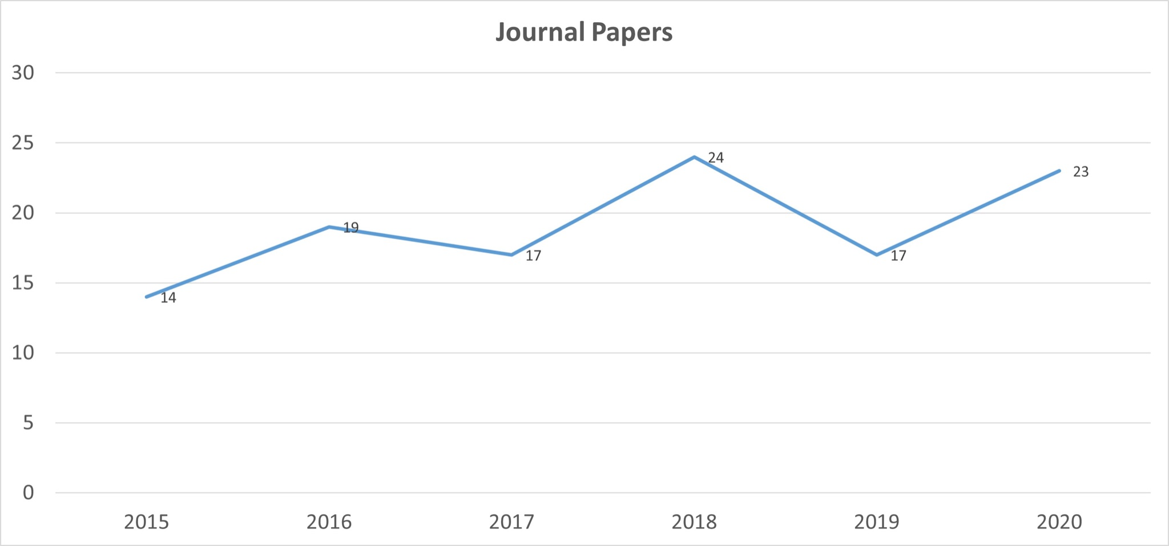

Figure x - the number of scientific journal papers per year

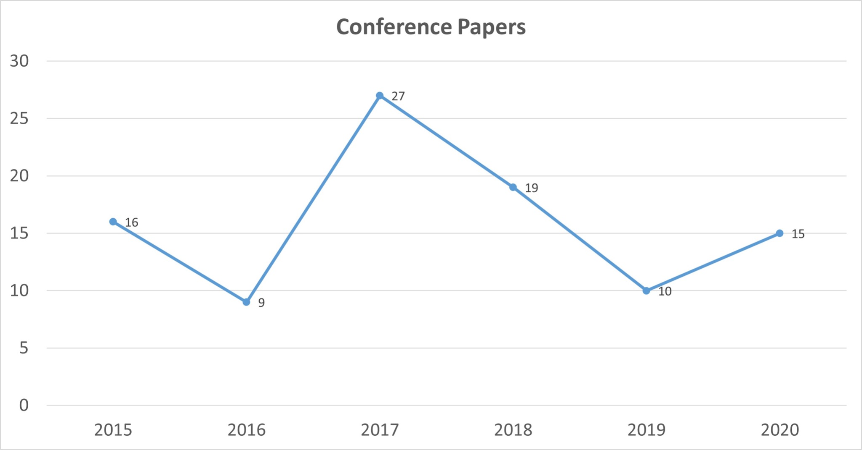

Figure x - number of conference papers per year

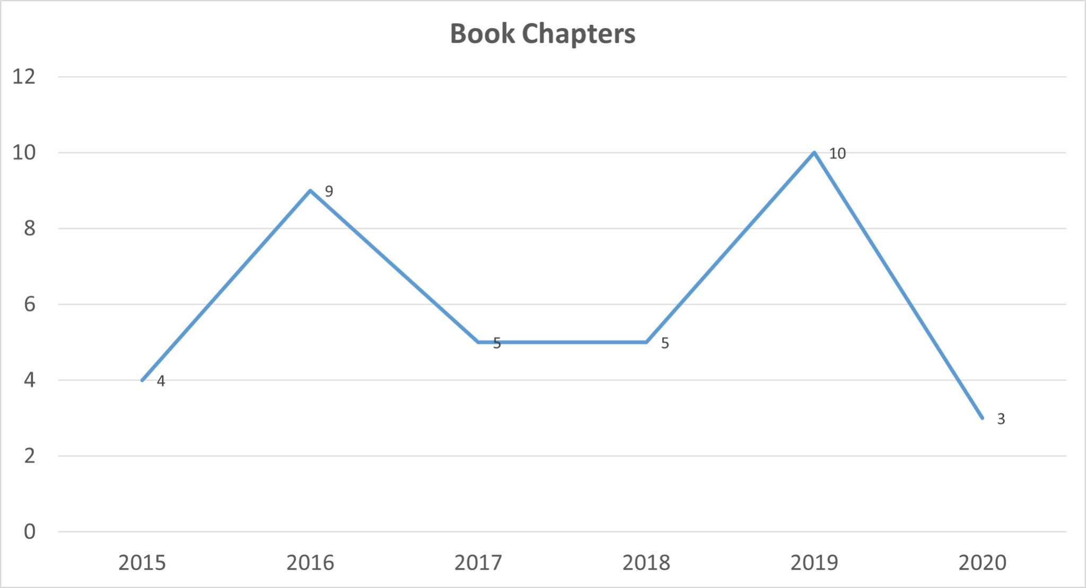

Figure x - number of book chapters papers per year

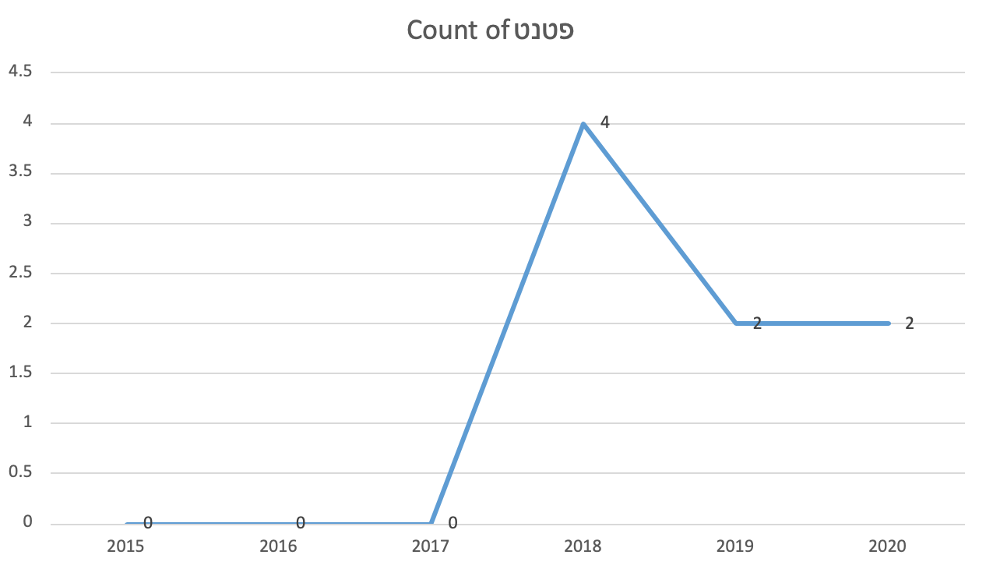

Figure x - number of patents per year

The following graph describes grant funds in the faculty and architectural program from 2015 - 2020.

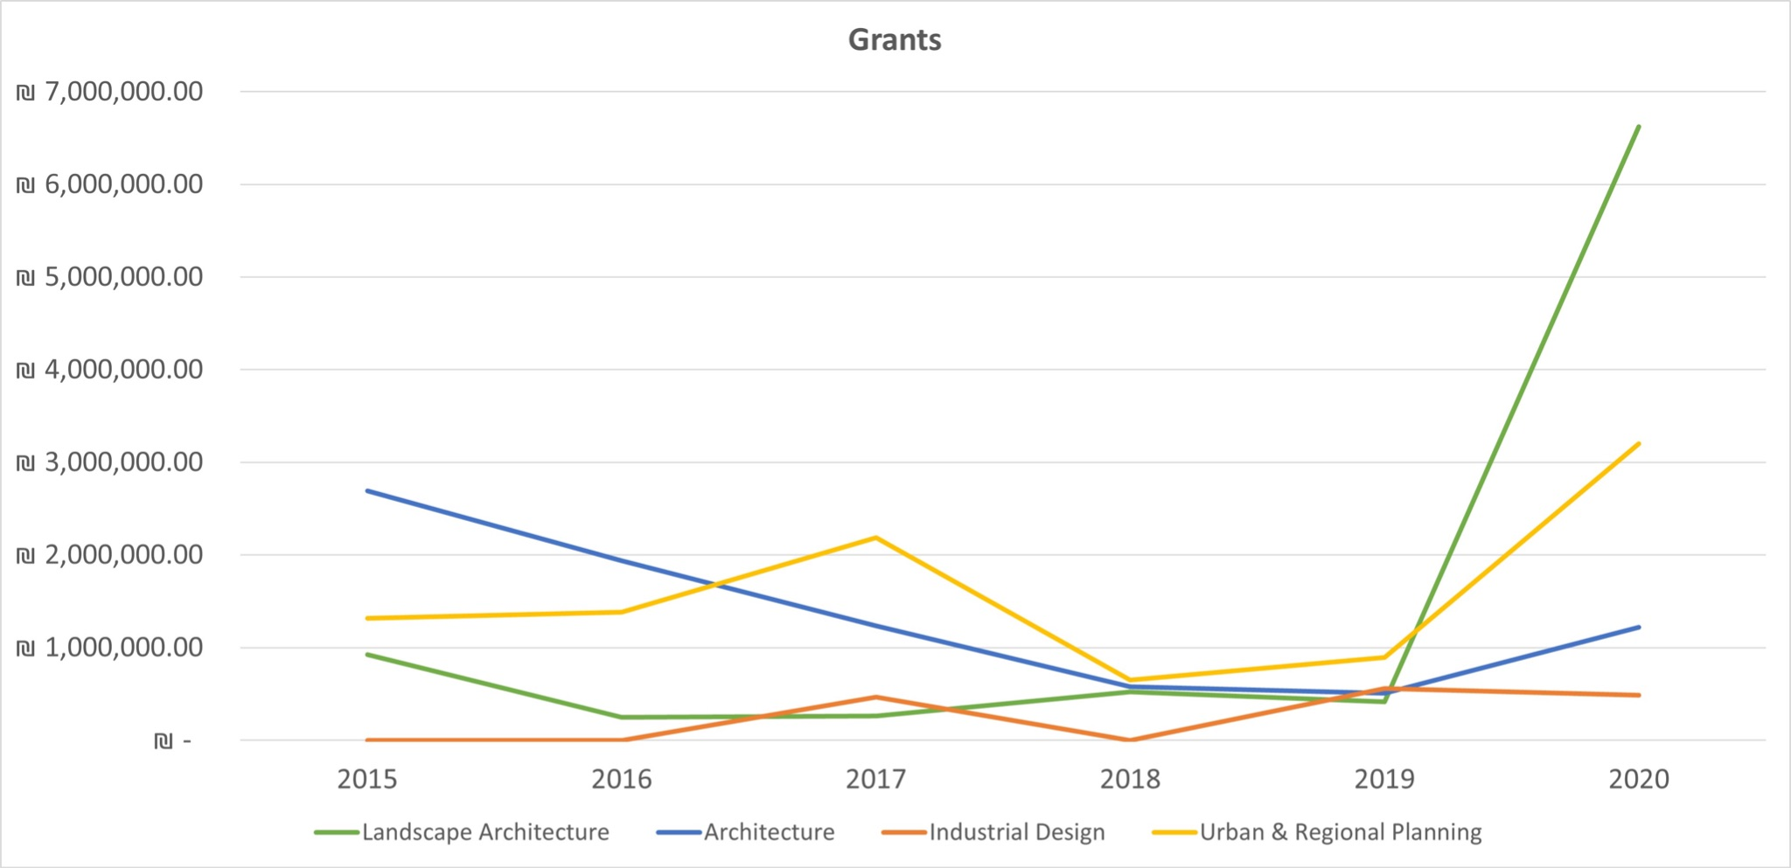

Figure x - grant funds per year - faculty

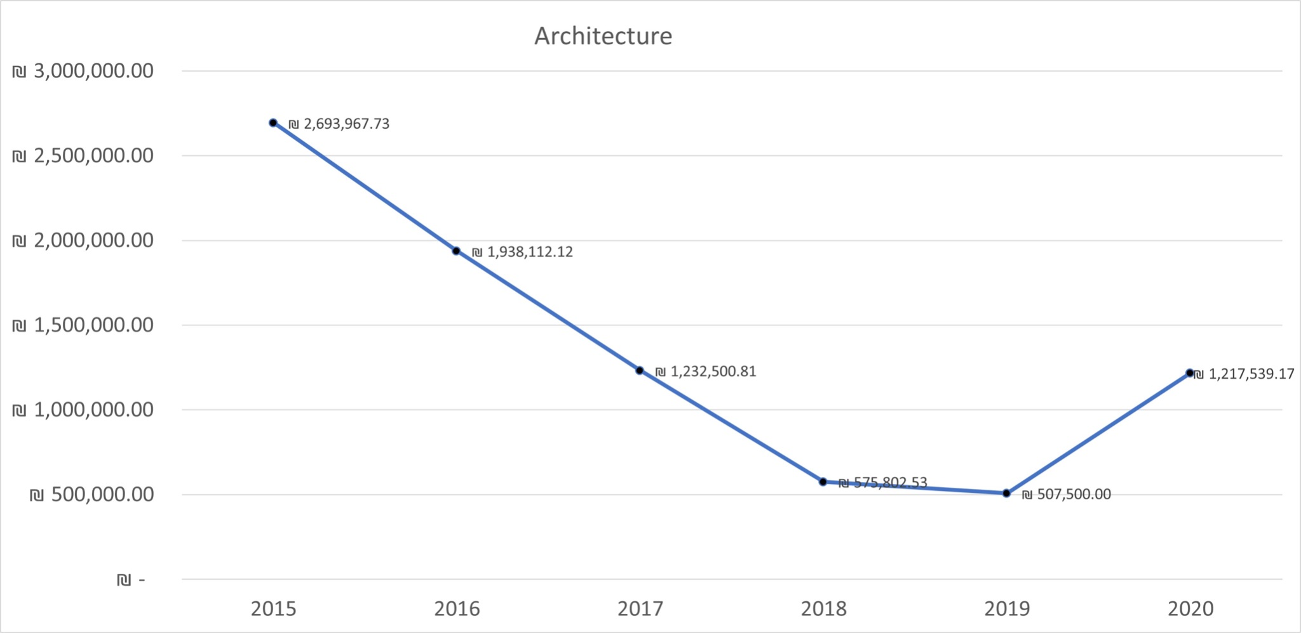

Figure x - grant funds per year - architectural program

The graphs show an increase in the publication of journal papers while conference paper (and conference) has suffered from covid 19. In terms of grant money, Prof. Kalay’s ERC grant of 2015 increased the program’s grant funds. There was a decline in research funds until 2019 when a new policy to encourage research was taken.

The faculty and the program plan to continue the emphasis and efforts for supporting advanced research. The three new recruits (research faculty) that join the program in late 2021 spring 2022 will contribute to the efforts in this direction. In particular, emphasize will be given to the following lines of activity:

* Recruit two research faculty and two practitioners (one in half position and the other in quarter position).
* Further increase the number of graduate research students with emphasis on PhD’s
* Increase the number of international graduate students at the program - a call for international graduate PhD students was published, faculty policy to allocate and advance support for international graduate student was promoted
* Increase collaboration in research with other Technion faculty members and international researchers.
* Continue the efforts in the research support for graduate students and establish an excellence plan for graduate students

**Recent awards and recognitions**

**Faculty:**

Shamay Assif and Bracha Chyutin - EMET prize for excellence in academic and professional achievements prize.

Aaron sprecher - American Architecture Award 2020, American Institute of Architects (AIA) Distinction Award 2019 St. Louis Chapter, Missouri, USA Project: Rajeunir Black Caviar​​. American Institute of Architects (AIA) Merit Award 2019 St. Louis Chapter, Missouri, USA Project: Student Housing, Sam Houston State University, Texas

Yasha Grobman won the Best Technion research in 2020 award, 2018 Technion best paper award

Alona Nitzan Shiftan - John Brinckerhoff Jackson Book Prize for 2018, The Foundation for Landscape Studies. (For the book Seizing Jerusalem.) Yonatan Shapiro Prize for best book in Israel Studies published during 2017, co-winner, The Association of Israel Studies. (For the book Seizing Jerusalem.)

Yael Allweil has been chosen as a member of the Young Israeli Academy.

Dan price - Union of Israeli Contractors Design quality of Public and Commercial Buildings(with David Robins) First Prize.

Gabi Shwarz - 2019 Israeli Design Award - POVZNER NAMED AWARD

Etan Kimmel - 'RIBA award for international excellence for The National Memorial on Mount Herzl

Ruth Liberti Shalev - 2020: Shortlist, The Plan Awards (Renovation category) for The Big House: Re-use of an Iconic Kibbutz Educational Institute.

**Students:**

**Research main lines of developments and challenges**

* Research support - research faculty PI do not fund lab managers from the Technion after the first 2 years which increases their administrative workload and reduces time available for research.
* Research infrastructure - workshop space reached its limits. funds needed for developing advanced workshop in Amado 2nd floor
* Research foundations (Research methods, Soft skills and writing abilities) - The faculty is currently reevaluating its research foundation education.
* Industry collaboration - although there has been an increase in recent years, there is not enough collaboration with Israeli and International leading building industry companies.
* Increase the number of International research students - a new faculty policy to increase the number of international research students is being developed and a call for international fully funded PhD has been published.

# **8. The Program During Covid-19**

General:

Online teaching at the Faculty, imposed per Covid regulations of social distancing, was adopted as soon as the Spring semester began in March 2020 using Technion institutional subscription to the Zoom platform. The Faculty transitioned to online learning within less than a week, with most classes transitioning seamlessly. This transition is based on good familiarity of both students and instructors with the Moodle platform as the main platform for class communication.

1. Students were provided with clear instructions on using the Zoom platform for online teaching, as well as clear instructions on ethics in an online classroom. See: [guidelines for students + moodle guidelines]

2. All class meetings were recorded and made available to registered students for the duration of the semester, allowing students with health, space and connection difficulties to access class materials.

3. Studio and related classes requiring in-class sketching during reviews have embedded software applications to compensate for in-person discussions of design, in particular the Miro software.

4. Maintaining personalized interaction, primarily in the studio, involved optional small group meetings on site, and maintaining Zoom links open for students to work ‘together’ outside of class time. Students themselves have organized study capsules by residence area (per health regulations) to maintain studio working environment.

5. Despite Covid we insisted on maintaining our events program as planned in order to keep students and faculty engaged in the program beyond class materials. All guest lectures and conferences were conducted via zoom and well attended by students and faculty.

6. Acknowledging the importance of Architectonic tours, either to the project site or to the course content, virtual tours (the teacher or one of the students would tour with online recordings) or capsule size tours were conducted. These have proven to be very effective.

Students:

All students suffered challenges related to the abrupt transformation to online teaching. Challenges include social isolation outside the studio setting; access to stable internet connection, workspace, and time constraints; the need to support family members; illness and anxiety; and often the need to relocate out of campus.

The Dean, vice-Deans for Students and Head of the program addressed student needs in two parallel ways: (a) general accommodations (b) individual accommodations.

General accommodations:

1. The Faculty prioritizes students in the first two years of study, namely in the ‘core years’ of their education, who experienced online teaching in their 1st, 2nd, and 3rd semesters. These students are prioritized in access to resources that would acculturate them into the faculty and studio culture, including meetings with heads of the program, mentorship from volunteer advanced students, and access to faculty equipment.

2. Final reviews of M.Arch graduates were conducted remotely, including a virtual exhibition of students’ work. This has enabled the participation of [number] of international reviewers.

Individual accommodations:

3. Students with disabilities, stress-related difficulties, limited access to internet connection and/or computers were supported in several important ways:

(a) The Faculty purchased several laptop computers, tablets and web cameras, and made them available for students and lecturers for short periods per an agreed protocol. See here: [add]

(b) Students facing stress, anxiety and learning difficulties in the online setting were directed to the referent for Architecture at T[echnion Counselling and Support Center](https://kidum.web.technion.ac.il/en/), where they received emotional support and practical tools.

(c) Students facing financial difficulties due to Covid were addressed by Technion, with no-interest loans made available for them per request.

(d) Students who had to leave the dormitories and return to their families faced difficulties with time allocation and workspace. Teachers and studio instructors were instructed to direct every such student to the Vice Dean for Students, who acted to help either within the Faculty or using Technion resources.

(e) We formulated a code of conduct in the online classroom for instructors and students, in order to set standards of good practice in attendance, participation and ethics based on a code of honor. Instructors were given training regarding care for students with disabilities and other difficulties in the online classroom. In a nutshell, the code sets standards for proper learning while clarifying the Faculty’s policy of tolerance and recognition of students’ objective hardships. See [here](https://architecture.technion.ac.il/wp-content/uploads/sites/41/2021/01/%D7%A0%D7%94%D7%9C%D7%99%D7%9D-%D7%9C%D7%A1%D7%98%D7%95%D7%93%D7%A0%D7%98%D7%99%D7%9D-%D7%91%D7%A4%D7%A7%D7%95%D7%9C%D7%98%D7%94-%D7%9C%D7%90%D7%A8%D7%9B%D7%99%D7%98%D7%A7%D7%98%D7%95%D7%A8%D7%94-18.10.2020.docx.pdf).

(f) No undergraduate students have dropped out of the program due to Covid conditions.

Graduate students:

As listed above, our graduate student body is composed of students in several programs: the M.Arch professional program, the M.Sc research program, the M.Sc academic program (no thesis), and the Ph.D program. Students in each program suffered the consequences of Covid differently:

(a) Research students (M.Sc and Ph.D):

1. Graduate students in the research programs (M.Sc, Ph.D.) faced various difficulties in conducting research, including the closure of research labs on campus, closure of all archives across the country, and the difficulty conducting user-based research during social distancing. Many of our research students are in their 30s and 40s and in charge of young children and aging parents. Many have therefore faced extensive setbacks in achieving their research.Further, school lockdowns, isolation etc prevented many students from writing papers, theses and research reports.

2. As a result, 8 of our graduate students requested extensions in submission of their research proposals, 2 students requested extensions in submission of their PhD concise description documents and 6 PhD students requested extensions in submission of their final dissertation, with the implication of research completion and research productivity postponement. Four students transferred to the no-thesis program.

3. While all extension requests were approved, Technion has not extended the duration of fellowships. Students are therefore receiving less effective support towards completing their studies.

4. The postponement and cancelation of academic conferences due to Covid has affected the timely progress of many research students, limiting their capacity to share their research with the international community and build their international profile.

5. While we supported every graduate student request for funding to participate in online conferences via the Azrieli Foundation grant, student participation in conferences during 2020 was lower than previous years.

6. We benefited from Covid flexibility in Technion regulations for examiners, and were able to include distinguished international scholars in Ph.D and M.Sc exams, for the benefit of our students and faculty.

(b) M.Arch students (professional program):

1. Overall, the advanced students in the professional program transitioned well into online teaching.

2. Despite Covid restrictions, the diploma project yielded excellent results from students.

3. No M.Arch student has dropped out of the program due to Covid.

4. Despite Covid we decided to maintain our yearly exhibition of student work, relocated to the virtual space of our website ([see here a link to the exhibition](https://architecture.technion.ac.il/360/)). The exhibition had significant reach to the professional and general public, and we intend to keep producing virtual exhibitions in addition to physical ones.

(c ) B.Sc. Program:   
1. During 2020, 40 students turned to the Center for Student Advancement due to personal problems, compared with 48 in 2019 and 37 in 2018. We actively forwarded twelve students to the center, a practice not customary in a regular academic year.

2. During online teaching due to Covid, eight students requested modifications or equipment loans due to connectivity difficulties.

3. Fourteen students requested deadline extensions for paper and presentation submission deadlines.

4. During the two Covid semesters, 24 and 19 students fell to the academic status of ‘מצב אקדמי לא תקין’, compared with 22 students in an average semester.

Faculty:

Covid imposition of online teaching posed significant challenges for teachers in all ranks, including faculty, affiliated faculty, and teaching assistants. The requirement of transition to the Zoom platform was especially challenging for less-savvy teachers, affiliated part-time teachers, and teachers caring for young children or older family members. We supported all teachers in several important ways:

(a) Providing technical support and manuals for online teaching in Zoom and Miro, produced by [Technion Center for Promotion of Learning and Teaching](https://promoteach.technion.ac.il/); architecture IT support; and fellow teachers. Training for online teaching included workshops for updating class pedagogy, as well as technical training about the zoom, moodle, upgrade and Miro platforms.

(b) We utilized the Moodle platform for teaching tips, support and communication among teachers, especially helpful for studio instructors at all levels. Peer support for online teaching was made available via the moodle platform, at the initiative of teachers across the program, providing teachers with professional, emotional and technical support. See: <https://moodle.technion.ac.il/course/view.php?id=7237>

(c) We provided tablets and web cameras for teachers whose personal equipment was lacking, prioritizing studio instructors and affiliated faculty, per agreed protocol. See: [Equipment Loan Form](https://docs.google.com/forms/d/e/1FAIpQLSeztKY9-XMpDZvl1dMexQjqO7NYj5f9195MchoPRZx_rmzTaA/viewform)

(d) Teachers lacking teaching space due to the care of young children or other family members were given access to campus classrooms. Several teachers were supported by part-time faculty who provided them with access to their office spaces. This solidarity was extremely important and appreciated, contributing to the department’s sense of identity.

(e) Librarians at the Faculty library assisted researchers and teachers at all levels in gaining access to research and teaching materials. See : https://library.technion.ac.il/he/books-scanning/

(f) Permanent and contingent faculty facing any health concerns were allowed to teach remotely. All teachers unable to teach from home and requiring a classroom for online teaching could coordinate that.

(g) Anticipating the transition to hybrid teaching, we secured Technion funds for upgrading the infrastructure in all classrooms, as listed above in item 6. Specifically, classrooms were equipped with television screens, online cameras and microphones to enable both in-person and remote teaching and learning. All studios now include an internet connection for stable communication.

Faculty advancement:

Research faculty have been facing dramatic setbacks to their academic activities in several important arenas: (1) conducting research, (2) publishing research outcomes, (3) engaging with the international academic community, (4) securing funding, (5) mentoring research students, (6) extended service and teaching obligations.

1. Research activity for many faculty has slowed due to the closure of research facilities and elimination of research personnel.

(2) publishing faced setbacks originating in researchers' own availability and in setbacks to the peer review process. Several reports attest to the global effect of Covid on academic publishing (see:). The effect of Covid on female scholars' publication record was dramatic, affecting primarily mothers of young children.

(3) engaging the international community suffered due to the elimination or postponement of academic conferences, and the transfer of some conferences to online format. Presenting one's research is especially important for young, untenured faculty who need to develop an international reputation. While in 2019 faculty attended 148 conferences, in 2020 only 48 conference applications were submitted, a 2/3 decrease.

Further, research sabbaticals for advanced faculty, planned years in advance, suffered dramatically. Sixty percent of faculty scheduled sabbaticals were cancelled and 20 percent conducted in israel. Only 20 percent of planned international sabbaticals were indeed executed, facing setbacks as wèll.

4. Due to covid setbacks, faculty's capacity to compete for research grant funding was challenged. While several grant programs extended their deadlines (for example isf) this was the exception.

5. Graduate student mentoring suffered greatly from students' difficulties, leading to setbacks in approving research proposals, submitting theses, conducting M.Sc and Ph.D exams.

6. All faculty faced extended service and teaching obligations required in order to meet the unforeseen demands of Covid, with implications on research performance and advancement.

7. Nonetheless, many faculty utilized the opportunities of remote communication to include international colleagues in their online seminars and studio reviews, exposing our students to international programs. Further, our faculty initiated several academic conferences via zoom which attracted scholars participating from across the world and a fraction of the regular cost.

Exams:

1. All exams during Covid semesters were conducted per Technion-set protocols, including supervision via cellphone to monitor cheating.

2. Architecture exams, like all Technion exams, are administered by Technion Undergraduate Studies using a single [exam platform](https://ugportal.technion.ac.il/%D7%9B%D7%A0%D7%99%D7%A1%D7%94-%D7%9C%D7%91%D7%97%D7%99%D7%A0%D7%95%D7%AA-%D7%9E%D7%A7%D7%95%D7%95%D7%A0%D7%95%D7%AA/) for all campus students.

Admissions to the program during Covid:

Admissions to the architecture program are based on (a) national matriculation exams (b) SAT exams and (c) creativity and spatial observation exams administered by the program (i.e. the architecture exam).

1. Last year, we changed the format of the architecture exam, transferring it from the Technion examination center to a studio setting with active involvement of faculty, better-suited to identify the best candidates. This change transferred the responsibility of administering the architecture exam from Technion to the faculty.

2. Due to Covid, the 2021 architecture exam was not administered in the studio setting as planned, but rather remotely.

3. Candidates received clear instructions on completing the exam's two questions, and submitting them online. Candidates received Exam questions digitally the morning of the exam and were asked to document their 2D and 3D exercises as images embedded in a ppt titled only with their identity no.

The exam was divided into two parts. The first question included two parts where in the first part a request to give examples on a particular topic based on the influence of a culture or geographical place (like different hats / roofs) and explain the reasons and components of the difference.In the second part candidates were asked to design an object for a particular character or use. The answers were given in two-dimensional drawings and short verbal explanations. The second question described a particular environmental situation and a requirement for intervention and the creation of a 3D model for a particular person or for a particular need. Candidates were asked to photograph the model and attach model photographs with a brief explanation and documentation of the development process.

4. Exam conditions relied on a code of honour by the candidates, namely that each candidate performed their assigned tasks on their own.

5. Our undergraduate officer recorded all submitted exames. All exams were evaluated by two faculty. In cases of disagreement, a third faculty reviewed the exam. In cases suspected of misconduct or any other concern, the candidate was summoned for a short interview with faculty.

6. In 2020, 375 candidates submitted applications to the program, 84 were accepted.

**Student registration and acceptance for 2021 (2022)**

This year we conducted two iterations for the exam, in order to inform the top 10 percent candidates early and secure their admission. Exams were similar in structure: The exam was an honors exam as it also took place last year with the outbreak of the corona. This year we had more candidates than in past years: 208 participated on the first date and 217 on the second date. All together 425 candidates. We plan to have 72 freshmen in the next academic year.

Practical training:

1. Due to Covid restrictions of social distancing on and outside campus, visits to construction sites and the construction industry were eliminated from the courses in details and technologies.

2. As the academic year 2020 was declared as the 'Haifa year' and most design project sites were in Haifa, we conducted several informal site tours in small groups and by individual students.

3. Studio training included training aids like tablets and miro in order to facilitate the practical elements of training.

4. The accreditation exam is administered by the Ministry of Labor rather than by the faculty.

Long term implications

Overall, faculty and instructors at all levels and cross sub-fields are happy with students’ learning outcomes in the two Covid-affected semesters. Students demonstrated a strong will to learn and excel, performing at the high academic level we expect in regular semesters.

While some classes suffered pedagogical challenges due to online teaching, several classes benefited tremendously from this pedagogy, with high student and teachers satisfaction records.

We therefore work to adapt our program to more diverse teaching and learning methods that adjust to the contents, learning outcomes and teaching styles for each class.

We intend to keep producing virtual exhibitions and guest lectures in addition to physical ones.

[Link to long term review of Covid19 teaching]