**הערה כללית עבור התרגום**

**המונח שנשתמש הינו**

**senior living community**

**ולכן מבקשים לשים לב לזה לאורך כל הטקסט.**

**אנחנו פונים לקהל צעיר יותר 60+ ולכן גם המונחים של דיירים / קשישים – לנסות להמנע.**

**תודה**

**Banners:**

1. Beresheet – A new senior living **on the Jerusalem mountains** Beresheet – A new senior living the Highest Standard
2. Beresheet anew
3. Beresheet – Take Part in a New Experience of Living
4. Beresheet –anew Concept for Seniors
5. Beresheet – senior living Community in the Heart of Nature
6. A Luxury senior living community on the Jerusalem mountains
7. Beresheet – Creating a New senior living Community Together
8. A new community for those looking for ongoing belonging and involvement

Impact

Creating Ongoing community Engagement in the new senior living

Think about tomorrow

דף נחיתה:

**זה הזמן לחשוב לתכנן את המחר**

**This Is Your Time**

Beresheet – A new senior living community **on the Jerusalem mountains** in Israel

This is your opportunity to be part of a unique, involved, and active **senior** living community **on the Jerusalem mountains**

A new senior living community is being established on the Jerusalem mountains.  
, Beresheet, will offer a high standard of living and extra facilities In the perfect location , around friends for Fulfilled living   
Beresheet is the best place for residentswho want to live their lives enjoying a breathtaking view, green meadows and self-fulfillment in a warm supporting community.

Bereshit – This is Your Time

**אכלוס 2023**

**Contact us for more information**

NAME PHONE

EMAIL

**Send**

Or dial *2349

Come to enjoy a high standard of living and luxury facilities in the perfect location with a spectacular  view

, friends  and a fulfilled living

For details

2349*

Beresheet, the place for new beginnings

For the first time in Israel, in the pastoral Motza on the Jerusalem mountains, we are offering a retirement experience for seniors who wish to be part of a community, allowing each and every member to fulfill themselves, both as individuals and together. Our residents are invited to become active members in the community, influencing decision making, choosing cultural activities, and participating in the senior living management. All of this with high standard of living and luxury facilities in the perfect location around friends , and , allowing you to experience your best years in a warm, supportive, and place. This is a truly unique experience, unlike anything you have ever seen before.



**This Is Your Time for Quality Life איכות חיים**

An extensive amount of thought was put into the design of Beresheet, in order to create a place that will allow you to lead the highest quality of life – a life of luxury and full of experiences. A semi-Olympic swimming pool, an innovative gym, a beautifulsynagogue, Highly Decorated Recreation Hall, and a wide range of leisure activities – soyou can enjoy these services and more, every single day.that you enjoy . The green spaces, the friendly coffee shop, and the historic nature reserve, which is open to the public, will allow you to experience the open environment with friends, family, and the local community.



**This is Your Time to Do What You Really Love**

After years of taking care of everyone around you, it is time to focus on you. This is your time to be daring – to fulfill your desires, discover your hidden talents, expand your horizons, and make new friends. Join us, and become a part of a strong, involved community. Discover a wide variety of cultural and social activities, in which every one can enjoy their personal preferences and lead the lifestyle that suits them best.

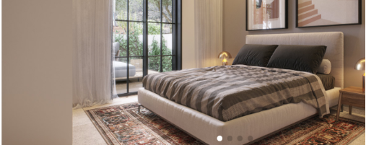

**This is Your Time to Feel at Home**

Luxurious garden apartments or apartments with balconies overlooking a spectacular Jerusalem view - all the options are open. . Every apartment includes fully equipped double bathrooms, to provide for a future caretaker if required, and smart home technologies The architectural design succeeded in maximizing the unique landscape of the Jerusalem Mountains, along with intimate spaces, and creating a sense of home

. It’s your time to choose the apartment that is right for you.

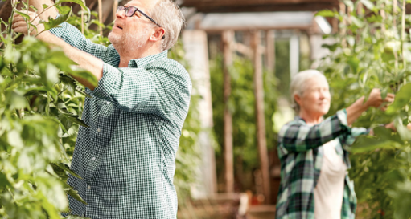

**This is Your Time to be a Part of Community**

Beresheet is the flagship project of the Lilchak chain/ family-owned and operated company , chain with 30 years of experience and professional reputation with senior living sector. We are proud to be the first ? in Israel to introduce a new, up-to-date way of senior living for doing away with the traditional structure, and creating a community living experience of the highest quality. We consider personal contact to be the most important element in our new living experience, and make it a point to know each and every one personally. We do our best to listen to what you have to say and build a supportive community together, an environment you can call home.

It’s your time to get involved

At Beresheet you determine how you want to live. The place is intended for people who want to be part of a community that allows everyone to fulfill themselves together or separately, and for those who are interested in influencing and being active partners in decisionmaking, content selection and lifestyle management at the home. You have the opportunity to start over, enjoy and make an impact.

**For the First Time in Years, New** senior living **in Jerusalem**

100% personal care * 30 years of experience * anew experience * A 5 minutes’ drive from Jerusalem * A community center * Breathtaking views * a unique, involved, and active **senior** living

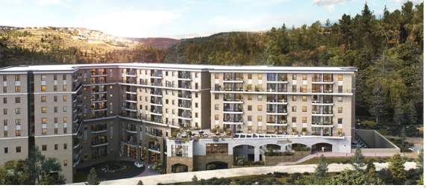

**This is Your Time to Feel Safe**

We know that an interesting, secure, and happy life begins with good health. For this reason,

we, provide personal care services and medical assistance including nursing department, round the clock personal medical supervision, and a recovery unit, ensuring that you will not need to change your place of residence in the future. The house has everything required to provide you with security and peace, so that you can enjoy your longevity and in the best quality of life.

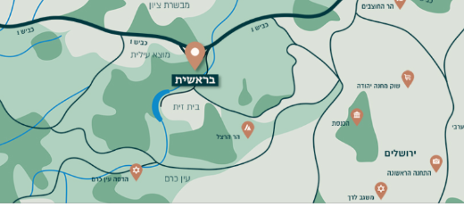

**This is Your Time to be Close to Everything**

We are located a 5 minutes’ drive from Jerusalem, and 40 minutes’ drive from Tel Aviv, in the very heart of Motza – a long-established, provincial, affluent, community village, surrounded by magical green mountains. We are located near Highway 16, a new highway currently being paved, which will provide an additional entrance to Jerusalem, as well as direct access to the south and central sections of the city, and a direct exit to Tel Aviv.

It’s your time to be with family

At Beresheet you can perfectly host the family. Together you can go on family trips, eat in private rooms in the restaurant, celebrate joint events and sleep in dedicated guest apartments. The grandchildren will especially enjoy the playground, activities and summer camp at their disposal. It’s your time to host the ones you love.

**Take your first step towards fulfilling your dream of living in Jerusalem.**

**Contact us today to learn more about the** new senior living community Full name:

Phone number:

E-mail address:

**Send**

* Motza, Jerusalem • call us now • [shirim@lichak.co.il](mailto:shirim@lichak.co.il) • follow us!