**Co-Teaching – From Theory to Practical Experience**

**Abstract** from research literature to the field of practical experience of training processes for teaching in the Class-Academy program at Ohalo College in the 2016-17 school year. in this paper we will examine the experience models as expressed in practice vs. the theory from the students’, teachers’ and training kindergarten teachers’ points of view. We will focus on the application of co-teaching practices in teaching in the Academy-Class program and examine the dominant teaching patterns found within.

One-hundred and twenty five male and female subjects participated in the study. The main research questions were:

1. To what extent are the six co-teaching models (as described in the research literature) expressed in practical and educational terms in the Academy-Class program?
2. What are the most common teaching practices, according to training teachers’ and students’ (who are participating in the program) reports, in comparison to the co-teaching model?

The main findings show that the co-teaching models were more dominant than the traditional teaching models, characterized in all sampled groups. Specifically, the greatest difference was found in the reports of the training teachers (0.79) at school, while the smallest difference was found amongst students of training to became techers(0.13). The T-Test found significant diversity in the difference (between co-teaching and traditional teaching) between the teachers and students: t(85)=2.56, p>0.05. On the other hand, the difference between the students (0.54) in the kindergarten early childhood education was found to be higher than the difference between kindergarten teachers (0.42). The T-Test found non-significant diversity in the difference (between low-level co-teaching and synergetic co-teaching) between the students and the kindergarten teachers: t(36)=1.81, p>0.05.

**Key words:** Academy-Class, co-teaching, experience models, teachers’ training.

**Introduction**

In the last decade, Researchers in the educational field are interested in co-teaching models. Schools around the world have tried to apply different and diverse methods of co-teaching in their classes. These models changed according to the needs and trends of the dynamic educational reality of the 21st century.

Several studies have spotlight the fact that the mutual relationship between teachers are critical and significant (Blank, 2013; Cleaveland, 2015; Petrick, 2015). In order to test this claim there is a need to expand the existing data on the issue. And shade more light on the subject. The current study aims to highlight and examining co-teaching models from a different angle. Emerging from the theory to the practical experiences in a unique practical experience program with in the framework of teachers training in Ohalo academic college.

**Co-Teaching**

Bacharach, Heck & Dank (2004) define co-teaching as a situation where two teachers (a training teacher and a trainee teacher) work together with groups of students – from the planning, through organization and up to implementation – in one classroom. Cook and Friend (1995) expand this definition and describe “co-teaching,” not necessarily as a pair of teachers, but as two or more teachers teaching together in significantly different ways which are intended for a diverse group of students – all in one physical space. Wenzlaff et al. (2002) emphasize the benefit of this teaching method, in terms of teaching a lesson that cannot be taught alone.

One application of the co-teaching model refers to co-teaching between trainer teachers and trainee teachers. In such a case, the recommendation is to divert from a traditional practical experience, with a hierarchy between trainer and trainee, to a process where both are partners sharing teaching and other responsibilities in the classroom (Roth & Tobin, 2005).

As derives from the literature, co-teaching has advantages in various areas. As the teacher receives significant assistance from another teacher and shares the work with him (Arbiv-Elyashiv, 2013; Forbes & Billet, 2012), the students receive greater learning opportunities and significant mediation. In other words, the model provides additional assistance to weak students and enrichment to students who are above the class level.

Studies that researched the influence of co-teaching on students’ achievements (Bacharach, Heck & Dahlberg, 2010; Forbes & Billet, 2010) found an advantage in math achievements amongst students in co-teaching classrooms, over students in regular classrooms.

In addition, the trainer teachers reported professional, authentic and significant development within co-teaching. The daily interactions required constant discussion and reflection on teaching, revitalized teaching methods and encouraged the trainee-teachers to expand their roles as leaders and teachers’ teachers in the school (Gallo-Fox & Scantlebury, 2016). In addition, co-teaching within a realm of mutual-respect, emotional support and trust gives an added value of constructing the teacher’s identity, sharpening and deepening his knowledge of the teaching material and raising the level of the actual teaching (Wehunt, & Weatherford, 2015). Students who were exposed to co-teaching reported that they experienced a gradual integration into the classroom, which focused on the connection between theory and practice. The students reported that the experience enabled mutual learning and that co-teaching provides a supportive environment for professional and in-depth teaching (Arbiv-Elyashiv, 2013; Forbes & Billet, 2012; Rytivaara & Kershner, 2012).

Co-teaching’s success is dependent on several elements: shared work that includes planning, organization and assessment. Shared planning is extremely important for co-teaching and sufficient time and attention must be given, allocated for this stage (Kamens, Susko & Elliott, 2013). At first, planning will be very explicit, but over time the student will become responsible for a greater part in this process (Bacharach, Heck & Dahlberg, 2010). Each of the co-teaching partners will contribute from his personal talents and skills (Murawski & Lochner, 2011). Following the lesson, the teachers will assess and reflect on the process and receive feedback from the students. Interpretation and analysis will clarify to the student what occurred and direct him to additional teaching strategies and techniques (Murawski & Lochner, 2011; Scantlebury, Gallo-Fox & Wassell, 2008).

**Possible Models for Co-Teaching as part of the Teaching Experience**

1. “One teacher teaches and the other observes” – according to this model the older and more experienced teacher leads the lesson, while the trainee teacher integrates gradually, mainly by observing lessons and then experiencing private, group and full-class teaching. The trainee student learns by observing an experienced model, hearing the students’ responses and analyzing the lesson (Bacharach, Heck & Dahlberg, 2010; Cook& Friend, 1995; Graziano & Navarrete, 2012).
2. “Head teacher teaches and the other teacher supports” – according to this model the head teacher takes main responsibility for the lesson and teaches the material. The trainee walks between the students, helps them with their work, explains and elaborates on the material, as needed (Bacharach, Heck & Dahlberg 2010; Cook & Friend, 1995; Graziano & Navarrete, 2012; Walsh & Johns, 2004).
3. “Parallel teaching” – according to this model the teachers teach an identical lesson simultaneously to two separate groups of students (Cook & Friend, 1995; Graziano & Navarrete, 2012; Villa, Navin & Thousand, 2004).
4. “Teaching in Stations” – the trainer and trainee teachers split the group of students and the content that each will teach. They each teach their part of the material to all groups, and then they switch.
5. “Variable Teaching” – one teacher teaches the entire class and the second teacher teaches one student or a small group of students at the same time.
6. “Group Teaching” – the teacher and the trainee split shared responsibility to teach the same content simultaneously to the same group of students. According to this approach the teachers use the same teaching methods, such as turns, role play, examples, etc. (Bacharach, Heck, & Dahlberg 2010; Cook & Friend, 2004).

**From Low-Level Co-Teaching to Synergetic Co-Teaching**

In the abovementioned teaching methods we find several models with a low level of collaboration – one teacher is dominant and leading the lesson, while the second is supportive but more passive. Tov-Li & Frisch (2008) state that this is the traditional model of co-teaching, and the risk with this model is that there will be no real co-teaching, such as in the more complex models of parallel teaching or stations, but parallel teaching, where each teacher works separately from his colleague.

In this regard Sachs et al. (2011) present the phrase Synergetic Collaboration in Teaching as a value. They claim that synergetic collaboration must include a clear consent, mutual collaboration in growth processes and a contribution to mutual development. New approaches contain the term Synergetic Co-Teaching as teaching that is adapted to the educational needs of the twenty-first century. In an age where the skills required from a worker already emphasize team work, problem solving and interpersonal relationships (De Fruyt, Wille & John, 2015), high-level collaborative teaching, which involved an in-depth combination between two teachers, strengthens the innovative teaching approach that prepares the student to be an independent, multidisciplinary student, who can learn in diverse locations and styles (Amar & Ben-David, 2016; Brown, 2016).

**Methodology**

**Study Questions**

1. To what extent do the six co-teaching methods represent the unique practical experience program from the teachers’ and trainees’ perspective?
2. How common is Synergetic Collaboration as a co-teaching method, in comparison to other low-level methods?

**The Study Population and Procedure**

At the end of the 2016/7 school year a questionnaire was sent by Google Drive to the participants – 140 students and 100 training teachers and kindergarten teachers – as part of their third year practical experiment. Responses were anonymous. Subjects were requested to answer a series of 13 statements, according to the Likert Scale of 1-5. Of these 125 subjects completed the questionnaire – 36 students of education, 20 students of childhood education, 51 training teachers and 18 kindergarten teachers, as detailed in Table 1. An average, as well as several statistical tests (T-Test), was calculated from all responses, to find significance.

*Table 1: Study Population/Questionnaire Respondents, according to Fields of Specialization*

|  |  |  |
| --- | --- | --- |
| Field of Specialization | Students | Teachers/Kindergarten Teachers |
| Early Childhood | 20 | 18 |
| Judaism | 18 | 2 |
| English | 10 | 16 |
| Science | 4 | 19 |
| Mathematics | 2 | 5 |
| Biology | 2 |  |
| Physical Education |  | 1 |
| Israel Studies |  | 1 |
| Homeroom Education??? |  | 7 |

**Research Tools**

The research tool was a validated questionnaire that included a series of 13 statements based on the Likert Scale (1-5). In all statements the high value (5) represents the high incidence and the low value (1) represents the low incidence. In the first stage the 13 statements expressed the traditional model that does not include co-teaching and the seven co-teaching models, as detailed in the literature. The teaching model “variable teaching” was divided into two models, in which one teacher teaches the entire class and the second teacher teaches a small group, or one or two students.

*Table 2: Distribution of Statements into Content Categories, According to the Co-Teaching Models*

|  |  |  |
| --- | --- | --- |
| **Model of Experience** | **Statement**  **No.** | **Content of Statement** |
| Traditional model of experience – one teacher teaching | 1 | Teacher teaches and I sit passively |
| 2 | I teach and the teacher sits passively |
| Model 1 – One teacher teaches and the other observes | 3 | The teacher teaches and I observe him and/or the other students |
| 4 | I teach and the teacher observes me and/or the other students |
| Model 2 – One teacher teaches and the other supports from the side | 5 | The teacher teaches and I support from the side, helping the students |
| 6 | I teach and the teacher supports from the side, helping the students |
| Model 3 – Two teachers teach the same material simultaneously in two separate groups (Parallel Teaching) | 7 | The teacher and I teach the same material simultaneously in two separate groups |
| Model 4 – Two teachers teach different material to two groups in “stations” | 8 | The teacher and I teach different material in two groups in “stations |
| Model 5 – One teacher teaches most of the class while the other teaches a small group | 9 | The teacher teaches most of the class while I teach a small group |
| 10 | I teach most of the class while the other teacher teaches a small group |
| Model 6 – One teacher teaches the whole class while the other teacher works with one or two students | 11 | The teacher teaches the whole class while I work with one or two students |
| 12 | I teach the whole class while the other teacher works with one or two students |
| Model 7 – Two teachers teach the class together simultaneously (Group Teaching) | 13 | The other teacher and I teach the class together simultaneously |

In the second stage the models were mapped by their level of co-teaching and models of experience were grouped into three categories – from lack of co-teaching to synergetic co-teaching, as detailed in the table.

*Table 3: Main Categories of Models, According to the Level of Co-Teaching in Co-Teaching Models*

|  |  |
| --- | --- |
| Category | Models |
| No co-teaching at all | Traditional experience model – one teacher only |
| Low-level co-teaching (one teacher is more dominant than the other) | Model 1 – one teacher teaches and the other observes him  Model 2 – one teacher teaches and the other supports from the side  Model 5 – one teacher teaches most of the class and the other teaches a small group  Model 6 – one teacher teaches the whole class and the other teaches one or two students |
| Synergetic co-teaching (two active teachers, equal partners, contributing equal values) | Model 3 – two teachers teach the same material simultaneously to two separate groups  Model 4 – two teachers teach the same material to two groups at “stations”  Model 7 – two teachers share teaching the class simultaneously |

**Findings**

The following tables present the subjects’ average responses for all statements, for each of the four groups.

*Table 4: Students of Education – Average Incidence of Co-Teaching*

|  |  |  |
| --- | --- | --- |
|  | Average | Standard Deviation |
| The teacher teaches and I sit passively | 2.50 | 1.48 |
| I teach and the teacher sits passively | 1.67 | .93 |
| The teacher teaches and I observe him and/or the students | 3.36 | 1.25 |
| I teach and the teacher observes me and/or the students | 2.58 | 1.13 |
| The teacher teaches and I support from the side, helping the students | 3.61 | 1.15 |
| I teach and the teacher supports from the side, helping the students | 2.67 | 1.43 |
| The teacher and I teach the same material simultaneously in two separate groups | 1.89 | 1.33 |
| The teacher and I teach different material in two groups in “stations” | 1.58 | 1.20 |
| The teacher teaches most of the class while I teach a small group | 1.83 | 1.16 |
| I teach most of the class while the other teacher teaches a small group | 1.25 | .60 |
| The teacher teaches the whole class while I work with one or two students | 1.92 | 1.18 |
| I teach the whole class while the other teacher works with one or two students | 1.39 | .96 |
| The other teacher and I teach the class together simultaneously | 2.22 | 1.61 |

*Diagram 1: Students of Education – Models of Experience in Co-Teaching*

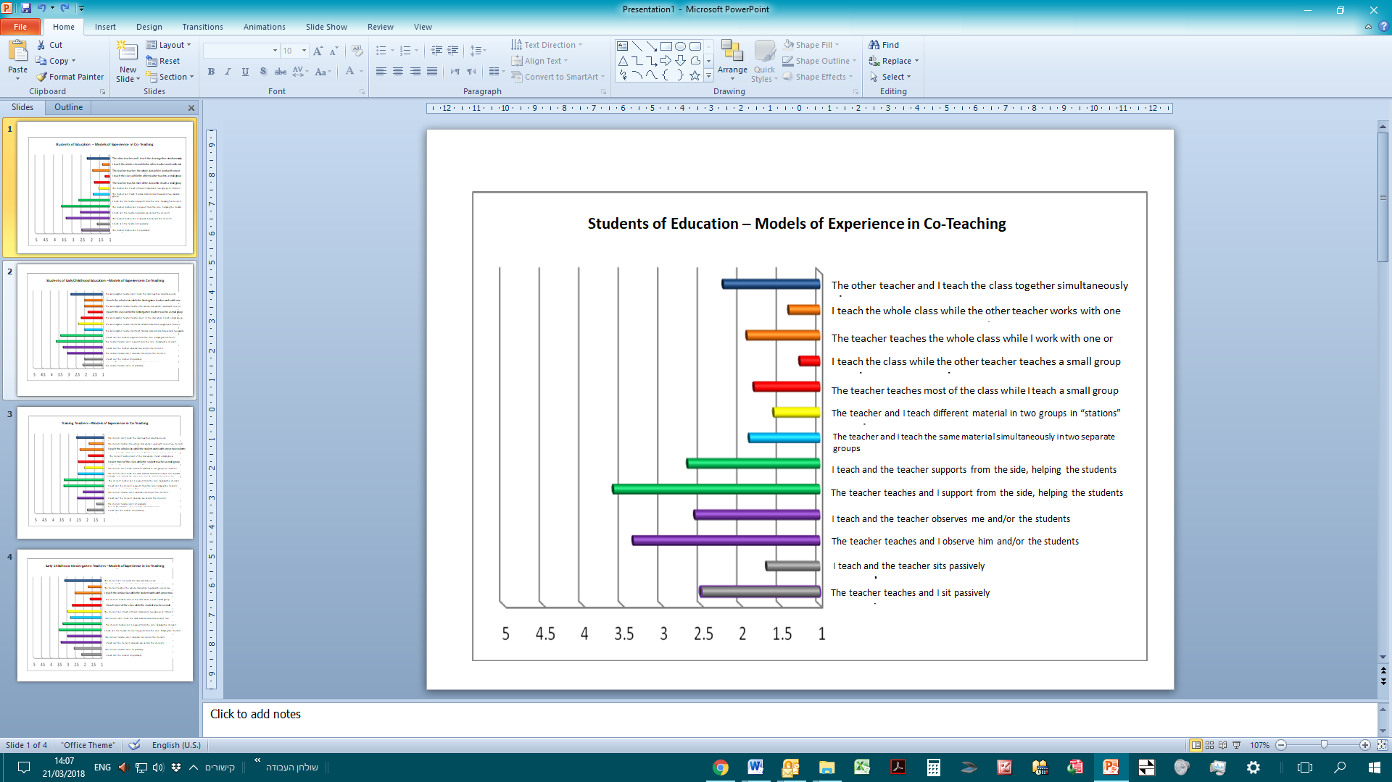

*Table 5: Students of Early Education – Average Incidence of Co-Teaching*

|  |  |  |
| --- | --- | --- |
|  | Average | Standard Deviation |
| The kindergarten teacher teaches and I sit passively | 2.15 | 1.23 |
| I teach and the kindergarten teacher sits passively | 2.05 | 1.15 |
| The kindergarten teacher teaches and I observe her and/or the other students | 3.05 | 1.00 |
| I teach and the kindergarten teacher observes me and/or the other students | 3.30 | 1.30 |
| The kindergarten teacher teaches and I support from the side, helping the students | 3.70 | 1.03 |
| I teach and the kindergarten teacher supports from the side, helping the students | 3.45 | 1.19 |
| The kindergarten teacher and I teach the same material simultaneously in two separate groups | 2.05 | 1.32 |
| The kindergarten teacher and I teach different material in two groups in “stations” | 2.40 | 1.35 |
| The kindergarten teacher teaches most of the class while I teach a small group | 2.25 | 1.33 |
| I teach most of the class while the kindergarten teacher teaches a small group | 1.85 | 1.18 |
| The kindergarten teacher teaches the whole class while I work with one or two students | 2.05 | 1.19 |
| I teach the whole class while the kindergarten teacher works with one or two students | 2.05 | 1.10 |
| The kindergarten teacher and I teach the class together simultaneously | 2.85 | 1.69 |

*Diagram 2: Students of Early Education – Average Incidence of Co-Teaching*



*Table 6: Training Teachers - Average Incidence of Co-Teaching*

|  |  |  |
| --- | --- | --- |
|  | Average | Standard Deviation |
| I teach and the student sits passively | 1.96 | 1.13 |
| The student teaches and I sit passively | 1.41 | .64 |
| I teach and the student observes me and/or the other students | 2.53 | .92 |
| The student teaches and I observe him and/or the other students | 2.20 | .83 |
| I teach and the student supports from the side, helping the students | 3.33 | .99 |
| The student teaches and I support from the side, helping the students | 3.31 | 1.29 |
| The student and I teach the same material simultaneously in two separate groups | 2.49 | 1.19 |
| The student and I teach different material in two groups in “stations” | 2.12 | 1.11 |
| I teach most of the class while the student teaches a small group | 2.49 | .86 |
| The student teaches most of the class while I teach a small group | 1.90 | .90 |
| I teach the whole class while the student works with one or two students | 2.39 | .90 |
| The student teaches the whole class while I work with one or two students | 1.86 | .92 |
| The student and I teach the class together simultaneously | 2.59 | 1.08 |

*Diagram 3: Training Teachers - Average Incidence of Co-Teaching*



*Table 7: Kindergarten Teachers – Training Teachers - Average Incidence of Co-Teaching*

|  |  |  |
| --- | --- | --- |
|  | Average | Standard Deviation |
| The student teaches and I sit passively | 2.17 | 1.15 |
| I teach and the student sits passively | 2.61 | 1.20 |
| I teach and the student observes me and/or the other students | 3.39 | .85 |
| The student teaches and I observe him and/or the other students | 3.00 | .84 |
| I teach and the student supports from the side, helping the students | 3.50 | 1.04 |
| The student teaches and I support from the side, helping the students | 3.28 | 1.13 |
| The student and I teach the same material simultaneously in two separate groups | 2.83 | 1.42 |
| The student and I teach different material in two groups in “stations” | 3.00 | 1.24 |
| I teach most of the class while the student teaches a small group | 2.72 | 1.02 |
| The student teaches most of the class while I teach a small group | 1.67 | .84 |
| I teach the whole class while the student works with one or two students | 2.56 | 1.04 |
| The student teaches the whole class while I work with one or two students | 1.78 | 1.00 |
| The student and I teach the class together simultaneously | 3.17 | 1.20 |

Diagram 4: Kindergarten Teachers – Average Incidence of Co-Teaching

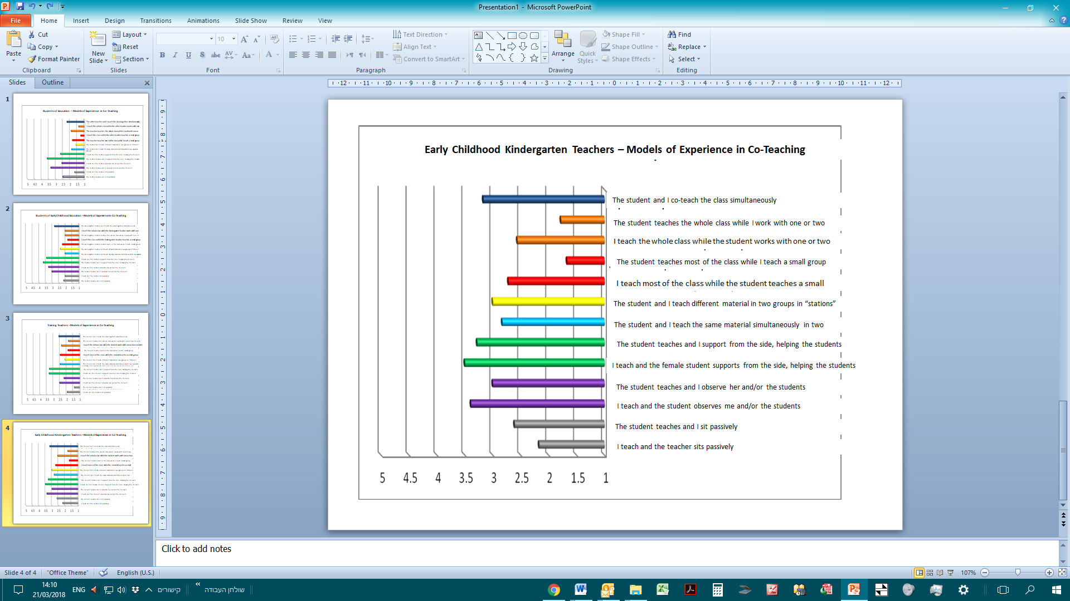

We will now present the averages of the traditional statements and the averages of the co-teaching statements. Statements 1-2, as they appear in the research questionnaire have been defined as “traditional teaching” (a teaching model that does not include co-teaching at all), while the remaining statements (3013) have been defined as co-teaching. Table 9 below displays the averages of these two indices amongst the four groups.

*Table 8: Traditional Teaching and Co-Teaching in the Four Groups*

|  |  |  |  |  |  |  |  |
| --- | --- | --- | --- | --- | --- | --- | --- |
|  | Traditional Teaching | | | Co-Teaching | | |  |
|  | N | Average | Standard Deviation | N | Average | Standard Deviation | Difference |
| Students of Education | 36 | 2.08 | 1.02 | 36 | 2.21 | .57 | .13 |
| Students of Early Education | 20 | 2.10 | 1.05 | 20 | 2.64 | .80 | .54 |
| Trainer Teachers | 51 | 1.69 | .73 | 51 | 2.47 | .52 | .79 |
| Kindergarten Teachers | 18 | 2.39 | .98 | 18 | 2.81 | .60 | .42 |

*Diagram 5: Traditional Teaching and Co-Teaching*

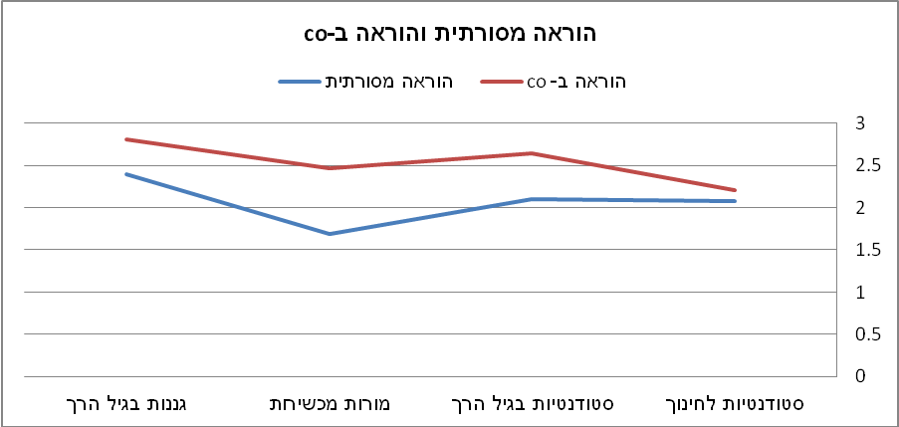

**Traditional Teaching and Co-Teaching**

Traditional Teaching

Co-Teaching

Early Childhood Kindergarten Teachers

Training Teachers

Early Childhood Students

Students of Education

A higher level of teaching was found in co-teaching than in traditional teaching in all groups. In particular, it was found that the highest difference in schools is amongst the trainer teachers (0.79), while the lowest difference was amongst students of education (0.13). The T-Test found significant diversity in the difference (between co-teaching and traditional teaching) between the teachers’ group and the students’ group: t(85)=2.56, p<0.05.

On the other hand, in kindergartens the difference amongst the students (0.54) was higher than the difference amongst the kindergarten teachers (0.42). The T-Test found non-significant diversity in the difference (between co-teaching and traditional teaching) between the students and kindergarten teachers: t(36)=0.29, p>0.05.

As stated above, the co-teaching statements, numbered 3-13 in the questionnaire, were divided into two groups according to the following definition: low-level co-teaching and synergetic co-teaching. Table 9 presents a comparison between the averages of the low-level co-teaching statements and the averages of the synergetic co-teaching statements.

*Table 9: Low-Level Co-Teaching and Synergetic Co-Teaching in the Four Groups*

|  |  |  |  |  |  |  |  |
| --- | --- | --- | --- | --- | --- | --- | --- |
| . | Low-Level Co-Teaching | | | Synergetic Co-Teaching | | |  |
|  | N | Average | Standard Deviation | N | Average | Standard Deviation | Difference |
| Students of Education | 36 | 2.33 | .52 | 36 | 1.90 | 1.00 | .43 |
| Student of Early Childhood Education | 20 | 2.71 | .72 | 20 | 2.43 | 1.26 | .28 |
| Training Teachers | 51 | 2.50 | .49 | 51 | 2.40 | .92 | .10 |
| Kindergarten Teachers | 18 | 2.74 | .50 | 18 | 3.00 | 1.15 | -.26 |

*Diagram 6: Low-Level Co-Teaching and Synergetic Co-Teaching in the Four Groups*

Low-Level Co-Teaching

Synergetic Co-Teaching

It was found that the level of low-level co-teaching was higher than the level of synergetic co-teaching amongst students of education, amongst students of early childhood education and amongst trainer teachers, while amongst early childhood kindergarten teachers the level of synergetic co-teaching was higher than the level of low-level co-teaching.

In particular it was found that in schools the greatest difference is between students of education (0.43), while amongst training teachers the difference is small (0.10). The T-Test found non-significant diversity in the difference (between low-level co-teaching and synergetic co-teaching) between the students and the kindergarten teachers is not significant: t(36)=1.81, p>0.05.

Table 10 presents the results of two school groups (students of education and training teachers) and of two kindergarten groups (students of early childhood education and early childhood kindergarten teachers).

*Table 10: Traditional Teaching, Low-Level Co-Teaching and Synergetic Co-Teaching in Schools and Kindergartens*

|  |  |  |  |  |  |  |  |  |  |
| --- | --- | --- | --- | --- | --- | --- | --- | --- | --- |
|  | Traditional Teaching | | | Low-Level Co-Teaching | | | Synergetic Co-Teaching | | |
|  | N | Average | Standard Deviation | N | Average | Standard Deviation | N | Average | Standard Deviation |
| School | 87 | 1.85 | 0.88 | 87 | 2.36 | 0.55 | 87 | 2.19 | .98 |
| Kindergarten | 38 | 2.24 | 1.01 | 38 | 2.72 | 0.71 | 38 | 2.70 | 1.22 |

Diagram 7: Traditional Teaching, Low-Level Co-Teaching and Synergetic Co-Teaching in Schools and Kindergartens

**Traditional Teaching and Co-Teaching**

Kindergarten

School

It is clear that the averages in the kindergartens are higher than the averages in schools in all three categories (traditional teaching, low-level co-teaching and synergetic co-teaching). In particular, it was found that both in school: F(2,172)=9.51, p<0.01 and in kindergarten: F(2,74)=3.49, p<0.05 the level of shared teaching in low-level co-teaching is the highest, followed by the level of synergetic co-teaching. The level of traditional teaching was the lowest in comparison to co-teaching.

**Conclusions and Discussion**

An analysis of the findings show that practical experience can be characterized in several models and that there exists a wide range of joint work – from the traditional model of practical experience, where the student is mainly passive, through a more joint model of teaching, where the student is the teacher’s helper and participates in this process, to a third, and new, model, which we are attempting to emphasize in the most significant way, the model of synergetic co-teaching.

Modern approaches and programs that are used in schools and emphasize innovativeness that is adapted to the 21st century, invite a new, alternative model of co-teaching, based on the theory of Connectivism (Siemens, 2008) (a theory of learning that is adapted to the modern, digital age, where co-teaching plays a central role). Studies in future-looking teaching approaches show that co-teaching, and the need for co-teaching, is based on the fact that the individual is part of a group. The group learns together, individually or in groups, and shares their resources of information with each member of the group. This method of learning is different to what existed in the past – where learning was paternalistic, centralized and based on a personal-competitive dimension. Today information is dispersed throughout social networks and in virtual realms (Siemens, 2004).

The frequent changes and trends that showed the main focus points of change in learning clarify that, without doubt, there are differences that require a widespread change of perspective, in order to prepare today’s students, in the best way possible, for tomorrow. At the same time, the process of student training, those who are preparing to be the teachers of the future, involves exactly the same differences. Thus, we ask the question – how can we bridge these differences?

The research findings show that the level of shared work and co-teaching is higher than the level of traditional teaching in all sampled groups. These findings support the goals of the unique practical experience program to make significant changes in the nature and essence of the training processes in educational and teaching professions. Thus, the findings show the changeover of an educational cadet from a passive observer sitting on the sidelines to a significant partner (Lehavi, 2010). This change was made possible thanks to an intensive three-day experience program, which enabled students and teacher to work together for many hours over several days a week and to create a relationship of shared work, guidelines and content. In addition, training teachers also learned during the seminars we held that emphasize the importance of co-teaching in training students (Ministry of Education Think Tank, 2014).

Despite reports on high levels of co-teaching in comparison to traditional patterns of teaching, an analysis of the various models that exist in co-teaching still show that the level of shared work is within the “low range.” In other words, despite the fact that the experience models exemplify a new approach of greater shared work in the classroom, the training teacher still plays a more significant role in leading teaching processes; he’s the one to direct the student’s role and generally, within a given time, works mainly with the students, and the trainee student is his assistant. This finding is naturally clarified in light of the relationship between the training teacher and the trainee student – veteran and more experienced vis-à-vis a new teacher, but this can also be explained by the traditional training pattern of training teachers, which was preserved amongst training teachers, who have more experience within the education system (Alian and Daniel-Sa'ad, 2013).

The complexity of the synergetic co-teaching approach that expects the teacher to “release some responsibility and control” to the trainee teacher could be another explanation of this pattern. Such a level of co-teaching is directed at teaching of various qualities, approaches and methods that are totally different to the one-teacher-in-the-classroom style of teaching (Cook & Friend, 1995; Wenzlaff et al., 2002). This fact might also explain the finding, according to which training kindergarten teachers reported a higher level of synergetic co-teaching; the dynamic nature of their work, which generally includes a freer and more multidisciplinary work schedule, enables greater flexibility when working in a team (Ministry of Education, 2010).

Research findings also show that participants in the training program reported the use of several teaching models in various configurations as described in the literature (Bacharach, Heck & Dahlberg, 2010; Cook & Friend, 1995; Graziano & Navarrete, 2012). No model was found to be significantly more dominant or apparent or to represent a model that characterizes the training process, but we found a wide range and various levels of shared work which were reported by the training teachers and kindergarten teachers, as well as the students. This finding correlates with the various models presented in the research literature and presents co-teaching within a structure of various models of experience, some more natural for a teacher – trainee teacher relationship, depending on the training teacher’s work in the past, and some exhibiting the out-start of co-teaching – according to the model of “two-teachers-in-the-classroom,” on an increasing synergetic level, as expected from the new program.

**Summary**

We have seen that experiencing the clinical model of teaching involves the shared work of a trained teacher and of a trainee student of education. According to the common traditional model, it was accepted to have an apprentice in the classroom and the teacher would play a significant role in teaching, with the trainee student observing passively, experiencing under supervision and controlled by the teacher – measured sparingly. Today, with the onset of the much-needed changes in training processes, we believe in the need to expand the theoretical approaches that describe the wide range of shared work. We recommend creating a language that characterizes events in the classroom and formulating an innovative theoretical framework that is adapted to the need of the 21st century. Then we must anchor these theories in an innovative and diverse field, which is not based only on differential models of experience and teaching practice, but on a model that describes the wide range of synergetic co-teaching between the training teacher and the trainee student. This kind of experience has many advantages. The teacher and students share the responsibility for the classroom, and the students benefit from having two teachers; they enjoy widespread arbitration, enrichment and in-depth learning. Moreover, the teachers themselves improve their professional skills and sharpen their thought processes and working methods, absorbing innovative skills from the younger students. The students, on their part, experience in real-time the great and diverse responsibilities that are part of the teacher’s role, while enjoying the protection, support and advice of the training teacher.

This model is suitable to be used as a working model for students in the 21st century, in an age where shared work, shared information, team efforts and normal working relationships are required in the world of tomorrow, required from the citizens of the future. Therefore, we greatly recommend creating a support system, a full security network that will not leave the trainee teacher alone and out of the picture, but gives him a significant field of experience where he is constantly active, learning, experiencing, feeling, teaching, correcting, improving and receiving reflective feedback in a clinical aspect of realizing his future role as the teacher of tomorrow. This method will encourage interdisciplinary and multidisciplinary teaching, where several teachers teach in large classes, using more creative and diverse methods of teaching.

**Study Limitations**

Despite all that stated above, this study’s limitation is its focus on one specific research population – a convenient model that was chosen in advance, in order to learn, observe and come to conclusions regarding groundwork, realizing didactic goals placed by the unique practical experience program, and other goals we set for ourselves as the program directors. Therefore, it deems fit to expand the study to future years, and have them experience the same program, in order to examine the trends of co-teaching in a focused and multi-annual manner and identify a possible significance in this approach.

**Bibliography**

Arbiv-Elyashiv, R. & Zimmerman, V. (2013). Dropping Out from Teaching in Israel: Who is the Drop-Out Teacher? And How does the System Deal with this Phenomenon? Tel Aviv: Ministry of Education, Mofet Institute.

Ariav, T. (2014). Practical Experience in Teachers Training: “Recalculating Destination”. Mofet Institute Journal, 53, 13-19.

Ariav, T & Smith, K. (2006). Creating Partnerships Between Teachers Training Colleges and Field Work: International Approach with a Focus on a Professional Development School. From: M. Zilberstein, M. Ben-Peretz & N. Greefeld (Eds.), New Trend in Teachers Training Programs: Partnerships between Colleges and Schools – The Israeli Story (pp. 21-67). Tel Aviv: Mofet Institute.

Tov Li, A. & Frisch, Y. (2008). Co-Teaching in a Teachers Training Course. Are We Facing “More of the Same” or “Another Way”? in the course: “Openness to Something Else – Nurturing Excellence in the Classroom”. Shaanan College Yearbook, 13, 199-230.

Lehavi, Y. (2010). First and Foremost Hands – On Practical Experience in Teachers Training. Masa, Mofet Institute. Retrieved on May 7, 2917. From: <http://portal.macam.ac.il/ArticlePage.aspx?id=2882>

Maskit, D. & Mevarech, Z. (2013). It can Be Another Way: Teachers Training According to the Colleagues’ Co-Teaching Model in PDS. Dapim – Journal in Educational Research, 56, 15-34.

Ministry of Education (2010). Educational Work in Kindergartens: Guidelines for the Educational Staff. Retrieved on December 26, 2017, from:http://meyda.education.gov.il/files/PreSchool/KavimManhim.pdf

Slotzker-Markowitz, G. (2015). The Protest of the Sardines: Parents Strike the Educational System in Protest Against Overcrowding. Retrieved on December 26, 2017 from <http://www.maariv.co.il/news/israel/Article-485242>

Alian, S. & Daniel-Sa'ad, A. (2013). Changing from the Traditional Model in Practical Experience to the Co-Teaching Model – a Slogan or Current Need? Dapim – Journal in Educational Research, 56, 35-59.

Ministry of Education Think Tank (2014). A Unique Practical Experience Program – Partnership in Strengthening Teaching: Think Tank’s Policy Paper. Ministry of Education. Retrieved on May 5, 2017 from <http://academia-kita.macam.ac.il/Documents/%D7%A2%D7%99%D7%A7%D7%A8%D7%99-%D7%9E%D7%A1%D7%9E%D7%9A-%D7%9E%D7%93%D7%99%D7%A0%D7%99%D7%95%D7%AA-%D7%90%D7%97%D7%A8%D7%99-%D7%AA%D7%99%D7%A7%D7%95%D7%A0%D7%99%D7%9D.pdf>

Amar, S. & Ben-david, N. (2016). Realistic Intelligence and 21 Century Skills in Adapted Learning Environment. In S. Amar., N. Bar David. & U. Carmi (Eds.), *Thoughts & Trends 2020-2025: Ohalo Education Conference Book* (pp. 23-41). Katzrin, Galilee Books PBH.

Bacharach, N., Heck, T. & Dank, M. (2004). *Co-Teaching in Student Teaching: A case study.* Paper presented at the annual meeting of the Association of Teacher Educators, Dallas, Texas.

Bacharach, N. L., Heck, T. W. & Dahlberg, K. (2010). *Changing the Face of Student Teaching Through Co-Teaching*. Teacher Development Faculty Publications.

Blank, C. (2013). *General and special educator’s perceptions of co-teaching in inclusive middle schools*. (Unpublished master’s thesis).

Brown, B. A. (2016). *Understanding the Flipped Classroom: Types, Uses and Reactions to a Modern and Evolving Pedagog*. retrieved July 18 2016, from<http://repository.stcloudstate.edu/cgi/viewcontent.cgi?article=1010&context=ed_etds>

Cleaveland, P. (2015). *A multi-case study examining co-teaching approaches and practices in high school math and literature/composition classes*. Doctoral Dissertations and Projects. Paper 1001.

Cook. L., & Friend, M. (1995). Co-teaching: Guidelines for creating effective practices. *Focus on Exceptional Children, 28*(3), 1-17.

Cook, L. & Friend, M. (2004). *Co-teaching: Principles, practices and pragmatics*. retrieved February 4 2018, from: <http://files.eric.ed.gov/fulltext/ED486454.pdf>

De Fruyt, F., Wille, B., & John, O. P. (2015). Employability in the 21st century: Complex (interactive) problem solving and other essential skills. *Industrial and Organizational Psychology*, *8*(02), 276-281

Forbes, L. & Billet, S. (2012). Successful Co-Teaching in the Science Classroom. *Science Scope, 36*(1), 61-64.

Gallo-Fox, J. & Scantlebury, K. (2016). Coteaching as professional development for cooperating teachers. *Teaching and Teacher Education, 60*, 191-202

Graziano, K. & Navarrete, L. A. (2012). Co-teaching in teacher education classroom:

Collaboration, compromise and creativity. *Issues in Teacher Education, 21*(1),

109-126.

Kamens, M. W., Susko, J. P., & Elliott, J. S. (2013). Evaluation and supervision of co-teaching: A study of administrator practices in New Jersey. *NASSP Bulletin, 97*(2), 166-190.

Kolb, D. A. (1983). *Experiential Learning: Experience as the Source of Learning and Development*. Prentice-Hall, Englewood cliffs, New-Jersey.

Murawski, W. W., & Lochner, W. W. (2011). Observing co-teaching: What to ask for, look for and listen for. *Intervention in School and Clinic, 46*(3), 174-183.

Petrick Jr, D. L. (2015). *An investigation into co-teacher relationship collaboration factors: Co-teachers' perceptions*. Indiana University of Pennsylvania.‏

Roth, W. M., & Tobin, K. (2005). *Teaching together, learning together*. Peter Lang, New York, NY.

Rytivaara, A., Kershner, R. (2012). Co-teaching as a context for professional learning and joint knowledge construction. *Teaching and Teacher Education, 28*, 999-1008.

Sachs, G. T., Fisher, T., & Canon, J. (2011). Collaboration, Mentoring and Co-teaching. *Journal of Teacher Education for Sustainability, 13*(2), 70-86.

Scantlebury, K., Gallo-Fox, J., & Wassell, B. A. (2008). Co-Teaching as a Model for Preservice Science Teacher Education. *Teaching and Teacher Education, 24*(4), 967-981.

Siemens, G. (2008). Learning and knowing in networks: Changing roles for educators and designers. ITFORUM for Discussion.

Stith, I. & Roth, W. M. (2008). *Students in action: Cogenerative dialogue from secondary to elementary schools*. Rotterdam: Sense Publisher.

Villa, R. A., Nevin, A. I., & Thousand, J. S. (2004). *A Guide to co-teaching*. Corwin Press. N.Y.

Walsh, J. M., & Jones, B. (2004). New models of cooperative teaching. *Teaching Exceptional Children*, *36*(5), 14-20.‏

Wehunt, M. D. & Weatherford, J. S. (2014). Co-teaching for student engagement. *The Researcher, 26*(1), 45-48.

Wenzlaff, T., Berak, L., Wieseman, K., Monroe-Baillargeon, A., Bacharach, N., & BradfieldKreider, P. (2002). Walking our talk as educators: Teaming as a best practice. In E. Guyton & J. Ranier (Eds.), *Research on meeting and using standards in the preparation of teachers* (pp. 11-24). Dubuque, IA: Kendall-Hunt Publishing.

Whitford, E. V., & Barnett, B. E. (2016). The Professional Development School Approach to Teacher Education: Identification of a Model. In *Conference Proceedings. The Future of Education* (pp. 457-460). libreriauniversitaria. it Edizioni.‏