THE PEDAGOGICAL INSTRUCTOR: TRAITS PREFERRED BY STUDENTS VERSUS TRAITS THAT PREDICT SUCCESS IN THE PRACTICAL WORK
Yamit MORSIANO

Abstract
The lack of satisfaction with the system of training teachers reflects social changes that occur in the Western world in general and in Israel in particular. It is determined that the quality of the teachers is the factor that most influences the student’s achievements. Therefore, the key question is: What is the quality of the pedagogical instructor that predicts the student’s success? This research focuses on both the students’ preferences and well as the actual factors that influence students’ achievements. It has been concluded that while the students emphasize the factor of feedback, the actual factor that influences the students’ success is in fact professionalism supported by the following factors: empowerment, counseling, and feedback. Since the factor of professionalism of the pedagogical instructor is the only factor that directly predicts the students’ achievements, it is essential to raise the level of professionalism among pedagogical instructors while taking under consideration the student’s preference – the ability of the pedagogical instructor to provide feedback.

Keywords: pedagogical instructor, professionalism, student's achievements, professional identity, personal advice, reflection.

Introduction
Recent goal of the European and Anglo-Saxon countries has been to improve the quality of teachers and consequently the levels of the student’s achievements. Global changes, such as postmodern society, multiculturalism, wide exposure to media and rapid changes of knowledge bases have led to lack of satisfaction with the training of teachers in these countries. The dissatisfaction in Israel with the level of the teachers and teaching is further reinforced with the poor results in the students’ achievements in the international tests (PISA, PIRL, TIMSS) and in the national tests (High School matriculation tests, Meytzav). It has been known that the most influential reforms derived from public discussions therefore, it is necessary to view the public pressure for change in a positive light. In the professional literature, pedagogical instruction is defined as an ongoing interpersonal process during which the skilled person (pedagogical instructor) helps the less skilled person (the teaching trainee) to develop the behavior and professional identity of a teacher (Yogev & Zozovsky, 2011).
The role of the pedagogical instructor develops from the support of the students during their studies in the academia and in the creation of a relationship between the theory learned in the colleges and what is done in the field work (Zeichner, 2010). There are functions which are reflected as standards for teaching that influence the setting of measures of quality for the performance of instructional tasks that must be expressed in the different training programs (Wang, & Odell, 2002). The standards are as follows: The pedagogical instructor is responsible for the learners’ cognitive, social and linguistic development. He must recognize the differences within the community of learners and ensure inclusive learning environments which enable each learner to meet high standards. The pedagogical instructor must support individual and collaborative learning, encourage social interaction and raise self-motivation. The instructor must understand the central topics, tools and structure of the discipline he teaches and create learning experiences which make the discipline accessible and meaningful for the learners. He must connect concepts and use different perspectives to engage learners in creativity, collaborative problem solving and critical thinking. The pedagogical instructor must use multiple methods of assessment and plan instructions that support every student. He must use a wide variety of instructional strategies to encourage learners to develop deep understanding of content areas and to develop the necessary skills. The pedagogical instructor must collaborate with learners, colleagues and professionals and other community members to ensure learners' development and growth. These standards for teaching should be expressed in every training program (Wang, & Odell, 2002).
The role and functioning of the pedagogical instructor can be examined from three perspectives (Emanuel, 2005).
- The Socio-psychological Aspect-is related to the pedagogical instructors’ support of choosing teaching as his profession. The instructor possesses the ability to help the trainees examine the value-oriented meaning inherent in their choice of teaching profession and to understand the constellation of the roles and expectations innate in an occupation with a social mission (Wang, & Odell, 2002). It is expected from the pedagogical instructor to create a caring and supportive environment for the trainees to broaden their perspective of the social cultural system, to help them examine the expectations and types of requirements and pressures exerted on the factors that operate in the institutional system.
- The Functional Professional Aspect- This aspect addresses the elements of knowledge skills and abilities that the pedagogical instructor must cultivate in the students, so they will accomplish the work of teaching with the complexity of their performance in a professional and in an appropriate matter (Zilberstein, 2002).
The Aspect of Assessment, Reflection and Feedback- The pedagogical instructor helps the development of knowledge, skills and evaluation skills of the student for the purpose of the evaluation of students. The pedagogical instructor provides a feedback to the practical experience and to the learning process of the trainees evaluates them constructively and critically (De Jong, Korthagen, & Wubbles, 1996; Korthagen, & Russell, 1995).
The pedagogical instructor has a main role in the training process of teachers. He bridges between the theory of teaching and the practice of teaching. He creates a relationship and coordination between the theoretical studies of pedagogy learned in the theoretical disciplinary courses and the practical activities with the students and directs towards the development of skills of the reflective self-evaluation (Cohn, & Gellman, 1988; Gold, 1996; Zahorik, 1988).

Research Purpose
The first goal of the research is to find out what kind of instructor performance does the population of the student teachers prefer for its training. The second goal is to examine which factors had a greater influence on the student’s achievements in their third and last year of training. Finally, to make a comparison between the preferable factors and the influential factors.

Research Method
In order to find out what kind of pedagogical instructor does the population of the student teachers prefers, it was necessary to conduct a preliminary qualitative research in order to build the instruments for the quantitative research. The construction of the instruments included two preliminary stages: First, an open interview has been conducted in which the respondents, who are training to be teachers, reported freely regarding their thoughts related to the roles of the pedagogical instructor. Second, the responses presented in the open interview were used to form closed questions to obtain final findings regarding the perception of the role of the pedagogical instructor. Then a factor analysis has been conducted in order to define the major factor that composes the questionnaire. Groups were determined according to the students’ preferences regarding the type of preferred pedagogical instructor. The differences regarding the attitudes which determine the students’ satisfaction were examined by using the Analysis of Variance Procedure. Additionally, Pearson correlations between the factors were computed. The items of the questionnaire were grouped into 5 relatively strong factors, explaining 55.33% of the variance.
To examine the relationships and factors of the research variables a path analysis has been conducted as well as structural equation model analysis. The structural equation model is based on the assumption that there is causality between the research variables and it is possible to identify the factors and their outcomes in the researched field. The path analysis examines the influence of independent variables on dependent variables, while examining the influence of latent mediating variables. To examine the compatibility of the model, Chi Square Test was performed with degrees of freedom equal to the difference between the number of known relationships and number of unknown indices. Non-significant Chi Square Test index confirms the assumption that this model fits with the empirical data. Significant Chi Square Test index shows no proof that the model is correct.

Results
Analysis of the variance performed to examine the differences between all the expectations indicated significant differences between each and every one, aside from the expectation for counseling and communication, which were found to low.
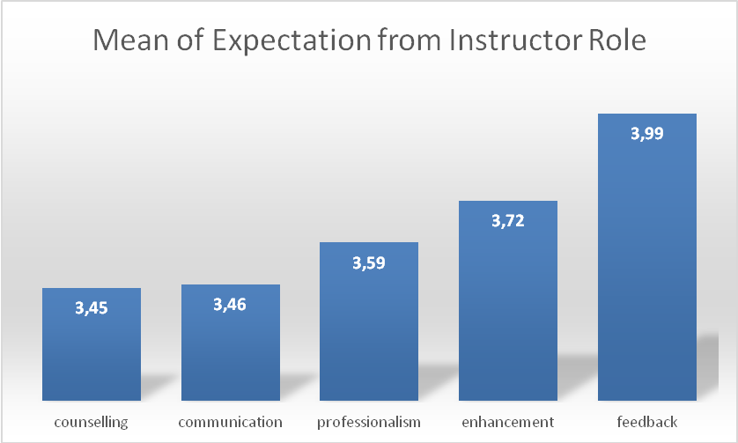
Figure 1: Mean of Expectations from the Pedagogical Instructor’s Role

The statistical findings showed that the feedback is perceived as the most important component and then by order: empowerment, professionalism, communication and personal advice. These findings support a similar research that was performed on the characteristics of the work of coach teachers in which the pedagogical instructors ranked the instructors' role according to their level of importance. The findings indicate that the feedback conversation, after a lesson given by the instructed person, is the most important role assigned to the instructor (Ziv et al., 1995).

The path Analysis produced the following results:
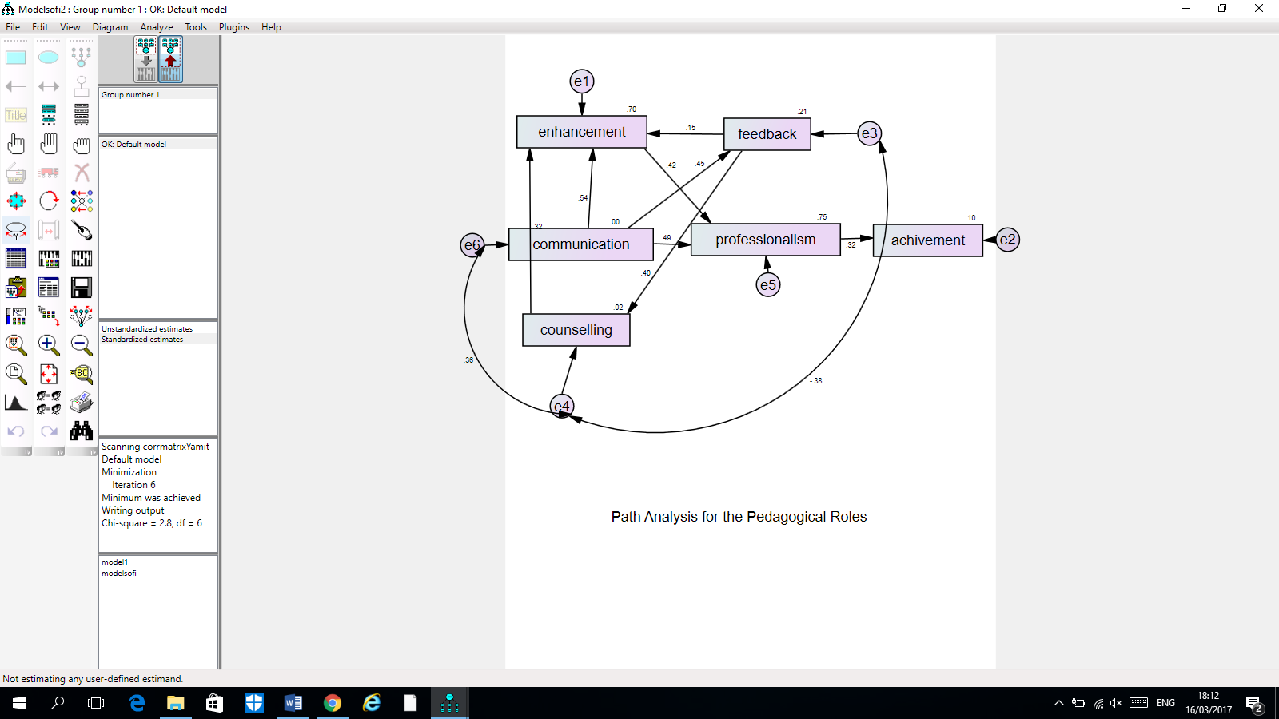
Figure 2: Findings of the Research Model of the Entire Sample

Study of the model shows that the main factor that predicts the achievements in the practical work is professionalism B=.32 However, the model also explains how other factors influence the professionalism. Two factors predict the professionalism significantly the enhancement of the students B=.42 and the communication with the students B=.49. The factor of enhancement is predicted by feedback B=.15 by communication B=.54 and by counseling B=.32 Counseling is influenced by feedback B=.40* and feedback is influenced by communication B=.45
Comparison of the Ranking Between the pedagogical Instructors Traits preferred by Student teachers and pedagogical instructor's traits that predict success in the practical work.

Discussion
The first research objective was to identify the factors that students attribute to the pedagogical instructor's effective role and the correlation between the students' expectations of the pedagogical instructor and the definition of the roles that were given to the pedagogical instructor in the professional literature and which of these factors have preferences from the students' point of view. The second research objective was to identify which factors predict achievements in the practical work. In addition, a comparison has been made between the factors that the students prefer and the factors that influence their success.
The quantitative research enabled the answer to the research questions in a clear manner. The description of the pedagogical instructor's role includes five main factors according to the initial objective of the research study. These factors are described as follows:

Professionalism
Pedagogical instructor takes part in the ideological development of the perception of training for teaching and improvement of the education and the teaching in the field, with construction of an ideological infrastructure of the college - field partnership and outlining of the ways of action for the promotion of the partners (Emanuel, 2005). This work entails the management of an instrumental dialog with all the partners - teaching students, mentors, school faculty and peers- so as to find solutions to the problems that arise from the field. In addition, the pedagogical instructor must act out of intentions for the personal and professional growth of the students as well as his personal development (Zilberstein, 2002; Zilberstein, 2005). These processes require abilities, skills and knowledge in wide variety of areas, some of which are modern. The pedagogical instructor must be able to perform diverse actions. He must support the students, encourage them to seek counseling of additional experts, observe the lessons and provide both feedback and guidance (Ariav, & Emanuel, 2006). He must also help the students integrate between different types of knowledge: content knowledge, knowledge on the teaching of the knowledge field, analysis of different situations, general pedagogical knowledge, and pedagogical learner knowledge, knowledge of educational context and knowledge of educational needs (Panso, 1995; Shulman, 1987). The pedagogical instructor must take the responsibility for building personal programs for the promotion of the students and act on both macro and the micro levels. He must form unique programs so as to provide diverse experiences in different learning environments where different kinds of knowledge must be applied (Eraut, & Hirsh, 2007). The knowledge types that the pedagogical instructor must acquire are diverse (Dror, 2009). He must remain updated in the innovations in all pedagogical fields, as well as participate in different professional development circles in the framework of the communities of the learners.

Communication
Communication constitutes a main and inseparable element in the preparation conversation and in the feedback conversation. Salomon states that effective instruction not only on communication, but also on the attribution of meanings and intentions to behaviors and to events. The emphasis is on the way that the instructed party will use the lessons of instructions (Salomon, 1987). It was found that the interpersonal dimensions of the instructors and interpersonal relations with the guided individuals have an influential contribution to quality of the instruction (Od-Cohen, 2004). Furthermore, the impact of the interpersonal dimension is equivalent to that the disciplinary knowledge regarding the component of teaching. Without solid interpersonal relations between the instructor and the instructed individual the knowledge is not perceived as useful (Od-Cohen, 2004).

Empowerment
According to Burk (1991) there are five processes of empowerment: providing a direction, arousal (intellectual new directions alongside cognitive and emotional), external rewards, internal rewards, development and appeal to the followers' needs.

Advice
The pedagogical instructor must help the guided individual find a solution to personal and interpersonal conflicts which sabotage the learning process, to help in the development in relations with the environment, to help develop skills of self-awareness and of independent thinking, to provide social psychological support. This process might also influence the students’ ability to support the future population of students (Amir, & Vaknin, 1988; De Jong, Korthagen, & Wubbles, 1996; Irwin, 1997; Korthagen, & Russell, 1995).

Feedback
The pedagogical instructor is required to provide feedback to the practical experience and to the learning process of the instructed population, to strengthen the learners, to evaluate them critically and constructively and to filter out candidates who are unsuited for teaching ((De Jong, Korthagen, & Wubbles, 1996; Korthagen, & Russell, 1995; Koster, Korthagen, & Wubbels, 1998; Rubin, 1991). The guidance interaction between the instructor and the instructed individual can be divided into three main stages which are mutually related and benefit each other. The pre-active stage includes the preparatory conversation for the lesson the instructed individual is about to perform. The active stage includes observation by the instructor. The post active stage includes a feedback conversation and further comments. The feedback conversation is the educated interpretation of the different teaching situations that the instructor has observed and the instructed individual has performed (Acherson, & Gall, 1980). Feedback conversation exposes the guided individual to educational didactic events that occurred during the teaching. The reconstruction during the feedback conversation enables the guided individual to judge and control the experience while accessing the achievements of the performance and making rational and ethical decisions (Goodman, 1985; Russell, 1989).

After the identification of the five factors, this research focused on the preference of the students. The statistical findings showed that the feedback was perceived as the most important component and then by order empowerment, professionalism, communication and feedback. These findings support previous research in which the pedagogical instructors ranked the instructor's roles according to their level of importance. The findings also indicate that the feedback conversation is the most important role assigned to the instructor (Ziv et al., 1995).
This research has also shown that the prediction of the achievements is primarily related to professionalism whereas the other factors intensify and strengthen the main factor. It is possible to indicate differences between the order of priority that the students attribute to the pedagogical instructor's roles and the prediction of the pedagogical instructor's roles in the practical work. While the students find the feedback to be the most important factor, the research shows that the prediction of the achievements is primarily related to the professionalism of the pedagogical instructor whereas other factors, including feedback, merely support and intensify the main factor.

Conclusions
The research indicates the existing gap between the roles of the pedagogical instructor as factors of success in the practical work and the roles of the pedagogical instructor in the students' personal performance. This gap is expressed in the preference that the students give to the feedback, while the success in the practical work depends on the professionalism of the pedagogical instructor. Based on these findings, the following action program is presented as a practical step:
- The gap between the students’ preference and the actual factors that predict success can be bridged if the findings of this research are presented to the pedagogical instructor before he is accepted into the instruction role and to the student before he enters the practical work, so that they can prepare for the role. It is necessary to emphasize the field of professionalism and also to take into consideration the students’ preference.
- The pedagogical instructor has a main role in the training of the teachers. He is the key figure in the training process and in the process of transformation of the student into a beginning teacher who accepts upon himself the management of a class. The findings indicate that the teacher - students' high achievements in the practical work depend on the pedagogical instructor's professionalism. Surprisingly, the role of the pedagogical instructor does not require special training. For the most part, senior teachers who have succeeded in their work as expert teachers and have Master’s degree in the studies of education are accepted to the role of a pedagogical instructor. Based on this research, we recommend considering the population of the pedagogical instructors to be the main target for the empowerment by instructions which specializes in teacher training and supervisory bodies in Academy and in the Ministry of Education. We also recommend considering the profession of a pedagogical instructor as any other profession, which requires specialization. Accordingly, the role of a pedagogical instructor should be upgraded to a pedagogical specialist.
- The analysis of the research enables to delineate the map of components that are required in order to improve the level of professionalism of the pedagogical instructor.
- There must be coordination of expectations of the instructor and the instructed individual. It is necessary to have a process of clarification of the coordination of expectations between the instructors and the students regarding who is a good teacher and what instruments must be obtained in order to achieve optimal teaching in the 21st century.
- The Component of Professionalism – During the specialization studies of the pedagogical instructor is vital to address topics related to the following subjects: what makes a teacher a good teacher, how to improve the teaching process. It is also necessary to get familiar with the styles of instruction as well as instruction process and instruction models.
- The Component of Communication – The students are not only the population of the guided individuals but also partners in a long mutual journey. As the pedagogical instructor extends the relevant knowledge related to the population of students in personal, theoretical, and practical aspects, there are increased chances of the pedagogical instructor to manage correct communication, productive conversation and instructions intended for the personal cultivation of every student.
- The component of empowerment - It is necessary to focus on the search for the ways to empower the students and to increase their involvement in the learning process.
- The component of counseling – The pedagogical instructor is called to fill the function of supporter in the integration of the students’ studies. Therefore, it is important for the pedagogical instructor to be engaged in issues such as the characteristics of the adult learners, the learning process itself, the viewpoints of the instructors versus the viewpoints of the instructed in different topics and skills.
- The component of Feedback – The feedback is an essential tool which helps the pedagogical instructor improves the students’ performance with each following instruction activity. The development of instruction abilities and the skills of feedback will help the pedagogical instructor in forming the students from a reflective point of view.

References
Acherson, K. A., & Gall, M. D. (1980). Techniques in the Classical Supervision of Teachers, New York, NY, and London, UK: Longman Inc.
Amir, M., & Vaknin, R. (1988). The Perception of the Role of the Instructor: Instruction as Education – A Reader (1-4), Jerusalem. (Hebrew)
Ariav, T., & Emanuel, D. (2006). The Mentor Teachers’ Role in the PDS Partnership Constellation, with the Post-Elementary Track: Role Perception, Formative Factors, Difficulties, and Contributions, The Unit for Research and Assessment, Beyt Berl Academic College. (Hebrew)
Burk, W. W. (1991). Leadership as Empowering Others. In: Srivastra, S. (Ed.) Executive Power. San Francisco: Jossey-Bass.
Cohn, M. M., & Gellman, V. C. (1988). Supervision: A Developmental Approach for Fostering Inquiry in Preservice Teacher Education. Journal of Teacher Education, 39(2), 2-8.
De Jong, J. A., Korthagen, F. A., & Wubbles, T. H. (1996). Learning From Practice in Teacher Education, Teachers and Teaching, October, 332-341.
Dror, I. (2009). Factors Affecting Learning and Types of Practical Knowledge Used by Student Teachers Mentor Teachers and Pedagogical Subject Teachers in a PDS Programme, Ph.D. Dissertation, University Sussex. U.K.
Emanuel, D. (2005). The Role Perception of the Pedagogical Instructor from Three Points of View, in M. Zilberstein & R. Reichenberg (Eds.) Renewed Study of the Specialization Studies Program in Pedagogical Instruction, Working Paper Number 2, Tel Aviv: Mofet Institute, 69-103. (Hebrew)
Eraut, M., & Hirsh, W. (2007). The Significance of Workplace Learning for Individuals Groups and Organisations, SKOPE, Monograph 9, Oxford University Department of Economics.
Gold, Y. (1996). Beginning Teacher Support: Attrition, Mentoring and Induction. In E. Guyton, J. Sikula, & T. J. Buttery (Eds.), Handbook of Research on Teacher Education. (2^{n} ed., pp. 548-616). New York: Macmillan.
Goodman, J. (1985). What Students Learn from Early Field Experience: A Case Study and Critical Analysis, Journal of Teacher Education, 36 (6), 42-48.
Irwin, W. J. (1997). Empowering Ourselves and Transforming Schools, Educators Making Difference. State University of N. Y., pp. 287-302
Korthagen, F. A., & Russell, T. (1995). Teachers Who Teach Teachers: Some Final Considerations, In: T. Russell & F. Korthagen (Eds.) Teachers Who Teach Teachers (pp. 187-192), London: Falmer Press.
Koster, B., Korthagen, F., & Wubbels, Th. (1998). Is There Anything Left for Us? Functions of Cooperating Teachers and Teacher Educators, European Journal of Teacher Education, 21(1), 75-89.
Od-Cohen, Y. (2004). The Contribution of the Interpersonal Dimension to the Quality of the Teachers’ Instruction, Ph.D. England: APU University. (Hebrew)
Panso, S. (1995). Content Knowledge of Profession and Content Knowledge of Pedagogy in the Training of Teaching, Ph.D. Dissertation, Haifa: Technion. (Hebrew)
Rubin, S. (1991). On Significant Instruction and Critical Moments in the Development of the Instructed, Conversations, 196-220. (Hebrew)
Russell, T. (1989). The Roles of Research Knowledge and Knowing in Action in Teachers’ Development of Professional Knowledge, Paper presented at the Annual Meeting of the American Educational Research Association, San Francisco, California.
Salomon, G. (1987). Communication: Concepts in Educational Discussion, Jerusalem: The Hebrew University. (Hebrew)
Shulman, L.S. (1987). Knowledge and Teaching: Foundation of a New Reform, Harvard Education Review, 55, 1-22.
Wang, J., & Odell, S. J. (2002). Mentored Learning to Teaching according to Standards-Based Reform: A Critical Review, Review of Educational Research, 72(3), 481-546.
Yogev, E., & Zozovsky, R. (Eds.) (2011). Instruction in the View of the Researcher, Tel Aviv: HaKibbutz HaMeuchad Press, in collaboration with the Mofet Institute and HaKibbutzim Seminar. (Hebrew)
Zahorik, J.A. (1988). The Observing-Conferencing Role of University Supervisors. Journal of Teacher Education, 39(2), 9-16.
Zeichner, K. (2010). Rethinking the Connections between Campus Courses and Field Experiences in College and University-Based Teacher Education. Journal of Teacher Education, 61, 89-99.
Zilberstein, M. (2002). Themes of a Program for the Learning of Specialization in Pedagogical Instruction – Position Paper, Tel Aviv: Mofet Institute. (Hebrew)
Zilberstein, M. (2005). The Pedagogical Instructor in the Educational Context of the Suitable Teacher, in M. Zilberstein, & R. Reichenberg (Eds.) Renewed Study of the Specialization Studies Program in Pedagogical Instruction, Working Paper Number 2, Tel Aviv: Mofet Institute, 5-13. (Hebrew)
Ziv, S., Katz, P., Zilberstein, M., & Tamir, P. (1995). Characteristics of the Work of the Pedagogical Instructors in the System of Teacher Training in Israel, Research Report, Mofet Institute. (Hebrew)

Institutional afiliation, City, Country. E-mail:

