**Initial post-contact behavior of an axially compressed fiber constrained inside a rigid cylinder –**

**Experimental, analytical, and numerical investigations**

Yossi Dayan†, David Durban**, Sefi Givli†*

†Faculty of Mechanical Engineering, **Faculty of Aerospace Engineering, Technion – Israel Institute of Technology, Haifa 32000, Israel

*Corresponding author, email: [givli@technion.ac.il](mailto:givli@technion.ac.il)

**Journal of Applied Mechanics, Copyright © 2018 by ASME**

# **Abstract**

We study the post-buckling behavior of a clamped-clamped elastic fiber constrained inside a rigid circular cylinder. The focus is placed on characterizing the contact configuration between the fiber and the cylinder wall during initial post contact stages of the fiber deformation, in which only a small segment of the fiber length makes contact with the cylinder wall. The main experimental challenge is to identify regions of contact between the fiber and the cylinder wall, yet distinguish them from segments of the fiber that are very close to the cylinder wall but make no contact with it. To this end, we employ a novel experimental setup consisting of a transparent rigid cylinder filled with an opaque milky fluid, combined with image processing and synchronized force measurements. The results agree with published theoretical predictions, which are based on a simplified theoretical model assuming a perfect fiber and no friction, under the restriction that initial diminutive geometrical imperfection. Supported by finite-element simulations, we find that friction increases the measured force for the same level of ends shortening, but has a small effect on the overall behavior. On the other hand, the initial geometrical imperfection may significantly affect the force-displacement relation and the evolution of the contact configuration. The research provides important insights regarding the influence of relevant parameters on the behavior of such systems. Additionally, the insights from the theory and the experiment may have practical implications in the fields of stent procedures, medical endoscopy, deep drilling, and the mechanics governing the growth of roots and plants.

# **Introduction**

The post-buckling behavior of a linearly elastic fiber subjected to lateral constraints is of practical importance in a variety of fields, ranging from medical procedures (like in vivo diagnosis) to engineering applications. Examples of medical procedures include the threading of a fiber for the purpose of medical imaging or for catheterization of the heart and blood vessels. Understanding the nonlinear behavior of such systems, and in particular the forces exerted by the fiber (the guidewire) on the constraining walls (artery) are highly important in order to guarantee the safety of the procedure [1]. In rare cases, the extensive deformations of the guidewire can result in the fracture of the guidewire or cause damage to the artery during the intervention procedure [2-3]. Other examples for applications involving the post-buckling of a laterally constrained fiber are the internal examination of pipe systems, the insertion of artificial fibers in industrial crimpers, drilling of wells from a platform to reach deep hydrocarbon or gas reservoirs [4], effects of delamination in composite materials [5-6], the insertion of a paper into a toner, growth of plant roots [7], and the growth of filopodia in living cells [8-11] .

Originally, the engineering community was mainly concerned with ways of avoiding large-deformations followed by buckling, and the scientific discussion focused mainly on assessing critical forces [12-15]. In the last century, starting at the early sixties, theoretical models dealing with the post-buckling behavior began to emerge. These early works focused on formulating and solving problems of (laterally-unconstrained) compressed columns and of curved beams subjected to various types of boundary conditions , [16-17]. In the last few decades, the interest in post-buckling behavior of laterally constrained fibers has constantly grown. Theoretical and experimental studies have shown that a bi-laterally constrained fiber undergoing plane deformations exhibits an intriguing behavior, and under a controlled axial end displacement, a rather rich sequence of events is presented [5, 18-20]. The sequence includes the formation of discrete (point-contact) or continuous (line-contact) regions of contact between the fiber and the constraining walls, and the instantaneous transition from one equilibrium configuration to another due to the onset of local instability. The specific details of these events depend on parameterssuch as slenderness of the fiber, the ratio between the fiber radius of gyration and the gap between the walls, the bending stiffness of the fiber, loading rate and friction [21]. Theoretical studies have adopted various strategies and simplifying assumptions, such as considering fixed constraints, frictionless walls, or assuming small deformations [4], and focused mainly on studying the range of possible equilibrium configuration, and the evolution of contact between the fiber and the constraining walls [4]. Also, numerical methods were employed to study the planar deformations of fibers subjected to more complex lateral constraints, such as non-parallel walls, non-continuous surfaces and curved surfaces [22-28]. Only a handful of studies took into account the effects of friction [29], and an even smaller body of work considered the realistic case of compliant (deformable) constraining walls [30-31].

The three-dimensional (3D) response of a fiber constrained inside a rigid cylinder has received much attention as well [32]. Here, in addition to the formation of discrete and/or continuous contact regions, the transition between planar deformations and three-dimensional configurations takes place. Typically, the initially straight elastic fiber buckles into a planar sinusoidal shape when subjected to edge-thrust. As the edge-thrust increases, the fiber makes contact with the cylinder wall, switches to a non-planar deformation, and eventually the fiber twists and adopts a helix-like shape. In some applications, such as oil well drilling, understanding the details of this behavior is crucial. In particular, once the fiber makes contact with the wall, the effectiveness of the drilling operation is dramatically decreased. Moreover, locking might occur when the fiber takes a helix-like shape with extensive wall contact. A similar phenomenon also occurs in stent operations [2-3, 21, 33]. Study of the (3D) deformations of a laterally constrained fiber was also carried out in the context of delamination occurring in fiber-reinforced composites, [34-35] .

Theoretical studies investigating the (3D) deformations of a fiber constrained inside a cylinder can be roughly divided into two main categories. The first category assumes that the constraining cylinder is slender and the deformation of the fiber is small, thus making the assumption of small-rotations applicable. Different formulations for the critical loads and post-critical configurations were studied, some considering the effects of friction [21], gravity [36, 37], and the inclination angle of the constraining cylinder [13, 38]. In the second category of studies, finite deformations are accounted for and the elastica theory is commonly adopted to describe the nonlinear behavior of a fiber undergoing finite deformations. The studies in this category are fewer, owing mainly to mathematical complexity.

Almost all theoretical works studying the finite deformations of a fiber constrained inside a cylinder have focused on the final stage of the fiber deformation, where almost the entire length of the fiber makes contact with the cylinder wall, and the fiber adopts a helix-like deformation [8-11]. The studies in [17, 37] are some of the earliest in this respect, in which an energy method was used to extract the relation between the edge-thrust and the pitch of the circular helix. To date, very little attention has been paid to the initial (post-contact) stages of the fiber deformation, following the first contact between the fiber and the cylinder wall. In this respect, the works of [39-41] provide valuable theoretical, numerical, and experimental information; however, focus was placed on extremely slender cylinders (inner radius to length ratio of ~) and on horizontal configuration, causing 90% of the fiber to be initially in contact with the cylinder even before the external load was applied. An exception is the work published recently by Chen and his collaborators [42, 43]. There, a rigorous theoretical model was developed to describe the post-buckling behavior of a perfect fiber inside a rigid and frictionless cylinder. Before external force is applied, the fiber is perfectly aligned in the center of the cylinder, making no contact with the cylinder wall. Numerical results considering relatively large inner radius to length ratio of ~, have demonstrated the wealth of possible equilibrium configurations and contact characteristics between the fiber and the cylinder wall. Yet, despite the significant contribution of that work, the inherent assumptions of the model make its applicability to real systems questionable. Further, there is currently no experimental study that systematically investigates the contact characteristics mentioned above. The goal of this paper is to make a step towards bridging this gap. We systematically study the initial deformation stages of a fiber constrained inside a rigid cylinder by means of novel experiments as well as finite-element (FE) simulations. Special effort has been put into developing an experimental method that enables the identification of contact characteristics between the fiber and the cylinder wall. This is a challenging task since even if one uses a transparent cylinder; the curvature of the cylinder strongly affects the optics and makes it practically impossible to categorically identify contact (or non-contact) between the fiber and the cylinder wall. The approach we adopted is based on filling the transparent cylinder with an opaque white fluid. Using a dark fiber and combining post-experiment image processing with synchronized force-displacement measurements has enabled quantitative identification of the deformation pattern and corresponding contact characteristics. Comparison of the results with the theoretical predictions of [42] provides valuable information regarding the applicability of the assumptions considered in that model. The assumptions of theoretical predictions include that the thin elastic fiber of length  with circular cross-section is inextensible and unshearable. Also, the fiber is uniform in mechanical properties along its length  and is stress-free when it is straight and untwisted. The fiber deformation is constrained inside a straight cylinder with radius. The centerline of the constraining cylinder coincides with the unstressed straight fiber. Gravity and friction force are not considered. The diameter of the fiber cross-section is negligible compared to that of the cylinder. We consider the deformation of the fiber when it is subject to prescribed edge thrust and under the constraint of the cylinder. It is assumed that the fiber is completely fixed at one end O. At the other end B, the fiber is clamped laterally, but is free to slide longitudinally see Fig. 1. Clamp B is not allowed to rotate about the longitudinal axis. The solution method in theoretical predictions, they have to “envision” first what the deformation pattern is, like 1-point contact or 2-point contact. In the early stage of the deformation sequence, they are guided by previous experience from the small-deformation theory, which leads us up to deformation 5. The constrained elastic deformation depends on the radius of the constraining cylinder. When  the ratio between cylinder radius and fiber length , for a relatively slender cylinder, such as , the early stage of the deformation sequence is similar to the one obtained from small-deformation theory. They are 1-point, 2-point, 3-point, and point-line-point contact deformations. However, some fundamental differences exist between these two theories even in this early stage of deformation. According to small-deformation theory, the 1-point contact deformation only exists in planar form. In the elastica model, it is found that the 1-point contact deformation of the spatial form also exists. According to small-deformation theory, the point-line-point contact deformation is the final stage of the deformation. As the radius of the constraining cylinder increases, the deformation patterns become less complicated. The number of deformation patterns before the two end clamps meet decreases. As expected, the difference between small-deformation theory and the elastica model grows as the radius of the constraining cylinder becomes larger. In the case when is larger than 0.384, the constraining cylinder has no effect on the elastica deformation. Since the model and results of [42] are highly relevant to the current contribution, we briefly review its main theoretical considerations and predictions in the next section.

# **Brief review of available theoretical predictions**

In a preliminary work, Chen and Fang [43] adopted the assumption of small deformations to study the post-buckling of a fiber constrained inside a rigid cylinder. The model considered a slender, isotropic, linear elastic, and perfect fiber (no geometrical or material imperfections) of length  and circular cross-section (bending stiffness ) where the quantityrepresents flexural rigidity of the beam in the plane of bending that is straight and stress-free prior to loading. The effects of gravity and friction were assumed negligible, and “clamped-clamped” boundary conditions were considered, i.e. one end of the fiber is completely fixed (displacements and rotations) at the center of the cylinder cross-section, while the other end can only move along the axis of the cylinder. The effects of the edge-thrust on of the fiber deformation and corresponding contact configuration were investigated. According to this model, the transition from 1-point contact configuration to 2-point contact configuration occurs at edge-thrust of , which corresponds to the critical (Euler) buckling load of a clamped-clamped column of length . Interestingly, it was found that this transition involves a “jump” in the ends shortening. It was argued that this peculiar jump phenomenon is due to the limitation of the small-deformation theory. In order to remedy this deficiency, a director theory associated with the elastica model was developed in [42] (a similar approach was applied in [44, 45] to study the deformation of a fiber subject to end-twist rather than end-thrust). All abovementioned model assumptions of [43] were adopted in [42], except the assumption of small deformations. It was found that, contrary to the small-deformation theory, the planar 1-point contact evolves to spatial (3D) 1-point contact first and then gradually transforms to the 2-point contact configuration. Further, seven deformation shapes, each characterized by a different contact configuration, were identified (see Fig. 1): (1) no-contact, the fiber “buckles” into a curved shape as force approaches Euler’s critical load, (2-1) contact forms between the fiber and the cylinder, leading to a planar (2D) 1-point contact configuration, which results in a sharp increase of the fiber response slope, (2-2) the fiber switches to a spatial (3D) 1-point configuration, which results in a significant decrease of the slope, (3) gradual evolution of a 2-point contact configuration, and (4) a 3-point contact configuration, (5) point-line-point contact, (6) 1-line contact, (7) 3-line contact.

In this paper, we investigate the mechanical response of a fiber undergoing large deformation inside a stiff cylinder with comparing between finite-element (FE) simulations, experiments, and theoretical predictions. This paper is organized as follows: In Sec. ‎2, we describe the method end materials which include an experimental system, image processing, and numerical simulations to characterize the contact configuration between the fiber and the cylinder wall during initial post contact stages of the fiber deformation and to predict the theoretical model. In Sec. ‎3, we discuss experimental, Image processing, numerical simulations results and compare them with the results from the theoretical model. Lastly, Sec. ‎4, summarizes the main conclusions drawn from this study and identifies problems for future research. The literature on nonlinear buckling and post-buckling is vast, but there is relatively

little work on contact problems. This research provides important insights regarding the influence of relevant parameters on the behavior of such systems. Additionally, the insights from the theory and the experiment may have practical implications in the fields of stent procedures, medical endoscopy, deep drilling, the mechanics governing the growth of roots and plants.

# **Materials and methods**

# **Experimental system**

Experiments were performed with an Instron 4483 machine, on which the designated experimental system was installed, see Fig. 2**.** The experimental system includes a fiber (a long and approximately  radius CSN EN 10270-1 steel wire) inside a transparent cylinder (a radius) filled with an opaque white fluid (metalworking-cooling fluid, PVR-925S, mixed with water). Due to the inherent curvature of the cylinder, which strongly affects the optics, it is practically impossible to identify the onset and progress of contact between the fiber and the cylinder wall. Filling the transparent circular cylinder with the opaque white milky fluid enables identification tracing the progress of these contact regions, as explained below. Special adapters were designed and installed to impose clamped boundary conditions at both ends of the fiber. The lower adapter was fixed to the cylinder, while the upper one was attached to the moving arm of the Instron machine, so the fiber coincided with the symmetry axis of the cylinder at the start of the experiment. During the experiment, the distance between the two ends of the fiber was slowly decreased, upon lowering the upper end, by the Instron machine; this resulted in the bending deformation of the fiber, constrained by the cylinder. This method in which the distance between the two ends of the fiber is shortened while the length of the fiber remains constant differs from the method in [34]. In that method, the fiber is injected from left to right and pulled over two feeder rollers through a slave injector and forms a slack loop and then is pulled through a primary injector into the constraining glass cylinder. Reaction forces are transmitted over an air bearing slider to the force sensor. The fiber is pulled through a channel by an idler wheel and a drive wheel that is driven by a servo-stepper motor close-up of an acrylic clamp holding the pipe in place. The deformation was examined for three different fiber radii and for two different inner radii of the cylinder as mentioned above. These geometries were chosen in order to enable quantitative comparison with the results presented in [42], i.e. two different values of the non-dimensional ratio , namely . Here  and  are the fiber radius and the inner radius of the cylinder, respectively, and  is the free length of the fiber in the initial unloaded state, i.e. the distance between the two clamping points at the beginning of the experiment. Ends shortening (decrease in the distance between the two clamps) was determined by the displacement of the upper clamp that is controlled by the Instron machine, in displacement control method. In this configuration, loads are applied to a part using a displacement, and the displacement is determined using an Encoder installed on the Instron. In this method, the displacement changes incrementally while the reaction force results depend on the stiffness of the structure. Edge thrust (axial compressive force) applied on the fiber was measured by a static load cell, and both were synchronized with a digital camera (MAKO G-223 with CMOSIS/ams CMV2000 sensor, global shutter; 50 frames per second) that was used to video the experiment. The maximum level of ends shortening was restricted in order to prevent plastic deformations.

In each experiment, two complementing characteristics of the response were recorded: First, the force-displacement relation, namely the axial force applied to the fiber along with the corresponding ends shortening. Examples of such force-displacement relations are displayed in Fig 4. Analysis of the force-displacement relation provides the core information on wire loading process revealing important aspects of the behavior, as discussed below. Second, details of contact between the fiber and the cylinder were determined by analyzing the successive frames taken by the camera, complemented with MATLAB assisted image processing. That image processing procedure aims at a clear representation of the contact region between the fiber and the cylinder wall. Synchronization between the camera and the Instron machine enables one to identify the contact configuration and relate it directly to the force-displacement relation. This enables qualitative and quantitative comparison between the behavior observed in the experiment and the structural response predicted by finite-element simulations and by the theoretical model of [42].

# **Image processing**

Each snapshot (image) underwent image processing with MATLAB, the purpose of which is to identify the contact region between the fiber and the inner wall of the cylinder. To this end, the following procedure was performed: First, the image was converted to a digital array of scalar integers in the range of [0,255]. The array size is identical to the number of pixels in the image, and the scalar values represent the gray level of each pixel, where the extreme values of 0 and 255 correspond to black and white, respectively.

Next, the image was corrected in order to produce a uniform background, i.e. make all pixels of the white fluid have the same gray level. The purpose of this step is to minimize the effects of non-uniform illumination due to the curvature of the cylinder wall. In particular, without this correction, columns of the array (image) that are far from the center are generally darker (have smaller gray-level values). The correction involved multiplying each column by a different factor, such that the average value of the fluid pixels in all columns is identical. Finally, we applied a threshold filter in order to isolate pixels corresponding to contact between the fiber and the cylinder. The threshold level was calibrated as follows: Using the force-displacement plots, we identified the image where the fiber makes first contact with the cylinder wall. In that stage of deformation, the contact configuration is necessarily a “point contact” configuration. Thus, the threshold level was set as the gray level of that contact point, and the “size” of the contact region associated with a “point contact” was determined (practically, due to effects such as imperfections and compression of the fiber against the cylinder wall, the so-called “point contact” configuration should be actually thought of as a small region of contact).

# **Finite-element simulations**

Finite element simulations were performed with the commercial finite-element software Abaqus FEA. A dynamic implicit analysis was designed to simulate the experimental system, which includes a  fiber (initial distance between end supports) that is clamped at both ends and is laterally constrained by a rigid cylinder. The symmetry axes of the fiber and of the constraining cylinder coincide at the beginning of the simulation. The fiber meshed with hexahedral solid elements, type C3D8R (8-node brick, accounting for geometrical nonlinearity), with over 50 elements in the fiber cross-section and a total of 2700 elements in the fiber. A Young’s modulus of  was assigned to the fiber, in accordance with tensile experiments which we performed with the Instron machine. Preliminary analysis with high-order brick elements and also with a larger number of elements in the mesh have resulted in similar results; thus all results shown in what follows are based on the abovementioned mesh (2700 elements, type C3D8R).

In developing equations for the implicit integration, a formula for predicting the internal forces  at in terms of the internal forces, such as the tangential stiffness, , at a time  is needed. For this purpose, two approaches are used: (1) tangential stiffness methods and (2) linear stiffness, pseudo-force methods. In the former, the internal nodal forces are predicted by [46]:



Whereas in the pseudo-force method, the internal forces are predicted using as the linear stiffness and as the pseudo-force matrix, which accounts for the non-linearities:



where the pseudo-force is either taken at time or extrapolated to from its value at .

Boundary conditions were implemented by defining zero-displacement of all degrees of freedom associated with the nodes at the two ends of the fiber. The only exception is the vertical displacement of the upper end, which was gradually increased during the simulation. The fiber’s other side had a different boundary condition in which any movement in any axes at any time could be made. In our analysis, an 80 mm ends shortening allowed in the axis which is parallel to the neutral axis of the fiber. In order to perform the analysis, the implicit method was chosen in comparison with the explicit method. The primary difference between an implicit FEM analysis and an explicit is that the implicit analysis uses Newton-Raphson iterations to enforce equilibrium of the internal structure forces with the externally applied loads. This type of analysis tends to be more accurate and can take somewhat larger increment steps. Also, this type of analysis can handle problems such as cyclic loading, snap through, and snap back as long as sophisticated control methods such as arc length control or generalized displacement control are used. One drawback of the method is that during the Newton-Raphson iterations, the stiffness matrix for each of iteration must be updated and reconstructed. This can be computationally costly. However, there are other techniques that try to avoid this cost by using Modified Newton-Raphson methods. It is useful to use both techniques on the same problem in order to be able to compare them. The type of analysis that will be suitable for solving the engineering problem depends on the kind of problem at hand. Computationally intensive dynamic analyses are often done with the explicit method.  However, for static problems now a day it is common to do the full implicit type of analysis, as the one chosen for this work. This vertical displacement describes the “shortening” between the two ends of the fiber, see Section ‎2.1. The vertical force on the upper end of the fiber, which is the force applied by the Instron machine in the experiment, was also recorded in the simulation. In all simulations, ends shortening rate was , which is comparable to the rate at which the experiments were performed. Preliminary finite-element simulations showed that lower rates produce similar results.

In order to facilitate fiber bending response from the outset, thus avoiding a bifurcation analysis at the first buckling load, we have introduced a realistic geometrical imperfection. Thus, the stress-free configuration of the fiber was assumed to admit the shape using  as the initial bending from the perfectly straight configuration, namely the deviation from the axis of symmetry of the constraining cylinder,  is the coordinate along the axis, and  denotes the amplitude of the deviation:



where all measured in millimeters and the maximum value geometrical imperfection obtained is 0.2% of fiber length  (approximately ). Eq. is recognized in post-buckling theory as the "worst" geometrical imperfection which is identical with the shape of the first buckling mode of a fiber subjected to clamped-clamped boundary conditions. Since  sets the magnitude of the geometrical imperfection, it can be used for examining the influence of imperfection on the behavior of the constrained fiber. In what follows, we show simulation results for several values of , which were implemented in Abaqus by means of an imported SolidWorks CAD model. Contact between the cylinder and the fiber was defined using penalty stiffness in the normal direction of the contact surfaces (pressure-overclosure with "hard" contact and no penetration). In addition, tangential interaction, accounting for friction between the two bodies, was set in the model. Several values of the friction coefficient were examined, representing the estimated range of the friction coefficient between the metal fiber and the Perspex wall of the cylinder, including a (greasy) metalworking-cooling fluid (more on this in Section ‎2.1).

# **Analytical insights**

In this section, we present analytical derivations for key features associated with the behavior of the fiber. The end displacement (shortening) of the fiber at the onset of the first contact between the fiber and the cylinder takes place. The analysis assumes linear stress-strain relation (Hooke’s law) and the two key features illustrated in Fig. 3.

# **End displacement for the first contact**

# The analysis in this section is based on a well-established elastic solution of a clamped-clamped fiber. An analytical model that describes the behavior of the fiber depending on the initial bending and material properties of the fiber is [12], where the initial shape of the axis of fiber is given by the eq. (3). Thus, the axis of the fiber has initially the form of a sine curve with a maximum ordinate at the middle equal to. If this fiber is submitted to the action of a longitudinal compressive force , additional deflection will be produced so that the final ordinates of the deflection curve are , quantity represents the flexural rigidity and represent the distance along the fiber. Since in determining critical load of buckled bars the lateral load vanishes, the differential equation for the column is:



Or, substituting 



Combining eq. (3), (5) with definition of  we obtain



And for the boundary condition that associated with the clamped-clamped at the ends of the fiber:



Placing the boundary conditions in eq. (7) into eq. curve (6) in , it can be solved analytically to obtain a closed form of the deflection,  (detailed results can be obtained through Maple)



While Euler buckling force, axial compressive force,  and magnitude of the geometrical imperfection, .

The bending in the  is:



Thus, eq. (9) can be used to calculate the value of amplitude of the deviation , where  represent the axial compressive force in contact moment:



Thus, eq. (11) can be used safely to calculate the value of end shortening :



In order to compare the resulting of analytical model to the empirical and numerical simulation results, we assign  as a function of for several value of , see Fig. 4 (purple line, azure point-line-point line and green line).

# **Results**

All results are presented in terms of non-dimensional quantitates [42], namely non-dimensional ends shortening, , vertical force, , and magnitude of the geometrical imperfection, . Here,  is the actual ends shortening between the two ends of the fiber,  is the initial unloaded length of the fiber, i.e. the vertical distance between the clamped ends of the fiber at the start of the experiment,  is the vertical force applied on the fiber,  is the Euler buckling force for a perfect clamped-clamped column,  is the Young's modulus of fiber,is moment of inertia of fiber, and  is the radius of the fiber.

Fig. 5 shows the force-displacement relation measured in three experiments that differ only in the radius of the fiber with values . For all three experiments, the free length of the fiber is  and the inner radius of the cylinder is are identical, implying the parameter. The results of the experiments are compared with the theoretical prediction (red dashed line). Following theoretical predictions, five distinct stages along the fiber bending process are identified to take place over the measured range of loading. These stages are indicated in the figure by numbers in parenthesis and are separated by the full circles that lie on the theoretical force-displacement curve. Those deformation stages are labeled as (1)–(4) (see Fig. 1). Due to the requirement of avoiding plastic deformations the range of ends shortening was limited in the experiments, and the theoretically-predicted deformation stage (5), point-line-point contact configuration, could not be reached. It is conceivable that the measured force-displacement relation for the (black line) fiber agrees well with the theoretical prediction. The minor deviation, smaller than 8%, in the critical value calculated for fiber buckling force is due to the effect of geometrical imperfection. This effect is expected to be more apparent with thinner fibers, which are more susceptible to geometrical imperfections. Indeed, the critical load measured for the  (blue line) and (azure line) fibers is lower than the Euler buckling load by close to 15% and 40%, respectively. As expected, the effect of geometrical imperfection diminishes as ends shortening increases. In fact, once contact forms between the fiber and the cylinder, the effect of initial imperfection becomes very small for both the and fibers. For the fiber, on the other hand, the imperfection is so significant that it influences the behavior over a large range of ends shortening, up to about. Note that the onset of (first) contact between the fiber and the cylinder wall can be directly deduced from the measured force-displacement relation; specifically, it is identified as the location on the curve at the end of the “plateau-like” region associated with , followed by a sharp increase (jump) in the loading curve slope. The first contact takes place at almost the same ends shortening value, , for all three fibers, in agreement with predictions by the theoretical model. This suggests that the initial deviation of the as-received fibers from the straight (perfect) geometry is very small. The transition from planar two-dimensional deformation to three-dimensional deformation occurs at a force , in agreement with results reported in [42-43]. The fluctuations in the measured force are presumably due to friction between the fiber and cylinder, causing a “stick-slip” like behavior; these fluctuations become larger as end shortening increases due to larger contact forces between the fiber and the cylinder wall. The contact configuration cannot be obtained directly from the force-displacement relation. To this end, we employ the image-processing procedure, as discussed next.

Fig. 6 presents the experimental results in which contact (between the fiber and the cylinder wall) is analyzed by means of the image-processing procedure described in Section ‎2.2. For each of the three fibers as mentioned above, the top row shows side-view snapshots at different ends shortening levels. For convenience and to enable comparison, these ends shortening levels and associated letters “a”-“i”, are identical with those indicated in Fig. 5 and also in the figures that follow. Specifically, ends shortening of  associated with deformation “i” could not be reached with the  fiber. Applying the image-processing procedure to the abovementioned snapshot results in the images presented in the bottom row of Fig. 6. For the  and  fibers, the deformation stages and evolution of contact show good qualitative agreement with the predictions of the theoretical model and the FE simulations, similar to deformation stages described in the preceding paragraph.

Perhaps the only discrepancy compared to the theoretical model is related to the notion of “point contact”. It is evident that point contact cannot practically occur. Instead, a small segment of contact may be considered equivalent to the theoretical notion of “point contact”. Bearing this in mind, it is argued that all images (for both fibers) up to stage “e”, indeed reflect a 1-point contact configuration. The images also clearly indicate the development of two distinct regions of contact that seem to further separate at higher levels of ends shortening, as predicted by the theoretical model in stages f, g, and h. Still, noteworthy that the size of these contacts regions changes with ends shortening. Hence, the claim that these are point-contacts is arguable. Finally, the image-processing procedure reveals three separate regions of contact in stage i, in agreement with the theoretical prediction. The good qualitative agreement, in terms of contact characteristics, between experimental and theoretical predictions is consistent with the good quantitative agreement in terms of the force-displacement relation. For the  fiber, on the other hand, the measured force-displacement relation deviates significantly from the results of the theoretical model, see Fig. 5. This is mainly due to the effects of geometrical imperfection. Fig. 6 shows that the deviation from the theoretical prediction is also reflected in the observed evolution of contact. For example, after the 2-point contact configuration forms, further increase of the ends shortening does not increase the distance between the contact points. Instead, the contact region at each of these locations increases, resulting in what appears as a line-contact configuration. This evolution of contact, which is not identical at the two contact locations, eventually evolves into (almost) a single line-contact configuration that connects between the two original point-contact locations. This behavior, and in particular the observed asymmetry evolves of single line-contact, is probably a consequence of significant geometrical imperfection combined with the effect of friction.

Next, the deformation of the constrained fiber was analyzed by means of FE simulations. Fig. 7 shows the results of finite-element (FE) simulations for the fiber with . Several force-displacement relations are shown, each associated with a different geometrical imperfection amplitude,, and friction coefficient (coulomb type friction),  (black dashed lines, red line, orange dashed lines, orange lines, azure line, and azure dashed line). For reference, the theoretical (red dashed line), analytical (purple line, azure point-line-point line and green line) and experimentally (black line) measured curves that appear in Fig. 5 (for this fiber) are recapitulated here as well. Also, we include a simulation with very small (negligible) geometrical imperfection and very small friction coefficient in Fig. 7 (red line). The results of this simulation are in excellent agreement with the theoretical prediction that assumes a perfect fiber and no friction. A minor discrepancy is observed only at relatively large levels of ends shortening, at which the transverse force applied on the fiber by the wall becomes very large resulting in non-negligible friction force. These results (and also the FE-based analysis of contact, which is discussed later) give confidence in the results of the FE simulations shown in Fig. 7, from which several conclusions can be drawn. As expected, smaller geometrical imperfections cause the height of the “plateau” region labeled as (1) in Fig. 7, before the first contact occurs, to become closer to the theoretical value of (red line). In addition, the results obtained from the analytic model shows that the geometrical imperfection affects force value before the first contact occurs when the larger the, the smaller the force to buckling.

By comparing the FE results with those of the experiment at that initial stage of deformation, we deduce that the level of imperfection in the experiment is equivalent to a value of  close to. Importantly, the influence of geometrical imperfection in later stages of the deformation is practically insignificant for values of . For larger values of  (azure line and azure dashed line), the external force is noticeably smaller, especially in the initial stages of the deformation, before the 2-point contact configuration takes place. A similar trend is also observed in the experiments when comparing the behavior of fibers with different radii, see Fig. 5. and Fig. 7 also demonstrates the effect of friction. A larger friction coefficient results in higher external force for the same ends shortening (azure dashed line). Contrary to the effect of geometrical imperfection, the effect of friction increases with ends shortening, and the difference between the measured force and the prediction of the theoretical model, in which friction was not accounted for, becomes larger. This is probably a consequence of the higher normal force and larger contact area that develop in the advanced stages of deformation.

Next, we study the evolution of contact based on the FE simulation for the  fiber, with conditions similar to those in the experiment, namely and . Fig. 8 shows the deformation of the fiber for different levels of ends shortening, , where the letters “a” to “i”, specify the corresponding locations on the force-displacement curve in Fig. 7. For each level of ends shortening, the top and bottom rows show side and top views, respectively. Interaction (contact) with the cylinder wall is illustrated by the lighter (greenish) color. The following contact configurations are identified: (a) no-contact, (b, c) planar (2D) 1-point contact, (d, e) spatial (3D) 1-point contact, (f, g, h) 2-point contact with increasing distance between the two contact points, (i) 3-point contact. These results are in complete agreement with the theoretical model, see also Fig. 1. It is important to note the extreme proximity of the fiber to the cylinder wall at deformation stages that include two or three point-contacts. This makes the investigation of contact characteristics an extremely challenging task. In fact, without the aid of the FE simulations or the unique experimental setup that we developed, one could easily (and incorrectly) interpret the contact characteristics as a continuous line contact, rather than the actual case of two (or three) small-size regions of contact separated by a rather long segment that is extremely close to the cylinder wall but does not interact with it.

Afterwards, we experimentally studied the behavior for . To this end, we used a cylinder with an inner radius of  and fibers with  (black line and azure line). The theoretical model predicts (red dashed line) that as the radius of the constraining cylinder increases, the deformation patterns become less complicated. In particular, for , it is predicted that only deformations 1–4 will be observed (see Fig. 1), while deformations 5-7, which appear for , will not show up in this case. In addition, the force-displacement relation for  is predicted to be significantly different compared to the case of . In addition, naturally, the first contact is expected to occur at a larger value of ends shortening. More important is the prediction that once spatial (3D) deformation takes place, at a force , the force does not increase any further, but slowly decreases. This is contrary to the case of , where force increases up to a level close to , during which the deformation evolves from configuration 2-2, to configurations 3,4, and 5. Except for the small discrepancy before the first contact takes place, which is associated with geometrical imperfection, as discussed earlier. The results shown in Fig. 9 agree well with the theoretical predictions. Following the experimental investigation and conclusions for the case of , it is not surprising that the evolution of contact between the fiber and the cylinder wall, shown in Fig. 10, agrees with the prediction of the theoretical model.

# **Summary and conclusions**

We investigated experimentally and numerically the post-buckling behavior of an elastic clamped-clamped fiber constrained inside a rigid cylinder. By employing a novel experimental setup, which uses a transparent cylinder filled with an opaque fluid, combined with image processing and synchronized force measurements, we were able to quantitatively study the evolution of contact between the fiber and the constraining cylinder. Up to this study, the only available experiments were performed with extremely slender constraining cylinders, namely, or for cases where (almost) the entire fiber is in contact with the cylinder. This paper presents for the first time experimental results for the evolution of deformation and contact configuration in the initial stages of deformation for non-small  values. Supported by FE simulations and analytical model, we were able to assess the contribution of geometrical imperfection and friction. Roughly speaking, the level of geometrical imperfection can be evaluated by analyzing the measured force-displacement relation before the fiber makes contact with the constraining cylinder. On the other hand, the influence of friction can be assessed by the difference between the measured force and the theoretical (no friction) prediction at advanced stages of the deformation, where the influence of geometrical imperfection is relatively small. We find that the main contribution of friction is by increasing the force (edge thrust) associated with ends shortening, and by adding “fluctuations” to the measured force which are associated with stick-slip behavior. Qualitatively, friction does not significantly affect the fiber deformation or the contact configuration (we note that this conclusion is limited to small-to-moderate values of the friction coefficient, and needs to be further examined for larger values). In addition, we found that the geometrical imperfection  of  of fiber length or larger can significantly influence the measured force as well as the evolution of contact. As long as the geometrical imperfection is smaller, we find excellent agreement between the experiment results, the FE simulations and the theoretical predictions, which considers a perfect fiber and ignores the effects of friction.

Future experiments should study the behavior of the fiber when subjected to boundary conditions different than those considered here, and extend the investigation to a range of sizes of the constraining cylinder (different values of ). It is also desired to enable larger ends shortening levels than those reached in this study, in order to examine more complicated contact configurations, such as the point-line-point and three-line contact configurations. To do this, one needs to manufacture an almost perfect long fiber (with very small geometrical imperfection) that can undergo very large deformations. It would also be interesting, and practically important, to be able to repeat the same experiment each time with a different friction coefficient. In principle, this can be done by using cylinders and/or fibers made from several types of materials, by controlling their surface roughness, or perhaps even by changing the fluid inside the cylinder.

**Acknowledgments**

This work was partially supported by the Israel Science Foundation grant ISF 581/17 to S.G.

The financial support to Y.D. by RAFAEL is gratefully acknowledged.

|  |
| --- |
| **References** |

[1] F. V. Katopodes*, et al.*, "Torsional deformation of an endoscope probe," *Proceedings of the Royal Society of London. Series A: Mathematical, Physical and Engineering Sciences,* vol. 457, p. 2491, 2001.

[2] S. Ito*, et al.*, "A case of fractured guide wire perforating the coronary artery and ascending aorta during percutaneous coronary intervention," *Journal of Cardiology Cases,* vol. 7, pp. e137-e141, 2013.

[3] J. R. López-Mínguez*, et al.*, "Rupture and Intracoronary Entrapment of an Angioplasty Guidewire With the X-Sizer Thromboatherectomy Catheter During Rescue Angioplasty," *Revista Española de Cardiología (English Edition),* vol. 57, pp. 180-183, 2004/02/01/ 2004.

[4] X. C. Tan and B. Forsman, "Buckling of slender string in cylindrical tube under axial load: Experiments and theoretical analysis," *Experimental Mechanics,* vol. 35, pp. 55-60, 1995/03/01 1995.

[5] H. Chai, "The post-buckling response of a bi-laterally constrained column," *Journal of the Mechanics and Physics of Solids,* vol. 46, pp. 1155-1181, 1998/07/01/ 1998.

[6] I. Sheinman*, et al.*, "Post-buckling analysis of multiply delaminated beams," *International Journal of Solids and Structures,* vol. 30, pp. 1289-1300, 1993/01/01/ 1993.

[7] J. L. Silverberga*, et al.*, "3D imaging and mechanical modeling of helical buckling in medicago truncatula plant roots," *Proceedings of the National Academy of Sciences,* vol. 109 (42), pp. 16794-16799, 2012.

[8] A. Mogilner and B. Rubinstein, "The Physics of Filopodial Protrusion," *Biophysical journal,* vol. 89(2), pp. 782-795, 2005.

[9] P. K. Mattila and P. Lappalainen, "Filopodia: molecular architecture and cellular functions," *Nature reviews. Molecular cell biology,* vol. 9(6), pp. 446-454, 2008.

[10] N. Leijnse*, et al.*, "Helical buckling of actin inside filopodia generates traction," *Proceedings of the National Academy of Sciences,* vol. 112, pp. 136-141, 2015.

[11] S. Pronk*, et al.*, "The Limits of Filopodium Stability," *Physical Review Letters,* vol. 100, p. 258102, 2008.

[12] S. P. Timoshenko and J. M. Gere, *Theory of elastic stability*: McGraw-Hill Book, 2009.

[13] A. Lubinski and H. B. Woods, "Factors affecting the angle of Inclination and Dog-Legging in Rotary Bore Holes," 1953.

[14] A. Lubinski and K. A. Blenkarn, "Buckling of Tubing in Pumping Wells, Its Effects and Means for Controlling It (includes associated paper 1053-G)," 1957/1/1/ 1957.

[15] I. Sheinman*, et al.*, "Post-buckling behavior of beams under contact constriants," *ASME Journal of Applied Mechanics,* vol. 61, pp. 764-772, 1994.

[16] A. Lubinski and W. S. Althouse, "Helical Buckling of Tubing Sealed in Packers," *Society of Petroleum Engineers,* vol. 14, pp. 655-670, 1962/6/1/ 1962.

[17] T. Seldenrath and A. W. Wright, "Note on Buckling of Tubing in Pumping Wells," *AIME Journal of Petroleum Transactions,* vol. 213, pp. 369-399, 1958.

[18] R. Vetter*, et al.*, "Morphogenesis of filaments growing in flexible confinements," *Nature Communications* vol. 5, pp. 1-11, 2014.

[19] S. A. Koehler and T. R. Powers, "Twirling Elastica: Kinks, Viscous Drag, and Torsional Stress," *Physical Review Letters,* vol. 85, pp. 4827-4830, 2000.

[20] H. Chai, "On the post-buckling behavior of bilaterally constrained plates," *International Journal of Solids and Structures,* vol. 39, pp. 2911-2926, 2002/06/01/ 2002.

[21] C.-W. Liu and J.-S. Chen, "Effect of Coulomb friction on the deformation of an elastica constrained in a straight channel with clearance," *European Journal of Mechanics - A/Solids,* vol. 39, pp. 50-59, 2013.

[22] P. Villaggio, "Buckling under unilateral constraints," *International Journal of Solids and Structures,* vol. 15, pp. 193-201, 1979/01/01/ 1979.

[23] J.-S. Chen and S.-Y. Hung, "Deformation and stability of an elastica constrained by curved surfaces," *International Journal of Mechanical Sciences,* vol. 82, pp. 1-12, 2014.

[24] Z.-H. Lu and J.-S. Chen, "Deformations of a clamped–clamped elastica inside a circular channel with clearance," *International Journal of Solids and Structures,* vol. 45, pp. 2470-2492, 2008.

[25] E. Miersemann and H. D. Mittelmann, "Stability and continuation of solutions to obstacle problems," *Journal of Computational and Applied Mathematics,* vol. 35, pp. 5-31, 1991/06/26/ 1991.

[26] T. C. Soong and I. Choi, "An elastica that involves continuous and multiple discrete contacts with a boundary," *International Journal of Mechanical Sciences,* vol. 28, pp. 1-10, 1986/01/01/ 1986.

[27] V. Denoël and E. Detournay, "Eulerian formulation of constrained elastica," *International Journal of Solids and Structures,* vol. 48, pp. 625-636, 2011.

[28] J.-S. Chen and W.-C. Ro, "Deformations and Stability of an Elastica Subjected to an Off-Axis Point Constraint," *Journal of Applied Mechanics,* vol. 77, p. 031006, 2010.

[29] X. Chateau and Q. Son Nguyen, "Buckling of elastic structures in unilateral contact with or without friction," *European Journal of Mechanics - A/Solids,* vol. 10, pp. 71-89, 1991 1991.

[30] S. Katz and S. Givli, "The post-buckling behavior of a beam constrained by springy walls," *Journal of the Mechanics and Physics of Solids,* vol. 78, pp. 443-466, 2015/05/01/ 2015.

[31] S. Katz and S. Givli, "The Postbuckling Behavior of Planar Elastica Constrained by a Deformable Wall," *ournal of applied mechanics,* vol. 84 (5), 2017.

[32] J. T. Miller*, et al.*, "Buckling of a thin elastic rod inside a horizontal cylindrical constraint," *Extreme Mechanics Letters,* vol. 3, pp. 36-44, 2015/06/01/ 2015.

[33] J.-S. Chen and C.-W. Li, "Planar elastica inside a curved tube with clearance," *International Journal of Solids and Structures,* vol. 44, pp. 6173-6186, 2007.

[34] J. T. Miller*, et al.*, "Buckling-induced lock-up of a slender rod injected into a horizontal cylinder," *International Journal of Solids and Structures,* vol. 72, pp. 153-164, 2015/10/15/ 2015.

[35] A. Martinez*, et al.*, "Experimental Evaluation of the Lateral Contact Force in Horizontal Wells," *Journal of Energy Resources Technology,* vol. 122, pp. 123-128, 2000.

[36] X. C. Tan and P. J. Digby, "Buckling of drill string under the action of gravity and axial thrust," *International Journal of Solids and Structures,* vol. 30, pp. 2675-2691, 1993/01/01/ 1993.

[37] P. R. Paslay and D. B. Bogy, "The Stability of a Circular Rod Laterally Constrained to Be in Contact With an Inclined Circular Cylinder," *Journal of Applied Mechanics,* vol. 31, pp. 605-610, 1964.

[38] N. C. Huang and P. D. Pattillo, "Helical buckling of a tube in an inclined wellbore," *International Journal of Non-Linear Mechanics,* vol. 35, pp. 911-923, 2000/09/01/ 2000.

[39] A. Liakou, "Constrained Buckling of Spatial Elastica Application of Optimal Control Method," *Journal of applied mechanics,* vol. 85(8), 2018.

[40] J.-P. Liu*, et al.*, "Post-Buckling Analysis of a Rod Confined in a Cylindrical Tube," *Journal of applied mechanics* vol. 85(7), 2018.

[41] J.-P. Liu*, et al.*, "Buckling of a slender rod conﬁned in a circular tube Theory, simulation, and experiment," *International journal of mechanical sciences,* vol. 140, pp. 288-305, 2018.

[42] J. Fang*, et al.*, "On a compressed spatial elastica constrained inside a tube," *Acta Mechanica,* vol. 224, pp. 2635-2647, 2013.

[43] J.-S. Chen and J. Fang, "Deformation sequence of a constrained spatial buckled beam under edge thrust," *International Journal of Non-Linear Mechanics,* vol. 55, pp. 98-101, 2013.

[44] J.-S. Chen and H.-C. Li, "On an Elastic Rod Inside a Slender Tube Under End Twisting Moment," *Journal of Applied Mechanics,* vol. 78, p. 041009, 2011.

[45] S.-Y. Li and J.-S. Chen, "A twisted elastica constrained inside a tube," *European Journal of Mechanics - A/Solids,* vol. 44, pp. 61-74, 2014/03/01/ 2014.

[46] T. Belytschko, "A survey of numerical methods and computer programs for dynamic structural analysis," *Nuclear Engineering and Design,* vol. 37, pp. 23-34, 1976/04/01/ 1976.

**Figures**

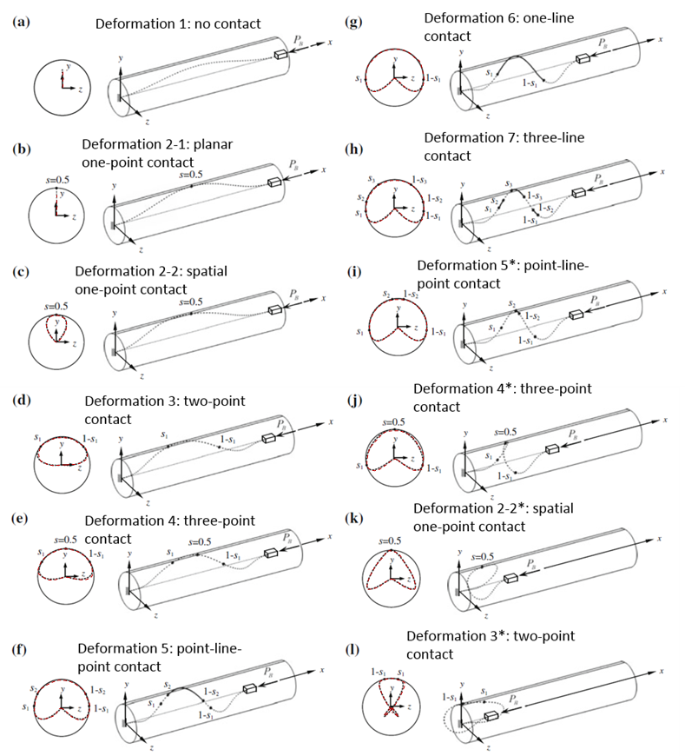

Fig. 1: Theoretical prediction (reproduced from [42]): Decreasing the distance between the ends of the clamped-clamped fiber results in stages (a) through (l), which involve seven different contact configurations.

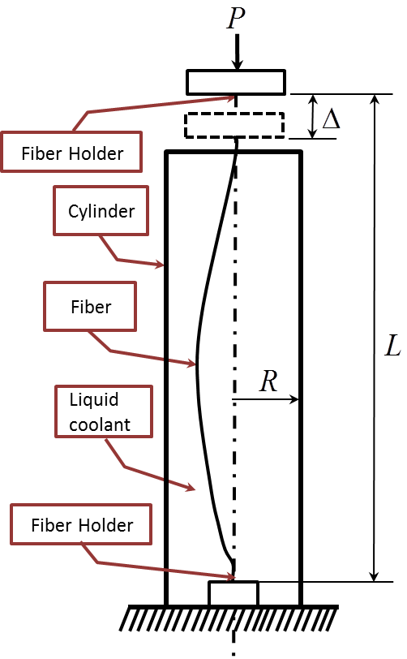

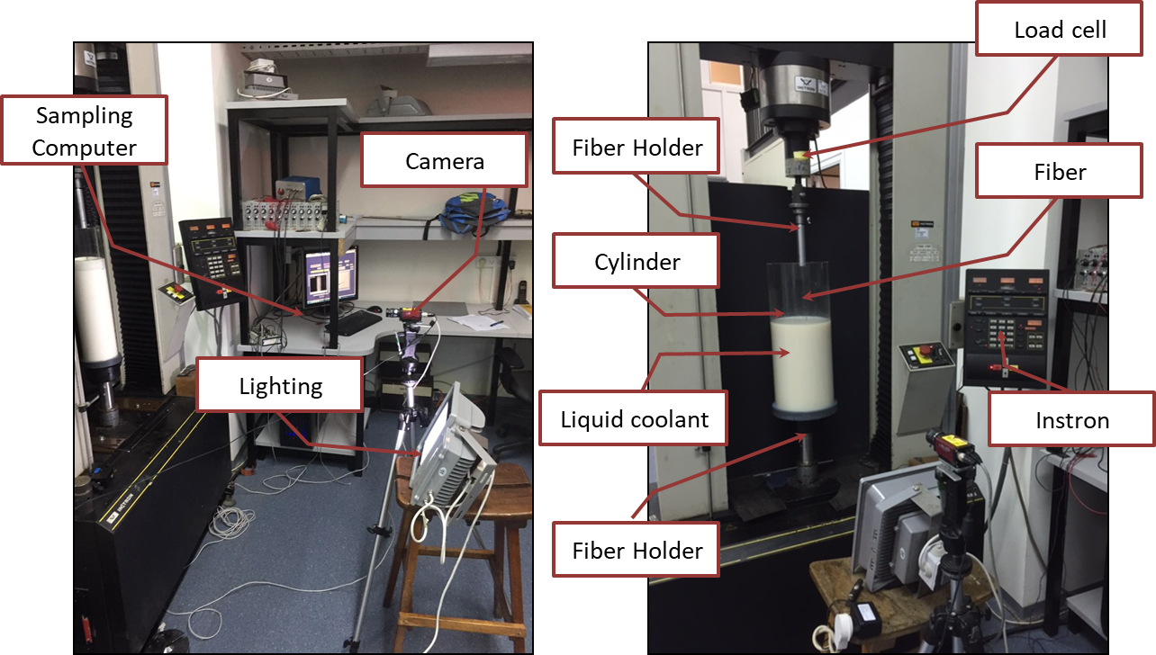

Fig. 2: (a) Schematic description of the main experiment,. (b) The experimental setup, with a cylinder

of  radius (left image), or (right image). In these images, the cylinder is not completely filled with an opaque milky fluid for the purpose of clarity.

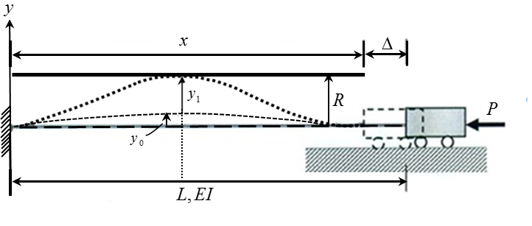

Fig. 3: Description of boundary conditions and post-buckling response of the fiber in this research

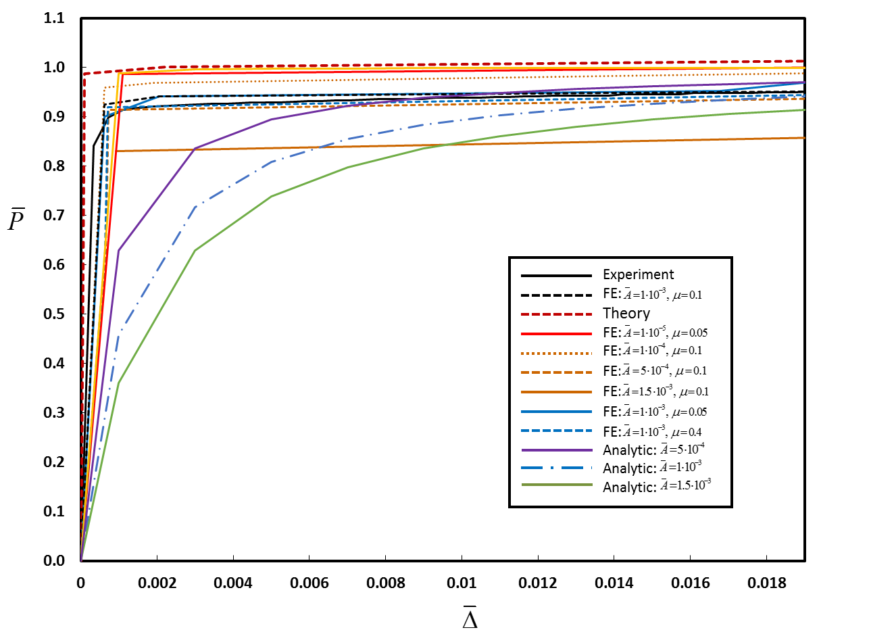

Fig. 4: Vertical force versus end shortening for a fiber of radius :,,, ε≈0.1. The experiment, analytical model and Finite-element simulations results are compared to the theoretical predictions of [42] (dashed line). Finite-element results are shown for simulations with various values of  (amplitude of the deviation) and  friction coefficient).

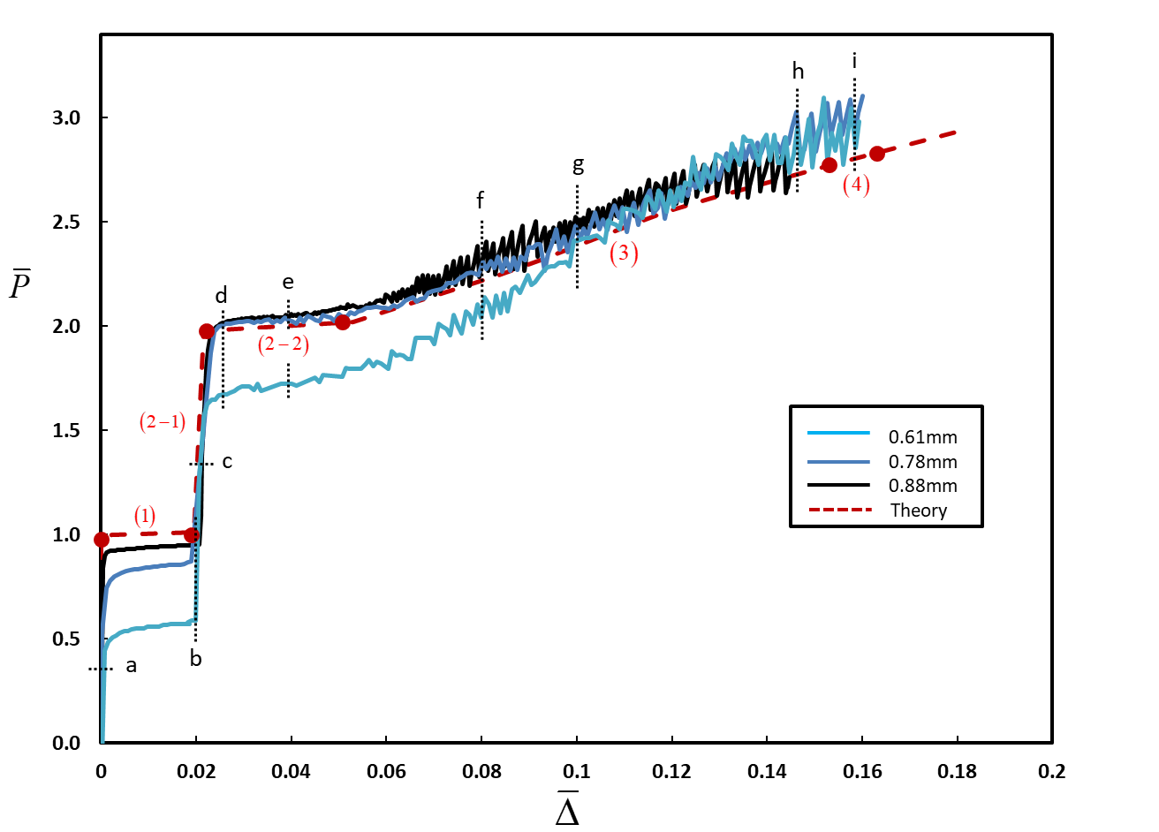

Fig. 5: Measured vertical force versus end shortening for three different fiber radii:,,, ε≈0.1. The experiment results are compared to the theoretical predictions of [42] for ε=0.1 (dashed line). Numbers in parenthesis indicate the contact configuration in accordance with Fig. 1. Filled circles identify transition from one configuration to the next.

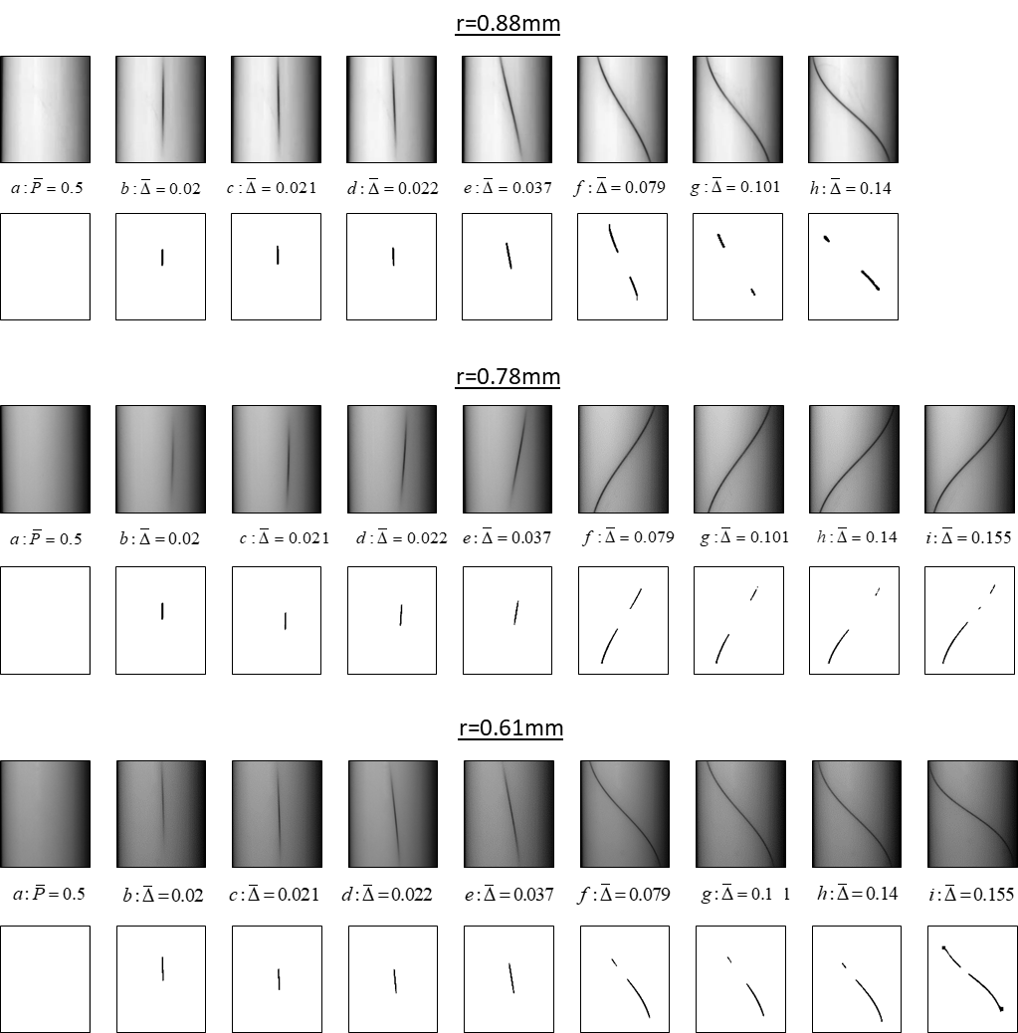

Fig. 6: Contact between the fiber and the cylinder wall at different stages of deformation for the fibers from Fig. 4 (ε≈0.1, ). For each fiber, the first row shows snapshots from the experiment at different levels of end shortening, while the second row show the same snapshot after applying the image-processing procedure. End shortening is indicated by the numbers between the two rows and also by the letters a-h that appear in the force-displacement curve, Fig. 4.

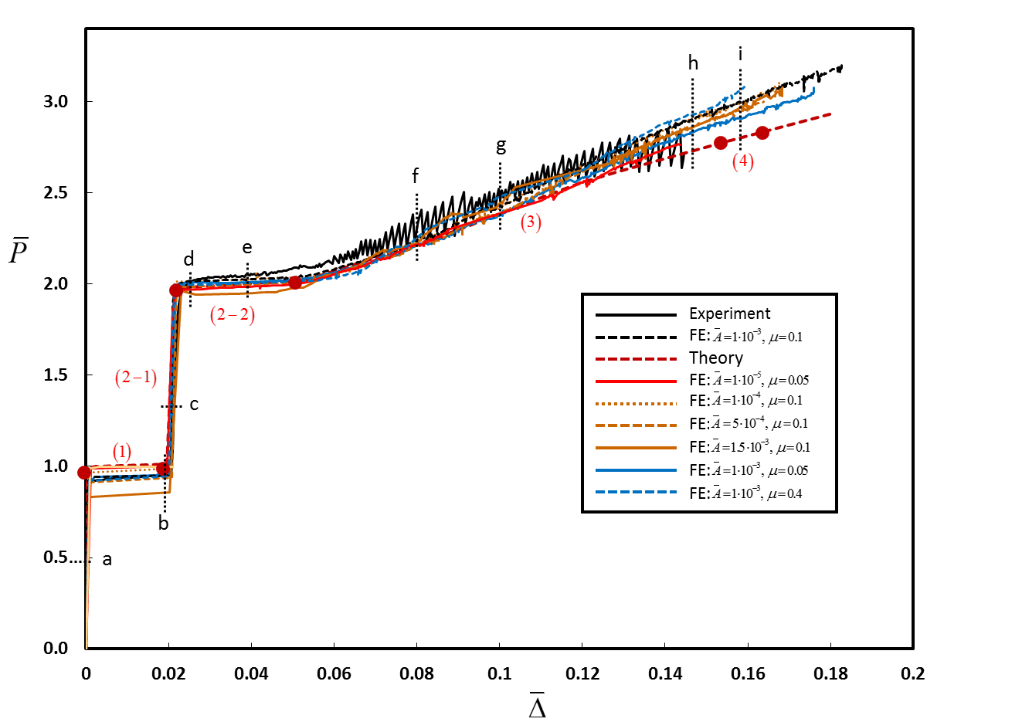

Fig. 7: Vertical force versus end shortening for a fiber of radius :,,, ε≈0.1. The experiment and Finite-element simulations results are compared to the theoretical predictions of [42] (dashed line). Finite-element results are shown for simulations with various values of  (amplitude of the deviation) and  friction coefficient). Numbers in parenthesis indicate the contact configuration in accordance with Fig. 1. Filled circles identify transition from one configuration to the next.

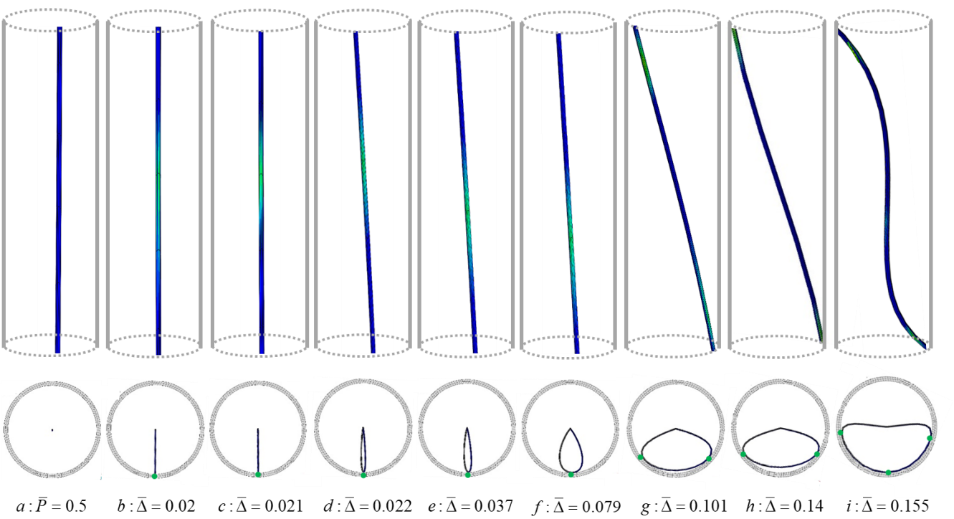

Fig. 8: Results of FE simulations showing the deformation of the fiber and contact with the cylinder wall, for a fiber of ,, ε=0.1. First row: side view, where a lighter (greenish) color indicates interaction with the wall (in these images, the schematic cylinder is shown for clarity/orientation, but the images are not at identical scale in order to allow focusing on the contact region). Second row: top view (all images are at identical scale)

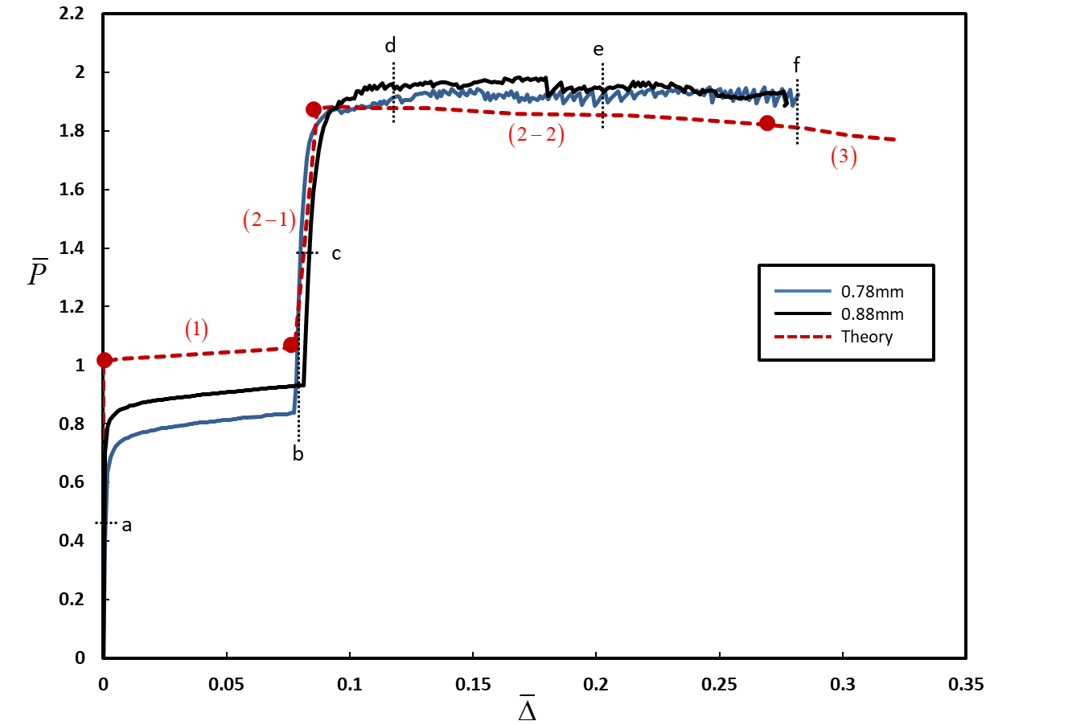

Fig. 9: Force-displacement relation. Measured vertical force versus end shortening for two different fiber radii: ,,, ε≈0.2. The experiment results are compared to the theoretical predictions of [42] for ε=0.2 (dashed line). Numbers in parenthesis indicate the deformation stage described in Fig. 1. Filled circles identify transition from one deformation pattern to the other

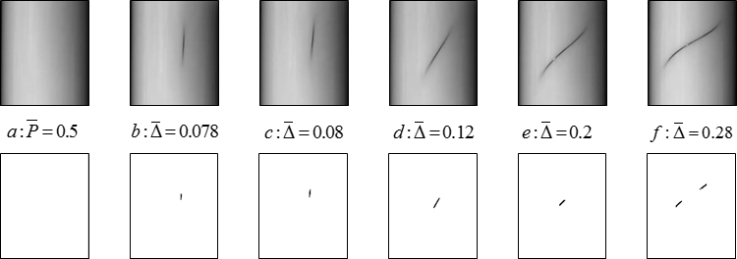

Fig.10: Force-displacement relation. Measured vertical force versus end shortening loading and unloading for radius of the fiber:.,, ε≈0.2. The experiment results are compared to the theoretical predictions of [42] for ε=0.2 (dashed line). Numbers in parenthesis indicate the deformation pattern described in Fig. 1. Filled circles identify transition from one deformation pattern to the other.