**ENHANCEMENT AND REVITALIZATION OF PUBLIC SPACES IN THE HISTORIC CENTER OF THE CITY OF GUAYAQUIL**

Abstract

The public spaces of the Euromerican and Latin American cities, differs according the characteristics that define them. A United Nations study presented in Habitat III, classified public spaces into three categories: streets, effective public spaces, and public facilities. The object of this research are the Effective Public Spaces in the Historical Centre of the city of Guayaquil (Ecuador), which has lost of its social congregation characteristic produce as the result of an internal migration process of the population abandoning the city centre to settle in the suburbs. Also causing the deterioration of the public spaces are the municipally Ordinance for Urban Regeneration focus preservation and isolation, that created limitations on their use and do not solve conflicts in the social relations between users and their environment. The aim of this research was interrelating the different public spaces scattered throughout the Historical Centre, integrating them and giving back its fundamental role of promoting their importance in the process of urban planning. The proposed empowerment and revitalization of the public spaces is develop thru: identification of the urban element, analysis of each of urban elements and design of material and immaterial connectors for the correct interrelation of the public spaces of Guayaquil.

Keywords: revitalization of public spaces, historic city centre, delimitation of historical spaces, urban landmark legislation.

# Introduction

With the interest of revitalizing and enhancing the public spaces of the Historical Centre of the city of Guayaquil (HCCG), the present study is developed to construct a proposal of urban design based on material and immaterial connectors. Different approaches proposed by prominent authors such as Allán (2011), Borja (2003), Vicherat (2007) Hakim (2007); can be integrated in defining the public space as the space where the inhabitants of the city of diverse chronological and social ranges circulate freely, socialize and recreate; All this can be characterized by accessibility, continuity of the urban environment, design and multi-functionality, security and the power of democratic call, characteristics that together provide quality of life (tangible or intangible) to the citizen.

Based on the face-to-face monitoring carried out during the first half of 2016 (7 h/day * 5 days/week), there is evidence of a loss of empowerment of the inhabitants with the public spaces in the city of Guayaquil. The limitations existing in the regulations established by local governments, despite being oriented to the preservation of the patrimonial value (Urban Regeneration Ordinance), together with the lack of regulations to the formal and informal commerce, as well as the inadequate use of the public spaces of the sector have led to this loss. Previous studies on urban regeneration and social exclusion carried out in the city of Guayaquil, show that the accelerated and disorganized growth of the city immerses the public spaces in processes of dispersion, losing their quality of public, transforming the image of the city and relationships between users, (Allán 2011).

This research establishes that: with the correct application of urban strategies oriented to the interconnection of the public spaces of the HCCG, it will contribute in the empowerment and revitalization of these spaces for the benefit of the community. The established premise and the works carried out by Architect Melvin Hoyos, in his book Two Centuries of Urban Evolution (Hoyos 2010) in relation to the historical survey of Guayaquil, are the point of reference for the development of this research. Before the problematic raised, the present research develops two proposals:

* A social initiative to promote urban regeneration of the HCCG, by including citizen participation.
* A technical proposal for adapting urban planning through the interconnection of existing public spaces in the Historic District through material connectors (green corridors, urban furniture, among others) and immaterial (referential).

As a methodological strategy, three stages will be developed for the achievement of the 2 proposals. The first stage consists in establishing the limits of the Historical Centre through the patrimonial architectural works and the public spaces of the city of Guayaquil. For this purpose, a documentary compilation and analysis of cartographic, sociological and historical data (Hoyos 2010) is carried out. The current situation of the sector is studied through the photographic survey, the technical-urban analysis of mobility and connectivity data, the relationship between full and empty spaces (Nolli map), the width of roads and sidewalks, and frequent users in the Historic District. In addition, the statistical data of two governmental institutions are evaluated: National Institute of Statistics and Censuses (INEC, 2010), and National Institute of Cultural Heritage (legal document: DR5-2016-0268-0) in relation to the level of inclusion in public spaces and technical data sheets of property considered assets. Finally, using the QGIS program, a GIS map of the Historical Area is prepared based on a geographic database, geographical charts and urban plans of specialized institutions of the city of Guayaquil, (QGIS, 2017).

The second stage identified the types of businesses present in the study sector, contrasting this information with that of Latin American cities to consider the incorporation and/or modification of the compatibility of land use with an emphasis on public spaces; this entails formulating strategies to revitalize commercial corridors without losing the main role that this sector of the city fulfills. In addition, the incorporation of an urban green infrastructure to interconnect the most representative ecological elements in the city centre (Parque Forestal, Cerro del Carmen and Cerro Santa Ana) is proposed.

In the third stage, the design of the regeneration master plan is carried out. It consists of the document base on the draft of the law to define municipal ordinances with respect to the subject treated, and of the technical proposal that facilitates the urban regeneration of the sector. The technical proposal incorporates possible connectivity solutions of the public space. The research developed interinstitutionally belongs to the line of research called sovereignty, rights and technologies of territorial and environmental ordering for construction.

Historical development of the historic centre

The Latin American cities were built on a grid drawn in planes with a capacity for growth and expansion seemingly unlimited. The centre of the city constituted a reference link for areas bordering it, implicitly defining the historical hulls for its centrality where all the buildings with artistic value, covering streets and buildings prior to the industrial revolution are concentrated. The city of Santiago de Guayaquil is located geographically to the east with the Guayas river, to the west with the Estero Salado and the hills Blue and White, to the south with the mouth of the Puntilla de Guayaquil that arrives until the Puná Island, and to the northwest with the beginning of the Cordillera Chongón-Colonche (Figure 1 left), (Municipality, 2016). In order to establish the limits of the Historic District through the patrimonial architectural works and the public spaces of the city, the area between the Venezuelan street and the street Dr. Julián Coronel Oyarvide is selected, and from Av. Quito to Av. Malecon Simón Bolívar delimiting a total of 3.7 km2, involving 7 of the 21 parishes that make up the canton of Guayaquil (parishes: Carbo, Rocafuerte, Olmedo, Bolivar, Ayacucho and Ximena, (Figure 1 rigth.)), (Hoyos, 2010).

Fig. 1

The chronological representation of the main squares and parks existing in the sector under study is presented in Figure 2. In 1881, the French artist Aime A. Millet, made the layout of the city in 156 blocks, incorporating the main squares of the city that defines the first public spaces. Unfortunately, a great part of the built heritage, 20% of the houses, and part of the historical records of the physical delimitation of the Historic Quarter were lost in the fire of 1896 (according to record of the Territorial Infrastructure Department, of the Decentralized Autonomous Government of the Municipality from Guayaquil).

Fig. 2

Since 1972, the city's public spaces have undergone no changes in form. In 1999 the Malecón 2000 enters a process of regeneration to improve the urban image of the city. In 2000, the city consolidated the parks, squares and other public spaces of its historic centre, which are the subject of this study. Table 1 presents a chronological summary of public spaces.

Table 1

# Delimitation strategy

In order to define the urban reality of the Historic District, 5 elements (distribution and land uses, population density, urban facilities, mobility and estates) are established as indicators, and are described below.

Distribution and uses of land

The Territorial Planning Plan of the Municipality of Guayaquil (SNI, 2011), outlines the city based on the land uses that predominate in each sector. As can be seen in Figure 3, within the urban boundary there is a predominance in residential use. In the Historic District the land distribution is classified into 7 zones. The central zone (1,507,758.34 m2) corresponds to 42.76% of the land of the Historic District, where the consolidation of the business sector and the presence of commerce leads to greater vehicular and pedestrian concurrency, thus promoting the reduction of residents in the sector (Allán, 2011).

Fig. 3

Population density

City of Guayaquil between 2010 and 2013, presents a variation of its population density in 100% of the parishes, as indicated in Figure 4. The migration of its inhabitants to the areas of expansion of the city and the consequent change in the land use of the sector (from residential use to commercial or administrative use) have been evidenced in the analysis of commercial corridors. This change of use modifies the activities of the users, producing high activity during working hours and reduced activity outside these hours and on holidays, which increases the risks due to insecurity. (SNI, 2011).

Fig. 4

Urban equipment

The consolidated urban layout of the Historic Quarter is compact, being this a limitation of the dimensions and the number of public spaces within. Because 42.76% of the area corresponding to the central area of the city of Guayaquil is located in the Historical Quarter, approximately 90% of the equipment registered for education, administration, worship, markets and health is located in this area (Figure 5). (SNI, 2011). On the other hand, the location of the Malecón 2000 in the plot of the historical centre and its proximity to the centennial park define the starting point of the reference axis for the interconnection of the various facilities of the Historic Quarter.

Fig*.* 5

Mobility

The urban mobility of the city of Guayaquil is organized by means of the fundamental road network and the secondary network, facilitating the main accesses to the different zones of the city of great traffic intensity (Figure 6). Road congestion is a factor that negatively affects pedestrians, cyclists, residents and the drivers themselves. According to (Zambrano et al., 2014) in the city of Guayaquil circulate approximate 380,000 vehicles between which only 4,000 are urban buses and 405 of the system of the Metro Vía and the remaining 375,595 correspond to private vehicles.

Fig. 6

The heritages

In the city of Guayaquil is identified as heritage buildings that are at least 100 years old, giving the historic character to the Centre of Guayaquil and positively impacting the city. Through the patrimony can reconstruct the trajectory of the sector, allowing to see all the historical stages and the different construction typologies used. The historic buildings surviving the fire of 1826, in 2017 are already considered heritage and are regulated as assets that safeguard the history of the time. Currently, in the historic centre of Guayaquil, 210 heritage buildings are identified (National Institute of Cultural Heritage).

# Procedure to include new spaces

When it is required to return to the central square its historical and cultural importance, the safe and comfortable transit of its users, the rescue of green spaces and other virtues inherent to it, the process of transformation of spaces is a challenge (Laub, 2007). Usually urban regeneration is conceived as the economic recovery of urban sectors in juxtaposition with terms such as rehabilitation, renovation and revitalization, with the common denominator of referring to already urbanized projects; it is necessary to consider urban regeneration as a way for economic recovery, which also guarantees a model based on sustainability and the integration of social, economic and environmental aspects (Sevilla et al., 2014).

The urban regeneration focused on the strengthening of the Historic District of the city of Guayaquil is proposed using material and immaterial connectors. The material connectors correspond to those linear pieces that have as a purpose to link urban nodes, neighbourhoods, squares and parks, improving the conditions of displacement of people (City, 2016). Among the material connectors are: urban furniture network, cycle paths and green infrastructure.

The green infrastructure or multifunctional network of ecosystems (such as: parks and gardens, streets and squares with trees, decks, green facades, water bodies, playgrounds, etc.) are included in land areas to improve bio-urban capacity. In addition, this infrastructure supports the development of territorial and sectoral policies (energy, climate change, biodiversity, public space, etc.) creating environments that improve the physical and mental health of its inhabitants and contributes to the development of a green and sustainable economy, (GIEC, 2013). Examples of this type of undertaking are the Green and Biodiversity Plan of Barcelona 2020, the National Ideas Competition for urban renewal in the central area of San Isidro, Argentina, the International Competition for the treatment of public spaces in the historic centre from Lima; the proposal of urban revitalization in General Jofré Street in the neighbourhood Vicuña Mackenna in Santiago de Chile, among others.

The intangible connectors, on the other hand, create an intangible link between the city and its users, indicating order, restriction, purchases and sales, guidelines as well as educating about the cultural and historical referents of the city. They are characterized because the interrelation with these signs creates unconsciously imaginary paths, nodes of convergence, collective memories and relations of mutually known places and allow the citizen to take possession of those spaces for coexistence. There is a diversity of urban signs that fill the city with codes and that the user must assimilate them to live in it, creating itineraries (or marks imposed by the urban space) for their use or enjoyment, (Certeau, 1999).

Analogous models of revitalization of public spaces as benchmarks for intervention

Since 1980 urban revitalization has been proposed as a mechanism to intervene in the central areas of cities that show signs of deterioration or abandonment. It requires the existence of social, economic and cultural understanding of the city to improve the urban landscape and the quality of life of its inhabitants (Allán, 2011).

Urban dynamics (day and night activities) with facilities that present social services are the most used for urban revitalization. In Latin America, the Santiago Patrimonial project created a tour through the centre of the Chilean city, implementing metal medallions installed on the ground, which allow users to rediscover the heritage value of their city. The medallions contemplate the first stage of a plan that seeks the incorporation of interactive points of information access that serves the users to be able to access a map of the full tour within the historic centre.

At the European level, the city of Copenhagen suggested that half of its inhabitants constantly use the bicycle to move to their jobs or places of study, something not so far-fetched for a city with a cycling culture. As a result, a green circuit is being planned, its object is to show that one of the keys to a more sustainable city is to ensure walking, cycling and public transport, thus reducing the use of private transport. (Martinez, 2014).

In order to guarantee the proper urban intervention of the Historical Centre, it is necessary to incorporate into the Territorial Planning Plan the strategies that allow to implement and manage the proposals that are approved for urban revitalization, rehabilitation and regeneration, as has been done in some Latin American countries and 59 % of the countries of Europe. Successful examples of previously mentioned cities in Europe point out that in making this incorporation it is possible to strengthen social and administrative cohesion for sustainable development, as well as to facilitate the participation of the private sector in the processes of urban transformation.

# Design of the intervention proposal

When spaces (squares, parks, among others) are neglected, it is evident the lack of sense of belonging of the inhabitants in the sector. The importance of public spaces in cities is related to the cultural, physical and recreational development of the people who inhabit them, so the appropriation of it by the users is one of the most important phenomena to take into consideration (Fonseca, 2015). The factors that influence the appropriation of public spaces correspond to the realization of cultural activities, social, sporting or recreational relations in places or public spaces forming part of a socio-historical construction, of territoriality by the feeling of property based on the needs and desires. (Nieto 2007).

This research analyzes the behaviour of users to appropriate public spaces with respect to the following factors: green areas, physical barriers, proximity to entities of public administration, type of design, continuity with the environment and time slots. The information gathering strategies are carried out through interviews and the application of surveys, evaluating the following criteria: knowledge, management and delimitation of the public space and Historical Centre of the city; frequency of use, motivation and factors that encourage the use of existing public spaces in the Historic District. When processing the information, a hierarchy is established regarding: the level and reasons for the use of public spaces, the use and availability of green infrastructure for such public spaces. Subsequently, an economically and technically viable, sustainable and effective solution is developed that allows the empowerment of citizens with regard to public spaces.

To achieve the strengthening and revitalization of the Historical Quarter, three fundamental aspects are defined: the ordinances to regulate the Historical Centre, the strategies of empowerment and revitalization, and the validation of the strategic proposal in the context under study.

Legal contextualization of intervention strategies: basic document of the bill to define municipal ordinances with respect to the treated topic.

The approach of urban problems requires the formulation of strategies to solve the deficiencies due to lack or poor planning; In addition, a legal frame of reference (municipal ordinances) is required to act on the previously delimited and characterized area, however, until December 2016 these aspects have not been defined and are indispensable to be able to apply the urban strategies proposed in this research.

Under the legal framework established in: the Organic Law of Municipal Regime (Article 263), the Cultural Heritage Law (Article 6), the Organic Code of Territorial Organization Autonomy and Decentralization (Art. 7), the Organic Functional Regulation of the Illustrious Municipality of Guayaquil, the Ordinances of Guayaquil, and the Cabildo of Guayaquil regulates the use, enjoyment, protection and conservation of municipal property. Taking into account the similarity existing in the urban contexts that should be regulated in the HCCG with the Ordinance of Guayaquil, the Ordinance for the Control and Administration of the Historical Centre of the city of Cuenca (Cuenca, 2016) and the Ordinance Regulator of the Historic Centre of the city of Santa Ana (Mendoza, 2012), a basic proposal is made for the development of the municipal ordinance with urbanistic approaches.

The legal framework must preserve the integrity of the public areas of the Historic District, in the event of improper use that could lead to its deterioration and destruction, as well as guarantee special protection measures in case of mass public gatherings, among other events. In establishing the guidelines for the authorization of activities and projects to be carried out within the HCCG, the priority is to protect the cultural heritage and contribute to the tourism, artistic, commercial, urban and economic development of the city's citizens. The field of application defines natural and legal persons, public or private that carry out projects within the area delimited as Historic Quarter.

The proposed HCCG delimitation is described with the aid of Figure 7, where a dashed line connecting primary and secondary points (labelled red 1-7, labelled a-m, n-o, p-s).

Fig. 7

The proposed delimitation for the HCCG is subject to approval by the National Institute of Cultural Heritage and represents the first step for the regulation of urban and architectural actions of the sector. After its approval, regulations are promoted on the management processes of the Historical Centre, based on the urban or architectural element that regulate:

1. Emerging buildings classified as monuments that make feasible the use in community equipment, administrative, religious and cultural uses.
2. Simple polarizing buildings that in their organization of spaces, forms and functions conform and delimit entire blocks.
3. Complex polarizing buildings formed by the integration of several simple polarizing elements.
4. Other buildings of monumental value.

With regard to the management of the Historical Centre, the national and regional institutions will have special and technical competences, according to the Law of Cultural Heritage (LCH), the Organic Law of Municipal Regime (OLMR) and the Municipal Ordinance (MO) derived from this proposal. The basic document of the Bill to define municipal ordinances was contextualized according to the following aspects:

1. Ensure to associate the LCH and OLMR, in their parts pertinent to the municipal ordinance.
2. Incorporate into the framework of the LCH and OLMR all the architectural and urban interventions that public institutions, private and citizens in general, which could carry out.
3. As stipulated in the LCH, the National Cultural Heritage Institute must be requested to declare property belonging to cultural heritage to sectors, streets, buildings, urban elements, architectural details of a public or private nature that merit its preservation and that whether they are included in the protection zones.
4. To request the Illustrious City Council to carry out a plan for the preservation of protected areas and their execution in a programmed manner, in accordance with the preservation and restoration policies.
5. A registration must be kept of the requests made by the citizens, works of restoration, maintenance, conservation, consolidation, new constructions, total or partial overthrows, among others, that are intended to be carried out in buildings and buildings included in the area of protection and its area of ​​influence, by the municipal body.
6. Regulate land use in the area of ​​protection and its area of ​​influence subject to the current Master Plan of Urban Development so that the vital and traditional activities of the same are not affected and distorted by new uses, especially those that promote speculation of urban land or affect the social use of it.
7. Indicate rules and measures to safeguard the integrity of sites and monumental property that have been or could be altered by changes or aggregates.
8. Inform and recommend to the Illustrious City Council on the need to perform repair, consolidation, restoration, or maintenance of urban or architectural elements.
9. To carry out constantly campaigns of evaluation and dissemination of what constitutes the cultural property of the HCCG and of the parishes of the canton, informing at the same time, about the policy and the Plan of Action realized by the Municipality.
10. Elaborate and periodically update the list of buildings and constructions that deserve to be considered by the Council as beneficiaries of the incentives contemplated in the LCH.
11. Promote public and private, national or foreign participation towards the creation of a foundation for restoration works in the Historic Quarter.
12. To establish agreements with state and private institutions, national or foreign, in order to undertake actions aimed at preserving the Historical Centre and areas declared as cultural property.
13. From the architectural - urban context it is necessary to present a glossary containing the following definitions to avoid inappropriate interpretations by professionals from other areas involved in the elaboration of ordinances: announcement, authorization, eaves, building height, use urban design of the ground, appraisal, pedestrian street, poster or signage, mapping, trade, compatibility of uses, commercial and service corridors, public space, urban image, construction line, factory line, porch line, construction permit, plans special, squares and parks, porch and land use.
14. Define the guidelines for urban planning and protection of cultural heritage with regard to the classification of land use.
15. Define the guidelines for urban planning and protection of cultural heritage with respect to the classification of the use of public spaces
16. Regulate the permissiveness that allows the operation of different activities in public spaces depending on the type of use. To this end, a tourism - cultural proposal must be presented containing at least one of the following options: exhibition of photographs, paintings, sculpture, poetry, or any other that, under the certification of the Directorate of Culture and Civic Promotion, culture, citizenship and strengthening of tourism among citizens.
17. Establish the works and types of intervention in the monumental properties of the Historic District, such as: preservation, conservation, consolidation, liberation, restoration, restitution, reconstruction, demolition, new building.
18. To create the norms of conservation, preservation, protection, urban and architectural action within the Historical Centre and its buildings, due to its historical, artistic and environmental value guaranteeing homogeneity and architectural-urban integrity.
19. Regulate commercial activities, occupation of roads and installation of signs, advertisements and propaganda in public spaces, streets and urban monuments.
20. Regulate the procedures and permits for actions that affect the urban image of the Historic Quarter.
21. Define the penalties for infraction of the effective ordinances.

The entity responsible for managing and enforcing the regulations will submit periodic reports that allow adequate follow-up to the updates and regulation for the well-being of the Historic Quarter.

Strategies for the empowerment and revitalization of public spaces in the Historic Quarter of Guayaquil.

The strategies developed are of an integrating nature, physically and visually link the urban environment and promote optimal mobility. The delimitation of the Historical Centre should be evaluated at each historical moment, allowing the establishment of relations with the dynamics of change in the rest of the city, giving the geographic place specific social content, integrating the historical elements of the city, activities and symbolic functions.

This research identified and analysed aspects and social characteristics as well as the use and activities with which the citizens refer to the Historic Quarter; additionally it was verified that there is no material delimitation established by municipal or governmental entities and no immaterial delimitation that is in the conscience of Guayaquil.



The use of material connectors (longitudinal and transverse) as urban revitalization agents, and of immaterial connectors as identity-enhancing agents are described below:

The Urban Green Infrastructure as the material connector in the Historic District seeks to strengthen its scarce presence. The green areas were estimated at 2.58 m² / hab, compared to 9 m² / hab which requires the World Health Organization. Therefore, it is proposed to increase the presence of Green Infrastructure by approximately 4 m² / inhabitant (representing 53% of the current situation).

Strategically the tree is assumed as the main element of the urban landscape because it gives benefits to the ecosystem and cities (Wiesner 2000). The incorporation of vegetation in the different urban paths also additionally allows to link the different parks and squares of the city of Guayaquil so its design will constitute a green network.

The implementation of green infrastructure in a longitudinal way, interconnects two large ecological systems of the city (Forest Park and Santa Ana Hill). Therefore, it is proposed to use tree species such as “Acacia Amarilla” and Jacaranda, which due to their landscape characteristics the colour of its flowers, abundant foliage and the low height, will improve the urban image of the Historic Quarter (Figure 8). Other benefits that these species have been:

Fig. 8

1. The noise mitigation (noise pollution) when the source of this is in the middle of the relation cup / height of the tree, (Posada et al., 2009). The mitigation effect generated by green corridors for the benefit of cities and their inhabitants is in an average reduction between 5 and 10 dB, (Figure 9 (up.)).
2. The environmental welfare of the city by the reduction of temperature, such that the increase of 10% in the cover of treetops in cities can decrease from 3 to 4 ° C at room temperature, according to data compiled in the United Kingdom by the United Nations Environment Program (Fernández 2013), (Figure 9 (low.)).

Fig. 9

The road proposal within the longitudinal connectivity proposes to reformulate the current function of vehicular containers of the streets of the Historic District, granting the street its condition of public space par excellence, making it more affordable for the pedestrian. In the west of the Historic District, the widening of the Quito Avenue of 3 to 8 meters is proposed, increasing by 5 m the current width of one of the sides along the 2.76 km (from the Forest Park to the Santa Ana hill). Where 3,30 m corresponds to the sidewalk which is destined only to the pedestrian circulation; 1.50 m to a strip of vegetation that will contain the tree species and the urban furniture that is destined to each sector and 2.50 m adjoining the strip of vegetation will incorporate a cycle network bi-directional, ending with a plant border of 0.70 m which will serve as protection between the main and the cycle route (Figure 10). Implicitly, it would be possible to increase the amount of effective public space in the Historic Quarter of the city by 38% (Garau, 2016).

Fig. 10

To finish the first longitudinal axis a plan view is presented at an intersection of av. Quito, where the distribution of the road cycle, the coverage area of the trees, the 5 channels for vehicular circulation, the pedestrian crossings, the changes of direction of the sidewalks, among others (Figure 11).

Fig. 11

A second longitudinal axis is to the east of the Historical Centre, where under the concept of urban path it is proposed to strengthen the urban axis through the interconnection of urban ecosystems (Parque Forestal, south of av. Quito, and the hill of Carmen to the north of this). Through urban analysis it is confirmed that this sector facilitates the connection of urban health facilities, administration, and the Victoria Square. It proposes to incorporate a bike path with two lanes and a vegetative border separating it and the avenue, a strip of afforestation that interconnects the ecological systems of the Historic Quarter.

Under the guidelines of the green infrastructure, along with the continuity of the public space Luque Street is selected as the most conducive to be intervened, because it has an average sidewalk width of 2.00 meters additional to the withdrawal allowed on the second floor. The second plant has a height of approximately 4.00 meters, so it is possible to incorporate the small tree species Samán and Acacia morada. Figure 12 shows the network of vegetation both longitudinal and transverse interconnecting public spaces, will generate comfort the users of the Historic District when circulating on different routes.

Fig. 12

The immaterial connectors as agents that enhance the identity, in this study correspond to the parks and squares, buildings and areas of great patrimonial wealth that constitute connections and generate the feeling of belonging or historical remembrance to own and strangers along the different routes which provides the historical case of the city of Guayaquil.

Among the alternatives detected as immaterial connectors is the creation of tourist corridors through the establishment of four routes:

Route of the churches (Blue line): it crosses the most significant centres of worship for the population. Connections (N-S, E-O) are proposed by means of immaterial corridors. It starts at the intersection between Clemente Ballén streets and Chile Street, La Catedral church. It is proposed to liberate the physical barriers of the Seminary Park, in order to promote the appropriation of this public space, its surroundings and the corridors raised within the urban proposal, (Figure 13 (low.)). Churches 1 to 5 run in chronological order (see Table 1).

Fig. 13

Route of the Independence (Pink line): it proposes the tourist potentiation of the axis formed by Av. Malecón Simón Bolívar and Av. Eloy Alfaro (Figure 14); representing there as the independence of the city of Guayaquil took shape. The points indicate the buildings where the meetings were held prior to the cry of independence. Route that manages close relation with the circulation of the trunk 1 of the Metro via.

Fig. 14

Patrimonial Route (Yellow Line): with the support of the National Institute of Cultural Heritage, each of the heritage buildings located within the Historic District of the city of Guayaquil is traversed and identified (Figure 15).

Despite the 276 heritage buildings in the centre of the city of Guayaquil, the patrimonial route will focus on connecting 243 buildings (more symbolic) according to data compiled by the National Institute of Cultural Heritage.

Fig. 15

Commercial Route (Fuchsia Line): defined by analysing the relationship between commercial activities (low, medium and high intensity) with the use of land, gauge and vegetation in the sector, respectively; also the level of satisfaction and demand of the users (residents of the sector, tourists, visitors among others) with respect to such relationships should be analysed. It is obtained that the Historic District presents / displays a mixture in the uses of soil, with sectors very marked by the commerce destined to the clothes and appliances. The inclusion of the urban green plan to the identified high-intensity routes (Avenues 10 de Agosto and Sucre, between the stretches comprised by Quito and Boyacá streets), generates an immaterial connection when looking for the intersection with another avenue of similar characteristics Boyacá).

With the elaboration of a commercial route (Figure 16) and the proposal of regulation with urban approach it is possible the transformation of the compatibility of land uses; In addition, commercial activities could be developed during the night-time in the quest to revitalize the HCCG. Due to the importance of the recovery of housing uses in the Historic District, it is proposed to allocate the housing on the upper floor and on the lower floor the trade, with pleasant commercial fronts to improve the urban image of the sector; thus enabling and revitalizing the partial pedestrianization.

Fig. 16

Validation of the strategic proposal

Using the Space Syntax program (SSNetwork, 2017) to corroborate the proposed routes of this research, a model of the different morphological configurations of the city is made. Space Syntax models through probabilistic analysis and makes possible the theory of natural movement; its application in the study of public spaces will determine how the physical environment influences the development of human activities (Arnaiz et al. 2013). The analysis of the different patterns of movement of the users of the historic centre will determine the different routes originated as connecting axes.

Space Syntax manages two theories for the analysis of the urban morphology of the city; in this research the choice theory refers to the routes as a measure for any socioeconomic relationship, focused directly on city-scale urban interventions. The integration theory then calculates the closeness of each element to the rest of the system components.

To perform the spatial analysis of the HCCG based on streets, squares, parks, an axial map is used, (Figure 17). Supported in axial map Space Syntax determines the connections between the various axes, and quantifies the degree of accessibility of the urban frame through the axial distance (distance between two elements of the space network such that the number of changes of direction to go from one to another is minimal); and additionally performs a correction based on how each one of the changes in direction occurs, defining a normalized magnitude (angular normalization). Normalization applies to the analysis of choice and integration, (Al Sayed et al., 2014)

Fig. 17

The sum of all the axial distances of an origin element with respect to all the elements of the system is called total axial distance. The lower total axial distance has connections with lower angle of rotation improving accessibility. This normalization applies to both choice and integration. When determining the proximity between the components of the system, it is measured how accessible each segment is to the rest and how much potential it has as a destination of movement. The smaller number of changes of direction between elements of the system indicates a greater integration between elements (Arnaiz et al. 2013). Space Syntax using a colour code associated to a numerical scale, indicates the range of interconnectivity that presents each segment studied as indicated in the legend of Figure 18. The results obtained from the axial categorization in the sector under study, indicating the total of segments that define the connectivity and its percentage weight (Figure 17 (low.)).

Spatial analysis continues with the application of choice theory; Space Syntax uses the standardized measure of choice (NACH) and by means of a colour code associated to a numerical scale, indicates the range of segments with greater value within the relation of the urban plot of the historical centre, which allows us to identify the most suitable routes to be intervened urbanistically within the Historic District, (Figure 18 (sup.)). The results obtained in the assessment of connectivity in the sector under study, indicating the total number of segments that define the connectivity value (Figure 18 (low.)) And its percentage weight.

Fig. 18

The choice analysis categorizes the accessibility of the segments by distributing them by ranges, the ranges from -2.49 to 1.34 correspond to segments less travelled by users; between 1.34 and 1.52 correspond to segments with characteristics suitable to be boosted by urban interventions; between 1.52 and 9.32 correspond to segments that have all the accessibility conditions determined by the natural movement theory of the Space Syntax.

The choice analysis allows to identify that only 16% of the routes under study have a high connectivity index. Additionally, the Avenues Quito, Chimborazo and Malecón are identified in the Historic District as the routes that allow greater connection of the south - north; the streets El Oro, Venezuela and Carlos Gómez Rendón as those with the greatest connection in the west - east direction (Figure 19 (left)). Therefore, these routes are fundamental within the socioeconomic relation of the historical centre. Testing a 100% accuracy between socioeconomic reality and modelling with Space Syntax for the sector under study. In Figure 19 (right), one can see how the different routes (heritage, commercial, independence and church route) overlap and complement each other in the established network.

Fig. 19

The incorporation of the proposed routes allows the integration of the south, centre - south and north zones of the historical centre (Figure 20 (sup.)), Serving as main axes for the enhancement of the road and pedestrian system; to achieve that 38% of the city's segments of roads increase the connectivity index (Figure 20 (low.)), being that with this model of empowerment for the historical centre through material and immaterial connectors achieves the goal. In addition, the correct interconnection between the public spaces of the Historic Quarter.

Fig. 20

Conclusions

The city of Guayaquil has been immersed in a process of transformation in its urban image in the last biennium product of urban models and urban regeneration programs, however the lack of adequate legislation makes it difficult to progress adequately if historical and patrimonial elements are involved.

If the safety and functionality components are included in the proposal of municipal ordinances, the competitiveness in different fields for the Historic District is strengthened, according to what was proposed in the New Urban Agenda.

The proposal of intervention of the historical centre as an urban strategy that contributes to return the city to its users, improving the social interaction in their spaces and directly promoting the feeling of belonging for their city. This results in the recognition of the heritage values ​​of the city using the sensations generated by the different corridors for the appropriation of the historical centre.

With the integration of material and immaterial connectors, sensations will be generated that strengthen the coexistence in their connections, improving the spatial quality, giving back to public spaces their characteristic of being meeting points by concentrating multiple activities and attracting the use of complementary ground in daily activities, providing well-being and security to people.

The incorporation of urban green infrastructure in the different sections presented in the proposal, as a result of this research, generate great environmental and social benefits, such as noise mitigation and temperature reduction according to the characteristics, structure and density of the selected tree species. The proposal of green corridors seeks to reduce the impact of the car park, harmonizing its relationship with pedestrians, cyclists and residents.

  On the other hand, the use of tree species of low height and great cup in the areas where there are urban nodes of considerable activity will guarantee a greater concentration of people, which turns these places into insurance. Finally, because the southern area has insufficient green areas and is a densely populated area, the proposal must be rectified from the exterior design incorporating vertical gardens and green roofs.

It is essential to understand that the delimitation of the Historical Centre should be evaluated in each historical moment, allowing to establish relations with the dynamics of change of the rest of the city, giving the geographic place specific social content, integrating the historical elements of the city, activities and symbolic functions.

List of references

Al Sayed, K., Turner, A., Hillier, B., Iida, S. and Penn, A., (2014) *Space Syntax Methodology*. 4 Ed. Bartlett School of Architecture, UCL, London.

Alcaldía (2000) Ordenanza de Regeneración Urbana para la ciudad de Guayaquil M. I. Municipalidad de Guayaquil. [http://guayaquil.gob.ec/Ordenanzas. Consulta junio 2017](http://guayaquil.gob.ec/Ordenanzas.%20Consulta%20junio%202017)

Allán, H. (2011) *Regeneración Urbana y exclusión social en la ciudad de Guayaquil: el caso de la playita Del Guasmo, Pobreza Urbana en América Latina y El Caribe*. Ed. CLACSO, Argentina, pp.69-104.

Arnaiz, M., Ruiz, B. and Ureña, J. (2013) El análisis de la traza mediante Space Syntax. Evolución de la accesibilidad configuracional de las ciudades de Toledo y Alcalá de Henares*. ZARCH: Journal of interdisciplinary studies in Architecture and Urbanism*, No.1, pp.128-141.

Borja, J. (2003) *La ciudad conquistada*. Ed. Alianza S.A. ISBN:84-206-4177-4 Madrid.

Certeau, M. (1999) *La invención de lo cotidiano 2. Habitar, cocinar*. *Universidad Iberoamericana, Instituto Tecnológico y de Estudios Superiores de Occidente*, México. ISBN:968-859-377-X.

Cuenca (2016) Ordenanza para el Control y Administración del Centro Histórico de la Ciudad de Cuenca. GAD MUNICIPAL DEL CANTÓN CUENCA, [www.cuenca.gov.ec/?q=node/8747](http://www.cuenca.gov.ec/?q=node/8747). Consulta junio 2017

Fernández, A. (2013) Árboles en las ciudades: seis razones para querer más. EROSKI CONSUMER, www.consumer.es/web/es/medio_ambiente/naturaleza/2013/01/10/215304.php 19 abril 2017

Fonseca, J. (2015) La importancia y la apropiación de los espacios públicos en las ciudades, PAAKAT

*Revista de Tecnología y Sociedad*, Vol.4, No. 7. ISSN:2007-3607 Universidad de Guadalajara

UDGVIRTUAL.

Garau, P. (2015) Global public space toolkit: from global principles to local policies and practice, United Nations Human Settlements Programme (UN-Habitat), Editor Dominic O’Reilly GOP-Kenya. ISBN:978-92-1-132656-7

GIEC, 2013. La Infraestructura Verde: concepto, multifuncionalidad y escalas. *La Infraestructura Verde Urbana de Vitoria-Gasteiz*. p. 6-7. Ed. Centro de Estudios Ambientales Ayuntamiento de Vitoria-Gasteiz

Hakim, B. (2007) *Generative processes for revitalizing historic towns or heritage districts* 12:87. Urban Des Int <https://doi.org/10.1057/palgrave.udi.9000194>. Palgrave Macmillan UK Online ISSN:1468-4519

Hoyos, M. (2010) *Los Planos de Guayaquil - Dos Siglos de Evolución Urbana*, Poligráfica, Guayaquil.

INEC (2010) Resultados del censo 2010. Instituto Nacional de Estadísticas y Censos, [www.ecuadorencifras.gob.ec/resultados/](http://www.ecuadorencifras.gob.ec/resultados/). Consulta 30 mayo 2017

Laub, C. (2007) La ciudad, los miedos y la reinstauración de los espacios públicos. *Espacios públicos y construcción social.* Hacia un ejercicio de ciudadanía. Editado por Olga Segovia Ediciones SUR, Chile, pp.49-56. ISBN:978-956-208-079-8

Martinez, C. (2014) Los planes que desarrollará Copenhague como Capital Verde Europea 2014. Plataforma Urbana, www.plataformaurbana.cl/archive/2014/03/27/los-planes-que-desarrollara-copenhague-como-capital-verde-europea-2014/ Consulta mayo 2017

Mendoza, E. (2012) Ordenanza Reguladora del Centro Histórico de la ciudad de Santa Ana. Diario Oficial, Vol. 126, No.400, pp.29-40 Rep. Salvador <http://www.diariooficial.gob.sv/diarios/do-2013/07-julio/10-07-2013.pdf> Consulta mayo 2017

Municipality (2016) Geográfia de Guayaquil. IMG. http://www.guayaquil.gob.ec/geograf%C3%ADa-de-guayaquil 14 febreró 2017

Nieto, C. (2007) Comunicación alternativa para la movilización ciudadana: un parque mil voces. Revista académica del *foro Iberoaméricano sobre estrategías de la comunicación*, Vol. 1, No.6, pp.3-23.

Posada, M., Arroyave, M. and Fernández, C. (2009) Influencia de la vegetación en los niveles de ruido urbano. *Revista EIA Escuela de Ingeniería de Antoquía*. ISSN:1794-1237 No.12, pp.79-89. Colombia

QGIS Quantum GIS Development Team (2017) Quantum GIS Geographic Information System, Open Source Geospatial Foundation Project, http://qgis.osgeo.org.

Sevilla, A., Castrillo, M., Matesanz, Á. and Sánchez, D. (2014) ¿Regeneración urbana? Deconstrucción y reconstrucción de un concepto incuestionado. *Papeles de relaciones ecososiales y cambio global*, No.126, pp.129-139.

SNI (2011) Ordenanza que incorpora a la noramtiva municipal el plan de desarrollo del cantón Guayaquil. Sistema Nacional de Información, app.sni.gob.ec/sni-link/sni/PORTAL_SNI/data_sigad_plus/

sigadplusdiagnostico/0960000220001_DOCUMENTO%20PDOT_13-03-2015_10-28-09.pdf. Consulta Marzo 2017

SSNetwork Space Syntax Network (2017) Version 027. The Space Syntax Laboratory, [www.spacesyntax.net/software/](http://www.spacesyntax.net/software/)

Vicherat, D. (2007) ¿Qué tienen en comun la identidad, el espacio publico y la democracia?. Olga SEGOVIA (ed.), Espacios Publicos y Construccion Social. Hacia un ejercio de ciudadania, Chile, Ed. SUR. http://hdl.handle.net/1814/8517. Consulta 5 septiembre 2017

Wiesner, D. (2000) Metodología para la definición de una Estrategia de Arborización. *Foro de Arborización Urbana*, Bogotá

Zambrano M. and Gavilanez P. (2014) Análisis de competitividad del transporte público y el transporte privado en la ciudad de Guayaquil – sector Sauces. MSc Thesis pp 35-36, Pontificia Univ. Católica de Guayauil.

Word count: 7990

Date of manuscript: 20 April 2018

Tables, Figures and plates

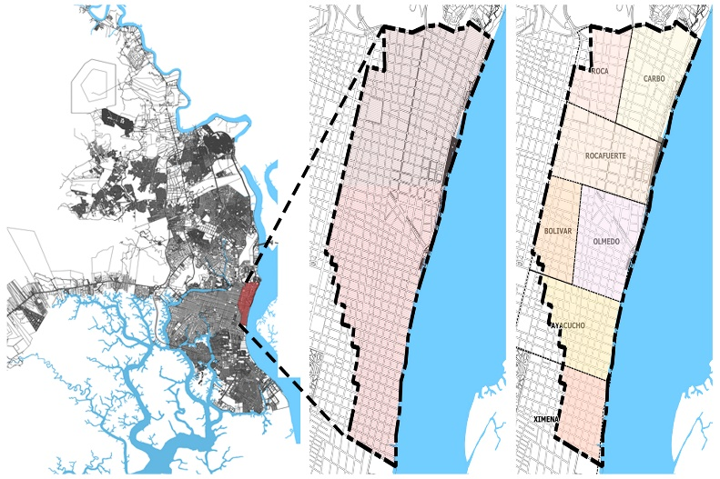

Fig. 1: Location of the study area: (left) Location of the city of Guayaquil; (right) Parishes that make up the Historic Quarter (Adapted from Cartography of Guayaquil, 2015)

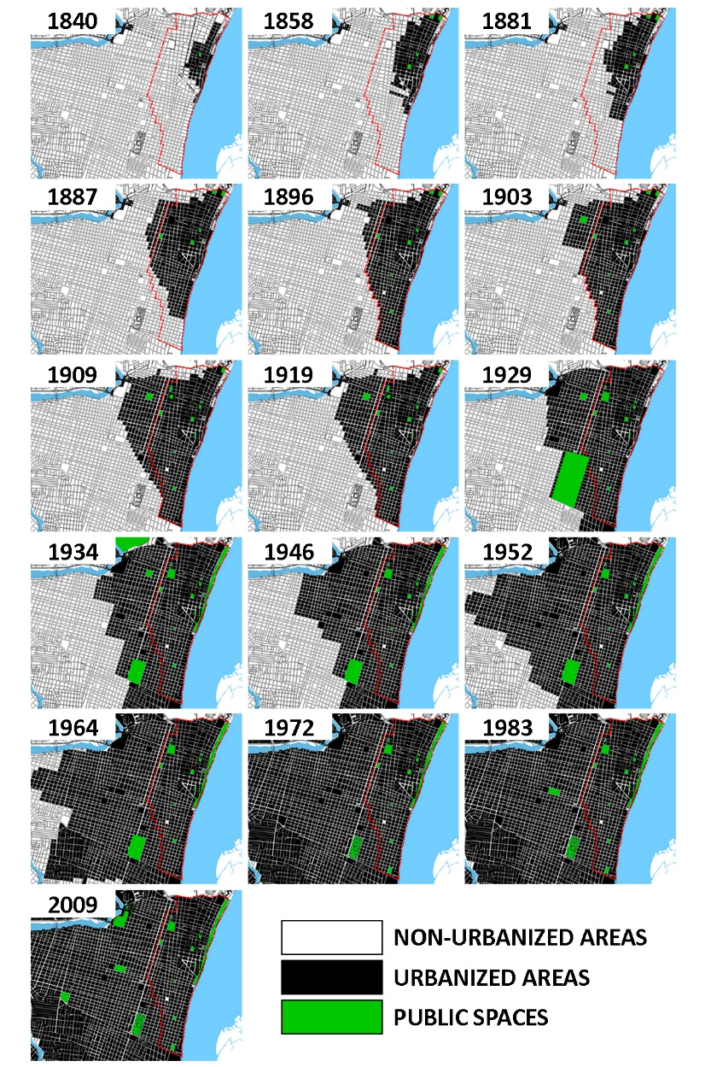

Fig. 2: Nolli Map of the Old Town, (Adapted from Hoyos, 2010).

|  |  |  |  |  |
| --- | --- | --- | --- | --- |
| **PARISHES WITHIN GUAYAQUIL’S HISTORICAL CENTER** | | | | |
| **Parish** | **Date** | **Parks** | **Squares** | **Heritage Buildings and Neighborhoods** |
| GUAYAQUIL | 1740 |  |  | Las Peñas neighborhood  El Astillero neighborhood  Santo Domingo de Guzmán church  San Francisco church |
| CARBO | 1840 |  |  | La Merced church |
| 1858 |  | San Agustín square  La Parroquia Square  Santo Domingo square | Artillery barracks |
| 1881 |  |  | La Concepción church |
| 1909 |  | Pedro Carbo Square |  |
| OLMEDO | 1840 |  |  | Governorate  Cathedral  Municipality  Market |
| 1858 |  |  | El Astillero |
| 1881 |  |  | Amphitheater |
| 1887 |  |  | Hippodrome |
| 1909 | Montalvo Square (Juan Montalvo Park) |  |  |
| 1934 | Olmedo Park |  |  |
| BOLÍVAR | 1887 |  |  |  |
| ROCAFUERTE | 1840 |  | San Francisco square |  |
| 1858 | Cathedral square (Seminario Park) |  |  |
| 1887 | Victoria plaza (Victoria Park) |  | Victoria church |
|  | Chile square (Parque Chile) |  |  |
| 1909 | La Independencia square (Centenario Park) |  |  |
| AYACUCHO | 1896 | República plaza (España park) |  |  |
| ROCA | 1934 | 24 de Mayo plaza (Mother’s park)  San Agustín park |  | Municipal park (Forest park) |
| XIMENA | 1972 | Armada’s park |  | Abdon Calderon museum |

Table 1: Chronological Synthesis of Public Spaces.

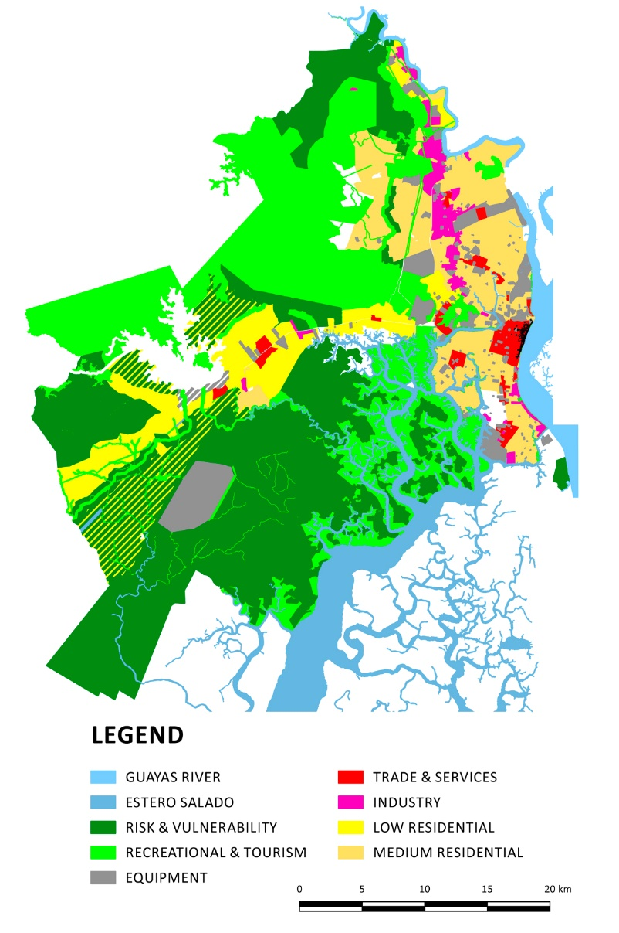

Fig. 3: Prevailing land uses by sector, (Cartography of Guayaquil, 2015).

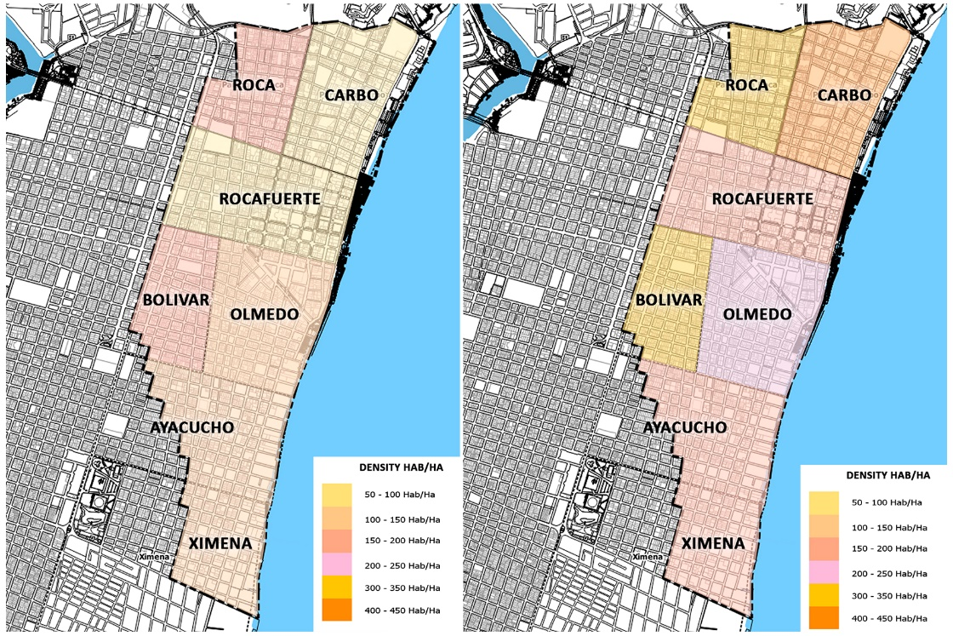

Fig. 4: Variation of population density by parish, (Adapted from Cartography of Guayaquil, 2015).

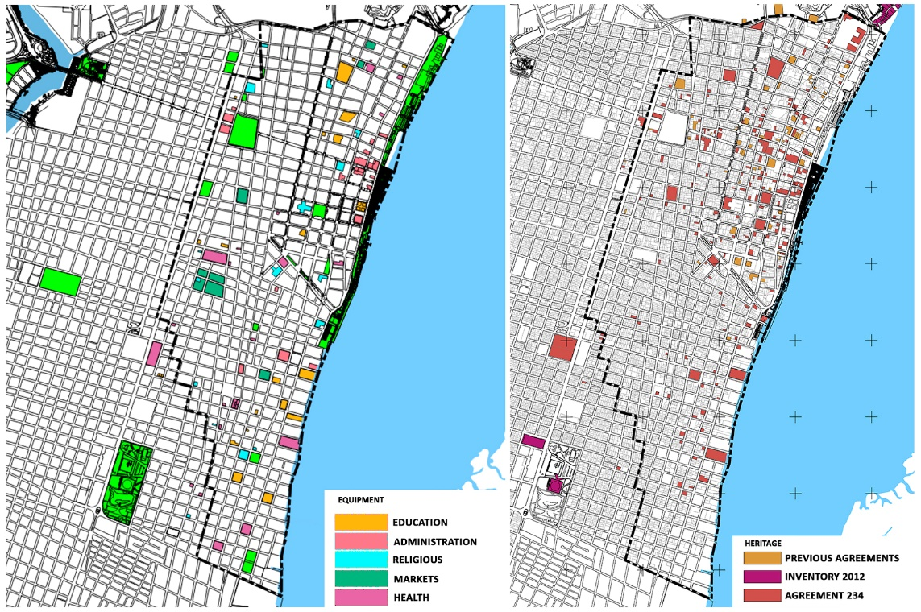

Fig*.* 5: (right) Equipment; (left) Properties listed as heritage, (Adapted from Cartography of Guayaquil, 2015).

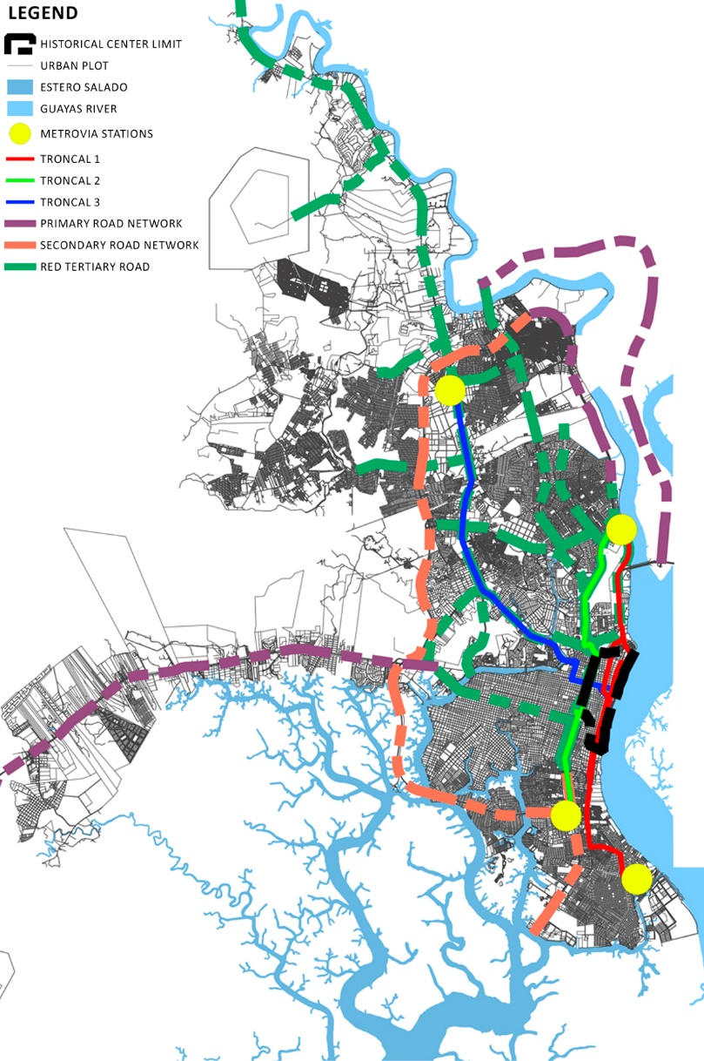

Fig. 6: High to low vehicular intensity roads within the Historic District, (Cartography of Guayaquil, 2015).

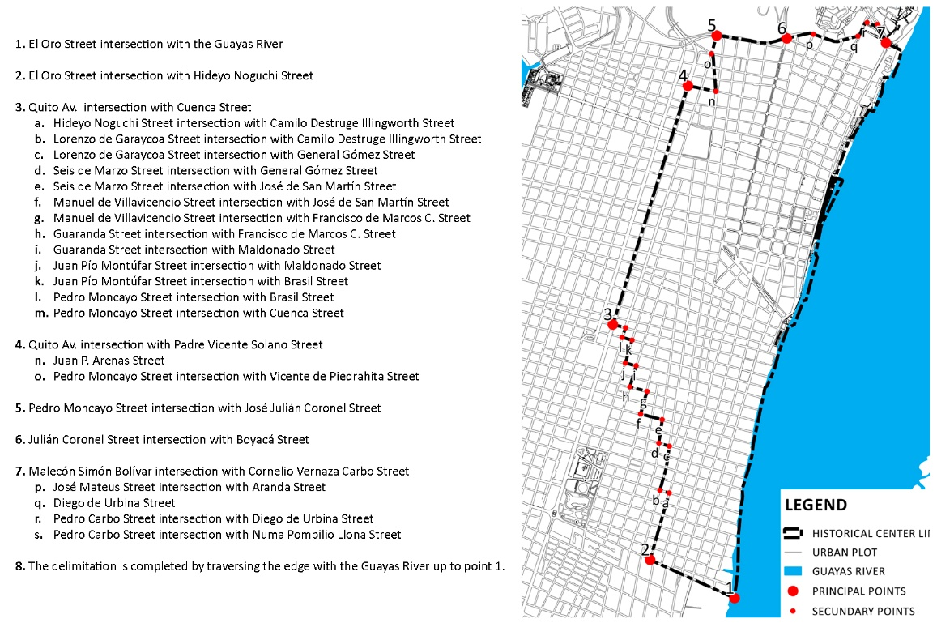

Fig. 7: Delimitation of the historic center

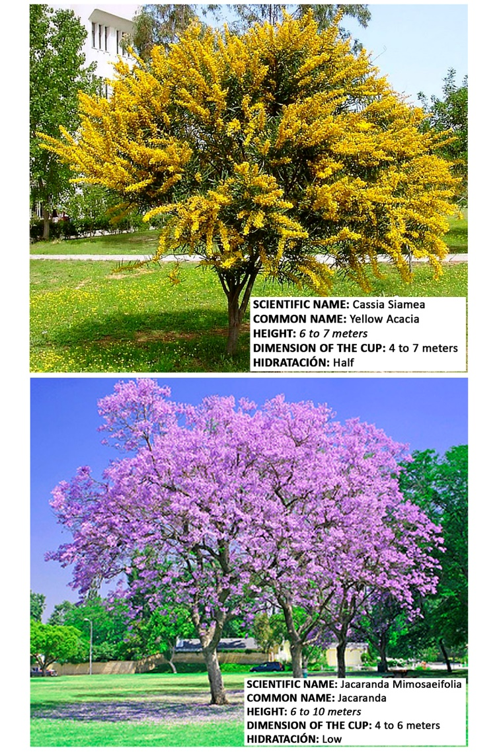

Fig. 8: Characteristics of tree species, (Jardin, Copyright © 2011-2015 Verde Jardín / Template Designed By : ThemeXpose)

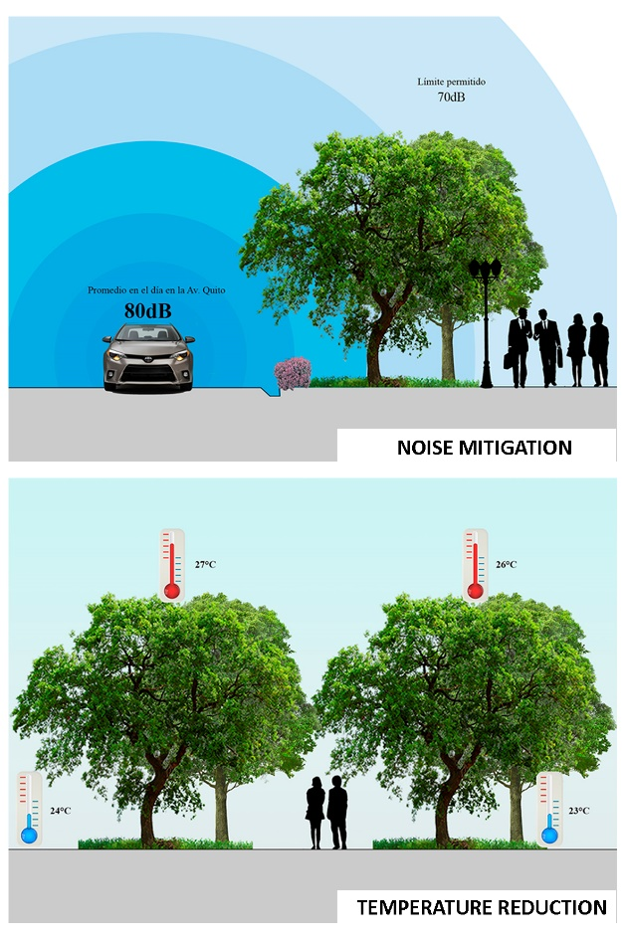

Fig. 9: Benefits to the city caused by the selected species: (up.) mitigation of noise; (low.) temperature reduction (Usvat, 2014 Copyright Liliana Usvat. Simple theme. Theme images by konradlew. Powered by Blogger.)

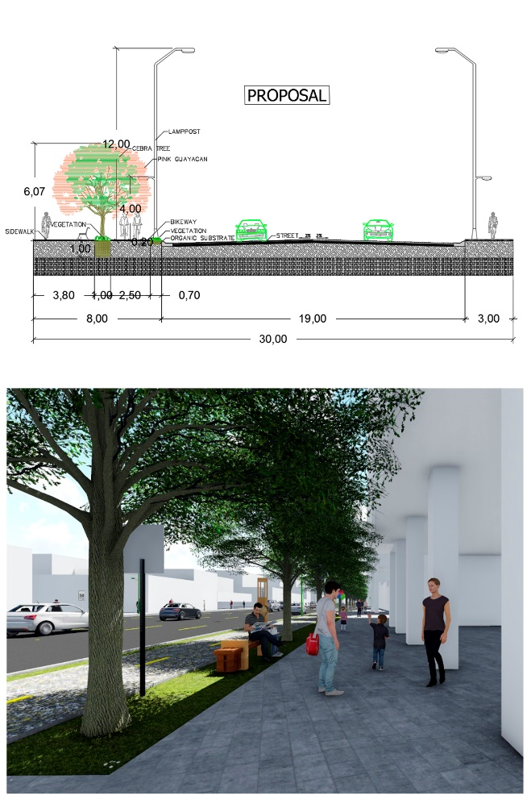

Fig. 10: Urban green infrastructure proposal: (up.) cut view av. Quito; (low.) 3D projection.

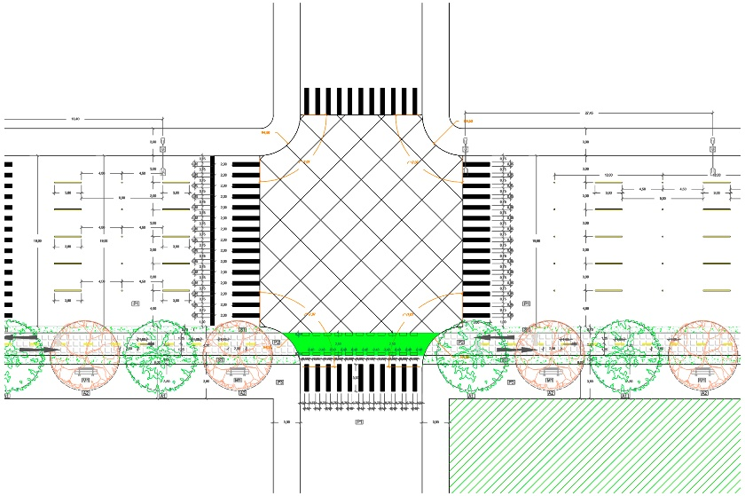

Fig. 11: Plan view av. Quito

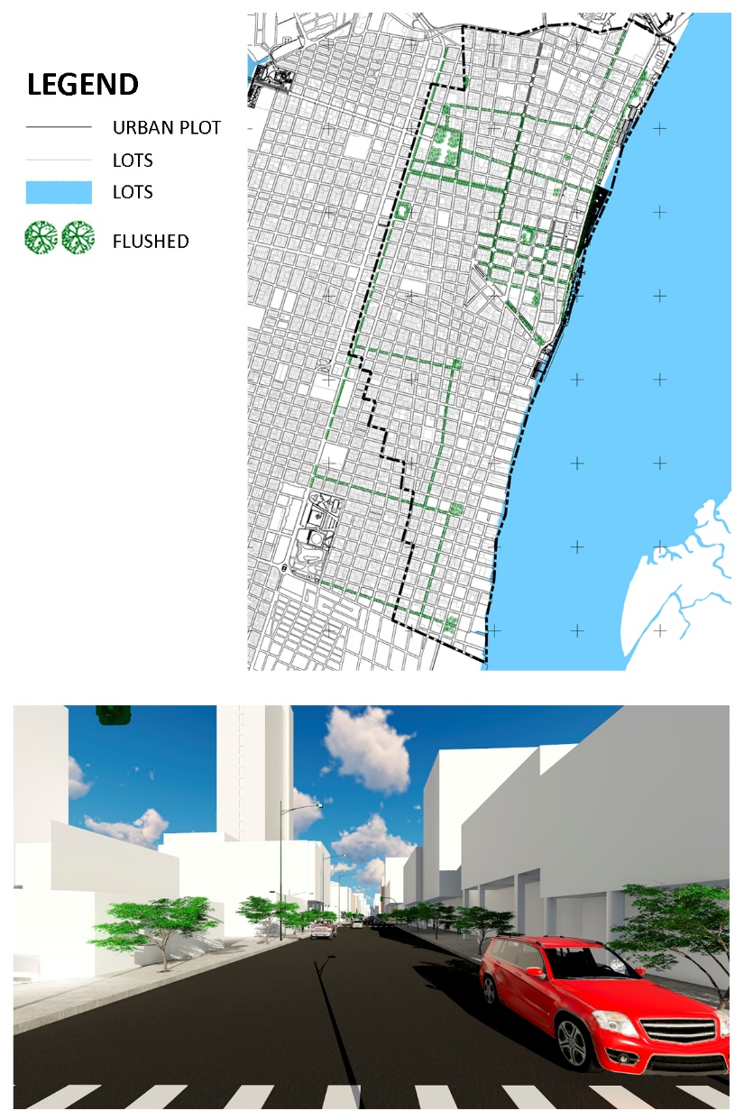

Fig. 12: Proposed incorporation of trees in Luque Street: (up.) Street view of the green corridor or the urban proposal; (low.)

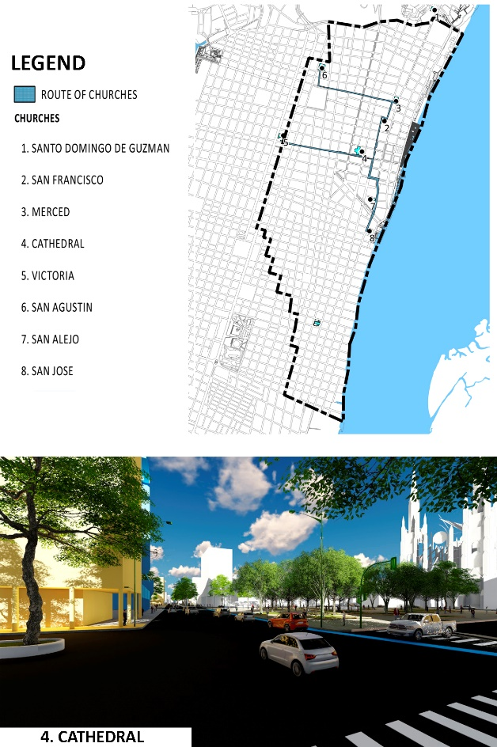

Fig. 13: Route of the churches:(up.) Street view of the route of the churches of the urban proposal; (low.)

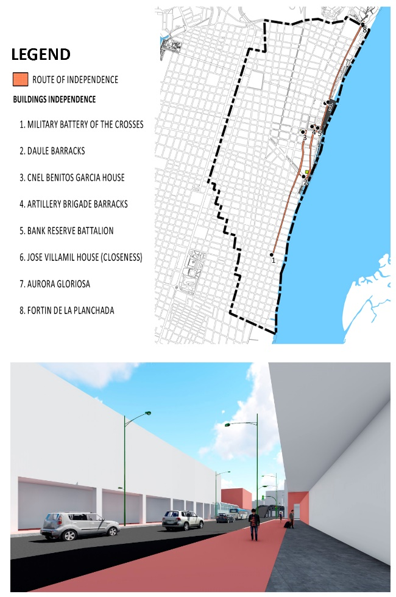

Fig. 14: Route of independence*:* (up.) Street view of the route of independence of the urban proposal; (low.)

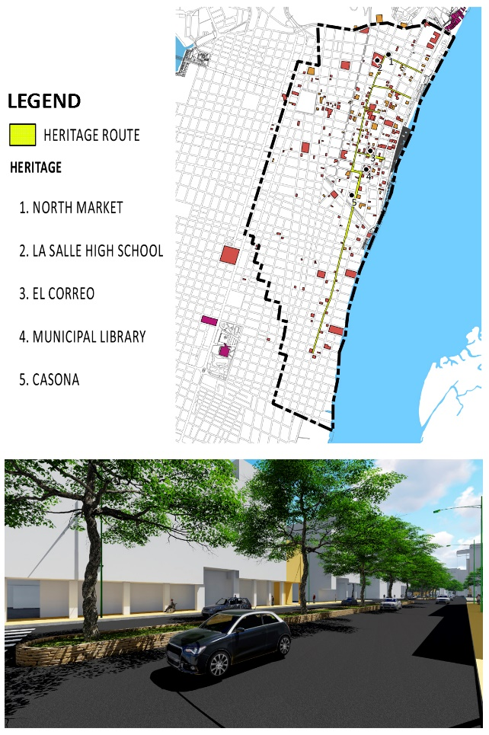

Fig. 15: Proposal for a patrimonial route: (up.) Street view of the patrimonial route of the urban proposal; (low.)

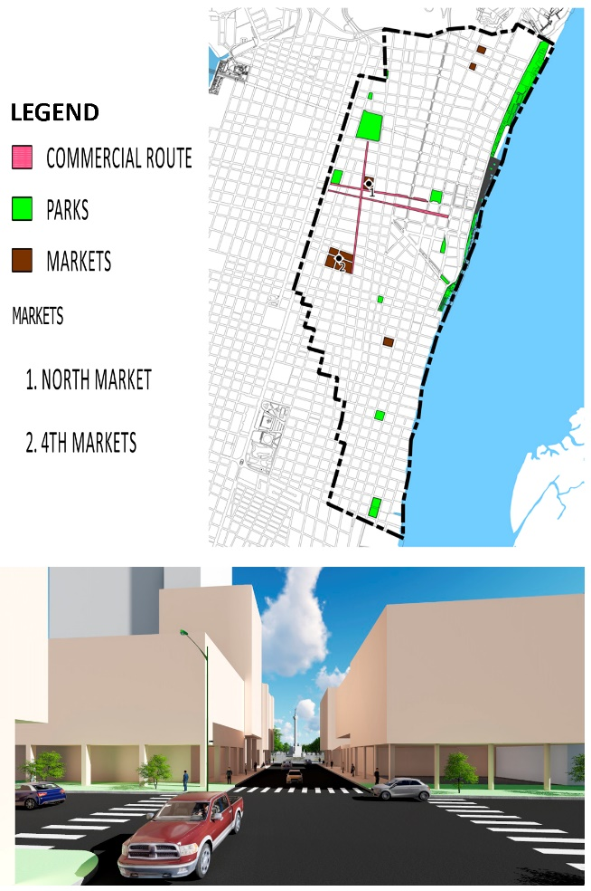

Fig. 16: Proposal of the c*ommercial route: :* (up.) Street view of the c*ommercial route* of the urban proposal; (low.)

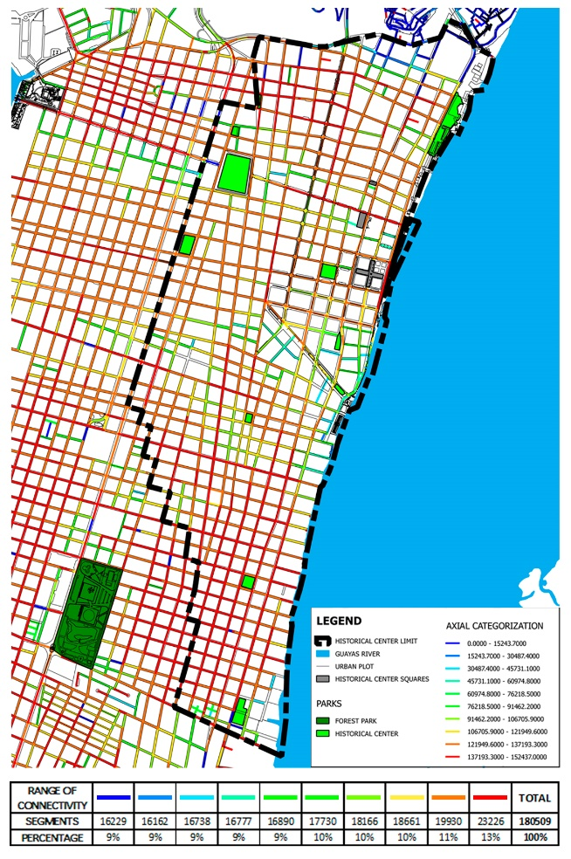

Fig. 17: Axial map

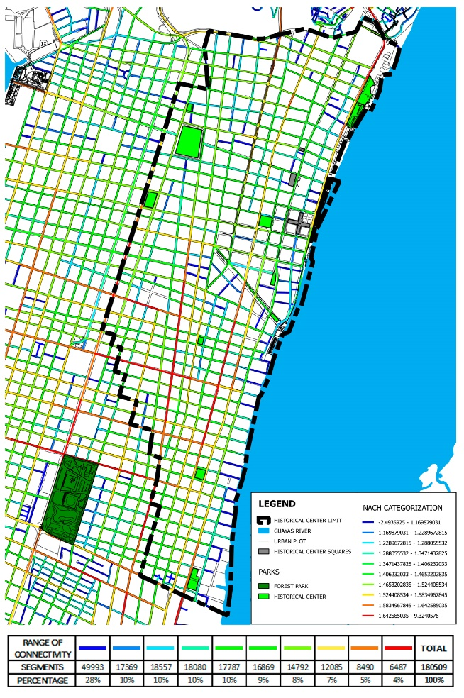

Fig. 18: Choice analysis

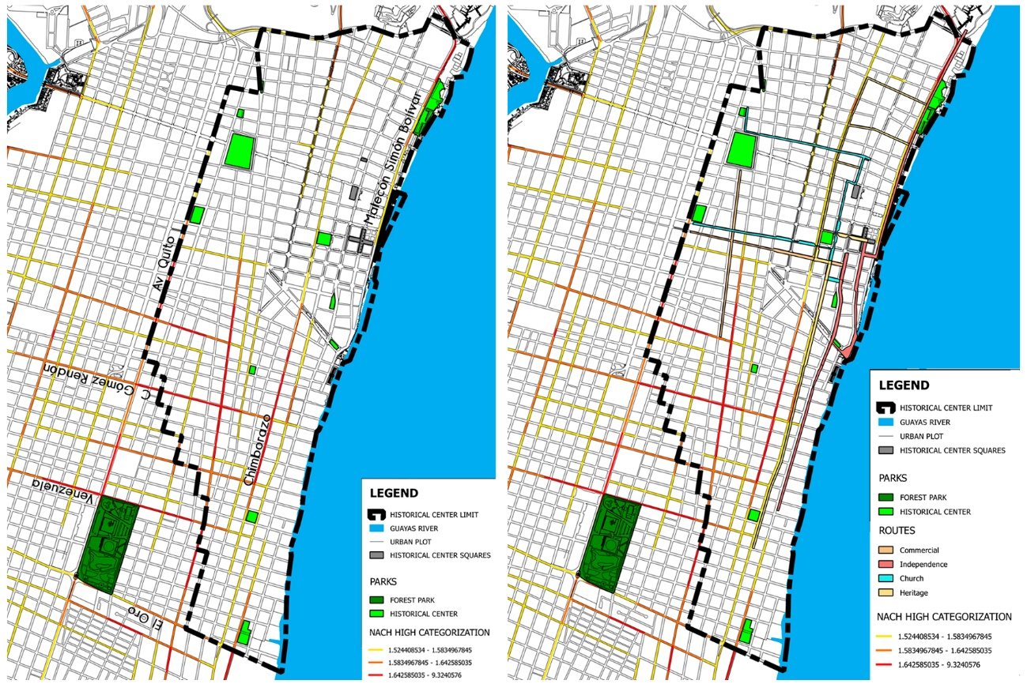

Fig. 19: (left). High analysis choice; (right) Routes high integration analysis

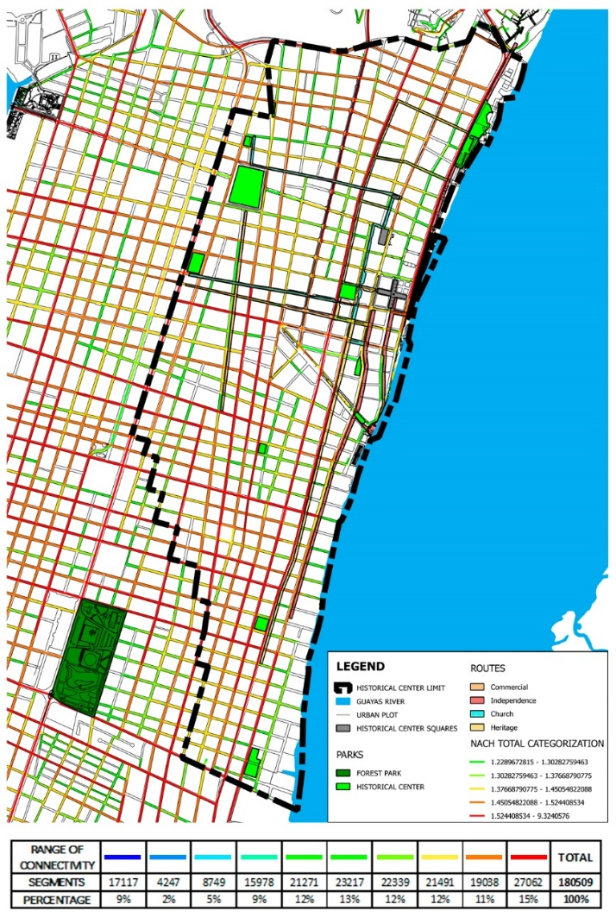

Fig. 20: Final analysis (up.); range of connectivities (low.)