Dr. David A. Falk

University of British Columbia

Dr. David A. Falk is a sessional instructor at the University of British Columbia.  He holds a Ph.D. in Egyptology from the University of Liverpool, an M.A. in Near and Middle Eastern Civilizations from the University of Toronto, and an M.Div. and M.A. in Near Eastern and Biblical Archaeology and Languages from Trinity International University.  His dissertation is titled, *Ritual Processional Furniture: A Material and Religious Phenomenon in Egypt,*and among his articles are, “The Egyptian Sojourn and the Exodus” and “Evaluating Chronological Hypotheses in Light of Low, Middle, and High Chronological Frameworks.”

What Kind of Construction Did the Israelites Do in Egypt?

Egyptian sources shed light on the nature of the work described in the Torah.

[Dr. David A. Falk](https://www.thetorah.com/author/david-a-falk)

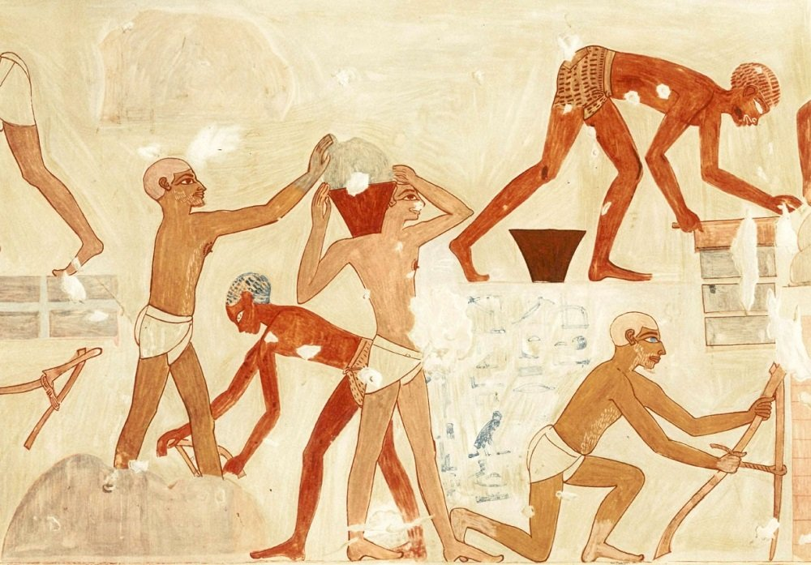

Figure 1: Levantine Asiatics making bricks (Illustration from N. D. G. Davies, *Paintings from the Tomb of Rekh-Mi-Rēˁ* [New York: Metropolitan Museum of Art, 1935], pl. 17)

‍Mud Brick versus Stone Construction

Buildings in ancient Egypt were constructed from either stone or mud bricks. Temples were generally built with stone since they were meant to be permanent structures to last throughout the ages. Palaces, on the other hand, were built for comfort and were made of mud brick, which was cool in the day and warm at night. To make that mud brick visually appealing, the brick work was painted over with plaster and then murals were painted over the plaster.[1]

Each type of construction would have been considered specialized labor; in other words, people who did one did not do the other. Which of these does the Bible envision the Israelites doing?[2]

Mud Bricks

Contrary to popular perception, the Bible is *not* claiming that the pyramids were built by the Israelites. Most of the pyramids, and certainly the famous pyramids of the Old Kingdom Period, were built hundreds of years before the period in question. Furthermore, Egyptian archaeological sources reveal that the pyramids were built by native Egyptians who were specialists in stone brick construction.

Instead, the biblical text describes the Israelite slaves working in mud brick construction.

שמות א:יג וַיַּעֲבִדוּ מִצְרַיִם אֶת בְּנֵי יִשְׂרָאֵל בְּפָרֶךְ. א:יד וַיְמָרְרוּ אֶת חַיֵּיהֶם בַּעֲבֹדָה קָשָׁה **בְּחֹמֶר וּבִלְבֵנִים** וּבְכָל עֲבֹדָה בַּשָּׂדֶה אֵת כָּל עֲבֹדָתָם אֲשֶׁר עָבְדוּ בָהֶם בְּפָרֶךְ.

Exod 1:13 The Egyptians became ruthless in imposing tasks on the Israelites 1:14 and made their lives bitter with hard service **in mortar and bricks** and in every kind of field labor. They were ruthless in all the tasks that they imposed on them.

According to the Bible, the Israelites not only built the buildings, but also made the bricks. This is made clear in Exodus 5, when, after Moses demands a three-day holiday for the Hebrews to go and worship YHWH, Pharaoh reacts by making the work harder:

שמות ה:ז לֹא תֹאסִפוּן לָתֵת תֶּבֶן לָעָם לִלְבֹּן הַלְּבֵנִים כִּתְמוֹל שִׁלְשֹׁם הֵם יֵלְכוּ וְקֹשְׁשׁוּ לָהֶם תֶּבֶן. ה:ח וְאֶת מַתְכֹּנֶת הַלְּבֵנִים אֲשֶׁר הֵם עֹשִׂים תְּמוֹל שִׁלְשֹׁם תָּשִׂימוּ עֲלֵיהֶם לֹא תִגְרְעוּ מִמֶּנּוּ...

Exod 5:7 “You shall no longer give the people straw to make bricks, as before; let them go and gather straw for themselves. 5:8 But you shall require of them the same quantity of bricks as they have made previously; do not diminish it…”

Gathering Straw

**‍**Pharaoh’s new decree here reveals another dimension to the work, namely the gathering of straw with which to make the bricks.

Mud bricks were made from Nile alluvium, which is a conglomerate of clay and sand. The proportion of clay within that alluvium determines much of the properties of the mud used to make the bricks. When the content of clay is proportionally high, mud bricks can be made without the use of straw. But when the content of clay is proportionally low, as is more typical, straw is needed as an additional ingredient to prevent a brick from falling apart as it dries.[3]

Brick Making: A Labor Specialization for Slaves

*Papyrus Anastasis IV*(12:5-6) expresses one Egyptian soldier’s frustration over the lack of brick makers and the lack of straw:

I am residing at Qenqen-en-ta, without provision, and there are neither men to make bricks nor straw in the region.

Brick making appears to have been a labor specialization that was normative for slaves in ancient Egypt. In the dynasty 18 tomb of Rekhmire (TT100), Levantine Asiatic and Nubian slaves were depicted making bricks (Figure 1 above).

That the Israelites were primarily, if not exclusively, brick makers as opposed to builders is apparent from the next part of the story, which focuses on the Israelite supervisors:

שמות ה:יד וַיֻּכּוּ שֹׁטְרֵי בְּנֵי יִשְׂרָאֵל אֲשֶׁר שָׂמוּ עֲלֵהֶם נֹגְשֵׂי פַרְעֹה לֵאמֹר מַדּוּעַ לֹא כִלִּיתֶם **חָקְכֶם לִלְבֹּן** כִּתְמוֹל שִׁלְשֹׁם גַּם תְּמוֹל גַּם הַיּוֹם.

Exod 5:14 And the supervisors of the Israelites, whom Pharaoh's taskmasters had set over them, were beaten, and were asked, "Why did you not finish **the required quantity of bricks** yesterday and today, as you did before?"

ה:טו וַיָּבֹאוּ שֹׁטְרֵי בְּנֵי יִשְׂרָאֵל וַיִּצְעֲקוּ אֶל פַּרְעֹה לֵאמֹר לָמָּה תַעֲשֶׂה כֹה לַעֲבָדֶיךָ. ה:טז תֶּבֶן אֵין נִתָּן לַעֲבָדֶיךָ **וּלְבֵנִים אֹמְרִים לָנוּ עֲשׂוּ** וְהִנֵּה עֲבָדֶיךָ מֻכִּים וְחָטָאת עַמֶּךָ.

5:15 Then the Israelite supervisors came to Pharaoh and cried, "Why do you treat your servants like this? 5:16 No straw is given to your servants, **yet they say to us, 'Make bricks!'** Look how your servants are beaten! You are unjust to your own people."

ה:יז וַיֹּאמֶר נִרְפִּים אַתֶּם נִרְפִּים עַל כֵּן אַתֶּם אֹמְרִים נֵלְכָה נִזְבְּחָה לַי-הוָה. ה:יח וְעַתָּה לְכוּ עִבְדוּ וְתֶבֶן לֹא יִנָּתֵן לָכֶם **וְתֹכֶן לְבֵנִים** תִּתֵּנּוּ.

5:17 He said, "You are lazy, lazy; that is why you say, 'Let us go and sacrifice to YHWH.' 5:18 Go now, and work; for no straw shall be given you, but you shall still deliver **the same number of bricks**."

ה:יט וַיִּרְאוּ שֹׁטְרֵי בְנֵי יִשְׂרָאֵל אֹתָם בְּרָע לֵאמֹר לֹא תִגְרְעוּ **מִלִּבְנֵיכֶם** דְּבַר יוֹם בְּיוֹמוֹ.

5:19 The Israelite supervisors saw that they were in trouble when they were told, "You shall not lessen **your** daily number of **bricks**."

The text here repeatedly mentions a brick-maker’s quota. We know from *Papyrus Anastasis III*(vs. 3:1-2) that the Egyptians did set quotas for brick makers, “Likewise, people are making bricks… they are making their quota of bricks daily.” It is not known exactly how many bricks make up the typical daily quota; however, if it was like other labor specializations then it would have constituted an expected full day of production.

Beaten then Questioned: Egyptian Interrogation

Without the straw, the Israelites efforts to make bricks and meet their quotas would have been intentionally hampered, which would give the Egyptian taskmasters pretense to beat the slaves. Note that in Exod 5:14 (quoted above), the supervisors are beaten first *then* questioned. This same interrogation technique was used with the tomb robbery incidents that took place during Ramesses IX where those interrogated were beaten before questioning.[4]

In the Egyptian mindset, one could guarantee that questions would be answered truthfully only after a severe beating had been done. *Papyrus BM 10052* (15:21-23) recorded several of these interrogations, e.g.,

Examination. There was brought the foreigner Ahautinūfer son of Nehk. He said, “Far be it from me, far be it from me.” He was examined with the stick and found innocent.

Also, we can glean from *Papyrus Amherst*(3:6-7) the severity of these beatings,

They were examined by beating with a stick, and their feet and hands were twisted. They told the same story.

Supply Cities and Storage Depots

One verse in the Torah describes the Israelites building actual structures, not only making bricks:

שמות א:יא וַיָּשִׂימוּ עָלָיו שָׂרֵי מִסִּים לְמַעַן עַנֹּתוֹ בְּסִבְלֹתָם וַיִּבֶן עָרֵי מִסְכְּנוֹת לְפַרְעֹה אֶת פִּתֹם וְאֶת רַעַמְסֵס.

Exod 1:11 Therefore they set taskmasters over them to oppress them with forced labor. They built supply cities, Pithom and Rameses, for Pharaoh. (NRSV)

What are supply cities? This cannot simply be coterminous with Pithom and Rameses since these two cities were large with multiple buildings in them,[5] including Temples made of stone. In other words, Pithom and Rameses were cities, but they cannot really be described as “supply” cities, and thus, the verse likely refers to structures *inside* these cities.

I suggest that the term “supply cities” refers to a series of mud brick storage depots that were attached to the temples in these two cities (and many others), and which were built to store vast quantities of food, that would be used for offerings to the Egyptian gods.

That the Bible refers to these structures as “cities” instead of merely “buildings” is likely a consequence of the magnitude of these projects. The area that these supply depots covered often exceeded by many times the area taken up by the temple itself.

Many examples of these storage depots can be found surrounding the mortuary temples of Egypt, e.g., the Ramesseum (Figure 2).

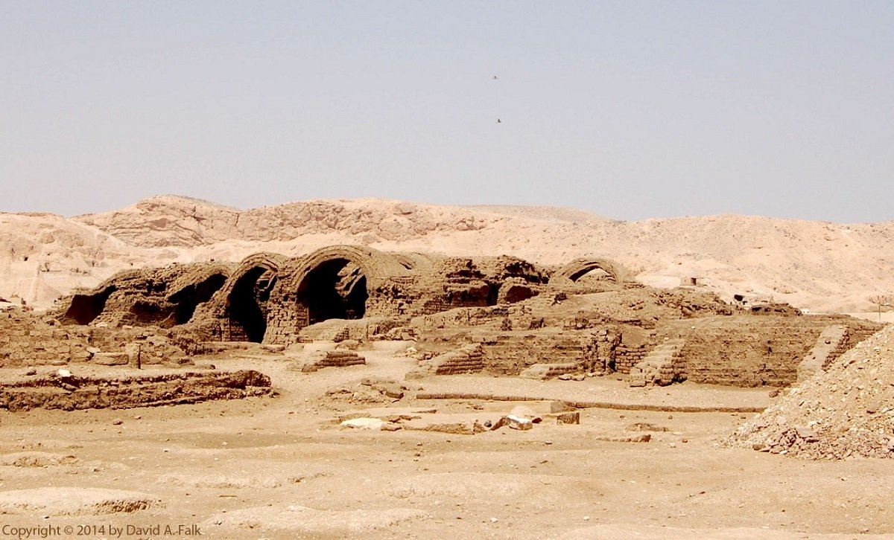

Figure 2: Storage magazines at the Ramesseum (Photograph by author)

‍The Importance of Storing Food in Temples

Why did the temples need such large storage depots? First of all, being a barter economy, Egypt did not concentrate wealth in the form of silver. Thus, storing of food for offerings would ensure that temple cults continue to run smoothly.

Granted, the major institutional temples that also acted as administrative centers, such as Karnak temple, received support from entire dynasties through perpetual land grants. These temples could operate with or without the blessings of the king and did not typically have the need for extensive storage depots to maintain the cult.

Nevertheless, most temples in Egypt could *not* count on the crown to support its endeavors once the king that patronized them died. Many temples were “special interest” cults, in support of minor deities venerated by a given pharaoh. It was common for a king to patronize deities outside of the official royal (e.g. Amunist) and funerary (Osirian) cults. For example, Amenhotep III’s veneration of Sekhmet or Thutmosis IV’s veneration of Horakhte-Khepri-Re-Atum.[6] These cults had no official recognition from the state after the patron king died.

The problem was even more acute with royal mortuary temples. In most cases, when the king died, work on most royal building projects and the collection of food for offerings, simply stopped.[7] Future pharaohs typically would not support the mortuary cults of predecessors since they had their own mortuary cults to build.

For this reason, kings would want to ensure a constant supply of offerings far into the future for their personal mortuary and special interest cults. And since any temple cult only lasted as long as there was food to make offerings and feed the priests, for a royal mortuary or patronized religious cult to survive long, vast amounts of food had to be stored during the lifetime of the pharaoh who built up the cult.

Given these circumstances, Pharaoh’s command to force the Israelites to build these temple storage depots was concomitantly a command to make YHWH’s chosen people labor in service to gods other than YHWH.

[View Footnotes](https://www.thetorah.com/article/what-kind-of-construction-did-the-israelites-do-in-egypt)

1. Editor’s note: For more on Egyptian palaces, see Rachel Kreiter, ["Pharaoh's Mudbrick Palace,"](http://thetorah.com/pharaohs-mudbrick-palace/) *TheTorah.com* (2017).
2. Editor’s note: For a discussion slavery in Egypt during this period, see Mark Janzen, ["What We Know about Slavery in Egypt,"](http://thetorah.com/what-we-know-about-slavery-in-egypt/) *TheTorah.com* (2015).
3. A. Lucas, *Ancient Egyptian Materials*(London: Edward Arnold & Co., 1926), 7.
4. T. E. Peet, *The Great Tomb-Robberies of the Twentieth Egyptian Dynasty*(Oxford: Clarendon Press, 1930), 24.
5. For more on the identification of these cities, see my, ["What We Know about the Egyptian Places Mentioned in Exodus,"](https://thetorah.com/what-we-know-about-the-egyptian-places-mentioned-in-exodus/)*TheTorah.com* (2018).
6. *Sphinxstele ThutmosisˀIV* (*Urk.* *IV*, 1542:17-18)
7. For example, the reliefs done on the Processional Colonnade at Luxor Temple that were begun under the patronage of Tutankhamun were never completed because of the premature the death of the king. An interesting historical exception to this was Ramesses II who continued the projects of his father Seti I for several years after the death of Seti I; however, Ramesses II used his father’s unfinished monuments to self-aggrandize and usurp many of his father’s inscriptions.