3 Baga Masters

In may 2019 Guinea former First Lady of 24 years ( 1984-2008 ) Henriette Conte’ has died.

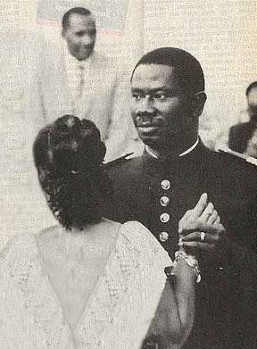Henriette was lancana conte’s first love, their image waltzing when lancana was a young captain serving in the Guinean border resonates till today.

Although president conte’ married three additional wives, Henriette which was known for her honesty compassion and integrity remained at his side and continued to serve as Guiana First Lady throughout lancana’s 24 long years in office.

She was often called to mediate between her husband and her countrymen, employing her skills in easing tensions between guinea’s unions and her husband military regime.

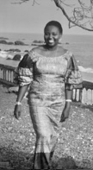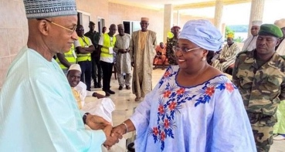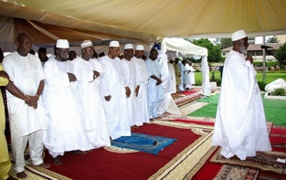Henriette Conte’ was a Guinean moral beacon and as such grieved by all aspects of the Guinean political sphere, the Guinean president Alfa Conde attended the state funeral held in her honor, as well as cellou Diallo head of the Guinean opposition. Lengthy Obituaries were published in all the Guinean media.

Being a Baga from boke’, born to the Bangoura of Taigbe, - Katako, she advocated Baga’s agenda at Conte’s centralist regime in Conakry.

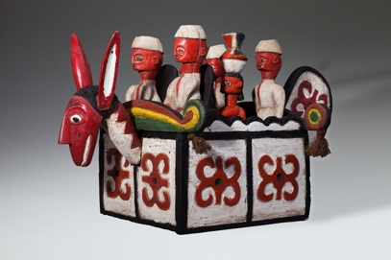Footprints of the Guinean governments close connections to the Baga community can be seen in the assortments of figures ridding atop the Sibindel headrests from the sixties and seventies of the last century, used by dancers during receptions honoring government dignitaries visiting the Bagaland.

Henriette like most of her female rural compatriots was initiated to the the Baga’s woman secret societies.

The Guinean various women’s association were the only traditional civil groups surviving

Sekou toure’s 25 long years of Marxist dictatorship, a time during which the Baga village skyline dominated for centuries by the silhouettes of the sacred cotton trees gradually gave way to a one of mosques and minarets.

Years in which the Baga male population converted amass to Islam, the old forest spirits and their advocates branded as colonial collaborators and foreign agents and village elders adhering to the “ancient regime” arrested, and their sacred groves uprooted.

Unlike their male parallels

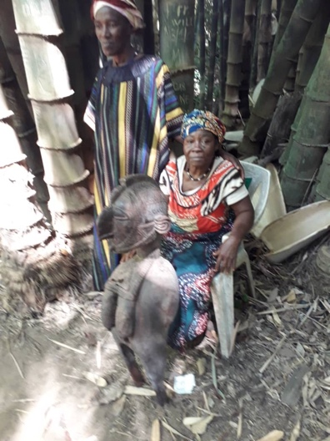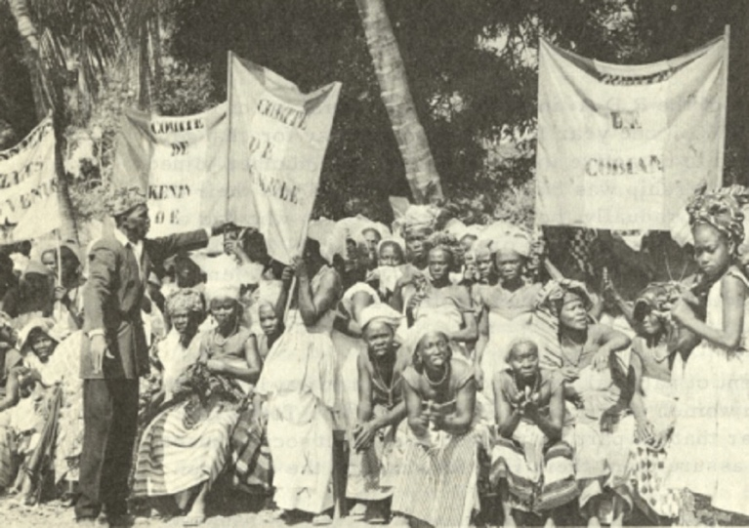the women’s secret associations challenged the revolutionary zeal of the central government advocating their responsibilities towards their community and thus managed to retain their power, traditions and morals. Sparing the women’s sacred groves and their domain virtually untouched.

Throughout her long career Henriette was approached by delegations and representatives of the Baga women’s association, pressing their cases. as customary in such meetings, gifts were exchanged. And Henriette due to her position as a Baga Elder was entrusted with major artifacts from the Baga women’s sacred paraphernalia.

Upon her death, due to her stature, elaborate farewell celebrations were held. Traditionally covering the costs of such week long receptions is done mainly by selling religious paraphernalia held by the deceased, an elder being only a custodian to the objects entrusted by the community to his care, and upon his death they are regarded as communal property. as customary I was approached by the Baga elders to mediate the funeral costs, and the week long receptions held in her honor.

Slowly, a group of twelve pieces emerged, ten of which Masterpieces created in the early 20th century, hidden from sight since the 1957 iconoclasm. Two were later versions from the eighties.

Some of the statues were in a progressive state of decay, therefore a major painstaking restoration project headed by master Nkai Sidime and Master Morri Curia a renown Guinean restoration expert was embarked upon.

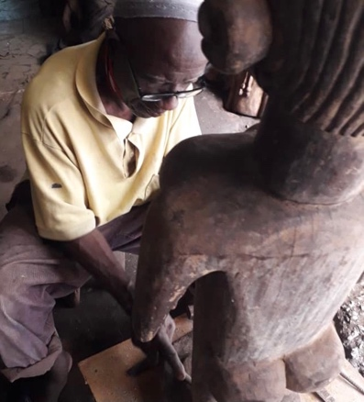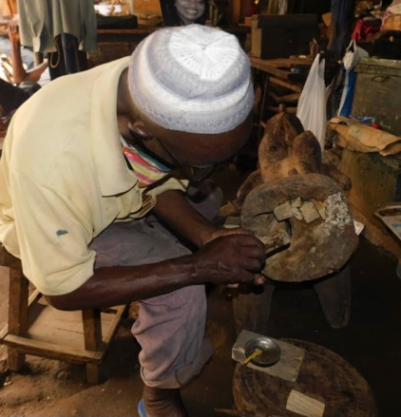

Henriette Conte’s collection supplemented by the Katako hoard, currently in the Israeli museum Jerusalem – ***Nimba*** *– Baga art & the great mother* exhibition consists most of the known oeuvre used by the Baga’s woman association of early 20th century.

A cohesive group representing Baga culture at it’s Zenith.

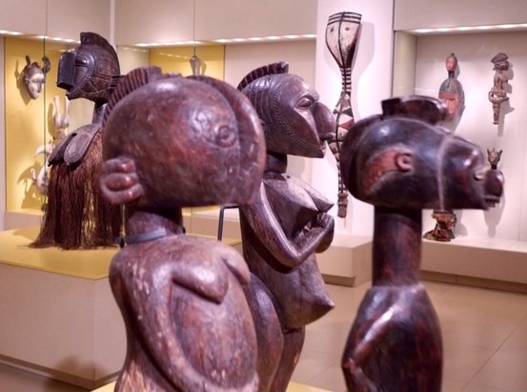

close examination revealed three distinctive artists within the group.

Each with his own unmistakable approach, manner and realm of interests.

All operating within the liturgy and Canon of Baga paraphernalia.

each employing unique and personal artistic vocabulary.

One embarking on a formalistic journey towards the abstract.

The second aiming to the metaphysical and the spiritual . And a third drown by love of the figurative and delight in detailing, towards realism and portraiture.

The still living Baga elders were approached with queries regarding the artists, their whereabouts biographies etc’ .

Contrary to earlier western perceptions all three artists were known figures. Respected members of their communities, some decedents to a long line of Masters, and their craft loved, known and appreciated for years.

Further research assisted by Boke governor revealed biographies date of birth,

Etc’.

The three Masters are :

.Famori Camara born 1885 in faraba.

.Mangue Bangoura born 1900 in Camala.

.Anadi fote’ Camara born 1890 in Taigbe

Comparative study of collections held in other western Museums enabled to attribute Additional works to the oeuvre of these three masters. For instance

Famori’ s Camara distinctive abstract vocabulary enabled the attribution of –

Standing male and female figures,Yale university Art gallery- acquired 1954.

Nimba headdress – Rierberg Museum Zurich.

A Janus head from the national museum van wereldculturen.

It is a great privilege to try and do this small gesture and replace the customary museum plaque accompanying African masterpieces stating an anonymous artist with a one bearing an actual name.

An artist working in his community, within the guidelines of his cult canon, tuned to the spirit of the time. his own artistic manner and a fully developed personal voice.

And give these three Masters the Pedestal they so truly deserve.

Michael Weiss – Tel Aviv – 2021.